Name of Journal: World Journal of Clinical Cases
Manuscript NO: 89210
Manuscript Type: META-ANALYSIS

Impact of body mass index on adverse kidney events in diabetes mellitus patients: A systematic-review and meta-analysis

Wan JF et al. BMI and kidney adverse events

Jing-Fang Wan, Yan Chen, Tian-Hua Yao, Ya-Zhou Wu, Huan-Zi Dai

Jing-Fang Wan, Department of Nephrology, Army Medical University, Chongqing 400042, China

Yan Chen, Department of Nephrology, Chongqing Western Hospital, Chongqing 400052, China

Tian-Hua Yao, Ya-Zhou Wu, Health Statistics, Army Medical University, Chongqing 400038, China

Huan-Zi Dai, Department of Nephrology, Daping Hospital, Army Medical University, Chongqing 400042, China

Co-first authors: Jing-Fang Wan and Yan Chen.

Co-corresponding authors: Ya-Zhou Wu and Huan-Zi Dai.

Author contributions: Wan JF, Chen Y, Dai HZ and Wu YZ conceived, designed and refined the study protocol; Wan JF and Chen Y and Yao TH were involved in the data collection; Wan JF, Yao TH, Dai HZ and Wu YZ analyzed the data; Wan JF, Chen Y, Dai HZ and Wu YZ drafted the manuscript; Dai HZ and Wu YZ contributed to review and editing, and final approval. All authors were involved in the critical review of the results and have contributed to, read, and approved the final manuscript.; Wan JF and Chen Y contributed equally to this work as co-first authors; Wu YZ and Dai HZ contributed equally to this work as co-corresponding authors. The reasons for designating Wu YZ and Dai HZ as co-corresponding authors are threefold. First, the research was performed as a collaborative effort, and the designation of co-corresponding authorship accurately reflects the distribution of responsibilities and burdens associated with the time and effort required to complete the study and the resultant paper. This also ensures effective communication and management of post-submission matters, ultimately enhancing the paper's quality and reliability. Second, the overall research team encompassed authors with a variety of expertise and skills from different fields, and the designation of co-corresponding authors best reflects this diversity. This also promotes the most comprehensive and in-depth examination of the research topic, ultimately enriching readers' understanding by offering various expert perspectives. Third, Wu YZ and Dai HZ contributed efforts of equal substance throughout the research process. The choice of these researchers as co-corresponding authors acknowledges and respects this equal contribution, while recognizing the spirit of teamwork and collaboration of this study. In summary, we believe that designating Wu YZ and Dai HZ as co-corresponding authors of is fitting for our manuscript as it accurately reflects our team's collaborative spirit, equal contributions, and diversity.

Supported by Special Project for Improving Science and Technology Innovation Ability of Army Medical University, No. 2022XLC09.

Corresponding author: Huan-Zi Dai, MD, PhD, Associate Chief Physician, Associate Professor, Department of Nephrology, Daping Hospital, Army Medical University, No. 10 Daping Changjiang Zhi Road, Yuzhong District, Chongqing 400042, China. daihzxyz@163.com

Received: October 24, 2023
Revised: December 10, 2023
Accepted: December 28, 2023
Published online: January 26, 2024

Abstract
BACKGROUND
The incidence of chronic kidney disease among patients with diabetes mellitus (DM) remains a global concern. Long-term obesity is known to possibly influence the development of type 2 diabetes mellitus. However, no previous meta-analysis has assessed the effects of body mass index (BMI) on adverse kidney events in patients with DM.

AIM
To determine the impact of BMI on adverse kidney events in patients with DM.

METHODS
A systematic literature search was performed on the PubMed, ISI Web of Science, Scopus, Ovid, Google Scholar, EMBASE, and BMJ databases. We included trials with the following characteristics: (1) Type of study: Prospective, retrospective, randomized, and non-randomized in design; (2) participants: Restricted to patients with DM aged ≥ 18 years; (3) intervention: No intervention; and (4) kidney adverse events: Onset of diabetic kidney disease [estimated glomerular filtration rate (eGFR) of < 60 mL/min/1.73 m² and/or microalbuminuria value of ≥ 30 mg/g Cr], serum creatinine increase of more than double the baseline or end-stage renal disease (eGFR < 15 mL/min/1.73 m² or dialysis), or death.

RESULTS
Overall, 11 studies involving 801 patients with DM were included. High BMI (≥ 25 kg/m²) was significantly associated with higher blood pressure (BP) [systolic BP by 0.20, 95% confidence interval (CI): 0.15–0.25, P < 0.00001; diastolic BP by 0.21 mmHg, 95%CI: 0.04–0.37, P = 0.010], serum albumin, triglycerides [standard mean difference (SMD) = 0.35, 95%CI: 0.29–0.41, P < 0.00001], low-density lipoprotein (SMD = 0.12, 95%CI: 0.04–0.20, P = 0.030), and lower high-density lipoprotein (SMD = –0.36, 95%CI: –0.51 to –0.21, P < 0.00001) in patients with DM compared with those with low BMIs (< 25 kg/m²). Our analysis showed that high BMI was associated with a higher risk ratio of adverse kidney events than low BMI (RR: 1.22, 95%CI: 1.01–1.43, P = 0.036).

CONCLUSION
The present analysis suggested that high BMI was a risk factor for adverse kidney events in patients with DM.

Key Words: Obesity; Body mass index; Diabetes mellitus; Adverse kidney events; Systematic-review; Meta-analysis

©The Author(s) 2024. Published by Baishideng Publishing Group Inc. All rights reserved.

Citation: Wan JF, Chen Y, Yao TH, Wu YZ, Dai HZ. Impact of body mass index on adverse kidney events in diabetes mellitus patients: A systematic-review and meta-analysis. World J Clin Cases 2024; 12(3): 538-550
URL: https://www.wjgnet.com/2307-8960/full/v12/i3/538.htm
DOI: https://dx.doi.org/10.12998/wjcc.v12.i3.538

Core Tip: The effect of body mass index (BMI) on adverse kidney events in patients with diabetes mellitus (DM) remains unclear. Our meta-analysis showed that patients with DM with higher BMIs had higher blood pressures and serum albumin levels, as well as worse lipid profiles. High BMI was found to be a risk factor contributing to adverse kidney events in patients with DM.

INTRODUCTION
According to the 2020 Hemodialysis Annual Report^{[1]}, approximately 700,000 patients with end-stage renal disease (ESRD) require maintenance hemodialysis. The incidence of chronic kidney disease (CKD) among patients with diabetes mellitus (DM) was noted to be as high as 64.0 cases per 1000 person-years (95%CI, 62.2–65.9)^{[2]}.
Patients with DM and CKD have a substantially increased risk of all-cause mortality, cardiovascular mortality, and ESRD^{[3]}. Obesity is a major contributor to the development of diabetes^{[4]}. A historical cohort study^{[5]} showed that a higher baseline body mass index (BMI) was an independent predictor of ESRD when compared to individuals with normal weight in the normal range (BMI: 18.5–24.9 kg/m²), and the adjusted relative risk of ESRD was 1.87 (95%CI, 1.64–2.14) for those who were overweight (BMI: 25–29.9 kg/m²). Long-term obesity has the potential to influence the development of type 2 diabetes mellitus and has significant effects on the kidneys that can include changes to intraglomerular hemodynamics, increased sympathetic activity, hypertension, systemic inflammation, endothelial dysfunction, expression of growth factors, and compression associated with visceral adiposity^{[6-8]}.
Some studies have found that obesity and DM exert a synergic effect on decreases in estimated glomerular filtration rate (eGFR)^{[5,9-11]}. However, the influence of BMI on adverse kidney events in patients with DM remains unclear, and some studies have shown that BMI is positively correlated with diabetic kidney disease (DKD)^{[12-14]}. Obesity has also been associated with an increased risk of decreased renal function in patients with DM^{[15-17]}. Other studies have suggested that BMI is a protective factor against renal function deterioration^{[18-21]} or that declines in renal parameters are not influenced by BMI^{[22,23]}.
To the best of our knowledge, no previous meta-analysis has evaluated the effects of BMI on adverse kidney events in patients with DM. Therefore, this study aimed to evaluate the effects of BMI on adverse kidney events in patients with DM.

MATERIALS AND METHODS
Literature search
This meta-analysis was conducted in accordance with the Preferred Reporting Items for Systematic Reviews and Meta-analysis (PRISMA) guidelines^{[24]}. Two reviewers independently identified relevant studies in the PubMed, ISI Web of Science, Scopus, Ovid, Google Scholar, EMBASE, and BMJ databases from their respective inceptions until December 2022. We restricted the included studies to those published in English. The following terms were used in our search: diabetes mellitus, diabetic kidney disease, diabetic nephropathy, DM, BMI, obesity, excessive body weight, overweight, and underweight.

Study selection
We included trials with the following characteristics: (1) Type of study: Prospective, retrospective, randomized, and non-randomized in design; (2) participants: restricted to patients with DM aged ≥ 18 years; (3) intervention: No intervention; and (4) kidney adverse events: Onset of (DKD; eGFR of < 60 mL/min/1.73 m² and/or microalbuminuria value of ≥ 30 mg/g. Cr), serum creatinine increase of more than double from baseline levels, ESRD (eGFR < 15 mL/min/1.73 m², or need for dialysis), or death. Studies were excluded if: (1) They involved particular niche-group populations, such as pregnant or lactating women; (2) they were meta-analyses, case studies, duplicates, repetitive results, or reviews; or (3) they were preclinical studies that used animal models. The following data were extracted: The study characteristics, baseline data, clinical comorbidities, and clinical outcomes.

BMI classifications
Various BMI classifications were observed in the selected studies. According to the World Health Organization, BMI values of > 30, 25–30, and < 25 kg/m² have been defined in the Western population as obesity, overweight, and normal, respectively. In the Asian population, the recommended cut-off values of BMI corresponding to these three categories are > 25, 23–25, and < 23 kg/m². Because of the variations in BMI classifications used in the studies we included, we simplified these classifications to ≥ 25 kg/m² or < 25 kg/m² to define high and low BMI, respectively.

Study quality assessment
We evaluated the quality of the cohort studies using the Newcastle–Ottawa Scale (NOS)^{[25]}. The NOS evaluates the quality of articles using three levels, with eight items. The three major aspects include the selection of study groups, the comparability of the groups, and the ascertainment of either the exposure or outcome of interest for case-control or cohort studies. A star rating system was used to assess the quality of the literature through a semi-quantitative principle, with the highest score being nine stars.
The reliability of the eligible studies was assessed using the quality assessment forms recommended by the United States Agency for Healthcare Research and Quality^{[26]}. This checklist comprises 11 items. Each item was coded with a “yes/no/unclear”: “no” or “unclear” was scored “0,” and “yes” was scored “1.” Quality scoring was performed out of 11, with scores of 8-11, 4-7, and < 3 indicating high, medium, and low quality, respectively.
Quality assessments demonstrated moderate to high quality for all included studies (Supplementary Tables 1 and 2).

Statistical analysis
Between-study heterogeneity was estimated using Cochran’s Chi-squared (χ²)-based Q statistical test and the I-squared (I²) statistic. Values of 25%, 50%, and 75% corresponded to the cut-off points for low, moderate, and high degrees of heterogeneity, respectively. Once high heterogeneity was confirmed, a random-effects model was adopted, or a subgroup analysis was conducted; otherwise, a fixed-effects model was used. A pooled analysis of categorical data was performed using the Mantel–Haenszel model, and odds ratios (ORs) with 95%CIs were reported. Our pooled analysis of continuous data was performed using the inverse variance (I-V) model and was reported as the weighted mean difference or standardized mean difference (SMD) at the 95%CI. ORs were converted to risk ratios (RRs)^{[27]}, which were presumed to be equivalent to hazard ratios. Statistical significance was set at two-tailed P values of < 0.05. As there were < 10 meta-analyses for each result in this study, Egger’s test was used to assess the possibility of publication bias. To exclude the possibility that one particular study exerted an excessive influence on the heterogeneity of the overall results, we conducted a sensitivity analysis by omitting one study at a time and reanalyzing the data to assess the corresponding change in effect size. All analyses were conducted using STATA (version 17, Stata Corporation, LLC, TX, United States) and RevMan Review Manager (version 5.4.1, The Cochrane Collaboration, Oxford, United Kingdom) softwares.

RESULTS
Flowchart of article selection and quality assessments
A flowchart of the article selection process is shown in Figure 1. We identified 889 articles through a literature search. After excluding systematic reviews and duplicate publications, as well as after reviewing the titles and abstracts, 18 studies remained. We further examined the full texts of these 18 studies and excluded incomplete data or data that could not be obtained through calculations. Ultimately, 11 studies^{[12,13,15-23]} were included in our meta-analysis.

Study characteristics
The included studies are summarized in Table 1. They were published between 1999 and 2022; of the 11 single-center studies, 5 were prospective, and 6 were retrospective. Data from 8011 patients were included, and the sample size varied from 49 (in the study by Kanauchi et al^{[21]}) to 3224 (in the study by Zhang et al^{[13]}). Three studies reported renal outcomes^{[19,22,23]}, one study evaluated mortality rates and renal endpoints^{[18]}, six studies included Asian Pacific populations [Chinese (n = 3)^{[13,18,19]}, Japanese (n = 2)^{[12,21]}, and Korean (n = 1)^{[17]}], whereas five included Afro-European populations (African (n = 1)^{[22]}, Dutch (n = 1)^{[20]}, German (n = 1)^{[14]}, British (n = 1)^{[23]}, and French (n = 1)^{[16]}.

Meta-analysis of baseline characteristics
The results of our pooled analysis revealed a significant positive association between high BMI and the incidence of hypertension (OR: 1.640, 95%CI: 1.17–2.29, P = 0.004; I² = 68%; Supplementary Figure 1A)^{[13,17,18]}, without publication bias (P = 0.378, Egger). High-BMI patients with DM were also associated with a low prevalence of Renin-angiotensin system blockers (RAS) (OR: 0.690, 95%CI: 0.57–0.84, P = 0.0002; I² = 0%; Supplementary Figure 1B)^{[13,18,22]}, without publication bias (P = 0.178, Egger). Using the random-effects model, we found a higher proportion of males in the high BMI group (OR: 1.33, 95%CI: 1.10–1. 61, P < 0.003), without publication bias (P = 0.087, Egger), but with higher heterogeneity (P = 0.0003, I² = 70%; Supplementary Figure 1C). The study by Haupt et al^{[14]} contributed to most of the heterogeneity. Compared to patients with low BMIs, high-BMI patients showed significantly higher systolic blood pressure (SBP) levels, by 0.20 mmHg (SMD: 0.20, 95%CI: 0.15–0.25, P < 0.00001; I² = 0%; P = 0.895, Egger; Supplementary Figure 1D) and diastolic blood pressure (DBP), by 0.21 mmHg (SMD: 0.21, 95%CI: 0.04–0.37, P = 0.010; I² = 85%; P = 0.858, Egger; Supplementary Figure 1E)^{[12,13,16,21-23]}. When we excluded the study by Zhang et al^{[13]}, the heterogeneity decreased significantly (rate of hypertension I²: From 68% to 0%, DBP I²: From 84% to 55%). We observed significantly higher serum albumin and lower serum uric acid levels in high-BMI patients with DM^{[13,19]}, although the data for this came from just two studies. The results revealed no significant differences in terms of hemoglobin A1C (HbA1c; SMD: 0.06, 95%CI: -0.11–0.23, P = 0.46; I² = 92%)^{[12-14,16-23]}, hemoglobin^{[18,22]}and age (SMD: -0.15, 95%CI: -0.33–0.04, P = 0.12; I² = 93%)^{[12-14,16-23]} between the two groups, without publication bias (HbA1c: P = 0.689, Egger; age: P = 0.492, Egger). The meta-analysis was performed using a random-effects model.
Our meta-analysis showed no significant increases in cholesterol levels in the high BMI group (SMD = 0.07, 95%CI: -0.13–0.26, P = 0.500; I² = 89%^{[12,14,16-18,22,23]}; Supplementary Figure 2A), without publication bias (P = 0.658, Egger). Lower heterogeneity values (I² = 69%, P = 0.007) were found when the study by Kim et al^{[17]} was excluded. We found significantly higher levels of triglycerides (TGs; SMD = 0.35, 95%CI: 0.29–0.41, P < 0.00001; I² = 42%^{[12,14,16-18,22]}; Supplementary Figure 2B) and low-density lipoprotein (LDL) (SMD = 0.12, 95%CI: 0.04–0.20, P = 0.030; I² = 43%^{[14,16-18,22]}; Supplementary Figure 2C) in the high BMI group. Publication bias in terms of TG levels was not detected by Egger’s test (P = 0.337), although publication bias was observed (P = 0.001, Egger) for LDL, suggesting that the sample sizes of the included studies were not well balanced and that the varying BMI grouping methods used may have been the most responsible for the publication bias. High BMI was associated with lower baseline levels of high-density lipoprotein (HDL) (SMD = -0.36, 95%CI: -0.51 to -0.21, P < 0.00001; Supplementary Figure 2D), with high heterogeneity (I² = 79%, P = 0.0002)^{[12,14,16-18,22]}. The study by Kim et al^{[17]} contributed to most of the heterogeneity, but we found no noticeable publication bias (P = 0.920, Egger).

Meta-analysis of baseline renal characteristics
The association between BMI and urine protein level was reported in four studies. Two assessed 24-h proteinuria^{[18,19]}, and two measured 24-h urinary albumin^{[14,21]}. No significant increase in urine protein levels was found in the high BMI group via random effects analyses. There was also no significant difference in baseline serum creatinine levels (SMD: 0.07, 95%CI -0.06–0.20, P = 0.310; I² = 70%; Figure 2A)^{[13,14,16,18-21]}, without publication bias (P = 0.141, Egger). Our subgroup analysis showed that the serum creatinine levels in the high BMI group were significantly higher compared to those of the low BMI group in the European population for those aged > 60 (sample size > 500; Table 2). When the study by Chen et al^{[19]} was excluded, heterogeneity decreased significantly (I² = 6%, P = 0.380).
No significant difference was found in baseline eGFR between the two groups (SMD = -0.03, 95%CI: -0.23–0.18, P = 0.800; I² = 89%; Figure 2B)^{[13,16-19,21,22]}, with no significant publication bias (P = 0.085, Egger). The study by Chen et al^{[19]} contributed the greatest source of heterogeneity; when this article was removed, the heterogeneity decreased significantly (I² = 68%, P = 0.009). Our results showed a significant decrease in eGFR in our subgroup analysis based on age > 60 and study sample size > 500 in the high BMI group (Table 2).

Meta-analysis of follow-up kidney adverse events
Six of the included studies reported adverse kidney events, but each reported different endpoints, and the definitions of these endpoints were inconsistent^{[12,17-19,22,23]}. These endpoints were combined to perform a meta-analysis. The random-effects model was used owing to the obvious heterogeneity (I² = 64%, P = 0.02). No significant difference was found between the two groups in terms of adverse kidney events (OR: 0.86, 95%CI: 0.70–1.05, P = 0.132; Figure 3A)^{[19,22,23]}, without publication bias (P = 0.389, Egger). The study by Chen et al^{[19]} was found to be the most significant source of heterogeneity, and six of the studies^{[12,13,16,17,19,23]} evaluated the risk of adverse kidney events. Various statistical indicators were pooled in this meta-analysis. The ORs and RRs were combined, which resulted in our meta-analysis suggesting that high BMI was associated with a higher RR than lower BMI (RR: 1.22, 95%CI: 1.01–1.43, P = 0.036; Figure 3B), without publication bias (P = 0.389, Egger).

DISCUSSION
Main findings
To the best of our knowledge, this is the first meta-analysis to assess the role that BMI plays in the renal prognoses of patients with DM. Our analysis showed that the Serum creatinine of the high BMI group was significantly higher in the older European population. Compared with patients with low BMIs, those with high BMIs showed significantly higher levels of blood pressure (BP), serum albumin, TG, LDL, and significantly lower levels of HDL. High BMI was also associated with higher RR in adverse kidney events. These results have important clinical implications for intervention and risk stratification.

Mechanisms behind BMI leading to adverse kidney events
Obesity is a global issue. According to an international epidemiologic study^{[28]}, the global prevalence of obesity will reach 18% in men and surpass 21% in women by 2025. Obesity is regarded as an overnutrition-induced state, with hypertension and diabetes representing its three most common comorbidities. We found higher levels of serum albumin and BP and rate of male sex in patients with DM with higher BMIs. These findings are consistent with those of other studies^{[29,30]}.
Obesity and DM lead to elevated serum uric acid levels^{[31]}, and we observed lower serum uric acid levels in patients with DM with higher BMIs; however, the data supporting this notion were provided by only two studies. Thus, more well-designed studies with larger sample sizes are warranted to confirm the relationship between BMI and serum uric acid levels in patients with DM. High BMI in patients with DM was associated with a low rate of RAS use; however, only three articles provided limited data on this matter. Therefore, more evidence is necessary to draw a clear relationship between RAS, BMI, and adverse kidney events in patients with DM.
Owing to factors such as ethnic differences and dietary habits, the median BMI is higher in the European population than in Asian ones^{[13,23,32]}. For example, the rate of high BMI (≥ 25 kg/m²) varies from 34.7% in Japan^{[21]} to 71.21% in the Netherlands^{[20]}. BMI is associated with new-onset CKD, CKD progression, and end-stage renal failure^{[33]}. Kidney complications are highly prevalent in patients with DM^{[8]}. The results of our study were similar to those of previous ones, with the scores of the high-BMI group being significantly higher in the European population aged > 60 years (sample size > 500). Obesity is the main cause of the worldwide DM epidemic^{[34]}. Studies have found that both DM and obesity may play key roles in the pathophysiology of CKD^{[32,35]}. However, other studies have suggested that BMI is a renal protective factor in patients with DM^{[18-21]}. Our study has answered this question by demonstrating that high BMI is associated with a higher RR of adverse kidney events than lower BMI (RR: 1.22, 95%CI: 1.01–1.43, P = 0.036).
Hypertension was found to be the most common comorbidity associated with obesity in patients with DM. Our study showed that high BMI was associated with significantly higher levels of BP (SBP by 0.20, 95%CI: 0.15–0.25, P < 0.00001; DBP by 0.21 mmHg, 95%CI: 0.04–0.37, P = 0.01). Tightening of the afferent arterioles in patients with hypertension may cause partial ischemia of the glomerulus with varying degrees of capillary collapse and tuft retraction; however, the ischemic glomerulosclerosis and nephron loss that occur over time are usually not sufficient to result in ESRD^{[36]}. Patients with hypertension progress to ESRD at a faster speed if their conditions are further complicated by obesity and DM^{[37]}.
Obesity and DM are also the most common causes of dyslipidemia^{[38-40]}, and our findings support this notion as well. Abnormal lipid homeostasis (biosynthesis, lipid transport, and degradation) was observed at a higher prevalence in patients with both obesity and DM^{[41]}, likely because these conditions produce local inflammation and oxidative stress that promote atherogenicity and the progression of kidney damage^{[42]}.

Relationship between BMI and adverse kidney events in diabetic and non-diabetic nephropathy
Two articles reported on adverse kidney events in patients with diabetic nephropathy (DN), but their results regarding the role of BMI were conflicting. Chen et al^{[19]} reported that the lean phenotype (BMI < 25 kg/m²) was associated with the development of ESRD, particularly in the later stages, while Bentata et al^{[22]} claimed that eGFR declines observed in patients with DN are not directly influenced by BMI. Thus, we did not examine the relationship between BMI and the development of CKD in this study owing to a lack of sufficient usable data.

Limitations
Our study has a few limitations worth noting. First, varying classifications of BMI were observed among the selected studies. Therefore, we divided the participants into high- and low-BMI groups according to a cut-off value of 25 kg/m². Second, we did not account for changes in BMI values during follow-ups, which may have influenced occurrences of adverse kidney events. Third, the use of varying eGFR calculation formulas means that final eGFR results may not always reflect actual renal status. Drion et al^{[20]} found that all equations used to predict renal function (including the Modification of Diet in Renal Disease formula and the Chronic Kidney Disease Epidemiology Collaboration equation) are biased when used in populations with DM who are overweight or obese but have preserved renal function. In these cases, the Cockcroft-Gault equation provides the best estimate of kidney function. Fourth, most of the included studies did not report renal endpoint events or mortality; therefore, we could not exclude the potential effects of survival bias and competing risks. Finally, high-quality and rigorously controlled observational studies were lacking from our pool of studies; currently, evidence to conclusively evaluate the effects of BMI on the long-term outcomes of patients with DM is insufficient.

CONCLUSION
Patients with DM and higher BMIs had higher BP and serum albumin levels, as well as worse lipid profiles. We demonstrated that high BMI was a risk factor that contributed to the development of adverse kidney events in patients with DM. Further studies that focus on the optimal weight range for patients with DM would be beneficial to this field of study.

ARTICLE HIGHLIGHTS
Research background
Obesity and diabetes are global public health concerns. Poor control of weight or blood sugar may lead to damage to multiple organs, including the kidneys.

Research motivation
The effect of obesity on adverse renal effects in patients with diabetes remains unclear.

Research objectives
This study aimed to explore the impact of body mass index (BMI) on adverse kidney events in patients with diabetes mellitus (DM).

Research methods
A systematic literature search was performed of the PubMed, ISI Web of Science, Scopus, Ovid, Google Scholar, EMBASE, and BMJ databases. We included trials with the following characteristics: (1) Type of study: Prospective, retrospective, randomized, and non-randomized in design; (2) participants: Restricted to patients with DM aged ≥ 18 years; (3) intervention: No intervention; (4) kidney adverse events: onset of diabetic kidney disease [estimated glomerular filtration rate (eGFR) of < 60 mL/min/1.73 m² and/or microalbuminuria value of ≥ 30 mg/g Cr], serum creatinine increase of more than double the baseline or end stage renal disease (eGFR < 15 mL/min/1.73 m² or dialysis), or death.

Research results
High BMI (≥ 25 kg/m²) was significantly associated with higher blood pressure, serum albumin, triglycerides, low-density lipoprotein cholesterol, and lower high-density lipoprotein cholesterol levels in patients with DM than in those with low BMIs (< 25 kg/m²). Our analysis showed that a high BMI was associated with a higher risk ratio of adverse kidney events than a low BMI.

Research conclusions
High BMI was identified as a risk factor contributing to adverse kidney events in patients with DM.

Research perspectives
A larger sample size and higher quality studies are warranted to corroborate the findings of this meta-analysis, and future studies focusing on the optimal weight range for patients with DM would also be beneficial.

ACKNOWLEDGEMENTS
We appreciate the statistical support from the Teaching and Research Office of the Statistics of the Army Medical University.

REFERENCES
1 Kidney Disease Medical Quality Control Center. The 2020 Hemodialysis Annual Report. Available from: http://www.cnrds.net
2 Tuttle KR, Jones CR, Daratha KB, Koyama AK, Nicholas SB, Alicic RZ, Duru OK, Neumiller JJ, Norris KC, Ríos Burrows N, Pavkov ME. Incidence of Chronic Kidney Disease among Adults with Diabetes, 2015-2020. N Engl J Med 2022; 387: 1430-1431 [PMID: 36239650 DOI: 10.1056/NEJMc2207018]
3 Ye N, Yang L, Wang G, Bian W, Xu F, Ma C, Zhao D, Liu J, Hao Y, Liu J, Yang N, Cheng H; CCC-ACS. Admission fasting plasma glucose is associated with in-hospital outcomes in patients with acute coronary syndrome and diabetes: findings from the improving Care for Cardiovascular Disease in China - Acute Coronary Syndrome (CCC-ACS) project. BMC Cardiovasc Disord 2020; 20: 380 [PMID: 32819275 DOI: 10.1186/s12872-020-01662-3]
4 Rasines-Perea Z, Teissedre PL. Grape Polyphenols' Effects in Human Cardiovascular Diseases and Diabetes. Molecules 2017; 22 [PMID: 28045444 DOI: 10.3390/molecules22010068]
5 Hsu CY, McCulloch CE, Iribarren C, Darbinian J, Go AS. Body mass index and risk for end-stage renal disease. Ann Intern Med 2006; 144: 21-28 [PMID: 16389251 DOI: 10.7326/0003-4819-144-1-200601030-00006]
6 D'Agati VD, Chagnac A, de Vries AP, Levi M, Porrini E, Herman-Edelstein M, Praga M. Obesity-related glomerulopathy: clinical and pathologic characteristics and pathogenesis. Nat Rev Nephrol 2016; 12: 453-471 [PMID: 27263398 DOI: 10.1038/nrneph.2016.75]
7 Forst T, Mathieu C, Giorgino F, Wheeler DC, Papanas N, Schmieder RE, Halabi A, Schnell O, Streckbein M, Tuttle KR. New strategies to improve clinical outcomes for diabetic kidney disease. BMC Med 2022; 20: 337 [PMID: 36210442 DOI: 10.1186/s12916-022-02539-2]
8 Thomas MC, Cooper ME, Zimmet P. Changing epidemiology of type 2 diabetes mellitus and associated chronic kidney disease. Nat Rev Nephrol 2016; 12: 73-81 [PMID: 26553517 DOI: 10.1038/nrneph.2015.173]
9 Chagnac A, Weinstein T, Korzets A, Ramadan E, Hirsch J, Gafter U. Glomerular hemodynamics in severe obesity. Am J Physiol Renal Physiol 2000; 278: F817-F822 [PMID: 10807594 DOI: 10.1152/ajprenal.2000.278.5.F817]
10 Ribstein J, du Cailar G, Mimran A. Combined renal effects of overweight and hypertension. Hypertension 1995; 26: 610-615 [PMID: 7558220 DOI: 10.1161/01.hyp.26.4.610]
11 Aksoy N, Şelimen D. Investigation of the Causes and Risk Factors of Previous End-Stage Renal Disease in Kidney Transplant Recipients. Transplant Proc 2020; 52: 140-145 [PMID: 31901330 DOI: 10.1016/j.transproceed.2019.11.019]
12 Nakanishi S, Hirukawa H, Shimoda M, Tatsumi F, Kohara K, Obata A, Okauchi S, Katakura Y, Sanada J, Fushimi Y, Kan Y, Tomita A, Isobe H, Iwamoto H, Takahashi K, Mune T, Kaku K, Kaneto H. Comparison of HbA1c levels and body mass index for prevention of diabetic kidney disease: A retrospective longitudinal study using outpatient clinical data in Japanese patients with type 2 diabetes mellitus. Diabetes Res Clin Pract 2019; 155: 107807 [PMID: 31394129 DOI: 10.1016/j.diabres.2019.107807]
13 Zhang Y, Guo Y, Shen X, Zhao F, Yan S. Lower body mass index is not of more benefit for diabetic complications. J Diabetes Investig 2019; 10: 1307-1317 [PMID: 30628186 DOI: 10.1111/jdi.13003]
14 Haupt E, Benecke A, Haupt A, Herrmann R, Vogel H, Walter C. The KID Study VI: diabetic complications and associated diseases in younger type 2 diabetics still performing a profession. Prevalence and correlation with duration of diabetic state, BMI and C-peptide. Exp Clin Endocrinol Diabetes 1999; 107: 435-441 [PMID: 10595594 DOI: 10.1055/s-0029-1212134]
15 Kutyrina IM, Savel'eva SA, Kriachkova AA, Shestakova MV. [Contribution of obesity to renal lesions in patients with type 2 diabetes mellitus]. Ter Arkh 2010; 82: 21-25 [PMID: 20731104]
16 Belhatem N, Mohammedi K, Rouzet F, Matallah N, Al Baloshi A, Travert F, Velho G, Roussel R, Le Guludec D, Marre M, Hansel B. Impact of morbid obesity on the kidney function of patients with type 2 diabetes. Diabetes Res Clin Pract 2015; 108: 143-149 [PMID: 25666105 DOI: 10.1016/j.diabres.2015.01.028]
17 Kim BY, Choi DH, Jung CH, Mok JO, Kim CH. Associations between obesity, weight change and decreased renal function in Korean type 2 diabetic patients: a longitudinal follow-up study. BMC Endocr Disord 2021; 21: 188 [PMID: 34535101 DOI: 10.1186/s12902-021-00853-z]
18 Huang WH, Chen CY, Lin JL, Lin-Tan DT, Hsu CW, Yen TH. High body mass index reduces glomerular filtration rate decline in type II diabetes mellitus patients with stage 3 or 4 chronic kidney disease. Medicine (Baltimore) 2014; 93: e41 [PMID: 25101985 DOI: 10.1097/MD.0000000000000041]
19 Chen HM, Shen WW, Ge YC, Zhang YD, Xie HL, Liu ZH. The relationship between obesity and diabetic nephropathy in China. BMC Nephrol 2013; 14: 69 [PMID: 23521842 DOI: 10.1186/1471-2369-14-69]
20 Drion I, Joosten H, Santing L, Logtenberg SJ, Groenier KH, Lieverse AG, Kleefstra N, Bilo HJ. The Cockcroft-Gault: a better predictor of renal function in an overweight and obese diabetic population. Obes Facts 2011; 4: 393-399 [PMID: 22166760 DOI: 10.1159/000333399]
21 Kanauchi M. Comparison in renal histology between Japanese obese and non-obese microalbuminuric type 2 diabetic patients. Nephrol Dial Transplant 2003; 18: 849-850 [PMID: 12637667 DOI: 10.1093/ndt/gfg046]
22 Bentata Y, Latrech H, Abouqal R. Does body mass index influence the decline of glomerular filtration rate in diabetic type 2 patients with diabetic nephropathy in a developing country? Ren Fail 2014; 36: 838-846 [PMID: 24673339 DOI: 10.3109/0886022X.2014.899472]
23 Mohsen A, Brown R, Hoefield R, Kalra PA, O'Donoghue D, Middleton R, New D. Body mass index has no effect on rate of progression of chronic kidney disease in subjects with type 2 diabetes mellitus. J Nephrol 2012; 25: 384-393 [PMID: 22241634 DOI: 10.5301/jn.5000062]
24 Liberati A, Altman DG, Tetzlaff J, Mulrow C, Gøtzsche PC, Ioannidis JP, Clarke M, Devereaux PJ, Kleijnen J, Moher D. The PRISMA statement for reporting systematic reviews and meta-analyses of studies that evaluate healthcare interventions: explanation and elaboration. BMJ 2009; 339: b2700 [PMID: 19622552 DOI: 10.1136/bmj.b2700]
25 Stang A. Critical evaluation of the Newcastle-Ottawa scale for the assessment of the quality of nonrandomized studies in meta-analyses. Eur J Epidemiol 2010; 25: 603-605 [PMID: 20652370 DOI: 10.1007/s10654-010-9491-z]
26 Rostom ADCCA. 2004. Appendix D quality assessment forms. Agency for Healthcare Research and Quality, 2004. Available from: https://www.ncbi.nlm.nih.gov/books/NBK35156/
27 Zhang J, Yu KF. What's the relative risk? A method of correcting the odds ratio in cohort studies of common outcomes. JAMA 1998; 280: 1690-1691 [PMID: 9832001 DOI: 10.1001/jama.280.19.1690]
28 NCD Risk Factor Collaboration (NCD-RisC). Trends in adult body-mass index in 200 countries from 1975 to 2014: a pooled analysis of 1698 population-based measurement studies with 19·2 million participants. Lancet 2016; 387: 1377-1396 [PMID: 27115820 DOI: 10.1016/S0140-6736(16)30054-X]
29 Kambham N, Markowitz GS, Valeri AM, Lin J, D'Agati VD. Obesity-related glomerulopathy: an emerging epidemic. Kidney Int 2001; 59: 1498-1509 [PMID: 11260414 DOI: 10.1046/j.1523-1755.2001.0590041498.x]
30 Regensteiner JG, Reusch JEB. Sex Differences in Cardiovascular Consequences of Hypertension, Obesity, and Diabetes: JACC Focus Seminar 4/7. J Am Coll Cardiol 2022; 79: 1492-1505 [PMID: 35422246 DOI: 10.1016/j.jacc.2022.02.010]
31 Ismail L, Materwala H, Al Kaabi J. Association of risk factors with type 2 diabetes: A systematic review. Comput Struct Biotechnol J 2021; 19: 1759-1785 [PMID: 33897980 DOI: 10.1016/j.csbj.2021.03.003]
32 Lu JL, Molnar MZ, Naseer A, Mikkelsen MK, Kalantar-Zadeh K, Kovesdy CP. Association of age and BMI with kidney function and mortality: a cohort study. Lancet Diabetes Endocrinol 2015; 3: 704-714 [PMID: 26235959 DOI: 10.1016/S2213-8587(15)00128-X]
33 Wang HY, Shi WR, Yi X, Wang SZ, Luan SY, Sun YX. Value of reduced glomerular filtration rate assessment with cardiometabolic index: insights from a population-based Chinese cohort. BMC Nephrol 2018; 19: 294 [PMID: 30359237 DOI: 10.1186/s12882-018-1098-8]
34 Chatterjee S, Khunti K, Davies MJ. Type 2 diabetes. Lancet 2017; 389: 2239-2251 [PMID: 28190580 DOI: 10.1016/S0140-6736(17)30058-2]
35 Man REK, Gan ATL, Fenwick EK, Gupta P, Wong MYZ, Wong TY, Tan GSW, Teo BW, Sabanayagam C, Lamoureux EL. The Relationship between Generalized and Abdominal Obesity with Diabetic Kidney Disease in Type 2 Diabetes: A Multiethnic Asian Study and Meta-Analysis. Nutrients 2018; 10 [PMID: 30400648 DOI: 10.3390/nu10111685]
36 Hill GS. Hypertensive nephrosclerosis. Curr Opin Nephrol Hypertens 2008; 17: 266-270 [PMID: 18408477 DOI: 10.1097/MNH.0b013e3282f88a1f]
37 Costantino VV, Gil Lorenzo AF, Bocanegra V, Vallés PG. Molecular Mechanisms of Hypertensive Nephropathy: Renoprotective Effect of Losartan through Hsp70. Cells 2021; 10 [PMID: 34831368 DOI: 10.3390/cells10113146]
38 Uno K, Yamada T, Ishigaki Y, Imai J, Hasegawa Y, Sawada S, Kaneko K, Ono H, Asano T, Oka Y, Katagiri H. A hepatic amino acid/mTOR/S6K-dependent signalling pathway modulates systemic lipid metabolism via neuronal signals. Nat Commun 2015; 6: 7940 [PMID: 26268630 DOI: 10.1038/ncomms8940]
39 Wu D, Yi Y, Sun F, Zhou L, Yang F, Wang H, Zhang G, Zhang YA, Yue F. Effects of age and sex on the hematology and blood chemistry of Tibetan macaques (Macaca thibetana). J Am Assoc Lab Anim Sci 2014; 53: 12-17 [PMID: 24411774]
40 Lumu W, Kampiire L, Akabwai GP, Ssekitoleko R, Kiggundu DS, Kibirige D. Dyslipidaemia in a Black African diabetic population: burden, pattern and predictors. BMC Res Notes 2017; 10: 587 [PMID: 29121994 DOI: 10.1186/s13104-017-2916-y]
41 Opazo-Ríos L, Mas S, Marín-Royo G, Mezzano S, Gómez-Guerrero C, Moreno JA, Egido J. Lipotoxicity and Diabetic Nephropathy: Novel Mechanistic Insights and Therapeutic Opportunities. Int J Mol Sci 2020; 21 [PMID: 32290082 DOI: 10.3390/ijms21072632]
42 Kramer HJ, Saranathan A, Luke A, Durazo-Arvizu RA, Guichan C, Hou S, Cooper R. Increasing body mass index and obesity in the incident ESRD population. J Am Soc Nephrol 2006; 17: 1453-1459 [PMID: 16597682 DOI: 10.1681/ASN.2005111241]

Footnotes
Conflict-of-interest statement: All the authors report no relevant conflicts of interest for this article.

PRISMA 2009 Checklist statement: The authors have read the PRISMA 2009 Checklist, and the manuscript was prepared and revised according to the PRISMA 2009 Checklist.

Open-Access: This article is an open-access article that was selected by an in-house editor and fully peer-reviewed by external reviewers. It is distributed in accordance with the Creative Commons Attribution NonCommercial (CC BY-NC 4.0) license, which permits others to distribute, remix, adapt, build upon this work non-commercially, and license their derivative works on different terms, provided the original work is properly cited and the use is non-commercial. See: https://creativecommons.org/Licenses/by-nc/4.0/

Provenance and peer review: Unsolicited article; Externally peer reviewed.
Peer-review model: Single blind

Peer-review started: October 24, 2023
First decision: November 22, 2023
Article in press: December 28, 2023

Specialty type: Urology & nephrology
Country/Territory of origin: China
Peer-review report’s scientific quality classification
Grade A (Excellent): 0
Grade B (Very good): 0
Grade C (Good): C
Grade D (Fair): 0
Grade E (Poor): 0

P-Reviewer: Eiras S, Spain S-Editor: Liu JH L-Editor: A P-Editor: Chen YX
Figure Legends
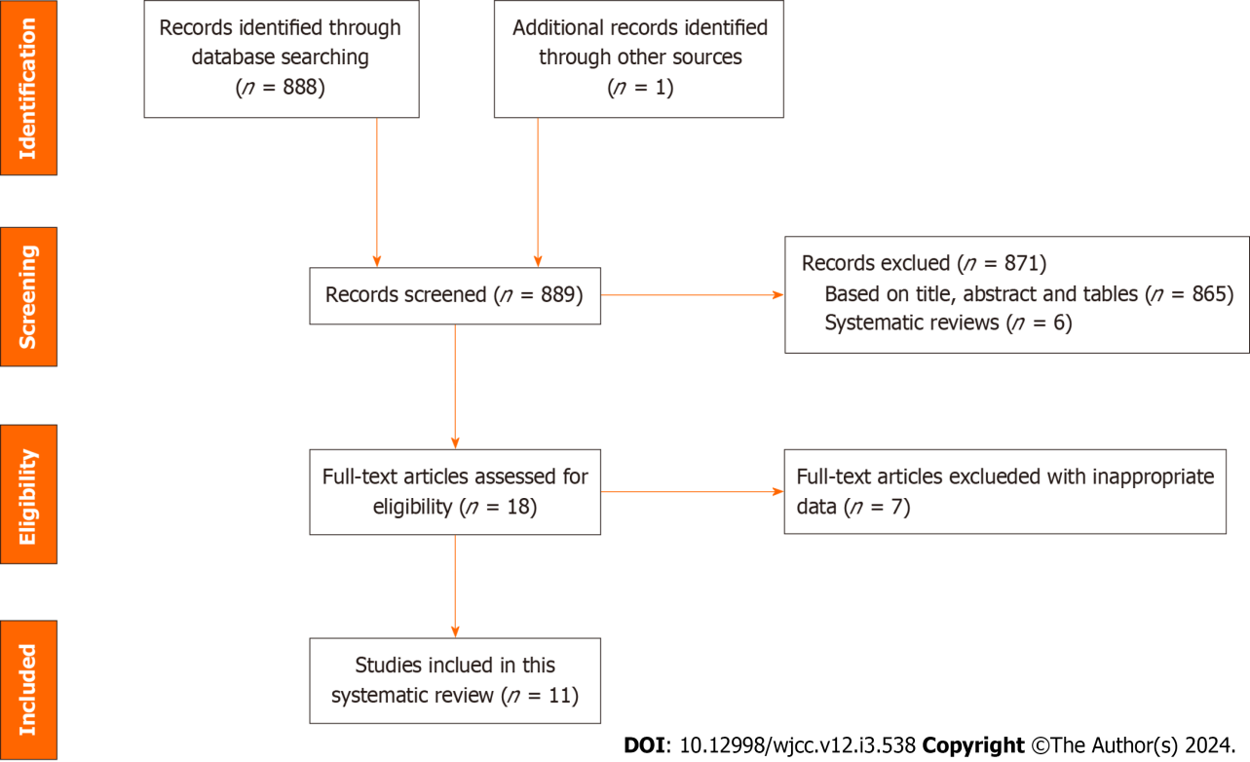
Figure 1 Flowchart detailing the literature search and screening strategy for this study.
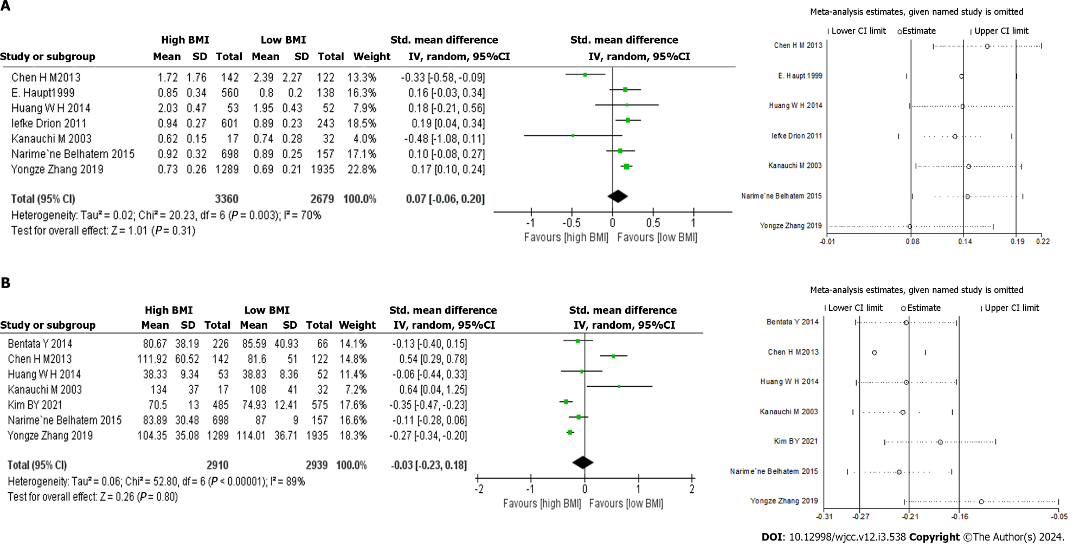
Figure 2 Forest plots of the baseline characteristics. A: Serum creatinine; B: Estimation of glomerular filtration rate. BMI: Body mass index; CI: Confidence interval.
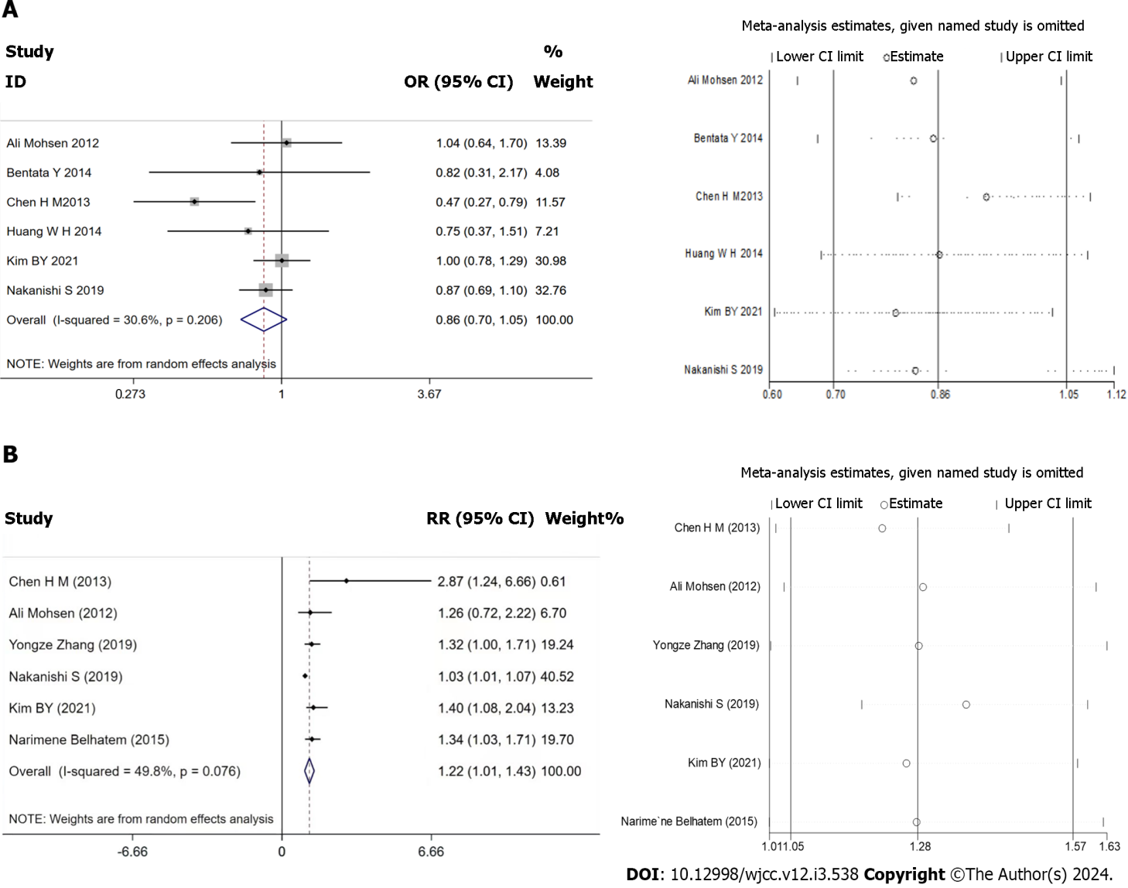
Figure 3 Forest plots of the kidney adverse events. A: The incidence rate of kidney adverse events; B: The risk of kidney adverse events. OR: Odds ratio; RR: Relative risk; CI: Confidence interval.
Table 1 Baseline characteristic of clinical studies included in the analysis
Ref. | Huang et al^{[18]}, 2014 | Bentata et al^{[22]}, 2014 | Chen et al^{[19]}, 2013 | Drion et al^{[20]}, 2011 | Haupt et al^{[14]}, 1999 | Mohsen et al^{[23]}, 2012 | Zhang et al^{[13]},2019 | Nakanishi et al^{[12]}, 2019 | Kanauchi et al^{[21]}, 2003 | Kim et al^{[17]}, 2021 | Belhatem et al^{[16]}, 2015
Country | Chinese | African | Chinese | Dutchman | Germany | British | Chinese | Japanese | Japanese | Korean | France
Study design | Prospective | Prospective | Retrospective | Retrospective | Prospective | Prospective | Retrospective | Retrospective | Retrospective | Prospective | Retrospective
Institution | Single-center | Single-center | Single-center | Single-center | Single-center | Single-center | Single-center | Single-center | Single-center | Single-center | Single-center
BMI Categories Reported | 18.5-22.9: 23-24.9: ≥ 25 | 18.5–24.9: 25–29.9: ≥ 30 | < 25: 25-28: ≥ 28 | 18-24.9: 25-29.9: ≥ 30 | < 25: 25-30: 30–35: > 35 | < 30: ≥ 30 | < 21.62: 21.62–23.50: 23.51–25.16: 25.17–27.33: > 27.33 | Controlled HbA1c non-overweight BMI < 25: controlled HbA1c overweight BMI ≥ 25): UNCONTROLLEd HbA1c non-overweight BMI < 25: uncontrolled HbA1c overweight BMI ≥ 25 | ≤ 25: > 25 | < 23: 23- 25: ≥ 25 | < 25: 25-30: 30-40: > 40
BMI Groups | 18.5-25: ≥ 25 | 18.5-25: ≥ 25 | < 25: ≥ 25 | 18-25: ≥ 25 | < 25: ≥ 25 | < 30: ≥ 30 | < 25.17: ≥ 25.17 | < 25: ≥ 25 | < 25: ≥ 25 | < 25: ≥ 25 | < 25: ≥ 25
Patient characteristics by BMI groups
Sample size | 105 | 292 | 264 | 844 | 698 | 229 | 3224 | 2306 | 49 | 1060 | 855
Age (yr) | 61.98 ± 9.27: 60.60 ± 10.37 | 61.00 ± 11.00: 59.15 ± 9.28 | 54.10 ± 9.34: 53.63 ± 8.81 | 61.84 ± 18.64: 63.18 ± 12.29 | 46.00 ± 8.40: 45.11 ± 8.93 | 71.00 ± 9.90: 68.00 ± 9.40 | 60.72 ± 1.98: 62.18 ± 11.16 | 64.2 ± 10.4: 57.4 ± 12.9 | 55.7 ± 9.0: 53.2 ± 9.1 | 56.48 ± 8.44: 54.10 ± 8.70 | 60 ± 12: 60.22 ± 10.03
Gender (Male %) | 0.6476 | 0.3801 | 0.5833 | 0.5403 | 0.692 | 0.655 | 0.507 | 0.6015 | 0.673 | 0.4557 | 0.6023
BMI value | 22.53 ± 1.36: 22.76 ± 2.09 | 23.06 ± 1.68: 3.19 ± 3.97 | 22.60 ± 1.59: 28.44 ± 2.79 | 23.00 ± 1.49: 30.58.00 ± 54.76 |  | 25.90 ± 2.60: 35.00 ± 4.90 |  | 21.70 ± 2.30: 28.70 ± 3.40 | 21.70 ± 2.50: 27.50 ± 2.30 | 22.65 ± 1.83: 29.4 ± 2.7 | 22.70 ± 2.00: 32.21 ± 5.88
RAS | 51:53 | 64:217 | NR | NR | NR | NR | 216:243 | NR | NR | NR | NR
Hypertension | 50:51 | NR | NR | NR | NR | NR | 1130:946 | NR | NR | 370:344 | NR
Follow-up (m) | 24 | 40.51 ± 14.00: 44.85 ± 11.21 | The median follow-up time was 39.0 0months (range 0–87.00) | NR | NR | 31.00 ± 19.50: 31.00 ± 19.40 | NR | NR | NR | NR | NR
Baseline renal characteristics
Serum creatinine (mg/dL) | 0.95 ± 0.43: 2.03 ± 0.47 | NR | 2.39 ± 2.27: 1.72 ± 1.76 | 0.89 ± 0.23: 0.94 ± 0.27 | 0.8 ± 0.2: 0.85 ± 0.34 | NR | 0.69 ± 0.21: 0.73 ± 0.26 | 0.74 ± 0.28: 0.62 ± 0.15 | NR | NR | 0.89 ± 0.25: 0.92 ± 0.32
eGFR (ml/min/1.73 m²) | 38.83 ± 8.36: 38.33 ± 9.34 | 85.59 ± 40.93: 80.67 ± 38.19 | 81.60 ± 51.00: 111.92 ± 60.52 | NR | NR | NR | 114.01 ± 36.71: 104.35 ± 35.08 | NR | 108.00 ± 41.00: 134.00 ± 37.00 | 74.93 ± 12.41: 70.50 ± 13.00 | 87.00 ± 9: 83.89 ± 30.48
Proteinuria | Daily urinary protein (g/24 h): 3.09 ± 2.62: 2.90 ± 2.35 |  | Urine protein excretion (g/24 h): 3.19 ± 2.19: 3.02 ± 2.55 |  | Albumin (mg in 24-h urine): 64.4 ± 294.9: 170.69 ± 776 |  |  |  | Urine protein (g/24 h): 72 (30-266): 67 (30-210)
Follow-up end kidney adverse events | Serum creatinine ≥ 2-fold vs Baseline, Dialysis, or Death | ESRD. ESRD was defined by eGFR < 15 ml/min/1.73 m² and/or initiation of dialysis. | ESRD. ESRD was defined as the requirement for permanent renal replacement therapy or serum creatinine exceeding 6.0 mg/dL for more than 1 mo without other causes of renal dysfunction | NR | NR | Deceased or commenced on renal replacement therapy | NR | eGFR of < 30 mL/min/1.73 m² and/or microalbuminuria value of ≥ 30 mg/gCr | NR | eGFR < 60 mL/min/1.73 m², or albumin/creatinine ratio in spot urine of 30–300 mg/g | NR
The risk of kidney adverse events |  |  | RR: 2.88 (95%CI: 1.24-6.66) |  |  | RR: 1.26 (95%CI: 0.72-2.22) | OR: 1.32 (95%CI: 1.00-1.71) | HR: 1.03 (95%CI: 1.01-1.07) |  | OR: 1.40 (95%CI: 1.08-2.04 ) | OR: 1.34 (95%CI: 1.03-1.43)
BMI: Body mass index; HbA1c: Glycated hemoglobin; RAS: Renin-angiotensin system blockers; eGFR: Estimated glomerular filtration rate; ESRD: End stage renal disease; RR: Relative risk; HR: Hazard ratio; OR: Odds ratio; CI: Confidence interval.

Table 2 Subgroup analyses of serum creatinine and estimated glomerular filtration rate due to body mass index
Serum creatinine |  |  |  |  |  |  |  | eGFR
Subgrouped | By No. of trials | SMD | 95%CI |  | P value | I2 (%) | P for heterogeneity | By No. of trials | SMD | 95%CI |  | P value | I2 (%) | P for heterogeneity
Country
Asian | 4 | -0.08 | -0.41 | 0.26 | 0.66 | 84.60 | < 0.001 | 6 | -0.01 | -0.24 | 0.23 | 0.96 | 90 | < 0.00001
European | 3 | 0.15 | 0.06 | 0.25 | < 0.001 | 0.00 | 0.71 | 1 | -0.11 | -0.28 | 0.06 | 0.12 | - | -
Age
≤ 60 | 3 | -0.18 | -0.59 | 0.24 | 0.41 | 83.40 | < 0.001 | 3 | -0.32 | -0.86 | 0.21 | 0.23 | 90.50 | < 0.001
> 60 | 4 | 0.17 | 0.11 | 0.23 | < 0.001 | 0.00 | 0.86 | 4 | 0.27 | 0.19 | 0.35 | < 0.001 | 22.00 | 0.28
Subject type
Retrospective | 5 | 0.02 | -0.16 | 0.20 | 0.81 | 0.80 | < 0.001 | 5 | -0.01 | -0.29 | 0.27 | 0.92 | 0.92 | < 0.001
Prospective | 2 | 0.16 | -0.01 | 0.33 | 0.06 | 0.00 | 0.93 | 2 | 0.10 | -0.06 | 0.26 | 0.20 | 0.00 | 0.80
Sample size
≤ 500 | 3 | -0.20 | -0.57 | 0.18 | 0.31 | 0.65 | 0.06 | 4 | -0.22 | -0.63 | 0.18 | 0.28 | 86.20 | < 0.001
> 500 | 4 | 0.17 | 0.11 | 0.22 | < 0.001 | 0.00 | 0.86 | 3 | 0.28 | 0.21 | 0.36 | < 0.001 | 21.70 | 0.28
eGFR: Estimated glomerular filtration rate; BMI: Body mass index; SMD: Standard mean deviation; CI: Confidence interval.

Published by Baishideng Publishing Group Inc
7041 Koll Center Parkway, Suite 160, Pleasanton, CA 94566, USA
Telephone: +1-925-3991568
E-mail: office@baishideng.com
Help Desk: https://www.f6publishing.com/helpdesk
https://www.wjgnet.com

© 2024 Baishideng Publishing Group Inc. All rights reserved.

