Name of Journal: World Journal of Clinical Cases
Manuscript NO: 75308
Manuscript Type: CASE REPORT

Delayed-release oral mesalamine tablet mimicking a small jejunal gastrointestinal stromal tumor: A case report

Frosio F et al. Mesalamine tablet mimicking a jejunal GIST

Fabio Frosio, Emanuele Rausa, Paolo Marra, Marie-Christine Boutron-Ruault, Alessandro Lucianetti

Fabio Frosio, Emanuele Rausa, Alessandro Lucianetti, Department of General Surgery, ASST Papa Giovanni XXIII Hospital, Bergamo 24127, Italy

Paolo Marra, Department of Radiology, ASST Papa Giovanni XXIII Hospital, Bergamo 24127, Italy

Marie-Christine Boutron-Ruault, Paris-Saclay University, UVSQ, Inserm, Gustave Roussy, Exposome and Heredity team, Centre for Epidemiology and Population Health (CESP U1018), Villejuif 94800, France

Author contributions: Frosio F collected the data and wrote the paper; Rausa E reviewed the literature; Marra P reviewed the CT images; Boutron-Ruault MC critically revised the manuscript; Lucianetti A gave the input in realizing this case report and critically revised it; and All authors gave their approval to the submitted version.

Corresponding author: Fabio Frosio, MD, Surgeon, Department of General Surgery, ASST Papa Giovanni XXIII Hospital, Piazza OMS 1, Bergamo 24127, Italy. fabio.frosio10@gmail.com

Received: January 24, 2022
Revised: April 13, 2022
Accepted: May 17, 2022
Published online:

Abstract
BACKGROUND
Enteric-coated medications are supposed to pass intact through the gastric environment and to release the drug content into the small intestine or the colon. Before dissolution of the enteric coating, they may appear hyperdense on computed tomography (CT). Unfortunately, few reports have been published on this topic so far. In this case report, the hyperdense appearance on contrast-enhanced CT of an enteric-coated mesalamine tablet was initially misinterpreted as a jejunal gastrointestinal stromal tumor (GIST).

CASE SUMMARY
An asymptomatic 81-year-old male patient, who had undergone laparoscopic right nephrectomy four years earlier for stage 1 renal carcinoma, was diagnosed with a jejunal GIST at the 4-year follow-up thoraco-abdominal CT scan. He was referred to our hub hospital for gastroenterological evaluation, and subsequently underwent 18-fluorodeoxyglucose positron emission tomography, abdominal magnetic resonance imaging, and video capsule endoscopy. None of these examinations detected any lesion of the small intestine. After reviewing all the CT images in a multidisciplinary setting, the panel estimated that the hyperdense jejunal image was consistent with a tablet rather than a GIST. The tablet was an 800 mg delayed-release enteric-coated oral mesalamine tablet (Asacol®), which had been prescribed for non-specific colitis, while not informing the hospital physicians.

CONCLUSION
Delayed-release oral mesalamine (Asacol®), like other enteric-coated medications, can appear as a hyperdense image on a CT scan, mimicking a small intestinal GIST. Therefore, a detailed knowledge of the patients’ medications and a multidisciplinary review of the images are essential.

Key words: Mesalamine; Enteric-coating; Asacol; Tablet; gastrointestinal stromal tumor; Case report

Frosio F, Rausa E, Marra P, Boutron-Ruault MC, Lucianetti A. Delayed-release oral mesalamine tablet mimicking a small jejunal gastrointestinal stromal tumor: A case report. World J Clin Cases 2022; In press

Core tip: Enteric-coated tablets may appear as hyperdense images on computed tomography (CT) scan, and lead to misdiagnosis, for example of small intestinal gastrointestinal stromal tumors which usually show homogeneous enhancement on contrast-enhanced CT phases. Therefore, when observing small hyperdense lesions in the gastrointestinal tract on CT scan, physicians should be aware of possible radiopaque medications. A perfect knowledge of the patients’ medical treatment (even occasional) and a multidisciplinary review of all the images are essential to avoid misdiagnosis and unnecessary investigations.
INTRODUCTION
Enteric-coated tablets pass intact through the gastric environment, and release the drug content into the small bowel or the colon. Enteric-coating polymers have long been known to be radiopaque to some degree^{[1]}, and their computed tomography (CT) density can be high, even though this has little been reported so far in the literature.
Gastrointestinal stromal tumors (GISTs) are a group of mesenchymal tumors of the digestive tract that originate from the interstitial cells of Cajal; approximately 30% of them are malignant. GISTs usually appear as sharply demarcated submucosal or subserosal lesions within the gastrointestinal tract^{[2]}. CT often provides both diagnosis and staging; after intravenous contrast, small-sized intestinal GISTs typically display strong homogeneous enhancement^{[3,4]}.
This report shows a case in which the hyperdense appearance on contrast-enhanced CT of an enteric-coated delayed-release oral mesalamine tablet was misinterpreted as a small jejunal GIST.

CASE PRESENTATION
Chief complaints
An 81-year-old male patient was referred to our surgical outpatient clinic for a suspected jejunal GIST detected on thoraco-abdominal CT.

History of present illness
The patient was free of any symptom. Thoraco-abdominal CT scan was performed in another hospital as part of the follow-up of a previous renal cell carcinoma.

History of past illness
The patient’s past medical history included hypertension, colonic diverticulosis, and right laparoscopic nephrectomy four years earlier for stage 1 renal cell carcinoma^{[5]}; there had been no adjuvant chemotherapy, and no recurrence was detected at follow-up.

Personal and family history
No significant family histories were identified.

Physical examination
The patient was in good condition with weight within the normal range (body mass index: 22.4 kg/m²). Physical examination was absolutely normal. There was no abdominal mass on palpation.

Laboratory examinations
Routine laboratory tests, including tumor markers, were all within the normal range.

Imaging examinations
Thorax-abdomen CT scan revealed an 18 mm x 8 mm lesion in the wall of a jejunal loop, which displayed strong homogeneous contrast enhancement in the arterial and venous phases (250 Hounsfield Unit)^{[6]} (Figure 1B and C), while it was isodense and barely visible in the pre-contrast and delayed-contrast phases (Figure 1A and D). In the CT report, the lesion was described as consistent with a GIST. Thus, the oncologist referred him to our hub hospital for gastroenterological assessment. This included 18-fluorodeoxyglucose positron emission tomography and abdominal magnetic resonance imaging, which both failed to detect any abnormal image. The patient also underwent gastroscopy, which was normal, and colonoscopy, where two adenomatous polyps of the right colon were resected, with low-grade dysplasia on pathological examinations. Finally, video capsule endoscopy was also carried out and did not record any small-intestinal lesion.

FINAL DIAGNOSIS
The patient was subsequently referred for multidisciplinary assessment. CD-ROMs with CT images were kept for second radiological opinion and multidisciplinary team discussion of the case.
When reviewing the CT scan with the radiologists, hyperdense jejunal images were also visible in the pre-contrast and delayed-contrast phases (Figure 2), more proximal and distal respectively than the image initially reported at the arterial and venous acquisition phases. The dimensions and the CT density, on the other hand, were the same. This led to suspect a foreign body rather than a GIST.
A thorough medical history revealed that the patient had recently been prescribed delayed-release oral mesalamine 800 mg tablets (Asacol®) for non-specific colitis. The CT scan hyperdense images were consistent with images expected for an enteric-coated tablet.

TREATMENT
As the initial diagnosis of GIST was ruled out, no treatment was requested. Follow-up was continued as previously planned.

OUTCOME AND FOLLOW-UP
The 5-year follow-up thoraco-abdominal CT scan was performed after discontinuation of mesalamine and did not reveal any abnormal image, which further confirmed our reassessment of the case. Laboratory tests and tumor markers were still normal. Physical examination was normal as well.

DISCUSSION
Oral delayed-release mesalamine is an enteric-coated formulation releasing mesalamine in the terminal ileum and the colon; it is effective for mild to moderately active ulcerative colitis and active Crohn’s disease^{[7]}. Like other enteric-coated medications, it may appear hyperdense on CT scan, before dissolution of the enteric coating. Nevertheless, there are few reports in the literature on this topic and no specific restrictions on its administration before abdominal imaging. Sieron et al^{[8]} recently investigated the CT density of frequently administered medications, but mesalamine was not included. A few cases have been reported in which the hyperdensity of a tablet led to a misdiagnosis, involving unnecessary investigations; the medications in question, however, were mainly iron^{[9]} and potassium tablets^{[10,11]}.
GISTs can occur anywhere along the gastrointestinal tract, most commonly in the stomach and small bowel. Small GISTs (< 2 cm) can be endoluminal and are often an incidental finding at CT, showing clear-cut shape and strong homogeneous contrast enhancement^{[12]}. In particular, contrast enhancement has been reported to be inversely proportional to tumor diameter in intestinal GISTs^{[4]}. This actually explains how a hyperdense tablet could have been misinterpreted as a small jejunal GIST on contrast-enhanced CT scan. We report here for the first time a diagnostic error caused by the hyperdense appearance of a delayed-release mesalamine tablet.
In this case, however, the radiologist who first examined the images did not notice that the lesion was also visible on the pre-contrast scan, although in another jejunal loop. When hyperdense lesions are observed on contrast-enhanced CT, it is essential to determine their presence or absence in the pre-contrast phase. In particular, if these lesions are gastric or intestinal, they should be carefully researched along the entire gastrointestinal tract; in fact, due to peristalsis, small foreign bodies may be found at slightly different levels during the different phases of the CT scan^{[13]}.
Along with the initial radiological assessment, it is crucial to address two other key points that could have helped the diagnostic process.
Firstly, the gastroenterologist who evaluated the patient had not obtained the CT images from the hospital where the examination had been performed, and decided to perform additional examinations on the basis of the CT report only. It is well recognized that obtaining all the images - and not just the report - of radiological examinations performed elsewhere is associated with higher quality of care^{[14]}. Moreover, it has been shown that just including at least the most relevant images in the radiology reports is associated with higher physicians' confidence in decision-making and possibly changes in patient management^{[15]}. Therefore, when a patient is referred from another center, the admitting physicians should be provided the images of all previous examinations, and easily request a second reading by another radiologist or a multidisciplinary assessment in case of any doubt. In the present case, such a procedure would have avoided unnecessary examinations.
Secondly, none of the four involved physicians (radiologist, oncologist, gastroenterologist, and surgeon) was aware that the patient had been taking mesalamine for some weeks. Patients’ occasional pharmacological treatments may not be readily available during outpatient visits, and patients tend to forget or underreport them, giving priority to everyday routine treatments. This is why occasional medications should be thoroughly investigated as part of the pharmacological history, and always reassessed before instrumental examinations. In this case report, information about the patient’s recent treatment with an enteric-coated tablet would definitely have helped in properly interpreting the CT scan.

CONCLUSION
Delayed-release mesalamine, like other enteric-coated preparations, is hyperdense on CT scan and may lead to misdiagnosis, for example of a small intestinal GIST. Therefore, when small hyperdense lesions in the gastrointestinal tract are detected, physicians should rule out radiopaque medications, by thoroughly investigating the patient’s medical treatment (even occasional), and possibly performing a multidisciplinary imaging review.

REFERENCES
1 Handy CA. Radiopacity of oral nonliquid medications. Radiology 1971; 98: 525-533 [PMID: 5544520 DOI: 10.1148/98.3.525]
2 Schaefer IM, Mariño-Enríquez A, Fletcher JA. What is New in Gastrointestinal Stromal Tumor? Adv Anat Pathol 2017; 24: 259-267 [PMID: 28632504 DOI: 10.1097/PAP.0000000000000158]
3 King DM. The radiology of gastrointestinal stromal tumours (GIST). Cancer Imaging 2005; 5: 150-156 [PMID: 16361144 DOI: 10.1102/1470-7330.2005.0109]
4 Inoue A, Ota S, Nitta N, Murata K, Shimizu T, Sonoda H, Tani M, Ban H, Inatomi O, Ando A, Kushima R, Watanabe Y. Difference of computed tomographic characteristic findings between gastric and intestinal gastrointestinal stromal tumors. Jpn J Radiol 2020; 38: 771-781 [PMID: 32246352 DOI: 10.1007/s11604-020-00962-0]
5 5 Amin MB, Edge S, Greene F, Byrd DR, Brookland RK, Washington MK, Gershenwald JE, Compton CC, Hess KR, Sullivan DC, Jessup JM, Brierley JD, Gaspar LE, Schilsky RL, Balch CM, Winchester DP, Asare EA, Madera M, Gres, DM, Meyer LR. AJCC Cancer Staging Manual. Ed. 8 Cham, Switzerland: Springer; 2017
6 DenOtter TD, Schubert J. Hounsfield Unit. 2021 Mar 16. In: StatPearls [Internet]. Treasure Island (FL): StatPearls Publishing; 2022 Jan- [PMID: 31613501]
7 Prakash A, Markham A. Oral delayed-release mesalazine: a review of its use in ulcerative colitis and Crohn's disease. Drugs 1999; 57: 383-408 [PMID: 10193690 DOI: 10.2165/00003495-199957030-00013]
8 Sieron DA, Steib M, Suter D, Obmann VC, Huber AT, Ebner L, Inderbitzin D, Christe A. Computed tomography imaging for the characterisation of drugs with radiation density measurements and HU spectroscopy. Swiss Med Wkly 2018; 148: w14585 [PMID: 29376556 DOI: 10.4414/smw.2018.14585]
9 Florez MV, Evans JM, Daly TR. The radiodensity of medications seen on x-ray films. Mayo Clin Proc 1998; 73: 516-519 [PMID: 9621857 DOI: 10.4065/73.6.516]
10 Onal B, Citgez S, Tansu N, Talat Z, Oner A. Tablets of the potassium citrate may cause a stone-like image: a case report. Urol Res 2009; 37: 165-168 [PMID: 19367401 DOI: 10.1007/s00240-009-0188-2]
11 Commandeur JP, Metwaly A, Büchler L, Speiser J, Brander L, Reintam Blaser A. A Degrading Potassium Tablet Mimicking Active Gastric Bleeding in a Computer Tomographic Investigation. Case Rep Radiol 2020; 2020: 9791519 [PMID: 32257495 DOI: 10.1155/2020/9791519]
12 Vernuccio F, Taibbi A, Picone D, LA Grutta L, Midiri M, Lagalla R, Lo Re G, Bartolotta TV. Imaging of Gastrointestinal Stromal Tumors: From Diagnosis to Evaluation of Therapeutic Response. Anticancer Res 2016; 36: 2639-2648 [PMID: 27272772]
13 13 Campbell EA, Wilbert CD. Foreign Body Imaging. [Updated 2021 May 7]. StatPearls [Internet]. Treasure Island(FL): Stat Pearls Publishing 2021; Available from: https://www.ncbi.nlm.nih.gov/books/NBK470294/
14 Jung HY, Gichoya JW, Vest JR. Providers' Access of Imaging Versus Only Reports: A System Log File Analysis. J Am Coll Radiol 2017; 14: 217-223 [PMID: 27475970 DOI: 10.1016/j.jacr.2016.06.014]
15 Iyer VR, Hahn PF, Blaszkowsky LS, Thayer SP, Halpern EF, Harisinghani MG. Added value of selected images embedded into radiology reports to referring clinicians. J Am Coll Radiol 2010; 7: 205-210 [PMID: 20193926 DOI: 10.1016/j.jacr.2009.10.014]

Footnotes
Informed consent statement: Informed written consent was obtained from the patient for publishing this case report of this report and any accompanying images.

Conflict-of-interest statement: The authors declare that they have no conflict of interest.

CARE Checklist (2016) statement: The authors have read the CARE Checklist (2016), and the manuscript was prepared and revised according to the CARE Checklist (2016).

Open-Access: This article is an open-access article that was selected by an in-house editor and fully peer-reviewed by external reviewers. It is distributed in accordance with the Creative Commons Attribution NonCommercial (CC BY-NC 4.0) license, which permits others to distribute, remix, adapt, build upon this work non-commercially, and license their derivative works on different terms, provided the original work is properly cited and the use is non-commercial. See: https://creativecommons.org/Licenses/by-nc/4.0/

Provenance and peer review: Unsolicited article; Externally peer reviewed.
Peer-review model: Single blind

Peer-review started: January 24, 2022
First decision: March 12, 2022
Article in press:

Specialty type: Radiology, nuclear medicine and medical imaging
Country/Territory of origin: Italy
Peer-review report’s scientific quality classification
Grade A (Excellent): 0
Grade B (Very good): B
Grade C (Good): 0
Grade D (Fair): 0
Grade E (Poor): E

P-Reviewer: Jeruc J, Slovenia; Lewitowicz P, Poland S-Editor: Ma YJ L-Editor: A P-Editor: Ma YJ

Figure Legends
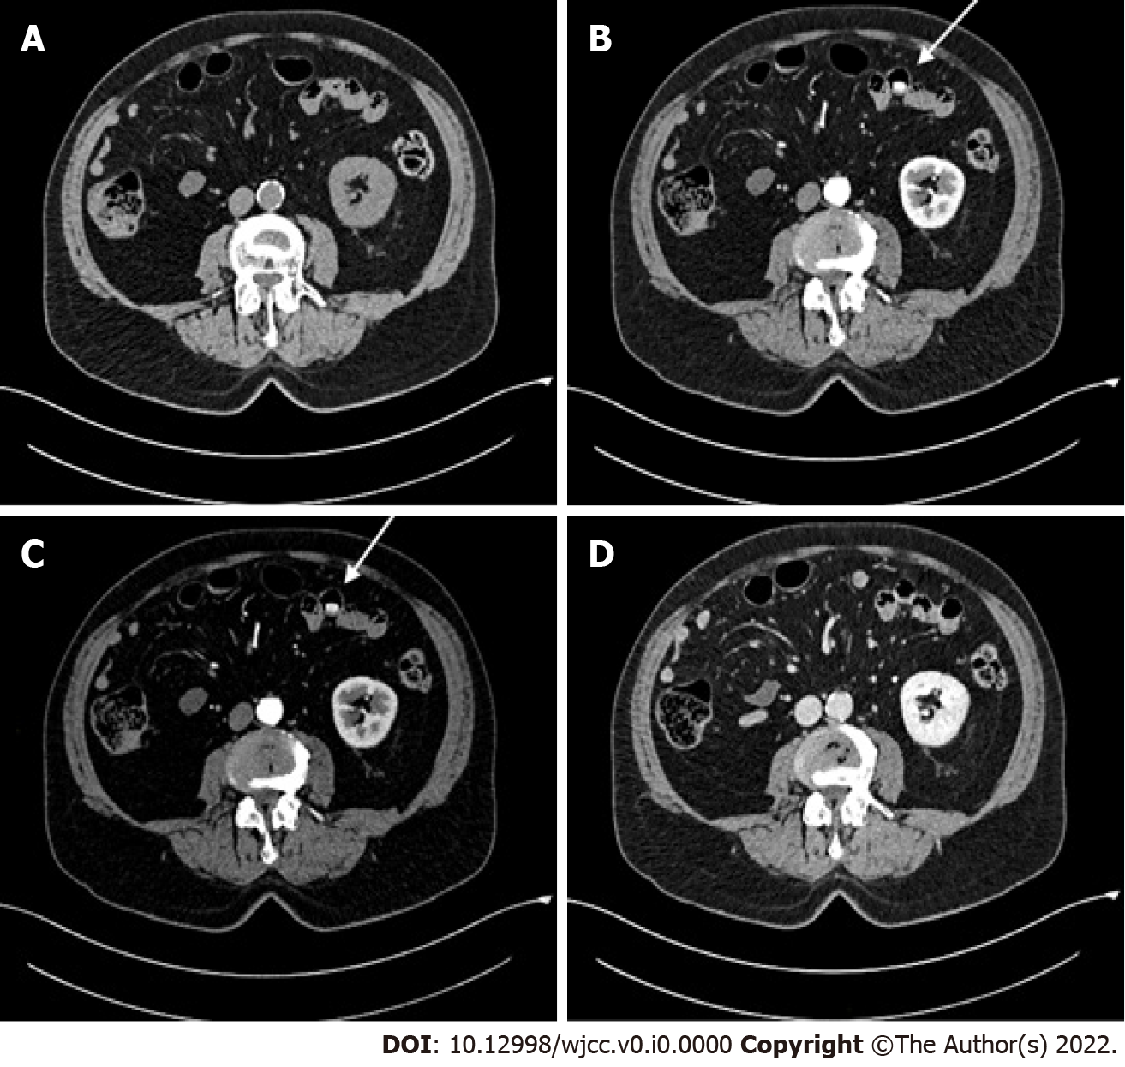
Figure 1 Abdominal contrast-enhanced computed tomography scan. A: Pre-contrast phase; B: Arterial phase; C: Venous phase; D: Delayed-contrast phase. A hyperdense jejunal image (white arrow) was observed in the arterial and venous phases.

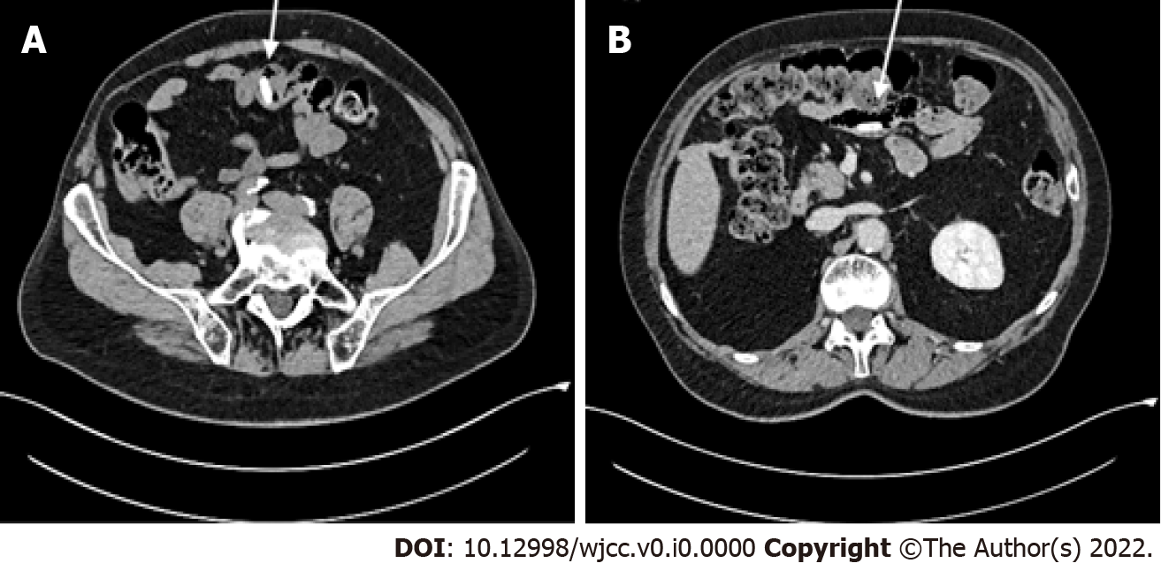
Figure 2 Revision of the abdominal computed tomography images. A: Pre-contrast phase; B: Delayed-contrast phase. The hyperdense jejunal image (white arrow) was found also in the pre-contrast and delayed-contrast phases, but in other jejunal loops.

