Name of Journal: World Journal of Immunology
ESPS Manuscript NO: 21656
Manuscript Type: Review

Dendritic cells and the extracellular matrix: A challenge for maintaining tolerance/homeostasis

Shankar SP et al. Dendritic cell homeostasis in extracellular matrix

Sucharita P Shankar, May Griffith, John V Forrester, Lucia Kuffová

Sucharita P Shankar, John V Forrester, Lucia Kuffová, Section of Immunology, Inflammation and Infection, Division of Applied Medicine, School of Medicine and Dentistry, University of Aberdeen, Institute of Medical Sciences, Scotland AB25 2ZD, United Kingdom

May Griffith, Integrative Regenerative Medicine Centre, Department of Clinical and Experimental Medicine, Cell Biology Bldg. Level 10, Linköping University, S-58185 Linköping, Sweden

May Griffith, Department of Ophthalmology, Maisonneuve-Rosemont Hospital, Montreal, QC H1T 2M4, Canada

Author contributions: Shankar SP performed the experiments, conducted the literature review and writing of the manuscript; Griffith M performed certain experiments and provided intellectual input; Forrester JV provided intellectual input, critical revision and approval of the final version; Kuffová L performed certain experiments and contributed to writing the manuscript.

Supported by The Royal College of Surgeons of Edinburgh.

Conflict-of-interest statement: Authors declare no conflict of interests for this article.

Open-Access: This article is an open-access article which was selected by an in-house editor and fully peer-reviewed by external reviewers. It is distributed in accordance with the Creative Commons Attribution Non Commercial (CC BY-NC 4.0) license, which permits others to distribute, remix, adapt, build upon this work non-commercially, and license their derivative works on different terms, provided the original work is properly cited and the use is non-commercial. See: http://creativecommons.org/licenses/by-nc/4.0/

Correspondence to: Dr. Lucia Kuffová, MD, PhD, Section of Immunology, Inflammation and Infection, Division of Applied Medicine, School of Medicine and Dentistry, University of Aberdeen, Institute of Medical Sciences, Foresterhill, Aberdeen, Scotland AB25 2ZD, United Kingdom. l.kuffova@abdn.ac.uk
Telephone: +44-1224-437505
Fax: +44-1224-437506

Received: July 23, 2015
Peer-review started: July 27, 2015
First decision: August 25, 2015
Revised: September 18, 2015
Accepted: November 10, 2015
Article in press:
Published online:

Abstract
The importance of the extracellular matrix (ECM) in contributing to structural, mechanical, functional and tissue-specific features in the body is well appreciated. While the ECM was previously considered to be a passive bystander, it is now evident that it plays active, dynamic and flexible roles in shaping cell survival, differentiation, migration and death to varying extents depending on the specific site in the body. Dendritic cells (DCs) are recognized as potent antigen presenting cells present in many tissues and in blood, continuously scrutinizing the microenvironment for antigens and mounting local and systemic host responses against harmful agents. DCs also play pivotal roles in maintaining homeostasis to harmless self-antigens, critical for preventing autoimmunity. What is less understood are the complex interactions between DCs and the ECM in maintaining this balance between steady-state tissue residence and DC activation during inflammation. DCs are finely tuned to inflammation-induced variations in fragment length, accessible epitopes and post-translational modifications of individual ECM components and correspondingly interpret these changes appropriately by adjusting their profiles of cognate binding receptors and downstream immune activation. The successful design and composition of novel ECM-based mimetics in regenerative medicine and other applications rely on our improved understanding of DC-ECM interplay in homeostasis and the challenges involved in maintaining it.

Key words: Dendritic cells; Extracellular matrix; Tolerance; Homeostasis; Biomaterials; Regenerative medicine; Biointeractive implants

© The Author(s) 2015. Published by Baishideng Publishing Group Inc. All rights reserved.

Core tip: The extracellular matrix (ECM) provides an essential framework for tissues in the body as well as actively orchestrates diverse cellular functions. Professional antigen presenting cells namely dendritic cells (DCs) are uniquely positioned to distinguish between self and non-self and accordingly regulate systemic immunity or tolerance. DCs and the ECM participate in finely-tuned, dynamic exchanges that ultimately impact the equilibrium between steady-state DC tissue residence or DC-instigated inflammation. To design biointeractive, ECM-inspired implants for regenerative medicine applications that retain functionality and undergo successful integration long-term, it is critical to understand the challenges involved in maintaining DC-ECM immune homeostasis under normal conditions.

Shankar SP, Griffith M, Forrester JV, Kuffová L. Dendritic cells and the extracellular matrix: A challenge for maintaining tolerance/homeostasis. World J Immunol 2015; In press

INTRODUCTION
Dendritic cells (DCs) are professional antigen presenting cells (APCs) that differentiate self from non-self and play crucial roles in determining the balance between tolerance and immunity. They were first discovered in mouse spleen by Steinman and Cohn^{[1]} in a seminal paper published in 1973. Since this initial finding, the dogma that DC maturation is essential for the initiation of immunity has been well established. Immature DCs are typically distinguished by high levels of intracellular major histocompatibility complex class II (MHCII), low expression of adhesive and costimulatory receptors, strong endocytic, pinocytic and phagocytic abilities and weak capacities for T cell stimulation^{[2,3]}. Immature DCs mount an immune surveillance program mediated in part by extracellular or cytoplasmic pattern recognition receptors (PRRs) expressed by DCs that identify evolutionarily conserved pathogen associated molecular pattern (PAMP) motifs on bacteria, viruses and on other foreign bodies or endogenous damage-associated molecular patterns (DAMPs). These recognition events trigger their transformation from rounded immature DCs into terminally differentiated mature DCs with enhanced motility, that exhibit extended dendritic processes and upregulate expression of co-stimulatory (CD80, CD86), MHCII molecules and adhesion molecules which bind T cells^{[2]}. Ingested antigens processed intracellularly and presented as spliced peptides are loaded on to MHC complexes on mature DCs. The interactions between MHC and T cell receptors (TCR) (MHCI: cytotoxic T cells (T_{c}) and MHCII: helper T cell (T_{h}) subsets) expressed on T cell surfaces drive antigen-specific cellular immunity. Notably, DCs are unique in their capacity to trigger T cell immunity. Taken together, DC-driven generation of cytokines, chemokines and other factors together orchestrate downstream host protective antigen-specific adaptive immune responses, as reviewed in^{[2]}. DCs have three broad functions – mounting an immune response, maintaining immune tolerance and regulating immune memory, underscoring their critical roles in maintaining the balance between immunity and homeostasis^{[2]}.
This review discusses the growing body of evidence that the extracellular matrix (ECM) orchestrates DC interactions at different sites both in homeostasis and in inflammation. These interactions are highly complex and have many redundancies since DCs possess numerous receptors capable of binding the multicomponent ECM and are capable of upregulating and downregulating the expressions of PRRs in response to alterations in the ECM, thereby making it essential to better understand this interchange. Many questions remain incompletely elucidated: why DCs are selective in terms of residing in certain tissues but not in others. For instance, what roles do tissue specific cytokines, chemokines and other factors associated with and released by the ECM play in regulating DC behaviour? To what extent are other tissue resident cells responsible for maintaining DC homeostasis, e.g., hepatic stellate cells (HSCs) in the liver^{[4]}, epithelial cells in intestine^{[5]}, or keratinocytes in skin^{[6]}. Finally, how do alterations in the ECM affect the DC steady-state and are these alterations reversible?

DC subsets
Over the last few decades several groups have contributed to the large body of work performed in characterizing DCs present in tissues and in blood and their in vitro generated counterparts. DCs are identified by the expression of MHCII and costimulatory markers, and the absence of lineage markers such as CD3 (T cell), CD14 (monocyte), CD19 (B cell), CD56 (natural killer cell) or CD66b (granulocyte)^{[2]}. DCs are described as two types: conventional DCs (cDCs) and plasmacytoid DCs (pDCs). The cDCs are a principal DC subset and are sub-divided into migratory and non-migratory. Migratory DCs arise from the tissues and reach secondary lymphoid organs (SLO) via the lymphatics. Tissue resident conventional migratory DCs are broadly classified as CD103⁺ CD11b⁻ and CD11b⁺ cDCs and have been described in intestine, liver, lung, kidney and skin as reviewed in^{[7,8]}. The specific locations and roles of the different DC subsets vary in different tissues. For instance, lung DC subsets include migratory CD103⁺ CD11c^{high} CD11b⁻ DCs in the intra-epithelial network, CD103⁻ CD11c^{high} CD11b⁺ DCs in the lamina propria (LP) and non-conventional pDCs^{[8]}. Intestinal DCs in Peyer’s Patches (PP), LP and mesenteric lymph nodes (MLNs) exhibit varied expression of CD103 and CX3CR1 of which migratory, conventional CD103+ DCs have been assigned both immunogenic and tolerogenic roles^{[8]}. Liver DCs consist of CD11c⁺ B220⁻ DCs (further divided into CD103⁺ and CD103–), both linked to T_{reg} induction as reviewed in^{[8]} and CD11c⁺ B220⁺ pDCs, the latter playing a role in maintaining steady state tolerance and the resolution of inflammation after liver injury^{[8]}. Kidney DCs comprise CX3CR1⁺ CD11b⁺ DCs, CX3CR1⁺ CD11b⁻ DCs and CD103⁺ DCs, while CD103⁺ cells are thought to play a tolerogenic role as opposed to other subsets as reviewed in^{[8]}. Skin DCs include dermal DCs which are Langerin+ (CD207⁺) CD103⁺ DCs and are categorized as cDCs with bone marrow precursors, as well as Langerin- CD103⁻ DCs (with unknown precursors)^{[8]}.
Conventional DCs also include lymphoid DCs that are distinct from myeloid DCs, lack expression of CD11b, CD13, CD14, and CD33 and are derived from precursors that have the ability to differentiate into T cells and NK cells as reported in^{[3]} as opposed to monocyte/macrophage lineages^{[9]}. While cDCs sample tissue antigens and migrate to present the processed peptide(s) to T cells in LNs, in contrast, non-migratory cDCs previously considered as “lymphoid” DCs reside in thymus, spleen, LNs or PP^{[3,10]}. Lymphoid DCs include CD4⁻CD8α⁺ DCs that cross present antigen to CD8⁺T cells, while CD4⁺CD8α⁻ DCs in spleen or CD4⁻CD8α⁻ DCs in mucosal associated lymphoid tissue, activate CD4⁺ T cells. Non migratory lymphoid DCs regulate thymic negative selection, drive T_{h2} responses in humans and stimulate regulatory responses overall^{[3]}.
The pDCs are found mostly in lymphoid tissues and secrete IFN-α upon exposure to viral antigens. Phenotypically, pDCs, the second principal DC subset express CD45RA, CD123, CD303 and CD304 as well as low levels of MHCII, costimulatory molecules and CD11c, while myeloid DCs express CD11c, CD13, CD33 and CD11b^{[11]}. The pDCs are highly secretory, exhibit plasma cell-like morphologies and display properties of both cDCs and lymphocytes. Importantly, pDCs express endosomal TLR7 and TLR9 that detect viral single stranded RNA and unmethylated CpG-containing DNA and respond by rapid and substantial production of type I IFN (IFN-α/β)^{[12]}. Plasmacytoid DCs start in bone marrow and enter lymphoid tissues where they mainly reside, through blood^{[7]}. Plasmacytoid DCs are important for mediating differentiation of B cells to plasma cells for antibody production and have been linked to immunogenic and tolerogenic responses in the liver and lung as reviewed in^{[8]}. Most DCs [(apart from yolk sac derived - Langerhans cells (LCs)] are generated in bone marrow from myeloid progenitor cells^{[13]} with some in situ proliferation in spleen. Another class of non-conventional DCs namely monocyte-derived “inflammatory” DCs have been detected in the skin and kidneys and intestine and have been implicated in the progression of inflammation in colitis and as CD103⁻ CX3CR1⁺ DCs in maintaining gut homeostasis. In the lung, CD103⁻ CD11c^{high} CD11b⁺ DCs play crucial roles in reacting to allergens and triggering T_{h2}-mediated immunity. Finally, self-renewing DC-like cells such as slow turnover LCs and microglia are specialized dendritiform cells derived from the yolk sac and reside in the squamous epithelium and in CNS parenchyma respectively and mediate tolerance in the resting states^{[8,11]}.
It is clear that DCs are not narrowly defined as a single type of cell but instead represent a diverse assortment of cells derived from different lineages^{[10,14-17]}. The generally accepted theory is that hematopoietic DC progenitors from the bone marrow circulate through the body and are receptive to specific combinations of cytokines and signals, resulting in DC subsets with specialized homing properties and roles. In vitro DCs have been generated from CD14⁺ monocytes in blood and CD34⁺ bone marrow precursors^{[2]}. “Classical” myeloid DCs have been generated from myeloid committed CD34+ progenitor cells and monocytes treated with granulocyte macrophage colony stimulating cells (GM-CSF) and tumour necrosis factor-α (TNF-α) ± interleukin-4 (IL-4) in vitro^{[7,8,11,18,19]}. Myeloid DCs regulate responses of CD4 and CD8 T cells and are involved in B cell differentiation into plasma cells. In addition, CD34+, CD14- cells differentiate into LCs in the presence of transforming growth factor-β (TGF-β)^{[7,8,11,18,19]}. Also, lymphoid committed CD34⁺ cells become pDCs in the presence of IL-3^{[20]}. Myeloid DCs are sometimes referred to as DC1 and express toll-like receptor 2 (TLR2), TLR3, TLR4, TLR7 and activate naïve T cells along T_{h1}, T_{h2} pathways^{[7,8,11,18,19]}. In contrast, lymphoid DCs or DC2 express TLR7 and TLR 9 and secrete IFN-α in response to invading viruses. Notably, high numbers of DCs have been generated in mice and in humans by recurrent injections with hematopoietin flt-3L, thought to act on DC precursors in the bone marrow^{[2,21,22]}.
Interestingly however, when tissue residence is discussed there is little reference to how the tissue might affect or even permit the DCs to migrate into tissue matrices and egress from it via the lymphatics. Furthermore changes in the tissue which occur during inflammation will affect not only the resident DCs but also newly recruited DCs. For instance, the retina in normal mice has a small population of MHCII⁺ 33D1⁺ DCs located mainly at the periphery while tissue resident microglia are macrophage-like cells. However, during inflammation, e.g., uveoretinitis, there is a marked increase in the numbers of antigen-presenting cDCs^{[23]}. Microglia mostly maintain tolerance in non-inflamed retina but can become activated during degenerative disease such as age-related macular degeneration (AMD) or inherited retinal degeneration^{[24]}. Dysregulated clearance/accumulation of debris result in microglial activation accompanied by elevated production of pro-inflammatory chemokines and cytokines. Similarly, bone and cartilage do not have DCs under steady state conditions^{[25]}, although activated DCs can trigger cartilage degradation by producing TNF-α. It is not clear why certain tissues restrict DCs from being present in steady state or why others permit their entry. It would be fascinating to gain an understanding of what the microenvironmental cues provided by the extracellular matrices (ECM) towards this are as well as how they these signals are altered in pathological conditions to pave the way for DC infiltration and subsequent immune responses.

Functional dichotomy of ECM
It has been well established that the ECM plays critical roles in regulating cellular differentiation, survival, shape and function including adhesion, motility, apoptosis and tissue specific alignment^{[26,27]}. The ECM is a three dimensional mixture of triple helical collagens, complex proteoglycans composed of glycosaminoglycans covalently linked to protein, glycoproteins, proteases, growth factors and cytokines that respond actively to microenvironmental conditions^{[28,29]}. Notably, dysregulation or mutations in the ECM have been linked to developmental, degenerative, malignant, and pathological states such as cancer and inflammatory arthritis^{[26]}, while oxidative impairment of ECM components by enzymatic or non-enzymatic pathways has been associated with progression of kidney disease, lung disease, arthritis, and chronic inflammation^{[30]}. Protein fragmentation has been proposed to form site-specific focusses for free radicals and reactive species as suggested in this review^{[31]}.
Remarkably, the ECM displays functional dichotomy. Besides forming a supporting mesh to stabilize cells, the ECM plays active roles in regulating normal or pathological states of inflammatory cells^{[27]}. Degradation of intact steady state high molecular weight (HMW) proteins to low molecular weight (LMW) fragments has been directly linked to initiating and contributing to the progression of inflammation as demonstrated for major constituents of the ECM such as collagen, elastin, laminin, hyaluronan or fibronectin, based on their effects on neutrophils, monocytes, macrophages^{[27,32-34]}. In chronic lung neutrophil-mediated diseases that affect the matrix such as chronic obstructive pulmonary disease or in cystic fibrosis, evidence suggests that the products of protease degradation of matrix proteins (elastin, collagen fragments) are active triggers of inflammation (chemotactic for neutrophils)^{[35]}. Interestingly, the degradation of interstitial matrix components such as collagen can induce peripheral blood mononuclear cells (PBMC) activation via IL-1β production, and to different extents depending on the nature of the collagen peptide^{[33]}. In homeostasis, matrix components such as fibronectin play essential roles in mediating tissue cell adhesion and stabilize the ECM by interactions with fibrinogen. In contrast, fibronectin fragments detected in synovial fluid in rheumatoid arthritis (RA) display pro-inflammatory characteristics such as enhanced monocyte chemoattraction, phagocytosis of polymorphonuclear leukocytes and complement engagement as compared to intact fibronectin^{[34]}. Similarly, ECM components can play dual roles, one during cardiac development and second in healthy recovery or persistent heart failure after myocardial infarction as indicated by the diverse expression of ECM factors in different physiological states (foetal, neonatal, adult)^{[28,36]}. Importantly, ECM interactions with cytokines including fibroblast growth factor, TGF-β, interferon-γ (IFN-γ), macrophage inflammatory protein-1β, ILs or TNF-α and enzymes such as heparanase, urokinase-type plasminogen activator, elastase or matrix metalloproteinases (MMP) regulate the increase or decrease of inflammation at sites of tissue injury^{[37]}. Blocking heparanase activity helps counteract early ECM degradation by controlling early inflammation^{[29]}. Heparan sulfate in ECM binds chemokines and cytokines such as IL-2 and IFN-γ in steady state and when freely available, IL-2 triggers immune responses underscoring the point that ECM channels the host response towards or away from homeostasis^{[29]}. Taken together, the picture emerging is that contrary to earlier concepts, the ECM is not a passive bystander but actively participates in the overall immune response. Indeed, the notion that the tissue regulates the immune response has been proposed by Matzinger^{[38]} although precisely how awaits discovery. At the microenvironmental level, the matrix is dynamic and attuned to the stage of the immune/inflammatory response, prompting factors that are pro-inflammatory early on in the response to have anti-inflammatory effects during wound resolution^{[29]}.

Tissue matrices and DCS in homeostasis
DCs occupy diverse matrices in different tissues. The matrices assist in preserving DC tolerance through unique interactions and support their immune surveillance program. Some of these examples have been briefly reviewed here namely for skin, intestine, liver, retina, cornea and spleen. Although this is not a comprehensive list, immune privilege at different sites has been exhaustively reviewed elsewhere^{[39]}. Long-lived LCs reside in skin epidermis (Figure 1) and maintain homeostasis by forming E-cadherin junctions with keratinocytes and by TGF-β mediated events via suppression of pro-inflammatory factors IL-1, and TNF-α^{[6,40,41]}. Resting epidermal LCs in normal adult human skin importantly have the capacity to preserve immune homeostasis by stimulating tolerogenic skin resident T_{reg} responses to self-antigens and can also elicit activation of T_{eff} cells in response to foreign pathogens^{[42]}. Interestingly, CD1a⁺ and Birbeck granule expressing LCs also express neuronal receptors and communications between LCs and nerves suggest bidirectional signalling towards sustaining homeostasis^{[43]}. Homeostasis and development of specialized DCs such as LCs and microglia rely on IL-34 secreted by epidermal keratinocytes and brain neurons respectively^{[44]} Neuropeptides have been shown capable of regulating DC function. Interestingly, the neurotransmitter neurokinin A activates bone marrow-derived DCs to drive type 1 immune responses by targeting the neurokinin-2 receptor on DCs^{[45]}, while other neuropeptides such as Substance P, calcitonin gene-related peptide (CGRP) and somatostatin importantly can be secreted by DCs and regulate T cell activation^{[46]}. Further, signalling via type 1 CGRP receptor on human DCs downregulates expression of MHCII and CD86 as well as decreases DC-associated T cell proliferation^{[47]}.
Similar to the skin, intestinal mucosa represent large surface areas exposed to the outside environment. It is therefore critical to maintain DC tolerance under steady state conditions. Intestinal CD103⁺ CD11b⁺ migratory DCs in LP, PP, gut-associated lymphoid tissues (GALT) or solitary intestinal lymphoid tissue (SILT) are key regulators of homeostasis^{[48]} and are capable of inducing anti-inflammatory T_{reg} differentiation^{[5]}. Also, CX3CR1⁺ and CD103⁺ mucosal DCs in the LP are important in maintaining gut immune homeostasis^{[49]}. Furthermore, DCs in PP and mucosal DCs in LP are involved in generating oral tolerance to collagen II in collagen-induced arthritis (CIA) models, mediated by TGF-β, T_{regs} and tipping the balance towards T_{h2} cytokines (IL-4)^{[50]}.
Liver resident professional and non-professional APCs including Kupffer cells (KCs), liver sinusoidal endothelial cells and DCs are crucial in maintaining hepatic tolerance under non-inflammatory condition^{[51,52]}. The HSCs located in perisinusoidal spaces of the liver have the ability to present antigen under tolerogenic conditions and exhibit cytoplasmic interactions with a broad range of functionally diverse cells such as hepatocytes, sinusoidal endothelial cells and KCs ^{[4]}. Specifically, HSCs co-exist with murine liver DCs in vivo under homeostatic conditions and were shown to downregulate DC activation via tryptophan-catabolizing enzyme indoleamine-2,3-dioxygenase expression, towards establishing an anti-inflammatory phenotype^{[4]}. Specifically, resident immature DCs operating in the microenvironment of anti-inflammatory IL-10 and TGF-β are tolerogenic and block the activation of liver penetrating lymphocytes via interactions of cytotoxic T lymphocyte associated antigen receptor-4 and PD-1, both of which are potent negative regulators of T cells^{[51]}.
The transparent, avascular cornea at the anterior of the eye is comprised of the epithelium, the highly stratified layers of collagen I and III that form the stroma and the endothelial layer at the posterior. Towards sustaining homeostasis in the normal healthy state, CD11b⁺ CD11c⁺ DCs present in the stroma act as sentinels, maintaining an MHCII^{low} CD80^{low} CD86^{low} immature phenotype in the centres of corneas vs at the periphery where immature and mature DCs coexist^{[53,54]}. Following inflammation, infection or corneal trauma, resident B220+ CD11c^{lo} pDCs, CD34⁺ MHCII myeloid precursors and CD11b⁺CD11c⁻ macrophages, as well as infiltrating DCs recruited from the bone marrow permeate the corneal collagen matrix as part of the protective response^{[55-57]}.
In the spleen, the largest secondary lymphoid organ, several resident DC populations including lymphoid DCs, myeloid DCs and pDCs have been identified in both humans^{[58]} and mice^{[59]}. However, relatively little is understood about the complex interactions between the matrix components and DCs occupying different splenic zones that are responsible for the crucial task of maintaining tolerance to self-components. Interestingly, splenic stroma has been shown capable of supporting hematopoiesis of dendritic-like cells from splenic or bone marrow precursors^{[60]}. Within the bone marrow, specialized tissue microenvironments or niches crucial for homeostasis of resident hematopoietic stem cell DC progenitors have been described at vascular sites mediated by associations with endothelial cells or at osteoblast sites^{[61]}. Furthermore, while cellular mechanisms responsible for DC tolerance in certain tissues have been elucidated, the specific nature of the ECM ligands and counterparts that form an important part of this ‘homeostasis handshake’ remain poorly characterized.
Markedly, DCs are absent or at least their presence is debated in certain tissues such as the brain^{[62]}, while others have contradicted this finding^{[63]}. It is important to mention that isolations of brain DCs have been contaminated with DCs from the meninges which are themselves very rich in DCs^{[64]}, analogous to the retina which has few, if any DCs as opposed to the uvea which is abundantly populated with DCs. Under steady-state conditions normal brain parenchyma was found to have resident CD11c⁺ MHCII_{neg} ramified cells, possibly differentiated from microglia^{[63]}. Also, brain resident DCs could be removed and differentiated into immature DCs with GM-CSF and to mature DCs with CD40 ligation as shown in^{[65]}. It is important to elucidate how DCs maintain homeostasis and also why they are absent in bone, cartilage and other tissues, yet these tissues are flooded with DCs during inflammation. What are the cues from the ECM that keeps DCs away during homeostasis? How does the ECM contribute towards this diversion/chemorepulsion event? Or do DCs gain entry but then undergo apoptosis? Finally, how is this phenomenon relevant to enhancing the immunocompatibility of artificial stroma utilized in regenerative medicine?

It works both ways: DC modulation of matrices
Communication between DCs and the ECM is bi-directional. The DCs signal out to the ECM and actively modulate the matrix which affects their ability to migrate, adhere, traffic into lymphatics, or cross the vascular endothelium. Specifically, epidermal LCs migrate towards skin-draining LNs after antigen encounter, a complex transmigration event mediated by chemokine receptors (CCR7), selectins, integrins and MMP activity to cleave ECM components (Figure 2)^{[6,40,41]}. In the LNs, LCs present antigens in the context of self/non-self to T cells to drive tolerance or immunity, as seen in T_{h2}-driven atopic dermatitis^{[66,67]}. Markedly, in heparanase deficient mice that are incapable of cleaving heparan sulfate in the ECM and on cell surfaces, the loss of heparanase results in critical defects in facilitating DC migration from skin to lymphatics. Intriguingly, immature DCs in these mice transition to mature DCs and appear more activated. Increased DC activation is possibly due to the compensatory elevation of C-C chemokine receptor type 7 (CCR7) expression and CCR7-CCL19-driven DC activation^{[68]}. Furthermore, DCs co-cultured with fibroblasts in the presence of TNF-α/IL-1β enhanced MMP-9 expression on DCs, important for DC migration via degradation of collagen IV in basement membranes^{[6]}, underscoring the important role played by the ECM in maintaining DC homeostasis and controlling DC localization within tissue. Tissue migratory cDCs display heterogeneity depending on their microanatomical location. For instance skin epidermal migratory LCs are distinct from dermal DC subsets (Langerin+CD11b^{low}, Langerin-CD11b⁻, and Langerin-CD11b^{low}) and display differential migratory characteristics depending on the nature of the antigen^{[69]}. Following skin infection with HSV, epidermal LCs migrated swiftly away from the epidermis, likely towards skin draining LNs in contrast to dermal DCs which collected in the dermis together with monocyte-derived DCs^{[70]}. On the other hand, skin painting with contact sensitizing substances resulted in differential migration kinetics within different dermal DC subsets and as compared to LCs, suggesting that dermal DCs arrive earlier in cutaneous LNs and are involved in the early response to skin immunization^{[71]}. This observation is supported by another study that demonstrated a vital role for tissue migratory dermal DCs rather than migratory LCs in response to contact hypersensitivity induced by 2,4-dinitro-1-fluorobenzene (DNFB) in terms of their abilities to elicit antigen-specific T cell proliferation. Taken together, these studies highlight the exquisite complexity that tissue migratory DCs demonstrate in their direction of response, migration kinetics and role depending on the specific properties of the matrix that they occupy. In other words, the DC subset that migrate initially to the site of an insult and therefore help shape the overall adaptive response may be profoundly impacted by the anatomical and microenvironmental location of the injury and the resident DC populations present there.

Major ECM components impinging on DC
Individual constituents of the ECM have been associated with differential impacts on inflammation and immunity. Distinct contributions of the various classes of ECM macromolecules have been reviewed in this section with special emphasis on their unique interactions with DCs to highlight how the specific biology, site in the body, phase of response, form (soluble or particulate), fragment length, post-translational adaptations and enzymatic modifications may vary in healthy vs pathological conditions (Table 1). While by no means a comprehensive list, we highlight that ECM components are crucial factors and play distinct roles in directing innate/adaptive responses, focusing on DC/cellular/humoral-orchestrated downstream homeostasis or inflammatory consequences.

Collagen
Collagens represent a major component of the ECM and connective tissue with characteristic Gly-Pro-X repeats, providing support and tensile strength^{[72]}. Collagen type I (skin, tendon, bone, interstitial tissues, ligaments, cornea), type II (cartilage, vitreous humour) and type III (skin, muscle, blood vessels) account for the majority of collagens present in the body^{[72]}. While types I, II and II are present as covalently crosslinked fibrils, notably, type IV collagen forms a two dimensional reticulum (basal laminaes)^{[73]}. The type and form (soluble or particulate) of collagen appear to be important determinants of their abilities to stimulate DC activation. Soluble Collagen I, II, III coated onto dishes activated murine/human BMDCs and resulted in elevated secretion of costimulatory receptors pro-inflammatory cytokines and allostimulatory capacities^{[74-76]}, demonstrating that ECM components-can trigger DC activation locally. In contrast, extracted dermal hydrogels composed of basement membrane constituents such as particulate collagen IV, collagen VII and laminin β3 improved dermal wound healing in a rodent model and mitigated granulation tissue thickness by assisting with wound contraction^{[77]}. Furthermore, in a study comparing the effects of individual matrix components on DC maturation, DCs cultured on plates coated with ECM components fibronectin, collagen, gelatin, or on poly-lysine or polystyrene surfaces were observed to upregulate CD80, MHCII in the presence of pro-inflammatory factors. Interestingly however, on Matrigel (collagen IV, laminin, entactin, heparan sulfate proteoglycans)-coated surfaces, the ECM components were able to inhibit DC maturation even in the presence of activating factors^{[78]}, suggesting that gelatinous Matrigel derived from murine tumour stroma and mimicking basement membranes promotes DC tolerance to maintain homeostasis under normal conditions.

Glycoproteins - fibronectin, vitronectin, laminin and fibrillin
Glycoprotein constituents of ECM play well defined roles during inflammation. In injury, fibronectin draws cells towards repopulating the wound by exploiting cell surface integrins, while laminin helps in the formation of blood vessels^{[72]}. Interestingly, fibronectin and laminin have been implicated in inhibiting DC maturation. Specifically, human monocyte-derived DCs cultured in the presence of pre-adsorbed fibronectin and laminin retained a less mature phenotype with enhanced endocytic capacities (Figure 3)^{[79]}. On the other hand, modified presentation of Arg-Gly-Asp (RGD) integrin-binding sequence of the ECM glycoprotein fibrillin in microfibrils disrupted murine pDC adherence and increased its activation (IFN-α, IL-6), plasma cell and B cell accretion and autoantibody secretion, skewing of T_{H} subsets and ultimately enhanced dermal fibrosis, showing a role for fibrillin in instigating pro-inflammatory, pro-fibrotic programmes^{[80]}.

Non-proteoglycan polysaccharides
Hyaluronan: Hyaluronan (HA) a copolymer of GlcNAc and GlcUA plays dual roles both as supporting meshwork of lymphatics as well as that of a potent danger signal, based on the fragment length^{[81]}. Breakdown of long glycosaminoglycan HA resulting in the formation of small hyaluronan fragments activated skin DCs. Higher serum and lymphatic HA levels have been associated with reduced DC maturation and feeble tumour responses correlating to higher HA in tumour ECM^{[82]}. Hyaluronic acid is a significant non-immunogenic component of healthy ECM linked to wound healing, inhibition of inflammation and angiogenesis. Hyaluronic acid hydrogels enhanced healing after myocardial infarction in rats by decreasing collagen production and increasing vascular endothelial growth factor levels^{[83]}.

Modulators: Periostin plays an anti-inflammatory role in IgE-mediated airway hyperresponsiveness and allergy via upregulating active TGF-β and therefore inducing differentiation of T_{regs}^{[84]}. Tenascin C is an ECM glycoprotein not normally detectable in healthy adult tissues but is present in pathological conditions such as arthritis^{[85]} and myocarditis^{[86]}. In tumours, tenascin C has been implicated in epithelial mesenchymal transition and migration of cancer cells^{[87]}. Secreted protein acidic and rich in cysteine (SPARC) is a Ca²⁺ binding matrix glycoprotein involved in organization of germinal centres of LNs and essential for follicular DCs to receive necessary cues to induce Th17 differentiation as shown in a model of experimental autoimmune encephalomyelitis^{[88]}. Thrombospondin 1-DC axis is a negative regulator of inflammation associated with elevated levels of anti-inflammatory mediators (PGE-2, TGF-β). It is critical towards maintaining homeostasis and serves to resolve inflammation during wound healing^{[89]}.

Matrix metalloproteinases
In injury, enzymes are involved in matrix turnover and remodelling, needed for cell entry and egress and proliferation, vasculogenesis and angiogenesis^{[72]}. Tumour enlargement and dissemination involve interplay between tumours, immune cells and ECM. Active MMP-2 acts as an endogenous anti-inflammatory mediator as evidenced by anti-inflammatory Th₂ profile of MMP-2 expressing CD4⁺ T cells that infiltrate tumours and the roles of MMP expressing DCs in inducing this profile via OX40L and inhibition of IL-12p70 production^{[90,91]}.

Post-translational modifications of ECM components and effects on DC homeostasis
Post-translational modifications (PMT) including glycation, carbamylation and citrullination have implication in diabetes, kidney fibrosis and inflammatory conditions such as rheumatoid arthritis respectively^{[92]}, via interactions with DC C- type lectin receptors (CLRs), a class of PRRs^{[2]}. Alterations of the ECM are strongly linked to altered ligand binding and cellular interactions^{[93]}. Inhibition of terminal fucosylation alters macrophage phenotype from pro- to anti-inflammatory, demonstrating how immune homeostasis can be compromised by altered glycosylations of ECM components^{[94]}. Altered fucosylation and exposure of glycans normally “buried” on serum IgG have been implicated in systemic lupus erythematosus progression^{[95]}, while changes in sialylations may transform it from being pro- to anti-inflammatory^{[96]}. Interestingly, mucosal surfaces of the human female reproductive tract display glycation patterns analogous to those seen on metastatic cells or on efficacious pathogens in order to promote anti-inflammatory responses for survival of placenta and human sperm^{[97]}, reinforcing the observations that host proteins can be altered to present tolerising or activating glycosylation patterns as reviewed in^{[98]}.

DC receptors for ECM
DCs express many receptors which interact with tissue or matrix components during homeostasis as well as with their breakdown products^{[78]}, some of which have been reviewed here and summarized in Table 2. Immature DCs express adhesion complexes to bind different structural ECM components: CD49a/CD29 and CD49b/CD29 to collagen and laminin; CD49c/CD29 to collagen, laminin, fibronectin and thrombospondin; CD49d/CD29 and CD49e/CD29 to fibronectin; CD49f/CD29 to laminin; CD41, CD51 and CD61 to fibrinogen, fibronectin, vitronectin and thrombospondin^{[78]}. Besides expressing adhesion molecules to direct their migration and localization within tissues, DCs express extracellular and cytoplasmic PRRs such as TLRs, RIG-I-like receptors (RLRs) and NOD-like receptors (NLRs) that respond to pathogens^{[99,100]}. Major PRRs such as TLRs bind bacterial and viral nucleic acids, lipopetides, and lipopolysaccharide and initiate signalling cascades triggering DC maturation^{[101]}. Cytoplasmic RLRs recognize bacterial and viral nucleic acids while NLRs such as NOD1 and NOD2 bind bacterial peptidoglycans^{[102]}. Endocytic scavenger receptors (SRs) recognize modified and unmodified lipoproteins^{[103]}.
Another class of PRRs, endocytic CLRs bind glycosylated moieties in a Ca²⁺ dependant manner, and internalize and present both self and non-self on MHC molecules^{[104,105]}. CLRs recognise glycations on ECM constituents - N-linked glycans present on glycoproteins as well as O-linked glycans on collagens^{[105]}. Importantly, antigen uptake by CLRs resulting in TLR ligation results in the generation of antigen-specific immunity, while in contrast, CLR-mediated recognition alone facilitates homeostasis and tolerance to tissue antigens, as discussed in this review^{[105]}. There is growing evidence that CLRs play significant roles in regulating immune tolerance in the gut^{[106]}. Dectin-1 and galectin-3 maintain tolerance to gut mucus by repression of NF-κB^{[107]}. Tolerogenic DCs recognize GalNAc on tumours by MGL (macrophage galactose/N-acetylgalactosamine-specific C-type lectin) binding^{[105]} and mannose receptor expressed by DCs has been implicated in maintaining immune homeostasis^{[108]}. Furthermore, MGL1⁺ and MGL2⁺ cells were detected in various tissues under normal conditions suggesting that they play an active role in tightly controlling DC homeostasis in tissues regularly exposed to antigens including thymus, intestine, stomach, trachea and skin^{[109]}. Modified glycosylation patterns alter CLR binding and contribute towards immune evasion by impacting CLR-TLR cross talk^{[105]}.
“Homeostatic danger signals” were defined in a recent review as disruptions in tissue steady-state that stimulate DC activation, typically occurring during inflammation^{[110]}. Endogenous DAMPs released or activated during injury or surgical trauma include degraded ECM constituents such as fibronectin, fibrinogen, hyaluronan^{[111,112]} heparan sulfate^{[113]}, biglycan^{[114,115]}, versican^{[116]} activate DCs mediated by TLRs resulting in pro-inflammatory outcomes^{[117,118]}. Heparan sulfate a TLR4 agonist stimulates DC activation and enhanced allostimulation in vitro^{[113]}. Blocking heparan sulfate serum levels with alpha-1-antitrypsin reduced extent of graft vs host diseases in mice^{[119]}. Biglycan is released from ECM during tissue damage or may be produced by inflammatory cells and activates DCs via TLR2/4^{[115]}, MyD88, TRIF as shown in myocardial matrix^{[120]}. Chondroitin sulfate proteoglycans regulate immunity in the CNS^{[121]}. Breakdown of long glycosaminoglycan HA resulting in the formation of small hyaluronan fragments activated skin DCs in a TLR4-mediated manner^{[122]}. Another ECM component, Tenascin C initiates TLR4-mediated DC activation and generation of Th₁₇ cells^{[85,86]}.
DC receptors that recognize collagen, a major constituent of the ECM, may be activating [discoidin domain receptors (DDRs)^{[74,75]}, mannose family receptors, glycoprotein VI) or tolerogenic (CD305/leukocyte-associated Ig-like receptor 1 (LAIR-1)^{[123]}]. LAIR-1 binds soluble adsorbed collagen (hydroxyproline in Gly-Pro-Hyp) and interferes with DC differentiation in an immunoreceptor tyrosine-based inhibitory motifs (ITIM)-mediated manner^{[124]}. LAIR-1 may play an important role in maintaining homeostasis and has been shown to be upregulated on tumour-associated DCs^{[125]}. On the other hand, soluble adsorbed collagen types I, II, III, ligands of osteoclast-associated receptor (OSCAR) were shown to activate human monocyte-derived DCs and triggered upregulation of maturation markers, TNF and TLR signalling demonstrating that ECM components-can trigger DC activation locally, important in the context of DC differentiation into bone-degrading osteoclasts in the synovial tissues of rheumatoid arthritis patients^{[76]}.

Intelligent biomaterial design to mimic ECM in tissue regeneration
In recent years, tissue engineering strategies have been proposed to address the shortfall of utilizable donor tissues for transplantation. The main objective is to generate functional, viable tissue substitutes that are well-integrated long-term in a site-specific manner. Several regenerative medicine approaches are ECM-based and some include the use of processed whole tissues such as decellularized stroma or human amniotic membrane where the intrinsic mechanical and functional properties of the matrix can be exploited to promote tissue regrowth. Other strategies employ ECM-derived biopolymers from mammalian and other sources including collagen, fibrin, chitin and chitosan, taking advantage of the dynamic, flexible nature of these scaffolds in directing cellular engineering of skin, cartilage, bone and nerve^{[126]}. As a next step, bio-interactive implants comprising polymers coated with ECM proteins such as laminin, fibronectin, collagen or with grafted or tethered cell adhesive peptides have been proposed^{[127]}.
Overcoming the host immune/inflammatory response remains a significant challenge to the long-term success of ECM-based implants. Most of this work addresses the effect of various biomaterials on the inflammatory response and particularly macrophage behaviour and its effects on the ECM. However, little work has been done on how biomaterials affect DC behaviour and function. Information is needed in this area since biomaterials may not only act as allo and xenoantigens but can directly behave like DAMPS (see Introduction) and thereby promote autoimmune responses through host tissues damage. Since tissue via the ECM tightly regulate DC homeostasis and inflammation, this directly impinges on how artificial matrices affect DC behaviour and hence the balance between immunogenicity and tolerance. Artificial stroma and their components may activate or suppress DCs, induce DC differentiation, promote or inhibit fibrosis or change DC interactions with other cells, e.g., other inflammatory cells or activate the adaptive immune response eg as an “autoimmune” response when human altered matrices are implanted in humans (or mouse into mouse, etc.). Studies have compared the individual effects of natural polymers on DC responses. Human monocytes differentiated to DCs in the presence of the natural, biocompatible polymer chitosan, a polysaccharide derived from the exoskeleton of crustaceans or cell walls of fungi, were activated to a pro-inflammatory state (higher CD86, TNF-α, IL-1β and lower IL-10 levels)^{[128]}. Also, it was observed that while alginate and hyaluronic acid were less maturing to DCs, the opposite effect was observed with chitosan or agarose^{[129,130]}, implying that specific ECM mimetics can have applications in vaccine delivery or in tissue engineering whether host immune responses are desired or not, as suggested in^{[129]}. Surprisingly, regenerative medicine approaches to reconstruct heart valves using xenogeneic porcine or bovine collagen and elastin, did not induce human DC maturation (low CD83 expression and TNF-α secretion)^{[131]}. Hydrogels fabricated from lyophilized constituents of porcine dermal ECM were coated onto polypropylene meshes as a means of reducing the inflammatory responses associated with these non-biodegradable materials. The presence of ECM hydrogels facilitated decreased recruitment of CD86⁺ CD68⁺ M1 macrophages by day 14 post implantation in rats and decreased collagen I deposition related to wound healing responses^{[132]}. Hyaluronan was electrospun into nanofibers to assist the adherence and survival of NIH-3T3 fibroblasts to mimic ECM properties to support cell adhesion^{[133]}.
ECM-based scaffolds have been developed to boost tissue repair and reconstruction. Since collagen is a major ECM component in most tissues, different strategies have been employed to generate 3D fibrillary collagen matrices, including plastic compression of hydrated polymerized collagen and fluid expulsion, using contractile properties of activated fibroblasts, as discussed in^{[134]}. Regenerative biomaterial scaffolds composed of clinical grade recombinant human collagen hydrogels crosslinked with water soluble carbodiimides have been fabricated to mimic the type I and III collagens predominantly present in natural corneas that are crosslinked with glycosaminoglycans^{[135]}. These ECM mimetics are cell free, chemically well characterized, resistant to biodegradation and mimic natural corneas in terms of optical and mechanical properties of corneas. They retained optical clarity in partial^{[136]} or full-thickness^{[137]} corneal transplants in animal models and promoted corneal cellular and nerve regrowth. ECM scaffolds have also been fabricated to elucidate mechanisms underlying cell-matrix interactions in physiologically relevant settings. DCs were recruited to murine corneas transplanted with RHCIII hydrogels and could be detected surrounding and within the artificial matrix, demonstrating their involvement in the host response (Figure 4)^{[138]}. Also, RHCIII hydrogels implanted in murine corneas underwent remodelling by cellular and ECM components as part of the wound healing process (Figures 5 and 6)^{[138]}. A 3D model composed of epithelial cells, fibroblasts generating ECM components such as tropoelastin, vimentin, collagen IV and laminin and DCs was developed to recapture the complexity and architecture of DC interplay with lung tissue mucosa towards maintaining homeostasis^{[139]}. Lung epithelial cells are no longer considered mere physical barricades against foreign allergens but key players in mediating DC responses and T_{H2} responses as reviewed in this paper^{[140]}.
Three dimensional ECM mimetics have shown promise in the transition from bench to bedside. Notably, RHCIII scaffolds were employed as partial thickness corneal transplants in a 4-year clinical study in 10 patients and demonstrated minimal rejection, enhanced stability, epithelial, stromal cell and nerve regeneration (human allografts) (Figure 7)^{[141]}. Remarkably, DCs were not recruited into transplanted RHCIII hydrogels but in contrast were present in donor human allografts^{[141]}. In another study, bone substitute P-15 comprising bone mineral calcium phosphate and cell-interactive peptide of collagen I acted as a promising alternative to allografts in its ability to repair non-union fractures as exhibited in a pilot clinical study with 22 patients, an example of an ECM mimetic that has successfully reached the bedside^{[142]}. A randomized clinical trial with 120 patients showed that natural tissues derived from porcine small intestinal mucosa consisting mainly of collagen along with other macromolecules, active forms of basic fibroblast growth factor and TGF-b, enhanced healing^{[143]}. While promising strides have been made, several challenges remain including gaining successful integration of scaffolds into host, retaining long-term stability and functionality and obtaining immune acceptance. Exploiting our knowledge of DC-ECM interactions would be an important way forward.

CONCLUSION
We have reviewed the body of evidence describing interactions between DCs and the ECM and the constantly changing role of the latter in directing DC responses in normal conditions vs in inflammation. These mechanisms may be active or reactive. While they offer us a glimpse of the numerous ways that the ECM restrains DCs to play very precise, context-dependant roles, there are probably many more aspects as yet undiscovered. It is possible that the decisions made by individual tissues in allowing DC to enter and reside in them or not and how and why this changes when the tissue is under attack will offer important insights into optimal design of artificial stroma.

ACKNOWLEDGEMENTS
We would like to thank the Microscopy Core Facility and the Medical Research Facility at the University of Aberdeen for technical assistance. All experiments on animals were performed according to the guidelines described in the Association for Research in Vision and Ophthalmology Statement for the Use of Animals in Vision and Ophthalmic Research and Animal License Act (United Kingdom).

REFERENCES
1 Steinman RM, Cohn ZA. Pillars Article: Identification of a novel cell type in peripheral lymphoid organs of mice. I. Morphology, quantitation, tissue distribution. J. Exp. Med.1973. 137: 1142-1162. J Immunol 2007; 178: 5-25 [PMID: 17182535 DOI: 10.1084/jem.137.5.1142]
2 Steinman RM. Decisions about dendritic cells: past, present, and future. Annu Rev Immunol 2012; 30: 1-22 [PMID: 22136168 DOI: 10.1146/annurev-immunol-100311-102839]
3 Satthaporn S, Eremin O. Dendritic cells (I): Biological functions. J R Coll Surg Edinb 2001; 46: 9-19 [PMID: 11242749]
4 Sumpter TL, Dangi A, Matta BM, Huang C, Stolz DB, Vodovotz Y, Thomson AW, Gandhi CR. Hepatic stellate cells undermine the allostimulatory function of liver myeloid dendritic cells via STAT3-dependent induction of IDO. J Immunol 2012; 189: 3848-3858 [PMID: 22962681 DOI: 10.4049/jimmunol.1200819]
5 Iliev ID, Spadoni I, Mileti E, Matteoli G, Sonzogni A, Sampietro GM, Foschi D, Caprioli F, Viale G, Rescigno M. Human intestinal epithelial cells promote the differentiation of tolerogenic dendritic cells. Gut 2009; 58: 1481-1489 [PMID: 19570762 DOI: 10.1136/gut.2008.175166]
6 Saalbach A, Klein C, Schirmer C, Briest W, Anderegg U, Simon JC. Dermal fibroblasts promote the migration of dendritic cells. J Invest Dermatol 2010; 130: 444-454 [PMID: 19710690 DOI: 10.1038/jid.2009.253]
7 Merad M, Sathe P, Helft J, Miller J, Mortha A. The dendritic cell lineage: ontogeny and function of dendritic cells and their subsets in the steady state and the inflamed setting. Annu Rev Immunol 2013; 31: 563-604 [PMID: 23516985 DOI: 10.1146/annurev-immunol-020711-074950]
8 Kushwah R, Hu J. Complexity of dendritic cell subsets and their function in the host immune system. Immunology 2011; 133: 409-419 [PMID: 21627652 DOI: 10.1111/j.1365-2567.2011.03457.x]
9 Peters JH, Gieseler R, Thiele B, Steinbach F. Dendritic cells: from ontogenetic orphans to myelomonocytic descendants. Immunol Today 1996; 17: 273-278 [PMID: 8962630 DOI: 10.1016/0167-5699(96)80544-5]
10 Shortman K, Caux C. Dendritic cell development: multiple pathways to nature's adjuvants. Stem Cells 1997; 15: 409-419 [PMID: 9402653 DOI: 10.1002/stem.150409]
11 Collin M, McGovern N, Haniffa M. Human dendritic cell subsets. Immunology 2013; 140: 22-30 [PMID: 23621371 DOI: 10.1111/imm.12117]
12 Reizis B, Bunin A, Ghosh HS, Lewis KL, Sisirak V. Plasmacytoid dendritic cells: recent progress and open questions. Annu Rev Immunol 2011; 29: 163-183 [PMID: 21219184 DOI: 10.1146/annurev-immunol-031210-101345]
13 Hoeffel G, Wang Y, Greter M, See P, Teo P, Malleret B, Leboeuf M, Low D, Oller G, Almeida F, Choy SH, Grisotto M, Renia L, Conway SJ, Stanley ER, Chan JK, Ng LG, Samokhvalov IM, Merad M, Ginhoux F. Adult Langerhans cells derive predominantly from embryonic fetal liver monocytes with a minor contribution of yolk sac-derived macrophages. J Exp Med 2012; 209: 1167-1181 [PMID: 22565823 DOI: 10.1084/jem.20120340]
14 Caux C, Massacrier C, Vanbervliet B, Dubois B, de Saint-Vis B, Dezutter-Dambuyant C, Jacquet C, Schmitt D, Banchereau J. CD34+ hematopoietic progenitors from human cord blood differentiate along two independent dendritic cell pathways in response to GM-CSF+TNF alpha. Adv Exp Med Biol 1997; 417: 21-25 [PMID: 9286332]
15 Hart DN. Dendritic cells: unique leukocyte populations which control the primary immune response. Blood 1997; 90: 3245-3287 [PMID: 9345009]
16 Reid CD. The dendritic cell lineage in haemopoiesis. Br J Haematol 1997; 96: 217-223 [PMID: 9029002]
17 Cella M, Sallusto F, Lanzavecchia A. Origin, maturation and antigen presenting function of dendritic cells. Curr Opin Immunol 1997; 9: 10-16 [PMID: 9039784]
18 Paul F, Amit I. Plasticity in the transcriptional and epigenetic circuits regulating dendritic cell lineage specification and function. Curr Opin Immunol 2014; 30: 1-8 [PMID: 24820527 DOI: 10.1016/j.coi.2014.04.004]
19 Mildner A, Jung S. Development and function of dendritic cell subsets. Immunity 2014; 40: 642-656 [PMID: 24837101 DOI: 10.1016/j.immuni.2014.04.016]
20 Demoulin S, Roncarati P, Delvenne P, Hubert P. Production of large numbers of plasmacytoid dendritic cells with functional activities from CD34(+) hematopoietic progenitor cells: use of interleukin-3. Exp Hematol 2012; 40: 268-278 [PMID: 22245566 DOI: 10.1016/j.exphem.2012.01.002]
21 Fong L, Engleman EG. Dendritic cells in cancer immunotherapy. Annu Rev Immunol 2000; 18: 245-273 [PMID: 10837059 DOI: 10.1146/annurev.immunol.18.1.245]
22 Syme R, Glück S. Generation of dendritic cells: role of cytokines and potential clinical applications. Transfus Apher Sci 2001; 24: 117-124 [PMID: 11501570 DOI: 10.1016/S1473-0502(01)00005-2]
23 Butler TL, McMenamin PG. Resident and infiltrating immune cells in the uveal tract in the early and late stages of experimental autoimmune uveoretinitis. Invest Ophthalmol Vis Sci 1996; 37: 2195-2210 [PMID: 8843906]
24 Karlstetter M, Ebert S, Langmann T. Microglia in the healthy and degenerating retina: insights from novel mouse models. Immunobiology 2010; 215: 685-691 [PMID: 20573418 DOI: 10.1016/j.imbio.2010.05.010]
25 Lakey RL, Morgan TG, Rowan AD, Isaacs JD, Cawston TE, Hilkens CM. A novel paradigm for dendritic cells as effectors of cartilage destruction. Rheumatology (Oxford) 2009; 48: 502-507 [PMID: 19269957 DOI: 10.1093/rheumatology/kep040]
26 Lukashev ME, Werb Z. ECM signalling: orchestrating cell behaviour and misbehaviour. Trends Cell Biol 1998; 8: 437-441 [PMID: 9854310]
27 Adair-Kirk TL, Senior RM. Fragments of extracellular matrix as mediators of inflammation. Int J Biochem Cell Biol 2008; 40: 1101-1110 [PMID: 18243041 DOI: 10.1016/j.biocel.2007.12.005]
28 Bowers SL, Banerjee I, Baudino TA. The extracellular matrix: at the center of it all. J Mol Cell Cardiol 2010; 48: 474-482 [PMID: 19729019 DOI: 10.1016/j.yjmcc.2009.08.024]
29 Wrenshall L. Role of the microenvironment in immune responses to transplantation. Springer Semin Immunopathol 2003; 25: 199-213 [PMID: 12955467 DOI: 10.1007/s00281-003-0138-y]
30 Rees MD, Kennett EC, Whitelock JM, Davies MJ. Oxidative damage to extracellular matrix and its role in human pathologies. Free Radic Biol Med 2008; 44: 1973-2001 [PMID: 18423414 DOI: 10.1016/j.freeradbiomed.2008.03.016]
31 Sibanda S, Akeel A, Martin SW, Paterson AW, Edge R, Al-Assaf S, Parsons BJ. Efficiencies of fragmentation of glycosaminoglycan chloramides of the extracellular matrix by oxidizing and reducing radicals: potential site-specific targets in inflammation? Free Radic Biol Med 2013; 65: 280-290 [PMID: 23811111 DOI: 10.1016/j.freeradbiomed.2013.06.036]
32 Bollyky PL, Falk BA, Wu RP, Buckner JH, Wight TN, Nepom GT. Intact extracellular matrix and the maintenance of immune tolerance: high molecular weight hyaluronan promotes persistence of induced CD4+CD25+ regulatory T cells. J Leukoc Biol 2009; 86: 567-572 [PMID: 19401397 DOI: 10.1189/jlb.0109001]
33 Thomas AH, Edelman ER, Stultz CM. Collagen fragments modulate innate immunity. Exp Biol Med (Maywood) 2007; 232: 406-411 [PMID: 17327474]
34 Barilla ML, Carsons SE. Fibronectin fragments and their role in inflammatory arthritis. Semin Arthritis Rheum 2000; 29: 252-265 [PMID: 10707992 DOI: 10.1016/S0049-0172(00)80012-8]
35 O'Reilly PJ, Gaggar A, Blalock JE. Interfering with extracellular matrix degradation to blunt inflammation. Curr Opin Pharmacol 2008; 8: 242-248 [PMID: 18346936 DOI: 10.1016/j.coph.2008.02.003]
36 Dobaczewski M, Gonzalez-Quesada C, Frangogiannis NG. The extracellular matrix as a modulator of the inflammatory and reparative response following myocardial infarction. J Mol Cell Cardiol 2010; 48: 504-511 [PMID: 19631653 DOI: 10.1016/j.yjmcc.2009.07.015]
37 Vaday GG, Lider O. Extracellular matrix moieties, cytokines, and enzymes: dynamic effects on immune cell behavior and inflammation. J Leukoc Biol 2000; 67: 149-159 [PMID: 10670574]
38 Matzinger P, Kamala T. Tissue-based class control: the other side of tolerance. Nat Rev Immunol 2011; 11: 221-230 [PMID: 21350581 DOI: 10.1038/nri2940]
39 Forrester JV, Xu H, Lambe T, Cornall R. Immune privilege or privileged immunity? Mucosal Immunol 2008; 1: 372-381 [PMID: 19079201 DOI: 10.1038/mi.2008.27]
40 Jakob T, Ring J, Udey MC. Multistep navigation of Langerhans/dendritic cells in and out of the skin. J Allergy Clin Immunol 2001; 108: 688-696 [PMID: 11692090 DOI: 10.1067/mai.2001.118797]
41 Harada Y, Tanaka Y, Terasawa M, Pieczyk M, Habiro K, Katakai T, Hanawa-Suetsugu K, Kukimoto-Niino M, Nishizaki T, Shirouzu M, Duan X, Uruno T, Nishikimi A, Sanematsu F, Yokoyama S, Stein JV, Kinashi T, Fukui Y. DOCK8 is a Cdc42 activator critical for interstitial dendritic cell migration during immune responses. Blood 2012; 119: 4451-4461 [PMID: 22461490 DOI: 10.1182/blood-2012-01-407098]
42 Seneschal J, Clark RA, Gehad A, Baecher-Allan CM, Kupper TS. Human epidermal Langerhans cells maintain immune homeostasis in skin by activating skin resident regulatory T cells. Immunity 2012; 36: 873-884 [PMID: 22560445 DOI: 10.1016/j.immuni.2012.03.018]
43 Misery L. Langerhans cells in the neuro-immuno-cutaneous system. J Neuroimmunol 1998; 89: 83-87 [PMID: 9726829]
44 Greter M, Lelios I, Pelczar P, Hoeffel G, Price J, Leboeuf M, Kündig TM, Frei K, Ginhoux F, Merad M, Becher B. Stroma-derived interleukin-34 controls the development and maintenance of langerhans cells and the maintenance of microglia. Immunity 2012; 37: 1050-1060 [PMID: 23177320 DOI: 10.1016/j.immuni.2012.11.001]
45 Kitamura H, Kobayashi M, Wakita D, Nishimura T. Neuropeptide signaling activates dendritic cell-mediated type 1 immune responses through neurokinin-2 receptor. J Immunol 2012; 188: 4200-4208 [PMID: 22474018 DOI: 10.4049/jimmunol.1102521]
46 Lambrecht BN. Immunologists getting nervous: neuropeptides, dendritic cells and T cell activation. Respir Res 2001; 2: 133-138 [PMID: 11686876 DOI: 10.1186/rr49]
47 Carucci JA, Ignatius R, Wei Y, Cypess AM, Schaer DA, Pope M, Steinman RM, Mojsov S. Calcitonin gene-related peptide decreases expression of HLA-DR and CD86 by human dendritic cells and dampens dendritic cell-driven T cell-proliferative responses via the type I calcitonin gene-related peptide receptor. J Immunol 2000; 164: 3494-3499 [PMID: 10725702 DOI: 10.4049/jimmunol.164.7.3494]
48 Persson EK, Jaensson E, Agace WW. The diverse ontogeny and function of murine small intestinal dendritic cell/macrophage subsets. Immunobiology 2010; 215: 692-697 [PMID: 20580119 DOI: 10.1016/j.imbio.2010.05.013]
49 Bogunovic M, Ginhoux F, Helft J, Shang L, Hashimoto D, Greter M, Liu K, Jakubzick C, Ingersoll MA, Leboeuf M, Stanley ER, Nussenzweig M, Lira SA, Randolph GJ, Merad M. Origin of the lamina propria dendritic cell network. Immunity 2009; 31: 513-525 [PMID: 19733489 DOI: 10.1016/j.immuni.2009.08.010]
50 Park KS, Park MJ, Cho ML, Kwok SK, Ju JH, Ko HJ, Park SH, Kim HY. Type II collagen oral tolerance; mechanism and role in collagen-induced arthritis and rheumatoid arthritis. Mod Rheumatol 2009; 19: 581-589 [PMID: 19697097 DOI: 10.1007/s10165-009-0210-0]
51 Racanelli V, Rehermann B. The liver as an immunological organ. Hepatology 2006; 43: S54-S62 [PMID: 16447271 DOI: 10.1002/hep.21060]
52 Heymann F, Peusquens J, Ludwig-Portugall I, Kohlhepp M, Ergen C, Niemietz P, Martin C, van Rooijen N, Ochando JC, Randolph GJ, Luedde T, Ginhoux F, Kurts C, Trautwein C, Tacke F. Liver inflammation abrogates immunological tolerance induced by Kupffer cells. Hepatology 2015; 62: 279-291 [PMID: 25810240 DOI: 10.1002/hep.27793]
53 Hamrah P, Liu Y, Zhang Q, Dana MR. Alterations in corneal stromal dendritic cell phenotype and distribution in inflammation. Arch Ophthalmol 2003; 121: 1132-1140 [PMID: 12912691 DOI: 10.1001/archopht.121.8.1132]
54 Hamrah P, Huq SO, Liu Y, Zhang Q, Dana MR. Corneal immunity is mediated by heterogeneous population of antigen-presenting cells. J Leukoc Biol 2003; 74: 172-178 [PMID: 12885933 DOI: 10.1189/jlb.1102544]
55 Forrester JV, Xu H, Kuffová L, Dick AD, McMenamin PG. Dendritic cell physiology and function in the eye. Immunol Rev 2010; 234: 282-304 [PMID: 20193026 DOI: 10.1111/j.0105-2896.2009.00873.x]
56 Sosnová M, Bradl M, Forrester JV. CD34+ corneal stromal cells are bone marrow-derived and express hemopoietic stem cell markers. Stem Cells 2005; 23: 507-515 [PMID: 15790772 DOI: 10.1634/stemcells.2004-0291]
57 Maruyama K, Ii M, Cursiefen C, Jackson DG, Keino H, Tomita M, Van Rooijen N, Takenaka H, D'Amore PA, Stein-Streilein J, Losordo DW, Streilein JW. Inflammation-induced lymphangiogenesis in the cornea arises from CD11b-positive macrophages. J Clin Invest 2005; 115: 2363-2372 [PMID: 16138190 DOI: 10.1172/JCI23874]
58 Velásquez-Lopera MM, Correa LA, García LF. Human spleen contains different subsets of dendritic cells and regulatory T lymphocytes. Clin Exp Immunol 2008; 154: 107-114 [PMID: 18727627 DOI: 10.1111/j.1365-2249.2008.03734.x]
59 Hey YY, O'Neill HC. Murine spleen contains a diversity of myeloid and dendritic cells distinct in antigen presenting function. J Cell Mol Med 2012; 16: 2611-2619 [PMID: 22862733 DOI: 10.1111/j.1582-4934.2012.01608.x]
60 Periasamy P, Tan JK, Griffiths KL, O'Neill HC. Splenic stromal niches support hematopoiesis of dendritic-like cells from precursors in bone marrow and spleen. Exp Hematol 2009; 37: 1060-1071 [PMID: 19539692 DOI: 10.1016/j.exphem.2009.06.001]
61 Yin T, Li L. The stem cell niches in bone. J Clin Invest 2006; 116: 1195-1201 [PMID: 16670760 DOI: 10.1172/JCI28568]
62 D'Agostino PM, Gottfried-Blackmore A, Anandasabapathy N, Bulloch K. Brain dendritic cells: biology and pathology. Acta Neuropathol 2012; 124: 599-614 [PMID: 22825593 DOI: 10.1007/s00401-012-1018-0]
63 Gottfried-Blackmore A, Kaunzner UW, Idoyaga J, Felger JC, McEwen BS, Bulloch K. Acute in vivo exposure to interferon-gamma enables resident brain dendritic cells to become effective antigen presenting cells. Proc Natl Acad Sci USA 2009; 106: 20918-20923 [PMID: 19906988 DOI: 10.1073/pnas.0911509106]
64 McMenamin PG. Distribution and phenotype of dendritic cells and resident tissue macrophages in the dura mater, leptomeninges, and choroid plexus of the rat brain as demonstrated in wholemount preparations. J Comp Neurol 1999; 405: 553-562 [PMID: 10098945]
65 Fischer HG, Reichmann G. Brain dendritic cells and macrophages/microglia in central nervous system inflammation. J Immunol 2001; 166: 2717-2726 [PMID: 11160337 DOI: 10.4049/jimmunol.166.4.2717]
66 Yoo J, Omori M, Gyarmati D, Zhou B, Aye T, Brewer A, Comeau MR, Campbell DJ, Ziegler SF. Spontaneous atopic dermatitis in mice expressing an inducible thymic stromal lymphopoietin transgene specifically in the skin. J Exp Med 2005; 202: 541-549 [PMID: 16103410 DOI: 10.1084/jem.20041503]
67 Koch S, Kohl K, Klein E, von Bubnoff D, Bieber T. Skin homing of Langerhans cell precursors: adhesion, chemotaxis, and migration. J Allergy Clin Immunol 2006; 117: 163-168 [PMID: 16387601 DOI: 10.1016/j.jaci.2005.10.003]
68 Benhamron S, Reiner I, Zcharia E, Atallah M, Grau A, Vlodavsky I, Mevorach D. Dissociation between mature phenotype and impaired transmigration in dendritic cells from heparanase-deficient mice. PLoS One 2012; 7: e35602 [PMID: 22590508 DOI: 10.1371/journal.pone.0035602]
69 Fukunaga A, Khaskhely NM, Sreevidya CS, Byrne SN, Ullrich SE. Dermal dendritic cells, and not Langerhans cells, play an essential role in inducing an immune response. J Immunol 2008; 180: 3057-3064 [PMID: 18292528 DOI: 10.4049/jimmunol.180.5.3057]
70 Eidsmo L, Allan R, Caminschi I, van Rooijen N, Heath WR, Carbone FR. Differential migration of epidermal and dermal dendritic cells during skin infection. J Immunol 2009; 182: 3165-3172 [PMID: 19234214 DOI: 10.4049/jimmunol.0802950]
71 Shklovskaya E, Roediger B, Fazekas de St Groth B. Epidermal and dermal dendritic cells display differential activation and migratory behavior while sharing the ability to stimulate CD4+ T cell proliferation in vivo. J Immunol 2008; 181: 418-430 [PMID: 18566408 DOI: 10.4049/jimmunol.181.1.418]
72 Hodde J, Hiles M. Constructive soft tissue remodelling with a biologic extracellular matrix graft: overview and review of the clinical literature. Acta Chir Belg 2007; 107: 641-647 [PMID: 18274177]
73 Lodish H, Berk A, Zipursky S, Matsudaira P, Baltimore S, Darnell J. Molecular Cell Biology, 4th edition. New York: W. H. Freeman and Company, 2000
74 Lee JE, Kang CS, Guan XY, Kim BT, Kim SH, Lee YM, Moon WS, Kim DK. Discoidin domain receptor 2 is involved in the activation of bone marrow-derived dendritic cells caused by type I collagen. Biochem Biophys Res Commun 2007; 352: 244-250 [PMID: 17113033 DOI: 10.1016/j.bbrc.2006.11.010]
75 Poudel B, Yoon DS, Lee JH, Lee YM, Kim DK. Collagen I enhances functional activities of human monocyte-derived dendritic cells via discoidin domain receptor 2. Cell Immunol 2012; 278: 95-102 [PMID: 23121981 DOI: 10.1016/j.cellimm.2012.07.004]
76 Schultz HS, Nitze LM, Zeuthen LH, Keller P, Gruhler A, Pass J, Chen J, Guo L, Fleetwood AJ, Hamilton JA, Berchtold MW, Panina S. Collagen induces maturation of human monocyte-derived dendritic cells by signaling through osteoclast-associated receptor. J Immunol 2015; 194: 3169-3179 [PMID: 25725106 DOI: 10.4049/jimmunol.1402800]
77 Engel H, Kao SW, Larson J, Uriel S, Jiang B, Brey EM, Cheng MH. Investigation of Dermis-derived hydrogels for wound healing applications. Biomed J 2015; 38: 58-64 [PMID: 25179708 DOI: 10.4103/2319-4170.132899]
78 Sprague L, Muccioli M, Pate M, Meles E, McGinty J, Nandigam H, Venkatesh AK, Gu MY, Mansfield K, Rutowski A, Omosebi O, Courreges MC, Benencia F. The interplay between surfaces and soluble factors define the immunologic and angiogenic properties of myeloid dendritic cells. BMC Immunol 2011; 12: 35 [PMID: 21645356 DOI: 10.1186/1471-2172-12-35]
79 García-Nieto S, Johal RK, Shakesheff KM, Emara M, Royer PJ, Chau DY, Shakib F, Ghaemmaghami AM. Laminin and fibronectin treatment leads to generation of dendritic cells with superior endocytic capacity. PLoS One 2010; 5: e10123 [PMID: 20419094 DOI: 10.1371/journal.pone.0010123]
80 Gerber EE, Gallo EM, Fontana SC, Davis EC, Wigley FM, Huso DL, Dietz HC. Integrin-modulating therapy prevents fibrosis and autoimmunity in mouse models of scleroderma. Nature 2013; 503: 126-130 [PMID: 24107997 DOI: 10.1038/nature12614]
81 Jackson DG. Immunological functions of hyaluronan and its receptors in the lymphatics. Immunol Rev 2009; 230: 216-231 [PMID: 19594639 DOI: 10.1111/j.1600-065X.2009.00803.x]
82 Cordo Russo RI, Ernst G, Lompardía S, Blanco G, Álvarez É, Garcia MG, Hajos S. Increased hyaluronan levels and decreased dendritic cell activation are associated with tumor invasion in murine lymphoma cell lines. Immunobiology 2012; 217: 842-850 [PMID: 22304941 DOI: 10.1016/j.imbio.2011.12.006]
83 Abdalla S, Makhoul G, Duong M, Chiu RC, Cecere R. Hyaluronic acid-based hydrogel induces neovascularization and improves cardiac function in a rat model of myocardial infarction. Interact Cardiovasc Thorac Surg 2013; 17: 767-772 [PMID: 23851989 DOI: 10.1093/icvts/ivt277]
84 Gordon ED, Sidhu SS, Wang ZE, Woodruff PG, Yuan S, Solon MC, Conway SJ, Huang X, Locksley RM, Fahy JV. A protective role for periostin and TGF-β in IgE-mediated allergy and airway hyperresponsiveness. Clin Exp Allergy 2012; 42: 144-155 [PMID: 22093101 DOI: 10.1111/j.1365-2222.2011.03840.x]
85 Ruhmann M, Piccinini AM, Kong PL, Midwood KS. Endogenous activation of adaptive immunity: tenascin-C drives interleukin-17 synthesis in murine arthritic joint disease. Arthritis Rheum 2012; 64: 2179-2190 [PMID: 22275298 DOI: 10.1002/art.34401]
86 Machino-Ohtsuka T, Tajiri K, Kimura T, Sakai S, Sato A, Yoshida T, Hiroe M, Yasutomi Y, Aonuma K, Imanaka-Yoshida K. Tenascin-C aggravates autoimmune myocarditis via dendritic cell activation and Th17 cell differentiation. J Am Heart Assoc 2014; 3: e001052 [PMID: 25376187 DOI: 10.1161/JAHA.114.001052]
87 Nagaharu K, Zhang X, Yoshida T, Katoh D, Hanamura N, Kozuka Y, Ogawa T, Shiraishi T, Imanaka-Yoshida K. Tenascin C induces epithelial-mesenchymal transition-like change accompanied by SRC activation and focal adhesion kinase phosphorylation in human breast cancer cells. Am J Pathol 2011; 178: 754-763 [PMID: 21281808 DOI: 10.1016/j.ajpath.2010.10.015]
88 Piconese S, Costanza M, Tripodo C, Sangaletti S, Musio S, Pittoni P, Poliani PL, Burocchi A, Passafaro AL, Gorzanelli A, Vitali C, Chiodoni C, Barnaba V, Pedotti R, Colombo MP. The matricellular protein SPARC supports follicular dendritic cell networking toward Th17 responses. J Autoimmun 2011; 37: 300-310 [PMID: 21962567 DOI: 10.1016/j.jaut.2011.09.002]
89 Doyen V, Rubio M, Braun D, Nakajima T, Abe J, Saito H, Delespesse G, Sarfati M. Thrombospondin 1 is an autocrine negative regulator of human dendritic cell activation. J Exp Med 2003; 198: 1277-1283 [PMID: 14568985 DOI: 10.1084/jem.20030705]
90 Godefroy E, Manches O, Dréno B, Hochman T, Rolnitzky L, Labarrière N, Guilloux Y, Goldberg J, Jotereau F, Bhardwaj N. Matrix metalloproteinase-2 conditions human dendritic cells to prime inflammatory T(H)2 cells via an IL-12- and OX40L-dependent pathway. Cancer Cell 2011; 19: 333-346 [PMID: 21397857 DOI: 10.1016/j.ccr.2011.01.037]
91 Keskinov AA, Shurin MR. Myeloid regulatory cells in tumor spreading and metastasis. Immunobiology 2015; 220: 236-242 [PMID: 25178934 DOI: 10.1016/j.imbio.2014.07.017]
92 Zeltz C, Gullberg D. Post-translational modifications of integrin ligands as pathogenic mechanisms in disease. Matrix Biol 2014; 40: 5-9 [PMID: 25116951 DOI: 10.1016/j.matbio.2014.08.001]
93 Leeming DJ, Bay-Jensen AC, Vassiliadis E, Larsen MR, Henriksen K, Karsdal MA. Post-translational modifications of the extracellular matrix are key events in cancer progression: opportunities for biochemical marker development. Biomarkers 2011; 16: 193-205 [PMID: 21506694 DOI: 10.3109/1354750X.2011.557440]
94 Li J, Hsu HC, Ding Y, Li H, Wu Q, Yang P, Luo B, Rowse AL, Spalding DM, Bridges SL, Mountz JD. Inhibition of fucosylation reshapes inflammatory macrophages and suppresses type II collagen-induced arthritis. Arthritis Rheumatol 2014; 66: 2368-2379 [PMID: 24838610 DOI: 10.1002/art.38711]
95 Sjöwall C, Zapf J, von Löhneysen S, Magorivska I, Biermann M, Janko C, Winkler S, Bilyy R, Schett G, Herrmann M, Muñoz LE. Altered glycosylation of complexed native IgG molecules is associated with disease activity of systemic lupus erythematosus. Lupus 2015; 24: 569-581 [PMID: 25389233 DOI: 10.1177/0961203314558861]
96 Böhm S, Schwab I, Lux A, Nimmerjahn F. The role of sialic acid as a modulator of the anti-inflammatory activity of IgG. Semin Immunopathol 2012; 34: 443-453 [PMID: 22437760 DOI: 10.1007/s00281-012-0308-x]
97 Clark GF, Schust DJ. Manifestations of immune tolerance in the human female reproductive tract. Front Immunol 2013; 4: 26 [PMID: 23407606 DOI: 10.3389/fimmu.2013.00026]
98 Erbacher A, Gieseke F, Handgretinger R, Müller I. Dendritic cells: functional aspects of glycosylation and lectins. Hum Immunol 2009; 70: 308-312 [PMID: 19236902 DOI: 10.1016/j.humimm.2009.02.005]
99 Janeway CA, Medzhitov R. Innate immune recognition. Annu Rev Immunol 2002; 20: 197-216 [PMID: 11861602 DOI: 10.1146/annurev.immunol.20.083001.084359]
100 Gordon S. Pattern recognition receptors: doubling up for the innate immune response. Cell 2002; 111: 927-930 [PMID: 12507420 DOI: 10.1016/S0092-8674(02)01201-1]
101 Thoma-Uszynski S, Stenger S, Takeuchi O, Ochoa MT, Engele M, Sieling PA, Barnes PF, Rollinghoff M, Bolcskei PL, Wagner M, Akira S, Norgard MV, Belisle JT, Godowski PJ, Bloom BR, Modlin RL. Induction of direct antimicrobial activity through mammalian toll-like receptors. Science 2001; 291: 1544-1547 [PMID: 11222859 DOI: 10.1126/science.291.5508.1544]
102 Newton K, Dixit VM. Signaling in innate immunity and inflammation. Cold Spring Harb Perspect Biol 2012; 4: [PMID: 22296764 DOI: 10.1016/j.humimm.2015.03.012]
103 Wang D, Sun B, Feng M, Feng H, Gong W, Liu Q, Ge S. Role of scavenger receptors in dendritic cell function. Hum Immunol 2015; 76: 442-446 [PMID: 25797205]
104 Weis WI, Taylor ME, Drickamer K. The C-type lectin superfamily in the immune system. Immunol Rev 1998; 163: 19-34 [PMID: 9700499]
105 van Kooyk Y. C-type lectins on dendritic cells: key modulators for the induction of immune responses. Biochem Soc Trans 2008; 36: 1478-1481 [PMID: 19021579 DOI: 10.1042/BST0361478]
106 Dambuza IM, Brown GD. C-type lectins in immunity: recent developments. Curr Opin Immunol 2015; 32: 21-27 [PMID: 25553393 DOI: 10.1016/j.coi.2014.12.002]
107 Shan M, Gentile M, Yeiser JR, Walland AC, Bornstein VU, Chen K, He B, Cassis L, Bigas A, Cols M, Comerma L, Huang B, Blander JM, Xiong H, Mayer L, Berin C, Augenlicht LH, Velcich A, Cerutti A. Mucus enhances gut homeostasis and oral tolerance by delivering immunoregulatory signals. Science 2013; 342: 447-453 [PMID: 24072822 DOI: 10.1126/science.1237910]
108 Allavena P, Chieppa M, Monti P, Piemonti L. From pattern recognition receptor to regulator of homeostasis: the double-faced macrophage mannose receptor. Crit Rev Immunol 2004; 24: 179-192 [PMID: 15482253 DOI: 10.1615/CritRevImmunol.v24.i3.20]
109 Denda-Nagai K, Aida S, Saba K, Suzuki K, Moriyama S, Oo-Puthinan S, Tsuiji M, Morikawa A, Kumamoto Y, Sugiura D, Kudo A, Akimoto Y, Kawakami H, Bovin NV, Irimura T. Distribution and function of macrophage galactose-type C-type lectin 2 (MGL2/CD301b): efficient uptake and presentation of glycosylated antigens by dendritic cells. J Biol Chem 2010; 285: 19193-19204 [PMID: 20304916 DOI: 10.1074/jbc.M110.113613]
110 Gallo PM, Gallucci S. The dendritic cell response to classic, emerging, and homeostatic danger signals. Implications for autoimmunity. Front Immunol 2013; 4: 138 [PMID: 23772226 DOI: 10.3389/fimmu.2013.00138]
111 Jiang D, Liang J, Fan J, Yu S, Chen S, Luo Y, Prestwich GD, Mascarenhas MM, Garg HG, Quinn DA, Homer RJ, Goldstein DR, Bucala R, Lee PJ, Medzhitov R, Noble PW. Regulation of lung injury and repair by Toll-like receptors and hyaluronan. Nat Med 2005; 11: 1173-1179 [PMID: 16244651 DOI: 10.1038/nm1315]
112 Taylor KR, Trowbridge JM, Rudisill JA, Termeer CC, Simon JC, Gallo RL. Hyaluronan fragments stimulate endothelial recognition of injury through TLR4. J Biol Chem 2004; 279: 17079-17084 [PMID: 14764599 DOI: 10.1074/jbc.M310859200]
113 Johnson GB, Brunn GJ, Kodaira Y, Platt JL. Receptor-mediated monitoring of tissue well-being via detection of soluble heparan sulfate by Toll-like receptor 4. J Immunol 2002; 168: 5233-5239 [PMID: 11994480 DOI: 10.4049/jimmunol.168.10.5233]
114 Babelova A, Moreth K, Tsalastra-Greul W, Zeng-Brouwers J, Eickelberg O, Young MF, Bruckner P, Pfeilschifter J, Schaefer RM, Gröne HJ, Schaefer L. Biglycan, a danger signal that activates the NLRP3 inflammasome via toll-like and P2X receptors. J Biol Chem 2009; 284: 24035-24048 [PMID: 19605353 DOI: 10.1074/jbc.M109.014266]
115 Schaefer L, Babelova A, Kiss E, Hausser HJ, Baliova M, Krzyzankova M, Marsche G, Young MF, Mihalik D, Götte M, Malle E, Schaefer RM, Gröne HJ. The matrix component biglycan is proinflammatory and signals through Toll-like receptors 4 and 2 in macrophages. J Clin Invest 2005; 115: 2223-2233 [PMID: 16025156 DOI: 10.1172/JCI23755]
116 Kim S, Takahashi H, Lin WW, Descargues P, Grivennikov S, Kim Y, Luo JL, Karin M. Carcinoma-produced factors activate myeloid cells through TLR2 to stimulate metastasis. Nature 2009; 457: 102-106 [PMID: 19122641 DOI: 10.1038/nature07623]
117 Beg AA. Endogenous ligands of Toll-like receptors: implications for regulating inflammatory and immune responses. Trends Immunol 2002; 23: 509-512 [PMID: 12401394 DOI: 10.1016/S1471-4906(02)02317-7]
118 Tsan MF, Gao B. Endogenous ligands of Toll-like receptors. J Leukoc Biol 2004; 76: 514-519 [PMID: 15178705 DOI: 10.1189/jlb.0304127]
119 Brennan TV, Lin L, Huang X, Cardona DM, Li Z, Dredge K, Chao NJ, Yang Y. Heparan sulfate, an endogenous TLR4 agonist, promotes acute GVHD after allogeneic stem cell transplantation. Blood 2012; 120: 2899-2908 [PMID: 22760779 DOI: 10.1182/blood-2011-07-368720]
120 Popovic ZV, Wang S, Papatriantafyllou M, Kaya Z, Porubsky S, Meisner M, Bonrouhi M, Burgdorf S, Young MF, Schaefer L, Gröne HJ. The proteoglycan biglycan enhances antigen-specific T cell activation potentially via MyD88 and TRIF pathways and triggers autoimmune perimyocarditis. J Immunol 2011; 187: 6217-6226 [PMID: 22095710 DOI: 10.4049/jimmunol.1003478]
121 Haylock-Jacobs S, Keough MB, Lau L, Yong VW. Chondroitin sulphate proteoglycans: extracellular matrix proteins that regulate immunity of the central nervous system. Autoimmun Rev 2011; 10: 766-772 [PMID: 21664302 DOI: 10.1016/j.autrev.2011.05.019]
122 Muto J, Morioka Y, Yamasaki K, Kim M, Garcia A, Carlin AF, Varki A, Gallo RL. Hyaluronan digestion controls DC migration from the skin. J Clin Invest 2014; 124: 1309-1319 [PMID: 24487587 DOI: 10.1172/JCI67947]
123 Meyaard L. The inhibitory collagen receptor LAIR-1 (CD305). J Leukoc Biol 2008; 83: 799-803 [PMID: 18063695 DOI: 10.1189/jlb.0907609]
124 Son M, Santiago-Schwarz F, Al-Abed Y, Diamond B. C1q limits dendritic cell differentiation and activation by engaging LAIR-1. Proc Natl Acad Sci USA 2012; 109: E3160-E3167 [PMID: 23093673 DOI: 10.1073/pnas.1212753109]
125 Sprague L, Muccioli M, Pate M, Singh M, Xiong C, Ostermann A, Niese B, Li Y, Li Y, Courreges MC, Benencia F. Dendritic cells: In vitro culture in two- and three-dimensional collagen systems and expression of collagen receptors in tumors and atherosclerotic microenvironments. Exp Cell Res 2014; 323: 7-27 [PMID: 24569142 DOI: 10.1016/j.yexcr.2014.01.031]
126 Wang HY, Wei RH, Zhao SZ. Evaluation of corneal cell growth on tissue engineering materials as artificial cornea scaffolds. Int J Ophthalmol 2013; 6: 873-878 [PMID: 24392340 DOI: 10.3980/j.issn.2222-3959.2013.06.23]
127 Griffith M, Polisetti N, Kuffova L, Gallar J, Forrester J, Vemuganti GK, Fuchsluger TA. Regenerative approaches as alternatives to donor allografting for restoration of corneal function. Ocul Surf 2012; 10: 170-183 [PMID: 22814644 DOI: 10.1016/j.jtos.2012.04.004]
128 Oliveira MI, Santos SG, Oliveira MJ, Torres AL, Barbosa MA. Chitosan drives anti-inflammatory macrophage polarisation and pro-inflammatory dendritic cell stimulation. Eur Cell Mater 2012; 24: 136-152; discussion 152-153 [PMID: 22828991]
129 Babensee JE, Paranjpe A. Differential levels of dendritic cell maturation on different biomaterials used in combination products. J Biomed Mater Res A 2005; 74: 503-510 [PMID: 16158496]
130 Park J, Babensee JE. Differential functional effects of biomaterials on dendritic cell maturation. Acta Biomater 2012; 8: 3606-3617 [PMID: 22705044 DOI: 10.1016/j.actbio.2012.06.006]
131 Bayrak A, Prüger P, Stock UA, Seifert M. Absence of immune responses with xenogeneic collagen and elastin. Tissue Eng Part A 2013; 19: 1592-1600 [PMID: 23406399 DOI: 10.1089/ten.TEA.2012.0394]
132 Faulk DM, Londono R, Wolf MT, Ranallo CA, Carruthers CA, Wildemann JD, Dearth CL, Badylak SF. ECM hydrogel coating mitigates the chronic inflammatory response to polypropylene mesh. Biomaterials 2014; 35: 8585-8595 [PMID: 25043571 DOI: 10.1016/j.biomaterials.2014.06.057]
133 Ji Y, Ghosh K, Shu XZ, Li B, Sokolov JC, Prestwich GD, Clark RA, Rafailovich MH. Electrospun three-dimensional hyaluronic acid nanofibrous scaffolds. Biomaterials 2006; 27: 3782-3792 [PMID: 16556462 DOI: 10.1016/j.biomaterials.2006.02.037]
134 Kim A, Lakshman N, Karamichos D, Petroll WM. Growth factor regulation of corneal keratocyte differentiation and migration in compressed collagen matrices. Invest Ophthalmol Vis Sci 2010; 51: 864-875 [PMID: 19815729 DOI: 10.1167/iovs.09-4200]
135 Liu W, Deng C, McLaughlin CR, Fagerholm P, Lagali NS, Heyne B, Scaiano JC, Watsky MA, Kato Y, Munger R, Shinozaki N, Li F, Griffith M. Collagen-phosphorylcholine interpenetrating network hydrogels as corneal substitutes. Biomaterials 2009; 30: 1551-1559 [PMID: 19097643 DOI: 10.1016/j.biomaterials.2008.11.022]
136 McLaughlin CR, Fagerholm P, Muzakare L, Lagali N, Forrester JV, Kuffova L, Rafat MA, Liu Y, Shinozaki N, Vascotto SG, Munger R, Griffith M. Regeneration of corneal cells and nerves in an implanted collagen corneal substitute. Cornea 2008; 27: 580-589 [PMID: 18520509 DOI: 10.1097/ICO.0b013e3181658408]
137 McLaughlin CR, Acosta MC, Luna C, Liu W, Belmonte C, Griffith M, Gallar J. Regeneration of functional nerves within full thickness collagen-phosphorylcholine corneal substitute implants in guinea pigs. Biomaterials 2010; 31: 2770-2778 [PMID: 20042235 DOI: 10.1016/j.biomaterials.2009.12.031]
138 Ahn JI, Kuffova L, Merrett K, Mitra D, Forrester JV, Li F, Griffith M. Crosslinked collagen hydrogels as corneal implants: effects of sterically bulky vs. non-bulky carbodiimides as crosslinkers. Acta Biomater 2013; 9: 7796-7805 [PMID: 23619290 DOI: 10.1016/j.actbio.2013.04.014]
139 Griffith LG, Swartz MA. Capturing complex 3D tissue physiology in vitro. Nat Rev Mol Cell Biol 2006; 7: 211-224 [PMID: 16496023 DOI: 10.1038/nrm1858]
140 Hammad H, Lambrecht BN. Dendritic cells and epithelial cells: linking innate and adaptive immunity in asthma. Nat Rev Immunol 2008; 8: 193-204 [PMID: 18301423 DOI: 10.1038/nri2275]
141 Fagerholm P, Lagali NS, Ong JA, Merrett K, Jackson WB, Polarek JW, Suuronen EJ, Liu Y, Brunette I, Griffith M. Stable corneal regeneration four years after implantation of a cell-free recombinant human collagen scaffold. Biomaterials 2014; 35: 2420-2427 [PMID: 24374070 DOI: 10.1016/j.biomaterials.2013.11.079]
142 Gomar F, Orozco R, Villar JL, Arrizabalaga F. P-15 small peptide bone graft substitute in the treatment of non-unions and delayed union. A pilot clinical trial. Int Orthop 2007; 31: 93-99 [PMID: 16761146 DOI: 10.1007/s00264-006-0087-x]
143 Mostow EN, Haraway GD, Dalsing M, Hodde JP, King D. Effectiveness of an extracellular matrix graft (OASIS Wound Matrix) in the treatment of chronic leg ulcers: a randomized clinical trial. J Vasc Surg 2005; 41: 837-843 [PMID: 15886669 DOI: 10.1016/j.jvs.2005.01.042]
144 Nestle FO, Nickoloff BJ. Deepening our understanding of immune sentinels in the skin. J Clin Invest 2007; 117: 2382-2385 [PMID: 17786233 DOI: 10.1172/JCI33349]
145 Mann ER, Li X. Intestinal antigen-presenting cells in mucosal immune homeostasis: crosstalk between dendritic cells, macrophages and B-cells. World J Gastroenterol 2014; 20: 9653-9664 [PMID: 25110405 DOI: 10.3748/wjg.v20.i29.9653]
146 Bates JM, Flanagan K, Mo L, Ota N, Ding J, Ho S, Liu S, Roose-Girma M, Warming S, Diehl L. Dendritic cell CD83 homotypic interactions regulate inflammation and promote mucosal homeostasis. Mucosal Immunol 2015; 8: 414-428 [PMID: 25204675 DOI: 10.1038/mi.2014.79]
147 Kelly A, Fahey R, Fletcher JM, Keogh C, Carroll AG, Siddachari R, Geoghegan J, Hegarty JE, Ryan EJ, O'Farrelly C. CD141⁺ myeloid dendritic cells are enriched in healthy human liver. J Hepatol 2014; 60: 135-142 [PMID: 23968887 DOI: 10.1016/j.jhep.2013.08.007]
148 Thomson AW, O'Connell PJ, Steptoe RJ, Lu L. Immunobiology of liver dendritic cells. Immunol Cell Biol 2002; 80: 65-73 [PMID: 11881616 DOI: 10.1046/j.0818-9641.2001.01058.x]
149 Xu H, Dawson R, Forrester JV, Liversidge J. Identification of novel dendritic cell populations in normal mouse retina. Invest Ophthalmol Vis Sci 2007; 48: 1701-1710 [PMID: 17389502 DOI: 10.1167/iovs.06-0697]
150 Bulloch K, Miller MM, Gal-Toth J, Milner TA, Gottfried-Blackmore A, Waters EM, Kaunzner UW, Liu K, Lindquist R, Nussenzweig MC, Steinman RM, McEwen BS. CD11c/EYFP transgene illuminates a discrete network of dendritic cells within the embryonic, neonatal, adult, and injured mouse brain. J Comp Neurol 2008; 508: 687-710 [PMID: 18386786 DOI: 10.1002/cne.21668]
151 Dalleywater WJ, Chau DY, Ghaemmaghami AM. Tissue transglutaminase treatment leads to concentration-dependent changes in dendritic cell phenotype--implications for the role of transglutaminase in coeliac disease. BMC Immunol 2012; 13: 20 [PMID: 22507564 DOI: 10.1186/1471-2172-13-20]

P-Reviewer: Nurzynska D, Vynios D S-Editor: Ji FF L-Editor: E-Editor:

Table 1 Dendritic cells and the maintenance of homeostasis in different tissues
Tissue | Location | Resident DC in naïve tissue | Resident associated cells/naïve tissue | Stromal/cellular interactions in immune homeostasis | Ref.
Skin | Epidermis | Cd1a⁺ Langerin+ Langerhans cells expressing Birbeck granules | Keratinocytes | E-cadherin junctions with keratinocytes, TGF-β production, tolerogenic T_{reg} responses | ^{[40]}, ^{[6]}, ^{[41]}, ^{[42]}
 | Dermis | CD1c⁺ DC-SIGN⁺ DEC205⁺ dermal DC subsets (Langerin+ CD11b^{low}, Langerin-CD11b⁻, and Langerin-CD11b^{low)} | To be elucidated (presumed dermal matrix, fibroblasts) | Pluripotent dermal DC may present antigen, migrate or reside in tissue depending on local interactions | ^{[69, 144]}
Intestinal mucosa | LP, Peyer’s patches, GALT, SILT | CD103⁺CD11b⁺ or CD103⁺ CD11b⁻migratory DC, CD103⁺Sirpα⁻ DC, pDC, CX3CR1⁺ DC | Macrophages, B cells | Maintain immune homeostasis, induce T_{reg} differentiation, oral tolerance (TGF-β, T_{reg}, T_{h2} factors).  Gut: Retinoic acid, Th17 cells  LP: indoleamine 2,3-dioxygenase  CD83 on DC regulates mucosal tolerance | ^{[48]}, ^{[5]}, ^{[49]}, ^{[50, 145, 146]}
Liver | Portal tracts, interstitial DC | CD103⁺DC, CD103⁻DC, CD103⁻CD11b⁺DC,  CD141⁺ DC (high in healthy liver) | Hepatic stellate cells, sinusoidal endothelial cells, Kupffer cells, hepatocytes | Inhibit DC activation (indoleamine-2,3-dioxygenase expression), repress T cell activation (IL-10, TGF-β) via CTLA-4, PD-1 | ^{[51]}, ^{[4]}, ^{[52, 147, 148]}
Cornea | Central/peripheral corneal stroma | CD11b⁺ CD11c⁺ DC, B220⁺ CD11c^{lo} pDC, CD34⁺ MHCII myeloid precursors | Stromal Collagen I, CD11b+ CD11c- macrophages, keratocytes | Maintain MHCII^{low} CD80^{low} CD86^{low} phenotype under normal conditions | ^{[54]}, ^{[54]}, ^{[57]}, ^{[56]}, ^{[55]}
Spleen | Marginal zones | Lymphoid, myeloid and pDC | Macrophages, T cells, B cells (zone dependant) | To be elucidated | ^{[58]}, ^{[59]}, ^{[60]}
Bone marrow | Osteoblastic or vascular niches | Resident hematopoietic stem cell DC progenitors | Osteoblasts, stromal cells and sinusoidal endothelial cells | - | ^{[61]}
Retina | Peripheral margins and juxtapapillary areas. | Presence of DCs is debated.  Few MHCII⁺ 33D1⁺ DC observed in naïve brain. | Likely migrated in from choroid, ciliary body and meninges | Perivasulcar - around retinal venules (initial site of immune disruption), but not arterioles. | ^{[149]}
Brain | Regions of synaptic plasticity and neurogenesis | Presence of DCs is debated.  Brain-derived CD11c⁺ DC | - | - | ^{[62, 63, 150]}
Bone/cartilage/vitreous | Not detected | - | - | - | -

DC: Dendritic cell; TGF-β: Transforming growth factor-β; LP: Lamina propria; GALT: Gut-associated lymphoid tissues; SILT: Solitary intestinal lymphoid tissue; MHCII: Major histocompatibility complex class II; IL: Interleukin-4.

Table 2 Dendritic cell interactions with extracellular matrix components
Class of component | ECM component | DC responses | DC receptors | Overall impact
Collagen | Soluble collagen I^{[74]} | Murine BMDC upregulated CD86, IL-12, antigen uptake | DDR2 | Pro-inflammatory
 | Soluble collagen I^{[75]} | Human MDDC increased IL-12p40, TNF-α, IFN-γ | DDR2 | Pro-inflammatory
 | Adsorbed collagen I, II, III^{[76]} | Human MDDC increased maturation markers, pro-inflammatory cytokines, allostimulation | OSCAR | Pro-inflammatory
 | Dermal hydrogel (laminin β3, collagen IV, VII)^{[77]} | Decreased width of granulation tissue | - | Skin regeneration, anti-infl.
 | Adsorbed fibronectin, collagen I, gelatin, Matrigel^{[78]} | Murine myeloid DC on Matrigel were less mature (maturation marker, cytokines, morphology) | Adhesion complexes (CD29, CD49a-f, CD41, CD51, CD61) | Differential effects – Matrigel less inflammatory vs collagen I
 | Collagen-like motifs in complement C1q^{[124]} | Inhibits MDDC differentiation,  TLR activity of pDC | LAIR-1 | Anti-inflammatory
Glycoproteins | Pre-adsorbed laminin, fibronectin^{[79]} | Human MDDC remained immature (maturation marker, high endocytosis) | Mannose receptor, DC-SIGN | Anti-inflammatory
 | Modified Arg-Gly-Asp (RGD) on fibrillin^{[80]} | Murine pDC adherence, TGB-β secretion increased in systemic sclerosis model | Integrins | Pro-fibrotic
Proteoglycans | Heparan sulfate^{[113,119]} | DC maturation increased  (morphology, costimulatory factors, T cell stimulation) | TLR4 | Pro-inflammatory
 |  | In GVHD blocking HS with alpha-1-antitrypsin limited alloreactive T cells | - | Pro-inflammatory
 | Chondroitin sulfate ^{[121]} | Impact immunity in CNS pathologies | - | Pro- and anti-inflammatory
 | DAMPs:^{[111-113,117,118]} | Activate DC | TLRs | Pro-infl.
Non-proteoglycan polysaccharides | Hyaluronan^{[82]} | Increased hylauronan corresponds to decreased murine DC activation | - | Anti-inflammatory (tumours)
 | Natural polymer hyaluronic acid^{[129,130]} | Decreased DC maturation (maturation markers, cytokines, allostimulation) | - | Anti-inflammatory
Modulators | Secreted protein acidic and rich in cysteine^{[88]} | Organization of germinal centres in LNs for Th17 by follicular DC | - | -
 | Thrombospondin-1^{[89]} | DC-derived thrombospondin inhibits resolution of inflammation | CD47, CD36 | Anti-inflammatory
Enzymes | Matrix metalloproteinases^{[90]} | Endogenous MMP-2 prime DC toTh2 (IL-12p70) | - | Th2 profile
 | Tissue transglutaminases^{[151]} | Influence DC activation (concentration-dependant) | - | Pro- and anti-inflammatory
Glycosylation modifications | Gut mucous^{[107]} | Decrease in DC activation by inhibition of NF-κB | Dectin-1, galectin-3 | Anti-inflammatory
 | Tissue matrix in skin thymus, trachea^{[109]}, | Steady state homeostasis | MGL1⁺ MGL2⁺ | Anti-inflammatory
DC: Dendritic cell; ECM: Extracellular matrix; OSCAR: Osteoclast-associated receptor; DDR: Discoidin domain receptors; IL: Interleukin-4; TNF-α: Tumour necrosis factor-α; IFN-γ: Interferon-γ; LAIR-1: Leukocyte-associated Ig-like receptor 1; TLR: Toll-like receptor; MGL: Macrophage galactose/N-acetylgalactosamine-specific C-type lectin.

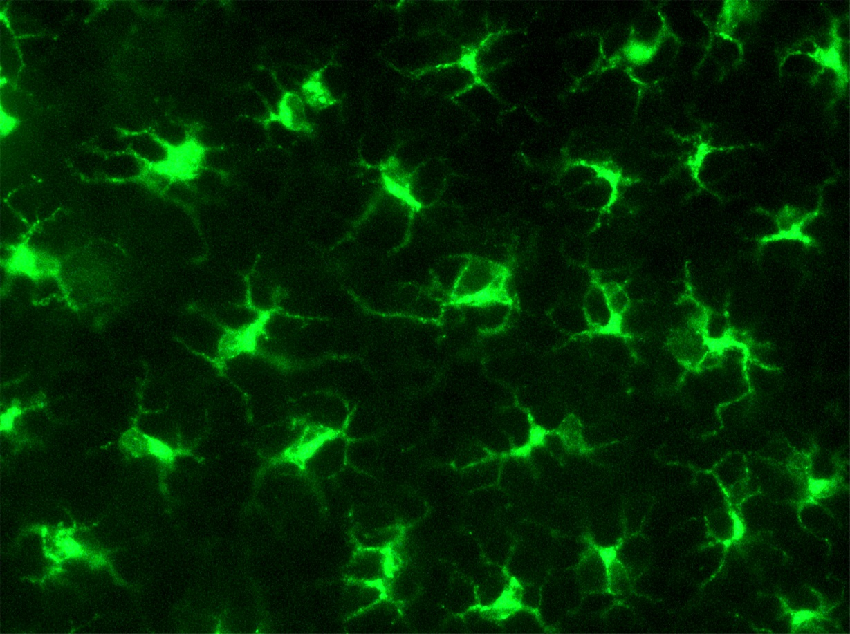
Figure 1 Murine Langerhans cells in ear skin reside in the epidermis, stained here for major histocompatibility complex class II (green). Reprinted from Jakob T, Ring J, Udey MC. Multistep navigation of Langerhans/dendritic cells in and out of the skin. J Allergy Clin Immunol 2001; 108: 688-696 Copyright (2001), with permission from Elsevier.

Figure 2 Mature skin dendritic cell egress via lymphatics that display secondary lymphoid tissue chemokine (SLC/CCL21) constitutively. Shown here are two mature DC expressing MHC class II (green) located within a lymphatic vessel that presents SLC (red). Reprinted from Jakob T, Ring J, Udey MC. Multistep navigation of Langerhans/dendritic cells in and out of the skin. J Allergy Clin Immunol 2001; 108: 688-696 Copyright (2001), with permission from Elsevier. Courtesy of Saeki H and Hwang S, National Cancer Institute, Bethesda, Md.

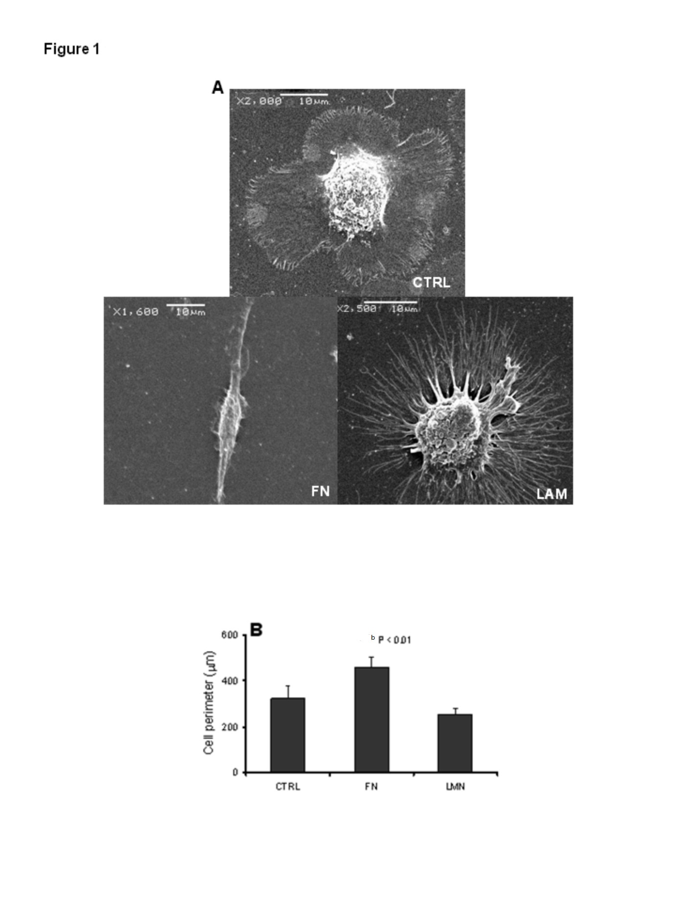
Figure 3 Scanning electron micrograph images demonstrate that dendritic cell cultured on fibronectin or laminin for 48 h exhibit widely differential morphologies. Taken in part from García-Nieto S, Johal RK, Shakesheff KM, Emara M, Royer PJ, Chau DY, Shakib F, Ghaemmaghami AM. Laminin and fibronectin treatment leads to generation of dendritic cells with superior endocytic capacity. PLoS One 2010; 5: e10123. Copyright (2011), published under the Creative Commons Attribution (CC BY) license. FN: Fibronectin; LAM: Laminin.

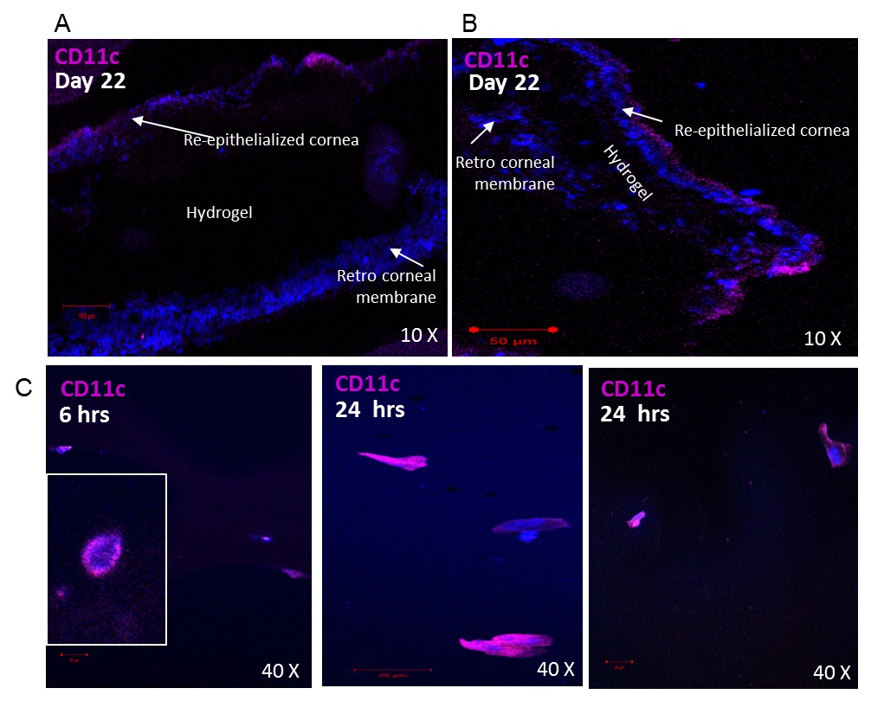
Figure 4 CD11c⁺ dendritic cell are involved in the host response to transplanted hydrogels. CD11c⁺ DC were detected in re-epithelialized layers surrounding RHCIII hydrogels transplanted in murine corneas, 22 d post transplantation (A, B). CD11c⁺ dendritic cells infiltrated hydrogels transplanted into murine corneas as early as 6 h (C) or 24 h (D) after transplantation and showed a transformation in morphology from rounded immature DC to well-differentiated DC at the latter time point after interacting with the three dimensional crosslinked collagen matrix. Images were taken within the hydrogel in (C, D) as shown in the schematic. DAPI: Nuclear staining shown in blue; DC: Dendritic cell.

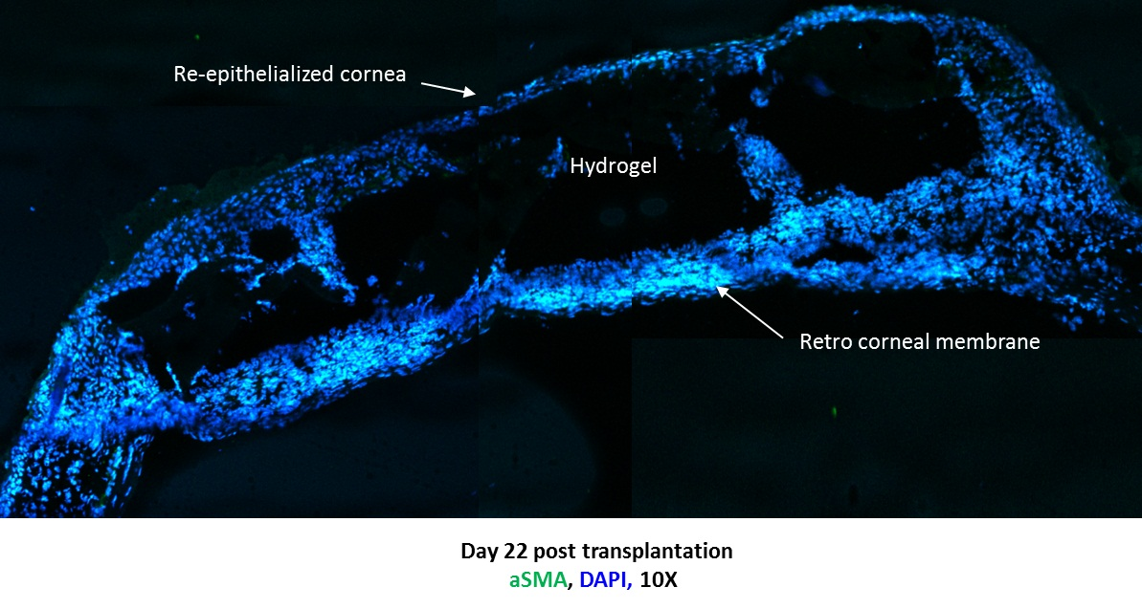
Figure 5 Merged images showing the formation of dense retro-corneal membrane separating corneal hydrogel from lens and posterior areas of eye, shown on day 22 after transplantation of murine corneas with RHCIII hydrogels. Newly generated membrane exhibits presence of alpha smooth muscle actin, likely produced by myofibroblasts recruited during the wound healing process. Tissue ingrowths into the RHCIII hydrogel are evidence of active remodelling of the artificial matrix scaffold by immune/inflammatory cells and ECM components, towards long-term integration with natural tissue. DAPI: Nuclear staining shown in blue; ECM: Extracellular matrix.

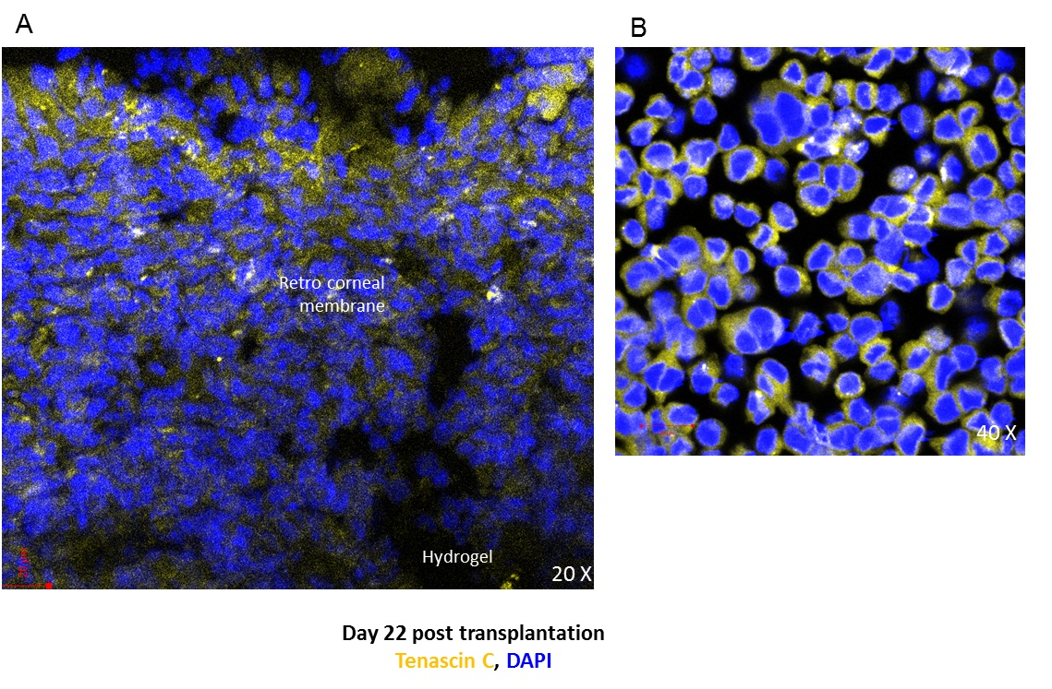
Figure 6 Murine corneas transplanted with RHCIII hydrogels stained positive for extracellular matrix constituent tenascin C in the retro-corneal membrane, a marker of epithelial to mesenchymal transition, indicative of active wound healing (A) and WEHI-164 murine fibrosarcoma cell line cultured with 5 ng/mL transforming growth factor-β1 for 48 h also produced tenascin C (positive control) (B). DAPI: Nuclear staining shown in blue.

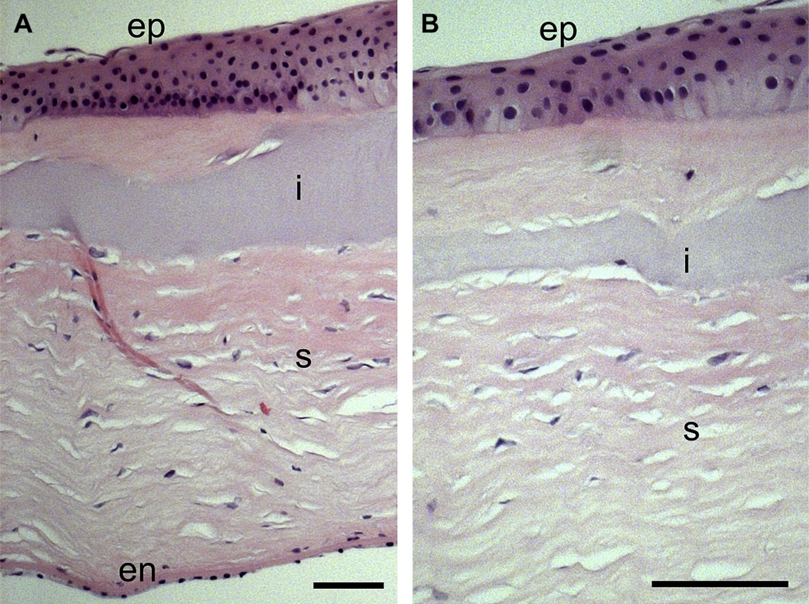
Figure 7 Immunohistochemistry image of biointeractive RHCIII hydrogel in a lamellar keratoplasty and removed after 4 years, upon regrafting of the patient. Notably, regrowth of characteristically stratified corneal epithelium (ep), layered stroma (s) and endothelial monolayer (en) left intact during transplantation, can be observed (A). A portion of the RHCIII implant (i) is visible in a higher magnification image (B), displaying a uniform assimilation with the native stroma in a dynamic, ongoing remodelling process. Reprinted from Fagerholm P, Lagali NS, Ong JA, Merrett K, Jackson WB, Polarek JW, Suuronen EJ, Liu Y, Brunette I, Griffith M. Stable corneal regeneration four years after implantation of a cell-free recombinant human collagen scaffold. Biomaterials 2014; 35: 2420-2427. Copyright (2014), with permission from Elsevier.

