Name of Journal: World Journal of Clinical Cases
Manuscript NO: 54162
Manuscript Type: ORIGINAL ARTICLE

Clinical and Translational Research
Role of peripheral eosinophilia in acute exacerbation of chronic obstructive pulmonary disease

Wu CW et al. Peripheral eosinophilia in AECOPD

Chih-Wei Wu, Chou-Chin Lan, Po-Chun Hsieh, I-Shiang Tzeng, Yao-Kuang Wu

Chih-Wei Wu, Chou-Chin Lan, Yao-Kuang Wu, Division of Pulmonary Medicine, Taipei Tzu Chi Hospital, Buddhist Tzu Chi Medical Foundation, New Taipei City 23142, Taiwan

Po-Chun Hsieh, Department of Chinese Medicine, Taipei Tzu Chi Hospital, Buddhist Tzu Chi Medical Foundation, New Taipei City 23142, Taiwan

I-Shiang Tzeng, Department of Research, Taipei Tzu Chi Hospital, Buddhist Tzu Chi Medical Foundation, New Taipei City 23142, Taiwan

Author contributions: Wu YK contributed to the study design and reviewed the manuscript; Tzeng IS and Lan CC analyzed the data. Wu CW contributed to data interpretation and manuscript writing; Hsieh PC contributed to data collection; Wu CW revised the paper.

Supported by Taipei Tzu Chi Hospital, No. TCRD-TPE-108-RT-4 and No. TCRD-TPE-108-4.

Corresponding author: Yao-Kuang Wu, MD, Attending Doctor, Division of Pulmonary Medicine, Taipei Tzu Chi Hospital, Buddhist Tzu Chi Medical Foundation, No. 289 Jianguo Road, Xindian District, New Taipei City 23142, Taiwan. drbfci@yahoo.com.tw

Received: January 16, 2020
Revised: April 26, 2020
Accepted: June 29, 2020
Published online: July 6, 2020

Abstract
BACKGROUND
Eosinophil counts are a promising guide to systemic steroid administration for chronic obstructive pulmonary disease (COPD).

AIM
To study the role of peripheral eosinophilia in hospitalized patients with acute exacerbation of COPD (AECOPD).

METHODS
From January 2014 to May 2017, patients with AECOPD hospitalized in Taipei Tzu Chi Hospital were retrospectively stratified into two groups according to their peripheral eosinophil count: the EOS group (eosinophil count ≥ 2%) and the non-EOS group (eosinophil count < 2%). Demographics, comorbidities, laboratory data, steroid use, length of hospital stay, and COPD-related readmissions were compared between the groups.

RESULTS
A total of 625 patients were recruited, with 176 patients (28.2%) in the EOS group. The EOS group showed a lower prevalence of infection, lower cumulative doses of prednisolone equivalents, shorter length of hospital stay, and higher number of COPD-related readmissions than the non-EOS group. There were significantly linear correlations between eosinophil percentage and number of readmissions and between eosinophil percentage and length of hospital stay (P < 0.001, Pearson's r = 0.147; P = 0.031, Pearson's r = -0.086, respectively). The EOS group and a lower percent-predicted value of forced expiratory volume in one second (FEV1) were associated with shorter time to first COPD-related readmission [adjusted hazard ratio (adj. HR) = 1.488, P < 0.001; adj. HR = 0.985, P < 0.001, respectively].

CONCLUSION
The study findings suggest that the EOS group had the features of a shorter length of hospital stay, and lower doses of systemic steroids, but more frequent readmissions. The EOS group and lower percent-predicted FEV1 values were risk factors for shorter time to first COPD-related readmission.

Key words: Chronic obstructive pulmonary disease; Exacerbation; Eosinophil; Readmission; Systemic steroid; Length of hospital stay; Forced expiratory volume in one second

Wu CW, Lan CC, Hsieh PC, Tzeng IS, Wu YK. Role of peripheral eosinophilia in acute exacerbation of chronic obstructive pulmonary disease. World J Clin Cases 2020; 8(13): 2727-2737 URL: https://www.wjgnet.com/2307-8960/full/v8/i13/2727.htm DOI: https://dx.doi.org/10.12998/wjcc.v8.i13.2727

Core tip: This is the first study in Taiwan that comprehensively evaluates the role of eosinophilia in chronic obstructive pulmonary disease (COPD). Eosinophilic COPD exacerbation is associated with a high risk of readmissions and a short length of hospital stay. It has the characteristics of non-infectious inflammation and is a predictor of steroid therapy. A routine survey of the peripheral blood eosinophil count is warranted for acute COPD exacerbations.

INTRODUCTION
Chronic obstructive pulmonary disease (COPD) is characterized by airway obstruction that is not completely reversible. It has been predicted to be the third most common cause of death in 2020^{[1]}. COPD exacerbation is associated with significant morbidity and mortality. Systemic steroid therapy is a cornerstone of the treatment of COPD exacerbation, but it can exacerbate hyperglycemia, psychiatric problems, and osteoporosis^{[2]}. Patients with COPD are of old age and have multiple comorbidities; therefore, they are vulnerable to the side effects of systemic steroids. Traditionally, asthma is considered as eosinophilic airway disease, while COPD is considered as neutrophilic airway disease. Bafadhel et al^{[3]} proposed four models of COPD exacerbation: bacterial (55%), viral (29%), eosinophilic (28%), and pauci-inflammatory. A classification of COPD exacerbation based on the phenotype is required for the development of precision medicine.
Eosinophilia in patients with COPD is a marker of steroid response. The 2020 Global Initiative for Chronic Obstructive Lung Disease (GOLD) guidelines recommend using the peripheral blood eosinophil count (PBEC) to guide the choice of inhalational steroids to prevent COPD exacerbation, and the cut-off values are the absolute values of PBEC (100 and 300 cells/μL)^{[1]}. Mepolizumab, an interleukin-5 antibody, showed slight efficacy for reducing the rate of exacerbations in patients with COPD and eosinophilia^{[4]}. Most studies used 2% of the total white blood cell (WBC) count as the cut-off value to diagnose patients with an eosinophilic or a non-eosinophilic COPD exacerbation. However, only a few studies focused on the impact of PBEC on systemic steroid administration for acute COPD exacerbation. Until recently, two prospective studies showed that PBEC-guided systemic steroid therapy could reduce the steroid exposure and improve the health status of patients but without altering survival^{[5,6]}.
The eosinophilic phenotype accounts for 20%-40% of COPD exacerbations^{[7]}. PBEC is a well-established predictor of the length of hospital stay, steroid response, prognosis, and readmission rate^{[7-13]}. Nevertheless, some characteristics of patients with eosinophilic COPD exacerbation, such as demographics, comorbidities, lung function, etc., are inconsistent across studies^{[14]}. Studies on the impact of the PBEC were primarily focused on the Caucasian race. Only a few studies investigated eosinophilic COPD exacerbation in the Asian populations, including patients from China and South Korea^{[13,15]}. The aim of the present study was to elucidate the role of peripheral eosinophilia in hospitalized patients with COPD exacerbation in Taiwan.

MATERIALS AND METHODS
Study design
We retrospectively screened the medical records for COPD-related hospitalizations in the department of pulmonary and critical care of Taipei Tzu chi Hospital from January 1, 2014 to May 31, 2017. Patients who experienced at least one COPD-related admission during this period were recruited. The index hospitalization was defined as the first COPD-related admission during the study period. Patients with COPD exacerbations were classified into two groups according to their blood eosinophil count at the time of the index hospitalization: the EOS group (PBEC ≥ 2% of the total WBC count) and the non-EOS group (PBEC < 2% of the total WBC count).
Other inclusion criteria were patients aged > 40 years and a post-bronchodilator forced expiratory volume in one second (FEV1)/forced vital capacity (FVC) ratio < 0.7, in accordance with 2020 GOLD guidelines^{[1]}. We excluded patients with a history of asthma and bronchiectasis, long-term oral steroid use, and those who received systemic steroids within 48 h before the blood test at the index hospitalization.
The protocol of PBEC processing was as follows: (1) The nurses or technicians collected 3 mL of venous blood in a lavender-top tube (ethylenediaminetetraacetic acid); (2) the sample was sent to the automated hematology analyzer Sysmex XN-9000™ (Sysmex Corporation, Kobe, Japan); (3) the complete and differential blood counts were reported within one hour; (4) the PBEC (%) was obtained from the differential count; and (5) if the PBEC (%) was larger than 30%, the technicians manually recalculated it.

Outcomes
The primary outcome was the total number of 12-mo COPD-related readmissions. The secondary outcomes were total cumulative dose of systemic steroids in the index hospitalization, the length of stay in the index hospitalization, time to first COPD-related readmission within 12 mo, risk factors for first COPD-related readmission, and the total number of 12-mo COPD-related admissions before the index hospitalization. We assessed the linear relationship between the percentage of eosinophils with the number of 12-mo COPD-related readmissions and the length of stay in the index hospitalization.

Covariables
We collected the following data from medical records before the index hospitalization: demographics, body mass index, smoking history, comorbidities (the neuromuscular disease included stroke, Parkinsonism), the use of home noninvasive ventilation, pulmonary function test, and the respiratory medicines including long-acting anti-muscarinic agents, long-acting beta-agonists, and inhaled corticosteroids. The following data were collected at the index hospitalization: hemogram, C-reactive protein (CRP) levels, chest X-ray (CXR) findings, length of hospital stay, hospital outcomes including home discharge, death, and respiratory care ward (RCW) discharge, and major in-hospital treatments including systemic steroids and antibiotics.

Ethical statement
The study was approved by Taipei Tzu Chi Hospital, Buddhist Tzu Chi Medical Foundation Institutional Review Board on September 2019 (protocol number 08-X-094).

Statistical analyses
Data were presented as mean ± standard deviation and number (percentage). The independent samples t-test was used for comparison of continuous data. Chi-squared test was used for comparison of categorical variables. Relationships between the continuous variables were assessed by the Pearson correlation coefficient (r) and simple linear regression analysis. R-values of < 0.3, 0.3-0.7, and > 0.7 were considered to indicate mild, moderate, and strong relationships, respectively. Cox regression analysis was used to clarify the risk factors for the time to first COPD-related readmission. We used the Kaplan-Meier method to plot the time to first COPD-related readmission curves of the two groups and the log-rank test to analyze the difference between the two groups. A P-value < 0.05 was considered to be statistically significant. SPSS software version 25 (IBM Corporation, Armonk, NY, United States) was used for all statistical analyses.

RESULTS
A total of 625 patients were enrolled. The EOS group and the non-EOS group included 176 (28.2%) and 449 (71.8%) patients, respectively. Table 1 shows the comparison of demographics, smoking history, hemogram data, infection status, use of home noninvasive ventilation, comorbidities, pulmonary function test and inhaled medications before admission between the two groups. The mean percentage of eosinophils in the EOS group was greater than in the non-EOS group (6.47% vs 0.79%, P < 0.001). In contrast, the percentage of neutrophils and the neutrophil to lymphocyte ratio (NLR) were significantly lower in the EOS group than in the non-EOS group (both P < 0.001). The EOS group had significantly lower burden of infectious inflammation (assessed by CXR infiltrate, fever, CRP level, and antibiotic administration) than the non-EOS group. There were no significant differences in the prevalence of comorbidities between the two groups, with the exception of neuromuscular disease (14.2% in the EOS group vs 7.1% in the non-EOS group, P = 0.009). Most of the pulmonary function test parameters showed no significant difference between the groups. However, the FVC was higher in the EOS group than in the non-EOS group (2.14 L^{[1]} vs 1.94 L, P = 0.002). Both groups received similar inhaled medications before admission.
Table 2 shows the comparison of the length of hospital stay, systemic steroid use, histories of admissions and readmissions, and hospital outcomes. We found that the mean prednisolone equivalent was 302.65 mg in the EOS group, and it was significantly lower than that of the non-EOS group (373.35 mg) (P = 0.021). There was no significant difference between the groups regarding major treatments including antibiotics and steroids (P = 0.095). The mean number of COPD-related readmissions within 12 mo was higher in the EOS group than in the non-EOS group (2.14 vs 1.53, P = 0.002). The EOS group had a higher proportion of patients with at least one COPD-related readmission within 12 mo than the non-EOS group (71.0% vs 55.9%, P = 0.001). The number of admissions in the previous 12 mo was also higher in the EOS group compared with the non-EOS group (2.05 vs 1.44, P = 0.004). In the EOS group, the mean length of hospital stay was 8.81 d. It was significantly shorter than that of the non-EOS group (10.00 d) (P = 0.049). No significant differences were observed in discharge outcomes evaluated by home discharge, RCW discharge, and death between the two groups (P = 0.204).
Table 3 integrates the risk factors for first COPD-related readmission by the Cox regression model. After adjustment, phenotype (EOS vs non-EOS), the percent-predicted value of FEV1, and age were significant risk factors. The adjusted hazard ratio (adj. HR) of the EOS group versus the non-EOS group was 1.488 [95% confidence interval (CI): 1.195-1.854, P < 0.001]. Higher percent-predicted value of FEV1 was associated with reduced risk of first COPD-related readmission (adj. HR = 0.985, 95%CI = 0.979-0.991, P < 0.001). Time to first COPD-related readmission of the EOS group and the non-EOS group is plotted in Figure 1.
There was a significantly mild linear correlation between the percentage of eosinophils and number of readmissions within 12 mo (Pearson's r = 0.147; P < 0.001) (Figure 2). The linear relationship between the percentage of eosinophils and the length of hospital stay in the index hospitalization showed a significantly mild correlation (Pearson's r = -0.086; P = 0.031) (Figure 3).

DISCUSSION
In the present study, we comprehensively evaluated the role of eosinophils in COPD exacerbation. We found that the EOS group (PBEC ≥ 2%) was associated with a shorter length of hospital stay, a lower dose of steroids, a shorter time to first COPD-related readmission, a higher number of COPD-related readmissions, and a tendency of non-infectious inflammation. Although most findings were consistent with previous literature, there are several novel findings in this study: (1) this was the first study in Taiwan; and (2) the PBEC had a significantly linear correlation with the number of readmissions and length of hospital stay.

Infection status and lung functions
Our findings supported the results of previous studies on the tendency of non-infectious inflammation in the EOS group (PBEC ≥ 2%). The hemogram and antibiotic administration in our study are consistent with those of a previous Chinese study by Xue et al^{[15]}. Duman et al^{[9]} reported that the non-EOS group (PBEC ≤ 2%) had higher NLR and CRP levels in a the Turkish population. Saltürk et al^{[16]} reported similar results for hemogram and CRP levels in the non-EOS group (PBEC ≤ 2%) in the intensive care unit (ICU) population.
Our study revealed that the EOS group (PBEC ≥ 2%) showed higher absolute values of FVC. Similarly, Singh reported that the EOS group (PBEC ≥ 2%) was characterized by higher absolute values of FEV1 and FVC^{[17]}. Kang et al^{[13]} also observed that the EOS group (PBEC > 2%) had higher absolute values of FEV1 and FVC in the Korean population. The aforementioned findings suggest that patients with eosinophilic COPD exacerbation have better lung function. However, a meta-analysis by Wu et al^{[14]} revealed that the percentage of predicted FEV1 value showed no significant difference between the EOS (PBEC > 2%) and non-EOS groups (PBEC ≤ 2%).

Readmission
In the present study, the EOS group (PBEC ≥ 2%) showed a shorter time to first COPD-related readmission. Previous studies that defined the EOS group by 2% eosinophilia or ≥ 200 cells/μL in the Caucasian^{[8,10]} and Asian races^{[15]} showed results similar to those of our study. Couillard et al^{[8]} stated that the EOS group (PBEC ≥ 200 cells/μL and/or ≥ 2%) had a higher risk of COPD-related readmissions within 12 mo and shorter time to the first COPD-related readmission within 12 mo. Bélanger et al^{[10]} reported that in infrequent exacerbations (defined as the first exacerbation in previous 5 years), the EOS group (PBEC ≥ 200 cells/μL and/or ≥ 2%) had a higher risk of COPD-related readmissions and shorter time to the first COPD-related readmission. In Asian races, Xue et al^{[15]} revealed that the EOS group (PBEC ≥ 2%) had a higher risk of severe exacerbation.
Eosinophilic COPD exacerbation is a well-known risk factor for COPD-related readmissions. The current study demonstrated a significant linear correlation between the percentage of blood eosinophil and the number of readmissions. Although our finding was intuitively reasonable, we believe it is novel in the current literature.

Systemic prednisolone administration
Among all hospitalized patients with acute COPD exacerbation, the EOS group (PBEC ≥ 2%) required a lower systemic steroid dose compared to the non-EOS group (PBEC < 2%) in the present study, consistent with previous retrospective studies^{[9,11]}. Serafino-Agrusa et al^{[11]} showed that a lower dose of daily systemic steroids was administered in the EOS group (≥ 2%) than in the non-EOS group (PBEC < 2%). Duman et al^{[9]} revealed that a lower proportion of the EOS group (PBEC > 2%) received systemic steroids compared to the non-EOS group (PBEC ≤ 2%).
To the best of our knowledge, only two prospective studies addressed the role of eosinophil on systemic steroids. In a prospective study enrolling outpatients, Bafadhel et al^{[5]} reported that eosinophil-guided therapy (cut-off value: PBEC = 2%) could decrease the proportion of patients receiving steroids (51% vs 100%) compared to the standard treatment, and steroid treatment in the non-EOS group is associated with a poorer health status and higher treatment failure rate (15% vs 2%) compared to placebo. In a prospective study enrolling inpatients by Sivapalan et al^{[6]}, eosinophil-guided therapy (cut-off value: absolute eosinophil count = 300 cells /μL) reduced the duration of steroid treatment (2 d vs 5 d), but there were no differences in the 30-d treatment failure rate (26% vs 26%) and 30-d survival rate (94% vs 96%) compared to the standard treatment.
In real-world practice, physicians in charge adjusted the steroid dose according to the clinical response (i.e., reduced the steroid dose according to the relief of breathlessness). Because eosinophilic COPD exacerbation has a better clinical response to systemic steroids, the EOS group required a lower systemic steroid dose than the non-EOS group in the present study.

Length of hospital stay
The length of hospital stay was shorter in the EOS group (PBEC ≥ 2%) in our study. Many retrospective studies enrolled patients with different in-hospital treatments, such as antibiotics and steroid use, for acute COPD exacerbation. Their findings related to the length of hospital stay are similar and consistent with those of our study^{[9,11,18]}. Duman et al^{[9]} reported that the EOS group (PBEC > 2%) had a shorter length of stay than the non-EOS group (PBEC ≤ 2%). In a study by Serafino-Agrusa et al^{[11]}, the EOS group (PBEC ≥ 2%) had a shorter length of stay compared to the non-EOS group (PBEC < 2%). Bafadhel et al^{[18]} revealed that the length of stay was shorter in the EOS group (PBEC ≥ 200 cells/μL and/or ≥ 2%) than in the non-EOS group.
Furthermore, Xue et al^{[15]} pointed out that the EOS group (PBEC ≥ 2%) showed a better steroid response after evaluation with the COPD assessment test (CAT) than the non-EOS group (PBEC < 2%). Shorter lengths of hospital stay, and better CAT responses are probably due to the fact that the use of steroids had a rationale only in the EOS group.

Morbidity and mortality
We found no difference in the discharge outcomes between the EOS (PBEC ≥ 2%) and the non-EOS groups (PBEC < 2%) in this study. Because eosinophilia is a risk factor for COPD-related readmissions, we could reasonably infer that eosinophilic COPD exacerbation has higher risks of mortality and morbidity. However, previous studies showed better mortality and morbidity in eosinophilic COPD exacerbation^{[12,13,16]}. Saltürk et al^{[16]} stated that the EOS group (PBEC > 2%) had a shorter median length of ICU stay and lower ICU mortality compared to the non-EOS group. Kang et al^{[13]} showed that the EOS group (PBEC > 2%) had lower rate of ICU admissions and lower mortality rate. Mendy et al^{[12]} reported that after a median follow-up of 3 years, the non-EOS group (PBEC < 2%) was a predictor of long-term COPD mortality.
Patients with long-term oral steroid use imply poor COPD control. In our study, we excluded these patients, and therefore, discharge outcomes may be similar. Additionally, eosinophils play an essential role in innate and adaptive immune response and takes part in the defense against various pathogens, including virus, bacteria, etc^{[19]}. Eosinopenia is associated with sepsis^{[20]}. Eosinophilic COPD exacerbation had a lower risk of pneumonia^{[21]}. These anti-infectious capacities of eosinophil may lead to better mortality and morbidity.

Limitations
This was a single-center study in Taiwan involving only the Asian race and a relatively small sample size. Moreover, the retrospective design of the study had intrinsic limitations.
Although eosinophilic COPD exacerbation COPD shows better systemic steroid responses, the precise mechanism is unknown. Systemic steroids can reduce the blood eosinophil count by > 50% within the first four hours after administration^{[22]}; thus, the anti-eosinophil capacity of steroids could partially explain this phenomenon.
The linear correlation between the PBEC and the number of readmissions and length of hospital stay is weak. Further studies are required to clarify the relationship.

Conclusion
The EOS group (PBEC ≥ 2%) was associated with a higher number of COPD-related readmissions within 12 mo, shorter time to the first COPD-related readmission, lower dose of systemic steroid use, and shorter length of hospital stay compared to the non-EOS group. Low percent-predicted FEV1 values were observed to be a risk factor for the first COPD-related readmission.
We should strengthen the management of comorbidities and optimization of inhaled medications to reduce the high readmission risk in the EOS group. Routine survey of the PBEC for acute COPD exacerbation is warranted to reduce the side effects of steroids. With meticulous exclusion of possible infections, we could avoid empirical antibiotic therapy since the EOS group has a non-infectious nature.

ARTICLE HIGHLIGHTS
Research background
The eosinophilic phenotype accounts for 20%-40% of chronic obstructive pulmonary disease (COPD) exacerbations. The peripheral blood eosinophil count (PBEC) is a well-established predictor of the length of hospital stay, steroid response, prognosis, and readmission rate. Additionally, previous research supported the tendency of non-infectious inflammation in the eosinophilic group.

Research motivation
Some characteristics of patients with eosinophilic COPD exacerbation, such as demographics, comorbidities, lung function, etc., are inconsistent across studies. Studies on the role of eosinophilia primarily focused on the Caucasian race. A few studies investigated eosinophilic COPD exacerbation in Asian populations.

Research objectives
We aimed to study the role of peripheral eosinophilia in hospitalized patients with COPD exacerbation in Taiwan.

Research methods
From January 2014 to May 2017, patients with COPD exacerbation hospitalized in Taipei Tzu Chi Hospital were retrospectively stratified into two groups according to their peripheral eosinophil count: the EOS group (eosinophil count ≥ 2%) and the non-EOS group (eosinophil count < 2%).

Research results
A total of 625 patients were recruited, with 176 patients (28.2%) in the eosinophilic group. The eosinophilic group showed a lower prevalence of infection, lower cumulative doses of prednisolone equivalents, shorter length of hospital stay, and higher number of COPD-related readmissions than the non-EOS group. There were significantly linear correlations between eosinophil percentage and number of readmissions and between eosinophil percentage and length of hospital stay (P < 0.001, Pearson's r = 0.147; P = 0.031, Pearson's r = -0.086, respectively).

Research conclusions
The PBEC had a positive linear correlation with the number of readmissions. Eosinophilia is a predictor of steroid response and non-infectious inflammation.

Research perspectives
We should strengthen the management of comorbidities and optimization of inhaled medications to reduce the high readmission risk in the EOS group. Routine survey of PBEC for acute COPD exacerbation is warranted to reduce the notorious side effects of steroids. With meticulous exclusion of possible infections, we could avoid empirical antibiotic therapy since the EOS group has a non-infectious nature. Effective target therapy for eosinophilic COPD exacerbation is urgently required.

REFERENCES
1 Global Initiative for Chronic Obstructive Lung Disease. Gold Reports for Personal Use 2020 GOLD Report. Available from: https://goldcopd.org/gold-reports/
2 Walters JA, Tan DJ, White CJ, Gibson PG, Wood-Baker R, Walters EH. Systemic corticosteroids for acute exacerbations of chronic obstructive pulmonary disease. Cochrane Database Syst Rev 2014: CD001288 [PMID: 25178099 DOI: 10.1002/14651858.CD001288.pub4]
3 Bafadhel M, McKenna S, Terry S, Mistry V, Reid C, Haldar P, McCormick M, Haldar K, Kebadze T, Duvoix A, Lindblad K, Patel H, Rugman P, Dodson P, Jenkins M, Saunders M, Newbold P, Green RH, Venge P, Lomas DA, Barer MR, Johnston SL, Pavord ID, Brightling CE. Acute exacerbations of chronic obstructive pulmonary disease: identification of biologic clusters and their biomarkers. Am J Respir Crit Care Med 2011; 184: 662-671 [PMID: 21680942 DOI: 10.1164/rccm.201104-0597OC]
4 Pavord ID, Chanez P, Criner GJ, Kerstjens HAM, Korn S, Lugogo N, Martinot JB, Sagara H, Albers FC, Bradford ES, Harris SS, Mayer B, Rubin DB, Yancey SW, Sciurba FC. Mepolizumab for Eosinophilic Chronic Obstructive Pulmonary Disease. N Engl J Med 2017; 377: 1613-1629 [PMID: 28893134 DOI: 10.1056/NEJMoa1708208]
5 Bafadhel M, McKenna S, Terry S, Mistry V, Pancholi M, Venge P, Lomas DA, Barer MR, Johnston SL, Pavord ID, Brightling CE. Blood eosinophils to direct corticosteroid treatment of exacerbations of chronic obstructive pulmonary disease: a randomized placebo-controlled trial. Am J Respir Crit Care Med 2012; 186: 48-55 [PMID: 22447964 DOI: 10.1164/rccm.201108-1553OC]
6 Sivapalan P, Lapperre TS, Janner J, Laub RR, Moberg M, Bech CS, Eklöf J, Holm FS, Armbruster K, Sivapalan P, Mosbech C, Ali AKM, Seersholm N, Wilcke JT, Brøndum E, Sonne TP, Rønholt F, Andreassen HF, Ulrik CS, Vestbo J, Jensen JS. Eosinophil-guided corticosteroid therapy in patients admitted to hospital with COPD exacerbation (CORTICO-COP): a multicentre, randomised, controlled, open-label, non-inferiority trial. Lancet Respir Med 2019; 7: 699-709 [PMID: 31122894 DOI: 10.1016/S2213-2600(19)30176-6]
7 Camp J, Cane JL, Bafadhel M. Shall We Focus on the Eosinophil to Guide Treatment with Systemic Corticosteroids during Acute Exacerbations of COPD?: PRO. Med Sci (Basel) 2018; 6 [PMID: 30208605 DOI: 10.3390/medsci6030074]
8 Couillard S, Larivée P, Courteau J, Vanasse A. Eosinophils in COPD Exacerbations Are Associated With Increased Readmissions. Chest 2017; 151: 366-373 [PMID: 27746201 DOI: 10.1016/j.chest.2016.10.003]
9 Duman D, Aksoy E, Agca MC, Kocak ND, Ozmen I, Akturk UA, Gungor S, Tepetam FM, Eroglu SA, Oztas S, Karakurt Z. The utility of inflammatory markers to predict readmissions and mortality in COPD cases with or without eosinophilia. Int J Chron Obstruct Pulmon Dis 2015; 10: 2469-2478 [PMID: 26648709 DOI: 10.2147/COPD.S90330]
10 Bélanger M, Couillard S, Courteau J, Larivée P, Poder TG, Carrier N, Girard K, Vézina FA, Vanasse A. Eosinophil counts in first COPD hospitalizations: a comparison of health service utilization. Int J Chron Obstruct Pulmon Dis 2018; 13: 3045-3054 [PMID: 30319252 DOI: 10.2147/COPD.S170743]
11 Serafino-Agrusa L, Scichilone N, Spatafora M, Battaglia S. Blood eosinophils and treatment response in hospitalized exacerbations of chronic obstructive pulmonary disease: A case-control study. Pulm Pharmacol Ther 2016; 37: 89-94 [PMID: 26996272 DOI: 10.1016/j.pupt.2016.03.004]
12 Mendy A, Forno E, Niyonsenga T, Gasana J. Blood biomarkers as predictors of long-term mortality in COPD. Clin Respir J 2018; 12: 1891-1899 [PMID: 29227024 DOI: 10.1111/crj.12752]
13 Kang HS, Rhee CK, Kim SK, Kim JW, Lee SH, Yoon HK, Ahn JH, Kim YH. Comparison of the clinical characteristics and treatment outcomes of patients requiring hospital admission to treat eosinophilic and neutrophilic exacerbations of COPD. Int J Chron Obstruct Pulmon Dis 2016; 11: 2467-2473 [PMID: 27757029 DOI: 10.2147/copd.S116072]
14 Wu HX, Zhuo KQ, Cheng DY. Prevalence and Baseline Clinical Characteristics of Eosinophilic Chronic Obstructive Pulmonary Disease: A Meta-Analysis and Systematic Review. Front Med (Lausanne) 2019; 6: 282 [PMID: 31921866 DOI: 10.3389/fmed.2019.00282]
15 Xue J, Cui YN, Chen P, Cai S, Chen L, Dai ZS, Chen Y. [Blood eosinophils: a biomarker of response to glucocorticoids and increased readmissions in severe hospitalized exacerbations of COPD]. Zhonghua Jie He He Hu Xi Za Zhi 2019; 42: 426-431 [PMID: 31189228 DOI: 10.3760/cma.j.issn.1001-0939.2019.06.005]
16 Saltürk C, Karakurt Z, Adiguzel N, Kargin F, Sari R, Celik ME, Takir HB, Tuncay E, Sogukpinar O, Ciftaslan N, Mocin O, Gungor G, Oztas S. Does eosinophilic COPD exacerbation have a better patient outcome than non-eosinophilic in the intensive care unit? Int J Chron Obstruct Pulmon Dis 2015; 10: 1837-1846 [PMID: 26392758 DOI: 10.2147/COPD.S88058]
17 Singh D, Kolsum U, Brightling CE, Locantore N, Agusti A, Tal-Singer R; ECLIPSE investigators. Eosinophilic inflammation in COPD: prevalence and clinical characteristics. Eur Respir J 2014; 44: 1697-1700 [PMID: 25323230 DOI: 10.1183/09031936.00162414]
18 Bafadhel M, Greening NJ, Harvey-Dunstan TC, Williams JE, Morgan MD, Brightling CE, Hussain SF, Pavord ID, Singh SJ, Steiner MC. Blood Eosinophils and Outcomes in Severe Hospitalized Exacerbations of COPD. Chest 2016; 150: 320-328 [PMID: 26851799 DOI: 10.1016/j.chest.2016.01.026]
19 Ravin KA, Loy M. The Eosinophil in Infection. Clin Rev Allergy Immunol 2016; 50: 214-227 [PMID: 26690368 DOI: 10.1007/s12016-015-8525-4]
20 Shaaban H, Daniel S, Sison R, Slim J, Perez G. Eosinopenia: Is it a good marker of sepsis in comparison to procalcitonin and C-reactive protein levels for patients admitted to a critical care unit in an urban hospital? J Crit Care 2010; 25: 570-575 [PMID: 20435431 DOI: 10.1016/j.jcrc.2010.03.002]
21 Pavord ID, Lettis S, Anzueto A, Barnes N. Blood eosinophil count and pneumonia risk in patients with chronic obstructive pulmonary disease: a patient-level meta-analysis. Lancet Respir Med 2016; 4: 731-741 [PMID: 27460163 DOI: 10.1016/S2213-2600(16)30148-5]
22 Thorn GW, Renold AE, Wilson DL, Frawley TF, Jenkins D, Garcia-Reyes J, Forsham PH. Clinical studies on the activity of orally administered cortisone. N Engl J Med 1951; 245: 549-555 [PMID: 14875208 DOI: 10.1056/nejm195110112451501]

Footnotes
Institutional review board statement: The study was approved by Taipei Tzu Chi Hospital, Buddhist Tzu Chi Medical Foundation Institutional Review Board on September 2019 (protocol number 08-X-094).

Clinical trial registration statement: The study was conducted retrospectively.

Informed consent statement: The informed consent to the study is not required because the clinical data were anonymous.

Conflict-of-interest statement: All authors declared no conflict-of-interest.

Data sharing statement: The authors could obtain the data under the permission of the corresponding author (ykwutzhtpe@gmail.com).

Open-Access: This article is an open-access article that was selected by an in-house editor and fully peer-reviewed by external reviewers. It is distributed in accordance with the Creative Commons Attribution NonCommercial (CC BY-NC 4.0) license, which permits others to distribute, remix, adapt, build upon this work non-commercially, and license their derivative works on different terms, provided the original work is properly cited and the use is non-commercial. See: http://creativecommons.org/licenses/by-nc/4.0/

Manuscript source: Unsolicited manuscript

Peer-review started: January 16, 2020
First decision: April 14, 2020
Article in press: June 29, 2020

Specialty type: Medicine, research and experimental
Country/Territory of origin: Taiwan
Peer-review report’s scientific quality classification
Grade A (Excellent): 0
Grade B (Very good): B, B
Grade C (Good): 0
Grade D (Fair): 0
Grade E (Poor): 0

P-Reviewer: Rouabhia M, Soriano-Ursúa MA S-Editor: Dou Y L-Editor: A E-Editor: Wang LL
Figure Legends
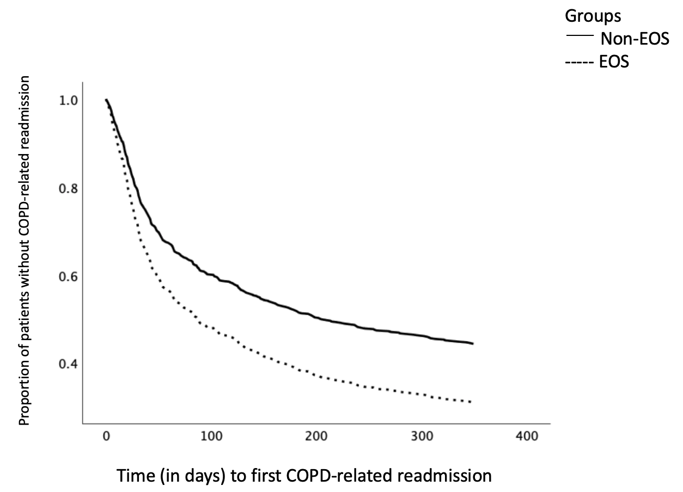
Figure 1 The Kaplan-Meier curves of time to first chronic obstructive pulmonary disease related readmission (P < 0.001; adjusted hazard ratio = 1.488, 95% confidence interval = 1.195-1.854). Log-rank method was used to test the difference between the two groups. COPD: Chronic obstructive pulmonary disease; EOS: Patients with eosinophil count ≥ 2%; Non-EOS: Patients with eosinophil count < 2%.

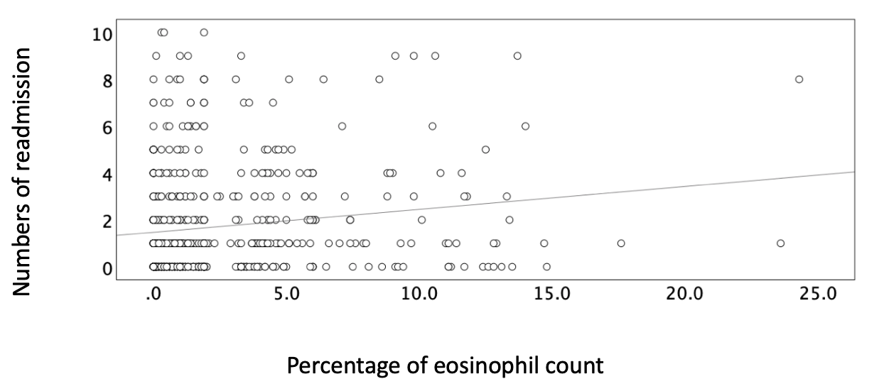
Figure 2 The correlation between the percentage of eosinophils and the number of readmissions within 12 mo (P < 0.001; Pearson's r = 0.147). The relationships between continuous variables were assessed by the Pearson's correlation coefficient (r) and simple linear regression analysis.

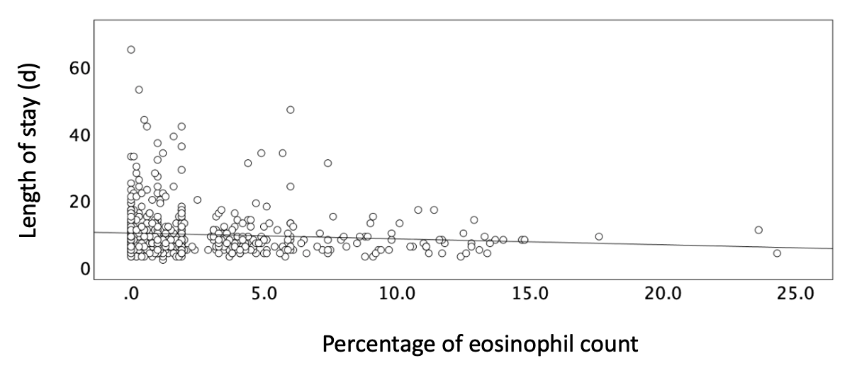
Figure 3 The correlation between the percentage of eosinophils and the length of stay (d) in the index hospitalization (P = 0.031; Pearson's r = -0.086). The relationships between continuous variables are assessed by the Pearson's correlation coefficient (r) and simple linear regression analysis.

Table 1 Comparison of clinical characteristics, laboratory findings, pulmonary function test, and inhaled medications between EOS group and non-EOS group
Variables | EOS group (n = 176) | Non-EOS group (n = 449) | P value
Male (%) | 166 (94.3) | 384 (85.5) | 0.004
BMI | 23.52 ± 4.19 | 23.23 ± 4.23 | 0.441
Age, yr | 74.90 ± 11.74 | 76.89 ± 10.09 | 0.049
Smoking, n (%) |  |  | 0.054
Never | 45 (25.6) | 142 (31.6)
Current | 54 (30.7) | 98 (21.8)
Ex-smoker | 77 (43.8) | 209 (46.5)
Hemogram values
Leukocyte count, 10⁹/ L | 8723.92 ± 3447.99 | 11002.72 ± 4311.44 | 0.000
Neutrophil, % | 64.50 ± 9.89 | 77.74 ± 9.86 | 0.000
Monocyte, % | 6.96 ± 2.20 | 6.71 ± 3.05 | 0.253
Lymphocyte, % | 21.30 ± 8.18 | 13.13 ± 8.50 | 0.000
Eosinophil count, % | 6.47 ± 3.81 | 0.79 ± 0.84 | 0.000
Basophil, % | 0.40 ± 0.30 | 0.19 ± 0.28 | 0.000
Hemoglobin, g/dL | 13.25 ± 2.31 | 13.24 ± 2.11 | 0.942
Hematocrit, % | 39.31 ± 6.33 | 39.37 ± 5.83 | 0.909
MCV, fL | 88.58 ± 7.58 | 89.35 ± 6.99 | 0.228
Platelet count, 10³/µL | 228.14 ± 86.15 | 206.59 ± 70.09 | 0.001
Mean platelet volume, fL | 9.63 ± 0.76 | 9.75 ± 0.81 | 0.106
Neutrophil count, 10⁹/L | 5715.46 ± 2872.96 | 8718.93 ± 3962.78 | 0.000
Lymphocyte count, 10⁹/ L | 1770.57 ± 822.48 | 1294.99 ± 840.47 | 0.000
Eosinophil count, 10⁹/ L | 543.18 ± 351.54 | 76.16 ± 82.77 | 0.000
Neutrophil-to-lymphocyte ratio | 4.39 ± 6.29 | 10.59 ± 13.11 | 0.000
Infection status, n (%)
CXR infiltrate | 18 (10.2) | 83 (18.5) | 0.016
Fever | 9 (5.1) | 51 (11.4) | 0.026
Antibiotics | 145 (82.4) | 404 (90.0) | 0.013
Inflammatory markers
CRP | 2.08 ± 3.76 | 4.64 ± 5.75 | 0.000
Home noninvasive ventilation, n (%) | 18 (10.2) | 43 (9.6) | 0.923
Comorbidities, n (%)
Neuromuscular disease | 25 (14.2) | 32 (7.1) | 0.009
Ischemic heart disease | 35 (19.9) | 92 (20.5) | 0.954
Cancer | 8.0 (14) | 30 (6.7) | 0.705
ESRD | 0 (0) | 3 (0.6) | 0.370
Hypertension | 82 (46.6) | 208 (46.3) | 0.715
Diabetes mellitus | 28 (15.9) | 65 (14.5) | 0.743
Liver cirrhosis | 3 (1.7) | 3 (0.6) | 0.238
Autoimmune disease | 1 (0.6) | 9 (2.0) | 0.327
Pulmonary function tests
FVC (L) | 2.14 ± 0.77 | 1.94 ± 0.65 | 0.002
FVC % predicted | 75.66 ± 27.52 | 73.16 ± 22.76 | 0.285
FEV1(L) | 1.07 ± 0.43 | 1.02 ± 0.42 | 0.247
FEV1 % predicted | 47.20 ± 17.70 | 48.55 ± 17.69 | 0.393
FEV1/FVC % | 50.90 ± 12.70 | 53.12 ± 13.02 | 0.054
Bronchodilator response, n (%) | 80 (45.5) | 170 (37.9) | 0.099
Inhaled medications before admission, n (%)
LAMA | 13 (7.4) | 32 (7.1) | 0.910
LAMA + LABA | 4 (2.3) | 13 (2.9) | 0.667
ICS + LABA | 43 (24.4) | 112 (24.9) | 0.894
LAMA + LABA + ICS | 68 (38.6) | 155 (34.5) | 0.334
Data are presented as mean ± SD and number (percentage). Independent samples t-test was used for comparison of continuous data. Chi-squared test was used for comparison of categorical variables. COPD: Chronic obstructive pulmonary disease; EOS group: Patients with eosinophil count ≥ 2%; Non-EOS group: Patients with eosinophil count < 2%; BMI: Body mass index; CRP: C-reactive protein; CXR: Chest X-ray; ESRD: End stage renal disease; MCV: Mean corpuscular volume; FEV1: Forced expiratory volume in one second; FVC: Forced vital capacity; ICS: Inhaled corticosteroids; LAMA: Long-acting muscarinic antagonists; LABA: Long-acting beta agonists.

Table 2 Comparison of length of hospital stay, steroid use, history of admissions and readmissions, and hospital discharge outcomes between the groups
Variables | EOS group (n = 176) | Non-EOS group (n = 449) | P value
Length of stay (d) | 8.81 ± 5.95 | 10.00 ± 7.12 | 0.049
Prednisolone equivalent, mg | 302.65 ± 341.35 | 373.35 ± 409.25 | 0.021
Major treatment (%) |  |  | 0.095
None | 4 (2.3) | 6 (1.3)
Antibiotics only | 25 (14.2) | 36 (8)
Steroid only | 27 (15.3) | 75 (16.7)
Antibiotics + steroid | 176 (68.2) | 332 (73.9)
Hospitalization before admission within 12 mo, n (%) | 111 (63.1) | 242 (53.9) | 0.047
No. of hospitalizations within 12 mo before admission | 2.05 ± 2.41 | 1.44 ± 2.12 | 0.004
Hospitalizations after admission within 12 mo, n (%) | 125 (71.0) | 251 (55.9) | 0.001
First readmission (days after discharge) | 83.13 ± 90.01 | 73.85 ± 77.13 | 0.301
No. of readmissions within 12 mo | 2.14 ± 2.34 | 1.53 ± 2.14 | 0.002
Discharge outcome, n (%) |  |  | 0.204
Home discharge | 176 (100.0) | 441 (98.2)
RCW | 0 (0) | 4 (0.9)
Death | 0 (0) | 4 (0.9)
Data are present as mean ± SD and number (percentage). Independent samples t-test was used for comparison of continuous data. Chi-squared test was used for comparison of categorical variables. RCW: Respiratory care ward; EOS group: Patients with eosinophil count ≥ 2%; Non-EOS group: Patients with eosinophil count < 2%.

Table 3 Cox regression analysis of time to first chronic obstructive pulmonary disease-related readmission
Variables | Hazard ratio (adjusted) | 95%CI: lower–upper limit | P value
Group (EOS vs non-EOS) | 1.488 | 1.195-1.854 | < 0.001
FEV1 % predicted value | 0.985 | 0.979-0.991 | < 0.001
Age | 1.010 | 1.000-1.020 | 0.049
BMI | 0.985 | 0.961-1.009 | 0.208
Gender (male vs female) | 0.951 | 0.692-1.305 | 0.754
Cox regression analysis was used to clarify the risk factors associated with time to first chronic obstructive pulmonary disease-related readmission. COPD: Chronic obstructive pulmonary disease; EOS: Patients with eosinophil count ≥ 2%; Non-EOS: Patients with eosinophil count < 2%; FEV1: Forced expiratory volume in one second; BMI: Body mass index; CI: Confidence interval.

