Name of Journal: World Journal of Clinical Oncology
Manuscript NO: 75416
Manuscript Type: ORIGINAL ARTICLE

Retrospective Study
Necessity of neutrophil-to-lymphocyte ratio monitoring for hypothyroidism using nivolumab in patients with cancer

Gannichida et al. NLR monitoring for nivolumab-induced hypothyroidism

Ako Gannichida, Yusuke Nakazawa, Akira Kageyama, Hirofumi Utsumi, Kazuyoshi Kuwano, Takashi Kawakubo

Ako Gannichida, Yusuke Nakazawa, Akira Kageyama, Takashi Kawakubo, Department of Pharmacy, The Jikei University Hospital, Tokyo 105-8471, Japan

Hirofumi Utsumi, Kazuyoshi Kuwano, Division of Respiratory Diseases, Department of Internal Medicine, The Jikei University School of Medicine, Tokyo 105-8461, Japan

Author contributions: Gannichida A drafted the article and collected the data; Nakazawa Y designed the research; Nakazawa Y and Kageyama A analyzed and interpreted the data; Utsumi H and Kuwano K provided clinical advice; Nakazawa Y, Kageyama A, Utsumi H, Kuwano K, and Kawakubo T contributed to the critical revision of the article for important intellectual content; Kawakubo T provided the final approval for this article.

Corresponding author: Yusuke Nakazawa, MDS, Assistant Lecturer, Department of Pharmacy, The Jikei University Hospital, 3-19-18 Nishi Shimbashi, Minato-ku, Tokyo 105-8471, Japan. y_nakazawa@jikei.ac.jp

Received: February 5, 2022
Revised: June 1, 2022
Accepted: June 21, 2022
Published online:

Abstract
BACKGROUND
Low neutrophil-to-lymphocyte ratio (NLR) has been shown to be associated with a favorable therapeutic response to nivolumab. The activation of immunocompetent cells such as lymphocytes exhibits an antitumor effect; however, the development of excessive immune responses in autologous organs along with the breakdown of self-tolerance causes immune-related adverse events, including hypothyroidism. Therefore, the possibility that NLR is associated with immune response shows that NLR can be not only a predictive factor for good response to nivolumab but also a predictive factor for the development of hypothyroidism.

AIM
To evaluate whether continuous NLR monitoring during nivolumab treatment is useful for predicting the incidence and onset period of hypothyroidism.

METHODS
This retrospective study comprised patients who received nivolumab for treating all types of cancer at our hospital between January 2015 and December 2019. The NLRs of patients were measured before each administration, and the patients were followed up till the administration of 12 doses. NLR at treatment initiation was compared between patients with and without hypothyroidism. Patients who developed hypothyroidism were categorized into three groups: those with NLR < 3.5, 3.5 to < 5, and ≥ 5 according to their maximum NLR from treatment initiation to hypothyroidism development. Further, the onset periods of hypothyroidism were compared between the groups.

RESULTS
Overall, 104 patients were included in the analysis. Twenty-one patients developed hypothyroidism throughout the observation period. NLR at treatment initiation was significantly lower (2.54 ± 1.21 vs 4.58 ± 4.03; P = 0.017) in patients with hypothyroidism than in those without hypothyroidism, and patients with NLR < 5 had a significantly higher incidence of hypothyroidism than those with NLR ≥ 5 (26%: 20 of 78 patients vs 4%: 1 of 26 patients; P = 0.022). Additionally, treatment continuity in patients with hypothyroidism was significantly longer than in those without hypothyroidism (median not reached vs 7 times administration, P = 0.010). Patients with maximum NLR < 3.5 until the development of hypothyroidism had a significantly earlier onset of hypothyroidism than those with maximum NLR ≥ 5 (hazard ratio for low tertile [NLR < 3.5] vs high tertile [NLR ≥ 5]: 5.33, P = 0.011).

CONCLUSION
Low NLR at treatment initiation increases the incidence of treatment-induced hypothyroidism. Furthermore, its persistence may be a risk factor for the early onset of hypothyroidism.

Key Words: Nivolumab; Hypothyroidism; Immune checkpoint inhibitors; Immune-related adverse event; Neutrophil-to-lymphocyte ratio

Gannichida A, Nakazawa Y, Kageyama A, Utsumi H, Kuwano K, Kawakubo T. Necessity of neutrophil-to-lymphocyte ratio monitoring for hypothyroidism using nivolumab in patients with cancer. World J Clin Oncol 2022; In press

Core Tip: This study evaluated whether continuous monitoring of neutrophil-to-lymphocyte ratio (NLR) during nivolumab treatment is useful for predicting the incidence and onset period of hypothyroidism. Patients with hypothyroidism had a significantly lower NLR at treatment initiation, and hypothyroidism incidence was higher among those with NLR < 5. Patients with persistently low NLR (< 3.5) developed hypothyroidism earlier than those with an NLR of 3.5 to < 5 and ≥ 5. Low NLR at treatment initiation increases the incidence of treatment-induced hypothyroidism. Furthermore, its persistence may be a risk factor for the early onset of hypothyroidism.

INTRODUCTION
The immune checkpoint inhibitor nivolumab restores and activates antigen-specific T cells that have become unresponsive to cancer cells by inhibiting the binding of programmed death-1 (PD-1) to PD-1 Ligands (PD-L1) and exerts antitumor effects^{[1]}. Nivolumab has been successfully used to treat various types of cancer, including advanced melanoma, non-small-cell lung cancer, renal cell carcinoma, classical Hodgkin lymphoma, head and neck cancer, gastric cancer, and malignant pleural mesothelioma. Although nivolumab exerts a remarkable effect on cancer, it requires a certain period until the manifestation of treatment response^{[2-10]}. Considering that other treatments may be required if nivolumab does not achieve a good treatment response, early identification of predictive factors for its efficacy is highly desired. Treatment with nivolumab is accompanied by immune-related adverse events (irAEs), such as hypothyroidism^{[11]}. A recent study suggested that the development of irAEs was associated with treatment benefit^{[12-15]}. The mechanism by which nivolumab elicits an antitumor and antithyroid immune response has not been fully elucidated. The activation of immunocompetent cells by nivolumab results in an antitumor effect. However, the development of excessive immune responses in autologous organs along with the breakdown of self-tolerance causes irAEs, such as hypothyroidism. Neutrophil-to-lymphocyte ratio (NLR) has gained attention as a predictive factor for the efficacy of nivolumab; particularly, low NLR at treatment initiation has been associated with a favorable therapeutic response^{[16-20]}. Therefore, it is assumed that the association of NLR with an immune response shows that NLR is both a predictive factor for nivolumab efficacy and an indicator of the risk for hypothyroidism. In our previous study with patients who responded to six or more doses of nivolumab, we showed that patients with NLR < 5 at the 6th administration had a significantly higher incidence of hypothyroidism^{[21]}. Although we showed the effect of low NLR on the incidence of hypothyroidism, NLR was evaluated only at a fixed observation point, i.e., at the 6th administration of nivolumab. In this study, we investigated whether continuous monitoring of NLRs during nivolumab treatment is necessary to predict the frequency and onset period of hypothyroidism.

MATERIALS AND METHODS
Patients
This single-center retrospective study comprised patients who received nivolumab regardless of the type of cancer at the Jikei University Hospital between January 2015 and December 2019. The dosage of nivolumab was 3 mg/kg every 2 wk up to October 2018, and due to the revision in guidelines, the dosage of nivolumab was 240 mg/person every 2 wk thereafter. This study included patients who underwent thyroid-stimulating hormone (TSH) and free thyroxine (FT4) measurements at every or alternate administration of nivolumab to assess fluctuation in NLR. The exclusion criteria were as follows: patients with a history of hypothyroidism, thyroid cancer; those at treatment initiation; and those with TSH levels above the upper limit or FT4 Levels below the lower limit of the reference values. Patients who discontinued nivolumab after single administration were also excluded from the analysis because fluctuations in laboratory data could not be analyzed. The reference values of TSH and FT4 Levels were 0.34-4.04 µIU/mL and 0.88-1.67 ng/dL, respectively, based on the Japanese Committee for Clinical Laboratory Standards. In this study, hypothyroidism was defined as TSH levels exceeding the upper limit or FT4 Levels falling below the lower limit of the reference values twice in a row during the nivolumab observation period, with the follow-up period being up to the 12th administration.

NLR and nivolumab treatment continuity
NLR was calculated by dividing the absolute neutrophil and lymphocyte counts measured in peripheral blood samples at each administration. The follow-up period was up to the 12th administration, and each NLR from treatment initiation to the 12th administration was investigated. The decision to discontinue treatment was made by the clinician depending on the progression of disease or the development of severe irAEs. Fluctuations in NLRs were assessed for the following groups of patients: those who discontinued treatment after administering nivolumab < 6 times, those who discontinued treatment after administering nivolumab 6-11 times, and those who administered nivolumab ≥ 12 times. In particular, we compared NLR fluctuation at treatment initiation and discontinuation among the patients who received nivolumab < 6 times and 6-11 times. Among the patients who received nivolumab ≥ 12 times, we compared NLR fluctuation at treatment initiation and the 12th administration.
Furthermore, we categorized the patients into three groups according to the tertiles of their mean NLR as follows: NLR < 3.5, NLR 3.5 to < 5, and NLR ≥ 5 during the observation points. This analysis compared the differences in treatment continuity between the NLR 3.5 to < 5 and NLR ≥ 5 groups relative to the NLR < 3.5 group.

NLR and hypothyroidism
Patients were classified into two groups according to the presence or absence of hypothyroidism, and the difference in treatment continuity between the two groups was evaluated.
Patients who developed hypothyroidism were categorized into three groups according to the tertiles of their maximum NLR from treatment initiation to development of hypothyroidism as follows: NLR < 3.5, NLR 3.5 to < 5, and NLR ≥ 5. The onset period of hypothyroidism was defined as the number of times nivolumab was administered until the onset. This analysis compared the differences in onset period of hypothyroidism between the NLR < 3.5 and NLR 3.5 to < 5 groups relative to the NLR ≥ 5 group.

Statistical analysis
The distribution of continuous variables was evaluated using the Shapiro-Wilk test. Based on the distribution of the data, continuous variables were statistically analyzed using the Student t test or Mann-Whitney’s U-test. Categorical variables were statistically analyzed using Fisher’s exact test. For comparing the NLR levels during nivolumab treatment or at discontinuation, we used the Wilcoxon signed-rank test for the following groups: patients who discontinued treatment after administering nivolumab < 6 times, those who discontinued treatment after administering nivolumab 6-11 times, and those who administered nivolumab ≥ 12 times. The differences in nivolumab treatment continuity and onset period of hypothyroidism were calculated using the Kaplan-Meier method and analyzed using the log-rank test and Cox proportional hazards analysis. All statistical data were analyzed using the BellCurve for Excel (Social Survey Research Information Co., Ltd. Tokyo, Japan). The significance level of the tests was set at 0.05.

RESULTS
Patients and NLR at treatment initiation
A total of 104 patients were included in the analysis. Nivolumab was administered primarily at 2-week intervals, but it was temporarily administered at 3-week intervals when the hospital was closed or requested by the patient. Table 1 summarizes the background characteristics of patients who received nivolumab and their types of cancers. Throughout the observation period, 21 of 104 (20%) patients developed hypothyroidism. NLR at treatment initiation in patients with hypothyroidism was significantly lower than that in patients without hypothyroidism (2.54 ± 1.21 vs 4.58 ± 4.03; P = 0.017). Patients with NLR < 5 had a significantly higher incidence of hypothyroidism than those with NLR ≥ 5 (26%: 20 of 78 patients vs 4%: 1 of 26 patients; P = 0.022).

Association between NLR and nivolumab treatment continuity
The median values of NLR at treatment initiation in patients who received nivolumab administration < 6, 6-11, and ≥ 12 times were 4.01, 3.03, and 2.64, respectively (Figure 1). A significant increase in NLR was observed at discontinuation in 40 patients who discontinued treatment after administering nivolumab < 6 times (median NLR, 4.01 vs 5.92, P = 0.020; Figure 1A). The reasons for the discontinuation of nivolumab in these patients were progression of disease in 34 patients and development of severe irAEs in six patients (pneumonitis: two patients, rashes: one patient, myocarditis: one patient, hypophysitis: one patient, and eosinophilia: one patient). A significant increase in NLR was observed at discontinuation in 32 patients who discontinued treatment after administering nivolumab 6-11 times (median NLR, 3.03 vs 3.50, P = 0.038; Figure 1B). The reasons for the discontinuation of nivolumab in these patients were progression of disease in 26 patients and severe irAEs in six patients (pneumonitis: three patients, rashes: two patients, and colitis: one patient). Finally, no significant differences in NLR were observed between the treatment initiation and the 12th administration in 32 patients who received nivolumab ≥ 12 times (median NLR, 2.64 vs 2.32, P = 0.940; Figure 1C).
When the population was categorized into three groups based on the tertiles of their mean NLR during the observation period as NLR < 3.5, 3.5 to < 5, and ≥ 5, we observed a significant difference in treatment continuity between the three groups, as shown in Figure 2. The median number of times that nivolumab was administered in each group with mean NLR < 3.5, 3.5 to < 5, and ≥ 5 was 11.5, 8, and 4, respectively. The groups with mean NLR < 3.5 and 3.5 to < 5 had significantly longer treatment continuity than the group with NLR ≥ 5 (hazard ratio [HR] for low tertile compared with high tertile: 0.23; 95% confidence interval [CI]: 0.13-0.41, P < 0.001; HR for middle tertile compared with high tertile: 0.32; 95% CI: 0.17-0.60; P < 0.001).

Association between NLR and hypothyroidism
Treatment continuity was significantly longer in patients who developed hypothyroidism than in patients without hypothyroidism (median not reached vs 7 times administration, P = 0.010; Figure 3).
No patients discontinued nivolumab due to hypothyroidism. In patients who developed hypothyroidism, the reasons for discontinuing nivolumab during the observation period were progression of disease in nine patients and severe irAEs in two patients (pneumonitis: one patient and rashes: one patient). In patients without hypothyroidism, the reasons for discontinuing nivolumab during the observation period were progression of disease in 51 patients and severe irAEs in ten patients (pneumonitis: four patients, rashes: two patients, myocarditis: one patient, colitis: one patient, eosinophilia: one patient, and hypophysitis: One patient).
When the population was categorized into three groups based on the tertiles of their maximum NLR from treatment initiation to development of hypothyroidism, we observed a significant difference in the onset period, as shown in Figure 4. The median onset periods of each group with maximum NLRs of < 3.5, 3.5 to < 5, and ≥ 5 were at 5th, 6th, and 9th administrations, respectively. The groups with maximum NLR < 3.5 had a significantly earlier onset of hypothyroidism than the group with NLR ≥ 5, whereas there was no significant difference in the onset periods of the groups with maximum NLRs of 3.5 to < 5 and ≥ 5 (HR for low tertile compared with highest tertile: 5.33; 95% CI: 1.47-19.33, P = 0.011; HR for middle tertile compared with highest tertile: 3.15; 95%CI: 0.83-11.89, P = 0.091).

DISCUSSION
This study evaluated treatment outcomes as the number of times of nivolumab administration. The median values of NLR at treatment initiation in patients who administered nivolumab < 6, 6-11, and ≥ 12 times were 4.01, 3.03, and 2.64, respectively. Previous studies have found that low NLR at treatment initiation is associated with favorable therapeutic outcomes^{[16-20]}; the results of this study are similar to those previously reported. Because the cancer treatment response to nivolumab is assessed up to the 6th administration^{[2-10]}, patients who discontinue after administering nivolumab < 6 times are considered to show a lack of therapeutic effect, whereas those who discontinue after administering nivolumab 6-11 and ≥ 12 times are considered to show a therapeutic effect. Therefore, patients with high NLR at treatment initiation may not show a therapeutic effect until the 6th administration, increasing the possibility of discontinuation.
A previous study reported that low NLR at the 4th administration of nivolumab was associated with prolongation in overall survival and that responding patients showed a decline in their longitudinal NLR over time^{[22,23]}. We found that patients with mean NLR < 3.5 and 3.5 to < 5 had significantly longer treatment continuity than those with mean NLR ≥ 5. Thus, we suggest that low NLR (mean NLR < 5) can be useful for predicting treatment continuity. Interestingly, a significant increase in NLR was observed at treatment discontinuation (Figure 1A-C). PD-1 expressed on activated T cells binds to PD-L1 expressed on cancer cells to transmit an inhibitory signal to T cells; however, nivolumab promotes the reactivation of the immune response by suppressing this inhibitory signal^{[1,24]}. Thus, low NLR levels indicates that the antitumor effect of nivolumab sustains the lymphocyte-dominant immune state, whereas an increase in NLR indicates that the weakened immune activation affects the discontinuation of nivolumab.
Patients who developed irAEs have shown favorable treatment response to nivolumab^{[12,13]}. Furthermore, it has recently been reported that patients who developed hypothyroidism, one of the irAEs, during treatment also showed a favorable therapeutic response^{[14,15]}. Our study showed that patients with hypothyroidism have a longer treatment continuity than those without hypothyroidism, supporting the results of the previous studies.
Although it has been mentioned above that monitoring NLR fluctuations during treatment is useful for predicting the therapeutic effect, whether NLR fluctuations can be used to predict the onset period of hypothyroidism is an interesting topic. However, Matsukane et al^{[25]} showed that there was no significant change in NLR from the period of treatment initiation to development of hypothyroidism in patients who developed hypothyroidism after administering nivolumab. Thus, NLR fluctuations during treatment cannot predict the development of hypothyroidism. However, the present study revealed that patients who developed hypothyroidism showed significantly lower NLR at treatment initiation and patients with NLR < 5 showed a significantly higher incidence of hypothyroidism than those with NLR ≥ 5. We further investigated whether the persistence of low NLR affected the difference in the onset period of hypothyroidism. In particular, we investigated whether patients with NLR < 3.5 and NLR 3.5 to < 5 at treatment initiation had an earlier onset period than those with NLR ≥ 5. This study showed that patients with maximum NLR of < 3.5 until the development of hypothyroidism had a significantly earlier onset of hypothyroidism than those with NLR ≥ 5. Thus, persistently low NLR may be a risk factor for the early development of hypothyroidism. Monitoring the maximum NLR using a cutoff value of < 3.5 as a reference is clinically helpful in predicting the early onset of hypothyroidism.
This study has several limitations. First, this was a retrospective study conducted at a single institution, and the cancer types of patients were not specified. Additionally, there was a bias in cancer types of the patient population. Second, due to the limited sample size of this study population, follow-up with larger populations is needed for verification. Third, the follow-up period was limited to the 12th dose of nivolumab. In fact, in some patients, hypothyroidism develops after 12 doses; hence, the incidence of hypothyroidism should be evaluated throughout the treatment period. Fourth, we analyzed the treatment continuity of nivolumab rather than its therapeutic response as a criterion of therapeutic effect. Further studies are needed on NLR fluctuations via treatment response.
The involvement of antithyroid peroxidase antibody or antithyroglobulin antibody has been shown as a factor related to the development of hypothyroidism^{[26]}. However, these laboratory data are not measured regularly in daily clinical practice. Alternatively, as the neutrophil and lymphocyte counts are regularly measured, the possibility of using NLR as a predictive factor was considered to be useful for the evaluation of the treatment continuity of nivolumab and associated adverse effects.

CONCLUSION
Low NLR at treatment initiation increased the incidence of treatment-induced hypothyroidism. Low NLR levels were also associated with the treatment continuity of nivolumab. Thus, the persistence of low NLR may be a risk factor for the early development of hypothyroidism.

ARTICLE HIGHLIGHTS
Research background
The activation of immunocompetent cells by nivolumab exerts an antitumor effect. However, excessive immune responses developed in autologous organs along with the breakdown of self-tolerance causes immune-related adverse events (irAEs), such as hypothyroidism.

Research motivation
Low neutrophil-to-lymphocyte ratio (NLR) values have been shown to be associated with a favorable therapeutic response to nivolumab. The possibility that NLR is associated with immune response implies that NLR can be not only a predictive factor for good response to nivolumab but also a predictive factor for the development of hypothyroidism.

Research objectives
To evaluate whether continuous monitoring of NLRs during nivolumab treatment is useful for predicting the incidence and onset period of hypothyroidism.

Research methods
NLR of patients who received nivolumab treatment was measured before each administration. NLR at treatment initiation was compared between patients with and without hypothyroidism during the treatment period. Patients who developed hypothyroidism were categorized into three groups as those with NLR < 3.5, NLR 3.5 to < 5, and NLR ≥ 5 according to their maximum NLR from treatment initiation to hypothyroidism development, and the onset periods of hypothyroidism were compared.

Research results
Patients with hypothyroidism showed significantly lower NLR at treatment initiation, and the incidence of hypothyroidism was higher among those with NLR < 5. Patients with persistently low NLR (< 3.5) developed hypothyroidism earlier than those with NLR 3.5 to < 5 and NLR ≥ 5.

Research conclusions
Low NLR at treatment initiation increases the incidence of treatment-induced hypothyroidism. Moreover, its persistence may be a risk factor for the early onset of hypothyroidism.

Research perspectives
The follow-up period in this study was limited to the 12th dose of nivolumab. The incidence of hypothyroidism should be evaluated throughout the treatment period.

ACKNOWLEDGEMENTS
We would like to thank all the patients and investigators who participated in this study.

REFERENCES
1 Wang C, Thudium KB, Han M, Wang XT, Huang H, Feingersh D, Garcia C, Wu Y, Kuhne M, Srinivasan M, Singh S, Wong S, Garner N, Leblanc H, Bunch RT, Blanset D, Selby MJ, Korman AJ. In vitro characterization of the anti-PD-1 antibody nivolumab, BMS-936558, and in vivo toxicology in non-human primates. Cancer Immunol Res 2014; 2: 846-856 [PMID: 24872026 DOI: 10.1158/2326-6066.CIR-14-0040]
2 Gettinger S, Rizvi NA, Chow LQ, Borghaei H, Brahmer J, Ready N, Gerber DE, Shepherd FA, Antonia S, Goldman JW, Juergens RA, Laurie SA, Nathan FE, Shen Y, Harbison CT, Hellmann MD. Nivolumab monotherapy for first-line treatment of advanced non-small-cell lung cancer. J Clin Oncol 2016; 34: 2980-2987 [PMID: 27354485 DOI: 10.1200/JCO.2016.66.9929]
3 Horn L, Spigel DR, Vokes EE, Holgado E, Ready N, Steins M, Poddubskaya E, Borghaei H, Felip E, Paz-Ares L, Pluzanski A, Reckamp KL, Burgio MA, Kohlhäeufl M, Waterhouse D, Barlesi F, Antonia S, Arrieta O, Fayette J, Crinò L, Rizvi N, Reck M, Hellmann MD, Geese WJ, Li A, Blackwood-Chirchir A, Healey D, Brahmer J, Eberhardt WEE. Nivolumab Versus Docetaxel in Previously Treated Patients With Advanced Non-Small-Cell Lung Cancer: Two-Year Outcomes From Two Randomized, Open-Label, Phase III Trials (CheckMate 017 and CheckMate 057). J Clin Oncol 2017; 35: 3924-3933 [PMID: 29023213 DOI: 10.1200/JCO.2017.74.3062]
4 Motzer RJ, Escudier B, McDermott DF, George S, Hammers HJ, Srinivas S, Tykodi SS, Sosman JA, Procopio G, Plimack ER, Castellano D, Choueiri TK, Gurney H, Donskov F, Bono P, Wagstaff J, Gauler TC, Ueda T, Tomita Y, Schutz FA, Kollmannsberger C, Larkin J, Ravaud A, Simon JS, Xu LA, Waxman IM, Sharma P; CheckMate 025 Investigators. Nivolumab vs Everolimus in Advanced Renal-Cell Carcinoma. N Engl J Med 2015; 373: 1803-1813 [PMID: 26406148 DOI: 10.1056/NEJMoa1510665]
5 Weber JS, D'Angelo SP, Minor D, Hodi FS, Gutzmer R, Neyns B, Hoeller C, Khushalani NI, Miller WH Jr, Lao CD, Linette GP, Thomas L, Lorigan P, Grossmann KF, Hassel JC, Maio M, Sznol M, Ascierto PA, Mohr P, Chmielowski B, Bryce A, Svane IM, Grob JJ, Krackhardt AM, Horak C, Lambert A, Yang AS, Larkin J. Nivolumab vs chemotherapy in patients with advanced melanoma who progressed after anti-CTLA-4 treatment (CheckMate 037): a randomised, controlled, open-label, phase 3 trial. Lancet Oncol 2015; 16: 375-384 [PMID: 25795410 DOI: 10.1016/S1470-2045(15)70076-8]
6 Robert C, Long GV, Brady B, Dutriaux C, Di Giacomo AM, Mortier L, Rutkowski P, Hassel JC, McNeil CM, Kalinka EA, Lebbé C, Charles J, Hernberg MM, Savage KJ, Chiarion-Sileni V, Mihalcioiu C, Mauch C, Arance A, Cognetti F, Ny L, Schmidt H, Schadendorf D, Gogas H, Zoco J, Re S, Ascierto PA, Atkinson V. Five-Year Outcomes With Nivolumab in Patients With Wild-Type BRAF Advanced Melanoma. J Clin Oncol 2020; 38: 3937-3946 [PMID: 32997575 DOI: 10.1200/JCO.20.00995]
7 Ferris RL, Blumenschein G Jr, Fayette J, Guigay J, Colevas AD, Licitra L, Harrington K, Kasper S, Vokes EE, Even C, Worden F, Saba NF, Iglesias Docampo LC, Haddad R, Rordorf T, Kiyota N, Tahara M, Monga M, Lynch M, Geese WJ, Kopit J, Shaw JW, Gillison ML. Nivolumab for Recurrent Squamous-Cell Carcinoma of the Head and Neck. N Engl J Med 2016; 375: 1856-1867 [PMID: 27718784 DOI: 10.1056/NEJMoa1602252]
8 Kang YK, Boku N, Satoh T, Ryu MH, Chao Y, Kato K, Chung HC, Chen JS, Muro K, Kang WK, Yeh KH, Yoshikawa T, Oh SC, Bai LY, Tamura T, Lee KW, Hamamoto Y, Kim JG, Chin K, Oh DY, Minashi K, Cho JY, Tsuda M, Chen LT. Nivolumab in patients with advanced gastric or gastro-oesophageal junction cancer refractory to, or intolerant of, at least two previous chemotherapy regimens (ONO-4538-12, ATTRACTION-2): a randomised, double-blind, placebo-controlled, phase 3 trial. Lancet 2017; 390: 2461-2471 [PMID: 28993052 DOI: 10.1016/S0140-6736(17)31827-5]
9 Younes A, Santoro A, Shipp M, Zinzani PL, Timmerman JM, Ansell S, Armand P, Fanale M, Ratanatharathorn V, Kuruvilla J, Cohen JB, Collins G, Savage KJ, Trneny M, Kato K, Farsaci B, Parker SM, Rodig S, Roemer MG, Ligon AH, Engert A. Nivolumab for classical Hodgkin's lymphoma after failure of both autologous stem-cell transplantation and brentuximab vedotin: a multicentre, multicohort, single-arm phase 2 trial. Lancet Oncol 2016; 17: 1283-1294 [PMID: 27451390 DOI: 10.1016/S1470-2045(16)30167-X]
10 Baas P, Scherpereel A, Nowak AK, Fujimoto N, Peters S, Tsao AS, Mansfield AS, Popat S, Jahan T, Antonia S, Oulkhouir Y, Bautista Y, Cornelissen R, Greillier L, Grossi F, Kowalski D, Rodríguez-Cid J, Aanur P, Oukessou A, Baudelet C, Zalcman G. First-line nivolumab plus ipilimumab in unresectable malignant pleural mesothelioma (CheckMate 743): a multicentre, randomised, open-label, phase 3 trial. Lancet 2021; 397: 375-386 [PMID: 33485464 DOI: 10.1016/S0140-6736(20)32714-8]
11 Postow MA, Sidlow R, Hellmann MD. Immune-Related Adverse Events Associated with Immune Checkpoint Blockade. N Engl J Med 2018; 378: 158-168 [PMID: 29320654 DOI: 10.1056/NEJMra1703481]
12 Haratani K, Hayashi H, Chiba Y, Kudo K, Yonesaka K, Kato R, Kaneda H, Hasegawa Y, Tanaka K, Takeda M, Nakagawa K. Association of Immune-Related Adverse Events With Nivolumab Efficacy in Non-Small-Cell Lung Cancer. JAMA Oncol 2018; 4: 374-378 [PMID: 28975219 DOI: 10.1001/jamaoncol.2017.2925]
13 Teraoka S, Fujimoto D, Morimoto T, Kawachi H, Ito M, Sato Y, Nagata K, Nakagawa A, Otsuka K, Uehara K, Imai Y, Ishida K, Fukuoka J, Tomii K. Early Immune-Related Adverse Events and Association with Outcome in Advanced Non-Small Cell Lung Cancer Patients Treated with Nivolumab: A Prospective Cohort Study. J Thorac Oncol 2017; 12: 1798-1805 [PMID: 28939128 DOI: 10.1016/j.jtho.2017.08.022]
14 Osorio JC, Ni A, Chaft JE, Pollina R, Kasler MK, Stephens D, Rodriguez C, Cambridge L, Rizvi H, Wolchok JD, Merghoub T, Rudin CM, Fish S, Hellmann MD. Antibody-mediated thyroid dysfunction during T-cell checkpoint blockade in patients with non-small-cell lung cancer. Ann Oncol 2017; 28: 583-589 [PMID: 27998967 DOI: 10.1093/annonc/mdw640]
15 Yamauchi I, Yasoda A, Matsumoto S, Sakamori Y, Kim YH, Nomura M, Otsuka A, Yamasaki T, Saito R, Kitamura M, Kitawaki T, Hishizawa M, Kawaguchi-Sakita N, Fujii T, Taura D, Sone M, Inagaki N. Incidence, features, and prognosis of immune-related adverse events involving the thyroid gland induced by nivolumab. PLoS One 2019; 14: e0216954 [PMID: 31086392 DOI: 10.1371/journal.pone.0216954]
16 Diem S, Schmid S, Krapf M, Flatz L, Born D, Jochum W, Templeton AJ, Früh M. Neutrophil-to-Lymphocyte ratio (NLR) and Platelet-to-Lymphocyte ratio (PLR) as prognostic markers in patients with non-small cell lung cancer (NSCLC) treated with nivolumab. Lung Cancer 2017; 111: 176-181 [PMID: 28838390 DOI: 10.1016/j.lungcan.2017.07.024]
17 Ueda T, Chikuie N, Takumida M, Furuie H, Kono T, Taruya T, Hamamoto T, Hattori M, Ishino T, Takeno S. Baseline neutrophil-to-lymphocyte ratio (NLR) is associated with clinical outcome in recurrent or metastatic head and neck cancer patients treated with nivolumab. Acta Otolaryngol 2020; 140: 181-187 [PMID: 31825711 DOI: 10.1080/00016489.2019.1699250]
18 Bagley SJ, Kothari S, Aggarwal C, Bauml JM, Alley EW, Evans TL, Kosteva JA, Ciunci CA, Gabriel PE, Thompson JC, Stonehouse-Lee S, Sherry VE, Gilbert E, Eaby-Sandy B, Mutale F, DiLullo G, Cohen RB, Vachani A, Langer CJ. Pretreatment neutrophil-to-lymphocyte ratio as a marker of outcomes in nivolumab-treated patients with advanced non-small-cell lung cancer. Lung Cancer 2017; 106: 1-7 [PMID: 28285682 DOI: 10.1016/j.lungcan.2017.01.013]
19 Ogata T, Satake H, Ogata M, Hatachi Y, Inoue K, Hamada M, Yasui H. Neutrophil-to-lymphocyte ratio as a predictive or prognostic factor for gastric cancer treated with nivolumab: a multicenter retrospective study. Oncotarget 2018; 9: 34520-34527 [PMID: 30349646 DOI: 10.18632/oncotarget.26145]
20 Park W, Kwon D, Saravia D, Desai A, Vargas F, El Dinali M, Warsch J, Elias R, Chae YK, Kim DW, Warsch S, Ishkanian A, Ikpeazu C, Mudad R, Lopes G, Jahanzeb M. Developing a Predictive Model for Clinical Outcomes of Advanced Non-Small Cell Lung Cancer Patients Treated With Nivolumab. Clin Lung Cancer 2018; 19: 280-288.e4 [PMID: 29336998 DOI: 10.1016/j.cllc.2017.12.007]
21 Nakazawa Y, Gannichida A, Kageyama A, Utsumi H, Kuwano K, Kawakubo T. Involvement of neutrophil-lymphocyte ratio in nivolumab therapy-induced hyperthyroidism. Jpn J Pharm Health Care Sci 2020; 46: 481-488 [DOI: 10.5649/jjphcs.46.481]
22 Dusselier M, Deluche E, Delacourt N, Ballouhey J, Egenod T, Melloni B, Vergnenègre C, Veillon R, Vergnenègre A. Neutrophil-to-lymphocyte ratio evolution is an independent predictor of early progression of second-line nivolumab-treated patients with advanced non-small-cell lung cancers. PLoS One 2019; 14: e0219060 [PMID: 31314761 DOI: 10.1371/journal.pone.0219060]
23 Ameratunga M, Chénard-Poirier M, Moreno Candilejo I, Pedregal M, Lui A, Dolling D, Aversa C, Ingles Garces A, Ang JE, Banerji U, Kaye S, Gan H, Doger B, Moreno V, de Bono J, Lopez J. Neutrophil-lymphocyte ratio kinetics in patients with advanced solid tumours on phase I trials of PD-1/PD-L1 inhibitors. Eur J Cancer 2018; 89: 56-63 [PMID: 29227818 DOI: 10.1016/j.ejca.2017.11.012]
24 Zhang Y, Huang S, Gong D, Qin Y, Shen Q. Programmed death-1 upregulation is correlated with dysfunction of tumor-infiltrating CD8+ T lymphocytes in human non-small cell lung cancer. Cell Mol Immunol 2010; 7: 389-395 [PMID: 20514052 DOI: 10.1038/cmi.2010.28]
25 Matsukane R, Watanabe H, Minami H, Hata K, Suetsugu K, Tsuji T, Masuda S, Okamoto I, Nakagawa T, Ito T, Eto M, Mori M, Nakanishi Y, Egashira N. Continuous monitoring of neutrophils to lymphocytes ratio for estimating the onset, severity, and subsequent prognosis of immune related adverse events. Sci Rep 2021; 11: 1324 [PMID: 33446685 DOI: 10.1038/s41598-020-79397-6]
26 Kobayashi T, Iwama S, Yasuda Y, Okada N, Tsunekawa T, Onoue T, Takagi H, Hagiwara D, Ito Y, Morishita Y, Goto M, Suga H, Banno R, Yokota K, Hase T, Morise M, Hashimoto N, Ando M, Kiyoi H, Gotoh M, Ando Y, Akiyama M, Hasegawa Y, Arima H. Patients With Antithyroid Antibodies Are Prone To Develop Destructive Thyroiditis by Nivolumab: A Prospective Study. J Endocr Soc 2018; 2: 241-251 [PMID: 29600292 DOI: 10.1210/js.2017-00432]

Footnotes
Institutional review board statement: The study protocol was approved by the Ethics Committee of the Jikei University [No. 31-048 (9547)].

Informed consent statement: This study was a retrospective observational study conducted using the opt-out method. Informed consent for the study was not required because the analysis used anonymous clinical data obtained after each patient had agreed to treatment through written consent. For full disclosure, the details of the study were mentioned in the opt-out document in the Jikei University School of Medicine.

Conflict-of-interest statement: Kazuyoshi Kuwano received study support from Ono Pharmaceutical Co., Ltd., Astellas Pharma Inc., Kyorin Pharmaceutical Co., Ltd. and Nippon Boehringer Ingelheim Co., Ltd. These companies did not have a role in conducting this study. All authors have no financial relationships to disclose.

Data sharing statement: No additional data are available.

Open-Access: This article is an open-access article that was selected by an in-house editor and fully peer-reviewed by external reviewers. It is distributed in accordance with the Creative Commons Attribution NonCommercial (CC BY-NC 4.0) license, which permits others to distribute, remix, adapt, build upon this work non-commercially, and license their derivative works on different terms, provided the original work is properly cited and the use is non-commercial. See: https://creativecommons.org/Licenses/by-nc/4.0/

Provenance and peer review: Unsolicited article; Externally peer reviewed.
Peer-review model: Single blind

Peer-review started: February 5, 2022
First decision: May 12, 2022
Article in press:

Specialty type: Oncology
Country/Territory of origin: Japan
Peer-review report’s scientific quality classification
Grade A (Excellent): A
Grade B (Very good): B
Grade C (Good): C
Grade D (Fair): 0
Grade E (Poor): 0

P-Reviewer: Chen YH, China; He XH, China; Li D, China S-Editor: Wang LL L-Editor: A P-Editor: Wang LL
Figure Legends
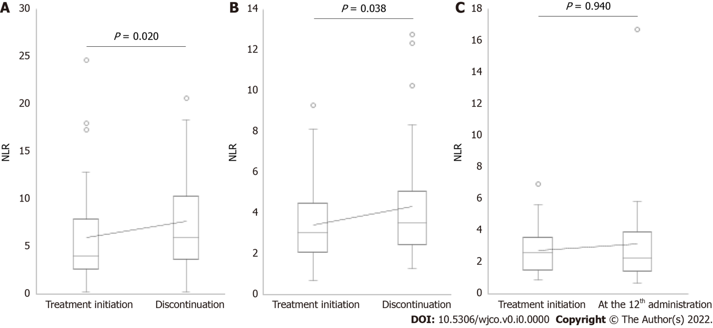
Figure 1 Neutrophil-to-lymphocyte ratio fluctuation in patients who discontinued treatment after administering nivolumab < 6 times, who discontinued treatment after administering nivolumab 6-11 times, and who administered nivolumab ≥ 12 times. A: A significant increase in neutrophil-to-lymphocyte ratio (NLR) was observed at the discontinuation (n = 40, median NLR = 4.01 vs 5.92, P = 0.020); B: A significant increase in NLR was observed at the discontinuation (n = 32, median NLR = 3.03 vs 3.50, P = 0.038); C: No significant difference in NLR was observed between treatment initiation and the 12th administration (n = 32, median NLR = 2.64 vs 2.32, P = 0.940). NLR: Neutrophil-to-lymphocyte ratio.

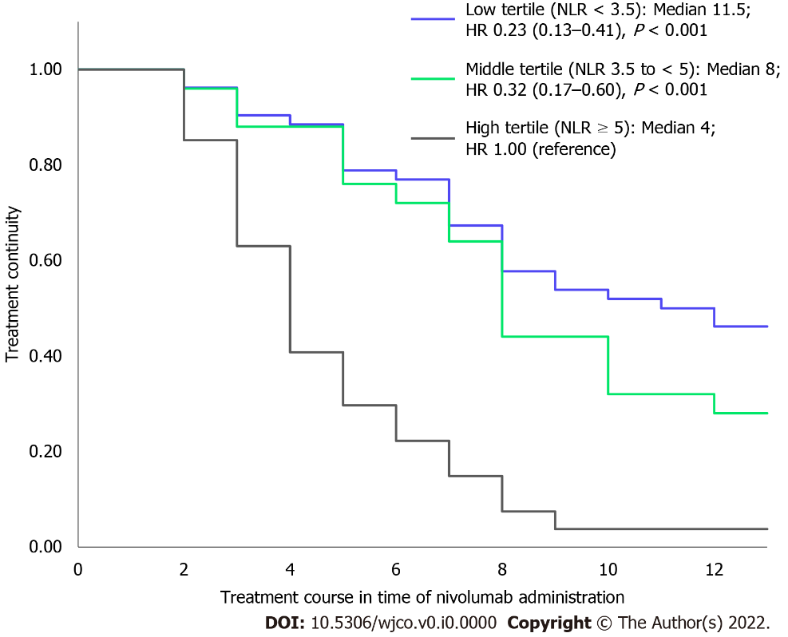
Figure 2 Relationship between neutrophil-to-lymphocyte ratio and nivolumab treatment continuity. The median numbers of nivolumab administration in each group with mean neutrophil-to-lymphocyte ratio (NLR) < 3.5, 3.5 to < 5, and ≥ 5 were 11.5 (n = 52), 8 (n = 25), and 4 (n = 27), respectively. The groups with mean NLR < 3.5 and 3.5 to < 5 had significantly higher treatment continuity than those with mean NLR ≥ 5 (hazard ratio [HR] for low tertile compared with high tertile: 0.23; 95% confidence interval [CI]: 0.13-0.41, P < 0.001; HR for middle tertile compared with high tertile: 0.32; 95% CI: 0.17-0.60; P < 0.001).

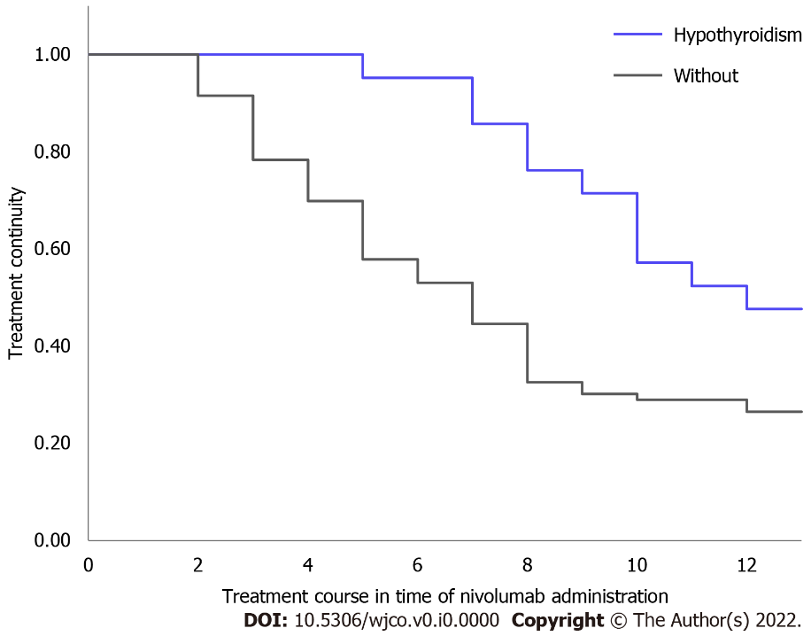
Figure 3 Nivolumab treatment continuity in patients who developed hypothyroidism. Treatment continuity in patients who developed hypothyroidism was significantly longer than in those who did not develop hypothyroidism (n = 104, median not reached vs 7 times administration, P = 0.010).

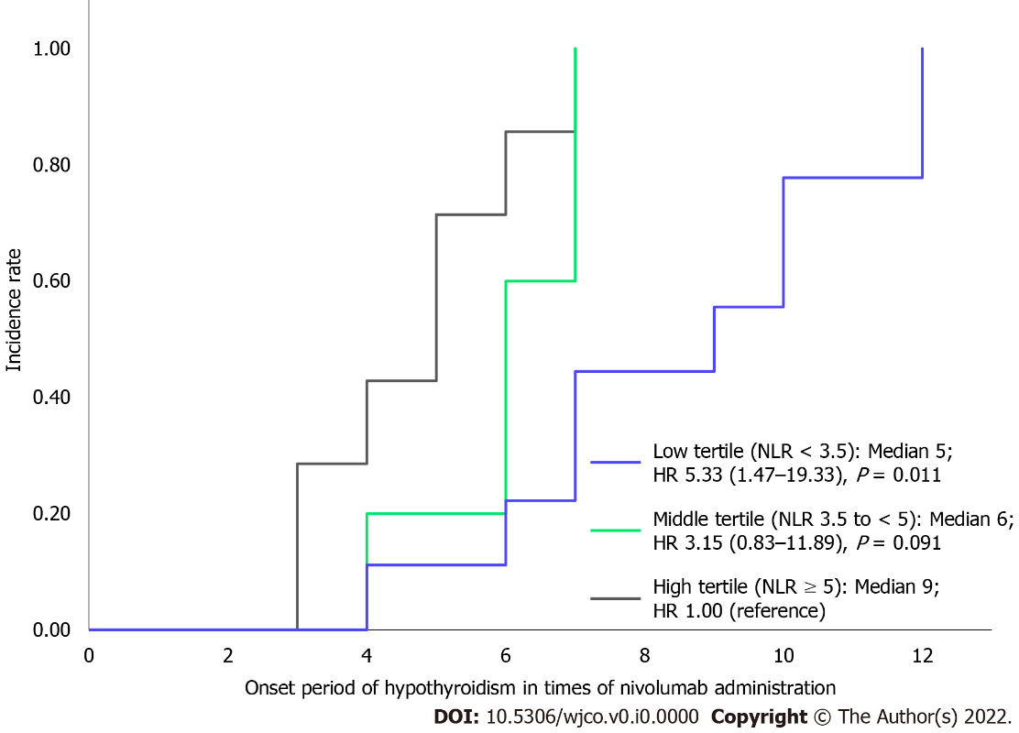
Figure 4 Relationship between neutrophil-to-lymphocyte ratio and the onset period of hypothyroidism. The median onset periods of each group with maximum neutrophil-to-lymphocyte ratio (NLR) values of < 3.5, 3.5 to < 5, and ≥ 5 were at 5th (n = 7), 6th (n = 5), and 9th administration (n = 9), respectively. The groups with a maximum NLR of < 3.5 had a significantly earlier onset of hypothyroidism than the group with NLR ≥ 5, whereas there was no significant difference in the onset periods of the groups with maximum NLR values of 3.5-5 and ≥ 5 (HR for low tertile compared with highest tertile: 5.33; 95% CI: 1.47-19.33, P = 0.011; HR for middle tertile compared with highest tertile: 3.15; 95% CI: 0.83-11.89, P = 0.091).

Table 1 Characteristics of patients at treatment initiation
 | All patients (n = 104) | Hypothyroidism
 |  | Yes (n = 21) | No (n = 83) | P value
Male/female | 69/35 | 14/7 | 55/28 | 1.000
Median age (min-max) (years) | 68.5 (32-91) | 70.0 (45-91) | 68.0 (32-88) | 0.382
Body weight (kg) | 52.7 ± 11.9 | 54.0 ± 9.6 | 52.4 ± 12.4 | 0.340
Cancer type
Head and neck cancer | 29 | 6 | 23 | 1.000
Non-small-cell lung cancer | 29 | 6 | 23 | 1.000
Malignant melanoma | 16 | 1 | 15 | 0.183
Renal cell cancer | 15 | 4 | 11 | 0.497
Gastric cancer | 15 | 4 | 11 | 0.497
Laboratory data
TSH (µIU/mL) | 2.08 ± 0.80 | 2.34 ± 0.78 | 2.02 ± 0.79 | 0.058
FT3 (pg/mL) | 2.21 ± 0.50 | 2.12 ± 0.32 | 2.23 ± 0.54 | 0.584
FT4 (ng/dL) | 1.18 ± 0.20 | 1.11 ± 0.20 | 1.20 ± 0.19 | 0.064
NLR | 4.17 ± 3.73 | 2.54 ± 1.21 | 4.58 ± 4.03 | 0.017
NLR < 3.5 | 60 | 16 | 44 | 0.082
NLR ≥ 3.5 | 44 | 5 | 39
NLR < 5 | 78 | 20 | 58 | 0.022
NLR ≥ 5 | 26 | 1 | 25
TSH: Thyroid-stimulating hormone; FT3: Free triiodothyronine; FT4: Free thyroxine; NLR: Neutrophil-to-lymphocyte ratio; min: Minimum; max: Maximum.

