Name of Journal: World Journal of Clinical Cases
Manuscript NO: 59596
Manuscript Type: CASE REPORT

Skeletal muscle metastases of hepatocellular carcinoma: A case report and literature review

Song Q et al. Skeletal muscle metastases of hepatocellular carcinoma

Qi Song, Xiao-Feng Sun, Xiao-Li Wu, Yi Dong, Le Wang

Qi Song, Xiao-Feng Sun, Xiao-Li Wu, Yi Dong, Le Wang, Department of Ultrasound, Bethune First Hospital of Jilin University, Changchun 130000, Jilin Province, China

Author contributions: Song Q was the patient’s physician, conceived the idea of the case report, and wrote the original draft; Dong Y and Wang L provided, analyzed and interpreted the imaging findings and contributed to manuscript drafting; Sun XF and Wu XL reviewed the literature and contributed to manuscript drafting; All authors approved the final version of the manuscript.

Corresponding author: Xiao-Feng Sun, MD, PhD, Academic Research, Professor, Department of Ultrasound, Bethune first Hospital of Jilin University, No. 71 Xinmin Street, Changchun 130000, Jilin Province, China. cuiyz18@mails.jlu.edu.cn

Received: September 28, 2020
Revised: December 24, 2020
Accepted: January 7, 2021
Published online: May 16, 2021

Abstract
BACKGROUND
The metastasis of liver cancer to skeletal muscle is extremely rare compared to other sites. We herein report a case of rapidly developing skeletal metastases following liver transplantation due to primary liver cancer.

CASE SUMMARY
A 70-year-old male with underlying chronic hepatitis B virus infection was diagnosed with hepatocellular carcinoma (HCC), for which he underwent liver transplantation in 2014. Six years after receiving the transplant, pathological examination confirmed the presence of HCC without vascular invasion. He was admitted to the hospital with a rapidly growing mass on his right thigh. Ultrasound examination revealed a mixed echo mass in the lateral soft tissue of the middle part of the right femur. Magnetic resonance imaging showed heterogeneous iso-signal intensity on T1-weighted images and heterogeneous hyper-intensity on T2-weighted images compared to the surrounding muscles. Pathological examination of the ultrasound-guided needle biopsy specimen revealed that it was similar to the previously detected liver cancer; the diagnosis was metastasis of HCC. Surgical excision was performed. There were no other sites of metastasis, and the patient recovered well after surgery.

CONCLUSION
This report presents a rare case of skeletal metastasis following liver transplantation for HCC. The study suggests a possible role for skeletal muscle metastasis mechanisms, which should be the focus of future research.

Key Words: Hepatocellular carcinoma; Transplant; Skeletal muscle metastasis; Pathological; Case report

©The Author(s) 2021. Published by Baishideng Publishing Group Inc. All rights reserved.

Citation: Song Q, Sun XF, Wu XL, Dong Y, Wang L. Skeletal muscle metastases of hepatocellular carcinoma: A case report and literature review. World J Clin Cases 2021; 9(14): 3334-3341
URL: https://www.wjgnet.com/2307-8960/full/v9/i14/3334.htm
DOI: https://dx.doi.org/10.12998/wjcc.v9.i14.3334

Core Tip: Skeletal muscle metastasis from hepatocellular carcinoma is extremely rare and is often accompanied by metastasis to other organs. We herein report a case of rapidly developing skeletal metastases after liver transplantation due to primary liver cancer, without any other organ metastases. There is a dearth of literature on the detailed prognosis of patients with skeletal muscle metastasis. Therefore, the correct interpretation of the molecular and pathophysiological mechanisms of skeletal muscle metastasis may help with the development of novel therapies to combat the progression of the disease.

INTRODUCTION
More than half a million new cases of hepatocellular carcinoma (HCC) are diagnosed annually worldwide. In China, HCC is the fourth most common cancer in males after pulmonary, stomach, and esophagus cancers, and the sixth most common in females^{[1]}. Extrahepatic HCC can occur in one of three ways: direct extension, hematogenous spread, or lymphatic invasion. Rupture of HCC may result in intraperitoneal implantation of tumor cells on peritoneal or omental surfaces. Reported HCC metastatic sites include lungs, lymph nodes, bone, and brain. Rare sites of metastasis include the rectum, spleen, diaphragm, duodenum, esophagus, pancreas, seminal vesicle, and the urinary bladder. Treatment is often based on the stage of a tumor^{[2]}. In addition to chemotherapy, liver transplantation offers the advantage of radical treatment for HCC because it can remove the tumor and restore normal liver function. A rare but possible outcome of this modality is skeletal muscle metastasis (SMM), a malignant tumor.
In this study, we report a case of a 70-year-old patient with long-term SMM of primary liver cancer in the muscularis of the right thigh, detected 6 years after liver transplantation without any other organ metastases.

CASE PRESENTATION
Chief complaints
A 70-year-old male had a rapidly growing mass on his right thigh, with no pain, redness, and swelling observed on the surface of the mass.

History of present illness
The patient had underlying chronic hepatitis B virus infection, and was diagnosed with HCC. He had received a liver transplant for primary liver cancer 6 years prior. He was admitted to the hospital after finding a rapidly growing mass on his right thigh.

History of past illness
The patient underwent a liver transplant for primary liver cancer 6 years prior.

Personal and family history
The patient was retired, living with his son, and had no family history of hereditary disease.

Physical examination
The patient was hospitalized and his physical parameters were examined. The vital signs were as follows: body temperature 36 °C, heart rate 85 beats/min, respiratory rate 16 breaths/min, blood pressure 130/85 mmHg, and oxygen saturation in room air 95%. There were no apparent signs of cranial nerve dysfunction. Muscle tone, strength, and deep tendon reflexes were normal in the upper extremities, while low in the inferior extremities with more on the right side. Abdominal cutaneous reflexes were normal. The remaining physical examination was unremarkable.

Laboratory examinations
After re-sectioning the right lateral femoral soft tissue mass, the patient was examined intraoperatively (right thigh mass) with a circumscribed mass of 5 cm × 3 cm × 2 cm. The findings revealed that small muscle tissue was attached to the surrounding mass, and a section of the mass was light brown, solid, and multinodular.

Imaging examinations
During admission, physical examination showed an oval-shaped mass with a diameter of about 5 cm on the anterolateral part of the right thigh. It was hard to touch, had poor mobility, and was attached to the surrounding soft tissue. He had normal blood flow from the right lower limb with adequate movement; the skin temperature was normal, no abnormality was found in the sensory nerve examination, the physiological reflex was normal, and no abnormality was found in the rest of the review. The ultrasound examination revealed a mixed echo mass in the lateral soft tissue of the middle part of the right femur, with a size of approximately 5 cm × 2 cm × 3 cm, which had a clear boundary and regular shape. Figure 1A presents an ultrasound image of the muscularis in the right thigh in which the blood flow is indicated with undefined boundaries. Figure 1B depicts the arterial spectrum taken by color Doppler flow imaging. The ultrasound image showed that soft tissues covered the right side of the femur, the nature of which remains to be determined. Figure 2 presents circular abnormal signals in the middle part of the right femur near the lateral soft tissue, accompanied by surrounding soft tissue edema by magnetic resonance imaging (MRI). The images showed heterogeneous iso-signal intensity on T1WI and heterogeneous hyper-intensity on T2WI compared to the surrounding muscles, which had signal inhomogeneity. The size was about 4.5 cm × 1.4 cm × 3.1 cm; the boundary was slightly blurred, and there were a few pieces of long T2 signal in the adjacent soft tissue (Figure 2A and B).

FINAL DIAGNOSIS
The final diagnosis of skeletal metastases was made based on pathological results and clinical history, where the patient had liver transplantation for liver cancer without affecting any other organ metastases.

TREATMENT
The patient underwent mass and peripheral musculature resection of the right vastus lateralis.

OUTCOME AND FOLLOW-UP
After resectioning the right lateral femoral soft tissue mass, the patient was examined intraoperatively (right thigh mass) with a circumscribed mass of 5 cm × 3 cm × 2 cm. Small muscle tissue was attached to the surrounding mass, and a section of the mass was light brown, solid, and multinodular. Figure 3 shows the immunohistochemical results: cluster of differentiation 68 (-), GATA (-), Inhibin A (-), Ki-67 (+40%), prostate-specific antigen (-), vimentin (-) cytokeratin 20 (CK20) (-), CK7 (-), CK-pan (+), giant cell fibroma-3 (lesions+), hepatocyte paraffin 1 (-), S-100 (-), thyroid transcription factor-1 (-), villin (weak + in local parts). The pathological testing confirmed the diagnosis of a malignant tumor based on medical history and immunohistochemical analysis, suggesting metastatic HCC with tumor thrombus visible in the vessel. After 1 mo, the patient was discharged, and he had no other symptoms.

DISCUSSION
HCC is ranked sixth in incidence of malignancies and fourth in mortality rate. The World Health Organization has predicted a global mortality of more than 1 million from HCC by 2030^{[1]}. In China, liver cancer is the second leading cause of cancer-associated deaths^{[2]}. Liver transplantation offers the advantage of radical treatment for HCC, as it can remove the tumor and restore normal liver function. The occurrence SMM, a malignant tumor that often occurs in patients with advanced cancer and appears to be a sign of systemic hematogenous metastases, is rare after liver transplant^{[3,4]}. Almusarhed et al^{[5]} reported a case of solitary biceps muscle metastasis from breast cancer, 6 mo after postoperative chemotherapy combined with endocrine therapy. Extensive European autopsy has shown that skeletal muscle subclinical metastases are more common than generally believed, with an incidence ranging from 0.2% to 17.5%^{[6]}. Researchers have found that most common tumors with muscle metastases come from the thyroid, esophagus, stomach, pancreas, colon, rectum, bladder, breast, ovary, and prostate^{[7-10]}. However, the most common sites of muscle metastases are the erector spine, iliopsoas, and paravertebral muscle^{[11-13]}, which are rare in skeletal muscles of limbs. Guidi et al^{[14]} reported a case of epithelial cell carcinoma in the bladder, metastasizing into the superficial flexor muscle of the thumb, while, Katafigiotis et al^{[15]} reported two cases of sartorius metastatic tumors. Nevertheless, long-term SMM as described in this study, with onset after 6 years of liver transplantation has rarely been reported. Clinically, the disease is insidious and is generally detected by imaging, with only a few patients showing specific clinical symptoms. Studies have addressed the rare pathogenesis of SMM such as a report by Pergolini et al^{[16]}. They found that: skeletal muscle had an impact on tumor cell sedimentation due to mechanical muscle movement, instability of blood flow, and changes in tissue pressure; lactic acid in the muscle inhibits the proliferation of tumor cells; and pH was reduced in the microenvironment of the skeletal muscle^{[16]}. Besides, muscle cells can secrete cytokines that inhibit tumor cell proliferation such as tumor necrosis factor, lymphocyte infiltration factor, and transforming growth factor. In a series of animal experiments, Luo et al^{[17]} showed that skeletal muscles produced specific muscle-derived inhibitors that could inhibit the growth of tumor cells through autocrine or paracrine signaling. Magee and Rosenthal pointed out that local trauma could be one of the risk factors for metastasis due to dynamic imbalances between local physiological and mechanical factors^{[18]}. Clinical symptoms or imaging examinations are often difficult to confirm the disease as there is a possibility of misdiagnosis of primary soft tissue tumor or soft tissue injury. Since early diagnosis and detection of skeletal muscle metastases are relevant for the treatment and prognosis, accurate diagnosis is essential. Commonly used clinical test methods include ultrasound, computed tomography, nuclear magnetism, and positron emission tomography computed tomography^{[19-23]}. MRI is used for differential diagnosis and to analyze and compare the range of affected muscles to the surrounding muscles across several sections and angles. Li et al^{[24]} performed MRI analysis on 31 patients with SMM. They found that most MRI images had heterogeneous iso-signals in T1W1, homogeneous high signals in T2W1, and heterogeneously enhanced signals in TT2W1. The soft tissues in the skeletal muscle need to be differentiated from the following diseases: Malignant fibrous histiocytoma, fibrosarcoma, rhabdomyosarcoma, schwannoma, chondroid lipoma, etc. Malignant fibrous histiocytoma, which is more common in middle-aged and older adults, is the most common type of soft tissue malignant tumor in the thigh. MRI shows equal or low signal in TIWl and high signal in TIW2. Fibrosarcoma is found in the deep soft tissue of the trunk and lower limbs of older adults, and the position is usually shallower than the surface. The MRI results indicate a low TIW1 signal, while TIW2 was high. Rhabdosarcoma typically occurs in children and adolescents, affecting the muscles of the limbs or trunk. It manifests itself as a fast-growing painful muscle mass. An MRI imaging shows TIWl and muscle signals, while TIW2 shows a high signal. Schwannoma referred to as a Schwann cell tumor is a condition in which any nerve around a larger nerve may be involved. Tinel is positive, and the MRI scan often shows fusiform masses along the direction of the peripheral nerve trunk. Chondroid lipoma is a benign adipose tissue tumor that exists as a slowly enlarging mass, mostly subcutaneous, with a partial intramuscular mass. Histology is composed of protocells, adipocytes, preadipocytes, mature adipocytes, and chondroid with features of embryonic fat and cartilage. Treatment for this disease is controversial as there is no exact treatment regimen addressing metastatic lesions located in the skeletal muscles. There is also no standard treatment strategy dealing with metastatic lesions without an intrahepatic component. Treatment modalities include a combination of surgery, chemotherapy, irradiation, and clinical practice. The prognosis of patients with SMM is extremely poor. Four cases died among the reported cases, with a median survival time range 6–18 mo. Only one patient, who underwent chemoradiotherapy for multiple skeletal metastases, remained alive at 24 mo after recurrence^{[25]}; however, the underlying mechanisms remain poorly understood^{[26-29]}. Skeletal muscle mass in the body accounts for a large percentage of overall body weight, and there is a significant amount of blood supply to the entire skeletal musculature of the body. Clinical and pathological data have shown that skeletal muscle tissue is resistant to the development of cancer metastases as muscular organs appear to be unsuitable for the growth of metastatic cells. Hence, the factors responsible for the rarity of skeletal muscle metastases are unknown. However, biomechanical destruction of cancer cells arrested in the skeletal muscle microvasculature is responsible for their rapid death^{[30]}. When SMM is present, it is often suggested that the disease is in the terminal stage of blood-borne metastasis. A retrospective study by Plaza et al^{[31]} observed that less than 2.5% of 174 SMM patients survived for more than 72 mo. No optimal treatment has been found so far for SMM due to its rarity, and the treatment of SMM lesions is limited to palliative treatment. Kim et al^{[32]} proposed that surgical resection or external radiotherapy should be considered for isolated masses without other metastases to reduce pain and mass effect. However, Purkayastha et al^{[33]} reported a case of lung adenocarcinoma with left gluteus muscle metastasis in which acute metastasis of the lower back, bilateral supraspinatus muscle, and psoas muscle occurred after three cycles of personal computer chemotherapy and subsequent low-dose external radiotherapy. These clinical cases suggest that more clinical practice studies are needed for the diagnosis and treatment of SMM. The correct interpretation of the molecular and pathophysiological mechanisms of SMM may help design new therapies to combat the progression of the disease.

CONCLUSION
Here we report a case of an elderly male with SMM to his right thigh, 6 years after liver transplantation for liver cancer without metastases to other organs. HCC metastasis to the skeletal muscle is rare, not previously reported, and recognized as a possibility in patients with HCC.
SMMs have a poor prognosis that could cause functional impairment and increased short-term postoperative morbidity in patients with and without malignant diseases^{[34]}. However, 1 mo later, this patient was discharged with no radiation or chemotherapy; we will continue to follow up for further analysis.

REFERENCES
1 Villanueva A. Hepatocellular Carcinoma. N Engl J Med 2019; 380: 1450-1462 [PMID: 30970190 DOI: 10.1056/NEJMra1713263]
2 Zhou M, Wang H, Zeng X, Yin P, Zhu J, Chen W, Li X, Wang L, Wang L, Liu Y, Liu J, Zhang M, Qi J, Yu S, Afshin A, Gakidou E, Glenn S, Krish VS, Miller-Petrie MK, Mountjoy-Venning WC, Mullany EC, Redford SB, Liu H, Naghavi M, Hay SI, Wang L, Murray CJL, Liang X. Mortality, morbidity, and risk factors in China and its provinces, 1990-2017: a systematic analysis for the Global Burden of Disease Study 2017. Lancet 2019; 394: 1145-1158 [PMID: 31248666 DOI: 10.1016/S0140-6736(19)30427-1]
3 Crombé A, Lintingre PF, Le Loarer F, Lachatre D, Dallaudière B. Multiple skeletal muscle metastases revealing a cardiac intimal sarcoma. Skeletal Radiol 2018; 47: 125-130 [PMID: 28887581 DOI: 10.1007/s00256-017-2768-5]
4 Basile D, Parnofiello A, Vitale MG, Cortiula F, Gerratana L, Fanotto V, Lisanti C, Pelizzari G, Ongaro E, Bartoletti M, Garattini SK, Andreotti VJ, Bacco A, Iacono D, Bonotto M, Casagrande M, Ermacora P, Puglisi F, Pella N, Fasola G, Aprile G, Cardellino GG. The IMPACT study: early loss of skeletal muscle mass in advanced pancreatic cancer patients. J Cachexia Sarcopenia Muscle 2019; 10: 368-377 [PMID: 30719874 DOI: 10.1002/jcsm.12368]
5 Almusarhed M, Eldeeb H. Solitary biceps muscle metastasis from breast cancer. BMJ Case Rep 2017; 2017 [PMID: 28827429 DOI: 10.1136/bcr-2017-220597]
6 Emmering J, Vogel WV, Stokkel MP. Intramuscular metastases on FDG PET-CT: a review of the literature. Nucl Med Commun 2012; 33: 117-120 [PMID: 22124361 DOI: 10.1097/MNM.0b013e32834e3ad0]
7 Leitner J, Pelster S, Schöpf V, Berghoff AS, Woitek R, Asenbaum U, Nenning KH, Widhalm G, Kiesel B, Gatterbauer B, Dieckmann K, Birner P, Prayer D, Preusser M, Furtner J. High correlation of temporal muscle thickness with lumbar skeletal muscle cross-sectional area in patients with brain metastases. PLoS One 2018; 13: e0207849 [PMID: 30496307 DOI: 10.1371/journal.pone.0207849]
8 Martínez Mullor C, de Aspe de la Iglesia E, Cordido Carro M. [Skeletal muscle metastases as the initial manifestation of an unknown primary lung cancer]. Semergen 2017; 43: 261-262 [PMID: 27162156 DOI: 10.1016/j.semerg.2016.03.019]
9 Dohzono S, Sasaoka R, Takamatsu K, Hoshino M, Nakamura H. Low paravertebral muscle mass in patients with bone metastases from lung cancer is associated with poor prognosis. Support Care Cancer 2020; 28: 389-394 [PMID: 31055666 DOI: 10.1007/s00520-019-04843-9]
10 Wright LE, Harhash AA, Kozlow WM, Waning DL, Regan JN, She Y, John SK, Murthy S, Niewolna M, Marks AR, Mohammad KS, Guise TA. Aromatase inhibitor-induced bone loss increases the progression of estrogen receptor-negative breast cancer in bone and exacerbates muscle weakness in vivo. Oncotarget 2017; 8: 8406-8419 [PMID: 28039445 DOI: 10.18632/oncotarget.14139]
11 Carey K, Bestic J, Attia S, Cortese C, Jain M. Diffuse skeletal muscle metastases from sacral chordoma. Skeletal Radiol 2014; 43: 985-989 [PMID: 24407557 DOI: 10.1007/s00256-013-1794-1]
12 Cincibuch J, Mysliveček M, Melichar B, Neoral C, Metelková I, Zezulová M, Procházková-Študentová H, Flodr P, Zlevorová M, Aujeský R, Cwiertka K. Metastases of esophageal carcinoma to skeletal muscle: single center experience. World J Gastroenterol 2012; 18: 4962-4966 [PMID: 23002370 DOI: 10.3748/wjg.v18.i35.4962]
13 Salman R, Sebaaly MG, Asmar K, Nasserdine M, Bannoura S, Khoury NJ. Rare skeletal muscle metastasis from renal cell carcinoma: case report and review of the literature. CEN Case Rep 2018; 7: 316-319 [PMID: 29978297 DOI: 10.1007/s13730-018-0350-1]
14 Guidi M, Fusetti C, Lucchina S. Skeletal Muscle Metastases to the Flexor Digitorum Superficialis and Profundus from Urothelial Cell Carcinoma and Review of the Literature. Case Rep Urol 2016; 2016: 2387501 [PMID: 27648338 DOI: 10.1155/2016/2387501]
15 Katafigiotis I, Athanasiou A, Levis PK, Fragkiadis E, Sfoungaristos S, Ploumidis A, Michalinos A, Alamanis C, Felekouras E, Constantinides CA. Metastasis to sartorius muscle from a muscle invasive bladder cancer. Case Rep Med 2014; 2014: 524757 [PMID: 25587283 DOI: 10.1155/2014/524757]
16 Pergolini I, Crippa S, Santinelli A, Marmorale C. Skeletal muscle metastases as initial presentation of gastric carcinoma. Am J Case Rep 2014; 15: 580-583 [PMID: 25544018 DOI: 10.12659/AJCR.891397]
17 Luo C, Jiang Y, Liu Y, Li X. Experimental study on mechanism and rarity of metastases in skeletal muscle. Chin Med J (Engl) 2002; 115: 1645-1649 [PMID: 12609079 DOI: 10.1097/00000441-200211000-00011]
18 Magee T, Rosenthal H. Skeletal muscle metastases at sites of documented trauma. AJR Am J Roentgenol 2002; 178: 985-988 [PMID: 11906887 DOI: 10.2214/ajr.178.4.1780985]
19 Gómez-León N, Pacheco-Barcia V, Ballesteros AI, Fraga J, Colomer R, Friera A. Skeletal muscle and solitary bone metastases from malignant melanoma: multimodality imaging and oncological outcome. Melanoma Res 2018; 28: 562-570 [PMID: 29975212 DOI: 10.1097/CMR.0000000000000466]
20 Eriksson S, Nilsson JH, Strandberg Holka P, Eberhard J, Keussen I, Sturesson C. The impact of neoadjuvant chemotherapy on skeletal muscle depletion and preoperative sarcopenia in patients with resectable colorectal liver metastases. HPB (Oxford) 2017; 19: 331-337 [PMID: 28089364 DOI: 10.1016/j.hpb.2016.11.009]
21 Ong N, George M, Dutta R, Ng CH. CT imaging features of skeletal muscle metastasis. Clin Radiol 2019; 74: 374-377 [PMID: 30709514 DOI: 10.1016/j.crad.2018.12.017]
22 Nocuń A, Chrapko B. Multiple and solitary skeletal muscle metastases on 18F-FDG PET/CT imaging. Nucl Med Commun 2015; 36: 1091-1099 [PMID: 26275016 DOI: 10.1097/MNM.0000000000000368]
23 Arpaci T, Ugurluer G, Akbas T, Arpaci RB, Serin M. Imaging of the skeletal muscle metastases. Eur Rev Med Pharmacol Sci 2012; 16: 2057-2063 [PMID: 23280019 DOI: 10.1002/ddr.21049]
24 Li Q, Wang L, Pan S, Shu H, Ma Y, Lu Z, Fu X, Jiang B, Guo Q. Skeletal muscle metastases on magnetic resonance imaging: analysis of 31 cases. Contemp Oncol (Pozn) 2016; 20: 242-250 [PMID: 27647989 DOI: 10.5114/wo.2016.61568]
25 Beşe NS, Ozgüroğlu M, Dervişoğlu S, Kanberoğlu K, Ober A. Skeletal muscle: an unusual site of distant metastasis in gastric carcinoma. Radiat Med 2006; 24: 150-153 [PMID: 16715679 DOI: 10.1007/BF02493284]
26 Wang G, Biswas AK, Ma W, Kandpal M, Coker C, Grandgenett PM, Hollingsworth MA, Jain R, Tanji K, Lόpez-Pintado S, Borczuk A, Hebert D, Jenkitkasemwong S, Hojyo S, Davuluri RV, Knutson MD, Fukada T, Acharyya S. Metastatic cancers promote cachexia through ZIP14 upregulation in skeletal muscle. Nat Med 2018; 24: 770-781 [PMID: 29875463 DOI: 10.1038/s41591-018-0054-2]
27 Bekir Hacioglu M, Kostek O, Kurt N, Kucukarda A, Gokyer A, Ustabasioglu FE, Karatas F, Tuncbilek N, Uzunoglu S, Bilici A, Cicin I, Erdogan B. Comparison of skeletal muscle mass loss in patients with metastatic colorectal cancer treated with regorafenib or TAS-102. J BUON 2019; 24: 2198-2204 [PMID: 31786894]
28 van Vugt JLA, Gaspersz MP, Vugts J, Buettner S, Levolger S, de Bruin RWF, Polak WG, de Jonge J, Willemssen FEJA, Groot Koerkamp B, IJzermans JNM. Low Skeletal Muscle Density Is Associated with Early Death in Patients with Perihilar Cholangiocarcinoma Regardless of Subsequent Treatment. Dig Surg 2019; 36: 144-152 [PMID: 29455204 DOI: 10.1159/000486867]
29 Kurk SA, Stellato RK, Peeters PHM, Dorresteijn B, Jourdan M, Oskam MJ, Punt CJA, Koopman M, May AM. Trajectory of body mass and skeletal muscle indices and disease progression in metastatic colorectal cancer patients. Am J Clin Nutr 2019; 110: 1395-1403 [PMID: 31515555 DOI: 10.1093/ajcn/nqz209]
30 Weiss L. Biomechanical destruction of cancer cells in skeletal muscle: a rate-regulator for hematogenous metastasis. Clin Exp Metastasis 1989; 7: 483-491 [PMID: 2752602 DOI: 10.1007/BF01753809]
31 Plaza JA, Perez-Montiel D, Mayerson J, Morrison C, Suster S. Metastases to soft tissue: a review of 118 cases over a 30-year period. Cancer 2008; 112: 193-203 [PMID: 18040999 DOI: 10.1002/cncr.23151]
32 Kim YW, Seo KJ, Lee SL, Kwon KW, Hur J, An HJ, Ko YH, Kim JS, Won HS. Skeletal muscle metastases from breast cancer: two case reports. J Breast Cancer 2013; 16: 117-121 [PMID: 23593092 DOI: 10.4048/jbc.2013.16.1.117]
33 Purkayastha A, Singh S, Bisht N, Mishra PS, Husain A. Upfront Skeletal Muscle Metastases from Non-small Cell Lung Carcinoma: Report of an Extremely Rare Occurrence Detected by 18F-Fluorodeoxyglucose Positron Emission Computed Tomography Scan. Indian J Nucl Med 2018; 33: 337-341 [PMID: 30386058 DOI: 10.4103/ijnm.IJNM_57_18]
34 Makary MA, Segev DL, Pronovost PJ, Syin D, Bandeen-Roche K, Patel P, Takenaga R, Devgan L, Holzmueller CG, Tian J, Fried LP. Frailty as a predictor of surgical outcomes in older patients. J Am Coll Surg 2010; 210: 901-908 [PMID: 20510798 DOI: 10.1016/j.jamcollsurg.2010.01.028]

Footnotes
Informed consent statement: Informed consent for publication was obtained from the patient.

Conflict-of-interest statement: The authors declare that they have no competing interests.

CARE Checklist (2016) statement: The authors have read the CARE Checklist, and the manuscript was prepared and revised according to the CARE Checklist.

Open-Access: This article is an open-access article that was selected by an in-house editor and fully peer-reviewed by external reviewers. It is distributed in accordance with the Creative Commons Attribution NonCommercial (CC BY-NC 4.0) license, which permits others to distribute, remix, adapt, build upon this work non-commercially, and license their derivative works on different terms, provided the original work is properly cited and the use is non-commercial. See: http://creativecommons.org/Licenses/by-nc/4.0/

Manuscript source: Unsolicited manuscript

Peer-review started: September 28, 2020
First decision: December 14, 2020
Article in press: January 7, 2021

Specialty type: Medicine, research and experimental
Country/Territory of origin: China
Peer-review report’s scientific quality classification
Grade A (Excellent): 0
Grade B (Very good): B
Grade C (Good): C
Grade D (Fair): D, D
Grade E (Poor): 0

P-Reviewer: Frena A, Paramesh AS, Rao V S-Editor: Zhang L L-Editor: Filipodia P-Editor: Ma YJ
Figure Legends
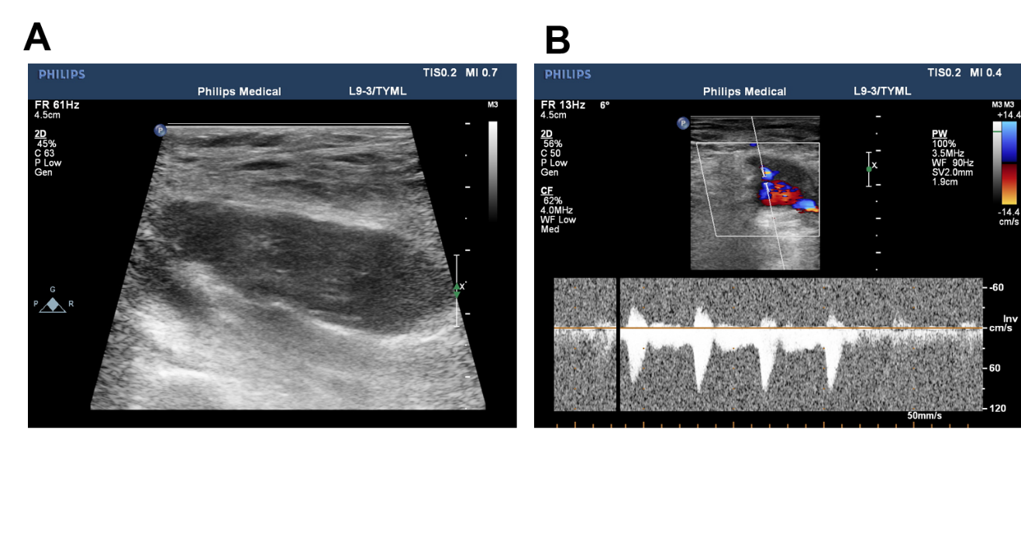Figure 1 Imaging examinations. A: Two-dimensional ultrasound images show mixed echoes in the muscularis of the right thigh with unclear boundaries; B: Power Doppler activity revealed significantly increased flow within the tumor.
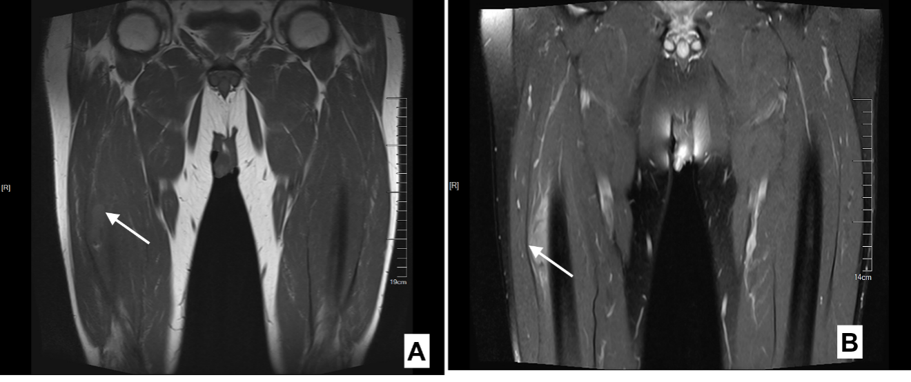
Figure 2 Magnetic resonance imaging. A: Coronal scan of the arrow points iso-signal of the tumor intensity on T1-weighted images; B: The arrow indicates high-signal intensity on T2-weighted images compared with the surrounding muscle.
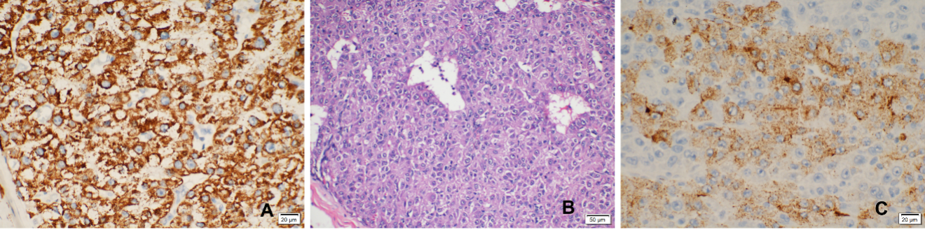
Figure 3 Pathological analysis. A: Immunohistochemical staining examination of metastatic hepatic carcinoma hepatocyte paraffine 1 (Stain, 400 ×); B: Pathological examination of the tumor in the right thigh (Hematoxylin stain, 200 ×); C: Immunohistochemical staining examination of the tumor in the right thigh of metastatic hepatic carcinoma glypican-3 (Stain, 400 ×).

Published by Baishideng Publishing Group Inc
7041 Koll Center Parkway, Suite 160, Pleasanton, CA 94566, USA
Telephone: +1-925-3991568
E-mail: bpgoffice@wjgnet.com
Help Desk: https://www.f6publishing.com/helpdesk
https://www.wjgnet.com

© 2021 Baishideng Publishing Group Inc. All rights reserved.

