Name of journal: World Journal of Gastroenterology
ESPS Manuscript NO: 18237
Columns: TOPIC HIGHLIGHT

2015 Advances in Gastrointestinal Endoscopy

Value of screening endoscopy in evaluation of esophageal, gastric, and colon cancers

Ro TH et al. Assessing screening endoscopy in gastrointestinal cancers

Tae H Ro, Michelle A Mathew, Subhasis Misra

Tae H Ro, Michelle A Mathew, Subhasis Misra, Division of Surgical Oncology, Texas Tech University Health Science Center School of Medicine, Amarillo, TX 79106, United States

Author contributions: Ro TH and Mathew MA contributed equally to the writing of this paper and should be deemed both first authors; Misra S was the senior author and guide for this paper.

Conflict-of-interest statement: Subhasis Misra has received a research grant from the Cancer Prevention Research, Institute of Texas for colorectal cancer screening. No other contributing authors from this manuscript has received fees for serving as a speaker, owns stocks and/or shares in any affiliated organization, or owns a patent related to this research.

Open-Access: This article is an open-access article which was selected by an in-house editor and fully peer-reviewed by external reviewers. It is distributed in accordance with the Creative Commons Attribution Non Commercial (CC BY-NC 4.0) license, which permits others to distribute, remix, adapt, build upon this work non-commercially, and license their derivative works on different terms, provided the original work is properly cited and the use is non-commercial. See: http://creativecommons.org/licenses/by-nc/4.0/

Correspondence to: Subhasis Misra, MD, MS, FACCWS, FACS, Associate Professor, Chief of GastroIntestinal and Hepato-Pancreato-Biliary Surgery, Division of Surgical Oncology, Texas Tech University Health Science Center School of Medicine, 1400 S Coulter St.Amarillo, Amarillo, TX 79106, United States. subhasis.misra@ttuhsc.edu
Telephone: +1-806-3545563
Fax: +1-806-3545561

Received: April 13, 2015
Peer-review started: April 15, 2015
First decision: May 18, 2015
Revised: May 27, 2015
Accepted: July 3, 2015

Article in press:
Published online:

Abstract
Esophageal, gastric, and colorectal cancers are deadly diseases that continue to plague our world today. The value of screening endoscopy in evaluating these types of cancers is a critical area of discussion due to a potential reduction in morbidity and mortality. This article describes how to identify a good screening test and explains what are important criteria in the field of screening endoscopy. Furthermore, the current status and progress of screening endoscopy for esophageal, gastric, and colorectal cancer will be evaluated and discussed. Mass screening programs have not been implemented for esophageal and gastric carcinomas in those with average or low risk populations. However, studies of high-risk populations have found value and a cost-benefit in conducting screening endoscopy. Colorectal cancer, on the other hand, has had mass screening programs in place for many years due to the clear evidence of improved outcomes. As the role of endoscopy as a screening tool has continued to develop, newer technology and techniques have emerged to improve its utility. Many new image enhancement techniques and computer processing programs have shown promise and may have a significant role in the future of endoscopic screening. These developments are paving the way for improving the diagnostic and therapeutic capability of endoscopy in the field of gastroenterology.

Key words: Endoscopic screening; Esophageal cancer; Gastric cancer; Colon cancer; Esophagogastroduodenoscopy

© The Author(s) 2015. Published by Baishideng Publishing Group Inc. All rights reserved.

Core tip: The value of screening endoscopy in evaluating esophageal, gastric, and colon cancers is a critical area of discussion due to a potential reduction in morbidity and mortality. Studies have found value and cost-benefit in conducting screening endoscopy in esophageal and gastric cancer in high-risk populations. Colorectal cancer has had mass screening programs implemented for many years due to the clear evidence of improved outcomes. New innovations in technology have emerged and shown promise in playing a significant role in the future of endoscopic screening. These developments are paving the way for improving the diagnostic capability of endoscopy in the field of gastroenterology.

Ro TH, Mathew MA, Misra S. Value of screening endoscopy in evaluation of esophageal, gastric, and colon cancers. World J Gastroenterol 2015; In press

INTRODUCTION
Screening tests are important tools for health maintenance that have been around for the past half-century. Since its development, the number of screening tests has increased exponentially and it has sparked the creation of many innovative technologies. The purpose of screening is to catch early stages of disease and to delay or prevent further development of the disease course. In contrast to diagnostic tests, screening tests evaluate individuals that have a low pretest probability of a particular disease. These individuals are either asymptomatic or are at preclinical stages of their disease^{[1]}.
While evaluating the utility of a screening tool, several aspects need to be examined in order to support its validity and practical use. For a screening test to be effective, there needs to be a change in patient outcome with early detection of a disease. Standard measures of patient outcome include morbidity, mortality, and quality of life. Once a value for the test is established, a risk-benefit analysis is typically assessed, and then accuracy of the test is evaluated. Screening test accuracy is measured by sensitivity, specificity, and predictive value. Sensitivity is the ability of a test to detect positive results in patients with disease, while specificity is the ability of a test to detect negative results in patients without disease, and predictive value is the probability of a condition given by the result of a test. A good screening test will have high percentages in these categories. Cost analysis is one of the last measures to determine practicality and implementation on a larger scale. Implementation of a screening program must find a balance between the reduction in cancer mortality and the costs associated with screening and subsequent diagnostic evaluations due to false-positive results^{[2]}. While there are many screening modalities used today, we will be discussing the efficacy of the screening endoscopy.
In 1853, the French surgeon Desormeaux, coined the term “endoscope” to describe the instrument he created to inspect cavities of the body. Through this illumination device, Kusmaul performed the first esophagoscopies in 1867-1868^{[3]}. Hollow tubes and spatulas connected to illumination sources were the main way esophagoscopies were first performed. Years later the light source was incorporated into the endoscopes, which was followed by the creation of the semi-flexible gastroscope by Wolf and Schindler in 1930. Due to the development of very transparent optical quality glass, Basil Hirschowitz and Larry Curtiss were able to build the flexible fiber optic endoscope in 1958^{[4]}. The flexible endoscope depends on delivering light and transmitting the image along bundles of chemically treated glass fibers. Initially, the endoscopist viewed the image through an eyepiece on the instrument, but eventually a video system was incorporated into the scope, which led to the videoscopes used today^{[5]}. While the basic structure has remained the same, there have been advances in technology that have led to the development of new endoscopic techniques. These developments are paving the way for improving the diagnostic and therapeutic capability of endoscopes in the field of gastroenterology. We will be discussing the value of screening endoscopies in the evaluation of esophageal, gastric, and colon carcinomas.

ESOPHAGEAL CANCER ENDOSCOPIC SCREENING
Epidemiology
In 2012, there was an estimated 455800 new cases of esophageal carcinoma and 400200 deaths worldwide^{[6]}. Esophageal carcinoma is the eighth most common cancer and sixth leading cause of cancer related deaths^{[7]}. While other types of cancer are expected to decrease in incidence over the next 10 years, the prevalence of esophageal cancer is expected to increase by 140% by the year 2025^{[7]}. The predominant esophageal cancer in North America and Europe is esophageal adenocarcinoma (EA), while esophageal squamous-cell carcinoma (ESCC) is the predominant type in Asia, Africa, and South America^{[8]}. The highest risk area is referred to as the “esophageal cancer belt” and runs from Northern Iran to North-Central China^{[6]}.

Risk factors
Obesity and gastroesophageal reflux disease are the key risk factors for EA, with Barrett’s esophagus as the precursor lesion in the majority of cases. Alcohol and tobacco are the leading risk factors for ESCC in Western countries, with esophageal squamous dysplasia as the precursor lesion. The risk factors in high-risk areas of Iran and China are not fully established, but are associated with poor nutritional status, low intake of fruits and vegetables, and drinking beverages at high temperatures^{[6]}. There is a higher risk of both types of esophageal cancer with high intake of fats, red meats, and processed foods. Adenocarcinoma is three to four times more common in men, and the incidence of both types of esophageal carcinoma increases with age^{[8]}.

Current screening methods
Early detection of esophageal carcinoma through cytological and endoscopic screening methods has been primarily concentrated in countries where there is a high incidence^{[9]}. Endoscopy is the gold standard for diagnosing esophageal cancer and precancerous lesions. The standard esophagogastroduodenoscopy (EGD) uses a small chip camera and a non-coaxial optic fiber system to carry white light down the oropharynx to examine different levels of the gastrointestinal mucosa. Other screening methods such as cytological examination and molecular markers have been studied, but endoscopy with biopsy and iodine staining remains as the diagnostic choice to detect esophageal squamous dysplasia^{[10]}. Endoscopy with iodine staining (Lugol’s solution) is known as chromoendoscopy. The normal squamous epithelium of the esophagus contains abundant glycogen, which the iodine stains brown. Abnormal mucosal lesions such as squamous dysplasia and carcinoma in situ remain unstained due to the low glycogen content^{[10]}. Lao-Sirieix et al^{[11]} discuss the accuracy of endoscopic modalities in esophageal carcinoma, which reveal the efficacy of endoscopic screening (Table 1).

Utility of endoscopic screening
Chromoendoscopy has been studied in various countries with high-risk populations. In a high-risk population of ESCC in Linxian, China, standard white light imaging (WLI) was used to detect severe dysplasia or cancer with a sensitivity of 62% and specificity of 79%, while chromoendoscopy had a sensitivity of 96% and specificity of 63%^{[12]}. In Japan, a study stratified Japanese men into high risk and low risk groups based on diet, drinking, and smoking. Chromoendoscopy resulted in a diagnosis of esophageal carcinoma in 0.86% of the subjects. The detection rate was 4.27% in the high-risk group, as opposed to 0.67% in the lower risk groups^{[13]}. A study of a high-risk population in the Henan province of China detected precancerous lesions in 46.6% of the subjects through chromoendoscopy, and 2.42% were cancerous. Among those diagnosed with cancer, 84.5% were in the early stage^{[14]}. These studies convey that in high-risk populations for esophageal carcinoma, there is value in implementing endoscopic screening for early detection and treatment of esophageal carcinoma. The effect of screening endoscopy on morbidity and mortality in esophageal carcinoma is an area that needs to be further studied.

Cost analysis
Evaluating the cost effectiveness of screening endoscopy is difficult due to the variability in costs and services in different countries. There is not enough evidence to implement a mass-screening program in the United States due to the low incidence of disease. However, in areas with high-risk populations, there may be value in implementing such screening measures. Yang et al^{[15]} found that screening in high risk areas of China, and subsequent early diagnosis and treatment, provide great cost savings due to the much lower cost of screening compared to the cost of multimodality treatment of invasive esophageal carcinoma with endoscopic mucosal resection, esophagectomy, radiotherapy, or chemotherapy. In another study in high-risk areas of China, chromoendoscopy screening resulted in substantial net price values and high benefit-cost ratios^{[16]}. Other factors must still be considered, such as the frequency of screening, the invasive nature of endoscopy with its accompanying complications, and health resource status.

Novel techniques and technology
Early diagnosis of esophageal cancers are difficult to make due to minimal morphological changes noted on visualization. Therefore, targeted biopsies for precise histological diagnosis requires better endoscopic sensitivity rates. Novel techniques and technology in this field have shown significant potential to improve screening utility for esophageal cancers^{[17]}.

Narrow band imaging
Narrow-band imaging (NBI) is an endoscopic imaging technique that displays microstructures and capillaries in the superficial mucosal layer by using optical filters that narrow the respective red-green-blue bands, while simultaneously increasing the relative intensity of the blue band. In theory, this allows the physician to distinguish tissue surfaces much easier and optimizes the ability to diagnose a cancerous lesion^{[18]}. Kara et al^{[19]} found that the sensitivity for detecting high-grade dysplasia or early cancerous lesions was 93% and 86% for indigo carmine chromoendoscopy and narrow band imaging, respectively. Muto et al^{[20]} compared NBI with conventional WLI to detect superficial ESCC lesions in patients with head and neck cancer. They found that NBI detected cancer more frequently than WLI (97% vs 55%, P < 0.001, respectively) with a sensitivity of 97.2%, specificity of 42.1%, and accuracy of 88.9% compared to 55.2%, 63.2%, and 56.5% with WLI, respectively. Yokoyama et al^{[21]} found that the sensitivity of NBI was superior to WLI and equivocal to chromoendoscopy (92% vs 42%, P < 0.05, 92% vs 100%, NS) and specificity of NBI was equivalent to WLI (89% vs 94%, NS). Images adapted from Muto et al^{[20]}, below, illustrate the differences in WLI from NBI (Figure 1).

Video capsule endoscopy
The videocapsule endoscopy system includes a wireless capsule that contains a video camera, a sensing system, and a personal computer workstation. Studies have shown that the Pillcam esophageal video capsule has good sensitivity and specificity in detecting abnormalities in the esophagus, including Barrett’s esophagus^{[22]}. Domingos et al^{[23]} assessed the use of esophageal capsule endoscopy (ECE) with methylene blue chromoendoscopy and found that the sensitivity, negative predictive value, and accuracy were 100%, 100%, and 79%, respectively for detecting esophageal lesions suspicious of cancer. ECE is still not as widely used as the standard chromoendoscopy with biopsy, but it is an acceptable and sensitive method to detect esophageal abnormalities.

Autofluorescence endoscopy
This method provides real-time fluorescent images provided by adding a fluorescent agent to the standard endoscope using an image-processing module. This provides cellular and histological details of the tissue, aiding in detection of mucosal lesion^{[24]}. Uedo et al^{[17]} studied the use of videoendoscopy system with autofluorescnce and reflectance imaging, which had a 100% detection rate of superficial esophageal cancers. The autofluorescnce imaging (AFI) revealed flat or isochromatic extensions that were not detected by WLI. Lopes and Fagundes discussed how AFI had a higher sensitivity than WLI in detecting superficial esophageal lesions (79% vs 51%, respectively), but its accuracy was worse than chromoendoscopy or NBI^{[25]}.

Ultrathin transnasal endoscopy
Another advance in technology is the use of transnasal endoscopy (TNE), which has the advantages of a small caliber device, ability for insufflation and biopsy, no need for sedation, and use with NBI and chromoendoscopy. Wang et al^{[26]} compared the different screening modalities (Table 2) and found that unsedated TNE is a safe and reasonable option for esophageal screening. They found that TNE had a detection rate of ESCC and high-grade intraepithelial neoplasms of 10.1% and 7.3%, respectively, with mean procedure duration of 14.6 min. Arantes et al^{[27]} studied the feasibility and tolerance of TNE in Brazilian patients undergoing esophageal screening. TNE was feasible in 99.1%, with an ESCC detection rate of 12.7%, and 92% of patients rated the discomfort as absent or minimal. They found no difference between WLI (sensitivity 92.3%, specificity 98.9%, accuracy 98.1%, area under curve 0.995) and digital chromoendoscopy [flexible spectral imaging color enhancement (FICE)] (sensitivity 100%, specificity 98.9%, accuracy 99%, area under curve 0.956) for detection of esophageal neoplasms. The ability to avoid sedation could be a significant advantage of TNE by decreasing complications.

GASTRIC CANCER ENDOSCOPIC SCREENING
Epidemiology
With the aging population, the burden of cancer continues to grow and remains one of the most difficult disease groups to cure. Gastric cancer is the third leading cause of cancer death worldwide, following lung and liver cancer. There was an estimated 951,600 new gastric cancer cases and 723100 deaths that occurred in 2012^{[6]}. However, gastric cancer rates have substantially declined in recent years. Studies have shown that this decline is due to refrigeration, less processed foods, and the availability of fresh produce^{[28]}. In addition, the dramatic reduction of Helicobacter Pylori infections and the implementation of endoscopic screening in high-risk populations have also played a critical role in this decline^{[29]}.

Risk factors
Gastric cancer has distinct geographical and socioeconomic differences in distribution. Much of these differences are due to specific ethnic diets that result in continuous inflammation of the gastric lining. Diets high in salt, processed foods, nitroso compounds, and low in fruits, vegetables, and fiber are at increased risk of epithelial cell damage and pre-cancerous lesions^{[30-32]}. Another major contributor to gastric cancer is H. pylori infections. They are the most common cause of gastritis and evidence suggests an approximate six-fold increase in the risk of gastric adenocarcinomas^{[33]}. Other major risk factors include atrophic gastritis, gastric surgery, obesity, smoking, and genetic predisposition^{[34]}.

Current screening methods
The implementation of endoscopic gastric cancer screening has been limited to high-risk populations. Several countries including Venezuela, Chile, and East Asian countries such as China and Japan have implemented a variety of screening programs. In 2001 the Korean Gastric Cancer Association and National Cancer Center established nationwide endoscopic screening guidelines to the general populous in the Republic of Korea. The guidelines recommended biennial endoscopy or upper gastrointestinal series (UGIS) in men and women aged 40 years or older^{[35]}. Several other screening methods for the early detection of gastric cancer include serum pepsinogen, serum gastrin-17, and Helicobacter pylori antibody testing. Endoscopic studies have shown the highest detection rates amongst the screening tests and have universally been used as the gold standard for diagnosis. Upper GI series has continuously been analyzed as a rivaling modality for cancer detection but has not shown clear benefits over endoscopy^{[36]}.

UTILITY OF ENDOSCOPIC SCREENING
Mortality rate evaluation
There has been considerable evidence that those with early gastric cancer who undergo surgical treatment have an excellent prognosis^{[37,38]}. However, there is a dramatic drop off in prognosis with the advanced stages of gastric cancer^{[39]}. In Table 3^{[40]}, the 5-year survival rates, by stage, for stomach cancer treated with surgery are provided by the National Cancer Institute’s SEER database.
A large cohort study done at the Korean National Cancer Center in Goyang, Korea discussed the relationship of gastric cancer stage and endoscopic screening intervals. Based on their findings, a significant benefit was observed in all screened subjects compared to those who were never screened, and they found that it was optimal to screen at intervals of 2 or 3 years. From Figure 2, it is evident that the diagnosis of stage IV gastric cancer increased substantially when the screening intervals extended beyond 3 years^{[41]}.
There are very few studies on the mortality reduction rates with the use of endoscopic screening programs. However, Hamashima et al^{[42]} conducted a case-control study evaluating mortality rates of those screened and not screened for gastric cancer. Case subjects were defined as those who had died of gastric cancer in a certain time period. Control subjects were required to be disease-free at the time when the corresponding case subjects were diagnosed with gastric cancer. Compared with those who had never been screened before the date of diagnosis of gastric cancer in the case subjects, the odds ratios within 36 mo from the date of diagnosis were 0.695 for endoscopic screening. Although the study admits bias limitations, the results suggested a 30% reduction in gastric cancer mortality by endoscopic screening compared to no screening at all.

Test accuracy
Esophagogastroduodenscopy (EGD) and UGIS have been the main screening tools for gastric cancer. However, there has historically been some debate as to which test is more effective. Two newer studies by Hamashima et al^{[42]} and Choi et al^{[43]} show a comparison of sensitivity, specificity, and positive predictive value (PPV) of these two modalities. Although there were some differences in sensitivity and specificity between the two studies, the conclusions were similar. The studies suggest that endoscopy is the better test for gastric cancer screening due to its superior performance and high detection rate. Table 4 displays the comparative values^{[35,43-45]}.

Cost analysis
Again, the analysis of cost effectiveness is a difficult evaluation to make due to the lack of consistency and prices in different world markets. However, in most high-risk populations, such as Singapore, Japan, and Korea, endoscopy was found to be the most cost-effective screening method using incremental cost-effective ratio (ICER) analysis^{[35]}. Additionally, in several other Korean studies, screening endoscopy was also found to be more cost-effective than no screening done at all^{[35]}. In low-incidence rate populations, such as the United States, there is not convincing evidence for a nationwide screening program. Gupta et al^{[46]} concluded that ICER remains high for upper GI screening and would not be a cost effective program in the United States. A separate study by Yet et al^{[47]} also concluded that endoscopic surveillance would not be cost-effective. However, the study suggested that immigrants from high-risk countries for gastric cancer might have a cost benefit. Although ethnic implications are not included, Table 5 constructed by Chan et al^{[48]} displays recommendations of endoscopic screening according to different risk factors.

Novel techniques and technology
In recent years there have been new techniques and technology that have showed significant promise in improving early gastric cancer diagnosis. Autofluorescence endoscopy and narrow-band imaging are some of the leading areas of technological development.

Autofluorescence endoscopy
Much like its use in esophageal cancer screening, autofluorescence imaging (AFI) is a newer concept that uses the natural tissue fluorescence emitted by endogenous molecules (fluorophores) after excitation by light to produce real-time images. Therefore, using the differences of fluorophore concentration, metabolic state, and spatial distribution allows the physician to identify irregular lesions^{[49]}. A pilot study from Japan compared the results of detecting gastric cancer lesions with AFI versus conventional EGD in experienced and less experienced endoscopists. While there wasn’t significant change in efficacy for the experienced endoscopists, for the less experienced endoscopists AFI substantially improved sensitivity of detecting neoplastic lesions. However, there was insignificant improvement in specificity and accuracy. A major reason for a lack of specificity was because the AFI was unable to distinguish cancerous lesions from inflammatory and hyperplastic changes. Nonetheless, the study argues that the primary objective in early gastric cancer screening should be higher sensitivity rather than diagnostic accuracy. Though there hasn’t been definitive evidence of significant benefit, especially in experienced endoscopists, high-risk populations that already follow screening guidelines might consider implementing AFI over white light endoscopy to improve sensitivities^{[50]}. Images adapted by the pilot study from Tada et al^{[50]}, demonstrate AFI’s limited role in certain lesions and benefit in others (Figure 3).

Ultrathin transnasal endoscopy with narrow-band imaging
Ultrathin transnasal endoscopy, as the name implies, is a much thinner scope that has fallen into favor over the conventional white-light imaging EGD due to decreased procedural discomfort and minimal effects on the circulatory system. However, since the endoscope is much thinner, there has historically been a sacrifice to the optical resolution, resulting in decreased detection rates. The development of a new ultrathin non-magnifying transnasal endoscope, the GIF-XP290N (Olympus Medical System, Tokyo, Japan), has been documented to provide better details and improved diagnostic utility. Many studies have determined that the use of narrow band imaging with this scope has demonstrated significant diagnostic usefulness. However, it has not shown reliability in predicting depth of invasion^{[51]}. Therefore, the use of these scopes have been considered limited in its role for gastric cancer T staging. The Kawai et al^{[52]} study showed that NBI examination using the new ultrathin endoscope yielded a sensitivity of 87.5%, specificity of 93.2%, and accuracy of 92.3%. Whereas WLI examination yielded a sensitivity of 50.0%, specificity of 63.6%, and accuracy 61.5%. Although it may have poor staging utility, the benefits of ultrathin transnasal endoscopy with narrow-band imaging are improving and can soon become the standard technique for diagnosing gastric cancer.

COLORECTAL CANCER ENDOSCOPIC SCREENING
Epidemiology
Colorectal cancer (CRC) is the third leading cause of cancer death in the United States and is a prevalent disease that accounted for an estimated 1.4 million cases and 693900 deaths worldwide in 2012. The most recent cancer data suggests that the mortality rates for colorectal cancer are trending down and are likely due to colorectal cancer screening, diminished risk factors, and improved treatment options^{[6,53]}.

Risk factors
Environmental influences and hereditary conditions are the primary risk factors for CRC. Inflammation of the large bowel result in the most substantial increases in risk for CRC and many of these diseases are inherited. To name a few, familial adenomatous polyposis, lynch syndrome (hereditary nonpolyposis colorectal cancer), or a family history of these diseases have shown to have very high risk of CRC^{[54]}. Other conditions that also increase risk include ulcerative colitis, Crohn’s disease, diabetes, and patients who received abdominal radiation in the past. After inflammatory bowel conditions, there has been substantial evidence that sedentary lifestyles and poor food choices have led to increased risk. Many describe these attributes as the “western lifestyle,” and have studied its detrimental effects in the body. Studies show that an active lifestyle with a diet high in nutrients, fruits, and vegetables are protective to the large bowel mucosa^{[55,56]}.

Current screening methods
The 1970s to 1990s marked an era of some of the greatest advancements in GI endoscopy. In those 20 years, the medical world saw the first utilizations of ERCP, endoscopic sphincterotomy, endoscopic ultrasound, and colonoscopies^{[57]}. Eventually, researches began to observe the benefits of colonoscopy as a screening tool and started to seriously consider implementation of its use globally. In the United States, the American College of Gastroenterology was the first organization to recommend colonoscopy as the preferred standard for CRC screening, which was subsequently endorsed by the American Society for Gastrointestinal Endoscopy and the National Comprehensive Cancer Network. These recommendations were quickly followed by the American Cancer Society in 1997 and the US Multi-Society Task Force in 2003 with a “menu of options” approach. This approach offered several options for screening and left it to the patients and physicians discretion to choose which method was preferred^{[58]}.
Today, screening for colorectal cancer is still offered in a “menu of options” approach and is largely influenced by two major United States guidelines: the Multi-Society Task Force and the US Preventative Services Task Force (USPSTF). The latest guidelines were released in 2008 and the two organizations have agreeing recommendations. These guidelines recommend the following options as acceptable choices for endoscopic colorectal cancer screening in average-risk adults between the age of 50 to 75: colonoscopy every 10 years, flexible sigmoidoscopy every 5 years, annual fecal occult blood test, computed tomography colonography every 5 years, annual fecal immunochemical test, and stool DNA testing (cologuard). Other than colonoscopy the remaining screening modalities will not be further discussed in this review article. Table 6 provides the colorectal cancer screening guidelines for the United States^{[59,60]}.

Utility of endoscopic screening
Since most colorectal cancers develop from precancerous polyps, it is important to detect these polyps early with colonoscopy. With early detection and removal of these polyps, it reduces the risk of developing colorectal cancer by up to 90 percent. In addition, early detection of cancer that is already present in the colon or rectum lead to better treatment outcomes and reduced chance of metastasis. There are several risks involved with the procedure, including severe bleeding or a tear in the intestinal wall. However, these risks are minimal and are usually avoided by sound clinical judgment^{[58,61,62]}.

Novel techniques and technology
Early detection and management is crucial for good prognosis in colorectal cancer. Unfortunately, several studies have shown close to 20% of adenomas are missed during colonoscopies^{[63,64]}. In order to improve visualization and increase the adenoma detection rates, there have been many advancements in endoscopic techniques and technology. Like all other endoscopy screens, the results of these new techniques are operator-dependent and vary according to the skills and experience of the physician performing the endoscopy.

High definition colonoscopy
One of many attempts to improve functionality was to have better quality images with high definition (HD) colonoscopy. This was a simple enhancement of resolution with refined images displayed by the scope. There has been mixed results with the use of HD colonoscopies. However, a meta-analysis of HD colonoscopy compared to standard colonoscopy showed a slight increase of 3.5% (95%CI: 0.9%-6.1%) for adenomatous polyp detection^{[65]}. Therefore the use of HD endoscopies combined with other image enhancement techniques have been in favor compared to HD enhancements alone.

Wide angle colonoscopies
In addition to quality images, another idea to improve detection rates was to widen the view of the camera in order to reduce blind spots. Wide angle and full spectrum colonoscopy are several techniques that were developed to accomplish this. The standard colonoscope allows 140 degrees of viewing angle. In comparison, the wide angle (WA) colonoscope reveals 170 degrees of forward viewing angle and the newer full spectrum endoscopy (FUSE; EndoChoice, Alpharetta, GA, United States) uses 3 different cameras to expose 330 degrees of viewing. Based on several studies, the WA colonoscopy showed no benefits for polyp detection rates but had marginally reduced withdrawal times (4.9 min vs 5.4 min, P = 0.0001). The FUSE technology, on the other hand, has a more promising outlook based on recent studies. In a 185 participant prospective, non-randomized study, there was significant decrease in adenoma miss rates compared to the standard forward-viewing colonoscope. Based on per-lesion analysis, the adenoma miss rate was 7% for the FUSE colonoscope and 41% for forward-viewing colonoscope (P < 0.0001). However, there was a median withdrawal time delay of about 30 seconds compared to the traditional method^{[66]}. This, we believe, is not too much of a delay for the benefit it may provide.

Third-Eye retroscope
Another new development of extended angle colonoscopes is the Third-Eye Retroscope (TER; Avantis Medical Systems, Sunnyval, CA, United States, Figure 3). This disposable device is an add-on instrument that is passed through the channel of a standard colonoscope that will allow the physician to have an accessory retrograde view that complements the forward view of the colonoscope. Several studies have shown evidence of significant increases in polyp and adenoma detection rates. Polyps are defined as projections of tissue from the inner lining of the colon into the lumen of the colon. An adenoma is a type of polyp that has a different growth pattern, only distinguished by pathology, which usually has higher risk for cancer. Initial pilot studies showed that there was an 11.8% increased diagnostic yield for these lesions with TER. Furthermore, DeMarco et al^{[67]} used a prospective, multicenter study to show a polyp detection rate (PDR) increase of about 14.8% (P < 0.001) and adenoma detection rate (ADR) increase by 16% (P < 0.001) compared to the traditional forward-facing scope. There was no evidence of significant increase in procedure time or complications. The most recent TERRACE study also concluded that the TER increases adenoma detection rate by visualizing areas behind folds^{[68]} (Figure 4^{[69]}). Thus far, the data suggests this instrument may be a safe and effective addition to screening endoscopies (Figure 5).

Colon capsule endoscopy
Colon Capsule Endoscopy (CCE, PillCam; Given Imaging; Yoqneam, Israel) is a ingestible double-sided camera to access nearly 360 degrees of viewing that was first used for large bowel imaging in 2006. There seemed to be a significant draw to the technology early in its development because it didn’t require sedation or gas insufflation. Unfortunately, the CCE lost favor and had many negative opinions due to high procedural costs, the need for extensive bowel cleansing, and poor accuracy. Since then, CCE technology has been constantly refined as new indications and new capsule functions have been developed in order to improve the diagnostic and possible therapeutic utility^{[22]}. The second generation of CCE (CCE-2) was developed to improve effectiveness and proved to be an accurate tool to detect colonic neoplastic lesions when used in average-risk individuals^{[70]}. However, many studies have concluded that CCE is not a first-line screening device due to the inability to take tissue samples and no significant improvement of accuracy compared to conventional colonoscopy. Current recommendations state that patients who have contraindications or do not wish to perform conventional colonoscopy, the CCE-2 remains a good second option for screening^{[71]} (Figure 6).

Image-enhanced endoscopy
A recent area of much interest is the use of image-enhanced endoscopies (IEEs). These are imaging techniques that may use topical dyes, optical filtering, or ultramagnification that allows more contrast and tissue differentiation during the endoscopic procedure. Chromoendoscopy with indigo carmine (IC), for example, has been a relatively classic procedure for diagnosis of colorectal cancer and remains one of the most effective techniques for evaluating lesions^{[72]}. The newer equipment-based IEEs include NBI, the Fujinon spectral estimation technology, and the Pentax surface enhancement endoscopy. Table 7 further explains each IEE and how they differ.

Narrow band imaging
Narrow band imaging trials have shown minimal benefits in decreasing lesion miss rates for colorectal cancer. According to a study by Pasha et al^{[73]}, HD-NBI compared with HD-WLI, did not increase the yield of colon polyps, adenomas, or flat adenomas, nor does it decrease the miss rate of colon polyps or adenomas for colorectal cancer screening or surveillance.

Fujinon spectral estimation technology
The Fujinon intelligent chromoendoscopy (FICE) uses different filters to visualize the mucosal tissue and reconstructs the image to display what the mucosa would look like if illuminated using certain wavelengths. The FICE allows a total of 10 different digital filters and does not need any dye spraying techniques, which gives its name “virtual chromoendoscopy”. Based on a recent Spanish study, indigo carmine dye (the classic chromoendoscopy) was better than any FICE filter setting. However, IC and FICE filter 4 were both found to be better than WLI alone. Therefore, FICE filter 4 was suggested a feasible option over the traditional WLI^{[74]}.

Pentax surface enhancement technology
The Pentax technology uses a similar image refining process to enhance the display of endoscopy. There has been mixed reports on the benefit of the Pentax HiLine colonscopy (PHL). One study concluded that PHL compared to NBI-White Light Endoscopy, which they refer to as Olympus Lucera (OL), showed no significant difference. According to the results the polyp detection rates were 58% in OL and 67% in PHL, with the adenoma detection rates of 49% in OL and 56% in PHL. The study concluded there was no advantage of using the PHL over NBI endoscopy^{[75]}. Image processing improvements with the Fujinon and Pentax still remain to show clear benefit and more investigation may be required to demonstrate utility in a theoretically promising field of technology.

CONCLUSION
Esophageal, gastric, and colorectal cancers are deadly diseases that continue to plague our world today. The value of screening endoscopy in evaluating these types of cancers is a critical area of discussion due to a potential reduction in morbidity and mortality. Esophageal and gastric cancers have yet to have mass screening programs in average-risk populations. However, in high-risk populations screening endoscopy has shown significant benefit and a decrease in mortality. Many researchers agree that cost analysis and risk-benefit show no practical implementation of esophageal and gastric endoscopic screening in average or low-risk populations. On the contrary, however, colorectal cancer screening programs have been implemented for many years. The use of colonoscopy has shown drastic improvements in morbidity and mortality, and is the reason it is recommended as the primary screening tool in colon cancer screening guidelines. As the role of endoscopy as a screening tool has continued to develop, newer technology and techniques have emerged to improve its utility. Many new image enhancement techniques and computer processing programs have shown promise and may have a significant role in the future of endoscopic screening.

REFERENCES
1 Black WC, Welch HG. Screening for disease. AJR Am J Roentgenol 1997; 168: 3-11 [PMID: 8976910 DOI: 10.2214/ajr.168.1.8976910]
2 Misra S, Solomon NL, Moffat FL, Koniaris LG. Screening criteria for breast cancer. Adv Surg 2010; 44: 87-100 [PMID: 20919516 DOI: 10.1016/j.yasu.2010.05.008]
3 Becker H. Introduction to Bronchoscopy, Cambridge: Cambridge University Press, 2009
4 Mancino MG, Bianchi M, Festa V, Koch M, Dezi A. Recent advances in endoscopic management of gastrointestinal cancers. Transl Gastrointest Cancer 2014 [DOI: 10.3978/j.issn.2224-4778.2013.10.05]
5 Marks J, Ponsky J. Upper Gastrointestinal Endoscopy: Decker Intellectual Properties Inc, 2010
6 Torre LA, Bray F, Siegel RL, Ferlay J, Lortet-Tieulent J, Jemal A. Global cancer statistics, 2012. CA Cancer J Clin 2015; 65: 87-108 [PMID: 25651787 DOI: 10.3322/caac.21262]
7 Napier KJ, Scheerer M, Misra S. Esophageal cancer: A Review of epidemiology, pathogenesis, staging workup and treatment modalities. World J Gastrointest Oncol 2014; 6: 112-120 [PMID: 24834141 DOI: 10.4251/wjgo.v6.i5.112]
8 Rustgi AK, El-Serag HB. Esophageal carcinoma. N Engl J Med 2014; 371: 2499-2509 [PMID: 25539106 DOI: 10.1056/NEJMra1314530]
9 Roshandel G, Nourouzi A, Pourshams A, Semnani S, Merat S, Khoshnia M. Endoscopic screening for esophageal squamous cell carcinoma. Arch Iran Med 2013; 16: 351-357 [PMID: 23725069 DOI: 013166/AIM.009]
10 Roshandel G, Semnani S, Malekzadeh R. None-endoscopic Screening for Esophageal Squamous Cell Carcinoma- A Review. Middle East J Dig Dis 2012; 4: 111-124 [PMID: 24829644]
11 Lao-Sirieix P, Fitzgerald RC. Screening for oesophageal cancer. Nat Rev Clin Oncol 2012; 9: 278-287 [PMID: 22430857 DOI: 10.1038/nrclinonc.2012.35]
12 Dawsey SM, Fleischer DE, Wang GQ, Zhou B, Kidwell JA, Lu N, Lewin KJ, Roth MJ, Tio TL, Taylor PR. Mucosal iodine staining improves endoscopic visualization of squamous dysplasia and squamous cell carcinoma of the esophagus in Linxian, China. Cancer 1998; 83: 220-231 [PMID: 9669803 DOI: 10.1002/(SICI)1097-0142(19980715)83: 2<220: : AID-CNCR4>3.0.CO; 2-U]
13 Yokoyama A, Oda J, Iriguchi Y, Kumagai Y, Okamura Y, Matsuoka M, Mizukami T, Yokoyama T. A health-risk appraisal model and endoscopic mass screening for esophageal cancer in Japanese men. Dis Esophagus 2013; 26: 148-153 [PMID: 22458712 DOI: 10.1111/j.1442-2050.2012.01343.x]
14 Lu YF, Liu ZC, Li ZH, Ma WH, Wang FR, Zhang YB, Lu JB. Esophageal/gastric cancer screening in high-risk populations in Henan Province, China. Asian Pac J Cancer Prev 2014; 15: 1419-1422 [PMID: 24606476 DOI: 10.7314/APJCP.2014.15.3.1419]
15 Yang J, Wei WQ, Niu J, He YT, Liu ZC, Song GH, Zhao de L, Qiao YL, Yang CX. Estimating the costs of esophageal cancer screening, early diagnosis and treatment in three high risk areas in China. Asian Pac J Cancer Prev 2011; 12: 1245-1250 [PMID: 21875275]
16 Yang J, Wei WQ, Niu J, Liu ZC, Yang CX, Qiao YL. Cost-benefit analysis of esophageal cancer endoscopic screening in high-risk areas of China. World J Gastroenterol 2012; 18: 2493-2501 [PMID: 22654446 DOI: 10.3748/wjg.v18.i20.2493]
17 Uedo N, Iishi H, Tatsuta M, Yamada T, Ogiyama H, Imanaka K, Sugimoto N, Higashino K, Ishihara R, Narahara H, Ishiguro S. A novel videoendoscopy system by using autofluorescence and reflectance imaging for diagnosis of esophagogastric cancers. Gastrointest Endosc 2005; 62: 521-528 [PMID: 16185965 DOI: 10.1016/j.gie.2005.06.031]
18 Matsuo K, Takedatsu H, Mukasa M, Sumie H, Yoshida H, Watanabe Y, Akiba J, Nakahara K, Tsuruta O, Torimura T. Diagnosis of early gastric cancer using narrow band imaging and acetic acid. World J Gastroenterol 2015; 21: 1268-1274 [PMID: 25632201 DOI: 10.3748/wjg.v21.i4.1268]
19 Kara MA, Peters FP, Rosmolen WD, Krishnadath KK, ten Kate FJ, Fockens P, Bergman JJ. High-resolution endoscopy plus chromoendoscopy or narrow-band imaging in Barrett's esophagus: a prospective randomized crossover study. Endoscopy 2005; 37: 929-936 [PMID: 16189764 DOI: 10.1055/s-2005-870433]
20 Muto M, Minashi K, Yano T, Saito Y, Oda I, Nonaka S, Omori T, Sugiura H, Goda K, Kaise M, Inoue H, Ishikawa H, Ochiai A, Shimoda T, Watanabe H, Tajiri H, Saito D. Early detection of superficial squamous cell carcinoma in the head and neck region and esophagus by narrow band imaging: a multicenter randomized controlled trial. J Clin Oncol 2010; 28: 1566-1572 [PMID: 20177025 DOI: 10.1200/JCO.2009.25.4680]
21 Yokoyama A, Ichimasa K, Ishiguro T, Mori Y, Ikeda H, Hayashi T. Is it proper to use non-magnified narrow-band imaging for esophageal neoplasia screening? Japanese single-center, prospective study. Dig Endosc 2012; 24: 412-418 [PMID: 23078432 DOI: 10.1111/j.1443-1661.2012.01309.x]
22 Bouchard S, Ibrahim M, Van Gossum A. Video capsule endoscopy: perspectives of a revolutionary technique. World J Gastroenterol 2014; 20: 17330-17344 [PMID: 25516644 DOI: 10.3748/wjg.v20.i46.17330]
23 Domingos TA, Moura EG, Mendes DC, Martins BC, Sallum RA, Nasi A, Sakai P, Cecconello I. Comparative evaluation of esophageal Barrett's epithelium through esophageal capsule endoscopy and methylene blue chromoendoscopy. Rev Gastroenterol Mex 2013; 78: 57-63 [PMID: 23680052 DOI: 10.1016/j.rgmx.2012.11.003]
24 Kwon RS, Sahani DV, Brugge WR. Gastrointestinal cancer imaging: deeper than the eye can see. Gastroenterology 2005; 128: 1538-1553 [PMID: 15887150 DOI: 10.1053/j.gastro.2005.03.034]
25 Lopes AB, Fagundes RB. Esophageal squamous cell carcinoma - precursor lesions and early diagnosis. World J Gastrointest Endosc 2012; 4: 9-16 [PMID: 22267978 DOI: 10.4253/wjge.v4.i1.9]
26 Wang CH, Lee YC, Wang CP, Chen CC, Ko JY, Han ML, Chen TC, Lou PJ, Yang TL, Hsiao TY, Wu MS, Wang HP, Tseng PH. Use of transnasal endoscopy for screening of esophageal squamous cell carcinoma in high-risk patients: yield rate, completion rate, and safety. Dig Endosc 2014; 26: 24-31 [PMID: 23551305 DOI: 10.1111/den.12053]
27 Arantes V, Albuquerque W, Salles JM, Freitas Dias CA, Alberti LR, Kahaleh M, Ferrari TC, Coelho LG. Effectiveness of unsedated transnasal endoscopy with white-light, flexible spectral imaging color enhancement, and lugol staining for esophageal cancer screening in high-risk patients. J Clin Gastroenterol 2013; 47: 314-321 [PMID: 23059405 DOI: 10.1097/MCG.0b013e3182617fc1]
28 Lee SA, Kang D, Shim KN, Choe JW, Hong WS, Choi H. Effect of diet and Helicobacter pylori infection to the risk of early gastric cancer. J Epidemiol 2003; 13: 162-168 [PMID: 12749604 DOI: 10.2188/jea.13.162]
29 Bertuccio P, Chatenoud L, Levi F, Praud D, Ferlay J, Negri E, Malvezzi M, La Vecchia C. Recent patterns in gastric cancer: a global overview. Int J Cancer 2009; 125: 666-673 [PMID: 19382179 DOI: 10.1002/ijc.24290]
30 Tsugane S, Sasazuki S. Diet and the risk of gastric cancer: review of epidemiological evidence. Gastric Cancer 2007; 10: 75-83 [PMID: 17577615 DOI: 10.1007/s10120-007-0420-0]
31 You WC, Zhang L, Yang CS, Chang YS, Issaq H, Fox SD, Utermahlen WE, Zhao L, Keefer L, Liu WD, Chow WH, Ma JL, Kneller R, Ho MY, Fraumeni JF, Xu GW, Blot WJ. Nitrite, N-nitroso compounds, and other analytes in physiological fluids in relation to precancerous gastric lesions. Cancer Epidemiol Biomarkers Prev 1996; 5: 47-52 [PMID: 8770466]
32 Peleteiro B, Lopes C, Figueiredo C, Lunet N. Salt intake and gastric cancer risk according to Helicobacter pylori infection, smoking, tumour site and histological type. Br J Cancer 2011; 104: 198-207 [PMID: 21081930 DOI: 10.1038/sj.bjc.6605993]
33 Hung IF, Wong BC. Assessing the risks and benefits of treating Helicobacter pylori infection. Therap Adv Gastroenterol 2009; 2: 141-147 [PMID: 21180540 DOI: 10.1177/1756283X08100279]
34 Compare D, Rocco A, Nardone G. Risk factors in gastric cancer. Eur Rev Med Pharmacol Sci 2010; 14: 302-308 [PMID: 20496539]
35 Choi KS, Suh M. Screening for gastric cancer: the usefulness of endoscopy. Clin Endosc 2014; 47: 490-496 [PMID: 25505713 DOI: 10.5946/ce.2014.47.6.490]
36 Tashiro A, Sano M, Kinameri K, Fujita K, Takeuchi Y. Comparing mass screening techniques for gastric cancer in Japan. World J Gastroenterol 2006; 12: 4873-4874 [PMID: 16937471]
37 Okada K, Fujisaki J, Yoshida T, Ishikawa H, Suganuma T, Kasuga A, Omae M, Kubota M, Ishiyama A, Hirasawa T, Chino A, Inamori M, Yamamoto Y, Yamamoto N, Tsuchida T, Tamegai Y, Nakajima A, Hoshino E, Igarashi M. Long-term outcomes of endoscopic submucosal dissection for undifferentiated-type early gastric cancer. Endoscopy 2012; 44: 122-127 [PMID: 22271022 DOI: 10.1055/s-0031-1291486]
38 Misra S, Pedroso FE, DiPasco PJ, Solomon NL, Gennis E, Franceschi D, Ardalan B, Koniaris LG. Does neoadjuvant chemotherapy improve outcomes for patients with gastric cancer? J Surg Res 2012; 178: 623-631 [PMID: 22682528 DOI: 10.1016/j.jss.2012.04.062]
39 Hundahl SA, Phillips JL, Menck HR. The National Cancer Data Base Report on poor survival of U.S. gastric carcinoma patients treated with gastrectomy: Fifth Edition American Joint Committee on Cancer staging, proximal disease, and the "different disease" hypothesis. Cancer 2000; 88: 921-932 [PMID: 10679663]
40 Howlader N, Noone AM, Krapcho M, Garshell J, Miller D, Altekruse SF, Kosary CL, Yu M, Ruhl J, Tatalovich Z, Mariotto A, Lewis DR, Chen HS, Feuer EJ, Cronin KA. SEER Cancer Statistics Review, 1975-2011, National Cancer Institute. Bethesda, MD. SEER data submission, posted to the SEER web site, April 2014. Available from: URL: http: //seer.cancer.gov/csr/1975_2011/ (accessed November 2013)
41 Nam JH, Choi IJ, Cho SJ, Kim CG, Jun JK, Choi KS, Nam BH, Lee JH, Ryu KW, Kim YW. Association of the interval between endoscopies with gastric cancer stage at diagnosis in a region of high prevalence. Cancer 2012; 118: 4953-4960 [PMID: 22806878 DOI: 10.1002/cncr.27495]
42 Hamashima C, Ogoshi K, Okamoto M, Shabana M, Kishimoto T, Fukao A. A community-based, case-control study evaluating mortality reduction from gastric cancer by endoscopic screening in Japan. PLoS One 2013; 8: e79088 [PMID: 24236091 DOI: 10.1371/journal.pone.0079088]
43 Choi KS, Jun JK, Park EC, Park S, Jung KW, Han MA, Choi IJ, Lee HY. Performance of different gastric cancer screening methods in Korea: a population-based study. PLoS One 2012; 7: e50041 [PMID: 23209638 DOI: 10.1371/journal.pone.0050041]
44 Hamashima C, Okamoto M, Shabana M, Osaki Y, Kishimoto T. Sensitivity of endoscopic screening for gastric cancer by the incidence method. Int J Cancer 2013; 133: 653-659 [PMID: 23364866 DOI: 10.1002/ijc.28065]
45 Choi KS, Jun JK, Lee HY, Park S, Jung KW, Han MA, Choi IJ, Park EC. Performance of gastric cancer screening by endoscopy testing through the National Cancer Screening Program of Korea. Cancer Sci 2011; 102: 1559-1564 [PMID: 21564421 DOI: 10.1111/j.1349-7006.2011.01982.x]
46 Gupta N, Bansal A, Wani SB, Gaddam S, Rastogi A, Sharma P. Endoscopy for upper GI cancer screening in the general population: a cost-utility analysis. Gastrointest Endosc 2011; 74: 610-624.e2 [PMID: 21741639 DOI: 10.1016/j.gie.2011.05.001]
47 Yeh JM, Hur C, Kuntz KM, Ezzati M, Goldie SJ. Cost-effectiveness of treatment and endoscopic surveillance of precancerous lesions to prevent gastric cancer. Cancer 2010; 116: 2941-2953 [PMID: 20564399 DOI: 10.1002/cncr.25030]
48 Chan A, Wong B. Risk factors and proposed screening recommendations for gastric cancer. Available from URL: http: //www.uptodate.com/contents/screening-and-prevention-of-gastric-cancer?source=search_result&search=screening and prevention of gastric cancer&selectedTitle=1~150 (accessed February 25, 2015)
49 Song LM, Banerjee S, Desilets D, Diehl DL, Farraye FA, Kaul V, Kethu SR, Kwon RS, Mamula P, Pedrosa MC, Rodriguez SA, Tierney WM. Autofluorescence imaging. Gastrointest Endosc 2011; 73: 647-650 [PMID: 21296349 DOI: 10.1016/j.gie.2010.11.006]
50 Tada K, Oda I, Yokoi C, Taniguchi T, Sakamoto T, Suzuki H, Nonaka S, Yoshinaga S, Saito Y, Gotoda T. Pilot study on clinical effectiveness of autofluorescence imaging for early gastric cancer diagnosis by less experienced endoscopists. Diagn Ther Endosc 2011; 2011: 419136 [PMID: 21804754 DOI: 10.1155/2011/419136]
51 Yoon H, Lee DH. New approaches to gastric cancer staging: beyond endoscopic ultrasound, computed tomography and positron emission tomography. World J Gastroenterol 2014; 20: 13783-13790 [PMID: 25320516 DOI: 10.3748/wjg.v20.i38.13783]
52 Kawai T, Yanagizawa K, Naito S, Sugimoto H, Fukuzawa M, Gotoda T, Matsubayashi J, Nagao T, Hoshino S, Tsuchida A, Moriyasu F. Evaluation of gastric cancer diagnosis using new ultrathin transnasal endoscopy with narrow-band imaging: preliminary study. J Gastroenterol Hepatol 2014; 29 Suppl 4: 33-36 [PMID: 25521731 DOI: 10.1111/jgh.12797]
53 Siegel RL, Miller KD, Jemal A. Cancer statistics, 2015. CA Cancer J Clin 2015; 65: 5-29 [PMID: 25559415 DOI: 10.3322/caac.21254]
54 Rustgi AK. The genetics of hereditary colon cancer. Genes Dev 2007; 21: 2525-2538 [PMID: 17938238 DOI: 10.1101/gad.1593107]
55 Terry P, Giovannucci E, Michels KB, Bergkvist L, Hansen H, Holmberg L, Wolk A. Fruit, vegetables, dietary fiber, and risk of colorectal cancer. J Natl Cancer Inst 2001; 93: 525-533 [PMID: 11287446 DOI: 10.1093/jnci/93.7.525]
56 Chan AT, Giovannucci EL. Primary prevention of colorectal cancer. Gastroenterology 2010; 138: 2029-2043.e10 [PMID: 20420944 DOI: 10.1053/j.gastro.2010.01.057]
57 Sivak MV. Polypectomy: looking back. Gastrointest Endosc 2004; 60: 977-982 [PMID: 15605015 DOI: 10.1016/S0016-5107(04)02380-6]
58 Whitlock EP, Lin JS, Liles E, Beil TL, Fu R. Screening for colorectal cancer: a targeted, updated systematic review for the U.S. Preventive Services Task Force. Ann Intern Med 2008; 149: 638-658 [PMID: 18838718 DOI: 10.7326/0003-4819-149-9-200811040-00245]
59 Levin B, Lieberman DA, McFarland B, Smith RA, Brooks D, Andrews KS, Dash C, Giardiello FM, Glick S, Levin TR, Pickhardt P, Rex DK, Thorson A, Winawer SJ. Screening and surveillance for the early detection of colorectal cancer and adenomatous polyps, 2008: a joint guideline from the American Cancer Society, the US Multi-Society Task Force on Colorectal Cancer, and the American College of Radiology. CA Cancer J Clin 2008; 58: 130-160 [PMID: 18322143 DOI: 10.3322/CA.2007.0018]
60 U.S. Preventive Services Task Force. Screening for colorectal cancer: U.S. Preventive Services Task Force recommendation statement. Ann Intern Med 2008; 149: 627-637 [PMID: 18838716 DOI: 10.7326/0003-4819-149-9-200811040-00243]
61 Vijan S, Hwang EW, Hofer TP, Hayward RA. Which colon cancer screening test? A comparison of costs, effectiveness, and compliance. Am J Med 2001; 111: 593-601 [PMID: 11755501 DOI: 10.1016/S0002-9343(01)00977-9]
62 Rex DK. Rationale for colonoscopy screening and estimated effectiveness in clinical practice. Gastrointest Endosc Clin N Am 2002; 12: 65-75 [PMID: 11916162 DOI: 10.1016/S1052-5157(03)00058-8]
63 van Rijn JC, Reitsma JB, Stoker J, Bossuyt PM, van Deventer SJ, Dekker E. Polyp miss rate determined by tandem colonoscopy: a systematic review. Am J Gastroenterol 2006; 101: 343-350 [PMID: 16454841 DOI: 10.1111/j.1572-0241.2006.00390.x]
64 Moriyama T, Uraoka T, Esaki M, Matsumoto T. Advanced technology for the improvement of adenoma and polyp detection during colonoscopy. Dig Endosc 2015; 27 Suppl 1: 40-44 [PMID: 25556542 DOI: 10.1111/den.12428]
65 Subramanian V, Mannath J, Hawkey CJ, Ragunath K. High definition colonoscopy vs. standard video endoscopy for the detection of colonic polyps: a meta-analysis. Endoscopy 2011; 43: 499-505 [PMID: 21360420 DOI: 10.1055/s-0030-1256207]
66 Gralnek IM, Siersema PD, Halpern Z, Segol O, Melhem A, Suissa A, Santo E, Sloyer A, Fenster J, Moons LM, Dik VK, D'Agostino RB, Rex DK. Standard forward-viewing colonoscopy versus full-spectrum endoscopy: an international, multicentre, randomised, tandem colonoscopy trial. Lancet Oncol 2014; 15: 353-360 [PMID: 24560453 DOI: 10.1016/S1470-2045(14)70020-8]
67 DeMarco DC, Odstrcil E, Lara LF, Bass D, Herdman C, Kinney T, Gupta K, Wolf L, Dewar T, Deas TM, Mehta MK, Anwer MB, Pellish R, Hamilton JK, Polter D, Reddy KG, Hanan I. Impact of experience with a retrograde-viewing device on adenoma detection rates and withdrawal times during colonoscopy: the Third Eye Retroscope study group. Gastrointest Endosc 2010; 71: 542-550 [PMID: 20189513 DOI: 10.1016/j.gie.2009.12.021]
68 Leufkens AM, DeMarco DC, Rastogi A, Akerman PA, Azzouzi K, Rothstein RI, Vleggaar FP, Repici A, Rando G, Okolo PI, Dewit O, Ignjatovic A, Odstrcil E, East J, Deprez PH, Saunders BP, Kalloo AN, Creel B, Singh V, Lennon AM, Siersema PD. Effect of a retrograde-viewing device on adenoma detection rate during colonoscopy: the TERRACE study. Gastrointest Endosc 2011; 73: 480-489 [PMID: 21067735 DOI: 10.1016/j.gie.2010.09.004]
69 Gralnek IM. Emerging technological advancements in colonoscopy: Third Eye® Retroscope® and Third Eye® Panoramic(TM) , Fuse® Full Spectrum Endoscopy® colonoscopy platform, Extra-Wide-Angle-View colonoscope, and NaviAid(TM) G-EYE(TM) balloon colonoscope. Dig Endosc 2015; 27: 223-231 [PMID: 25251748 DOI: 10.1111/den.12382]
70 Spada C, Barbaro F, Andrisani G, Minelli Grazioli L, Hassan C, Costamagna I, Campanale M, Costamagna G. Colon capsule endoscopy: What we know and what we would like to know. World J Gastroenterol 2014; 20: 16948-16955 [PMID: 25493007 DOI: 10.3748/wjg.v20.i45.16948]
71 Tal AO, Vermehren J, Albert JG. Colon capsule endoscopy: current status and future directions. World J Gastroenterol 2014; 20: 16596-16602 [PMID: 25469027 DOI: 10.3748/wjg.v20.i44.16596]
72 Ko BM. Colon cancer screening with image-enhanced endoscopy. Clin Endosc 2014; 47: 504-508 [PMID: 25505715 DOI: 10.5946/ce.2014.47.6.504]
73 Pasha SF, Leighton JA, Das A, Harrison ME, Gurudu SR, Ramirez FC, Fleischer DE, Sharma VK. Comparison of the yield and miss rate of narrow band imaging and white light endoscopy in patients undergoing screening or surveillance colonoscopy: a meta-analysis. Am J Gastroenterol 2012; 107: 363-70; quiz 371 [PMID: 22186978 DOI: 10.1038/ajg.2011.436]
74 Parra-Blanco A, Jiménez A, Rembacken B, González N, Nicolás-Pérez D, Gimeno-García AZ, Carrillo-Palau M, Matsuda T, Quintero E. Validation of Fujinon intelligent chromoendoscopy with high definition endoscopes in colonoscopy. World J Gastroenterol 2009; 15: 5266-5273 [PMID: 19908333 DOI: 10.3748/wjg.15.5266]
75 Chernolesskiy A, Swain D, Lee JC, Corbett GD, Cameron EA. Comparison of Pentax HiLine and Olympus Lucera systems at screening colonoscopy. World J Gastrointest Endosc 2013; 5: 62-66 [PMID: 23424182 DOI: 10.4253/wjge.v5.i2.62]
P-Reviewer: Pan WS S-Editor: Yu J L-Editor: E-Editor:

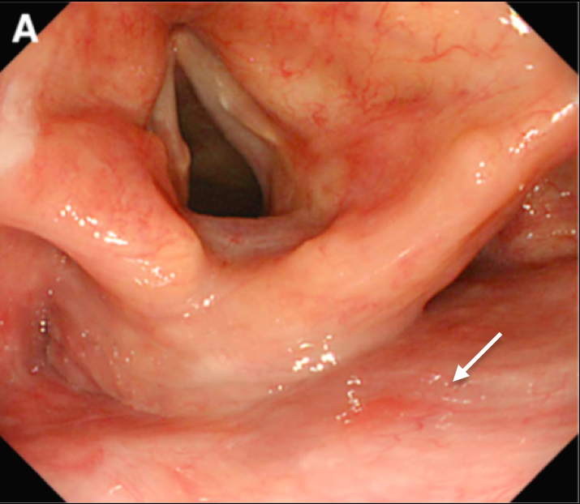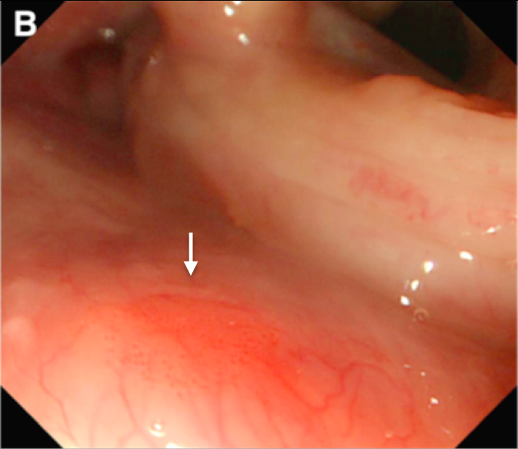

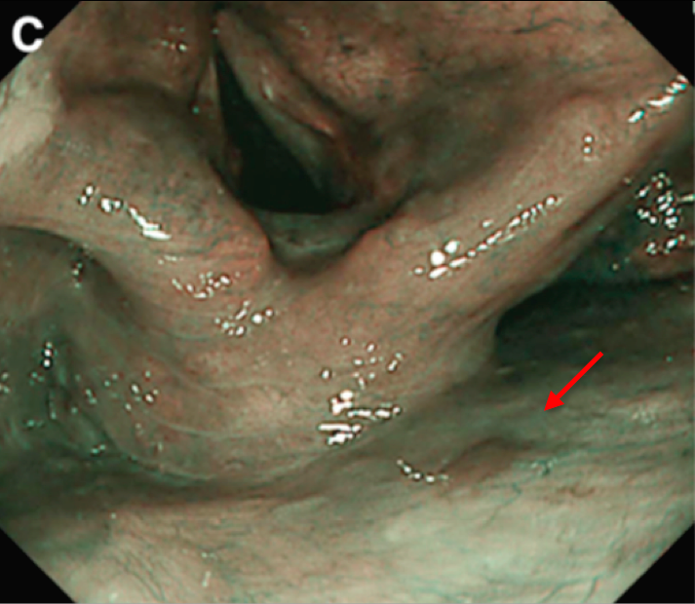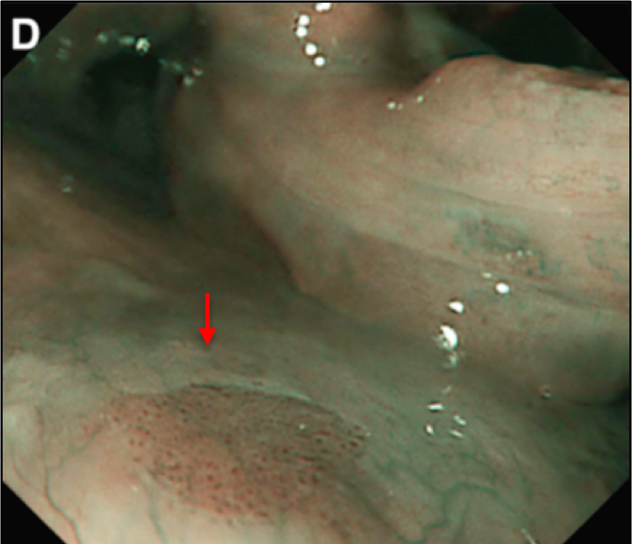
Figure 1 Differences in white light imaging from narrow-band imaging. A: White light imaging (WLI) displays an erythematous area in the posterior wall of the hypopharynx (white arrow); B: Magnifying WLI reveals a minimally erythematous patch with tiny microdots (white arrow): C: Narrow-band imaging (NBI) locates a distinct brown lesion in the posterior wall of the hypopharynx (red arrow); D: Magnifying NBI also demonstrates a distinct brown lesion with microdots that can be distinguished from the healthy mucosa surrounding it (red arrow)^{[20]}.

Figure 2 Diagnosis of stage IV gastric cancer increased substantially when the screening intervals extended beyond 3 years. Adapted from Nam et al^{[41]}. EGD: Esophagogastroduodenscopy.

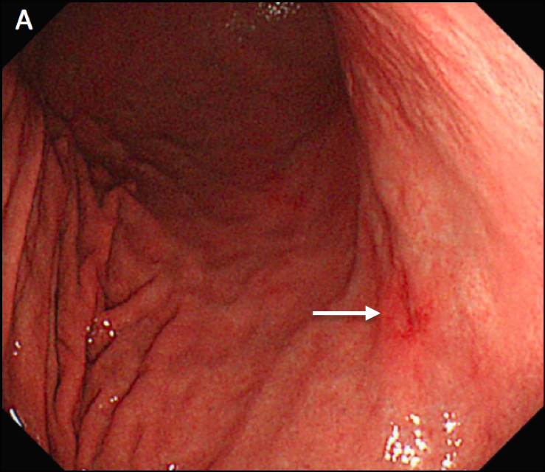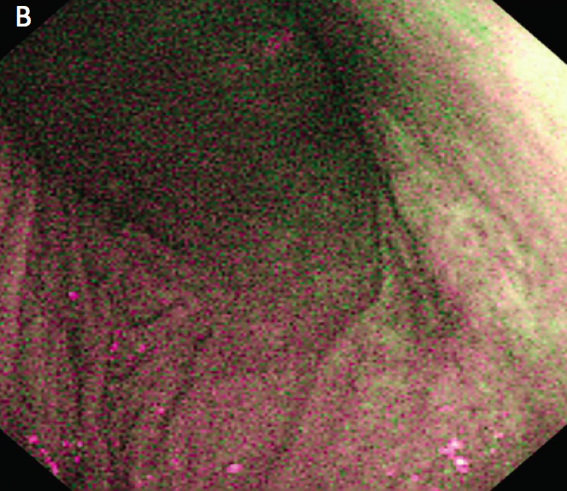

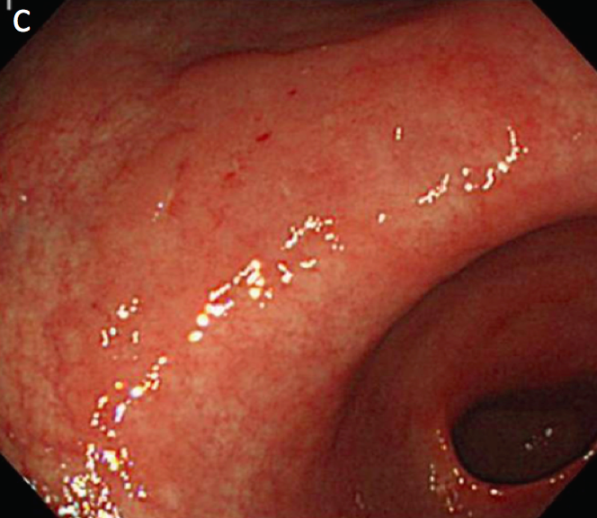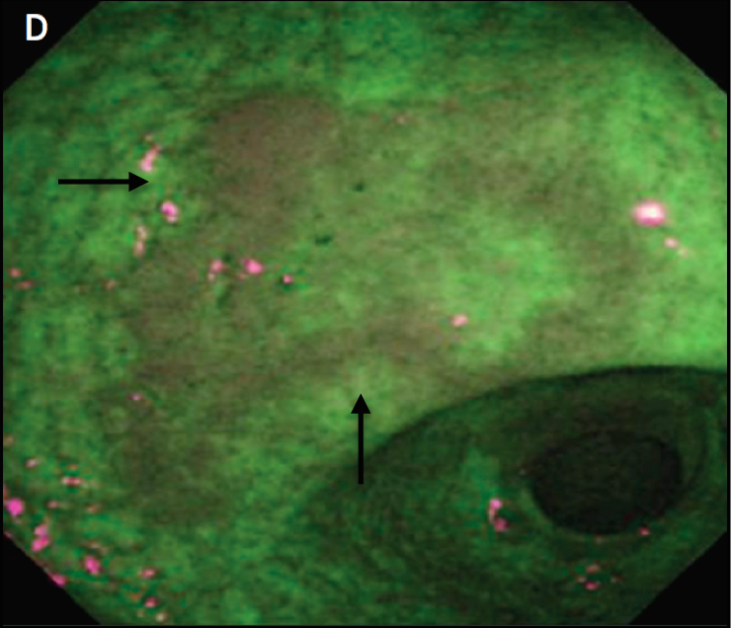
Figure 3 Autofluorescnce imaging’s limited role in certain lesions and benefit in others. A: White light imaging (WLI) displays a red lesion with a slightly depressed area on the bottom right corner (white arrow); B: Autofluorescnce imaging (AFI) does not demonstrate a distinct lesion that can be ruled neoplastic; C: WLI made it difficult for the endoscopists to identify the isochromatic flat lesion: D: AFI displays a well-marked lesion with slightly raised borders (black arrows)^{[50]}.

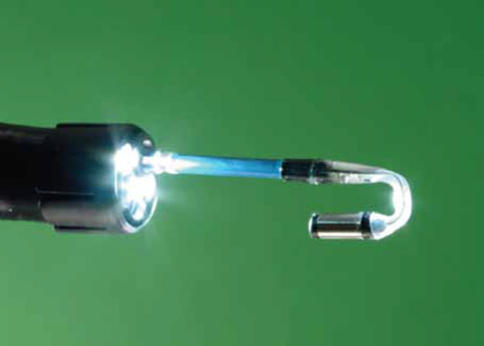
Figure 4 Third Eye Retroscope® attachment, extends out in its retroflexed position^{[69]}.

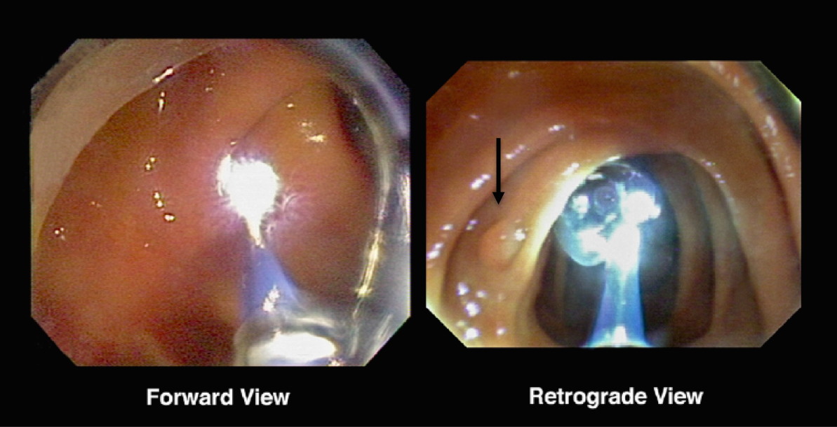
Figure 5 Advantage of retrograde visibility. The retrograde view (right) clearly sights a polyp (black arrow) that the forward view (left) would not have spotted^{[67]}.

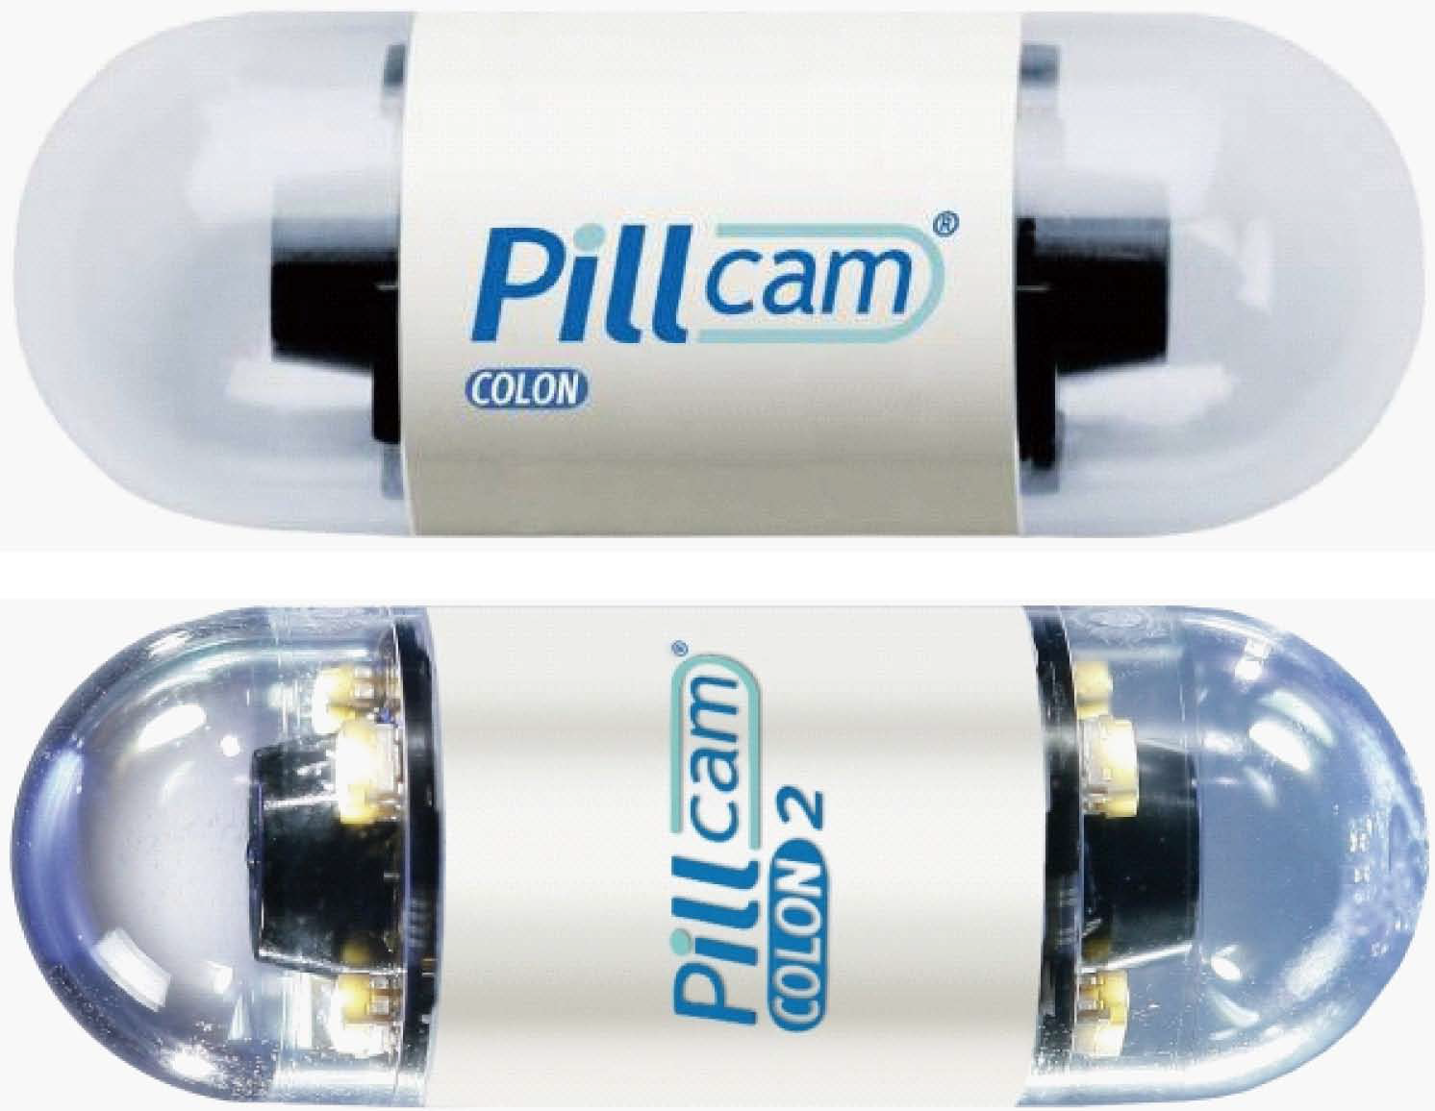
Figure 6 First and second generation CCE by Given Imaging^{[71]}.

Table 1 Accuracy of endoscopic modalities in esophageal carcinoma, which reveal the efficacy of endoscopic screening
Type of study | BE/ESCC | Patient group | Disease prevalence (%) | Accuracy of screen (%)
Endoscopic screening
Prospective | ESCC | Asymptomatic; Linxian, China | ESCC: 9.5 | Relative risk of ESCC: 2.9/9.8/28.3 (mild/moderate/sever dysplasia); 34.4 (carcinoma in situ)
Prospective | ESCC | Asymptomatic; Linxian, China | Not determined | Sensitivity/specificity for high-grade dysplasia or ESCC: 62/79 (visible lesions); 96/63 (unstained lesions)
Ultrathin endoscopes
Randomized crossover | BE | GERD; United States | Not determined | Sensitivity: 26/30 (standard/small caliber endoscopy)
Randomized crossover | BE | BE and controls; United Kingdom | Not determined | Sensitivity/specificity small vs standard caliber: 100/100
Capsule endoscopy
Prospective single screen | BE | GERD and under surveillance BE; United States | Not determined | Sensitivity/specificity for BE: 67/84
Prospective single screen | BE | GERD; United States | Not determined | Sensitivity/specificity for BE: 60/100
Prospective single screen | BE | GERD; United States | Not determined | Sensitivity/specificity for BE: 78/82 (visual lesions); 93/78 (biopsy)
Adapted from Lao-Sirieix et al^{[11]}. BE: Barrett’s esophagus; ESCC: Esophageal squamous cell cancer; GERD: Gastro-esophageal reflux disease.

Table 2 Different screening modalities
Modality | %Sensitivity (95%CI) | %Specificity (95%CI) | %PPV  (95%CI) | %NPV  (95%CI) | %Accuracy (95%CI)
WL | 47.3 | 97.4 | 79.4 | 89.8 | 88.7
NBI | 84.2 | 95.6 | 80.0 | 96.6 | 93.6
Lugol¹ | 93.0 | 90.7 | 67.9 | 98.4 | 91.1
NBI or Lugol | 94.7 | 90.4 | 67.5 | 98.8 | 91.1
NBI or Lugol | 82.6 | 95.9 | 81.0 | 93.6 | 93.6
¹Lugol is iodine staining solution used in chromoendoscopy. Adapted from Kwon et al^{[24]}

Table 3 Five-year survival rates by stage for stomach cancer treated with surgery
Stage | 5-year observed survival rate
Stage IA | 71%
Stage IB | 57%
Stage IIA | 46%
Stage IIB | 33%
Stage IIIA | 20%
Stage IIIB | 14%
Stage IIIC | 9%
Stage IV | 4%
Adapted from National Cancer Institute’s SEER database^{[40]}.

Table 4 Endoscopy used in cancer screening
Author | Number of Subjects | Sensitivity | Specificity | PPV
Hamashima et al^{[44]}, 2013 | EGD: 7388 | 88.6%  (69.8-97.6)¹ | 85.1%  (84.3–85.9)¹ | 5.5%  (4.3–7.0)¹
 | Upper GI series: 5410 | 83.1%  (58.6-96.4)¹ | 85.6%  (84.6–86.5)¹ | 4.3%  (3.4–5.2)¹
Choi et al^{[43,45]}, 2011 | EGD: 924,822 | 66.9%  (59.8-74.0)¹ | 96.2%  (95.7–96.7)¹ | 5.3%  (4.8–5.9)¹
 | Upper GI series:  1,765,909 | 27.3%  (22.6–32.0)¹ | 96.6%  (96.3–97.0)¹ | 1.3%  (1.1–1.6)¹
¹The 95% confidential intervals are given in parentheses^{[35]}. Adapted from Choi et al^{[43]}.

Table 5 Risk factors and proposed screening recommendations for gastric cancer
Risk factors | Risk for developing gastric cancer | Recommendation | First author
Helicobacter pylori infection | Odds ratio (OR): 2.3 | High risk area - mass screening possible benefit  Low risk area - mass screening not cost-effective | Huang, 1998
Pernicious anemia | Standardized incidence ratio: 5 | Screening by upper endoscopy (UE) recommended | Kokkola, 1998
Partial gastrectomy | 15-24 years, RR = 9.4  25-46 years, RR = 55.6 | Screening by UE recommended | Lundegardh, 1988  Tersmette, 1991
Familial adenomatous polyposis | Not available | Screening by UE recommended | Alexander, 1989
Hereditary nonpolyposis colorectal cancer | Not available | Screening by UE recommended | Aarnio, 1997
Positive family history of gastric cancer | OR: 2.5-5.1 | HP eradication +/- UE screening | Yatsuya, 2004  Chen, 2004
Adapted from Chan et al^{[48]}.

Table 6 Colorectal cancer screening guidelines for the United States
Guidelines for screening for the early detection of colorectal cancer and adenomas for average-risk women and men aged 50 years and older
Tests that detect adenomatous polyps and cancer
Test | Interval
FSIG with insertion up to 40 cm from anal verge or to splenic flexure | Every 5 Years
Colonoscopy | Every 10 Years
DCBE | Every 5 Years
CTC | Every 5 Years
Tests that primarily detect cancer
Test | Interval
gFOBT | Annual
FIT | Annual
sDNA | Interval Uncertain
Adapted from Levin et al^{[59]}. FSIG: Flexible sigmoidoscopy; DCBE: Double-contrast barium enema; CTC: Computed tomography colonography; gFOBT: Guaiac-based fecal occult blood test; FIT: Fecal immunochemical test; sDNA: Stool DNA test.

Table 7 Different image-enhanced endoscopy
Type | Mode (Solution/Instrument) | Mechanism of Contrast
Dye-based IEE (Chromoscopy)
Dye Enhancement
Contrast dye Indigo Carmine | 0.1%–0.4% solution  For 0.2% dilution, mix 5 mL 0.8% solution) with 15 mL sterile water. | Dye pools in mucosal crevices; no cellular staining
Equipment-based IEE
Optical Enhancement
Narrow band imaging | Olympus | Modification of light source with narrowed wavelengths to enhance capillary patterns
Electronic Enhancement
Spectral estimation technology | Fujinon | Processing of image to enhance capillary patterns
Surface enhancement | Pentax | Processing of image to enhance color pattern or structure (I-Scan Technology)
Adapted from Ko et al^{[72]}. IEE: Image-enhanced endoscopy.

