Name of journal: World Journal of Gastroenterology
ESPS Manuscript NO: 12756
Columns: CASE REPORT

Gastrointestinal hemorrhage due to ileal metastasis from primary lung cancer

Liu W et al. Ileal metastasis from lung cancer

Wei Liu, Wei Zhou, Wei-Lin Qi, Ya-Dan Ma, Yun-Yun Xu

Wei Liu, Wei Zhou, Wei-Lin Qi, Ya-Dan Ma, Yun-Yun Xu, Department of General Surgery, Sir Run Run Shaw Hospital, School of Medicine, Zhejiang University, Hangzhou 310016, Zhejiang Province, China

Author contributions: Zhou W and Liu W performed the operation; Qi WL; Ma YD and Xu YY collected case data and prepared the photo; Liu W wrote the manuscript; Zhou W proofread and revised the manuscript; all authors approved the final version to be published.

Correspondence to: Wei Zhou, MD, Department of General Surgery, Sir Run Run Shaw Hospital, 3 East Qingchun Road, Hangzhou 310016, China. nuzwlvran@aliyun.com

Telephone: +86- 571-86090073 Fax: +86- 571-86090073
Received: July 24, 2014 Revised: September 21, 2014
Accepted: November 7, 2014

Published online:

Abstract
We report a patient with small intestinal metastasis from lung squamous cell carcinoma. A 66-year-old man who underwent radical lung cancer surgery was admitted to our hospital. Before starting his fifth cycle of chemotherapy, he was found to have a positive fecal occult blood test. Abdominal computed tomography scan revealed an ileal tumor with mesenteric lymph node enlargement. He underwent laparoscopic resection of the involved small intestine and mesentery. Histopathological analysis confirmed metastasis from lung cancer. We conducted a review of the literature and 64 documented cases of small intestinal metastasis from lung cancer were found. The pathologic diagnosis, clinical presentation, site of metastasis, and survival time in these cases were reviewed.

© 2014 Baishideng Publishing Group Inc. All rights reserved.

Key words: Lung cancer; Metastasis; Gastrointestinal hemorrhage; Small intestine; Gastrointestinal neoplasms.

Core tip: Gastrointestinal tract metastases from lung cancer are relatively rare. We describe a patient with melena due to small intestinal metastasis from lung squamous cell carcinoma. We collected 64 similar documented cases from 2000 to date, and reviewed the pathologic diagnosis, clinical presentation, site of metastasis, treatment, and survival time.
Liu W, Zhou W, Qi WL, Ma YD, Xu YY. Gastrointestinal hemorrhage due to ileal metastasis from primary lung cancer. World J Gastroenterol 2014; In press

INTRODUCTION
Lung cancer is a malignant tumor with high incidence and mortality^{[1]}. The prognosis of lung cancer is poor as metastases are often present at the time of diagnosis. Distant metastases are usually found in the adrenal glands, bone, liver, brain, and kidney, however, metastases in the gastrointestinal tract are relatively rare^{[2]}. In this report, we present a patient with gastrointestinal bleeding due to ileal metastasis from primary lung carcinoma.

CASE REPORT
A 66-year-old male patient who presented with shortness of breath and hemoptysis for 1 week was admitted to our hospital on May 8, 2013. On chest computed tomography (CT), a mass was seen in the right lower lobe. He underwent a right lower lobectomy with lymph node dissection on May 10, 2013. At surgery, a 3.5 cm mass was found in the right upper lobe near the right lung hilum. In addition, hilum, carina, and mediastinum lymphadenopathy were found. The pathological study confirmed moderately differentiated squamous cell carcinoma with lymph node metastasis (1+/38) (T2N1M0). The patient received four cycles of adjuvant chemotherapy with docetaxel/nedaplatin from June 2013 to September 2013. Just before the fifth cycle of chemotherapy (January 3, 2014), the patient complained of melena. The stool examination for occult blood was strongly positive. On abdominal examination, no abnormalities were found. Colonoscopy also revealed no abnormalities. An abdominal CT scan revealed ileal wall thickening and nearby mesenteric lymph node enlargement, indicating a malignant ileal tumor (Figure 1). Tumor markers were within normal ranges, including CEA which was 2.75 ng/mL. A complete blood count showed anemia with a hemoglobin (Hb) level of 9.6 g/dL. The patient then underwent laparoscopic exploration. A 4.5x3.0 cm small intestinal tumor with serosal infiltration was found 150 cm from the cecum (Figure 2). Lymph node enlargement was seen near the mesenteric root. The involved small bowel and mesentery were resected. Histopathological analysis confirmed that the tumor was a moderately differentiated squamous cell carcinoma (Figure 3). Immunohistochemically, tumor cells were positive for CKH and P63, but negative for CK20 and CK7 (Figure 4), indicating a metastasis from primary lung carcinoma. One of the two resected mesenteric lymph nodes contained metastasis, and the surgical margins were negative. The patient had no postoperative complications and was discharged 5 days after surgery. Postoperatively, he underwent four cycles of chemotherapy with gemcitabine/nedaplatin. Brain magnetic resonance imaging and SPECT/CT during chemotherapy revealed no other metastasis. The patient is still alive with no recurrence.

DISCUSSION
We searched the PubMed database for relevant English language publications from 2000 to June 2014 using the MeSh terms “Gastrointestinal Neoplasms/complications”, “Gastrointestinal Neoplasms/secondary”, and “Lung Neoplasms/pathology”. The age and sex of patients, pathologic diagnosis, clinical presentation, site of metastasis, and the survival time of the reported cases were reviewed and analyzed. In total, 64 cases were identified and reviewed^{[3-33]}, including 58 (90.6%) male and 6 (9.4%) female patients. The mean age of these patients was 61.4 years (ranging from 36 years to 88 years).
In lung cancer, metastases to the gastrointestinal tract are quite rare and mostly found in the advanced stages of the disease. Yang et al reported that the incidence of symptomatic gastrointestinal metastasis from primary lung cancer was 1.77%^{[21]}. However, the prevalence at autopsy is much higher, ranging from 4.7% to 14%^{[34,35]}. This can be explained by the fact that most patients with small bowel metastases have no specific symptoms. In the 64 documented cases, 59 patients had certain clinical presentations, of whom 22 (37.3%) had perforation, 19 (32.2%) had obstruction, 10 (16.9%) had hemorrhage and 8 (13.6%) had intussusception. Perforation was the most common symptom in patients with bowel metastases. The toxicity of chemotherapy is likely to be the etiology of bowel perforation^{[30]}.
In the 64 documented cases, 57 patients had metastatic sites. The jejunum was the most common site in 50.9% (29/57) of patients, followed by the ileum in 33.3% (19/57), and the duodenum in 15.8% (9/57). The general route of gastrointestinal metastasis has been suggested to be hematogenous metastasis through the spinal veins or lymphogenous metastasis from the mediastinum through the retroperitoneum and mesentery^{[9]}. The difference in incidence between these metastatic sites may be because the jejunum and ileum have a more abundant blood supply and lymphoid tissues.
In lung cancer, all tumor cell types may develop small intestinal metastases. Adenocarcinoma (31.6%, 18/57), squamous cell carcinoma (28.1%, 16/57) and large cell carcinoma (24.6%, 14/57) were most common, followed by other types such as carcinosarcoma, adenosquamous, and neuroendocrine carcinoma (10.5% 6/57) and small cell carcinoma (5.3%, 3/57). Yoshimoto et al reported that patients with large cell carcinoma had a significantly higher rate of gastrointestinal metastases (P = 0.004, odds ratio 3.524) compared with patients with non-large cell carcinoma^{[34]}. However, the reasons for this are unknown.
Due to the unclear clinical symptoms in patients with small bowel metastases, early diagnosis and treatment are difficult. CT plays an important role in identifying the exact cause of abdominal symptoms in patients with lung cancer^{[36]}. The metastatic lesions were seen on CT scans as wall thickening, an intraluminal polypoid mass or an exophytic mass. PET-CT may be more accurate than CT or other conventional imaging methods for the diagnosis of metastatic malignant sites. However, due to the high cost and the lack of clinical cases, the role of PET-CT in the diagnosis of lung cancer gastrointestinal metastasis is still controversial. Capsule endoscopy has the capability of providing visual images of the bowel and is superior in many aspects of gastrointestinal disease evaluation and management. It can provide help in identifying the presence of small intestinal metastasis when a patient with lung cancer presents with suspected small intestinal bleeding. However, it may have a limited role in patients with bowel perforation and obstruction.
As most lung cancer patients with gastrointestinal metastasis exhibit bowel perforation or an acute abdomen, surgical intervention is required. Dabaja et al^{[37]} showed that the 5-year overall survival rate was signiﬁcantly higher for patients who underwent surgery compared with patients who did not. Laparoscopic surgery not only has the advantages of less trauma, less blood loss and quicker recovery, but also has huge potential in diagnosis. Postoperative chemotherapy and individualized treatment may improve the survival rate for these lung cancer patients. For the lung cancer patient with distant metastasis, the guideline indicates that cisplatin/pemetrexed is recommended for patients with non-squamous non-small cell lung cancer patients with squamous cell carcinoma, cisplatin/gemcitabine is an option^{[38]}. The chemotherapy regimen should be changed when there are other metastases present.
Many patients with small bowel metastases had synchronous metastasis in other organs. PAUL reported that 46 patients had small bowel metastasis of 431 autopsies on patients with lung cancer. In addition, all patients with small bowel metastases had at least one other metastatic site with an average of 4.8 sites such as the adrenal gland, liver, and kidney. This indicated that gastrointestinal metastasis is a late symptom of lung cancer and a poor prognostic indicator in the course of lung cancer^{[39]}. In the documented cases, the median survival time was 3 months after detection of small bowel metastases in 48 patients. The poor prognosis was mainly due to late detection, the malignant biological behavior of lung cancer, abdominal infections, surgical complications, and other metastases. Brain and bone are common sites of distant metastases in lung cancer. In contrast, the median survival time of patients with bone metastases was 7 mo. Patients with brain metastases had a median survival of 3–6 mo^{[40]}. Metastases to the small bowel have a worse prognosis than metastases to the brain and bone.
Due to better diagnostic methods and prolonged survival of lung cancer patients, gastrointestinal metastases are more common. When abdominal symptoms are present or persistent positive occult blood tests are found, bowel metastases should be considered. Abdominal CT has high value in diagnosing gastrointestinal metastases. With regard to the treatment of gastrointestinal metastases from lung cancer, surgery can be a curative treatment option. Chemotherapy and supportive care can improve the prognosis.

COMMENTS
Case characteristics
A 66-year-old man with a history of radical lung cancer surgery presented with melena.

Clinical diagnosis
On abdominal examination, no abnormalities were found.

Differential diagnosis
Primary small intestinal carcinoma; colorectal cancer; peptic ulcer.

Laboratory diagnosis
Tumor markers were within normal ranges, including CEA which was 2.75 ng/mL. A complete blood count showed anemia with an Hb level of 9.6 g/dL.

Imaging diagnosis
An abdominal CT scan revealed ileal wall thickening and nearby mesenteric lymph node enlargement, indicating a malignant ileal tumor.

Pathological diagnosis
Histopathological analysis confirmed a moderately differentiated squamous cell carcinoma; immunohistochemistry indicated metastasis from primary lung carcinoma.

Treatment
The patient underwent resection of the involved small bowel and mesentery. Postoperatively, he received four cycles of chemotherapy with gemcitabine/nedaplatin.

Related reports
Gastrointestinal tract metastases from lung cancer are relatively rare, and the clinical symptoms are unclear. The general route of gastrointestinal metastasis and the prognosis are also unclear.

Experiences and lessons
This case report not only presents a rare case of small intestinal metastasis from lung cancer, but also reviews the pathologic diagnosis, clinical presentation, site of metastasis, treatment and survival time.

Peer review
The authors reported a rare and interesting case of a patient with small intestine metastasis from lung squamous cell carcinoma, and they reviewed 64 documented cases with small intestine metastasis from lung cancer.

REFERENCES
1 Siegel R, Naishadham D, Jemal A. Cancer statistics, 2013. CA Cancer J Clin 2013; 63: 11-30 [PMID: 23335087 DOI: 10.3322/caac.21166]
2 Hoffman PC, Mauer AM, Vokes EE. Lung cancer. Lancet 2000; 355: 479-485 [PMID: 10841143 DOI: 10.1016/S0140-6736(00)82038-3]
3 Song Y, Li M, Shan J, Ye X, Tang S, Fang X, Ding K, Yuan Y. Acute small bowel obstruction: a rare initial presentation for the metastasis of the large-cell carcinoma of the lung. World J Surg Oncol 2012; 10: 26 [PMID: 22284720 DOI: 10.1186/1477-7819-10-26]
4 Salemis NS, Nikou E, Liatsos C, Gakis C, Karagkiouzis G, Gourgiotis S. Small bowel perforation secondary to metastatic non-small cell lung cancer. A rare entity with a dismal prognosis. J Gastrointest Cancer 2012; 43: 391-395 [PMID: 22033892 DOI: 10.1007/s12029-011-9329-2]
5 Mulder MC, Kist JW, Consten EC, Verheijen PM. Gastrointestinal metastasis as the first presentation of lung carcinoma. Int J Colorectal Dis 2012; 27: 839-840 [PMID: 22006495 DOI: 10.1007/s00384-011-1326-1]
6 Jung LY, Jeon SY, Kim SR, Chung MJ, Lee YC. Pulmonary sarcomatoid carcinoma accompanying duodenal involvement. Am J Respir Crit Care Med 2012; 185: 899-900 [PMID: 22505760 DOI: 10.1164/ajrccm.185.8.899]
7 Guner A, Karyagar S, Livaoglu A, Kece C, Kucuktulu U. Small Bowel Intussusception due to Metastasized Sarcomatoid Carcinoma of the Lung: A Rare Cause of Intestinal Obstruction in Adults. Case Rep Surg 2012; 2012: 962683 [PMID: 23346451 DOI: 10.1155/2012/962683]
8 Nishizawa Y, Kobayashi A, Saito N, Nagai K, Sugito M, Ito M, Nishizawa Y. Surgical management of small bowel metastases from primary carcinoma of the lung. Surg Today 2012; 42: 233-237 [PMID: 22045233 DOI: 10.1007/s00595-011-0005-8]
9 Yamada H, Akahane T, Horiuchi A, Shimada R, Shibuya H, Hayama T, Nozawa K, Ishihara S, Matsuda K, Watanabe T. A case of lung squamous cell carcinoma with metastases to the duodenum and small intestine. Int Surg 2011; 96: 176-181 [PMID: 22026313]
10 Lee PC, Lo C, Lin MT, Liang JT, Lin BR. Role of surgical intervention in managing gastrointestinal metastases from lung cancer. World J Gastroenterol 2011; 17: 4314-4320 [PMID: 22090788 DOI: 10.3748/wjg.v17.i38.4314]
11 Bugiantella W, Cavazzoni E, Graziosi L, Valiani S, Franceschini MS, Donini A. Small bowel metastasis from lung cancer: a possible cause of acute abdomen. Case report and literature review. G Chir 2011; 32: 120-122 [PMID: 21453601]
12 Sayilir A, Oztaş E, Onal IK, Kurt M, Kekıllı M, Akdoğ G, Ibış M. Small bowel obstruction: a presenting symptom of squamous cell carcinoma of the lung. Turk J Gastroenterol 2011; 22: 440-442 [PMID: 21948581 DOI: 10.4318/tjg.2011.0292]
13 Kim SY, Ha HK, Park SW, Kang J, Kim KW, Lee SS, Park SH, Kim AY. Gastrointestinal metastasis from primary lung cancer: CT findings and clinicopathologic features. AJR Am J Roentgenol 2009; 193: W197-W201 [PMID: 19696259 DOI: 10.2214/AJR.08.1907]
14 Chiu WK, Lin YC, Wang LT, Chen JH, Yu JC, Hsieh CB. Jejunojejunal intussusception secondary to metastasis from adenocarcinoma of the lung--a case report. Acta Chir Belg 2009; 109: 519-522 [PMID: 19803270]
15 Huang YJ, Wu MH, Lin MT. Multiple small-bowel intussusceptions caused by metastatic malignant melanoma. Am J Surg 2008; 196: e1-e2 [PMID: 18513686 DOI: 10.1016/j.amjsurg.2007.05.062]
16 Kagohashi K, Kadono K, Satoh H, Ohtsuka M. Intussusception due to intestinal metastasis from lung cancer. Lung Cancer 2007; 57: 247-248 [PMID: 17602784 DOI: 10.1016/j.lungcan.2007.05.008]
17 Goh BK, Yeo AW, Koong HN, Ooi LL, Wong WK. Laparotomy for acute complications of gastrointestinal metastases from lung cancer: is it a worthwhile or futile effort? Surg Today 2007; 37: 370-374 [PMID: 17468816 DOI: 10.1007/s00595-006-3419-y]
18 Kostakou C, Khaldi L, Flossos A, Kapsoritakis AN, Potamianos SP. Melena: a rare complication of duodenal metastases from primary carcinoma of the lung. World J Gastroenterol 2007; 13: 1282-1285 [PMID: 17451216]
19 Gómez-Patiño JA, Almaraz CS, Sánchez MI. [Primary lung carcinoma with intestinal metastases: 3 cases in a series of 420 patients]. Arch Bronconeumol 2007; 43: 472-473 [PMID: 17692250 DOI: 10.1016/S1579-2129(07)60106-2]
20 Yuksel O, Uyar P, Sahin TT, Demirhan B. Small bowel perforation due to metastatic lung squamous cell carcinoma. Saudi Med J 2007; 28: 631-633 [PMID: 17457493]
21 Yang CJ, Hwang JJ, Kang WY, Chong IW, Wang TH, Sheu CC, Tsai JR, Huang MS. Gastro-intestinal metastasis of primary lung carcinoma: clinical presentations and outcome. Lung Cancer 2006; 54: 319-323 [PMID: 17010474 DOI: 10.1016/j.lungcan.2006.08.007]
22 Kanemoto K, Kurishima K, Ishikawa H, Shiotani S, Satoh H, Ohtsuka M. Small intestinal metastasis from small cell lung cancer. Intern Med 2006; 45: 967-970 [PMID: 16974060 DOI: 10.2169/internalmedicine.45.1651]
23 Alvarez Laso C, Paredes Aracil E, Azcano González E, Ots Gutiérrez JR, Bernabeu Miralles M, Compañ Rosique A. Small bowel occlusion due to intussusception of a single metastasis of lung cancer. Clin Transl Oncol 2006; 8: 833-834 [PMID: 17134974]
24 Yilmaz S, Dursun M, Canoruç F, Bayan K, Büyükbayram H. Upper gastrointestinal bleeding caused by small-cell lung cancer: a case report. Dig Dis Sci 2006; 51: 788-790 [PMID: 16615004 DOI: 10.1007/s10620-006-3207-y]
25 Tomas D, Ledinsky M, Belicza M, Kruslin B. Multiple metastases to the small bowel from large cell bronchial carcinomas. World J Gastroenterol 2005; 11: 1399-1402 [PMID: 15761985]
26 Burnette RE, Ballard BR. Metastatic pleomorphic carcinoma of lung presenting as abdominal pain. J Natl Med Assoc 2004; 96: 1657-1660 [PMID: 15622698]
27 Felsher J, Brodsky J, Brody F. Laparoscopic small bowel resection of metastatic pulmonary carcinosarcoma. J Laparoendosc Adv Surg Tech A 2003; 13: 397-400 [PMID: 14733704 DOI: 10.1089/109264203322656478]
28 Sakorafas GH, Pavlakis G, Grigoriadis KD. Small bowel perforation secondary to metastatic lung cancer: a case report and review of the literature. Mt Sinai J Med 2003; 70: 130-132 [PMID: 12634905]
29 Testini M, Trabucco S, Di Venere B, Piscitelli D. Ileal intussusception due to intestinal metastases from primary malignant melanoma of the lung. Am Surg 2002; 68: 377-379 [PMID: 11952250]
30 Yuen JS, Chow PK, Ahmed Q. Metastatic lung cancer causing bowel perforations: spontaneous or chemotherapy-related? ANZ J Surg 2002; 72: 245-246 [PMID: 12071466 DOI: 10.1046/j.1445-2197.2002.02236.x]
31 Cremon C, Barbara G, De Giorgio R, Salvioli B, Epifanio G, Gizzi G, Stanghellini V, Corinaldesi R. Upper gastrointestinal bleeding due to duodenal metastasis from primary lung carcinoma. Dig Liver Dis 2002; 34: 141-143 [PMID: 11926559 DOI: 10.1016/S1590-8658(02)80245-6]
32 Lee KA, Lee SK, Seo DW, Kim MH. Duodenal metastasis from lung cancer presenting as obstructive jaundice. Gastrointest Endosc 2001; 54: 228 [PMID: 11474398 DOI: 10.1067/mge.2001.116896]
33 Chagpar A, Moyana TN, Chappell EW. Isolated metachronous jejunal metastases after resection of bronchogenic carcinoma. Can J Surg 2000; 43: 57-58 [PMID: 10714260]
34 Yoshimoto A, Kasahara K, Kawashima A. Gastrointestinal metastases from primary lung cancer. Eur J Cancer 2006; 42: 3157-3160 [PMID: 17079136 DOI: 10.1016/j.ejca.2006.08.030]
35 Antler AS, Ough Y, Pitchumoni CS, Davidian M, Thelmo W. Gastrointestinal metastases from malignant tumors of the lung. Cancer 1982; 49: 170-172 [PMID: 6274500]
36 Rossi G, Marchioni A, Romagnani E, Bertolini F, Longo L, Cavazza A, Barbieri F. Primary lung cancer presenting with gastrointestinal tract involvement: clinicopathologic and immunohistochemical features in a series of 18 consecutive cases. J Thorac Oncol 2007; 2: 115-120 [PMID: 17410025]
37 Dabaja BS, Suki D, Pro B, Bonnen M, Ajani J. Adenocarcinoma of the small bowel: presentation, prognostic factors, and outcome of 217 patients. Cancer 2004; 101: 518-526 [PMID: 15274064 DOI: 10.1002/cncr.20404]
38 Ettinger DS, Akerley W, Borghaei H, Chang AC, Cheney RT, Chirieac LR, D'Amico TA, Demmy TL, Ganti AK, Govindan R, Grannis FW, Horn L, Jahan TM, Jahanzeb M, Kessinger A, Komaki R, Kong FM, Kris MG, Krug LM, Lennes IT, Loo BW, Martins R, O'Malley J, Osarogiagbon RU, Otterson GA, Patel JD, Pinder-Schenck MC, Pisters KM, Reckamp K, Riely GJ, Rohren E, Swanson SJ, Wood DE, Yang SC, Hughes M, Gregory KM. Non-small cell lung cancer. J Natl Compr Canc Netw 2012; 10: 1236-1271 [PMID: 23054877]
39 McNeill PM, Wagman LD, Neifeld JP. Small bowel metastases from primary carcinoma of the lung. Cancer 1987; 59: 1486-1489 [PMID: 3028602]
40 D'Antonio C, Passaro A, Gori B, Del Signore E, Migliorino MR, Ricciardi S, Fulvi A, de Marinis F. Bone and brain metastasis in lung cancer: recent advances in therapeutic strategies. Ther Adv Med Oncol 2014; 6: 101-114 [PMID: 24790650 DOI: 10.1177/1758834014521110]

P-Reviewer: Tsuchiya A, Herszenyi L, Keishiro A S-Editor: Yu J
L-Editor: E-Editor:

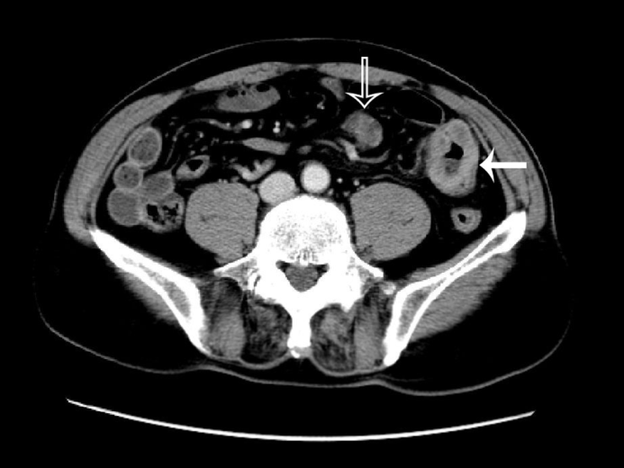

Figure 1 Abdominal computed tomography scan revealed metastatic tumor mass of ileum (the hollow arrow) and the enlarged lymph node (the solid arrow).

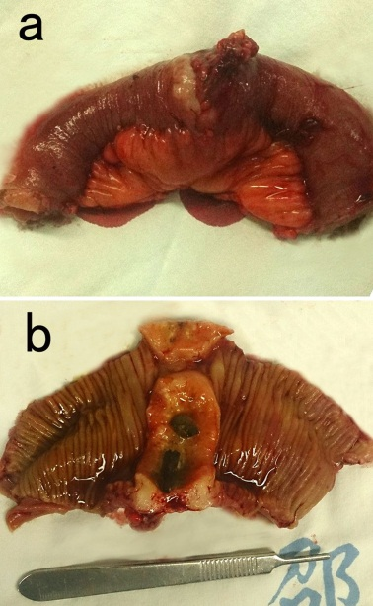

Figure 2 Intraoperative imaging of the resected tumor of the ileum. The tumor was 4.5 cm × 3.0 cm in size, with a clear margin and ulceration on the intraluminal surface.

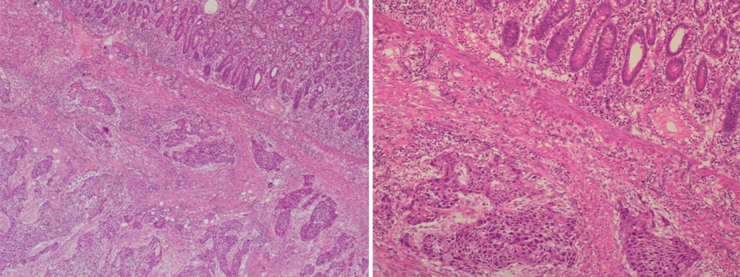

Figure 3 Microscopic findings of metastatic lung squamous cell carcinoma in the ileum.

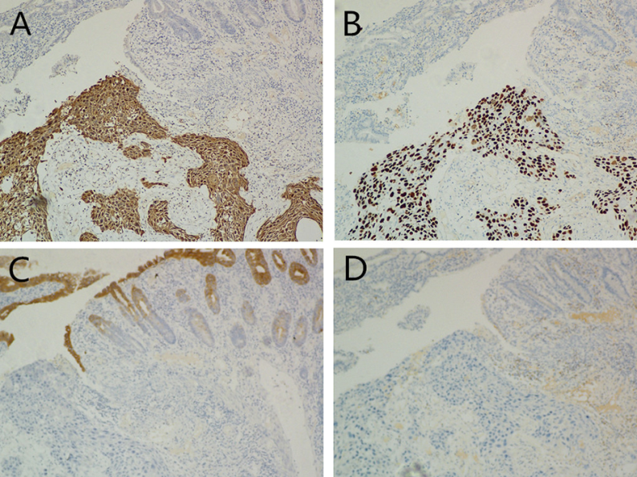

Figure 4 By immunohistochemistry, the tumor cells were found to be positive for CK (A) and P63 (B), but negative for CK20 (C) and CK7 (D).

