Name of Journal: World Journal of Clinical Cases
Manuscript NO: 78269
Manuscript Type: ORIGINAL ARTICLE

Retrospective Study
Significance of incidental focal fluorine-18 fluorodeoxyglucose uptake in colon/rectum, thyroid, and prostate: With a brief literature review

Lee H et al. Incidental colorectal, thyroid, prostate fluorodeoxyglucose uptake

Haejun Lee, Kyung-Hoon Hwang

Haejun Lee, Kyung-Hoon Hwang, Department of Nuclear Medicine, Gachon University College of Medicine, Gil Medical Center, Incheon 21565, South Korea

Author contributions: Lee H and Hwang KH contributed to this work, designed the research study, performed the research, analyzed the data, and wrote the manuscript; Lee H contributed analytic tools; All authors have read and approved the final manuscript.

Corresponding author: Kyung-Hoon Hwang, MD, PhD, Professor, Nuclear Medicine, Gachon University College of Medicine, Gil Medical Center, Namdong-daero 774beon-gil, Namdong-gu, Incheon 21565, South Korea. forrest88@hanmail.net

Received: June 17, 2022
Revised: August 10, 2022
Accepted: November 8, 2022
Published online:

Abstract
BACKGROUND
Fluorine-18 fluorodeoxyglucose positron emission tomography/computed tomography (F-18 FDG PET/CT), a functional imaging method, is usually performed on the entire torso, and regions of unexpected suspicious focal hypermetabolism are not infrequently observed. Among the regions, colon, thyroid, and prostate were found to be the common organs in a recent umbrella review. Some studies reported that a high rate of malignancy was shown in incidentally identified focal hypermetabolic regions and suggested that further examinations should not be ignored.

AIM
To investigate the malignancy rate of incidental focal FDG uptake, useful PET parameters and their cutoffs in discrimination between malignant and benign lesions.

METHODS
Retrospectively, the final reports of 16510 F-18 FDG PET/CT scans performed at our hospital between January 2016 and March 2022 were reviewed to identify incidentally observed FDG uptake in the colon/rectum, thyroid, and prostate. The scans of patients with current or prior malignancies at each corresponding location, without the final reports of histopathology or colonoscopy (for colon and rectum) for the corresponding hypermetabolic regions, or with diffuse (not focal) hypermetabolism were excluded. Finally, 88 regions of focal colorectal hypermetabolism in 85 patients (48 men and 37 women with mean age 67.0 ± 13.4 years and 63.4 ± 15.8 years, respectively), 48 focal thyroid uptakes in 48 patients (12 men and 36 women with mean age 62.2 ± 13.1 years and 60.8 ± 12.4 years, respectively), and 39 focal prostate uptakes in 39 patients (mean age 71.8 ± 7.5 years) were eligible for this study. For those unexpected focal hypermetabolic regions, rates of malignancy were calculated, PET parameters, such as standardized uptake value (SUV), capable of distinguishing between malignant and benign lesions were investigated, and the cutoffs of those PET parameters were determined by plotting receiver operating characteristic curves.

RESULTS
In the colon and rectum, 29.5% (26/88) were malignant and 33.0% (29/88) were premalignant lesions. Both SUVmax and SUVpeak differentiated malignant/premalignant from benign lesions, however, no parameters could distinguish malignant from premalignant lesions. Higher area under the curve was shown with SUVmax (0.752, 95%CI: 0.649-0.856, P < 0.001) and the cutoff was 7.6. In the thyroid, 60.4% (29/48) were malignant. The majority were well-differentiated thyroid cancers (89.7%, 26/29). The results of BRAF mutation tests were available for 20 of the 26 well-differentiated thyroid cancers and all 20 had the mutation. Solely SUVmax differentiated malignant from benign lesions and the cutoff was 6.9. In the prostate, 56.4% (22/39) were malignant. Only SUVmax differentiated malignant from benign lesions and the cutoff was 3.8. Overall, among the 175 focal hypermetabolic regions, 60.6% (106/175) were proven to be malignant and premalignant (in colon and rectum) lesions.

CONCLUSION
Approximately 60% of the incidentally observed focal F-18 FDG uptake in the colon/rectum, thyroid, and prostate were found to be malignant. Of the several PET parameters, SUVmax was superior to others in distinguishing between malignant/premalignant and benign lesions. Based on these findings, incidental focal hypermetabolism should not be ignored and lead physicians to conduct further investigations with greater confidence.

Key Words: Incidental; Focal; Uptake; Fluorine-18 fluorodeoxyglucose; Positron emission tomography/computed tomography; Standardized uptake value

Lee H, Hwang KH. Significance of incidental focal fluorine-18 fluorodeoxyglucose uptake in colon/rectum, thyroid, and prostate: with a brief literature review. World J Clin Cases 2022; In press

Core Tip: Unexpectedly identified uptake on fluorine-18 fluorodeoxyglucose positron emission tomography/computed tomography (F-18 FDG PET/CT) is not a rare finding. Among the uptakes, focal uptake may have clinical implications by harboring malignant lesions. In this study, the clinical significance of the incidentally identified focal FDG uptake in the colon/rectum, thyroid, and prostate was investigated with the malignancy rate, comparison of PET parameters, and receiver operating characteristic curve. Overall, approximately up to 60% were malignancies (including premalignancy) for the regions and SUVmax was a superior PET parameter in discrimination between malignant/premalignant and benign lesions. The findings should lead physicians to conduct further investigations more confidently without ignoring the focal uptake.

INTRODUCTION
Fluorine-18 fluorodeoxyglucose positron emission tomography/computed tomography (F-18 FDG PET/CT) is an established and widely used imaging modality for the evaluation and follow-up of various cancers. It is an imaging examination that principally provides functional information, which is new or additional, as compared to conventional computed tomography or magnetic resonance imaging, which mainly provides anatomical information^{[1,2]}. The fused F-18 FDG PET/CT provides the extent and intensity of FDG metabolism on precise structural information compared to PET alone. As PET/CT is usually performed on the entire torso, regions of unexpected suspicious focal hypermetabolism are not infrequently observed among patients undergoing the scan for known existing or newly diagnosed diseases. Incidental focal hypermetabolism can be observed in virtually any area of the scan-covered body. Unexpected focal hypermetabolic locations that have been widely studied include colon/rectum^{[3-5]} and thyroid^{[6-8]}. Likewise, a recent umbrella study reported the three most common organs for incidental FDG uptake were the colon, thyroid, and prostate (colon, 1.95% and 2.03%; thyroid, 1.85%; parotid, 0.42%; breast, 0.30%; prostate, 1.48%)^{[9]}. Based on the findings, this study was conducted retrospectively at our hospital to investigate the malignancy rate of incidental focal FDG uptake, PET parameters and their cutoffs in distinguishing between malignant and benign lesions in colon/rectum, thyroid, and prostate; and ultimately whether these findings can help physicians in clinical field. Finally, a brief literature review on the clinical significance of incidental focal hypermetabolism is presented together.

MATERIALS AND METHODS
Patients
The final reports of 16510 F-18 FDG PET/CT scans performed at our hospital between January 2016 and March 2022 were retrospectively reviewed to identify incidentally observed FDG uptake in the colon/rectum, thyroid, and prostate. The scans of patients with current or prior malignancies at each corresponding location, without the final reports, as a gold standard, of histopathology or colonoscopy (for colon and rectum) for the corresponding hypermetabolic regions, or with diffuse hypermetabolism were excluded. Finally, 88 regions of focal colorectal hypermetabolism in 85 patients (48 men and 37 women with mean age of 67.0 ± 13.4 years and 63.4 ± 15.8 years, respectively), 48 regions of focal thyroid uptake in 48 patients (12 men and 36 women with mean age of 62.2 ± 13.1 years and 60.8 ± 12.4 years, respectively), and 39 regions of focal prostate uptake in 39 patients (mean age: 71.8 ± 7.5 years) were eligible for this study.

F-18 FDG PET/CT imaging
The image quality of F-18 FDG PET/CT is known to be affected by blood glucose levels owing to the structural similarity between FDG and glucose. As high blood glucose levels can result in less FDG uptake into cells because of competition between blood sugar and FDG for glucose transport protein^{[10]}, all patients were required to fast for 4–6 h prior to the scan, and their blood glucose levels were checked to acquire optimal image quality. The examination was rescheduled for patients with blood glucose levels ≥ 11 mmol/L (200 mg/dL). PET/CT scan was performed 60 min after the injection of 185 MBq F-18 FDG intravenously. Images from the base of the skull to the mid-thighs were acquired using a dedicated PET/CT scanner (Biograph mCT 128; Siemens Healthcare GmbH, Erlangen, Germany). The PET scans were acquired using the step and shoot method for 3 minutes per bed, and the CT scans using the continuous spiral mode with activated CareDose4D and CARE kV functions based on 60 mAs and 120 kVp, respectively, to acquire individually optimized images and reduce radiation exposure to the patients. No contrast material was used for the CT scans. PET and CT images were reconstructed using the iterative reconstruction method, and the final fused PET/CT images were generated on a dedicated image-processing workstation supplied with the PET/CT unit.

Analysis of the PET/CT images and histopathological reports
The selected images of eligible patients were thoroughly reviewed by two nuclear medicine physicians, one with over two decades of experience. When an unexpected focal hypermetabolic region was identified in the colon/rectum, thyroid, or prostate, the patient’s medical records were searched to obtain a final histopathological report of the corresponding location. The lesions identified visually were classified histopathologically as malignant, benign, or, additionally, premalignant for colorectal lesions. A semi-quantitative PET parameter called standardized uptake value (SUV), and metabolic tumor volume (MTV) for these lesions were measured to obtain maximum SUV (SUVmax), peak SUV (SUVpeak), hypermetabolic tumor volume, and mean SUV of the hypermetabolic tumor volume (mSUVmtv). When measuring the MTV, various volumes of interest can be set using different values of the SUV threshold. In this study, several SUV thresholds, ranging from 2 to 5 in increments of 0.5, were used to obtain multiple MTVs and the mean SUV of each MTV with specific SUV threshold # (MTV# and mSUVmtv#, respectively). Finally, total lesion glycolysis (TLG) was calculated by multiplying the volume by the mSUVmtv. Measurements of these parameters were performed on a dedicated PET/CT workstation equipped with a SyngoMMWP (Siemens Healthcare GmbH). The measured values were compared among the malignant, premalignant (in colon/rectum), and benign lesions. Receiver operating characteristic (ROC) curves were plotted to determine cutoff values.

Statistical analysis
Parametric (Student's t-test) and non-parametric (such as Mann–Whitney U test) methods were used to compare the measured or calculated values of the classified lesions. The cutoff value for differentiating malignant/premalignant from benign lesions was determined by plotting the ROC curve and obtaining the area under the curve (AUC). Statistical analysis was performed using SPSS for Windows (version 16.0; SPSS, Inc., Chicago, IL, United States). Statistical significance was set at P < 0.05.

Literature search
The literature search for this article was conducted using databases such as PubMed, EMBASE, Scopus, MEDLINE, Web of Science, and search engines like Google Scholar and ScienceDirect.

Ethics
This retrospective study was approved by the Institutional Review Board of our hospital (IRB No. GAIRB2020-297) and the requirement for informed consent was waived. The study was conducted in accordance with the tenets of the 1964 Declaration of Helsinki and its later amendments.

RESULTS
The demographic features of the patients with incidental focal colon/rectum, thyroid, and prostate hypermetabolic lesions classified by histopathological report are shown in Table 1.

Colon and rectum
Among the 88 eligible regions of focal hypermetabolism, 26 were diagnosed with malignant lesions and 29 premaligncies. The remaining 33 were benign. To be specific, 29.5% (26/88) of the cases had malignant lesions that consisted of 25 adenocarcinomas and one neuroendocrine tumor. Premalignant lesions comprised 33.0% (29/88) and consisted of 23 tubular (79.3%), 2 villous (6.9%), and 4 tubulovillous (13.8%) adenomas. The remaining 33 (37.5%) benign hypermetabolic regions included inflammation or physiologic uptake. Both SUVmax and SUVpeak differentiated malignant/premalignant from benign lesions. No PET parameters could differentiate malignant from premalignant lesions. SUVmax showed higher AUC (0.752, 95% confidence interval (CI) 0.649-0.856, P < 0.001) than SUVpeak, and a cutoff was 7.6 (sensitivity of 0.673, specificity of 0.676).

Thyroid
Forty-eight focal hypermetabolic regions were identified as nodules on ultrasonography (US) and confirmed histopathologically. Of those lesions, 60.4% (29/48) were malignant, and the remaining 39.6% (19/48) were benign. Among the malignancy cases, 86.2% (25/29) were papillary, 3.4% (1/29) follicular, 3.4% (1/29) poorly differentiated, and 6.9% (2/29) Hurthle cell cancer. Additionally, BRAF mutation test results were available for 20 of the 26 well-differentiated (papillary and follicular) thyroid cancer lesions, and all 20 lesions were confirmed to have the mutation. Only SUVmax differentiated malignant from benign lesions. AUC was 0.676 (95%CI: 0.521-0.832, P = 0.025) with a cutoff of 6.9, sensitivity of 0.630, and specificity of 0.632.

Prostate
There was a total of 8800 male patients. Sixty-nine had incidental focal hypermetabolism in the prostate, and 39 had histopathologic report of the corresponding region. Among the 39 focal hypermetabolic regions, 56.4% (22/39) were malignant (adenocarcinoma) and 43.6% (17/39) were benign (hyperplasia or benign prostatic tissue) lesions. Only SUVmax differentiated malignant from benign lesions. AUC was 0.706 (95%CI: 0.544-0.868, P = 0.026) and a cutoff was 3.8 (sensitivity of 0.591, specificity of 0.588). Figure 1 shows an example of incidental focal prostate uptake, which was diagnosed as adenocarcinoma in a patient with known non-small cell lung cancer.
Overall, 175 incidental focal hypermetabolic regions with final histopathological results were identified in those organs. Among the regions, 106 (60.6%, 106/175) were proven to be malignant and premalignant (in colon and rectum) lesions. Figure 2 shows a brief graphical presentation of the results. SUVmax superiorly distinguished malignant/premalignant from benign lesions with statistical significance. Figure 3 and Table 2 show the ROC curves, AUCs, and cutoffs.

DISCUSSION
Incidental focal FDG uptake
Unexpected suspicious focal hypermetabolic FDG uptake is not an uncommon finding in clinical PET/CT studies and many papers on such the incidental focal FDG activities have demonstrated varying results for colorectal^{[11-13]}, thyroid^{[14-16]}, and prostate^{[17-19]} regions. Nuclear medicine physicians or radiologists sometimes have trouble interpreting imaging findings and recommending further investigation to clinicians when they face ambiguous metabolism in unexpected regions. It would be a great help to have standards or criteria for judgement. The uptake of radiopharmaceuticals can be measured and represented as the SUV. The SUV is a representative semi-quantitative parameter of PET. The higher the SUV, the more likely it is to be malignant or have advanced disease or poor prognosis/overall survival in various cancers^{[20-23]}. This study assessed the clinical significance of incidental focal FDG uptake in the colon/rectum, thyroid, and prostate by comparing the several PET parameters and the results suggested that SUVmax was the most useful parameter as it differentiated malignant and premalignant from benign lesions better than other parameters for all the evaluated organs. Cutoffs for SUVmax were also obtained and they may help in decision-making. The following are about our experience and a brief review of the literature on incidental focal F-18 FDG uptake in colorectal, thyroid, and prostate tissues.

Colon and rectum
The incidental FDG uptake in the colon or rectum ranged from 0.90% to 4.75% in patients undergoing evaluation for non-gastrointestinal disease^{[24-26]}. The uptake may be diffuse, segmental, or focal and studies have shown that a focal pattern of incidental FDG uptake is more likely to be malignant than a non-focal pattern^{[12]}. Diffuse and segmental patterns of uptake are generally considered to have a low risk of malignancy and usually result from inflammation, physiologic uptake, or radiopharmaceutical excretion^{[27,28]}. In other words, incidental focal colorectal FDG uptake may represent benign, premalignant, or malignant lesions^{[13,29]} and various articles have reported inconsistent results on the malignant risk of incidental focal colorectal FDG uptake. Of the 88 eligible lesions in this study, 55 (62.5%) were malignant (29.5%, 26/88) or premalignant (33.0%, 29/88) lesions, comparable to other studies^{[13]}. Among the investigated PET parameters, SUVmax was better at discriminating between malignant/premalignant and benign lesions than other parameters, and had the highest AUC as well. As nearly two-thirds of the unexpected focal colorectal hypermetabolic regions turned out to be malignant/premalignant lesions, such a region warrants further investigation. On the other hand, some issues have been raised. Some patients without any significant colorectal FDG uptake were found to have malignant or premalignant lesions on colonoscopy^{[30]}. As there are cancers that are not FDG-avid, aside from the radiation exposure, F-18 FDG PET/CT is considered to be of little use as an initial workup modality for such non-FDG-avid cancers. However, it was recently reported that in patients with incomplete preoperative colonoscopy due to stenotic left-sided colorectal cancer, the finding of negative FDG-avid lesions in the proximal colon ensures the absence of additional lesions^{[31]}. Some researchers reported that whole-body FDG PET imaging-based health screening programs could successfully detect various cancers including colorectal cancers in early stages^{[32]} and that FDG PET was a satisfactory complementary diagnostic test, together with colonoscopy, for colorectal cancer in patients with incomplete colonoscopy^{[33]}. Hence, it would be useful to perform FDG PET for the surveillance of patients after colorectal cancer surgery or for screening subjects at high risk for colorectal cancer.

Thyroid
The number of diagnoses of thyroid cancer has been increasing for several decades, and part of it is identified incidentally (thyroid incidentaloma) by several imaging studies, including F-18 FDG PET/CT. Well-differentiated thyroid cancers (papillary and follicular types) account for more than 85% of all thyroid cancers^{[34,35]} and are known to be less aggressive, with a better prognosis than other types of thyroid cancer such as poorly differentiated thyroid cancer, anaplastic thyroid cancer, or Hurthle cell cancer. However, up to 5% of well-differentiated thyroid cancers may become dedifferentiated and aggressive^{[36,37]}. Dedifferentiated thyroid cancer becomes less-/non-iodine-avid and, therefore, less responsive to radioactive iodine therapy. FDG is easily taken up by aggressive tumor cells due to the elevated expression of glucose transporter 1 (GLUT-1). As slow-growing well-differentiated types are the majority of thyroid cancers, they are generally less FDG-avid and F-18 FDG PET/CT has a limited role in the initial workup. Instead, this metabolic imaging is considered for the evaluation of recurrence in cases with suspicious serum thyroglobulin level without significantly abnormal findings on US or iodine whole-body scans after thyroidectomy or iodine therapy.
It was reported that approximately 2.5%–5% of subjects who underwent F-18 FDG PET/CT had thyroid incidentallomas, and 25%–50% of focal hypermetabolic thyroid incidentallomas were histopathologically confirmed to be malignant^{[38-40]} including rare metastasis from other cancers^{[41-43]}. Diffuse incidental FDG uptake is more likely to indicate benign lesions such as thyroiditis or hypothyroidism^{[44,45]}. In this study, over half of the focal hypermetabolic thyroid incidentalomas (60.4%, 29/48) were diagnosed as malignant lesions, and therefore, further investigation is suggested. Although 89.7% (26/29) of histopathologically proven malignant lesions were well-differentiated thyroid cancers, they were identified on PET/CT. Considering that there were 20 cases of BRAF mutation out of 26 well-differentiated thyroid cancers (the remaining six had no BRAF test), the relationship between visualization on imaging and the mutation could be carefully expected.
SUVmax was the sole parameter that could distinguish malignant from benign lesions and none of other parameters were successful. On the other hand, some papers on thyroid incidentalomas suggested that other PET parameters such as MTV or TLG were useful^{[14,16,46]}.

Prostate
It is generally accepted that the FDG uptake in normal prostate is relatively low and the degree of uptake may overlap in prostate cancer, benign prostate hyperplasia, and normal prostate; F-18 FDG PET/CT is not commonly advocated in detection or initial staging of primary prostate cancer^{[47,48]}. Although the limited role of F-18 FDG PET/CT is generally expected in the evaluation of prostate cancer, incidentally observed focal FDG uptake in the prostate may have clinical implications^{[17-19,49]}.
In our study, 69 cases (0.78%, 69/8800) with incidental hypermetabolism of the prostate were observed. Of those, 30 cases did not have histopathological report and excluded from this study. Contrary to other studies, SUVmax distinguished malignant from benign lesions with statistical significance and no other parameters succeeded. However, it is thought that the SUVmax of malignant (6.0 ± 4.8) and benign (3.4 ± 0.9) lesions overlap relatively much and possibly resulted in relatively low sensitivity and specificity for the cutoff. This may have an association with the results of other studies that described SUVmax was of little help in discrimination. Nevertheless, based on the high rate of malignancy (56.4%, 22/39) of the incidental focal hypermetabolism in this and other studies^{[49-51]}, further evaluation for the uptake can be emphasized.

Limitations
This study was conducted retrospectively at a single institution. A possibility of bias may exist in the selection of research subjects. Firstly, only visualized hypermetabolic lesions were included in the study. Non-FDG-avid malignant or benign lesions which are indistinguishable from the environment were excluded naturally. Secondly, depending on the image reader, only a very clear high uptake can be judged as a lesion and recorded in the report. As the final reports were reviewed first to collect suspicious hypermetabolic regions, uptakes that were less significant to the reader might not have been recorded in the report and not included. Thirdly, what may seem significant to the reader may not be meaningful to the clinicians or patients, and the observed incidental focal hypermetabolism may not lead to pathological report. These factors may lead to a higher rate of malignancy.
There are several known non-FDG-avid malignant lesions, such as well-differentiated thyroid cancers. On the other hand, some benign lesions such as Hurthle cell adenoma of thyroid were reported to have high FDG uptake^{[52-54]}. Both cases make a discrimination between malignant and benign lesions difficult. This study included several cases of prostate cancer with relatively low values of SUVmax (< 3.0) and a few benign Hurthle cell adenomas with high SUVmax that might have affected the results in an unwanted way.
The qualitative reading of F-18 FDG PET/CT images mainly relies on the naked eye, and because the non-specific nature of FDG, it is not simple to distinguish malignant from benign hypermetabolic lesions, therefore, it sometimes would not be fully confident for the image readers to recommend further workup. Several FDG PET parameters help suggest a high malignancy potential on the basis of (semi) quantitative values. Although there are some limitations, the high rate of malignancy in incidental focal hypermetabolic regions and the derived cutoffs in this study can help recommend further workup with elevated confidence.

CONCLUSION
Incidental focal F-18 FDG uptake was observed in the colon/rectum, thyroid, and prostate and had malignancy rates of up to 60%. Among the several PET parameters, SUVmax presented its ability in distinguishing malignant/premalignant from benign lesions. These findings should attract physicians in clinical fields and lead them to conduct further investigations confidently without ignoring the unexpected focal uptake.

ARTICLE HIGHLIGHTS
Research background
Regions of unexpected hypermetabolism were not rare findings on fluorine-18 fluorodeoxyglucose positron emission tomography/computed tomography (F-18 FDG PET/CT). There are studies on the incidentally identified FDG uptake and some suggested a high possibility of malignancy.

Research motivation
A confirmation of high malignancy rate in incidentally observed focal FDG uptake may assist physicians to conduct further investigations more reliably and confidently.

Research objectives
To investigate the malignancy rate, useful PET parameters and their cutoffs in discrimination between malignant and benign lesions for the assessment of clinical implications of the incidentally identified focal F-18 FDG uptake.

Research methods
The final reports of 16510 F-18 FDG PET/CT scans performed at our hospital between January 2016 and March 2022 were retrospectively reviewed to identify incidentally observed FDG uptake in the colon/rectum, thyroid, and prostate. Eighty-eight regions of colon/rectum, 48 regions of thyroid, and 39 regions of prostate were eligible for this study. For the total of 175 regions, the classification as malignant, premalignant, or benign was performed according to the final histopathological reports. PET parameters such as maximum and peak standardized uptake values (SUVmax and SUVpeak), MTV, mean SUV of metabolic tumor volume (mSUVmtv), and TLG were measured or calculated for the regions and compared among the malignant, premalignant, and benign lesions. ROC curves were plotted to determine the cutoff values for the parameters.

Research results
For the incidental focal colorectal hypermetabolic regions, 62.5% (55/88) had malignant or premalignant lesions. Both SUVmax and SUVpeak differentiated malignant/premalignant from benign lesions. No PET parameters involved in this study could differentiate malignant from premalignant lesions. SUVmax showed higher AUC than SUVpeak and had a cutoff of 7.6. For thyroid, 60.4% (29/48) of the cases were malignant. A high rate (89.7%, 26/29) of well-differentiated thyroid cancers were identified on FDG PET. BRAF mutation test results were available for 20 of 26 well-differentiated thyroid cancers and all 20 were confirmed to have the mutation. SUVmax alone differentiated malignant from benign lesions and a cutoff was 6.9. For prostate, 56.4% (22/39) were malignant. Only SUVmax differentiated malignant from benign lesions and a cutoff was 3.8. Overall, of the 175 focal hypermetabolic regions with final histopathological reports, 60.6% (106/175) were proven to be malignant or premalignant (in colon and rectum) lesions.

Research conclusions
Approximately up to 60% of malignancy rate was shown for the incidentally observed focal hypermetabolic uptake in the colon/rectum, thyroid, or prostate. Overall, SUVmax was superior to several other PET parameters in distinguishing between malignant/premalignant and benign lesions. Hence, these findings may lead physicians to conduct further investigations more reliably and confidently.

Research perspectives
A high rate of malignancy in the unexpectedly identified focal FDG uptake may assist the decision-making process for the nuclear medicine physicians, radiologists, and clinical physicians.

REFERENCES
1 Almuhaideb A, Papathanasiou N, Bomanji J. 18F-FDG PET/CT imaging in oncology. Ann Saudi Med 2011; 31: 3-13 [PMID: 21245592 DOI: 10.4103/0256-4947.75771]
2 Shreve PD, Anzai Y, Wahl RL. Pitfalls in oncologic diagnosis with FDG PET imaging: physiologic and benign variants. Radiographics 1999; 19: 61-77; quiz 150-1 [PMID: 9925392 DOI: 10.1148/radiographics.19.1.g99ja0761]
3 Albertsen LN, Jaensch C, Tornbjerg SM, Teil J, Madsen AH. Correlation between incidental focal colorectal FDG uptake on PET/CT and colonoscopic and histopathological results. Scand J Gastroenterol 2022; 57: 246-252 [PMID: 34735311 DOI: 10.1080/00365521.2021.1998602]
4 Kousgaard SJ, Gade M, Petersen LJ, Thorlacius-Ussing O. Incidental detection of colorectal lesions on ¹⁸ F-FDG-PET/CT is associated with high proportion of malignancy: A study in 549 patients. Endosc Int Open 2020; 8: E1725-E1731 [PMID: 33269303 DOI: 10.1055/a-1266-3308]
5 Son GM, Kim SJ. Diagnostic accuracy of F-18 FDG PET/CT for characterization of colorectal focal FDG uptake: a systematic review and meta-analysis. Abdom Radiol (NY) 2019; 44: 456-463 [PMID: 30132094 DOI: 10.1007/s00261-018-1747-1]
6 de Leijer JF, Metman MJH, van der Hoorn A, Brouwers AH, Kruijff S, van Hemel BM, Links TP, Westerlaan HE. Focal Thyroid Incidentalomas on ¹⁸F-FDG PET/CT: A Systematic Review and Meta-Analysis on Prevalence, Risk of Malignancy and Inconclusive Fine Needle Aspiration. Front Endocrinol (Lausanne) 2021; 12: 723394 [PMID: 34744999 DOI: 10.3389/fendo.2021.723394]
7 Roddy S, Biggans T, Raofi AK, Kanodia A, Sudarshan T, Guntur Ramkumar P. Prevalence of incidental thyroid malignancy on routine ¹⁸F-fluorodeoxyglucose PET-CT in a large teaching hospital. Eur J Hybrid Imaging 2020; 4: 21 [PMID: 34191154 DOI: 10.1186/s41824-020-00089-5]
8 Nishimori H, Tabah R, Hickeson M, How J. Incidental thyroid "PETomas": clinical significance and novel description of the self-resolving variant of focal FDG-PET thyroid uptake. Can J Surg 2011; 54: 83-88 [PMID: 21251421 DOI: 10.1503/cjs.023209]
9 O'Sullivan JW, Muntinga T, Grigg S, Ioannidis JPA. Prevalence and outcomes of incidental imaging findings: umbrella review. BMJ 2018; 361: k2387 [PMID: 29914908 DOI: 10.1136/bmj.k2387]
10 Wahl RL, Henry CA, Ethier SP. Serum glucose: effects on tumor and normal tissue accumulation of 2-[F-18]-fluoro-2-deoxy-D-glucose in rodents with mammary carcinoma. Radiology 1992; 183: 643-647 [PMID: 1584912 DOI: 10.1148/radiology.183.3.1584912]
11 Servente L, Gigirey V, García Fontes M, Alonso O. Incidental focal colonic uptake in studies ¹⁸F-FDG PET/CT. Rev Esp Med Nucl Imagen Mol (Engl Ed) 2018; 37: 15-19 [PMID: 28750749 DOI: 10.1016/j.remn.2017.03.012]
12 Shmidt E, Nehra V, Lowe V, Oxentenko AS. Clinical significance of incidental [18 F]FDG uptake in the gastrointestinal tract on PET/CT imaging: a retrospective cohort study. BMC Gastroenterol 2016; 16: 125 [PMID: 27716085 DOI: 10.1186/s12876-016-0545-x]
13 Treglia G, Taralli S, Salsano M, Muoio B, Sadeghi R, Giovanella L. Prevalence and malignancy risk of focal colorectal incidental uptake detected by (18)F-FDG-PET or PET/CT: a meta-analysis. Radiol Oncol 2014; 48: 99-104 [PMID: 24991198 DOI: 10.2478/raon-2013-0035]
14 Erdoğan M, Korkmaz H, Torus B, Avcı M, Boylubay ŞM, Çiriş M, Yıldız M, Şengül SS. The Role of Metabolic Volumetric Parameters in Predicting Malignancy in Incidental Thyroid Nodules Detected in ¹⁸F-FDG PET/CT Scans. Mol Imaging Radionucl Ther 2021; 30: 86-92 [PMID: 34082507 DOI: 10.4274/mirt.galenos.2021.75983]
15 Thuillier P, Bourhis D, Roudaut N, Crouzeix G, Alavi Z, Schick U, Robin P, Kerlan V, Salaun PY, Abgral R. Diagnostic Value of FDG PET-CT Quantitative Parameters and Deauville-Like 5 Point-Scale in Predicting Malignancy of Focal Thyroid Incidentaloma. Front Med (Lausanne) 2019; 6: 24 [PMID: 30809525 DOI: 10.3389/fmed.2019.00024]
16 Shi H, Yuan Z, Yuan Z, Yang C, Zhang J, Shou Y, Zhang W, Ping Z, Gao X, Liu S. Diagnostic Value of Volume-Based Fluorine-18-Fluorodeoxyglucose PET/CT Parameters for Characterizing Thyroid Incidentaloma. Korean J Radiol 2018; 19: 342-351 [PMID: 29520193 DOI: 10.3348/kjr.2018.19.2.342]
17 Brown AM, Lindenberg ML, Sankineni S, Shih JH, Johnson LM, Pruthy S, Kurdziel KA, Merino MJ, Wood BJ, Pinto PA, Choyke PL, Turkbey B. Does focal incidental 18F-FDG PET/CT uptake in the prostate have significance? Abdom Imaging 2015; 40: 3222-3229 [PMID: 26239399 DOI: 10.1007/s00261-015-0520-y]
18 Sahin E, Elboga U, Kalender E, Basıbuyuk M, Demir HD, Celen YZ. Clinical significance of incidental FDG uptake in the prostate gland detected by PET/CT. Int J Clin Exp Med 2015; 8: 10577-10585 [PMID: 26379847]
19 Bertagna F, Piccardo A, Dib B, Bertoli M, Fracassi F, Bosio G, Giubbini R, Biasiotto G, Giovanella L, Treglia G. Multicentre study of 18F-FDG-PET/CT prostate incidental uptake. Jpn J Radiol 2015; 33: 538-546 [PMID: 26153112 DOI: 10.1007/s11604-015-0453-y]
20 Chin AL, Kumar KA, Guo HH, Maxim PG, Wakelee H, Neal JW, Diehn M, Loo BW Jr, Gensheimer MF. Prognostic Value of Pretreatment FDG-PET Parameters in High-dose Image-guided Radiotherapy for Oligometastatic Non-Small-cell Lung Cancer. Clin Lung Cancer 2018; 19: e581-e588 [PMID: 29759331 DOI: 10.1016/j.cllc.2018.04.003]
21 Kwon SY, Choi EK, Kong EJ, Chong A, Ha JM, Chun KA, Cho IH, Bom HS, Min JJ, Kim J, Song HC, O JH, Kim SH. Prognostic value of preoperative 18F-FDG PET/CT in papillary thyroid cancer patients with a high metastatic lymph node ratio: a multicenter retrospective cohort study. Nucl Med Commun 2017; 38: 402-406 [PMID: 28306621 DOI: 10.1097/MNM.0000000000000657]
22 Özgü E, Öz M, Yıldız Y, Özgü BS, Erkaya S, Güngör T. Prognostic value of 18F-FDG PET/CT for identifying high- and low-risk endometrial cancer patients. Ginekol Pol 2016; 87: 493-497 [PMID: 27504941 DOI: 10.5603/GP.2016.0032]
23 Cheng NM, Hsieh CE, Liao CT, Ng SH, Wang HM, Fang YD, Chou WC, Lin CY, Yen TC. Prognostic Value of Tumor Heterogeneity and SUVmax of Pretreatment 18F-FDG PET/CT for Salivary Gland Carcinoma With High-Risk Histology. Clin Nucl Med 2019; 44: 351-358 [PMID: 30932974 DOI: 10.1097/RLU.0000000000002530]
24 van Hoeij FB, Keijsers RG, Loffeld BC, Dun G, Stadhouders PH, Weusten BL. Incidental colonic focal FDG uptake on PET/CT: can the maximum standardized uptake value (SUVmax) guide us in the timing of colonoscopy? Eur J Nucl Med Mol Imaging 2015; 42: 66-71 [PMID: 25139518 DOI: 10.1007/s00259-014-2887-3]
25 Keyzer C, Dhaene B, Blocklet D, De Maertelaer V, Goldman S, Gevenois PA. Colonoscopic Findings in Patients With Incidental Colonic Focal FDG Uptake. AJR Am J Roentgenol 2015; 204: W586-W591 [PMID: 25905966 DOI: 10.2214/AJR.14.12817]
26 Peng J, He Y, Xu J, Sheng J, Cai S, Zhang Z. Detection of incidental colorectal tumours with 18F-labelled 2-fluoro-2-deoxyglucose positron emission tomography/computed tomography scans: results of a prospective study. Colorectal Dis 2011; 13: e374-e378 [PMID: 21831098 DOI: 10.1111/j.1463-1318.2011.02727.x]
27 Şimşek FS, İspiroğlu M, Taşdemir B, Köroğlu R, Ünal K, Özercan IH, Entok E, Kuşlu D, Karabulut K. What approach should we take for the incidental finding of increased 18F-FDG uptake foci in the colon on PET/CT? Nucl Med Commun 2015; 36: 1195-1201 [PMID: 26426964 DOI: 10.1097/MNM.0000000000000388]
28 Salazar Andía G, Prieto Soriano A, Ortega Candil A, Cabrera Martín MN, González Roiz C, Ortiz Zapata JJ, Cardona Arboniés J, Lapeña Gutiérrez L, Carreras Delgado JL. Clinical relevance of incidental finding of focal uptakes in the colon during 18F-FDG PET/CT studies in oncology patients without known colorectal carcinoma and evaluation of the impact on management. Rev Esp Med Nucl Imagen Mol 2012; 31: 15-21 [PMID: 21640441 DOI: 10.1016/j.remn.2011.03.014]
29 Lin M, Koo JH, Abi-Hanna D. Management of patients following detection of unsuspected colon lesions by PET imaging. Clin Gastroenterol Hepatol 2011; 9: 1025-1032 [PMID: 21723237 DOI: 10.1016/j.cgh.2011.06.028]
30 Kei PL, Vikram R, Yeung HW, Stroehlein JR, Macapinlac HA. Incidental finding of focal FDG uptake in the bowel during PET/CT: CT features and correlation with histopathologic results. AJR Am J Roentgenol 2010; 194: W401-W406 [PMID: 20410385 DOI: 10.2214/AJR.09.3703]
31 Lee JI, Cho SS, Shin US, Jeon BH, Moon SM, Kim Y, Yang KY, Kim BI. Implication of FDG-PET/CT without synchronous colonic lesion in patients with stenotic left-sided colorectal cancer. Sci Rep 2021; 11: 14730 [PMID: 34282192 DOI: 10.1038/s41598-021-94030-w]
32 Anzai Y, Nishizawa S, Shinke T, Takesono S, Asai T, Okada H. Prospective Employer-Initiated Whole-Body Cancer Screening-Costs and Outcomes of a Cancer Screening Program in Japan. J Am Coll Radiol 2021; 18: 140-147 [PMID: 33413890 DOI: 10.1016/j.jacr.2020.09.065]
33 Doruk Seyfi CB, Walid Barto, Assad Zahid, Christopher J Young. FDG PET/CT and Colonoscopy Combine Synergistically in Colorectal Cancer Primary Diagnosis. Iranian Journal of Colorectal Research 2021; 9: 58-62 [DOI: 10.30476/ACRR.2021.91044.1095]
34 Haddad RI, Nasr C, Bischoff L, Busaidy NL, Byrd D, Callender G, Dickson P, Duh QY, Ehya H, Goldner W, Haymart M, Hoh C, Hunt JP, Iagaru A, Kandeel F, Kopp P, Lamonica DM, McIver B, Raeburn CD, Ridge JA, Ringel MD, Scheri RP, Shah JP, Sippel R, Smallridge RC, Sturgeon C, Wang TN, Wirth LJ, Wong RJ, Johnson-Chilla A, Hoffmann KG, Gurski LA. NCCN Guidelines Insights: Thyroid Carcinoma, Version 2.2018. J Natl Compr Canc Netw 2018; 16: 1429-1440 [PMID: 30545990 DOI: 10.6004/jnccn.2018.0089]
35 Shah JP. Thyroid carcinoma: epidemiology, histology, and diagnosis. Clin Adv Hematol Oncol 2015; 13: 3-6 [PMID: 26430868]
36 Antonelli A, Ferri C, Ferrari SM, Sebastiani M, Colaci M, Ruffilli I, Fallahi P. New targeted molecular therapies for dedifferentiated thyroid cancer. J Oncol 2010; 2010: 921682 [PMID: 20628483 DOI: 10.1155/2010/921682]
37 Sturgeon C, Angelos P. Identification and treatment of aggressive thyroid cancers. Part 1: subtypes. Oncology (Williston Park) 2006; 20: 253-260 [PMID: 16629257]
38 Gavriel H, Tang A, Eviatar E, Chan SW. Unfolding the role of PET FDG scan in the management of thyroid incidentaloma in cancer patients. Eur Arch Otorhinolaryngol 2015; 272: 1763-1768 [PMID: 24902804 DOI: 10.1007/s00405-014-3120-5]
39 Bertagna F, Treglia G, Piccardo A, Giubbini R. Diagnostic and clinical significance of F-18-FDG-PET/CT thyroid incidentalomas. J Clin Endocrinol Metab 2012; 97: 3866-3875 [PMID: 22904176 DOI: 10.1210/jc.2012-2390]
40 Choi JY, Lee KS, Kim HJ, Shim YM, Kwon OJ, Park K, Baek CH, Chung JH, Lee KH, Kim BT. Focal thyroid lesions incidentally identified by integrated 18F-FDG PET/CT: clinical significance and improved characterization. J Nucl Med 2006; 47: 609-615 [PMID: 16595494]
41 Nagarajah J, Ho AL, Tuttle RM, Weber WA, Grewal RK. Correlation of BRAFV600E Mutation and Glucose Metabolism in Thyroid Cancer Patients: An ¹⁸F-FDG PET Study. J Nucl Med 2015; 56: 662-667 [PMID: 25814520 DOI: 10.2967/jnumed.114.150607]
42 Kim H, Na KJ, Choi JH, Ahn BC, Ahn D, Sohn JH. Feasibility of FDG-PET/CT for the initial diagnosis of papillary thyroid cancer. Eur Arch Otorhinolaryngol 2016; 273: 1569-1576 [PMID: 25971994 DOI: 10.1007/s00405-015-3640-7]
43 Yoon S, An YS, Lee SJ, So EY, Kim JH, Chung YS, Yoon JK. Relation Between F-18 FDG Uptake of PET/CT and BRAFV600E Mutation in Papillary Thyroid Cancer. Medicine (Baltimore) 2015; 94: e2063 [PMID: 26632889 DOI: 10.1097/MD.0000000000002063]
44 Karantanis D, Bogsrud TV, Wiseman GA, Mullan BP, Subramaniam RM, Nathan MA, Peller PJ, Bahn RS, Lowe VJ. Clinical significance of diffusely increased 18F-FDG uptake in the thyroid gland. J Nucl Med 2007; 48: 896-901 [PMID: 17504869 DOI: 10.2967/jnumed.106.039024]
45 Liu Y. Clinical significance of thyroid uptake on F18-fluorodeoxyglucose positron emission tomography. Ann Nucl Med 2009; 23: 17-23 [PMID: 19205834 DOI: 10.1007/s12149-008-0198-0]
46 Ceriani L, Milan L, Virili C, Cascione L, Paone G, Trimboli P, Giovanella L. Radiomics Analysis of [¹⁸F]-Fluorodeoxyglucose-Avid Thyroid Incidentalomas Improves Risk Stratification and Selection for Clinical Assessment. Thyroid 2021; 31: 88-95 [PMID: 32517585 DOI: 10.1089/thy.2020.0224]
47 Jadvar H. Imaging evaluation of prostate cancer with 18F-fluorodeoxyglucose PET/CT: utility and limitations. Eur J Nucl Med Mol Imaging 2013; 40 Suppl 1: S5-10 [PMID: 23429934 DOI: 10.1007/s00259-013-2361-7]
48 Minamimoto R, Senda M, Jinnouchi S, Terauchi T, Yoshida T, Murano T, Fukuda H, Iinuma T, Uno K, Nishizawa S, Tsukamoto E, Iwata H, Inoue T, Oguchi K, Nakashima R, Inoue T. The current status of an FDG-PET cancer screening program in Japan, based on a 4-year (2006-2009) nationwide survey. Ann Nucl Med 2013; 27: 46-57 [PMID: 23086544 DOI: 10.1007/s12149-012-0660-x]
49 Hwang I, Chong A, Jung SI, Hwang EC, Kim SO, Kang TW, Kwon DD, Park K, Ryu SB. Is further evaluation needed for incidental focal uptake in the prostate in 18-fluoro-2-deoxyglucose positron emission tomography-computed tomography images? Ann Nucl Med 2013; 27: 140-145 [PMID: 23076866 DOI: 10.1007/s12149-012-0663-7]
50 Kang PM, Seo WI, Lee SS, Bae SK, Kwak HS, Min K, Kim W, Kang DI. Incidental abnormal FDG uptake in the prostate on 18-fluoro-2-deoxyglucose positron emission tomography-computed tomography scans. Asian Pac J Cancer Prev 2014; 15: 8699-8703 [PMID: 25374193 DOI: 10.7314/apjcp.2014.15.20.8699]
51 Seino H, Ono S, Miura H, Morohashi S, Wu Y, Tsushima F, Takai Y, Kijima H. Incidental prostate ¹⁸F-FDG uptake without calcification indicates the possibility of prostate cancer. Oncol Rep 2014; 31: 1517-1522 [PMID: 24503866 DOI: 10.3892/or.2014.3011]
52 Yu R, Auerbach MS. FDG-Avid Hürthle Cell Thyroid Adenoma. Clin Nucl Med 2019; 44: 752-753 [PMID: 31135518 DOI: 10.1097/RLU.0000000000002617]
53 Hassan A, Riaz S, Asif A. Hypermetabolic Hurthle Cell Adenoma on ¹⁸F-FDG PET/CT. Mol Imaging Radionucl Ther 2018; 27: 96-98 [PMID: 29889034 DOI: 10.4274/mirt.49469]
54 Pathak KA, Klonisch T, Nason RW, Leslie WD. FDG-PET characteristics of Hürthle cell and follicular adenomas. Ann Nucl Med 2016; 30: 506-509 [PMID: 27221817 DOI: 10.1007/s12149-016-1087-6]

Footnotes
Institutional review board statement: The study was reviewed and approved by the Institutional Review Board at our institution.

Informed consent statement: The requirement for informed consent was waived by the Institutional Review Board at our institution.

Conflict-of-interest statement: The authors declare that they have no conflicting interests.

Data sharing statement: The data that support the findings of this study are available from the corresponding author, [Hwang KH], upon reasonable request.

Open-Access: This article is an open-access article that was selected by an in-house editor and fully peer-reviewed by external reviewers. It is distributed in accordance with the Creative Commons Attribution NonCommercial (CC BY-NC 4.0) license, which permits others to distribute, remix, adapt, build upon this work non-commercially, and license their derivative works on different terms, provided the original work is properly cited and the use is non-commercial. See: https://creativecommons.org/Licenses/by-nc/4.0/

Provenance and peer review: Unsolicited article; Externally peer reviewed.
Peer-review model: Single blind

Peer-review started: June 17, 2022
First decision: July 29, 2022
Article in press:

Specialty type: Radiology, nuclear medicine and medical imaging
Country/Territory of origin: South Korea
Peer-review report’s scientific quality classification
Grade A (Excellent): 0
Grade B (Very good): B
Grade C (Good): C
Grade D (Fair): D
Grade E (Poor): 0

P-Reviewer: Akbulut S, Turkey; Mahmoud MZ, Saudi Arabia; Zhou S, China S-Editor: Ma YJ L-Editor: Filipodia P-Editor: Ma YJ
Figure Legends
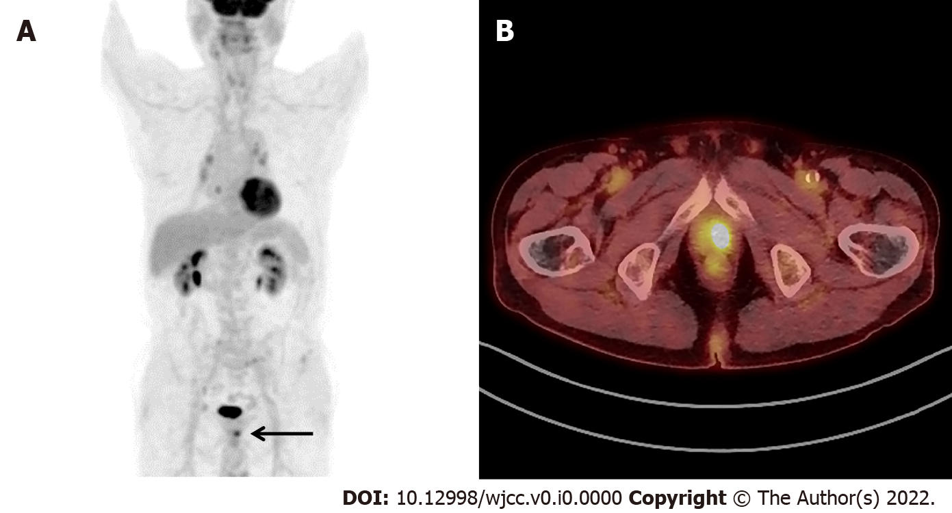
Figure 1 A case of malignant incidental focal prostate fluorine-18 fluorodeoxyglucose uptake. A: Focal uptake (black arrow) below the radioactivity of bladder on the maximum intensity projection image of a 76-year-old man diagnosed with non-small cell lung cancer; B: Axial image of fused positron emission tomography/computed tomography showing hypermetabolism (maximum standardized uptake value 8.1) in the left prostate region and histopathologically confirmed as an adenocarcinoma of the prostate gland.

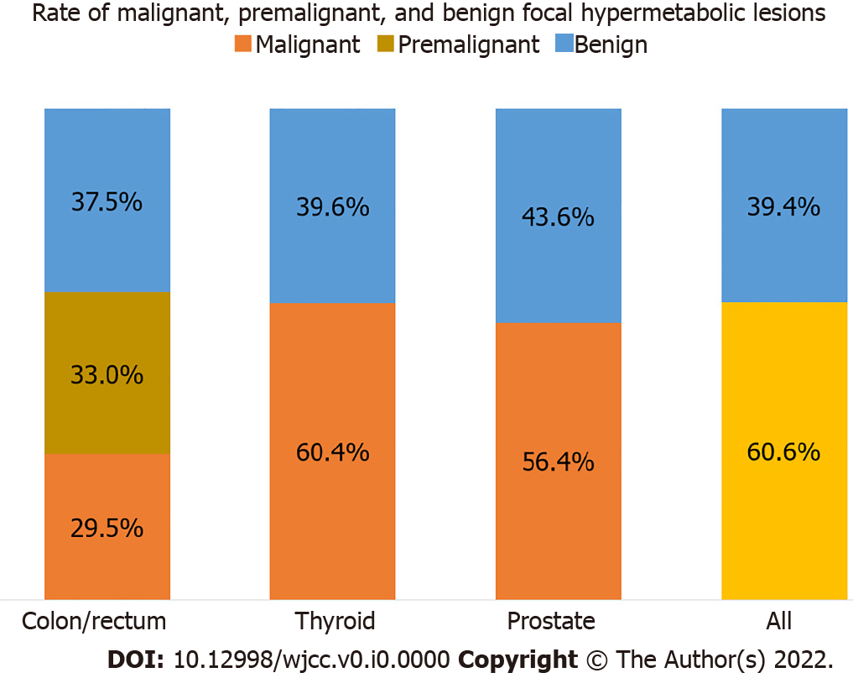
Figure 2 Rates of malignant, premalignant (in colon and rectum), and benign incidental focal hypermetabolic fluorine-18 fluorodeoxyglucose uptake in the colon/rectum, thyroid, and prostate. “ALL” indicates benign (39.4%) and malignant/premalignant (60.6%) lesions.
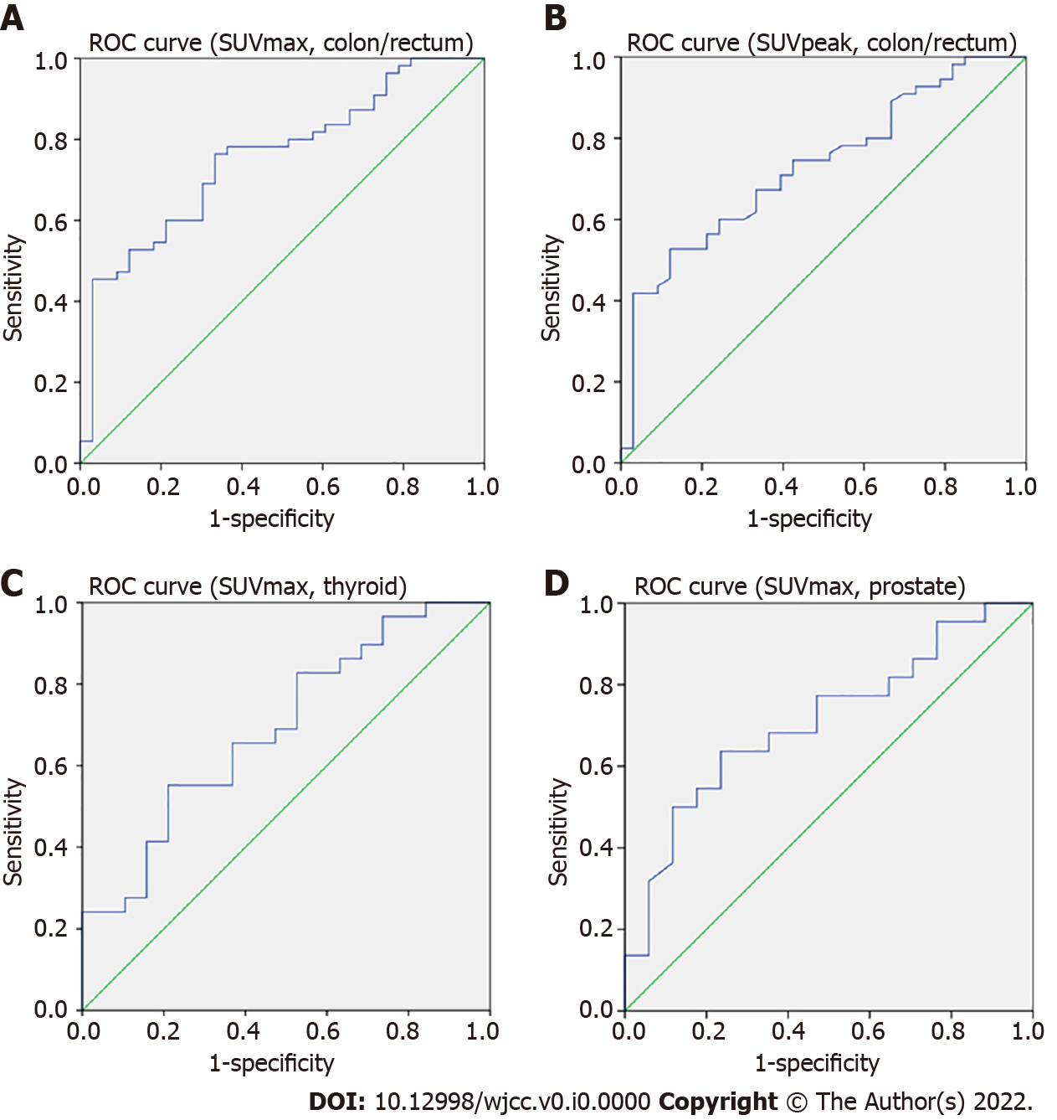
Figure 3 Representative receiver operating characteristic curves. A: Standardized uptake value (SUV)max of colon/rectum; B: SUVpeak of colon/rectum; C: SUVmax of thyroid; D: SUVmax of prostate. Area under the curves are 0.752, 0.729, 0.676, and 0.706, respectively. ROC: Receiver operating characteristic.
Table 1 Demographic features of patients with incidental focal hypermetabolism in colon/rectum, thyroid, and prostate
Lesion | Status | Men, n, (age in mean yr ± SD) | Women, n, (age in mean yr ± SD) | Total, n, (age in mean yr ± SD)
Colon/rectum | Malignant | 17 (70.5 ± 11.1) | 8 (72.5 ± 14.1) | 25 (70.8 ± 12.0)
 | Premalignant | 22 (68.1 ± 6.3) | 7 (67.6 ± 17.4) | 29 (67.9 ± 9.9)
 | Benign | 9 (60.7 ± 14.3) | 22 (58.7 ± 14.6) | 31 (59.3 ± 14.3)
Thyroid | Malignant | 10 (61.1 ± 13.1) | 19 (58.7 ± 10.7) | 29 (59.8 ± 11.1)
 | Benign | 2 (67.5 ± 16.3) | 17 (61.2 ± 13.1) | 19 (61.9 ± 13.1)
Prostate | Malignant | 22 (74.1 ± 7.7) | N/A | N/A
 | Benign | 17 (68.8 ± 6.1) | N/A | N/A
SD: Standard deviation.

Table 2 AUCs and cutoffs for malignant colorectal¹, thyroid, and prostate lesions
Lesion | SUV | AUC | 95% confidence interval | P value | Cutoff | Sensitivity | Specificity
Colorectal | SUVmax | 0.752 | 0.649-0.856 | P < 0.001 | 7.6 | 0.673 | 0.676
 | SUVpeak | 0.729 | 0.62-0.836 | P < 0.001 | 6.2 | 0.673 | 0.706
Thyroid | SUVmax | 0.676 | 0.521-0.832 | P = 0.025 | 6.9 | 0.63 | 0.632
Prostate | SUVmax | 0.706 | 0.544–0.868 | P = 0.026 | 3.8 | 0.591 | 0.588
AUC: Area under the curve; SUV: Standardized uptake value.
¹Focal colorectal uptake includes both malignant and premalignant lesions.

