Name of journal: World Journal of Gastroenterology
Manuscript NO: 41799
Manuscript type: ORIGINAL ARTICLE

Basic Study
Mismatched effects of receptor interacting protein kinase-3 on hepatic steatosis and inflammation in non-alcoholic fatty liver disease

Saeed WK et al. RIP3 deletion and NAFLD

Waqar Khalid Saeed, Dae Won Jun, Kiseok Jang, Sang Bong Ahn, Ju Hee Oh, Yeon Ji Chae, Jai Sun Lee, Hyeon Tae Kang

Waqar Khalid Saeed, Dae Won Jun, Department of Gastroenterology, Hanyang University College of Medicine, Seoul 04763, South Korea

Kiseok Jang, Department of Pathology, Hanyang University College of Medicine, Seoul 04763, South Korea

Sang Bong Ahn, Department of Internal Medicine, Eulji University, Daejeon 34824, South Korea

Ju Hee Oh, Yeon Ji Chae, Jai Sun Lee, Hyeon Tae Kang, Department of Translational Medicine, Hanyang University College of Medicine, Seoul 04763, South Korea

ORCID number: Waqar Khalid Saeed (0000-0002-7888-9108); Dae Won Jun (0000-0002-2875-6139); Kiseok Jang (0000-0002-6585-3990); Sang Bong Ahn (0000-0001-7419-5259); Ju Hee Oh (0000-0003-3031-0272); Yeon Ji Chae (0000-0001-7126-1070); Jai Sun Lee (0000-0002-1673-8777); Hyeon Tae Kang (0000-0002-0595-3025).

Author contributions: Saeed WK drafted the manuscript; Jun DW research design and supervision; Oh JH, Chae YJ, Lee JS, and Kang HT collected data; Lee JS analyzed the data; Jang K analyzed histology data; Ahn SB supervised and revised manuscript.

Supported by National Research Foundation of Korea (NRF), funded by the South Korean Government, No. NRF-2017R1C1B5074215.

Institutional animal care and use committee statement: All the experimental procedures were approved by the Hanyang University Institutional Animal Care and Use Committee of (HY-IACUC-16-0075).

Conflict-of-interest statement: The authors have declared no conflicts of interest.

Data sharing statement: No additional data is available.

Open-Access: This is an open-access article that was selected by an in-house editor and fully peer-reviewed by external reviewers. It is distributed in accordance with the Creative Commons Attribution Non Commercial (CC BY-NC 4.0) license, which permits others to distribute, remix, adapt, build upon this work non-commercially, and license their derivative works on different terms, provided the original work is properly cited and the use is non-commercial. See: http://creativecommons.org/licenses/by-nc/4.0/

Manuscript source: Unsolicited manuscript

Correspondence to: Dae Won Jun, MD, PhD, Professor, Department of Internal Medicine, Hanyang University College of Medicine, 222 Wangsimni-ro, Seongdong-gu, Seoul 04763, South Korea. noshin@hanyang.ac.kr
Telephone: +82-2-22908338
Fax: +82-2-9720068

Received: August 27, 2018
Peer-review started: August 27, 2018
First decision: October 24, 2018
Revised: November 8, 2018
Accepted: November 13, 2018
Article in press:
Published online:

Abstract
AIM
To validate the effects of receptor interacting protein kinase-3 (RIP3) deletion in non-alcoholic fatty liver disease (NAFLD) and to clarify the mechanism of action.

METHODS
Wild-type (WT) and RIP3 knockout (KO) mice were fed with normal chow and high fat (HF) diet for 12 wk. The body weight was assessed once weekly. After 12 wk, the liver and serum samples were extracted. The liver tissue expressions for RIP3, microsomal triglyceride transfer protein (MTTP), protein disulfide isomerase (PDI), apolipoprotein-B (ApoB), X-box binding protein-1, sterol regulatory element-binding protein-1c, fatty acid synthase, cluster of differentiation-36, diglyceride acyltransferase, peroxisome proliferator-activated receptor alpha, tumor necrosis factor alpha (TNF-α), and interleukin-6 (IL-6) were assessed. Oleic acid treated primary hepatocytes from WT and RIP3KO mice were stained with Nile red. The monocytes expression for inflammatory cytokines including chemokine (C-X-C motif) ligand 1 (CXCL1), CXCL2, and TNF-α was evaluated.

RESULTS
RIP3KO HF diet fed mice showed a significant gain in body weight. The liver weight, liver to body weight ratio, and liver triglycerides were increased in HF diet fed RIP3KO mice. RIP3KO primary hepatocytes also had increased intracellular fat droplet compared to WT primary hepatocytes after oleic acid treatment. RIP3 overexpression decreased hepatic fat contents. Quantitative real-time PCR analysis showed that RIP3KO mice had significantly suppressed very-low-density lipoproteins secretion markers (MTTP, PDI, and ApoB expressions). The overall NAFLD Activity Score was the same between WT and RIP3KO mice; however, RIP3KO mice had increased fatty change and decreased lobular inflammation compared to WT mice. Inflammatory signals (CXCL1/2, TNF-α, and IL-6) increased after lipopolysaccharide and pan-caspase inhibitor (necroptotic condition) in monocyte. And neutrophil chemokines (CXCL1, and CXCL2) were decreased, but TNF-α was increased after RIP3 inhibitor treatment in monocyte.

CONCLUSION
RIP3 deletion exacerbates steatosis, and partially inhibit inflammation in HF diet induced NAFLD model.

Key words: Necroptosis; Receptor interacting protein kinase-3; Mixed lineage kinase domain-like protein; Necroptosis; Non-alcoholic fatty liver disease; Steatosis

© The Author(s) 2018. Published by Baishideng Publishing Group Inc. All rights reserved.

Core tip: Receptor interacting protein kinase-3 (RIP3) deletion was associated with increased fatty change, hepatic tissue triglycerides, body weight and serum aspartate aminotransferase and alanine aminotransferase. Very-low-density lipoproteins secretion markers including apolipoprotein-B, microsomal triglyceride transfer protein, and protein disulfide isomerase were suppressed with RIP3 deletion. High fat (HF) diet fed RIP3KO mice had reduced tumor necrosis factor alpha, and neutrophil chemokines [Chemokine (C-X-C motif) ligands: CXCL1, and CXCL2] expressions compared to HF diet fed wild-type mice. In vitro analysis suggests that necroptotic stimulation [lipopolysaccharide + N-Benzyloxycarbonyl-Val-Ala-Asp(O-Me) fluoromethyl ketone] increased CXCL1/2 expressions in monocytes. RIP3 inhibitor (GSK'843) decreased CXCL1/2 as well as interleukin-6 expressions.

Saeed WK, Jun DW, Jang K, Ahn SB, Oh JH, Chae YJ, Lee JS, Kang HT. Mismatched effects of receptor interacting protein kinase-3 on hepatic steatosis and inflammation in non-alcoholic fatty liver disease. World J Gastroenterol 2018; In press

INTRODUCTION
Non-alcoholic fatty liver disease (NAFLD) comprises one of the major liver disease burden in the developed world. In the United States, the prevalence of NAFLD is up to 25 percent^{[1]}. NAFLD, the hepatic component of metabolic syndrome, is a multifactorial wide spectrum disease ranging from simple steatosis to steatohepatitis and further progressing to fibrosis and the hepatocellular carcinoma. In NAFLD increased lipids accumulation in hepatocytes leads to steatosis, inflammation and fibrosis. NAFLD could also be hinting towards decreasing heart function^{[2]}. In youngers, NAFLD is also associated with decreased sleep, decreased quality and frequency of food intake, and the sedentary life-style^{[3]}. The lifestyle modifications directed towards reduced steatosis in NAFLD would not only improve NAFLD but also the cardiac function^{[2]}. Although the prevalence of NAFLD is increasing; however, there are still numerous diagnostic and treatment issues associated with NAFLD. For instance, although, liver biopsy remains the gold standard method for NAFLD diagnosis; however, currently no diagnostic method can correctly distinguish between simple steatosis and steatohepatitis. Moreover, there is still a lack of satisfactory treatment strategy for NAFLD^{[4]}.
In NAFLD, the ‘first hit’ comprises of accumulation of fatty acids in hepatocytes facilitated by increased fatty acids synthesis and increased insulin resistance. Later, the multiple ‘parallel hits’ mainly comprising of endoplasmic reticulum stress, mitochondrial dysfunction, oxidative stress, and inflammatory cytokines further facilitate the hepatocytes dysfunction and death^{[5]}. Cell death is the fundamental step leading to steatohepatitis from benign steatosis. The increased steatosis and inflammation can trigger hepatocytes death by either apoptosis or necrosis^{[6-8]}. Recently, the significance of inhibiting alternate cell death pathways including necroptosis has been extensively reported^{[9]}.
Necroptosis, receptor interacting protein kinase 1 and 3 (RIP1/RIP3) and mixed lineage kinase domain like pseudokinase (MLKL) dependent, apoptosis alternate programmed, and necrosis like cell death pathway has been evaluated in various hepatic pathologies^{[10-17]}. The increased RIP3 and MLKL expressions observed in human NASH, type II diabetes and obese patients^{[11-13]} highlights the significance of necroptosis in human disease conditions. Moreover, human metabolic disease serum markers including HbA1c and insulin are also correlated with RIP3 and p-MLKL expressions^{[13]}.
Previously, several studies reported varying results of necroptosis inhibition in animal NAFLD models^{[11-13,18]}. To evaluate the role of necroptosis inhibition, the studies utilized methionine choline deficient (MCD) diet, high fat (HF) diet and choline-deficient HF diet (CD-HFD) induced NAFLD models^{[11-13,18]}. In HF diet induced NAFLD model, RIP3 inhibition led to increased steatosis and glucose intolerance^{[13,18]}. The global RIP3 deletion led to increased body weight and hepatic steatosis in HF diet induced NAFLD model, while in MCD diet induced NAFLD model, RIP3 deletion showed protective effects on both hepatic steatosis and inflammation^{[11,12]}. Interestingly, HF diet fed RIP3KO mice also had increased hepatic apoptosis, inflammation, and fibrosis^{[18]}. Moreover, adipose tissue apoptosis and inflammation were also increased in RIP3KO mice compared to WT mice^{[13,18]}. An additional vivo signaling was suspected leading to increased steatosis^{[13,18]} and adipocytes apoptosis and inflammation^{[13]}. On contrary, in MCD diet induced NAFLD model, RIP3KO mice had decreased inflammation, steatosis and fibrosis compared to WT mice^{[11,12]}. Although, the previous studies evaluated the effect of RIP3 deletion in HF diet induced NAFLD model; however, the detailed mechanism of increased steatosis associated with RIP3 deletion was still not clear.
Therefore, by using HF diet induced NAFLD in RIP3KO mice, we aimed to validate and evaluate the precise underlying mechanism of steatosis and inflammation in hepatocytes and inflammatory cells.

MATERIALS AND METHODS

Animal experiments
C57BL/6 wild-type (WT) (8-9 wk old) and RIP3-KO mice (8-9 wk old) were randomly divided into following groups (n = 8); WT- normal chow (NC), WT-HF, RIP3KO-NC, RIP3KO-HF. To evaluate the effects of RIP3 inhibition on HF diet induced NAFLD development, NC, and HF (60% kcal) diets were fed for 12 wk to the assigned groups. Four animals were kept per cage and animals were maintained in a temperature-controlled room (22 °C) on a 12:12 h light-dark cycle. The body weight was recorded once weekly. After 12 wk, the animals were sacrificed. The liver weight and liver to body weight ratio were measured. All the experimental procedures were approved by the Hanyang University Institutional Animal Care and Use Committee of (HY-IACUC-16-0075). RIP3-KO animals were generously provided by Newton et al^{[19]} Genentech (San Francisco, CA, United States).

Histological assessment of liver biopsy samples
For histological assessment, paraformaldehyde fixed, paraffin embedded liver tissue samples were sectioned (4 µm) and stained with hematoxylin & eosin. The stained liver biopsy samples were analyzed by a single pathologist. The NASH clinical research network scoring system was used to histological grade the NAFLD in mice liver^{[20]}. Briefly, steatosis degree, hepatocytes ballooning, and lobular inflammation were graded semi-quantitatively. The NAFLD Activity Score (NAS) was assessed by a combination of each score. Based on the NAS score, the commutative score of (0-2), control; (3-4), NAFLD; and (> 5), NASH was assigned.

Triglyceride quantification
To quantify liver triglycerides (TG) contents, triglyceride quantification kit (Abcam, Cambridge, MA, United States) was used. Briefly, snap-frozen livers tissues (50–100 mg) were homogenized in 5% NP-40, and then slowly heated to 80 °C for 5 min and cooled down. The process was repeated twice. The samples were then centrifuged for 5 min, and supernatants were diluted 20-folds with distilled water and were analyzed calorimetrically according to manufacturer's instructions.

HepG2 cells culture and maintenance
HepG2 cells were seeded on 6-well plate using Dulbecco's modified Eagle's medium (DMEM; Gibco, CA, United States) containing 10% fetal bovine serum (FBS) and 1% penicillin/streptomycin (P/S). After 24 h, the media was removed, the cells were washed with Dulbecco's phosphate-buffered saline (DPBS) followed by treatment with oleic acid (OA; 400 µmol/L, Sigma Aldrich, St Louis, MO, United States), palmitic acid (PA; 400 µmol/L, Sigma Aldrich, St Louis, MO, United States) and GSK'843 (5 µmol/L, AOBIOUS INC, 9 Blackburn Drive, Gloucester, MA, United States). After 24 h, the RNA was isolated using the RNeasy mini kit (Qiagen, Hilden, Germany) according to manufacturer's instructions.

Primary hepatocytes isolation and culture
Primary hepatocytes from WT and RIP3-KO mice were isolated by a two-step collagenase perfusion method as described previously^{[21]}. Briefly, mice were anesthetized using Zoletil and Rompun 1:1. The liver was perfused using calcium and magnesium-free Hanks' Balanced Salt Solution (HBSS; Welgene, Gyeongsan, South Korea) supplemented with 25 mmol/L, 4-(2-hydroxyethyl)−1-piperazine ethanesulfonic acid (HEPES; Amresco, Solon, OH, United States) and 0.5 mmol/L, ethylene-glycol-bis-(β-aminoethylene)-N,N,N',N'-tetraacetic acid (EGTA; Sigma-Aldrich, MO, United States), followed by perfusion with low glucose DMEM supplemented with 15 mmol/L HEPES and Collagenase Type IV (100 U/mL; Worthington Biochemical Corporation, Lakewood, NJ, United States), (pH 7.4, 37 °C). After perfusion, the liver was carefully removed and gently minced in 20 mL ice-cold William’s E medium (Gibco, CA, United States) supplemented with 10% heat-inactivated FBS, 10 mL/L Insulin-Transferrin-Selenium (ITS; Gibco, Grand Island, NY, United States) and 10 mL/L P/S. The homogenized liver suspension was filtered using 70 μm cell strainer. The cell suspension was centrifuged at 50 × g for 5 min. The pellet was re-suspended in 10 mL William’s Medium supplemented with 10% FBS, ITS (10 mL/L), P/S (10 mL/L) and 10 mL buffered Percoll (Sigma-Aldrich, St. Louis, MO, United States). The resultant cell suspension was centrifuged at 50 × g for 5 min and the pellet re-suspended in William’s E medium supplemented with 10% FBS, ITS (10 mL/L), 1 µmol/L dexamethasone and P/S (10 mL/L). The cell viability was determined using the Trypan Blue exclusion method and was generally > 85%. After isolation, primary hepatocytes were plated on rat-tail collagen I (Corning Inc., Corning, NY, United States) coated culture dishes (Thermo Fisher Scientific Inc., United States) at 3 × 10⁵ cells/mL. The hepatocytes were maintained at 37 ℃ in a humidified atmosphere of 5% CO₂ for 4 h. After 4 h, the media was removed and cells were treated with OA (400 µmol/L), in serum-free William’s E medium containing ITS (10 mL/L), 1 µmol/L dexamethasone and P/S (10 mL/L). The control group was treated with equal volumes of DMSO. After 24 h, the hepatocytes were processed as per experimental protocols.

Macrophage cell culture and maintenance
Macrophage U937 cell line were used. The cells were seeded on 6-well plate using DMEM supplemented with 10% FBS and 1% P/S. After 24 h, the media was removed, the cells were washed with DPBS followed by incubation with tumor necrosis factor alpha (TNF-α) (10 ng/mL, R&D Systems, Minneapolis, MN, United States), N-Benzyloxycarbonyl-Val-Ala-Asp(O-Me) fluoromethyl ketone (zVAD) (30 µmol/L, R&D Systems, Minneapolis, MN, United States), lipopolysaccharide (LPS) (25 ng/mL, Sigma Aldrich, St Louis, MO, United States), and GSK'843 (5 µmol/L). After 24 h, the RNA was isolated using the RNeasy mini kit (Qiagen, Hilden, Germany) according to manufactures instructions.

Serum biochemical analysis
The whole blood samples collected in BD serum separation tubes were centrifuged at 3000 rpm at 4 °C for 10 min. The serum samples were collected and stored at -80 °C until analysis. Serum alanine aminotransferase (ALT), aspartate aminotransferase (AST) and TG were measured with an automatic chemical analyzer (Hitachi-747; Hitachi, Tokyo, Japan).

Nile red staining
For lipid droplets staining, primary hepatocytes and HepG2 cells were seeded on a coverslip and were maintained for 4 and 24 h respectively. After attached, the media was removed and cells were co-treated with OA (400 µmol/L) and GSK'843 (5 µmol/L). The control groups were also treated with equal volumes of DMSO. After 24 h, the media was removed and cells were washed twice with DPBS, fixed with 4% paraformaldehyde in PBS for 30 min at room temperature, rinsed twice with DPBS and incubated with fluorescence dye Nile red (0.5 mg/mL in acetone). The confocal imaging was performed using a Leica TCS SP5 confocal microscope (Leica Microsystems, Wetzlar, Germany).

RIP3 non-viral vector construction
The human RIP3 (NM_006871) coding regions were amplified by PCR using TrueORF cDNA Clones (Origene, Rockville, MD, United States) for genes. The fragments were cloned into the pECFP (enhanced green fluorescent protein)-C1 vector (Clontech, Palo Alto, CA, United States). Later, RIP3 PCR products were subcloned into pGEM-T easy vector (Promega, Madison, WI, United States), and then cloned into EcoRI - BamHI sites of the pECFP-C1 vector.

RIP3 overexpression in primary hepatocytes
The primary hepatocytes were isolated and maintained as previously described. RIP3 was overexpressed in primary hepatocytes using JetPEI DNA transfection reagent (Polyplus-transfection SA, Illkirch, France) according to manufacturer's instructions. Briefly, 1 × 10⁵/mL primary hepatocytes were seeded on collagen-coated cover slides in 24-well plates. After 4 h, the media was replaced with fresh culture media supplemented with 10% FBS. RIP3 DNA (3 µg/well) was diluted in 100 µL NaCl (150 mmol/L) and was gently vortexed and spin down. Six microliter per well JetPEI reagent was diluted in 100 µL NaCl (150 mmol/L) and was gently vortexed and spin down. The diluted reagent was mixed and vortexed with diluted DNA and incubated for 30 min at room temperature. After 30 min, 50 µL JetPEI/DNA mix was added to each well of 24-well plates. After 12 h, the transfection was confirmed by visualizing green fluorescence of EGFP-C1 using a Leica DMI 14000B inverted microscope (Leica Microsystem, Wetzlar, Germany).

RNA isolation and quantitative real-time PCR
The total liver RNA was isolated from liver tissue using the TRIzol Reagent (Invitrogen, Carlsbad, United States) according to the manufacturer’s instructions. The isolated RNA samples were converted to cDNA using reverse transcriptase (SuperScript III; Invitrogen) and oligo (dT) primers. All PCR reactions were performed on the LightCycler 480 system (Roche Diagnostics, Mannheim, Germany) using LightCycler480 SYBRGreen I Mastermix (Roche Diagnostics) in standard 10 µL reaction volumes as follows: 4 µL (100 ng) cDNA, 0.5 µL of 10 pmol/L sense primer, 0.5 µL of 10 pmol/L antisense primer, and 5 µL LightCycler 480 SYBRGreen I Mastermix (Roche Diagnostics). To guarantee the reliability of the obtained results, all samples were processed in triplicate, and was performed using a negative control. The values thus obtained were normalized versus the control and were expressed as fold changes.

Data analysis
The values are expressed as mean ± SD. Statistical analysis was performed using SPSS for Windows version 21.0 (SPSS Inc., Chicago, IL, United States). All experiments were performed three times. One-way ANOVA and Mann-Whitney U test were performed to compare the mean between different values and a P-value <0.05 was considered significant.

RESULTS

Exacerbated intrahepatic fat amount, but attenuated hepatic inflammation in HF diet fed RIP3KO mice
RIP3KO mice showed increased hepatic fat deposition on histological and hepatic tissue TG contents analysis compared to WT mice (4.58 nm/µL vs 6.92 nm/µL, P = 0.000) when fed with 60% HF, but not with normal chow diet (Figure 1A and C). A significant increase in body weight of HF diet fed RIP3KO mice was observed compared to WT group. Overall NAS score was insignificant between the both WT-HF and RIP3KO-HF groups; however, the fatty change was significantly increased (2 vs 3, P = 0.000), and lobular inflammation was decreased (1.5 vs 0.75, P = 0.007) in HF fed RIP3KO mice (Figure 1B, D-F). The liver weight (1.87 g vs 2.43 g, P = 0.001) and liver to body weight ratio (5.09 vs 3.91, P = 0.000) were also increased in HF diet fed RIP3KO mice compared to WT mice (Figure 1H and I). The serum ALT was also increased in HF diet fed RIP3KO mice (Figure 1K).

Effect of RIP3 ablation on hepatic fat regulation
RIP3 expression increased following HF diet feeding (Figure 2A) as previously observed^{[18]}. Other genes expressions involved in lipids homeostasis including sterol regulatory element-binding protein-1c (SREBP1c), fatty acid synthase (FAS), cluster of differentiation-36 (CD36), diglyceride acyltransferase (DGAT), and peroxisome proliferator-activated receptor alpha (PPAR-α) were not definite (Figure 2F-J). The genes involved in very-low-density lipoprotein (VLDL) secretion were analyzed to evaluate increased hepatic tissue TG contents. The mRNA analysis showed that RIP3KO mice had significantly decreased VLDL secretion markers including microsomal triglyceride transfer protein (MTTP), protein disulfide isomerase (PDI), and apolipoprotein-B (ApoB). VLDL secretion markers were further suppressed in RIP3KO animals following HF diet feeding (Figure 2B-D).
Next, to confirm whether the effect of RIP3 deletion could also be observed in in vitro settings, primary hepatocytes from WT and RIP3KO mice were isolated. Following treatment with OA, Nile red staining increased in both WT and RIP3KO primary hepatocytes. However, OA treated RIP3KO primary hepatocytes had increased Nile red staining compared to WT primary hepatocytes (Figure 3A). Next, to further confirm, RIP3 was overexpressed in primary hepatocytes using RIP3 overexpression system. If RIP3 ablation exacerbates hepatic lipid storage then RIP3 overexpression should decrease the lipid storage. As expected, RIP3 overexpressed primary hepatocytes had decreased Nile red staining compared to control (Figure 3B). Next, we evaluated whether RIP3 inhibition using GSK'843 would also depict the similar results in HepG2 cells. However, GSK'843 treated HepG2 cells did not show increase in Nile red staining, decrease in MTTP, PDI and ApoB expressions (Figure 3C and D) and changes in SREBP1c, FAS and Stearyl-CoA desaturase (SCD-1) expressions (Figure 3E).

RIP3 partially regulated macrophage activation
HF diet fed RIP3KO mice also had reduced TNF-α, CXCL1 and CXCL2 expressions compared to HF diet fed WT mice (Figure 4A and B). In vitro analysis suggested that necroptotic stimulation (LPS+zVAD) increased CXCL1/2 expressions in monocytes. RIP3 inhibitor (GSK'843) decreased CXCL1/2 expressions as well as IL-6 expression, but GSK'843 did not reduce TNF-α expression. The neutrophil chemokines (CXCL1, and CXCL2) were decreased with GSK'843 (Figure 5A and B).

DISCUSSION
Our results suggest that RIP3 inhibition is associated with suppression of VLDL secretion markers, and partial inhibition of macrophage activation via inhibiting CXCL1 and 2 expressions.
Previously, varying results of RIP3 inhibition in HF and MCD diet induced animal NAFLD models were observed. In HF diet induced NAFLD models^{[18]}, RIP3 deletion was associated with increased fatty change, hepatic tissue triglycerides, body weight and serum AST and ALT. But the other study reported that in MCD diet induced NAFLD model, RIP3 deletion did not affect lipidosis score in the early phase (2-wk) while decreased lipidosis score in the late phase (8-wk)^{[11]}. The MCD diet induced NAFLD studies did not extensively evaluate for hepatic steatosis^{[11,12]}. None of the previous studies evaluated the precise mechanism of hepatic fat accumulation and the interaction with hepatocytes pathways of lipid de novo synthesis, transportation, and metabolism. Our results also showed that VLDL secretion markers including ApoB, MTTP, and PDI were suppressed with RIP3 deletion (Figure 2). The primary hepatocytes isolated from WT and RIP3KO mice were treated with DMSO and OA. Similar to increased hepatic TG contents in RIP3KO mice, OA treated RIP3KO primary hepatocytes had increased Nile red staining compared to OA treated WT primary hepatocytes. Correspondingly, RIP3 overexpressed primary hepatocytes also showed decreased Nile red staining compared to control (Figure 3). However, we did not observe decrease in MTTP, PDI and ApoB expressions following treatment with GSK'843 in HepG2 cells.
Similar to previous finding^{[13]}, our results showed that the overall NAS score was the same between HF diet fed WT and RIP3KO mice; however, lobular inflammation was decreased in our study. Moreover, in contrast to MCD diet induced NAFLD model, RIP3 deletion associated reduction in serum AST, and ALT were not observed in our study. On contrary, in HF diet induced NAFLD model, RIP3 induction was thought to protect hepatocytes against further steatosis and, thus the RIP3 deletion might had led to more deleterious effects^{[18]}. Moreover, RIP3 deletion was also associated with exacerbated inflammation in HF diet induced NAFLD^{[18]}. Interestingly, RIP3 deletion reduced ethanol induced steatosis^{[22]}. In our study, following HF diet feeding CXCL1/2 expressions increased in liver tissue. RIP3KO mice had reduced CXCL1/2 expressions compared to corresponding controls. In in vitro setting, TNFα/LPS+zVAD induced CXCL1/2 expressions. GSK'843 treatment although reduced CXCL1 and CXCL2 expressions in U937 macrophages and HepG2 cells; however, TNF-α expressions was not reduced (Figures 5 and 6).
Our study has the following limitations. First, we did not evaluate the long-term effects of RIP3 deletion associated exacerbated response in HF diet induced NAFLD model. Moreover, we also did not evaluate the previously highlighted contribution of increased hepatic and adipose tissues apoptosis associated with RIP3 deletion in NAFLD. RIP3 ablation in adipose tissue leads to the metabolic phenotype in RIP3KO mice. Moreover, RIP3 has a role in maintaining white adipose tissue homeostasis and systemic RIP3 ablation lead to insulin resistance and glucose intolerance. RIP3 overexpression is thought to balance caspase-8 mediated increased apoptosis. Following, RIP3 deletion, a switch towards increased apoptosis in both liver and adipose tissues was observed and increased adipocytes apoptosis was thought to mediate systemic effects^{[13]}. Therefore, to further elaborate the detailed mechanism of additional vivo signaling, a further in depth analysis would be needed. Second, hepatocytes specific RIP3 knockout and RIP3 kinase dead mice would be further useful in HF diet induced NAFLD. Furthermore, the pathogenic context, initiating stimulus, and compartment specific RIP3 regulation^{[12,13]} might also explain why such diverse results of RIP3 deletion are observed in NAFLD model. Other studies also reported that the expression of regulated necrosis molecules could be different according to the trigger, disease pathogenesis, organs involved and species^{[23]}. Moreover, studies also suggest that different cell types could be responding differentially to necroptosis stimuli^{[13]}.
In conclusion, our results show that RIP3 deletion aggravates hepatic steatosis in HF diet induced NAFLD model. RIP3 deletion was also associated with suppression of VLDL secretion from hepatocytes. Moreover, targeting RIP3 could have deleterious systemic consequences. The future research should consider the diverse and unwanted systemic consequences of RIP3 deletion in NAFLD. The role of RIP3 could be a double-edged sword in NAFLD. Although RIP3 has a crucial role in necroptosis, RIP3 showed diverse effects in metabolic disease. Therefore, careful attention and more extensive studies are needed to further elaborate the interactions between RIP3 and NAFLD associated signaling pathways.

ARTICLE HIGHLIGHTS

Research background
The receptor interacting protein kinase-3 (RIP3) inhibition in various non-alcoholic fatty liver disease (NAFLD) models has shown varied results. The underlying mechanism associated with these diverse outcomes is still not clear. The evaluation of necroptosis signaling molecules in NAFLD might provide a useful therapeutic target.

Research motivation
Previous studies report that in HF induced NAFLD, RIP3 deletion exacerbated fatty change, inflammation, fibrosis and apoptosis. However, in methionine choline deficient diet induced NAFLD model, these changes were not observed. The reason for these varies results associated with RIP3 deletion in different NAFLD model is still not clear.

Research objective
To validate the effects of RIP3 deletion in NAFLD and to clarify the mechanism of action.

Research methods
Wild type (WT) and RIP3 knockout (KO) mice were fed with high fat (HF) and normal chow (NC) diets for 12 wk. The body weight was assessed weekly. After 12 wk, the liver and serum samples were analysed for changes. Hematoxylin & eosin staining, NAFLD Activity Score evaluation and triglyceride quantification were performed. The changes in very-low-density lipoproteins (VLDL) secretion and inflammation markers were recorded. Primary hepatocytes were evaluated for lipid contents. HepG2 cells and U937 cells were evaluated for changes in inflammatory markers.

Research results
Our results show that RIP3 deletion is associated with exacerbated hepatic lipids contents, suppressed VLDL secretion markers and partially suppressed inflammation.

Research conclusion
In HF diet induced NAFLD, RIP3 deletion is associated with increased hepatic steatosis and partially suppressed inflammation

Research perspective
Necroptosis signaling molecules, especially mixed lineage kinase domain-like protein, should be further explored for its therapeutic potential in NAFLD.

REFERENCES
1 Fingas CD, Best J, Sowa J-P, Canbay A. Epidemiology of nonalcoholic steatohepatitis and hepatocellular carcinoma. Clinical Liver Disease 2016; 8: 119-122 [DOI: 10.1002/cld.585]
2 Trovato FM, Martines GF, Catalano D, Musumeci G, Pirri C, Trovato GM. Echocardiography and NAFLD (non-alcoholic fatty liver disease). Int J Cardiol 2016; 221: 275-279 [PMID: 27404689 DOI: 10.1016/j.ijcard.2016.06.180]
3 Trovato FM, Martines GF, Brischetto D, Catalano D, Musumeci G, Trovato GM. Fatty liver disease and lifestyle in youngsters: diet, food intake frequency, exercise, sleep shortage and fashion. Liver Int 2016; 36: 427-433 [PMID: 26346413 DOI: 10.1111/liv.12957]
4 Oh H, Jun DW, Saeed WK, Nguyen MH. Non-alcoholic fatty liver diseases: update on the challenge of diagnosis and treatment. Clin Mol Hepatol 2016; 22: 327-335 [PMID: 27729634 DOI: 10.3350/cmh.2016.0049]
5 Bessone F, Razori MV, Roma MG. Molecular pathways of nonalcoholic fatty liver disease development and progression. Cell Mol Life Sci 2018 Epub ahead of print [PMID: 30343320 DOI: 10.1007/s00018-018-2947-0]
6 Ipsen DH, Lykkesfeldt J, Tveden-Nyborg P. Molecular mechanisms of hepatic lipid accumulation in non-alcoholic fatty liver disease. Cell Mol Life Sci 2018; 75: 3313-3327 [PMID: 29936596 DOI: 10.1007/s00018-018-2860-6]
7 Atay K, Canbakan B, Koroglu E, Hatemi I, Canbakan M, Kepil N, Tuncer M, Senturk H. Apoptosis and Disease Severity is Associated with Insulin Resistance in Non-alcoholic Fatty Liver Disease. Acta Gastroenterol Belg 2017; 80: 271-277 [PMID: 29560693]
8 Farrell GC, Haczeyni F, Chitturi S. Pathogenesis of NASH: How Metabolic Complications of Overnutrition Favour Lipotoxicity and Pro-Inflammatory Fatty Liver Disease. Adv Exp Med Biol 2018; 1061: 19-44 [PMID: 29956204 DOI: 10.1007/978-981-10-8684-7_3]
9 Galluzzi L, Bravo-San Pedro JM, Vitale I, Aaronson SA, Abrams JM, Adam D, Alnemri ES, Altucci L, Andrews D, Annicchiarico-Petruzzelli M, Baehrecke EH, Bazan NG, Bertrand MJ, Bianchi K, Blagosklonny MV, Blomgren K, Borner C, Bredesen DE, Brenner C, Campanella M, Candi E, Cecconi F, Chan FK, Chandel NS, Cheng EH, Chipuk JE, Cidlowski JA, Ciechanover A, Dawson TM, Dawson VL, De Laurenzi V, De Maria R, Debatin KM, Di Daniele N, Dixit VM, Dynlacht BD, El-Deiry WS, Fimia GM, Flavell RA, Fulda S, Garrido C, Gougeon ML, Green DR, Gronemeyer H, Hajnoczky G, Hardwick JM, Hengartner MO, Ichijo H, Joseph B, Jost PJ, Kaufmann T, Kepp O, Klionsky DJ, Knight RA, Kumar S, Lemasters JJ, Levine B, Linkermann A, Lipton SA, Lockshin RA, López-Otín C, Lugli E, Madeo F, Malorni W, Marine JC, Martin SJ, Martinou JC, Medema JP, Meier P, Melino S, Mizushima N, Moll U, Muñoz-Pinedo C, Nuñez G, Oberst A, Panaretakis T, Penninger JM, Peter ME, Piacentini M, Pinton P, Prehn JH, Puthalakath H, Rabinovich GA, Ravichandran KS, Rizzuto R, Rodrigues CM, Rubinsztein DC, Rudel T, Shi Y, Simon HU, Stockwell BR, Szabadkai G, Tait SW, Tang HL, Tavernarakis N, Tsujimoto Y, Vanden Berghe T, Vandenabeele P, Villunger A, Wagner EF, Walczak H, White E, Wood WG, Yuan J, Zakeri Z, Zhivotovsky B, Melino G, Kroemer G. Essential versus accessory aspects of cell death: recommendations of the NCCD 2015. Cell Death Differ 2015; 22: 58-73 [PMID: 25236395 DOI: 10.1038/cdd.2014.137]
10 Saeed WK, Jun DW. Necroptosis: an emerging type of cell death in liver diseases. World J Gastroenterol 2014; 20: 12526-12532 [PMID: 25253954 DOI: 10.3748/wjg.v20.i35.12526]
11 Afonso MB, Rodrigues PM, Carvalho T, Caridade M, Borralho P, Cortez-Pinto H, Castro RE, Rodrigues CM. Necroptosis is a key pathogenic event in human and experimental murine models of non-alcoholic steatohepatitis. Clin Sci (Lond) 2015; 129: 721-739 [PMID: 26201023 DOI: 10.1042/CS20140732]
12 Gautheron J, Vucur M, Reisinger F, Cardenas DV, Roderburg C, Koppe C, Kreggenwinkel K, Schneider AT, Bartneck M, Neumann UP, Canbay A, Reeves HL, Luedde M, Tacke F, Trautwein C, Heikenwalder M, Luedde T. A positive feedback loop between RIP3 and JNK controls non-alcoholic steatohepatitis. EMBO Mol Med 2014; 6: 1062-1074 [PMID: 24963148 DOI: 10.15252/emmm.201403856]
13 Gautheron J, Vucur M, Schneider AT, Severi I, Roderburg C, Roy S, Bartneck M, Schrammen P, Diaz MB, Ehling J, Gremse F, Heymann F, Koppe C, Lammers T, Kiessling F, Van Best N, Pabst O, Courtois G, Linkermann A, Krautwald S, Neumann UP, Tacke F, Trautwein C, Green DR, Longerich T, Frey N, Luedde M, Bluher M, Herzig S, Heikenwalder M, Luedde T. The necroptosis-inducing kinase RIPK3 dampens adipose tissue inflammation and glucose intolerance. Nat Commun 2016; 7: 11869 [PMID: 27323669 DOI: 10.1038/ncomms11869]
14 Afonso MB, Rodrigues PM, Simão AL, Ofengeim D, Carvalho T, Amaral JD, Gaspar MM, Cortez-Pinto H, Castro RE, Yuan J, Rodrigues CM. Activation of necroptosis in human and experimental cholestasis. Cell Death Dis 2016; 7: e2390 [PMID: 27685634 DOI: 10.1038/cddis.2016.280]
15 Dara L, Johnson H, Suda J, Win S, Gaarde W, Han D, Kaplowitz N. Receptor interacting protein kinase 1 mediates murine acetaminophen toxicity independent of the necrosome and not through necroptosis. Hepatology 2015; 62: 1847-1857 [PMID: 26077809 DOI: 10.1002/hep.27939]
16 Deutsch M, Graffeo CS, Rokosh R, Pansari M, Ochi A, Levie EM, Van Heerden E, Tippens DM, Greco S, Barilla R, Tomkötter L, Zambirinis CP, Avanzi N, Gulati R, Pachter HL, Torres-Hernandez A, Eisenthal A, Daley D, Miller G. Divergent effects of RIP1 or RIP3 blockade in murine models of acute liver injury. Cell Death Dis 2015; 6: e1759 [PMID: 25950489 DOI: 10.1038/cddis.2015.126]
17 Saeed WK, Jun DW, Jang K, Chae YJ, Lee JS, Kang HT. Does necroptosis have a crucial role in hepatic ischemia-reperfusion injury? PLoS One 2017; 12: e0184752 [PMID: 28957350 DOI: 10.1371/journal.pone.0184752]
18 Roychowdhury S, McCullough RL, Sanz-Garcia C, Saikia P, Alkhouri N, Matloob A, Pollard KA, McMullen MR, Croniger CM, Nagy LE. Receptor interacting protein 3 protects mice from high-fat diet-induced liver injury. Hepatology 2016; 64: 1518-1533 [PMID: 27301788 DOI: 10.1002/hep.28676]
19 Newton K, Sun X, Dixit VM. Kinase RIP3 is dispensable for normal NF-kappa Bs, signaling by the B-cell and T-cell receptors, tumor necrosis factor receptor 1, and Toll-like receptors 2 and 4. Mol Cell Biol 2004; 24: 1464-1469 [PMID: 14749364]
20 Kleiner DE, Brunt EM, Van Natta M, Behling C, Contos MJ, Cummings OW, Ferrell LD, Liu YC, Torbenson MS, Unalp-Arida A, Yeh M, McCullough AJ, Sanyal AJ; Nonalcoholic Steatohepatitis Clinical Research Network. Design and validation of a histological scoring system for nonalcoholic fatty liver disease. Hepatology 2005; 41: 1313-1321 [PMID: 15915461 DOI: 10.1002/hep.20701]
21 Riccalton-Banks L, Bhandari R, Fry J, Shakesheff KM. A simple method for the simultaneous isolation of stellate cells and hepatocytes from rat liver tissue. Mol Cell Biochem 2003; 248: 97-102 [PMID: 12870660]
22 Roychowdhury S, McMullen MR, Pisano SG, Liu X, Nagy LE. Absence of receptor interacting protein kinase 3 prevents ethanol-induced liver injury. Hepatology 2013; 57: 1773-1783 [PMID: 23319235 DOI: 10.1002/hep.26200]
23 Honarpisheh M, Desai J, Marschner JA, Weidenbusch M, Lech M, Vielhauer V, Anders HJ, Mulay SR. Regulated necrosis-related molecule mRNA expression in humans and mice and in murine acute tissue injury and systemic autoimmunity leading to progressive organ damage, and progressive fibrosis. Biosci Rep 2016; 36: [PMID: 27811014 DOI: 10.1042/bsr20160336]
P-Reviewer: Kanda T, Musumeci G
S-Editor: Ma RY L-Editor: E-Editor:
Specialty type: Gastroenterology and hepatology
Country of origin: South Korea
Peer-review report classification
Grade A (Excellent): A
Grade B (Very good): 0
Grade C (Good): C
Grade D (Fair): 0
Grade E (Poor): 0
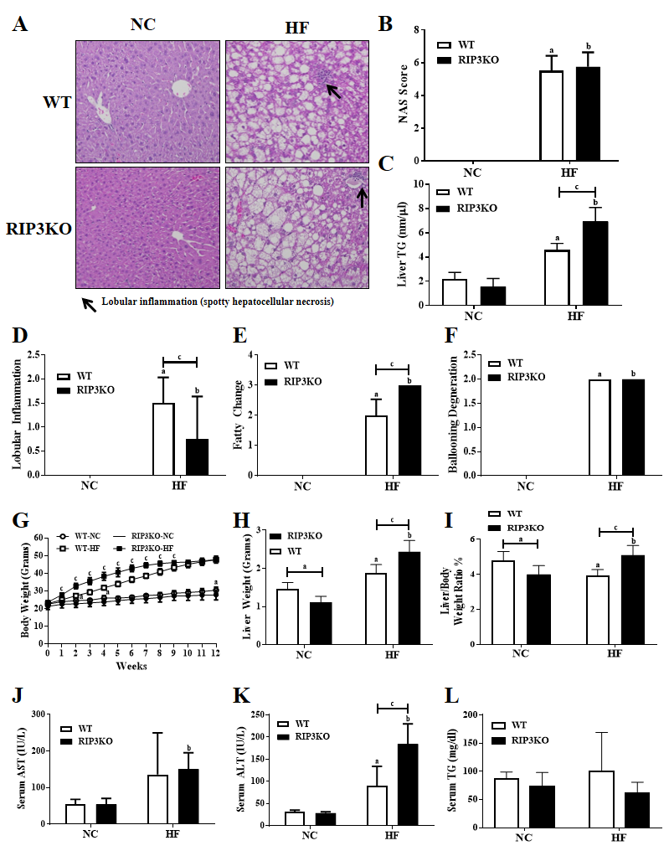
Figure 1 Receptor interacting protein kinase-3 deletion exacerbates high fat diet induced steatosis. A: Following 12-wk high fat (HF) diet feeding, the liver tissue hematoxylin & eosin staining showed increased steatosis in receptor interacting protein kinase-3 knockout (RIP3KO)-HF group compared to wild-type (WT)-HF group. B-F: Liver triglycerides (TG) contents were significantly increased in RIP3KO-HF group compared to WT-HF group. RIP3KO-HF group had increased steatosis and decreased lobular inflammation. G-L: HF diet fed RIP3KO mice had an increased liver weight and liver/body weight ratio compared to HF diet fed WT mice. RIP3KO-HF group had increased serum aspartate aminotransferase, alanine aminotransferase but decreased serum TG compared to WT-HF group. ªP < 0.05 by Mann-Whiteney U test, compared to NC diet fed WT group; ^{b}P < 0.05 by Mann-Whiteney U test, compared to normal chow diet fed RIP3-KO group; ^{c}P < 0.05 by Mann-Whiteney U test, compared to HF diet fed WT group. HF: High fat; NC: Normal chow; WT: Wild-type; KO: Knockout; RIP3: Receptor interacting protein kinase-3; AST: Aspartate aminotransferase; ALT: Alanine aminotransferase; TG: Triglycerides.
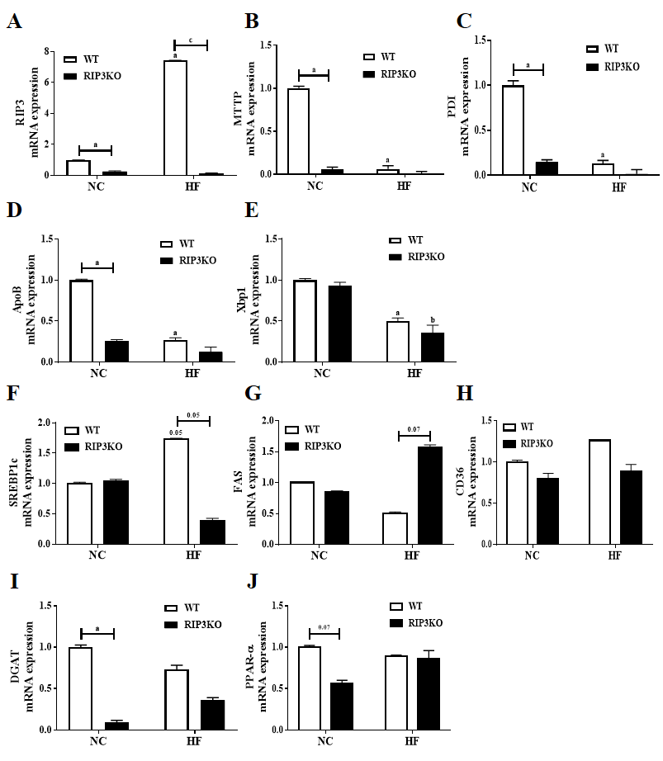
Figure 2 Effect of receptor interacting protein kinase-3 deletion on fat synthesis. A-J: Quantitative real-time PCR analysis showed an increased receptor interacting protein kinase-3 (RIP3) expression in wild-type (WT)-high fat (HF) group after HF diet feeding. Interestingly, very-low-density lipoprotein secretion markers including apolipoprotein-B, microsomal triglyceride transfer protein, protein disulfide isomerase, and X-box binding protein-1 were decreased in RIP3 knockout (KO)-HF group compared to WT-HF group. The differences in sterol regulatory element-binding protein-1c, fatty acid synthas, cluster of differentiation-36, diglyceride acyltransferas, and peroxisome proliferator-activated receptor alpha expressions were not definite. ªP < 0.05 by Mann-Whiteney U test, compared to normal chow (NC) diet fed WT group; ^{b}P < 0.05 by Mann-Whiteney U test, compared to NC diet fed RIP3-KO group; ^{c}P < 0.05 by Mann-Whiteney U test, compared to HF diet fed WT group. HF: High fat; NC: Normal chow; WT: Wild-type; RIP3: Receptor interacting protein kinase-3; VLDL: Very-low-density lipoproteins; ApoB: Apolipoprotein-B; MTTP: Microsomal triglyceride transfer protein; PDI: Protein disulfide isomerase; XBP1: X-box binding protein-1; SREBP1c: Sterol regulatory element-binding protein-1c; FAS: Fatty acid synthase; CD36: Cluster of differentiation-36; DGAT: Diglyceride acyltransferase; PPAR-α: Peroxisome proliferator-activated receptor alpha.
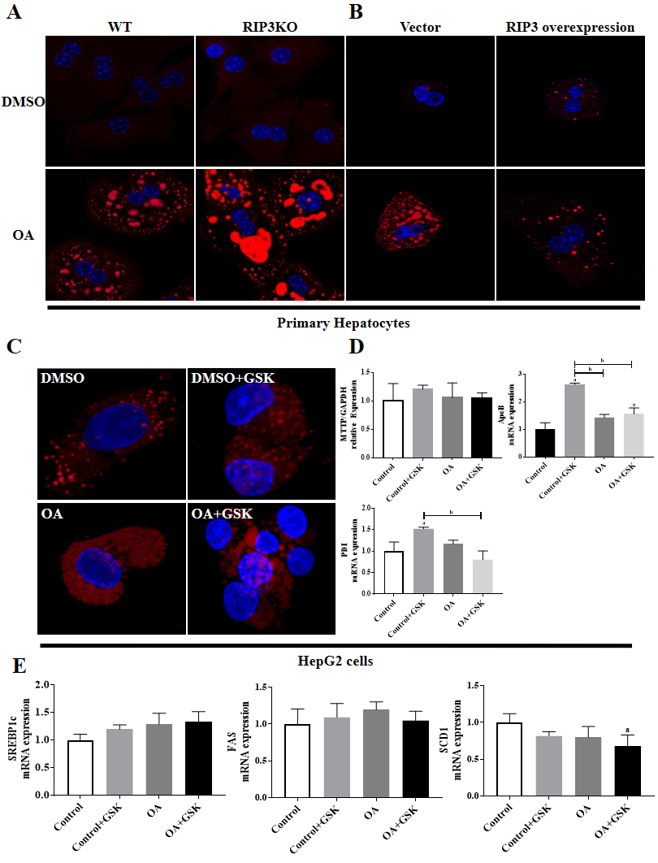

Figure 3 Receptor interacting protein kinase-3 deletion increases hepatic fat storage. A and B: The primary hepatocytes from wild-type (WT) and receptor interacting protein kinase-3 (RIP3) knockout (KO) mice were treated with dimethyl sulfoxide and oleic acid (OA). The RIP3KO primary hepatocytes had increased Nile red staining compared to WT primary hepatocytes. RIP3 overexpression decreased the Nile red staining compared to the vector group treated with OA. C and D: HepG2 cells treated with GSK'843 did not show increase Nile red staining. Microsomal triglyceride transfer protein, protein disulfide isomerase, and apolipoprotein-B expressions were also not decreased in GSK'843 treated HepG2 cells. E: GSK'843 treatment did not increase sterol regulatory element-binding protein-1c, fatty acid synthase and Stearyl-CoA desaturase-1 expressions in HepG2 cells. ªP < 0.05 by ANOVA, Duncan post hoc analysis, compared to control; ^{b}P < 0.05 by ANOVA, Duncan post hoc analysis. WT: Wild-type; RIP3: Receptor interacting protein kinase-3; DMSO: Dimethyl sulfoxide; OA: Oleic acid; ApoB: Apolipoprotein-B; MTTP: Microsomal triglyceride transfer protein; PDI: Protein disulfide isomerase; XBP1: X-box binding protein-1; SREBP1c: Sterol regulatory element-binding protein-1c; FAS: Fatty acid synthase; SCD-1: Stearyl-CoA desaturase-1.
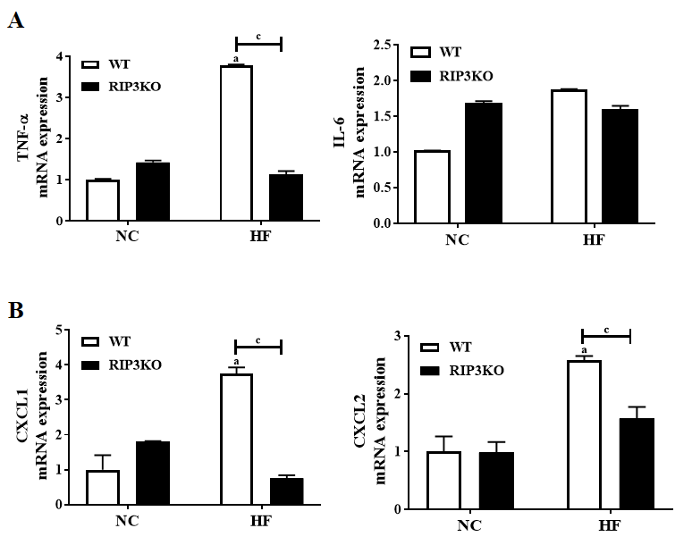
Figure 4 Receptor interacting protein kinase-3 deletion reduces inflammation in liver tissue. Following high fat (HF) diet feeding, receptor interacting protein kinase-3 knockout mice had reduced tumor necrosis factor alpha, chemokine (C-X-C motif) ligand-1 and 2 expressions compared to HF diet fed wild-type (WT) mice. ªP < 0.05 by Mann-Whiteney U test, compared to normal chow diet fed WT group; ^{c}P < 0.05 by Mann-Whiteney U test, compared to HF diet fed WT group. HF: High fat; WT: Wild-type; NC: Normal chow; RIP3: Receptor interacting protein kinase-3; TNF-α: Tumor necrosis factor alpha; CXCL1: Chemokine (C-X-C motif) ligand-1; CXCL2: Chemokine (C-X-C motif) ligand-2.
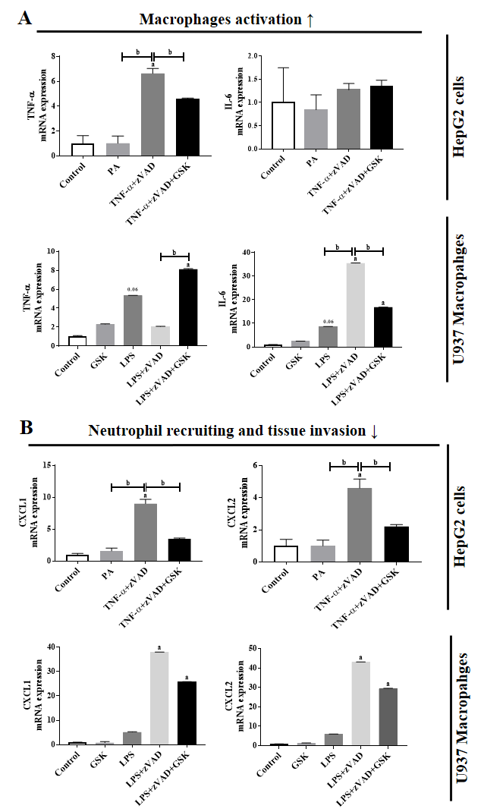
Figure 5 Effect of Receptor interacting protein kinase-3 inhibitor on inflammatory markers. A and B: Tumor necrosis factor alpha (TNF-α)/ lipopolysaccharide (LPS) + N-Benzyloxycarbonyl-Val-Ala-Asp(O-Me) fluoromethyl ketone (zVAD) induced increased expression of TNF-α, was exacerbated with GSK'843 treatment. TNF-α/LPS+zVAD induced increased expression of chemokine (C-X-C motif) ligand-1 and 2 were decreased with GSK'843 treatment. ªP < 0.05 by ANOVA, Duncan post hoc analysis, compared to control; ^{b}P < 0.05 by ANOVA, Duncan post hoc analysis. TNF-α: Tumor necrosis factor alpha; LPS: Lipopolysaccharide; zVAD: N-Benzyloxycarbonyl-Val-Ala-Asp(O-Me) fluoromethyl ketone; CXCL1: Chemokine (C-X-C motif) ligand-1; CXCL2: Chemokine (C-X-C motif) ligand-2.

Figure 6 Conceptual diagram. GSK'843 treatment decreases neutrophil recruitment markers including chemokine (C-X-C motif) ligand-1 and 2, and thereby, reduces neutrophils recruitment to the tissue. However, receptor interacting protein kinase-3 inhibition increases fat de novo synthesis while decreases very-low-density lipoprotein secretion. RIP3: Receptor interacting protein kinase-3; CXCL1: Chemokine (C-X-C motif) ligand-1; CXCL2: Chemokine (C-X-C motif) ligand-2; VLDL: Very-low-density lipoproteins.

