Name of Journal: World Journal of Clinical Cases
Manuscript NO: 60869
Manuscript Type: CASE REPORT

Endoscopic diagnosis and treatment of an appendiceal mucocele: A case report

Wang TT et al. Endoscopic treatment of an appendiceal mucocele

Ting-Ting Wang, Jia-Jun He, Ping-Hong Zhou, Wei-Wei Chen, Chao-Wu Chen, Jun Liu

Ting-Ting Wang, Jia-Jun He, Department of Gastroenterology, The First Clinical Medical College, Dalian Medical University, Dalian 116044, Liaoning Province, China

Ping-Hong Zhou, Department of General Surgery, Zhongshan Hospital, Fudan University, Shanghai 200032, China

Wei-Wei Chen, Chao-Wu Chen, Jun Liu, Endoscopy Center, Department of Gastroenterology, Clinical Medical College, Yangzhou University, Yangzhou 225009, Jiangsu Province, China

Author contributions: Wang TT reviewed the literature and contributed to manuscript drafting; He JJ modified the manuscript; Zhou PH performed the endoscopic procedure; Chen WW and Chen CW contributed to manuscript drafting; Liu J was responsible for the revision of the manuscript for important intellectual content; all authors issued final approval for the version to be submitted.

Corresponding author: Jun Liu, MD, Chief Physician, Endoscopy Center, Department of Gastroenterology, Clinical Medical College, Yangzhou University, No. 88 South University Ave, Yangzhou 225009, Jiangsu Province, China. sbyy_liujun@163.com

Received: November 16, 2020
Revised: December 26, 2020
Accepted: March 18, 2021
Published online:

Abstract
BACKGROUND
Appendiceal mucocele is a rare disease that causes obstructive dilatation of the appendix due to the intraluminal accumulation of mucin. We report a case of endoscopic diagnosis and treatment of an appendiceal mucocele.

CASE SUMMARY
A 47-year-old man presented with a protrusion around the orifice of the appendix discovered by colonoscopy incidentally. He was admitted to our hospital for a routine checkup without any symptoms. Abdominal computed tomography showed a cystic mass approximately 3 cm in diameter with fat stranding. The preoperative diagnosis was non-neoplastic appendiceal mucocele, and endoscopic treatment was performed. The endoscopic findings and pathological results supported our preoperative diagnosis. The endoscopic treatment of appendiceal mucocele was feasible and effective, which was confirmed by repeated endoscopy and post-operative computed tomography after 7 mo.

CONCLUSION
Endoscopic therapy provides a new method for the treatment of appendiceal mucocele.

Key Words: Appendiceal mucocele; Endoscopy; Colonoscopy; Diagnosis; Treatment; Case report

Wang TT, He JJ, Zhou PH, Chen WW, Chen CW, Liu J. Endoscopic diagnosis and treatment of an appendiceal mucocele: A case report. World J Clin Cases 2021; In press

Core Tip: Appendiceal mucocele is rare and was formerly treated by surgical resection. However, iatrogenic rupture of the mucocele may lead to peritoneal dissemination in malignant cases. Colonoscopy is not only significant for diagnosis but also helps treat appendiceal mucocele. Here, we report a case of appendiceal mucocele that was successfully diagnosed and treated by endoscopy.

INTRODUCTION
Appendiceal mucocele is a rare disease that causes obstructive dilatation of the appendix due to the intraluminal accumulation of mucin. The incidence of this condition is 0.2%-0.3% of all appendectomy specimens and 8%-10% of all appendiceal tumors^{[1]}. Appendiceal mucocele is more common in females aged 50-60 years old^{[2]}. Mucoceles may mostly result from luminal obstruction of the appendix root and mucus retention secreted by the distal appendiceal mucosa, causing the appendix to gradually expand into a cystic structure^{[3]}. The preoperative diagnosis of appendiceal mucocele is very difficult. Up to 50% of cases are asymptomatic and discovered incidentally during radiology, endoscopy, or surgery^{[4]}. The most frequent symptom is nonspecific abdominal pain, usually accompanied by a palpable mass in the right iliac fossa, nausea, vomiting, and weight loss^{[5]}. Surgical resection is the traditionally recommended management strategy for appendiceal mucocele. We report a case of endoscopic diagnosis and treatment of an appendiceal mucocele.

CASE PRESENTATION
Chief complaints
A 47-year-old man presented with a protrusion around the orifice of the appendix discovered by colonoscopy incidentally.

History of present illness
The patient denied the presence of abdominal pain, abdominal distention, nausea, or vomiting without weight loss.

History of past illness
No significant past medical history was recorded, such as smoking or drinking.

Personal and family history
The patient had no previous or family history of similar illnesses.

Physical examination
The vital signs and physical examination showed no pathological changes.

Laboratory examinations
All the laboratory test results were within the reference ranges.

Imaging examinations
Abdominal computed tomography (CT) revealed a cystic mass approximately 3 cm in diameter with fat stranding (Figure 1).

FINAL DIAGNOSIS
The preoperative diagnosis was non-neoplastic appendiceal mucocele. Biopsy of the protrusion revealed inflammatory changes in the cecal mucosa and a small amount of myxoid tissue in the focal zone (Figure 2). The intraoperative findings and histopathology further confirmed the preoperative diagnosis.

TREATMENT
The patient underwent endoscopic treatment under intravenous anesthesia. The procedure was performed using a single-channel endoscope (CV-290, Olympus) and a high-frequency electric cutting device (VIO 300D, ERBE). The unit was set for Endocut-Q, effect 3, cutting width 2, and time interval 4.
The detailed operation steps in our case were as follows: Endoscopy revealed a smooth-surfaced submucosal mass of the cecum, in which the appendiceal orifice was located in the center (Figure 3A). We injected the mixed solution of saline, indigo carmine, and epinephrine into the submucosa to elevate the lesion. Then, a snare was placed at the base of the lesion, and the submucosal mass was removed after tightening the snare. After resection of the submucosal mass, a large amount of clear yellowish mucus flowed through the appendiceal orifice into the cecum (Figure 3B). The endoscope was advanced into the appendiceal cavity after flushing the mucus completely. After clearing the mucus, the smooth inner wall of the appendix was exposed, and no nodules were visualized (Figure 3C).

OUTCOME AND FOLLOW-UP
The patient was asymptomatic during follow-up. Repeat endoscopy performed approximately 7 mo later revealed no submucosal mound in the normal appendiceal orifice (Figure 4). Postoperative CT showed no abnormalities in the appendix (Figure 5).

DISCUSSION
In this study, we report a case of appendiceal mucocele that was asymptomatic and discovered incidentally during colonoscopy. It was successfully diagnosed and treated by endoscopy. And there was no recurrence at the 7-mo follow-up.
Appendiceal mucoceles have been classified into four pathologic entities^{[6]}: (1) Simple/retention mucocele; (2) hyperplastic mucocele (5%-25%); (3) mucinous cystadenoma (63%-84%); and (4) mucinous cystadenocarcinoma (11%-20%). Luminal dilatation of a simple mucocele and hyperplastic mucocele is generally mild, and their short-axis diameter rarely exceeds 2 cm. However, mucoceles greater than 6 cm in size may be associated with cystadenoma or cystadenocarcinoma and have a higher perforation rate, which may lead to the development of pseudomyxoma peritonei (PMP)^{[7]}.
It is difficult to make an appropriate preoperative diagnosis because of the nonspecific clinical presentation of appendiceal mucocele. In recent years, with the improvement of diagnostic techniques and accumulation of clinical experience, the preoperative diagnosis rate has been improved. CT is the most commonly used preoperative diagnosis method. The typical feature of a mucocele is a well-encapsulated, round, thin-wall cystic mass filled with mildly attenuated material in the right lower abdomen, and up to 50% of the cases show mural calcification^{[8]}. The wall thickness of the appendix is less than 6 mm with no periappendicular inflammation generally, which is helpful to distinguish mucocele from acute appendicitis^{[9,10]}. Besides, ultrasound and magnetic resonance imaging (MRI) are also useful for the diagnosis of appendiceal mucocele. The “onion skin sign” is a specific ultrasonic appearance that suggests mucocele^{[11]}. MRI could help to differentiate appendiceal mucocele from other cystic lesions in the right lower abdomen. Unlike imaging, colonoscopy usually reveals a smooth ball-shaped mound at the orifice of the appendix, moving in and out with respiratory movement. The appendiceal orifice is in the center of the mound, which is known as the “volcano sign”^{[12]}. In terms of tumor markers, the high serum or cystic fluid concentrations of carcinoembryonic antigen and CA19-9 may be associated with neoplastic appendiceal mucocele and recurrence of the tumor^{[13-15]}. In the present case, luminal dilatation of the mucocele was relatively mild, and the short-axis diameter was approximately 3 cm. In addition, the serum tumor markers were within the reference ranges. Therefore, we considered that the preoperative diagnosis was more likely to be non-neoplastic appendiceal mucocele.
Surgical resection is the only recommended treatment for appendiceal mucocele. Carcinomas represent 11%-20% of all cases and the surgical treatment plan should be carefully made on the basis of pathology. Cubro et al^{[6]} reported a case of appendiceal mucocele that was discovered accidentally by surgical procedure. And there was no recurrence at the 6-mo follow-up after a simple appendectomy. Motsumi et al^{[4]} presented a case of giant appendiceal mucocele that was treated by a right hemicolectomy, and the patient recovered uneventfully. Simple appendectomy is the optimal treatment for patients with a histological diagnosis of benign mucocele. If the histological diagnosis is cystadenocarcinoma, appendectomy combined with right colectomy should be performed^{[13]}. However, the disadvantages of surgical procedures include a high degree of trauma, high cost, and possible serious complications caused by mucocele rupture. For non-neoplastic appendiceal mucocele, colonoscopy could replace traditional surgery to achieve good therapeutic effects by fully flushing the mucus. For neoplastic appendiceal mucocele, surgical resection increases the risk of implantation metastasis caused by mucocele rupture if the intraluminal pressure of the appendix is high. However, colonoscopy can relieve the pressure on the appendicular lumen by flushing the mucus, thus reducing the risk of rupture caused by subsequent surgery. Due to the disadvantages of surgical procedures that have been described above and the patients’ preference for endoscopic minimally invasive treatment, we decided to try to achieve a satisfactory therapeutic effect by endoscopic treatment.
Appendectomy for simple mucocele, hyperplastic mucocele, and mucinous cystadenoma has a 90%-100% 5-year survival rate. The outcome of cystadenocarcinoma without the base of the appendix or peritoneal or adjacent organ involvement after surgical resection is also excellent^{[14]}. However, PMP often recurs after treatment and the 10-year survival rate falls to 63% for PMP after surgery^{[15]}. Our patient in this case had no evidence of recurrence over 7 mo of follow-up after endoscopic treatment. Therefore, we did not recommend further surgical resection for this patient.

CONCLUSION
In conclusion, we report a case of appendiceal mucocele that was successfully diagnosed and treated by endoscopy. For non-neoplastic appendiceal mucocele, the colonoscopy procedure can not only help obtain a diagnosis but also help achieve a satisfactory therapeutic effect by fully flushing the mucus. Moreover, for neoplastic appendiceal mucocele, colonoscopy might relieve the pressure on the appendicular lumen by flushing the mucus and reduce the risk of rupture.

REFERENCES
1 Abuoğlu H, Yıldız MK, Kaya B, Odabaşı M. Clinicopathological analysis of patients operated for appendiceal mucocele. Ulus Travma Acil Cerrahi Derg 2017; 23: 230-234 [PMID: 28530777 DOI: 10.5505/tjtes.2016.30276]
2 Van Hooser A, Williams TR, Myers DT. Mucinous appendiceal neoplasms: pathologic classification, clinical implications, imaging spectrum and mimics. Abdom Radiol (NY) 2018; 43: 2913-2922 [PMID: 29564494 DOI: 10.1007/s00261-018-1561-9]
3 Athanassiou E, Spyridakis M, Karasavvidou F, Vamvakopoulou D, Karaiskou E, Vamvakopoulos N, Theodosiou P, Hatzitheofilou C. Low-Grade Appendiceal Mucinous Neoplasm Presenting as a Surgical Emergency: A Case Report. Case Rep Oncol 2009; 2: 7-11 [PMID: 20740138 DOI: 10.1159/000192775]
4 Motsumi MJ, Motlaleselelo P, Ayane G, Sesay SO, Valdes JR. A case report of a giant appendiceal mucocele and literature review. Pan Afr Med J 2017; 28: 106 [PMID: 29515724 DOI: 10.11604/pamj.2017.28.106.13832]
5 Rymer B, Forsythe RO, Husada G. Mucocoele and mucinous tumours of the appendix: A review of the literature. Int J Surg 2015; 18: 132-135 [PMID: 25917270 DOI: 10.1016/j.ijsu.2015.04.052]
6 Cubro H, Cengic V, Burina N, Kravic Z, Beciragic E, Vranic S. Mucocele of the appendix presenting as an exacerbated chronic tubo-ovarian abscess: A case report and comprehensive review of the literature. Medicine (Baltimore) 2019; 98: e17149 [PMID: 31574819 DOI: 10.1097/MD.0000000000017149]
7 Pickhardt PJ, Levy AD, Rohrmann CA Jr, Kende AI. Primary neoplasms of the appendix: radiologic spectrum of disease with pathologic correlation. Radiographics 2003; 23: 645-662 [PMID: 12740466 DOI: 10.1148/rg.233025134]
8 Dixit A, Robertson JH, Mudan SS, Akle C. Appendiceal mucocoeles and pseudomyxoma peritonei. World J Gastroenterol 2007; 13: 2381-2384 [PMID: 17511043 DOI: 10.3748/wjg.v13.i16.2381]
9 Sharma P, Soin P, Chugh M, Goyal P. Dilated Appendix: Is There More to It? Case Report and Brief Review of Literature with Radiologic-Pathological Correlation. J Clin Imaging Sci 2019; 9: 9 [PMID: 31448160 DOI: 10.25259/JCIS_105_18]
10 Sharma P, Hegde R, Kulkarni A, Soin P, Kochar P, Rotem E. Imaging right lower quadrant pain: Not always appendicitis. Clin Imaging 2020; 63: 65-82 [PMID: 32163846 DOI: 10.1016/j.clinimag.2020.02.012]
11 Leshchinskiy S, Ali N, Akselrod D. The onion skin sign of appendiceal mucocele. Abdom Radiol (NY) 2018; 43: 2527-2528 [PMID: 29450602 DOI: 10.1007/s00261-018-1489-0]
12 Zanati SA, Martin JA, Baker JP, Streutker CJ, Marcon NE. Colonoscopic diagnosis of mucocele of the appendix. Gastrointest Endosc 2005; 62: 452-456 [PMID: 16111974 DOI: 10.1016/j.gie.2005.04.018]
13 Nagata H, Kondo Y, Kawai K, Ishihara S, Kazama S, Nirei T, Soma D, Yamada J, Sunami E, Kitayama J, Kubota Y, Watanabe T. A giant mucinous cystadenocarcinoma of the appendix: a case report and review of the literature. World J Surg Oncol 2016; 14: 64 [PMID: 26945579 DOI: 10.1186/s12957-016-0828-2]
14 McFarlane ME, Plummer JM, Bonadie K. Mucinous cystadenoma of the appendix presenting with an elevated carcinoembryonic antigen (CEA): Report of two cases and review of the literature. Int J Surg Case Rep 2013; 4: 886-888 [PMID: 23973902 DOI: 10.1016/j.ijscr.2013.07.007]
15 Glasgow SC, Gaertner W, Stewart D, Davids J, Alavi K, Paquette IM, Steele SR, Feingold DL. The American Society of Colon and Rectal Surgeons, Clinical Practice Guidelines for the Management of Appendiceal Neoplasms. Dis Colon Rectum 2019; 62: 1425-1438 [PMID: 31725580 DOI: 10.1097/DCR.0000000000001530]

Footnotes
Informed consent statement: Written informed consent was obtained from the patient for publication of this case report.

Conflict-of-interest statement: The authors declare that they have no conflicts of interest regarding this work.

CARE Checklist (2016) statement: The authors have read the CARE Checklist (2016), and the manuscript was prepared and revised according to the CARE Checklist (2016).

Open-Access: This article is an open-access article that was selected by an in-house editor and fully peer-reviewed by external reviewers. It is distributed in accordance with the Creative Commons Attribution NonCommercial (CC BY-NC 4.0) license, which permits others to distribute, remix, adapt, build upon this work non-commercially, and license their derivative works on different terms, provided the original work is properly cited and the use is non-commercial. See: http://creativecommons.org/Licenses/by-nc/4.0/

Manuscript source: Unsolicited manuscript

Peer-review started: November 16, 2020
First decision: December 13, 2020
Article in press:

Specialty type: Medicine, research and experimental
Country/Territory of origin: China
Peer-review report’s scientific quality classification
Grade A (Excellent): 0
Grade B (Very good): 0
Grade C (Good): C
Grade D (Fair): 0
Grade E (Poor): 0

P-Reviewer: Bustamante-Balen M S-Editor: Fan JR L-Editor: Wang TQ P-Editor:

Figure Legends
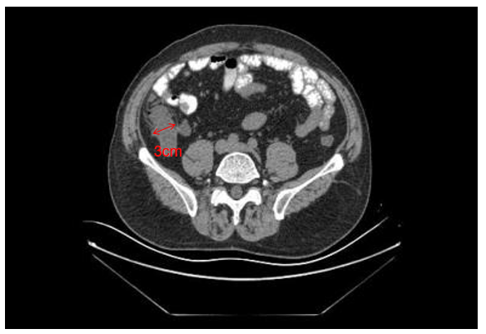
Figure 1 Abdominal computed tomography revealed a cystic mass approximately 3 cm in diameter with fat stranding.
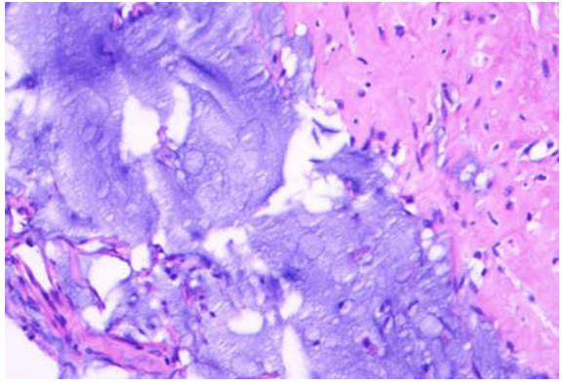
Figure 2 Biopsy of the protrusion revealed inflammatory changes in the cecal mucosa and a small amount of myxoid tissue in the focal zone.
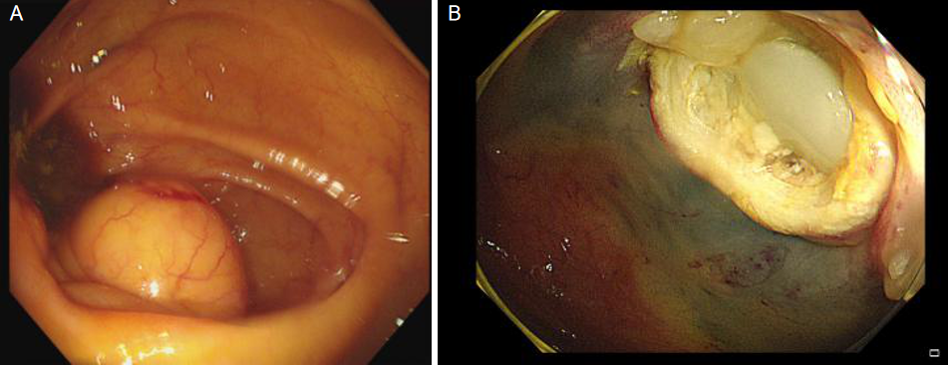
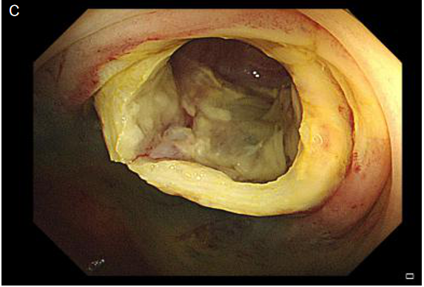
Figure 3 Colonoscopy. A: A smooth-surfaced submucosal mass of the cecum with the appendiceal orifice in the center; B: A large amount of clear yellowish mucus flowing through the appendiceal orifice into the cecum after removing the submucosal mass; C: The inner wall of the appendix was smooth with no nodules.
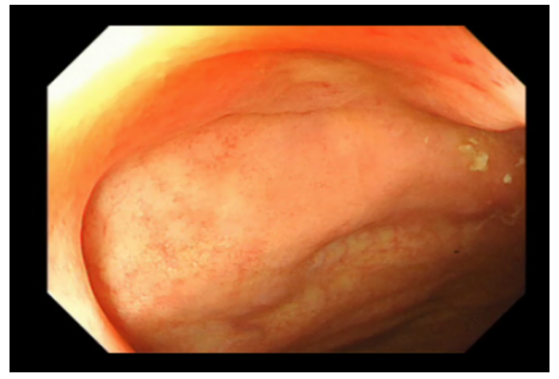
Figure 4 Repeat colonoscopy revealed no submucosal mound in the normal appendiceal orifice.
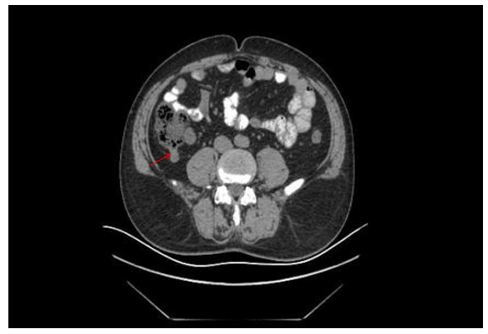
Figure 5 Postoperative computed tomography showed no abnormalities in the appendix.

