Name of Journal: World Journal of Psychiatry
Manuscript NO: 67104
Manuscript Type: SYSTEMATIC REVIEWS

Impacts of acupressure treatment on depression: A systematic review and meta-analysis

Lin JX et al. Meta-analysis of acupressure for depression

Jingxia Lin, Tianhao Chen, Jiali He, Raymond CK Chung, Haixia Ma, HWH Tsang

Jingxia Lin, Tianhao Chen, Jiali He, Raymond CK Chung, Haixia Ma, HWH Tsang, Department of Rehabilitation Sciences, The Hong Kong Polytechnic University, Hong Kong 00852, China

Jingxia Lin, HWH Tsang, Mental Health Research Centre, The Hong Kong Polytechnic University, Hong Kong 00852, China

Author contributions: Lin J acquisition of data, analysis and interpretation of data, drafting the article, final approval; Chen T acquisition of data, analysis of data, drafting the results, final approval; He J acquisition of data, quality and risk of bias assessment, drafting the introduction, final approval; Chung RC analysis and interpretation of data, final approval; Ma H results interpretation and critical revision; Tsang H conception and design of the study, critical revision, final approval.

Corresponding author: HWH Tsang, PhD, Chair Professor, Department of Rehabilitation Sciences, The Hong Kong Polytechnic University, Hung Hom, Kowloon, Hong Kong 00852, China. hector.tsang@polyu.edu.hk

Received: April 27, 2021
Revised: July 18, 2021
Accepted: November 26, 2021
Published online:

Abstract
BACKGROUND
Depression is recognized as a major public health problem with a substantial impact on individuals and society. Complementary therapies such as acupressure may be considered a safe and cost-effective treatment for people with depression. An increasing body of research has been undertaken to assess the effectiveness of acupressure in various populations with depression, but the evidence thus far is inconclusive.

AIM
To examine the efficacy of acupressure on depression.

METHODS
A systematic literature search was performed on PubMed, PsycINFO, Scopus, Embase, MEDLINE, and China National Knowledge (CNKI). Randomized clinical trials (RCTs) or single-group trials in which acupressure was compared with control methods or baseline in people with depression were included. Data were synthesized using a random-effects or a fixed-effects model to analyze the impacts of acupressure treatment on depression and anxiety in people with depression. The primary outcome measures were set for depression symptoms. Subgroups were created, and meta-regression analyses were performed to explore which factors are relevant to the greater or lesser effects of treating symptoms.

RESULTS
A total of 14 RCTs (1439 participants) were identified. Analysis of the between-group showed that acupressure was effective in reducing depression [Standardized mean differences (SMDs) = -0.58, 95%CI: -0.85 to -0.32, P < 0.0001] and anxiety (SMD = -0.67, 95%CI: -0.99 to -0.36, P < 0.0001) in participants with mild-to-moderate primary and secondary depression. Subgroup analyses suggested that acupressure significantly reduced depressive symptoms compared with different controlled conditions and in participants with different ages, clinical conditions, and duration of intervention. Adverse events, including hypotension, dizziness, palpitation, and headache, were reported in one study.

CONCLUSION
The evidence of acupressure for mild-to-moderate depressive symptoms was significant. Importantly, the findings should be interpreted with caution due to study limitations. Future research with a well-designed mixed method is required to consolidate the conclusion and provide an in-depth understanding of potential mechanisms underlying the effects.

Key Words: Acupressure; Depression; Mild-to-moderate depressive symptoms; Systematic review; Meta-analysis

Lin J, Chen T, He J, Chung RC, Ma H, Tsang H. Impacts of acupressure treatment on depression: A systematic review and meta-analysis. World J Psychiatr 2021; In press

Core Tip: Acupressure is effective on mild-to-moderate depressive symptoms. However, no confirmed evidence is available about the impacts of acupressure on patients with severe depressive disorders. This is the first study investigating the impacts of acupressure on depression among clinical and general populations.

INTRODUCTION
Depression is a prevalent and debilitating mental disorder that is estimated to affect more than 264 million people worldwide^{[1]}. Individuals with depression commonly experience dysfunctional symptoms, including undesirable mood, impaired concentration, poor quality of sleep, and a high risk of suicide. Up to 15% of clinically depressed patients eventually commit suicide^{[2]}. Besides, depression is the commonest comorbidity of chronic physical illnesses, such as cardiovascular and respiratory diseases, diabetes, arthritis and osteoporosis, and cancer^{[3]}. Moreover, evidence shows that depression is also a risk factor for physical illnesses^{[4]}. It will become the second major contributor to the general medical service burden by 2030^{[5]}. Thus, depression needs to be considered when providing integrated treatments for common chronic diseases.
In primary care, subthreshold and mild depression are most often managed with psychological interventions, such as cognitive-behavioral therapies, interpersonal therapy, and psychological counseling. Antidepressant medication is usually prescribed for moderate-to-severe depression^{[6]}. However, medications are associated with drug dependence and side effects, which negatively impact adherence. Psychological therapies require considerable time and resources, resulting in high drop-out rates and unsustainable effects. Surveys have shown that self-help and complementary therapies for depression were extensively reported^{[7,8]}.
Acupressure is a non-invasive complementary and alternative technique that shares common characteristics with acupuncture^{[9]}. It is defined as the stimulation on acupuncture points located along meridians (also known as “acupoints”) using fingers, hands, knuckles, or dull instruments to exert pressure, leading to a sensation of soreness, numbness, and distention^{[10]}. According to the core concept of traditional Chinese medicine (TCM) theory, acupressure stimulates the meridian. It restores health by balancing the “qi” flow, which could be described as bioenergy^{[11]}. Results from studies of acupuncture have suggested that effects on neurotransmitter levels of serotonin and noradrenaline may be one of the potential mechanisms underlying the therapeutic effects. On the other hand, the pressure exerted on the acupoints regulates the sympathetic and parasympathetic nervous systems to create feelings of calm and relaxation^{[12]}.
Acupressure has received increased attention for the alleviation of pain or discomfort associated with physical illnesses, injuries, and surgical operations in different populations, ranging from children^{[13]} to the elderly^{[14]}. Furthermore, the benefits of acupressure in psychological well-being have also been observed. While emerging evidence shows that acupressure has encouraging and promising effects on depression^{[15,16]}, there has been no systematic review and meta-analysis of its effectiveness for this condition. The present study aimed to synthesize findings of randomized clinical trials (RCTs) and quantify the effectiveness of acupressure for the treatment of depression in adults. Moreover, selection of acupoints and manipulation techniques, adverse events, drop-out rates, and quality of the included RCTs are described for treatment decision-making.

MATERIALS AND METHODS
This systematic review and meta-analysis were performed according to the PRISMA (Preferred Reporting Items for Systematic Reviews and Meta-Analyses) statement guideline.

Literature search
The following electronic databases were systematically searched until December 2020: PubMed, PsycINFO, Scopus, Embase, MEDLINE, and China National Knowledge (CNKI). The main keywords used were “acupressure” OR “finger massage” OR “acupoint massage” OR “shiatsu” AND “depress*” OR “mental health” OR “mental disorder*” OR “psychiatric disorder*” OR “mood disorder*” OR “bipolar disorder.*” Reference lists of retrieved studies and review articles were screened for additional references.
We screened the studies in two phases. First, two review authors (He J and Chen T) independently screened the titles and the abstracts. Second, the full text of potentially eligible studies was retrieved and assessed independently by the same two authors. Any disagreement between the review authors was resolved by a third review author (Lin J).

Study selection
Inclusion criteria were defined using the PICO (Population, Intervention, Comparison, and Outcomes)^{[17]}: (1) Were clinical trials, including RCTs and non RCTs that included acupressure as one of the study groups; (2) Used acupressure as the sole intervention compared with the control condition of either sham control or standard control (e.g., standard care); (3) Used a sample of participants aged 18 years old or above; and (4) Were published in either English or Chinese.
Studies were excluded: (1) If they did not target depression as one of the outcome measures before and after acupressure intervention; or (2) If they used acupressure as part of a multi-component intervention.

Data extraction
All data were extracted from studies by two review authors (He J and Chen T) according to predefined criteria, including: (1) The first author, year, and country of publication; (2) The number and characteristics of the participants; (3) The regimen of the experimental and control interventions; (4) The manipulation techniques of acupressure; (5) Drop-out rate; (6) Baseline depressive symptoms; and (7) Outcome measures. For the purpose of this review, our primary outcome was the change of depressive symptoms before and after an intervention. That was evaluated using any standardized clinical measures, including Beck Depression Inventory (BDI), Geriatric Depression Scale (GDS), Hospital Anxiety and Depression Scale (HADS), Depression Anxiety Stress Scales (DASS), Major Depression Inventory (MDI), and Edinburgh Postnatal Depression Scale (EPDS). The anxiety level, manipulation, and frequency of acupressure, drop-out rate, and adverse events were reported as the secondary outcomes. Discrepancies between the two reviewers were resolved by consensus decision.

Quality and risk of bias evaluation
The quality of reporting for the acupressure trials was evaluated independently by two authors (He J and Chen T) using revised STRICTA (Standards for Reporting Interventions in Clinical Trials of Acupuncture). A total of 10 items were applicable to the acupressure studies, which covered acupressure rationale, pressure details (instead of needling details), treatment regimen, other components of treatment, practitioner background, and control intervention^{[18]}. The acupressure procedure was considered well-reported if at least six out of the ten STRICTA items were reported.
The methodological quality of identified studies was assessed according to the six domains in the Cochrane risk of bias tool. These are random sequence generation, allocation concealment, blinding of participants and personnel, blinding of outcome assessors, incomplete outcome data, and selective outcome reporting. Each domain was rated as “high” (seriously weakens confidence in the results), “unclear,” or “low” (unlikely to significantly alter the results). Given the nature of the intervention, it was difficult to blind the personnel who applied the acupressure, so only the participants and outcome assessors were blinded. To follow the guidelines recommended by the Cochrane Back Review Group, a compliance threshold of < 50% of the criteria was associated with bias^{[19]}. Studies that met at least four domains with no serious flaws were considered as having a low risk of bias. If necessary, attempts were made to contact authors to obtain additional information.
Funnel plots were constructed to assess the risk of publication bias across series for all outcome measures. The Egger regression was used to test the asymmetry of the Funnel plots, with P > 0.1 indicating no publication bias.

Data synthesis and statistical analysis
According to Jackson & Turner^{[20]}, meta-analysis was performed when at least five studies with similarities in clinical characteristics and with no domain rated as having a high risk of bias were included. Meta-analyses were conducted using the changes of the scores between pre- and post-intervention measured by different scales. Heterogeneity among studies was evaluated by calculating the I² statistic and ꭓ² test (assessing the P value) using Review Manager 5 software (V5.4, The Nordic Cochrane Centre, Copenhagen). If the P value was < 0.05 and I² > 50%, we considered the heterogeneity to be substantial. A random-effect model was used to combine the data if significant heterogeneity existed. Standardized mean differences (SMDs) with 95%CI were used for continuous outcomes. The magnitude of the overall effect size was calculated based on the pooled SMD. Following Cohen’s categories, the effect sizes of 0.20, 0.50, and 0.80 were considered small, medium, and large, respectively^{[21]}.
Sensitivity analyses and subgroup analyses were performed to investigate the effects of acupressure with different study designs, ages of participants, control conditions, and treatment duration. Meta-regression was also performed to identify the potential predictors of the effects of acupressure on depression.

RESULTS
Study selection
A PRISMA flow diagram is shown in Figure 1. The search initially found 552 articles. After screening the title and abstract, 46 of which were examined full text. Of these, 16 were excluded based on the inclusion/exclusion criteria, and 16 Chinese articles were excluded due to their low quality, resulting in a total of 14 eligible articles for systematic review. There was no publication bias based on the Funnel plots and Egger-regression test results (Figure 2). Fourteen RCTs involving 1439 participants were included for meta-analyses.

Study characteristics
The main characteristics of the included studies are described in Table 1. The sample size of the 14 studies varied from 12 to 288. Four studies focused on old participants (aged 65 or above)^{[22-25]}, while the remaining studies recruited participants from 20-64 years. Ten studies recruited participants with chronic diseases, including chronic obstructive pulmonary disease^{[22]}, lung cancer^{[26]}, acute myocardial infarction^{[27]}, breast cancer^{[28]}, low back pain^{[29]}, multiple sclerosis^{[30]}, hemodialysis^{[31-33]}, and unilateral knee osteoarthritis^{[34]}. Three studies recruited patients with depression^{[24,25,35]}. One study was for patients with Alzheimer’s disease comorbided with depression^{[23]}. None of them included patients with major depressive disorders (MDD), and the overall severity of depressive symptoms in the participants was mild to moderate. The drop-out rate ranged from 0 to 28.8%, with a mean of 10.2%.

Quality and risk of bias assessment
Table 2 describes the standards of reporting for the included trials. The standards reflect the revised STRICTA criteria (2010). All studies reported the frequency of treatment, the setting and context of intervention, and the control condition. Only one study did not mention the rationale of acupressure^{[27]}. Three studies did not report the acupoints used in the intervention^{[23,27,35]}. All studies provided a detailed description of the method/materials used for acupressure. All studies except two^{[23,25]} specified the duration of pressure retention. Two studies reported other components, such as the details of other interventions^{[23,26]}.
Risk of bias was assessed and summarized in Figure 3. Fourteen studies were described as “randomized,” of which eight studies reported detailed randomization methods^{[25,26,28,30-34]}. All studies reported allocation concealment in detail. Blinding of outcome assessments was sufficiently carried out in 13 studies, with only one study providing no detailed description^{[26]}. Five of them expressly stated a completion rate of their participants and were at low risk of attrition bias^{[22,24,26,27,34]}, while the others gave no details of missing data. All studies presented the outcomes clearly and were rated as having a low risk of selection bias. Overall, all studies were rated low in at least four domains, and therefore, were considered as having low risk of bias.

Rationale of acupoint selection
Among the included studies, five of them applied three acupoints or fewer^{[25,26,30-32]}, and six studies applied more than three acupressure points^{[22,24,28,29,33,34]}. However, three studies did not report the specific acupoints used for the intervention^{[23,27,35]}. The most used acupoints were Zusanli, Sanyinjiao, and Shenmen.
All studies mentioned that selection of acupoints was based on the TCM principles and aimed to improve the body’s natural self-healing capacity by regulating and balancing Qi. Three studies^{[22,24,29]} selected the acupoints based on a thorough literature review of the effects of acupressure on depression. Hmwe et al^{[32]} reported that two TCM specialists from local universities had reviewed the selection of acupoints.

Manipulation technique
The duration of acupressure interventions varied across studies. They ranged from 5 s to 4 min on each acupressure point and from 30 s to 45 min per session, with an average of 15-20 min per session in most studies. The study duration ranged from 2 wk^{[25]} to 40 wk^{[23]}. All studies applied acupressure with finger pressure, except one study which applied the magnetic bead at relevant points^{[25]}.
The background of the therapists delivering acupressure differed in the included studies: Two trials involved research personnel^{[22,26]}, two trials employed allied health professionals^{[27,35]}, and three trials involved an acupuncturist^{[28,33,34]}. Either “sham” or “treat as usual” (TAU) were used as controls. Nine studies employed sham stimulation that located around the true acupoints and were irrelevant to the treatment of depression^{[22,24-26,28-31,33]}. Four studies had both a sham and a TAU control group^{[24,26,28,33]}. The other studies used TAU as the control group.

Overall effectiveness of acupressure on depression
Three trials adopted BDI^{[31,33,35]}; four trials adopted GDS^{[22-25]}; two trial used HADS^{[26,28]}; three trials used DASS^{[30,32,34]}; one trial used MDI^{[27]}, and the other trial used EPDS for depression^{[29]}. Similar findings were reported in all studies that the acupressure group had a greater reduction in depression after treatment than the sham or the TAU control groups.
Meta-analysis of these 14 RCTs suggested a lager overall improvement in the depression level in the acupressure group than sham or TAU control groups (SMD = -0.58; 95%CI = -0.85 to -0.32; P < 0.0001; I² = 84%;ꭓ² = 110.96; P < 0.0001) (Figure 4). The combined effect size was 4.39, which equals to a small effect size according to Cohen’s categories.

Effectiveness of acupressure on depression with different control conditions
Subgroup analyses were performed in studies using different control groups (Figure 4). The combined results of 10 studies using TAU control groups showed a greater reduction in depression level in the acupressure group with a small effect size (SMD = -0.34; 95%CI = -0.63 to -0.05; P = 0.02; I² = 76%;ꭓ² = 37.78; P < 0.00001; Z = 2.33). Similar results were shown in the nine studies using sham controls with a moderate effect size (SMD = -0.83; 95%CI = -1.2 to -0.46; P < 0.00001; I² = 80%; ꭓ² =39.77; P < 0.00001; Z = 4.42).

Effectiveness of acupressure on depression with different treatment durations
Subgroup analyses were also performed in studies with different durations. The combined results of eight studies with a duration of 2-4 wk showed acupressure significantly reduced depression levels compared to sham or TAU controls with a moderate effect size (SMD = -0.67; 95%CI = -0.99 to -0.35; P < 0.0001; I² = 71%; ꭓ² = 30.82; P = 0.0003; Z = 4.16) (Figure 5). Significant reductions in the depression levels were found in six studies with a duration of more than 4 wk in the acupressure group compared to the sham or TAU controls with a small effect size (SMD = -0.48; 95%CI = -0.9 to -0.07; P = 0.02; I² = 90%; ꭓ² = 78.05; P < 0.00001; Z = 2.28) (Figure 6).

Effectiveness of acupressure on depression in different participants
Subgroup analyses were also performed in studies with different participants. The combined results of eleven studies in participants with depressive symptoms comorbidded with chronic diseases showed acupressure significantly reduced depression level compared to sham or TAU controls with a small effect size (SMD = -0.48; 95%CI = -0.77 to -0.19; P = 0.001; I² = 85%; ꭓ² = 91.96; P < 0.00001; Z = 3.23) (Figure 7). Significant reductions of depressive symptoms were also found in three studies in participants with depression with a moderate effect size (SMD = -1; 95%CI = -1.40 to -0.60; P < 0.00001; I² = 48%; ꭓ² = 5.79; P = 0.12; Z = 4.91) (Figure 8).

Effectiveness of acupressure on depression in participants of different ages
Subgroup analyses were also performed in studies with different ages. The combined results of ten studies with individuals aged 20-64 showed acupressure significantly reduced depression levels compared to the sham or TAU controls with a small effect size (SMD = -0.42; 95%CI = -0.71 to -0.14; P = 0.004; I² = 85%; ꭓ² = 84.08; P < 0.00001; Z = 2.89) (Figure 9). Significant reductions in depression levels after acupressure interventions with a large effect size were also found in four studies in participants over 65 years old (SMD = -1.09; 95%CI = -1.45 to -0.72; P < 0.00001; heterogeneity: I² = 43%; ꭓ² = 7.01; P = 0.14; Z = 5.82) (Figure 10).

Effects of acupressure on depression using different acupoints
Subgroup analyses were performed in studies using different numbers of acupoints. The combined results of RCTs with no more than 3 acupoints (3 included) (SMD = -0.36; 95%CI = -0.56 to -0.17; P < 0.0001; I² = 79%; ꭓ² = 28.86; P = 0.0003; Z = 3.63) (Figure 11), and more than 3 acupoints showed significant effects on depression in acupressure compared to controls with moderate effects (SMD = -0.74; 95%CI = -1.13 to -0.36; P = 0.0002; I² = 88%; ꭓ² = 66.63; P < 0.00001; Z = 3.75) (Figure 12).
Subgroup analyses were also performed in studies using the three most used acupoints. The combined results of the studies showed significant beneficial effects on depression in the acupressure treatment group compared to controls, with a large effect size for Sanyinjiao (SMD = -0.54; 95%CI= -0.69 to -0.39; P < 0.00001; heterogeneity: I² = 89%; ꭓ²=72.17; P < 0.00001; Z = 7.03), a moderate effects size for Shenmen (SMD = -0.75; 95%CI = -1.03 to -0.47; P < 0.00001; I² = 60%; ꭓ²=15.14; P = 0.02; Z = 5.20) and a small effect size for Zusanli (SMD = -0.56; 95%CI = -0.97 to -0.15; P = 0.008; I² = 89%; ꭓ²=71.65; P < 0.00001; Z = 2.67).

Effect of acupressure on anxiety
Three trials adopted HADS^{[26,28,31]}, one trial used Beck Anxiety Inventory (BAI)^{[25]}, and two trials used DASS^{[32,34]} to measure anxiety level. Consistent findings were found in six studies that the acupressure group reported a greater reduction in anxiety after acupressure application than the sham or TAU controls. Meta-analyses of the six trials indicated an overall improvement in anxiety levels in the acupressure group compared with sham or TAU control groups with a small effect size (SMD = -0.67; 95%CI = -0.99 to -0.36; P < 0.0001; I² = 79%; ꭓ²=37.82; P < 0.00001; Z = 4.16) (Figure 13).

Adverse events
Only one study^{[32]} reported the adverse events of acupressure during four-week acupressure in patients with end-stage renal disease, including intradialytic hypotension (n = 11), dizziness (n = 6), palpitation (n = 2), and headache (n = 1). Intradialytic hypotension was reported to occur within 30 min after acupressure, and two participants discontinued the study in the final week due to the increased frequency of hypotension. The episodes of dizziness, palpitation, and headache occurred while acupressure was being applied. These side-effects disappeared within a few min and the acupressure treatment did not cease.

Sensitivity analyses
Sensitivity analyses were performed after excluding one study^{[26]}, as it contained no description of blinding details. The results were similar to all the other studies involved (Figure 14).

Meta-regression analyses
Meta-regression analyses were performed to investigate if there were any factors associated with the effects on depression. Age, the number of acupoints used, the total time of intervention, and the physical illnesses were included to investigate if there were any associated factors with the effects on depression. However, no significant results were found.

DISCUSSION
We included in the systematic review and meta-analysis 14 RCTs with 1439 participants with depressive symptoms. Overall, the data showed that acupressure had great potential to improve mild-to-moderate depressive symptoms in both primary and secondary depression. No systematic review and meta-analysis have been performed to assess the effectiveness of acupressure on depression in various clinical population. A recent integrative review showed that acupressure reduced depression in older people in the community, whether or not they had chronic illnesses^{[32]}. Subgroup analyses in our meta-analysis consistently showed significant reductions in depression levels after acupressure treatment for adults with a large effect size in participants aged 65 years or above. Moreover, subgroup analyses also suggested that acupressure significantly reduced depression regardless of the clinical conditions. A recent scope review of six studies indicated that acupressure improved depression and psychological health in dementia^{[36]}, which is consistent with our findings in participants with Alzheimer’s disease. However, these significant findings should be interpreted with caution due to the heterogeneity of the clinical conditions of the participants, manipulation techniques of acupressure, the selected acupoints, and the outcome measures.
Most studies in our review investigated the effects of acupressure on mild-to-moderate secondary depression in patients with chronic diseases. Three studies examined in patients with mild-to-moderate primary depression and all reported significant improvement in symptoms. However, it is not clear if acupressure is effective for patients with moderate-to-severe primary depressive disorders. Furthermore, none of the studies included in our meta-analysis mentioned specifically which symptom domains of depression were improved by acupressure treatment. Future research may focus on the effects of acupressure for moderate-to-severe depressive disorders and specific symptom domains.
Data showed a wide range of durations in acupressure interventions, ranging from 2 wk to 40 wk. More than half the studies (57.1%) involved acupressure treatment for 2-4 wk. The subgroup analyses suggested significant reductions in depression after either less than or more than 4 wk, indicating that acupressure benefits psychological well-being even after short-term treatment.
The acupressure manipulation applied in the included studies differed widely, and no confirmative conclusion could be drawn on the most effective acupressure technique. In general, 15 to 20-min sessions and 4-wk durations were commonly adopted. The majority of studies applied more than three acupoints, and the commonest acupoints used for depression are Yintang, Sanyinjiao, and Zusanli. Future research may compare the effects on depression among different acupoints to ascertain the effect of acupressure using specific acupoints. The most fundamental technique of acupressure is firm pressure on the acupoints. No included studies mentioned the amount of pressure on the acupoint, which is related to the thickness of skin, muscle, and fatty tissue at the point. The intensity of the pressure may be associated with the effect of acupressure due to the potential mechanism of stimulating the nerve systems; this needs to be clarified. Furthermore, adjusting the intensity of pressure based on the individual’s tolerance is important in clinical practice.
All studies mentioned that the selection of acupoints was based on the TCM principles of balancing the “qi” flow in the body to promote inner self-recovery abilities. However, none of the included studies measured “qi” which may be a confounding factor for the outcomes, and none of them specified the particular neuro-mechanisms underlying the selection of acupoints. According to TCM, the “qi” circulates through 12 principal meridians between different organs of the body. There are 361 acupoints distributed along the meridians, and each is associated with a specific part of the body. Selecting acupoints along the meridian is the vital principle for acupressure treatment in depression. The application of specific acupoints related to refreshing the brain and soothing the liver function is the primary procedure across all the studies.
Acupressure also reduced anxiety in participants with psychiatric disorders, sclerosis, uremia, and osteoarthritis in both clinical and community settings. The findings were consistent with a previous systematic review and meta-analysis of acupressure on anxiety by Au et al^{[16]}. However, Hmwe et al^{[32]} suggested inconsistent findings on the effects of acupressure on anxiety and agitation in older people. Anxiety is a common comorbidity of depression, and the generalization of the effects of acupressure on anxiety needs to be further explored.
Ten of the 14 studies reported drop-out rates ranging from 0 to 28.8%, with a mean drop-out rate of 10.2%. Only one study reported the number that dropped out from each group and the reasons for withdrawal^{[24]}. The completion rate was similar to previous studies of acupressure in older people in both clinical and community settings^{[32]}. It was relatively lower than psychological treatment in depression^{[37]}. It should be noted that none of the included studies had long-term follow-up. Furthermore, only one study reported adverse events, including hypotension, dizziness, palpitation, and headache, but without details. Addressing the effects during medium and long-term follow-up periods and the detailed adverse events of acupressure are the priorities suggested for future studies.
Only one study included in our review suggested the potential mechanisms through which the stimulation of particular acupoints on the skin can reduce depression and anxiety by altering the concentration of neurotransmitters, reducing the levels of adrenocorticotrophic hormones and hydroxytryptamine-5 in the brain, resulting in calmness^{[31]}. Previous studies of acupuncture, which shared the same TCM theory with acupressure but used different manipulation technique (acupuncture uses needle), suggested that antidepressant effects of acupuncture are the result of the interaction inbetween multiple targets and levels in neural system. Acupuncture not only improves monoamine neurotransmitters, inhibits the hyperactive HPA axis, but also activates neurotrophic pathways, improves hippocampal neurogenesis, and inhibits inflammatory cytokines^{[38]}. A study of electroacupuncture of acupoints "Baihui" and "Sanyingjiao" in chronically stressed rates significantly increased the activities of 5-HT by increasing the bingding site of 5-HT_{1A} receptors in the hippocampus of depressed rats^{[39]}. A clinical study of acupuncture in women with menopausal depression showed significant increases in serum levels of Norepinephrine and Dopamine^{[40]}. Furthermore, acupuncture at acupoints "Baihui" and "Yintang" combined with 5-HT reuptake inhibitors in older adults with depression significantly increased the serum Brain-derived Neurotrophic Factor (BDNF) level^{[41]}. Song et al^{[42]} found that electroacupuncture can significantly reduce the levels of serum interleukin IL-1β and tumor necrosis privacy (TNF-α) in patients with depression, and the ratio of interferon to IL-4.

Limitations of the review
The first systematic review and meta-analysis of acupressure in depression showed a significantly greater overall effect than the controls. However, it is important to be aware of several limitations when interpreting the results.
We excluded 16 Chinese studies that reported poorly, and we were unable to find complete details of study design features relevant to the risk of bias assessment. Thus, trials meeting our inclusion criteria beyond those identified may exist.
Also, only three included trials focused on mild-to-moderate primary depression, and no evidence was found in patients with moderate or severe depression, making generalizability to this patient group difficult.
The included studies differ substantially with regard to participants, treatment frequency and duration, and acupoints selected. Meanwhile, the exact techniques of acupressure and therapeutic composition of acupoints were less undermined and inclusive, making comparisons between these included RCT studies difficult.
No study included in our meta-analysis measured “qi”, which is the primary rationale for the selection of acupoints, and may be a confounding factor for the interpretation of the findings. Even though, we could still perform a meta-analysis and a quantitative synthesis of the included studies.
Implications for clinical practice and further research
As a non-invasive, safe and simple technique, acupressure has the potential to be promoted in clinical practice. The present study found that acupressure is feasible to improve depression and anxiety. Integration of this technique in the care of people vulnerable to mental illnesses, such as older people and postnatal women, would promote their emotional well-being and quality of life. That should further reduce the costs and side effects of conventional medication treatment in the standard care system. However, well-designed trials are recommended to provide more solid evidences on the effectiveness of acupressure for mental health promotion.
It is apparent that research in acupressure for mental health is still in its infancy, and further studies of high quality, with large sample sizes and medium- to long-term follow-ups, are warranted to examine the impacts on depression with different severity. Furthermore, effects of different acupoints and pressure retention on depression should be further examined for better understanding of the underlying mechanisms of acupressure in depression. Preliminary findings from our review suggested the potential mechanisms of acupressure may be associated with sympathetic and parasympathetic activities and the concentration of neurotransmitters and hormones in the neural networks. Future studies investigating the neurophysiological changes using imaging techniques (e.g., fNIRS and MRI) are suggested.

CONCLUSION
This review found emerging evidence to support certain positive effects of acupressure for adults suffering from mild-to-moderate depression. Future well-designed research is needed to provide robust evidence for clinical practice and recommendation for its application, and an in-depth understanding of acupressure treatment in the context of integrative care as well.

ARTICLE HIGHLIGHTS
Research background
Originated from traditional Chinese medicine (TCM), acupressure is a safe and cost-effective complementary treatment for depression.

Research motivation
An increase body of research has been undertaken to assess effectiveness of acupressure in depression, but the evidence thus far is inconclusive.

Research objectives
Via the systematic review and meta-analysis, we compared clinical data using acupressure and controls with usual care or sham treatment.

Research methods
The databases PubMed, PsycINFO, Scopus, Embase, MEDLINE, and China National Knowledge (CNKI) were searched. Randomized clinical trials (RCTs) or single-group trials in which acupressure was compared with control methods or baseline in people with depressive symptoms were included. The primary outcomes were the change between pre- and post-treatment in depression measures. Data were synthesized using a random-effects or a fixed-effects model to analyze the impacts of acupressure treatment on depression and anxiety in people with depression.

Research results
A total of 14 RCTs (1439 participants) were identified. Analysis of the between-group showed that acupressure was effective in reducing depression (SMD = -0.58, 95%CI: -0.85 to -0.32, P < 0.0001) and anxiety (SMD = -0.67, 95%CI: -0.99 to -0.36, P < 0.0001) in clinical patients with depressive symptoms. The evidence of acupressure for mild-to-moderate depressive symptoms in patients with chronic diseases was significant. The evidence of certainty in moderate-to-severe primary depression was low. No severe adverse events were reported.

Research conclusions
This present review indicated acupressure to be safe and exert certain positive effects in people with mild-to-moderate depressive symptoms. Importantly, the findings should be interpreted with caution due to study limitaitons, including heterogeneity of participants, treatment frequency and duration, the selected acupoints, and sample size.

Research perspectives
Future research with a well-designed mixed method is required to provide stronger evidence for clinical decisions and recommendations for its application, as well as an in-depth understanding of acupressure mechanisms and symptoms domains in depression.

REFERENCES
1 GBD 2017 Disease and Injury Incidence and Prevalence Collaborators. Global, regional, and national incidence, prevalence, and years lived with disability for 354 diseases and injuries for 195 countries and territories, 1990-2017: a systematic analysis for the Global Burden of Disease Study 2017. Lancet 2018; 392: 1789-1858 [PMID: 30496104 DOI: 10.1016/S0140-6736(18)32279-7]
2 Alsalman R, Alansari B. Relationship of suicide ideation with depression and hopelessness. European Psychiatry 2020; 33: S597-S597 [DOI: 10.1016/j.eurpsy.2016.01.2228]
3 Clarke DM, Currie KC. Depression, anxiety and their relationship with chronic diseases: a review of the epidemiology, risk and treatment evidence. Med J Aust 2009; 190: S54-S60 [PMID: 19351294 DOI: 10.5694/j.1326-5377.2009.tb02471.x]
4 Wulsin LR, Vaillant GE, Wells VE. A systematic review of the mortality of depression. Psychosom Med 1999; 61: 6-17 [PMID: 10024062 DOI: 10.1097/00006842-199901000-00003]
5 Mathers CD, Loncar D. Projections of global mortality and burden of disease from 2002 to 2030. PLoS Med 2006; 3: e442 [PMID: 17132052 DOI: 10.1371/journal.pmed.0030442]
6 Goldman LS, Nielsen NH, Champion HC. Awareness, diagnosis, and treatment of depression. J Gen Intern Med 1999; 14: 569-580 [PMID: 10491249 DOI: 10.1046/j.1525-1497.1999.03478.x]
7 Jorm AF, Medway J, Christensen H, Korten AE, Jacomb PA, Rodgers B. Public beliefs about the helpfulness of interventions for depression: effects on actions taken when experiencing anxiety and depression symptoms. Aust Nz J Psychiat 2000; 34: 619-626 [DOI: 10.1046/j.1440-1614.2000.00761.x]
8 Kessler RC, Soukup J, Davis RB, Foster DF, Wilkey SA, Van Rompay MI, Eisenberg DM. The use of complementary and alternative therapies to treat anxiety and depression in the United States. Am J Psychiatry 2001; 158: 289-294 [PMID: 11156813 DOI: 10.1176/appi.ajp.158.2.289]
9 Maxwell J. The gentle power of acupressure. RN 1997; 60: 53-56 [PMID: 9110874]
10 Beal MW. Acupuncture and oriental body work: traditional and modern biomedical concepts in holistic care--conceptual frameworks and biomedical developments. Holist Nurs Pract 2000; 15: 78-87 [PMID: 12119622 DOI: 10.1097/00004650-200010000-00010]
11 Robinson N, Lorenc A, Liao X. The evidence for Shiatsu a systematic review of Shiatsu and acupressure. BMC Complement Altern Med 2011; 11: 88 [PMID: 21982157 DOI: 10.1186/1472-6882-11-88]
12 Lane JR. The neurochemistry of counterconditioning Acupressure desensitization in psychotherapy. Energy Psychology Theory, Research, Treatment 2009; 1: 31-44 [DOI: 10.9769/EPJ.2009.1.1.JRL]
13 Borimnejad LAN, Seydfatemi N. The effects of acupressure on preoperative anxiety reduction in school aged children. Healthmed 2012; 6: 2359-2361
14 Yang MH, Lin L-C. Acupressure in the care of the elderly. Hu Li Za Zhi J Nurs 2007; 54: 10-11
15 Lee EJ, Frazier SK. The efficacy of acupressure for symptom management: a systematic review. J Pain Symptom Manage 2011; 42: 589-603 [PMID: 21531533 DOI: 10.1016/j.jpainsymman.2011.01.007]
16 Au DW, Tsang HW, Ling PP, Leung CH, Ip PK, Cheung WM. Effects of acupressure on anxiety: a systematic review and meta-analysis. Acupunct Med 2015; 33: 353-359 [PMID: 26002571 DOI: 10.1136/acupmed-2014-010720]
17 Moher D, Liberati A, Tetzlaff J, Altman DG; PRISMA Group. Preferred reporting items for systematic reviews and meta-analyses: the PRISMA statement. Int J Surg 2010; 8: 336-341 [PMID: 20171303 DOI: 10.1016/j.ijsu.2010.02.007]
18 Prady SL, Richmond SJ, Morton VM, Macpherson H. A systematic evaluation of the impact of STRICTA and CONSORT recommendations on quality of reporting for acupuncture trials. PLoS One 2008; 3: e1577 [PMID: 18270568 DOI: 10.1371/journal.pone.0001577]
19 Furlan AD, Pennick V, Bombardier C, van Tulder M; Editorial Board, Cochrane Back Review Group. 2009 updated method guidelines for systematic reviews in the Cochrane Back Review Group. Spine (Phila Pa 1976) 2009; 34: 1929-1941 [PMID: 19680101 DOI: 10.1097/BRS.0b013e3181b1c99f]
20 Jackson D, Turner R. Power analysis for random-effects meta-analysis. Res Synth Methods 2017; 8: 290-302 [PMID: 28378395 DOI: 10.1002/jrsm.1240]
21 Cohen J. Statistical Power Analysis for the Behavioral Sciences. 1988 [DOI: 10.4324/9780203771587]
22 Wu HS, Lin LC, Wu SC, Lin JG. The psychologic consequences of chronic dyspnea in chronic pulmonary obstruction disease: the effects of acupressure on depression. J Altern Complement Med 2007; 13: 253-261 [PMID: 17388769 DOI: 10.1089/acm.2006.5342]
23 Lanza G, Centonze SS, Destro G, Vella V, Bellomo M, Pennisi M, Bella R, Ciavardelli D. Shiatsu as an adjuvant therapy for depression in patients with Alzheimer's disease: A pilot study. Complement Ther Med 2018; 38: 74-78 [PMID: 29857884 DOI: 10.1016/j.ctim.2018.04.013]
24 Molassiotis A, Suen L, Lai C, Chan B, Wat KHY, Tang J, To KL, Leung CO, Lee S, Lee P, Chien WT. The effectiveness of acupressure in the management of depressive symptoms and in improving quality of life in older people living in the community: a randomised sham-controlled trial. Aging Ment Health 2020; 24: 1001-1009 [PMID: 30869991 DOI: 10.1080/13607863.2019.1584789]
25 Tseng YT, Chen IH, Lee PH, Lin PC. Effects of auricular acupressure on depression and anxiety in older adult residents of long-term care institutions: A randomized clinical trial. Geriatr Nurs 2021; 42: 205-212 [PMID: 32921508 DOI: 10.1016/j.gerinurse.2020.08.003]
26 Tang WR, Chen WJ, Yu CT, Chang YC, Chen CM, Wang CH, Yang SH. Effects of acupressure on fatigue of lung cancer patients undergoing chemotherapy: an experimental pilot study. Complement Ther Med 2014; 22: 581-591 [PMID: 25146059 DOI: 10.1016/j.ctim.2014.05.006]
27 Bergmann N, Ballegaard S, Bech P, Hjalmarson A, Krogh J, Gyntelberg F, Faber J. The effect of daily self-measurement of pressure pain sensitivity followed by acupressure on depression and quality of life vs treatment as usual in ischemic heart disease: a randomized clinical trial. PLoS One 2014; 9: e97553 [PMID: 24849077 DOI: 10.1371/journal.pone.0097553]
28 Zick SM, Sen A, Hassett AL, Schrepf A, Wyatt GK, Murphy SL, Arnedt JT, Harris RE. Impact of Self-Acupressure on Co-Occurring Symptoms in Cancer Survivors. JNCI Cancer Spectr 2018; 2: pky064 [PMID: 30687806 DOI: 10.1093/jncics/pky064]
29 Yu HC, Carol S; Wu B; Cheng YF. Effect of acupressure on postpartum low back pain, salivary cortisol, physical limitations, and depression: a randomized controlled pilot study. J Tradit Chin Med 2020; 40: 128-136
30 Rahimi H,Mehrpooya N, Vagharseyyedin S, BahramiTaghanaki H. Self-acupressure for multiple sclerosis-related depression and fatigue A feasibility randomized controlled trial. J Adv Med Biomed Res 2020; 28: 276-283 [DOI: 10.30699/jambs.28.130.276]
31 Dehghanmehr S, Sargazi GH, Biabani A, Nooraein S, Allahyari J. Comparing the Effect of Acupressure and Foot Reflexology on Anxiety and Depression in Hemodialysis Patients: A Clinical Trial. Med Sur Nur J 2020; 8 [DOI: 10.5812/msnj.100386]
32 Hmwe NT, Subramanian P, Tan LP, Chong WK. The effects of acupressure on depression, anxiety and stress in patients with hemodialysis: a randomized controlled trial. Int J Nurs Stud 2015; 52: 509-518 [PMID: 25468282 DOI: 10.1016/j.ijnurstu.2014.11.002]
33 Kalani L,Aghababaeian, H, Majidipour, N., Alasvand M, Bahrami H. The effects of acupressure on severity of depression in hemodialysis patients a randomized controlled Trial. J Advanced Pharmacy Education Research 2019; 9: 67-72
34 Rani M, Sharma L, Advani U, Kumar S. Acupressure as an Adjunct to Pharmacological Treatment for Depression, Anxiety, and Stress in Patients with Knee Osteoarthritis. J Acupunct Meridian Stud 2020; 13: 129-135 [PMID: 32738365 DOI: 10.1016/j.jams.2020.07.001]
35 Honda Y, Tsuda A, Horiuchi S. Four-Week Self-Administered Acupressure Improves Depressive Mood. Psychology 2012; 3: 802-804 [DOI: 10.4236/psych.2012.329121]
36 Harris ML, Titler MG, Struble LM. Acupuncture and Acupressure for Dementia Behavioral and Psychological Symptoms: A Scoping Review. West J Nurs Res 2020; 42: 867-880 [PMID: 31802723 DOI: 10.1177/0193945919890552]
37 Smith CA, Armour M, Lee MS, Wang LQ, Hay PJ. Acupuncture for depression. Cochrane Database Syst Rev 2018; 3: CD004046 [PMID: 29502347 DOI: 10.1002/14651858.CD004046.pub4]
38 Hu L, Liang J, Jin SY, Han YJ, Lu J, Tu Y. [Progress of researches on mechanisms of acupuncture underlying improvement of depression in the past five years]. Zhen Ci Yan Jiu 2013; 38: 253-258 [PMID: 24006675]
39 Kang HT, Wang. CW. Effect of electroacupuncture on 5-HT1A receptor of hippocampus of the rat model with chronic stress depression. Henan Zhongyi Zazhi. 2010; 30: 38-40
40 Zhou SH, Wu FD. [Therapeutic effect of acupuncture on female's climacteric depression and its effects on DA, NE and 5-HIAA contents]. Zhongguo Zhen Jiu 2007; 27: 317-321 [PMID: 17645249]
41 Huang XB, Mu N, Mei. F, et al Therapeutic effect of acupuncture combined with medicine for the aged depression and its effect on the level of serum brain derived neurotrophic factor. J Pract Med 2011; 27: 127-129
42 Song C, Halbreich U, Han C, Leonard BE, Luo H. Imbalance between pro- and anti-inflammatory cytokines, and between Th1 and Th2 cytokines in depressed patients: the effect of electroacupuncture or fluoxetine treatment. Pharmacopsychiatry 2009; 42: 182-188 [PMID: 19724980 DOI: 10.1055/s-0029-1202263]

Footnotes
Conflict-of-interest statement: All the authors have no conflict-of-interest.

PRISMA 2009 Checklist statement: The authors have read the PRISMA 2009 Checklist, and the manuscript was prepared and revised according to the PRISMA 2009 Checklist.

Open-Access: This article is an open-access article that was selected by an in-house editor and fully peer-reviewed by external reviewers. It is distributed in accordance with the Creative Commons Attribution NonCommercial (CC BY-NC 4.0) license, which permits others to distribute, remix, adapt, build upon this work non-commercially, and license their derivative works on different terms, provided the original work is properly cited and the use is non-commercial. See: http://creativecommons.org/Licenses/by-nc/4.0/

Provenance and peer review: Invited article; Externally peer reviewed.
Peer-review model: Single blind

Peer-review started: April 27, 2021
First decision: June 17, 2021
Article in press:

Specialty type: Integrative and complementary medicine
Country/Territory of origin: China
Peer-review report’s scientific quality classification
Grade A (Excellent): A
Grade B (Very good): B
Grade C (Good): C, C
Grade D (Fair): D
Grade E (Poor): 0

P-Reviewer: Alkhatib AJ, Stoyanov D, Wang W S-Editor: Wu YXJ L-Editor: A P-Editor: Wu YXJ

Figure Legends
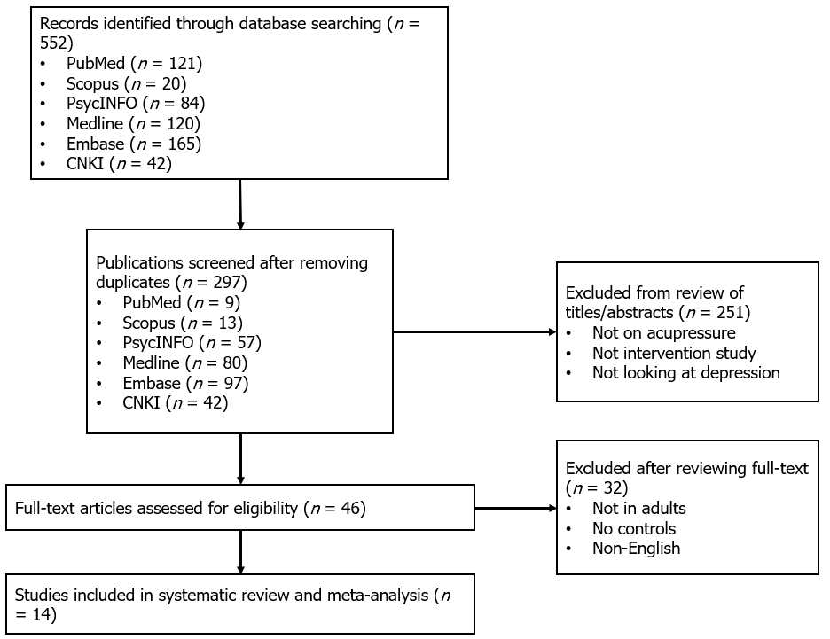
Figure 1 Flow diagram for data collection and analysis.

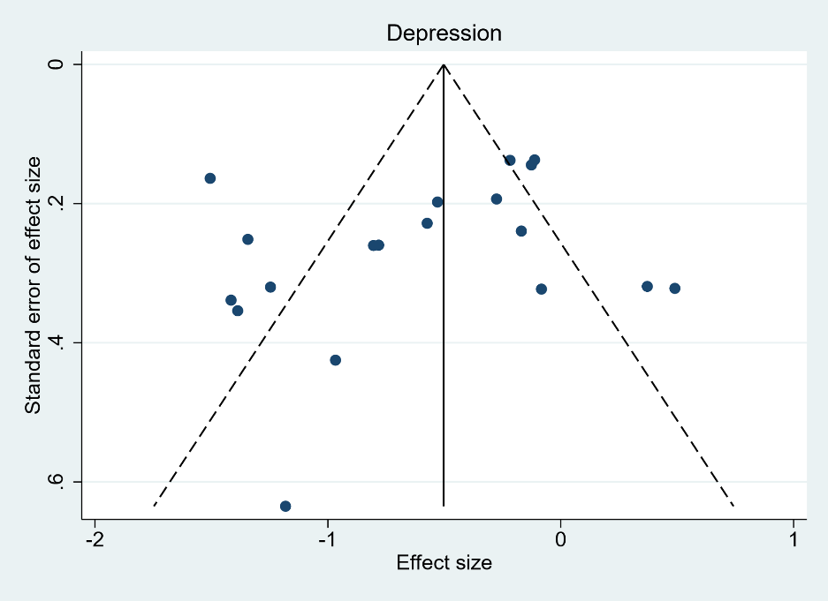
Figure 2 Funnel plots of studies with depression outcomes.

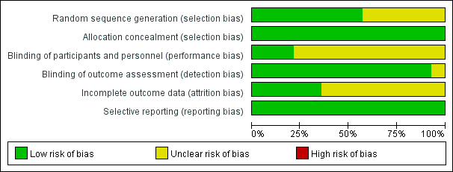
Figure 3 Risk of bias evaluation for the included studies.

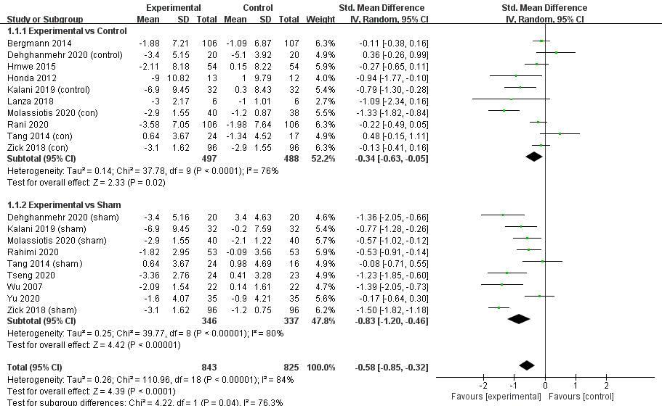
Figure 4 Effects of acupressure on depression. 1.1.1. Subgroup meta-analyses of studies using treat-as-usual (TAU) as controls; 1.1.2. Subgroup meta-analyses of studies using Sham controls.

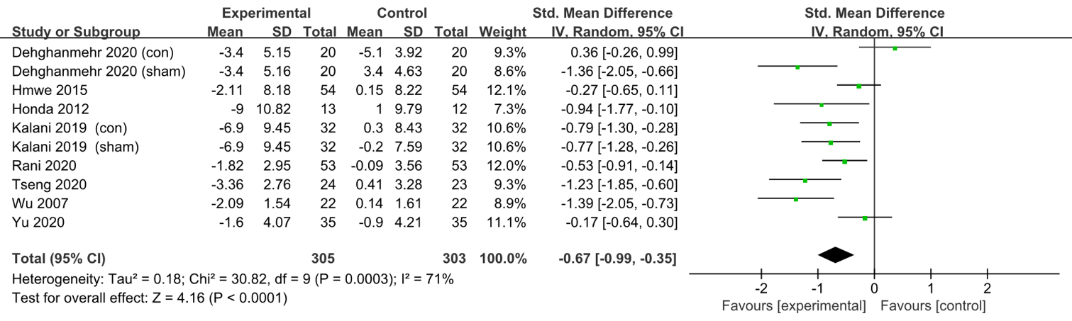
Figure 5 Effects of acupressure on depression with treatment duration of 2 to 4 wk.

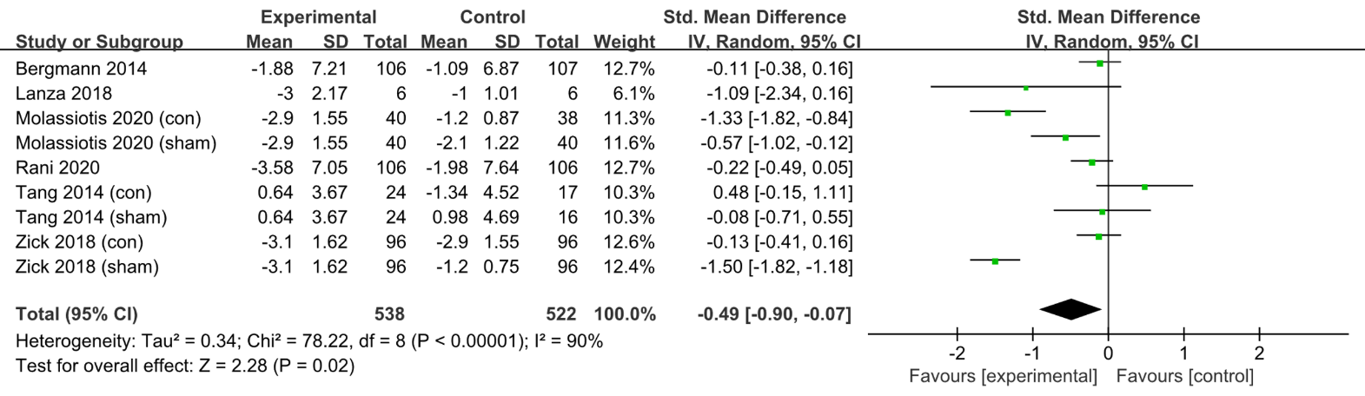
Figure 6 Effects of acupressure on depression with treatment duration of more than 4 wk.

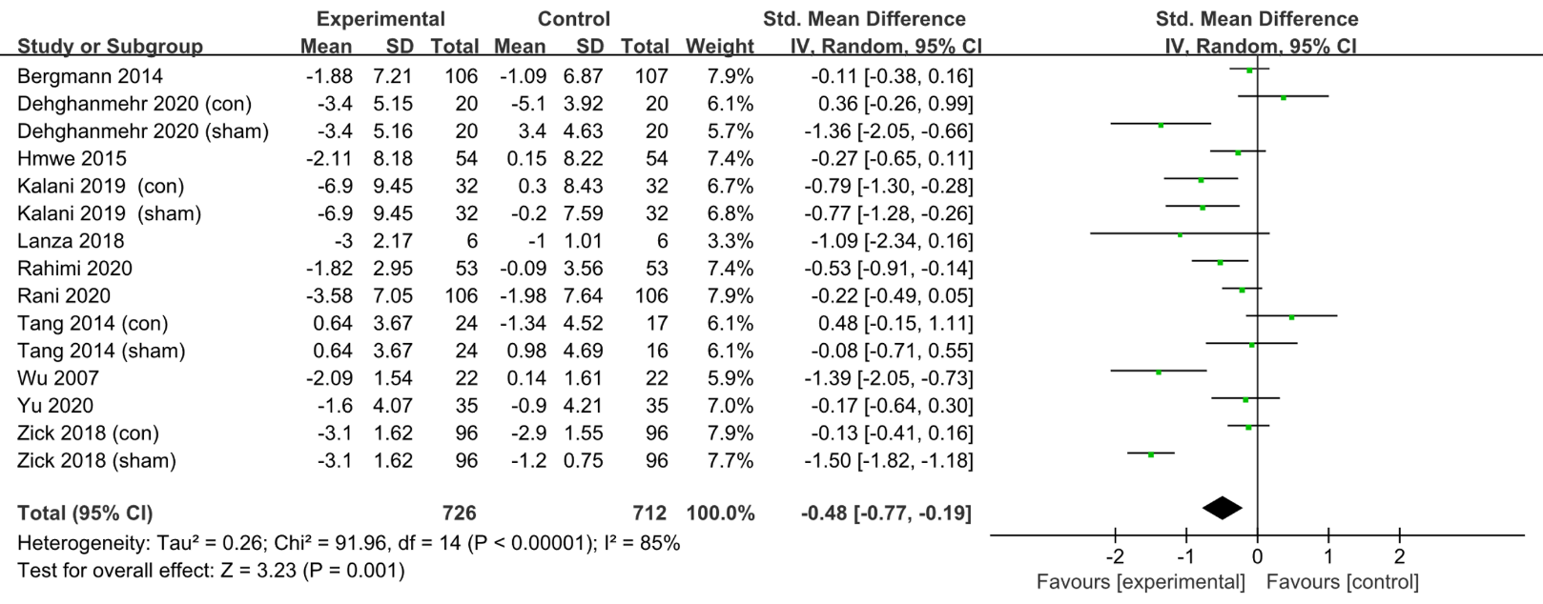
Figure 7 Effects of acupressure on depressive symptoms in participants with chronic diseases.

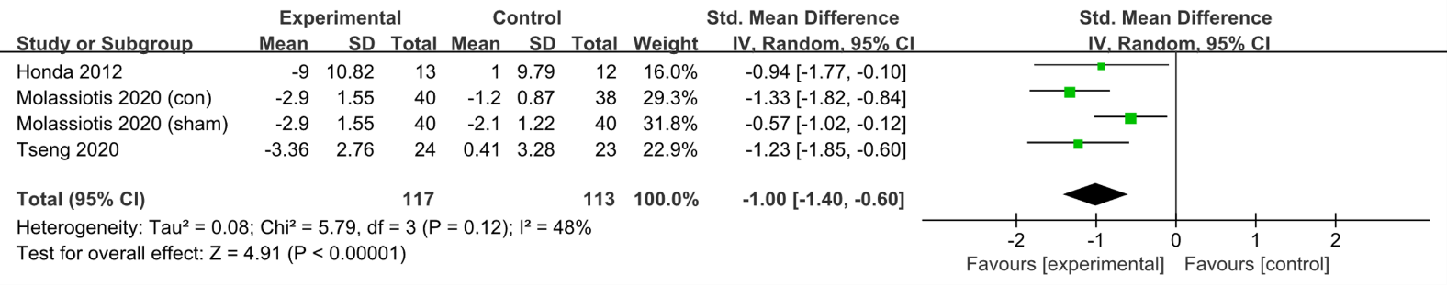
Figure 8 Effects of acupressure on depressive symptoms in participants with primary depression.

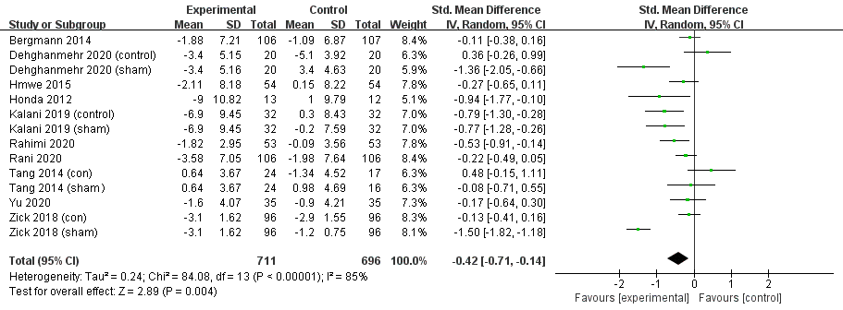
Figure 9 Effects of acupressure on depression in participants aged 18-64 years old.

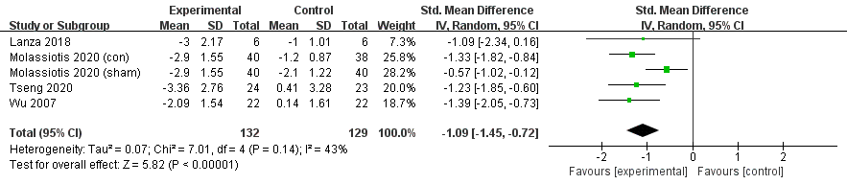
Figure 10 Effects of acupressure on depression in participants aged 65 years old or above.

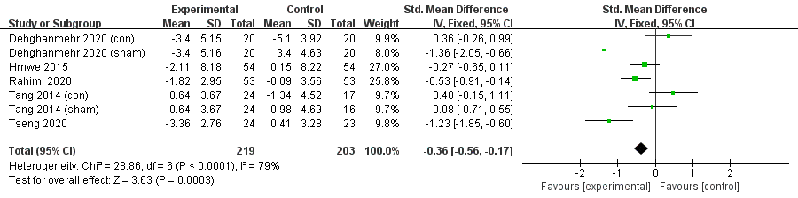
Figure 11 Effects of acupressure using no more than 3 (3 included) acupoints on depression.

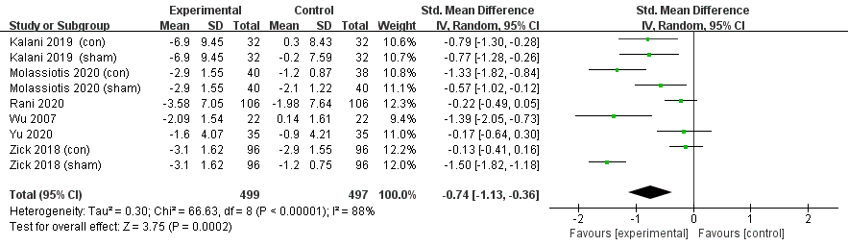
Figure 12 Effects of acupressure using more than 3 acupoints on depression.

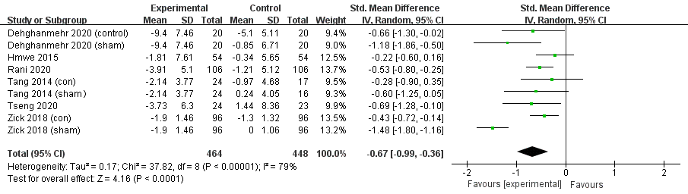
Figure 13 Effects of acupressure on anxiety.

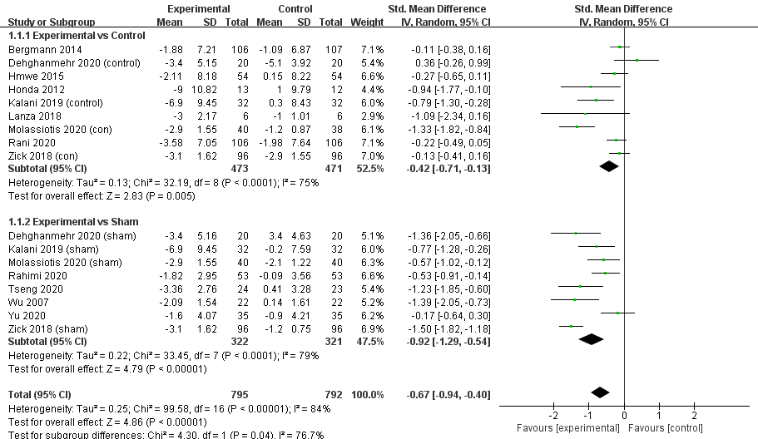
Figure 14 Sensitivity analyses of acupressure on depression.

Table 1 Characteristics of included studies
Ref. | Type of study | Participants (sample size, mean age ± SD) | Drop-out rate, n (%) | Treatment (frequency and duration) | Manupilation techniques (acupoints composition, and techniques used) | Control | Depressive symptoms at baseline M (SD) | Outcome measures
Bergmann et al^{[27]}, 2014 | RCT | Acute myocardial infarction with PPS acore ≥ 60 (213, 61.0 ± 8.1) | 32 (15.0) | Acupressure (45 min twice a day for 12 wk) | Figure pressure on two points at the sternum | Treat as usual (TAU) | MDI: 8.9 (7.4), PPS: 81 (13) | MDI, QOL, WHO-5’s well-being index, PPS
Dehghanmehr et al^{[31]}, 2020 | RCT | Hemodialysis with no severe depression and anxiety (60, 39.2 ± 11.32) | 0 | Acupressure (8 min, 3 d weekly for 4 wk) | Figure pressure on acupoint Saiyinjiao | Sham, TAU | BDI: 31.44 (20.95), STAI: 47.60 (7.04) | STAI, BDI
Hmwe et al^{[32]},2015 | RCT | Hemodialysis with depressive symptom (108, 58.06 ± 11.4) | 0 | Acupressure (12 min per session, 3 sessions weekly for 4 wk) | Figure pressure on acupoints Yintang, Shenmen, and Taixi | TAU | DASS depression: 10.93 (8.38), GHQ total: 25.33 (12.56) | DASS, GHQ-28
Honda et al^{[35]}, 2012 | RCT | College students with depressive symptoms (25, 33.2 ± 10.0) | Not mentioned | Acupressure (30 seconds per session, 3 sessions daily for 4 wk) | Figure pressure on six points on the neck (three points on the left and right side each) | TAU | BDI: 55 (10) | BDI
Kalani et al^{[33]}, 2019 | RCT | Hemodialysis with BDI score ≥ 10 (96, 53.4 ± 13.9) | 0 | Acupressure (18 min per session, 3 sessions weekly for 4 wk) | Figure pressure on acupoints Sanyinjiao, Zusanli, Yanglingquan, Yongquan, Shenshu, and Shenmen | Sham, TAU | BDI: 27.5 (9.1) | BDI
Lanza et al^{[23]}, 2018 | RCT | Alzheimer with CDR score ≤ 2 (12, 80.0 ± 9.0) | 0 | Acupressure (40 min weekly for 40 wk) | Figure pressure on relevant trigger points of the meridians | TAU | GDS: 13 (2) | GDS, MMSE, ADL, IADL
Molassiotis et al^{[24]}, 2020 | RCT | Depression with GDS score ≥ 8 (118, 79.5 ± 14.5) | 34 (28.8) | Acupressure (5 min per session, twice weekly for 12 wk) | Figure pressure on acupoints Zusanli, Zhongfu, Shenmen, Taichong, Baihui | Sham, TAU | GDS: 10.6 (2.1), GHQ: 18.8 (5.9) | GDS, PSQI
Rahimi et al^{[30]}, 2020 | RCT | Multiple sclerosis with EDSS score = 0-5.5 (106, 20-45 years old) | 20 (18.9) | Acupressure (15 min every day for 4 wk) | Figure pressure on acupoints Shenmen and Yintang | Sham | DASS depression: 11.48 (3.1) | DASS, FSS
Rani et al^{[34]}, 2020 | RCT | Knee osteoarthritis with Kellgrene Lawrance scale grade 2 or 3 (212, 58.07 ± 11.22) | 11 (5.2) | Acupressure (15 min per session, 2 sessions per day, 5 d weekly for 32 wk) | Figure pressure on acupoints Liangqiu, Dubi, Zusanli, Yinglingquan, Xuehai, Yanglingquan | TAU | DASS depression: 14.56 (8.63) | DASS, VAS, GHQ-12, BMSWBI, WHOQOL-BREF
Tang et al^{[26]}, 2014 | RCT | Lung cancer undergoing chemotherapy (40, 64.4 ± 9.2) | 10 (25) | Acupressure (3 min once every morning for 20 wk) | Figure pressure on acupoints Hegu, Zusanli, and Sanyinjiao | Sham | HADS: 7.29 (4.39),  ECOG-PSR: 11 (45.8) | HADS, TFRS, ECOG-PSR, PSQI
Tseng et al^{[25]}, 2020 | RCT | Depression with GDS score > 5 (47, 82.78 ± 6.88) | 8 (17.0) | Acupressure with a magnetic bead (7 d weekly for 2 wk) | Magnetic bead on ear Shenmen point | Sham | GDS: 8.71 (2.31)  BAI: 13.63 (7.36) | GDS, BAI
Wu et al^{[22]}, 2007 | RCT | Chronic obstructive pulmonary disease with depressive symptom (44, 73.0 ± 9.7) | 0 | Acupressure (16 min per session, 5 sessions weekly for 4 wk) | Figure pressure on acupoints Dazhui, Tiantu, Shousaili, Feishu, Shenshu | Sham | GDS score at basline not available | GDS, DVAS
Yu et al^{[29]}, 2020 | RCT | Postpartum wome with low back pain score ≥ 1 (70, 34.4 ± 4.8) | 0 | Acupressure (10 min per session, 5 sessions weekly for 4 wk) | Figure pressure on acupoints Shenhu, Dachangshu, Guanyuanshu, Weiyang, and Sanyinjiao | Sham | EPDS: 9.4 (4.5) | EPDS, RMDQ, ODI, VAS
Zick et al^{[28]}, 2018 | RCT | Breast cancer with depressive symptom (288, 60.5 ± 10.0) | Not mentioned | Acupressure (30 min every day for 10 wk) | Figure pressure on acupoints Hegu, Zusanli, Sanyinjiao, Taixi, Baihui, and Qihai | Sham, TAU | HADS: 6.2 (3.2) | VAS, BPI
ADL: Activity of daily living; BAI: Beck anxiety inventory; BDI: Beck depression inventory; BMSWBI: Body-mind-spirit well-being inventory; BPI: Brief pain inventory; CDR: Clinical dementia rating; COPD: Chronic obstructive pulmonary disease; DASS: Depression anxiety stress scales; DVAS: Dyspnea visual analogue scale; ECOG-PSR: Eastern cooperative oncology group performance status rating; EDSS: Expanded disability status scale; EPDS: Edinburgh postnatal depression scale; FSS: Fatigue severity scale; GDS: Geriatric depression scale; GHQ: General health questionnaire; HADS: Hospital anxiety and depression scale; IADL: Instrumental ADL; MDI: Major depression inventory; MMSE: Mini mental state examination; ODI: Oswestry disability index; PFS: Piper fatigue scale; PPS: Pressure pain sensitivity; PSQI: Pittsburgh sleep quality index; QOL: SF-36 quality of life; RMDQ: Roland-morris disability questionnaire; STAI: Spielberger state-trait anxiety inventory; TAU: treat as usual; TFRS: Tang fatigue rating scale; VAS: Visual analog scale.

Table 2 Quality assessment using standards for reporting interventions in clinical trials of acupuncture for the included studies
 | Acupressure details |  |  |  |  |  | Other components of treatment
Ref. | Acupressure rationale | Acupoints used | Materials used for acupressure | Frequency of acupressure | Acupressure retention | Description of method/materials used for acupressure | Other components | Setting and context | Practitioner background | Control intervention
Bergmann (2014) | NR | NR | Y | Y | Y | Y | NR | Y | Y | Y
Dehghanmehr (2020) | Y | Y | Y | Y | Y | Y | NR | Y | NR | Y
Hmwe (2015) | Y | Y | NR | Y | Y | Y | NR | Y | NR | Y
Honda (2012) | Y | NR | NR | Y | Y | Y | NR | Y | Y | Y
Kalani (2019) | Y | Y | Y | Y | Y | Y | NR | Y | NR | Y
Lanza (2018) | Y | NR | NR | Y | NR | Y | Y | Y | NR | Y
Molassiotis (2020) | Y | Y | Y | Y | Y | Y | NR | Y | NR | Y
Rahimi (2020) | Y | Y | Y | Y | Y | Y | NR | Y | Y | Y
Rani (2020) | Y | Y | NR | Y | Y | Y | NR | Y | Y | Y
Tang (2014) | Y | Y | Y | Y | Y | Y | Y | Y | Y | Y
Tseng (2020) | Y | Y | NR | Y | NR | Y | NR | Y | NR | Y
Wu (2007) | Y | Y | Y | Y | Y | Y | NR | Y | Y | Y
Yu (2020) | Y | Y | NR | Y | Y | Y | NR | Y | NR | Y
Zick (2018) | Y | Y | Y | Y | Y | Y | NR | Y | Y | Y
NR: Not reported; Y: Reported.

