Name of Journal: World Journal of Clinical Cases
Manuscript NO: 72757
Manuscript Type: ORIGINAL ARTICLE

Retrospective Study
Nomogram to predict postoperative complications in elderly with total hip replacement

Tan XJ et al. Nomogram of THR for postoperative complications

Xiu-Juan Tan, Xiao-Xia Gu, Feng-Min Ge, Zhi-Yi Li, Liang-Qing Zhang

Xiu-Juan Tan, Department of Anesthesiology, The First Affiliated Hospital, Jinan University, Guangzhou 510630, Guangdong Province, China

Xiao-Xia Gu, Feng-Min Ge, Zhi-Yi Li, Liang-Qing Zhang, Department of Anesthesiology, The Affiliated Hospital of Guangdong Medical University, Zhanjiang 524001, Guangdong Province, China

Author contributions: Tan XJ is first Author, participated in protocol writing, collecting data, statistical analysis, interpretation of results and manuscript writing; Ge FM helped collection of cases; Li ZY participated in protocol writing, essay writing; Gu XX helped interpretation of results and manuscript writing; Zhang LQ did the statistical analysis and reviewed the manuscript.

Corresponding author: Liang-Qing Zhang, MD, PhD, Professor, Department of Anesthesiology, Affiliated Hospital of Guangdong Medical University, No. 57 South People's Avenue Xiashan District, Zhanjiang 524001, Guangdong Province, China. lngkkt@126.com

Received: October 28, 2021
Revised: February 22, 2022
Accepted: March 25, 2022
Published online: April 26, 2022

Abstract
BACKGROUND
By analyzing the risk factors of postoperative complications in elderly patients with hip replacement, We aimed to develop a nomogram model based on preoperative and intraoperative variables and verified the sensitivity and specificity for risk stratification of postoperative complications in elderly with total hip replacement patients.

AIM
To develop a nomogram model for risk stratification of postoperative complications in elderly with total hip replacement patients.

METHODS
A total of 414 elderly patients who underwent surgical treatment for total hip replacement hospitalized at the Affiliated Hospital of Guangdong Medical University from March 1, 2017 to August 31, 2019 were included into this study. Univariate and multivariate logistic regression were conducted to identify independent risk factors of postoperative complication in the 414 patients. A nomogram was developed by R software and validated to predict the risk of postoperative complications.

RESULTS
Multivariate logistic regression analysis revealed that age (OR = 1.05, 95%CI: 1.00-1.09), renal failure (OR = 0.90, 95%CI: 0.83-0.97), Type 2 diabetes (OR = 1.05, 95%CI: 1.00-1.09), albumin (ALB) (OR = 0.91, 95%CI: 0.83-0.99) were independent risk factors of postoperative complication in elderly patients with hip replacement (P < 0.05). For validation of the nomogram, receive operating characteristic curve revealed that the model predicting postoperative complication in elderly patients with hip replacement was the area under the curve of 0.8254 (95%CI: 0.78-0.87), the slope of the calibration plot was close to 1 and the model passed Hosmer-Lemeshow goodness of fit test (χ² = 10.16, P = 0.4264), calibration in R E_{max} = 0.176, E_{avg} = 0.027, which all demonstrated that the model was of good accuracy.

CONCLUSION
The nomogram predicting postoperative complications in patients with total hip replacement constructed based on age, type 2 diabetes, renal failure and ALB is of good discrimination and accuracy, which was of clinical significance.

Key Words: Elderly; Total hip replacement; Postoperative complication; Nomogram

©The Author(s) 2022. Published by Baishideng Publishing Group Inc. All rights reserved.

Citation: Tan XJ, Gu XX, Ge FM, Li ZY, Zhang LQ. Nomogram to predict postoperative complications in elderly with total hip replacement. World J Clin Cases 2022; 10(12): 3720-3728
URL: https://www.wjgnet.com/2307-8960/full/v10/i12/3720.htm
DOI: https://dx.doi.org/10.12998/wjcc.v10.i12.3720

Core Tip: Predictive models refer to the use of multivariate methods in the design and analysis of prognostic studies to identify important predictors of outcomes and to provide a combination of outcome probabilities or tools for estimating such probabilities. Predictive models can be used in a variety of medical settings, primarily to predict the course (or risk) of an individual disease, and to guide doctors and patients in deciding together on further treatment. This study aims to establish prediction model of postoperative complications in elderly patients with total hip replacement is use individualized treatment to assist complex decision-making.
INTRODUCTION
Hip replacement is a frequently done and highly successful surgical intervention^{[1]}. More than one million hip arthroplasties are performed annually worldwide^{[2]}. Kurtz et al^{[3]} projected the demand for primary total hip arthroplasty (THA) to grow 174% to 572000 procedures per year by 2030. These procedures carry a complication rate estimated to be between 2% and 14%; higher complication rates are associated with more elderly and comorbid patient populations^{[4]}. Numerous clinical tools have been developed to predict a variety of THA patient outcomes^{[5-7]}, but the risk calculator to be a poor predictor of postoperative complications in Chinese. This is likely due to the complexity of the environment, race and personal differences. As an anesthetist, when we go to the inpatient ward for preoperative evaluation, patient often ask: what is the proportion of risk in my surgery? The answer is perhaps or we don’t know. So we want to create a tool not only can predict the risk precisely, but also guide the clinical work. Therefore this study will analyze clinical data, explored the independent risk factors for postoperative complications in elderly patients undergoing total hip replacement, develop a nomogram for accurate risk stratification of postoperative complications based on preoperative and intraoperative variables, and verify whether this tool would have good predictive for patients undergoing total hip replacement in our hospital.

MATERIALS AND METHODS
Patients
Approved by the Ethics Committee of the Affiliated Hospital of Guangdong Medical University committee (PJ2020-022), we were collected from all patients undergoing total hip replacement from March 1, 2017 to August 31, 2019 at the Affiliated Hospital of Guangdong Medical University. Inclusion criteria were age > 65 years, elective surgical treatment with total hip replacement. Non-inclusion criteria were age < 65 years, electronic medical records incomplete, patients or family members disagree with the study.

Research methods
Data on general patient information, comorbidities, laboratory test results, intraoperative variables, and postoperative complications during hospitalization were collected from electronic medical records and electronic Anesthesia Information Management System. Known patient-related factors of complications are age, gender, fractures or not and comorbidity such as renal failure, hypertension, diabetes, coronary heart disease, stroke, laboratory test results of white blood cells, red blood cells, hemoglobin, platelets, albumin (ALB) and blood urea nitrogen. Intraoperative variables included estimated blood loss, lowest heart rate, the type of anesthesia, preoperative American Society of Anesthesiologists Score and operation time.
The primary outcome measure was the incidence of a postoperative complication or death during hospitalization. Complications were identified from diagnoses in discharge summaries, operative reports, and International Classification of Diseases-9 codes by a single investigator. Included: cardiac arrest, deep venous thrombosis, myocardial infarction, pneumonia, pulmonary embolism, systemic inflammatory response syndrome, infection, dislocation, delirium, according to definitions from the National Quality Improvement Project^{[8]}.

Statistical analysis
All statistical analyses were performed using the STATA14.0 statistical software package and R software (R3.2.3) with rms package added. Differences between patients with and without complications were compared with t-test or Wilcoxon rank-sum test using the mean ± SD and the median (range) for quantitative variables and chi-squared test using n (%) for qualitative variables. Univariate logistic regression for patients clinical data were analyzed to identify the independent risk factors for postoperative complications after surgery. A multivariate logistic regression model was built using the factors associated with P values < 0.05 by univariate analysis. Selection values of P < 0.05 variables by multivariate analysis to create a nomogram model by R software (R3.2.3) rms package, evaluated the nomogram by assessing discrimination and calibration.

RESULTS
In our study 414 elderly total hip replacement patients of 59 cases with postoperative complications after surgery, the incidence was 14.3%. The demographics and descriptive statistics for our patient cohort are given in Table 1. Multivariable logistic regression of each clinical variable of patients related factors for postoperative complications include patients age (OR = 1.05, 95%CI: 1.00-1.09), renal failure (OR = 0.90, 95%CI: 0.83-0.97), diabetes (OR = 2.37, 95%CI: 1.04-5.40) and ALB (OR = 0.91, 95%CI: 0.83-0.99) (Table 2).
According to the above multivariable logistic regression analysis results, choose P < 0.05 variable apply R software to build a nomogram model of postoperative complications in elderly total hip replacement patients (Figure 1).
Using nomogram model to predict postoperative complications in elderly total hip replacement patients risk receive operating characteristic (ROC) curve, area under curve (AUC) is 0.8254 (95%CI: 0.78-0.87), indicating that the nomogram model has a good bootstrap-corrected concordance (Figure 2).
Perform Hosmer-Lemeshow goodness-of-fit test and evaluate nomogram Model accuracy, Hosmer-Lemeshow fit goodness test χ² = 10.16, P = 0.4264 (Figure 3), calibration in rms package by R software E_{max} = 0.176, E_{avg} = 0.027 (Figure 4), all shows that the model appears to be well-calibrated, with predicted outcome rates closely reflecting the observed rates.

DISCUSSION
China is the most populated country in the world, and now has the second-largest economy in the world^{[9]}. As nearly 166 million Chinese are aged more than 65 years^{[10]}. The demand for healthcare, including hip arthroplasty is increasing^{[11,12]}. There are several predict complications model have be reported^{[13-15]}, but on one is modeling by Chinese. In this study, 59 of the 414 elderly total hip replacement patients who underwent surgical treatment were developed postoperative complication, the incidence is 14.3%, morbidity is much higher than 3.9%^{[16]}. Probably because our definition of complications not only included dislocation, pulmonary embolism, and infection as reported previously, but included systemic inflammatory response syndrome, delirium which are common in elderly. Among 566 older patients (mean age, 76.7 years) undergoing a variety of elective operations (including orthopedic, general, and vascular), 23.9% patients developed postoperative delirium^{[17]}. The incidence of postoperative delirium was reported as 7.0%-30.2% in hip arthroplasty^{[18,19]}. In this study the average age is 75.09 ± 7.8. As a result, the morbidity 14.3% is considered to be reasonable.
Age is a recognized risk factor for postoperative complications. The results of this study indicate that elderly patients with renal failure and diabetes are more likely to have postoperative complications after total hip replacement. It is Consistent with the research results of Merrill et al^{[20]}. One possible reason is that elderly patients have more comorbidities will make them less able to withstand the stresses of anesthesia and surgery^{[21,22]}. Diabetes have been reported to be significant predictors for complications such as surgical site infections^{[23]}. The available data suggest that diabetes may promote the development of osteoarthritis^{[24]}. Our results for the outcome measure indicate that elderly patients with renal failure and diabetes increase the weight of the nomogram model score by 25 points and 24 points, respectively.
Interestingly, our data suggest that low preoperative albumin levels can predict the incidence of postoperative complications following surgery for total hip replacement. The result is consistent with Kishawi et al^{[25]}. Since ALB is a biomarker of visceral protein and immune-competence status, it is commonly used for nutritional assessment^{[26]}. Preoperative albumin bears strong potential as a practical metric to assess a patient’s overall health^{[27]}. Recent studies even show that low ALB rather reflects a state of persistent inflammation^{[28]}. The perhaps reason for ALB as an independent predictor of major complications is that ALB recapitulates the physiological stress intensity triggered by surgery, which is determined by several factors, such as the invasiveness of surgery and its duration, as well as the intrinsic characteristics of the patient^{[29]}. Our results pointed out that the weight of 12.7 points in the nomogram model score will be increased for every 5 g/L decrease in ALB. We recommend surgeons and anesthetists should ideally attempt to optimize patient nutritional status before total hip replacement in elderly in order to avoid a greater likelihood of postoperative complications or mortality.
However our study has several limitations. First, our data were limited only 414 patients, it only represents an elective patient population. Second, complications were only collected while in hospital, some of these complications could have occurred after discharge. Third, the predict model quality checks only with internal validation, so external validation will have to be included in future studies in order to promote use. Fourth, this was a retrospective study that relied on 9th edition coding, which can lead to errors and/or incomplete coding.
Risk calculators should serve as a tool to help clinical decision-making, promote individualized medicine, and aid in the shared decision-making process^{[30]}. Many of the studies report poor discrimination and calibration of the investigated risk calculators. In our study, founded that age, diabetes, renal failure, and Albumin value are independent risk factors for postoperative complications in elderly patients with total hip replacement, ROC curve shows the AUC is 0.8254, indicating that the nomogram model has a good discrimination. The Hosmer-Lemeshow fit goodness test χ² = 10.16, P = 0.4264 and calibration curve is a straight line with a slope close to 1, indicating that the nomogram model has good accuracy in predicting the risk of postoperative complications in elderly patients with total hip replacements surgery and has clinical application value.

CONCLUSION
This study created a nomogram model based on age, diabetes, renal failure, and albumin value independent risk factors for postoperative complications, has good indexing and accuracy can provide scientific guidance for individualized clinical prevention and treatment of postoperative complications in elderly patients with total hip replacements surgery in our hospital. This four variables are easy to get in clinical practice, has clinical application value especially for basic-level hospital.

ARTICLE HIGHLIGHTS
Research background
As living standards and medical technology improve, the average lifespan and demand for medical care are gradually increasing, and the number of total hip replacements in elderly individuals is also increasing. Patients who undergo total hip replacement often experience trauma, pain, bleeding, and immobilization, leading to a cascade of inflammatory and metabolic processes that lead to severe postoperative complications. Numerous clinical tools have been developed to predict a variety of THA patient outcomes, but these risk calculators are poor predictors of postoperative complications in Chinese patients. The aim of this study was to analyse and assess postoperative complications and develop a nomogram model based on the related risk factors in elderly patients who underwent total hip replacement to guide surgeons and anaesthesiologists in developing strategies to minimize complications in elderly patients.

Research motivation
Develop a nomogram model to provide scientific guidance for the individualized prevention and treatment of postoperative complications in elderly patients who underwent total hip replacement.

Research objectives
To develop a nomogram model based on preoperative and intraoperative variables to predict postoperative complications in elderly patients who underwent total hip replacement.

Research methods
We collected the clinical data of all patients who underwent total hip replacement from March 1, 2017 to August 31, 2019 at the Affiliated Hospital of Guangdong Medical University, including patient information, comorbidities, laboratory test results, intraoperative variables, and postoperative complications during hospitalization. The STATA 14.0 statistical software package and R software (R3.2.3) were used to develop a nomogram to predict the risk of postoperative complications in elderly patients who underwent total hip replacement surgery. The nomogram model can predict the risk of adverse clinical events individually by quantifying and visually displaying the results of the logistic regression.

Research results
Age, diabetes, renal failure, and albumin value were independent risk factors for postoperative complications in elderly patients who underwent total hip replacement surgery.

Research conclusions
The nomogram model can integrate the related risk factors and predict the risk of adverse clinical events for individual patients and provide scientific guidance for the individualized clinical prevention and treatment of postoperative complications in elderly patients who underwent total hip replacement surgery.

Research perspectives
We will increase the sample size used to construct the model, perform prolonged follow-up, and conduct a multicenter study in the future.

REFERENCES
1 Ferguson RJ, Palmer AJ, Taylor A, Porter ML, Malchau H, Glyn-Jones S. Hip replacement. Lancet 2018; 392: 1662-1671 [PMID: 30496081 DOI: 10.1016/S0140-6736(18)31777-X]
2 Pivec R, Johnson AJ, Mears SC, Mont MA. Hip arthroplasty. Lancet 2012; 380: 1768-1777 [PMID: 23021846 DOI: 10.1016/S0140-6736(12)60607-2]
3 Kurtz S, Ong K, Lau E, Mowat F, Halpern M. Projections of primary and revision hip and knee arthroplasty in the United States from 2005 to 2030. J Bone Joint Surg Am 2007; 89: 780-785 [PMID: 17403800 DOI: 10.2106/JBJS.F.00222]
4 Nanjayan SK, Swamy GN, Yellu S, Yallappa S, Abuzakuk T, Straw R. In-hospital complications following primary total hip and knee arthroplasty in octogenarian and nonagenarian patients. J Orthop Traumatol 2014; 15: 29-33 [PMID: 23989856 DOI: 10.1007/s10195-013-0262-y]
5 Konopka JF, Hansen VJ, Rubash HE, Freiberg AA. Risk assessment tools used to predict outcomes of total hip and total knee arthroplasty. Orthop Clin North Am 2015; 46: 351-362, ix-ix [PMID: 26043049 DOI: 10.1016/j.ocl.2015.02.004]
6 Schwartz PB, Stahl CC, Ethun C, Marka N, Poultsides GA, Roggin KK, Fields RC, Howard JH, Clarke CN, Votanopoulos KI, Cardona K, Abbott DE. Retroperitoneal sarcoma perioperative risk stratification: A United States Sarcoma Collaborative evaluation of the ACS-NSQIP risk calculator. J Surg Oncol 2020 [PMID: 32557654 DOI: 10.1002/jso.26071]
7 Lakomkin N, Lajam C, Holt GE, Hutzler L, Iorio R, Bosco JA III. The Utility of Preoperative Labs in Predicting Postoperative Complications Following Primary Total Hip and Knee Arthroplasty. Bull Hosp Jt Dis (2013) 2020; 78: 266-274 [PMID: 33207149]
8 Khuri SF, Daley J, Henderson W, Barbour G, Lowry P, Irvin G, Gibbs J, Grover F, Hammermeister K, Stremple JF. The National Veterans Administration Surgical Risk Study: risk adjustment for the comparative assessment of the quality of surgical care. J Am Coll Surg 1995; 180: 519-531 [PMID: 7749526]
9 Open Knowledge Repository (OKR). World Bank Group. World Development Indicators 2017. [cited 2019 Jul 8]. Available from: https://openknowledge.worldbank.org/han-dle/10986/26447
10 National Bureau of Statistics of China. China Statistics Press. China Statistical Yearbook 2017. [cited 2019 Jul 8]. Available from: http://www.stats.gov.cn/tjsj/ndsj/2019/indexeh.htm
11 Wang K. Brief discussion on present status and future of joint replacement in China. Chin J Joint Surg 2015; 9: 12-14
12 Pei FX. The current status and future perspective of hip and knee arthroplasty in China. Chin J Bone Joint 2012; 1: 4-8
13 Wuerz TH, Kent DM, Malchau H, Rubash HE. A nomogram to predict major complications after hip and knee arthroplasty. J Arthroplasty 2014; 29: 1457-1462 [PMID: 24793891 DOI: 10.1016/j.arth.2013.09.007]
14 Wuerz TH, Regenbogen SE, Ehrenfeld JM, Malchau H, Rubash HE, Gawande AA, Kent DM. The Surgical Apgar Score in hip and knee arthroplasty. Clin Orthop Relat Res 2011; 469: 1119-1126 [PMID: 21132410 DOI: 10.1007/s11999-010-1721-x]
15 Inneh IA, Lewis CG, Schutzer SF. Focused risk analysis: regression model based on 5,314 total hip and knee arthroplasty patients from a single institution. J Arthroplasty 2014; 29: 2031-2035 [PMID: 24970581 DOI: 10.1016/j.arth.2014.05.007]
16 Phillips CB, Barrett JA, Losina E, Mahomed NN, Lingard EA, Guadagnoli E, Baron JA, Harris WH, Poss R, Katz JN. Incidence rates of dislocation, pulmonary embolism, and deep infection during the first six months after elective total hip replacement. J Bone Joint Surg Am 2003; 85: 20-26 [PMID: 12533567 DOI: 10.2106/00004623-200301000-00004]
17 Zenilman ME. Delirium: An Important Postoperative Complication. JAMA 2017; 317: 77-78 [PMID: 28030685 DOI: 10.1001/jama.2016.18174]
18 Chung KS, Lee JK, Park JS, Choi CH. Risk factors of delirium in patients undergoing total knee arthroplasty. Arch Gerontol Geriatr 2015; 60: 443-447 [PMID: 25704295 DOI: 10.1016/j.archger.2015.01.021]
19 Scott JE, Mathias JL, Kneebone AC. Incidence of delirium following total joint replacement in older adults: a meta-analysis. Gen Hosp Psychiatry 2015; 37: 223-229 [PMID: 25774049 DOI: 10.1016/j.genhosppsych.2015.02.004]
20 Merrill RK, Ibrahim JM, Machi AS, Raphael JS. Analysis and Review of Automated Risk Calculators Used to Predict Postoperative Complications After Orthopedic Surgery. Curr Rev Musculoskelet Med 2020; 13: 298-308 [PMID: 32418072 DOI: 10.1007/s12178-020-09632-0]
21 Monk TG, Saini V, Weldon BC, Sigl JC. Anesthetic management and one-year mortality after noncardiac surgery. Anesth Analg 2005; 100: 4-10 [PMID: 15616043 DOI: 10.1213/01.ANE.0000147519.82841.5E]
22 Higuera CA, Elsharkawy K, Klika AK, Brocone M, Barsoum WK. 2010 Mid-America Orthopaedic Association Physician in Training Award: predictors of early adverse outcomes after knee and hip arthroplasty in geriatric patients. Clin Orthop Relat Res 2011; 469: 1391-1400 [PMID: 21347818 DOI: 10.1007/s11999-011-1804-3]
23 Saucedo JM, Marecek GS, Wanke TR, Lee J, Stulberg SD, Puri L. Understanding readmission after primary total hip and knee arthroplasty: who's at risk? J Arthroplasty 2014; 29: 256-260 [PMID: 23958236 DOI: 10.1016/j.arth.2013.06.003]
24 Illingworth KD, El Bitar YF, Banerjee D, Scaife SL, Saleh KJ. Inpatient mortality after primary total hip arthroplasty: analysis from the National Inpatient Sample database. J Arthroplasty 2015; 30: 369-373 [PMID: 25529285 DOI: 10.1016/j.arth.2014.08.002]
25 Kishawi D, Schwarzman G, Mejia A, Hussain AK, Gonzalez MH. Low Preoperative Albumin Levels Predict Adverse Outcomes After Total Joint Arthroplasty. J Bone Joint Surg Am 2020; 102: 889-895 [PMID: 32079884 DOI: 10.2106/JBJS.19.00511]
26 Seltzer MH, Bastidas JA, Cooper DM, Engler P, Slocum B, Fletcher HS. Instant nutritional assessment. JPEN J Parenter Enteral Nutr 1979; 3: 157-159 [PMID: 573345 DOI: 10.1177/014860717900300309]
27 Gupta A, Upadhyaya S, Cha T, Schwab J, Bono C, Hershman S. Serum albumin levels predict which patients are at increased risk for complications following surgical management of acute osteoporotic vertebral compression fractures. Spine J 2019; 19: 1796-1802 [PMID: 31255789 DOI: 10.1016/j.spinee.2019.06.023]
28 de Mutsert R, Grootendorst DC, Indemans F, Boeschoten EW, Krediet RT, Dekker FW; Netherlands Cooperative Study on the Adequacy of Dialysis-II Study Group. Association between serum albumin and mortality in dialysis patients is partly explained by inflammation, and not by malnutrition. J Ren Nutr 2009; 19: 127-135 [PMID: 19218039 DOI: 10.1053/j.jrn.2008.08.003]
29 Labgaa I, Mantziari S, Genety M, Elliott JA, Kamiya S, Kalff MC, Winiker M, Pasquier J, Allemann P, Messier M, van Berge Henegouwen MI, Nilsson M, Reynolds JV, Piessen G, Hübner M, Demartines N, Schäfer M. Early postoperative decrease of albumin is an independent predictor of major complications after oncological esophagectomy: A multicenter study. J Surg Oncol 2021; 123: 462-469 [PMID: 33289149 DOI: 10.1002/jso.26317]
30 Mansmann U, Rieger A, Strahwald B, Crispin A. Risk calculators-methods, development, implementation, and validation. Int J Colorectal Dis 2016; 31: 1111-1116 [PMID: 27108006 DOI: 10.1007/s00384-016-2589-3]

Footnotes
Institutional review board statement: This study was reviewed and approved by the Ethics Committee of the Affiliated Hospital of Guangdong Medical University with the reference number PJ2020-022.

Conflict-of-interest statement: We have no financial relationships to disclose.

Data sharing statement: No additional data are available.

Open-Access: This article is an open-access article that was selected by an in-house editor and fully peer-reviewed by external reviewers. It is distributed in accordance with the Creative Commons Attribution NonCommercial (CC BY-NC 4.0) license, which permits others to distribute, remix, adapt, build upon this work non-commercially, and license their derivative works on different terms, provided the original work is properly cited and the use is non-commercial. See: https://creativecommons.org/Licenses/by-nc/4.0/

Provenance and peer review: Unsolicited article; Externally peer reviewed.
Peer-review model: Single blind

Peer-review started: October 28, 2021
First decision: February 14, 2022
Article in press: March 25, 2022

Specialty type: Medicine, research and experimental
Country/Territory of origin: China
Peer-review report’s scientific quality classification
Grade A (Excellent): 0
Grade B (Very good): 0
Grade C (Good): C, C
Grade D (Fair): 0
Grade E (Poor): 0

P-Reviewer: Ewers A, Austria; Ewers A, Austria; Hori T, Japan; Hori T, Japan S-Editor: Zhang H L-Editor: A P-Editor: Zhang H

Figure Legends
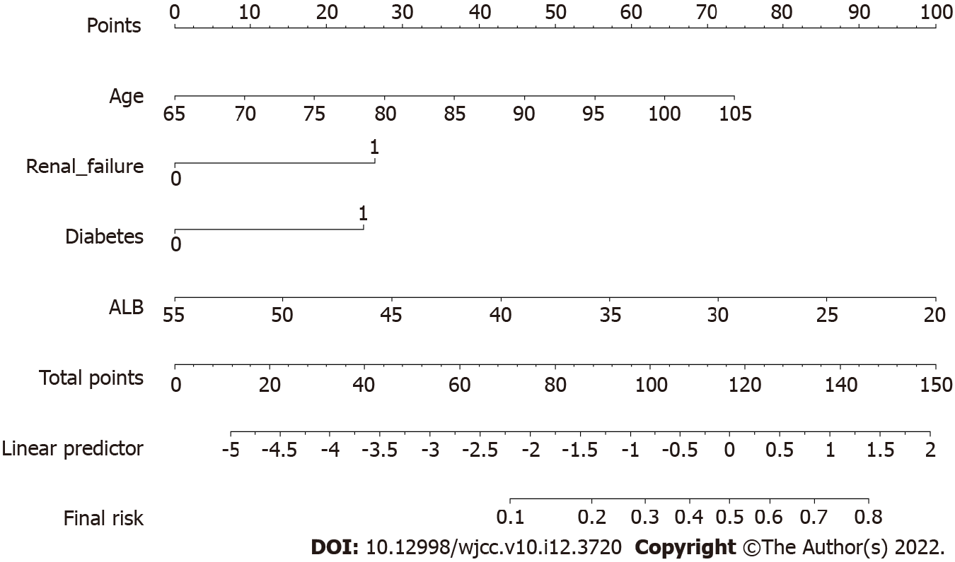
Figure 1 Nomogram. The Morbidity and Mortality Acute Predictor (arthro-MAP). The nomogram computes the probability of having a postoperative complication. In order to compute the predicted complication probability, a vertical line is to be drawn from the values of the individual variables to the scale for points on the top. Then a vertical line from the total points to the corresponding predicted complication probability.
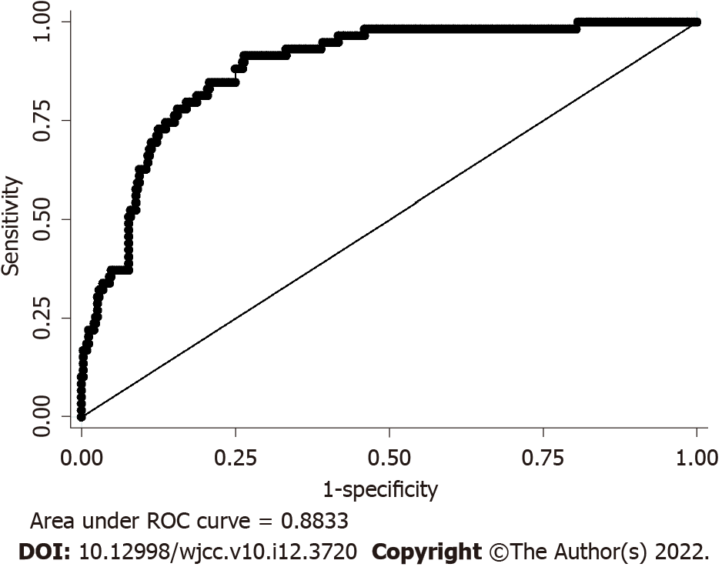
Figure 2 Receive operating characteristic curve. It also name sensitivity curve, the area under curve (AUC) can evaluate the nomogram model discrimination degree. AUC > 0.6: May make sence; AUC > 0.7: Not bad; AUC > 0.8: Excellent. ROC: Receive operating characteristic; AUC: Area under curve.
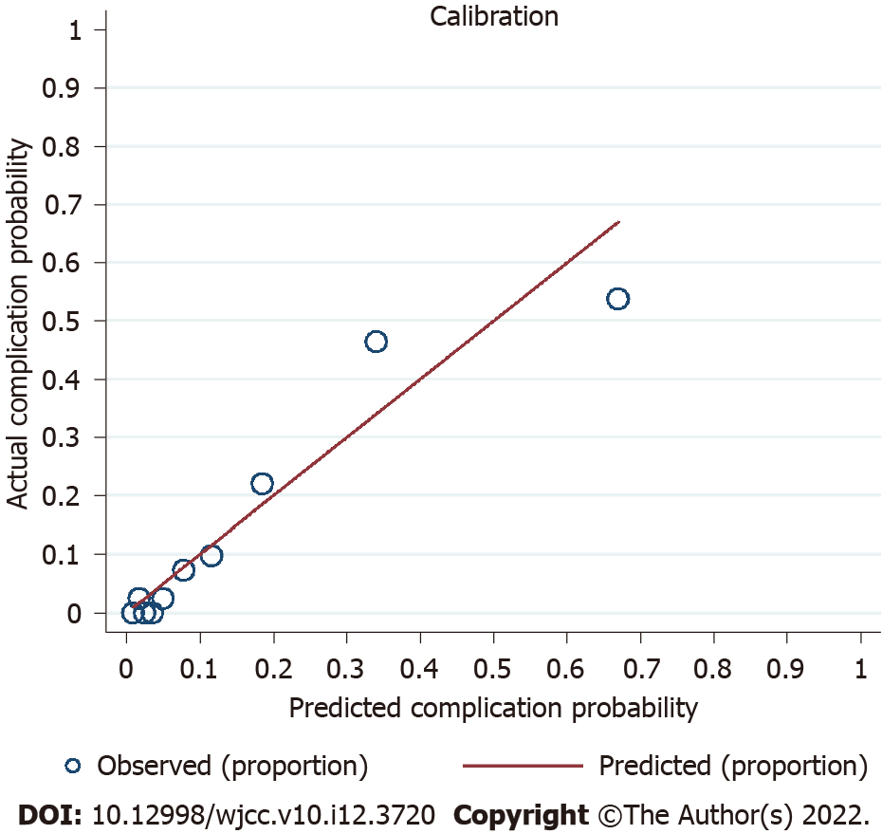
Figure 3 Hosmer-Lemeshow test. The null hypothesis is that the fitting probability pi is grouped by 10 decile, and the difference between the fitted value and the observed value in each group, P < 0.05 shows that the scatter separation is significantly deviated from the reference line, the predicted value is not equal to the actual value. Otherwise, the test passes, the predicted value is equal to the actual value.
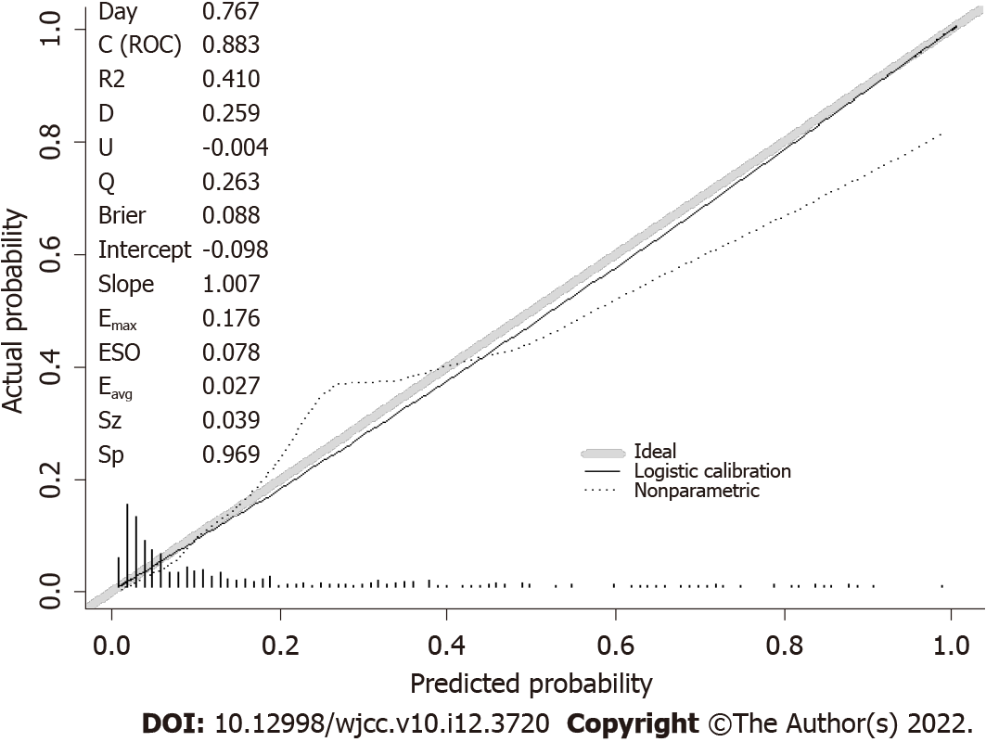
Figure 4 Calibration plot. A calibration plot compares the model’s predicted probabilities and observed proportions. The diagonal line reflects the ideal situation (predicted probability = observed proportion). The curve represents the relation nonparametrically. The calibration curve is a straight line with a slope close to 1, indicating that this model predicts postoperative complication risk in elderly total hip replacement patients consistent with the actual risk.
Table 1 Comparison of clinical data between no complications and complications
Patient characteristics | No complications (n = 355) | Complications (n = 59) | t/χ²/Z value | P value
Age (yr)¹ | 74.06 ± 7.25 | 81.29 ± 8.19 | 6.96 | 0.000
Male gender (%)² | 149 (41.9) | 24(40.7) | 0.03 | 0.852
Weight (kg)¹ | 58.93 ± 10.23 | 57.2 ± 9.93 | 1.2 | 0.226
Comorbidities
Hypertension (%)² | 114 (32.1) | 30 (50.8) | 7.83 | 0.006
Diabetes (%)² | 50 (14.1) | 16 (27.1) | 6.41 | 0.017
Coronary heart disease (%)² | 30 (5) | 10 (16.9) | 4.19 | 0.041
Stroke (%)² | 16 (4.5) | 12 (20.3) | 20.11 | 0.000
Renal failure (%)² | 13 (3.7) | 7 (11.9) | 7.404 | 0.017
Fractures (%)² | 123 (34.6) | 45 (76.3) | 36.35 | 0.000
Laboratory data
WBC (10⁹/L)¹ | 7.6 ± 2.46 | 8.69 ± 2.93 | 2.7 | 0.003
RBC (10¹²/L)¹ | 4.21 ± 0.59 | 3.89 ± 0.69 | 3.81 | 0.000
Hb (g/L)¹ | 123.37 ± 20.99 | 111.89 ± 22.64 | 3.85 | 0.000
PLT (10⁹/L)¹ | 235.66 ± 71.56 | 247.91 ± 115.27 | 0.79 | 0.272
ALB (g/L)¹ | 39.37 ± 4.51 | 35.75 ± 4.41 | 5.72 | 0.000
BUN (mmol/L)¹ | 6.05 ± 4.02 | 7.71 ± 5.08 | 2.39 | 0.019
Intraoperative characteristics
EBL (mL)³ | 203.79 (50-1500) | 229.8 (50-1000) | 1.5 | 0.134
Lowest heart rate (bpm)¹ | 59.39 ± 10.49 | 65.37 ± 13.88 | 3.16 | 0.001
Operation time (min)¹ | 100.85 ± 40.26 | 89.41 ± 37.24 | 2.04 | 0.505
General anesthesia (%)² | 159 (44.8) | 24 (40.7) | 0.35 | 0.556
ASA class ΙΙΙ or ΙV (%)² | 159 (44.8) | 518 (86.4) | 39.35 | 0.000
¹t test;
²Chi-square test;
³Wilcoxon rank-sum test.
Preoperative patient characteristics for 414 total hip replacement procedures between March 1, 2017 and August 31, 2019. Results are presented as number (percentage) of patients, or as mean ± SD. The P values were obtained from chi-square tests, t-tests, or Wilcoxon rank-sum tests, as indicated. EBL: Estimated blood loss; ASA: American Society of Anesthesiologists.
Table 2 Multivariable logistic regression analysis results
Variables | OR | SE | Z | 95%CI | P value
Age | 1.05 | 0.02 | 2.04 | 1.00-1.09 | 0.041
Renal failure | 3.96 | 2.44 | 2.23 | 1.18-13.27 | 0.026
Hypertension | 1.31 | 0.47 | 0.74 | 0.65-2.64 | 0.457
Coronary heart disease | 0.84 | 0.41 | 0.36 | 0.32-2.18 | 0.722
Diabetes | 2.37 | 1.00 | 2.05 | 1.04-5.40 | 0.040
Stroke | 2.41 | 1.15 | 1.84 | 0.94-6.16 | 0.066
Fractures | 2.21 | 0.95 | 1.86 | 0.96-5.12 | 0.063
ASA class ΙΙΙ or ΙV | 1.85 | 0.68 | 1.69 | 0.91-3.79 | 0.090
Lowest heart rate | 1.02 | 0.01 | 1.10 | 0.99-1.05 | 0.272
RBC | 1.05 | 0.34 | 0.16 | 0.56-1.99 | 0.869
WBC | 1.03 | 0.64 | 0.44 | 0.91-1.16 | 0.657
Hb | 1.00 | 0.01 | 0.10 | 0.98-1.02 | 0.922
ALB | 0.90 | 0.04 | 2.73 | 0.83-0.97 | 0.006
BUN | 1.00 | 0.04 | 0.13 | 0.94-1.08 | 0.893
RBC: Red blood cell; WBC: White blood cell; Hb: Hemoglobin; ALB: Albumin; BUN: Blood urea nitrogen; ASA: American Society of Anesthesiologists.

Published by Baishideng Publishing Group Inc
7041 Koll Center Parkway, Suite 160, Pleasanton, CA 94566, USA
Telephone: +1-925-3991568
E-mail: bpgoffice@wjgnet.com
Help Desk: https://www.f6publishing.com/helpdesk
https://www.wjgnet.com

© 2022 Baishideng Publishing Group Inc. All rights reserved.

