Name of Journal: World Journal of Clinical Cases
Manuscript NO: 69140
Manuscript Type: META-ANALYSIS

Clinical significance of signet ring cells in surgical esophageal and esophagogastric junction adenocarcinoma: A systematic review and meta-analysis

Wang YF et al. SRCs in EEGJA patients

Yi-Fan Wang, Si-Yu Xu, Yan Wang, Guo-Wei Che, Hai-Tao Ma

Yi-Fan Wang, Department of Thoracic Surgery, Affiliated Hospital of Chengdu University, Chengdu 610081, Sichuan Province, China

Yi-Fan Wang, Hai-Tao Ma, Department of Thoracic Surgery, The First Affiliated Hospital of Soochow University, Suzhou 215006, Jiangsu Province, China

Si-Yu Xu, West China Second University Hospital, Sichuan University, Chengdu 610041, Sichuan Province, China

Yan Wang, Guo-Wei Che, Department of Thoracic Surgery, West China Hospital, Chengdu 610041, Sichuan Province, China

Author contributions: Ma HT made substantial contributions to the conception and design of the work; Wang YF and Xu SY searched and selected the materials and extracted the data; Wang YF and Xu SY wrote this manuscript; Yan Wang and Che GW revised the paper carefully and also contributed to the statistical analysis; Wang YF and Xu SY contributed equally to this work; and all authors have read and approved the final manuscript.

Corresponding author: Hai-Tao Ma, MD, Professor, Department of Thoracic Surgery, The First Affiliated Hospital of Soochow University, No. 899 Pinghai Road, Suzhou 215006, Jiangsu Province, China. mht7403@163.com

Received: June 18, 2021
Revised: July 29, 2021
Accepted: October 25, 2021
Published online: December 16, 2021

Abstract
BACKGROUND
The clinical significance of signet ring cells (SRCs) in surgical esophageal and esophagogastric junction adenocarcinoma (EEGJA) remains unclear now.

AIM
To explore the association between the presence of SRCs and the clinicopathological and prognostic characteristics in surgical EEGJA patients by combining and analyzing relevant studies.

METHODS
The PubMed, Web of Science, and EMBASE electronic databases were searched for the relevant literature up to March 28, 2021. The relative risk (RR) with 95% confidence interval (CI) was calculated to assess the relationship between SRCs and clinicopathological parameters of surgical EEGJA patients, and the hazard ratio (HR) with 95%CI was calculated to explore the impact of SRC on the prognosis. All statistical analyses were conducted with STATA 12.0 software.

RESULTS
A total of ten articles were included, involving 30322 EEGJA patients. The pooled results indicated that the presence of SRCs was significantly associated with tumor location (RR: 0.76, 95%CI: 0.61-0.96, P = 0.022; I² = 49.4%, P = 0.160) and tumor-node-metastasis stage (RR: 1.30, 95%CI: 1.02-1.65, P = 0.031; I² = 73.1%, P = 0.002). Meanwhile, the presence of SRCs in surgical EEGJA patients predicted a poor overall survival (HR: 1.36, 95%CI: 1.12-1.65, P = 0.002; I² = 85.7%, P < 0.001) and disease-specific survival (HR: 1.86, 95%CI: 1.55-2.25, P < 0.001; I² = 63.1%, P = 0.043).

CONCLUSION
The presence of SRCs is related with advanced tumor stage and poor prognosis and could serve as a reliable and effective parameter for the prediction of postoperative survival and formulation of therapy strategy in EEGJA patients. However, more high-quality studies are still needed to verify the above findings.

Key Words: Signet ring cells; Esophageal and esophagogastric junction adenocarcinoma; Clinicopathological characteristics; Prognosis; Systematic review; Meta-analysis

©The Author(s) 2021. Published by Baishideng Publishing Group Inc. All rights reserved.

Citation: Wang YF, Xu SY, Wang Y, Che GW, Ma HT. Clinical significance of signet ring cells in surgical esophageal and esophagogastric junction adenocarcinoma: A systematic review and meta-analysis. World J Clin Cases 2021; 9(35): 10969-10978
URL: https://www.wjgnet.com/2307-8960/full/v9/i35/10969.htm
DOI: https://dx.doi.org/10.12998/wjcc.v9.i35.10969

Core Tip: Our manuscript indicated that the presence of signet ring cells (SRCs) was significantly associated with the tumor location (P = 0.022) and tumor-node-metastasis stage (P = 0.031). Meanwhile, the presence of SRCs in surgical esophageal and esophagogastric junction adenocarcinoma (EEGJA) patients predicted a poor overall survival (P = 0.002) and disease-specific survival (P < 0.001). The presence of SRC was related with advanced tumor stage and poor prognosis and could serve as a reliable and effective parameter for the prediction of postoperative survival and formulation of therapy strategy in EEGJA patients. However, more high-quality studies are still needed to verify the above findings.

INTRODUCTION
Esophageal carcinoma is the eighth most common tumor worldwide with an estimated 456000 new cases in 2012 and an increasing incidence has been observed in recent decades (7.9/100000 in males and 1.4/100000 in females)^{[1-3]}. Although great progress has been made in the surgical and adjuvant therapy of esophageal cancer in recent years, the survival of esophageal cancer patients remains poor due to the advanced stage at the time of diagnosis^{[4]}. In Western countries, adenocarcinoma is the most common pathological subtype of esophageal cancer, although squamous cell carcinoma accounts for the highest proportion in Asian countries^{[5]}. Signet ring cell (SRC) carcinoma is a rare mucinous subtype of adenocarcinoma that has been reported to be related with aggressive biology in gastrointestinal cancer^{[6,7]}.
Actually, the clinical significance of SRCs in gastric and colorectal carcinomas has been widely verified. Nie et al^{[8]} included 19 studies involving 35947 cases and demonstrated that gastric carcinoma patients with SRCs tended to be younger (weighted mean difference = -3.88, P = 0.001) and predominantly female [odds ratio (OR): 1.60, P < 0.001]. Besides, early-stage gastric cancer patients with SRCs were related with a better overall survival (OS) [hazard ratio (HR): 0.57, P = 0.002], but advanced stage patients with SRCs were related with a worse prognosis (HR: 1.17, P < 0.001); however, in the total population, no significant difference in OS between non-SRC and SRC patients was observed (HR: 1.02, P = 0.830). Besides, after analyzing 2454 colorectal cancer patients, Tan et al^{[9]} demonstrated that the presence of SRCs was an independent prognostic risk factor in colorectal cancer patients (SRC ratio < 50%: 2.182, P = 0.005; SRC ratio > 50%: 1.699, P = 0.016). Meanwhile, it has been reported that patients with an SRC ratio > 50% are more likely to experience an advanced stage of disease and worse survival than patients with an SRC ratio < 50%^{[10]}. However, these meta-analyses focused on the gastric and colorectal carcinomas which are more likely to be combined with SRCs and their results were inconsistent with the studies about esophageal and esophagogastric junction adenocarcinoma (EEGJA). Meanwhile, for EEGJA, the clinical significance of SRCs remains unclear because of the inconsistent reports^{[11-20]}.
Therefore, we conducted this systematic review and meta-analysis to explore the clinical significance of the presence of SRCs in EEGJA patients and the impact of SRCs on the clinicopathological and prognostic characteristics, which might contribute to the prediction of prognosis and formulation of treatment strategy for EEGJA patients.

MATERIALS AND METHODS
This systematic review and meta-analysis were conducted according to the Preferred Reporting Items for Systematic Reviews and Meta-Analyses guidelines^{[21]}.

Inclusion criteria
The inclusion criteria were as follows: (1) Patients were pathologically diagnosed with EEGJA; (2) All patients received surgical therapy; (3) Patients were divided into two groups according to the presence or absence of SRCs, and prospective randomized controlled trials (RCTs) or retrospective cohort studies were both available; (4) Clinicopathological parameters or prognosis between the two groups were compared and relevant data were provided; (5) Although the HRs with corresponding 95% confidence intervals (CIs) were not directly reported in articles, the Kaplan-Meier survival curves were provided to calculate them; and (6) The articles were published in English.

Literature retrieval
The PubMed, Web of Science, and EMBASE electronic databases were searched from the establishment date to March 28, 2021. The following terms were used: “esophageal”, “esophagus”, “esophagogastric”, “gastroesophageal”, “adenocarcinoma”, and “significance of signet ring cell”. A combination of subject terms and free words was applied. Besides, the references cited in included studies were also reviewed for availability (Figure 1).

Exclusion criteria
The exclusion criteria were as follows: (1) Duplicated studies or studies with severely overlapped data; (2) Case reports, reviews, meeting abstracts, and animal trials; and (3) Adenocarcinomas located in other sites like the stomach were also enrolled without subgroup analysis for EEGJA patients.
The titles and abstracts were screened first and irrelevant publications were excluded. Then full texts of potentially related studies were further reviewed for availability.
The literature retrieval and selection were conducted by two investigators (Wang YF and Xu SY).

Data extraction
The data extraction was conducted by two authors (Wang YF and Xu SY) through the Microsoft Excel sheet independently. The following information was extracted from each included studies: The author, publication year, country where the study was conducted, sample size, tumor location (esophageal vs esophagogastric), tumor-node-metastasis (TNM), SRC ratio, sex, smoking, family history, lymph node metastasis status, relative risk (RR), and HR with 95%CI or corresponding data for their calculation.
The association of SRCs with sex, smoking, family history, tumor location, lymph node metastasis, and TNM stage were measured in this study. For the prognostic role of SRCs in EEGJA, the primary outcome was the OS and the second outcomes included the disease-free survival (DFS) and disease-specific survival (DSS).

Quality assessment
The Newcastle-Ottawa Scale (NOS) was applied to evaluate the quality of included studies^{[22]}. This scale includes object selection, comparability, and exposure assessment and objectively evaluates the risk of bias with the maximum score of 9, and studies with a score ≥ 6 were considered to have high quality. The quality assessment was performed by two authors (Wang YF and Xu SY) independently. Any disagreement was solved by team discussion.

Statistical analysis
All statistical analyses were conducted with STATA 12.0 software. The RR and HR with corresponding 95%CI were calculated to assess the association between the presence of SRCs and clinicopathological characteristics and prognosis of EEGJA patients, respectively. If the HR with 95%CI was not reported in articles directly, they would be calculated from Kaplan-Meier curves^{[23]}. The heterogeneity among the included studies was evaluated by I² statistics and Q test. When significant heterogeneity was observed [I² > 50% and (or) P < 0.1], the random effects model was applied; otherwise, the fix effects model was used. The sensitivity analysis and meta-regression analysis were performed to detect the source of heterogeneity and evaluate the stability of pooled results. Besides, the Begg’s funnel plot and Egger’s test were conducted to detect publication bias^{[24,25]}. Significant publication bias was defined as P < 0.05.

RESULTS
Literature retravel
Initially, 631 records were searched and then 90 duplicated records were excluded. After reviewing the titles and abstracts, 503 records without any relativity were excluded. Then, 17 full tests were assessed for eligibility after eliminating 21 publications according to our exclusion criteria. Finally, ten retrospective articles were included in this systematic review and meta-analysis^{[11-20]}.

Basic characteristics
Among the ten included articles, Chirieac et al^{[11]} and van Hootegem et al^{[17]} enrolled two different subgroups of patients, which were regarded as two studies separately. Thus, a total of 12 retrospective cohort studies from ten publications were included, involving 30322 EEGJA patients. Most cases were from America and the sample size ranged from 163 to 14224. Three studies only enrolled esophageal adenocarcinoma patients. All studies were high-quality studies with an NOS score of 6 or higher. Detailed information is presented in Table 1.

Association between presence of SRCs and clinicopathological characteristics of EEGJA patients
The pooled results indicated that SRCs were more likely to occur in esophageal adenocarcinoma rather than esophagogastric junction adenocarcinoma (RR: 0.76, 95%CI: 0.61-0.96, P = 0.022; I² = 49.4%, P = 0.160) and TNM stage III/IV EEGJA patients (RR: 1.30, 95%CI: 1.02-1.65, P = 0.031; I² = 73.1%, P = 0.002). However, no significant relation was observed between SRCs and the sex (RR: 0.99, 95%CI: 0.87-1.13, P = 0.917; I² = 39.4%, P = 0.105), smoking (RR: 0.86, 95%CI: 0.55-1.35, P = 0.507; I² = 86.9%, P = 0.006), family history (RR: 1.157, 95%CI: 0.762-1.757), and lymph node metastasis (RR: 1.05, 95%CI: 0.92-1.20, P = 0.488; I² = 7.2%, P = 0.340) (Table 2).

Association between presence of SRCs and prognosis of EEGJA patients
A total of 11 studies explored the relationship of SRCs with the OS of EEGJA patients (16-18, and 20-25), and the pooled results demonstrated that the presence of SRCs predicted a much poor OS (HR: 1.36, 95%CI: 1.12-1.65, P = 0.002; I² = 85.7%, P < 0.001) (Figure 2). Meanwhile, four studies assessed the impact of SRCs on the DFS of EEGJA patients^{[12,15,17]} and the pooled results did not predict a significant association between SRCs and DFS (HR: 1.21, 95%CI: 0.94-1.57, P = 0.145; I² = 63.1%, P = 0.043) (Figure 3). Besides, after combining two studies^{[17,19]}, a significant relationship was observed between the presence of SRCs and poor DSS (HR: 1.86, 95%CI: 1.55-2.25, P < 0.001; I² = 0.0%, P = 0.323) (Table 3).

Sensitivity analysis and publication bias
According to Figure 4, the sensitivity analysis revealed that the pooled results were stable and reliable.
Besides, the Begg’s funnel plot was symmetrical (Figure 5) and the P value of Egger’s test was 0.572, which indicated nonsignificant publication bias.

Meta-regression analysis
Due to the significant heterogeneity of the OS, meta-regression analysis was conducted based on some variables including the publication year, country, sample size, location, SRC ratio, TNM stage, and NOS score. Unfortunately, none of these parameters were the causes of heterogeneity.

DISCUSSION
The current systematic review and meta-analysis demonstrated that the presence of SRCs was significantly associated with tumor location (RR: 0.76, P = 0.022) and TNM stage (RR: 1.30, P = 0.031). Meanwhile, the presence of SRCs in surgical EEGJA patients predicted a poor OS (HR: 1.36, P = 0.002) and DSS (HR: 1.86, P < 0.001). The presence of SRCs might be an independent prognostic factor in EEGJA patients and contribute to the evaluation of prognosis and decision making.
Interestingly, Chirieac et al^{[11]} demonstrated that the presence of SRCs predicted a much poor prognosis in patients who received surgery alone (P = 0.05), but for patients who received neoadjuvant chemotherapy and surgery, the presence of SRCs predicted a better prognosis (P = 0.02). This phenomenon indicated that SRCs might play an essential role in the response to chemotherapy. In the study by Corsini et al^{[18]}, EEGJA patients with usual type had a much higher pathologic complete response than patients with SRCs (25% vs 10%, P = 0.006). Meanwhile, Solomon et al^{[20]} also revealed that patients with SRCs were less sensitive to neoadjuvant chemoradiotherapy (OR: 6.118, 95%CI: 1.299-28.821, P = 0.022) and less likely to experience downstaging after neoadjuvant chemotherapy (OR: 0.306, 95%CI: 0.099-0.946, P = 0.040). The presence of SRCs may predicted a poor response to chemotherapy, which is opposite to the results reported by Chirieac et al^{[11]}. Thus, more relevant studies are still needed to identify the clinical role of SRC in the chemotherapy and radiotherapy of EEGJA patients.
Although the pooled results indicated that there was no significant association between the presence of SRCs and DFS of EEGJA patients (HR: 1.21, 95%CI: 0.94-1.57, P = 0.145), Yoon et al^{[12]} and Patel et al^{[15]} both reported that patients with SRCs were more likely to experience a worse DFS (HR: 1.49, 95%CI: 1.15-1.93, P = 0.001; HR: 1.34, 95%CI: 1.02-1.80, P = 0.048). Therefore, we believed that SRCs might also predict a poor DFS in EEGJA patients, which needs more studies to further verify.
Besides, Nafteux et al^{[14]} demonstrated that the presence of SRCs was significantly associated with a higher recurrence rate (56% vs 42% for usual type adenocarcinoma, P = 0.003). In their multivariate analysis, SRC ratio > 50% was an independent risk factor for recurrence (OR: 2.070, 95%CI: 1.159-3.696, P = 0.014), which also indicated that the presence of SRCs was related with a poor prognosis in EEGJA patients.
Actually, there are still several valuable fields about the clinical significance of SRCs in EEGJA patients that are worth further investigation. First, as mentioned above, the role that SRCs play in the chemotherapy and radiotherapy is unclear, and more studies comparing the clinical outcomes between EEGJA patients with and without neoadjuvant chemoradiotherapy or postoperative chemoradiotherapy are needed. Second, it is necessary to identify whether SRCs could serve as a reliable predictor for the selection of therapeutic strategies. Third, to explore the role of the proportion change of SRC during chemotherapy in predicting the prognosis of EEGJA patients might be significative. Fourth, according to previous reports, the proportion of SRCs may also be related with the prognosis of EEGJA patients and patients with different ratios of SRCs might have different survival rates.
There were some limitations in this study. First, all included studies were retrospective, which may cause some bias. Second, the association of SRCs with other parameters such as alcohol drinking, differentiation status, Helicobacter pylori infection, and age was not explored due to the lack of relevant data. Third, we failed to conduct subgroup analysis based on the clinicopathological parameters such as age, sex, and TNM stage because the detailed data were not available even if we contacted the authors of included studies.

CONCLUSION
The presence of SRCs is related with advanced tumor stage and poor prognosis and could serve as a reliable and effective parameter for the prediction of postoperative survival and formulation of therapy strategy in EEGJA patients. However, more prospective high-quality studies are still needed to verify our findings.

ARTICLE HIGHLIGHTS
Research background
The clinical role of signet ring cells (SRCs) in surgical esophageal and esophagogastric junction adenocarcinoma (EEGJA) remains unclear now.

Research motivation
To explore the clinical role of the presence of SRCs in surgical EEGJA patients.

Research objectives
To explore the association between the presence of SRCs and the clinicopathological and prognostic characteristics in surgical EEGJA patients.

Research methods
Several electronic databases were searched to identify the relevant articles. The relative risks and hazard ratios with their corresponding 95% confidence intervals were estimated, respectively.

Research results
The presence of SRCs was significantly associated with the tumor location (P = 0.022) and tumor-node-metastasis stage (P = 0.031). Meanwhile, the presence of SRCs in surgical EEGJA patients predicted a poor overall survival (P = 0.002) and disease-specific survival (P < 0.001).

Research conclusions
SRC was significantly related with advanced tumor stage and poor prognosis in EEGJA patients.

Research perspectives
The presence of SRCs could serve as a reliable and effective parameter for the prediction of postoperative survival and formulation of therapy strategy in EEGJA patients.

REFERENCES
1 Wheeler JB, Reed CE. Epidemiology of esophageal cancer. Surg Clin North Am 2012; 92: 1077-1087 [PMID: 23026270 DOI: 10.1016/j.suc.2012.07.008]
2 Njei B, McCarty TR, Birk JW. Trends in esophageal cancer survival in United States adults from 1973 to 2009: A SEER database analysis. J Gastroenterol Hepatol 2016; 31: 1141-1146 [PMID: 26749521 DOI: 10.1111/jgh.13289]
3 Arnold M, Soerjomataram I, Ferlay J, Forman D. Global incidence of oesophageal cancer by histological subtype in 2012. Gut 2015; 64: 381-387 [PMID: 25320104 DOI: 10.1136/gutjnl-2014-308124]
4 Sung H, Ferlay J, Siegel RL, Laversanne M, Soerjomataram I, Jemal A, Bray F. Global Cancer Statistics 2020: GLOBOCAN Estimates of Incidence and Mortality Worldwide for 36 Cancers in 185 Countries. CA Cancer J Clin 2021; 71: 209-249 [PMID: 33538338 DOI: 10.3322/caac.21660]
5 Rice TW, Gress DM, Patil DT, Hofstetter WL, Kelsen DP, Blackstone EH. Cancer of the esophagus and esophagogastric junction-Major changes in the American Joint Committee on Cancer eighth edition cancer staging manual. CA Cancer J Clin 2017; 67: 304-317 [PMID: 28556024 DOI: 10.3322/caac.21399]
6 Song IH, Hong SM, Yu E, Yoon YS, Park IJ, Lim SB, Kim JC, Yu CS, Kim J. Signet ring cell component predicts aggressive behaviour in colorectal mucinous adenocarcinoma. Pathology 2019; 51: 384-391 [PMID: 31029443 DOI: 10.1016/j.pathol.2019.03.001]
7 Piessen G, Messager M, Lefevre JH, Goéré D, Mabrut JY, Meunier B, Brigand C, Hamy A, Glehen O, Mariette C; FREGAT Working Group – FRENCH. Signet ring cell adenocarcinomas: different clinical-pathological characteristics of oesophageal and gastric locations. Eur J Surg Oncol 2014; 40: 1746-1755 [PMID: 25012732 DOI: 10.1016/j.ejso.2014.04.019]
8 Nie RC, Yuan SQ, Li YF, Chen YM, Chen XJ, Zhu BY, Xu LP, Zhou ZW, Chen S, Chen YB. Clinicopathological Characteristics and Prognostic Value of Signet Ring Cells in Gastric Carcinoma: A Meta-Analysis. J Cancer 2017; 8: 3396-3404 [PMID: 29151922 DOI: 10.7150/jca.21017]
9 Tan Y, Fu J, Li X, Yang J, Jiang M, Ding K, Xu J, Li J, Yuan Y. A minor (<50%) signet-ring cell component associated with poor prognosis in colorectal cancer patients: a 26-year retrospective study in China. PLoS One 2015; 10: e0121944 [PMID: 25789685 DOI: 10.1371/journal.pone.0121944]
10 An Y, Zhou J, Lin G, Wu H, Cong L, Li Y, Qiu X, Shi W. Clinicopathological and Molecular Characteristics of Colorectal Signet Ring Cell Carcinoma: A Review. Pathol Oncol Res 2021; 27: 1609859 [PMID: 34381313 DOI: 10.3389/pore.2021.1609859]
11 Chirieac LR, Swisher SG, Correa AM, Ajani JA, Komaki RR, Rashid A, Hamilton SR, Wu TT. Signet-ring cell or mucinous histology after preoperative chemoradiation and survival in patients with esophageal or esophagogastric junction adenocarcinoma. Clin Cancer Res 2005; 11: 2229-2236 [PMID: 15788671 DOI: 10.1158/1078-0432.CCR-04-1840]
12 Yoon HH, Khan M, Shi Q, Cassivi SD, Wu TT, Quevedo JF, Burch PA, Sinicrope FA, Diasio RB. The prognostic value of clinical and pathologic factors in esophageal adenocarcinoma: a mayo cohort of 796 patients with extended follow-up after surgical resection. Mayo Clin Proc 2010; 85: 1080-1089 [PMID: 21123634 DOI: 10.4065/mcp.2010.0421]
13 Yendamuri S, Huang M, Malhotra U, Warren GW, Bogner PN, Nwogu CE, Groman A, Demmy TL. Prognostic implications of signet ring cell histology in esophageal adenocarcinoma. Cancer 2013; 119: 3156-3161 [PMID: 23719932 DOI: 10.1002/cncr.28099]
14 Nafteux PR, Lerut TE, Villeneuve PJ, Dhaenens JM, De Hertogh G, Moons J, Coosemans WJ, Van Veer HG, De Leyn PR. Signet ring cells in esophageal and gastroesophageal junction carcinomas have a more aggressive biological behavior. Ann Surg 2014; 260: 1023-1029 [PMID: 24836142 DOI: 10.1097/SLA.0000000000000689]
15 Patel VR, Hofstetter WL, Correa AM, Agarwal A, Rashid A, Bhutani MS, Lin SH, Ajani JA, Swisher SG, Maru DM. Signet ring cells in esophageal adenocarcinoma predict poor response to preoperative chemoradiation. Ann Thorac Surg 2014; 98: 1064-1071 [PMID: 25038008 DOI: 10.1016/j.athoracsur.2014.04.099]
16 Chen L, Liu X, Gao L, Wang R, Gao D, Bai D. The clinicopathological features and prognosis of signet ring cell carcinoma of the esophagus: A 10-year retrospective study in China. PLoS One 2017; 12: e0176637 [PMID: 28486494 DOI: 10.1371/journal.pone.0176637]
17 van Hootegem SJM, Smithers BM, Gotley DC, Brosda S, Thomson IG, Thomas JM, Gartside M, van Lanschot JJB, Lagarde SM, Wijnhoven BPL, Barbour AP. The Impact of Signet Ring Cell Differentiation on Outcome in Patients with Esophageal and Gastroesophageal Junction Adenocarcinoma. Ann Surg Oncol 2019; 26: 2375-2384 [PMID: 30941657 DOI: 10.1245/s10434-019-07322-x]
18 Corsini EM, Foo WC, Mitchell KG, Zhou N, Maru DM, Ajani JA, Hofstetter WL; Esophageal Adenocarcinoma Working Group, Correa AM, Antonoff MB, Lin SH, Mehran RJ, Rajaram R, Rice DC, Roth JA, Sepesi B, Swisher SG, Vaporciyan AA, Walsh GL. Esophageal adenocarcinoma with any component of signet ring cells portends poor prognosis and response to neoadjuvant therapy. J Thorac Cardiovasc Surg 2020 [PMID: 33010880 DOI: 10.1016/j.jtcvs.2020.08.108]
19 Sathe TS, Resio BJ, Hoag JR, Monsalve AF, Pathak R, Blasberg JD, Mase V Jr, Dhanasopon A, Boffa DJ. Surgically Managed Signet Ring Cell Esophageal Carcinomas in the National Cancer Database. Ann Thorac Surg 2020; 109: 1656-1662 [PMID: 32109449 DOI: 10.1016/j.athoracsur.2020.01.021]
20 Solomon D, Abbas M, Feferman Y, Haddad R, Perl G, Kundel Y, Morgenstern S, Menasherov N, Kashtan H. Signet Ring Cell Features are Associated with Poor Response to Neoadjuvant Treatment and Dismal Survival in Patients with High-Grade Esophageal Adenocarcinoma. Ann Surg Oncol 2021; 28: 4929-4940 [PMID: 33709175 DOI: 10.1245/s10434-021-09644-1]
21 McLeroy KR, Northridge ME, Balcazar H, Greenberg MR, Landers SJ. Reporting guidelines and the American Journal of Public Health's adoption of Preferred Reporting Items for Systematic reviews and Meta-Analyses. Am J Public Health 2012; 102: 780-784 [PMID: 22420806 DOI: 10.2105/AJPH.2011.300630]
22 Stang A. Critical evaluation of the Newcastle-Ottawa scale for the assessment of the quality of nonrandomized studies in meta-analyses. Eur J Epidemiol 2010; 25: 603-605 [PMID: 20652370 DOI: 10.1007/s10654-010-9491-z]
23 Wang Y, Wu Y, Li J, Lai Y, Zhou K, Che G. Prognostic and clinicopathological significance of FGFR1 gene amplification in resected esophageal squamous cell carcinoma: a meta-analysis. Ann Transl Med 2019; 7: 669 [PMID: 31930070 DOI: 10.21037/atm.2019.10.69]
24 Begg CB, Mazumdar M. Operating characteristics of a rank correlation test for publication bias. Biometrics 1994; 50: 1088-1101 [PMID: 7786990]
25 Egger M, Davey Smith G, Schneider M, Minder C. Bias in meta-analysis detected by a simple, graphical test. BMJ 1997; 315: 629-634 [PMID: 9310563 DOI: 10.1136/bmj.315.7109.629]

Footnotes
Conflict-of-interest statement: The authors declare no potential conflicts of interest with respect to the research, authorship, and/or publication of this article.

PRISMA 2009 Checklist statement: This systematic review and meta-analysis were conducted according to the Preferred Reporting Items for Systematic Reviews and Meta-Analyses guidelines.

Open-Access: This article is an open-access article that was selected by an in-house editor and fully peer-reviewed by external reviewers. It is distributed in accordance with the Creative Commons Attribution NonCommercial (CC BY-NC 4.0) license, which permits others to distribute, remix, adapt, build upon this work non-commercially, and license their derivative works on different terms, provided the original work is properly cited and the use is non-commercial. See: http://creativecommons.org/Licenses/by-nc/4.0/

Provenance and peer review: Unsolicited article; Externally peer reviewed

Peer-review started: June 18, 2021
First decision: July 26, 2021
Article in press: October 25, 2021

Specialty type: Medicine, research and experimental
Country/Territory of origin: China
Peer-review report’s scientific quality classification
Grade A (Excellent): A
Grade B (Very good): B
Grade C (Good): C
Grade D (Fair): D
Grade E (Poor): 0

P-Reviewer: Ayenew AA, Patil S, Sánchez JIA S-Editor: Wang JJ L-Editor: Wang TQ P-Editor: Wang JJ

Figure Legends
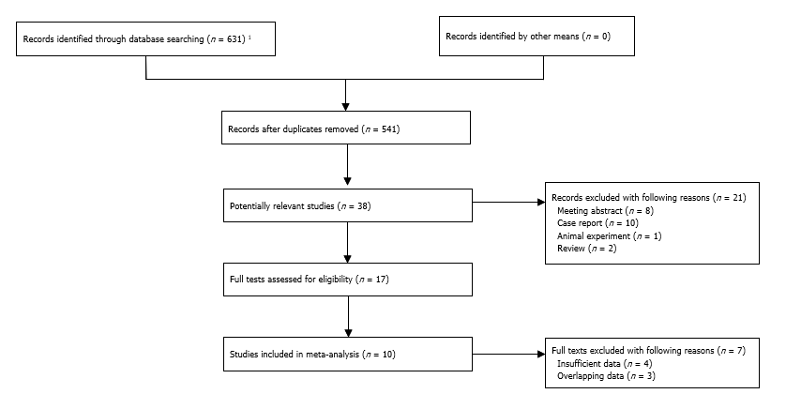
Figure 1 Flow diagram of this meta-analysis. ¹PubMed (n = 175), EMBASE (n = 169), and Web of Science (n = 287).
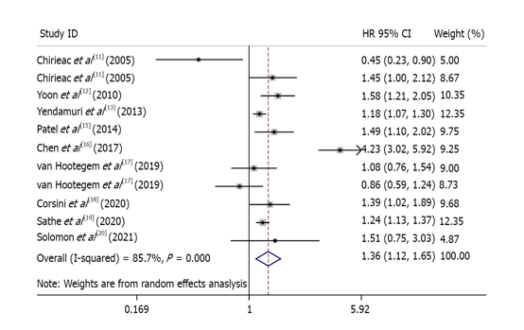
Figure 2 Forest plot of association between presence of signet ring cells and overall survival^{[11-13,15- 20]}. HR: Hazard ratio; CI: Confidence interval.

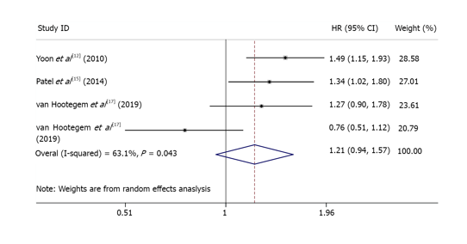
Figure 3 Forest plot of association between presence of signet ring cells and disease-free survival^{[12,15,17]}. HR: Hazard ratio; CI: Confidence interval.
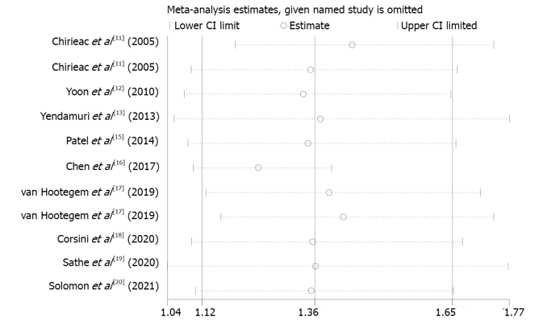
Figure 4 Sensitivity analysis of association between presence of signet ring cells and overall survival^{[11-13,15-20]}. CI: Confidence interval.

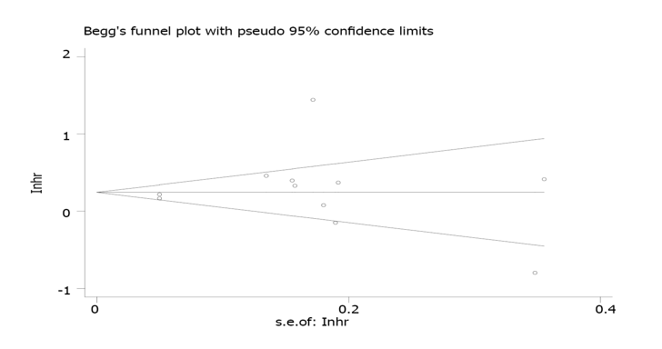
Figure 5 Begg’s funnel plot of association between presence of signet ring cells and overall survival.

Table 1 Basic characteristics of included studies
Author | Year | Country | Sample size | Location | TNM | SRC ratio | Endpoint | NOS
Chirieac et al^{[11]} | 2005 | United States (ACC: 1985-2003) | 193 | Esophageal + EGJ | I-IV | > 0% | OS | 7
Chirieac et al^{[11]} | 2005 | United States (ACC: 1985-2003) | 219 | Esophageal + EGJ | I-IV | > 0% | OS | 7
Yoon et al^{[12]} | 2010 | United States (MCTR) | 796 | Esophageal + EGJ | NR | > 0% | OS, DSS, DFS | 6
Yendamuri et al^{[13]} | 2013 | United States (SEER) | 11825 | Esophageal | I-IV | > 0% | OS, | 7
Nafteux et al^{[14]} | 2014 | Belgium | 779 | Esophageal + EGJ | I-IV | 1%-50%, > 50% | DSS | 7
Patel et al^{[15]} | 2014 | United States (ACC: 2000-2012) | 723 | Esophageal + EGJ | II-IV | > 0% | OS, DFS | 7
Chen et al ^{[16]} | 2017 | China | 671 | Esophageal | I-III | 1%-50%, > 50% | OS | 8
Van Hootegem et al^{[17]} | 2019 | Australia | 298 | Esophageal + EGJ | NR | > 0% | OS, DFS | 7
Van Hootegem et al^{[17]} | 2019 | Australia | 391 | Esophageal + EGJ | NR | > 0% | OS, DFS | 7
Corsini et al^{[18]} | 2020 | United States (ACC: 2006-2018) | 819 | Esophageal | NR | 1%-10%, 11%-49%, ≥ 50% | OS | 8
Sathe et al^{[19]} | 2020 | United States (NCD: 2004-2015) | 14224 | Esophageal + EGJ | I-III | NR | OS | 7
Solomon et al^{[20]} | 2021 | Israel | 163 | Esophageal + EGJ | I-III | > 0% | OS | 6
SRC: Signet ring cell; NOS: Newcastle-Ottawa Scale; EGJ: Esophagogastric junction; Surg: Surgery; nCT: Neoadjuvant chemotherapy; OS: Overall survival; DSS: Disease-specific survival; DFS: Disease-free survival; SEER: Surveillance, Epidemiology, and End Results; R: Recurrence; ACC: Anderson Cancer Center; MCTR: Mayo Clinic Tumor Registry; RTCT: Response to chemotherapy; NCD: National Cancer Database; DS: Downstaging; TNM: Tumor-node-metastasis; NR: Not reported.
Table 2 Association between signet-ring cells and clinicopathological characteristics
Study | Sex (male) | Smoking | Family history | Tumor location (esophageal) | Lymph node metastasis | TNM stage (III/IV)
Chirieac et al^{[11]} 2005 | 0.722 (0.254-2.053) | - | - | - | - | 0.895 (0.522-1.532)
Chirieac et al^{[11]} 2005 | 0.730 (0.341-1.564) | - | - | - | - | 1.855 (0.997-3.454)
Yoon et al^{[12]} 2010 | - | - | - | - | - | -
Yendamuri et al^{[13]} 2013 | 0.975 (0.783-1.214) | - | - | - | - | 1.267 (1.060-1.513)
Nafteux et al^{[14]} 2014 | 0.882 (0.558-1.395) | - | - | 0.636 (0.451-0.896) | - | 1.048 (0.702-1.563)
Patel et al^{[15]} 2014 | 0.518 (0.309-0.867) | - | - | - | 1.357 (0.907-2.028) | -
Chen et al^{[16]} 2017 | 1.461 (0.945-2.258) | 0.667 (0.495-0.899) | 1.157 (0.762-1.757) | - | - | 1.095 (0.811-1.480)
Van Hootegem et al^{[17]} 2019 | 1.138 (0.662-1.956) | - | - | 0.888 (0.649-1.216) | 0.929 (0.677-1.275) | -
Corsini et al^{[18]} 2020 | 0.771 (0.460-1.292) | 1.061 (0.923-1.219) | - | - | 1.038 (0.888-1.215) | -
Sathe et al^{[19]} 2020 | 1.164 (0.912-1.485) | - | - | - | - | 1.832 (1.542-2.177)
Solomon et al^{[20]} 2021 | - | - | - | - | - | -
Overall | 0.99, 0.87-1.13, P = 0.917 | 0.86, 0.55-1.35, P = 0.507 | 1.157 (0.762-1.757) | 0.76, 0.61-0.96, P = 0.022 | 1.05, 0.92-1.20, P = 0.488 | 1.30, 1.02-1.65, P = 0.031
TNM: Tumor-node-metastasis.

Table 3 Results of meta-analysis
 | No. of studies | HR | 95%CI | P value | I² | P value
Overall survival | 11^{[11-13,15-20]} | 1.36 | 1.12-1.65 | 0.002 | 85.7 | < 0.001
Disease-free survival | 4^{[12,15,17]} | 1.21 | 0.94-1.57 | 0.145 | 63.1 | 0.043
Disease-specific survival | 2^{[12,14]} | 1.86 | 1.55-2.25 | < 0.001 | 0.0 | 0.323
HR: Hazard ratio; CI: Confidence interval.

Published by Baishideng Publishing Group Inc
7041 Koll Center Parkway, Suite 160, Pleasanton, CA 94566, USA
Telephone: +1-925-3991568
E-mail: bpgoffice@wjgnet.com
Help Desk: https://www.f6publishing.com/helpdesk
https://www.wjgnet.com

© 2021 Baishideng Publishing Group Inc. All rights reserved.

