Name of Journal: World Journal of Clinical Cases
Manuscript NO: 42885
Manuscript Type: CASE REPORT

Post-appendectomy pelvic abscess with extended-spectrum beta-lactamase producing Escherichia coli: A case report and review of literature

Tse A et al. Post-appendectomy ESBL E. coli pelvic abscess

Andrew Tse, Rajkumar Cheluvappa, Selwyn Selvendran

Andrew Tse, Selwyn Selvendran, Department of Surgery, St George Public Hospital, Kogarah NSW 2217, Australia

Andrew Tse, Selwyn Selvendran, St George and Sutherland Clinical School, University of New South Wales, Sydney NSW 2052, Australia

Rajkumar Cheluvappa, BN Program, Discipline of Nursing and Midwifery, University of Canberra, Bruce ACT 2617, Australia

ORCID number: Andrew Tse (0000-0002-5491-1307); Rajkumar Cheluvappa (0000-0002-3472-9591); Selwyn Selvendran (0000-0001-9888-3574).

Author contributions: Tse A and Cheluvappa R performed research and wrote this paper; Cheluvappa R addressed reviewers’ comments and did the final submission; Selvendran S designed research and supervised the writing of this paper.

Informed consent statement: Informed consent was obtained from the patient, and appropriate signed documentation was obtained and retained.

Conflict-of-interest statement: The authors have no conflicts of interests to declare.

CARE Checklist (2013) statement: Guidelines of the CARE Checklist (2013) have been adopted while writing this manuscript.

Open-Access: This article is an open-access article which was selected by an in-house editor and fully peer-reviewed by external reviewers. It is distributed in accordance with the Creative Commons Attribution Non Commercial (CC BY-NC 4.0) license, which permits others to distribute, remix, adapt, build upon this work non-commercially, and license their derivative works on different terms, provided the original work is properly cited and the use is non-commercial. See: http://creativecommons.org/licenses/by-nc/4.0/

Manuscript source: Invited manuscript

Corresponding author to: Rajkumar Cheluvappa, MBBS, PhD, Professor, BN Program, Discipline of Nursing and Midwifery, University of Canberra, Bruce ACT 2617, Australia. rajkumarchel@gmail.com
Telephone: +61-406-040620

Received: October 19, 2018
Peer-review started: October 19, 2018
First decision: November 12, 2018
Revised: November 11, 2018
Accepted: November 14, 2018
Article in press:
Published online:

Abstract
BACKGROUND
Appendicitis, the inflammation of the appendix, is the most common abdominal surgical emergency requiring expedient surgical intervention. Extended-spectrum beta-lactamases (ESBLs) are bacterial enzymes that catalyse the degradation of the beta-lactam ring of penicillins and cephalosporins (but without carbapenemase activity), leading to resistance of these bacteria to beta-lactam antibiotics. Recent increases in incidence of ESBL-producing bacteria have caused alarm worldwide. Proportion estimates of ESBL-Enterobacteriaceae hover around 46% in China, 42% in East Africa, 12% in Germany, and 8% in the United States.

CASE SUMMARY
The impact of ESBL-producing bacteria on appendiceal abscesses and consequent pelvic abscesses are yet to be examined in depth. A literature review using the search words “appendiceal abscesses” and “ESBL Escherichia coli (E. coli)” revealed very few cases involving ESBL E. coli in any capacity in the context of appendiceal abscesses. This report describes the clinical aspects of a patient with appendicitis who developed a postoperative pelvic abscess infected with ESBL-producing E. coli. In this report, we discuss the risk factors for contracting ESBL E. coli infection in appendicitis and post-appendectomy pelvis abscesses. We also discuss our management approach for post-appendectomy ESBL E. coli pelvic abscesses, including drainage, pathogen identification, and pathogen characterisation. When ESBL E. coli is confirmed, carbapenem antibiotics should be promptly administered, as was done efficaciously with this patient. Our report is the first one in a developed country involving ESBL E. coli related surgical complications in association with a routine laparoscopic appendectomy.

CONCLUSION
Our report is the first involving ESBL E. coli and appendiceal abscesses, and that too consequent to laparoscopic appendectomy.

Key words: Antibiotic resistance; Appendectomy; Appendiceal abscess; Appendicitis; Beta-Lactam; Beta-Lactamase; Carbanepem; Cephalosporin; Escherichia coli; Extended-spectrum beta-lactamase; Infection; Pelvic abscess; Penicillin; Case report

© The Author(s) 2018. Published by Baishideng Publishing Group Inc. All rights reserved.

Core tip: This report describes the clinical aspects of a patient with appendicitis who developed a postoperative pelvic abscess infected with extended-spectrum beta-lactamase (ESBL) producing Escherichia coli (E. coli). Our report is the first reliable report involving ESBL E. coli and appendiceal abscesses. This report is also the first one in a developed country involving ESBL E. coli related surgical complications in association with a routine laparoscopic appendectomy.

Tse A, Cheluvappa R, Selvendran S. Post-appendectomy pelvic abscess with extended-spectrum beta-lactamase producing Escherichia coli: A case report and review of literature. World J Clin Cases 2018; In press

INTRODUCTION
Extended-spectrum beta-lactamases (ESBLs) are bacterial enzymes that lead to the degradation of the beta-lactam ring of pencicillins, cephalosporins, and monobactams (but not carbapenems) leading to these beta-lactam antibiotics being ineffective in treating infections with bacteria producing ESBLs^{[1]}. Beta-lactamase inhibitors, such as clavulanic acid, inhibit ESBLs. However, there is sparse evidence available for good clinical outcomes with beta-lactamase inhibitor combinations^{[2]}. The bacterial ESBLs are commonly encoded by transferable multi-antibiotic resistance plasmids, often including resistance to aminoglycosides^{[2]}. Therefore, the antibiotic choices are limited to carbapenems (drug-group of choice), fluoroquinolones, tigecycline and polymyxins^{[2]}. The substantial increases in recent worldwide prevalence of ESBL-producing bacteria have alarmed public health officials and infectious diseases personnel^{[1]}. Bacteria producing ESBLs have been isolated with significant rates in Asia, Latin America and the Middle East^{[3]}. Recent global increases in faecal colonisation by ESBL bacteria have been noted^{[4]}. South and South East Asia are considered to be major regions for ESBL related infections and colonisation^{[5-7]}. A Pakistani meta-analysis estimated the proportion of ESBL Enterobacteriaceae colonisation (nosocomial and community) to be 40%^{[8]}. Proportion estimates of ESBL Enterobacteriaceae hover around 46% in China^{[9]}, 42% in East Africa^{[10]}, 10% to 15% in Germany^{[11]}, and 4% to 12% in the United States^{[12,13]}. These data have significant clinical and public health import. However, the specific impact of ESBL bacteria on appendiceal abscesses and consequent pelvic abscesses are yet to be determined.
The human vermiform appendix has abundant lymphoid tissue and is exposed constantly to gastrointestinal bacteria and viruses of various hues. Inflammation of the appendix is termed “appendicitis’’. The causality of acute appendicitis has been shrouded in mystery, although the most popular theory posits luminal obstruction of the appendix (by faecoliths, lymphoid hyperplasia, or malignancy) incarcerating gut secretions, leading to increased intraluminal pressure and mucosal ischemia, resulting in gut bacterial infection^{[14]}. The incidence of appendicitis is approximately 7%, making it the most common abdominal pathology requiring emergency surgery^{[15]}. The peak incidence of appendicitis without perforation is in the 2nd and 3rd decades of life^{[16]}. Mortality due to acute appendicitis is around 0.3%^{[17]}. The mortality increases to 1.7% if perforation is present^{[17]}. The approximate annual incidence of acute appendicitis in Australia is 177 per 100000^{[18]}. Appendectomy for appendicitis is one of the most common emergency surgeries performed in public hospitals in Australia^{[19]}. A well-known complication of appendectomies is the development of postoperative intra-abdominal abscesses. It occurs in 3% to 25% of appendectomies^{[20,21]}, with higher occurrences after perforated or gangrenous appendicitis^{[22-25]}.
Our patient was a 16-year-old girl from a Pakistani background who presented with acute appendicitis but went on to develop a pelvic abscess with ESBL E. coli after laparoscopic appendectomy. We monitored and treated this patient at various stages. Data was collated from progress notes, procedure summaries, pathology reports, radiology films or reports, surgical procedure-entries, and clinical files pertaining to this patient. We carried out a systematic literature search on Pubmed and Google Scholar using different combinations of the words: appendiceal, appendicitis, appendectomy, appendicectomy, abscess, ESBL, extended spectrum beta lactamase, or E. coli. There have only been 2 previous reports involving ESBL E. coli in any context of appendiceal abscesses. One of the 2 reports was 6-years-old, and the other, 9-years-old^{[26,27]}. Unfortunately, those 2 reports appeared to be from publications not affiliated to reputable publishing houses^{[26,27]}. Moreover, those 2 reports are not indexed in Pubmed^{[26,27]}.

CASE PRESENTATION
A 16-year-old girl of Pakistani extraction presented with a 7-d-history of right iliac fossa pain with anorexia, diarrhoea, and a body temperature of 38.7℃. Her outpatient ultrasound scan did not show the appendix, although the possibility of the presence of a right ovarian cyst was suspected. Laboratory examination showed elevated levels of inflammatory markers: white cell count (WCC) 21.61 x 10⁹/L, and C reactive protein (CRP) 69 mg/L. Based on these findings, a clinical diagnosis of appendicitis was made and the patient was commenced on 1 g Ceftriaxone daily and 500 mg of Metronidazole twice-daily. The patient underwent emergency surgery on the same night of arrival. On laparoscopy, a large phlegmon was identified, encompassing a perforated appendix and a faecolith. An appendectomy was performed with irrigation of the right para-colic gutter and pelvis with approximately 500 ml of normal saline, which we thought was adequate. The appendiceal stump area chosen for closure with Polydioxanone Endoloop® was free from visible inflammation. A 15 French Blake drain was placed in the pelvis extending to the right iliac fossa at the site of the phlegmon.
Subsequent histopathological examination reported acute suppurative and necrotic appendix (Figure 1). The 15 French Blake drain was removed on post-operative day 2 with minimal drainage. However, on postoperative day 3, the patient developed persistent pyrexia of 38.2 ℃, in conjunction with increased haematological inflammatory markers (WCC 28.78 x 10⁹/L, CRP 100 mg/L). A computed tomography (CT) scan performed on day 4 showed a large pelvic collection 10.1 cm x 9.6 cm (Figures 2 and 3).

FINAL DIAGNOSIS
The CT report stated that there was “a peripheral enhancing collection in the pelvis on the right tracking inferiorly and along anterior pelvic side wall, crossing the midline, and being continuous with a large low density collection containing high density material in the pouch of Douglas".

TREATMENT
The pelvic collection in the pouch of Douglas was drained percutaneously under CT-guidance, and an 8 French Pigtail drain was left in situ in the rectouterine pouch of Douglas (Figure 4).
The tissue culture and percutaneously drained collection culture grew ESBL E. coli, susceptible only to Gentamicin and Meropenem. Our patient’s antibiotic regimen was then changed from Ceftriaxone and Metronidazole to Meropenem. Meropenem was given for 5 d during the patient’s hospital stay. On postoperative day 9, the percutaneous 8 French Pigtail drain was removed under aseptic conditions and the patient was discharged.

MULTIDISCIPLINARY EXPERT CONSULTATION
Under the instructions of the Infectious Diseases Specialist, a further 4 d of Irtepenum were given to the patient to be taken as an outpatient in ambulatory care.

OUTCOME AND FOLLOW-UP
Follow up ultrasounds were done at discharge and 2 wk after surgery. The ultrasonograms showed residual volumes of 53 ml at discharge; and 66 ml, 2 wk after surgery. However, the patient was clinically stable, and quite involved in her day-to-day activities. A follow up ultrasound done 2 mo after surgery showed complete resolution of the pelvic collection. The patient was then discharged from our surgical services.

DISCUSSION
Bacteria producing ESBLs were first described in Germany in 1983^{[28]}. The ESBL enzymes hydrolyse the oxymino group on the beta-lactam cores of beta-lactam antibiotics^{[29]}. The ESBL enzymes do not seem to have the ability to degrade carbapenems and cephamycins, which are structurally similar to cephalosporins, albeit with increased anaerobic coverage^{[29]}. The ESBLs are often encoded by large plasmids which also encode resistance to other antibiotics simultaneously, most commonly quinolones and aminoglycosides^{[2]}. These transferrable bacterial plasmids confer multi-drug resistance to bacteria which host them, thereby limiting the repertoire of efficacious antibacterial options^{[30]}.
Nosocomial infections with ESBL E. coli are common worldwide^{[1]}. The incidence of community-acquired infections with ESBL E. coli are also increasing worldwide^{[31]}. The gastrointestinal tract is obviously the main reservoir for ESBL producing Enterobactericeae, including the notorious 2, E. coli and Klebsiella^{[5-7]}. Colonisation is a strong risk factor for subsequent infection^{[5-7]}. Travel to South Asia has emerged as a major risk factor for colonisation^{[5-7]}. The unscrupulous misuse of antibiotics for traveller’s diarrhoea in South Asia has only served to promote travel to South Asia as one of the most important risk factors for colonisation with ESBL Enterobacteriaceae^{[32,33]}. Traditionally, colonisation has been iatrogenically associated with exposure to healthcare, as in the case of nosocomial infections during hospital stay^{[34]}. More recently, community acquired ESBL bacterial infections have increased in incidence and prevalence, especially in the community setting of antimicrobial, immunosuppressive, and/or corticosteroid use^{[34]}.
The prevalence of ESBL-producing E.coli in acute appendicitis has been reported to be from 3.5% to 16.6%^{[35-37]}. One study held ESBL E. coli accountable for 74.5% of isolated resistant bacteria isolated from acute appendicitis^{[38]}. ESBL-producing E. coli can have a significant impact on the management of acute appendicitis. However there is scanty evidence describing the impact of ESBL-producing Enterobacteriaceae on appendiceal abscesses.
In this report, our patient developed a large postoperative pelvic abscess despite being on broad-spectrum antibiotics and a pelvic drain. The abscess was promptly identified, percutaneously drained and sent for culture and sensitivity. When the microbiology report identified ESBL-producing E. coli in the fluid drained, the patient was promptly treated with carbapenem under the guidance of the Infectious Diseases Specialists. The patient recovered and returned to her daily lifestyle quickly.
The choice of Polydioxanone Endoloop® or Endostapler did not seem to be influential in the pathogenesis of intraabdominal abscess. A retrospective study of 708 patients displayed a higher incidence (OR = 1.36) of developing intraabdominal abscess whilst using Endoloop®, when compared to Endostapler^{[39]}. Conversely, a retrospective study involving 242 patients showed higher incidence of intraabdominal abscess when Endostapler was used in cases of perforated appendicitis, in contrast to when Endoloop® was used (OR = 7.09)^{[40]}. However, a larger, better-designed, technically-superior, prospective study involving 1369 patients showed no difference in incidence of intraabdominal abscess between Endoloop® use versus Endostapler use (OR = 0.96)^{[41]}. Interestingly, using multivariable analysis, this prospective study also showed that complicated appendicitis was the only independent risk factor for an intraabdominal abscess (OR = 6.26) ^{[41]}. Another retrospective study showed no difference^{[42]}.
Although carbapenems like imipenem, meropenem, doripenem, and ertapenem are also antibiotics containing beta-lactam rings, they are the first-line option for treating ESBL bacteria. Ertapenem may be preferred for community-acquired infections due to its once-daily dosing regimen^{[43]}. However, it is indeed noteworthy that perioperative appendicitis patients colonised with ESBL bacteria do not necessarily require cultures or specific antibiotics; unless there is a complication like abscess, perforation, or peritonitis^{[44]}.
Bacteria producing ESBLs are not widely considered in surgical prophylaxis or postoperative complications unless the patient is previously known to be colonised. This is the first case report on ESBL related surgical complications in a routine laparoscopic appendectomy published in a developed Western country^{[45]}. There are currently 2 published case reports, one of which was 6-years-old and the other 9-years-old, describing patients with perforated appendicitis with an abscess due to ESBL-producing E. coli^{[26,27]}. We had mentioned in the Methods section earlier that these 2 reports were from journals neither indexed in Pubmed nor from reputable publishing groups^{[26,27]}.

CONCLUSION
Our report is the first reliable report involving ESBL E. coli and appendiceal abscesses. This report is also the first one in a developed country involving ESBL E. coli related surgical complications in association with a routine laparoscopic appendectomy. In a major multicultural city like Sydney (our location), ESBL bacterial complications need to be carefully considered in perioperative infections, recalcitrant or otherwise. Moreover, surgical antimicrobial prophylaxis and guidelines may need to be reviewed, as ESBL bacterial infections become widespread.

REFERENCES
1 Paterson DL, Bonomo RA. Extended-spectrum beta-lactamases: a clinical update. Clin Microbiol Rev 2005; 18: 657-686 [PMID: 16223952 DOI: 10.1128/CMR.18.4.657-686.2005]
2 Falagas ME, Karageorgopoulos DE. Extended-spectrum beta-lactamase-producing organisms. J Hosp Infect 2009; 73: 345-354 [PMID: 19596491 DOI: 10.1016/j.jhin.2009.02.021]
3 Morrissey I, Hackel M, Badal R, Bouchillon S, Hawser S, Biedenbach D. A Review of Ten Years of the Study for Monitoring Antimicrobial Resistance Trends (SMART) from 2002 to 2011. Pharmaceuticals (Basel) 2013; 6: 1335-1346 [PMID: 24287460 DOI: 10.3390/ph6111335]
4 Karanika S, Karantanos T, Arvanitis M, Grigoras C, Mylonakis E. Fecal Colonization With Extended-spectrum Beta-lactamase-Producing Enterobacteriaceae and Risk Factors Among Healthy Individuals: A Systematic Review and Metaanalysis. Clin Infect Dis 2016; 63: 310-318 [PMID: 27143671 DOI: 10.1093/cid/ciw283]
5 Tängdén T, Cars O, Melhus A, Löwdin E. Foreign travel is a major risk factor for colonization with Escherichia coli producing CTX-M-type extended-spectrum beta-lactamases: a prospective study with Swedish volunteers. Antimicrob Agents Chemother 2010; 54: 3564-3568 [PMID: 20547788 DOI: 10.1128/AAC.00220-10]
6 Strysko JP, Mony V, Cleveland J, Siddiqui H, Homel P, Gagliardo C. International travel is a risk factor for extended-spectrum β-lactamase-producing Enterobacteriaceae acquisition in children: A case-case-control study in an urban U.S. hospital. Travel Med Infect Dis 2016; 14: 568-571 [PMID: 27890813 DOI: 10.1016/j.tmaid.2016.11.012]
7 Arcilla MS, van Hattem JM, Haverkate MR, Bootsma MCJ, van Genderen PJJ, Goorhuis A, Grobusch MP, Lashof AMO, Molhoek N, Schultsz C, Stobberingh EE, Verbrugh HA, de Jong MD, Melles DC, Penders J. Import and spread of extended-spectrum β-lactamase-producing Enterobacteriaceae by international travellers (COMBAT study): a prospective, multicentre cohort study. Lancet Infect Dis 2017; 17: 78-85 [PMID: 27751772 DOI: 10.1016/S1473-3099(16)30319-X]
8 Abrar S, Hussain S, Khan RA, Ul Ain N, Haider H, Riaz S. Prevalence of extended-spectrum-β-lactamase-producing Enterobacteriaceae: first systematic meta-analysis report from Pakistan. Antimicrob Resist Infect Control 2018; 7: 26 [PMID: 29484173 DOI: 10.1186/s13756-018-0309-1]
9 Zhang J, Zheng B, Zhao L, Wei Z, Ji J, Li L, Xiao Y. Nationwide high prevalence of CTX-M and an increase of CTX-M-55 in Escherichia coli isolated from patients with community-onset infections in Chinese county hospitals. BMC Infect Dis 2014; 14: 659 [PMID: 25466590 DOI: 10.1186/s12879-014-0659-0]
10 Sonda T, Kumburu H, van Zwetselaar M, Alifrangis M, Lund O, Kibiki G, Aarestrup FM. Meta-analysis of proportion estimates of Extended-Spectrum-Beta-Lactamase-producing Enterobacteriaceae in East Africa hospitals. Antimicrob Resist Infect Control 2016; 5: 18 [PMID: 27186369 DOI: 10.1186/s13756-016-0117-4]
11 Leistner R, Schröder C, Geffers C, Breier AC, Gastmeier P, Behnke M. Regional distribution of nosocomial infections due to ESBL-positive Enterobacteriaceae in Germany: data from the German National Reference Center for the Surveillance of Nosocomial Infections (KISS). Clin Microbiol Infect 2015; 21: 255.e1-255.e5 [PMID: 25658549 DOI: 10.1016/j.cmi.2014.07.015]
12 Flamm RK, Sader HS, Farrell DJ, Jones RN. Ceftaroline potency among 9 US Census regions: report from the 2010 AWARE Program. Clin Infect Dis 2012; 55 Suppl 3: S194-S205 [PMID: 22903952 DOI: 10.1093/cid/cis562]
13 Castanheira M, Farrell SE, Krause KM, Jones RN, Sader HS. Contemporary diversity of β-lactamases among Enterobacteriaceae in the nine U.S. census regions and ceftazidime-avibactam activity tested against isolates producing the most prevalent β-lactamase groups. Antimicrob Agents Chemother 2014; 58: 833-838 [PMID: 24247134 DOI: 10.1128/AAC.01896-13]
14 Larner AJ. The aetiology of appendicitis. Br J Hosp Med 1988; 39: 540-542 [PMID: 2840156]
15 Addiss DG, Shaffer N, Fowler BS, Tauxe RV. The epidemiology of appendicitis and appendectomy in the United States. Am J Epidemiol 1990; 132: 910-925 [PMID: 2239906 DOI: 10.1016/j.jss.2011.07.017]
16 Marudanayagam R, Williams GT, Rees BI. Review of the pathological results of 2660 appendicectomy specimens. J Gastroenterol 2006; 41: 745-749 [PMID: 16988762 DOI: 10.1007/s00535-006-1855-5]
17 Velanovich V, Satava R. Balancing the normal appendectomy rate with the perforated appendicitis rate: implications for quality assurance. Am Surg 1992; 58: 264-269 [PMID: 1586087]
18 Organisation for Economic Co-operation and Development. Health at a glance 2015: health care activities. Paris: OECD-Organisation for Economic Co-operation and Development, 2016. Available from: URL: https://www.oecd-ilibrary.org/social-issues-migration-health/health-at-a-glance-2015_health_glance-2015-en
19 Australia Institute of Health and Welfare. Admitted patient care 2016-2017: Australian hospital statistics. 2018
20 Emil S, Elkady S, Shbat L, Youssef F, Baird R, Laberge JM, Puligandla P, Shaw K. Determinants of postoperative abscess occurrence and percutaneous drainage in children with perforated appendicitis. Pediatr Surg Int 2014; 30: 1265-1271 [PMID: 25362478 DOI: 10.1007/s00383-014-3617-4]
21 Fike FB, Mortellaro VE, Juang D, Sharp SW, Ostlie DJ, St Peter SD. The impact of postoperative abscess formation in perforated appendicitis. J Surg Res 2011; 170: 24-26 [PMID: 21550056 DOI: 10.1016/j.jss.2011.03.038]
22 Asarias JR, Schlussel AT, Cafasso DE, Carlson TL, Kasprenski MC, Washington EN, Lustik MB, Yamamura MS, Matayoshi EZ, Zagorski SM. Incidence of postoperative intraabdominal abscesses in open versus laparoscopic appendectomies. Surg Endosc 2011; 25: 2678-2683 [PMID: 21416175 DOI: 10.1007/s00464-011-1628-y]
23 Kouwenhoven EA, Repelaer van Driel OJ, van Erp WF. Fear for the intraabdominal abscess after laparoscopic appendectomy: not realistic. Surg Endosc 2005; 19: 923-926 [PMID: 15920693 DOI: 10.1007/s00464-004-2083-9]
24 Reid RI, Dobbs BR, Frizelle FA. Risk factors for post-appendicectomy intra-abdominal abscess. Aust N Z J Surg 1999; 69: 373-374 [PMID: 10353555 DOI: 10.1046/j.1440-1622.1999.01576.x]
25 Guy S, Wysocki P. Risk factors for intra-abdominal abscess post laparoscopic appendicectomy for gangrenous or perforated appendicitis: A retrospective cohort study. Int J Surg Open 2018; 10: 47-54 [DOI: 10.1016/j.ijso.2017.12.003]
26 Miyagi H, Okada T, Honda S, Minato M, Taketomi A. Appendical Perforation by Infection with Extended-Spectrum Beta-Lactamase (ESBL)-Producing Escherichia coli: Case Report. Surg Sci 2012; 3: 53-55 [DOI: 10.4236/ss.2012.31009]
27 Nakata M, Miyauchi Y, Sonoda M. A Case of Appendicitis with Postoperative Infections Due to ESBL- Producing E. coli. Japanese J Pediatr Surg 2009; 41: 762-766
28 Knothe H, Shah P, Krcmery V, Antal M, Mitsuhashi S. Transferable resistance to cefotaxime, cefoxitin, cefamandole and cefuroxime in clinical isolates of Klebsiella pneumoniae and Serratia marcescens. Infection 1983; 11: 315-317 [PMID: 6321357]
29 Stapley EO, Birnbaum J, Miller AK, Wallick H, Hendlin D, Woodruff HB. Cefoxitin and cephamycins: microbiological studies. Rev Infect Dis 1979; 1: 73-89 [PMID: 400941 DOI: 10.1093/clinids/1.1.73]
30 Hague R. What is the threat from extended spectrum β-lactamase-producing organisms in children? Arch Dis Child 2011; 96: 325-327 [PMID: 20880944 DOI: 10.1136/adc.2010.184911]
31 Doi Y, Park YS, Rivera JI, Adams-Haduch JM, Hingwe A, Sordillo EM, Lewis JS 2nd, Howard WJ, Johnson LE, Polsky B, Jorgensen JH, Richter SS, Shutt KA, Paterson DL. Community-associated extended-spectrum β-lactamase-producing Escherichia coli infection in the United States. Clin Infect Dis 2013; 56: 641-648 [PMID: 23150211 DOI: 10.1093/cid/cis942]
32 Reuland EA, Sonder GJ, Stolte I, Al Naiemi N, Koek A, Linde GB, van de Laar TJ, Vandenbroucke-Grauls CM, van Dam AP. Travel to Asia and traveller's diarrhoea with antibiotic treatment are independent risk factors for acquiring ciprofloxacin-resistant and extended spectrum β-lactamase-producing Enterobacteriaceae-a prospective cohort study. Clin Microbiol Infect 2016; 22: 731.e1-731.e7 [PMID: 27223840 DOI: 10.1016/j.cmi.2016.05.003]
33 Kantele A, Lääveri T, Mero S, Vilkman K, Pakkanen SH, Ollgren J, Antikainen J, Kirveskari J. Antimicrobials increase travelers' risk of colonization by extended-spectrum betalactamase-producing Enterobacteriaceae. Clin Infect Dis 2015; 60: 837-846 [PMID: 25613287 DOI: 10.1093/cid/ciu957]
34 Lee JA, Kang CI, Joo EJ, Ha YE, Kang SJ, Park SY, Chung DR, Peck KR, Ko KS, Lee NY, Song JH. Epidemiology and clinical features of community-onset bacteremia caused by extended-spectrum β-lactamase-producing Klebsiella pneumoniae. Microb Drug Resist 2011; 17: 267-273 [PMID: 21388296 DOI: 10.1089/mdr.2010.0134]
35 Lob SH, Badal RE, Bouchillon SK, Hawser SP, Hackel MA, Hoban DJ. Epidemiology and susceptibility of Gram-negative appendicitis pathogens: SMART 2008-2010. Surg Infect (Larchmt) 2013; 14: 203-208 [PMID: 23540793 DOI: 10.1089/sur.2012.034]
36 Chan KW, Lee KH, Mou JW, Cheung ST, Sihoe JD, Tam YH. Evidence-based adjustment of antibiotic in pediatric complicated appendicitis in the era of antibiotic resistance. Pediatr Surg Int 2010; 26: 157-160 [PMID: 19921209 DOI: 10.1007/s00383-009-2540-6]
37 Jeon HG, Ju HU, Kim GY, Jeong J, Kim MH, Jun JB. Bacteriology and changes in antibiotic susceptibility in adults with community-acquired perforated appendicitis. PLoS One 2014; 9: e111144 [PMID: 25343342 DOI: 10.1371/journal.pone.0111144]
38 Coccolini F, D'Amico G, Sartelli M, Catena F, Montori G, Ceresoli M, Manfredi R, Di Saverio S, Ansaloni L. Antibiotic resistance evaluation and clinical analysis of acute appendicitis; report of 1431 consecutive worldwide patients: A cohort study. Int J Surg 2016; 26: 6-11 [PMID: 26739114 DOI: 10.1016/j.ijsu.2015.12.063]
39 Escolino M, Becmeur F, Saxena A, Till H, Holcomb GW 3rd, Esposito C. Endoloop versus endostapler: what is the best option for appendiceal stump closure in children with complicated appendicitis? Results of a multicentric international survey. Surg Endosc 2018; 32: 3570-3575 [PMID: 29404732 DOI: 10.1007/s00464-018-6081-8]
40 Safavi A, Langer M, Skarsgard ED. Endoloop versus endostapler closure of the appendiceal stump in pediatric laparoscopic appendectomy. Can J Surg 2012; 55: 37-40 [PMID: 22269300 DOI: 10.1503/cjs.023810]
41 van Rossem CC, van Geloven AA, Schreinemacher MH, Bemelman WA; snapshot appendicitis collaborative study group. Endoloops or endostapler use in laparoscopic appendectomy for acute uncomplicated and complicated appendicitis : No difference in infectious complications. Surg Endosc 2017; 31: 178-184 [PMID: 27129569 DOI: 10.1007/s00464-016-4951-5]
42 Naiditch J, Lautz T, Chin A, Browne M, Rowell E. Endoloop as the first line tool for appendiceal stump closure in children with appendicitis. Eur J Pediatr Surg 2015; 25: 155-159 [PMID: 24327215 DOI: 10.1055/s-0033-1360455]
43 Delgado-Valverde M, Sojo-Dorado J, Pascual A, Rodríguez-Baño J. Clinical management of infections caused by multidrug-resistant Enterobacteriaceae. Ther Adv Infect Dis 2013; 1: 49-69 [PMID: 25165544 DOI: 10.1177/2049936113476284]
44 Gupta N, Sohanlal T, Soman R, Shetty A, Rodrigues C. The relevance of ESBL producing isolates in patients surgically treated for acute appendicitis. J Assoc Physicians India 2011; 59: 293-295 [PMID: 21751605]
45 Bhatia R, Narain JP. The growing challenge of antimicrobial resistance in the South-East Asia Region--are we losing the battle? Indian J Med Res 2010; 132: 482-486 [PMID: 21149995]
P-Reviewer: Erginel B, Hawser S, Okumura K, Otowa Y S-Editor: Ma YJ L-Editor: E-Editor:

Specialty type: Medicine, research and experimental
Country of origin: Australia
Peer-review report classification
Grade A (Excellent): 0
Grade B (Very good): B, B
Grade C (Good): C
Grade D (Fair): D
Grade E (Poor): 0

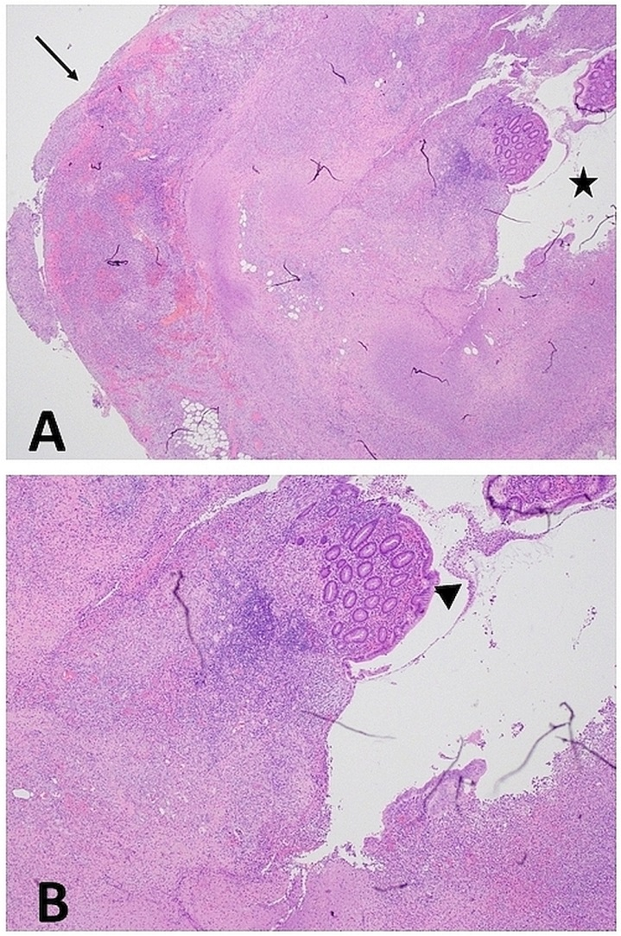
Figure 1 Histopathology of appendiceal specimen with appendicitis. A: This slide is a cross-section of the appendix showing the appendiceal lumen indicated by the star displaying extensive ulceration and pervasive inflammation; with minimal residual mucosa. The transmural inflammation, involves the serosa as shown by the arrow; and depicts mucosal ulceration and necrosis; B: This slide image, photographed at a higher magnification, shows the residual mucosa (which appears normal) surrounded by necrotic tissue and cellular debris. The residual mucosa is indicated by the arrowhead.

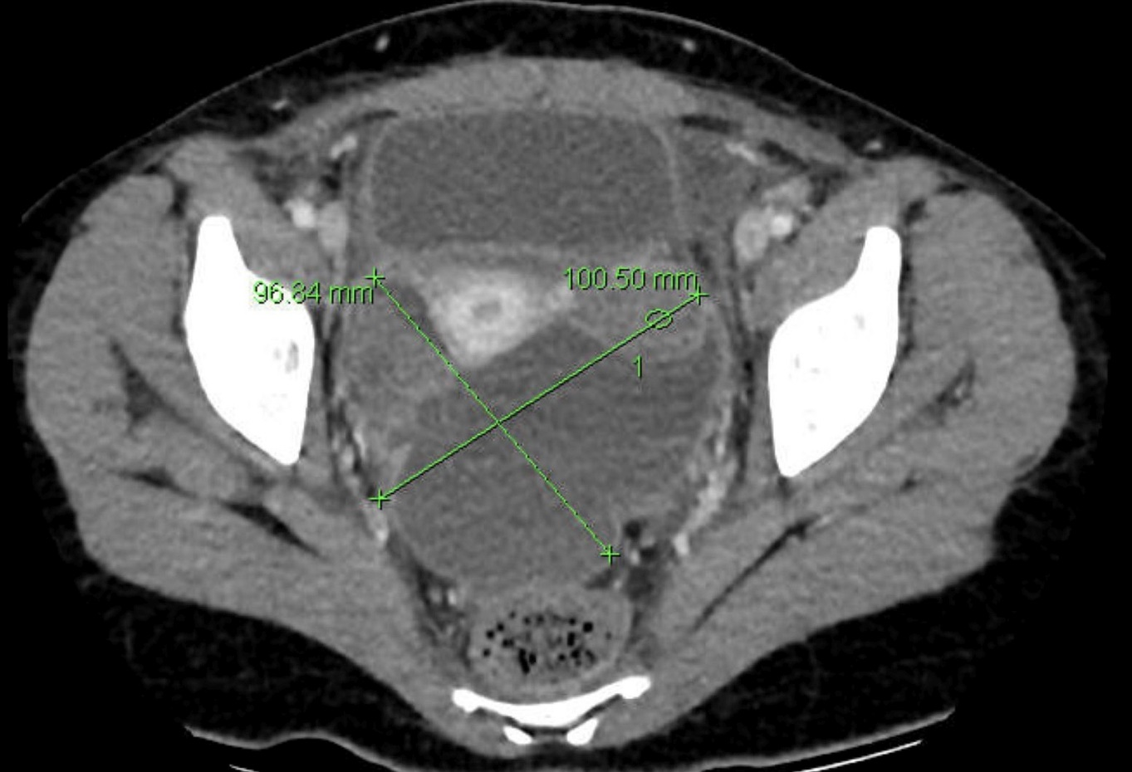
Figure 2 Pelvic collection - axial view. The computerised tomography (CT) scan on postoperative day 4 shows a large pelvic collection with dimensions of 10.1 cm x 9.6 cm. This CT view is the axial view. The collection shows different segments displaying different densities.

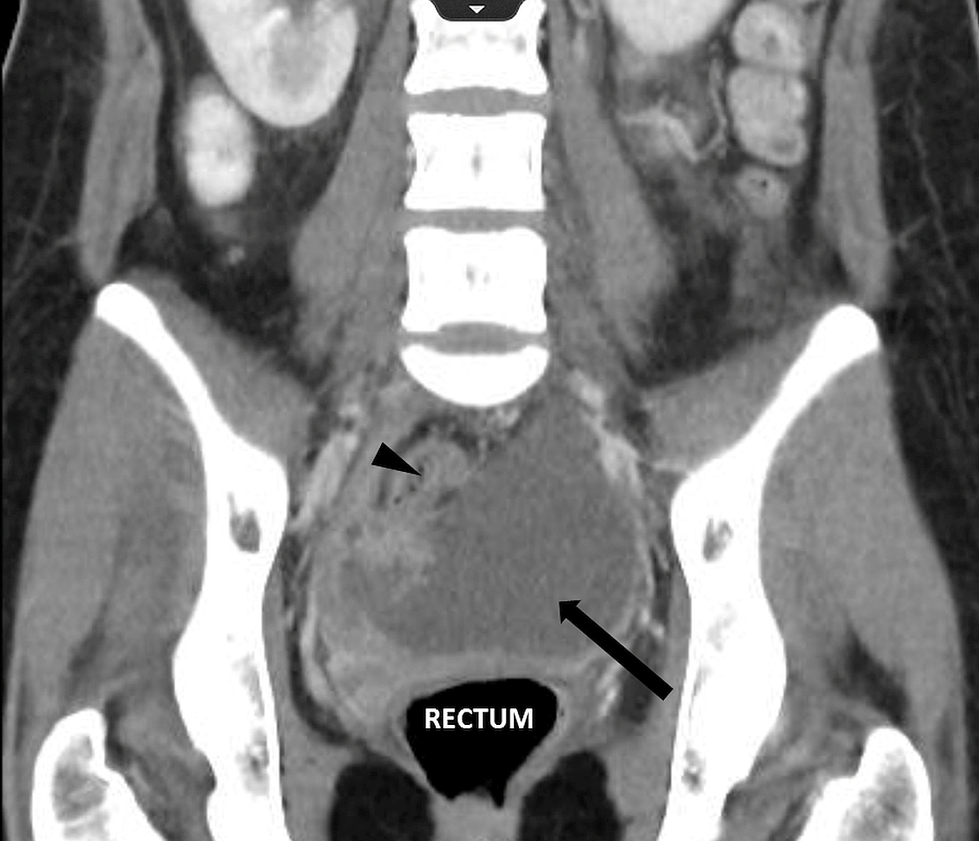
Figure 3 Pelvic collection - coronal view. The computerised tomography (CT) scan on postoperative day 4 shows a large pelvic collection with dimensions of 10.1 cm x 9.6 cm, as indicated by the arrow. This CT view is the coronal view. The pelvic collection displays different segments portraying different densities, as well as loculated portions as shown by the arrowhead.

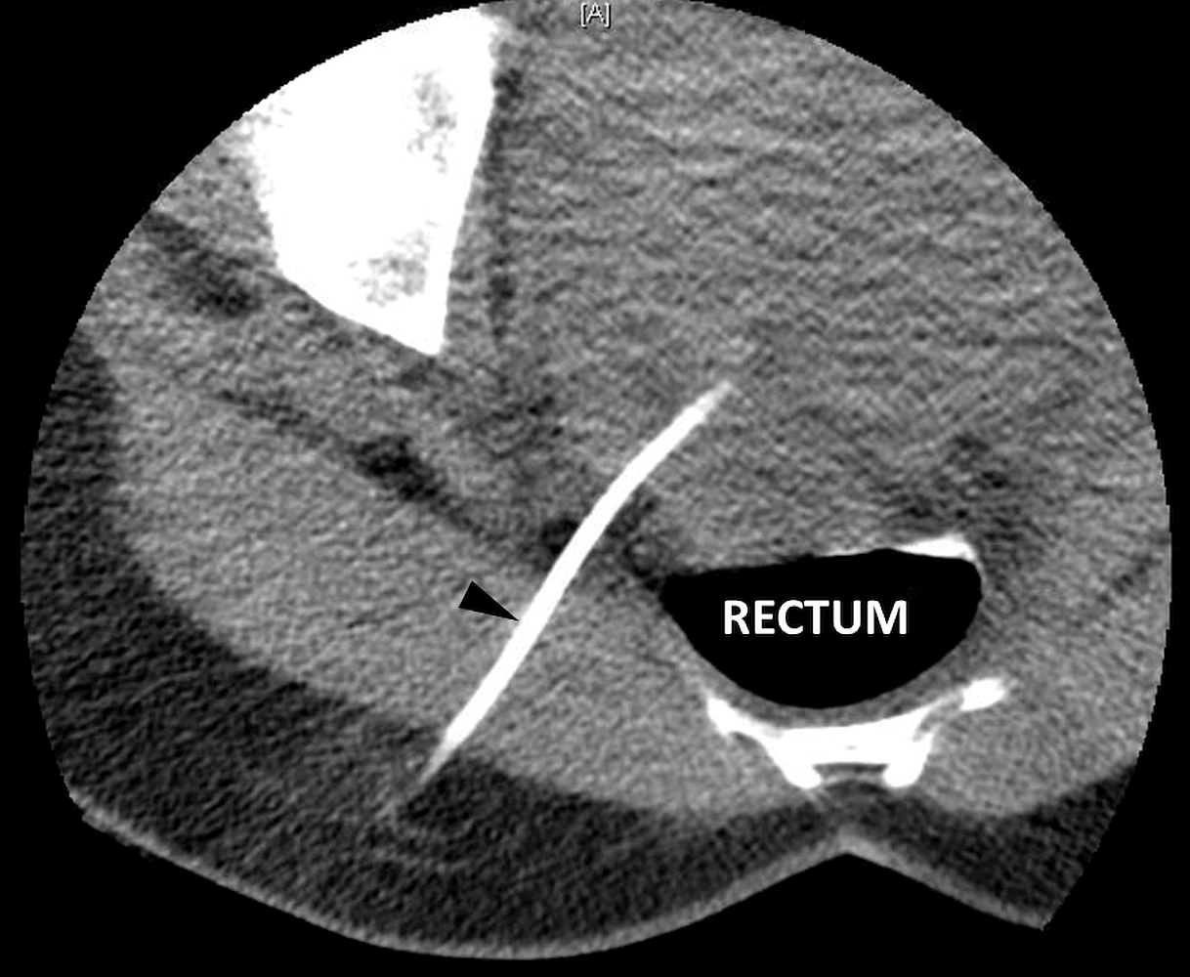
Figure 4 Percutaneous drainage of pelvic collection - axial view. The large pelvic collection (10.1 cm x 9.6 cm) was drained percutaneously under computerised tomography guidance, and an 8 French Pigtail drain was left in situ in the rectouterine pouch of Douglas, as evident by the radio-opaque linear object at the 7 o’clock position, as indicated by the arrowhead.

