Name of Journal: World Journal of Gastroenterology
Manuscript NO: 83546
Manuscript Type: MINIREVIEWS

Difficult colorectal polypectomy: Technical tips and recent advances

Pattarajierapan S et al. Difficult colorectal polypectomy

Sukit Pattarajierapan, Hiroyuki Takamaru, Supakij Khomvilai

Sukit Pattarajierapan, Supakij Khomvilai, Surgical Endoscopy Colorectal Division, Department of Surgery, Faculty of Medicine, Chulalongkorn University, Bangkok 10330, Thailand

Hiroyuki Takamaru, Endoscopy Division, National Cancer Center Hospital, Tokyo 104-0045, Japan

Author contributions: Pattarajierapan S wrote the article; Takamaru H and Khomvilai S made substantial contributions to the content, offered critical revisions, and approved the final version of the article.

Corresponding author: Sukit Pattarajierapan, MD, Doctor, Surgeon, Surgical Endoscopy Colorectal Division, Department of Surgery, Faculty of Medicine, Chulalongkorn University, 1873 Rama IV Road, Pathumwan, Bangkok 10330, Thailand. sukit.p@chulahospital.org

Received: January 29, 2023
Revised: February 24, 2023
Accepted: April 12, 2023
Published online:

Abstract
Colonoscopy has been shown to be an effective modality to prevent colorectal cancer (CRC) development. CRC reduction is achieved by detecting and removing adenomas, which are precursors of CRC. Most colorectal polyps are small and do not pose a significant challenge for trained and skilled endoscopists. However, up to 15% of polyps are considered “difficult”, potentially causing life-threatening complications. A difficult polyp is defined as any polyp that is challenging for the endoscopist to remove owing to its size, shape, or location. Advanced polypectomy techniques and skills are required to resect difficult colorectal polyps. There were various polypectomy techniques for difficult polyps such as endoscopic mucosal resection (EMR), underwater EMR, Tip-in EMR, endoscopic submucosal dissection (ESD), or endoscopic full-thickness resection. The selection of the appropriate modality depends on the morphology and endoscopic diagnosis. Several technologies have been developed to aid endoscopists in performing safe and effective polypectomies, especially complex procedures such as ESD. These advances include video endoscopy system, equipment assisting in advanced polypectomy, and closure devices/techniques for complication management. Endoscopists should know how to use these devices and their availability in practice to enhance polypectomy performance. This review describes several useful strategies and tips for managing difficult colorectal polyps. We also propose the stepwise approach for difficult colorectal polyps.

Key Words: Adenoma; Colonic polyps; Colonoscopy; Endoscopic mucosal resection; Endoscopic submucosal dissection; Polypectomy

Pattarajierapan S, Takamaru H, Khomvilai S. Difficult colorectal polypectomy: Technical tips and recent advances. World J Gastroenterol 2023; In press

Core Tip: Most colorectal polyps are small and do not pose a significant challenge to resection. However, up to 15% of polyps are considered “difficult” because of their size, shape, or location. Advanced polypectomy techniques and skills are required for the resection of difficult colorectal polyps. Recent advancements in techniques and devices for endoscopic mucosal resection, endoscopic submucosal dissection, and endoscopic full-thickness resection allow curative therapy of these difficult polyps and avoid unnecessary surgery that carries the risk of morbidity and mortality. However, the proper selection of adjunct endoscopic devices/techniques and stepwise training for skill improvement are critical for successful advanced polypectomy.

INTRODUCTION
In 2020, colorectal cancer (CRC) was the fourth most common malignancy worldwide, with 1.9 million new cases recorded^{[1]}. Colonoscopy has been shown to be an effective modality to prevent CRC development. Previous studies have shown a 60%-90% reduction in CRC incidence after screening colonoscopy^{[2,3]}. CRC reduction is achieved by detecting and removing adenomas, which are precursors of CRC. Most colorectal polyps detected during colonoscopy are small, benign, and easily resected by skilled endoscopists. However, 10%-15% of colorectal polyps are classified as “difficult” colorectal polyps^{[4,5]}. Generally, difficult colorectal polyps are defined as any polyps that are technically challenging for endoscopic resection because of their size (> 20 mm), morphology (pedunculated polyp with a thick stalk, laterally spreading tumor), or location (ileocecal valve, appendiceal orifice, dentate line)^{[5,6]}.
Endoscopic resection of difficult polyps is associated with an increased risk of incomplete resection and serious adverse events, including intra-procedural massive bleeding and perforation. Therefore, difficult polypectomy should be performed or supervised by an experienced endoscopist. This review describes helpful strategies and tips for dealing with difficult colorectal polyps.

THE STEPWISE APPROACH FOR DIFFICULT COLORECTAL POLYPS
Lesion assessment
The first step in managing colorectal polyps is lesion assessment. Dye-based chromoendoscopy and image-enhanced endoscopy (IEE) with magnifying observation should be used to distinguish benign lesions, adenomas, and adenocarcinomas. Dye-based chromoendoscopy with indigo carmine and crystal violet enables pit pattern diagnosis based on Kudo’s classification^{[7]}. However, IEE techniques such as narrow-band imaging (NBI) and blue laser imaging are more common than chromoendoscopy in clinical practice outside Japan. IEE can diagnose lesions by visualizing surface patterns and microvessels based on the NBI International Colorectal Endoscopic (NICE) and Japan NBI Expert Team (JNET) classification^{[8,9]} (Table 1). The accuracy of discriminating non-neoplastic from neoplastic lesions was 95% for magnifying observation with IEE and 96%-98% for pit pattern observation with chromoendoscopy, while the accuracy for discriminating adenomas from adenocarcinomas was 70%-90% for both IEE and chromoendoscopy^{[10]}.
Colorectal cancers with submucosal invasion have a 7%-14% risk of lymph node metastasis^{[11-14]}. For submucosal cancers, it is crucial to differentiate between superficial (< 1000 µm) and deep submucosal invasive (≥ 1000 µm) cancer. Current evidence strongly supports the theory that superficial cancer with submucosal invasion < 1000 µm without lymphovascular invasion, grade 2/3 tumor budding, or poorly differentiated component have no risk of lymph node metastasis^{[15,16]}. A Japanese study suggested that magnifying chromoendoscopy with crystal violet is the best modality for estimating the invasion depth in early colorectal lesions. Matsuda et al^{[17]} found that the diagnostic accuracy of the invasive pattern in magnifying chromoendoscopy with crystal violet to differentiate superficial (< 1000 µm) and deep submucosal invasive (≥ 1000 µm) cancers was 98.8%. Patients with submucosal invasive cancer should undergo radical colectomy considering the risk of nodal metastasis, whereas patients with adenoma or cancer with submucosal superficial invasion are candidates for endoscopic resection. It should be noted that experienced examiners performed magnifying chromoendoscopy in this study; therefore, the effectiveness of magnifying chromoendoscopy should be revalidated in general endoscopists. Togashi et al^{[18]} reported a minimum experience of observing 200 lesions with magnifying chromoendoscopy is needed to understand pit pattern diagnosis. Moreover, the limited availability of crystal violet outside Japan makes this approach difficult to apply in clinical practice.

Identification of the causes of difficult polypectomy
Table 2 shows the causes of difficult polypectomy. The difficulty might arise from the size, location, morphology, or other specific conditions. Possible solutions for each complex polyp character or situation are described in the following subsections.
The Size, Morphology, Site, Access (SMSA) classification system has been proposed by Gupta et al^{[19]} for stratifying lesion complexity (Table 3). This stratifies polyps into 4 levels of difficulty, with level 1 being the easiest to resect by all endoscopists and level 4 being very difficult to resect. Longcroft-Wheaton et al^{[20]} validated the SMSA system in a prospective study of 220 lesions ≥ 20 mm in diameter. They found that lesions with SMSA level 4 had higher complication rates (8.6% vs 0%, P = 0.007) and lower complete resection rates (87.5% vs 97.5%, P = 0.009) than the lesions with SMSA level 2 and 3. European Society of Gastrointestinal Endoscopy guideline for colorectal polypectomy and endoscopic mucosal resection recommends using the SMSA system to assess large and complex polyps. If the lesions have SMSA level 4, they should be resected by experts at a high-volume tertiary care center^{[21]}.

Basic techniques of colorectal polypectomy
Endoscopists should have the appropriate basic skills to conduct a colorectal polypectomy. First, looping on the colonoscope should be unwound by shortening before performing polypectomy; otherwise, colonoscope manipulation would be paradoxical and troublesome. Second, endoscopists should position the polyp at 5-6 o’clock on the monitor because the instrument exits the colonoscope channel at 5 o’clock (Figure 1A). Finally, the base of the polyp, particularly that of a pedunculated polyp, should lie opposite to gravity. Polyp stretching by gravity improves the visualization of the polyp base, and this maneuver prevents blood pooling at the resected site (Figure 1B and C).

Selection of therapeutic modality for large colorectal polyps
The selection of the appropriate modality from various polypectomy techniques depends on the morphology and endoscopic diagnosis. Large pedunculated polyps are mainly resected by polypectomy with a prophylactic strategy against bleeding. The selection of a therapeutic modality for large non-pedunculated polyps, mostly laterally spreading tumors (LSTs), is highly debated. LST is defined as a lesion ≥ 10 mm in diameter, extending laterally with a low vertical axis^{[22]}. The comparison between endoscopic mucosal resection (EMR) and endoscopic submucosal dissection (ESD) is an important issue for large LSTs. ESD has higher en bloc resection and lower recurrence rates than EMR because the snare EMR method tends to result in piecemeal resection for large lesions^{[23,24]}. Moreover, ESD allows accurate histopathologic diagnosis regarding the depth of invasion without segmentation of the carcinomatous part, which compromises the pathological diagnosis^{[25]}. Nevertheless, colorectal ESD is one of the most challenging endoscopic procedures with high complications. The learning curve of colorectal ESD is steep, with approximately 80 procedures required to gain proficiency in large polyp resection^{[26]}. Recently, Tip-in EMR was proposed as a promising modified EMR technique for the resection of large nonpedunculated polyps^{[27,28]}. After the submucosal injection, the snare tip with a cut current was used to make a spot-shaped mucosal incision at the proximal side of the tumor. The small incision helps fix the snare tip in the submucosal layer during the snare placement; therefore, endoscopists could place the snare flexibly and repeatedly in the appropriate position. Takada et al^{[29]} compared Tip-in EMR with ESD for the resection of 20- to 30-mm nonpedunculated polyp using propensity score matching. They found that Tip-in EMR had a lower en bloc resection (85% vs 99%, P < 0.001) and R0 resection rates (63% vs 91%, P < 0.001) than ESD; however, Tip-in had a shorter procedural time (8 min vs 60 min, P < 0.001) and comparable local recurrence rate (2% vs 0%, P = 0.386). They concluded that Tip-in EMR could be a feasible alternative to ESD for 20- to 30-mm nonpedunculated polyps.
LST is classified as granular type (LST-G), which has a nodular surface, or non-granular type (LST-NG), which has a smooth surface. These two types have different patterns of submucosal invasion. In a large retrospective cohort study by Yamada et al^{[30]}, 19% of the LST-G cases had submucosal invasion; the invasion site was the large nodule in 56%, the depression area in 28%, and multifocal in 16%. LST-NG showed 39% submucosal invasion, and the invasion site was 10% at submucosal mass-like elevation, 45% at depression, or 45% multifocal. Because of the substantial risk of multifocal submucosal invasion, ESD is warranted for LST-NG, and en bloc resection is required for large LST-G nodules. Table 4 shows the indications for colorectal ESD suggested by the 2020 Japan Gastroenterological Endoscopy Society (JGES) guidelines for colorectal ESD and EMR^{[10]}.

APPROACHES TO DIFFICULT POLYPECTOMY IN SPECIFIC SITUATIONS
Pedunculated polyp with thick stalk and large head
The risk of bleeding after polypectomy of large pedunculated polyps with thick stalk increases due to the possibility of large blood vessels in the stalk. A prospective study found that pedunculated polyps with stalk diameter > 5 mm and polyp size > 17 mm are risk factors for post-polypectomy bleeding^{[31]}. Therefore, prophylactic strategies against bleeding should be implemented prior to polypectomy.
A randomized controlled trial (RCT) by Dobrowolski et al^{[32]} found that colorectal polyps ≥ 1 cm that underwent prophylactic adrenaline injection at the stalk before polypectomy had a lower immediate bleeding rate than conventional polypectomy (2% vs 16%, P < 0.05). In contrast, another RCT by Lee et al^{[33]} revealed no statistical difference in immediate and delayed post-polypectomy bleeding rates between the prophylactic adrenaline injection and control groups.
A detachable snare (endoloop) was developed by Hachisu to prevent post-polypectomy bleeding from large pedunculated polyps^{[34]}. A nylon-thread loop is tightened around the polyp stalk to ensure hemostasis before polypectomy (Figure 2). Three RCTs confirmed that a detachable snare effectively prevents post-polypectomy bleeding in large colorectal polyps^{[35-37]}. However, endoloop placement might not be possible for all polyps, especially those with a large head or a short stalk. A previous study reported an 8.3% failure rate in endoloop placement^{[37]}. Although the largest available endoloop has an opening diameter of 30 mm, it is floppy and challenging to place at the stalk of large polyps. Moreover, the polyp stalk will be shortened after endoloop tightening; therefore, endoloop-assisted polypectomy might not be suitable for polyps with short stalks due to the possibility of incomplete resection. A case series reported successful ESD for large pedunculated polyps with failed endoloop placement using a scissor-type knife^{[38]}, which allows precise dissection with targeted hemostasis. With a scissor-type knife, the tissue and vessels could be grasped between two blades and pre-coagulated before cutting (Figure 3). In addition, a case report described successful ESD with a scissor-type knife for a large pedunculated polyp with a short, thick stalk^{[39]}.
Prophylactic clip application at the thick stalk before polypectomy may prevent post-polypectomy bleeding (Figure 4). Soh et al^{[40]} conducted an RCT of 137 pedunculated polyps ≥ 1 cm in 116 patients and found that prophylactic clip application before polypectomy significantly decreased immediate bleeding compared with conventional polypectomy [odds ratio (OR): 0.22; 95% confidence interval (95%CI): 0.08-0.57]. The delayed bleeding rate did not differ between the two groups. However, this technique is difficult to apply to polyps with a short thick stalk due to the risk of incomplete resection, and endoscopists should be aware of transmural burns from electrical current conducted by the endoscopic clip.
A meta-analysis of 15 RCTs involving 3,462 patients found that both prophylactic adrenaline injection and mechanical therapy reduced the risk of early post-polypectomy bleeding [injection therapy, risk ratio (RR): 0.32; 95%CI: 0.11-0.67; mechanical therapy: RR: 0.13; 95%CI: 0.03-0.37], although no prophylactic therapy decreased the risk of delayed bleeding^{[41]}. In conclusion, prophylactic therapy, including adrenaline injection, detachable snare, or clipping, should be performed before the resection of a pedunculated polyp with a thick stalk or large head. However, detachable snare placement or prophylactic clipping may not be possible for polyps with a short, thick stalk, which may be suitably resected using ESD.

Polyps involving the appendiceal orifice
Endoscopic resection of polyps involving the appendiceal orifice is technically challenging because of the poor-lifting nature of submucosal fibrosis, thin cecal wall, and inability to access the lesion extending deep into the appendiceal orifice. Traditionally, these polyps have been managed surgically. However, recent advances have allowed endoscopists to perform a safe endoscopic resection for these polyps.
A Japanese retrospective study revealed the safety and effectiveness of ESD for the treatment of polyps involving the appendiceal orifice. For a total of 76 lesions, the authors reported a 95.0% en bloc resection rate, 1.3% perforation, and 2.6% post-ESD appendicitis rate. However, they excluded patients with lesions deeply involving the orifice and without a history of appendectomy. The authors emphasized that ESD should be performed by experienced and skilled endoscopists in this situation^{[42]}.
Binmoeller et al^{[43]} suggested the usefulness of underwater endoscopic mucosal resection (UEMR) without submucosal injection for polyps involving the appendiceal orifice. With a water-filled lumen, the floating effect facilitated snare capture (Figure 5). They reported an 89% success ratio for UEMR in 27 polyps involving the appendiceal orifice (rim, 5 patients; extending deep inside, 22 patients). There was no perforation or post-resection appendicitis; however, 7% of the patients had post-polypectomy syndrome. During surveillance, 10% of the patients had residual adenomas that could be treated endoscopically.
Endoscopic full-thickness resection (EFTR) has recently been employed for difficult polyps and is another suitable modality for polyps involving the appendiceal orifice. In a multicenter retrospective study, Schmidbaur et al^{[44]} found that EFTR achieved R0 resection in 64% of 50 lesions involving the appendiceal orifice. However, 14% of patients developed acute appendicitis, and 42% of those with appendicitis required appendectomy. Similarly, a multicenter retrospective study by Ichkhanian et al^{[45]}, including 66 appendiceal orifice lesions (61% polyps extending deep into the appendiceal lumen) with a mean size of 14.5 mm, found that EFTR achieved an 89% technical success ratio and 93% R0 resection of the neoplastic lesions. Post-resection appendicitis occurred in 17% of patients without a prior history of appendectomy, and 60% (six patients) required appendectomy. Even with the promising outcomes of EFTR, the authors of both studies emphasized that patients must be counseled about the risk of post-resection appendicitis.
In summary, ESD is a viable option for polyps involving the rim of the appendiceal orifice for experienced endoscopists. However, ESD may not be feasible for lesions with a deep extension into the appendiceal orifice. UEMR is also a decent modality that is less technically demanding and has a high success rate. For lesions with deep extension into the appendiceal orifice, EFTR is the suitable option due to the high R0 resection rate. However, patients must be counseled regarding the risk of post-resection appendicitis.

Polyps on the ileocecal valve
Polyps on the ileocecal valve are technically challenging for endoscopic resection because the valve shape and orifice make it difficult to approach the lesions. Moreover, lesions may extend from the valve orifice to the terminal ileum. Therefore, resection is extremely difficult and associated with a high risk of recurrence^{[46]}. A large retrospective study revealed a high complete resection rate (76.3%) of piecemeal EMR for polyps on the ileocecal valve, and the rate increased to 93.0% in the most recent eight years. Delayed bleeding and perforation occurred in 3.3% and 0% of the patients, and residual polyps were found in 16.5% and 18.6% during the first and second surveillance, respectively. They suggested four EMR keys for polyps on the ileocecal valve: (1) Use of a high-definition colonoscope; (2) use of a cap on the distal end of the scope; (3) inclusion of a dye in the injection fluid; and (4) initiating injection at the margin of the polyp with the valve orifice^{[47]}.
ESD for polyps on the ileocecal valve may be necessary for lesions suspected to be early carcinomas. However, ESD in this area is technically challenging because of the valve anatomy and composition. The ileocecal valve has abundant submucosal fatty tissue; consequently, the colonoscope lens often becomes cloudy during dissection. Yoshizaki et al^{[48]} found no difference in the en bloc resection and perforation rates between ESD of lesions involving the ileocecal valve and lesions that did not involve it. Lesions involving the ileocecal valve were reported to have a 97% en bloc resection rate without perforation. The authors highlighted the critical steps for successful ESD. The mucosal incision should be started on the ileal side of the tumor to prevent the tumor from prolapsing into the terminal ileum. For areas with abundant submucosal fatty tissue, the electrical setting should be changed from the forced coagulation mode to the endocut or swift coagulation mode to enhance tissue cutting. Recently, Tanaka et al^{[49]} conducted a study to evaluate the outcomes of ESD for polyps of the ileocecal valve with extension into the terminal ileum. They found that ESD of lesions with or without extension into the terminal ileum showed no difference in the en bloc resection rate (95% vs 94%, P = 0.79), R0 resection rate (90% vs 89%, P = 0.89), postoperative bleeding (5% vs 3%, P = 0.79), intraoperative perforation (0% vs 4%, P = 0.34), or delayed perforation (0% vs 0%, respectively). Therefore, ESD for polyps involving the ileocecal valve with extension into the terminal ileum is safe and effective in expert hands.

Polyps at the anorectal junction
Polyps close to the dentate line can be challenging to resect because of the risk of bleeding from the hemorrhoids. Polypectomy in this area is painful due to the sensory nerves in the squamous epithelium below the dentate line. Moreover, the anatomy of the anal sphincter makes it difficult to maintain good visualization^{[50]}. For polyps at the anorectal junction that are indicated for ESD, Imai et al^{[51]} proposed the following strategies: (1) Using a cap on the distal end of the scope to maintain good visualization in the narrow space of the anal canal; (2) addition of 1% lidocaine to the submucosal injection solution to prevent pain; (3) employing a horizontal approach with an endoscopic knife to minimize thermal damage to the muscular layer; and (4) performing preventive hemostasis when thick hemorrhoidal vessels are observed. With these strategies, they reported an en bloc resection rate of 95.6% and an R0 resection rate of 53.3%. The low R0 resection rate was due to burning artifacts on the anal side of the specimens. They reported a 4.4% perforation and a 2.2% postoperative bleeding rate. Tamaru et al^{[52]} investigated the outcomes of ESD for polyps at the anorectal junction in patients with and without hemorrhoids. They found no differences in en bloc resection (93% vs 95%) or postoperative bleeding (16% vs 11%) rates between patients with and without hemorrhoids. Therefore, ESD is safe and effective for patients with lesions near the anorectal junction and hemorrhoids. Similarly, several studies have shown the safety and effectiveness of ESD for polyps at the anorectal junction^{[53-55]}. In conclusion, ESD for polyps at the anorectal junction is safe even in the presence of hemorrhoids, and special strategies to prevent bleeding and pain should be implemented (Figure 6).

Locally recurrent colorectal polyps
Locally recurrent polyps mostly result from incomplete resections. A systematic review and meta-analysis found that local recurrence after EMR of non-pedunculated polyps occurred in 3% of en bloc resections and 20% of piecemeal resections, and 90% of recurrences were detected within 6 mo after EMR^{[56]}. Locally recurrent polyps without risk factors for lymph node metastasis and positive vertical margins can be resected endoscopically^{[57]}. However, endoscopic resection of locally recurrent polyps is extraordinarily challenging because it is associated with poor lifting with submucosal injection from submucosal fibrosis^{[58]}.
The 2020 JGES guidelines for colorectal ESD and EMR suggest that local recurrence of early carcinoma after endoscopic resection is an indication of ESD^{[10]}. A Japanese retrospective study revealed that ESD had a higher en bloc resection rate than EMR for locally recurrent lesions (56% vs 39%, respectively), although the lesions in the ESD group were significantly larger than those in the EMR group (mean size; 25.3 mm vs 7.8 mm, P = 0.001)^{[59]}. Perforations were not observed in the ESD group. However, this study was conducted at a single center with expertise in ESD. ESD for locally recurrent lesions is technically demanding and requires high operator skills. It is noted that the en bloc resection rate of locally recurrent polyps was much lower than their previous report of colorectal ESD (168/200 patients, 84%)^{[60]}. Ide et al^{[61]} conducted a retrospective study comparing ESD with the pocket-creation method using a traction device and conventional ESD for locally recurrent lesions. They found that ESD using the pocket-creation method with a traction device had higher en bloc resection and R0 resection rates than conventional ESD (100% vs 78%, P = 0.008, and 97% vs 66%, P=0.001, respectively). Therefore, the combination of the pocket creation method and traction device is a promising strategy for the resection of locally recurrent polyps.
UEMR without submucosal injection has been reported as a promising technique for the salvage treatment of recurrent adenomas. Fibrosis prevents elevation of the recurrent lesion after submucosal injection, while the surrounding normal mucosa still elevates around the non-lifting lesion after the injection. This makes snare capture difficult. The floating effect after UEMR facilitates snare capture with minimal risk of perforation because the colonic muscularis propria remains circular with a water-filling lumen. Kim et al^{[62]} conducted a retrospective, cross-sectional study involving patients with recurrent adenomas after piecemeal resection of colorectal LSTs. They found that the en bloc resection and complete resection rates were higher in the UEMR group than in the EMR group (47.2% vs 15.9%, P = 0.002, and 88.9% vs 31.8%, P < 0.001, respectively). The recurrence rate on surveillance colonoscopy was lower in the UEMR group than in the EMR group (10.0% vs 39.4%, P = 0.020). In this study, UEMR was an independent predictor of en bloc resection and complete removal.
In summary, ESD and UEMR are the appropriate modalities for treating locally recurrent colorectal polyps. Previous studies have shown a higher en bloc resection rate with ESD than with UEMR and ESD using the pocket-creation method and a traction device is a promising strategy for locally recurrent polyps. However, ESD for locally recurrent lesions is only suitable for centers with high ESD expertise because it is technically difficult, even with advances in ESD devices and techniques. In extremely difficult cases, endoscopists may consider surgery if the anticipated risk of complications is too high.

Polypectomy in patients with strong colonic peristalsis
Strong colonic spasm is a common obstacle during colorectal polypectomy, limiting visualization and scope manipulation. In this situation, endoscopists generally use antispasmodic drugs. Hyoscine butylbromide is the most common antispasmodic agent in practice, and the recommended dose is 20 mg via intravenous injection. Hyoscine butylbromide exerts an antimuscarinic anticholinergic effect that reduces the smooth muscle tone at multiple sites in the gastrointestinal tract. Contraindications of hyoscine butylbromide include cardiovascular disease, glaucoma, myasthenia gravis, and hypersensitivity to the drug^{[63]}. In patients with these contraindications, other antispasmodic agents, including glucagon or peppermint oil, should be administered. The dose of glucagon is 1 mg via intravenous injection, which is contraindicated in patients with pheochromocytoma^{[64]}. Peppermint oil was administered via intraluminal application of 20 mL of 1.6% L-menthol solution without contraindications^{[65]}. Topical lidocaine, a local anesthetic, also functions as an antispasmodic agent by blocking the Na⁺ channels. It was administered via the intraluminal application of 30 mL of 2% lidocaine hydrochloride. An RCT found no difference in the inhibitory duration between topical lidocaine and peppermint oil; however, topical lidocaine significantly decreased rebound spasm^{[66]}.
In specific situations with intense colonic spasms, even with the administration of antispasmodic drugs, UEMR may be a decent modality. Another advantage of the water-filled lumen in UEMR is the stabilized visualization of the lumen. Pattarajierapan et al^{[67]} reported successful UEMR for rectal adenoma in the non-distensible rectum due to severe fecal incontinence and intense colonic peristalsis. Therefore, UEMR may be a suitable option for patients with intense colonic spasms who have failed medication.

RECENT ADVANCES IN POLYPECTOMY DEVICES AND TECHNIQUES
Several technologies have been developed to aid endoscopists in performing safe and effective polypectomies, especially complex procedures such as ESD. These advances include video endoscopy system, equipment assisting in advanced polypectomy, and closure devices/techniques for complication management. Endoscopists should know how to use these devices and their availability in practice to enhance polypectomy performance, particularly in challenging cases.

Video endoscopy system
Red dichromatic imaging (RDI) was recently installed in the latest Olympus endoscopy system EVIS X1. RDI utilizes two long-wavelength lights (600 nm and 630 nm), which improve the visibility of thick blood vessels in deep tissues^{[68,69]}. Therefore, easier identification of bleeding sources during polypectomy is expected in the RDI mode (Figure 7). Fujimoto et al^{[69]} conducted an RCT comparing hemostatic procedures using RDI and white-light imaging (WLI). Although they found that RDI did not shorten the hemostatic time, it significantly reduced psychological stress compared to WLI. They concluded that it is safe and reasonable to use the RDI during hemostatic procedures to reduce the psychological stress experienced by endoscopists.

Equipment assisting advanced polypectomy
Although ESD has been widely accepted as a standard procedure for colorectal polyps that require en bloc resection, a limited number of endoscopists outside East Asia are competent owing to the difficulty of the method^{[70]}. Colorectal ESD is more technically demanding than gastric or esophageal ESD because of its thin colonic wall and narrow colonic lumen, as well as peristalsis and respiratory movement. In addition to good training with experienced endoscopists, the recent development of traction devices and techniques may facilitate the procedure. The lack of traction during dissection contributes to the technical difficulty of ESD; therefore, various traction devices and techniques have been proposed (Figure 8). These devices include the clip-line method^{[71]}, S-O clip^{[72]}, double clips and rubber band traction^{[73]}, and traction wire^{[74]}. To date, there have been no head-to-head comparisons of these traction devices, and the traction method has been selected based on tumor location and preference^{[75]}. The clip-line method is helpful for rectal lesions but may not be feasible for colon lesions. For colonic ESD, endoscopists can use an S-O clip, double clips and rubber band traction, or traction wire. Without traction devices, ESD using the pocket creation method is a special technique that maintains a stable scope position inside the pocket while sustaining good traction^{[76,77]}. This technique starts with an initial small mucosal incision, the creation of a submucosal pocket under most of the tumor, and then the completion of opening the pocket in a step-by-step manner.

Closure devices and techniques for complication management
Perforation is the most feared complication of polypectomy. With advances in closure devices, most perforations after polypectomy can be closed endoscopically, thereby eliminating the need for surgery, which is associated with morbidity and mortality^{[78]}. Endoscopic closure devices can be classified into through-the-scope clips (TTSC), over-the-scope clips (OTSC), and suturing devices. Useful modified techniques in TTSC include the hold-and-drag closure technique using reopenable clips^{[78]}, mucosal incision method^{[79]}, endoloop-assisted clip closure^{[80]}, over-the-line clip method^{[80]}, and dual-action clip closure^{[81]}. To date, no RCT has compared these closure techniques after colorectal polypectomy. Modified techniques in TTSC help close defects larger than the width of the clips. Therefore, endoscopists should learn these modified techniques, which are feasible for their centers because they may occasionally be necessary.
The OTSC system is a super-elastic nitinol clip that must be mounted at the end of an endoscope before deployment. This results in full-thickness closure of the teeth arranged in a bear-trap shape^{[78]}. The reported successful closure rate for iatrogenic colon perforation for OTSC is 89%-100%^{[82-85]}. However, the limitations of OTSC include lower success rates in the right colon compared with the left side and limited availability.
Endoscopic suturing is a promising method for defect closure with a 100% success rate in a report of 16 patients^{[86]}. The endoscopic suturing device consists of a curved needle placed on the endoscope tip, a catheter-based suture anchor, and an operating handle attached to the neck of the instrument channel of the endoscope^{[87]}. Limitations to the suturing device include the requirement of a double-channel endoscope and special training in endoscopic suturing to become competent in this technique. In addition, endoscopic suturing devices are expensive and limited in availability.

CONCLUSION
Recent advancements in EMR, ESD, and EFTR techniques and devices allow curative therapy of difficult colorectal polyps and prevent unnecessary surgery that carries the risk of morbidity and mortality. Moreover, these advancements also help endoscopists cope with feared complications, such as massive intra-procedural bleeding and perforation. However, proper selection of adjunct endoscopic devices/techniques according to polyp characteristics and step-by-step training for skill improvement are critical for successful advanced polypectomies. Based on current evidence, we summarize the stepwise approach (Figure 9) that might help endoscopists make better decisions for the treatment of difficult colorectal polyps.

REFERENCES
1 Sung H, Ferlay J, Siegel RL, Laversanne M, Soerjomataram I, Jemal A, Bray F. Global Cancer Statistics 2020: GLOBOCAN Estimates of Incidence and Mortality Worldwide for 36 Cancers in 185 Countries. CA Cancer J Clin 2021; 71: 209-249 [PMID: 33538338 DOI: 10.3322/caac.21660]
2 Winawer SJ, Zauber AG, Ho MN, O'Brien MJ, Gottlieb LS, Sternberg SS, Waye JD, Schapiro M, Bond JH, Panish JF. Prevention of colorectal cancer by colonoscopic polypectomy. The National Polyp Study Workgroup. N Engl J Med 1993; 329: 1977-1981 [PMID: 8247072 DOI: 10.1056/NEJM199312303292701]
3 Baxter NN, Warren JL, Barrett MJ, Stukel TA, Doria-Rose VP. Association between colonoscopy and colorectal cancer mortality in a US cohort according to site of cancer and colonoscopist specialty. J Clin Oncol 2012; 30: 2664-2669 [PMID: 22689809 DOI: 10.1200/JCO.2011.40.4772]
4 Gallegos-Orozco JF, Gurudu SR. Complex colon polypectomy. Gastroenterol Hepatol (N Y) 2010; 6: 375-382 [PMID: 20733940]
5 Ngamruengphong S, Pohl H, Haito-Chavez Y, Khashab MA. Update on Difficult Polypectomy Techniques. Curr Gastroenterol Rep 2016; 18: 3 [PMID: 26714965 DOI: 10.1007/s11894-015-0476-7]
6 Mann R, Gajendran M, Umapathy C, Perisetti A, Goyal H, Saligram S, Echavarria J. Endoscopic Management of Complex Colorectal Polyps: Current Insights and Future Trends. Front Med (Lausanne) 2021; 8: 728704 [PMID: 35127735 DOI: 10.3389/fmed.2021.728704]
7 Kudo S, Tamura S, Nakajima T, Yamano H, Kusaka H, Watanabe H. Diagnosis of colorectal tumorous lesions by magnifying endoscopy. Gastrointest Endosc 1996; 44: 8-14 [PMID: 8836710 DOI: 10.1016/s0016-5107(96)70222-5]
8 Sano Y, Tanaka S, Kudo SE, Saito S, Matsuda T, Wada Y, Fujii T, Ikematsu H, Uraoka T, Kobayashi N, Nakamura H, Hotta K, Horimatsu T, Sakamoto N, Fu KI, Tsuruta O, Kawano H, Kashida H, Takeuchi Y, Machida H, Kusaka T, Yoshida N, Hirata I, Terai T, Yamano HO, Kaneko K, Nakajima T, Sakamoto T, Yamaguchi Y, Tamai N, Nakano N, Hayashi N, Oka S, Iwatate M, Ishikawa H, Murakami Y, Yoshida S, Saito Y. Narrow-band imaging (NBI) magnifying endoscopic classification of colorectal tumors proposed by the Japan NBI Expert Team. Dig Endosc 2016; 28: 526-533 [PMID: 26927367 DOI: 10.1111/den.12644]
9 Hayashi N, Tanaka S, Hewett DG, Kaltenbach TR, Sano Y, Ponchon T, Saunders BP, Rex DK, Soetikno RM. Endoscopic prediction of deep submucosal invasive carcinoma: validation of the narrow-band imaging international colorectal endoscopic (NICE) classification. Gastrointest Endosc 2013; 78: 625-632 [PMID: 23910062 DOI: 10.1016/j.gie.2013.04.185]
10 Tanaka S, Kashida H, Saito Y, Yahagi N, Yamano H, Saito S, Hisabe T, Yao T, Watanabe M, Yoshida M, Saitoh Y, Tsuruta O, Sugihara KI, Igarashi M, Toyonaga T, Ajioka Y, Kusunoki M, Koike K, Fujimoto K, Tajiri H. Japan Gastroenterological Endoscopy Society guidelines for colorectal endoscopic submucosal dissection/endoscopic mucosal resection. Dig Endosc 2020; 32: 219-239 [PMID: 31566804 DOI: 10.1111/den.13545]
11 Tateishi Y, Nakanishi Y, Taniguchi H, Shimoda T, Umemura S. Pathological prognostic factors predicting lymph node metastasis in submucosal invasive (T1) colorectal carcinoma. Mod Pathol 2010; 23: 1068-1072 [PMID: 20473277 DOI: 10.1038/modpathol.2010.88]
12 Yamaoka Y, Shiomi A, Kagawa H, Hino H, Manabe S, Chen K, Nanishi K, Notsu A. Lymph node metastasis in T1 colorectal cancer with the only high-risk histology of submucosal invasion depth ≥ 1000 μm. Int J Colorectal Dis 2022; 37: 2387-2395 [PMID: 36283994 DOI: 10.1007/s00384-022-04269-6]
13 Suh JH, Han KS, Kim BC, Hong CW, Sohn DK, Chang HJ, Kim MJ, Park SC, Park JW, Choi HS, Oh JH. Predictors for lymph node metastasis in T1 colorectal cancer. Endoscopy 2012; 44: 590-595 [PMID: 22638780 DOI: 10.1055/s-0031-1291665]
14 Kikuchi R, Takano M, Takagi K, Fujimoto N, Nozaki R, Fujiyoshi T, Uchida Y. Management of early invasive colorectal cancer. Risk of recurrence and clinical guidelines. Dis Colon Rectum 1995; 38: 1286-1295 [PMID: 7497841 DOI: 10.1007/BF02049154]
15 Kitajima K, Fujimori T, Fujii S, Takeda J, Ohkura Y, Kawamata H, Kumamoto T, Ishiguro S, Kato Y, Shimoda T, Iwashita A, Ajioka Y, Watanabe H, Watanabe T, Muto T, Nagasako K. Correlations between lymph node metastasis and depth of submucosal invasion in submucosal invasive colorectal carcinoma: a Japanese collaborative study. J Gastroenterol 2004; 39: 534-543 [PMID: 15235870 DOI: 10.1007/s00535-004-1339-4]
16 Nakadoi K, Tanaka S, Kanao H, Terasaki M, Takata S, Oka S, Yoshida S, Arihiro K, Chayama K. Management of T1 colorectal carcinoma with special reference to criteria for curative endoscopic resection. J Gastroenterol Hepatol 2012; 27: 1057-1062 [PMID: 22142484 DOI: 10.1111/j.1440-1746.2011.07041.x]
17 Matsuda T, Fujii T, Saito Y, Nakajima T, Uraoka T, Kobayashi N, Ikehara H, Ikematsu H, Fu KI, Emura F, Ono A, Sano Y, Shimoda T, Fujimori T. Efficacy of the invasive/non-invasive pattern by magnifying chromoendoscopy to estimate the depth of invasion of early colorectal neoplasms. Am J Gastroenterol 2008; 103: 2700-2706 [PMID: 18853968 DOI: 10.1111/j.1572-0241.2008.02190.x]
18 Togashi K, Konishi F, Ishizuka T, Sato T, Senba S, Kanazawa K. Efficacy of magnifying endoscopy in the differential diagnosis of neoplastic and non-neoplastic polyps of the large bowel. Dis Colon Rectum 1999; 42: 1602-1608 [PMID: 10613481 DOI: 10.1007/BF02236215]
19 Gupta S, Miskovic D, Bhandari P, Dolwani S, McKaig B, Pullan R, Rembacken B, Riley S, Rutter MD, Suzuki N, Tsiamoulos Z, Valori R, Vance ME, Faiz OD, Saunders BP, Thomas-Gibson S. A novel method for determining the difficulty of colonoscopic polypectomy. Frontline Gastroenterol 2013; 4: 244-248 [PMID: 28839733 DOI: 10.1136/flgastro-2013-100331]
20 Longcroft-Wheaton G, Duku M, Mead R, Basford P, Bhandari P. Risk stratification system for evaluation of complex polyps can predict outcomes of endoscopic mucosal resection. Dis Colon Rectum 2013; 56: 960-966 [PMID: 23838864 DOI: 10.1097/DCR.0b013e31829193e0]
21 Ferlitsch M, Moss A, Hassan C, Bhandari P, Dumonceau JM, Paspatis G, Jover R, Langner C, Bronzwaer M, Nalankilli K, Fockens P, Hazzan R, Gralnek IM, Gschwantler M, Waldmann E, Jeschek P, Penz D, Heresbach D, Moons L, Lemmers A, Paraskeva K, Pohl J, Ponchon T, Regula J, Repici A, Rutter MD, Burgess NG, Bourke MJ. Colorectal polypectomy and endoscopic mucosal resection (EMR): European Society of Gastrointestinal Endoscopy (ESGE) Clinical Guideline. Endoscopy 2017; 49: 270-297 [PMID: 28212588 DOI: 10.1055/s-0043-102569]
22 Kudo Se, Lambert R, Allen JI, Fujii H, Fujii T, Kashida H, Matsuda T, Mori M, Saito H, Shimoda T, Tanaka S, Watanabe H, Sung JJ, Feld AD, Inadomi JM, O'Brien MJ, Lieberman DA, Ransohoff DF, Soetikno RM, Triadafilopoulos G, Zauber A, Teixeira CR, Rey JF, Jaramillo E, Rubio CA, Van Gossum A, Jung M, Vieth M, Jass JR, Hurlstone PD. Nonpolypoid neoplastic lesions of the colorectal mucosa. Gastrointest Endosc 2008; 68: S3-47 [PMID: 18805238 DOI: 10.1016/j.gie.2008.07.052]
23 Hotta K, Fujii T, Saito Y, Matsuda T. Local recurrence after endoscopic resection of colorectal tumors. Int J Colorectal Dis 2009; 24: 225-230 [PMID: 18972121 DOI: 10.1007/s00384-008-0596-8]
24 Oka S, Tanaka S, Saito Y, Iishi H, Kudo SE, Ikematsu H, Igarashi M, Saitoh Y, Inoue Y, Kobayashi K, Hisabe T, Tsuruta O, Sano Y, Yamano H, Shimizu S, Yahagi N, Watanabe T, Nakamura H, Fujii T, Ishikawa H, Sugihara K; Colorectal Endoscopic Resection Standardization Implementation Working Group of the Japanese Society for Cancer of the Colon and Rectum, Tokyo, Japan. Local recurrence after endoscopic resection for large colorectal neoplasia: a multicenter prospective study in Japan. Am J Gastroenterol 2015; 110: 697-707 [PMID: 25848926 DOI: 10.1038/ajg.2015.96]
25 Tanaka S, Saitoh Y, Matsuda T, Igarashi M, Matsumoto T, Iwao Y, Suzuki Y, Nozaki R, Sugai T, Oka S, Itabashi M, Sugihara KI, Tsuruta O, Hirata I, Nishida H, Miwa H, Enomoto N, Shimosegawa T, Koike K. Evidence-based clinical practice guidelines for management of colorectal polyps. J Gastroenterol 2021; 56: 323-335 [PMID: 33710392 DOI: 10.1007/s00535-021-01776-1]
26 Hotta K, Oyama T, Shinohara T, Miyata Y, Takahashi A, Kitamura Y, Tomori A. Learning curve for endoscopic submucosal dissection of large colorectal tumors. Dig Endosc 2010; 22: 302-306 [PMID: 21175483 DOI: 10.1111/j.1443-1661.2010.01005.x]
27 Chien H, Imai K, Hotta K, Ito S, Yamaguchi Y, Kawata N, Tanaka M, Takizawa K, Kakushima N, Matsubayashi H, Ono H. Tip-in EMR for R0 resection for a large flat colonic tumor. Gastrointest Endosc 2016; 84: 743 [PMID: 27207826 DOI: 10.1016/j.gie.2016.05.017]
28 Sato Y, Ozawa SI, Yasuda H, Kato M, Kiyokawa H, Yamashita M, Matsuo Y, Yamamoto H, Itoh F. Tip-in endoscopic mucosal resection for large colorectal sessile polyps. Surg Endosc 2021; 35: 1820-1826 [PMID: 32356110 DOI: 10.1007/s00464-020-07581-w]
29 Takada K, Hotta K, Imai K, Ito S, Kishida Y, Minamide T, Yamamoto Y, Yabuuchi Y, Yoshida M, Maeda Y, Kawata N, Takizawa K, Ishiwatari H, Matsubayashi H, Kawabata T, Ono H. Tip-in EMR as an alternative to endoscopic submucosal dissection for 20- to 30-mm nonpedunculated colorectal neoplasms. Gastrointest Endosc 2022; 96: 849-856.e3 [PMID: 35798055 DOI: 10.1016/j.gie.2022.06.030]
30 Yamada M, Saito Y, Sakamoto T, Nakajima T, Kushima R, Parra-Blanco A, Matsuda T. Endoscopic predictors of deep submucosal invasion in colorectal laterally spreading tumors. Endoscopy 2016; 48: 456-464 [PMID: 26919264 DOI: 10.1055/s-0042-100453]
31 Dobrowolski S, Dobosz M, Babicki A, Głowacki J, Nałecz A. Blood supply of colorectal polyps correlates with risk of bleeding after colonoscopic polypectomy. Gastrointest Endosc 2006; 63: 1004-1009 [PMID: 16733117 DOI: 10.1016/j.gie.2005.11.063]
32 Dobrowolski S, Dobosz M, Babicki A, Dymecki D, Hać S. Prophylactic submucosal saline-adrenaline injection in colonoscopic polypectomy: prospective randomized study. Surg Endosc 2004; 18: 990-993 [PMID: 15108107 DOI: 10.1007/s00464-003-9214-6]
33 Lee SH, Chung IK, Kim SJ, Kim JO, Ko BM, Kim WH, Kim HS, Park DI, Kim HJ, Byeon JS, Yang SK, Jang BI, Jung SA, Jeen YT, Choi JH, Choi H, Han DS, Song JS. Comparison of postpolypectomy bleeding between epinephrine and saline submucosal injection for large colon polyps by conventional polypectomy: a prospective randomized, multicenter study. World J Gastroenterol 2007; 13: 2973-2977 [PMID: 17589949 DOI: 10.3748/wjg.v13.i21.2973]
34 Hachisu T. A new detachable snare for hemostasis in the removal of large polyps or other elevated lesions. Surg Endosc 1991; 5: 70-74 [PMID: 1948617 DOI: 10.1007/BF00316840]
35 Di Giorgio P, De Luca L, Calcagno G, Rivellini G, Mandato M, De Luca B. Detachable snare vs epinephrine injection in the prevention of postpolypectomy bleeding: a randomized and controlled study. Endoscopy 2004; 36: 860-863 [PMID: 15452780 DOI: 10.1055/s-2004-825801]
36 Kouklakis G, Mpoumponaris A, Gatopoulou A, Efraimidou E, Manolas K, Lirantzopoulos N. Endoscopic resection of large pedunculated colonic polyps and risk of postpolypectomy bleeding with adrenaline injection vs endoloop and hemoclip: a prospective, randomized study. Surg Endosc 2009; 23: 2732-2737 [PMID: 19430833 DOI: 10.1007/s00464-009-0478-3]
37 Paspatis GA, Paraskeva K, Theodoropoulou A, Mathou N, Vardas E, Oustamanolakis P, Chlouverakis G, Karagiannis I. A prospective, randomized comparison of adrenaline injection in combination with detachable snare vs adrenaline injection alone in the prevention of postpolypectomy bleeding in large colonic polyps. Am J Gastroenterol 2006; 101: 2805; quiz 2913 [PMID: 17026560 DOI: 10.1111/j.1572-0241.2006.00855.x]
38 Jawaid S, Draganov PV, Yang D. Endoscopic resection of large pedunculated colon polyps using only a scissor-type knife: a case series. VideoGIE 2020; 5: 264-266 [PMID: 32529165 DOI: 10.1016/j.vgie.2020.02.016]
39 Yamamoto S, Shafazand M. Endoscopic submucosal dissection with scissor-type knife for pedunculated polyp with short and thick stalk. VideoGIE 2018; 3: 189-190 [PMID: 30128383 DOI: 10.1016/j.vgie.2018.04.001]
40 Soh JS, Seo M, Kim KJ. Prophylactic clip application for large pedunculated polyps before snare polypectomy may decrease immediate postpolypectomy bleeding. BMC Gastroenterol 2020; 20: 68 [PMID: 32164613 DOI: 10.1186/s12876-020-01210-5]
41 Park CH, Jung YS, Nam E, Eun CS, Park DI, Han DS. Comparison of Efficacy of Prophylactic Endoscopic Therapies for Postpolypectomy Bleeding in the Colorectum: A Systematic Review and Network Meta-Analysis. Am J Gastroenterol 2016; 111: 1230-1243 [PMID: 27402502 DOI: 10.1038/ajg.2016.287]
42 Jacob H, Toyonaga T, Ohara Y, Tsubouchi E, Takihara H, Baba S, Yoshizaki T, Kawara F, Tanaka S, Ishida T, Hoshi N, Morita Y, Umegaki E, Azuma T. Endoscopic submucosal dissection of cecal lesions in proximity to the appendiceal orifice. Endoscopy 2016; 48: 829-836 [PMID: 27467815 DOI: 10.1055/s-0042-110396]
43 Binmoeller KF, Hamerski CM, Shah JN, Bhat YM, Kane SD. Underwater EMR of adenomas of the appendiceal orifice (with video). Gastrointest Endosc 2016; 83: 638-642 [PMID: 26375437 DOI: 10.1016/j.gie.2015.08.079]
44 Schmidbaur S, Wannhoff A, Walter B, Meier B, Schäfer C, Meining A, Caca K. Risk of appendicitis after endoscopic full-thickness resection of lesions involving the appendiceal orifice: a retrospective analysis. Endoscopy 2021; 53: 424-428 [PMID: 32894866 DOI: 10.1055/a-1227-4555]
45 Ichkhanian Y, Barawi M, Seoud T, Thakkar S, Kothari TH, Halabi ME, Ullah A, Edris W, Aepli P, Kowalski T, Shinn B, Shariaha RZ, Mahadev S, Mosko JD, Andrisani G, Di Matteo FM, Albrecht H, Giap AQ, Tang SJ, Naga YM, van Geenen E, Friedland S, Tharian B, Irani S, Ross AS, Jamil LH, Lew D, Nett AS, Farha J, Runge TM, Jovani M, Khashab MA. Endoscopic full-thickness resection of polyps involving the appendiceal orifice: a multicenter international experience. Endoscopy 2022; 54: 16-24 [PMID: 33395714 DOI: 10.1055/a-1345-0044]
46 Nanda KS, Tutticci N, Burgess NG, Sonson R, Williams SJ, Bourke MJ. Endoscopic mucosal resection of laterally spreading lesions involving the ileocecal valve: technique, risk factors for failure, and outcomes. Endoscopy 2015; 47: 710-718 [PMID: 25763831 DOI: 10.1055/s-0034-1391732]
47 Ponugoti PL, Broadley HM, Garcia J, Rex DK. Endoscopic management of large ileocecal valve lesions over an 18-year interval. Endosc Int Open 2019; 7: E1646-E1651 [PMID: 31788547 DOI: 10.1055/a-0990-9035]
48 Yoshizaki T, Toyonaga T, Tanaka S, Ohara Y, Kawara F, Baba S, Tsubouchi E, Takihara H, Watanabe D, Ishida T, Hoshi N, Morita Y, Umegaki E, Azuma T. Feasibility and safety of endoscopic submucosal dissection for lesions involving the ileocecal valve. Endoscopy 2016; 48: 639-645 [PMID: 26990510 DOI: 10.1055/s-0042-102783]
49 Tanaka H, Oka S, Kunihiro M, Nagata S, Kitamura S, Kuwai T, Hiraga Y, Furudoi A, Tanaka S. Endoscopic submucosal dissection for tumors involving the ileocecal valve with extension into the terminal ileum: a multicenter study from the Hiroshima GI Endoscopy Research Group. Surg Endosc 2023; 37: 958-966 [PMID: 36070146 DOI: 10.1007/s00464-022-09542-x]
50 Nakadoi K, Tanaka S, Hayashi N, Ozawa S, Terasaki M, Takata S, Kanao H, Oka S, Chayama K. Clinical outcomes of endoscopic submucosal dissection for rectal tumor close to the dentate line. Gastrointest Endosc 2012; 76: 444-450 [PMID: 22817799 DOI: 10.1016/j.gie.2012.04.004]
51 Imai K, Hotta K, Yamaguchi Y, Shinohara T, Ooka S, Shinoki K, Kakushima N, Tanaka M, Takizawa K, Matsubayashi H, Oishi T, Ono H. Safety and efficacy of endoscopic submucosal dissection of rectal tumors extending to the dentate line. Endoscopy 2015; 47: 529-532 [PMID: 25502418 DOI: 10.1055/s-0034-1391078]
52 Tamaru Y, Oka S, Tanaka S, Hiraga Y, Kunihiro M, Nagata S, Furudoi A, Ninomiya Y, Asayama N, Shigita K, Nishiyama S, Hayashi N, Chayama K. Endoscopic submucosal dissection for anorectal tumor with hemorrhoids close to the dentate line: a multicenter study of Hiroshima GI Endoscopy Study Group. Surg Endosc 2016; 30: 4425-4431 [PMID: 26895899 DOI: 10.1007/s00464-016-4761-9]
53 Tanaka S, Toyonaga T, Morita Y, Hoshi N, Ishida T, Ohara Y, Yoshizaki T, Kawara F, Umegaki E, Azuma T. Feasibility and safety of endoscopic submucosal dissection for lower rectal tumors with hemorrhoids. World J Gastroenterol 2016; 22: 6268-6275 [PMID: 27468216 DOI: 10.3748/wjg.v22.i27.6268]
54 Matsumoto S, Mashima H. The efficacy of endoscopic submucosal dissection for colorectal tumors extending to the dentate line. Int J Colorectal Dis 2017; 32: 831-837 [PMID: 28188417 DOI: 10.1007/s00384-017-2775-y]
55 Probst A, Ebigbo A, Märkl B, Ting S, Schaller T, Anthuber M, Fleischmann C, Messmann H. Endoscopic submucosal dissection for rectal neoplasia extending to the dentate line: European experience. Endosc Int Open 2018; 6: E1355-E1362 [PMID: 30410957 DOI: 10.1055/a-0749-8735]
56 Belderbos TD, Leenders M, Moons LM, Siersema PD. Local recurrence after endoscopic mucosal resection of nonpedunculated colorectal lesions: systematic review and meta-analysis. Endoscopy 2014; 46: 388-402 [PMID: 24671869 DOI: 10.1055/s-0034-1364970]
57 Shichijo S, Takeuchi Y, Uedo N, Ishihara R. Management of local recurrence after endoscopic resection of neoplastic colonic polyps. World J Gastrointest Endosc 2018; 10: 378-382 [PMID: 30631401 DOI: 10.4253/wjge.v10.i12.378]
58 Sato K, Ito S, Kitagawa T, Kato M, Tominaga K, Suzuki T, Maetani I. Factors affecting the technical difficulty and clinical outcome of endoscopic submucosal dissection for colorectal tumors. Surg Endosc 2014; 28: 2959-2965 [PMID: 24853849 DOI: 10.1007/s00464-014-3558-y]
59 Sakamoto T, Saito Y, Matsuda T, Fukunaga S, Nakajima T, Fujii T. Treatment strategy for recurrent or residual colorectal tumors after endoscopic resection. Surg Endosc 2011; 25: 255-260 [PMID: 20559661 DOI: 10.1007/s00464-010-1169-9]
60 Saito Y, Uraoka T, Matsuda T, Emura F, Ikehara H, Mashimo Y, Kikuchi T, Fu KI, Sano Y, Saito D. Endoscopic treatment of large superficial colorectal tumors: a case series of 200 endoscopic submucosal dissections (with video). Gastrointest Endosc 2007; 66: 966-973 [PMID: 17524403 DOI: 10.1016/j.gie.2007.02.053]
61 Ide D, Ohya TR, Ishioka M, Enomoto Y, Nakao E, Mitsuyoshi Y, Tokura J, Suzuki K, Yakabi S, Yasue C, Chino A, Igarashi M, Nakashima A, Saruta M, Saito S, Fujisaki J. Efficacy of the pocket-creation method with a traction device in endoscopic submucosal dissection for residual or recurrent colorectal lesions. Clin Endosc 2022; 55: 655-664 [PMID: 35636748 DOI: 10.5946/ce.2022.009]
62 Kim HG, Thosani N, Banerjee S, Chen A, Friedland S. Underwater endoscopic mucosal resection for recurrences after previous piecemeal resection of colorectal polyps (with video). Gastrointest Endosc 2014; 80: 1094-1102 [PMID: 25012560 DOI: 10.1016/j.gie.2014.05.318]
63 Sanagapalli S, Agnihotri K, Leong R, Corte CJ. Antispasmodic drugs in colonoscopy: a review of their pharmacology, safety and efficacy in improving polyp detection and related outcomes. Therap Adv Gastroenterol 2017; 10: 101-113 [PMID: 28286563 DOI: 10.1177/1756283X16670076]
64 Hosseinnezhad A, Black RM, Aeddula NR, Adhikari D, Trivedi N. Glucagon-induced pheochromocytoma crisis. Endocr Pract 2011; 17: e51-e54 [PMID: 21324811 DOI: 10.4158/EP10388.CR]
65 Inoue K, Dohi O, Gen Y, Jo M, Mazaki T, Tokita K, Yoshida N, Okayama T, Kamada K, Katada K, Uchiyama K, Ishikawa T, Handa O, Takagi T, Konishi H, Wakabayashi N, Yagi N, Naito Y, Itoh Y. L-menthol improves adenoma detection rate during colonoscopy: a randomized trial. Endoscopy 2014; 46: 196-202 [PMID: 24573731 DOI: 10.1055/s-0034-1365035]
66 Nemoto D, Utano K, Isohata N, Endo S, Kumamoto K, Koshimizu TA, Lefor A, Togashi K. Topical lidocaine inhibits spasm during colonoscopy: a double-blind, randomized controlled trial (with video). Endosc Int Open 2017; 5: E402-E407 [PMID: 28573171 DOI: 10.1055/s-0043-105489]
67 Pattarajierapan S, Khomvilai S. Underwater endoscopic mucosal resection of a rectal adenoma in the nondistensible rectum from severe fecal incontinence. VideoGIE 2021; 6: 275-276 [PMID: 34141972 DOI: 10.1016/j.vgie.2021.02.014]
68 Uraoka T, Igarashi M. Development and clinical usefulness of a unique red dichromatic imaging technology in gastrointestinal endoscopy: A narrative review. Therap Adv Gastroenterol 2022; 15: 17562848221118302 [PMID: 36082177 DOI: 10.1177/17562848221118302]
69 Fujimoto A, Saito Y, Abe S, Hoteya S, Nomura K, Yasuda H, Matsuo Y, Uraoka T, Kuribayashi S, Tsuji Y, Ohki D, Maehata T, Kato M, Yahagi N. Clinical usefulness of red dichromatic imaging in hemostatic treatment during endoscopic submucosal dissection: First report from a multicenter, open-label, randomized controlled trial. Dig Endosc 2022; 34: 379-390 [PMID: 34775648 DOI: 10.1111/den.14191]
70 Ma MX, Bourke MJ. Endoscopic submucosal dissection in the West: Current status and future directions. Dig Endosc 2018; 30: 310-320 [PMID: 28884493 DOI: 10.1111/den.12960]
71 Yamasaki Y, Takeuchi Y, Uedo N, Kanesaka T, Kato M, Hamada K, Tonai Y, Matsuura N, Akasaka T, Hanaoka N, Higashino K, Ishihara R, Okada H, Iishi H. Efficacy of traction-assisted colorectal endoscopic submucosal dissection using a clip-and-thread technique: A prospective randomized study. Dig Endosc 2018; 30: 467-476 [PMID: 29424030 DOI: 10.1111/den.13036]
72 Sakamoto N, Osada T, Shibuya T, Beppu K, Matsumoto K, Shimada Y, Konno A, Kurosawa A, Nagahara A, Ohkusa T, Ogihara T, Watanabe S. The facilitation of a new traction device (S-O clip) assisting endoscopic submucosal dissection for superficial colorectal neoplasms. Endoscopy 2008; 40 Suppl 2: E94-E95 [PMID: 19085712 DOI: 10.1055/s-2007-995603]
73 Oung B, Rivory J, Chabrun E, Legros R, Faller J, Léger-Nguyen F, Rostain F, Ber CE, Hervieu V, Saurin JC, Ponchon T, Jacques J, Pioche M. ESD with double clips and rubber band traction of neoplastic lesions developed in the appendiceal orifice is effective and safe. Endosc Int Open 2020; 8: E388-E395 [PMID: 32118111 DOI: 10.1055/a-1072-4830]
74 Bhatt A, Hwang JH, Sharma NR, Waxman I. Traction wire endoscopic submucosal dissection: tips and techniques from 4 institutions. VideoGIE 2022; 7: 21-22 [PMID: 35059534 DOI: 10.1016/j.vgie.2021.08.011]
75 Abe S, Wu SYS, Ego M, Takamaru H, Sekiguchi M, Yamada M, Nonaka S, Sakamoto T, Suzuki H, Yoshinaga S, Matsuda T, Oda I, Saito Y. Efficacy of Current Traction Techniques for Endoscopic Submucosal Dissection. Gut Liver 2020; 14: 673-684 [PMID: 31887810 DOI: 10.5009/gnl19266]
76 Hayashi Y, Sunada K, Takahashi H, Shinhata H, Lefor AT, Tanaka A, Yamamoto H. Pocket-creation method of endoscopic submucosal dissection to achieve en bloc resection of giant colorectal subpedunculated neoplastic lesions. Endoscopy 2014; 46 Suppl 1 UCTN: E421-E422 [PMID: 25314173 DOI: 10.1055/s-0034-1377438]
77 Hayashi Y, Miura Y, Yamamoto H. Pocket-creation method for the safe, reliable, and efficient endoscopic submucosal dissection of colorectal lateral spreading tumors. Dig Endosc 2015; 27: 534-535 [PMID: 25708068 DOI: 10.1111/den.12465]
78 Raju GS. Closure of Defects and Management of Complications. Gastrointest Endosc Clin N Am 2019; 29: 705-719 [PMID: 31445692 DOI: 10.1016/j.giec.2019.06.005]
79 Otake Y, Saito Y, Sakamoto T, Aoki T, Nakajima T, Toyoshima N, Matsuda T, Ono H. New closure technique for large mucosal defects after endoscopic submucosal dissection of colorectal tumors (with video). Gastrointest Endosc 2012; 75: 663-667 [PMID: 22341112 DOI: 10.1016/j.gie.2011.10.037]
80 Nomura T, Sugimoto S, Temma T, Oyamada J, Ito K, Kamei A. Suturing techniques with endoscopic clips and special devices after endoscopic resection. Dig Endosc 2023; 35: 287-301 [PMID: 35997063 DOI: 10.1111/den.14427]
81 Wei MT, Friedland S. Use of a novel dual-action clip for closure of complex endoscopic resection defects. VideoGIE 2022; 7: 389-391 [PMID: 36407049 DOI: 10.1016/j.vgie.2022.08.005]
82 Verlaan T, Voermans RP, van Berge Henegouwen MI, Bemelman WA, Fockens P. Endoscopic closure of acute perforations of the GI tract: a systematic review of the literature. Gastrointest Endosc 2015; 82: 618-28.e5 [PMID: 26005015 DOI: 10.1016/j.gie.2015.03.1977]
83 Voermans RP, Le Moine O, von Renteln D, Ponchon T, Giovannini M, Bruno M, Weusten B, Seewald S, Costamagna G, Deprez P, Fockens P; CLIPPER Study Group. Efficacy of endoscopic closure of acute perforations of the gastrointestinal tract. Clin Gastroenterol Hepatol 2012; 10: 603-608 [PMID: 22361277 DOI: 10.1016/j.cgh.2012.02.005]
84 Gubler C, Bauerfeind P. Endoscopic closure of iatrogenic gastrointestinal tract perforations with the over-the-scope clip. Digestion 2012; 85: 302-307 [PMID: 22614286 DOI: 10.1159/000336509]
85 Kirschniak A, Subotova N, Zieker D, Königsrainer A, Kratt T. The Over-The-Scope Clip (OTSC) for the treatment of gastrointestinal bleeding, perforations, and fistulas. Surg Endosc 2011; 25: 2901-2905 [PMID: 21424197 DOI: 10.1007/s00464-011-1640-2]
86 Kantsevoy SV, Bitner M, Hajiyeva G, Mirovski PM, Cox ME, Swope T, Alexander K, Meenaghan N, Fitzpatrick JL, Gushchin V. Endoscopic management of colonic perforations: clips versus suturing closure (with videos). Gastrointest Endosc 2016; 84: 487-493 [PMID: 26364965 DOI: 10.1016/j.gie.2015.08.074]
87 Staudenmann D, Choi KKH, Kaffes AJ, Saxena P. Current endoscopic closure techniques for the management of gastrointestinal perforations. Ther Adv Gastrointest Endosc 2022; 15: 26317745221076705 [PMID: 35252863 DOI: 10.1177/26317745221076705]

Footnotes
Conflict-of-interest statement: The authors have no conflicts of interest or financial ties to disclose.

Open-Access: This article is an open-access article that was selected by an in-house editor and fully peer-reviewed by external reviewers. It is distributed in accordance with the Creative Commons Attribution NonCommercial (CC BY-NC 4.0) license, which permits others to distribute, remix, adapt, build upon this work non-commercially, and license their derivative works on different terms, provided the original work is properly cited and the use is non-commercial. See: https://creativecommons.org/Licenses/by-nc/4.0/

Provenance and peer review: Invited article; Externally peer reviewed.
Peer-review model: Single blind
Corresponding Author's Membership in Professional Societies: American Society for Gastrointestinal Endoscopy, No. 162994.

Peer-review started: January 29, 2023
First decision: February 14, 2023
Article in press:

Specialty type: Gastroenterology and hepatology
Country/Territory of origin: Thailand
Peer-review report’s scientific quality classification
Grade A (Excellent): 0
Grade B (Very good): B, B, B
Grade C (Good): C
Grade D (Fair): D
Grade E (Poor): 0

P-Reviewer: Argyriou K, Greece; Gao SG, China; Ichita C, Japan; Rasa K, Turkey S-Editor: Chen YL L-Editor: A P-Editor:

Figure Legends
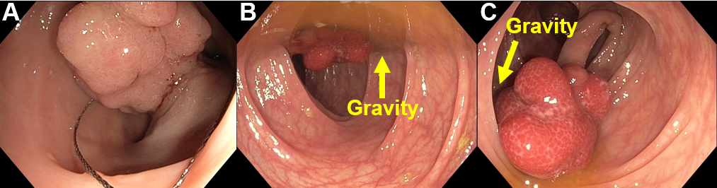
Figure 1 Basic maneuvers of polypectomy. A: Positioning the polyp at 5-6 o’clock on the monitor before polypectomy; B: The polyp’s base lying on gravity, this leads to poor visualization of the resection area; therefore, the patient’s position should be altered; C: The polyp’s base lying opposite to gravity after changing the patient’s position. This position change allows polyp stretching and avoids blood pooling on the resected site.

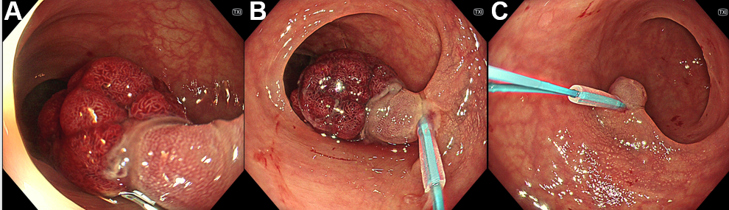
Figure 2 Endoloop-assisted polypectomy. A: A pedunculated polyp with a thick stalk; B: Endoloop tightening around the stalk before snaring, the polyp’s color turned deep purple due to the ischemia; C: No bleeding evidence after the resection.

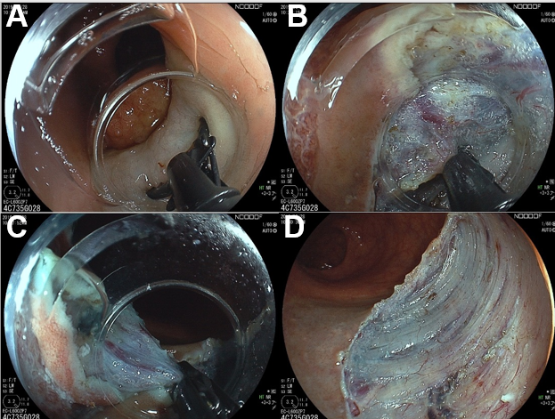
Figure 3 Endoscopic submucosal dissection with a scissor-type knife for a large subpedunculated polyp. A: After submucosal injection, a scissor-type knife could be used to perform mucosal incision; B: The tissue and vessels could be grasped between two blades and precoagulated before cutting; C: Final cut of the procedure; D: Mucosal defect after completed endoscopic submucosal dissection.

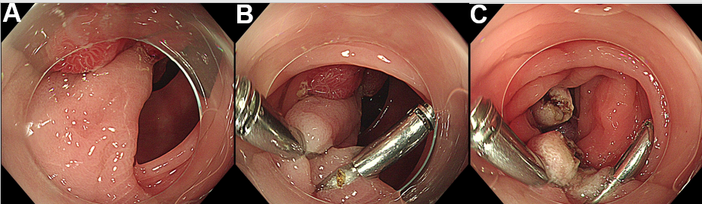
Figure 4 Prophylactic clip application at the stalk before polypectomy. A: A pedunculated polyp with a thick stalk and large head. There were failed attempts placing the endoloop due to the large polyp head; B: Clip application before snaring; C: No bleeding evidence after the resection.

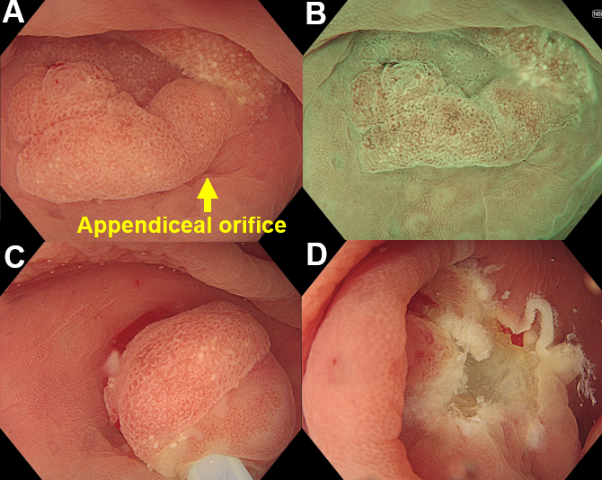
Figure 5 Underwater endoscopic mucosal resection for a polyp involving appendiceal orifice. A: Endoscopic image showing a 15-mm sessile polyp involving the appendiceal orifice; B: Magnifying narrow-band image showing a type 1 polyp of the Japanese Narrow-band Imaging Expert Team classification with open pit pattern. The most likely diagnosis was sessile serrated lesion; C: Underwater snaring without submucosal injection; D: Mucosal defect after completed underwater endoscopic mucosal resection.

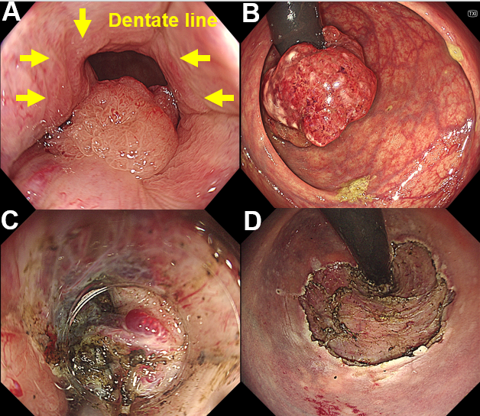
Figure 6 Endoscopic submucosal dissection for a polyp involving the anorectal junction. A: Endoscopic image showing a 6-cm laterally spreading tumor involving the dentate line; B: Retroflexed view of the same polyp; C: Hemorrhoidal plexus at the anus makes the endoscopic submucosal dissection (ESD) challenging with the bleeding risk; D: Mucosal defect after completed ESD.

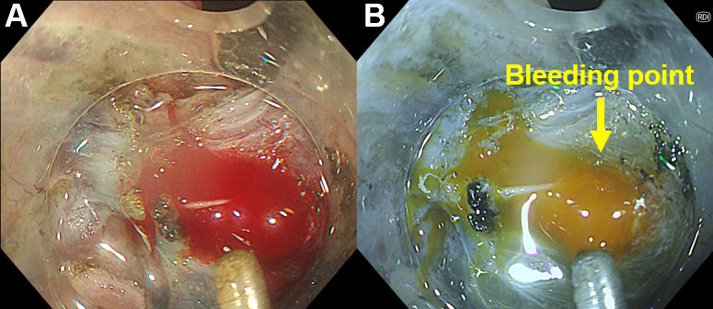
Figure 7 Bleeding during endoscopic submucosal dissection. A: Endoscopic image in white light imaging showing the bleeding from the large vessels of the polyp; B: Identification of bleeding sources during polypectomy is easier in the Red Dichromatic Imaging (RDI) mode. RDI mode also reduces the endoscopists’ psychological stress by turning the blood color yellow.

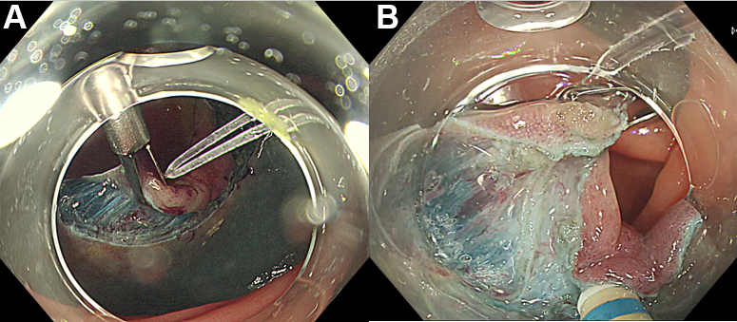
Figure 8 Traction device during endoscopic submucosal dissection. A: Rubber band traction clip facilitating endoscopic submucosal dissection of a laterally spreading tumor with submucosal fibrosis; B: Traction force from the device helping during the submucosal dissection.

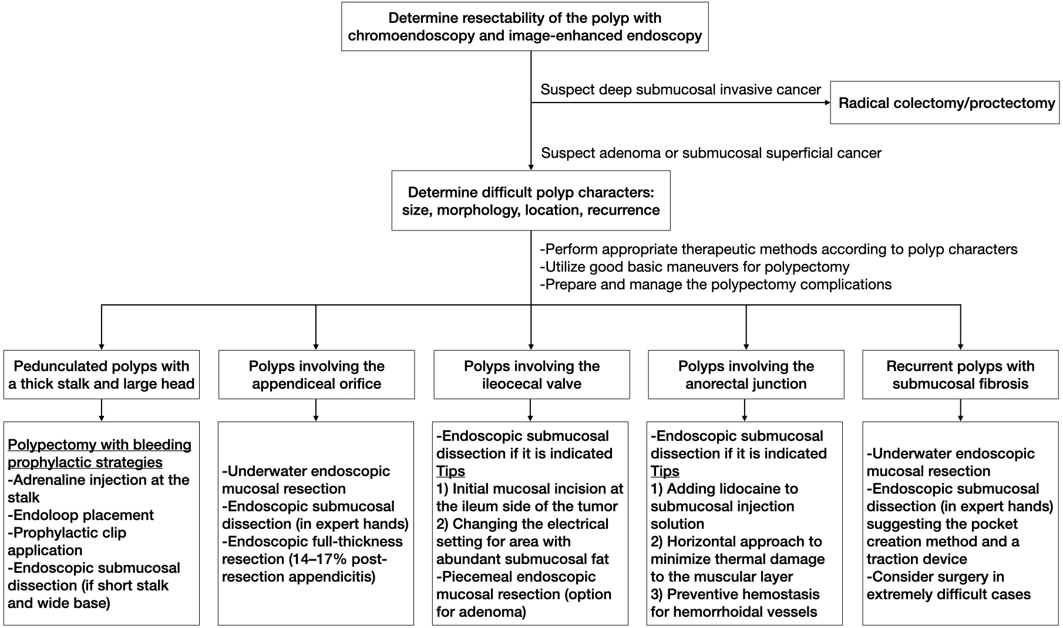
Figure 9 Stepwise approach for difficult colorectal polyps.

Table 1 The Japan Narrow-band Imaging Expert Team classification^{[8]}
 | Type 1 | Type 2A | Type 2B | Type 3
Vessel pattern | Invisible | Regular caliber, regular distribution (meshed/spiral pattern) | Variable caliber, irregular distribution | Loose vessel areas, interruption of thick vessels
Surface pattern | Regular dark or white spots, similar to surrounding normal mucosa | Regular (tubular/branched/papillary) | Irregular or obscure | Amorphous areas
Suspected pathology | Hyperplastic polyp/sessile serrated polyp | Low grade intramucosal neoplasia | High grade intramucosal neoplasia/shallow submucosal invasive cancer | Deep submucosal invasive cancer
Table 2 Characteristics of the difficult colorectal polyps
Size | > 20 mm
Location | Near or involving the appendiceal orifice
 | Ileocecal valve
 | Anorectal junction
 | Behind the fold
 | Angulated segment
Morphology | Pedunculated polyp with thick stalk and large head
 | Laterally spreading tumor
 | Submucosal fibrosis or positive non-lifting sign
Special situation | Recurrent lesion
 | Strong colonic peristalsis
Table 3 Size/Morphology/Site/Access scoring system^{[19]}
Parameter | Range | Score
Size | < 1 cm | 1
 | 1.0-1.9 cm | 3
 | 2.0-2.9 cm | 5
 | 3.0-3.9 cm | 7
 | > 4 cm | 9
Morphology | Pedunculated | 1
 | Sessile | 2
 | Flat | 3
Site | Left | 1
 | Right | 2
Access | Easy | 1
 | Difficult | 3
Size/Morphology/Site/Access (SMSA) level 1: 4-5 points, level 2: 6-8 points, level 3: 9-12 points, level 4: > 12 points.
Table 4 Indications for colorectal endoscopic submucosal dissection^{[10]}
 | Lesions requiring en bloc resection
1 | Lesions which en bloc resection with EMR is difficult
 | LST-NG, particularly LST-NG with pseudo-depressed type
 | Lesions with V_{I}-type pit pattern
 | Carcinoma with shallow T1 invasion
 | Large depressed-type tumor
 | Large protruded-type lesions suspected to be carcinoma
2 | Mucosal tumors with submucosal fibrosis
3 | Sporadic tumors in conditions of chronic inflammation such as ulcerative colitis
4 | Local residual or recurrent early carcinomas after endoscopic resection
EMR: Endoscopic mucosal resection; LST-NG: Laterally spreading tumor non-granular type.

