Name of Journal: World Journal of Gastrointestinal Oncology
Manuscript NO: 72712
Manuscript Type: CORRECTION

Correction to "MicroRNA-320a suppresses tumor progression by targeting PBX3 in gastric cancer and is downregulated by DNA methylation"

Li YS et al. Role of PBX3 in GC

Yong-Shuang Li, Ying Zou, Dong-Qiu Dai

Yong-Shuang Li, Ying Zou, Dong-Qiu Dai, Department of Gastrointestinal Surgery, The Fourth Affiliated Hospital of China Medical University, Shenyang 110032, Liaoning Province, China

Author contributions: Li YS and Dai DQ submitted the final manuscript and all authors read and approved the final version.

Corresponding author: Dong-Qiu Dai, MD, PhD, Chief Doctor, Professor, Surgical Oncologist, Department of Gastrointestinal Surgery, The Fourth Affiliated Hospital of China Medical University, No. 4 Chongshan East Road, Shenyang 110032, Liaoning Province, China. daidq63@163.com

Received: October 25, 2021
Revised: April 19, 2022
Accepted: April 22, 2022
Published online:

Abstract
We rechecked the original data of Figure 3, Part.B, and found that 0 h group in the BGC-823 cell wound scratch assay was misapplied. Therefore, we are writing to apply for the modification of Figure 3, Part.B.

Key Words: Correction; Gastric cancer; miRNA-320a; DNA methylation

Li YS, Zou Y, Dai DQ. Correction to "MicroRNA-320a suppresses tumor progression by targeting PBX3 in gastric cancer and is downregulated by DNA methylation". World J Gastrointest Oncol 2022; In press

Core Tip: This is a correction to "MicroRNA-320a suppresses tumor progression by targeting PBX3 in gastric cancer and is downregulated by DNA methylation".

CORRECTION
Correction to: Li YS, Zou Y, Dai DQ. MicroRNA-320a suppresses tumor progression by targeting PBX3 in gastric cancer and is downregulated by DNA methylation. World J Gastrointest Oncol 2019; 11(10): 842-856 PMID: 31662823 DOI: 10.4251/wjgo.v11.i10.842.
We recently read our manuscript published in the World Journal of Gastrointestinal Oncology (Manuscript NO: 48527, DOI: 10.4251/wjgo.v11.i10.842), we have carefully rechecked the original data of Figure 3, Part.B, and found that 0 h group in the BGC-823 cell wound scratch assay was misapplied. Therefore, we are writing to apply for the modification of Figure 3, Part.B. The revised Figure 3, Part.B is showed below. We feel deeply sorry for this mistake during the proofreading process. This correction does not alter any interpretation of the results or conclusion of this study^{[1]}.
We apologize for any inconvenience caused by this mistake.

REFERENCES
1 Li YS, Zou Y, Dai DQ. MicroRNA-320a suppresses tumor progression by targeting PBX3 in gastric cancer and is downregulated by DNA methylation. World J Gastrointest Oncol 2019; 11: 842-856 [PMID: 31662823 DOI: 10.4251/wjgo.v11.i10.842]

Footnotes
Conflict-of-interest statement: All authors declare that they have no conflicts of interest.

Open-Access: This article is an open-access article that was selected by an in-house editor and fully peer-reviewed by external reviewers. It is distributed in accordance with the Creative Commons Attribution NonCommercial (CC BY-NC 4.0) license, which permits others to distribute, remix, adapt, build upon this work non-commercially, and license their derivative works on different terms, provided the original work is properly cited and the use is non-commercial. See: https://creativecommons.org/Licenses/by-nc/4.0/

Provenance and peer review: Unsolicited article; Externally peer reviewed.
Peer-review model: Single blind

Peer-review started: October 25, 2021
First decision: April 17, 2022
Article in press:

Specialty type: Oncology
Country/Territory of origin: China
Peer-review report’s scientific quality classification
Grade A (Excellent): 0
Grade B (Very good): B, B
Grade C (Good): C
Grade D (Fair): 0
Grade E (Poor): 0

P-Reviewer: Hori T, Japan; Kapritsou M, Greece; Moshref L, Saudi Arabia S-Editor: Wang LL L-Editor: A P-Editor: Wang LL
Figure Legends
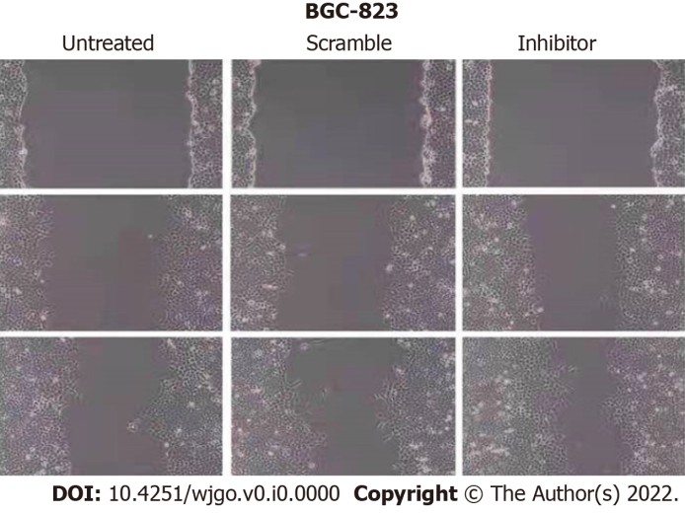
Figure 3 Part.B. Overexpression of miR-320a suppressed gastric cancer cell migration and invasion.

