Name of Journal: World Journal of Meta-Analysis
Manuscript NO: 63412
Manuscript Type: MINIREVIEWS

Prediabetes and cardiovascular complications study: Highlights on gestational diabetes, self-management and primary health care

Nwose EU et al. GDM, diabetes self-management, primary health care

Ezekiel Uba Nwose, Phillip Taderera Bwititi, Otovwe Agofure, Echinei Jacob Oshionwu, Ekenechukwu Esther Young, Eferhire Aganbi, Solomon Ekwuweokwuenu Egwenu, Helen Egoyibo Chime, Fortunatus Darius Gbeinbo, Alex Odufu, John Nwakaego Okuzor, Azuka Okuleye, Kennedy Aninze, Innocent Chuks Onyia, Euzebus Chinonye Ezugwu, Eunice Obiajuru Igumbor, Ifeoma Isabel Ulasi

Ezekiel Uba Nwose, Otovwe Agofure, Solomon Ekwuweokwuenu Egwenu, Helen Egoyibo Chime, Fortunatus Darius Gbeinbo, Eunice Obiajuru Igumbor, Department of Public and Community Health, Novena University, Kwale 322107, Nigeria

Ezekiel Uba Nwose, Phillip Taderera Bwititi, School of Dentistry and Medical Sciences, Charles Sturt University, Wagga campus, New South Wales 2650, Australia

Ezekiel Uba Nwose, Echinei Jacob Oshionwu, Alex Odufu, John Nwakaego Okuzor, Azuka Okuleye, Kennedy Aninze, Innocent Chuks Onyia, Global Medical Research and Development Organization (GMRDO) group, Abbi Delta State 322107, Nigeria

Echinei Jacob Oshionwu, California Department of State Hospital, Stockton, CA 95215, United States

Ekenechukwu Esther Young, Euzebus Chinonye Ezugwu, Ifeoma Isabel Ulasi, Department of Medicine, College of Medicine, University of Nigeria, Ituku-Ozalla campus, Enugu 402109, Nigeria

Eferhire Aganbi, Biochemistry Department, Delta State University, Abraka 330105, Nigeria

John Nwakaego Okuzor, Department of Clinical Laboratory Services, Texas Health (HMH HEB), Bedford, TX 76022, United States

Kennedy Aninze, Clinic Department, Donak Hospital, Kwale 2539083, Nigeria

Innocent Chuks Onyia, Clinic Department, U-Turn Hospital, U-Turn Abule Egba 100276, Nigeria

Author contributions: Nwose EU and Bwititi PT conceptualized the research program; Oshionwu EJ, Young EE, Igumbor EO and Ulasi II reviewed different components of the studies’ designs and supervised clinical field work, including ethics; Agofure O, Aganbi E, Egwenu SE, Chime HE, Gbeinbo FD, Aninze K and Onyia IC collected data as well as reviewed the first draft of the manuscript; Odufu A, Okuzor JN, Okuleye A and Ezugwu EC were involved in discussions throughout the study and made intellectual contributions to the study performance; Nwose EU, Bwititi PT and Agofure O drafted the manuscript; All authors revised the manuscript and approved the final version for submission.

Supported by Bringing Research in Diabetes to Global Environments and Systems (BRIDGES2) program.

Corresponding author: Ezekiel Uba Nwose, PhD, Professor, Department of Public and Community Health, Novena University, PMB 2, Kwale 322107, Nigeria. nwoseeu@hotmail.com

Received: January 28, 2021
Revised: May 21, 2021
Accepted: November 28, 2021
Published online: December 28, 2021

Abstract
International collaboration on the prediabetes and cardiovascular complications study started in 2013. In 2017, a reflection was reported. Incompleteness of documentation and screening of antenatal cases for gestational diabetes mellitus (GDM) was concerning. Hence, further observations have been made that warrant an update. The objective of this review is to highlight gaps between clinical knowledge and practice in GDM, diabetes self-management and primary health care (PHC) for rural dwellers. We followed a descriptive field notes method. Antenatal records of patients screened for GDM with incomplete documentation were examined to determine incompleteness of data in those that also met the criteria for GDM risk assessment. Experiences on development of a diabetes register and education and notes on behavioural change wheel were also reviewed. Other data included cross-sectional evaluation of activities of daily living at two private hospitals. Up to 29% had high GDM risk factors, which fulfilled selection criteria for laboratory screening. Demographic data was complete in all women; however, incomplete documentation was observed with as much as 98% of basic data. High levels of physical activity were found in the population, and health lectures proved effective in food choices. The workforce need for diabetes care seems underestimated, but this may be better understood with reactivation of PHC services. The observations highlight behavioural change wheel issues on GDM and PHC services that need concerted focus. Two proposals are to advance the use of a ‘risk assessment and screening sheet’ for GDM screening and enlightenment of stakeholders on the central hub role of PHC in diabetes management.

Key Words: Behavioural change wheel; Community health; Diabetes education; Knowledge vs practice gap; Lifestyle; Patient follow-up; Screening services; Telehealth

©The Author(s) 2021. Published by Baishideng Publishing Group Inc. All rights reserved.

Citation: Nwose EU, Bwititi PT, Agofure O, Oshionwu EJ, Young EE, Aganbi E, Egwenu SE, Chime HE, Gbeinbo FD, Odufu A, Okuzor JN, Okuleye A, Aninze K, Onyia IC, Ezugwu EC, Igumbor EO, Ulasi II. Prediabetes and cardiovascular complications study: Highlights on gestational diabetes, self-management and primary health care. World J Meta-Anal 2021; 9(6): 543-556
URL: https://www.wjgnet.com/2308-3840/full/v9/i6/543.htm
DOI: https://dx.doi.org/10.13105/wjma.v9.i6.543

Core Tip: There is a gap between knowledge and practice among stakeholders in diabetes management. Behavioural change wheel issues on gestational diabetes mellitus (GDM) and primary health care (PHC) services need concerted focus. The necessity for GDM selective screening is recognized. ‘Risk assessment and screening sheet’ needs to be employed in clinical practice. Stakeholders including individuals living with diabetes, community leadership, policy makers and health care provision staff need enlightenment to deliberately use PHC centres for diabetes management. PHC centres have a central-hub role in community health. Medical records need to include patients’ phone numbers to maximize potential for follow-up and telehealth.

INTRODUCTION
Diabetes mellitus is a global challenge and public health concern that has continued to attract multifaceted research^{[1-3]}. These interests include laboratory examinations for definitive diagnosis of gestational diabetes mellitus (GDM)^{[4-6]}, lifestyle treatment options^{[7-9]} and use of technologies for patient follow-up and self-management^{[10-12]}.
In 2013, a proposal for an international collaboration on prediabetes and cardiovascular complications study was launched^{[13]}. In 2017, an update with future directions was reported^{[14]}. In the last 3 years, the program has been expounded, with niches developing from parts of the research. The Global Medical Research and Development Organization that oversees the activities at Catholic Hospital Abbi conceptualized the integration of a monthly diabetes clinic and GDM screening and registry for antenatal clinic patients^{[15-17]}. A user-friendly GDM risk assessment and screening form was proposed in January 2020 in collaboration with the University of Nigeria Teaching Hospital.
An opportunity arose after the acquisition of the BRIDGES2 grant [Eli Lily and International Diabetes Federation (IDF)] for a targeted diabetes self-management education trial. This created impetus to develop the lifestyle component of the research. In addition to reports^{[18-20]}, two field notes detailing dietary options and food choices as well as physical activities of daily living (ADL) were presented.
To further add to the diabetes registry and BRIDGES2 project, the Global Medical Research and Development Organization reviewed primary health care (PHC) services. This included a discussion about telehealth capacities to enhance diabetes services^{[21,22]}. Telehealth is becoming an invaluable resource. The lessons from the coronavirus disease 2019 pandemic have proven this. Hence, field note observations relevant to PHC and telehealth constitute part of this update, including lessons from the World Diabetes Day (WDD) 2020.

Objective and approach of review
The objective of this paper is to give a periodic review of trends^{[23-25]}. This review is based on our current prediabetes and cardiovascular complications study research with a focus on the gap between knowledge and practice in laboratory testing for GDM diagnosis, including the use of risk assessment factors for selective screening. Other focus areas are emerging treatments (specifically nutrition) and technologies (medical record documentation and telehealth).

DESCRIPTIVE FIELD NOTES REVIEW
This review was designed to follow a descriptive field notes study method. The notes were based on the international collaboration on a prediabetes and cardiovascular complications study program. The study was carried out in Delta State, Nigeria and at health care centres/hospitals. For this update, the ‘project evaluation’ looked at notes and data from the ongoing study, and the goals for each section are given as subheadings.

GDM screening
GDM constitutes a subsequent health risk to the mother and child. Several risk factors for GDM are known; hence, screening is encouraged. However, the adoption of robust screening protocols in various health care facilities is lacking, and reports have indicated a similar situation in our research performance sites^{[15,29]}. One notable observation was that selection criteria for lab tests in GDM screening were being followed^{[16]} but arbitrarily and with rampant incompleteness of procedure. Therefore, while a screening flow sheet has been articulated^{[15]}, it was appropriate to develop another sheet with selective screening criteria (Table 1). This proposed GDM risk assessment and screening sheet was informed by two points: (1) Risk factors are generally non-invasive and can be obtained during antenatal registration and history taking^{[30-32]}; and (2) Risk scoring systems exist. One includes gestational age^{[31]}, while the other is without gestational age^{[32]}.

Standard selection for screening: A user-friendly algorithm or chart is yet to be developed. Pending the adoption of the risk scoring chart, this evaluation would assess antenatal patients with three risk factors for laboratory investigation of GDM. Two retrospective cohort reviews have tabulated the GDM risk assessment and screening sheet (Table 1). Furthermore, the mother’s blood type is a potential genetic factor for the likelihood of GDM developing overt diabetes mellitus (DM) postpartum^{[33]}. Blood type assessments are determined for antenatal patients but may not be included in GDM screening sheets. Nevertheless, it is important to identify this as part of GDM management.

GDM screening register: In another field note, evaluation was specifically aimed to (1) Progress the development of screening registers, (2) Determine the level of attention given to or the potential of monitoring the rate of increase in body mass index (BMI) among the patients; and (3) Update the prevalence of GDM among pregnant women.

Diabetes self-management
Four items are imperative components of behavioural change included in diabetes education programs^{[34]}. They are dietary options, physical ADL, adherence to medical check-ups and adherence to prescription medicine. For this update, two field notes on dietary options and physical ADL are presented.

Physical ADL: Physical inactivity predisposes a person to DM. Thus, engaging in physical activities is preventive and therapeutic. The study evaluated ADL of local residents with diabetes who attended two non-government health facilities in rural communities of Delta State, Nigeria. This study was an addendum to a previous report^{[20]}. A cross-sectional descriptive design was used and comprised 48 participants from Catholic Hospital Abbi and Novena Health Centre Amai. A semi-structured questionnaire with integrated anthropometric and blood pressure measurements (weight, height, blood pressure, and BMI) was used. ADL of participants was delineated into blue vs white collar jobs, depicting physically-active and -inactive occupations respectively. The data were analysed using the Microsoft Excel Analysis ToolPak. A demographic description of the respondents is presented in Table 2. Among the women, 11/21 (52.4%) were widows, and the average age of all respondents was 57 years.

Dietary options and food choices: In another study niche, the consumption of indigenous carbohydrate foods was evaluated. This niche was originally studied to determine the agribusiness and health economics nexus^{[35]}, but the basis of this field note was the controversy around cassava^{[36,37]} that was buoyed by indigenously sourced cassava meal (eba/garri) being omitted from a hospital-based menu^{[19]}. The study involved baseline and post-intervention surveys of community members including hospital visitors, and the intervention was public health lectures on medical nutrition therapy value of cassava. Information collected included consumption habits regarding farmed choices (cassava and yam) and an imported option (wheat).

Other evaluations
PHC needs – lessons from WDD 2020: With the invaluable support from the Public Health Department of Novena University, the WDD event was organized at 11 health facilities, including four research performance sites, a general hospital, two PHC centres in the Delta state, one centre in the southern Nigeria, and three centres in northern Nigeria. There were 23 volunteers comprised of academic staff and postgraduate students of the Public Health Department of the Novena University who facilitated the event. An additional 79 health care personnel were recruited who delivered public health lectures and diabetes screening. A total of 286 community members benefited from the event^{[38]}. Observations were made from this event.

Telehealth potential in rural communities of Nigeria: Development of diabetes registers was started at the research performance sites, i.e. health facilities. However, evaluation of the usefulness for patient recall and telehealth have yet to be reviewed. Hence, in the hospital cohort study of 123 cases, the evaluation approach for telehealth involved assessing previous antenatal patients by telephone.

PERSPECTIVES ON GDM, SELF-MANAGEMENT AND PHC IN PREDIABETES AND CARDIOVASCULAR COMPLICATIONS
GDM screening
In a hospital cohort involving 90 cases, there was no urinalysis on the antenatal patients despite various prevalent risk factors. A history of GDM was the least common risk factor, and age over 35 years was the most common risk factor (Figure 1). Considering the prevalence of risk factors at initial registration, the lack of urinalysis is inexplicable. In another hospital cohort of 123 cases, 29% of those assessed had three or more risk factors that warranted screening (unpublished data). These reports provide evidence that screening education should be provided to antenatal providers.

Level of completeness of data collected during GDM screening: We collected data from 391 antenatal cases that were seen from September 2018 to December 2018. The women’s ages ranged from 15 to 46 years, and average gestational age was 23 wk, with the earliest clinic visit occurring at the fourth week. Further, several of the women were in their first pregnancy, and cohort average was less than gravida 3 (Table 3).
Among the 391 cases, the names, ages, medical record numbers and dates of hospital visits were complete, i.e., 100% documentation. Information on the mother’s and/or family history of type 2 diabetes and GDM were not indicated, i.e., 0% documentation on hereditary risk factor. There were also no records of lipid profiles. Other relevant data that were collected are presented in Table 4. Blood sugar tests were undocumented for 98.7% of patients, and BMI was not reported for 76.7% of patients. Overall, our results show that the average level of completeness of data collection during GDM screening was 79% (Figure 2). The figure shows the percentages of completeness that were not captured in Table 4.

Level of attention given to BMI: The 301/391 cases lacking BMI measurement had missing data on height (Table 4), but only 14 Lacked weight measurements. A critical evaluation showed that 5% of the cases without BMI values were due to lack of height and weight measurements, and 95% were solely due to lack of height data (Figure 3). Further review of the potential monitoring rate of increase in BMI among the patients showed that 13% (12/90) were in the first trimester and 48% (43/90) in the second trimester. There was a noticeably higher level of BMI in the third trimester relative to the earlier trimesters, but the difference was not statistically significant.

ADL in the community
This analysis was based on the occupation of the participants. The indicated occupations were categorized into blue collar (manual labour, e.g., agriculture, construction, etc.) and white collar (office or non-hard manual work professional) depending on assumptions of physical demands of the jobs. Forty-eight respondents were analysed, including four who did not indicate their occupations and were assumed to be blue collar. Evaluation showed that 73% were involved in physically demanding ADL (Figure 4).

Level of physical activities among participants
Evaluation of responses to exercise ADL indicated that over 50% of the respondents were not able to stretch or swim, while walking appeared to be the activity for most (Table 5). Evaluation of interference of basic ADL showed that ill health interfered mostly with respondents’ hobbies, but generally all people engaged in a variety of physical activities.

Effect of diabetes on the ADL of participants in the community
When participants were categorized based on DM and hypertension + DM, the results showed that diabetes interfered with hobbies and work the most. However, the interference was minimal. The impact of hypertension + DM on all the surveyed ADL items was higher (moderate interference of hobbies and work) (Figure 5).
It was concluded that participants in manual jobs constituted about three-quarters of the diabetes patients. Nevertheless, the proportion of those in non-manual jobs with hypertension comorbidity was higher, which implies healthy occupational ADL as indicated by a preponderance of manual occupations in people with diabetes. The impact of ill health on leisure ADL was also indicated, especially that it was worse in those with hypertension comorbidity. This highlights that a pivotal focus on diabetes self-management regarding physical activities should include evaluation of the patient’s capacity to engage in ADL, especially as the impact of diabetes on ADL translates to a barrier of a therapeutic lifestyle regimen. Given that the interference of ADL by ill health was worse among those with hypertension and diabetes, both groups require different levels of care.

Effect of public education on food consumption
A baseline survey showed that 100% of rural farmers harvest cassava. The survey also showed that only 48% consumed cassava as one of their food choices, and 10% consumed wheat only and disregarded other options (Figure 6). This observation differed from other cohorts, such as urban dwellers who were wheat consumers and included a high proportion of educated people. After the public health lecture, the post-intervention survey showed a shift in consumption patterns, in favour of cassava products^{[39]}.

WDD 2020 highlights
At WDD 2020, the IDF highlighted the following three urgent facts about Nigeria and diabetes: (1) Six million nurses are needed; (2) About 50% of adults living with diabetes are undiagnosed; and (3) Over 75% of people living with diabetes live in urban areas and are of working age.
Lessons from the event can be summarized in two themes. First, there is an underestimated burden of diabetes in terms of the nursing workforce requirement in PHC. During preparation for the event, it was determined that the 6 million projection is an underestimation. This determination was based on: (1)Australia being speculated to require about 120000 nurses in the next 10 years, which is 2% of the projected 6 million need^{[40]}; and (2) More than 75% of people in African countries being undiagnosed for diabetes^{[41]}, making the actual burden yet to be estimated. This implies that Nigeria, with a population of over 200 million, needs to train and recruit many health care workers in diabetes care. Considering the current nursing workforce in the country, Nigeria will need more than the estimated 6 million.
Non-governmental organizations run diabetes screening services at community and PHC centres, but resident staff of the health care centres do not. Therefore, the knowledge is present but is not practiced, hence the apparent gap in knowledge vs practice. Importantly, most of the health care workers in the rural community-based PHC facilities are unaware of the WDD diabetes educator courses. However, these courses are well-received because the general hospitals requested a reschedule of the WDD from a Saturday to a weekday, in order for the staff to benefit. In addition, at three of the hospitals, the event was carried out twice, once for the general public and again for the hospital staff.

Telehealth
Our data indicates that 20% of the cases on medical records did not have phone numbers on record. However, 80% of the patients were able to receive services via telehealth. A pertinent observation is that some of the phone numbers were actually owned by the patient’s child who was not living with the patient. Although many of the calls were unsuccessful, 34% of the cohort received telehealth services, and 29% of the sub-cohort received health advice (Figure 7). In light of the coronavirus disease 2019 pandemic and its effects on routine health care provision, this is an area that can be further utilised and expanded.

DISCUSSION
This review highlighted some of the problems in diabetes research and practice. Specifically, the issues of GDM, nutrition in terms of carbohydrate food choices, PHC, and telehealth. Links have been made to the concept of behavioural change wheel (BCW_ regarding the gap between knowledge vs practice. BCW is important in managing chronic conditions. It is a guide for designing intervention programs, and it is predicated on capacity, motivation, and opportunity^{[26]}. It is a comprehensive framework for designing interventions by explicitly integrating behaviour theory to understand and target mechanisms of action within the intervention^{[27]}, and it is mindful that individual and collective behaviour change is key to implementing new practices and to improving health outcomes. It also incorporates context, which is key to effective design and implementation of interventions^{[28]}.
There has been a lack of clarity on the universal screening of pregnant women for GDM^{[42-44]}, and the result is that this service remains under-utilised^{[45]}. This low level of GDM screening service appears to represent a gap between knowledge and practice among the clinicians. The positive note is that GDM risk assessment for selective screening of pregnant women now exists^{[30-32]}. The user-friendly risk assessment sheet needs to be validated for local clinical use and integrated into GDM screening services. Two notable pieces of clinical knowledge include (1) BMI may be more reliable as a risk factor when measured in the first trimester, and (2) More weight measurements should be done because gestational weight gain is imperative in monitoring well-being of the baby and mother. Therefore, most antenatal clinics assess these at every visit, but height is documented at registration. This review highlighted the proportions of cases missing different necessary measurements and/or documentation.
Our cohort of 391 antenatal patients in the register were reviewed to determine the number of conclusive GDM diagnoses. This review was an addendum to a previous observation^{[15]}, and it was observed that 385 patients had a urine glucose test, out of which 16 (4%) were positive for glucosuria. Glucosuria may be found in about 50% at some point because of the associated changes in glomerular filtration rate. However, a follow-up blood sugar test for at-risk women is still essential^{[46]}. None of the 16 cases were followed-up with a blood sugar test. Instead, 5 other patients had blood glucose test results without urinalysis. Therefore, we do not know the incidence rate of GDM at our hospital. This highlights a knowledge and practice gap in antenatal patient laboratory test requisition and follow-up.
The four components of necessary diabetes education are: Adherence to medication, nutritional lifestyle, physical ADL, and up-to-date medical check-ups including laboratory tests^{[2,47,48]}. This review reported on carbohydrate nutrition and highlighted that people are still unaware of the values of their indigenous foods. This lack of knowledge was identified long ago^{[49]}, hence this report suggests that the problem is yet to be resolved. Therefore, more concerted efforts are needed to advance the knowledge of the glycaemic index of Nigerian carbohydrate foods. This report also highlighted physical ADL affordances and their effectiveness in the rural community.
PHC care is a function of the state, regarding the government’s policy and practice on health services. One of the issues, at least in developing communities such as Africa, is limited resources^{[50]}. However, studies on knowledge, attitude and practice have indicated that there are patient factors to consider^{[51]}. The Alma Ata declaration identified the necessity and potential of PHC to play a central hub role, and diabetes care services are encompassed^{[52]}. This report highlights a known problem that is still unresolved.
Therefore, it is recommended for the World Health Organization and other stakeholders (community, community leadership, policy makers and health care provision staff) to focus on PHC for diabetes care. For instance, looking at the Nigerian health care system, there are PHC centres scattered and operated by local governments, but the community dwellers rarely patronize the centres. By implication, the feedback to the government is hampered, and the impression is that “the government is not doing enough.” However, it is not entirely the fault of the government per se^{[18]}. This requires behavioural change of the community, inclusive of the ministry of health^{[53]}. It was reported from a BCW survey that about 40% of stakeholders agreed on the ability of PHC to offer diabetes services, whereas over 70% believed the motivation was poor^{[18]}. Therefore, this update highlights one area of need of BCW for IDF and the World Health Organization.
Over the past 3 years, translational research efforts have included development of a Diabetes Registry in the health facilities^{[17,54,55]}. It has been reported that a major factor to consider is concerted integration of telephone numbers of patients in medical files^{[54]}. For this obvious reason, the Global Medical Research and Development Organization is developing telehealth services for the area, of which telephone numbers are indispensable.
There is ongoing interest to utilise accessible and affordable telecommunication tools including telephones in community health service delivery^{[56-58]}. This review reported the potential to use the telephone for follow-up in rural communities. It also highlighted two limitations, which are non-documentation of the patient’s phone number or the patient providing another person’s telephone. This observation calls for awareness for health care providers to document phone numbers in patients’ records as well as alert patients on the importance of providing their own numbers.

CONCLUSION
These updated field note observations from ongoing research and topical research areas include prediabetes, diabetes registry, GDM screening concerns, PHC and telehealth potential for rural dwellers. From experience on the development of a diabetes register and intensive diabetes education, notes on BCW were reviewed and this is a work in progress, especially due to the negative impact of the coronavirus disease 2019 pandemic. Other field data included a cross-sectional study of ADL at two private hospitals. One of the important topics in diabetes care is that of PHC. There is a knowledge and practice gap for the important role that PHC must play in diabetes care, and this constitutes another point on BCW. This problem is likely confounded by the IDF and World Health Organization underestimating the nursing workforce. It is possible that a proactive PHC system equipped with various registries, such as a diabetes registry, could minimize the documentation issues as well as improving screening procedures. Mobile phones and internet services are becoming affordable and accessible, and research needs to focus on their utilisation. Future research should also advance BCW of all stakeholders (community, community leadership, policy makers and health care provision staff) to maximize the impact of diabetes research.

ACKNOWLEDGEMENTS
Some postgraduate and undergraduate students of the Public Health Department of Novena University supported the data collection during their research training, which have been duly published. This group includes Annette Orove, Edmond Anowa, Emmanuel Agege, Garba Ahmed, and Joseph Odoko. The staff and managements of Catholic Hospital Abbi, Donak Hospital Kwale, Eku Baptist Government Hospital, Friends Medical Laboratory Service and Novena University Health Centre are hereby appreciated.

REFERENCES
1 Bongaerts BW, Müssig K, Wens J, Lang C, Schwarz P, Roden M, Rathmann W. Effectiveness of chronic care models for the management of type 2 diabetes mellitus in Europe: a systematic review and meta-analysis. BMJ Open 2017; 7: e013076 [PMID: 28320788 DOI: 10.1136/bmjopen-2016-013076]
2 Khunti K, Gray LJ, Skinner T, Carey ME, Realf K, Dallosso H, Fisher H, Campbell M, Heller S, Davies MJ. Effectiveness of a diabetes education and self management programme (DESMOND) for people with newly diagnosed type 2 diabetes mellitus: three year follow-up of a cluster randomised controlled trial in primary care. BMJ 2012; 344: e2333 [PMID: 22539172 DOI: 10.1136/bmj.e2333]
3 Yang M, Ni C, Chang B, Jiang Z, Zhu Y, Tang Y, Li Z, Li C, Li B. Association between serum total bilirubin levels and the risk of type 2 diabetes mellitus. Diabetes Res Clin Pract 2019; 152: 23-28 [PMID: 31078667 DOI: 10.1016/j.diabres.2019.04.033]
4 Boyle DIR, Versace VL, Dunbar JA, Scheil W, Janus E, Oats JJN, Skinner T, Shih S, O'Reilly S, Sikaris K, Kelsall L, Phillips PA, Best JD; MAGDA Study Group. Results of the first recorded evaluation of a national gestational diabetes mellitus register: Challenges in screening, registration, and follow-up for diabetes risk. PLoS One 2018; 13: e0200832 [PMID: 30089149 DOI: 10.1371/journal.pone.0200832]
5 Zhang C, Li Y, Wang L, Sun S, Liu G, Leng J, Guo J, Lv L, Li W, Zhang C, Hu G, Yu Z, Yang X. Blood group AB is protective factor for gestational diabetes mellitus: a prospective population-based study in Tianjin, China. Diabetes Metab Res Rev 2015; 31: 627-637 [PMID: 25820620 DOI: 10.1002/dmrr.2650]
6 Zhang S, Liu H, Zhang C, Wang L, Li N, Leng J, Li Y, Liu G, Fan X, Yu Z, Yang X, Baccarelli AA, Hou L, Hu G. Maternal glucose during pregnancy and after delivery in women with gestational diabetes mellitus on overweight status of their children. Biomed Res Int 2015; 2015: 543038 [PMID: 25802854 DOI: 10.1155/2015/543038]
7 Kerrison G, Gillis RB, Jiwani SI, Alzahrani Q, Kok S, Harding SE, Shaw I, Adams GG. The Effectiveness of Lifestyle Adaptation for the Prevention of Prediabetes in Adults: A Systematic Review. J Diabetes Res 2017; 2017: 8493145 [PMID: 28567425 DOI: 10.1155/2017/8493145]
8 American Diabetes Association.. Evidence-based nutrition principles and recommendations for the treatment and prevention of diabetes and related complications. Diabetes Care 2002; 25: 202-212 [PMID: 11772917 DOI: 10.2337/diacare.25.1.202]
9 Sapkota S, Brien JE, Gwynn J, Flood V, Aslani P. Perceived impact of Nepalese food and food culture in diabetes. Appetite 2017; 113: 376-386 [PMID: 28288801 DOI: 10.1016/j.appet.2017.03.005]
10 Evans M. Current methods of assessing blood glucose control in diabetes. Br J Diabetes 2016; 16: S7-S9 [DOI: 10.15277/bjd.2016.071]
11 Aponte J, Nokes KM. Electronic health literacy of older Hispanics with diabetes. Health Promot Int 2017; 32: 482-489 [PMID: 26681770 DOI: 10.1093/heapro/dav112]
12 Izahar S, Lean QY, Hameed MA, Murugiah MK, Patel RP, Al-Worafi YM, Wong TW, Ming LC. Content Analysis of Mobile Health Applications on Diabetes Mellitus. Front Endocrinol (Lausanne) 2017; 8: 318 [PMID: 29230195 DOI: 10.3389/fendo.2017.00318]
13 Nwose EU, Richards RS, Digban K, Bwititi PT, Ennis G, Yee KC, Oguoma VM, Liberato S. Cardiovascular risk assessment in prediabetes and undiagnosed diabetes mellitus study: international collaboration research overview. N Am J Med Sci 2013; 5: 625-630 [PMID: 24404539 DOI: 10.4103/1947-2714.122303]
14 Nwose EU, Richards RS, Bwititi PT, Igumbor EO, Oshionwu EJ, Okolie K, Onyia IC, Pokhrel A, Gyawali P, Okuzor JN, Oguoma VM, Gardiner FW, Wang L. Prediabetes and cardiovascular complications study (PACCS): international collaboration 4 years' summary and future direction. BMC Res Notes 2017; 10: 730 [PMID: 29228975 DOI: 10.1186/s13104-017-3017-7]
15 Nwose EU, Mogbusiaghan M, Bwititi PT, Adoh G, Agofure O, Igumbor EO. Barriers in determining prevalence of type 2 diabetes mellitus among postpartum GDM: The research and retraining needs of healthcare professionals. Diabetes Metab Syndr 2019; 13: 2533-2539 [PMID: 31405673 DOI: 10.1016/j.dsx.2019.07.002]
16 Orru MI, Nwose EU, Bwititi PT, Igumbor EO. Screening for gestational diabetes: evaluation of prevalence in age-stratified subgroups at Central hospital Warri Nigeria. Int J Reprod Contracept Obstet Gynecol 2018; 7: 63-68 [DOI: 10.18203/2320-1770.ijrcog20175487]
17 Nwose EU, Gbeinbor FD, Obodo CP, Jato EF, Agofure O, Bwititi PT, Igumbor EO. Developing diabetes register in rural areas of low-mid income country. Online proceedings of International Diabetes Federation Congress 2019; 2019 Dec 2-7; Busan, South Korea. Morressier, 2019 [DOI: 10.26226/morressier.5d9b622bea541d6ca8493b11]
18 Nwose EU, Ejiofor V, Agofure O, Igumbor EO. Behavioural change wheel to scale-up intensive diabetes peer-education in Nigeria: Perceptions of stakeholders. Online proceedings of International Diabetes Federation Congress 2019; 2019 Dec 2-7; Busan, South Korea. Morressier, 2019 [DOI: 10.26226/morressier.5d9b622bea541d6ca8493a56]
19 Nwose EU, Onokade M, Agofure O, Igumbor EO. Diabetes peer-education on food choices part II: Adoptability of menu plans in low-mid income communities. Integr Food Nutr Metab 2019; 6 [DOI: 10.15761/IFNM.1000248]
20 Nwose EU, Ekotogbo B, Ogbolu CN, Mogbusiaghan M, Agofure O, Igumbor EO. Evaluation of ADL and BMI in the management of diabetes mellitus at secondary and tertiary health facilities. Diabetes Metab Syndr 2019; 13: 2266-2271 [PMID: 31235167 DOI: 10.1016/j.dsx.2019.05.033]
21 Nwose EU, Okwelum A, Chidubem PN, et al. Development of DM register in low-mid income countries and importance of phone number in contact details: Field note. Online proceedings of International Diabetes Federation Congress 2019; 2019 Dec 2-7; Busan, South Korea. Morressier, 2019 [DOI: 10.26226/morressier.26225d26229b26230ea26541d26226ca28493e26233]
22 Ndubueze PC, Igumbor EO, Agofure O, Okwelum AC, Ozuem PC, Nwose EU. Prospects of diabetes registry and standard care at primary health facilities in Nigeria: experiential note. Int J Community Med Public Health 2019; 7:144-147 [DOI: 10.18203/2394-6040.ijcmph20195844]
23 Bloomgarden ZT. A review of current trends in diabetes. Diabetes Care 1994; 17: 786-790 [PMID: 7924799 DOI: 10.2337/diacare.17.7.786]
24 Guariguata L, Whiting DR, Hambleton I, Beagley J, Linnenkamp U, Shaw JE. Global estimates of diabetes prevalence for 2013 and projections for 2035. Diabetes Res Clin Pract 2014; 103: 137-149 [PMID: 24630390 DOI: 10.1016/j.diabres.2013.11.002]
25 Lu JB, Danko KJ, Elfassy MD, Welch V, Grimshaw JM, Ivers NM. Do quality improvement initiatives for diabetes care address social inequities? Secondary analysis of a systematic review. BMJ Open 2018; 8: e018826 [PMID: 29444781 DOI: 10.1136/bmjopen-2017-018826]
26 Nwose EU, Digban KA, Anyasodor AE, Bwititi PT, Richards RS, Igumbor EO. Development of public health program for type 1 diabetes in a university community: preliminary evaluation of behavioural change wheel. Acta Biomed 2017; 88: 281-288 [PMID: 29083332 DOI: 10.23750/abm.v88i3.5803]
27 Munir F, Biddle SJH, Davies MJ, Dunstan D, Esliger D, Gray LJ, Jackson BR, O'Connell SE, Yates T, Edwardson CL. Stand More AT Work (SMArT Work): using the behaviour change wheel to develop an intervention to reduce sitting time in the workplace. BMC Public Health 2018; 18: 319 [PMID: 29510715 DOI: 10.1186/s12889-018-5187-1]
28 Oliwa JN, Nzinga J, Masini E, van Hensbroek MB, Jones C, English M, Van't Hoog A. Improving case detection of tuberculosis in hospitalised Kenyan children-employing the behaviour change wheel to aid intervention design and implementation. Implement Sci 2020; 15: 102 [PMID: 33239055 DOI: 10.1186/s13012-020-01061-4]
29 Mogbusiaghan M, Nwose EU, Adoh G, Agofure O, Igumbor EO, Bwititi PT. Assessment of the barriers in determining prevalence of type 2 diabetes mellitus among postpartum GDM in Nigeria. Online proceedings of International Diabetes Federation Congress 2019; 2019 Dec 2-7; Busan, South Korea. Morressier, 2019 [DOI: 10.26226/morressier.5d9b6234ea541d6ca849439c]
30 Pons RS, Rockett FC, de Almeida Rubin B, Oppermann MLR, Bosa VL. Risk factors for gestational diabetes mellitus in a sample of pregnant women diagnosed with the disease. Diabetol Metab Syndr 2015; 7 Suppl 1: A80 [DOI: 10.1186/1758-5996-7-S1-A80]
31 Phaloprakarn C, Tangjitgamol S, Manusirivithaya S. A risk score for selective screening for gestational diabetes mellitus. Eur J Obstet Gynecol Reprod Biol 2009; 145: 71-75 [PMID: 19446948 DOI: 10.1016/j.ejogrb.2009.04.016]
32 Nombo AP, Mwanri AW, Brouwer-Brolsma EM, Ramaiya KL, Feskens EJM. Gestational diabetes mellitus risk score: A practical tool to predict gestational diabetes mellitus risk in Tanzania. Diabetes Res Clin Pract 2018; 145: 130-137 [PMID: 29852237 DOI: 10.1016/j.diabres.2018.05.001]
33 Karagoz H, Erden A, Ozer O, Esmeray K, Cetinkaya A, Avci D, Karahan S, Basak M, Bulut K, Mutlu H, Simsek Y. The role of blood groups in the development of diabetes mellitus after gestational diabetes mellitus. Ther Clin Risk Manag 2015; 11: 1613-1617 [PMID: 26527878 DOI: 10.2147/TCRM.S92294]
34 Nwose EU, Agofure O. Training Handbook for Intensive Diabetes Peer-Education. Mauritius: Lap Lambert, 2019: 1-140
35 Onodu BC, Culas RJ, Nwose EU. Chapter 1. Revitalizing the Agricultural Sector in Nigeria: Implications for Root and Tuber Crops Value Chains and Contribution to Health Care. In: Agricultural Production: Management, Opportunities and Challenges. Waechter S, editor. US: Nova Science Publishers Inc, 2018: 1-19
36 Nwose EU, Onodu BC, Anyasodor AE, Sedowo MO, Okuzor JN, Culas RJ. Ethnopharmacological values of cassava and its potential for diabetes and dyslipidemia management: Knowledge survey and critical review of report. J Intercult Ethnopharmacol 2017; 6: 260-266 [PMID: 28894623 DOI: 10.5455/jice.20170606094119]
37 Olamijulo S. Furore over cassava flour, diabetes link. [cited 10 December 2020]. Available from: https://groups.google.com/forum/#!topic/yorubaaffairs/CovRZB7KlV8
38 Nwose EU. People volunteering with us should know they’re saving lives. [cited 10 December 2020]. Available from https://theeagle.com.ng/people-volunteering-with-us-should-know-theyre-saving-lives/
39 Onodu B, Culas R, Nwose EU. Impact of public health lecture intervention on consumption behaviour towards indigenous staple carbohydrate foods. Int J Community Med Public Health 2020; 7: 841-847 [DOI: 10.18203/2394-6040.ijcmph20200932]
40 Madigan N. 3 high-demand nursing career specialisations in Australia's future. In: Health Times. [cited 29 June 2020]. Available from: https://healthtimes.com.au/hub/nursing-careers/6/news/nm/3-highdemand-nursing-career-specialisations-in-australias-future/3805/
41 Diabetes Australia. Diabetes globally. In: Diabetes Australia November 2020. [cited 10 December 2020]. Available from: https://www.diabetesaustralia.com.au/about-diabetes/diabetes-globally/.
42 Agarwal MM, Shah SM, Al Kaabi J, Saquib S, Othman Y. Gestational diabetes mellitus: Confusion among medical doctors caused by multiple international criteria. J Obstet Gynaecol Res 2015; 41: 861-869 [PMID: 25546555 DOI: 10.1111/jog.12661]
43 Agarwal MM. Gestational diabetes mellitus: An update on the current international diagnostic criteria. World J Diabetes 2015; 6: 782-791 [PMID: 26131321 DOI: 10.4239/wjd.v6.i6.782]
44 Sacks DB, Coustan DR, Cundy T, Donovan L, Hod M. Gestational Diabetes Mellitus: Why the Controversy? Clin Chem 2018; 64: 431-438 [PMID: 29021327 DOI: 10.1373/clinchem.2016.266577]
45 Mukuve A, Noorani M, Sendagire I, Mgonja M. Magnitude of screening for gestational diabetes mellitus in an urban setting in Tanzania; a cross-sectional analytic study. BMC Pregnancy Childbirth 2020; 20: 418 [PMID: 32703290 DOI: 10.1186/s12884-020-03115-3]
46 Alto WA. No need for glycosuria/proteinuria screen in pregnant women. J Fam Pract 2005; 54: 978-983 [PMID: 16266604]
47 Debussche X, Besançon S, Balcou-Debussche M, Ferdynus C, Delisle H, Huiart L, Sidibe AT. Structured peer-led diabetes self-management and support in a low-income country: The ST2EP randomised controlled trial in Mali. PLoS One 2018; 13: e0191262 [PMID: 29357380 DOI: 10.1371/journal.pone.0191262]
48 Basu S, Sharma N. Diabetes self-care in primary health facilities in India - challenges and the way forward. World J Diabetes 2019; 10: 341-349 [PMID: 31231457 DOI: 10.4239/wjd.v10.i6.341]
49 Fasanmade AA, Anyakudo MMC. Glycemic indices of selected Nigerian flour meal products in male type 2 diabetes subjects. Diabetologia Croatica 2007; 36: 33-38
50 Pastakia SD, Pekny CR, Manyara SM, Fischer L. Diabetes in sub-Saharan Africa - from policy to practice to progress: targeting the existing gaps for future care for diabetes. Diabetes Metab Syndr Obes 2017; 10: 247-263 [PMID: 28790858 DOI: 10.2147/DMSO.S126314]
51 TRIAD Study Group. Health systems, patients factors, and quality of care for diabetes: a synthesis of findings from the TRIAD study. Diabetes Care 2010; 33: 940-947 [PMID: 20351230 DOI: 10.2337/dc09-1802]
52 Kalra S, Akanov ZA, Pleshkova AY. Thoughts, Words, Action: The Alma-Ata Declaration to Diabetes Care Transformation. Diabetes Ther 2018; 9: 873-876 [PMID: 29744821 DOI: 10.1007/s13300-018-0440-2]
53 Okonji C. My yearly medical expedition to Nigeria, by Australia-based doctor. [cited 21 June 2020]. Available from: https://thenationonlineng.net/my-yearly-medical-expedition-to-nigeria-by-australia-based-doctor/
54 Obodo CO, Igumbor EO, Agofure O, Gbeinbo FD, Ocheli H, Nwose EU. Diabetes registry and service in Nigerian suburban areas: experience at a secondary healthcare facility. Int J Community Med Public Health 2019; 7: 189-195 [DOI: 10.18203/2394-6040.ijcmph20195852]
55 Gbeinbo FD, Igumbor EO, Agofure O, Obodo CO, Olu-Ero E, Nwose EU. Diabetes registry and service in Nigerian suburban-based tertiary healthcare facility. Int J Community Med Public Health 2019; 7:,250-255 [DOI: 10.18203/2394-6040.ijcmph20195862]
56 Montero AR, Dubin JS, Sack P, Magee MF. Future technology-enabled care for diabetes and hyperglycemia in the hospital setting. World J Diabetes 2019; 10: 473-480 [PMID: 31558981 DOI: 10.4239/wjd.v10.i9.473]
57 Delaney G, Newlyn N, Pamplona E, Hocking SL, Glastras SJ, McGrath RT, Fulcher GR. Identification of Patients With Diabetes Who Benefit Most From a Health Coaching Program in Chronic Disease Management, Sydney, Australia, 2013. Prev Chronic Dis 2017; 14: E21 [PMID: 28253473 DOI: 10.5888/pcd14.160504]
58 Dettori N, Flook BN, Pessl E, Quesenberry K, Loh J, Harris C, McDowall JM, Butcher MK, Helgerson SD, Gohdes D, Harwell TS. Improvements in care and reduced self-management barriers among rural patients with diabetes. J Rural Health 2005; 21: 172-177 [PMID: 15859055 DOI: 10.1111/j.1748-0361.2005.tb00078.x]

Footnotes
Conflict-of-interest statement: All authors have no conflict-of-interest to declare.

Open-Access: This article is an open-access article that was selected by an in-house editor and fully peer-reviewed by external reviewers. It is distributed in accordance with the Creative Commons Attribution NonCommercial (CC BY-NC 4.0) license, which permits others to distribute, remix, adapt, build upon this work non-commercially, and license their derivative works on different terms, provided the original work is properly cited and the use is non-commercial. See: https://creativecommons.org/Licenses/by-nc/4.0/

Provenance and peer review: Invited article; Externally peer reviewed.
Peer-review model: Single blind

Peer-review started: January 28, 2021
First decision: May 3, 2021
Article in press: November 28, 2021

Specialty type: Medicine, research and experimental
Country/Territory of origin: Nigeria
Peer-review report’s scientific quality classification
Grade A (Excellent): 0
Grade B (Very good): 0
Grade C (Good): 0
Grade D (Fair): D
Grade E (Poor): 0

P-Reviewer: Pustozerov EA S-Editor: Liu M L-Editor: A P-Editor: Liu M
Figure Legends
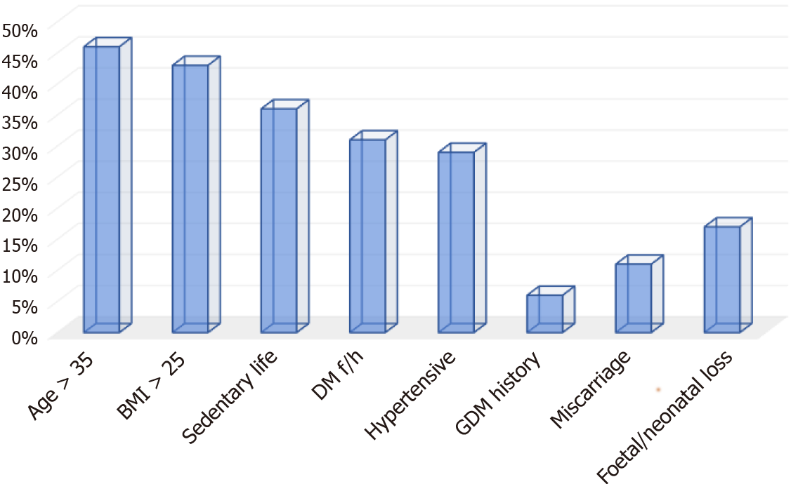
Figure 1 Prevalence of gestational diabetes risk factors in a hospital cohort from Delta State, Nigeria. History of gestational diabetes mellitus was the least common risk factor, while age was the most common risk factor. BMI: Body mass index; DM: Diabetes mellitus; GDM: Gestational diabetes mellitus.
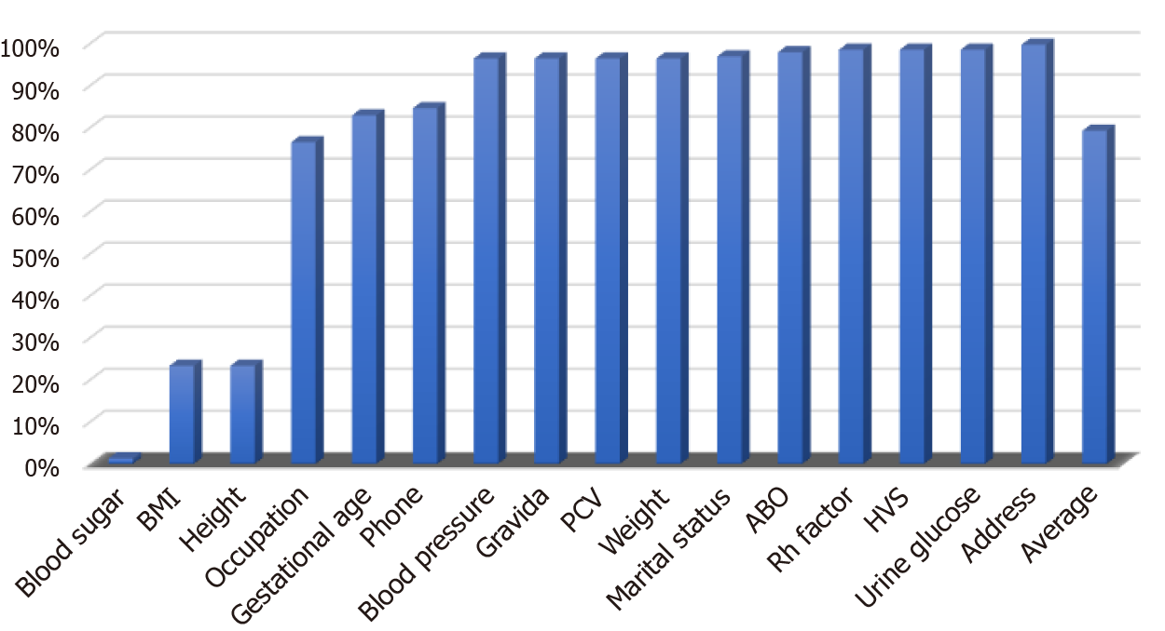
Figure 2 Translated percentage completeness of data collection. Most antenatal patients lacked blood sugar and body mass index measurements. ABO: Blood grouping system; HVS: High vaginal swab; PCV: Packed cell volume; BMI: Body mass index.
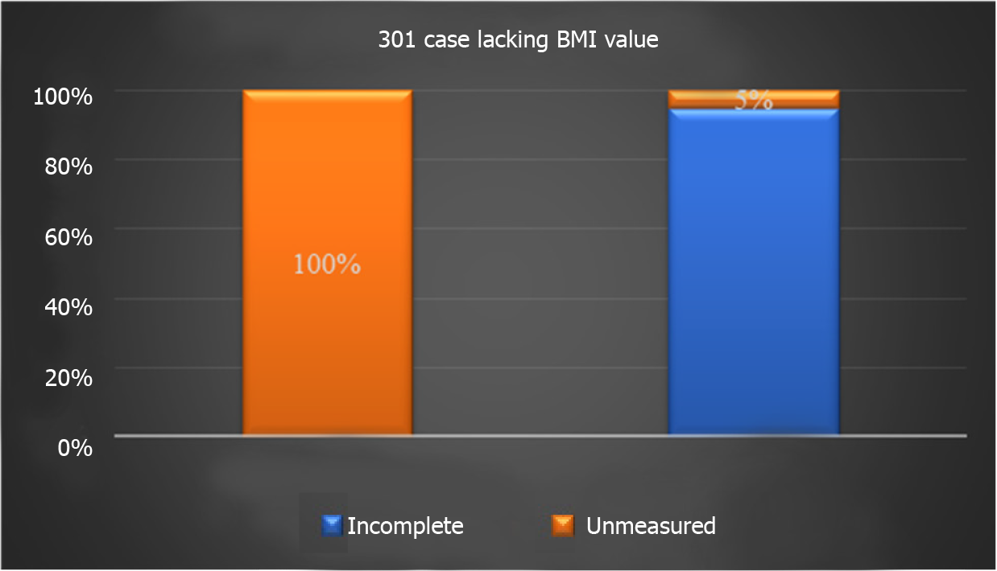
Figure 3 Proportions of missing body mass index values attributable to either missing height or weight. Most cases without body mass index data were due to a lack of height measurement. BMI: Body mass index.
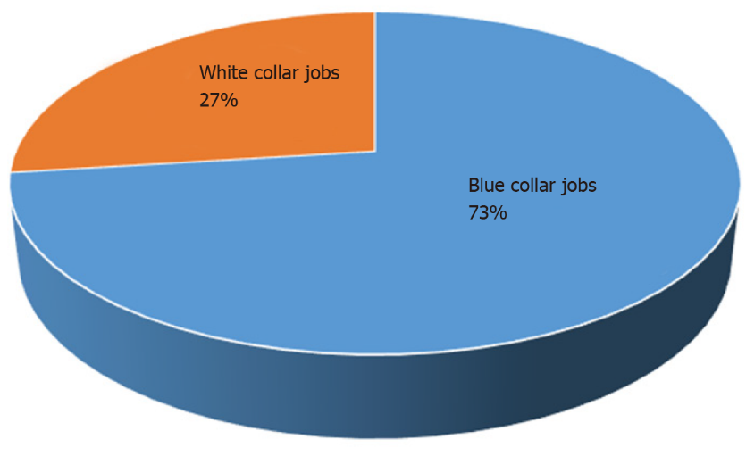
Figure 4 Distribution between manual and non-manual jobs. Most cases were in occupations with physically demanding activities of daily living.
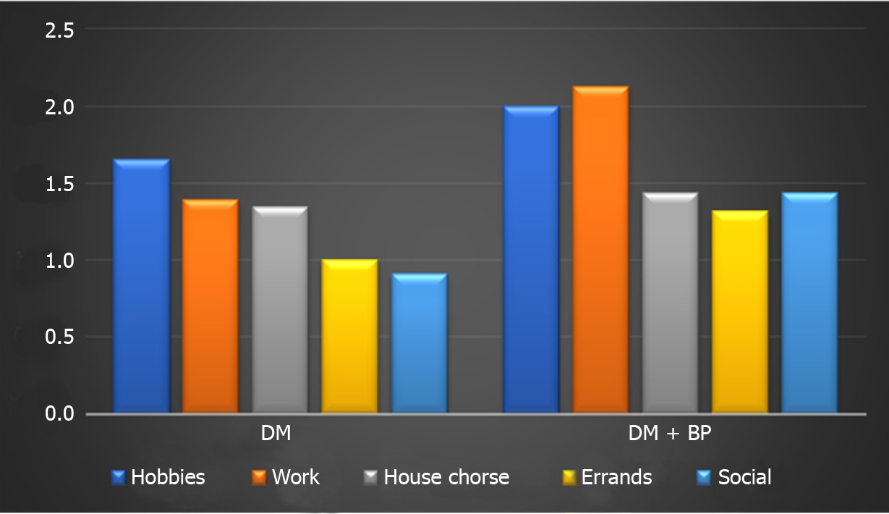
Figure 5 Average responses on interference of ill health on activities of daily living. The group with diabetes mellitus only was more responsive to physical activities of daily living. DM: Diabetes mellitus; BP: Blood pressure (indicated hypertension in this graph).
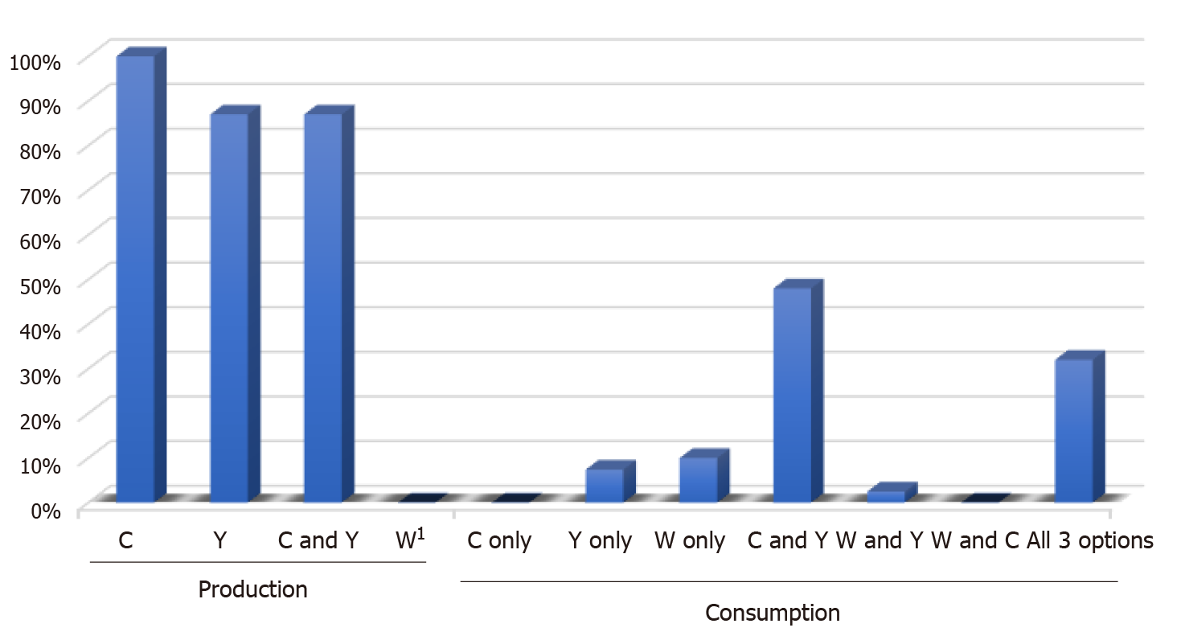
Figure 6 Consumption and production carbohydrate food choices. Most individuals undervalued their indigenous healthy food options, such as cassava and yams. ¹Never farmed in the area. C: Cassava; W: Wheat; Y: Yam.
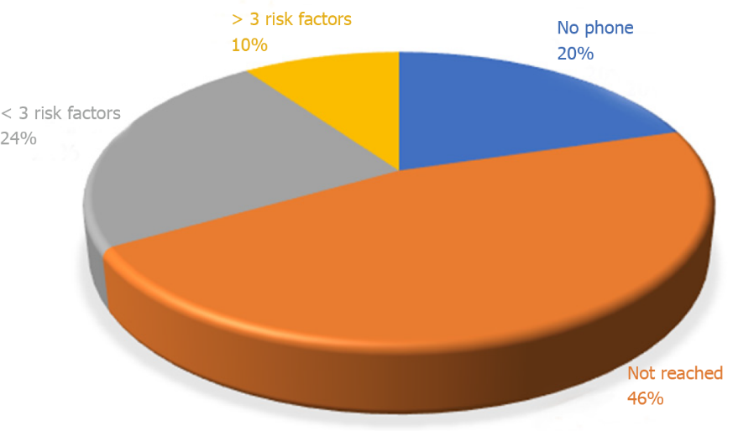
Figure 7 Distribution of cohort of cases assessed by telehealth. Most cases provided incomplete or incorrect phone numbers on their medical records.
Table 1 Proposed gestational diabetes risk assessment and screening sheet
SN | Assessment stage | Factor | Yes | No
1 | Initial routine data | Age > 35 yr
2 |  | Overweight¹ (BMI > 25)
3 |  | Hypertension
4 |  | Sedentary lifestyle²
5 |  | Family history of diabetes
6 | Previous history | GDM
7 |  | Miscarriage
8 |  | Foetal/neonatal death
9 |  | Polycystic ovary syndrome
10 | Antenatal monitoring | Presentation of GDM symptoms
11 |  | Excess gestational weight gain³
12 |  | Foetal growth
13 |  | Macrosomia
14 | Lab tests⁵ | Urinalysis for glucosuria
15 |  | Blood sugar test⁴
Keys to positive risk factors for ‘Yes’ response.
¹Especially obesity (body mass index > 30), which also defines nutritional status. ²Activities of daily living being non-physical and/or mainly sitting position.
³> 1.80 kg in first trimester and/or > 0.45 kg per week during the rest of pregnancy.
⁴Interpret according to method.
⁵For antenatal GDM screening.
GDM: Gestational diabetes.
Table 2 Descriptive statistics of respondents
 |  | Male | Female
 | n | 27 | 21
 | Age in yr | 59 | 55
Educational status | ≤ Secondary school | 19 | 14
 | ≥ Tertiary education | 8 | 7
Marital status | Married | 23 | 10
 | Single | 4 | 11
Table 3 Descriptive statistics of patients entered in a gestational diabetes screening register
 | Age in yr | Gestational age in wk | Gravida¹
Mean | 28.57 | 23.01 | 2.60
Standard error | 0.30 | 0.41 | 0.08
Median | 28.00 | 23.00 | 2.00
Mode | 25.00 | 24.00 | 1.00
Standard deviation | 5.91 | 7.33 | 1.63
Sample variance | 34.97 | 53.72 | 2.67
Range | 31 | 35 | 9
Minimum | 15 | 4 | 1
Maximum | 46 | 39 | 10
Count | 391 | 324 | 377
¹Number of times a woman has been pregnant.
Table 4 Level of incompleteness of data
Missing data | n/391 | Absolute Hz | Relative Hz
Address | 1 | 0.2558 | 0.0760
Rh factor | 6 | 1.5345 | 0.4563
HVS, 2/385 positive | 6 | 1.5345 | 0.4563
Urine glucose | 6 | 1.5345 | 0.4563
ABO | 8 | 2.0460 | 0.6084
Marital status | 12 | 3.0691 | 0.9125
Weight in kg | 14 | 3.5806 | 1.0646
SBP in mmHg | 14 | 3.5806 | 1.0646
DBP in mmHg | 14 | 3.5806 | 1.0646
Gravida | 14 | 3.5806 | 1.0646
Packed cell volume, % | 15 | 3.8363 | 1.1407
Phone number | 60 | 15.3453 | 4.5627
Gestational age in wk | 67 | 17.1355 | 5.0951
Occupation | 92 | 23.5294 | 6.9962
Height in cm | 301 | 76.9821 | 22.8897
BMI | 301 | 76.9821 | 22.8897
Blood sugar, as FBS or RBS | 386 | 98.7212 | 29.3536
ABO: Blood grouping system; BMI: Body mass index; DBP: Diastolic blood pressure; FBS: Fasting blood sugar; HVS: High vaginal swab; RBS: Random blood sugar; SBP: Systolic blood pressure.
Table 5 Responses to exercise abilities, n = 48
Duration | Stretching | Walking | Swimming | Bicycling
None | 28 | 15 | 41 | 24
< 30 min | 11 | 10 | 2 | 6
30 min–1 h | 4 | 13 | 3 | 7
1–3 h | 2 | 6 | 2 | 4
> 3 h | 3 | 4 | 0 | 7

Published by Baishideng Publishing Group Inc
7041 Koll Center Parkway, Suite 160, Pleasanton, CA 94566, USA
Telephone: +1-925-3991568
E-mail: bpgoffice@wjgnet.com
Help Desk: https://www.f6publishing.com/helpdesk
https://www.wjgnet.com

© 2021 Baishideng Publishing Group Inc. All rights reserved.

