Name of Journal: World Journal of Gastrointestinal Surgery
Manuscript NO: 64646
Manuscript Type: MINIREVIEWS

Retrorectal tumors: A challenge for the surgeons

Balci B et al. Retrorectal tumors

Bengi Balci, Alp Yildiz, Sezai Leventoğlu, Bulent Mentes

Bengi Balci, Department of General Surgery, Ankara Oncology Training and Research Hospital, Ankara 06060, Turkey

Alp Yildiz, Department of General Surgery, Ankara Yenimahalle Training and Research Hospital, Ankara 06370, Turkey

Sezai Leventoğlu, Department of Surgery, Gazi University Medical School, Ankara 06530, Turkey

Bulent Mentes, Department of General Surgery, Memorial Ankara Hospital, Ankara 06060, Turkey

Author contributions: Balci B and Yildiz A reviewed the literature; Balci B wrote the manuscript; Yildiz A arranged the figures; Mentes B and Leventoğlu S reviewed and edited the manuscript; all authors read and agreed to the published version of the manuscript.

Corresponding author: Sezai Leventoğlu, MD, Professor, Surgeon, Department of Surgery, Gazi University Medical School, 22 Sokak 26-2 Emek, Ankara 06530, Turkey. sezaileventoglu@hotmail.com

Received: February 21, 2021
Revised: July 26, 2021
Accepted: September 22, 2021
Published online:

Abstract
Retrorectal or presacral tumors are rare lesions located in the presacral area and considered as being derived from multiple embryological remnants. These tumors are classified as congenital, neurogenic, osseous, inflammatory, or miscellaneous. The most common among these are congenital benign lesions that present with non-specific symptoms, such as lower back pain and change in bowel habit. Although congenital and developmental tumors occur in younger patients, the median age of presentation is reported to be 45 years. Magnetic resonance imaging plays a crucial role in treatment management through accurate diagnosis of the lesion, the evaluation of invasion to adjacent structures, and the decision of appropriate surgical approach. The usefulness of preoperative biopsy is still debated; currently, it is only indicated for solid or heterogeneous tumors if it will alter the treatment management. Surgical resection with clear margins is considered the optimal treatment; described approaches are transabdominal, perineal, combined abdominoperineal, and minimally invasive. Benign retrorectal tumors have favorable long-term outcomes with a low incidence of recurrence, whereas malignant tumors have a potential for distant organ metastasis in addition to local recurrence.

Key Words: Retrorectal tumors; Congenital cystic lesions; Teratomas; Perineal approach; Transabdominal approach, Combined abdominoperineal approach

Balci B, Yildiz A, Leventoğlu S, Mentes B. Retrorectal tumors: A challenge for the surgeons. World J Gastrointest Surg 2021; In press

Core Tip: With advances in imaging modalities and increased clinicians' awareness, the diagnosis of a retrorectal tumor has been improving over the years. This review article discusses the epidemiology, classification and suggested diagnostic methods, with current treatment options mostly focusing on surgical approaches and follow-up recommendations, for patients with retrorectal tumors.
INTRODUCTION
Retrorectal or presacral tumors are extremely rare. Although their true incidence in the general population is unknown, it has been reported that the number of patients diagnosed yearly with retrorectal tumor is approximately 1-6 in tertiary referral centers and the estimated incidence is 1 in 40.000 hospital admissions^{[1]}. Most of the retrorectal tumors are benign, but malignant cases account for 21%-50% of patients^{[1,2]}.
The retrorectal space is an anatomic area formed by the rectum's posterior wall anteriorly and the sacrum posteriorly. It extends to the peritoneal reflection superiorly and to Waldeyer's fascia inferiorly^{[3]}. The histopathological varieties of retrorectal tumors result from the multiple embryological remnants located in this potential space^{[4]}. Due to their unusual localization and mimicry of symptoms caused by other joint diseases, the diagnosis and treatment of retrorectal tumors are challenging for clinicians^{[5]}. As well, different surgical approaches and procedures are described for these tumors, to provide optimal exposure to the lesional field and decrease postoperative morbidity^{[6-8]}.
Herein, we present a comprehensive review of surgical management and share our clinical experiences for retrorectal tumors.

CLINICAL PRESENTATION AND CLASSIFICATION
Retrorectal tumors are usually asymptomatic lesions (26%-50% of cases), being discovered incidentally on routine digital rectal examination. Symptoms such as sacral pain, constipation, incontinence, and pencil-thin stools usually indicate tumor invasion to adjacent structures^{[1]}. Patients may present with lower back pain that worsens with sitting and is alleviated by walking and standing^{[4]}. Patients who present with recurrent anal fistula and perirectal abscesses should be suspected of retrorectal tumor and subjected to additional imaging studies^{[9]}.
Retrorectal tumors are classified based on their origin, namely congenital, neurogenic, osseous, inflammatory, or miscellaneous. Moreover, these tumors can be divided according to the lesions' histopathology, as benign congenital, malignant congenital, benign acquired, and malignant acquired (Table 1)^{[10,11]}.

Congenital lesions
The most common type of retrorectal tumor is congenital, of which two-thirds are cystic lesions, such as tail-gut, epidermoid and dermoid cysts^{[1,4,10]}. The incidence of those developmental cysts tends to be higher in females. Although many of them are benign lesions, malignant transformation of tail-gut cysts has also been reported by tertiary centers^{[12,13]}. Epidermoid and dermoid cysts can communicate with skin and present as postanal dimple or sinus, which can be easily misdiagnosed as pilonidal sinus or perirectal abscess (Figures 1 and 2)^{[14,15]}.
The risk of malignancy is higher for solid retrorectal tumors, the most common of which are the chordomas^{[16]}. These slow-growing tumors arise from the fetal notochord's vestiges, usually from within the vertebral bodies. Unlike developmental cysts, chordomas are more common in males. Patients with chordomas usually present with urinary or gas incontinence and intensive sacral or perineal pain due to invasion of the adjacent structures. Radical resection is usually required because of the relatively higher recurrence rates of this type of congential lesion^{[17,18]}.
Teratomas are true neoplasms, that include all three germ layers. They can be solid or cystic, and often contain both components. They are also more common in females and associated with a 40%-50% risk of malignant degeneration in the adult population^{[19]}. In the absence of malignancy, they rarely adhere to the rectum or other adjacent viscera^{[4]}.

Neurogenic lesions
Neurogenic tumors are the second most common retrorectal tumors, after congenital lesions. These are slow-growing tumors that typically arise from peripheral nerves, and 85% of them are benign, consisting of neurofibromas and schwannomas^{[20]}.

Osseous lesions
Osseous tumors account for 10% of retrorectal tumors and have a high risk of recurrence. These include benign tumors (i.e. osteoblastoma, giant-cell tumor) and malignant tumors (i.e. Ewing sarcoma, chondrosarcoma, osteogenic sarcoma), which arise from bone, cartilage, ﬁbrous tissue, and marrow^{[4,21]}.

Inflammatory lesions
Inﬂammatory tumors are less common than congenital lesions and are considered secondary reactions to foreign substances left in the body from previous surgeries^{[22]}. It has been reported that they can also result from an extension of infection from either the perirectal space or abdomen^{[2,6]}.

Miscellaneous lesions
Miscellaneous tumors account for 10%-25% of all retrorectal tumors, including lipoma, ﬁbroma, hemangioma, leiomyoma, and liposarcoma^{[21]}. These lesions can also be a metastasis from primary rectal cancer.

DIAGNOSIS
A careful rectal examination carries the utmost importance for making a diagnosis, accounting for diagnosis in 90% of cases. Unfortunately, unless the physician has a high index of suspicion, these soft and compressible lesions can easily be missed^{[4]}. As such, magnetic resonance imaging (MRI) in conjunction with computed tomography (CT) has emerged as the diagnostic tool of choice (Figure 3)^{[5]}. CT is useful for demonstrating the nature of the lesion (cystic-solid) and bone destruction, whereas MRI is more advanced in evaluating soft tissue and adjacent structures’ involvement (Figures 4 and 5)^{[23]}. On MRI, based on the lesion's internal signal characteristics, the lesion is diagnosed as a cystic tumor when it displays cystic elements comprising greater than 80% of the lesion and a solid tumor when the lesion shows solid elements in greater than 80%; the remainder are classified as heterogeneous^{[6]}. Radiological features that indicate malignant lesions are heterogeneous signal intensity, irregular infiltrative margin, sacral destruction or remodeling, and enhancement^{[24]}. MRI also enables the surgical care team to plan for extent of resection (local vs en bloc) and surgical approach (anterior vs posterior vs combined) in a preoperative setting^{[22]}.
Other applicable imaging modalities are flexible sigmoidoscopy, transrectal ultrasonography (TRUS), and fistulograms. The flexible sigmoidoscopy is a newly established option to demonstrate rectal mucosa involvement or exclude a primary rectal cancer, whereas TRUS provides detailed information on the size, consistency of the tumor, and evidence of local invasion^{[2,5]}. Fistulograms can be preferred in patients with a chronically draining sinus, to evaluate underlying pathology such as developmental cyst^{[21]}.
Preoperative biopsy has been controversial for retrorectal tumors, according to the potential risk of secondary infection and seeding of the tumor^{[1,8,21]}. With the advances in imaging modalities and improved neoadjuvant therapy options that have become available in recent years, it has become a feasible technique^{[25]}. On the other hand, a preoperative biopsy may lead to misdiagnosis, with a reported rate of incorrect diagnosis as high as 44%^{[8]}. Nevertheless, studies have demonstrated preoperative biopsy to have better diagnostic accuracy in solid or heterogeneous tumors and to affect treatment management^{[26,27]}. Neoadjuvant chemotherapy is essential for some retrorectal tumors, such as Ewing sarcoma and osteogenic sarcoma, or metastatic chordoma, and tyrosine kinase inhibitors have been shown effective in progression-free survival^{[28-30]}.
In our clinical practice, if preoperative imaging modalities provide sufficient information regarding the nature of the lesion and if the treatment management will not change according to additional findings, we do not advocate performing a preoperative biopsy. It should be emphasized that if it is indicated, performing biopsies by an experienced radiologist and choosing the appropriate transperineal or parasacral approach have been recommended. However, transperitoneal, transretroperitoneal, transvaginal, and transrectal biopsies should be avoided, and the biopsy tract must be removed en bloc^{[21]}.

SURGICAL APPROACH
The optimal management of retrorectal tumors is surgical resection, including of benign tumors, given the potential for developing symptoms and malignancy^{[2,31,32]}. The morphology of tumor determines the level of extension of surgery. Complete gross resection is recommended for benign tumors, whereas radical resection or en bloc resection of involved adjacent organs is required for malignant tumors^{[21]}. Surgical approaches include those from the anterior (transabdominal), the combined abdominoperineal, and the posterior (perineal). A general consideration is that an anterior or combined approach is preferred for tumors above the level of S3 and a posterior approach for lesions below the level of S3.

Anterior (transabdominal) approach
The anterior approach is recommended for tumors located above S3 or which show sign(s) of pelvic wall involvement in the preoperative investigation. If the tumor cells have invaded into adjacent structures or an en bloc resection for malignant lesions (such as sacrectomy) is required, this approach is more feasible^{[33,34]}. For such, the patient is placed in the modified Lloyd-Davis position. The dissection starts with the opening of the pelvic peritoneum and continues to the posterior of the rectum. After the anterior margins of the tumor are dissected from the mesorectum, it is separated from the presacral fascia. Since the arterial supply of the tumor can originate from the middle sacral artery, it is crucial to identify and ligate the tumor's vascular structures first^{[25,35]}.

Posterior (perineal) approach
The posterior approach is indicated for tumors below S3 without any involvement of the sacrum and other pelvic organs (Figures 6-8). The patient is placed in the prone jack-knife position, and a midline or parasagittal incision is performed. Excision or elevation of the coccyx can be necessary for better exposure to the retrorectal space^{[23]}. The division of the levator muscles follows, to enable access into the retrorectal space. Abdominoperineal resection may be required in patients with malignant tumors, as part of the en bloc resection. It has been reported that the posterior approach is preferred over the combined abdominoperineal approach, due to its lower morbidity rate than the latter, which has the highest recurrence and complication rate of all approaches^{[8,36-38]}.

Combined abdominoperineal approach
The combined abdominoperineal approach is recommended for malignant lesions, invading adjacent structures and obscuring normal surgical planes. The patient is placed in a modified Lloyd-Davies position, in order to access both areas^{[23]}. If an extended soft tissue resection is required to achieve clear surgical margins, simultaneous or staged pedicle or free flap transfers can be used to prevent chronic sinus formation and fistulation^{[39,40]}. Permacol mesh can also be applied for the reconstruction of the pelvic wall.

Minimally invasive surgery
Although it has not been reported whether laparotomy or laparoscopy has better long-term results, it is known that the laparoscopic approach provides an enhanced visualization of pelvic structures and facilitates precise dissection of the tumor from adjacent structures^{[8]}. The laparoscopic approach has been demonstrated as a safe and feasible technique for treating retrorectal tumors^{[41,42]}. There have also been case series reporting that the robotic approach can be chosen for large tumors, offering the benefits of shorter operation time and shorter length of hospitalization compared to laparotomy^{[43,44]}.
Transanal endoscopic microsurgery (TEMS) is also newly being applied to retrorectal tumors; however, with this approach, following oncological principles for malignant tumors is difficult^{[45,46]}. Thus, it is recommended that malignancy should be excluded before TEMS is performed^{[23]}.
FOLLOW-UP AND SURVEILLANCE
Long-term results depend on the type of tumor and the successful surgical resection with clear margins achieved in the first operation. Although many authors have reported that benign retrorectal tumors have 100% overall survival rates with no recurrences^{[2,11]}, the patients should be followed-up for potential risk of local recurrence. Benign local recurrences' have been shown to have a good prognosis, even after repeated resection^{[47]}. In contrast, malignant tumors can metastasize to the liver, lung, and brain, which are all associated with significantly worse prognosis^{[48-50]}.

CONCLUSION
Retrorectal tumors are uncommon lesions occurring in the retrorectal space. The most common retrorectal tumors are congenital benign tumors. The diagnostic algorithm starts with suspicion by a physician who carries out a thorough physical examination. MRI is the chosen imaging modality, with or without CT and TRUS. The preoperative biopsy is highly recommended for solid or heterogeneous tumors, although it is contraindicated for pure cystic lesions. The posterior approach is the preferred surgical method for most retrorectal tumors, producing lower morbidity rates. A multidisciplinary team is usually required, since these complex tumors have a potential risk of invading adjacent structures and necessitating an en bloc resection.

ACKNOWLEDGEMENTS
The authors extend a special thanks to Dr. Murat Ucar, Department of Radiology, Gazi University Hospital, and Dr. Mehmet Yorubulut, Department of Radiology, Acibadem Ankara Hospital, for their contributions to the preparation of this review article.

REFERENCES
1 Jao SW, Beart RW Jr, Spencer RJ, Reiman HM, Ilstrup DM. Retrorectal tumors. Mayo Clinic experience, 1960-1979. Dis Colon Rectum 1985; 28: 644-652 [PMID: 2996861 DOI: 10.1007/BF02553440]
2 Wolpert A, Beer-Gabel M, Lifschitz O, Zbar AP. The management of presacral masses in the adult. Tech Coloproctol 2002; 6: 43-49 [PMID: 12077641 DOI: 10.1007/s101510200008]
3 Mirilas P, Skandalakis JE. Surgical anatomy of the retroperitoneal spaces part II: the architecture of the retroperitoneal space. Am Surg 2010; 76: 33-42 [PMID: 20135937]
4 Hobson KG, Ghaemmaghami V, Roe JP, Goodnight JE, Khatri VP. Tumors of the retrorectal space. Dis Colon Rectum 2005; 48: 1964-1974 [PMID: 15981068 DOI: 10.1007/s10350-005-0122-9]
5 Carpelan-Holmström M, Koskenvuo L, Haapamäki C, Renkonen-Sinisalo L, Lepistö A. Clinical management of 52 consecutive retro-rectal tumours treated at a tertiary referral centre. Colorectal Dis 2020; 22: 1279-1285 [PMID: 32336000 DOI: 10.1111/codi.15080]
6 Woodfield JC, Chalmers AG, Phillips N, Sagar PM. Algorithms for the surgical management of retrorectal tumours. Br J Surg 2008; 95: 214-221 [PMID: 17933000 DOI: 10.1002/bjs.5931]
7 Brown KGM, Lee PJ. Algorithms for the surgical management of benign and malignant presacral tumors. Semi Colon Rec Surg 2020; 31: 3 [DOI: 10.1016/j.scrs.2020.100762]
8 Baek SK, Hwang GS, Vinci A, Jafari MD, Jafari F, Moghadamyeghaneh Z, Pigazzi A. Retrorectal Tumors: A Comprehensive Literature Review. World J Surg 2016; 40: 2001-2015 [PMID: 27083451 DOI: 10.1007/s00268-016-3501-6]
9 Menteş BB, Kurukahvecioğlu O, Ege B, Karamercan A, Leventoğlu S, Yazicioğlu O, Oğuz M. Retrorectal tumors: a case series. Turk J Gastroenterol 2008; 19: 40-44 [PMID: 18386239]
10 Uhlig BE, Johnson RL. Presacral tumors and cysts in adults. Dis Colon Rectum 1975; 18: 581-589 [PMID: 1181162 DOI: 10.1007/BF02587141]
11 Lev-Chelouche D, Gutman M, Goldman G, Even-Sapir E, Meller I, Issakov J, Klausner JM, Rabau M. Presacral tumors: a practical classification and treatment of a unique and heterogeneous group of diseases. Surgery 2003; 133: 473-478 [PMID: 12773974 DOI: 10.1067/msy.2003.118]
12 Li W, Li J, Yu K, Zhang K, Li J. Retrorectal adenocarcinoma arising from tailgut cysts: a rare case report. BMC Surg 2019; 19: 180 [PMID: 31775691 DOI: 10.1186/s12893-019-0639-9]
13 Lee A, Suhardja TS, Nguyen TC, Teoh WM. Neuroendocrine tumour developing within a long-standing tailgut cyst: case report and review of the literature. Clin J Gastroenterol 2019; 12: 539-551 [PMID: 31147970 DOI: 10.1007/s12328-019-00998-4]
14 Stewart RJ, Humphreys WG, Parks TG. The presentation and management of presacral tumours. Br J Surg 1986; 73: 153-155 [PMID: 3947908 DOI: 10.1002/bjs.1800730227]
15 Li Z, Lu M. Presacral Tumor: Insights From a Decade's Experience of This Rare and Diverse Disease. Front Oncol 2021; 11: 639028 [PMID: 33796466 DOI: 10.3389/fonc.2021.639028]
16 Farsad K, Kattapuram SV, Sacknoff R, Ono J, Nielsen GP. Sacral chordoma. Radiographics 2009; 29: 1525-1530 [PMID: 19755609 DOI: 10.1148/rg.295085215]
17 Gray SW, Singhabhandhu B, Smith RA, Skandalakis JE. Sacrococcygeal chordoma: Report of a case and review of the literature. Surgery 1975; 78: 573-582 [PMID: 1188599]
18 Bergh P, Kindblom LG, Gunterberg B, Remotti F, Ryd W, Meis-Kindblom JM. Prognostic factors in chordoma of the sacrum and mobile spine: a study of 39 patients. Cancer 2000; 88: 2122-2134 [PMID: 10813725 DOI: 10.1002/(sici)1097-0142(20000501)88:9<2122::aid-cncr19>3.0.co;2-1]
19 Waldhausen JA, Kolman JW, Vellos F, Battersby JS. Sacrocococcygeal Teratoma. Surgery 1963; 54: 933-949 [PMID: 14087131]
20 Gordon PH. Retrorectal tumors. In: Gordon PH, Nivatvongs S, eds. Principles and Practice of Surgery for the Colon, Rectum and Anus. St. Louis, MO: Quality Medical Publishing, 1999: 427–445
21 Dozois EJ, Jacofsky DJ, Dozois RR. Presacral tumors. In: Wolff BG, Fleshman JW, Beck DE, et al, eds. The ASCRS Textbook of Colon and Rectal Surgery. New York: Springer, 2007: 501–514
22 Freier DT, Stanley JC, Thompson NW. Retrorectal tumors in adults. Surg Gynecol Obstet 1971; 132: 681-686 [PMID: 4995717]
23 Toh JW, Morgan M. Management approach and surgical strategies for retrorectal tumours: a systematic review. Colorectal Dis 2016; 18: 337-350 [PMID: 26663419 DOI: 10.1111/codi.13232]
24 Murphy A, O'Sullivan H, Stirling A, Fenlon H, Cronin C. Integrated multimodality and multi-disciplinary team approach to pre-sacral lesions. Clin Imaging 2020; 67: 255-263 [PMID: 32890910 DOI: 10.1016/j.clinimag.2020.08.011]
25 Neale JA. Retrorectal tumors. Clin Colon Rectal Surg 2011; 24: 149-160 [PMID: 22942797 DOI: 10.1055/s-0031-1285999]
26 Merchea A. Role of preoperative biopsy in the management of presacral tumors. Seminars in Colon and Rectal Surgery 2020; 31: 3 [DOI: 10.1016/j.scrs.2020.100761]
27 Paradies G, Zullino F, Orofino A, Leggio S. Unusual presentation of sacrococcygeal teratomas and associated malformations in children: clinical experience and review of the literature. Ann Ital Chir 2013; 84: 333-346 [PMID: 23160138]
28 Casali PG, Messina A, Stacchiotti S, Tamborini E, Crippa F, Gronchi A, Orlandi R, Ripamonti C, Spreafico C, Bertieri R, Bertulli R, Colecchia M, Fumagalli E, Greco A, Grosso F, Olmi P, Pierotti MA, Pilotti S. Imatinib mesylate in chordoma. Cancer 2004; 101: 2086-2097 [PMID: 15372471 DOI: 10.1002/cncr.20618]
29 Varga PP, Bors I, Lazary A. Sacral tumors and management. Orthop Clin North Am 2009; 40: 105-123, vii [PMID: 19064059 DOI: 10.1016/j.ocl.2008.09.010]
30 Hof H, Welzel T, Debus J. Effectiveness of cetuximab/gefitinib in the therapy of a sacral chordoma. Onkologie 2006; 29: 572-574 [PMID: 17202828 DOI: 10.1159/000096283]
31 Glasgow SC, Dietz DW. Retrorectal tumors. Clin Colon Rectal Surg 2006; 19: 61-68 [PMID: 20011312 DOI: 10.1055/s-2006-942346]
32 Bullard Dunn K. Retrorectal tumors. Surg Clin North Am 2010; 90: 163-171, Table of Contents [PMID: 20109640 DOI: 10.1016/j.suc.2009.09.009]
33 Sagar AJ, Tan WS, Codd R, Fong SS, Sagar PM. Surgical strategies in the management of recurrent retrorectal tumours. Tech Coloproctol 2014; 18: 1023-1027 [PMID: 24925354 DOI: 10.1007/s10151-014-1172-6]
34 Localio SA, Eng K, Ranson JH. Abdominosacral approach for retrorectal tumors. Ann Surg 1980; 191: 555-560 [PMID: 6929181 DOI: 10.1097/00000658-198005000-00006]
35 Young-Fadok TM, Dozois EJ. Retrorectal tumors. In: Yeo CJ, ed. Shackelford's Surgery of the Alimentary Tract. Philadelphia: Saunders, 2007: 2299–2311
36 Chéreau N, Lefevre JH, Meurette G, Mourra N, Shields C, Parc Y, Tiret E. Surgical resection of retrorectal tumours in adults: long-term results in 47 patients. Colorectal Dis 2013; 15: e476-e482 [PMID: 23601092 DOI: 10.1111/codi.12255]
37 Alsofyani TM, Aldossary MY, AlQahtani FF, Sabr K, Balhareth A. Successful excision of a retrorectal cyst through trans-sacral approach: A case report. Int J Surg Case Rep 2020; 71: 307-310 [PMID: 32485636 DOI: 10.1016/j.ijscr.2020.05.023]
38 Buchs N, Taylor S, Roche B. The posterior approach for low retrorectal tumors in adults. Int J Colorectal Dis 2007; 22: 381-385 [PMID: 16909248 DOI: 10.1007/s00384-006-0183-9]
39 Yalav O, Topal U, Eray İC, Deveci MA, Gencel E, Rencuzogullari A. Retrorectal tumor: a single-center 10-years' experience. Ann Surg Treat Res 2020; 99: 110-117 [PMID: 32802816 DOI: 10.4174/astr.2020.99.2.110]
40 Beier JP, Croner RS, Lang W, Arkudas A, Schmitz M, Göhl J, Hohenberger W, Horch RE. [Avoidance of complications in oncological surgery of the pelvic region : combined oncosurgical and plastic reconstruction measures]. Chirurg 2015; 86: 242-250 [PMID: 25620285 DOI: 10.1007/s00104-014-2835-6]
41 Duclos J, Maggiori L, Zappa M, Ferron M, Panis Y. Laparoscopic resection of retrorectal tumors: a feasibility study in 12 consecutive patients. Surg Endosc 2014; 28: 1223-1229 [PMID: 24263459 DOI: 10.1007/s00464-013-3312-x]
42 Mullaney TG, Lightner AL, Johnston M, Kelley SR, Larson DW, Dozois EJ. A systematic review of minimally invasive surgery for retrorectal tumors. Tech Coloproctol 2018; 22: 255-263 [PMID: 29679245 DOI: 10.1007/s10151-018-1781-6]
43 Oh JK, Yang MS, Yoon DH, Rha KH, Kim KN, Yi S, Ha Y. Robotic resection of huge presacral tumors: case series and comparison with an open resection. J Spinal Disord Tech 2014; 27: E151-E154 [PMID: 23698108 DOI: 10.1097/BSD.0b013e318299c5fd]
44 Morelli L, Tassinari D, Rosati CM, Palmeri M, Boggi U, Mosca F. Robot-assisted excision of a huge pararectal dermoid cyst via a totally transabdominal route. J Minim Invasive Gynecol 2012; 19: 772-774 [PMID: 23084685 DOI: 10.1016/j.jmig.2012.06.008]
45 Duek SD, Gilshtein H, Khoury W. Transanal endoscopic microsurgery: also for the treatment of retrorectal tumors. Minim Invasive Ther Allied Technol 2014; 23: 28-31 [PMID: 24329013 DOI: 10.3109/13645706.2013.872663]
46 Raestrup H, Manncke K, Mentges B, Buess G, Becker HD. Indications and technique for TEM (transanal endoscopic microsurgery). Endosc Surg Allied Technol 1994; 2: 241-246 [PMID: 7866754]
47 Messick CA, Hull T, Rosselli G, Kiran RP. Lesions originating within the retrorectal space: a diverse group requiring individualized evaluation and surgery. J Gastrointest Surg 2013; 17: 2143-2152 [PMID: 24146338 DOI: 10.1007/s11605-013-2350-y]
48 Spada F, Pelosi G, Squadroni M, Lorizzo K, Farris A, de Braud F, Fazio N. Neuroendocrine tumour arising inside a retro-rectal tailgut cyst: report of two cases and a review of the literature. Ecancermedicalscience 2011; 5: 201 [PMID: 22276050 DOI: 10.3332/ecancer.2011.201]
49 Li GD, Chen K, Fu D, Ma XJ, Sun MX, Sun W, Cai ZD. Surgical strategy for presacral tumors: analysis of 33 cases. Chin Med J (Engl) 2011; 124: 4086-4091 [PMID: 22340347]
50 Yoshida A, Maoate K, Blakelock R, Robertson S, Beasley S. Long-term functional outcomes in children with Currarino syndrome. Pediatr Surg Int 2010; 26: 677-681 [PMID: 20473613 DOI: 10.1007/s00383-010-2615-4]

Footnotes
Conflict-of-interest statement: All authors declare having no conflict of interests for this article.

Open-Access: This article is an open-access article that was selected by an in-house editor and fully peer-reviewed by external reviewers. It is distributed in accordance with the Creative Commons Attribution NonCommercial (CC BY-NC 4.0) license, which permits others to distribute, remix, adapt, build upon this work non-commercially, and license their derivative works on different terms, provided the original work is properly cited and the use is non-commercial. See: http://creativecommons.org/Licenses/by-nc/4.0/

Manuscript source: Invited manuscript

Peer-review started: February 21, 2021
First decision: July 16, 2021
Article in press:

Specialty type: Gastroenterology and hepatology
Country/Territory of origin: Turkey
Peer-review report's scientific quality classification
Grade A (Excellent): A
Grade B (Very good): B, B
Grade C (Good): 0
Grade D (Fair): D
Grade E (Poor): 0

P-Reviewer: Bogach J, Bustamante-Lopez LA, Piozzi GN, Sano W S-Editor: Fan JR L-Editor: P-Editor:
Figure Legends
Figure 1 A patient presented with complaints of recurrent fistula, which was ultimately diagnosed as epidermoid cyst.
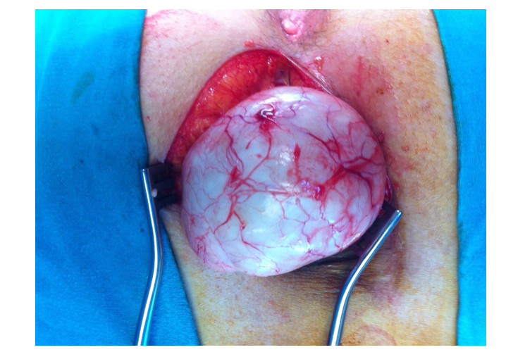
Figure 2 Intraoperative image of the epidermoid cyst.
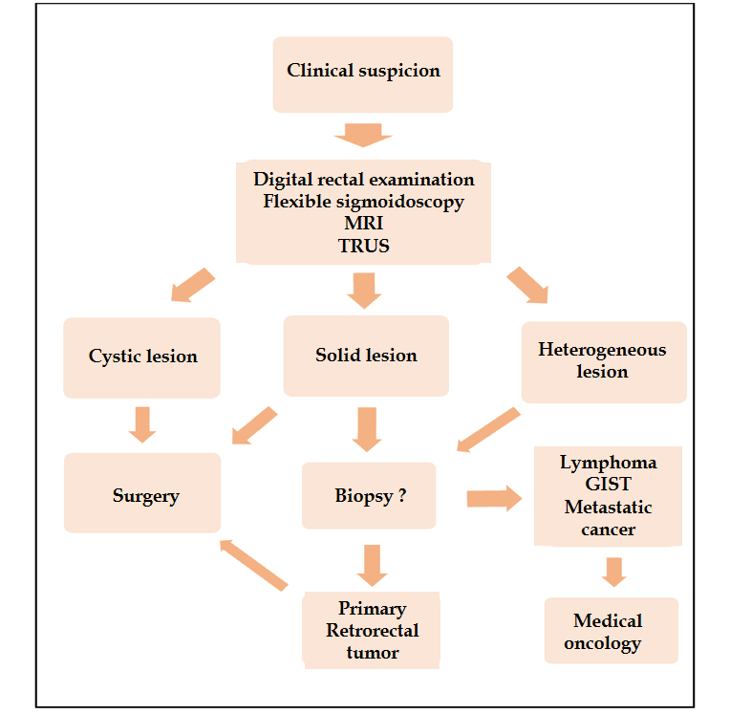
Figure 3 Flow diagram for the management of retrorectal tumors. MRI: Magnetic resonance imaging; GIST: Gastrointestinal stromal tumor; TRUS: Transrectal ultrasonography.
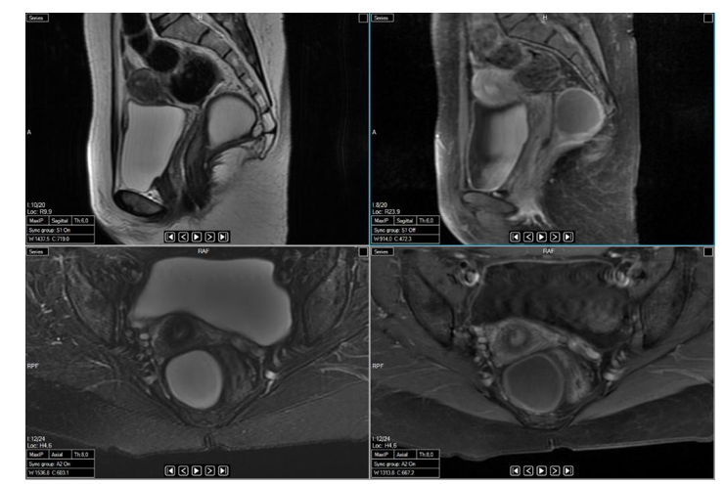
Figure 4 Sagittal and axial magnetic resonance images showing a cystic teratoma localized in the retrorectal area.
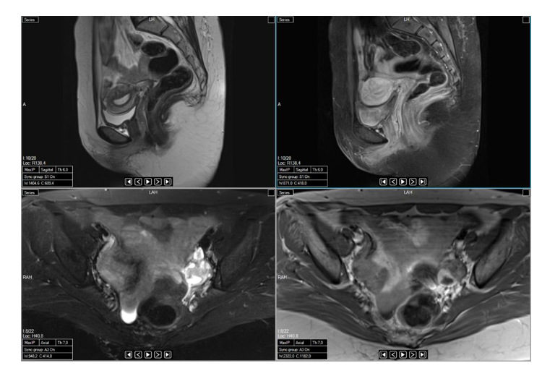
Figure 5 Sagittal and axial magnetic resonance images taken after resectioning the cystic teratoma shown in Figure 4.
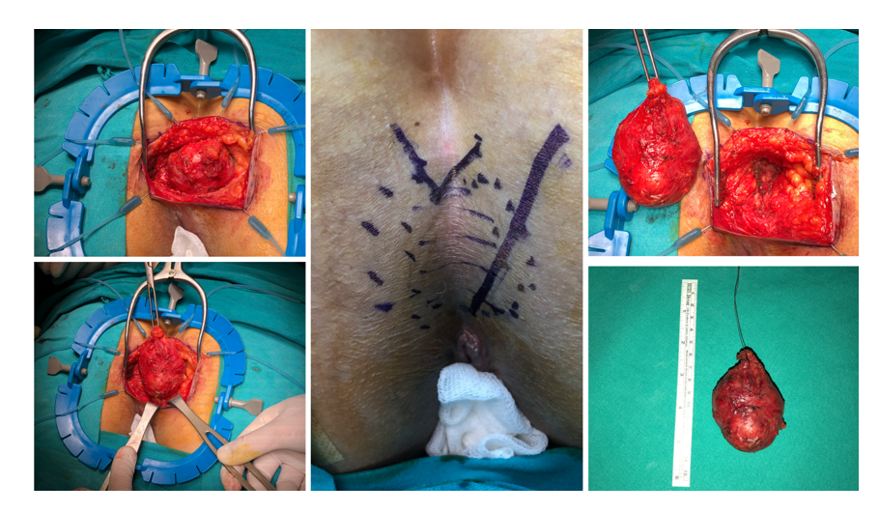
Figure 6 Perineal approach via parasagittal incision in a patient with a tail-gut cyst.
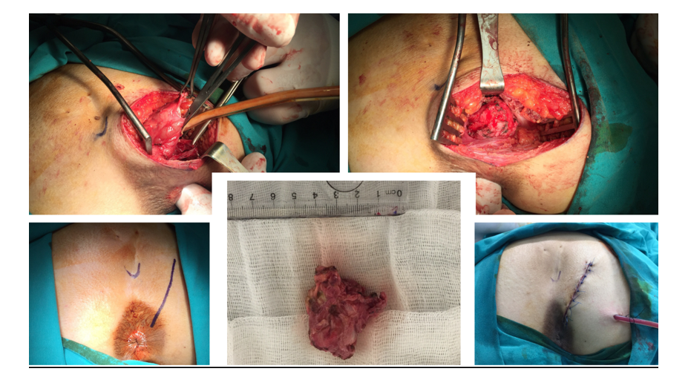
Figure 7 Perineal approach via parasagittal incision in a patient with an epidermoid cyst.
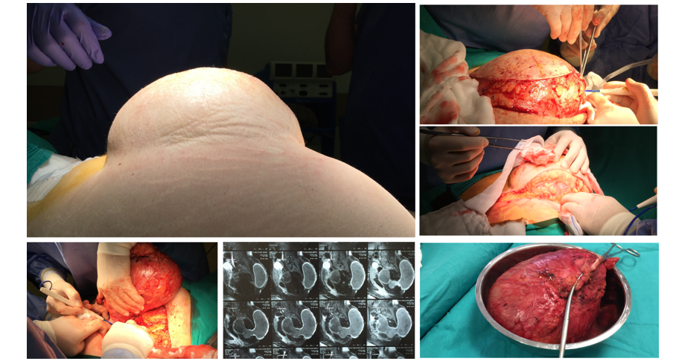
Figure 8 Perineal approach via parasagittal incision in a patient with a teratoma.

Table 1 The classification of retrorectal tumors^{[10,11]}
 | Benign | Malignant
Congenital | Developmental cysts (Tail-gut, epidermoid, dermoid, teratoma) | Chordoma
 | Anterior sacral meningocele | Teratocarcinoma
 | Adrenal rest tumor
Neurogenic | Schwannoma | Neuroblastoma
 | Neurofibroma | Malignant nerve sheath tumors
 | Ganglioneuroma | Ganglioneuroblastoma Ependymoma
Osseous | Giant-cell tumor | Osteogenic sarcoma
 | Osteoblastoma | Ewing sarcoma
 | Aneurysmal bone cyst | Chondrosarcoma
 |  | Myeloma
Inflammatory | Abscess/hematoma
Miscellaneous | Lipoma | Liposarcoma
 | Fibroma | Fibrosarcoma
 | Hemangioma | Hemangiopericytoma
 | Endothelioma | Leiomyosarcoma
 | Leiomyoma | Metastatic carcinoma

