Name of Journal: World Journal of Clinical Cases
Manuscript NO: 72157
Manuscript Type: CASE REPORT

Endoscopic clipping for the secondary prophylaxis of bleeding gastric varices in a patient with cirrhosis: A case report

Yang GC et al. EVC prevents GOV rebleeding

Guang-Chao Yang, Ya-Xian Mo, Wei-Hua Zhang, Li-Bin Zhou, Xu-Ming Huang, Li-Ming Cao

Guang-Chao Yang, Ya-Xian Mo, Wei-Hua Zhang, Li-Bin Zhou, Xu-Ming Huang, Department of Gastroenterology, Shenzhen Shiyan People's Hospital, Shenzhen 518000, Guangdong Province, China

Li-Ming Cao, Department of Internal Medicine, Shenzhen University The First Affiliated Hospital, Shenzhen 518000, Guangdong Province, China

Author contributions: Yang GC and Mo YX contributed equally to this work; Yang GC and Mo YX performed the research and revised the manuscript; Zhang WH and Zhou LB provided and analyzed the data; Huang XM designed the study and wrote the manuscript; Cao LM reviewed and revised the manuscript; all authors have read and approved the final manuscript.

Corresponding author: Xu-Ming Huang, MD, Doctor, Department of Gastroenterology, Shenzhen Shiyan People's Hospital, No. 11 Jixiang Road, Bao'an District, Shenzhen 518000, Guangdong Province, China. huangxm-2007@163.com

Received: October 6, 2021
Revised: November 7, 2021
Accepted: December 25, 2021
Published online: February 6, 2022

Abstract
BACKGROUND
Bleeding from gastroesophageal varices (GOV) is a serious complication in patients with liver cirrhosis, carrying a very high mortality rate. For secondary prophylaxis against initial and recurrent bleeding, endoscopic therapy is a critical intervention. Endoscopic variceal clipping for secondary prophylaxis in adult GOV has not been reported.

CASE SUMMARY
A 66-year-old man with cirrhosis was admitted to our hospital complaining of asthenia and hematochezia for 1 wk. His hemoglobin level and red blood cell counts were significantly decreased, and his fecal occult blood test was positive. An enhanced computed tomography of the abdomen showed GOV. The patient was diagnosed with hepatitis B cirrhosis-related GOV bleeding. A series of palliative treatments were administered, resulting in significant clinical improvement. Subsequently, an endoscopic examination revealed severe gastric fundal varices, prompting endoscopic variceal clipping. There were no further episodes of gastrointestinal bleeding. The GOV improved significantly on follow-up imaging and was confirmed as improved on endoscopy at the 5th postoperative month.

CONCLUSION
Our results suggest that endoscopic clipping is an inexpensive, safe, easy, effective, and tolerable method for the secondary prophylaxis of bleeding from gastric type 2 GOV. However, additional research is indicated to confirm its long-term safety and efficacy.

Key Words: Endoscopy; Metal clips; Gastric varices; Endoscopic variceal clipping; Secondary prophylaxis; Case report

©The Author(s) 2022. Published by Baishideng Publishing Group Inc. All rights reserved.

Citation: Yang GC, Mo YX, Zhang WH, Zhou LB, Huang XM, Cao LM. Endoscopic clipping for the secondary prophylaxis of bleeding gastric varices in a patient with cirrhosis: A case report. World J Clin Cases 2022; 10(4): 1447-1453
URL: https://www.wjgnet.com/2307-8960/full/v10/i4/1447.htm
DOI: https://dx.doi.org/10.12998/wjcc.v10.i4.1447

Core Tip: Gastrointestinal bleeding as a sequela of portal hypertension can be catastrophic and fatal. For patients without secondary prevention, the rebleeding and mortality rate is high; therefore, secondary prophylaxis is vital, and endoscopic techniques are primary methods used to perform this. Our novel endoscopic technique could play a critical role in the prevention of variceal re-bleeding, and we propose that it is a safe and efficacious method for the secondary prophylaxis of Type 2 GOV rebleeding. Our work provides an idea for the further study in this field.

INTRODUCTION
One of the most life-threatening complications of liver cirrhosis is acute variceal bleeding, which is associated with an increased mortality rate of approximately 20% at 6 wk^{[1]}. For patients without secondary prevention, the rebleeding rate was as high as 60%, and the mortality rate reached 33% within 1-2 years^{[2]}. Therefore, secondary prophylaxis is vital, and endoscopy is the primary method used to perform secondary prophylaxis techniques. A variety of techniques, including endoscopic variceal ligation (EVL), endoscopic injection sclerosis (EIS), and tissue adhesive injection, are available to manage gastroesophageal varices (GOV). GOV can be divided into Type 1 GOV and Type 2 GOV (GOV 2). GOV1 manifests as relatively straight varices extending along the lesser curvature of stomach to 2-5 cm below the gastroesophageal junction, while GOV 2 extends beyond the gastroesophageal junction into the fundus of the stomach^{[3]}. However, these treatments are not without potentially serious complications. EVL, which can cause cerebral air embolism^{[4]} and infective endocarditis^{[5]}, has not been widely used in gastric varices. EIS has a high complication rate for gastric ulceration, perforation, and rebleeding (37%-53%)^{[3,6]}, and its sclerosing agent can leak into the inferior vena cava^{[7]}. The tissue adhesive injection procedure can result in embolization, leading to potentially fatal complications such as pulmonary^{[8]} and spinal cord embolisms^{[9]}. Endoscopic hemostatic metal clips were first designed by Hayashi et al^{[10]} in 1975 and were initially used to achieve hemostasis in focal gastrointestinal bleeding^{[11]} with the added benefit of a low rebleeding rate^{[12]}. To our knowledge, endoscopic variceal clipping (EVC) for secondary prophylaxis in adult GOV has not been reported. Therefore, we present a retrospective case in which metal clips were utilized for the treatment of severe GOV 2 in a cirrhotic patient and evaluate the efficacy of EVC.

CASE PRESENTATION
Chief complaints
A 66-year-old man with cirrhosis was admitted to our hospital with a complaint of asthenia and hematochezia for 1 wk.

History of present illness
The patient had black stool for 1 wk and frequent bouts of asthenia.

History of past illness
He had a significant medical history of diabetes, hypersplenism, hypoalbuminemia, cholecystitis, mild anemia and bradycardia, and hepatitis B/decompensated cirrhosis, for which he received entecavir.

Personal and family history
He had no history of alcohol abuse, toxic exposure, or hereditary disease.

Physical examination
His vitals at admission and pertinent physical examination findings were notable for a pulse of 84 and blood pressure 134/76 mmHg; he was lucid with a hepatic face, pale lips and conjunctiva, palmar erythema, chest spider angiomas, and mild bilateral pitting edema; the rest of his examination findings were unremarkable.

Laboratory examinations
Initial laboratory test results were shown in Table 1. The 14C-urea breath test was negative.

Imaging examinations
Chest computed tomography (CT) showed inflammation in the middle lobe of the right lung, and an enhanced upper abdominal CT showed gastric varices (Figure 1A-D).

FINAL DIAGNOSIS
The patient was diagnosed with hepatitis B cirrhosis-related GOV bleeding.

TREATMENT
The patient and their family members refused emergency endoscopy as they were worried about endoscopy related complications. At the same time, blood transfusion therapy with 1000 mL of packed red blood cells, acid suppressive agents (lansoprazole), hemostatic agents, antibiotic therapy (levofloxacin), somatostatin injection, glycemic control agents, enteral fasting, parenteral nutrition, and a laxative (lactulose) were all administered for 11 d. He responded well to treatment as his hemoglobin level stabilized (> 70 g/dL) and no rebleeding occurred. On day 4, he was administered meperidine and diazepam before an upper gastrointestinal endoscopy [Olympus CV290 (Olympus Corporation, Tokyo, Japan)] was performed; several large gastric fundal varices without a spurting bleeding point were found (Figure 1E-H). The patient refused EIS and tissue adhesive injection as he was worried about procedural complications and treatment costs. We therefore used EVC to treat the severe gastric varices. Subsequently, the varicose veins were successfully managed with 20 metal clips (Nanwei Medical Pharmaceutical Co., Ltd, Nanjing, China; Figure 1I-L). Specifically, we adopted the rotatable metal clips ROCC-F-26-195-C (opening size 14 mm, working length 1950 mm) and ROCC-D-26-195 (opening size 10 mm, working length 1950 mm), respectively. In the reversal location for endoscope, we adjusted the front end of endoscope to be perpendicular to the vessel cross-section, and subsequently, pushed the clip from biopsy channel, then slowly closed the clip after the varicose vein was completely caught in the clip; with the cardia as the center, we first clamped the small diameter and relatively isolated varicose veins, then clamped the larger varices. First, we clamped the inflow segment of the varices, and then clamped the outflow segment of the varices. The clip should be as close as possible to muscularis propria when clamping the varices, and the distance between the clip and dentate margin of cardia must be more than 10 mm.

OUTCOME AND FOLLOW-UP
The patient had no black stools on the 2nd postoperative day and was discharged a week after operation. He had no further episodes of gastrointestinal bleeding with a normal hemoglobin level and liver function tests noted at the 5th month of follow-up. Follow-up imaging showed significantly improved gastric varices (Figure 2A-D), and the follow-up endoscopy showed well-healed gastric varices at the 5th postoperative month (Figure 2E-H).
This retrospective case report was approved by the ethics review board of Shenzhen Shiyan People's Hospital (Approval no. 2021SZSY-01). The patient provided written informed consent for the participation and publication of this report. He was satisfied with the treatment received.

DISCUSSION
A new method of endoscopic therapy using metal clips for the secondary prevention of bleeding from gastric varices in patients with cirrhosis was devised. Our study expands the clinical application of endoscopic clipping and offers a new solution for secondary prophylaxis of bleeding from gastric varices. The results suggested that our endoscopic clip method is safe, inexpensive, easy, and effective and was well tolerated by a patient with GOV 2.
EVC appears to be an effective technique for the secondary prophylaxis of bleeding from GOV 2. During the procedure, the endoscope did not have to be withdrawn, simplifying the operation by shortening the surgical time while minimizing medical risks. In addition, metal clips are more cost-efficient than tissue adhesives and sclerosing agents and have good histocompatibility; furthermore, their safety and efficacy profile in endoscopic hemostasis has garnered more approval in the literature. Employing EVC not only simplifies the endoscopy but precludes the need for surgery and long-term conventional treatment. Mitsunaga et al^{[13]} reported 82 prophylactic (primary prevention) EVCs without variceal progression in 89.9% with good security. Miyoshi et al^{[14]} first reported EVC applied prophylactically to 9 patients with esophageal (rather than gastric) varices without major complications such as massive bleeding, achieving the desired effect. In this case, we utilized EVC for the secondary prophylaxis of gastric varices with encouraging results.
We believe that EVC is suitable for LDRf Type D 1.0-2.0 gastric varices and GOV 2, which are long, nodular, and tortuous veins that are continuous with esophageal varices^{[3]}. Following the flow direction of varicose veins, metal clips were used by clipping both ends of the vein; this effectively blocks part of the blood flow, resulting in vessel collapse. The clips should be applied gently and released slowly to avoid pulling the veins. The time of shedding of the clips was longer, and more clips were required for simple EVC. Somatostatin was then employed, which reduces splanchnic blood flow, decreases portal venous pressure, and improves the safety and efficacy of the endoscopic procedure^{[2]}. EVC relieves gastric varices and decreases portal vein pressures, so we had expected liver function to improve. The patient had normal liver function at postoperative five-month follow-up, indicating that our theory was correct.
However, there were some EVC complications, such as uncorrected hemorrhagic shock, uncontrolled hepatic encephalopathy, and uncooperative patients, that must also be considered. Therefore, future large-scale randomized controlled trials would be prudent to provide qualitative evidence and confirm the efficacy of EVC for secondary prophylaxis in bleeding from gastric varices.

CONCLUSION
In conclusion, gastrointestinal bleeding can be a fatal complication of portal hypertension. Endoscopic techniques play a critical role in the prevention of variceal rebleeding. We propose that EVC is a safe and effective method for the secondary prophylaxis of GOV 2. Our report supports endoscopic clipping as an important treatment modality in the secondary prophylaxis of GOV. However, additional research is needed to confirm its long-term safety and efficacy.

REFERENCES
1 Ibrahim M, Mostafa I, Devière J. New Developments in Managing Variceal Bleeding. Gastroenterology 2018; 154: 1964-1969 [PMID: 29481777 DOI: 10.1053/j.gastro.2018.02.023]
2 Xu X, Ding H, Jia J, Wei L, Duan Z, Ling-Hu E, Liu Y, Zhuang H. Guidelines for the diagnosis and treatment of esophageal and gastric variceal bleeding in cirrhotic portal hypertension. Zhongguo Ganzangbing Zazhi (Electronic Version) 2016; 1: 1-18
3 Sarin SK, Lahoti D, Saxena SP, Murthy NS, Makwana UK. Prevalence, classification and natural history of gastric varices: a long-term follow-up study in 568 portal hypertension patients. Hepatology 1992; 16: 1343-1349 [PMID: 1446890 DOI: 10.1002/hep.1840160607]
4 Bai XS, Yang B, Yu YJ, Liu HL, Yin Z. Cerebral air embolism following an endoscopic variceal ligation: A case report. Medicine (Baltimore) 2018; 97: e10965 [PMID: 29879047 DOI: 10.1097/MD.0000000000010965]
5 Zhang X, Liu X, Yang M, Dong H, Xv L, Li L. Occurrence of infective endocarditis following endoscopic variceal ligation therapy: A case report. Medicine (Baltimore) 2016; 95: e4482 [PMID: 27583858 DOI: 10.1097/MD.0000000000004482]
6 Trudeau W, Prindiville T. Endoscopic injection sclerosis in bleeding gastric varices. Gastrointest Endosc 1986; 32: 264-268 [PMID: 3488937 DOI: 10.1016/s0016-5107(86)71843-9]
7 Irisawa A, Obara K, Sato Y, Saito A, Orikasa H, Ohira H, Sakamoto H, Sasajima T, Rai T, Odajima H, Abe M, Kasukawa R. Adherence of cyanoacrylate which leaked from gastric varices to the left renal vein during endoscopic injection sclerotherapy: a histopathologic study. Endoscopy 2000; 32: 804-806 [PMID: 11068842 DOI: 10.1055/s-2000-7702]
8 Bhat YM, Weilert F, Fredrick RT, Kane SD, Shah JN, Hamerski CM, Binmoeller KF. EUS-guided treatment of gastric fundal varices with combined injection of coils and cyanoacrylate glue: a large U.S. experience over 6 years (with video). Gastrointest Endosc 2016; 83: 1164-1172 [PMID: 26452992 DOI: 10.1016/j.gie.2015.09.040]
9 Liu S, Wu N, Chen M, Zeng X, Wang F, She Q. Neurological symptoms and spinal cord embolism caused by endoscopic injection sclerotherapy for esophageal varices: A case report and literature review. Medicine (Baltimore) 2018; 97: e0622 [PMID: 29718871 DOI: 10.1097/MD.0000000000010622]
10 Hayashi T, Yonezawa M, Kawabara T. The study on stanch clips for the treatment by endoscopy. Gastroenterol Endosc 1975; 17: 92-101
11 Hachisu T. Evaluation of endoscopic hemostasis using an improved clipping apparatus. Surg Endosc 1988; 2: 13-17 [PMID: 3051463 DOI: 10.1007/BF00591392]
12 Zhu WH, Jiang HG, Liu J. [Application of metal clip with endoscopic treatment for difficult cases of immediate hemostasis of esophagogastric variceal bleeding]. Zhonghua Ganzangbing Zazhi 2020; 28: 266-268 [PMID: 32306661 DOI: 10.3760/cma.j.cn501113-20190801-00283]
13 Mitsunaga T, Yoshida H, Kouchi K, Hishiki T, Saito T, Yamada S, Sato Y, Terui K, Nakata M, Takenouchi A, Ohnuma N. Pediatric gastroesophageal varices: treatment strategy and long-term results. J Pediatr Surg 2006; 41: 1980-1983 [PMID: 17161186 DOI: 10.1016/j.jpedsurg.2006.08.022]
14 Miyoshi H, Shikata J, Tokura Y. Endoscopic clipping of esophageal varices. Dig Endosc 1992; 4: 147-150

Footnotes
Informed consent statement: Informed consent was obtained from the patient. We obtained written consent for publication from the patient.

Conflict-of-interest statement: The authors declare that they have no conflict of interest.

CARE Checklist (2016) statement: The authors have read the CARE Checklist (2016), and the manuscript was prepared and revised according to the CARE Checklist (2016).

Open-Access: This article is an open-access article that was selected by an in-house editor and fully peer-reviewed by external reviewers. It is distributed in accordance with the Creative Commons Attribution NonCommercial (CC BY-NC 4.0) license, which permits others to distribute, remix, adapt, build upon this work non-commercially, and license their derivative works on different terms, provided the original work is properly cited and the use is non-commercial. See: https://creativecommons.org/Licenses/by-nc/4.0/

Provenance and peer review: Unsolicited manuscript; Externally peer reviewed.
Peer-review model: Single blind

Peer-review started: October 6, 2021
First decision: October 27, 2021
Article in press: December 23, 2021

Specialty type: Gastroenterology and hepatology
Country/Territory of origin: China
Peer-review report’s scientific quality classification
Grade A (Excellent): 0
Grade B (Very good): B, B
Grade C (Good): 0
Grade D (Fair): D
Grade E (Poor): 0

P-Reviewer: Batyrbekov K, Oda M S-Editor: Liu JH L-Editor: A P-Editor: Liu JH

Figure Legends
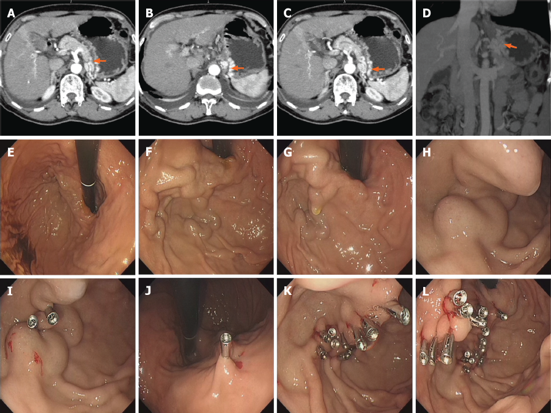
Figure 1 Preoperative abdominal computed tomography, preoperative and intraoperative endoscopy images. A-D: Preoperative abdominal computed tomography showing esophagogastric venous plexus presenting multiple dilated, tortuous blood vessels (arrows, gastric varices); E-H: Preoperative endoscopic examination revealing several large, nodular gastric fundal varices (largest diameter 15 mm), with no bleeding points or red-color signs revealed during endoscopy; I-L: Immediately after deployment of the clips, the outlet and inlet of the gastric varices were closed by clips, resulting in variceal atelectasis.
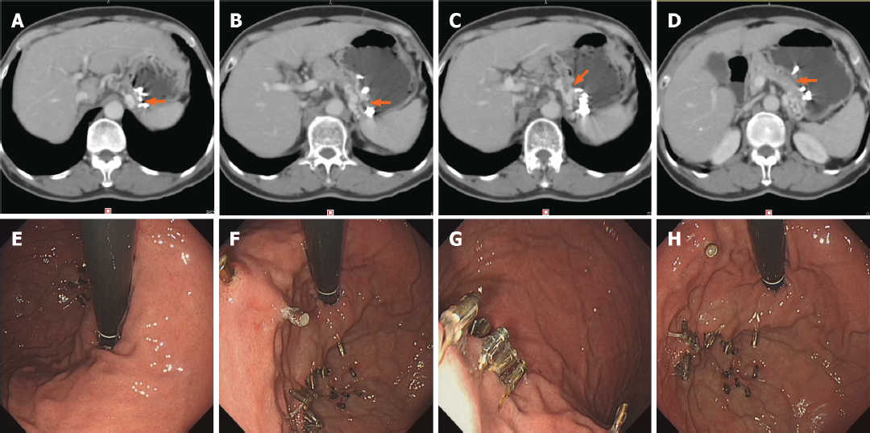
Figure 2 Follow up imaging and endoscopy images. A-D: Imaging follow-up showing the significantly improved gastric varices (arrows) at the 5th postoperative month; E-H: Gastroscopy showing the clips still in place with well-healed varices at the 5th postoperative month.

Table 1 Laboratory findings on admission
 | Result | Reference range
Red blood cell count, × 10¹²/L | 1.89 | 3.8-5.8 | Decreased
Hemoglobin level, g/dL | 59 | 115-175 | Decreased
Alkaline phosphatase, U/L | 43 | 45-125 | Decreased
Albumin, g/L | 29.4 | 40-55 | Decreased
Total protein, g/L | 56.1 | 65-85 | Decreased
Alanine aminotransferase, U/L | 16 | 9-50 | Normal
Serum creatinine, μmol/L | 75 | 57-111 | Normal
Direct bilirubin, μmol/L | 7.9 | 0-6.89 | Increased
Plasma fibrinogen level, g/L | 4.44 | 2-4 | Increased
Random blood glucose, mmol/L | 29.45 | 3.89-6.11 | Increased
Plasma D-dimer, mg/L | 0.61 | 0-0.5 | Increased
Urea nitrogen, mmol/L | 9.76 | 3.6-9.5 | Increased
Serum lipase, U/L | 133.9 | 13-60 | Increased
Creatine kinase, U/L | 382 | 50-310 | Increased
Alpha-fetoprotein, ng/mL | 17.4 | 0-13.6 | Increased
Glycosylated hemoglobin, % | 7.6 | 4.0-6.5 | Increased
Hepatitis B virus DNA, iu/mL | 9020 | < 100 | Increased
Hepatitis B virus surface antigen | Positive | Negative | Abnormal
Hepatitis B E antibody | Positive | Negative | Abnormal
Hepatitis B core antibody | Positive | Negative | Abnormal
Fecal occult blood test | Positive | Negative | Abnormal
Hepatitis C virus antibody | Negative | Negative | Normal
Helicobacter pylori antibody | Negative | Negative | Normal
Human immunodeficiency virus antibody | Negative | Negative | Normal
Syphilis antibody | Negative | Negative | Normal

Published by Baishideng Publishing Group Inc
7041 Koll Center Parkway, Suite 160, Pleasanton, CA 94566, USA
Telephone: +1-925-3991568
E-mail: bpgoffice@wjgnet.com
Help Desk: https://www.f6publishing.com/helpdesk
https://www.wjgnet.com

© 2022 Baishideng Publishing Group Inc. All rights reserved.

