Name of journal: World Journal of Gastroenterology
ESPS Manuscript No: 9424
Columns: meta-analysis

Three-dimensional conformal radiotherapy combined with transcatheter arterial chemoembolization for hepatocellular carcinoma: a meta-analysis

Zou LQ et al. HCC Treated with 3D-CRT and TACE

Li-Qun Zou, Bing-Lan Zhang, Qing Chang, Fu-Ping Zhu, Yan-Yan Li, Yu-Quan Wei, Yong-Song Guan

Li-Qun Zou, Bing-Lan Zhang, Yan-Yan Li, Yu-Quan Wei, Yong-Song Guan, Department of Oncology, Cancer Center, State Key Laboratory of Biotherapy, West China Hospital, Sichuan University, Chengdu 610041, Sichuan Province, China

Qing Chang, Fu-Ping Zhu, Department of Hepatobiliary Surgery, The Ninth People's Hospital of Chongqing, Chongqing 400700, China

Author contributions: Zou LQ, Zhang BH and Chang Q contributed equally to this work; Zou LQ, Zhang BL, Chang Q, Zhu FP, Li YY, Wei YQ and Guan YS designed research; Zou LQ, Zhang BL, Chang Q, Zhu FP and Li YY performed research; Zou LQ, Zhang BL, Chang Q, Wei YQ and Guan YS analyzed data; and Zou LQ, Zhang BL and Chang Q, wrote the paper.

Correspondence to: Yong-song Guan, MD, Department of Oncology, Cancer Center, State Key Laboratory of Biotherapy, West China Hospital, Sichuan University, 37 Guoxuexiang Street, Chengdu 610041, Sichuan Province, China. yongsongguan@yahoo.com

Telephone: +86-28-85422683 Fax: +86-28-85423046
Received: February 11, 2014 Revised: June 5, 2014
Accepted: July 22, 2014

Published online:

Abstract
Aim: To compare transcatheter arterial chemoembolization (TACE) and three-dimensional conformal radiotherapy (3D-CRT) with TACE monotherapy in hepatocellular carcinoma (HCC).

Methods: We searched all the eligible studies from the Cochrane Library, PubMed, Medline, Embase, and CNKI. The meta-analysis was performed to assess the survival beneﬁt, tumor response, and the decline rates of α fetal protein (AFP) level. According to the heterogeneity of the studies, pooled odds ratios (ORs) with 95% conﬁdence interval (CI) were calculated using the fixed-effects or random-effects model. An observed OR > 1 indicated that the addition of 3D-CRT to TACE could offer survival beneﬁts to patients and would be considered statistically significant. Statistical analyses were performed using Review Manager Software.

Results: Ten studies met the criteria to perform a meta-analysis including 908 HCC participants, in which 400 patients in the combination of TACE and 3D-CRT group while 508 patients in the group of TACE alone. TACE combining 3D-CRT signiﬁcantly improved 1-, 2-, and 3-year overall survival compared with TACE monotherapy [OR = 1.87, 95%CI: 1.37–2.55, P < 0.0001], (OR = 2.38, 95%CI: 1.78–3.17, P < 0.00001) and (OR = 2.97, 95%CI: 2.10–4.21, P < 0.00001). In addition, TACE plus 3D-CRT was associated with a higher tumor response (complete remission and partial remission) (OR = 3.81; 95%CI: 2.70–5.37; P < 0.00001), and decline rates of AFP level (OR = 3.24, 95%CI: 2.09–5.02, P < 0.00001).

Conclusion: This meta-analysis demonstrated that TACE combining 3D-CRT was better than TACE monotherapy for patients with HCC, which needs to be conﬁrmed by large multicenter trials．

© 2014 Baishideng Publishing Group Inc. All rights reserved.

Key words: Hepatocellular carcinoma; Chemoembolization; Three-dimensional conformal radiotherapy; Meta-analysis

Core tip: Transcatheter arterial chemoembolization (TACE) is the most commonly used for patients with unresectable hepatocellular carcinoma (HCC) as a palliative therapy that could prolong survival with unsatisfactory long-term effect. Three-dimensional conformal radiotherapy (3D-CRT) has been utilized for HCC in a series of trials resulting in promising results. This meta-analysis demonstrated that TACE combining 3D-CRT was better than TACE monotherapy in the treatment of HCC, which still needs to be confirmed by large prospectively randomized, controlled, multicenter trials.

Zou LQ, BL, Chang Q, Zhu FP, Li YY, Wei YQ, Guan YS. Three-dimensional conformal radiotherapy combined with transcatheter arterial chemoembolization for hepatocellular carcinoma: A meta-analysis. World J Gastroenterol 2014; In press

Introduction
Liver cancer in human is the ﬁfth most frequently diagnosed cancer worldwide and the second most frequent cause of cancer death^{[1]}. The highest liver cancer rates are found in East and South-East Asia, especially in China. It is recognized that only a small proportion of patients with early-stage hepatocellular carcinoma (HCC) may beneﬁt from surgical resection. Transcatheter arterial chemoembolization (TACE) is the most commonly used for patients with unresectable HCC as a palliative therapy that could prolong survival^{[2-5]}. However, the long-term curative effect is unsatisfactory for TACE alone, because of tumor relapse from intracapsular or extracapsular invasion by HCC and remaining tumor cells after the treatment^{[6]}. In addition, severe side effects were observed with the use of repeated rigorous TACE, including liver and renal failure, bone marrow depression, postembolization syndrome, and liver abscess^{[7]}.
Traditionally, radiation therapy (RT) has played a minor role in the treatment of hepatic cancers because of the low tolerance of the whole-organ to irradiation, with a limit of approximately 30–35 Gy^{[8]}. With the advent of new elegant three-dimensional conformal radiotherapy (3D-CRT), it allows the tumor to receive a higher dose and the surrounding normal liver tissue to receive lower doses^{[9,10]}. Currently, 3D-CRT has been utilized for HCC in a series of trials resulting in promising results in asian countries, including improvements in response rate, disease control and overall survival.
Therefore, we did this meta-analysis to evaluate whether the addition of 3D-CRT to TACE could offer any survival beneﬁts to asian patients with advanced HCC.

Materials and methods
Literature search
PubMed, Medline, Embase, Chinese BioMedical Literature Database (CBM), and the Cochrane Library were searched for studies published from October 2000 to October 2013. The following medical subject heading (MeSH) terms were used: (“hepatocellular carcinoma” or “HCC”) AND (“transcatheter arterial chemoembolization” or “TACE”) AND (“three-dimensional conformal radiotherapy” or “3D-CRT”).

Selection criteria
Studies were considered eligible if they met the following inclusion criteria: (1) study designs were prospective cohort studies or case-control studies; (2) patients in the treatment group received combination therapy consisting of 3D-CRT and TACE with TACE alone in the control group; (3) participants had unresectableHCC; (4) data were reported on outcomes of overall survival (OS). Studies were excluded in the analysis if: (1) reviews, commentaries, editorials, case reports, and letters; (2) patients included received surgery; (3) lacked of key information for calculation with methods developed by Parmaret al^{[11]}, Williamson et al^{[12]}, and Tierney et al^{[13]}; and (4) duplicated or redundant publications.

Data extraction
Each study was evaluated and classified by two independent investigators (Liqun Zou and Binglan Zhang). Disagreements were resolved in consultation with a third investigator. The extracted items comprised: first author, publication year, country, study design, number of patients, number of combination group and sole TACE group, tumor size and stage, survival rates.

Statistical analysis
Statistical analyses were performed using Review Manager Software (RevMan 5.2; Cochrane Collaboration, Oxford, United Kingdom). Odds ratios (OR) with 95% confidence intervals (CIs) was calculated for the quantitative aggregation of survival result. An observed OR > 1 indicated that the addition of 3D-CRT to TACE could offer survival beneﬁts to patients and would be considered statistically significant.
Forrest plots were used to estimate the therapeutic effect on survival. Heterogeneity was defined as p < 0.10 or I² > 50%^{[14]}. Data that were not significantly heterogeneous (p ≥ 0.10, I² ≤ 50%) were calculated using a fixed effects model. If not, a random effect model was used. The Begg’s test was used to assess potential publication bias, p > 0.05 was considered that there was no potential publication bias^{[15]}.

Results
Selection of studies
This meta-analysis yielded a total of 653 trials. After reviewing the titles and abstracts, 598 studies were excluded and 55 left for further evaluation. Of the 55 trials, 22 were excluded for inadequate control group, 15 for reviews or case reports, 5 for surgical intervention, and 3 for interventions other than TACE alone in the control group. Finally, there were 10 studies^{[16-25]} fulfilling the inclusion criteria and being sent for review in our meta-analysis (Figure 1).
The main characteristics of included studies are listed in Table 1. Among these included studies published between 2001 and 2010, two were randomized clinical trials and 8 were nonrandomized observational studies. All the trials originated from Asia because of the high incidence of hepatitis B infection here. In addition to two articles that did not report liver function of the patients, all the other 8 studies included patients with liver function of Child–Pugh class A or B. The Karnofsky score of most patients is equal or greater than 70. There were 400 patients in the combination of TACE and 3D-CRT group, and 508 patients in the group of TACE alone. Among the 10 studies, there were eight, nine, and eight studies that reported comparative data for overall survival rate at 1, 2, and 3 years, respectively (Table 2); seven and four studies that reported comparative data for tumor response and the decline rates of the α fetal protein (AFP) level, respectively.

Survival rates
One-year survival: Eight trials (802 patients) were identiﬁed with the outcome measurements of 1-year survival rates. Meta-analysis showed a signiﬁcant improvement in the 1-year survival favoring combination therapy (OR = 1.87, 95%CI: 1.37–2.55, P < 0.0001) (Figure 2). There is no heterogeneity among the trials included, using ﬁxed-effects model (heterogeneity χ² = 9.02, P = 0.25; I² = 22%).

Two-year survival: Data of 2-year survival rate were reported in nine studies (860 patients) and there was also no heterogeneity among these studies (heterogeneity χ² = 7.10, P = 0.53; I² = 0%), thus the fixed-effects model was used to pool the results. Meta-analysis showed the combination of 3D-CRT and TACE was also associated with a higher 2-year survival rate compared with the TACE alone group (OR = 2.38, 95%CI: 1.78–3.17, P < 0.00001) (Figure 2).

Three-year survival: Eight trials (802 patients) were identiﬁed with the outcome measurements of 3-year survival rates. Analysis of the 3-year survival (425 participants) also showed a significant benefit with the combination therapy method (OR = 2.97, 95%CI: 2.10–4.21, P < 0.00001)(Figure 2). In the chi-square and I-square tests, there were no heterogeneous findings (heterogeneity χ² = 3.02, P = 0.88; I² = 0%).

Tumor response
Seven trials (698 patients) were identiﬁed with outcome measurements of complete response (CR) and partial response (PR). There is no heterogeneity among the trials included, using ﬁxed-effects model (heterogeneity χ² = 5.90, P = 0.43; I² = 0%).The pooled analysis showed that compared with TACE alone, the combination method signiﬁcantly improved CR+PR (OR = 3.81; 95%CI: 2.70–5.37; P < 0.00001) (Figure 3).

decline rates of AFP level
Four trials (391 participants) were identified with the outcome measurements of the decline rates of AFP level. There was no evidence of heterogeneity among the trials included, using ﬁxed-effects model (heterogeneity χ² = 2.47, P = 0.48; I² = 0%). Meta-analysis showed the combination of 3D-CRT and TACE was associated with a higher decline rate of AFP level compared with the TACE monotherapy (OR = 3.24, 95%CI: 2.09–5.02, P < 0.00001), and the results are shown in Figure 3.

Publication bias
Begg’s funnel plot was performed to assess the publication bias in all included studies for evaluation of survival rates, tumor response and the decline rates of AFP level separately. Begg’s funnel plot did not reveal any evidence of significant asymmetry in the 1-year OS (p = 0.621), 2-year OS (p = 0.835), and 3-year OS (p = 0.138) (Figure 4). There was also no indication of publication bias in Begg’s test of tumor response (p = 0.652) and the decline rates of AFP level (p = 0.497) (Figure 5).

Discussion
Since the hepatic artery provides at least 80% of the blood supply to HCC, TACE has been suggested as a standard therapeutic method for patients who are unsuitable for surgical management^{[2,26]}. However, TACE alone frequently results in incomplete tumor necrosis^{[27]}. Previous meta-analysis has shown that the efficacy of TACE combined with radiofrequency ablation (RFA), high-intensity focused ultrasound (HIFU), or percutaneous ethanol injection (PEI) was significantly better than that of TACE alone in patients with HCC^{[3,28-35]}. PEI has been widely used in treating HCC, but the effectiveness is limited to the diameter of HCC lesions^{[36]}. RFA monotherapy was found to be associated with a higher tumor progression rate, and the main cause is the residual tumor tissue after RFA. Additionally, RFA cannot be a suitable treatment for tumors with multiple nodules. Consequently, the combination of TACE and other local therapies may have several theoretical advantages. So far, there is no meta-analysis performed to assess the efficacy of the combination of TACE and 3D-CRT compared with TACE alone for treatment of HCC, and we performed this meta-analysis in which 10 studies were included eventually. However, incidence of complication in CRT with TACE might be higher than TACE alone.
The result of our meta-analysis demonstrated that the combination of 3D-CRT and TACE was associated with higher survival rates (OR 1-year = 1.87, 95%CI: 1.37–2.55, P < 0.0001; OR 2-year = 2.38, 95%CI: 1.78–3.17, P < 0.00001; OR 3-year = 2.97, 95%CI: 2.10–4.21, P < 0.00001). In addition, the combination of TACE and 3d-CRT had a significantly better tumor response (OR = 3.81; 95%CI: 2.70–5.37; P < 0.00001) and higher decline rate of AFP level (OR = 3.24, 95%CI: 2.09–5.02, P < 0.00001). Thus, the method with TACE plus 3D-CRT was a better choice than the method with only TACE for treatment of patients with HCC.
In the past, there was the concern that the normal liver tissue is sensitive and of poor tolerance to radiation, so radiotherapy was limited in the treatment of HCC. Fortunately, with the advent of 3-dimensional planning systems, 3D-CRT can minimize the irradiation of normal tissue and improve the distribution of target irradiation dose to tumors. Numerous clinical studies of TACE in combination with 3D-CRT for treatment of patients with HCC have emerged in recent years. In our meta-analysis, all the included trials adopted 3D-CRT technique. About 20% of the blood supply of HCC comes from the portal vein, resulting in that a small number of tumor cells remain viable and the tumor may recur after TACE. And 3D-CRT can make as a consolidation planned procedure to target residual hepatic tumor. Furthermore, Seong et al has reported that the anticancer drugs applied in the procedure of TACE will retain in the tumor and may have a radiosensitizing effect^{[37]}.
In addition, we evaluated the adverse effects of TACE and 3D-CRT in the included studies. Five trials reported the development of radiation-induced liver disease (RILD), but no difference in results of liver function test was found between the combination and control groups. Other common adverse effects were the postembolization syndrome including leukocyte count decline, fever, mild nausea, abdominal pain, and elevation of serum aminotransferase level or total bilirubin, which were transient and the patients often recovered in a short time.
Although there was no heterogeneity and publication bias in our meta-analysis, this study may have several possible limitations. Firstly, the number of RCT was very limited, and only two RCTs were included. Secondly, the basic characteristics of included cases are not all the same, including clinical stage, the microvascular infiltration, tumor number and size, and different stage of liver function. In addition, the interventional measures used (anticancer drugs of TACE, TACE course, radiation dose and methods) were different. Future studies need better design and more strict management of conduction. More patients’ information should be collected in the trials, including status of infection by hepatitis virus and degree of tumor cell differentiation. Last but not the least, a major limitation is that the studies included in our meta-analysis are all come from Asia countries, owing to no articles published comparing the efficacy of TACE plus 3D-CRT versus TACE alone in non-asian areas.
In conclusion, this meta-analysis based on 10 included studies indicates that TACE combined with 3D-CRT is a promising treatment for HCC. Importantly, these results need to be validated in further prospectively randomized, controlled multi-center clinical trials.

comments
Background
transcatheter arterial chemoembolization (TACE) has been recognized as a standard treatment for unresectable hepatocellular carcinoma(HCC), but TACE alone has achieved very limited success. With the advent of three-dimensional conformal radiotherapy (3D-CRT), it has been utilized for HCC in a series of trials resulting in promising results. However, the role of TACE combined with 3D-CRT remains unclear.

Research frontiers
Three-dimensional conformal radiotherapy (3D-CRT) allows higher RT doses HCC and minimizes liver injury, which can result in promising outcomes, including increases in response rate, tumor control and overall survival. In the current study, the authors did a meta-analysis to assess the efficacy of 3D-CRT plus TACE compared with TACE alone for HCC, and our meta-analysis was the first to do so.

Innovations and breakthroughs
Previous studies assessing the effectiveness of 3D-CRT plus TACE compared with TACE alone reported conflicting results. Consequently, the authors did a meta-analysis to evaluate whether the addition of 3D-CRT to TACE could offer any survival beneﬁts for hepatocellular carcinoma. The result indicated that 1-, 2-, and 3-year overall survival, tumor response, and decline rates of AFP level treated with 3D-CRT plus TACE were significantly higher than those with TACE alone.

Applications
This current limited evidence demonstrated that TACE plus 3D-CRT was better than TACE monotherapy in the treatment of hepatocellular carcinoma, which can improve the overall survival rate and provides better prognosis for patients with HCC.

Terminology
TACE is performed with the infusion of a mixture of chemotherapy drugs and has been widely used to treat HCC. 3D-CRT is operated by three-dimensional conformal RT treatment planning system and would be possible to minimize liver injury and increase irradiation dose to HCC.

Peer review
This manuscript presents a meta-analysis of ten studies (two of them were randomized trials) comparing TACE alone to its combination with 3D-CRT in the treatment of hcc. Although, as stated by the authors at the end of the discussion, there is a variety of drugs and techniques used and more studies will be required, this paper provides an important overview on this subject.

References
1 Jemal A, Bray F, Center MM, Ferlay J, Ward E, Forman D. Global cancer statistics. CA Cancer J Clin 2011; 61: 69-90 [PMID: 21296855 DOI: 10.3322/caac.20107caac.20107]
2 Rahbari NN, Mehrabi A, Mollberg NM, Müller SA, Koch M, Büchler MW, Weitz J. Hepatocellular carcinoma: current management and perspectives for the future. Ann Surg 2011; 253: 453-469 [PMID: 21263310 DOI: 10.1097/SLA.0b013e31820d944f]
3 Oliveri RS, Wetterslev J, Gluud C. Transarterial (chemo)embolisation for unresectable hepatocellular carcinoma. Cochrane Database Syst Rev 2011; (3): CD004787 [PMID: 21412886 DOI: 10.1002/14651858.CD004787.pub2]
4 Myers RP. Meta-analysis of transarterial embolization in patients with unresectable hepatocellular carcinoma. Radiology 2003; 227: 611-62; author reply 611-62 [PMID: 12732709 DOI: 10.1148/radiol.2272021187227/2/611]
5 Cammà C, Schepis F, Orlando A, Albanese M, Shahied L, Trevisani F, Andreone P, Craxì A, Cottone M. Transarterial chemoembolization for unresectable hepatocellular carcinoma: meta-analysis of randomized controlled trials. Radiology 2002; 224: 47-54 [PMID: 12091661 DOI: 10.1148/radiol.2241011262]
6 Jansen MC, van Hillegersberg R, Chamuleau RA, van Delden OM, Gouma DJ, van Gulik TM. Outcome of regional and local ablative therapies for hepatocellular carcinoma: a collective review. Eur J Surg Oncol 2005; 31: 331-347 [PMID: 15837037 DOI: 10.1016/j.ejso.2004.10.011]
7 Chan AO, Yuen MF, Hui CK, Tso WK, Lai CL. A prospective study regarding the complications of transcatheter intraarterial lipiodol chemoembolization in patients with hepatocellular carcinoma. Cancer 2002; 94: 1747-1752 [PMID: 11920537 DOI: 10.1002/cncr.10407]
8 Dhir V, Swaroop VS, Mohandas KM, Dinshaw KA, Desai DC, Nagral A, Sharma V, Jagannath P, Desouza LJ. Combination chemotherapy and radiation for palliation of hepatocellular carcinoma. Am J Clin Oncol 1992; 15: 304-307 [PMID: 1381143 DOI: 10.1097/00000421-199208000-00005]
9 Liu MT, Li SH, Chu TC, Hsieh CY, Wang AY, Chang TH, Pi CP, Huang CC, Lin JP. Three-dimensional conformal radiation therapy for unresectable hepatocellular carcinoma patients who had failed with or were unsuited for transcatheter arterial chemoembolization. Jpn J Clin Oncol 2004; 34: 532-539 [PMID: 15466827 DOI: 10.1093/jjco/hyh089]
10 Kim TH, Kim DY, Park JW, Kim YI, Kim SH, Park HS, Lee WJ, Park SJ, Hong EK, Kim CM. Three-dimensional conformal radiotherapy of unresectable hepatocellular carcinoma patients for whom transcatheter arterial chemoembolization was ineffective or unsuitable. Am J Clin Oncol 2006; 29: 568-575 [PMID: 17148993 DOI: 10.1097/01.coc.0000239147.60196.1100000421-200612000-00009]
11 Parmar MK, Torri V, Stewart L. Extracting summary statistics to perform meta-analyses of the published literature for survival endpoints. Stat Med 1998; 17: 2815-2834 [PMID: 9921604 DOI: 10.1002/(SICI)1097-0258(19981230)17:24<2815::AID-SIM110>3.0.CO;2-8]
12 Williamson PR, Smith CT, Hutton JL, Marson AG. Aggregate data meta-analysis with time-to-event outcomes. Stat Med 2002; 21: 3337-3351 [PMID: 12407676 DOI: 10.1002/sim.1303]
13 Tierney JF, Stewart LA, Ghersi D, Burdett S, Sydes MR. Practical methods for incorporating summary time-to-event data into meta-analysis. Trials 2007; 8: 16 [PMID: 17555582 DOI: 10.1186/1745-6215-8-16]
14 Higgins JP, Thompson SG, Deeks JJ, Altman DG. Measuring inconsistency in meta-analyses. BMJ 2003; 327: 557-560 [PMID: 12958120 DOI: 10.1136/bmj.327.7414.557327/7414/557]
15 Begg CB, Mazumdar M. Operating characteristics of a rank correlation test for publication bias. Biometrics 1994; 50: 1088-1101 [PMID: 7786990 DOI: 10.2307/2533446]
16 Zhao MH, Lang FP, Jiang QA, Ma JJ, Song YX. Three-dimensional conformal radiotherapy combined with transcatheter arterial chemoembolization for inoperable primary liver cancer. Zhonghua Fangshe Chongliuxue Zazhi 2006; 15: 39-41
17 Zeng ZC, Tang ZY, Fan J, Zhou J, Qin LX, Ye SL, Sun HC, Wang BL, Yu Y, Wang JH, Guo W. A comparison of chemoembolization combination with and without radiotherapy for unresectable hepatocellular carcinoma. Cancer J 2004; 10: 307-316 [PMID: 15530260 DOI: 10.1097/00130404-200409000-00008]
18 Wu DH, Zhi FC, Chen LH. Evaluating the efﬁcacy of transcatheter arterial chemoembolization combinedwith hypofractionated 3-dimensional conformal radiotherapy for hrpstocellular carcinoma. Zhonghua Xiaohua Zazhi 2004; 24: 353-357
19 Shim SJ, Seong J, Han KH, Chon CY, Suh CO, Lee JT. Local radiotherapy as a complement to incomplete transcatheter arterial chemoembolization in locally advanced hepatocellular carcinoma. Liver Int 2005; 25: 1189-1196 [PMID: 16343071 DOI: 10.1111/j.1478-3231.2005.01170.x]
20 Shang Y, You GX, Xu HY, Chen MC. Prospective randomized clinical study of transcatheter arterial chemoembolization, combined with three-dimensional conformal radiotherapy for primary liver cancer: An analysis of 40 cases. Shijie Huaren Xiaohua Zazhi 2007; 15: 3140-3142
21 Liu MZ, Wang XS, Cai L, Gu MF, Liu H, Li Q, Cui NJ, Zhang YQ, Li GH, Li JQ. [External radiation and combined transcatheter arterial chemoembolization for unresectable primary liver cancer]. Ai Zheng 2005; 24: 82-86 [PMID: 15642207 DOI: 1000467X20050082]
22 Liao XF, He HJ, Zhou ZS, Hu W, Zhu XP. Three-dimensional conformal radiotherapy combined with interventional therapy in treatment of primary hepatocellular carcinoma. J Prac Oncol 2010; 25: 681-683
23 Li Y, Yan Y, Zhang HB, Guo ZW, Yan ZC, Li D. Three-dimensional conformal radiation combined with transarterial chemoembolization for unresectable primary liver cancer. Zhonghua Fangshe Zhongliuxue Zazhi 2003; 12: 30-32
24 Lan DQ, Gong XH, Wei XL. The efficacy analysis of transcatheter hepatic arterial chemoembolization combined with radiotherapy for primary liver cancer. Zhonghua Fangshe Zhongliuxue Zazhi 2005; 14: 152-153
25 Chia-Hsien Cheng J, Chuang VP, Cheng SH, Lin YM, Cheng TI, Yang PS, Jian JJ, You DL, Horng CF, Huang AT. Unresectable hepatocellular carcinoma treated with radiotherapy and/or chemoembolization. Int J Cancer 2001; 96: 243-252 [PMID: 11474499 DOI: 10.1002/ijc.1022]
26 Bruix J, Sala M, Llovet JM. Chemoembolization for hepatocellular carcinoma. Gastroenterology 2004; 127: S179-S188 [PMID: 15508083 DOI: S0016508504016117]
27 Yu YQ, Xu DB, Zhou XD, Lu JZ, Tang ZY, Mack P. Experience with liver resection after hepatic arterial chemoembolization for hepatocellular carcinoma. Cancer 1993; 71: 62-65 [PMID: 8380123 DOI: 10.1002/1097-0142(19930101)71:1<62::AID-CNCR2820710111>3.0.CO;2-8]
28 Wang N, Guan Q, Wang K, Zhu B, Yuan W, Zhao P, Wang X, Zhao Y. TACE combined with PEI versus TACE alone in the treatment of HCC: a meta-analysis. Med Oncol 2011; 28: 1038-1043 [PMID: 20632218 DOI: 10.1007/s12032-010-9620-2]
29 Ni JY, Liu SS, Xu LF, Sun HL, Chen YT. Meta-analysis of radiofrequency ablation in combination with transarterial chemoembolization for hepatocellular carcinoma. World J Gastroenterol 2013; 19: 3872-3882 [PMID: 23840128 DOI: 10.3748/wjg.v19.i24.3872]
30 Cao H, Xu Z, Long H, Zhang LL, Zhang J, Peng ZP, Li SL. Transcatheter arterial chemoembolization in combination with high-intensity focused ultrasound for unresectable hepatocellular carcinoma: a systematic review and meta-analysis of the chinese literature. Ultrasound Med Biol 2011; 37: 1009-1016 [PMID: 21640479 DOI: 10.1016/j.ultrasmedbio.2011.03.003S0301-5629(11)00138-4]
31 Gu L, Liu H, Fan L, Lv Y, Cui Z, Luo Y, Liu Y, Li G, Li C, Ma J. Treatment outcomes of transcatheter arterial chemoembolization combined with local ablative therapy versus monotherapy in hepatocellular carcinoma: a meta-analysis. J Cancer Res Clin Oncol 2014; 140: 199-210 [PMID: 24077865 DOI: 10.1007/s00432-013-1528-8]
32 Liao M, Huang J, Zhang T, Wu H. Transarterial chemoembolization in combination with local therapies for hepatocellular carcinoma: a meta-analysis. PLoS One 2013; 8: e68453 [PMID: 23844203 DOI: 10.1371/journal.pone.0068453PONE-D-13-13354]
33 Lu Z, Wen F, Guo Q, Liang H, Mao X, Sun H. Radiofrequency ablation plus chemoembolization versus radiofrequency ablation alone for hepatocellular carcinoma: a meta-analysis of randomized-controlled trials. Eur J Gastroenterol Hepatol 2013; 25: 187-194 [PMID: 23134976 DOI: 10.1097/MEG.0b013e32835a0a07]
34 Wang W, Shi J, Xie WF. Transarterial chemoembolization in combination with percutaneous ablation therapy in unresectable hepatocellular carcinoma: a meta-analysis. Liver Int 2010; 30: 741-749 [PMID: 20331507 DOI: 10.1111/j.1478-3231.2010.02221.xLIV2221]
35 Yan S, Xu D, Sun B. Combination of radiofrequency ablation with transarterial chemoembolization for hepatocellular carcinoma: a meta-analysis. Dig Dis Sci 2013; 58: 2107-2113 [PMID: 23361576 DOI: 10.1007/s10620-013-2570-8]
36 Tesdal IK, Wikström M, Flechtenmacher C, Filser T, Dueber C. Percutaneous treatment of hepatocellular carcinoma in patients with transjugular intrahepatic portosystemic shunts. Cardiovasc Intervent Radiol 2006; 29: 778-784 [PMID: 16779690 DOI: 10.1007/s00270-005-0063-7]
37 Seong J, Kim SH, Suh CO. Enhancement of tumor radioresponse by combined chemotherapy in murine hepatocarcinoma. J Gastroenterol Hepatol 2001; 16: 883-889 [PMID: 11555102]

P-Reviewer: Cerwenka hr, Mizuguchi T, Morise z, Ramia jm, Yan Y, Zhang Q S-Editor: Ma YJ L-Editor: E-Editor:

Table 1 Clinical characteristics of 10 included trials
Author | Year | Study design | n (CMT/TACE) | Tumor stage | KPS | Child-Pugh Class (A/B/C) | Anticancer drug of TACE
Chia-Hsien Cheng et al^{[25]} | 2001 | Nonrandomized | 33 (17/16) | II, IIIA, IVA | ≥ 70 | 33/0/0 | doxorubicin, cisplatin, MMC
Lan et al^{[24]} | 2005 | Nonrandomized | 102 (42/60) | II, III |  |  | 10-Hydroxycamptothecine, DDP, 5-FU
Li et al^{[23]} | 2003 | Nonrandomized | 82 (41/41) |  |  | 50/32/0 | 10-Hydroxycamptothecine, 5-FU, MMC or ADM
Liao et al^{[22]} | 2010 | Randomized | 48 (24/24) | III, IV |  | 34/14/0 | 5-FU, DDP, ADM
Liu et al^{[21]} | 2005 | Nonrandomized | 114 (54/60) |  | ≥ 70 | 83/31/0 | MMC, ADM, CBP
Shang et al^{[20]} | 2007 | Nonrandomized | 76 (40/36) | T1-2N0M0 | ≥ 70 |  | 5-FU, DDP, ADM or MMC
Shim et al^{[19]} | 2005 | Nonrandomized | 73 (38/35) | III, IVa |  | 65/8/0 | doxorubicin
Wu et al^{[18]} | 2004 | Nonrandomized | 81 (41/40) | I, II | ≥ 70 | 55/26/0 | MMC, ADM, CBP or DDP
Zeng et al^{[17]} | 2004 | Nonrandomized | 203 (54/149) |  |  | 158/45/0 | 5-FU, DDP, MMC
Zhao et al^{[16]} | 2006 | Randomized | 96 (49/47) | T1N0M0, T2N0M0 | ≥ 70 | 96/0/0 | 10-Hydroxycamptothecine, DDP, 5-FU
TACE: transcatheter arterial chemoembolization; CMT: Combination therapy; KPS: Karnofsky score; ADM: Doxorubicin; CBP: Carboplatin; 5-FU: 5-fluorouracil; MMC: Mitomycin C.
Table 2 Outcomes of the combination therapy groups and the sole transcatheter arterial chemoembolization groups

 |  | 1-year survival |  | 2-year survival |  | 3-year survival
Ref. | Year | TACE + 3D-CRT | TACE alone | TACE + 3D-CRT | TACE alone | TACE + 3D-CRT | TACE alone
Chia-Hsien Cheng et al^{[25]} | 2001 |  |  | 58% | 56%
Lan et al^{[24]} | 2005 | 57.10% | 61.70% | 40.50% | 30.00% | 26.20% | 16.70%
Li et al^{[23]} | 2003 | 73. 2 % | 54. 8 % | 58. 7 % | 27. 3 % | 41. 9 % | 12. 8 %
Liao et al^{[22]} | 2010 | 74.00% | 50% |  |  | 30.00% | 14%
Liu et al^{[21]} | 2005 | 66.50% | 53.90% | 48.40% | 37.20% | 37.40% | 17.80%
Shang et al^{[20]} | 2007 | 78% | 50% | 60% | 32% | 34% | 18%
Shim et al^{[19]} | 2005 |  |  | 36.80% | 14.30%
Wu et al^{[18]} | 2004 | 90. 2% | 89. 7% | 75. 6% | 58. 7% | 44. 6% | 24. 0%
Zeng et al^{[17]} | 2004 | 71.50% | 59.60% | 42.30% | 26.50% | 24.00% | 11.10%
Zhao et al^{[16]} | 2006 | 82% | 55% | 63% | 28% | 43% | 15%
TACE: transcatheter arterial chemoembolization; 3D-CRT: Three-dimensional conformal radiotherapy.

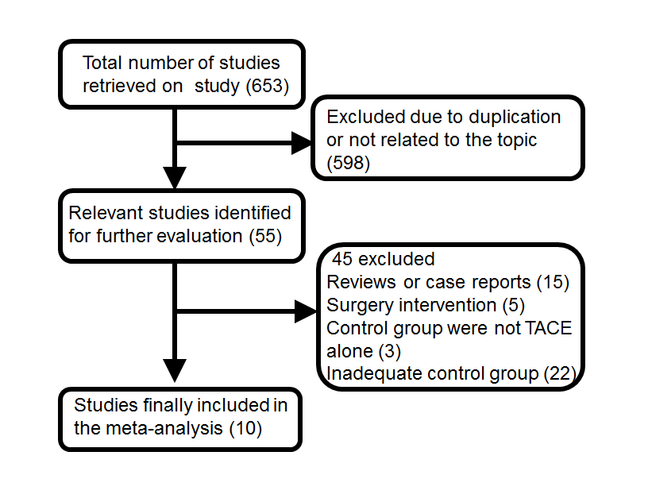
Figure 1 Route and results of including trials of the meta-analysis.

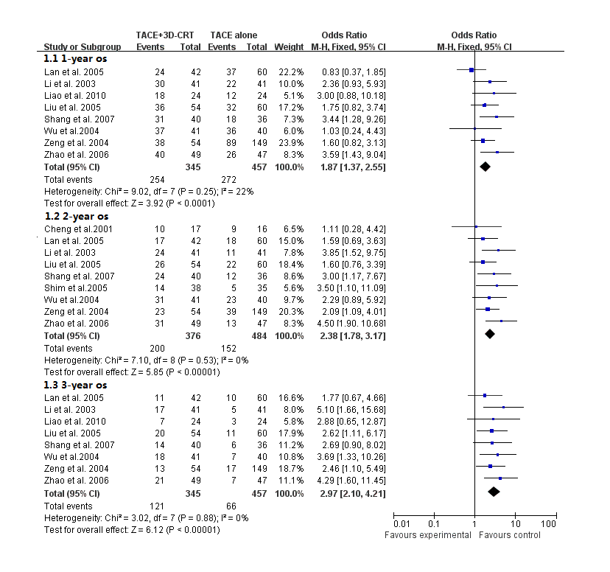
Figure 2 Outcomes of overall survival of combination therapy compared with sole transcatheter arterial chemoembolization therapy.

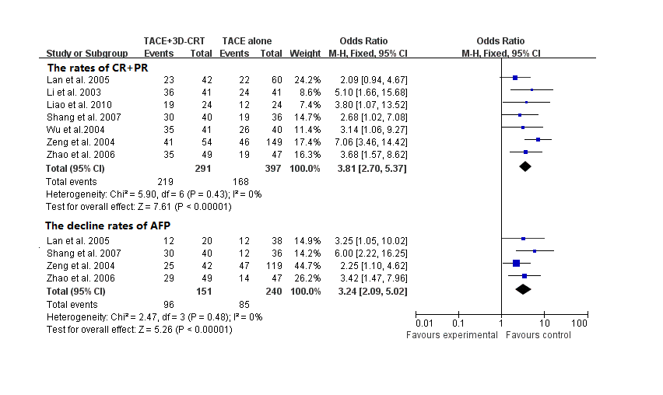
Figure 3 Better tumor response and higher decline in α fetal protein level were shown in patients treated with combination therapy.

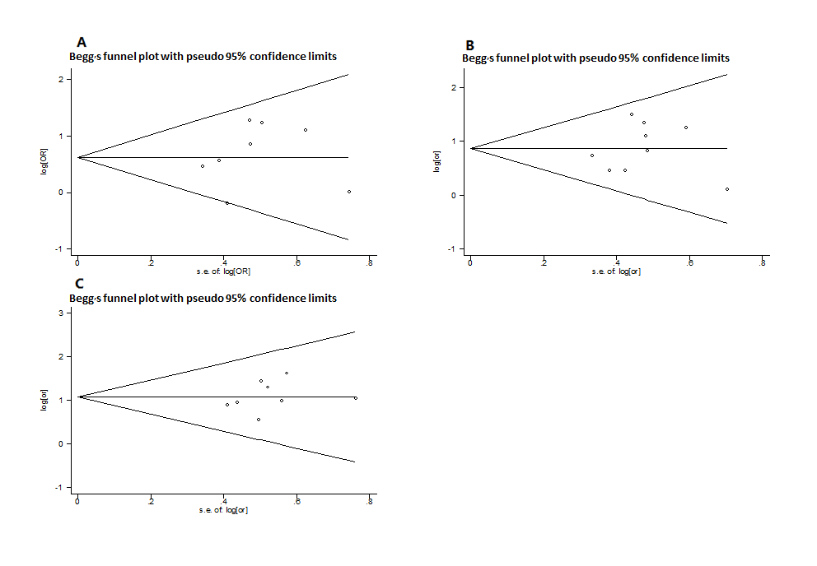
Figure 4 No significant asymmetry was revealed in 1-year (A), 2-year (B) and 3-year (C) overall survival.

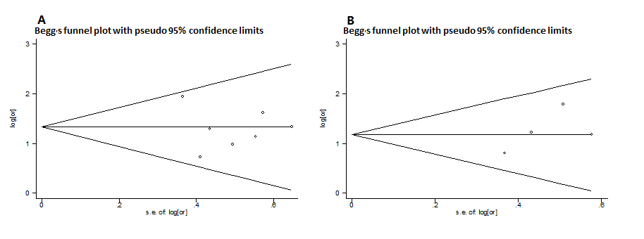
Figure 5 No publication bias was found in tumor response (A) and reduction in α fetal protein level (B).

