Name of Journal: World Journal of Clinical Cases
Manuscript NO: 70262
Manuscript Type: CASE REPORT

Posterior reversible encephalopathy syndrome in a patient with metastatic breast cancer: A case report

Song CH et al. PRES in metastatic breast cancer

Chae Hyun Song, Seung Jun Lee, Ha Ra Jeon

Chae Hyun Song, Seung Jun Lee, Department of Physical Medicine and Rehabilitation, National Health Insurance Service Ilsan Hospital, Goyang-si Gyeonggi-do 10444, South Korea

Ha Ra Jeon, Department of Physical Medicine and Rehabilitation, National Health Insurance Service Ilsan Hospital, Goyang-si Gyeonggi-do ASI/KR/KS009/Goyang, South Korea

Author contributions: Jeon HR, and Song CH designed the research study; Jeon HR, Song CH, and Lee SJ wrote the manuscript; all authors have read and approve the final manuscript.

Corresponding author: Ha Ra Jeon, MD, Doctor, Department of Physical Medicine and Rehabilitation, National Health Insurance Service Ilsan Hospital, 100 ilsan-ro, ilsan-donggu, Goyang-si Gyeonggi-do ASI/KR/KS009/Goyang, 10444 Korea, South Korea. jeon1021@nhimc.or.kr

Received: July 28, 2021
Revised: November 5, 2021
Accepted: January 25, 2022
Published online: March 6, 2022

Abstract
BACKGROUND
Posterior reversible encephalopathy syndrome (PRES) is a neurotoxic encephalopathic state with clinical symptoms such as headache, altered consciousness, visual disturbances, and seizures. Vasogenic edema occurs predominantly in the posterior occipital and parietal lobes of the brain. PRES is caused by various diseases, and its mechanism remains unclear. However, it can be easily diagnosed based on characteristic lesions on magnetic resonance imaging.

CASE SUMMARY
A 51-year-old woman with unremarkable past medical history presented with progressively worsening back pain since 2 mo. Physical examinations revealed paralumbar muscle tenderness, a large lesion on the right breast and several mass-like lesions on both breasts. The blood pressure (BP) was elevated (150/90 mmHg), and did not respond to antihypertensive medication. On the seventh day of hospitalization, she exhibited a confused mental status and generalized tonic-clonic seizures. On magnetic resonance imaging, bilateral cortical and subcortical edema of the occipital lobes, suggestive of PRES, was observed. The serum calcium was 15.8 mg/dL. After two days of treatment with nicardipine, elcatonin, and zolendronic acid, her BP was 130/91 mmHg and serum calcium was 10.1 mg/dL. The patient regained consciousness and her mental status improved. Fluorodeoxyglucose-positron emission tomography revealed right breast cancer with extensive metastases.

CONCLUSION
Although rare, hypercalcemia can lead to PRES by causing uncontrolled hypertension. Prompt diagnosis can help prevent severe mental disturbances and even death.

Key Words: Posterior reversible encephalopathy syndrome; Breast cancer; Hypercalcemia; Hypertension; Case report

©The Author(s) 2022. Published by Baishideng Publishing Group Inc. All rights reserved.

Citation: Song CH, Lee SJ, Jeon HR. Posterior reversible encephalopathy syndrome in a patient with metastatic breast cancer: A case report. World J Clin Cases 2022; 10(7): 2281-2285
URL: https://www.wjgnet.com/2307-8960/full/v10/i7/2281.htm
DOI: https://dx.doi.org/10.12998/wjcc.v10.i7.2281

Core Tip: Posterior reversible encephalopathy syndrome (PRES) is a treatable but potentially fatal encephalopathic state that can accompany various conditions. Although hypercalcemia-related PRES is rare, it may occur in certain diseases. In this case report, metastatic breast cancer led to hypercalcemia, which led to uncontrolled hypertension and finally, PRES.

INTRODUCTION
Posterior reversible encephalopathy syndrome (PRES) is a neurotoxic encephalopathic state with clinical features such as headache, vomiting, altered consciousness, visual disturbances, and seizures. The radiologic findings demonstrate vasogenic edema in the posterior occipital and parietal lobes of the brain^{[1]}. The pathogenesis of PRES remains unclear, but it is likely related to cerebral autoregulatory failure and endothelial dysfunction.
Hypertension is the most common cause of PRES. Post-transplantation, immune suppression, infection, or autoimmune disease are also risk factors for PRES. In cancer patients, wide use of chemotherapy and targeted agents can be associated with PRES. Hypercalcemia rarely causes PRES, but there have been few reports on hypercalcemia-induced PRES^{[2]}.
Hypercalcemia is a common finding in patients with advanced stage cancer. Hypercalcemia develops in cancer patients via parathyroid hormone-related peptide (PTHrP) production, osteolytic metastasis, excessive calcium release from the bone, ectopic 1-alpha-hydroxylase activity, and 1,25-dihydroxycholecalciferol formation^{[3]}.
We present a case of PRES caused by hypercalcemia and hypertension in a patient with advanced breast cancer with multiple bone metastasis who had never received chemotherapy.

CASE PRESENTATION
Chief complaints
A 51-year-old woman with unremarkable medical history was admitted to the hospital via the emergency room for lower back pain.

History of present illness
She complained of worsening back pain after lifting a heavy object two months ago. The numeric rating scale (NRS) score for back pain was seven points.

History of past illness
The patient had an unremarkable medical history.

Personal and family history
The patient had an unremarkable personal and family history.

Physical examination
Physical examination revealed paralumbar muscle tenderness, a 5 cm × 8 cm skin ulcer on her right breast, and several mass-like lesions on both breasts. We planned to evaluate the multiple breast masses under the impression of breast cancer while treating her lumbar pain.
Her blood pressure on admission was 150/90 mmHg despite no history of hypertension. When the patient complained of severe pain, the blood pressure elevated to 170-180 mmHg, and when the pain was relieved, it decreased to 150 mmHg. Therefore, we concluded that the increased blood pressure was likely due to the uncontrolled pain, since the patient did not have a history of hypertension. Attempts to alleviate the pain included physical therapy, trigger point injection, and medication (intravenous nefopam and methocarbamol, as well as oral acetaminophen and tramadol). However, the pain and elevated blood pressure persisted (systolic BP, 160–180 mmHg). On the 4th day of admission, the patient continued to complain of severe pain (NRS score 8-9), and the patient's blood pressure was measured up to 186/106 mmHg. Therefore, we added oral and intravenous antihypertensive drugs to control her BP, but no improvement was observed.
On the 7th day of hospitalization, the patient had an altered mental status with generalized tonic-clonic seizures lasting for 1 min.

Laboratory examinations
Her serum calcium level was 15.8 mg/dL.

Imaging examinations
Electroencephalography showed repetitive seizures localized in the bilateral posterior region that were more prominent on the left side. Brain magnetic resonance imaging showed bilateral cortical and subcortical edema of the occipital lobes suggesting PRES lesions (Figure 1).

FINAL DIAGNOSIS
The final diagnosis of the presented case was PRES due to uncontrolled hypertension and hypercalcemia.

TREATMENT
Her high BP was controlled using intravenous nicardipine, while the hypercalcemia was treated using normal saline, elcatonin, and zoledronic acid.

OUTCOME AND FOLLOW-UP
After two days of treatment, she had a BP of 130/91 mmHg and a serum cacium level of 10.1 mg/dL. Moreover, her mental status improved. After regaining consciousness, she experienced a partial visual field defect for a few days because of the occipital lobe involvement of PRES.
After the patient regained consciousness, fluorodeoxyglucose-positron emission tomography (FDG-PET) imaging was performed to evaluate the cancer status. FDG-PET imaging suggested right large breast cancer with extensive metastatic lesions, including the left breast, right axillary lymph node, and multiple bones (Figure 2). In addition, a biopsy for histopathological examination of the breast lesion, confirmed invasive ductal carcinoma.

DISCUSSION
The pathophysiology of PRES remains unclear, but there are two leading theories. First, when the blood pressure exceeds the upper limit of cerebral blood flow autoregulation, cerebral hyperperfusion occurs, and the blood-brain barrier breaks, allowing interstitial extravasation, which may cause vascular leakage and vasogenic edema^{[1]}. The posterior brain areas are particularly susceptible to hyperperfusion due to the lack of sympathetic innervation. The second theory suggests that the syndrome is triggered by endothelial dysfunction, caused by circulating endogenous or exogenous toxins. The excessive release of pro-inflammatory cytokines results in endothelial activation, enhancing the release of vasoactive agents, and increasing vascular permeability and edema formation, which can also cause hypertension^{[1]}.
In this case, the patient had uncontrolled progressive hypertension after admission. Her systolic BP reached ≥ 180 mmHg. Her elevated BP was one of the leading causes of PRES.
Another consideration was her high calcium level, associated with her advanced breast cancer and multiple bone metastasis. Hypercalcemia is common in breast cancer patients, especially those with advanced-stage and multiple skeletal metastases^{[3]}. The intervention of osteoclasts is the main mechanism of hypercalcemia in patients with extensive osteolytic bone metastases^{[4]}. Excessive osteoclast activation, resulting from RANKL/RANK interaction and malignancy-secreted cytokines, leads to enhanced bone resorption and hypercalcemia.
Although the precise mechanism remains unclear, the pathophysiology of PRES can be correlated with increased calcium levels. Hypercalcemic conditions impair endothelial function by inhibiting the activation of nitric oxide released from endothelial cells. This has a vasodilating effect and increases systolic blood pressure^{[5]}. In this case, the patient's high blood pressure was not controlled by antihypertensive drugs but was controlled after hypercalcemia was corrected. Another hypothesis is that hypercalcemia-induced hypomagnesemia results in hypertension. Based on the antagonism between calcium and magnesium, and the vasodilating properties of magnesium elevated calcium levels lower magnesium concentration. Thus, a magnesium deficit contributes to the development of vasoconstriction. The patient had slight hypomagnesemia (0.72 mmol/L, reference value 0.77-1.03 mmol/L). Based on this, the excessive calcium level of the patient made her vulnerable to developing PRES.
PRES has been reported in cancer patients who have undergone chemotherapy of targeted agents^{[6,7]}. However, herein we focused on the pathophysiology found in advanced cancer in a case of PRES in an untreated breast cancer patient.

CONCLUSION
This was a rare case of PRES caused by hypertension and hypercalcemia. Although hypercalcemia is a rare cause of PRES, it can, directly and indirectly, result in uncontrolled hypertension, which can lead to PRES. Thus, it is essential to recognize diseases that induce hypercalcemia because PRES has been associated with severe consciousness disturbances and can be fatal. A prompt diagnosis is essential for adequate treatment.

REFERENCES
1 Fugate JE, Rabinstein AA. Posterior reversible encephalopathy syndrome: clinical and radiological manifestations, pathophysiology, and outstanding questions. Lancet Neurol 2015; 14: 914-925 [PMID: 26184985 DOI: 10.1016/S1474-4422(15)00111-8]
2 Bolanthakodi N, Vidyasagar S, Varma M, Holla A. Posterior reversible encephalopathy syndrome due to hypercalcaemia: a rare cause. BMJ Case Rep 2019; 12 [PMID: 30755423 DOI: 10.1136/bcr-2017-223415]
3 Mirrakhimov AE. Hypercalcemia of Malignancy: An Update on Pathogenesis and Management. N Am J Med Sci 2015; 7: 483-493 [PMID: 26713296 DOI: 10.4103/1947-2714.170600]
4 Feldenzer KL, Sarno J. Hypercalcemia of Malignancy. J Adv Pract Oncol 2018; 9: 496-504 [PMID: 31086686]
5 Nilsson IL, Rastad J, Johansson K, Lind L. Endothelial vasodilatory function and blood pressure response to local and systemic hypercalcemia. Surgery 2001; 130: 986-990 [PMID: 11742327 DOI: 10.1067/msy.2001.118368]
6 Cacho-Díaz B, Lorenzana-Mendoza NA, Salmerón-Moreno K, Reyes-Soto G, Castillo-Rangel C, Corona-Cedillo R, Escobar-Ceballos S, Garza-Salazar JG. Chemotherapy-induced posterior reversible encephalopathy syndrome: Three case reports. Medicine (Baltimore) 2019; 98: e15691 [PMID: 31083272 DOI: 10.1097/MD.0000000000015691]
7 Ladwa R, Peters G, Bigby K, Chern B. Posterior Reversible Encephalopathy Syndrome in Early-Stage Breast Cancer. Breast J 2015; 21: 674-677 [PMID: 26385119 DOI: 10.1111/tbj.12502]

Footnotes
Informed consent statement: This report is a retrospective study based on medical records, and written consent was obtained from the Ethics Committee.

Conflict-of-interest statement: The authors declare that they have no conflict of interest.

CARE Checklist (2016) statement: The authors have read the CARE Checklist (2016), and the manuscript was prepared and revised according to the CARE Checklist (2016)

Open-Access: This article is an open-access article that was selected by an in-house editor and fully peer-reviewed by external reviewers. It is distributed in accordance with the Creative Commons Attribution NonCommercial (CC BY-NC 4.0) license, which permits others to distribute, remix, adapt, build upon this work non-commercially, and license their derivative works on different terms, provided the original work is properly cited and the use is non-commercial. See: https://creativecommons.org/Licenses/by-nc/4.0/

Provenance and peer review: Unsolicited Manuscript; Externally peer reviewed.

Peer-review started: July 28, 2021
First decision: October 25, 2021
Article in press: January 25, 2022

Specialty type: Clinical neurology
Country/Territory of origin: South Korea
Peer-review report’s scientific quality classification
Grade A (Excellent): 0
Grade B (Very good): B
Grade C (Good): C
Grade D (Fair): 0
Grade E (Poor): 0

P-Reviewer: Hasan A S-Editor: Liu JH L-Editor: A P-Editor: Liu JH
Figure Legends
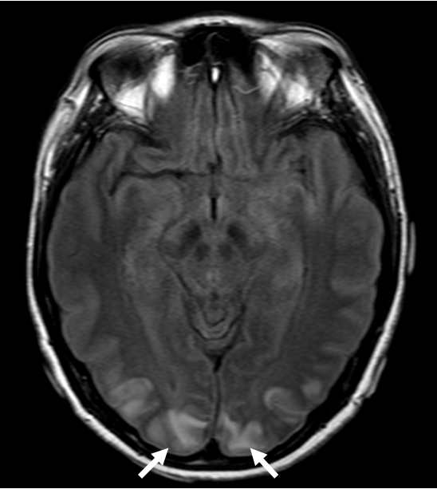
Figure 1 Brain magnetic resonance imaging showed T2 fluid-attenuated inversion recovery hyperintensities in the occipital cortex.

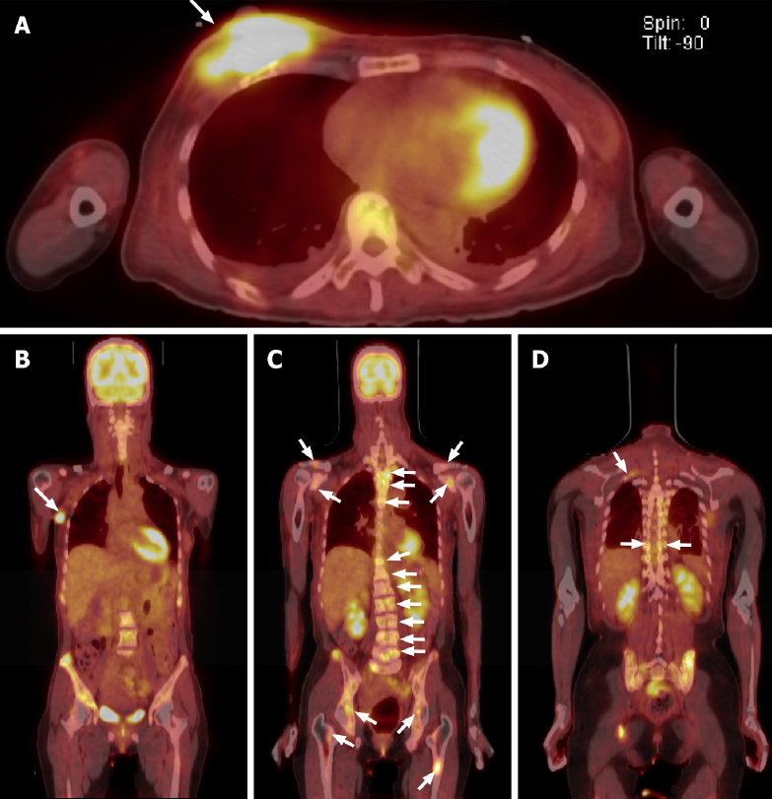
Figure 2 Fluorodeoxyglucose-positron emission tomography showed high uptake. A: Both breasts; B: The right axillary lymph node; C: Both clavicles, scapulars, pelvic bones, femurs, entire spines; D: The sternum, and ribs.

Published by Baishideng Publishing Group Inc
7041 Koll Center Parkway, Suite 160, Pleasanton, CA 94566, USA
Telephone: +1-925-3991568
E-mail: bpgoffice@wjgnet.com
Help Desk: https://www.f6publishing.com/helpdesk
https://www.wjgnet.com

© 2022 Baishideng Publishing Group Inc. All rights reserved.

