Name of Journal: World Journal of Gastrointestinal Surgery
Manuscript NO: 60843
Manuscript Type: SYSTEMATIC REVIEWS

Is colonic lavage a suitable alternative for left-sided colonic emergencies?

Tham HY et al. Colonic lavage for left-sided colon surgery

Hui Yu Tham, Wen Hui Lim, Sneha Rajiv Jain, Cheng Han Mg, Snow Yunni Lin, Jie Ling Xiao, Fung Joon Foo, Kar Yong Wong, Choon Seng Chong

Hui Yu Tham, Department of Surgery, University Surgical Cluster, National University Hospital, Singapore 11759, Singapore

Wen Hui Lim, Sneha Rajiv Jain, Cheng Han Mg, Snow Yunni Lin, Jie Ling Xiao, Department of Medicine, Yong Loo Lin School of Medicine, National University of Singapore, Singapore 11759, Singapore

Fung Joon Foo, Department of Colorectal Surgery, Singapore General Hospital, Singapore 169608, Singapore

Fung Joon Foo, Department of General Surgery, Sengkang Health, Singapore 544886, Singapore

Kar Yong Wong, Colorectal Surgery Service, Department of General Surgery, Tan Tock Seng Hospital, Singapore 308433, Singapore

Choon Seng Chong, Division of Colorectal Surgery, University Surgical Cluster, National University Health System, Singapore 119228, Singapore

Choon Seng Chong, Department of General Surgery, Yong Loo Lin School of Medicine, National University of Singapore, Singapore 119228, Singapore

Author contributions: Study conception and design was conducted by Jain SR, Mg CH and Chong CS; material preparation, data collection, analysis and interpretation were performed by Tham HY, Lim WH, Jain SR, Mg CH and Lin SY; the first draft was written by Tham HY, Lim WH, Jain SR and Mg CH; all authors commented on previous versions of the manuscript, read and approved the final manuscript.

Corresponding author: Choon Seng Chong, FRCS (Ed), MBBS, Assistant Professor, Division of Colorectal Surgery, University Surgical Cluster, National University Health System, 1E Kent Ridge Road, Singapore 119228, Singapore. choon_seng_chong@nuhs.edu.sg

Received: November 16, 2020
Revised: February 16, 2021
Accepted: March 12, 2021
Published online: April 27, 2021

Abstract
BACKGROUND
The use of intra-operative colonic lavage (IOCL) with primary anastomosis remains controversial in the emergency left-sided large bowel pathologies, with alternatives including Hartmann’s procedure, manual decompression and subtotal colectomy.

AIM
To compare the peri-operative outcomes of IOCL to other procedures.

METHODS
Electronic databases were searched for articles employing IOCL from inception till July 13, 2020. Odds ratio and weighted mean differences (WMD) were estimated for dichotomous and continuous outcomes respectively. Single-arm meta-analysis was conducted using DerSimonian and Laird random effects.

RESULTS
Of 28 studies were included in this meta-analysis, involving 1142 undergoing IOCL, and 634 other interventions. IOCL leads to comparable rates of wound infection when compared to Hartmann’s procedure, and anastomotic leak and wound infection when compared to manual decompression. There was a decreased length of hospital stay (WMD = -7.750; 95%CI: -13.504 to -1.996; P = 0.008) compared to manual decompression and an increased operating time. Single-arm meta-analysis found that overall mortality rates with IOCL was 4% (CI: 0.03-0.05). Rates of anastomotic leak and wound infection were 3% (CI: 0.02-0.04) and 12% (CI: 0.09-0.16) respectively.

CONCLUSION
IOCL leads to similar rates of post-operative complications compared to other procedures. More extensive studies are needed to assess the outcomes of IOCL for emergency left-sided colonic surgeries.

Key Words: Colon; Colonic irrigation; Intra-operative colonic lavage; Anastomosis; Emergency surgery; Colonic neoplasm

©The Author(s) 2021. Published by Baishideng Publishing Group Inc. All rights reserved.

Citation: Tham HY, Lim WH, Jain SR, Mg CH, Lin SY, Xiao JL, Foo FJ, Wong KY, Chong CS. Is colonic lavage a suitable alternative for left-sided colonic emergencies? World J Gastrointest Surg 2021; 13(4): 379-391
URL: https://www.wjgnet.com/1948-9366/full/v13/i4/379.htm
DOI: https://dx.doi.org/10.4240/wjgs.v13.i4.379

Core Tip: Comparing the intra and post-operative outcomes of primary resection and immediate reconstruction after either intra-operative colonic lavage (IOCL), manual decompression or without IOCL against Hartmann’s procedure and subtotal colectomy in the management of colorectal emergencies, intraoperative colonic lavage was found to have largely similar rates of post-operative complications compared to other procedures. The operative duration was observed to be statistically longer in IOCL than without IOCL. However, hospitalization stay was significantly shorter in duration in those with IOCL compared to Hartmann’s. Thus, there may be merits in choosing IOCL especially for patients who are hemodynamically stable.

INTRODUCTION
First described by Dudley in 1983^{[1]}, the use of intraoperative colonic lavage (IOCL) with primary anastomosis remains controversial in the colorectal emergency surgery. Large bowel obstruction represents up to 80% of emergencies associated with colorectal carcinoma while perforations, diverticulitis, and colonic volvulus accounts for the remaining^{[2,3]}. The mechanics were intended to remove fecal material to reduce the chances of contamination and served to reduce colonic distention facilitating closure, improving colonic blood supply and reducing anastomotic tension^{[4]}. Primary anastomosis after IOCL has since been thought to facilitate good bowel preparation for a safe anastomosis and avoid the disadvantages associated with staged operations^{[5,6]}.
Current literature, however, suggests that complete cleaning of the colon from fecal matter may not be necessary to ensure anastomotic integrity^{[7,8]}. Furthermore, there is evidence that IOCL may lead to greater proximal colonic mobilization, longer operating time, electrolyte abnormalities and hypothermia from infusion with large amounts of saline^{[9]}. Alternative options thus include performing a primary anastomosis using unprepped colon, or manual decompression. For most left-sided emergencies, Hartmann’s procedure is commonly performed^{[10]} although it has been associated with increased morbidity due to the need for a second operation to reestablish intestinal continuity^{[11]} with up to 50% having permanent stomas^{[12]}. Alternatively, subtotal and total colectomy are practiced in cases of impending cecal perforation or synchronous colonic neoplasms^{[13]} but the post-operative increased frequency of motion relative to other colon sparing operations, may adversely affect quality of life^{[14]}.
Therefore, in light of the uncertainty concerning the necessity and efficacy of IOCL and alternative procedures, this study aims to compare the intra and post-operative outcomes of primary resection and immediate reconstruction after either IOCL, manual decompression or without IOCL against Hartmann’s procedure and subtotal colectomy in the management of colorectal emergencies.

MATERIALS AND METHODS
Search strategy
The Preferred Reporting Items for Systematic Reviews and Meta-Analyses (PRISMA) guidelines were adhered to in the synthesis of this review^{[15]}. A systematic literature search was conducted on Medline, Embase and China National Knowledge Infrastructure from inception till July 13, 2020. The full search strategy for Medline is attached in Supplementary search strategy. Citations were then downloaded and reviewed in Endnote Reference Manager X9.

Study selection and eligibility criteria
Citations deemed potentially relevant were first screened by title and abstract, followed by full text for inclusion by two independent authors, with final inclusion of the articles based on consensus. Both comparative and non-comparative articles about IOCL for both benign and malignant conditions were included. Prospective and retrospective studies, and randomized controlled trials (RCTs) in English and Chinese were included. Studies were excluded if there was no mention of an IOCL or if the publication type was deemed unsuitable (conference abstract, case series, correspondence and reviews). Separate analysis was conducted on studies comparing IOCL and Hartmann’s procedure, manual decompression, subtotal colectomy and no IOCL.

Data extraction and outcomes
For each included article, data were extracted by two independent authors (Tham HY and Lim WH) onto a structured proforma. For each study, details of the author, publication year, country of origin, study design, indication for surgery, population demographics and study outcomes were extracted. Operative time, blood loss, hospital stay, mortality, and complications were collected for intra and post-operative outcomes. Transformation of values were carried out using pre-existing formulae, with mean and standard deviations being calculated from continuous variables of median and range using calculations from Wan et al^{[16]}.

Statistical analysis and quality assessment
Comparative analysis and meta-analysis of proportions was performed using STATA (16.1 StataCorp LLC). In single-arm meta-analysis, the “metaprop” function was used to calculate overall incidence and proportions using the Freeman-Tukey double arcsine transformation to stabilize variance^{[17]}, with DerSimonian and Laird random effects model used for pooled analysis^{[18]}. For pairwise comparison, weighted mean differences (WMD) and odds ratio (OR) were estimated for continuous and dichotomous outcomes respectively. Random effects by Dersimonian and Laird were used regardless of heterogeneity measures (Cochrane Q test, I² and tau)^{[19,20]}. Significance was considered when P < 0.05.
The quality of included articles was independently assessed by two authors using the Jadad Scale for RCTs and the Newcastle-Ottawa Scale (NOS) for cohort studies^{[21,22]}. The Jadad Scale is a 5-point scale for measuring the quality of RCTs, assessing the randomization, blinding and withdrawals within the study^{[23]}. A score of three or more points on the Jadad Scale indicates high quality. The NOS assesses the selection, comparability and outcomes in the relevant articles.

RESULTS
A systematic search of the literature utilizing the above search strategy yielded a total of 789 articles, with 637 remaining after duplicate removal. 500 were excluded based on the study title and abstract, and 137 full text articles were derived for a full text review, of which 29 articles were subsequently included in the meta-analysis. Nine studies originated from China, five studies arising from Spain, three studies from the United Kingdom, two from Italy, Egypt and Singapore as well as one from the United States of America, France, Japan, Lithuania, Turkey and Nigeria. Of the 29 included studies, 17 were single-arm studies^{[6,24-40]}, 2 were retrospective cohort studies^{[41,42]}, 9 were prospective cohort studies^{[4,31,43-49]}, and 1 was an RCT^{[50]}. A summary of the selection strategy is presented in Figure 1.
Of 15 studies were solely focused on patients with colorectal cancer, whilst 14 studies contained patients with both malignant and benign etiologies, and three studies involved patients with solely benign conditions. In total, 1142 patients underwent single-staged colonic resection with IOCL and primary anastomosis, 183 patients had colonic resection with primary anastomosis without IOCL, 128 patients underwent single-staged colonic resection, intraoperative manual colonic decompression with primary anastomosis, while 35 patients received subtotal colectomy and 288 patients underwent Hartman’s procedure. A summary of the characteristics of included studies can be found in Supplementary Table 1. Table 1 presents the summary of results of comparative and Table 2 presents the results of single-arm meta-analysis. Results of quality assessment are available in Supplementary Table 2.

IOCL vs other procedures
IOCL was compared between Hartmann’s procedure, manual decompression, subtotal colectomy and no intervention and the results are summarized in Table 1. The results of 30-d mortality across all procedures are presented in Figure 2.

IOCL vs Hartmann’s procedure
Hospitalization stay was observed to be significantly shorter in duration in those with IOCL (WMD = -7.750, 95%CI: -13.50 to -1.97, P = 0.008). However, there was no significant difference in the rates of 30-d mortality (OR = 0.525; 95%CI: 0.272-1.012; P = 0.054) and post-operative complications including wound infection (OR = 0.755; 95%CI: 0.433-1.314; P = 0.320), paralytic ileus (OR = 3.405; 95%CI: 0.791-14.644; P = 0.100), pneumonia (OR = 0.473; 95% CI: 0.168-1.332; P = 0.156), and re-operation (OR = 0.560; 95%CI: 0.094-3.324; P = 0.523) between those undergoing IOCL compared to Hartmann’s procedure.

IOCL vs manual decompression
Comparing between the two groups, there were no statistically significant differences in 30-d mortality (OR = 1.054 95%CI: 0.245-4.569; P = 0.943), anastomotic leak (OR = 0.585; 95%CI: 0.177-1.937; P = 0.380), wound infection (OR = 1.996; 95%CI: 0.402-9.926; P = 0.398), and reoperation rate (OR = 1.237; 95%CI: 0.366-4.185; P = 0.733).

IOCL vs subtotal colectomy
There were no statistically significant differences in the incidences of 30-d mortality (OR = 0.356; 95%CI: 0.035-3.608; P = 0.382). Postoperative complications such as anastomotic leak (OR = 13.462; 95%CI: 0.704-257.477; P = 0.718), intra-abdominal infection (OR = 0.266; 95%CI: 0.012-6.133; P = 0.408), pneumonia (OR = 0.266; 95%CI: 0.012-6.133; P = 0.408) and sepsis (OR = 2.30; 95%CI: 0.075-71.005; P = 0.634) were otherwise comparable amongst both groups. Pooled analysis did not demonstrate any significant differences in duration of hospitalization between IOCL and subtotal colectomy (WMD = 0.3; 95%CI: -6.146-6.746; P = 0.927).

IOCL vs no IOCL
The operative duration was observed to be statistically longer in IOCL than no IOCL (WMD = 27.553; 95%CI: 10.560-44.546; P = 0.001). However, 30-d mortality rates did not differ significantly between IOCL and no IOCL (OR = 0.625; 95%CI: 0.144-2.711; P = 0.53). Post-operative complications including anastomotic leak (OR = 0.549; 95%CI: 0.121–2.472; P = 0.434), wound infection (OR = 4.130; 95%CI: 1.112-15.338; P = 0.522) and paralytic ileus (OR = 0.474; 95%CI: 0.121-1.859; P = 0.285) were also found to be similar amongst both groups. Rates of intra-abdominal infection (OR = 1.012; 95%CI: 0.116 – 8.821; P = 0.991) and pneumonia (OR = 0.445; 95%CI: 0.114-1.737; P = 0.244), and re-operation (OR = 0.194; 95%CI: 0.008-4.407; P = 0.296) were observed to be comparable. There was no difference in duration of hospital stay (WMD = -25.911; 95%CI: -67.404-15.582; P = 0.221).

Intra-operative colonic lavage only
The pooled estimate of the 30-d mortality in patients with IOCL was 4% (CI: 0.03-0.05). Analysis of significant postoperative outcomes reported the incidence of anastomotic leak to be 3% (CI: 0.02-0.04, Figure 3), wound infection at 12% (CI: 0.09-0.16, Figure 4), intra-abdominal infection at 3% (CI: 0.01-0.04), and sepsis at 2% (CI: 0.01-0.05). The pooled estimate reported for the duration of surgery was 194.754 min (CI: 164.834-224.276) respectively. Pooled analysis of intraoperative blood loss and duration of hospital stay was 290.996 mL (CI: -184.98-766.973) and 15.935 d (CI: 12.927-18.944). Analysis of other outcomes are presented in Table 2. The results of single-arm meta-analysis for rates of anastomotic leak and wound infection are presented in Figures 3 and 4 respectively.

Sensitivity analysis
A sensitivity analysis was conducted on patients that only had cancer as the disease etiology. The 30-d mortality rate was reported to be 2% (CI: 0.01-0.04). Rates of complications such as anastomotic leak, wound infection, paralytic ileus, and pneumonia were found to be 3% (CI: 0.01-0.05), 11% (CI: 0.07-0.16), 7% (CI: 0.00-0.18), and 5% (CI: 0.00-0.12) respectively. Patients who had cancer had a sepsis rate of 2% (CI: 0.01-0.05). Re-operation rates in only patients who had malignant etiologies were found to be 2% (CI: 0.00-0.07).

DISCUSSION
With the evolution of colonic preparation and irrigation, this review serves to consolidate the existing knowledge regarding the need for and importance of IOCL in left-sided colonic emergencies. Conversion into a clean, decompressed colon improves the anastomotic healing process, but there is no consensus on its impact on anastomotic leak rates. IOCL has been hypothesized to decrease the rate of suture failure and its associated complications^{[49]}, while also being an acceptable one-stage procedure that avoids contamination. Previous literature suggests that IOCL can be performed based on the comfort level of the surgeon^{[51]}. However, there are controversies with the current practice of IOCL when compared to alternatives such as manual decompression, Hartmann’s procedure and subtotal colectomy for emergency left-sided colorectal surgeries.
IOCL before a primary anastomosis enables the surgeon to prepare the colon and is thought to reduce the rate of anastomotic leak and wound dehiscence^{[6]}. Studies have suggested that complete cleaning of the colon from fecal matter may not be necessary to ensure anastomotic integrity^{[7,8]}. This review found that post-operative complications including anastomotic leak rates (OR = 1.168; 95%CI: 0.502-2.717; P = 0.718) and wound dehiscence (OR = 0.915; 95%CI: 0.161-5.192; P = 0.920) were largely comparable to other interventions. This is similar to previous studies that found that there is no significant benefit to bowel preparation in elective settings^{[52]}. Although IOCL aids in the removal of fecal material, the colon is not completely sterile despite thorough lavage. Hence, IOCL during emergency colorectal surgery does not necessarily lead to a significant change in the rates of anastomotic leak or wound dehiscence after surgery, as supported by the results of this meta-analysis. While intraoperative complications were by and large similar between IOCL and other modalities, the use of IOCL consistently led to a decreased length of stay compared to other modalities, including Hartmann’s procedure (WMD = -7.750; 95%CI: -13.504 to -1.996; P = 0.008), and manual decompression (WMD = 3.500; 95%CI: 2.943-4.057; P < 0.001). A prolonged length of stay leads to increased use of healthcare resources, greater stress on the country’s healthcare system and is a predictor for readmission^{[53]}.
Over the years and with the creation of new techniques in management of colonic emergencies, the practice of IOCL has been gradually been forgotten, with current guidelines in management either recommending alternative procedures depending on the skill level of the surgeon^{[2]}, or advising against the use of IOCL in emergent left-sided colorectal surgeries^{[54,55]}. This can also be due to the possibility of complications such as electrolyte abnormalities and hypothermia from infusion with large amounts of saline^{[9]}, increase in operative time and supporting this, the results of this meta-analysis found an increase in operative time compared to without lavage (WMD = 27.553; 95%CI: 10.560-44.546; P = 0.001) and with manual decompression (WMD = 22.593; 95%CI: -6.364-51.550; P = 0.126) resulted from IOCL requiring a significantly longer time to prepare (WMD = 15.00; 95%CI: 9.746-20.254; P < 0.001).
It is worth noting that surgeons surveyed preferred performing an on-table lavage when performing a resection with primary anastomosis for a left-sided obstruction^{[3,56,57]}. Where on-table lavage was concerned, the single-arm meta-analysis found the rate of 30-d mortality to be 4% (CI: 0.03-0.05), intra-abdominal infection to be 3% (CI: 0.01-0.04), and re-operation to be 5% (CI: 0.02-0.07) across the included articles. A sensitivity analysis for cancer as the only indication for left-sided colonic emergencies was conducted as cancer is the cause of 80% of colorectal emergencies^{[2,3]}. The sensitivity analysis found a decrease in 30-d mortality to 2% (CI: 0.01-0.04), intra-abdominal infection 1% (CI: 0.00-0.03), and re-operation to 2% (CI: 0.00-0.07). However, while there was a lower rate of complications for malignant etiologies, the mechanism of which remains unknown and further studies are required to explore studies are required to explore the impact of benign and malignant etiologies in table lavage. Additionally, when compared other procedures in managing left-sided colorectal emergencies, especially a manual decompression and subtotal colectomy, an IOCL procedure confers a benefit in terms of proximal colon preservation and reduced intraluminal bacterial load, possibly leading to better outcomes including anastomotic leak and post-operative bowel function. The use of IOCL especially in obstructed colorectal cancer thus may facilitate on-table colonoscopy to detect synchronous lesions, which may alter surgical plans if deemed significant. Hence, in situations where IOCL may not be considered due to surgeon or other factors, its merits of decreased short-term mortality, a shortened length of stay, and comparable short-term complications are not to be dismissed, and it is worth reconsidering the use of IOCL in left-sided colonic emergencies. As more studies are conducted on the outcomes of management of left-sided colorectal emergencies, larger and more extensive, randomized, prospective studies need to be conducted to effectively assess the effectiveness of IOCL in such emergent cases.

Limitations
Limitations of this study should be considered when interpreting the results. A majority of the included papers were written more than a decade ago and hence this study may not be representative of the current standard of practice for IOCL. Newer strategy in managing left sided colonic obstruction such as colonic stenting followed by elective surgery is also not discussed in this paper. Due to a limited sample size in the comparison between IOCL and subtotal colectomy, results of this analysis need to be interpreted with caution. Additionally, the inherent quality of study designs with a large majority presented by observational cohort studies (n = 27) lack the rigor of RCTs. Furthermore, only papers in English and Chinese were included due to linguistic constraint.

CONCLUSION
Despite the gradual phasing out of practice, IOCL leads to a shortened hospital stay and comparable post-operative complications compared to other modalities of managing left-sided colonic emergencies in patients who are hemodynamically stable and are hence able to tolerate a longer time under general anesthesia. Added with the ability to conduct an on-table colonoscopy, the merits of IOCL should not be dismissed while keeping in mind its disadvantages in increased operative time. However, due to a lack of randomized trials, further studies need to be conducted to fairly assess the outcomes of IOCL in the present-day management of emergent left-sided colonic surgeries.

ARTICLE HIGHLIGHTS
Research background
The use of intra-operative colonic lavage (IOCL) with primary anastomosis remains controversial in the emergency left-sided large bowel pathologies. There is little literature present that concludes the effectiveness of IOCL over its alternatives, including Hartmann’s procedure, manual decompression and subtotal colectomy.

Research motivation
To establish safety and effectiveness of IOCL, compared to Hartmann’s procedure, manual decompression and subtotal colectomy

Research objectives
To review the perioperative outcomes of IOCL compared to other modalities of bowel preparation for left-sided colorectal surgery.

Research methods
Electronic databases were searched for articles employing IOCL. Studies meeting inclusion criteria were reviewed and information regarding variables of interest were extracted. Odds ratio and weighted mean differences were estimated for dichotomous and continuous outcomes respectively. Single-arm meta-analysis was conducted using DerSimonian and Laird random effects.

Research results
Of 28 studies were included in this meta-analysis. IOCL leads to comparable rates of wound infection when compared to Hartmann’s procedure, and anastomotic leak and wound infection when compared to manual decompression. There was a decreased length of hospital stay (weighted mean differences = -7.750; 95%CI: -13.504 to -1.996; P = 0.008) compared to manual decompression and an increased operating time. Overall mortality rates with IOCL were 4% (95%CI: 0.03-0.05). Rates of anastomotic leak and wound infection were 3% (95%CI: 0.02-0.04) and 12% (95%CI: 0.09-0.16) respectively.

Research conclusions
IOCL leads to similar rates of post-operative complications compared to other procedures.

Research perspectives
More extensive studies are needed to assess the outcomes of IOCL for emergency left-sided colonic surgeries.

REFERENCES
1 Radcliffe AG, Dudley HA. Intraoperative antegrade irrigation of the large intestine. Surg Gynecol Obstet 1983; 156: 721-723 [PMID: 6857450]
2 Pisano M, Zorcolo L, Merli C, Cimbanassi S, Poiasina E, Ceresoli M, Agresta F, Allievi N, Bellanova G, Coccolini F, Coy C, Fugazzola P, Martinez CA, Montori G, Paolillo C, Penachim TJ, Pereira B, Reis T, Restivo A, Rezende-Neto J, Sartelli M, Valentino M, Abu-Zidan FM, Ashkenazi I, Bala M, Chiara O, De’ Angelis N, Deidda S, De Simone B, Di Saverio S, Finotti E, Kenji I, Moore E, Wexner S, Biffl W, Coimbra R, Guttadauro A, Leppäniemi A, Maier R, Magnone S, Mefire AC, Peitzmann A, Sakakushev B, Sugrue M, Viale P, Weber D, Kashuk J, Fraga GP, Kluger I, Catena F, Ansaloni L. 2017 WSES guidelines on colon and rectal cancer emergencies: obstruction and perforation. World J Emerg Surg 2018; 13: 36 [PMID: 30123315 DOI: 10.1186/s13017-018-0192-3]
3 Sawai RS. Management of colonic obstruction: a review. Clin Colon Rectal Surg 2012; 25: 200-203 [PMID: 24294120 DOI: 10.1055/s-0032-1329533]
4 Kassem M, ElHaddad H. Colectomy and immediate anastomosis vs on-table colonic lavage for the management of acutely obstructed left colon. ACES 2017; 6 [DOI: 10.5455/aces.20161017105054]
5 Murray JJ, Schoetz DJ Jr, Coller JA, Roberts PL, Veidenheimer MC. Intraoperative colonic lavage and primary anastomosis in nonelective colon resection. Dis Colon Rectum 1991; 34: 527-531 [PMID: 2055137 DOI: 10.1007/bf02049889]
6 Forloni B, Reduzzi R, Paludetti A, Colpani L, Cavallari G, Frosali D. Intraoperative colonic lavage in emergency surgical treatment of left-sided colonic obstruction. Dis Colon Rectum 1998; 41: 23-27 [PMID: 9510306 DOI: 10.1007/BF02236891]
7 Scabini S, Rimini E, Romairone E, Scordamaglia R, Damiani G, Pertile D, Ferrando V. Retraction: Colon and rectal surgery for cancer without mechanical bowel preparation: one-center randomized prospective trial. World J Surg Oncol 2012; 10: 196 [PMID: 22992274 DOI: 10.1186/1477-7819-10-196]
8 Cross KL, Rees JR, Soulsby RH, Dixon AR. Primary anastomosis without colonic lavage for the obstructed left colon. Ann R Coll Surg Engl 2008; 90: 302-304 [PMID: 18492393 DOI: 10.1308/003588408X285874]
9 Kam MH, Tang CL, Chan E, Lim JF, Eu KW. Systematic review of intraoperative colonic irrigation vs. manual decompression in obstructed left-sided colorectal emergencies. Int J Colorectal Dis 2009; 24: 1031-1037 [PMID: 19415306 DOI: 10.1007/s00384-009-0723-1]
10 Regenet N, Tuech JJ, Pessaux P, Ziani M, Rouge C, Hennekinne S, Arnaud JP. Intraoperative colonic lavage with primary anastomosis vs. Hartmann's procedure for perforated diverticular disease of the colon: a consecutive study. Hepatogastroenterology 2002; 49: 664-667 [PMID: 12063965]
11 Leong QM, Koh DC, Ho CK. Emergency Hartmann's procedure: morbidity, mortality and reversal rates among Asians. Tech Coloproctol 2008; 12: 21-25 [PMID: 18512008 DOI: 10.1007/s10151-008-0393-y]
12 Hallam S, Mothe BS, Tirumulaju R. Hartmann's procedure, reversal and rate of stoma-free survival. Ann R Coll Surg Engl 2018; 100: 301-307 [PMID: 29484943 DOI: 10.1308/rcsann.2018.0006]
13 Arnaud JP, Bergamaschi R. Emergency subtotal/total colectomy with anastomosis for acutely obstructed carcinoma of the left colon. Dis Colon Rectum 1994; 37: 685-688 [PMID: 8026235 DOI: 10.1007/bf02054412]
14 FitzHarris GP, Garcia-Aguilar J, Parker SC, Bullard KM, Madoff RD, Goldberg SM, Lowry A. Quality of life after subtotal colectomy for slow-transit constipation: both quality and quantity count. Dis Colon Rectum 2003; 46: 433-440 [PMID: 12682533 DOI: 10.1007/s10350-004-6576-3]
15 Moher D, Liberati A, Tetzlaff J, Altman DG; PRISMA Group. Preferred reporting items for systematic reviews and meta-analyses: the PRISMA statement. BMJ 2009; 339: b2535 [PMID: 19622551 DOI: 10.1136/bmj.b2535]
16 Wan X, Wang W, Liu J, Tong T. Estimating the sample mean and standard deviation from the sample size, median, range and/or interquartile range. BMC Med Res Methodol 2014; 14: 135 [PMID: 25524443 DOI: 10.1186/1471-2288-14-135]
17 Nyaga VN, Arbyn M, Aerts M. Metaprop: a Stata command to perform meta-analysis of binomial data. Arch Public Health 2014; 72: 39 [PMID: 25810908 DOI: 10.1186/2049-3258-72-39]
18 DerSimonian R, Laird N. Meta-analysis in clinical trials. Control Clin Trials 1986; 7: 177-188 [PMID: 3802833 DOI: 10.1016/0197-2456(86)90046-2]
19 Doi SA, Barendregt JJ, Khan S, Thalib L, Williams GM. Advances in the meta-analysis of heterogeneous clinical trials I: The inverse variance heterogeneity model. Contemp Clin Trials 2015; 45: 130-138 [PMID: 26003435 DOI: 10.1016/j.cct.2015.05.009]
20 Fletcher J. What is heterogeneity and is it important? BMJ 2007; 334: 94-96 [PMID: 17218716 DOI: 10.1136/bmj.39057.406644.68]
21 Wells G, Shea B, O'connell DL, Peterson J, Welch V, Losos M, Tugwell P. The Newcastle-Ottawa Scale (NOS) for Assessing the Quality of Nonrandomised Studies in Meta-Analyses. Psychology 2014
22 Higgins JP, Altman DG, Gøtzsche PC, Jüni P, Moher D, Oxman AD, Savovic J, Schulz KF, Weeks L, Sterne JA; Cochrane Bias Methods Group; Cochrane Statistical Methods Group. The Cochrane Collaboration's tool for assessing risk of bias in randomised trials. BMJ 2011; 343: d5928 [PMID: 22008217 DOI: 10.1136/bmj.d5928]
23 Jadad AR, Moore RA, Carroll D, Jenkinson C, Reynolds DJ, Gavaghan DJ, McQuay HJ. Assessing the quality of reports of randomized clinical trials: is blinding necessary? Control Clin Trials 1996; 17: 1-12 [PMID: 8721797 DOI: 10.1016/0197-2456(95)00134-4]
24 Mohamed A. Emergency laparoscopic left sided colonic resection with primary anastomosis: Feasibility and Safety. Arch Surg 2018; 2: 31-38 [DOI: 10.29328/journal.ascr.1001021]
25 Edino ST, Mohammed AZ, Anumah M. Intraoperative colonic lavage in emergency surgical treatment of left-sided large bowel lesions. Trop Doct 2005; 35: 37-38 [PMID: 15712545 DOI: 10.1258/0049475053001741]
26 Biondo S, Jaurrieta E, Martí Ragué J, Ramos E, Deiros M, Moreno P, Farran L. Role of resection and primary anastomosis of the left colon in the presence of peritonitis. Br J Surg 2000; 87: 1580-1584 [PMID: 11091249 DOI: 10.1046/j.1365-2168.2000.01556.x]
27 Biondo S, Jaurrieta E, Jorba R, Moreno P, Farran L, Borobia F, Bettonica C, Poves I, Ramos E, Alcobendas F. Intraoperative colonic lavage and primary anastomosis in peritonitis and obstruction. Br J Surg 1997; 84: 222-225 [PMID: 9052441]
28 Lee EC, Murray JJ, Coller JA, Roberts PL, Schoetz DJ Jr. Intraoperative colonic lavage in nonelective surgery for diverticular disease. Dis Colon Rectum 1997; 40: 669-674 [PMID: 9194460 DOI: 10.1007/BF02140895]
29 Tan SG, Nambiar R, Rauff A, Ngoi SS, Goh HS. Primary resection and anastomosis in obstructed descending colon due to cancer. Arch Surg 1991; 126: 748-751 [PMID: 2039362 DOI: 10.1001/archsurg.1991.01410300094014]
30 Gramegna A, Saccomani G. On-table colonic irrigation in the treatment of left-sided large-bowel emergencies. Dis Colon Rectum 1989; 32: 585-587 [PMID: 2737058 DOI: 10.1007/BF02554178]
31 Koruth NM, Hunter DC, Krukowski ZH, Matheson NA. Immediate resection in emergency large bowel surgery: a 7 year audit. Br J Surg 1985; 72: 703-707 [PMID: 4041729 DOI: 10.1002/bjs.1800720910]
32 Ma RL, Zhang X, Yang XP, Zhang WZ, Zhang DJ, Li H, Niu GG. Intraoperative colon lavage and one-stage operation for the treatment of left colon cancer obstruction. Henan Waike Zazhi 2001; 1: 84-85
33 Zhuang ST, Cheng SB, Zheng K, Xu M, Tang YZ, Qin Y, Chen B. Application of intraoperative colon lavage in left colon cancer with acute colonic obstruction. Hainan Yixue Zazhi 2009; 20: 41-41
34 Koruth NM, Krukowski ZH, Youngson GG, Hendry WS, Logie JR, Jones PF, Munro A. Intra-operative colonic irrigation in the management of left-sided large bowel emergencies. Br J Surg 1985; 72: 708-711 [PMID: 4041730 DOI: 10.1002/bjs.1800720911]
35 Zhou QH. Application of proximal colon lavage in primary surgery for obstructive colon cancer: report of 25 cases. Sichuan Yixue Zazhi 2004; 4 [DOI: 10.3969/j.issn.1004-0501.2004.04.077]
36 Chen SB, Li GQ, Li YC, Huang ML. Application of total colon lavage in primary radical resection of left colon cancer. Youjiang Yixue Zazhi 2004; 6 [DOI: 10.3969/j.issn.1003-1383.2004.06.039]
37 Liu QL, Chen JH. Clinical application of intraoperative colon lavage in the first stage resection and anastomosis of obstructive left colon cancer. Yiliao Xinxi 2007; 8
38 Peng DH, Chen DC. Application of Colon Lavage in Surgery of Colon Cancer and Intestinal Obstruction. Yiliao Xinxi 2008; 21: 396-396 [DOI: 10.3969/j.issn.1006-1959.2008.03.050]
39 Du XZ, Meng QH, Ni JX, Fu XM. Application of colon lavage via appendix intubation in the operation of colonic cancer-induced intestinal obstruction. Qilu Yixue Zazhi 2006
40 Application of intraoperative colon lavage in colon cancer with intestinal obstruction. Zhongguo Shequ Yishi 2010; 33
41 Poskus E, Jotautas V, Zeromskas P, Stratilatovas E, Stasinskas A, Strupas K. One-stage operation for cancer of the left colon with bowel obstruction: Do we need on-table wash-out of the colon? Chirurgische Gastroenterologie Interdisziplinar 2006; 22: 47-51 [DOI: 10.1159/000091660]
42 Oren D, Atamanalp SS, Aydinli B, Yildirgan MI, Başoğlu M, Polat KY, Onbaş O. An algorithm for the management of sigmoid colon volvulus and the safety of primary resection: experience with 827 cases. Dis Colon Rectum 2007; 50: 489-497 [PMID: 17205203 DOI: 10.1007/s10350-006-0821-x]
43 Awotar GK, Guan G, Sun W, Yu H, Zhu M, Cui X, Liu J, Chen J, Yang B, Lin J, Deng Z, Luo J, Wang C, Nur OA, Dhiman P, Liu P, Luo F. Reviewing the Management of Obstructive Left Colon Cancer: Assessing the Feasibility of the One-stage Resection and Anastomosis After Intraoperative Colonic Irrigation. Clin Colorectal Cancer 2017; 16: e89-e103 [PMID: 28254356 DOI: 10.1016/j.clcc.2016.12.001]
44 Regenet N, Pessaux P, Hennekinne S, Lermite E, Tuech JJ, Brehant O, Arnaud JP. Primary anastomosis after intraoperative colonic lavage vs. Hartmann's procedure in generalized peritonitis complicating diverticular disease of the colon. Int J Colorectal Dis 2003; 18: 503-507 [PMID: 12910361 DOI: 10.1007/s00384-003-0512-1]
45 Torralba JA, Robles R, Parrilla P, Lujan JA, Liron R, Piñero A, Fernandez JA. Subtotal colectomy vs. intraoperative colonic irrigation in the management of obstructed left colon carcinoma. Dis Colon Rectum 1998; 41: 18-22 [PMID: 9580083 DOI: 10.1007/bf02236890]
46 Mochizuki H, Nakamura E, Hase K, Tamakuma S. The advantage of primary resection and anastomosis with intraoperative bowel irrigation for obstructing left-sided colorectal carcinoma. Surg Today 1993; 23: 771-776 [PMID: 8219609 DOI: 10.1007/bf00311618]
47 Allen-Mersh TG. Should primary anastomosis and on-table colonic lavage be standard treatment for left colon emergencies? Ann R Coll Surg Engl 1993; 75: 195-198 [PMID: 8323217]
48 Villar JM, Martinez AP, Villegas MT, Muffak K, Mansilla A, Garrote D, Ferron JA. Surgical options for malignant left-sided colonic obstruction. Surg Today 2005; 35: 275-281 [PMID: 15815842 DOI: 10.1007/s00595-004-2931-1]
49 Ortiz H, Biondo S, Ciga MA, Kreisler E, Oteiza F, Fraccalvieri D. Comparative study to determine the need for intraoperative colonic irrigation for primary anastomosis in left-sided colonic emergencies. Colorectal Dis 2009; 11: 648-652 [PMID: 18624813 DOI: 10.1111/j.1463-1318.2008.01617.x]
50 Lim JF, Tang CL, Seow-Choen F, Heah SM. Prospective, randomized trial comparing intraoperative colonic irrigation with manual decompression only for obstructed left-sided colorectal cancer. Dis Colon Rectum 2005; 48: 205-209 [PMID: 15714241 DOI: 10.1007/s10350-004-0803-9]
51 Baccari P, Bisagni P, Crippa S, Sampietro R, Staudacher C. Operative and long-term results after one-stage surgery for obstructing colonic cancer. Hepatogastroenterology 2006; 53: 698-701 [PMID: 17086871]
52 Güenaga KF, Matos D, Wille-Jørgensen P. Mechanical bowel preparation for elective colorectal surgery. Cochrane Database Syst Rev 2011; CD001544 [PMID: 21901677 DOI: 10.1002/14651858.CD001544.pub4]
53 Morandi A, Bellelli G, Vasilevskis EE, Turco R, Guerini F, Torpilliesi T, Speciale S, Emiliani V, Gentile S, Schnelle J, Trabucchi M. Predictors of rehospitalization among elderly patients admitted to a rehabilitation hospital: the role of polypharmacy, functional status, and length of stay. J Am Med Dir Assoc 2013; 14: 761-767 [PMID: 23664484 DOI: 10.1016/j.jamda.2013.03.013]
54 Sartelli M, Catena F, Ansaloni L, Coccolini F, Griffiths EA, Abu-Zidan FM, Di Saverio S, Ulrych J, Kluger Y, Ben-Ishay O, Moore FA, Ivatury RR, Coimbra R, Peitzman AB, Leppaniemi A, Fraga GP, Maier RV, Chiara O, Kashuk J, Sakakushev B, Weber DG, Latifi R, Biffl W, Bala M, Karamarkovic A, Inaba K, Ordonez CA, Hecker A, Augustin G, Demetrashvili Z, Melo RB, Marwah S, Zachariah SK, Shelat VG, McFarlane M, Rems M, Gomes CA, Faro MP, Júnior GA, Negoi I, Cui Y, Sato N, Vereczkei A, Bellanova G, Birindelli A, Di Carlo I, Kok KY, Gachabayov M, Gkiokas G, Bouliaris K, Çolak E, Isik A, Rios-Cruz D, Soto R, Moore EE. WSES Guidelines for the management of acute left sided colonic diverticulitis in the emergency setting. World J Emerg Surg 2016; 11: 37 [PMID: 27478494 DOI: 10.1186/s13017-016-0095-0]
55 Vogel JD, Eskicioglu C, Weiser MR, Feingold DL, Steele SR. The American Society of Colon and Rectal Surgeons Clinical Practice Guidelines for the Treatment of Colon Cancer. Dis Colon Rectum 2017; 60: 999-1017 [PMID: 28891842 DOI: 10.1097/DCR.0000000000000926]
56 Kozman DR, Engledow AH, Keck JO, Motson RW, Lynch AC. Treatment of left-sided colonic emergencies: a comparison of US, UK and Australian surgeons. Tech Coloproctol 2009; 13: 127-133 [PMID: 19484347 DOI: 10.1007/s10151-009-0469-3]
57 Engledow AH, Bond-Smith G, Motson RW, Jenkinson A. Treatment of left-sided colonic emergencies: a comparison of US and UK surgical practices. Colorectal Dis 2009; 11: 642-647 [PMID: 18637938 DOI: 10.1111/j.1463-1318.2008.01631.x]

Footnotes
Conflict-of-interest statement: The authors declare no conflicts of interest.

PRISMA 2009 Checklist statement: The authors have read the PRISMA 2009 Checklist, and the manuscript was prepared and revised according to the PRISMA 2009 Checklist.

Open-Access: This article is an open-access article that was selected by an in-house editor and fully peer-reviewed by external reviewers. It is distributed in accordance with the Creative Commons Attribution NonCommercial (CC BY-NC 4.0) license, which permits others to distribute, remix, adapt, build upon this work non-commercially, and license their derivative works on different terms, provided the original work is properly cited and the use is non-commercial. See: http://creativecommons.org/Licenses/by-nc/4.0/

Manuscript source: Invited manuscript

Peer-review started: November 16, 2020
First decision: February 14, 2021
Article in press: March 12, 2021

Specialty type: Gastroenterology and hepatology
Country/Territory of origin: Singapore
Peer-review report’s scientific quality classification
Grade A (Excellent): A
Grade B (Very good): 0
Grade C (Good): 0
Grade D (Fair): 0
Grade E (Poor): 0

P-Reviewer: Shah OJ S-Editor: Fan JR L-Editor: A P-Editor: Li JH

Figure Legends
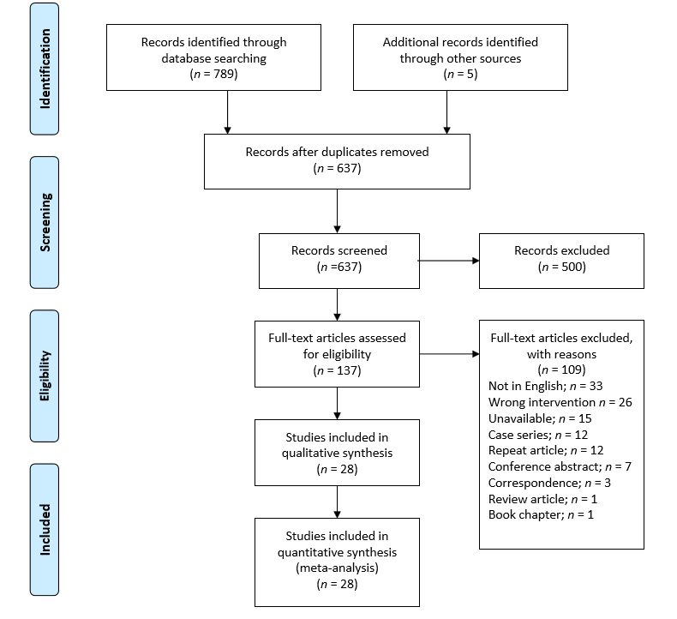
Figure 1 Preferred Reporting Items for Systematic Reviews and Meta-Analyses flowchart.
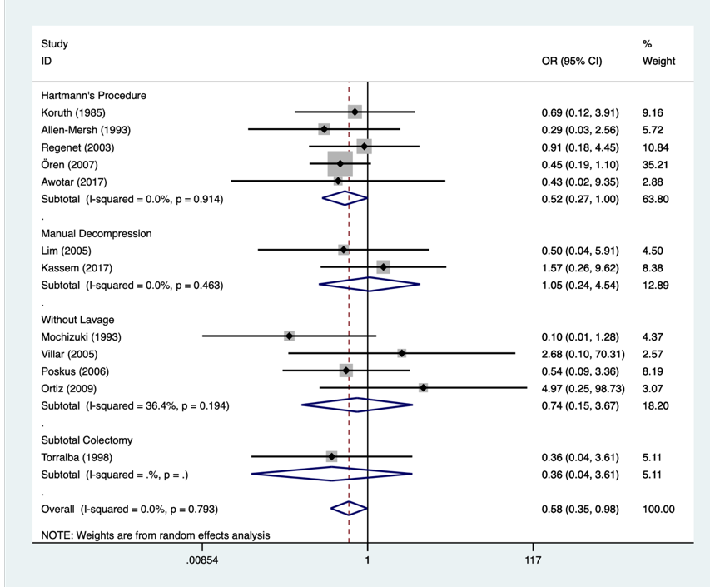
Figure 2 Meta-analysis of 30-d mortality.
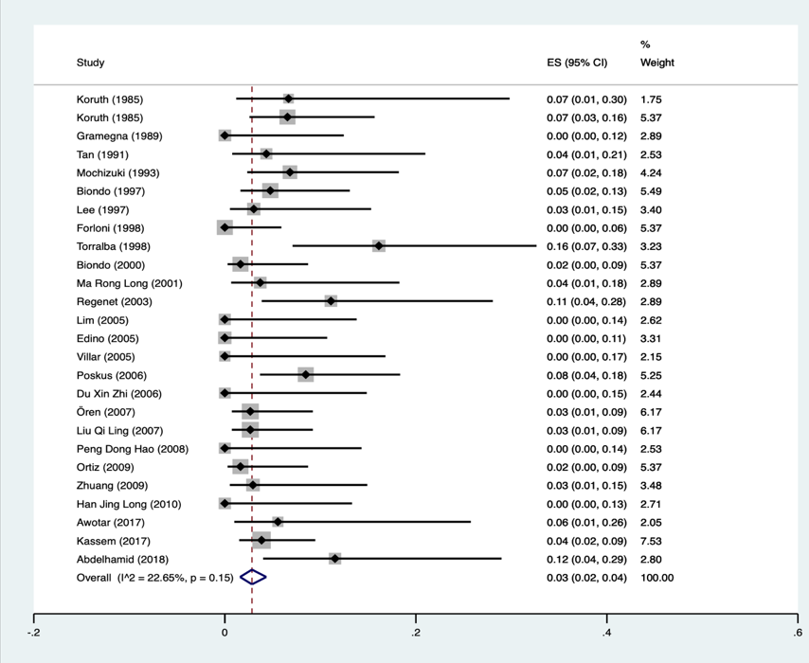
Figure 3 Single-arm meta-analysis of anastomotic leak rates in intra-operative colonic lavage.
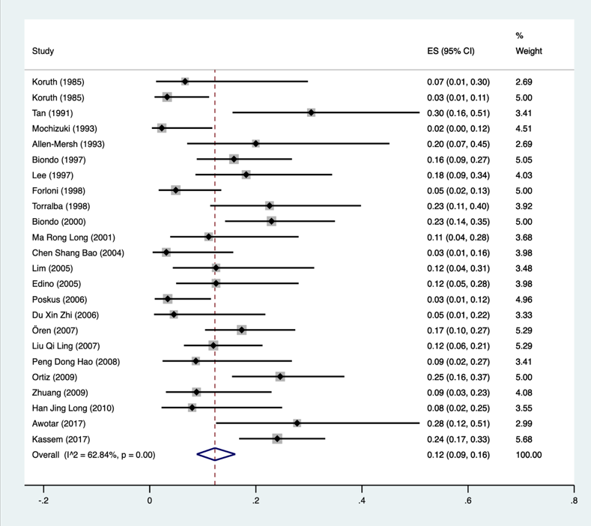
Figure 4 Single-arm meta-analysis of wound infection rates in intra-operative colonic lavage.
Table 1 Summary of comparative results
Intra-operative colonic anastomosis for left-sided colonic emergencies (dichotomous)
Outcome | Hartmann’s procedure |  | Manual decompression |  | Without lavage |  | Subtotal colectomy
 | OR; 95%CI | P value | OR; 95%CI | P value | OR; 95%CI | P value | OR; 95%CI | P value
30-d mortality | 0.525; 0.272-1.012 | 0.054 | 1.054; 0.245-4.569 | 0.943 | 0.625; 0.144-2.711 | 0.530 | 0.356; 0.035-3.608; | 0.382
Anastomotic leak | - | - | 0.585; 0.177-1.937 | 0.380 | 0.548; 0.121-2.472 | 0.434 | 13.462; 0.704-257.466 | 0.718
Wound infection | 0.755; 0.433-1.314 | 0.320 | 1.996; 0.402-9.926 | 0.398 | 4.130; 1.112-15.338 | 0.522 | - | -
Paralytic ileus | 3.405; 0.791-14.655 | 0.100 | - | - | 0.474; 0.121-1.859 | 0.285 | - | -
Intra-abdominal infection | 0.434; 0.067-2.814 | 0.381 | 0.794; 0.284-2.216 | 0.659 | 1.012; 0.116-8.821 | 0.991 | 0.266; 0.012-6.133 | 0.408
Pneumonia | 0.473; 0.168-1.332 | 0.156 | - | - | 0.445; 0.114-1.737 | 0.244 | 0.266; 0.012-6.133 | 0.408
Wound dehiscence | 2.560; 0.219-29.869 | 0.453 | 1.042; 0.020-54.629 | 0.984 | 0.160; 0.007-3.638 | 0.250 | - | -
Evisceration | 0.773; 0.146-4.080 | 0.761 | - | - | 4.241; 0.207-86.954 | 0.348 | - | -
Sepsis | 0.348; 0.096-1.257 | 0.107 | - | - | - | - | 2.300; 0.075-71.005 | 0.634
Re-operation | 0.560; 0.094-3.324 | 0.523 | 1.237; 0.366-4.185 | 0.733 | 0.184; 0.008-4.407 | 0.296 | - | -
Intra-operative colonic anastomosis for left-sided colonic emergencies (continuous)
Outcome | WMD; 95%CI | P value | WMD; 95%CI | P value | WMD; 95%CI | P value | WMD; 95%CI | P value
Duration of surgery (min) | -4.890; 34.708-24.928 | 0.748 | 22.593; -6.364-51.550 | 0.126 | 27.553; 10.560-44.546 | 0.001^{b} | 45.000; 25.475-64.525 | < 0.001^{c}
Time to carry out intervention (min) | - | - | 15.000; 9.746-20.254 | < 0.001^{c} | - | - | - | -
Intraoperative blood loss (ml) | 93.222; -103.779-290.223 | 0.354 | - | - | - | - | - | -
Duration of hospital stay (days) | -7.750; -13.504- -1.996 | 0.008^{b} | 3.500; 2.943-4.057 | < 0.001^{c} | -25.911; -67.404-15.582 | 0.221 | 0.300; -6.146-6.746 | 0.927
^{b}P < 0.01.
^{c}P < 0.001.
OR: Odds ratio; WMD: Weighted mean differences.
Table 2 Results of intra-operative colonic lavage only
Outcome | All indications |  |  | Cancer only
 | Sample size | Incidence | CI | Sample size | Incidence | CI
Intra-operative colonic anastomosis for left-sided colonic emergencies (dichotomous)
30-d mortality | 1091 | 0.04 | 0.03-0.05 | 517 | 0.02 | 0.01-0.04
Anastomotic leak | 1070 | 0.03 | 0.02-0.04 | 485 | 0.03 | 0.01-0.05
Wound infection | 1018 | 0.12 | 0.09-0.16 | 498 | 0.11 | 0.07-0.16
Paralytic ileus | 342 | 0.06 | 0.03-0.11 | 143 | 0.07 | 0.00-0.18
Intra-abdominal infection | 630 | 0.03 | 0.01-0.04 | 249 | 0.01 | 0.00-0.03
Pneumonia | 444 | 0.07 | 0.02-0.15 | 219 | 0.05 | 0.00-0.12
Sepsis | 341 | 0.02 | 0.01-0.05 | 131 | 0.02 | 0.00-0.05
Re-operation | 420 | 0.05 | 0.02-0.07 | 78 | 0.02 | 0.00-0.07
Intra-operative colonic anastomosis for left-sided colonic emergencies (continuous)
Duration of surgery (min) | 513 | 194.555 | 164.834- 224.276 | 361 | 189.565 | 145.293-233.837
Intra-operative Blood loss (mL) | 52 | 290.996 | -184.98-766.973 | 37 | 104.170 | -72.227-280.567
Duration of hospital stay (d) | 563 | 15.935 | 12.927-18.944 | 135 | 15.720 | 9.233-22.207

Published by Baishideng Publishing Group Inc
7041 Koll Center Parkway, Suite 160, Pleasanton, CA 94566, USA
Telephone: +1-925-3991568
E-mail: bpgoffice@wjgnet.com
Help Desk: https://www.f6publishing.com/helpdesk
https://www.wjgnet.com

© 2021 Baishideng Publishing Group Inc. All rights reserved.

