Name of Journal: World Journal of Clinical Cases
Manuscript NO: 73886
Manuscript Type: CASE REPORT

Successful treatment of hyperglycemia with liraglutide in a hospitalized 27-year-old patient with schizophrenia: A case report

Zhang L et al. Liraglutide treatment for hyperglycemia with antipsychotics

Lei Zhang, Wen-Juan Yu, Hui Zhu, Hua-Fang Li, Jie Qiao

Lei Zhang, Wen-Juan Yu, Hua-Fang Li, Department of Psychiatry, Shanghai Mental Health Center, Shanghai 200030, China

Lei Zhang, Wen-Juan Yu, Hui Zhu, Hua-Fang Li, Jie Qiao, School of Medicine, Shanghai Jiaotong University, Shanghai 200025, China

Hui Zhu, Jie Qiao, Department of Endocrinology, Shanghai Jiaotong University School of Medicine, Shanghai 9th Hospital, Shanghai 200011, China

Author contributions: Zhang L performed the disease consultation, acquired the clinical data, and drafted the manuscript; Yu WJ and Zhu H reviewed the literature; Qiao J and Li HF edited and reviewed the manuscript.

Supported by the National Natural Science Foundation of China, No. 81873652; and the Programs Foundation of Shanghai Mental Health Center, China, No. 2020-QH-03.

Corresponding author: Jie Qiao, MD, PhD, Chief Doctor, Department of Endocrinology, Shanghai Jiaotong University School of Medicine, Shanghai 9th Hospital, No. 369 Zhizaoju Road, Shanghai 200011, China. qiaoj2001@126.com

Received: December 30, 2021
Revised: February 24, 2022
Accepted: June 3, 2022
Published online:

Abstract
BACKGROUND
Antipsychotics are associated with abnormalities in glucose metabolism in patients with schizophrenia. Liraglutide, a GLP-1 receptor agonist, is Food and Drug Administration approved for the treatment of type 2 diabetes mellitus. However, ways to maintain the long-term stability of psychotic symptoms and balance the disadvantages of obesity, diabetes, and other metabolic disorders caused by antipsychotic medications remain unclear. In this study, we present a case of weight gain and hyperglycemia in a schizophrenia patient who received antipsychotic polypharmacy for 6 years.

CASE SUMMARY
A 27-year-old man with olanzapine and sodium valproate-treated disorganized schizophrenia was admitted to a diabetes outpatient clinic. He was diagnosed with type 2 diabetes (fasting blood glucose, 20 mmol/L) and obesity (body mass index, 38.58 kg/m²). The patient had been treated with glargine (40 IU/d) and metformin (1.5 g/d) and showed a poor response for 2 mo. Two years of liraglutide treatment resulted in stable blood glucose levels and weight loss in addition to a maintained stable mental status for a long time. The biological activities of GLP-1 significantly improved glucose levels and body weight in the schizophrenia patient treated with antipsychotic medications.

CONCLUSION
Liraglutide administration can be considered an effective alternative treatment for abnormalities in glucose metabolism in schizophrenia patients receiving antipsychotics.

Key Words: Hyperglycemia; Liraglutide; GLP-1 receptor agonist; Schizophrenia; Antipsychotics; Case report

Zhang L, Yu WJ, Zhu H, Li HF, Qiao J. Successful treatment of hyperglycemia with liraglutide in a hospitalized 27-year-old patient with schizophrenia: A case report. World J Clin Cases 2022; In press

Core Tip: This report describes the effects of GLP-1 receptor agonist treatment in a young schizophrenia patient with long-term use of antipsychotics, which induced type 2 diabetes. It presents the success of blood glucose control with the GLP-1 receptor agonist in a short period of time during his hospitalization and helped him to control his blood glucose and lose weight while maintaining a stable mental status in the long-term.

INTRODUCTION
The use of antipsychotics has been associated with abnormalities in glucose metabolism in patients with schizophrenia^{[1-3]}. A high prevalence of metabolic disturbances and type 2 diabetes among patients with schizophrenia was found to increase the risk of cardiovascular morbidity and mortality^{[4,5]}. Current intervention strategies against antipsychotic-induced weight gain and diabetes mellitus include switching to other antipsychotics, adding glucose-lowering drugs (e.g., metformin), or initiating insulin therapy. However, ways to maintain the long-term stability of psychotic symptoms and balance the disadvantages of obesity, diabetes, and other metabolic disorders caused by antipsychotic medications remain unclear.
Liraglutide is a GLP-1 receptor agonist (Victoza, Novonordisk) that was approved for the treatment of type 2 diabetes in 2009^{[6]}. As this medicine induces weight loss, the Food and Drug Administration FDA expanded its indications for obesity treatment in 2015^{[6,7]}.
Herein, we present the case of a young man with schizophrenia who had markedly increased weight gain and hyperglycemia after 6 years of combined antipsychotic therapy. After attempting to control hyperglycemia with insulin and metformin with a poor response, we successfully attained satisfactory blood glucose control with liraglutide in a short period during hospitalization. Furthermore, liraglutide helped the patient to lose weight while maintaining a stable mental status.

CASE PRESENTATION
Chief complaints
Exceedingly thirsty, polydipsia, and polyuria for 2 mo.

History of present illness
A 27-year-old, unemployed man with schizophrenia was previously prescribed olanzapine (10 mg/d) and sodium valproate (1 g/d). Six years ago, the patient was diagnosed with schizophrenia, and since then he had been taking many antipsychotics, such as risperidone, aripiprazole, and ziprasidone, with poor responsiveness. However, the patient had gained almost 50 kg in the past 2 years, and on admission, he weighed 106.3 kg (body mass index, 38.58 kg/m²). Two months ago, he began to feel exceedingly thirsty. Polydipsia and polyuria were established at the time of the checkup. His fasting blood glucose (FBG) level was 20 mmol/L, and glycated hemoglobin A1c (HbA1c) was 12.3%. The patient was treated with glargine (40 IU/d) and metformin (1.5 g/d) in a local hospital, but his FBG and postprandial blood glucose (PBG) levels fluctuated within the range of 10-20 mmol/L and 13-24 mmol/L, respectively.

History of past illness
The patient was diagnosed with schizophrenia 6 years ago.

Personal and family history
The patient denied any other specific personal or family history of other diseases.

Physical examination
The physical examination and diabetes complications-related examinations including fundus examination, electromyography (EMG), and renal function showed no obvious abnormalities.

Laboratory examinations
After admission, we conducted many related examinations, such as urine free cortisol and blood cortisol, blood potassium, blood pressure, thyroid function, hormone, etc. The physical examination and diabetes complications-related examinations including fundus examination, EMG, and renal function showed no obvious abnormalities. The specific results are shown in Table 1.

FINAL DIAGNOSIS
He was then transferred to the Department of Endocrinology of Shanghai Ninth Hospital with a diagnosis of diabetes, obesity, and schizophrenia (DSM-5 criteria) after psychiatric consultation at Shanghai Mental Health Center (Shanghai, China).

TREATMENT
When the diagnosis was confirmed, metformin was discontinued, and the patient was treated with an insulin pump (Medtronic, MMT-712EWS). After treatment with continuous subcutaneous insulin infusion (CSII, dose 48 U/d) for 3 d, we administered an add-on treatment with liraglutide (Victoza 0.6 mg/d, subcutaneous injection). Three days later, the dosage of liraglutide was increased to 1.2 mg/d, whereas that of insulin (NovoMix 30) was decreased to 14 U/d. Two days later, the liraglutide dosage was increased to 1.8 mg/d; insulin administration was stopped without changing the prior to admission therapy regimen of olanzapine and sodium valproate (Figure 1A). The diet during hospitalization was a diabetic diet pattern. Although daily exercise was recommended, it seemed difficult, and the patient only seemed to be able to walk for 10 min after meals. Blood glucose levels were measured five times per day, including the determination of FBG and PBG levels after three meals and before bedtime (Figure 1B). FBG dropped from 15.0 mmol/L at admission to 4.9 mmol/L at discharge, and PBG from 13.1 mmol/L to 5.1 mmol/L. Blood glucose before bedtime dropped from 9.9 mmol/L to 5.2 mmol/L. Meanwhile, his weight dropped from 106.3 kg to 104 kg in one week. When he was found to be medically stabilized, he was discharged from the hospital and advised to attend a psychiatric unit for further treatment.

OUTCOME AND FOLLOW-UP
The patient was followed up by telephone. After 2 years of treatment, his blood glucose levels were well controlled within the normal range, and his total weight loss was almost 8 kg (a 7.5% body weight reduction) when treated with liraglutide (Victoza 0.6 mg/day, subcutaneous injection). His laboratory examinations are shown in Table 1. Meanwhile, his psychiatric status was stable during the previous 2-year period, without hospital admissions. The initiation of liraglutide treatment led to significant clinical improvement, as evidenced by decreased blood glucose levels and reduced weight.

DISCUSSION
The postulated underlying mechanisms for the development of diabetes in patients treated with antipsychotics, particularly with the drugs olanzapine and clozapine, involve carbohydrate intolerance. This is associated with increased insulin resistance^{[1]}. These medicines cause abnormalities in glucose tolerance by perturbing appetite regulation, insulin secretion and action, and release of insulin counter-regulatory hormones^{[8]} (Figure 2).
GLP-1 is an incretin hormone secreted by L cells in the intestinal mucosa in response to nutrients. The biological activities of GLP-1 include stimulation of insulin biosynthesis and glucose-dependent insulin secretion by pancreatic beta cells, inhibition of glucagon secretion, delay in gastric emptying, and inhibition of food intake^{[9]}. The time course of reduction in HbA1c showed full effects of liraglutide after 12 wk of treatment by liraglutide monotherapy^{[10]}. Liraglutide reduces appetite and food intake, thereby ensuring that body weight is kept low^{[11,12]}. The results of an animal study confirmed that olanzapine-induced weight gain and metabolic derangements were found to be reversed after treatment with the GLP-1 analog liraglutide^{[13]}. FBG generally represents the sugar output of the liver in the body, which is a basic state. PBG generally reflects the influence of diet on blood glucose, and to some extent represents the response of the body's own islets to diet^{[14]}. In this case, the patient's FBG and PBG were both high at admission but returned to normal after 12 days of liraglutide treatment.
To the best of our knowledge, few relevant research has reported findings that are applicable to the current clinical practice regarding the treatment of schizophrenia with glucose and lipid metabolic disturbance in China. Therefore, the potential metabolic improvement effects of GLP-1 receptor agonists in antipsychotic-treated patients require further investigation. Randomized, double-blind, controlled trials need to be conducted in the future to document the efficacy and safety of Victoza in the treatment of acute hyperglycemia and/or obesity.
Empiric treatment of hyperglycemia in patients with schizophrenia involves reducing the dosage of antipsychotics or choosing to switch to antipsychotics. In the absence of drug-specific evidence, the treatment of drug-induced hyperglycemia and diabetes is similar to the full range of standard diabetes care, including lifestyle changes, oral/injectable antidiabetic drugs, and insulin^{[15]}. The concomitant use of metformin has been used as the first choice in the treatment of schizophrenia patients with antipsychotic-induced obesity and type 2 diabetes to counteract antipsychotic-induced weight gain and other metabolic adversities in schizophrenia^{[16]}. However, in most patients, good blood glucose control could not be achieved by the administration of metformin only, and the addition of an insulin secretagogue or insulin is always required, which, in turn, hampers effective weight control, especially at a larger dosage. In a previous study, switching the antipsychotic medication led to a reduction in weight and contributed to achieving broader health benefits, such as decreased FBG levels^{[17]}. But reducing antipsychotic dosage or choosing to switch to antipsychotic medications may lead to relapse. Important clinical considerations for patients with schizophrenia taking antipsychotic medications is monitoring metabolic markers such as glucose before and during treatment. Changing unhealthy lifestyles is considered essential in preventive measures. Long-term outcomes of the patient included stabilization of psychiatric symptoms and improvement of metabolic disorders. Although we could only follow up by telephone, which was a shortcoming of this study, we also obtained the patient's review indicators during this period. For patients with chronic diseases, it is very important to maintain a good lifestyle, which also requires patients to pay more perseverance. Future research is needed to elucidate pathophysiology and optimal targeted treatment for antipsychotics-induced diabetes and obesity. In the present case, the use of liraglutide achieved satisfactory short- and long-term glucose control and mild weight loss without any recurrent schizophrenia attack. Moreover, the large dose of insulin was gradually reduced until final cessation. The implementation of liraglutide treatment for 16 wk as an adjunctive therapy along with clozapine or olanzapine resulted in stabilization in overweight or obese patients with schizophrenia spectrum disorders and prediabetes and significantly improved glucose tolerance and glycemic control^{[11]}.

CONCLUSION
When monopharmacological strategies alone are insufficient and switching from antipsychotics to relatively weight-neutral agents is not feasible, Victoza can be considered an effective alternative treatment for schizophrenia patients with hyperglycemia and obesity. Large-scale longitudinal blinded studies should be adopted to obtain more objective and effective results in future.

ACKNOWLEDGEMENTS
We thank the participants in the study.

REFERENCES
1 Lindenmayer JP, Nathan AM, Smith RC. Hyperglycemia associated with the use of atypical antipsychotics. J Clin Psychiatry 2001; 62 Suppl 23: 30-38 [PMID: 11603883 DOI: 10.1029/98GL51991]
2 Buse JB. Metabolic side effects of antipsychotics: focus on hyperglycemia and diabetes. J Clin Psychiatry 2002; 63 Suppl 4: 37-41 [PMID: 11913675 DOI: 10.1076/jcen.24.5.705.1011]
3 Sernyak MJ, Gulanski B, Rosenheck R. Undiagnosed hyperglycemia in patients treated with atypical antipsychotics. J Clin Psychiatry 2005; 66: 1463-1467 [PMID: 16420085 DOI: 10.4088/jcp.v66n1117]
4 Laursen TM, Munk-Olsen T, Vestergaard M. Life expectancy and cardiovascular mortality in persons with schizophrenia. Curr Opin Psychiatry 2012; 25: 83-88 [PMID: 22249081 DOI: 10.1097/YCO.0b013e32835035ca]
5 Soleimani M. Insulin resistance and hypertension: new insights. Kidney Int 2015; 87: 497-499 [PMID: 25723632 DOI: 10.1038/ki.2014.392]
6 Davies MJ, Bergenstal R, Bode B, Kushner RF, Lewin A, Skjøth TV, Andreasen AH, Jensen CB, DeFronzo RA; NN8022-1922 Study Group. Efficacy of Liraglutide for Weight Loss Among Patients With Type 2 Diabetes: The SCALE Diabetes Randomized Clinical Trial. JAMA 2015; 314: 687-699 [PMID: 26284720 DOI: 10.1001/jama.2015.9676]
7 Pi-Sunyer X, Astrup A, Fujioka K, Greenway F, Halpern A, Krempf M, Lau DC, le Roux CW, Violante Ortiz R, Jensen CB, Wilding JP; SCALE Obesity and Prediabetes NN8022-1839 Study Group. A Randomized, Controlled Trial of 3.0 mg of Liraglutide in Weight Management. N Engl J Med 2015; 373: 11-22 [PMID: 26132939 DOI: 10.1056/NEJMoa1411892]
8 Elias AN, Hofflich H. Abnormalities in glucose metabolism in patients with schizophrenia treated with atypical antipsychotic medications. Am J Med 2008; 121: 98-104 [PMID: 18261494 DOI: 10.1016/j.amjmed.2007.08.036]
9 Holst JJ. The physiology of glucagon-like peptide 1. Physiol Rev 2007; 87: 1409-1439 [PMID: 17928588 DOI: 10.1152/physrev.00034.2006]
10 Garber A, Henry R, Ratner R, Garcia-Hernandez PA, Rodriguez-Pattzi H, Olvera-Alvarez I, Hale PM, Zdravkovic M, Bode B; LEAD-3 (Mono) Study Group. Liraglutide versus glimepiride monotherapy for type 2 diabetes (LEAD-3 Mono): a randomised, 52-week, phase III, double-blind, parallel-treatment trial. Lancet 2009; 373: 473-481 [PMID: 18819705 DOI: 10.1016/S0140-6736(08)61246-5]
11 Larsen JR, Vedtofte L, Jakobsen MSL, Jespersen HR, Jakobsen MI, Svensson CK, Koyuncu K, Schjerning O, Oturai PS, Kjaer A, Nielsen J, Holst JJ, Ekstrøm CT, Correll CU, Vilsbøll T, Fink-Jensen A. Effect of Liraglutide Treatment on Prediabetes and Overweight or Obesity in Clozapine- or Olanzapine-Treated Patients With Schizophrenia Spectrum Disorder: A Randomized Clinical Trial. JAMA Psychiatry 2017; 74: 719-728 [PMID: 28601891 DOI: 10.1001/jamapsychiatry.2017.1220]
12 Vilsbøll T, Christensen M, Junker AE, Knop FK, Gluud LL. Effects of glucagon-like peptide-1 receptor agonists on weight loss: systematic review and meta-analyses of randomised controlled trials. BMJ 2012; 344: d7771 [PMID: 22236411 DOI: 10.1136/bmj.d7771]
13 Lykkegaard K, Larsen PJ, Vrang N, Bock C, Bock T, Knudsen LB. The once-daily human GLP-1 analog, liraglutide, reduces olanzapine-induced weight gain and glucose intolerance. Schizophr Res 2008; 103: 94-103 [PMID: 18579346 DOI: 10.1016/j.schres.2008.05.011]
14 Penninx BWJH, Lange SMM. Metabolic syndrome in psychiatric patients: overview, mechanisms, and implications. Dialogues Clin Neurosci 2018; 20: 63-73 [PMID: 29946213 DOI: 10.31887/DCNS.2018.20.1/bpenninx]
15 Jain V, Patel RK, Kapadia Z, Galiveeti S, Banerji M, Hope L. Drugs and hyperglycemia: A practical guide. Maturitas 2017; 104: 80-83 [PMID: 28923179 DOI: 10.1016/j.maturitas.2017.08.006]
16 Mizuno Y, Suzuki T, Nakagawa A, Yoshida K, Mimura M, Fleischhacker WW, Uchida H. Pharmacological strategies to counteract antipsychotic-induced weight gain and metabolic adverse effects in schizophrenia: a systematic review and meta-analysis. Schizophr Bull 2014; 40: 1385-1403 [PMID: 24636967 DOI: 10.1093/schbul/sbu030]
17 Mukundan A, Faulkner G, Cohn T, Remington G. Antipsychotic switching for people with schizophrenia who have neuroleptic-induced weight or metabolic problems. Cochrane Database Syst Rev 2010: CD006629 [PMID: 21154372 DOI: 10.1002/14651858.CD006629.pub2]

Footnotes
Informed consent statement: Informed written consent was obtained from the patient for publication of this report and any accompanying images.

Conflict-of-interest statement: The authors declare that they have no conflict of interest.

CARE Checklist (2016) statement: The authors have read the CARE Checklist (2016), and the manuscript was prepared and revised according to the CARE Checklist (2016).

Open-Access: This article is an open-access article that was selected by an in-house editor and fully peer-reviewed by external reviewers. It is distributed in accordance with the Creative Commons Attribution NonCommercial (CC BY-NC 4.0) license, which permits others to distribute, remix, adapt, build upon this work non-commercially, and license their derivative works on different terms, provided the original work is properly cited and the use is non-commercial. See: https://creativecommons.org/Licenses/by-nc/4.0/

Provenance and peer review: Unsolicited article; Externally peer reviewed.
Peer-review model: Single blind

Peer-review started: December 30, 2021
First decision: February 8, 2022
Article in press:

Specialty type: Psychiatry
Country/Territory of origin: China
Peer-review report’s scientific quality classification
Grade A (Excellent): 0
Grade B (Very good): B
Grade C (Good): C, C, C
Grade D (Fair): D
Grade E (Poor): 0

P-Reviewer: Liao Z, Singapore; Nishihama K, Japan; Timsina LR, United States A-Editor: Ahmed S, Pakistan S-Editor: Yan JP L-Editor: A P-Editor: Yan JP

Figure Legends
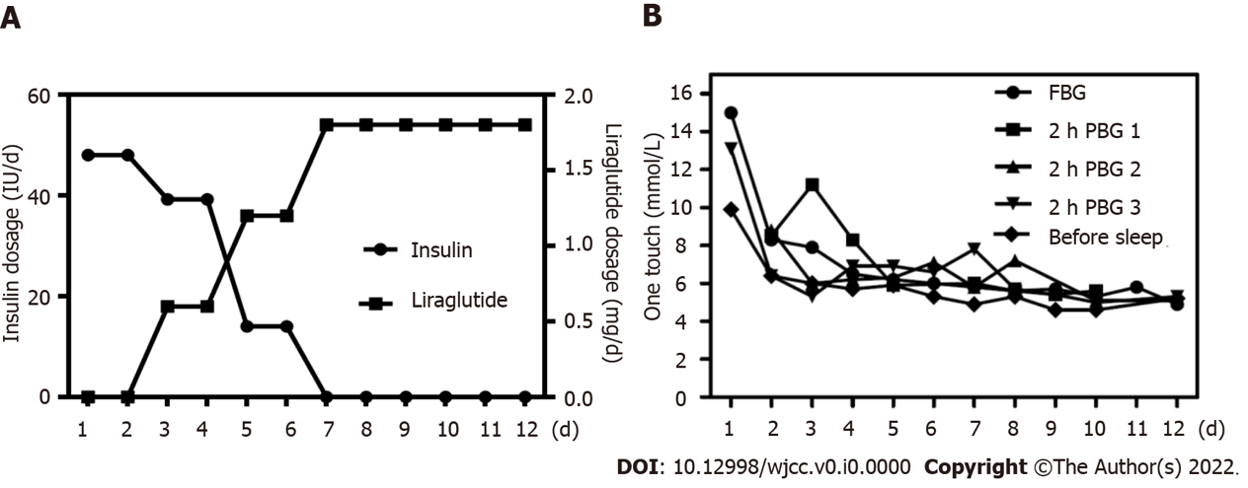

Figure 1 Dosage of insulin and liraglutide, and change of the blood glucose. A: Dosage of insulin and liraglutide. Treatment with continuous subcutaneous insulin infusion for three days, than we applied an add-on treatment with liraglutide. After the liraglutide dosage was increased to 1.8 mg/d, all insulin was stopped; B: Change of the blood glucose. Blood glucose levels were measured five times each day, including determination of fasting blood glucose and 2 h postprandial blood glucose after three meals. FBG: Fasting blood glucose; PBG: Postprandial blood glucose.

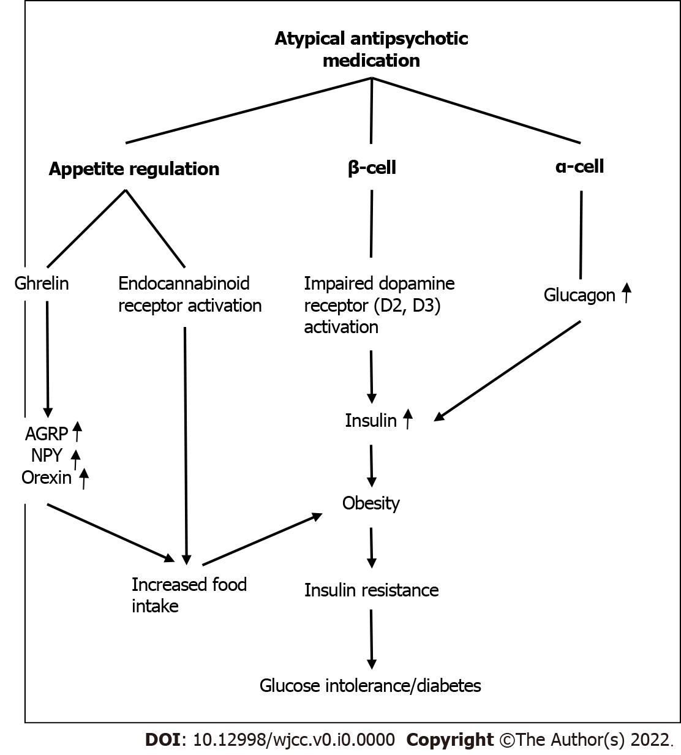
Figure 2 Potential pathways leading to carbohydrate intolerance and diabetes in patients receiving atypical antipsychotic medications. AGRP: Agouti-related peptide; NPY: Neuropeptide Y.

Table 1 Changes in clinical indicators during treatment
 | Hospital admission¹ | Hospital discharge² | Follow-up³
Height (cm) | 166 | 166 | 166
Weight (kg) | 106.3 | 104 | 98.4
BMI (kg/m²) | 38.58 | 37.74 | 35.71
Blood pressure (mmHg) | 130/80 | 122/78 | 120/80
Pulse rate (times/min) | 80 | 78 | 78
Blood glucose (mmol/L) | 15.0 | 4.9 | 5.07
HbA1c (%) | 12.3 | NA | 6.0
Insulin (pmol/L) | 733.10 | NA | NA
Total bilirubin (μmol/L) | 12.11 | NA | 4.93
Albumin (g/L) | 45.1 | NA | 47.5
ALT (IU/L) | 22 | NA | 26
AST (IU/L) | 27 | NA | 26
Total cholesterol (mmol/L) | 6.02 | NA | 5.00
Triglyceride (mmol/L) | 1.81 | 1.7 | 1.62
Uric acid (μmol/L) | 484 | 366 | 382
Creatinine (μmol/L) | 70 | NA | 72
HDL (mmol/L) | 1.20 | NA | 1.39
LDL (mmol/L) | 3.48 | 3.21 | 2.29
Testosterone (nmol/L) | 14.940 | NA | NA
TSH (mIU/L) | 1.770 | NA | 3.500
Serum potassium (mmol/L) | 4.26 | 4.25 | 4.51
Urine free cortisol (nmol/24 h) | 168.3 | NA | NA
Fasting plasma cortisol (nmol/L) | 254 | NA | NA
¹Date of admission: December 20, 2019.
²Date of discharge: December 31, 2019.
³Date of follow-up: November 20, 2021.
BMI: Body mass index; ALT: Alanine transaminase; AST: Aspertate Aminotransferase; HDL: High-density lipoprotein; LDL: Low-density lipoprotein; TSH: Thyroid stimulating hormone; NA: Unmeasured; HbA1c: Hemoglobin A1c.

