Name of Journal: World Journal of Gastroenterology
ESPS Manuscript NO: 27769
Manuscript Type: ORIGINAL ARTICLE

Retrospective Study
Neuroendocrine neoplasms of liver – A 5-year retrospective clinico-pathological study applying World Health Organization 2010 classification

Burad DK et al. Neuroendocrine neoplasms of liver

Deepak Kalyansingh Burad, Thomas Alex Kodiatte, Sayd Mohamed Rajeeb, Ashish Goel, Chundamannil Eapen Eapen, Banumathi Ramakrishna

Deepak Kalyansingh Burad, Thomas Alex Kodiatte, Banumathi Ramakrishna, Department of Pathology, Christian Medical College, Vellore 632004, Tamil Nadu, India

Sayd Mohamed Rajeeb, Ashish Goel, Chundamannil Eapen Eapen , Department of Hepatology, Christian Medical College, Vellore 632004, Tamil Nadu, India

Author contributions: Burad DK contributed to data collection, data analysis and wrote the paper; Kodiatte TA contributed to data analysis and references; Rajeeb SM contributed to clinical data collection and analysis; Goel A analysed the clinical data and wrote the clinical part; Eapen CE provided clinical advice; Ramakrishna B designed and supervised the study, and wrote the paper.

Institutional review board statement: This study was approved by Institutional review board of Christian Medical College, Vellore, India.

Informed consent statement: This study is exempt from informed consent, since it is a retrospective study and the data collection and analysis were carried out without disclosing patient’s identity.

Conflict-of-interest statement: All the authors declare that there are no commercial, personal and any other potential conflicting interests related to the submitted manuscript.

Data sharing statement: No additional data are available.

Open-Access: This article is an open-access article which was selected by an in-house editor and fully peer-reviewed by external reviewers. It is distributed in accordance with the Creative Commons Attribution Non Commercial (CC BY-NC 4.0) license, which permits others to distribute, remix, adapt, build upon this work non-commercially, and license their derivative works on different terms, provided the original work is properly cited and the use is non-commercial. See: http://creativecommons.org/licenses/by-nc/4.0/

Manuscript source: Invited manuscript

Correspondence to: Banumathi Ramakrishna MD, MAMS, Former Professor and Head, Department of Pathology, Christian Medical College, Vellore 632004, Tamil Nadu, India. banu_ramakrishna@hotmail.com
Telephone: +91-416-2282005
Fax: +91-416-2232035

Received: June 15, 2016
Peer-review started: June 17, 2016
First decision: July 12, 2016
Revised: July 29, 2016
Accepted: August 23, 2016
Article in press:
Published online:

Abstract
AIM: To study the clinicopathological characteristics of neuroendocrine neoplasms on liver samples and apply World Health Organization (WHO) 2010 grading of gastroenteropancreatic neuroendocrine neoplasms.

METHODS: Clinicopathological features of 79 cases of neuroendocrine neoplasms (NEN) of the liver diagnosed between January 2011 to December 2015 were analyzed. WHO 2010 classification of gastroenteropancreatic (GEP) neuroendocrine neoplasms was applied and the tumors were graded as G1, G2 or G3. Two more categories, D1/2 (discordant 1/2) and D2/3 (discordant 2/3) were also applied. The D1/2 grade tumors had a mitotic count of G1 and Ki-67 index of G2. The D2/3 tumors had a mitotic count of G2 and Ki-67 index of G3. The follow up details which were available till the end of the study period (December 2015) were collected.

RESULTS: Of the 79 tumors, 16 each were G1 and G2, and 18 were G3 tumors. Of the remaining 29 tumors, 13 were assigned to D1/2 and 16 were D2/3 grade. Male preponderance was noted in all tumors except for G2 neoplasms, which showed a slight female predilection. The median age at presentation was 47 years (range 10-82 years). The most common presentation was abdominal pain (81%). Pancreas (49%) was the most common site of primary followed by gastrointestinal tract (24.4%) and lungs (18%). Radiologically, 87% of the patients had multiple liver lesions. Histopathologically, necrosis was seen in only D2/3 and G3 tumors. Microvascular invasion was seen in all grades. Metastasis occurred in all grades of primary neuroendocrine neoplasms and the grades of the metastatic tumors and their corresponding primary tumors were similar in 67% of the cases. Of the 79 patients, 36 had at least one follow up visit with a median duration of follow up of 8.5 mo (range: 1-50 mo). This study did not show any impact of the grade of tumor on the short term clinical outcome of these patients.

CONCLUSION: Liver biopsy is an important tool for clinicopathological characterization and grading of neuroendocrine neoplasms, especially when the primary is not identified. 87% of the patients had multifocal liver lesions irrespective of the WHO grade, indicating a higher stage of disease at presentation. Follow up duration was inadequate to derive any meaningful conclusion on long term outcome in our study patients.

Key words: Liver; Neuroendocrine neoplasms; Gastroenteropancreatic neuroendocrine neoplasms; Ki-67; Metastasis; Microvascular invasion

© The Author(s) 2016. Published by Baishideng Publishing Group Inc. All rights reserved.

Core tip: Neuroendocrine neoplasms in liver are commonly metastatic. The clinicopathological features of neuroendocrine neoplasms diagnosed on liver samples were analyzed and graded applying World Health Organization (WHO) 2010 classification of GEP neuroendocrine neoplasms. A marked male preponderance was noted in all WHO grades except for G2 tumors, wherein a slight female predilection was seen. Necrosis was noted only in higher grade tumors. Most patients had multifocal liver lesions favoring metastasis and higher stage of disease at presentation. Follow up duration was inadequate to derive any meaningful conclusion on long term outcome in our study patients.

Burad DK, Kodiatte TA, Rajeeb SM, Goel A, Eapen CE, Ramakrishna B. Neuroendocrine neoplasms of liver – A 5-year retrospective clinico-pathological study applying World Health Organization 2010 classification. World J Gastroenterol 2016; In press

INTRODUCTION
Neuroendocrine neoplasms are tumors arising from the neuroendocrine cells which are distributed throughout the body^{[1,2]}. They commonly originate from gastrointestinal tract, lungs and pancreas and rarely from other sites such as gall bladder, thymus, testes and ovaries^{[3-6]}. Neuroendocrine neoplasms are the second most common tumors to metastasize to liver after adenocarcinomas^{[7,8]}. Neuroendocrine neoplasms in the liver are usually metastatic and primary tumors are rare^{[9-13]}. Liver is the second most common site of metastatic neuroendocrine neoplasms following lymph nodes^{[5]}. Amongst the metastatic neuroendocrine neoplasms in liver, those originating from gastroenteropancreatic region are more common due to spread via the portal vein^{[14]}.
The GEP neuroendocrine neoplasms have been classified by the World Health Organization (WHO) 2010^{[15]} into 3 (G1-G3) grades based on mitotic activity and Ki-67/MIB-1 proliferation index. These are G1: mitotic count < 2/10 high power fields (hpf) and/or Ki-67 index ≤ 2%, G2: mitotic count 2-20/10 hpf and/or Ki-67 index 3%-20% and G3: mitotic count > 20/10 hpf and/orKi-67 index > 20%. If the mitotic count or Ki-67 proliferation index points to different grades, a higher grade has to be given^{[15,16]}. Some studies have shown discordance between mitotic count and Ki-67 index^{[17,18]} in some cases. They have shown that the grade discordant tumors with mitotic count of G1 and Ki-67 index of G2 behave worse than grade concordant tumors^{[17,18]}.
Targeted biopsy of the liver lesion is often required to confirm the diagnosis of neuroendocrine neoplasm, as often the primary may not be identified.
Utility of WHO 2010 grading of neuroendocrine neoplasms in liver biopsies has not been carried out and hence, we undertook this study to pathologically characterize these cases and to correlate with clinical findings.

MATERIALS AND METHODS
This study included all cases of neuroendocrine neoplasms involving the liver diagnosed in the Department of Pathology, from January 2011 to December 2015. The data was collected from Pathology online data base. A total of 82 cases were available. Of the 82 cases, 3 had only cytology smears without cell block material and hence were excluded from the study. The remaining 79 cases included liver biopsies (59), resection specimens (5), cytology smears with cell block (5) and referred slides and blocks (10). Of the 59 liver biopsies, 58 were ultrasound (US) guided and, 1 was a per-operative wedge biopsy sample. Of the 5 resection specimens, 3 were localized segmentectomy specimens and the remaining 2 were left lateral segmentectomies. All the 5 cytology cases were US guided. Of the 10 cases of referred slides and blocks, 6 were US guided biopsies, 2 were per-operative wedge biopsies and the remaining 2 were resections.
One resection (left lateral segmentectomy) case included in this study was from a 40 year old lady diagnosed with neuroendocrine neoplasm by biopsy in 2009, who received 6 cycles of chemotherapy and Metaiodobenzylguanidine (MIBG) ablation prior to resection.
The histopathological features and immunohistochemistry details in 79 cases were analyzed. Based on WHO 2010 classification of GEP neuroendocrine neoplasms, all cases were graded as G1, G2 or G3. In this study, we assigned 2 more categories which included D1/2 (discordant 1/2) and D2/3 (discordant 2/3). The D1/2 grade tumors had a mitotic count of G1 and Ki-67 index of G2. The D2/3 tumor had a mitotic count of G2 and Ki-67 index of G3. We did not have any cases wherein the mitotic count was of a higher grade and Ki-67 index of a lower grade.
The relevant clinical and radiological findings and the follow up details which were available till the end of the study period (December 2015) were collected.
Continuous data was described as number, mean, median, minimum and maximum; and categorical data was described as number with percentage. Categorical data was compared with chi-square test. A two sided p-value of < 0.05 was considered statistically significant. All statistical analyses were done using SPSS software version 17.0.
This study was approved by Institutional review board.

RESULTS
Of the 79 patients, 71 were of Indian origin, 7 from Bangladesh and 1 from Srilanka. Overall, there was a male preponderance (Male:Female = 53:26) in this study. G2 tumors showed a slight female predilection (M:F = 7:9) as compared to the other grades (M:F = 46:17).
The median age at presentation was 47 years (range 10-82 years). 56% of the cases were seen between 5th to 6th decade.
The study patients had a delay of 3 mo (0-24 mo; median, range) from their first symptoms to their final diagnosis at hospital. The most common presentation was abdominal pain (81%) followed by loss of weight and appetite (41%), altered bowel habits (14%) and mass per abdomen (9%). In 9% of the patients, the tumor was incidentally detected.
A clinical diagnosis of malignancy was given in 77% of the patients.
In 18 patients, the primary site was identified by biopsy and in another 27 patients, a probable primary lesion was identified on radiological examination alone. In both the groups, the most common primary site was pancreas (Table 1). In the remaining 34 patients, a definite primary site could not be identified.
In this study we encountered three interesting cases. The first case was a 46 year old male presented with 2 years duration of pain in right hip and lower limbs, acromegaly and erectile dysfunction in 2009. Based on radiological, serological and pathological examination, he was diagnosed with MEN (Multiple endocrine neoplasia) type 1 with pituitary macroadenoma, insulinoma, gastrinoma, bilateral inferior parathyroid adenomas, primary hyperparathyroidism, thymic carcinoid and adrenal adenoma. In 2012, Computed tomography (CT) of the abdomen revealed a 2.5-cm lesion in segment 3 of liver along with multiple pancreatic lesions. The patient underwent a distal pancreatectomy with splenectomy and resection of segment 3 of liver in 2014, which on pathological examination confirmed neuroendocrine neoplasm of WHO grade 2, in both pancreas and in liver. The tumor was multifocal in pancreas.
The second case was a 22 year old male presented with left flank pain of 2 mo duration in 2013. CT scan showed a 10-cm lobulated mass in the left kidney and a diagnosis of renal cell carcinoma was suspected. Patient underwent left nephrectomy and histologically, diagnosed as large cell neuroendocrine carcinoma. On follow-up, 2 years later, patient was detected to have multiple hypodense lesions in the liver, in segments 6, 4a, and 2, and the largest measured 1.7 cm. An US guided biopsy confirmed metastatic neuroendocrine neoplasm, WHO grade 2.
The third case was a 40 year old female who presented with jaundice, loss of weight and appetite, lower limb weakness and abdominal distension of 2 years duration. She was recently detected to have hypertension. Blood investigations revealed hypokalemia, hypomagnesaemia and elevated serum adrenocorticotropic hormone (ACTH) and cortisol levels. In view of the above findings, she was diagnosed with ACTH dependent Cushing syndrome. CT scan revealed multiple liver lesions in both lobes, largest measuring 2.8 cm. An US guided biopsy of liver lesion was diagnosed as neuroendocrine neoplasm, WHO grade 2.

Radiological findings
Radiological findings were available in all 79 cases. In 69 cases (87%), the patients had multiple liver lesions (1.8 cm to 15.9 cm in maximum dimension) involving both the left and the right lobes. Remaining 10 patients (13%) had a single lesion (2.7 cm to 12.5 cm in maximum dimension), 4 of which were in the left lobe and 6 in the right lobe. A radiological diagnosis of metastases was made in 66 (83.5%) cases, hepatocellular carcinoma in 5 (6.3%) and non-neoplastic etiology in 7 (8.9%) cases, which includes 4 cases diagnosed as abscess and hemangioma in 1 (1.3%) case.

Pathological findings
Of the seven liver resections in our study, five were available for gross examination and the remaining two were slides and blocks. Of the five, 3 were segmental resection specimens of segment 3, 6 and 8 respectively and the remaining 2 were left lateral segmentectomies. All resection specimens except one left lateral segmentectomy specimen had a single tumor nodule, ranging in size from 2.5 cm to 7.5 cm with a firm grey white to yellow cut surface (Figure 1). Focal area of hemorrhage was seen in one case. There was no evidence of necrosis or gross vascular invasion. The surrounding liver parenchyma was normal. One left lateral segmentectomy specimen following chemotherapy showed 2 tumor nodules, measuring 0.7 cm and 6.5 cm respectively. The cut surface of the tumor was firm grey white with focal areas of necrosis amounting to approximately 20% of the total tumor volume. There was no gross vascular invasion. The surrounding liver parenchyma was normal.
Based on WHO 2010 grading of the 79 tumors, 16 each were G1 and G2 and 18 were G3 tumors. Of the remaining 29 tumors, 13 were assigned to D1/2 grade and 16 were assigned D2/3 grade.
Histologically, the low grade tumors (G1, G2, D1/2) had a classical pattern of arrangement including nests, trabeculae, cords, ribbons, festoons, sheets, gyriform, pseudopapillary and acinar patterns (Figure 2A and C). The cells were round to polygonal with moderate to abundant amounts of eosinophilic granular cytoplasm and uniform to mildly pleomorphic nuclei with uniformly dispersed coarse chromatin and inconspicuous mitotic activity (Figure 3A).
The high grade tumors (G3, D2/3) showed nests and sheets of medium sized polygonal cells with mild to moderately pleomorphic nuclei with finely dispersed chromatin and scant to moderate amounts of eosinophilic cytoplasm. There was increased mitotic and apoptotic activity (Figures 2E and 3C).
Six cases had morphology consistent with small cell carcinoma with sheets and nests of polygonal cells displaying moderate nuclear pleomorphism, moulding, overlapping and increased mitotic and apoptotic activity.
The post chemotherapy and MIBG ablation resection specimen showed presence of occasional peritumoral non necrotizing epithelioid cell granulomas, probably reactive. Special stains for acid fast bacilli and fungal organisms were negative. None of the other 78 cases showed granulomas.
There was one interesting case of a 63 year old female with multiple liver nodules who underwent an US guided liver biopsy. Histologically, the tumor was composed of sheets and closely packed clusters of polygonal cells with eccentrically placed mild to moderately pleomorphic nuclei and abundant amounts of pale eosinophilic cytoplasm, resembling signet ring cells (Figure 4A). Occasional cells contained intracytoplasmic mucin droplets (Figure 4B). This case was diagnosed as signet ring cell neuroendocrine neoplasm.
Necrosis was identified in 12 cases and all were biopsies. Six of these were D2/3 grade and the remaining 6 were G3 grade. In 9 cases, it was present in small foci, while the remaining 3 showed extensive areas of necrosis (1 was G3 and 2 were D2/3). There was no necrosis in any of the resection cases except in the post chemotherapy case which showed necrosis and hyalinization, amounting to 20% of the entire tumor volume. However, there was no necrosis in the initial pre chemotherapy biopsy.
Microvascular invasion (MVI) was seen in 17 cases (4 resection cases and 13 biopsies). Of these 17 cases, 3 were G1, 4 G2, 6 G3 and 4 D2/3 grade tumors. In all the cases, tumor emboli were present in thin walled vascular channels and/or within sinusoids.
MVI was seen more frequently in high grade (G3 and D2/3) tumors (59%) when compared to low grade (G1 and G2) tumors (41%). However, it was not statistically significant. As most of these cases were biopsies, this increased frequency is most probably a chance finding.
We also looked at the presence of MVI in the 18 proven primary cases (12 resection, 4 biopsies and 2 cytology with cell block material). MVI was seen in 10 of 12 resection cases and none of the biopsied cases.
Status of nodal disease was also noted. Of the 79 patients, 7 had biopsy proven nodal metastasis and 35 had significant nodes on radiological examination. The remaining 37 patients did not have any significant lymph node enlargement.

Immunohistochemistry
Immunostaining for two markers - synaptophysin and chromogranin were carried out in all 79 cases. Synaptophysin (Figure 2G) was positive in 77 and chromogranin (Figure 2H) in 75 cases, respectively.
In all 6 cases which were negative for either synaptophysin or chromogranin, CD 56 was found to be positive.
Pancytokeratin immunostaining done in 34 cases with high grade (G3:18, D2/3:16) neoplasms, showed positive staining in all except two cases with G3 tumor.
Immunostaining for Thyroid transcription factor (TTF-1) was carried out in 9 cases. Six of these had morphology of small cell carcinoma and the remaining three had a lung lesion on radiology. Five out of 6 cases of small cell carcinoma type were TTF1 positive and 2 of these cases had a lung mass indicating a lung primary. One of the 3 cases with radiologically detected lesion in the lung was TTF1 positive.
The patient with signet ring cell NEN showed the tumor cells to be positive for CK7, synaptophysin (Figure 4C) and chromogranin (Figure 4D) and negative for CK20 and CDX2. Ki-67 proliferation index was 15%.
The patient with Cushing’s syndrome showed neuroendocrine neoplasm with patchy cytoplasmic positivity within tumor cells for ACTH on immunohistochemistry (Figure 5A and B).
Ki-67 proliferation index in various grades of tumors are shown in Figures 2B, 2D, 2F, 3B and 3D. The medians of mitotic and Ki-67 proliferation indices are shown as box plots (Figure 6A and B). We did not have any cases, wherein mitotic count was of higher grade and Ki-67 index was of lower grade.
We also compared the WHO grading of tumors metastatic to liver with their biopsy proven 18 primary tumors (Figure 7). The grades of the metastatic tumors and the corresponding primary tumors were similar in 12 /18 cases (67%), lower in 5/18 (28%) and higher in 1/18 (5%) cases.
We noticed that metastasis can occur in neuroendocrine neoplasms irrespective of whether the tumor is a low grade or high grade.
Comparison of G1 tumors (16 cases) with discordant D1/2 tumors (13 cases) revealed slightly lower median age at presentation in (47 years vs 52 years) and presence of MVI (19% vs 0%) in the former. However, there was no difference in sex distribution between the two groups.
Comparison of G2 tumors (16 cases) with discordant D1/2 tumors (13 cases) also revealed slightly lower median age at presentation (47 years vs 52 years), presence of MVI (25% vs 0%) and female predilection (56% vs 23%) in the former. Necrosis was not seen in any case in both grades.
Comparison of discordant D2/3 tumors (16 cases) with G2 tumors (16 cases) showed a slightly higher median age of presentation (51 years vs 47 years), male predilection (75% vs 44%) and presence of necrosis (25% vs 0%) in the former. Microvascular invasion was seen in 25% of cases in both grades.
There was no statistically significant difference in any of these features between various groups.
Comparison of concordant G3 tumors (18 cases) with discordant D2/3 tumors showed no difference in age of presentation, sex distribution or presence of necrosis or MVI.

Treatment and follow-up
Forty (51%) of the 79 study patients were offered specific mode(s) of therapy - 9 (11.4%) underwent surgical resection which were either only liver resection (3 cases), both liver and primary tumor resection (2 cases; one with right hemicolectomy and the other with distal pancreatectomy) or only primary tumor resection (4 cases; 2 distal pancrea- tectomies, 1 lung resection and 1 subtotal gastrectomy). 33 (43%) had chemotherapy and 7 (9%) had therapeutic 131l-MIBG therapy. 3 patients received a combination of chemotherapy and MIBG therapy, 4 patients underwent surgery in combination with chemotherapy and 1 patient received all three. Only 12 patients (Grade 1:4, Grade 2:4, Grade D2/D3:2, Grade 3: 2) were deemed as cured after the initial therapy. There was no association of grade of disease and curative intent/achievement.
Of the 79 study patients, 36 patients had at least one follow up visit after diagnosis of neuroendocrine neoplasm. The median duration of follow up was 8.5 mo (range: 1-50 mo). During the follow up, five (Grade 3: 2, Grade 2: 2, Grade D1/D2:1) of the initial 12 cured patients suffered recurrence (median duration: 32 mo, range: 13-33 mo). Two patients (Grade 1:1, Grade D1/D2:1) showed continuous downhill course. Rest 29 followed patients (Grade 1:6, Grade D1/D2:5, Grade 2:5, Grade D2/D3:9, Grade 3:4) remained stable till the last follow up. One patient died (Grade D2/D3) within 10 d after the diagnosis.

DISCUSSION
To the best of our knowledge, this is the largest study describing detailed histological findings and relevant clinical data of 79 patients with hepatic neuroendocrine neoplasms, metastatic in most cases.
Metastases from neuroendocrine neoplasms are much more common than primary neuroendocrine neoplasms in liver^{[9-13]}. In a study of 393 digestive neuroendocrine tumors, only 5% had a primary neuroendocrine neoplasm in liver^{[19]}. In a study of 13715 neuroendocrine tumors, liver was the second most common site of metastasis after lymph nodes^{[5]}.
In our study, pancreas was the most common site of primary tumor metastasizing to liver accounting for 49% of the cases followed by GIT (24.4%) and lungs (18%). Other studies have also reported that pancreas to be the most common primary site followed by rectum, stomach and ileum amongst the GEP neuroendocrine neoplasms metastasizing to liver^{[20-22]}. Begum et al^{[23]} have shown that in their study of 2009 cases of GEP neuroendocrine neoplasms, pancreas was the most common site accounting for 34.2% of cases followed by midgut (5.8%), gastric (6.5%), colon (6.9%) and duodenum (4.8%). Dromain et al^{[24]} have shown that small bowel as the common primary site in their study (43%) followed by pancreas (25%), lung (15%), colon (5%), thymus (2%) and unknown primary (10%).
In our study 69 (87%) patients had multiple liver lesions involving both lobes of liver, which is similar to the study done by Niederle et al^{[25]} where multiple liver lesions were seen in 92% of their cases.
It has been shown that the primary hepatic neuroendocrine neoplasms to be predominantly a single lesion when compared to metastatic neuroendocrine neoplasms^{[26]}. In our study, a single lesion was identified in 10/79 cases (13%), of which a biopsy proven primary was confirmed in 7 cases and probable primary was identified by radiology in 2 and in one case, no primary was detected.
In our study, males were twice more commonly affected than females. Male predilection has been shown in both metastatic and primary neuroendocrine tumors by Shen et al^{[26]} and Shin et al^{[22]} in their studies. However, some studies have reported almost similar incidence in males and females^{[2,5,17,20,27-29]}. The median age at diagnosis was 47 years in this study which was slightly lower compared to other studies, which have reported from 55-62 years^{[2,5,20,23,26]}.
The most common presentation was abdominal pain (81%). A similar finding was reported by Chan et al^{[20]} in their study on 126 GEP neuroendocrine neoplasms.
Three interesting cases were encountered in this study. One case was a primary renal neuroendocrine carcinoma which is very rare^{[30,31]} and the patient developed liver metastasis 2 years after nephrectomy.
Another case was signet ring cell neuroendocrine neoplasm which is also very rare and is characterized by the presence of cytoplasmic vacuoles that are negative for mucin stain and positive for cytokeratin^{[32-34]}.
The third case was a 40 year old female who was diagnosed with ACTH dependent Cushing syndrome with a concomitant neuroendocrine neoplasm, diagnosed on liver biopsy. Ectopic secretion of ACTH by neuroendocrine neoplasms of liver is extremely rare and has been described^{[6,35]}.
In our study, necrosis was identified only in high grade tumors, either G3 or D2/3. However, McCall et al^{[18]} have shown in their study of 297 G1 and G2 pancreatic neuroendocrine neoplasms, necrosis in both grades, but the frequency was higher in G2 as compared to G1.
In our study, among the 18 pathology proven primary cases, liver metastases occurred irrespective of the grade of the tumor. In contrast, liver metastases were seen more often in grade 2 or 3 tumors in a study of gastrointestinal neuroendocrine tumors^{[36]}.
In our study, the grades of the primary and secondary tumors were similar in 67% of the cases and there was no difference in grade and metastatic potential. This was in contrast to the study by Chanjuan et al^{[37]}, in which 65% of the patients with grade 1 primary tumor developed a higher grade (G2 or 3) liver metastasis. This could be explained partly by the fact that the Ki-67 index was determined on multiple resected tumors in a single patient in their study and the highest WHO grade was taken, indicating the importance of intertumoral heterogeneity. Our study involves mainly samples from a single lesion (91% cases) and hence intertumoral heterogeneity could not be assessed. Intratumoral and intertumoral heterogeneity in Ki-67 index has also been described in a study of metastatic neuroendocrine neoplasms of liver by Yang et al^{[38]}.
Of the 79 study patients, 36 patients had at least one follow up visit after diagnosis of neuroendocrine neoplasm with a median duration of follow up of 8.5 mo (range: 1-50 mo). However, this duration was not adequate to derive any meaningful conclusion on long term outcomes in our study patients. Shen et al^{[26]} have shown in their study on liver NEN, a better survival in low grade tumors as compared to high grade tumors. This could be due to the fact that this study included only liver resection cases but our study was done predominantly on biopsy samples and also due to lesser number of patients available for follow-up. Also, 87% of our patients had multifocal liver lesions irrespective of the WHO grade, indicating a higher stage of disease at presentation itself.
The limitations of the study were the following; lack of follow-up data on all patients included in this study and though most of the patients had multiple liver lesions, biopsy or cytology sample was obtained from only one lesion. Intratumoral and intertumoral heterogeneity in Ki-67 index also could not be determined, which has been described in few studies^{[37,38]}.
In conclusion, liver biopsy is an important tool for clinicopathological characterization and grading of neuroendocrine neoplasms, especially when the primary is not identified. Most of the cases had multifocal disease indicating metastasis. However, a possibility of a primary hepatic neuroendocrine tumor should be kept in mind, especially when it is a single lesion and a definite primary is not identified after extensive workup.

COMMENTS
Background
Neuroendocrine neoplasms in liver are commonly metastatic. In many cases, a primary cannot be identified and in some cases where primary is identified, the site may not be accessible for biopsy. In such scenarios, a liver biopsy is of great help to characterize these tumors.

Research frontiers
The authors have studied the clinicopathological features of neuroendocrine neoplasms in liver and graded them according to the World Health Organization (WHO) 2010 grading of gastroenteropancreatic neuroendocrine neoplasms.

Innovations and breakthrough
The grades of the metastatic tumors and the corresponding primary tumors were similar in 67% of the cases. Few interesting and rare cases were also identified.

Applications
Liver biopsy is an important tool for clinicopathological characterization and grading of neuroendocrine neoplasms, especially when the primary is not identified.

Terminology
Neuroendocrine neoplasms are tumors arising from the neuroendocrine cells which are distributed throughout the body. The WHO 2010 grades these tumors in to grade 1, 2 and 3 based on mitotic activity and Ki-67 proliferation index.

Peer-review
The authors provide a comprehensive study of neuroendocrine neoplasms of liver that includes 79 patients, some interesting cases among them. Neuroendocrine neoplasm in the liver is not a common disease. According to the authors, this is the largest study so far describing detailed histological findings and relevant clinical data of patients with hepatic neuroendocrine neoplasms. The authors had drawn some valuable conclusions for this disease.
REFERENCES
1 Langley K. The neuroendocrine concept today. Ann N Y Acad Sci 1994; 733: 1-17 [PMID: 7978856 DOI: 10.1111/j.1749-6632.1994.tb17251.x]
2 Yao JC, Hassan M, Phan A, Dagohoy C, Leary C, Mares JE, Abdalla EK, Fleming JB, Vauthey JN, Rashid A, Evans DB. One hundred years after "carcinoid": epidemiology of and prognostic factors for neuroendocrine tumors in 35,825 cases in the United States. J Clin Oncol 2008; 26: 3063-3072 [PMID: 18565894 DOI: 10.1200/JCO.2007.15.4377]
3 Soga J. Primary endocrinomas (carcinoids and variant neoplasms) of the gallbladder. A statistical evaluation of 138 reported cases. J Exp Clin Cancer Res 2003; 22: 5-15 [PMID: 12725316]
4 Soga J. Carcinoids and their variant endocrinomas. An analysis of 11842 reported cases. J Exp Clin Cancer Res 2003; 22: 517-530 [PMID: 15053292]
5 Modlin IM, Lye KD, Kidd M. A 5-decade analysis of 13,715 carcinoid tumors. Cancer 2003; 97: 934-959 [PMID: 12569593 DOI: 10.1002/cncr.11105]
6 Watson RG, Johnston CF, O'Hare MM, Anderson JR, Wilson BG, Collins JS, Sloan JM, Buchanan KD. The frequency of gastrointestinal endocrine tumours in a well-defined population--Northern Ireland 1970-1985. Q J Med 1989; 72: 647-657 [PMID: 2575263]
7 Kasper HU, Drebber U, Dries V, Dienes HP. [Liver metastases: incidence and histogenesis]. Z Gastroenterol 2005; 43: 1149-1157 [PMID: 16220456 DOI: 10.1055/s-2005-858576]
8 Khadim MT, Jamal S, Ali Z, Akhtar F, Atique M, Sarfraz T, Ayaz B. Diagnostic challenges and role of immunohistochemistry in metastatic liver disease. Asian Pac J Cancer Prev 2011; 12: 373-376 [PMID: 21545197]
9 Iwao M, Nakamuta M, Enjoji M, Kubo H, Fukutomi T, Tanabe Y, Nishi H, Taguchi KI, Kotoh K, Nawata H. Primary hepatic carcinoid tumor: case report and review of 53 cases. Med Sci Monit 2001; 7: 746-750 [PMID: 11433205]
10 Nikfarjam M, Muralidharan V, Christophi C. Primary hepatic carcinoid tumours. HPB (Oxford) 2004; 6: 13-17 [PMID: 18333038 DOI: 10.1080/13651820310017228]
11 Fenoglio LM, Severini S, Ferrigno D, Gollè G, Serraino C, Bracco C, Castagna E, Brignone C, Pomero F, Migliore E, David E, Salizzoni M. Primary hepatic carcinoid: a case report and literature review. World J Gastroenterol 2009; 15: 2418-2422 [PMID: 19452590 DOI: 10.3748/wjg.15.2418]
12 Shetty PK, Baliga SV, Balaiah K, Gnana PS. Primary hepatic neuroendocrine tumor: an unusual cystic presentation. Indian J Pathol Microbiol 2010; 53: 760-762 [PMID: 21045409 DOI: 10.4103/0377-4929.72078]
13 Gravante G, De Liguori Carino N, Overton J, Manzia TM, Orlando G. Primary carcinoids of the liver: a review of symptoms, diagnosis and treatments. Dig Surg 2008; 25: 364-368 [PMID: 18984960 DOI: 10.1159/000167021]
14 Goodman ZD, Terracciano LM, Wee A. Tumours and tumour-like lesions of the liver. 6th ed. In: Burt A, Portmann B, Ferrell L, editors. MacSween's pathology of the liver. Edinburg: Churchill Livingstone, Elsevier, 2012: 761-851 [PMid: 22626267 DOI: 10.1016/B978-0-7020-3398-8.00014-3]
15 Klimstra DS, Arnold R, Capella C, Hruban RH, Klöppel G, Komminoth P, Solcia E, Rindi G. Neuroendocrine neoplasms of the pancreas. 4th ed. In: Bosman F, Carneiro, F, Hruban RH, Theise N, editors. WHO Classification of tumours of the digestive system. Lyon: IARC Press, 2010: 322-326
16 Yang Z, Tang LH, Klimstra DS. Gastroenteropancreatic neuroendocrine neoplasms: historical context and current issues. Semin Diagn Pathol 2013; 30: 186-196 [PMID: 24144288 DOI: 10.1053/j.semdp.2013.06.005]
17 Khan MS, Luong TV, Watkins J, Toumpanakis C, Caplin ME, Meyer T. A comparison of Ki-67 and mitotic count as prognostic markers for metastatic pancreatic and midgut neuroendocrine neoplasms. Br J Cancer 2013; 108: 1838-1845 [PMID: 23579216 DOI: 10.1038/bjc.2013.156]
18 McCall CM, Shi C, Cornish TC, Klimstra DS, Tang LH, Basturk O, Mun LJ, Ellison TA, Wolfgang CL, Choti MA, Schulick RD, Edil BH, Hruban RH. Grading of well-differentiated pancreatic neuroendocrine tumors is improved by the inclusion of both Ki67 proliferative index and mitotic rate. Am J Surg Pathol 2013; 37: 1671-1677 [PMID: 24121170 DOI: 10.1097/PAS.0000000000000089]
19 Maire F, Couvelard A, Vullierme MP, Kianmanesh R, O'Toole D, Hammel P, Belghiti J, Ruszniewski P. Primary endocrine tumours of the liver. Br J Surg 2005; 92: 1255-1260 [PMID: 15988793 DOI: 10.1002/bjs.5073]
20 Chan DT, Luk AO, So WY, Kong AP, Chow FC, Ma RC, Lo AW. Natural history and outcome in Chinese patients with gastroenteropancreatic neuroendocrine tumours: - a 17-year retrospective analysis. BMC Endocr Disord 2016; 16: 12 [PMID: 26911576 DOI: 10.1186/s12902-016-0087-9]
21 Hentic O, Couvelard A, Rebours V, Zappa M, Dokmak S, Hammel P, Maire F, O'Toole D, Lévy P, Sauvanet A, Ruszniewski P. Ki-67 index, tumor differentiation, and extent of liver involvement are independent prognostic factors in patients with liver metastases of digestive endocrine carcinomas. Endocr Relat Cancer 2011; 18: 51-59 [PMID: 20959440 DOI: 10.1677/ERC-09-0319]
22 Shin Y, Ha SY, Hyeon J, Lee B, Lee J, Jang KT, Kim KM, Park YS, Park CK. Gastroenteropancreatic Neuroendocrine Tumors with Liver Metastases in Korea: A Clinicopathological Analysis of 72 Cases in a Single Institute. Cancer Res Treat 2015; 47: 738-746 [PMID: 25687852 DOI: 10.4143/crt.2014.224]
23 Begum N, Maasberg S, Plöckinger U, Anlauf M, Rinke A, Pöpperl G, Lehnert H, Izbicki JR, Krausch M, Vashist YK, Raffel A, Bürk CG, Hoffmann J, Goretzki P, Pape UF. [Neuroendocrine tumours of the GI tract--data from the German NET Registry]. Zentralbl Chir 2014; 139: 276-283 [PMID: 23042103]
24 Dromain C, de Baere T, Lumbroso J, Caillet H, Laplanche A, Boige V, Ducreux M, Duvillard P, Elias D, Schlumberger M, Sigal R, Baudin E. Detection of liver metastases from endocrine tumors: a prospective comparison of somatostatin receptor scintigraphy, computed tomography, and magnetic resonance imaging. J Clin Oncol 2005; 23: 70-78 [PMID: 15625361 DOI: 10.1200/JCO.2005.01.013]
25 Niederle MB, Hackl M, Kaserer K, Niederle B. Gastroenteropancreatic neuroendocrine tumours: the current incidence and staging based on the WHO and European Neuroendocrine Tumour Society classification: an analysis based on prospectively collected parameters. Endocr Relat Cancer 2010; 17: 909-918 [PMID: 20702725 DOI: 10.1677/ERC-10-0152]
26 Shen YH, Chen S, Zhang WT, Ji Y, Yu L, Sun HC, Qiu SJ, Ren N, Zhou J. Clinical analysis of gastroenteropancreatic neuroendocrine tumor with liver metastasis, compared with primary hepatic neuroendocrine tumor. J Cancer Res Ther 2014; 10 Suppl: 276-280 [PMID: 25693935 DOI: 10.4103/0973-1482.151532]
27 Vagefi PA, Razo O, Deshpande V, McGrath DJ, Lauwers GY, Thayer SP, Warshaw AL, Fernández-Del Castillo C. Evolving patterns in the detection and outcomes of pancreatic neuroendocrine neoplasms: the Massachusetts General Hospital experience from 1977 to 2005. Arch Surg 2007; 142: 347-354 [PMID: 17438169 DOI: 10.1001/archsurg.142.4.347]
28 Ahmed A, Turner G, King B, Jones L, Culliford D, McCance D, Ardill J, Johnston BT, Poston G, Rees M, Buxton-Thomas M, Caplin M, Ramage JK. Midgut neuroendocrine tumours with liver metastases: results of the UKINETS study. Endocr Relat Cancer 2009; 16: 885-894 [PMID: 19458024 DOI: 10.1677/ERC-09-0042]
29 Panzuto F, Nasoni S, Falconi M, Corleto VD, Capurso G, Cassetta S, Di Fonzo M, Tornatore V, Milione M, Angeletti S, Cattaruzza MS, Ziparo V, Bordi C, Pederzoli P, Delle Fave G. Prognostic factors and survival in endocrine tumor patients: comparison between gastrointestinal and pancreatic localization. Endocr Relat Cancer 2005; 12: 1083-1092 [PMID: 16322345 DOI: 10.1677/erc.1.01017]
30 Hansel DE, Epstein JI, Berbescu E, Fine SW, Young RH, Cheville JC. Renal carcinoid tumor: a clinicopathologic study of 21 cases. Am J Surg Pathol 2007; 31: 1539-1544 [PMID: 17895755 DOI: 10.1097/PAS.0b013e318042d596]
31 Dvorackova J, Macak J, Brzula P, Tomanova R, Dokulil J. Primary neuroendocrine carcinoma of the kidney. Biomed Pap Med Fac Univ Palacky Olomouc Czech Repub 2013; 157: 257-260 [PMID: 23073523 DOI: 10.5507/bp.2012.053]
32 Sioutos N, Virta S, Kessimian N. Primary hepatic carcinoid tumor. An electron microscopic and immunohistochemical study. Am J Clin Pathol 1991; 95: 172-175 [PMID: 1704179 DOI: 10.1093/ajcp/95.2.172]
33 Oh YH, Kang GH, Kim OJ. Primary hepatic carcinoid tumor with a paranuclear clear zone: a case report. J Korean Med Sci 1998; 13: 317-320 [PMID: 9681813 DOI: 10.3346/jkms.1998.13.3.317]
34 Zhu H, Sun K, Ward SC, Schwartz M, Thung SN, Qin L. Primary hepatic signet ring cell neuroendocrine tumor: a case report with literature review. Semin Liver Dis 2010; 30: 422-428 [PMID: 20960381 DOI: 10.1055/s-0030-1267542]
35 El Zein M, Vali R, Charron M, Manson D, Perlman K, Shammas A. Neuroendocrine tumor in liver with positive ACTH receptor: a case report. J Pediatr Hematol Oncol 2014; 36: e1-e4 [PMID: 23528909 DOI: 10.1097/MPH.0b013e318286d2ba]
36 Geramizadeh B, Kashkooe A, Malekhosseini SA. Liver Metastasis of Gastrointestinal Neuroendocrine Tumors: A Single Center Experience. Hepat Mon 2016; 16: e37293 [PMID: 27330538 DOI: 10.5812/hepatmon.37293]
37 Shi C, Gonzalez RS, Zhao Z, Koyama T, Cornish TC, Hande KR, Walker R, Sandler M, Berlin J, Liu EH. Liver metastases of small intestine neuroendocrine tumors: Ki-67 heterogeneity and World Health Organization grade discordance with primary tumors. Am J Clin Pathol 2015; 143: 398-404 [PMID: 25696798 DOI: 10.1309/AJCPQ55SKOCYFZHN]
38 Yang Z, Tang LH, Klimstra DS. Effect of tumor heterogeneity on the assessment of Ki67 labeling index in well-differentiated neuroendocrine tumors metastatic to the liver: implications for prognostic stratification. Am J Surg Pathol 2011; 35: 853-860 [PMID: 21566513 DOI: 10.1097/PAS.0b013e31821a0696]
P-Reviewer: Corrales FJ, Peck-Radosavljevic M, Wu SL
S-Editor: Gong ZM L-Editor: E-Editor:

Specialty type: Gastroenterology and hepatology
Country of origin: India
Peer-review report classification
Grade A (Excellent): 0
Grade B (Very good): B, B, B
Grade C (Good): 0
Grade D (Fair): 0
Grade E (Poor): 0

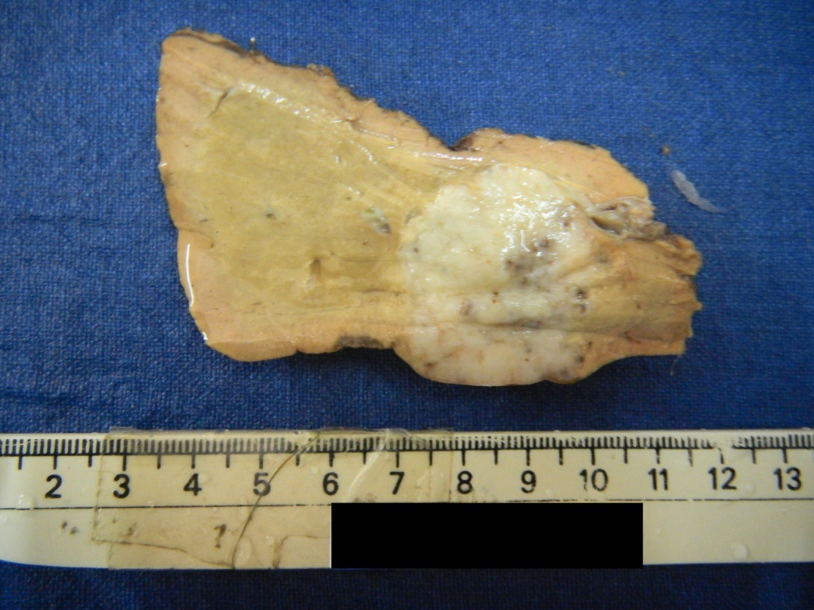
Figure 1 Liver with a fairly circumscribed tumor with a firm grey white cut surface.

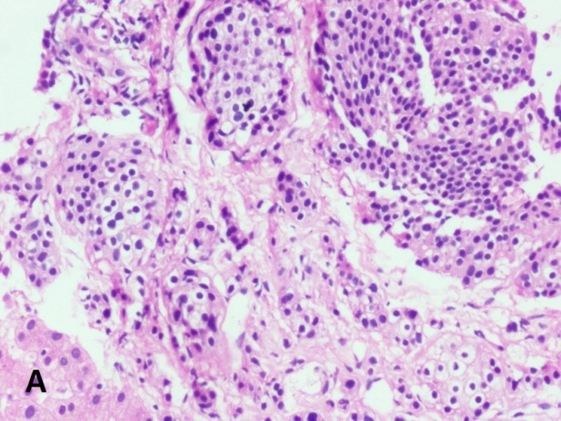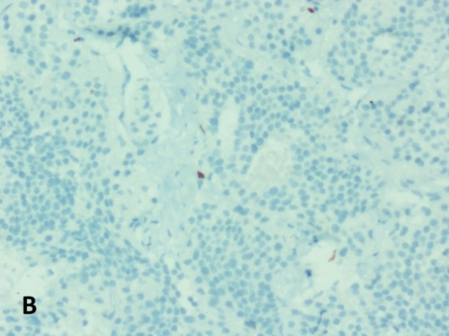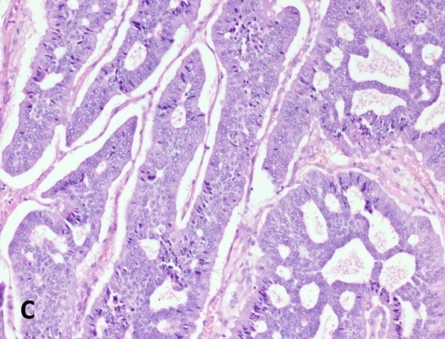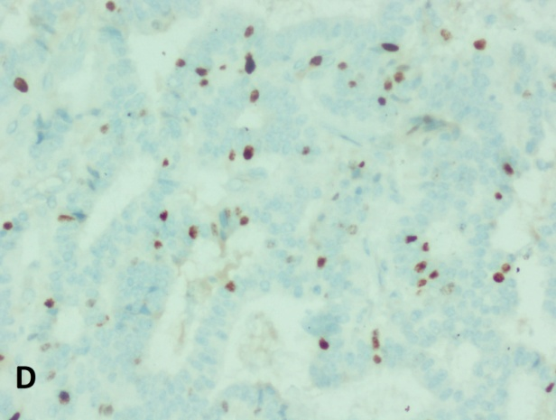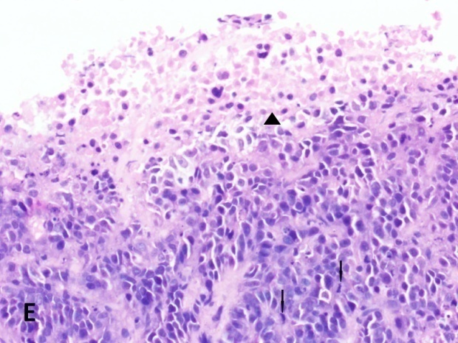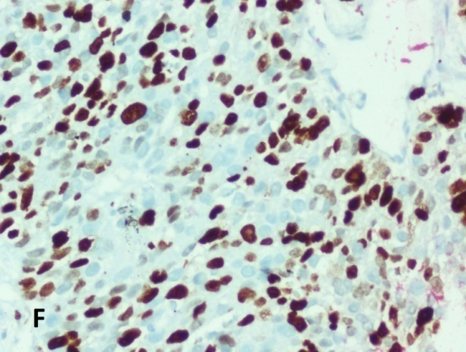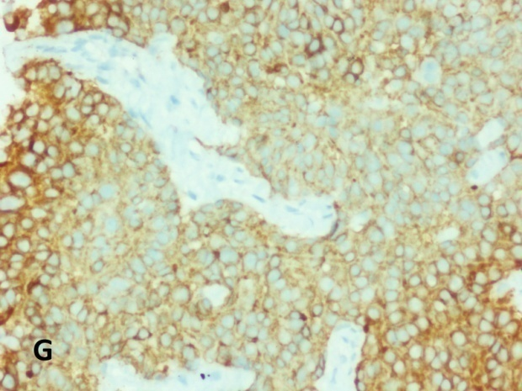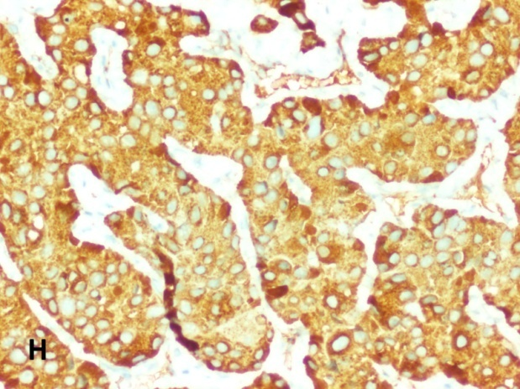
Figure 2 G1-G3 neuroendocrine neoplasms. A: G1 - Tumor with trabecular and nested pattern (H&E × 200); B: Tumor cells displaying Ki-67 index of < 1% (Immunohistochemistry × 200); C : G2 - Tumor with gyriform and festooning patterns and the tumor cells display mildly pleomorphic nuclei with coarse stippled chromatin (H&E × 200); D: Tumor cells displaying Ki-67 index of approximately 16% (Immunohistochemistry × 200); E: G3 - Tumor cells with pleomorphic and hyperchromatic nuclei displaying brisk mitotic (arrow) and apoptotic activity and focal necrosis (arrow head) (H&E × 200); F: Tumor cells displaying Ki-67 index of approximately 80% ( immunohistochemistry × 200); G: Tumor cells displaying diffuse cytoplasmic positivity for synaptophysin (Immunohistochemistry × 200); H - Tumor cells displaying diffuse cytoplasmic positivity for chromogranin (Immunohistochemistry × 200).

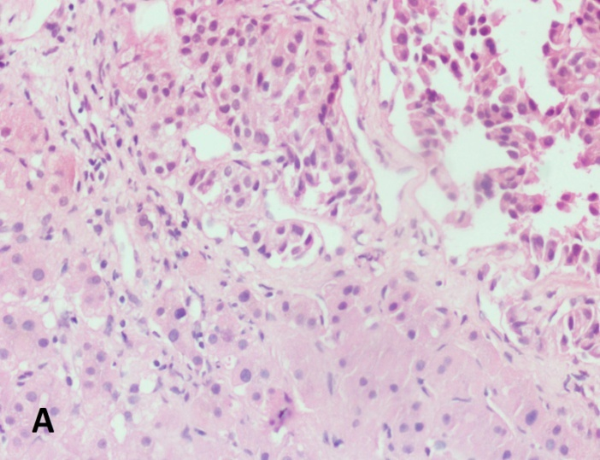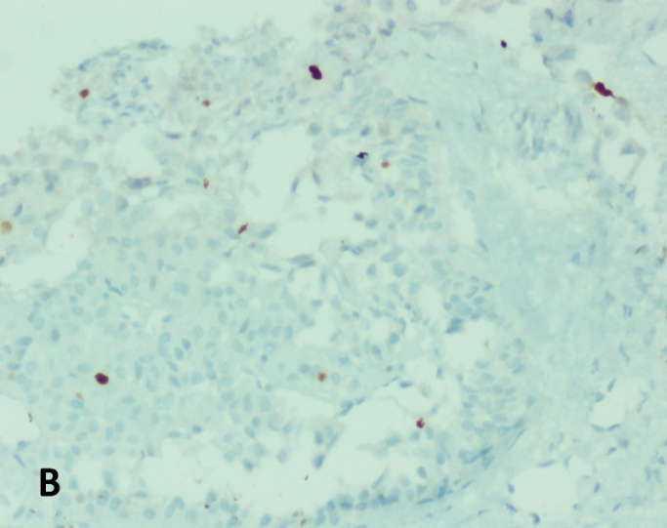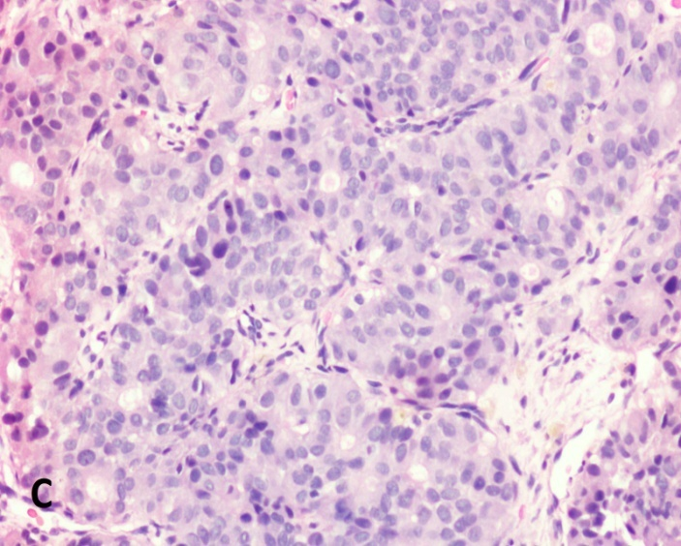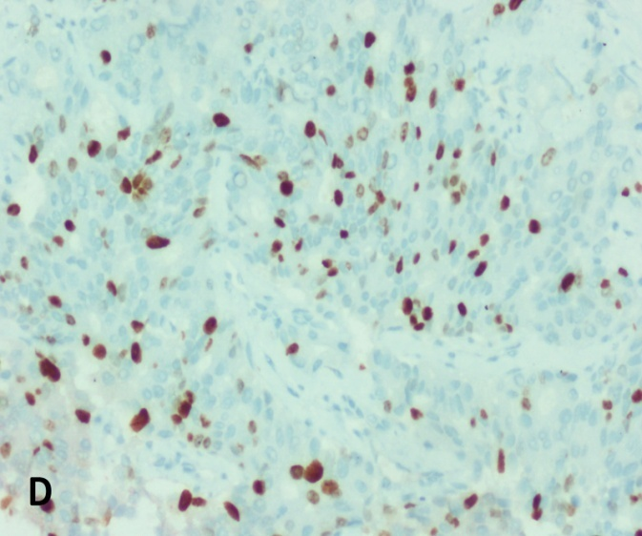
Figure 3 D1/D2 and D2/D3 neuroendocrine neoplasms. A: D1/2 - Liver biopsy showing clusters of tumor cells with uniform nuclei and no conspicuous mitotic activity ( H&E × 200); B: Tumor cells displaying Ki-67 index of approximately 5% (Immunohistochemistry × 200); C: D2/D3 shows tumor cells arranged in trabeculae and focal acinar pattern with mildly pleomorphic nuclei (H&E × 200); D: Tumor cells displaying Ki-67 index of approximately 30% (Immunohistochemistry × 200).

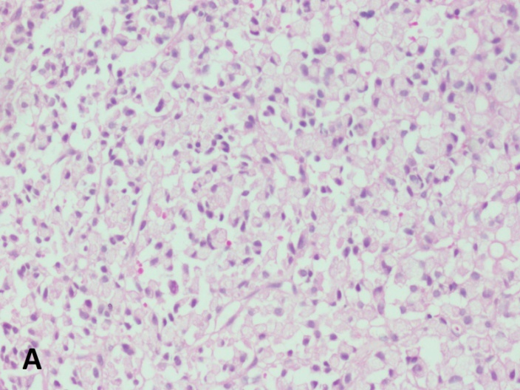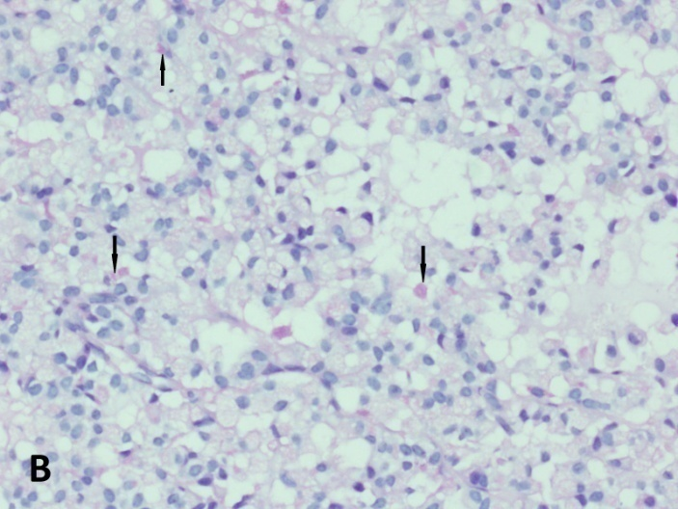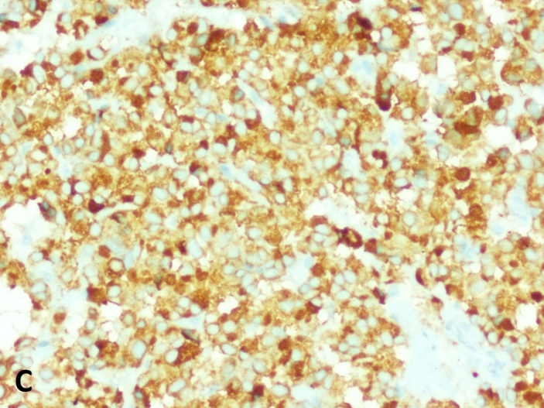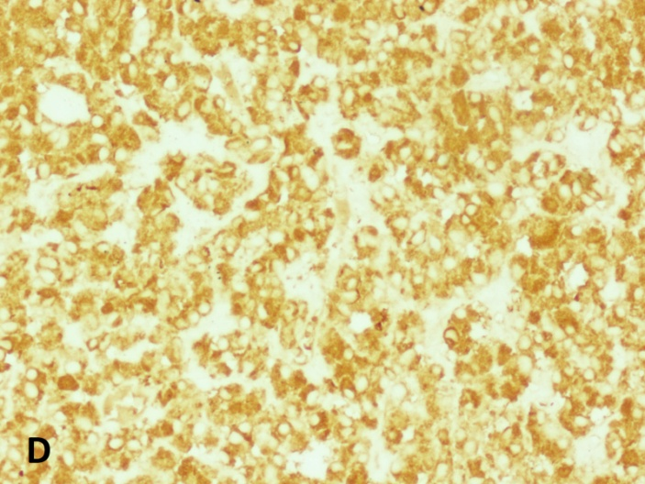
Figure 4 Signet ring cell neuroendocrine neoplasms, G2. A: Tumor cells arranged in sheets and composed of polygonal cells with abundant clear to vacuolated cytoplasm and eccentrically placed uniform nuclei (H&E × 200); B: Occasional tumor cells containing pale staining cytoplasmic mucin (arrows) (PAS-D × 200); C: Tumor cells displaying diffuse cytoplasmic positivity for synaptophysin (Immunohistochemistry × 200); D: Tumor cells displaying diffuse cytoplasmic positivity for chromogranin (Immunohistochemistry × 200).

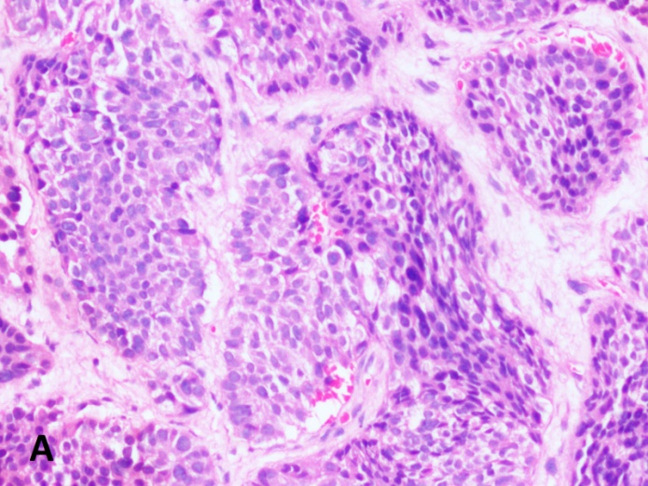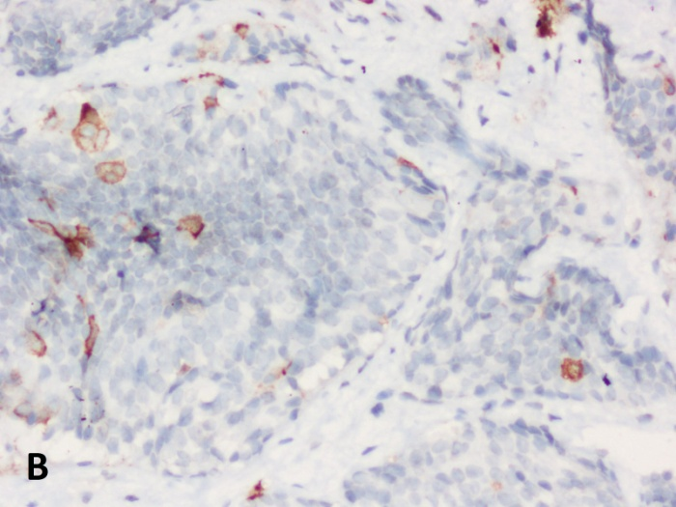
Figure 5 adrenocorticotropic hormone producing neuroendocrine neoplasms, G2. A - Tumor cells arranged in nests and islands. (H&E × 200); B: Occasional tumor cells displaying cytoplasmic positivity for ACTH (Immunohistochemistry × 200). ACTH: adrenocorticotropic hormone.

B
A
Figure 6 Correlation between the mitotic index and Ki67 index and the World Health Organization grading in liver neuroendocrine neoplasms. A: Box-plot showing the median, interquartile range and range of the mitotic index for each WHO grade of tumor. B: Box-plot showing the median, interquartile range and range of the Ki67 index for each WHO grade of tumor.

Figure 7 Shown here are tumor pairs in which the World Health Organization grade of the primary and metastatic tumors could be compared. G1-P, G2-P and G3-P refer to the WHO grade of the primary tumor, while G1-M, G2-M and G3-M refer to WHO grade of the metastatic tumor.

Table 1 Distribution of known primary sites n (%)
Site of primary | Biopsy proven (n = 18) | Lesion-on radiology (n = 27) | Total
Pancreas | 6 | 16 | 22 (49)
Lung | 4 | 4 | 8 (18)
Duodenum | 1 | 3 | 4 (8.8)
Rectum | 2 | 1 | 3 (6.6)
Ileum | 2 | - | 2 (4.4)
Esophagus | 1 | - | 1 (2.2)
Cecum | - | 1 | 1 (2.2)
Gall bladder | 1 | 1 | 2 (4.4)
Anterior mediastinum | - | 1 | 1 (2.2)
Kidney | 1 | - | 1 (2.2)

