Name of journal: World Journal of Gastroenterology
Manuscript NO: 36951
Manuscript type: ORIGINAL ARTICLE

Retrospective Cohort Study
Role of relevant immune-modulators and cytokines in hepatocellular carcinoma and premalignant hepatic lesions

Zekri AN et al. Role of immune-modulators in HCC progression

Abdel-Rahman N Zekri, Somaya El Deeb, Abeer A Bahnassy, Abeer M Badr, Mona S Abdellateif, Gamal Esmat, Hosny Salama, Marwa Mohanad, Ahmed Esam El-dien, Shimaa Rabah, Assmaa Abd elkader

Abdel-Rahman N Zekri, Molecular Virology and Immunology Unit, Department of Cancer Biology, National Cancer Institute, Cairo University, Cairo 11976, Egypt

Somaya El Deeb, Abeer M Badr, Ahmed Esam El-dien, Shimaa Rabah, Assmaa Abd Elkader, Department of Zoology, Faculty of Science, Cairo University, Giza 12613, Egypt

Abeer A Bahnassy, Department of Pathology, National Cancer Institute, Cairo University, Cairo 11976, Egypt

Mona S Abdellateif, Medical Biochemistry and molecular biology, Department of Cancer Biology, National Cancer Institute, Cairo University, Cairo 11976, Egypt

Gamal Esmat, Hosny Salama, Department of Hepatology and Tropical Medicine, Faculty of Medicine, Cairo University, Cairo 11441, Egypt

Marwa Mohanad, Department of Biochemistry, Misr University for Science and Technology, 6th October 12945, Egypt

ORCID number: Abdel-Rahman N Zekri (0000-0003-3939-0416); Somaya El Deeb (0000-0002-1826-1503); Abeer Bahnassy (0000-0001-5454-6576); Abeer M Badr (0000-0003-3503-6639); Mona S Abdellateif (0000-0002-5510-4435); Gamal Esmat (0000-0001-8614-1629); Hosny Salama (0000-0003-0670-3770); Marwa Mohanad (0000-0002-3827-9647); Ahmed Esam El-dien (0000-0002-7357-3235); Shimaa Rabah (0000-0003-0477-8672); Assmaa Abd Elkader (0000-0001-7945-1610).

Author contributions: Zekri AN is the main supervisor, put the idea and plan of work, data interpretation; El Deeb S supervised the biochemical work; Bahnassy AA supervised the flow cytometry work and revised the paper; Badr AM revised the paper; Abdellateif MS analyzed data and wrote the paper; Esmat G and Salama H performed the medical care and follow up of the patients; Mohanad M analysed data; El-dien AE performed the immunophenotyping; Rabah S and Abd Elkader A performed the ELISA work.

Institutional review board statement: The study was reviewed and approved for publication by our Institutional Reviewer.

Informed consent statement: All study participants or their legal guardian provided informed written consent about personal and medical data collection prior to study enrolment.

Conflict-of-interest statement: All the authors have no conflict of interest related to the manuscript.

Data sharing statement: The original anonymous dataset is available on request from the corresponding author at ncizekri@yahoo.com.

Open-Access: This article is an open-access article which was selected by an in-house editor and fully peer-reviewed by external reviewers. It is distributed in accordance with the Creative Commons Attribution Non Commercial (CC BY-NC 4.0) license, which permits others to distribute, remix, adapt, build upon this work non-commercially, and license their derivative works on different terms, provided the original work is properly cited and the use is non-commercial. See: http://creativecommons.org/licenses/by-nc/4.0/

Manuscript source: Invited manuscript

Correspondence to: Abdel-Rahman N Zekri, MSc, PhD, Professor, Molecular Virology and Immunology Unit, Department of Cancer Biology, National Cancer Institute, Cairo University, Kasr Al-Aini Street, Fom El-Khaleeg, Cairo 11976, Egypt. ncizekri@yahoo.com
Telephone: +2-10-01413521
Fax: +2-202-23644720

Received: November 5, 2017
Peer-review started: November 6, 2017
First decision: November 27, 2017
Revised: December 24, 2017
Accepted: January 17, 2018
Article in press:
Published online:

abstract
AIM
to assess the levels of different immune modulators in patients with hepatocellular carcinoma (HCC) in relation to other hepatic diseases.

METHODS
Eighty eight patients were included in the current study; patients with HCC (20), liver cirrhosis (28), chronic hepatitis (CH; 25), and normal control (NC; 15). Peripheral blood were isolated for immunophenotyping of active myeloid dendriti cells (mDCs) (CD1c and CD40), mature inactive myeloid cells (CD1c and HLA), active plasmacytoid cells (pDCs) (CD303 and CD40), mature inactive pDC (CD30 and HLA), active natural killer (NK) cells (CD56 and CD161), active NK cells (CD56 and CD314) and inactive NK cells (CD56 and CD158) was done by flow cytometry. Serum levels of interleukin (IL)-2, IL-10, IL-12, IL-1β, interferon-α (IFN-α), IFN-γ and tumor necrosis factor (TNF)-αR2 were assessed by ELISA.

RESULTS
Active mDCs (CD1C+/CD40+) and inactive mDCs (CD1c+/HLA+) were significantly decreased in HCC patients in relation to NC (P < 0.001). CD40+ expression on active pDCs was decreased in HCC patients (P < 0.001), and its level was not significantly changed among other groups. Inactive pDCs (CD303+/HLA+), inactive NKs (CD56+/CD158+) and active NKs (CD56+/CD161+) were not statistically changed among the four studied groups, however the latter was increased in CH (P < 0.05). NKG2D was statistically decreased in HCC, CH and cirrhosis (P < 0.001), and it was not expressed in 63% (12/20) of HCC patients. There was significant decrease of IL-2, IFN-α, and IFN-γ (P < 0.001), while a significant increase in IL-10, IL-1β, and TNF-αR2 (P <0.01, P < 0.001 and P < 0.001; respectively) in HCC patients. There was inverted correlation between IL-12 and IL-1 β in HCC (r = - 0.565, P < 0.01), strong correlation between pDCs (CD303+/CD40+) and NKs (CD56+/CD161+; r = 0.512, P < 0.05). Inactive mDCs (CD1c+/HLA+) and Inactive NK cells (CD56+/CD158+; r = 0.945, P < 0.001).

CONCLUSION
NKG2D, CD40, IL-2 and IL-10 are important modulators in the development and progression of HCC.

Key words: Hepatocellular carcinoma; Hepatitis C virus; NKG2D; CD40; interleukin-2; interleukin-10; myeloid dendriti cells; plasmacytoid cells; natural killer cell; Cytokines

© The Author(s) 2018. Published by Baishideng Publishing Group Inc. All rights reserved.

Core tip: We assessed the levels of different immune modulatory cytokines and innate immune cells as natural killer (NK) cells and dendritic cells (DCs) in patients with disease progression of hepatocarcinogenesis. Our results showed significant downregulation in active mDCs and pDCs expressing CD40 as well as NK cells expressing NKG2D. The expression of NKG2D on NKs was not expressed in 63% of hepatocellular carcinoma (HCC) patients. Also, there was significant decrease of interleukin (IL)-2, interferon-α, interferon-γ, while a significant increase in IL-10, IL-1β, and TNF-αR2 in HCC patients. These factors could be implicated in the pathogenesis of HCC, and provides an attractive targets for therapy in chronic hepatitis C virus hepatitis and HCC.

Zekri AN, El Deeb S, Bahnassy AA, Badr AM, Abdellateif MS, Esmat G, Salama H, Mohanad M, El-dien AE, Rabah S, Abd Elkader A. Role of relevant immune-modulators and cytokines in hepatocellular carcinoma and premalignant hepatic lesions. World J Gastroenterol 2018; In press
Introduction
Hepatocellular carcinoma (HCC) is a major health problem worldwide. It is the sixth most common cancer and the second leading cause of cancer-related death in the world^{[1]}. In Egypt HCC ranks the first among cancers in males (33.6%), and the 2nd in females after breast cancer (13.5%)^{[2]}. this high incidence is attributed to the high prevalence of hepatitis C virus (HCV) infection especially genotype IV in Egypt^{[3]}. Despite advances in treatment modalities, Sorafenib is still the only treatment approved by the Food and Drug Administration (FDA) for HCC, however, it extends the overall survival (OS) by 3 mo only. Hence, it is crucial to understand the underlying biological and immunological changes in HCC and to develop new treatment modalities based on these data^{[4,5]}.
The body’s immune defense mechanism(s) plays an important role in the inhibition or progression of cancer. However, tumors can escape immune surveillance via producing a local and/or systemic immune-suppressive environment^{[6]}. Although the underlying molecular mechanisms are not yet fully clear, recent studies show that the immune response in cancer patients is usually down regulated by immunosuppressive cells, mainly T regulatory cells (Tregs) and myeloid-derived suppressor cells (MDSCs), which suppress the immune system and promote immunologic tolerance^{[7]}. These inhibitory cells accumulate during advanced cancer stages, they are involved in chronic inflammation and tumor progression and they can inhibit many immune cells e.g., CD4+, CD8+, natural killer (NK)^{[8]}. They also secrete many immune-suppressive cytokines, such as IL-6, IL-10, and transforming growth factor β (TGF-β) creating a tolerogenic and suppressive environment^{[9]}.
The NK cells represent 25%-30% of the human liver lymphocytes compared to 10%-20% of the total peripheral blood lymphocyte^{[10]}. They are the main effector cells of innate immunity, which play an important role in tumor surveillance. The NK cells achieve their functions through the release of cytolytic mediators, such as perforin and granzymes, or the induction of apoptosis via the expression of TNF ligands and IFN-γ^{[11]}. Activation of NK cells is strictly regulated by a balance between activating and inhibitory signals whereas, the inhibitory signals are mainly induced by receptors for MHC class I molecules (KIRs, CD94/NKG2A). The activating signals are mainly achieved through NKG2D, a C-type lectin-like receptor which is expressed on NK cells, γδ T cells and CD8+ T cells^{[12,13]}. NKG2D is responsible for detection and elimination of transformed cells via binding to MICA (MHC class I–related chain), MICB and the UL16-binding proteins^{[14]}. Activation of NKG2D provides unique co-stimulation to antigen-specific CD8 T cells that is non-redundant to CD28 co-stimulation^{[15]}.
Dendritic cells (DCs) are the most professional antigen-presenting cells which respond rapidly to microenvironment signals. Upon maturation by tumor antigen, cross-priming to T and B lymphocytes occurs to produce antitumor adaptive immune responses^{[16]}. There are 2 subsets of DCs; the myeloid dendriti cells (mDCs); which are characterized by their ability to produce IL-12 and plasmacytoid cells (pDCs); which are responsible for the production of over 95% of type-I IFNs in response to viral infection^{[17]}. On activation, the CD8+ cytotoxic T cells (CTLs) eliminate tumor cells by the production of IFN-γ, whereas CD4+ T helper cells stimulate B cells to support the cytotoxic and humoral immune response^{[18]}.
Interleukin-1 Beta is a regulatory cytokine which is produced by tumor and immune cells such as myeloid dendritic suppressor cells (MDSC). It also induces COX-2 expression, which prevents maturation and activation of antigen presenting cells at the tumor site^{[19]}.
In the current study we assessed the role(s) of different immune regulatory cells and cytokines in the development and progression of chronic liver disease (chronic active hepatitis, cirrhosis and HCC) compared to the normal healthy volunteers. We believe that this could allow for better understanding of different pathways implicated in the development and progression of hepatocarcinogenesis, and could also be help in designing new immune-therapeutic drugs.

materials and Methods
Patients
The current study included 88 patients who attended the medical oncology clinics of the National Cancer Institute (NCI), Cairo University during the period from 2014 to 2016. Patients were divided into 4 groups: HCC (20 patients - G1), liver cirrhosis (28 patients - G2), chronic hepatitis (25 patients - G3) and normal healthy volunteers as a control group (15 persons, matched for age and sex - G4). The Ethical Committee of the NCI, Egypt approved the study protocol and an informed consent was obtained from all participants before enrollment in the study.

Characterization of immune cells by Flowcytometry
Peripheral blood samples were isolated from patients and healthy subjects for immuno-phenotyping of active mDCs (CD1c and CD40), mature inactive myeloid cells (CD1c and HLA), active pDC (CD303 and CD40), mature inactive pDC (CD303 and HLA), active NK cells (CD56 and CD161), active NK cells (CD56F CD314) and inactive NK cells (CD56 and CD158) using the specific monoclonal antibodies according to manufactures protocols (all monoclonal antibodies were purchased from (Invitrogen, eBioscience, San Diego). Samples were then analyzed by Flowcytometry (FACSCaliber, Becton and Dickenson).

Detection of cytokines’ levels by ELISA
Serum levels of IL-2, IL-10, IL-12, IL-1β, IFN-α, IFN-γ and TNF-αR2 were measured by the ELISA technique according to manufacturers' instructions (Invitrogen, eBioscience, San Diego, United States), using ELISA reader (Sunrise, TECAN).

Statistical analysis
Data were expressed as mean ± SE of mean for continuous variables. Comparison between cytokine levels and immune cells were performed using one way ANOVA followed by Tukeys’ post HOC test. Pearson’s correlation was used to assess the strength of correlation between different variables and a two tailed P value was determined. The P value was considered significant at value < 0.05. All statistical analysis were performed using SPSS, version 22 (IBM SPSS, Armonk, NY, United States).

Results
Patients' characteristics
The mean age of the patients included in the current study was 57.1 ± 4.76 in HCC, patients, 51.29 ± 9.03 in liver cirrhosis, 49.64 ± 7.2 in CH and 42.9 ± 10.2 in NC (Table 1).

Flowcytometry data
There was a significant decreased in active mDCs (CD1C+/CD40+) and inactive mDCs (CD1c+/HLA+) in HCC patients compared to the NC group (P < 0.001) as well as active mDCs (CD1C+/CD40+) in cirrhotic patients compared to chronic hepatitis patients (P = 0.003; Table 2). Also, the expression level of CD40+ on active pDCs (CD303+) was significantly decreased in HCC compared to the NC (P < 0.001). However, there was no significant difference was reported with other groups (cirrhosis and chronic hepatitis). Meanwhile, the level of inactive pDCs (CD303+/HLA+) did not differ significantly between the four studied groups (Table 2, Figure 1).
The level of the non-active NK cells (CD56+/CD158+) did not differ significantly among groups. However, the active NK cells (CD56+/CD161+) showed a significant increase in the CH group (P < 0.05) whereas the level of active NK cells (CD56+/CD314+), was statistically decreased in HCC, chronic hepatitis and cirrhotic patients compared to the normal control group (P < 0.001), indicating an important role of these cells in the pathogenesis of HCC (Table 2). The expression of all cell types in each patient showed that active NK cells (CD56+/CD314+) were not expressed in 63% (12/20) of HCC patients. However two patients showed unexplainable high variability (Figure 2).
We also reported a significant decrease in the active NK cells (CD56+/CD314+; P < 0.05), and active pDCs (CD303+, CD40+; P < 0.05) compared to the inactive NK cells (CD56+/CD158+) and inactive pDCs (CD303+/HLA+); respectively in HCC. On contrary, the NK cells (CD56+/CD161+) and the mDCs did not differ significantly between groups (Figure 3).

Serum levels of cytokines
There was a significant decrease in serum levels of IL-2, IFN-α, and IFN-γ in HCC patients compared to the NC group (P < 0.001) and a significant increase in serum levels of IL-10, IL-1β, and TNF-αR2 in HCC compared to the NC group (P < 0.01, P < 0.001, and P < 0.001; respectively). However there was no statistically significant change in the serum level of IL-12 (P = 0.393) among the four studied groups (Table 3 and Figure 4).
Significant correlation was also reported in HCC patients between (1) serum level of IL-12 and IL-1 β (r = - 0.565, P < 0.01); (2) The expression of CD40 on pDCs (CD303+, CD40+) and active NK cells (CD56+/CD161+; r = 0.512, P < 0.05); and (3) Inactive mDCs (CD1c+/HLA+) and Inactive NK cells (CD56+/CD158+; r = 0.945, P < 0.001, Figure 5A-C).
Patients with chronic active hepatitis showed strong significant correlation between active NK cells (CD56+/CD161+) and IL-2, IL-12 (r = 0.549, P = 0.004 and r = 0.660, P < 0.001; respectively). Strong correlations were also reported between the expression of CD314 on NK cells and IL-2 (r = 0.548, P < 0.01), and active mDCs CD1c+/CD40+ (r = 0.577, P = 0.003). The level of IL-10 was strongly correlated with (1) increased inactive NK cells (CD56+/CD158+; r = 0.604, P = 0.001); and (2) inactive mDCs CD1c+/HLA+ (r = 0.588, P = 0.002; Table 4).

Discussion
Identification of inflammatory mediators which promote or prevent the progression of cancer depends on the tumor microenvironment. Thus, this study was designed to assess the levels of different immune modulators and cytokines in patients with HCC, nonmalignant hepatic diseases (e.g., chronic hepatitis and liver cirrhosis) compared to normal group. This would enable us to study different pathways that help in identifying immune cells or biomarkers that may be implicated in hepatocellular carcinogenesis. This may also explain why liver disease progresses more rapidly in some patients than in others and provides additional therapeutic modalities for viral infections and HCC (immunotherapy).
One of the most powerful antigen presenting cells is DCs, which play an important role in antitumor immune response. Our data revealed that active and inactive mDCs were significantly decreased in HCC patients compared to normal control group (P< 0.001), however, the level of active mDCs (CD1C+/CD40+) was significantly decreased in cirrhosis compared to chronic hepatitis (P = 0.003). These data are consistent with Obermajer et al^{[20]}, who reported that the inhibition of DC maturation in HCC may prove to be a critical feature of tumor escape as well as with other two recent studies which reported numerical and functional defects in the peripheral DCs in hepatitis B and C- associated HCC patients^{[21,22]}.
The plasmacytoid dendretic cell (pDCs; CD303+ CD40+) is the major cell responsible for antiviral immunity, and the main source of IFN-α in the body. Our data revealed that the expression level of CD40+ on active pDCs was significantly decreased in HCC patients compared to NC (P < 0.001). Meanwhile, Inactive pDCs (CD303+/HLA+) did not change significantly among the four studied groups. This was also confirmed by the significant decrease of serum IFN-α, and the increase of IL-10 in HCC patients compared to NC group (P < 0.001 and P < 0.01; respectively). This is in concordance with previous reports showing that IL-10 inhibits IFN-α production and promotes apoptosis of human plasmacytoid dendritic cells^{[23,24]}. Moreover, Gonzalez-Carmona et al^{[25]}, demonstrated that cancer patients had low CD40 expression on DCs or CD40L on T-cells, which is associated with an impaired immune response and Shurin et al^{[26]}, reported that the tumor-derived IL-10, inhibits CD40 expression on DCs and DC precursors and suppress their maturation and function.
NK cells play an important role in controlling viral hepatitis, liver fibrosis, and carcinogenesis. Their functions are modulated by different classes of receptors present on its surface^{[27]}. Thus it is essential to identify the roles of these cells in different stages of HCC development. Among which we investigated the role of the killer cell immunoglobulin-like receptors (KIR; CD158), NKR-P1A (CD161) and NKG2D (CD314) in HCV chronic hepatitis patients, liver cirrhosis and its progression to HCC.
Our results revealed that the expression of the inhibitory KIR (CD158+) receptors and the activating NKR-P1A (CD161) on NK cells was not statistically changed between HCC and NC (P = 0.827, P = 0.788 respectively). Thus these two pathways may not be involved in the pathogenesis of HCC. However the latter were statistically increased in chronic hepatitis (P < 0.05). This result was supported by our finding of a strong statistical correlation between the expression of CD161 on NK cells and IL-12, r = 0.77, P < 0.001, in patients with HCV chronic active hepatitis. This illustrates the role of NK cells (CD56+/CD161+) in viral hepatitis.
On the other hand, the level of active NK cells expressing NKG2D, were statistically decreased in HCC, chronic hepatitis and cirrhosis in relation to normal group (P < 0.001), that could indicate the implication of these cells in the progression of HCC. This was clarified by representing its expression in each patient, it was not expressed in 63% (12/20) of HCC patients, emphasizing its important role in HCC development. These data were consistent with Lanier et al^{[28]}, and Yoon et al^{[29]}, reported that direct interaction between human NK cells and HCV-infected hepatoma cells downregulate NK cell NKG2D expression and effector function with diminished IFN-γ production. Another study done by Kamiya et al^{[30]}, proved that NKG2D was an important mediator of anti-HCC activity. On the contrary, Oliviero et al^{[31]}, found a decreased percentage of NK cells expressing the inhibitory receptor KIR3DL1 and a concomitant increase in the proportion of NKG2D⁺ NK cells in Italian patients with chronic HCV. This could be explained by racial and environmental differences with different viral genotype, and also according to the clinical stage.
Our results regarding DCs and NK cells were supported by assessment of the cytokine serum levels in the four studied groups. We found that there was a significant increase in IL-1β (P < 0.001) in HCC patients compared to normal group. However there was no statistical significant change in the serum level of IL-12 (P = 0.393) among the four studied groups. Furthermore we had a significant increase in the serum level of IL-10 in cirrhosis and HCC group compared to NC. This is consistent with Accapezzato et al^{[32]}. IL-10 is important for allowing liver NK cells to maintain immune- tolerant states^{[33]}. Its significant increase in HCC patients is responsible for the abnormal tolerant NK cells that cannot eliminate infected or transformed cells, which leads to immune evasion.
In the current study, there was a significant decrease of the serum levels of IFN-γ in chronic HCV hepatitis, cirrhosis and HCC patients in comparison to NC (P < 0.001). This is in agreement with Li et al^{[34]}, who found that NK cells cultured with cancer-associated fibroblasts from HCC (H-CAFs) downregulate NKG2D and NKp46 and decrease expression of Granzyme B, perforin, and INF-γ. Later, another study showed that TGF-β and IL-10 in hepatic carcinoma patients induce the expression of microRNA (miR)-146a, which causes reduced IFN-γ production and cytotoxicity, resulting in a poorer prognosis^{[35]}. Meanwhile Zhang et al^{[36]} found that MDSCs selectively suppressed the IFN-γ production deriving from NKT cells through membrane-bound TGF-β.
IL-2 plays a critical role in the activation of immune system which could be used to eradicate cancer. It had been demonstrated as monotherapy, and was approved for metastatic renal cell carcinoma and metastatic melanoma by FDA^{[37]}. Our results showed a significant increase in TNF-αR2 (P < 0.001), and significant decrease in IL-2 (P < 0.001) in HCC patients in relation to other groups, that consistent with our previous results^{[38,39]} that concluded the possible use of serum TNFR-II, IL-2Ra and IL-8, as combined biomarkers in HCV infected patients at high risk of developing HCC.
Another important finding in the current study was that HCC patients had a significant decrease of active NK cells CD56+/CD314+ (P < 0.05), and active pDCs CD303+, CD40+ (P < 0.05) in comparison to inactive NK cells CD56+/CD158+ and inactive pDCs CD303+/HLA+ respectively. NK cells expressing CD56+/CD161+ and mDCs were not statistically affected. This revealed the importance of these two subsets of cells [active NK cells (CD56+/CD314+), and active pDCs CD303+, CD40+] in the pathogenesis of HCC, and allow for further researches around the state of this imbalance that emerge in HCC patients.
We conclude that there is immunological changes occurred in HCC patients which could be a possible candidate for future immunotherapy for these patients. Among which is NK cells expressing NKG2D, pDCs expressing CD40, IL-2 and IL-10. These factors could be implicated in the pathogenesis of HCC, and provides an attractive target for therapeutics in chronic HCV hepatitis and liver cancer.

Article Highlights
Research background
Hepatocellular carcinoma (HCC) is a major health problem worldwide and mainly in Egypt, due to the high prevalence of HCV infection especially genotype IV. It ranks the first among cancers in males (33.6%), and the 2nd in females after breast cancer. Sorafenib is still the only treatment approved by the Food and Drug Administration for HCC, however, it extends the overall survival (OS) by 3 mo only. Hence, it is crucial to understand the underlying biological and immunological changes in HCC Egyptian patients, and to develop new treatment modalities based on these data.

Research motivation
The immune system plays an important role in suppression of cancer. However, tumors can escape immune surveillance via producing immune-suppressive environment in which the underlying mechanisms are not fully clear. Recent studies show that the immune response in HCC patients is usually down regulated by immunosuppressive cells (MDSCs and Tregs) that involved in chronic inflammation and tumor progression. Also these inhibitory cells secrete many immune-suppressive cytokines, such as IL-6, IL-10, and transforming growth factor β (TGF-β) creating a tolerogenic and suppressive environment^{[9]}.

Research objectives
The objectives of this study was to assess the levels of different immune modulators and cytokines that may play a role in the pathogenesis of HCC and other hepatic diseases e.g., chronic hepatitis and liver cirrhosis compared to normal group. This would help in identifying additional therapeutic modalities for viral infections and HCC in the context of immunotherapy.

Research methods
This retrospective cohort study included 88 patients who attended the medical oncology clinics of the National Cancer Institute, Cairo University during the period from 2014 to 2016. Patients were divided into HCC group (20 patients-G1), liver cirrhosis group (28 patients-G2), chronic hepatitis group (25 patients-G3) and normal healthy volunteers as a control group (15 persons). The immune system of the patients was assessed through immuno-phenotyping of CD1c and CD40, CD1c and HLA, CD303 and CD40, CD303 and HLA, CD56 and CD161, CD56 and CD314, and CD56 and CD158 by Flowcytometry. On the other hand, serum levels of IL-2, IL-10, IL-12, IL-1β, IFN-α, IFN-γ and TNF-αR2 were measured by the ELISA technique according to manufacturers' instructions. Data were expressed as mean ± SE of mean, and comparison between cytokine levels and immune cells were performed.

Research results
There was a significant decreased in active and inactive mDCs in HCC patients compared to the NC group as well as active mDCs (CD1C+/CD40+) in cirrhotic patients compared to chronic hepatitis patients. The expression level of CD40+ on active pDCs (CD303+) was significantly decreased in HCC compared to the NC. However, there was no significant difference with other groups (cirrhosis and chronic hepatitis). Meanwhile, the level of inactive pDCs (CD303+/HLA+) and inactive NK cells (CD56+/CD158+) did not differ significantly between the four studied groups.
The active NK cells (CD56+/CD161+) showed a significant increase in the CH group whereas the level of active NK cells (CD56+/CD314+) was statistically decreased in HCC, chronic hepatitis and cirrhotic patients compared to the normal control group, indicating an important role of these cells in the pathogenesis of HCC. The individual expression of each cell type in patients showed that active NK cells (CD56+/CD314+) were not expressed in 63% (12/20) of HCC patients.
There was a significant decrease in serum levels of IL-2, IFN-α, and IFN-γ in HCC patients compared to the NC group and a significant increase in serum levels of IL-10, IL-1β, and TNF-αR2 in HCC compared to the NC group. However there was no statistically significant change in the serum level of IL-12 among the four studied groups.

Research conclusions
We conclude that there is immunological changes occurred in HCC patients in relation to other liver diseases. These immunological factors are NKG2D expressed on NK cells, pDCs expressing CD40, IL-2 and IL-10. These factors could be implicated in the pathogenesis of HCC, and provides an attractive target for therapeutics in chronic HCV hepatitis and liver cancer.

Research perspectives
NKG2D, CD40, IL-2 and IL-10 could be a possible candidate for future immunotherapy for HCC patients. However further studies are recommended regarding correlation of these factors and clinco-pathological features as well as the overall survival of the patients.

References
1 Ferlay J, Soerjomataram I, Dikshit R, Eser S, Mathers C, Rebelo M, Parkin DM, Forman D, Bray F. Cancer incidence and mortality worldwide: sources, methods and major patterns in GLOBOCAN 2012. Int J Cancer 2015; 136: E359-E386 [PMID: 25220842 DOI: 10.1002/ijc.29210]
2 Ibrahim AS, Khaled HM, Mikhail NN, Baraka H, Kamel H. Cancer incidence in egypt: results of the national population-based cancer registry program. J Cancer Epidemiol 2014; 2014: 437971 [PMID: 25328522 DOI: 10.1155/2014/437971]
3 Zekri AR, Hafez MM, Bahnassy AA, Hassan ZK, Mansour T, Kamal MM, Khaled HM. Genetic profile of Egyptian hepatocellular-carcinoma associated with hepatitis C virus Genotype 4 by 15 K cDNA microarray: preliminary study. BMC Res Notes 2008; 1: 106 [PMID: 18959789 DOI: 10.1186/1756-0500-1-106]
4 Knudsen ES, Gopal P, Singal AG. The changing landscape of hepatocellular carcinoma: etiology, genetics, and therapy. Am J Pathol 2014; 184: 574-583 [PMID: 24388934 DOI: 10.1016/j.ajpath.2013.10.028]
5 Llovet JM, Villanueva A, Lachenmayer A, Finn RS. Advances in targeted therapies for hepatocellular carcinoma in the genomic era. Nat Rev Clin Oncol 2015; 12: 408-424 [PMID: 26054909 DOI: 10.1038/nrclinonc.2015.103]
6 Ostrand-Rosenberg S. Tolerance and immune suppression in the tumor microenvironment. Cell Immunol 2016; 299: 23-29 [PMID: 26435343 DOI: 10.1016/j.cellimm.2015.09.011]
7 Gabrilovich DI, Ostrand-Rosenberg S, Bronte V. Coordinated regulation of myeloid cells by tumours. Nat Rev Immunol 2012; 12: 253-268 [PMID: 22437938 DOI: 10.1038/nri3175]
8 Shrihari TG. Dual role of inflammatory mediators in cancer. Ecancermedicalscience 2017; 11: 721 [PMID: 28275390 DOI: 10.3332/ecancer.2017.721]
9 Costa A, Scholer-Dahirel A, Mechta-Grigoriou F. The role of reactive oxygen species and metabolism on cancer cells and their microenvironment. Semin Cancer Biol 2014; 25: 23-32 [PMID: 24406211 DOI: 10.1016/j.semcancer.2013.12.007]
10 Zeromski J, Mozer-Lisewska I, Kaczmarek M, Kowala-Piaskowska A, Sikora J. NK cells prevalence, subsets and function in viral hepatitis C. Arch Immunol Ther Exp (Warsz) 2011; 59: 449-455 [PMID: 21972016 DOI: 10.1007/s00005-011-0145-y]
11 Zhong Z, Sanchez-Lopez E, Karin M. Autophagy, Inflammation, and Immunity: A Troika Governing Cancer and Its Treatment. Cell 2016; 166: 288-298 [PMID: 27419869 DOI: 10.1016/j.cell.2016.05.051]
12 Lanier LL. NK cell recognition. Annu Rev Immunol 2005; 23: 225-274 [PMID: 15771571 DOI: 10.1146/annurev.immunol.23.021704.115526]
13 Dai Z, Turtle CJ, Booth GC, Riddell SR, Gooley TA, Stevens AM, Spies T, Groh V. Normally occurring NKG2D+CD4+ T cells are immunosuppressive and inversely correlated with disease activity in juvenile-onset lupus. J Exp Med 2009; 206: 793-805 [PMID: 19289577 DOI: 10.1084/jem.20081648]
14 Guerra N, Tan YX, Joncker NT, Choy A, Gallardo F, Xiong N, Knoblaugh S, Cado D, Greenberg NM, Raulet DH. NKG2D-deficient mice are defective in tumor surveillance in models of spontaneous malignancy. Immunity 2008; 28: 571-580 [PMID: 18394936 DOI: 10.1016/j.immuni.2008.02.016]
15 Wu J, Groh V, Spies T. T cell antigen receptor engagement and specificity in the recognition of stress-inducible MHC class I-related chains by human epithelial gamma delta T cells. J Immunol 2002; 169: 1236-1240 [PMID: 12133944 DOI: 10.4049/jimmunol.169.3.1236]
16 Burkholder B, Huang RY, Burgess R, Luo S, Jones VS, Zhang W, Lv ZQ, Gao CY, Wang BL, Zhang YM, Huang RP. Tumor-induced perturbations of cytokines and immune cell networks. Biochim Biophys Acta 2014; 1845: 182-201 [PMID: 24440852 DOI: 10.1016/j.bbcan.2014.01.004]
17 Tel J, van der Leun AM, Figdor CG, Torensma R, de Vries IJ. Harnessing human plasmacytoid dendritic cells as professional APCs. Cancer Immunol Immunother 2012; 61: 1279-1288 [PMID: 22294456 DOI: 10.1007/s00262-012-1210-z]
18 Korniluk A, Koper O, Kemona H, Dymicka-Piekarska V. From inflammation to cancer. Ir J Med Sci 2017; 186: 57-62 [PMID: 27156054 DOI: 10.1007/s11845-016-1464-0]
19 Kanterman J, Sade-Feldman M, Baniyash M. New insights into chronic inflammation-induced immunosuppression. Semin Cancer Biol 2012; 22: 307-318 [PMID: 22387003 DOI: 10.1016/j.semcancer.2012.02.008]
20 Obermajer N, Muthuswamy R, Lesnock J, Edwards RP, Kalinski P. Positive feedback between PGE2 and COX2 redirects the differentiation of human dendritic cells toward stable myeloid-derived suppressor cells. Blood 2011; 118: 5498-5505 [PMID: 21972293 DOI: 10.1182/blood-2011-07-365825]
21 Nakamoto Y, Guidotti LG, Kuhlen CV, Fowler P, Chisari FV. Immune pathogenesis of hepatocellular carcinoma. J Exp Med 1998; 188: 341-350 [PMID: 9670046 DOI: 10.1084/jem.188.2.341]
22 Kakumu S, Ito S, Ishikawa T, Mita Y, Tagaya T, Fukuzawa Y, Yoshioka K. Decreased function of peripheral blood dendritic cells in patients with hepatocellular carcinoma with hepatitis B and C virus infection. J Gastroenterol Hepatol 2000; 15: 431-436 [PMID: 10824889 DOI: 10.1046/j.1440-1746.2000.02161.x]
23 Dolganiuc A, Chang S, Kodys K, Mandrekar P, Bakis G, Cormier M, Szabo G. Hepatitis C virus (HCV) core protein-induced, monocyte-mediated mechanisms of reduced IFN-alpha and plasmacytoid dendritic cell loss in chronic HCV infection. J Immunol 2006; 177: 6758-6768 [PMID: 17082589 DOI: 10.4049/jimmunol.177.10.6758]
24 Duramad O, Fearon KL, Chan JH, Kanzler H, Marshall JD, Coffman RL, Barrat FJ. IL-10 regulates plasmacytoid dendritic cell response to CpG-containing immunostimulatory sequences. Blood 2003; 102: 4487-4492 [PMID: 12946990 DOI: 10.1182/blood-2003-07-2465]
25 Gonzalez-Carmona MA, Lukacs-Kornek V, Timmerman A, Shabani S, Kornek M, Vogt A, Yildiz Y, Sievers E, Schmidt-Wolf IG, Caselmann WH, Sauerbruch T, Schmitz V. CD40ligand-expressing dendritic cells induce regression of hepatocellular carcinoma by activating innate and acquired immunity in vivo. Hepatology 2008; 48: 157-168 [PMID: 18537185 DOI: 10.1002/hep.22296]
26 Shurin MR, Yurkovetsky ZR, Tourkova IL, Balkir L, Shurin GV. Inhibition of CD40 expression and CD40-mediated dendritic cell function by tumor-derived IL-10. Int J Cancer 2002; 101: 61-68 [PMID: 12209589 DOI: 10.1002/ijc.10576]
27 Tian Z, Chen Y, Gao B. Natural killer cells in liver disease. Hepatology 2013; 57: 1654-1662 [PMID: 23111952 DOI: 10.1002/hep.26115]
28 Lanier LL. NKG2D Receptor and Its Ligands in Host Defense. Cancer Immunol Res 2015; 3: 575-582 [PMID: 26041808 DOI: 10.1158/2326-6066.CIR-15-0098]
29 Yoon JC, Lim JB, Park JH, Lee JM. Cell-to-cell contact with hepatitis C virus-infected cells reduces functional capacity of natural killer cells. J Virol 2011; 85: 12557-12569 [PMID: 21937646 DOI: 10.1128/JVI.00838-11]
30 Kamiya T, Chang YH, Campana D. Expanded and Activated Natural Killer Cells for Immunotherapy of Hepatocellular Carcinoma. Cancer Immunol Res 2016; 4: 574-581 [PMID: 27197065 DOI: 10.1158/2326-6066.CIR-15-0229]
31 Oliviero B, Varchetta S, Paudice E, Michelone G, Zaramella M, Mavilio D, De Filippi F, Bruno S, Mondelli MU. Natural killer cell functional dichotomy in chronic hepatitis B and chronic hepatitis C virus infections. Gastroenterology 2009; 137: 1151-1160, 1160.e1-1160.e7 [PMID: 19470388 DOI: 10.1053/j.gastro.2009.05.047]
32 Accapezzato D, Francavilla V, Paroli M, Casciaro M, Chircu LV, Cividini A, Abrignani S, Mondelli MU, Barnaba V. Hepatic expansion of a virus-specific regulatory CD8(+) T cell population in chronic hepatitis C virus infection. J Clin Invest 2004; 113: 963-972 [PMID: 15057302 DOI: 10.1172/JCI200420515]
33 Wu Y, Tian Z, Wei H. Developmental and Functional Control of Natural Killer Cells by Cytokines. Front Immunol 2017; 8: 930 [PMID: 28824650 DOI: 10.3389/fimmu.2017.00930]
34 Li T, Yang Y, Hua X, Wang G, Liu W, Jia C, Tai Y, Zhang Q, Chen G. Hepatocellular carcinoma-associated fibroblasts trigger NK cell dysfunction via PGE2 and IDO. Cancer Lett 2012; 318: 154-161 [PMID: 22182446 DOI: 10.1016/j.canlet.2011.12.020]
35 Xu D, Han Q, Hou Z, Zhang C, Zhang J. miR-146a negatively regulates NK cell functions via STAT1 signaling. Cell Mol Immunol 2017; 14: 712-720 [PMID: 26996068 DOI: 10.1038/cmi.2015.113]
36 Zhang H, Li Z, Wang L, Tian G, Tian J, Yang Z, Cao G, Zhou H, Zhao L, Wu Z, Yin Z. Critical Role of Myeloid-Derived Suppressor Cells in Tumor-Induced Liver Immune Suppression through Inhibition of NKT Cell Function. Front Immunol 2017; 8: 129 [PMID: 28243237 DOI: 10.3389/fimmu.2017.00129]
37 Jiang T, Zhou C, Ren S. Role of IL-2 in cancer immunotherapy. Oncoimmunology 2016; 5: e1163462 [PMID: 27471638 DOI: 10.1080/2162402X.2016.1163462]
38 Zekri AR, Youssef AS, Bakr YM, Gabr RM, El-Rouby MN, Hammad I, Ahmed EA, Marzouk HA, Nabil MM, Hamed HA, Aly YH, Zachariah KS, Esmat G. Serum biomarkers for early detection of hepatocellular carcinoma associated with HCV infection in egyptian patients. Asian Pac J Cancer Prev 2015; 16: 1281-1287 [PMID: 25735368 DOI: 10.7314/APJCP.2015.16.3.1281]
39 Zekri AR, Alam El-Din HM, Bahnassy AA, Zayed NA, Mohamed WS, El-Masry SH, Gouda SK, Esmat G. Serum levels of soluble Fas, soluble tumor necrosis factor-receptor II, interleukin-2 receptor and interleukin-8 as early predictors of hepatocellular carcinoma in Egyptian patients with hepatitis C virus genotype-4. Comp Hepatol 2010; 9: 1 [PMID: 20051112 DOI: 10.1186/1476-5926-9-1]
P-Reviewer: Liu XL S-Editor: Wang JL
L-Editor: E-Editor:
Specialty type: Gastroenterology and hepatology
Country of origin: Egypt
Peer-review report classification
Grade A (Excellent): 0
Grade B (Very good): 0
Grade C (Good): C
Grade D (Fair): 0
Grade E (Poor): 0

Table 1 Patients’ characteristics n (%)
 | Normal | Chronic hepatitis | Cirrhosis | HCC
Sex
Male | 11 (73.3 ) | 9 (36.0) | 19 (67.9) | 19 (95.0)
Female | 4 (26.7) | 16 (64.0) | 9 (32.1) | 1 (5.0)
Age(mean ± SD) | 42.9 ± 10.2 | 49.64 ± 7.2 | 51.29 ± 9.03 | 57.1 ± 4.76
HCV | +ve | +ve | +ve | +ve
Total | 15 | 25 | 28 | 20
HCC: Hepatocellular carcinoma; HCV: Hepatitis C virus.

Table 2 Differential counts of nature killer cells and dendritic cells among studied groups
 | Normal  Mean ± SEM | Chronic hepatitis  Mean ± SEM | Cirrhosis  Mean ± SEM | HCC  Mean ± SEM | P value
Active mDCs (CD1C+/CD40+) | 652.4 ± 15.9^{A1} | 154.1 ± 40.9^{B} | 25.5 ± 4.3^{C} | 82.8 ± 28.7^{BC} | P < 0.001
mature in-active mDCs (CD1c+/HLA+) | 627.1 ± 14.8^{A} | 134.4 ± 37.1^{B} | 54.7 ± 12.3^{B} | 121.8 ± 44.8^{B} | P < 0.001
Active pDCs (CD303+/CD40+) | 782.2 ± 89.6^{A} | 237.8 ± 56.2^{B} | 164.1 ± 45.9^{B} | 251 ± 55.9^{B} | P < 0.001
Inactive mature pDCs (CD303+/HLA+) | 727.5 ± 18.7^{A} | 318.5 ± 61.4^{A} | 385.7 ± 233.3^{A} | 339.2 ± 67.5^{A} | P = 0.339
Active NK cells (CD56+/CD161+) | 535 ± 83.4^{AB} | 1166.3 ± 426.3^{B} | 399.8 ± 139.8^{AB} | 145.5 ± 30.2^{A} | P < 0.05
Inactive NK cells (CD56+/CD158+) | 710.3 ± 127.9^{A} | 656.3 ± 235.7^{A} | 462.6 ± 105.3^{A} | 456.7 ± 218.1^{A} | P = 0.708
Active NK cells (CD56+/CD314+) | 585.5 ± 35.9^{A} | 188.5 ± 69.4^{B} | 123.5 ± 47.6^{B} | 196 ± 110.8^{B} | P < 0.001
¹Groups having the same letters in the same variable are statistically insignificant.

Table 3 Levels of the studied cytokines among different studied groups
 | Normal  Mean ± SEM | chronic hepatitis  Mean ± SEM | Cirrhosis  Mean ± SEM | HCC  Mean ± SEM | P value
IL-2 | 22.13 ± 2.21^{A1} | 16.28 ± 2.12^{B} | 11.36 ± 0.95^{C} | 10.24 ± 0.64^{C} | P < 0.001
IL-10 | 74.8 1 ± 1.34^{A} | 98.46 ± 4.01^{AB} | 104.11 ± 9.35^{B} | 132.1 ± 14.26^{C} | P < 0.01
IL-12 | 0.06 ± 0.01^{A} | 0.09 ± 0.01^{A} | 0.15 ± 0.06^{A} | 0.08 ± 0.01^{A} | P = 0.393
IL-1β | 3.46 ± 0.15^{A} | 6.48 ± 0.58^{A} | 6.71 ± 2.39^{A} | 21.38 ± 4.88^{B} | P < 0.001
IFN-α | 31.20 ± 0.67^{A} | 32.28 ± 1.44^{A} | 21.31 ± 1.01^{B} | 18.49 ± 1.37^{B} | P < 0.001
IFN-γ | 20.47 ± 0.49^{A} | 29.75 ± 0.68^{B} | 17.51 ± 1.18^{C} | 10.46 ± 0.56^{D} | P < 0.001
TNF-αR2 | 6.03 ± 0.07^{A} | 13.25 ± 1.73^{A} | 10.09 ± 0.97^{A} | 47.42 ± 6.74^{B} | P < 0.001
¹Groups having the same letters in the same variable are statistically insignificant.

Table 4 Correlation between dendritic cells and nature killer cells count and the levels of studied cytokines in chronic active hepatitis
 | IL-2 | IL-12 | IL-10 | Active mDCs (CD1c+/CD40+)
Active NK cells (CD56+/CD161+) | r = 0.549^{b}  P = 0.004 | r = 0.660^{b}  P < 0.001
Active NK cells (CD56+/CD314+) | r = 0.548ª  P = 0.005 |  |  | r = 0.577^{b}  p = 0.003
Inactive NK cells (CD56+/CD158+) |  |  | r = 0.604^{b}  p = 0.001
Inactive mDCs (CD1c+/HLA+) |  |  | r = 0.588^{b}  p = 0.002
ªp < 0.05 (2-tailed); ^{b}p < 0.01 (2-tailed).
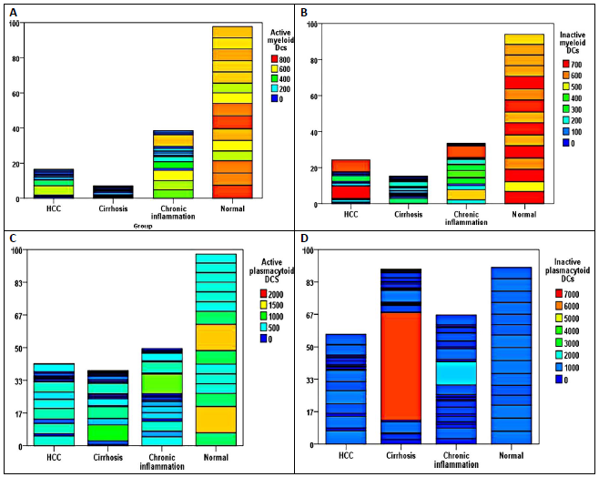
Figure 1 Heatmap of the differential levels of (A) active myeloid dendriti cells, (B) inactive myeloid dendriti cells, (C) active plasmacytoid cells, and (D) inactive plasmacytoid cells in the four studied groups.

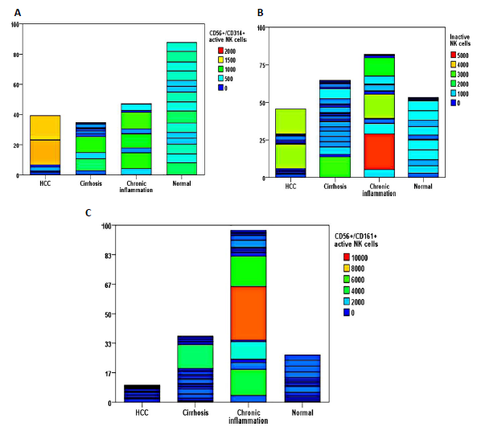
Figure 2 Heatmap of the differential levels of (A) active natural killer cells (CD56+/CD314+); (B) inactive natural killer cells (CD56+/CD158+); and (C) natural killer cells (CD56+/CD161+) in the four studied groups.

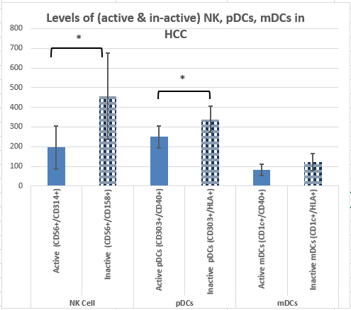
a
a
Figure 3 balance between active and inactive natural killer cells, plasmacytoid cells, and myeloid dendriti cells in hepatocellular carcinoma patients in relation to normal group. ªP < 0.05.

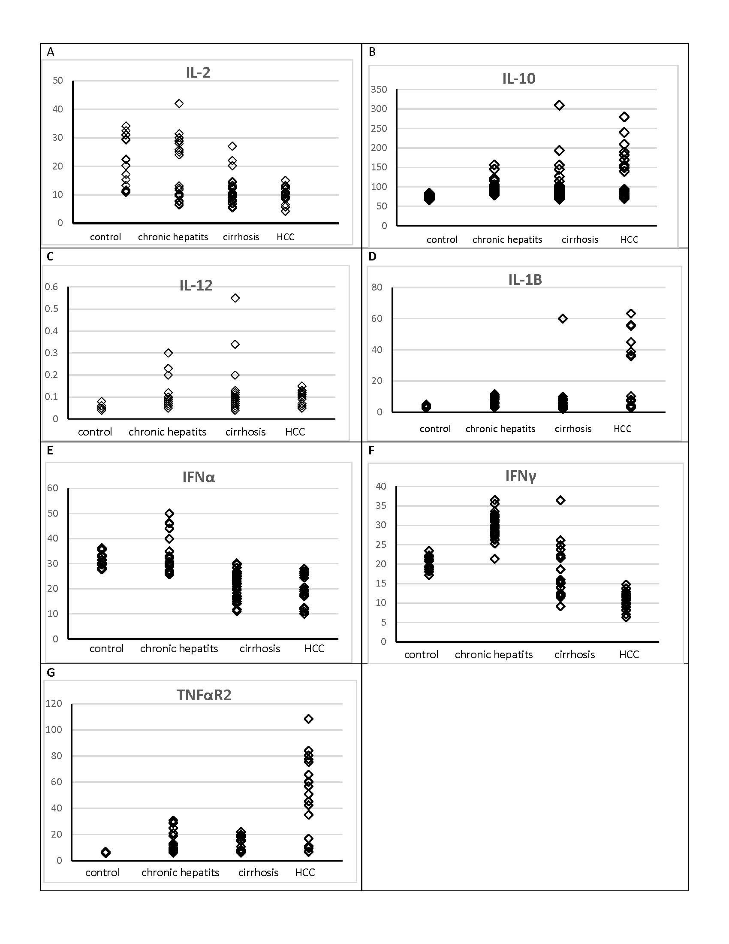
Figure 4 different levels of serum cytokines in the four studied groups. A: IL-2, B: IL-10, C: IL-12, D: IL-1Β, E: IFN-Α, F: IFN-Γ, G: TNF-ΑR2.

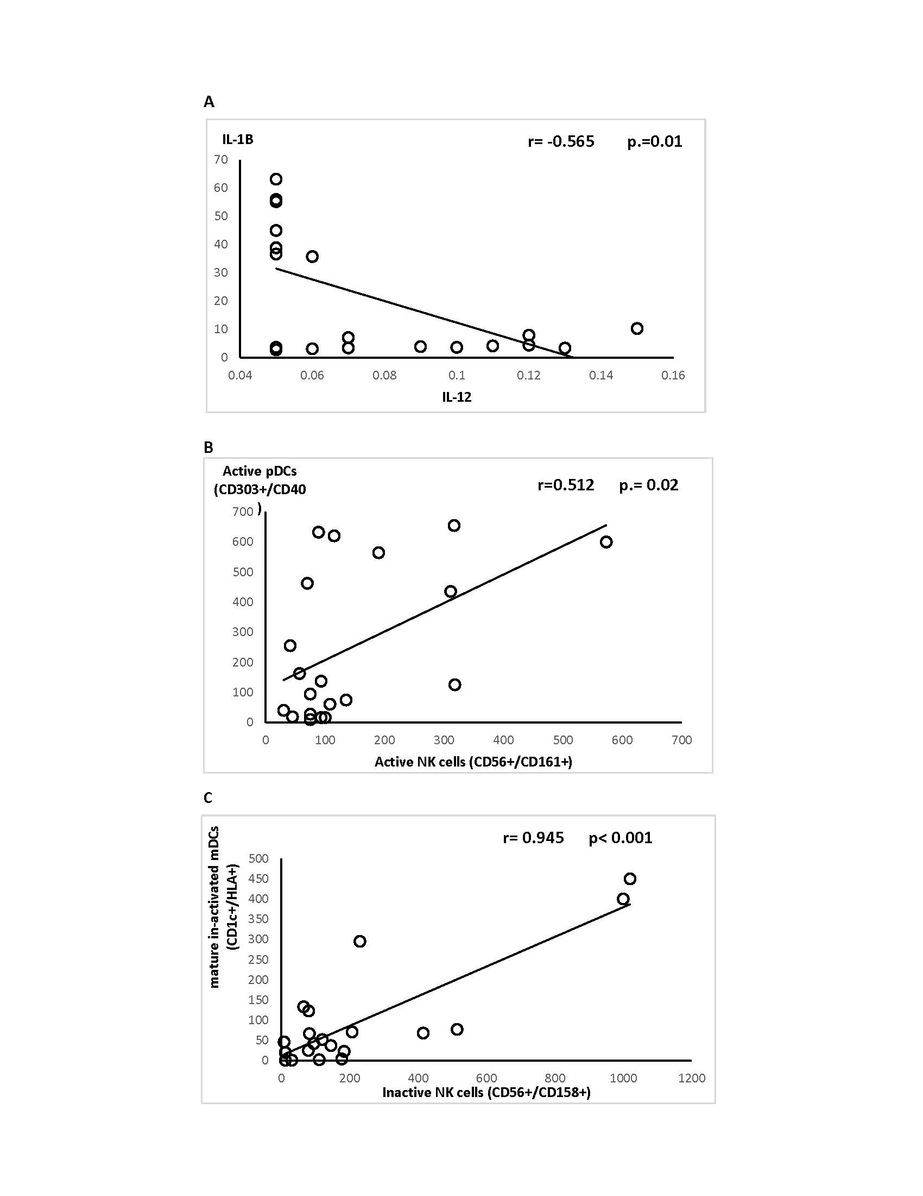
Figure 5 Correlation between immune cells and cytokine levels in hepatocellular carcinoma patients.

