Name of Journal: World Journal of Clinical Cases
Manuscript NO: 82612
Manuscript Type: CASE REPORT

Malignant melanoma resection and reconstruction with the first manifestation of lumbar metastasis: A case report

Guo ZX et al. Malignant melanoma spinal metastases

Zi-Xuan Guo, Xue-Lin Zhao, Zi-Yi Zhao, Qing-Yan Zhu, Zi-Ying Wang, Meng Xu

Zi-Xuan Guo, Xue-Lin Zhao, Zi-Yi Zhao, Qing-Yan Zhu, Zi-Ying Wang, Graduate School, Medical School of Chinese PLA, Beijing 100853, China

Meng Xu, Department of Orthopedics, The Forth Medical Center of PLA General Hospital, Beijing 100037, China

Author contributions: Guo ZX participated in manuscript writing, editing, and literature search; Zhao XL, Zhao ZY, Zhu QY and Wang ZY performed data collection under the supervision of Xu M; the manuscript was drafted by Guo ZX, reviewed by all authors, and revised with contributions from all authors under the supervision and final revision of Xu M; Xu M was responsible for the integrity of the work from inception to the end; all authors read and approved the final manuscript and contributed to the review and interpretation of data.

Supported by The National Defense Science and Technology Foundation Enhancement Plan, No. 2019-JCJQ-JJ-147.

Corresponding author: Meng Xu, MD, Chief Doctor, Department of Orthopedics, The Forth Medical Center of PLA General Hospital, No. 51 Fucheng Road, Haidian District, Beijing 100037, China. 13501175839@163.com

Received: December 24, 2022
Revised: March 5, 2023
Accepted: April 19, 2023
Published online: May 26, 2023
Abstract
BACKGROUND
Malignant melanoma (MM) has shown an increasing incidence worldwide, and a potential to metastasize to almost any part of the body. Clinically, MM with bone metastasis as the initial manifestation is extremely rare. Spinal metastatic MM can cause spinal cord or nerve root compression, resulting in severe pain and paralysis. Currently, the primary clinical treatments for MM are surgical resection in conjunction with chemotherapy, radiotherapy, and immunotherapy.

CASE SUMMARY
Here, we report the case of a 52-year-old male who presented to the clinic with progressive low back pain and limited nerve function. No primary lesion or spinal cord compression was detected from computed tomography and magnetic resonance imaging of the lumbar vertebrae and positron emission tomography scan. A lumbar puncture biopsy confirmed the diagnosis of lumbar spine metastatic MM. Following surgical resection, the patient’s quality of life improved, symptoms were relieved, and comprehensive treatment was initiated, which prevented recurrence.

CONCLUSION
Spinal metastatic MM is clinically rare, and may cause neurological symptoms, including paraplegia. Currently, the clinical treatment plan consists of surgical resection in combination with chemotherapy, radiotherapy, and immunotherapy.

Key Words: Spinal metastatic malignant melanoma; Surgical resection; Comprehensive treatment; Pathological report; Case report

©The Author(s) 2023. Published by Baishideng Publishing Group Inc. All rights reserved.

Citation: Guo ZX, Zhao XL, Zhao ZY, Zhu QY, Wang ZY, Xu M. Malignant melanoma resection and reconstruction with the first manifestation of lumbar metastasis: A case report. World J Clin Cases 2023; 11(15): 3571-3577
URL: https://www.wjgnet.com/2307-8960/full/v11/i15/3571.htm
DOI: https://dx.doi.org/10.12998/wjcc.v11.i15.3571

Core Tip: The worldwide incidence of malignant melanoma (MM) is increasing every year. MM is very aggressive and has the potential to metastasize to any part of the body. However, symptoms of spinal metastasis are rare in their initial manifestation. Here, we performed total vertebral body resection, three-dimensional printed artificial vertebral body reconstruction, and comprehensive treatment, including targeted therapy and chemotherapy, which effectively controlled the condition.
INTRODUCTION
Malignant melanoma (MM) is a highly invasive malignant tumor with an increasing incidence and poor prognosis^{[1,2]}. MM primarily originates in the skin and mucosa and can spread to any organ, most commonly the lymph nodes, lungs, and brain, but rarely the spine^{[3,4]}.
Initially, the patient presented with symptoms of aggravated lumbago, back pain, progressive numbness, and weakness of the lower limbs. A biopsy confirmed an isolated metastatic MM in the lumbar spine, but the primary lesion was not found. The symptoms improved after surgery, and his lower limb muscle strength recovered. The overall condition of the patient was good following continuous, comprehensive treatment.

CASE PRESENTATION
Chief complaints
A 52-year-old male presented to our hospital with low back pain for 1 mo and numbness and pain in the left thigh for 27 d.

History of present illness
One month ago, the patient experienced low back pain and discomfort, as well as obvious limitations in inactivity, whenever he suddenly turned around. The pain was constant, aggravated by activity, and occasionally worsened at night. He visited our hospital for treatment after experiencing numbness in the lateral side of his left thigh, pain, and weakness for 27 d.

History of past illness
The patient had diabetes and had been taking insulin injection, with good glycemic control. He denied any history of hypertension, coronary heart disease, tuberculosis, malaria, and other infectious diseases, other surgical histories, major trauma, blood transfusion history, and food or drug allergy.

Personal and family history
The patient married at the appropriate age, had two daughters, and a healthy spouse and parents, and denied any family history of infectious or genetic diseases.

Physical examination
Consciousness is clear, walking into the ward, the waist does not touch an obvious mass, the skin color is normal, tenderness and percussion pain are positive, the pain radiates to the back of the left thigh, bilateral iliopsoas muscle strength level 5, both lower limb sensation and muscle strength are normal, bilateral dorsal foot and posterior tibial artery pulse can be palpatible, bilateral tendon reflex and Achilles tendon reflex are normal, bilateral patellar clonic and ankle clonic are negative.

Laboratory examinations
Routine blood test results were as follows: White blood cells, 8 × 10⁹ cells/L; hemoglobin, 145 g/L; and total platelet count, 438 × 10⁹ cells/L. Biochemical analysis revealed the following: Total protein level, 71 g/L; albumin, 46.8 g/L; creatinine 61 μmol/L; C-reactive protein, 2.8 mg/L; D-dimer, 2.39 mg/L; and erythrocyte sedimentation rate, 16 mm. The urine and stool examination results were normal.

Imaging examinations
Magnetic resonance imaging (MRI) of lumbar spine showed that the lumbar 2 vertebral body was irregularly and slightly longer, short T1-weighted imaging (T1WI) and slightly longer and short T2-weighted imaging (T2WI) mixed signals, local protrusion to the left posterior, spinal canal and left intervertebral foramen compression changes, left pedicle involvement. Computed tomography (CT) findings of the lumbar vertebrae showed pathological changes in lumbar vertebra 2, bone destruction, involvement of the left vertebral arch, and pathological fractures. Combined positron emission tomography (PET) and CT (PET/CT): First, there was local bone destruction and increased metabolism in the lumbar vertebrae 2, small cavities in cervical 7, thoracic 3, 7, and normal metabolism in 8 vertebral bodies. Second, multiple slightly low-density nodular shadows with normal metabolism suggested that the liver was punctured and biopsied in the lumbar vertebrae 2. Therefore, it was recommended to combine enhanced CT and MRI examinations. Third, both lungs had multiple nodules but no increase in metabolism. Therefore, it was advisable to re-examine the anti-inflammatory treatment. Finally, PET/CT of the brain revealed no clear signs of abnormal metabolisms (Figure 1).

Histological findings
Lumbar puncture biopsy showed small round cell tumors in the trabecula, with small, medium, large and nucleoli. Combined with the immunohistochemical results, this finding was consistent with that of metastatic MM (Figure 2).
Immunohistochemistry results were as follows: HMB45(+), S100(+), CK(-), CK20(-), Villin(-), CD3(-), CD138(-), Kap(-), Lam(-), PLAP(-), alkp80(NKX2.2(+)), CD43(-), MPO(-), CD1a(-), CgA(-), Syn(-), CD56(-), and Ki-67(40%+).

FINAL DIAGNOSIS
Lumbar spine metastatic MM.

TREATMENT
After admission, pertinent preoperative examinations were first improved, and after obtaining conclusive pathological findings, posterior lumbar tumor block resection, laminectomy, three-dimensional (3D) printed artificial vertebral body reconstruction, and nail-rod system internal fixation were performed (Figure 3).

OUTCOME AND FOLLOW-UP
The wound healed well 2 wk after the operation. The patient could move around on the ground with braces in good condition. He was transferred to the oncology department for comprehensive care, including chemotherapy regimens of albumin-paclitaxel, dacarbazine, nedaplatin, bevacizumab, and tereplizumab. Except for the side effects of chemotherapy, the patient is currently in good health.

DISCUSSION
MM is a highly malignant tumor caused by abnormal proliferation nerve spine melanocytes. This highly aggressive tumor primarily affects the skin mucosa and pigmented membranes. Lymphatic and blood metastases can occur in the early stages and are associated with a poor prognosis, with a 5-year survival rate of only 10%^{[5]}. One study found that patients diagnosed with MM had a 24% higher risk of subsequent primary cancers, including breast cancer, prostate cancer and non-Hodgkin lymphoma, which may be due to genetic predisposition or environmental risk factors. However, most patients also develop MM in other sites, although the base may be thinner and less malignant^{[6]}. MM can spread to any part of the body, but spinal metastasis is rare, with an incidence of only 2.4%^{[4]}. However, MM with spinal metastasis as the first manifestation is even rarer^{[7]}. If a patient’s biopsy reveals metastatic MM without primary lesions, metastatic MM of unknown origin is assumed. Several hypotheses have been proposed to explain the origin of MM with an unknown primary tumor, including spontaneous regression of the primary tumor and the presence of ectopic melanocytes in lymph nodes or internal organs. Although these hypotheses have only been tested in a few studies, preliminary evidence suggests a molecular basis for this disease^{[8]}. Therefore, for patients who have been diagnosed with MM, we recommend lifelong follow-up and close clinical observation. This is especially important for the early detection of metastatic MM.
Imaging findings, in addition to performing a biopsy to confirm the pathology, are useful for the early detection of metastatic MM. Most melanoma bone metastases are osteolytic (87.5%), causing pathological fractures and soft tissue mass formation in approximately 22.5% and 12.5% of the patients^{[9]}. MRI has significant advantages for the detection and diagnosis of spinal metastatic MM. Melanoma typically has a high signal intensity on T1WI and a low signal intensity on T2WI. According to Müller-Horvat et al^{[10]}, MRI has a higher detection rate for MM bone metastasis than CT, and could detect MM earlier in 14.6% of the patients. In addition, PET/CT showed that the patient had multiple slightly low-density nodular opacities in the liver. Therefore, combined contrast CT or MRI examination was recommended, but the patient refused further examination. Although cases of cystic liver metastases caused by MM are extremely rare, for patients with a relatively high degree of malignancy, further relevant liver tests can clarify the patient’s systemic condition and help develop appropriate treatment plans for them. Currently, few studies have described the radiographic findings of cystic liver metastases, and are mostly based on contrast-enhanced CT or contrast-enhanced MRI^{[11]}. However, these techniques have low sensitivity and may not differentiate these metastases from other liver disorders^{[12]}. Corvino et al^{[13]} reported a case of rectal melanoma patient with cystic liver metastases detected using early liver contrast (CEUS). The technique supported a comprehensive and correct diagnosis, which led to an optimal treatment regimen for the patient. They believe that CEUS imaging can detect the liver-enhanced cyst wall and septum. In addition, the contrast agent enters the microvessels of the cyst wall and septum, and once destroyed, produces a high signal, which can be used to assess the internal structure of the cyst wall and cystic lesions. Using this approach, malignant lesions can be detected earlier, avoiding complications of invasive examinations and improving the accuracy of diagnosis.
Surgical resection is the first-line treatment option for neurological symptoms in spinal metastatic MM. Surgical resection and nerve decompression have been shown to improve neurological function, pain, and quality of life. With the improvement of surgical techniques, Tomita et al^{[14]} proposed total en bloc spondylectomy, which can be used to treat primary spinal tumors and solitary spinal metastases for the following indications: (1) Primary lumbar malignant tumors in stage I and II in Enneking's surgical stage; (2) stage III benign aggressive tumor; and (3) isolated metastatic lumbar spine tumor, and expected survival time > 6 mo. Total vertebral body resection of spinal tumors is widely used by oncology surgeons because it ensures safe oncological boundaries and reduces tumor recurrence and metastasis.
In this report, patients with L2 vertebral metastatic MM were in a good general condition, with a Tomita score of 5 and a Tokuhashi score of 9, indicating an expected survival time > 6 mo, which met the indications for block resection. Here, we performed L2 total body resection and 3D-printed artificial vertebral body reconstruction surgery. The patient recovered well after surgery, and the numbness and muscle strength of both lower limbs were significantly improved. The rough surface and micropore design of 3D-printed prostheses not only increase osteoblast adhesion but also stimulate cell differentiation and promote bone growth. The porous structure allows tissue fluid to flow and promotes bone cell migration and proliferation^{[15]}. Studies have shown that the best structures for bone integration have a pore size of 600–800 µm and porosity of 70%–80%, which are conducive to the recruitment of anti-inflammatory molecules, promotion of osteoblast differentiation, and cultivation of a microenvironment conducive to bone integration^{[16]}. Three months after the operation, imaging revealed preliminary bone healing between the artificial vertebral body and adjacent vertebral body, indicating that the artificial vertebral body was biocompatible. Six months after the operation, a large number of bony connections were formed between the artificial and the adjacent vertebral bodies, and osseointegration occurred. This indicated that the artificial vertebral body could meet the requirements of interbody fusion and eventually achieve anterior column fusion.
Although surgical treatment can only improve the patients’ quality of life and relieve their pain symptoms, it does not appear to increase their survival rate. Currently, the clinical treatment for MM is based on surgical resection in conjunction with chemotherapy, radiotherapy, and immunotherapy. With advances in molecular biology technology and extensive research, drug therapy targeting key receptors and signal transduction kinases in the cancer process has been approved for clinical application, providing a new scheme for patients with MM. BRAF mutations account for 40%–50% of cases with MM. These gene mutations significantly increase the activity of the BRAF enzyme and continuously activate the signaling pathway of the targeted mitogen-activated protein kinase, leading to uncontrolled proliferation of tumor cells via various mechanisms, resulting in MM^{[17]}. A multi-center controlled trial published in the New England Journal of Medicine used a BRAF inhibitor to treat MM, and the results were promising^{[18]}. Furthermore, targeted drugs combined with immunotherapy are more likely to cause coordinated sensitization, play an early and powerful antitumor role, and achieve higher clinical efficacy compared with monotherapy. Experiments have shown that combining a BRAF/mitogen-activated protein kinase (MEK) inhibitor with a cytotoxic T lymphocyte antigen-4/programmed death-1 monoclonal antibody is more effective than either single-targeted therapy or immunotherapy^{[19]}. Furthermore, whereas traditional radiotherapy and chemotherapy have low sensitivity and a poor curative effect, when combined with targeted therapy or immunotherapy, they have a stronger synergistic antitumor effect^{[20]}.
Indeed, immunotherapy for MM and targeted therapy with BRAF and MEK inhibitors have distinct advantages, but their potential side effects must also be considered. Increasing evidence suggests that the drugs used in MM therapy can produce more specific responses to MM cells and have less toxicity to organisms, leading to their wide use in various treatment schemes. However, there is currently no relevant, clear guideline for the treatment of patients with MM that demonstrates its curative effect. Therefore, medical professionals should collaborate and lead efforts to develop and apply MM therapy in clinical practice.

CONCLUSION
In this case report, we presented a rare case of MM with lumbar metastatic lesions as the first symptom. Diagnosing and treating such a rare case can be significantly challenging for surgeons. When pathology reveals that a patient has metastatic MM, surgical resection should be considered because it can effectively relieve symptoms and improve the patient’s quality of life. However, if the goal is to improve patient prognosis, surgery should be used with chemotherapy, vaccination, or targeted therapy.

REFERENCES
1 Sacchetto L, Zanetti R, Comber H, Bouchardy C, Brewster DH, Broganelli P, Chirlaque MD, Coza D, Galceran J, Gavin A, Hackl M, Katalinic A, Larønningen S, Louwman MWJ, Morgan E, Robsahm TE, Sanchez MJ, Tryggvadóttir L, Tumino R, Van Eycken E, Vernon S, Zadnik V, Rosso S. Trends in incidence of thick, thin and in situ melanoma in Europe. Eur J Cancer 2018; 92: 108-118 [PMID: 29395684 DOI: 10.1016/j.ejca.2017.12.024]
2 Turner N, Ware O, Bosenberg M. Genetics of metastasis: melanoma and other cancers. Clin Exp Metastasis 2018; 35: 379-391 [PMID: 29722002 DOI: 10.1007/s10585-018-9893-y]
3 Gokaslan ZL, Aladag MA, Ellerhorst JA. Melanoma metastatic to the spine: a review of 133 cases. Melanoma Res 2000; 10: 78-80 [PMID: 10711643]
4 Spiegel DA, Sampson JH, Richardson WJ, Friedman AH, Rossitch E, Hardaker WT Jr, Seigler HF. Metastatic melanoma to the spine. Demographics, risk factors, and prognosis in 114 patients. Spine (Phila Pa 1976) 1995; 20: 2141-2146 [PMID: 8588172 DOI: 10.1097/00007632-199510000-00013]
5 Redman JM, Gibney GT, Atkins MB. Advances in immunotherapy for melanoma. BMC Med 2016; 14: 20 [PMID: 26850630 DOI: 10.1186/s12916-016-0571-0]
6 Bradford PT, Freedman DM, Goldstein AM, Tucker MA. Increased risk of second primary cancers after a diagnosis of melanoma. Arch Dermatol 2010; 146: 265-272 [PMID: 20231496 DOI: 10.1001/archdermatol.2010.2]
7 Ku A, Henry A, Tunkel R, Lachmann E, Nagler W. Lumbosacral radiculopathy secondary to L5 metastatic melanoma of unknown primary. Arch Phys Med Rehabil 1996; 77: 307-309 [PMID: 8600878 DOI: 10.1016/s0003-9993(96)90118-5]
8 Scott JF, Gerstenblith MR. Melanoma of Unknown Primary. In: Noncutaneous Melanoma [Internet]. Brisbane (AU): Codon Publications; 2018 [PMID: 29874016]
9 Patnana M, Bronstein Y, Szklaruk J, Bedi DG, Hwu WJ, Gershenwald JE, Prieto VG, Ng CS. Multimethod imaging, staging, and spectrum of manifestations of metastatic melanoma. Clin Radiol 2011; 66: 224-236 [PMID: 21295201 DOI: 10.1016/j.crad.2010.10.014]
10 Müller-Horvat C, Radny P, Eigentler TK, Schäfer J, Pfannenberg C, Horger M, Khorchidi S, Nägele T, Garbe C, Claussen CD, Schlemmer HP. Prospective comparison of the impact on treatment decisions of whole-body magnetic resonance imaging and computed tomography in patients with metastatic malignant melanoma. Eur J Cancer 2006; 42: 342-350 [PMID: 16364631 DOI: 10.1016/j.ejca.2005.10.008]
11 Sugawara Y, Yamamoto J, Yamasaki S, Shimada K, Kosuge T, Sakamoto M. Cystic liver metastases from colorectal cancer. J Surg Oncol 2000; 74: 148-152 [PMID: 10914826 DOI: 10.1002/1096-9098(200006)74:2<148::AID-JSO13>3.0.CO;2-N]
12 Qian LJ, Zhu J, Zhuang ZG, Xia Q, Liu Q, Xu JR. Spectrum of multilocular cystic hepatic lesions: CT and MR imaging findings with pathologic correlation. Radiographics 2013; 33: 1419-1433 [PMID: 24025933 DOI: 10.1148/rg.335125063]
13 Corvino A, Catalano O, Corvino F, Petrillo A. Rectal melanoma presenting as a solitary complex cystic liver lesion: role of contrast-specific low-MI real-time ultrasound imaging. J Ultrasound 2016; 19: 135-139 [PMID: 27298643 DOI: 10.1007/s40477-015-0182-1]
14 Tomita K, Kawahara N, Baba H, Tsuchiya H, Nagata S, Toribatake Y. Total en bloc spondylectomy for solitary spinal metastases. Int Orthop 1994; 18: 291-298 [PMID: 7852009 DOI: 10.1007/BF00180229]
15 Yang J, Cai H, Lv J, Zhang K, Leng H, Wang Z, Liu Z. Biomechanical and histological evaluation of roughened surface titanium screws fabricated by electron beam melting. PLoS One 2014; 9: e96179 [PMID: 24788866 DOI: 10.1371/journal.pone.0096179]
16 Olivares-Navarrete R, Hyzy SL, Slosar PJ, Schneider JM, Schwartz Z, Boyan BD. Implant materials generate different peri-implant inflammatory factors: poly-ether-ether-ketone promotes fibrosis and microtextured titanium promotes osteogenic factors. Spine (Phila Pa 1976) 2015; 40: 399-404 [PMID: 25584952 DOI: 10.1097/BRS.0000000000000778]
17 Ottaviano M, Giunta EF, Tortora M, Curvietto M, Attademo L, Bosso D, Cardalesi C, Rosanova M, De Placido P, Pietroluongo E, Riccio V, Mucci B, Parola S, Vitale MG, Palmieri G, Daniele B, Simeone E, On Behalf Of Scito Youth. BRAF Gene and Melanoma: Back to the Future. Int J Mol Sci 2021; 22 [PMID: 33801689 DOI: 10.3390/ijms22073474]
18 Flaherty KT, Yasothan U, Kirkpatrick P. Vemurafenib. Nat Rev Drug Discov 2011; 10: 811-812 [PMID: 22037033 DOI: 10.1038/nrd3579]
19 Cohen-Inbar O, Shih HH, Xu Z, Schlesinger D, Sheehan JP. The effect of timing of stereotactic radiosurgery treatment of melanoma brain metastases treated with ipilimumab. J Neurosurg 2017; 127: 1007-1014 [PMID: 28059663 DOI: 10.3171/2016.9.JNS161585]
20 Fusi A, Dalgleish A. The importance for immunoregulation for long-term cancer control. Future Oncol 2017; 13: 1619-1632 [PMID: 28776411 DOI: 10.2217/fon-2017-0085]
Footnotes
Informed consent statement: Informed written consent was obtained from the patient for publication of this report and any accompanying images.

Conflict-of-interest statement: All the authors report no relevant conflicts of interest for this article.

CARE Checklist (2016) statement: The authors have read the CARE Checklist (2016), and the manuscript was prepared and revised according to the CARE Checklist (2016).

Open-Access: This article is an open-access article that was selected by an in-house editor and fully peer-reviewed by external reviewers. It is distributed in accordance with the Creative Commons Attribution NonCommercial (CC BY-NC 4.0) license, which permits others to distribute, remix, adapt, build upon this work non-commercially, and license their derivative works on different terms, provided the original work is properly cited and the use is non-commercial. See: https://creativecommons.org/Licenses/by-nc/4.0/

Provenance and peer review: Unsolicited article; Externally peer reviewed.
Peer-review model: Single blind

Peer-review started: December 24, 2022
First decision: February 20, 2023
Article in press: April 19, 2023

Specialty type: Medicine, research and experimental
Country/Territory of origin: China
Peer-review report’s scientific quality classification
Grade A (Excellent): A
Grade B (Very good): 0
Grade C (Good): C
Grade D (Fair): 0
Grade E (Poor): 0

P-Reviewer: Corvino A, Italy; Seledtsov V, Russia S-Editor: Liu JH L-Editor: A P-Editor: Chen YX

Figure Legends
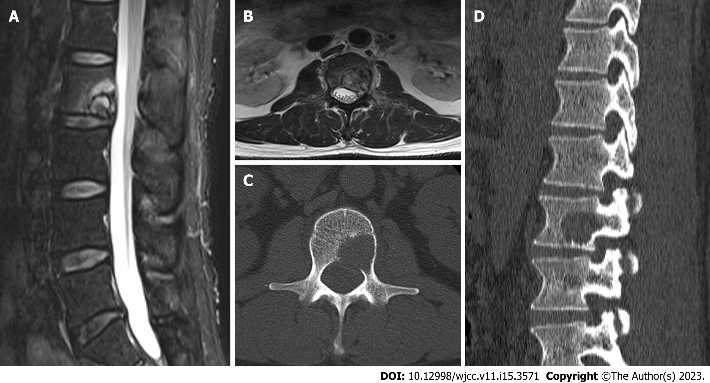
Figure 1 Magnetic resonance imaging and computed tomography of the patient's lumbar spine. A: In the sagittal position, tumors may be compressing the spinal cord; B: The transverse view shows that the right spinal cord is compressed by a tumor; C: The transverse position shows destruction of the right pedicle and vertebral body; D: In the sagittal position, the posterior side of the spine is destroyed by tumors.
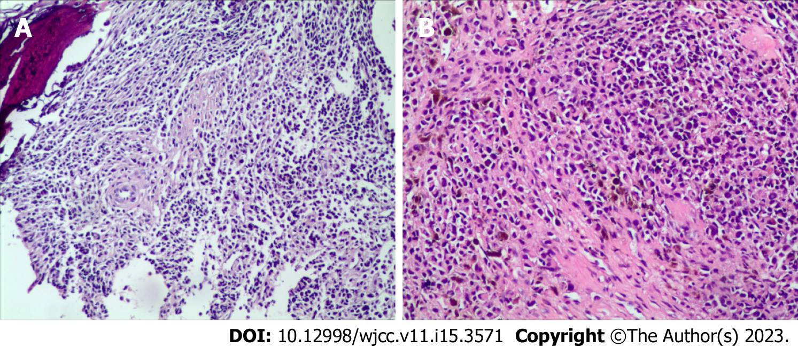
Figure 2 Histopathology of lumbar melanoma. A: Vertebral biopsy shows some tumor cells; B: After vertebral body resection, a large number of tumor cells can be seen.
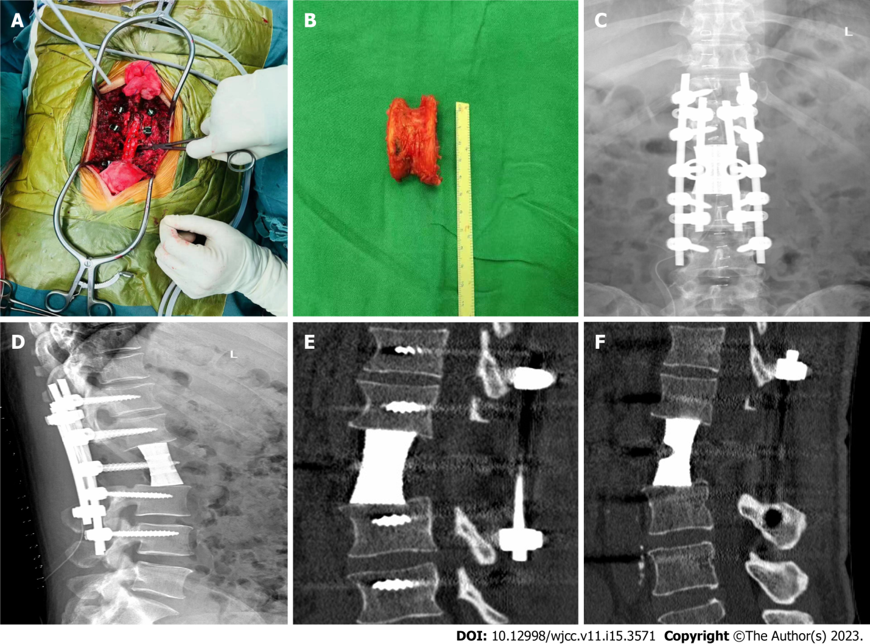
Figure 3 Patient intraoperative and postoperative follow-up results. A and B: During the operation, the lumbar vertebra 2 was completely removed; C and D: The anteroposterior X-ray film of the lumbar spine 2 wk after surgery revealed that the 3D-printed prosthesis was well attached to the upper and lower vertebral plates; E and F: Six months after surgery, a lumbar computed tomography revealed that the boundary between the three-dimensional (3D)-printed prosthesis and the adjacent vertebral body had disappeared and bone trabeculae had grown in.

Published by Baishideng Publishing Group Inc
7041 Koll Center Parkway, Suite 160, Pleasanton, CA 94566, USA
Telephone: +1-925-3991568
E-mail: bpgoffice@wjgnet.com
Help Desk: https://www.f6publishing.com/helpdesk
https://www.wjgnet.com

© 2023 Baishideng Publishing Group Inc. All rights reserved.

