Name of Journal: World Journal of Clinical Cases
Manuscript NO: 89283
Manuscript Type: LETTER TO THE EDITOR

Response letter to “Acute cholangitis: Does malignant biliary obstruction vs choledocholithiasis etiology change the outcomes?” with imaging aspects

Aydin S et al. Response letter to with imaging aspects

Sonay Aydin, Baris Irgul

Sonay Aydin, Baris Irgul, Department of Radiology, Erzincan Binali Yildirim University, Erzincan 24100, Turkey

Author contributions: Aydin S and Irgul B conceived and designed the analysis, collected the data, wrote the paper and performed the analysis.

Corresponding author: Baris Irgul, MD, Research Assistant, Department of Radiology, Erzincan Binali Yildirim University, No. 32 Haci Ali Akin Street, Erzincan 24100, Turkey. barisirgul@gmail.com

Received: October 26, 2023
Revised: December 12, 2023
Accepted: January 24, 2024
Published online:

Abstract
Radiological imaging findings may contribute to the differentiation of malignant biliary obstruction from choledocholithiasis in the etiology of acute cholangitis.

Key Words: Malignant biliary obstruction; Choledocholithiasis; Acute cholangitis; Dilated bile ducts; Magnetic resonance cholangiopancreatography; Endoscopic retrograde cholangiopancreatography

Aydin S, Irgul B. Response letter to “Acute cholangitis: Does malignant biliary obstruction vs choledocholithiasis etiology change the outcomes?” with imaging aspects. World J Clin Cases 2024; In press

Core Tip: In malignant biliary obstructions, irregular walls, increased wall thickness, and blunt termination are seen in the choledochal duct. In choledocholithiasis, stones are seen in the lumen and the choledochal walls are regular.

TO THE EDITOR
We were intrigued by the paper “Acute cholangitis: Does malignant biliary obstruction vs choledocholithiasis etiology change the clinical presentation and outcomes?” by Tsou et al^{[1]}. This study primarily examined laboratory data to distinguish between malignant biliary obstruction and obstruction caused by stones and underscored it’s significance. However, the study did not investigate the role and significance of imaging in this differentiation. In this letter to the editor, we aim to highlight the crucial imaging indicators for the aforementioned differentiation.
In the current era of medical imaging, which offers a wide range of imaging techniques from basic radiographs to advanced magnetic resonance imaging (MRI) scans, the role of the radiologist is to assist the physician in choosing the appropriate imaging method and addressing important patient care issues. Ultrasound (US) is used as a preliminary method to screen for biliary obstruction, but it cannot accurately establish the severity and cause of obstructive jaundice. Therefore, further imaging with techniques like contrast enhanced computerized tomography and magnetic resonance cholangiopancreatography (MRCP) are necessary as they are more effective in providing accurate diagnostic information. MRCP has become the preferred method for examining biliary obstruction, with endoscopic retrograde cholangiopancreatography being reserved for patients who are more likely to require therapeutic intervention^{[2]}.
The Tokyo Guidelines are employed for the diagnosis of acute cholangitis. According to these criteria, acute cholangitis can be diagnosed based on signs of systemic inflammation, cholestasis, and imaging results^{[3]}. Calculi and dilatation can be observed in the bile ducts on US and computed tomography (CT) scans due to the presence of stones in acute cholangitis caused by choledocholithiasis. MRCP scans reveal signal attenuation caused by the presence of calculi. The bile duct walls exhibit a rather slender and sleek shape^{[4]} (Figure 1).
Acute cholangitis caused by malignant biliary obstructions is characterized by the enlargement of the biliary tract, which can be detected using US, CT, and MRCP, similar to the presentation in cases of choledocholithiasis. Furthermore, intraductal mass lesions are present, with extensive segments of contrasting bile duct walls that are uneven and thicker (> 1.5 mm). Additionally, blunt terminations in the bile ducts caused by distal tumoral lesions are visible^{[4]} (Figure 2).
In conclusion, while certain imaging findings have been identified to distinguish between cancer and stone-induced blockages, there is currently no universally accepted approach or finding to definitively differentiate between the two. If a routinely used imaging modality like MRCP reveals any secondary finding that indicates malignant blockage, multiphase-dynamic CT/MRI is recommended for optimal evaluation of nearby organs such as the biliary system and pancreas. In addition, US is sufficient to explain the etiology of biliary obstructions such as stones. When the cause of obstruction cannot be found with US, second- and third-level imaging techniques such as CT, MRI, or endoscopic ultrasonography are needed; however, their unnecessary overuse should be avoided.

REFERENCES
1 Tsou YK, Su YT, Lin CH, Liu NJ. Acute cholangitis: Does malignant biliary obstruction vs choledocholithiasis etiology change the clinical presentation and outcomes? World J Clin Cases 2023; 11: 6984-6994 [PMID: 37946763 DOI: 10.12998/wjcc.v11.i29.6984]
2 Joshi, A., Rajpal, K., Kakadiya, K, Ashank Bansal.Role of CT and MRCP in Evaluation of Biliary Tract Obstruction. Curr Radiol Rep 2014; 72: 2 [DOI: 10.1007/s40134-014-0072-x]
3 Kiriyama S, Kozaka K, Takada T, Strasberg SM, Pitt HA, Gabata T, Hata J, Liau KH, Miura F, Horiguchi A, Liu KH, Su CH, Wada K, Jagannath P, Itoi T, Gouma DJ, Mori Y, Mukai S, Giménez ME, Huang WS, Kim MH, Okamoto K, Belli G, Dervenis C, Chan ACW, Lau WY, Endo I, Gomi H, Yoshida M, Mayumi T, Baron TH, de Santibañes E, Teoh AYB, Hwang TL, Ker CG, Chen MF, Han HS, Yoon YS, Choi IS, Yoon DS, Higuchi R, Kitano S, Inomata M, Deziel DJ, Jonas E, Hirata K, Sumiyama Y, Inui K, Yamamoto M. Tokyo Guidelines 2018: diagnostic criteria and severity grading of acute cholangitis (with videos). J Hepatobiliary Pancreat Sci 2018; 25: 17-30 [PMID: 29032610 DOI: 10.1002/jhbp.512]
4 Choi SH, Han JK, Lee JM, Lee KH, Kim SH, Lee JY, Choi BI. Differentiating malignant from benign common bile duct stricture with multiphasic helical CT. Radiology 2005; 236: 178-183 [PMID: 15955859 DOI: 10.1148/radiol.2361040792]

Footnotes
Conflict-of-interest statement: All the authors report no relevant conflicts of interest for this article.

Open-Access: This article is an open-access article that was selected by an in-house editor and fully peer-reviewed by external reviewers. It is distributed in accordance with the Creative Commons Attribution NonCommercial (CC BY-NC 4.0) license, which permits others to distribute, remix, adapt, build upon this work non-commercially, and license their derivative works on different terms, provided the original work is properly cited and the use is non-commercial. See: https://creativecommons.org/Licenses/by-nc/4.0/

Provenance and peer review: Unsolicited article; Externally peer reviewed.

Peer-review model: Single blind

Peer-review started: October 26, 2023
First decision: December 7, 2023
Article in press:

Specialty type: Medicine, research and experimental
Country/Territory of origin: Turkey
Peer-review report’s scientific quality classification
Grade A (Excellent): 0
Grade B (Very good): B
Grade C (Good): C
Grade D (Fair): 0
Grade E (Poor): E

P-Reviewer: Dabbous H, Egypt; Salerno R, Italy; Wen XL, China S-Editor: Qu XL L-Editor: Filipodia P-Editor:
Figure Legends
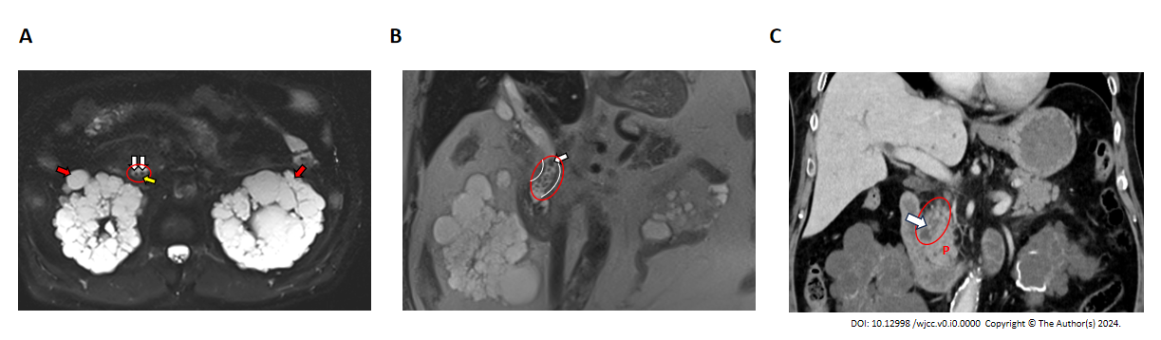
Figure 1 Choledochal obstruction caused by calculus．A: Fat-suppressed T2 WI shows calculus (white arrows) in the dilated choledochal duct (circle) and bile sludge (yellow arrow). The patient also has autosomal dominant polycystic kidney disease (red arrows); B: HASTE coronal image shows calculus (white arrow) in the dilated choledochal duct (circle) with smooth borders (curved lines); C: Coronal computed tomography image shows a dilated choledochal duct (circle) with calculus (white arrow) P: Pancreas.

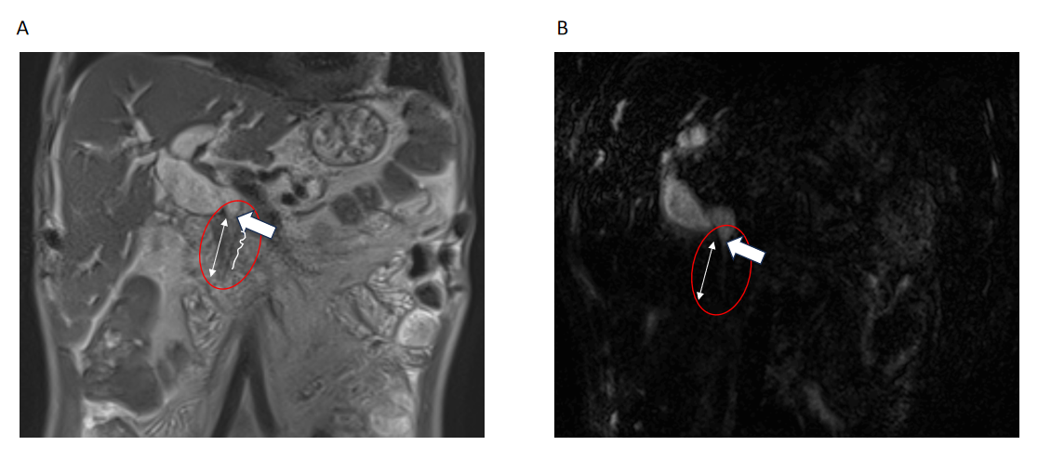
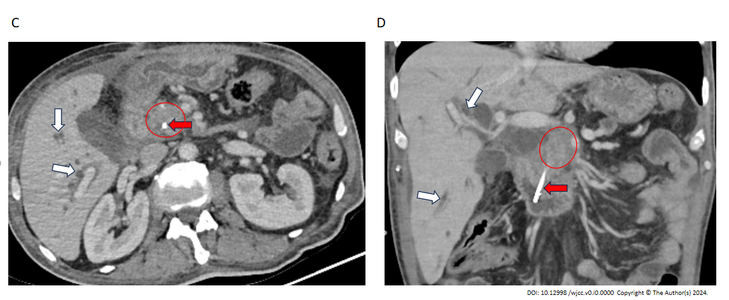
Figure 2 Choledochal involvement of a pancreatic mass. A and B: Coronal T2 WI and coronal magnetic resonance cholangiopancreatography images. The dilated choledochal duct (circle) abruptly narrows bluntly (white arrow) and continues narrowly in a long segment more distally (two-headed arrow). Contour irregularities (serrated lines) are seen on the distal walls of the choledochal duct; C and D: Post-treatment axial and coronal computed tomography images of the same patient show an irregularly bordered, hypodense, heterogeneous, solid mass lesion (circle) in the head of the pancreas, stent material extending from the duodenum to the pancreas (red arrow), and dilated intrahepatic bile ducts (white arrow).

