Name of journal: World Journal of Gastroenterology
ESPS Manuscript NO: 6133
Columns: BRIEF ARTICLES

Utility and safety of endoscopic ultrasound-guided fine-needle aspiration for resectable pancreatic cancer as a preoperative diagnostic modality

Kudo T et al. EUS-FNA for resectable pancreatic cancer

Taiki Kudo, Hiroshi Kawakami, Masaki Kuwatani, Kazunori Eto, Shuhei Kawahata, Yoko Abe, Manabu Onodera, Nobuyuki Ehira, Hiroaki Yamato, Shin Haba, Kazumichi Kawakubo, Naoya Sakamoto

Taiki Kudo, Hiroshi Kawakami, Masaki Kuwatani, Kazunori Eto, Shuhei Kawahata, Yoko Abe, Manabu Onodera, Nobuyuki Ehira, Hiroaki Yamato, Shin Haba, Kazumichi Kawakubo, Naoya Sakamoto, Department of Gastroenterology and Hepatology, Hokkaido University Graduate School of Medicine, Sapporo 060-8638, Japan

Author contributions: Kudo T and Kawakami H contributed equally to this work; Kawakami H managed the patient, performed the endoscopic examination, designed the research and provided discussion; Kudo T and Kawakami H analysed the data; Kuwatani M, Eto K, Kawahata S, Abe Y, Onodera M, Ehira N, Yamato H, Haba S and Kawakubo K collected the data and provided clinical advice; Kudo T and Kawakami H collected the data and wrote the paper; Kawakami H and Kuwatani M revised the paper; Sakamoto N supervised the research; all authors approved the final manuscript for publication.

Correspondence to: Hiroshi Kawakami, MD, PhD, Department of Gastroenterology and Hepatology, Hokkaido University Graduate School of Medicine, Kita 15, Nishi 7, Kita-ku, Sapporo 060-8638, Japan. hiropon@med.hokudai.ac.jp
Telephone: +81-11-7161161-5920 Fax: +81-11-7067867

Received: October 3, 2013 Revised: December 1, 2013
Accepted: January 3, 2014

Published online:

Abstract
AIM: To evaluate the safety and diagnostic accuracy of endoscopic ultrasound-guided fine-needle aspiration (EUS-FNA) in a cohort of pancreatic cancer patients.

METHODS: Of 213 patients with pancreatic cancer evaluated between April 2007 and August 2011, 82 were thought to have resectable pancreatic cancer on the basis of cross-sectional imaging findings. Of these, 54 underwent EUS-FNA before surgery (FNA+ group) and 28 underwent surgery without preoperative EUS-FNA (FNA- group).

RESULTS: All 54 lesions were visible on EUS, and all 54 attempts at FNA were technically successful. The diagnostic accuracy according to cytology and histology findings was 98.1% (53/54) and 77.8% (42/54), respectively, and the total accuracy was 98.1% (53/54). One patient developed mild pancreatitis after EUS-FNA but was successfully treated by conservative therapy. No severe complications occurred after EUS-FNA. In the FNA+ and FNA- groups, the median relapse-free survival (RFS) was 742 and 265 d, respectively (P = 0.0099), and the median overall survival (OS) was 1042 and 557 d, respectively (P = 0.0071). RFS and OS were therefore not inferior in the FNA+ group. These data indicate that the use of EUS-FNA did not influence RFS or OS, nor did it increase the risk of peritoneal recurrence.

CONCLUSION: In patients with resectable pancreatic cancer, preoperative EUS-FNA is a safe and accurate diagnostic method.

© 2014 Baishideng Publishing Group Co., Limited. All rights reserved.

Keywords: Pancreatic cancer; Diagnosis; Biopsy; Endoscopic ultrasound-guided fine-needle aspiration; Preoperative diagnosis

Core tip: Whether preoperative endoscopic ultrasound-guided fine-needle aspiration (EUS-FNA) is safe and effective for resectable pancreatic cancer has not yet been established. In the present study, patients who underwent EUS-FNA had better relapse-free survival and overall survival than did those who did not, although it should be noted that more patients in the FNA before surgery group received adjuvant chemotherapy. Our findings suggest that preoperative EUS-FNA does not adversely affect surgery or prognosis in patients with resectable pancreatic cancer. EUS-FNA can also potentially reduce the inappropriate performance of pancreatic surgery by facilitating an accurate diagnosis. These findings are important because the use of preoperative EUS-FNA is becoming more widespread.

Kudo T, KawakamiH, Kuwatani M, Eto K, Kawahata S, Abe Y, Onodera M, Ehira N, Yamato H, Haba S, Kawakubo K, Sakamoto N. Utility and safety of endoscopic ultrasound-guided fine-needle aspiration for resectable pancreatic cancer as a preoperative diagnostic modality.
World J Gastroenterol 2013;
Available from:
DOI:

INTRODUCTION
Pancreatic cancer is the fourth and fifth leading cause of cancer-related deaths in the United States and Japan, respectively, with 227000 deaths per year worldwide^{[1,2]}. Patients with unresectable pancreatic cancer have a much worse prognosis than do those with resectable disease^{[2]}, making a sensitive screening examination and early diagnosis essential.
Endoscopic ultrasound-guided fine-needle aspiration (EUS-FNA) was first reported by Vilmann et al^{[3]} in 1992 and has been increasingly used worldwide to diagnose pancreatic tumors, because it can be difficult to distinguish between benign and malignant tumors using conventional imaging modalities. EUS-FNA can be used to make a pathological diagnosis of pancreatic tumors and has several advantages over computed tomography (CT)- or ultrasound (US)-guided biopsy with respect to its success rate and safety^{[1]}. However, whether the use of preoperative EUS-FNA for diagnosing pancreatic tumors is safe, given the risk of complications such as bleeding, perforations, pancreatitis, and tumor seeding, is still a matter of debate^{[4-13]}. Previous studies have found that EUS-FNA used for pancreatic cancer is associated with only a very low risk of complications^{[13]} and that there was no significant increase in pancreatic adenocarcinoma seeding, suggesting that the risk associated with EUS-FNA is outweighed by the likely benefit of making an accurate and early pathological diagnosis^{[6,8,11,12]}.
The utility and safety of EUS-FNA for the diagnosis of cancer in the body and tail of the pancreas has also been reported recently^{[14]}. However, the safety and efficacy of preoperative EUS-FNA in diagnosing pancreatic cancer and the long-term prognoses of patients who have undergone preoperative EUS-FNA have not yet been reported^{[4]}.
The need for a more accurate diagnostic test is emphasized by cases in which benign pancreatic disease has been misdiagnosed as cancer and resected, increasing the associated risk of morbidity and mortality. Preoperative EUS-FNA may also reduce the misdiagnosis of benign pancreatic diseases^{[15]}. The purpose of this study was to evaluate the efficacy and safety of preoperative EUS-FNA for diagnosing pancreatic cancer and the long-term prognosis of patients after surgery.

MATERIALS AND METHODS
Patients
We evaluated 213 consecutive patients with pancreatic cancer between April 2007 and August 2011. Among them, 91 patients were diagnosed with resectable pancreatic cancer, 9 of whom underwent neoadjuvant chemotherapy or chemoradiotherapy to treat local invasion. After excluding these 9 cases, 82 patients were enrolled: 54 patients underwent EUS-FNA before surgery (FNA+ group) and 28 patients underwent surgery without preoperative EUS-FNA (FNA- group) (Figure 1). We performed EUS-FNA when requested by the surgeon or if patients were hospitalized at our department. The preoperative levels of tumor markers such as carcinoembryonic antigen (CEA), carbohydrate antigen 19-9 (CA19-9), SPan-1, and DU-PAN- 2, were examined in all cases. US or CT was performed in all cases.

EUS-FNA procedure
Preoperative EUS-FNA was performed by a single endoscopist (H.K.) using a curvilinear echoendoscope (GF-UCT240-AL5; Olympus Medical Systems Co., Tokyo, Japan) and 19, 22 and 25-gauge needles (Echotip® ultra; Cook-Japan, Tokyo, Japan) under conscious sedation. Briefly, the lesions were visualized by EUS, after which, the needle was advanced into the lesion through the gastric or duodenal wall. The central stylet was removed, and a syringe was attached to the needle hub to apply negative suction pressure. The needle was then moved back and forth within the lesion at least 10 times, it was removed from the lesion through the scope, and the stylet was inserted back into the needle. The specimen obtained by aspiration was placed on a slide, air-dried, alcohol-fixed, and used to prepare smears. These were then stained using the rapid Romanowsky technique allowing them to be quickly interpreted and assessed for sample adequacy (Diff-Quik stain; Kokusai Shiyaku, Kobe, Japan). Diff-Quik staining was performed on all specimens by a cytotechnologist. Cytological and histological diagnoses were made for the specimens obtained by EUS-FNA.

Outcome measurements
The characteristics of the patients, operative procedures, pathological stage according to the Union Internationale Contre le Cancer (UICC) classification, microscopic margin, the use of adjuvant chemotherapy, and the diagnostic accuracy and complications of EUS-FNA were investigated. An EUS-FNA diagnosis was considered to be accurate if it matched the pathological diagnosis of the corresponding resected specimens.
Diagnostic accuracy was assessed by comparing biopsy results with those of the final pathological diagnosis. Complications arising from the use of EUS-FNA (as described by Eloubeidi et al^{[5]}) were monitored until surgery was performed. Pancreatitis and its severity were defined according to the criteria proposed by Cotton et al^{[16]}. We referred to the Standards of Practice Committee of the American Society for Gastrointestinal Endoscopy workshop^{[17]} for the definition of other complications.
All the procedures were performed on an inpatient basis. Our institute’s review board approved the study. All patients provided written, informed consent.

Statistical analysis
Statistical analyses were performed using JMP software version 8 (SAS Institute, Cary, NC, United States). Patient characteristics were compared using the Fisher’s exact test and chi-square test. The median relapse-free survival (RFS) and overall survival (OS) time were calculated in October 2011 and were estimated using the Kaplan–Meier method and the log-rank test. The Cox proportional hazard model was used to analyze the prognostic factors for OS, including age (≥ 65 vs < 65 years), serum CEA and CA19-9 levels prior to surgery, tumor size (> 20 mm vs ≤ 20 mm), portal vein invasion (yes vs no), pathological stage according to the UICC classification (IIB-4 vs 0-IIA), microscopic margin (positive vs negative), the use of adjuvant chemotherapy (yes vs no), and EUS-FNA before surgery (yes vs no). CEA and CA19-9 were categorized into two groups according to the median value of the total study population. All reported P values are the results of two-sided tests, with P < 0.05 considered statistically significant.

RESULTS
Patient characteristics and the locations of the lesions are shown in Table 1. Patient characteristics did not differ significantly between the FNA+ and FNA- groups. The preoperative levels of tumor markers such as CEA, CA19-9, SPan-1, and DU-PAN-2, did not differ significantly between the 2 groups (Table 1).
All lesions could be visualized using EUS, and all 54 procedures to puncture the lesions were successful. Among them, 25 procedures were performed via the gastric wall and 29 procedures were performed via the duodenal wall. The mean number of needle passes was 2.6 (range, 1–5). We used a 22-gauge, 25-gauge, and 19-gauge needle in 43, 9, and 5 procedures, respectively (in 4 cases, we used both a 22-gauge and a 25-gauge needle). The mean duration from EUS-FNA to surgery was 22.3 d (range, 5–57 d).
All procedures yielded specimens for diagnosis by cytology or histology. The accuracy of diagnoses based on cytology and histology findings was 98.1% (53/54) and 77.8% (42/54), respectively (Table 2), and the overall accuracy was 98.1% (53/54). One patient developed mild pancreatitis after EUS-FNA, but this was successfully treated by conservative therapy. In that particular case, a 22-mm lesion was found in the head of the pancreas. This was assessed using EUS-FNA with a 22-gauge needle and by making 2 punctures through the duodenal wall.
All patients underwent curative surgical resection. One patient in the FNA+ group was found to have malignant cells in a peritoneal lavage cytology sample. However, there was no sign of peritoneal dissemination, for example, omental inflammation or a nodule in the peritoneum. Table 3 summarizes the operative methods, surgical outcome, tumor size, histological type of the resected specimen, UICC stage of resected specimens, and the use of adjuvant chemotherapy. We pathologically checked for lymph node metastasis, perineural and lymphovascular invasion, histological type of the lesion, and transfusion rates. No significant differences were found with respect to any of these factors between the 2 groups (data not shown). However, adjuvant chemotherapy was significantly more common among patients in the FNA+ group than among those in the FNA- group (P < 0.05).
The median RFS times in the FNA+ and FNA- groups were 742 days (range, 69–1528 d) and 265 days (range, 24–1330 d), respectively (P < 0.05) (Figure 2). The median OS times in the FNA+ and FNA- groups were 1042 d (range, 114–1528 d) and 557 days (range, 119–1337 d), respectively (P < 0.05) (Figure 3). Recurrent lesions occurred in the liver (14 in the FNA+ group and 11 in the FNA- group), peripancreatic soft tissue (7 in the FNA+ group and 6 in the FNA- group), peritoneum (7 in the FNA+ and 5 in the FNA- group), lymph nodes, lungs, bone, and adrenal body. RFS and OS were also analyzed according to the administration of adjuvant chemotherapy. The RFS of patients in the FNA+ (n = 40) and FNA- (n = 14) groups who were treated with adjuvant chemotherapy was 596 days and 332 days, respectively (P = 0.30, log-rank test) (Figure 4A). The median OS of patients treated with adjuvant chemotherapy in the FNA+ and FNA- groups was 1,042 days and 636 days, respectively (P < 0.05, log-rank test) (Figure 4B). For patients who did not receive adjuvant chemotherapy the RFS of the FNA+ (n = 14) and FNA- (n = 14) groups was 852 days and 158 days, respectively (P = 0.04, log-rank test) (Figure 5A). However, the median OS of patients not treated with adjuvant chemotherapy in the FNA+ and FNA- groups was 829 and 400 d, respectively (P = 0.08, log-rank test) (Figure 5B). In addition, we performed univariate and multivariate analyses for OS (Table 4) and RFS (Table 5). The hazard ratios of EUS-FNA for OS and RFS were 0.46 (P < 0.05) and 0.46 (P = 0.060), respectively, indicating that EUS-FNA was not an adverse prognostic factor for pancreatic surgery. These data indicate that the use of EUS-FNA did not influence RFS and OS, nor did it increase the risk of peritoneal recurrence.

DISCUSSION
The sensitivity and specificity of diagnostic tests for pancreatic neoplasms are gradually improving with the technological progress of imaging modalities. However, the diagnostic accuracy of pancreatic neoplasms based on imaging studies alone remains unsatisfactory. Approximately 10% of resected specimens that are preoperatively diagnosed as malignant pancreatic neoplasms^{[18]} are subsequently found to be benign lesions, including focal autoimmune pancreatitis or chronic pancreatitis^{[19-21]}. The overall mortality rate after pancreatic surgery generally ranges from 0% to 10%^{[22,23]}. Pancreatoduodenectomy is associated with relatively high mortality and morbidity rates, ranging from 0% to 7.1% and 20.8% to 59%, respectively^{[24]}, as is distal pancreatectomy, with mortality and morbidity rates ranging from 0% to 6% and 10% to 47%, respectively^{[25].} Thus, surgery for patients with benign pancreatic lesions must be avoided.
EUS-FNA provides an accurate preoperative diagnosis of pancreatic solid tumors, compared to other imaging modalities, with a diagnostic accuracy^{[14]} of 75%–95%^{[26-30]}. The performance of EUS-FNA depends to a large extent on the ability of the endoscopist, and indeed, the diagnostic accuracy of EUS-FNA for adenocarcinoma of the pancreas has been shown to increase with operator experience^{[31]}. It is noteworthy that the reported specificity of EUS-FNA for pancreatic solid neoplasms is almost 100%^{[32]} and that the associated complication rate is < 1%^{[13]}.
Major complications of EUS-FNA are rare, but can include pancreatitis, bleeding, and post-procedural pain^{[13]}, although tumor seeding following EUS-FNA has been reported in 7 cases, 4 of which involved adenocarcinoma^{[6-12]}. Preoperative EUS-FNA is avoided by some surgeons and physicians because of the risk of these complications, and it remains controversial as to whether preoperative EUS-FNA for pancreatic solid masses is always necessary^{[33]}. Therefore, we reviewed the prognosis of postsurgical patients with pancreatic cancer and examined whether EUS-FNA adversely affected survival after pancreatic surgery. The results revealed no significant differences in complications or sites of recurrent lesions between patients who underwent FNA before surgery and those who did not.
In our study, patients who underwent EUS-FNA had better RFS and OS than did those who did not, although it should be noted that more patients in the FNA+ group underwent adjuvant chemotherapy. Multivariate analysis revealed that tumor size and adjuvant chemotherapy were both prognostic factors for OS and RFS in this study. EUS-FNA, however, was not a prognostic factor for RFS. Thus, it is possible that patients in the FNA+ group benefited from the chemotherapy administered immediately after surgery. Furthermore, neither RFS nor OS were significantly different between the 2 groups when the administration of adjuvant chemotherapy was accounted for. These data indicate that preoperative EUS-FNA does not adversely affect surgery or prognosis in patients with resectable pancreatic cancer. EUS-FNA can also potentially improve the outcomes of pancreatic surgery by providing a more accurate diagnosis. These findings are important because the use of preoperative EUS-FNA is becoming more widespread.
This study had some limitations. First, it was conducted in a single center with a small sample size, and a population bias is possible because our institute is a pancreatobiliary cancer referral center. Second, this was a retrospective study and some selection bias was observed between the 2 groups as described above. A randomized controlled trial in a multicenter setting is needed to confirm our results.

ACKNOWLEDGEMENTS
We thank Mr. Katsuji Marukawa, CT IAC and Mr. Jun Moriya, CT IAC of the Department of Surgical Pathology, Hokkaido University Hospital for their technical assistance. We also thank Satoshi Hirano, MD, PhD and Eiichi Tanaka, MD, PhD of the Department of Gastroenterological Surgery II, Hokkaido University Graduate School of Medicine for their assistance with surgical treatment.

COMMENTS
Background
Endoscopic ultrasound-guided fine-needle aspiration (EUS-FNA) has been developed as a practical method for obtaining specimens for the definitive diagnosis of pancreatic lesions, with a low risk of adverse events. However, it is not yet fully established whether preoperative EUS-FNA is safe and effective for resectable pancreatic cancer, and there have been very few studies to address this.

Research frontiers
As it is now possible to resect some pancreatic cancers, the key research question is whether preoperative EUS-FNA is associated with an increased risk of adverse surgical events and whether preoperative EUS-FNA affects relapse-free survival (RFS) and overall survival (OS).

Innovations and breakthroughs
The diagnostic accuracy of EUS-FNA based on cytology and histology findings was 98.1% (53/54) and 77.8% (42/54), respectively, and the overall accuracy was 98.1% (53/54). No severe complications occurred after EUS-FNA. In the EUS-FNA and non-EUS-FNA groups, the median RFS was 742 and 265 d, respectively (P = 0.0099), and the median OS was 1042 and 557 d, respectively (P = 0.0071).

Applications
The study results suggest that preoperative EUS-FNA does not adversely affect surgery or prognosis in patients with resectable pancreatic lesions.

Terminology
Relapse-free survival: In cancer cases, the length of time after the end of primary treatment for a cancer for which the patient survives without any signs or symptoms of that cancer. In a clinical trial, measuring relapse-free survival is one way to determine the efficacy of a new treatment.

Peer review
This is a good descriptive study in which preoperative EUS-FNA is shown to be a practical and safe technique for acquiring pancreatic specimens. These results are interesting and suggest that preoperative EUS-FNA does not adversely affect surgery or prognosis in patients with resectable pancreatic lesions.

REFERENCES
1 Raimondi S, Maisonneuve P, Lowenfels AB. Epidemiology of pancreatic cancer: an overview. Nat Rev Gastroenterol Hepatol 2009; 6: 699-708 [PMID: 19806144 DOI: 10.1038/nrgastro.2009.177]
2 Vincent A, Herman J, Schulick R, Hruban RH, Goggins M. Pancreatic cancer. Lancet 2011; 378: 607-620 [PMID: 21620466 DOI: 10.1016/S0140-6736(10)62307-0]
3 Vilmann P, Jacobsen GK, Henriksen FW, Hancke S. Endoscopic ultrasonography with guided fine needle aspiration biopsy in pancreatic disease. Gastrointest Endosc 1992; 38: 172-173 [PMID: 1568614 DOI: 10.1016/S0016-5107(92)70385-X]
4 Mizuno N, Hara K, Hijioka S, Bhatia V, Shimizu Y, Yatabe Y, Yamao K. Current concept of endoscopic ultrasound-guided fine needle aspiration for pancreatic cancer. Pancreatology 2011; 11 Suppl 2: 40-46 [PMID: 21464586 DOI: 10.1159/000323502]
5 Eloubeidi MA, Gress FG, Savides TJ, Wiersema MJ, Kochman ML, Ahmad NA, Ginsberg GG, Erickson RA, Dewitt J, Van Dam J, Nickl NJ, Levy MJ, Clain JE, Chak A, Sivak MV, Wong R, Isenberg G, Scheiman JM, Bounds B, Kimmey MB, Saunders MD, Chang KJ, Sharma A, Nguyen P, Lee JG, Edmundowicz SA, Early D, Azar R, Etemad B, Chen YK, Waxman I, Shami V, Catalano MF, Wilcox CM. Acute pancreatitis after EUS-guided FNA of solid pancreatic masses: a pooled analysis from EUS centers in the United States. Gastrointest Endosc 2004; 60: 385-389 [PMID: 15332028 DOI: 10.1016/S0016-5107(04)01714-6]
6 Ahmed K, Sussman JJ, Wang J, Schmulewitz N. A case of EUS-guided FNA-related pancreatic cancer metastasis to the stomach. Gastrointest Endosc 2011; 74: 231-233 [PMID: 21168837 DOI: 10.1016/j.gie.2010.10.008]
7 Hirooka Y, Goto H, Itoh A, Hashimoto S, Niwa K, Ishikawa H, Okada N, Itoh T, Kawashima H. Case of intraductal papillary mucinous tumor in which endosonography-guided fine-needle aspiration biopsy caused dissemination. J Gastroenterol Hepatol 2003; 18: 1323-1324 [PMID: 14535994 DOI: 10.1046/j.1440-1746.2003.03040.x]
8 Paquin SC, Gariépy G, Lepanto L, Bourdages R, Raymond G, Sahai AV. A first report of tumor seeding because of EUS-guided FNA of a pancreatic adenocarcinoma. Gastrointest Endosc 2005; 61: 610-611 [PMID: 15812422 DOI: 10.1016/S0016-5107(05)00082-9]
9 Shah JN, Fraker D, Guerry D, Feldman M, Kochman ML. Melanoma seeding of an EUS-guided fine needle track. Gastrointest Endosc 2004; 59: 923-924 [PMID: 15173817 DOI: 10.1016/S0016-5107(04)00340-2]
10 Doi S, Yasuda I, Iwashita T, Ibuka T, Fukushima H, Araki H, Hirose Y, Moriwaki H. Needle tract implantation on the esophageal wall after EUS-guided FNA of metastatic mediastinal lymphadenopathy. Gastrointest Endosc 2008; 67: 988-990 [PMID: 18279861 DOI: 10.1016/j.gie.2007.10.025]
11 Katanuma A, Maguchi H, Hashigo S, Kaneko M, Kin T, Yane K, Kato R, Kato S, Harada R, Osanai M, Takahashi K, Shinohara T, Itoi T. Tumor seeding after endoscopic ultrasound-guided fine-needle aspiration of cancer in the body of the pancreas. Endoscopy 2012; 44 Suppl 2 UCTN: E160-E161 [PMID: 22622721 DOI: 10.1055/s-0031-1291716]
12 Chong A, Venugopal K, Segarajasingam D, Lisewski D. Tumor seeding after EUS-guided FNA of pancreatic tail neoplasia. Gastrointest Endosc 2011; 74: 933-935 [PMID: 21951481 DOI: 10.1016/j.gie.2010.10.020]
13 Wang KX, Ben QW, Jin ZD, Du YQ, Zou DW, Liao Z, Li ZS. Assessment of morbidity and mortality associated with EUS-guided FNA: a systematic review. Gastrointest Endosc 2011; 73: 283-290 [PMID: 21295642 DOI: 10.1016/j.gie.2010.10.045]
14 Beane JD, House MG, Coté GA, DeWitt JM, Al-Haddad M, LeBlanc JK, McHenry L, Sherman S, Schmidt CM, Zyromski NJ, Nakeeb A, Pitt HA, Lillemoe KD. Outcomes after preoperative endoscopic ultrasonography and biopsy in patients undergoing distal pancreatectomy. Surgery 2011; 150: 844-853 [PMID: 22000199 DOI: 10.1016/j.surg.2011.07.068]
15 Klapman JB, Chang KJ, Lee JG, Nguyen P. Negative predictive value of endoscopic ultrasound in a large series of patients with a clinical suspicion of pancreatic cancer. Am J Gastroenterol 2005; 100: 2658-2661 [PMID: 16393216 DOI: 10.1111/j.1572-0241.2005.00315.x]
16 Cotton PB, Lehman G, Vennes J, Geenen JE, Russell RC, Meyers WC, Liguory C, Nickl N. Endoscopic sphincterotomy complications and their management: an attempt at consensus. Gastrointest Endosc 1991; 37: 383-393 [PMID: 2070995 DOI: 10.1016/S0016-5107(91)70740-2]
17 Davila RE, Rajan E, Adler DG, Egan J, Hirota WK, Leighton JA, Qureshi W, Zuckerman MJ, Fanelli R, Wheeler-Harbaugh J, Baron TH, Faigel DO. ASGE Guideline: the role of endoscopy in the patient with lower-GI bleeding. Gastrointest Endosc 2005; 62: 656-660 [PMID: 16246674 DOI: 10.1016/j.gie.2005.07.032]
18 Wolfson D, Barkin JS, Chari ST, Clain JE, Bell RH, Alexakis N, Neoptolemos JP. Management of pancreatic masses. Pancreas 2005; 31: 203-217 [PMID: 16163050 DOI: 10.1097/01.mpa.0000180613.07948.ca]
19 Smith CD, Behrns KE, van Heerden JA, Sarr MG. Radical pancreatoduodenectomy for misdiagnosed pancreatic mass. Br J Surg 1994; 81: 585-589 [PMID: 7911387 DOI: 10.1002/bjs.1800810435]
20 Abraham SC, Wilentz RE, Yeo CJ, Sohn TA, Cameron JL, Boitnott JK, Hruban RH. Pancreaticoduodenectomy (Whipple resections) in patients without malignancy: are they all 'chronic pancreatitis'? Am J Surg Pathol 2003; 27: 110-120 [PMID: 12502933 DOI: 10.1097/00000478-200301000-00012]
21 van Gulik TM, Reeders JW, Bosma A, Moojen TM, Smits NJ, Allema JH, Rauws EA, Offerhaus GJ, Obertop H, Gouma DJ. Incidence and clinical findings of benign, inflammatory disease in patients resected for presumed pancreatic head cancer. Gastrointest Endosc 1997; 46: 417-423 [PMID: 9402115 DOI: 10.1016/S0016-5107(97)70034-8]
22 Gooiker GA, van Gijn W, Wouters MW, Post PN, van de Velde CJ, Tollenaar RA. Systematic review and meta-analysis of the volume-outcome relationship in pancreatic surgery. Br J Surg 2011; 98: 485-494 [PMID: 21500187 DOI: 10.1002/bjs.7413].]
23 Nimura Y, Nagino M, Takao S, Takada T, Miyazaki K, Kawarada Y, Miyagawa S, Yamaguchi A, Ishiyama S, Takeda Y, Sakoda K, Kinoshita T, Yasui K, Shimada H, Katoh H. Standard versus extended lymphadenectomy in radical pancreatoduodenectomy for ductal adenocarcinoma of the head of the pancreas: long-term results of a Japanese multicenter randomized controlled trial. J Hepatobiliary Pancreat Sci 2012; 19: 230-241 [PMID: 22038501 DOI: 10.1007/s00534-011-0466-6]
24 Diener MK, Knaebel HP, Heukaufer C, Antes G, Büchler MW, Seiler CM. A systematic review and meta-analysis of pylorus-preserving versus classical pancreaticoduodenectomy for surgical treatment of periampullary and pancreatic carcinoma. Ann Surg 2007; 245: 187-200 [PMID: 17245171 DOI: 10.1097/01.sla.0000242711.74502.a9]
25 Knaebel HP, Diener MK, Wente MN, Büchler MW, Seiler CM. Systematic review and meta-analysis of technique for closure of the pancreatic remnant after distal pancreatectomy. Br J Surg 2005; 92: 539-546 [PMID: 15852419 DOI: 10.1002/bjs.5000]
26 Hartwig W, Hackert T, Hinz U, Gluth A, Bergmann F, Strobel O, Büchler MW, Werner J. Pancreatic cancer surgery in the new millennium: better prediction of outcome. Ann Surg 2011; 254: 311-319 [PMID: 21606835 DOI: 10.1097/SLA.0b013e31821fd334]
27 Wiersema MJ, Vilmann P, Giovannini M, Chang KJ, Wiersema LM. Endosonography-guided fine-needle aspiration biopsy: diagnostic accuracy and complication assessment. Gastroenterology 1997; 112: 1087-1095 [PMID: 9097990 DOI: 10.1016/S0016-5085(97)70164-1]
28 Yamao K, Ohashi K, Mizutani S, Furukawa T, Watanabe Y, Nakamura T, Suzuki T, Takeda K. Endoscopic ultrasound-guided fine-needle aspiration (EUS-FNA) for the diagnosis of digestive diseases. Endoscopy 1998; 30 Suppl 1: A176-A178 [PMID: 9765119 DOI: 10.1055/s-2007-1001513]
29 Itoi T, Sofuni A, Itokawa F, Irisawa A, Khor CJ, Rerknimitr R. Current status of diagnostic endoscopic ultrasonography in the evaluation of pancreatic mass lesions. Dig Endosc 2011; 23 Suppl 1: 17-21 [PMID: 21535194 DOI: 10.1111/j.1443-1661.2011.01132.x]
30 Haba S, Yamao K, Bhatia V, Mizuno N, Hara K, Hijioka S, Imaoka H, Niwa Y, Tajika M, Kondo S, Tanaka T, Shimizu Y, Yatabe Y, Hosoda W, Kawakami H, Sakamoto N. Diagnostic ability and factors affecting accuracy of endoscopic ultrasound-guided fine needle aspiration for pancreatic solid lesions: Japanese large single center experience. J Gastroenterol 2013; 48: 973-981 [PMID: 23090002 DOI: 10.1007/s00535-012-0695-8]
31 Mertz H, Gautam S. The learning curve for EUS-guided FNA of pancreatic cancer. Gastrointest Endosc 2004; 59: 33-37 [PMID: 14722544 DOI: 10.1016/S0016-5107(03)02028-5]
32 Hewitt MJ, McPhail MJ, Possamai L, Dhar A, Vlavianos P, Monahan KJ. EUS-guided FNA for diagnosis of solid pancreatic neoplasms: a meta-analysis. Gastrointest Endosc 2012; 75: 319-331 [PMID: 22248600 DOI: 10.1016/j.gie.2011.08.049]
33 Lachter J, Rosenthal Y, Kluger Y. A multidisciplinary survey on controversies in the use of EUS-guided FNA: assessing perspectives of surgeons, oncologists and gastroenterologists. BMC Gastroenterol 2011; 11: 117 [PMID: 22047595 DOI: 10.1186/1471-230X-11-117]

P-Reviewers: Shah OJ, Swan Michael, Teoh AYB
S-Editor: Qi Y L-Editor: E-Editor:

Figure 1 Study participants. This flowchart explains how the final sample size was arrived at and which patients were included. Ninety-one patients with pancreatic cancer underwent radical surgery. Nine patients were treated with chemotherapy or chemoradiotherapy preoperatively and were therefore excluded. The remaining 82 patients were divided into 2 groups. One group consisted of patients who underwent endoscopic ultrasound-guided fine-needle aspiration (EUS-FNA) before the operation (FNA+ group; n = 54), and the other group included patients who did not undergo EUS-FNA before the operation (FNA- group; n = 28). The decision to use preoperative EUS-FNA was made by a surgeon. NAC: Neoadjuvant chemotherapy or chemoradiotherapy; EUS-FNA: Endoscopic ultrasound-guided fine-needle aspiration.

Figure 2 Kaplan-Meier curves for relapse-free survival in pancreatic cancer patients. Kaplan–Meier curves for relapse-free survival in patients who underwent resection for pancreatic cancer. The solid line indicates the Kaplan–Meyer curve for the FNA+ group and the dotted line represents that for the FNA- group. The median relapse-free survival time of the FNA+ and FNA- groups was 742 and 265 days, respectively (log-rank test; P < 0.05). FNA+: The group of patients who underwent endoscopic ultrasound-guided fine-needle aspiration before surgery; FNA-: The group of patients who did not undergo endoscopic ultrasound-guided fine-needle aspiration before surgery.

Figure 3 Kaplan-Meier curves for overall survival in pancreatic cancer patients. Kaplan–Meier curves for overall survival in patients who underwent resection for pancreatic cancer. The solid line indicates the Kaplan–Meyer curve for the FNA+ group and the dotted line represents that for the FNA- group. The median survival time of the FNA+ and FNA- groups was 1042 and 557 d, respectively (log-rank test; P < 0.05). FNA+: The group of patients who underwent endoscopic ultrasound-guided fine-needle aspiration before surgery; FNA-: The group of patients who did not undergo endoscopic ultrasound-guided fine-needle aspiration before surgery.

Figure 4 Kaplan-Meier curves for relapse-free survival and overall survival in patients who received adjuvant chemotherapy. A: Kaplan–Meier curves for relapse-free survival in patients who underwent resection for pancreatic cancer and who received adjuvant chemotherapy. The solid line indicates the Kaplan–Meyer curve for the FNA+ group and the dotted line represents that for the FNA- group. The median relapse-free survival time of the FNA+ and FNA- groups was 596 and 332 d, respectively (log-rank test; P = 0.30); B: Kaplan–Meier curves for overall survival in patients who underwent resection for pancreatic cancer and who received adjuvant chemotherapy. The solid line indicates the Kaplan–Meyer curve for the FNA+ group and the dotted line represents that for the FNA- group. The median overall survival time of the FNA+ and FNA- groups was 1042 and 636 d, respectively (log-rank test; P < 0.05). FNA+: The group of patients who underwent endoscopic ultrasound-guided fine-needle aspiration before surgery; FNA-: The group of patients who did not undergo endoscopic ultrasound-guided fine-needle aspiration before surgery.

Figure 5 Kaplan-Meier curves for relapse-free survival and overall survival in patients who did not receive adjuvant chemotherapy. A: Kaplan–Meier curves for relapse-free survival in patients who underwent resection for pancreatic cancer without adjuvant chemotherapy. The solid line indicates the Kaplan–Meyer curve for the FNA+ group and the dotted line represents that for the FNA- group. The median relapse-free survival time of the FNA+ and FNA- groups was 852 and 158 days, respectively (log-rank test; P = 0.04). B: Kaplan–Meier curves for overall survival in patients who underwent resection for pancreatic cancer without adjuvant chemotherapy. The solid line indicates the Kaplan–Meyer curve for the FNA+ group and the dotted line represents that for the FNA- group. The median overall survival time of the FNA+ and FNA- groups was 829 and 400 d, respectively (log-rank test; P = 0.08). FNA+: The group of patients who underwent endoscopic ultrasound-guided fine-needle aspiration before surgery; FNA-: The group of patients who did not undergo endoscopic ultrasound-guided fine-needle aspiration before surgery.
Table 1 Patient characteristics

 | FNA+ | FNA-
Number of patients | 54 | 28
Median age (range), years | 68 (43–82) | 70 (45–84) | NS¹
Gender (male/female) | 34/20 | 16/12 | NS²
Location (Ph/Pb/Pt) | 33/17/4 | 20/6/2 | NS²
Median CEA (95% CI), ng/mL | 4.89 (3.6–5.3) | 5.18 (-0.6–45.1) | NS¹
Median CA19-9 (95% CI), U/mL | 46.1 (71.5–248.9) | 96.7 (-158.9–1,661.9) | NS¹
Median SPan-1 (95% CI), U/mL | 33.65 (40.3–191.0) | 64.5 (-58.3–945.3) | NS¹
Median DU-PAN-2 (95% CI), U/mL | 129 (215–726) | 303 (211–630) | NS¹
¹Mann-Whitney U- test; ²Fisher’s exact test. FNA+: The patient group who underwent endoscopic ultrasound-guided fine-needle aspiration before surgery; FNA-: The patient group who did not undergo endoscopic ultrasound-guided fine-needle aspiration before surgery; NS: No significant difference; Ph: Pancreas head; Pb: Pancreas body; Pt: Pancreas tail; CEA: Carcinoembryonic antigen; CA 19-9: Carbohydrate antigen 19-9.

Table 2 Endoscopic ultrasound-guided fine-needle aspiration procedure and its diagnostic accuracy

Puncture position | Stomach/duodenum | 25/29
Needle size | 19-gauge | 5
 | 22-gauge | 43
 | 25-gauge | 9
Puncture number, range (mean) |  | 1–5 (2.6)
Mean duration from EUS-FNA to surgery (d) |  | 22.3
Accuracy of cytology diagnosis |  | 98.1% (53/54)
Accuracy of histology diagnosis |  | 77.8% (42/54)

EUS-FNA: Endoscopic ultrasound-guided fine-needle aspiration.

Table 3 Operative method, outcome, tumor size, histological type, pathological stage, and adjuvant chemotherapy

 | FNA+ | FNA-
Number of patients | 54 | 28
Operative method (%)  PD  DP  TP  Partial resection | 59.3 (32/54)  38.9 (21/54)  1.9 (1/54)  1.9 (1/54) | 75 (21/28)  17.9 (5/28)  3.6 (1/28)  3.6 (1/28) | NS¹
Outcome (%)  R0  R1  R2 | 96.3 (52/54)  3.7 (2/54)  0 (0/54) | 96.4 (27/28)  3.6 (1/28)  0 (0/28) | NS¹
Tumor size (mm) | 30.0 ± 1.9 SD | 29.5 ± 2.5 SD | NS¹
Histological type  Adenocarcinoma  Adenosquamous carcinoma  IPMC | 53  1  0 | 26  0  2 | NS¹
UICC (%)  0  IA  IB  IIA  IIB  III  IV | 0 (0/54)  3.7 (2/54)  1.9 (1/54)  48.1 (26/54)  38.9 (21/54)  3.7 (2/54)  3.7 (2/54) | 3.6 (1/28)  7.1 (2/28)  0 (0/28)  21.4 (6/28)  53.6 (15/28)  3.6 (1/28)  10.7 (3/28) | NS¹
AC administration (%) | 74.1 (40/54) | 50 (14/28) | P < 0.05¹
¹Pearson’s chi-square test. FNA+: The patient group who underwent endoscopic ultrasound-guided fine-needle aspiration before surgery; FNA-: The patient group who did not undergo endoscopic ultrasound-guided fine-needle aspiration before surgery; PD: Pancreatoduodenectomy; DP: Distal pancreatectomy; TP: Total pancreatectomy; SD: Standard deviation; IPMC: Intraductal papillary mucinous carcinoma of the pancreas; UICC: Pathological stage of the Union Internationale Contre le Cancer; AC: Adjuvant chemotherapy.
Table 4 Univariate and multivariate analyses of factors affecting overall survival
 | Univariate |  | Multivariate
 | HR  (95% CI) | P value | HR  (95% CI) | P value
Age  (over 65 years old) | 0.95  (0.53–1.73) | 0.864 | 0.98  (0.48–2.01) | 0.946
CEA ≥ 3.85 ng/mL | 1.72  (0.93–3.28) | 0.0827 | 1.49  (0.74–3.07) | 0.265
CA19-9 ≥ 56.8 U/mL | 2.61  (1.38–5.15) | 0.003 | 1.98  (0.92–4.36) | 0.0798
Tumor size  (> 20 mm) | 1.46  (0.78–2.88) | 0.242 | 3.27  (1.13–10.1) | 0.0283
Portal vein invasion | 1.88  (1.00–3.49) | 0.0487 | 0.67  (0.28–1.59) | 0.364
UICC ≥ IIB | 1.57  (0.89–2.88) | 0.121 | 0.78  (0.37–1.62) | 0.503
R1/R0 | 2.59  (0.41–8.96) | 0.259 | 2.29  (0.36–9.38) | 0.346
Adjuvant chemotherapy | 0.68  (0.38–1.24) | 0.204 | 0.46  (0.23–0.93) | 0.0312
EUS-FNA | 0.46  (0.26–0.83) | 0.0093 | 0.44  (0.20–0.95) | 0.0365
HR: Hazard ratio; UICC: Pathological stage of the Union Internationale Contre le Cancer; EUS-FNA: Endoscopic-ultrasound-guided fine-needle aspiration.

Table 5 Univariate and multivariate analyses of factors affecting relapse-free survival after surgery
 | Univariate |  | Multivariate
 | HR  (95% CI) | P value | HR  (95% CI) | P value
Age  (over 65 years old) | 0.81  (0.47–1.43) | 0.864 | 0.84  (0.42–1.68) | 0.63
CEA ≥ 3.85 ng/mL | 1.28  (0.72–2.28) | 0.0827 | 1.12  (0.57–2.19) | 0.736
CA19-9 ≥ 56.8 U/mL | 2.58  (1.43–4.82) | 0.003 | 2.34  (1.14–4.92) | 0.0798
Tumor size  (> 20 mm) | 1.67  (0.92–2.28) | 0.242 | 3.31  (1.15–10.3) | 0.0254
Portal vein invasion | 2.12  (1.18–3.78) | 0.0123 | 0.61  (0.24–1.47) | 0.2752
UICC ≥ IIB | 2.44  (1.39–4.42) | 0.0016 | 1.97  (0.98–4.16) | 0.0588
R1/R0 | 1.98  (0.32–6.54) | 0.259 | 1.96  (0.29–7.60) | 0.4266
Adjuvant chemotherapy | 0.78  (0.44–1.40) | 0.204 | 0.43  (0.22–0.85) | 0.0168
EUS-FNA | 0.50  (0.29–0.87) | 0.015 | 0.46  (0.20–1.03) | 0.0606
HR: Hazard ratio; UICC: Pathological stage of the Union Internationale Contre le Cancer; EUS-FNA: Endoscopic ultrasound-guided fine-needle aspiration.

Figure 1
Excluded the patients with NAC
Pancreatic cancer
n = 204
No
n = 122
Resectability
EUS-FNA
Yes
n = 54
No
n = 28
Yes
n = 82
NAC
n = 9

Figure 2

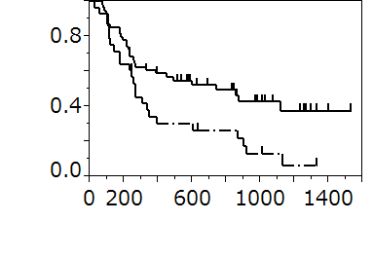
1.0
0.5
1,000
0
0
Relapse free survival
Time from surgery (days)
Logrank
P < 0.05
FNA+
FNA-

Figure 3

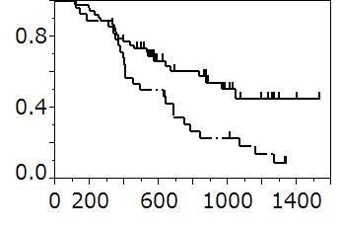
1.0
0.5
0
1,000
0
Time from surgery (days)
Logrank
P < 0.05
FNA+
FNA-
Overall survival

Figure 4

(a)
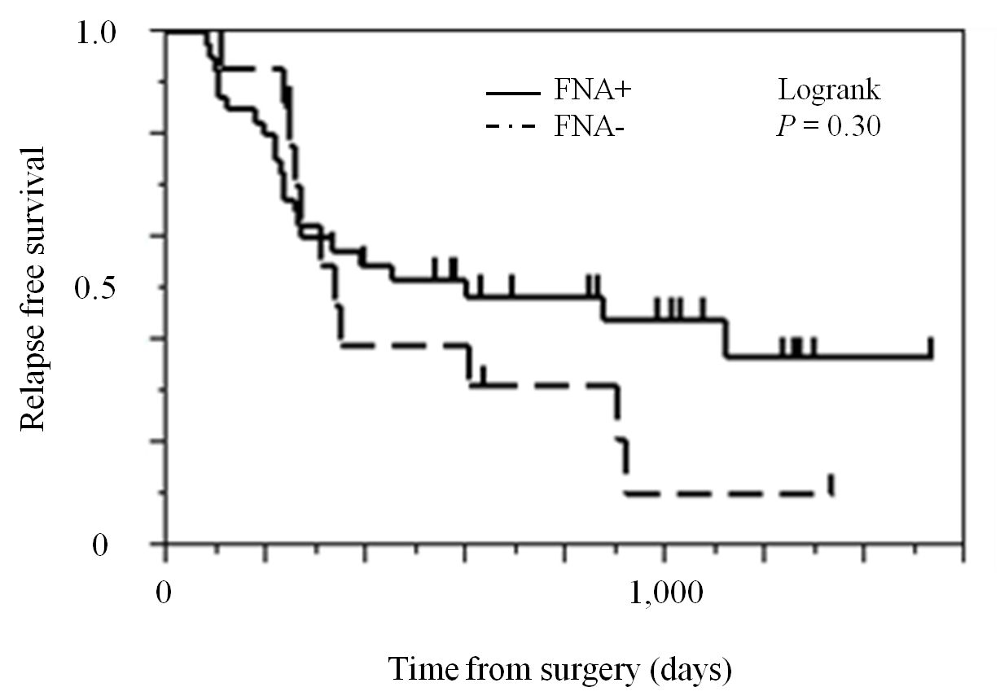

(b)
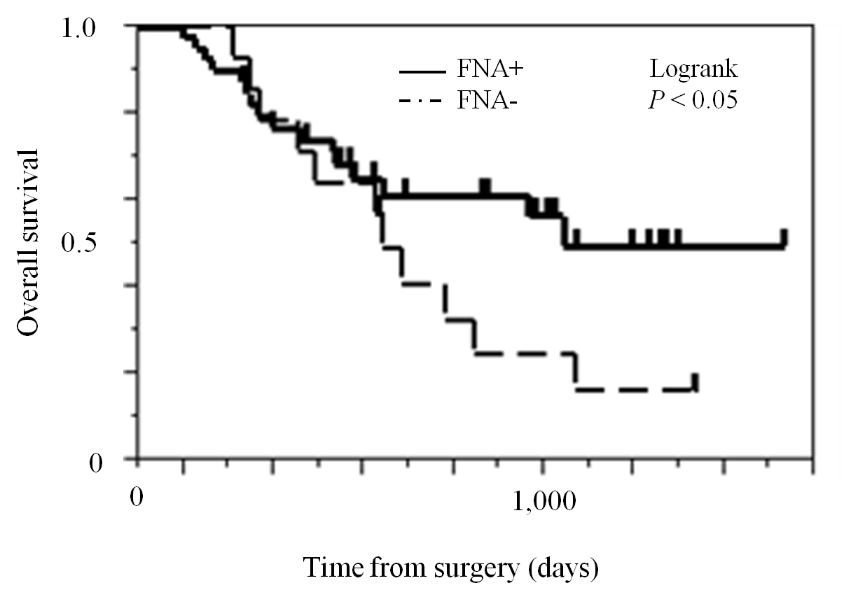

Figure 5

(a)
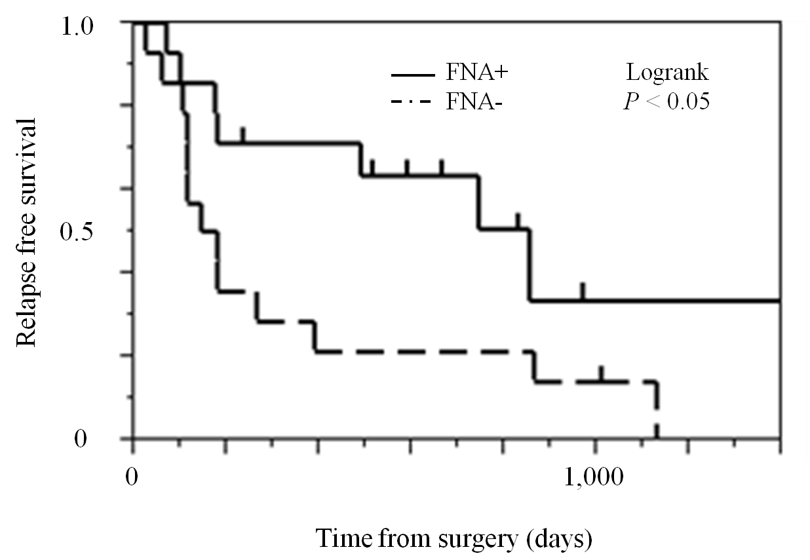

(b)
