Name of Journal: World Journal of Clinical Cases
ESPS Manuscript NO: 26813
Manuscript Type: Case Report

Tooth loss caused by displaced elastic during simple preprosthetic orthodontic treatment

Dianiskova S et al. Tooth loss caused by displaced elastic

Simona Dianiskova, Chiara Calzolari, Marco Migliorati, Armando Silvestrini-Biavati, Gaetano Isola, Fabio Savoldi, Domenico Dalessandri, Corrado Paganelli

Simona Dianiskova, Dental School, Orthodontic Postgraduate Programme, Slovak Medical University, 83303 Bratislava, Slovakia

Chiara Calzolari, Marco Migliorati, Armando Silvestrini-Biavati, Orthodontics Department, School of Dentistry, University of Genova, 16132 Genova, Italy

Gaetano Isola, Department of Biomedical, Odontostomatological Sciences and of Morphological and Functional Images, University of Messina, 98122 Messina, Italy

Gaetano Isola, Department of Neurosciences, Reproductive and Odontostomatological Sciences, School of Medicine, University “Federico II”, 80131 Napoli, Italy

Fabio Savoldi, Domenico Dalessandri, Corrado Paganelli, Department of Orthodontics, School of Dentistry, University of Brescia, 25123 Brescia, Italy

Author contributions: Dianiskova S and Migliorati M conceived the study; Calzolari C and Dalessandri D did the study design and drafting of the manuscript; Savoldi F and Isola G did the literature review and provided additional information; Silvestrini-Biavati A and Paganelli C contributed in revision and approval of the final draft of the manuscript.

Institutional review board statement: This case report was exempt by the Institutional Review Board Standards of the School of Dentistry of University of Brescia.

Informed consent statement: The authors certify that they have obtained the appropriate patient consent form. In the form the patient gave his consent for his images and other clinical information to be reported in the journal. The patient understands that his name and initials will not be published, and his anonymity will be guaranteed.

Conflict-of-interest statement: The authors declare the absence of conflicting interests.

Open-Access: This article is an open-access article which was selected by an in-house editor and fully peer-reviewed by external reviewers. It is distributed in accordance with the Creative Commons Attribution Non Commercial (CC BY-NC 4.0) license, which permits others to distribute, remix, adapt, build upon this work non-commercially, and license their derivative works on different terms, provided the original work is properly cited and the use is non-commercial. See: http://creativecommons.org/licenses/by-nc/4.0/

Manuscript source: Invited manuscript

Correspondence to: Domenico Dalessandri, DDS, MS (Ortho), PhD, Adjunct Assistant Professor, Department of Orthodontics, School of Dentistry, University of Brescia, 1 p.le Spedali Civili, 25123 Brescia, Italy. dalessandridomenico@libero.it
Telephone: +39-030-3995783
Fax: +39-030-3996097

Received: April 27, 2016
Peer-review started: April 28, 2016
First decision: May 17, 2016
Revised: June 4, 2016
Accepted: July 11, 2016
Article in press:
Published online:
Abstract
The use of elastics to close a diastema or correct tooth malpositions can create unintended consequences if not properly controlled. The American Association of Orthodontists recently issued a consumer alert, warning of “a substantial risk for irreparable damage” from a new trend called “do-it-yourself” orthodontics, consisting of patients autonomously using elastics to correct tooth position. The elastics can work their way below the gums and around the roots of the teeth, causing damage to the periodontium and even resulting in tooth loss. The cost of implants to replace these teeth would well exceed the cost of proper orthodontic care. This damage could also occur in a dental office, when a general dentist tries to perform a simplified orthodontic correction of a minor tooth malposition. The present case report describes a case of tooth loss caused by a displaced intraoral elastic, which occurred during a simple preprosthetic orthodontic treatment.

Key words: Orthodontics; Intraoral elastics; Periodontal damage; Tooth extraction; Pre-prosthetic treatment

© The Author(s) 2016. Published by Baishideng Publishing Group Inc. All rights reserved.

Core tip: This article describes the harmful effects caused by the subgingival displacement of an intraoral elastic during a simple preprosthetic orthodontic treatment. The paper highlights the importance of being referred to an orthodontist to correct malocclusions, warning general dentists against undertaking complex orthodontic treatments without having the necessary orthodontic skills. This work also describes a phenomenon called, “do-it-yourself orthodontics”, which is gaining in popularity amongst adolescents thanks to the tutorials available on various websites such as YouTube, and strongly warns against this practice because it may cause irreparable periodontal damage and tooth loss.

Dianiskova S, Calzolari C, Migliorati M, Silvestrini-Biavati A, Isola G, Savoldi F, Dalessandri D, Paganelli C. Tooth loss caused by displaced elastic during simple preprosthetic orthodontic treatment. World J Clin Cases 2016; In press

INTRODUCTION
Orthodontic treatments represent a major investment in the future dental health and appearance of adolescent smiles. Teeth move as a reaction to forces applied to them, and in many cases orthodontists use different teeth in the same jaw to give the resistance or anchorage needed to provide the required forces.
During some phases of an orthodontic treatment, elastics or rubber bands are used to move teeth or jaws, or sometimes both. By careful treatment planning and controlling the strength, direction, and duration of forces, orthodontists aim to minimize the use of elastics, which requires patients’ active cooperation and could be harmful if improperly controlled. Unfortunately, there are cases in which good treatment outcomes would be impossible without the use of elastics^{[1-8]}.
In 1728, Pierre Fouchard proposed a method to close an anterior diastema using a silk ligature. From this moment, on the history of using elastics in orthodontics has abounded in literature, culminating with Ricketts in 1970, who applied a bioprogressive segmented light square wire technique in open bite cases, and suggested the use of anterior vertical elastics to close the bite. In other cases, Roth recommended short Class II intermaxillary elastics to help level the curve of Spee in association with extraoral forces, and Langlade developed clinical guidelines for elastics applications in different situations, proposing helpful guides for biomechanics management^{[8-15]}.
Today, an odd new craze is taking over the Internet, with YouTube videos of teenagers making “do-it-yourself” (DIY) orthodontics. Youngsters are sticking elastic bands around their teeth in a bid to help straighten wonky teeth or to close gaps, a practice becoming known as a “gap band”, but dentists have warned against people adopting this gap band as they could cause damage to their gums and are potentially lose their teeth entirely.

CASE REPORT
A 37-year-old male underwent a simple orthodontic preprosthetic treatment, after signing informed consent, with the aim to correct a scissor-bite between the upper second molar and the lower second molar on the right side (Figure 1).
A general dentist placed a buccal orthodontic button in the centre of the crown of the upper second molar and another button on the lower second molar lingual surface, and then instructed the patient to wear an orthodontic elastic to correct the scissor bite. The patient had to wear the elastic all day, except during meals and oral hygiene.
The patient was recalled monthly in order to check tooth movements, but after a few months he experienced discomfort in the gum at the level of the second lower molar, where the rubber band was applied. During a clinical examination, slight mobility of the lower molar was observed, which was attributed to the orthodontic force application, even if in presence of augmented periodontal probing (7 mm). A periapical radiograph revealed the presence of a small periodontal angular defect mesial to the molar, in absence of foreign bodies or tartar (Figure 2). The elastic use was immediately suspended and the lingual button removed, in order to avoid any interference with oral hygiene maintenance. After consultation with a periodontist, subgingival root planning under anaesthesia, followed by chlorhexidine gel insertion and a systemic antibiotic therapy, was performed. The patient was than recalled one week later, at which point no improvement was found, but rather a significant mobility increase was noted. Periodontal probing was 12 mm all around the tooth. In a periapical radiograph, was obtained and worsening of the mesial angular defect was observed, affecting the root length (Figure 3). The dentist then decided to extract the second molar.
During the extraction procedure, the dentist found an intraoral elastic around the root, in proximity to the apex (Figure 4). It was not possible to visualize this elastic in the radiological exams because this type of elastic is, unlike separator elastics, not radiopaque. After treatment failure, considering that the second upper molar was very buccally inclined and that the patient did not want to undergo a complete orthodontic treatment, the dentist decided to extract the molar to avoid occlusal interference and accumulation of food between 16 and 17, with the risk of upper first molar loss (Figure 5).
Three years later, a good bone level was noticed around the implant and the teeth adjacent to the second molars extraction sites (Figure 6).

DISCUSSION
The popularity of peer-to-peer education, employing powerful diffusion channels such as YouTube, makes it possible for people to find instructions to create everything from home decorations and recipes to home repairs and design inspiration based on a DIY approach. The DIY pins and videos most often shared make a complex task seem effortless, like anyone can do it.
The practice of closing an interincisal diastema as shown in several YouTube tutorials is gaining more and more interest, with emulation between adolescents now causing several dental associations to issue severe warnings about this dangerously growing trend that sees young people using cheap elastics to straighten their teeth, a procedure that could cause permanent damage to their gums and even result in tooth loss. For example, the American Association of Orthodontists (AAO) has issued a series of television and radio public service announcements (PSAs) as part of a public health campaign to inform consumers about the risks associated with DIY orthodontics. AAO provides a simple message to the viewing and listening audiences: “Moving teeth is a medical procedure and needs personal supervision by an orthodontist. Orthodontists are specialists who, after graduating from dental school, receive two to three years of additional education in orthodontics at an accredited orthodontic residency program”^{[1-8]}.
Though approximately 60% of Americans have dental coverage as part of their insurance plan, many are not covered for orthodontic procedures, and this lack of coverage is a concern-especially for young people, whose insecurities about the appearance of their smile cause some to resort to a dangerous short cut in order to achieve “perfect” straight teeth.
Unfortunately, DIY orthodontics have taken on a whole new life, over the last couple of years. DIY can be a scary trend, especially in terms of self-diagnosing or self-treating dental health problems: after reading some articles on DIY teeth straightening, people may believe that they can safely straighten their own teeth without oversight from an orthodontist, based on the advice from a young blogger, who has tens of thousands of viewers watching her enthusiastically describe how to use elastic rubber bands to fix a gap in her teeth. A simple search on YouTube shows many others who have filmed their DIY teeth-straightening journey.
Even if conducted by a general dentist, a superficial approach to an excessively simplified “orthodontic” treatment could be dangerous if not properly controlled, potentially leading to more harm than benefit.
In the present case report, the absence of a radiopaque elastic did not allow the dentist to detect the elastic that was in the periodontal pocket, which was not even clinically identified during initial periodontal probing. Effectively, the early identification of it would avoid tooth loss: The absence of a correct differential diagnosis between severe and aggressive periodontitis and the presence of the elastic in the pocket, together with the lack of orthodontic experience and competence, is the real cause of the tooth loss.
A qualified orthodontist creates a unique individualized treatment plan that takes into account an individual patient’s needs and objectives, strategically placing braces for tooth movement in a structured and biologically sensible manner. This placement typically involves several different movements and force levels, moving certain teeth into different places to allow other teeth to move correctly, thereby allowing each tooth the necessary room to move, leading to the creation of a straight, beautiful, and healthy smile. The orthodontist monitors tooth movement and makes necessary adjustments to advance the process; they assess the health of the patient’s teeth and gums at regular appointments and alerts the patient about actions to take if anything is amiss^{[16-26]}.
Indeed, even if performing simply teeth position corrections, appropriate orthodontic oversight in conjunction with regular in-person visits is needed, because an overly simplified approach could easily become an uncontrolled treatment that could then lead to important side effects.
The aim of this case report was to warn both general dentists and patients against undertaking a simplified orthodontic treatment, without the appropriate oversight of a well-trained orthodontist, showing the possible consequences and damages to dental structures. Furthermore, this article highlights the importance of producing radiopaque intraoral orthodontic elastics that could be easily detected in the case of unexpected subgingival displacement.

ACKNOWLEDGMENTS
The authors are grateful to Dr. Piero Rossi for the clinical documentation of this case report.

COMMENTS
Case characteristics
A 37-year-old male underwent a simple orthodontic preprosthetic treatment using an intraoral elastic that was anchored to a vestibular button that was placed on the upper right second molar, and a lingual button placed on the lower right second molar. After few months the patient reported significant pain and presented with impressive bone loss around the lower right second molar.

Clinical diagnosis
Tooth mobility accompanied with periodontal probing on the right-side lower second molar.

Differential diagnosis
Aggressive periodontitis.

Laboratory diagnosis
All laboratory values were within normal limits.

Imaging diagnosis
Periapical radiography revealed an angular bone defect around the tooth.

Pathological diagnosis
Loss of periodontal attachment.

Treatment
Tooth extraction.

Related reports
Tooth loss caused by displaced elastic should be suspected if a significant periodontal defect suddenly appears that involves only one or two teeth, for no other apparent reason.

Term explanation
Preprosthetic orthodontic treatment is an orthodontic treatment performed to allow a better restorative solution that ameliorates the position of teeth that must be restored.

Experiences and lessons
Appropriate orthodontic oversight in conjunction with regular in-person visits is needed even if performing simple tooth position corrections. In addition, this article highlights the importance of producing radiopaque intraoral orthodontic elastics in order to better visualize them during a radiological exam, especially cases in which they become displaced under the gingival level.

Peer-review
This is a very good case report, which describes a severe periodontal destruction caused by an orthodontic elastic displacement.

REFERENCES
1 Bratu CD, Fleser C, Glavan F. The effect of intermaxillary elastics in orthodontic therapy. Timisoara Medical J 2004; 54: 406-409
2 Nelson B, Hansen K, Hägg U. Class II correction in patients treated with class II elastics and with fixed functional appliances: a comparative study. Am J Orthod Dentofacial Orthop 2000; 118: 142-149 [PMID: 10935954 DOI: 10.1067/mod.2000.104489]
3 Kersey ML, Glover KE, Heo G, Raboud D, Major PW. A comparison of dynamic and static testing of latex and nonlatex orthodontic elastics. Angle Orthod 2003; 73: 181-186 [PMID: 12725375]
4 Parikakis KA, Moberg S, Hellsing E. Evaluation of the variable anchorage straightwire technique using Ricketts' growth prediction. Eur J Orthod 2009; 31: 76-83 [PMID: 18832190 DOI: 10.1093/ejo/cjn038]
5 Hocevar RA. Begg-edgewise diagnosis-determined totally individualized orthodontic technique: introduction to clinical applications. Am J Orthod Dentofacial Orthop 1987; 92: 50-69 [PMID: 3474885 DOI: 10.1016/0002-9416(85)90105-8]
6 Mittal M, Thiruvenkatachari B, Sandler PJ, Benson PE. A three-dimensional comparison of torque achieved with a preadjusted edgewise appliance using a Roth or MBT prescription. Angle Orthod 2015; 85: 292-297 [PMID: 24978676 DOI: 10.2319/122313-941]
7 Moesi B, Dyer F, Benson PE. Roth versus MBT: does bracket prescription have an effect on the subjective outcome of pre-adjusted edgewise treatment? Eur J Orthod 2013; 35: 236-243 [PMID: 22051535 DOI: 10.1093/ejo/cjr126]
8 Egolf RJ, BeGole EA, Upshaw HS. Factors associated with orthodontic patient compliance with intraoral elastic and headgear wear. Am J Orthod Dentofacial Orthop 1990; 97: 336-348 [PMID: 2321602 DOI: 10.1016/0889-5406(90)70106-M]
9 Langlade M. Optimization of Orthodontic elastics. GAC International Ed, New York, 2000
10 McSherry PF, Bradley H. Class II correction-reducing patient compliance: a review of the available techniques. J Orthod 2000; 27: 219-225 [PMID: 11099554 DOI: 10.1179/ortho.27.3.219]
11 Rock WP, Wilson HJ, Fisher SE. Force reduction of orthodontic elastomeric chains after one month in the mouth. Br J Orthod 1986; 13: 147-150 [PMID: 3460631 DOI: 10.1179/bjo.13.3.147]
12 Aras A, Cinsar A, Bulut H. The effect of zigzag elastics in the treatment of Class II division 1 malocclusion subjects with hypo- and hyperdivergent growth patterns. A pilot study. Eur J Orthod 2001; 23: 393-402 [PMID: 11544789 DOI: 10.1093/ejo/23.4.393]
13 Reddy P, Kharbanda OP, Duggal R, Parkash H. Skeletal and dental changes with nonextraction Begg mechanotherapy in patients with Class II Division 1 malocclusion. Am J Orthod Dentofacial Orthop 2000; 118: 641-648 [PMID: 11113799 DOI: 10.1067/mod.2000.110584]
14 Gracco A, Siviero L, de Stefani A, Bruno G, Stellini E. Anterior open-bite orthodontic treatment in an adult patient: A clinical case report. Int Orthod 2016; 14: 171-183 [PMID: 27080595 DOI: 10.1016/j.ortho.2016.03.011]
15 Dalessandri M, Buffoli B, Scavia S, Dalessandri D, Di Rosario F, Rodella LF, Salgarello S. Socket and ridge preservation using a mixture of nano-hydroxyapatite, polylactic and polyglycolic acid: histological evaluation. Dental Cadmos 2015; 83: 472-484 [DOI: 10.1016/S0011-8524(15)30065-9]
16 Buffoli B, Dalessandri M, Favero G, Mensi M, Dalessandri D, Di Rosario F, Stacchi C, Rezzani R, Salgarello S, Rodella LF. AQP1 expression in human gingiva and its correlation with periodontal and peri-implant tissue alterations. Acta Histochem 2014; 116: 898-904 [PMID: 24698289 DOI: 10.1016/j.acthis.2014.02.010]
17 Pacheco AA, Saga AY, de Lima KF, Paese VN, Tanaka OM. Stress Distribution Evaluation of the Periodontal Ligament in the Maxillary Canine for Retraction by Different Alveolar Corticotomy Techniques: A Three-dimensional Finite Element Analysis. J Contemp Dent Pract 2016; 17: 32-37 [PMID: 27084860 DOI: 10.5005/jp-journals-10024-1799]
18 Castelli A, Le Gall M, Monnet-Corti V. [Behavior of the periodontium during leveling of the mandibular incisors: what precautions are needed?]. Orthod Fr 2016; 87: 99-102 [PMID: 27083231 DOI: 10.1051/orthodfr/2016006]
19 Pignoly M, Monnet-Corti V, Le Gall M. [Reason for failure in the treatment of impacted and retained teeth]. Orthod Fr 2016; 87: 23-38 [PMID: 27083220 DOI: 10.1051/orthodfr/2016001]
20 Silvestrini-Biavati A, Migliorati M, Demarziani E, Tecco S, Silvestrini-Biavati P, Polimeni A, Saccucci M. Clinical association between teeth malocclusions, wrong posture and ocular convergence disorders: an epidemiological investigation on primary school children. BMC Pediatr 2013; 13: 12 [PMID: 23343244 DOI: 10.1186/1471-2431-13-12]
21 Agarwal A, Mahajan S, Verma S, Bhardwaj P, Sharma G. Evaluation of the Stress Induced in Tooth, Periodontal Ligament & amp; Alveolar Bone with Varying Degrees of Bone Loss During Various Types of Orthodontic Tooth Movements. J Clin Diagn Res 2016; 10: ZC46-ZC52 [PMID: 27042585 DOI: 10.7860/JCDR/2016/17206.7235]
22 Livada R, Shiloah J, Hottel TL. Non-Orthodontic, Non-Restorative Closure of Acquired Diastemata. J Tenn Dent Assoc 2015; 95: 34-36; quiz 37-38 [PMID: 27008768]
23 Cui J, Li J, Wang W, Han X, Du J, Sun J, Feng W, Liu B, Liu H, Amizuka N, Li M. The effect of calcitriol on high mobility group box 1 expression in periodontal ligament cells during orthodontic tooth movement in rats. J Mol Histol 2016; 47: 221-228 [PMID: 26956363 DOI: 10.1007/s10735-016-9669-0]
24 Migliorati M, Isaia L, Cassaro A, Rivetti A, Silvestrini-Biavati F, Gastaldo L, Piccardo I, Dalessandri D, Silvestrini-Biavati A. Efficacy of professional hygiene and prophylaxis on preventing plaque increase in orthodontic patients with multibracket appliances: a systematic review. Eur J Orthod 2015; 37: 297-307 [PMID: 25246605 DOI: 10.1093/ejo/cju044]
25 Feng X, Oba T, Oba Y, Moriyama K. An interdisciplinary approach for improved functional and esthetic results in a periodontally compromised adult patient. Angle Orthod 2005; 75: 1061-1070 [PMID: 16448256]
26 Janson M, Janson G, Murillo-Goizueta OE. A modified orthodontic protocol for advanced periodontal disease in Class II division 1 malocclusion. Am J Orthod Dentofacial Orthop 2011; 139: S133-S144 [PMID: 21435531 DOI: 10.1016/j.ajodo.2009.03.053]

P-Reviewer: Siqueira SRDT, Yuan K S-Editor: Ji FF L-Editor: E-Editor:

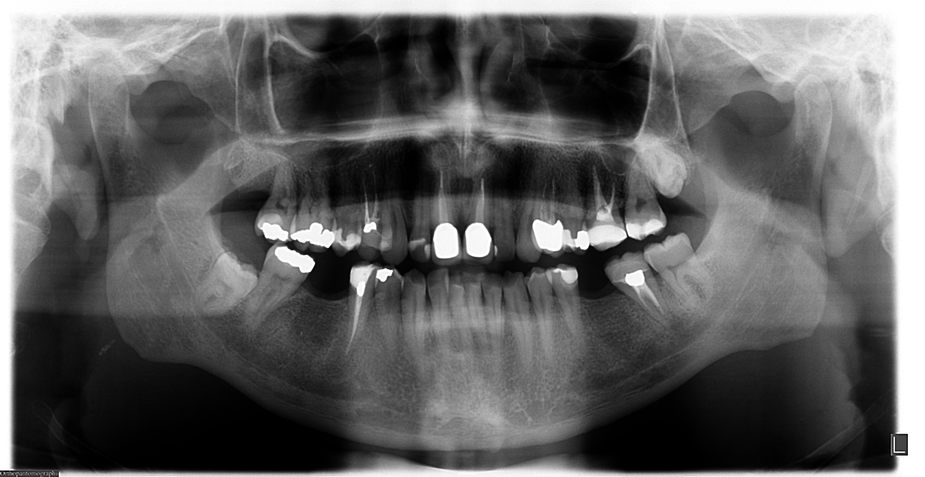

Figure 1 Pretreatment orthopantomography.

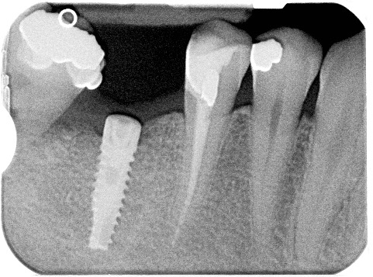

Figure 2 Lower second molar mesial angular periodontal defect.

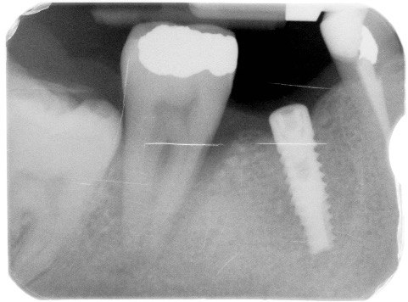

Figure 3 Worsening of lower second molar mesial angular periodontal defect.

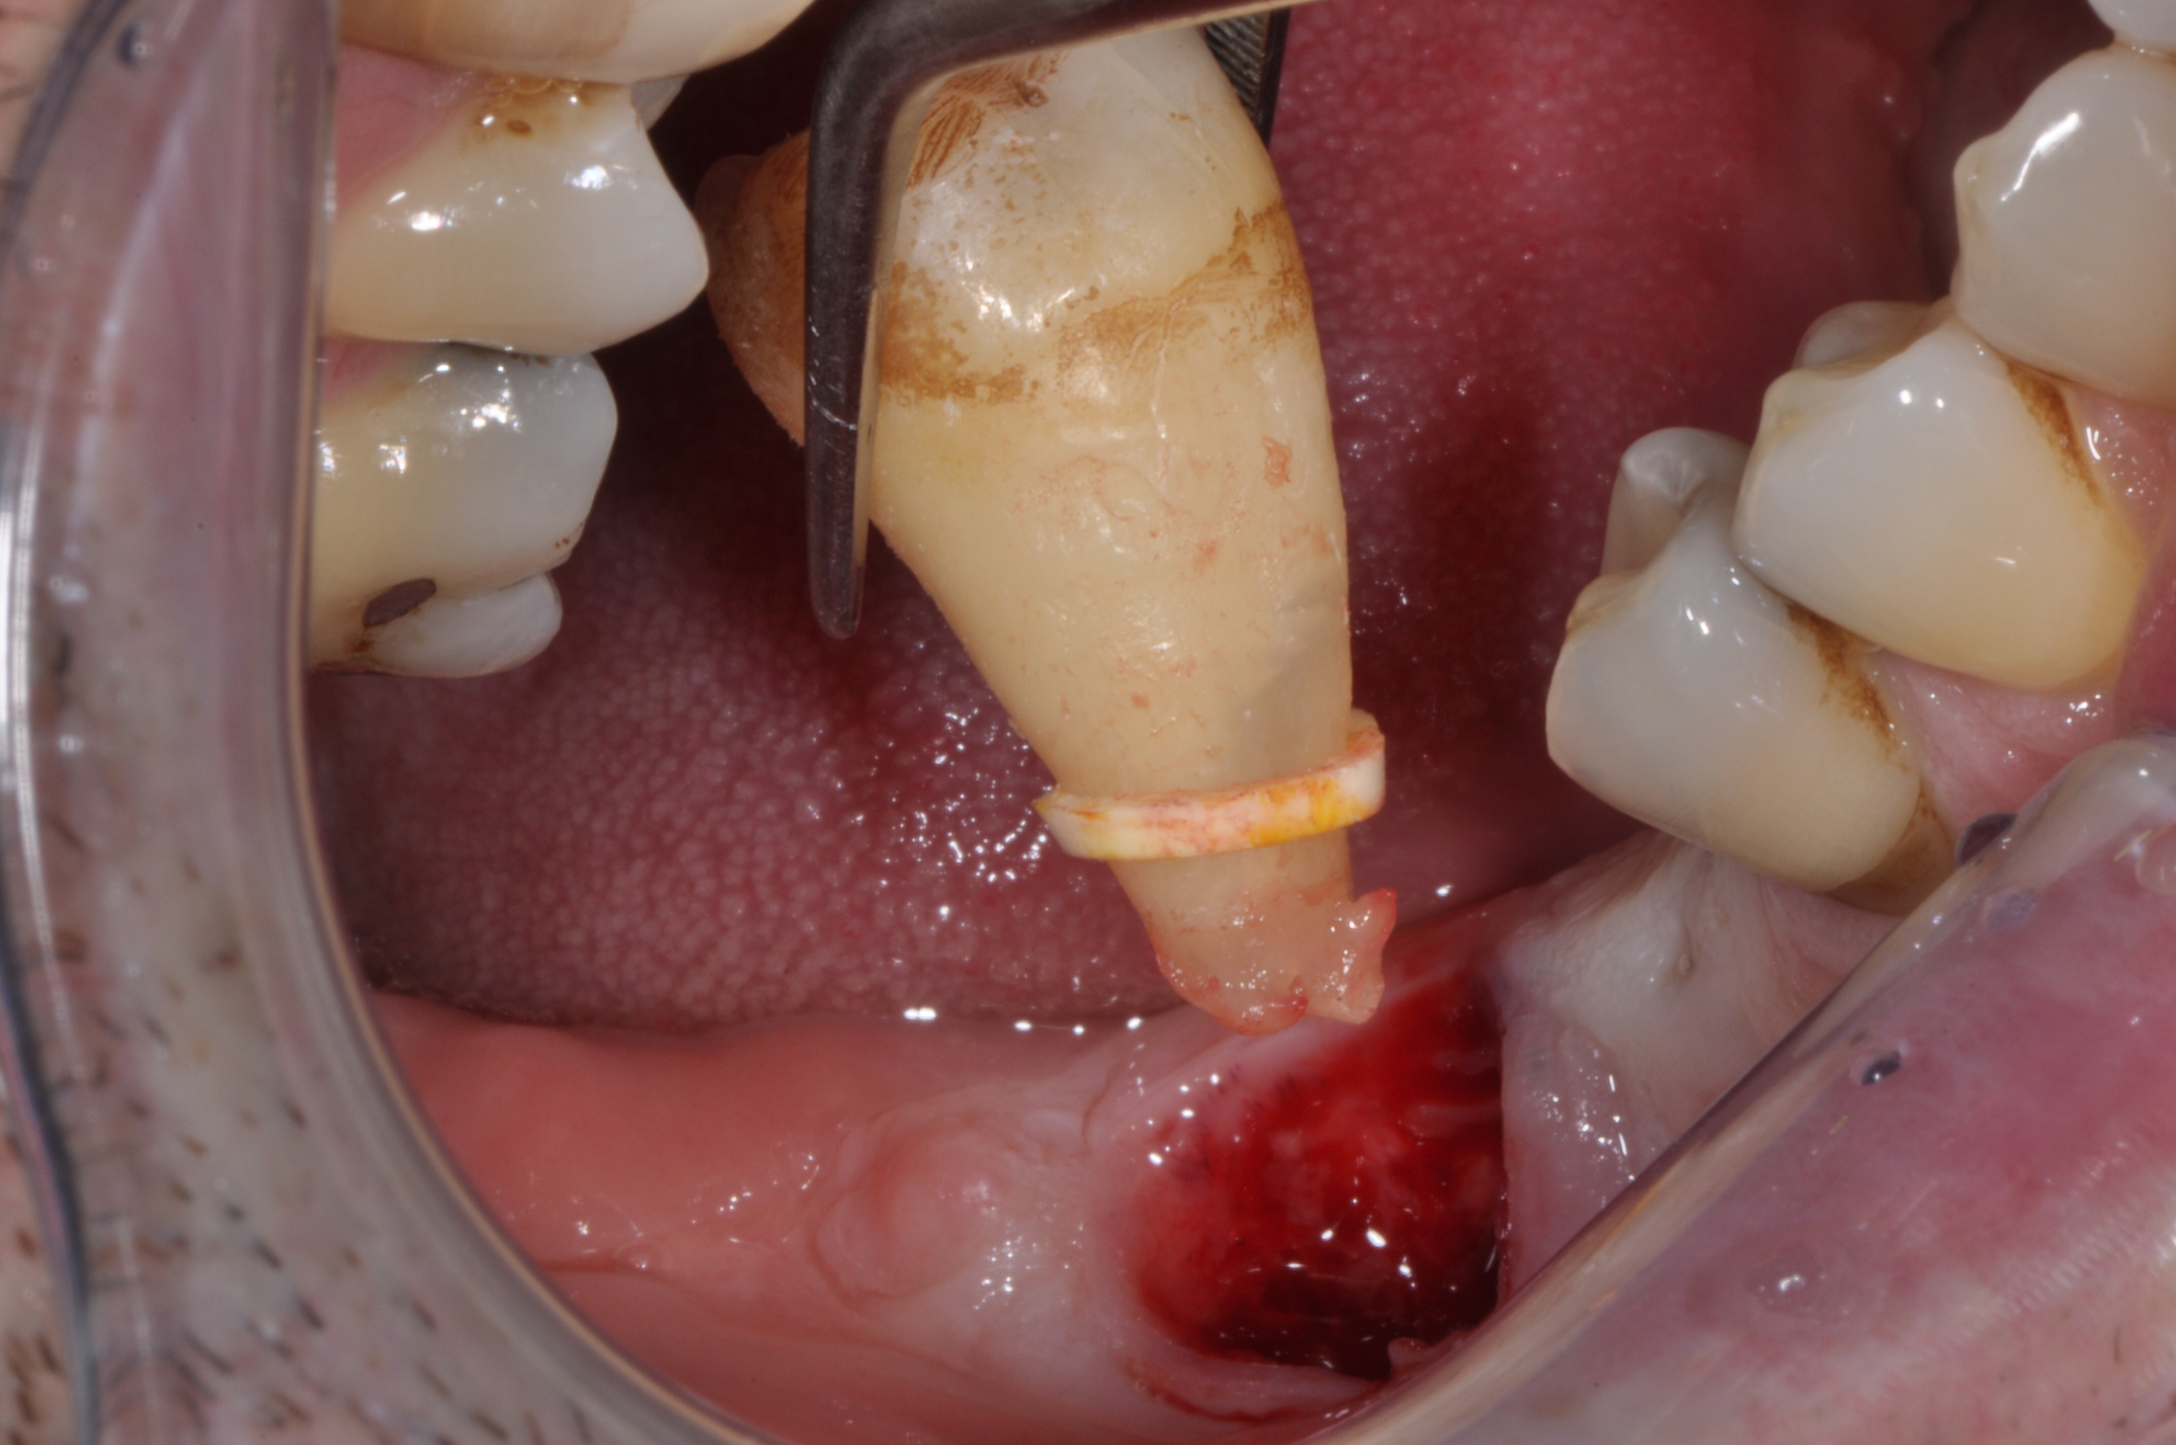

Figure 4 Lower second molar extraction.

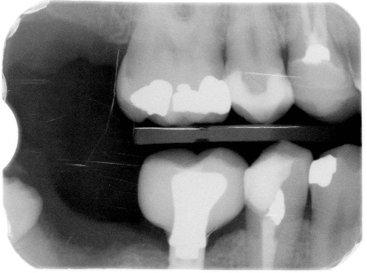

Figure 5 Post-treatment radiograph after second molar extraction.

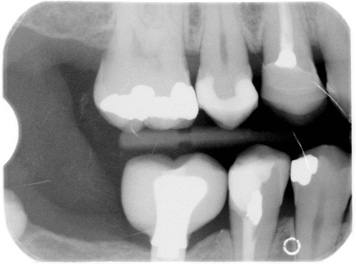

Figure 6 Three-year follow-up.

