Name of Journal: World Journal of Clinical Cases
Manuscript NO: 51946
Manuscript Type: CASE REPORT

Combined surgical and interventional treatment of tandem carotid artery and middle cerebral artery embolus: a case report

Zhang M et al. Tandem carotid artery and middle cerebral artery embolus occlusion

Meng Zhang, Ji-Heng Hao, Kai Lin, Qing-Ke Cui, Li-Yong Zhang

Meng Zhang, Ji-Heng Hao, Kai Lin, Qing-Ke Cui, Li-Yong Zhang, Department of Neurosurgery, Liaocheng Brain Hospital, Liaocheng 252000, Shandong Province, China

ORCID Number: Meng Zhang (0000-0001-9868-6431); Ji-Heng Hao (0000-0002-0299-3830); Kai Lin ( 0000-0002-3563-6127); Qing-Ke Cui (0000-0002-7124-8164); Li-Yong Zhang ( 0000-0001-5831-6823).

Author contributions: Zhang LY and Zhang M designed the report; Zhang LY, Cui QK and Zhang M performed the operation; Hao JH and Lin K helped with the patient examination.

Informed consent statement: Informed written consent was obtained from the patient.

Conflict-of-interest statement: The authors declare that they have no conflict of interest.

CARE Checklist (2016) statement: The manuscript was prepared and revised according to the CARE Checklist (2016).

Open-Access: This article is an open-access article which was selected by an in-house editor and fully peer-reviewed by external reviewers. It is distributed in accordance with the Creative Commons Attribution Non Commercial (CC BY-NC 4.0) license, which permits others to distribute, remix, adapt, build upon this work non-commercially, and license their derivative works on different terms, provided the original work is properly cited and the use is non-commercial. See: http://creativecommons.org/licenses/by-nc/4.0/

Manuscript source: Unsolicited manuscript

Corresponding author: Li-Yong Zhang, PhD, Chief Physician, Surgeon, Department of Neurosurgery, Liaocheng Brain Hospital, No. 45 Huashan Road, Dongchangfu District, Liaocheng 252000, Shandong Province, China. 13346256936@163.com
Telephone: +86-13346256936

Received: October 13, 2019
Peer-review started: October 13, 2019
First decision: November 13, 2019
Revised: November 19, 2019
Accepted: December 6, 2019
Article in press:
Published online:

Abstract
Background
The 2018 American Heart Association/American Stroke Association guidelines for early management of acute ischemic stroke recommend the use of retrievable stents for mechanical thrombectomy in patients with acute internal carotid artery or middle cerebral artery M1 occlusion that can be treated within 6 h from onset. For cases of carotid artery with ipsilateral middle cerebral artery tandem embolization, the operation is more complicated and challenging. We here report a case of a tandem embolism, and the anatomy of the aortic arch was complex. Direct carotid artery incision and thrombectomy can not only prevent the escape of the carotid embolus but also save time during establishment of the thrombectomy access.

Case summary
The patient was a 70-year-old man. He was admitted to hospital due to sudden inability to speak and inability to move his right limb for 3 h. Imaging confirmed a diagnosis of a tandem embolism in the left carotid artery with left M1 occlusion. Carotid artery incision thrombectomy combined with stent thrombectomy was performed. The operation was successful, and 24 h later the patient was conscious and mentally competent but had motor aphasia. His bilateral limb muscle strength level was 5, and his neurologic severity scores score was 2.

Conclusion
Carotid artery incision thrombectomy combined with stenting for carotid artery plus cerebral artery tandem embolization is clinically feasible. For patients with a complicated aortic arch and an extremely tortuous carotid artery, carotid artery incision can be chosen to establish the interventional path.

Key words: Carotid artery incision thrombectomy; Mechanical thrombectomy; Carotid thrombosis; Middle cerebral artery occlusion; Tandem occlusion; Case report

© The Author(s) 2019. Published by Baishideng Publishing Group Inc. All rights reserved.

Core tip: We report a case of acute carotid artery and ipsilateral middle cerebral artery occlusion. The anatomy of the aortic arch was complex. We chose carotid artery incision thrombectomy combined with stent thrombectomy for this patient because of the following reasons. First, the anatomy of the aortic arch was complex, and simple intravascular treatment would take a longer time to establish the interventional path. Second, the embolus was located in the bifurcation of the carotid artery and the ipsilateral middle cerebral artery. There was no obvious embolus in the remaining segments of the internal carotid artery, so there was positive blood flow in the internal carotid artery. In such patients, carotid stent implantation for carotid artery embolization might result in distal escape of the thrombus.

Zhang M, Hao JH, Lin K, Cui QK, Zhang LY. Combined surgical and interventional treatment of tandem carotid artery and middle cerebral artery embolus: a case report. World J Clin Cases 2019; In press

Introduction
The 2018 American Heart Association/American Stroke Association guidelines for early management of acute ischemic stroke recommend the use of retrievable stents for mechanical thrombectomy in patients with acute internal carotid artery or middle cerebral artery M1 occlusion that can be treated within 6 h from onset^{[1]}. Few cases of carotid artery combined with ipsilateral middle cerebral artery tandem embolism, have been reported. In addition, the operation is more complex and challenging, and the prognosis of such patients is poor^{[2]}. We treated a case of carotid artery combined with middle cerebral artery tandem embolization with carotid artery incision thrombectomy combined with stenting. The result was satisfactory.

CASE PRESENTATION
Chief complaints
A 70-year-old man complained of sudden inability to speak and inability to move his right limb for 3 h.

History of present illness
A history of atrial fibrillation for more than 1 year.

Personal and family history
No history of hypertension, diabetes, coronary heart disease or other chronic diseases. There was no similar event or known genetic history in his family.

Physical examination
The patient presented with drowsiness and complete mixed aphasia. The right nasolabial groove had become shallow, and his mouth was askew to the left. His left limb was movable, and the right limb was unmovable. The muscle tension of the extremities was normal, and pathological signs on the right side were positive. His baseline neurologic severity scores (NHISS) score was 23.

Imaging examination
Electrocardiogram examination showed atrial fibrillation. Head and neck computed tomography angiography (CTA) showed embolisms in the left carotid bifurcation and left middle cerebral artery. Brain computed tomography showed a small infarct in the left insular lobe (Figure 1).

Laboratory examination
Blood routine examination and coagulation mechanism showed no obvious abnormalities.

Final diagnosis
Carotid artery combined with ipsilateral middle cerebral artery acute tandem embolism.

Treatment
Alteplase was administered at a dose of 0.9 mg/kg 200 min after symptom onset. Revascularization was initiated 210 min after onset. Cerebral angiography showed a type III aortic arch, where the left common carotid artery shared the main trunk with the brachiocephalic trunk. A Simmon 2 angiography catheter was placed for left common carotid artery angiography. The left external carotid artery was not visible, and the left internal carotid artery showed slow blood flow. Thrombosis at the beginning of the internal carotid artery and occlusion of the upper trunk of the left middle cerebral artery was considered. The left anterior cerebral artery provided secondary compensatory blood supply to the left middle cerebral artery (Figure 2). Repeated attempts were made to place the 8F guiding catheter into the left common carotid artery, which took 40 min. The 8F guiding catheter was aspirated at the bifurcation of the left carotid artery, and no reverse bleeding was observed. A percutaneous carotid artery incision was made to remove the thrombus in the neck under direct vision, and it only took 20 min (Figure 3). The left carotid artery was sutured, and angiography showed that the thrombosis in the bifurcation of the carotid artery had disappeared and that the internal and external carotid arteries were unblocked. Using the Solitaire intermediate catheter for mechanical thrombectomy , a 5Fr Navien intermediate catheter was placed across the carotid bifurcation into the petrosal segment. The left middle cerebral artery clot was removed with a Solitaire FR 6–30 mm. After two attempts, the patient was re-examined by angiography, which revealed middle cerebral artery blood flow recanalization, with modified thrombolysis in cerebral infarction score level III (Figure 4).

Outcome and follow-up
Neurological examination was performed 24 h after the operation. The patient was conscious and mentally competent, accompanied by motor aphasia. His bilateral limb muscle strength level was 5, and his NHISS score was 2. Brain magnetic resonance imaging showed small infarcts in the frontal and temporal lobes (Figure 5). Pathological examination of the thrombus showed a mixed thrombus (Figure 6). His mRS score was 0 at 3 mo of follow-up (Table 1).

Discussion
Severe acute ischemic stroke is often caused by acute tandem occlusion of the internal carotid artery and the ipsilateral middle cerebral artery. External carotid artery occlusion is mainly caused by arterial dissection and atherosclerotic plaques^{[3]}. Ipsilateral middle cerebral artery occlusion is usually caused by thrombus or plaque detachment in the lesion site near the internal carotid artery^{[4-6]}. Treatment for patients with such tandem occlusions has been reported at several centers^{[7-9]}. Balloon dilatation or combined stenting was used to treat the occlusion of the external segment of the internal carotid artery, and mechanical thrombectomy was used to solve the occlusion of the ipsilateral middle cerebral artery. It has also been reported that due to the hardness of the plaque in the initial segment of the internal carotid artery, various microcatheter and guidewire techniques were attempted but could not pass through the occlusion site of the external cranial segment of the internal carotid artery. Carotid artery puncture was performed to establish thrombectomy access. Mechanical thrombectomy of the ipsilateral middle cerebral artery occlusion was performed first, and carotid endarterectomy was then performed to treat the internal carotid artery lesions^{[10]}. One study evaluated outcomes and feasibility of carotid artery stenting versus carotid endarterectomy, and performed both procedures in the same patient. Carotid endarterectomy confirms its efficacy in carotid revascularization, but carotid artery stenting constitutes a good alternative when the procedures are selected based on patient-specific risk factors^{[11]}.
The case reported here is considered to be due to embolic events and is thus different from tandem occlusion due to atherosclerotic plaques and arterial dissection. It is also different from the occlusion of the internal carotid artery and middle cerebral artery caused by a high load embolism. The embolus in this patient was located in the bifurcation of the carotid artery and the ipsilateral middle cerebral artery, and no obvious embolus was found in the remaining internal carotid artery, so there was positive blood flow in the internal carotid artery. If a carotid artery embolization is treated with carotid stent implantation in such patients, it may result in distal escape of the thrombus. Studies have shown that aortic arch and proximal carotid artery anatomic factors seriously affect the time required for thrombectomy and are independent risk factors leading to a poor prognosis^{[12,13]}. Carotid puncture is an option. It is difficult to stop the bleeding after postoperative removal of the artery sheath tube after carotid artery puncture. Nii et al^{[14]} applied percutaneous carotid artery puncture for intracranial aneurysm embolization in 27 patients, and 4% of the patients developed a neck hematoma after surgery. In this case, the thrombus was located at the bifurcation of the carotid artery, and percutaneous carotid artery puncture was likely to cause embolus shedding and embolization of the distal blood vessel.
During the operation in the presented case, simple endovascular treatment was considered first. Repeated attempts were made to place the 8F guiding catheter into the left carotid artery, which took 40 min. The 8F catheter was used to aspirate the thrombus at the bifurcation. There was no obvious recanalization of blood after the aspiration, and it was believed that the catheter was stuck against the vessel wall or the thrombus blocked the tube. Then, the 8F catheter was withdrawn to the common carotid artery at the time of aspiration, and no reverse blood was found. The thrombus was considered to be large and stiff and obstructed the 8F catheter. If the 8F catheter is withdrawn from the body, it will take too long to replace the catheter and the thrombus may detach into the femoral artery sheath during retraction. So we chose to dissect and expose the carotid bifurcation. First, the internal carotid artery blood flow was blocked and partial recanalization of the external carotid artery was found by low-flow hand push angiography. However, some thrombus had still not been removed, so carotid artery incision thrombectomy was selected. The internal carotid artery was blocked during the process to avoid the distal escape of the embolus. The safety of emergency carotid endarterectomy (CEA) after intravenous thrombolysis has been confirmed by many reports, and the shortest time reported so far for CEA surgery after intravenous thrombolysis is 120 min^{[10,15,16]}.

Conclusion
Carotid artery incision thrombectomy combined with stenting for the treatment of carotid artery plus cerebral artery tandem embolization is clinically feasible. For patients with a complicated aortic arch and an extremely tortuous carotid artery who cannot receive simple endovascular treatment, carotid artery incision can be chosen to establish the interventional path. A large sample of cases is still needed for further study and confirmation.

References
1 Warner JJ, Harrington RA, Sacco RL, Elkind MSV. Guidelines for the Early Management of Patients with Acute Ischemic Stroke: 2019 Update to the 2018 Guidelines for the Early Management of Acute Ischemic Stroke. Stroke 2019; 50: 3331-3332 [PMID: 31662117 DOI: 10.1161/STROKEAHA.118.020176]
2 Rubiera M, Ribo M, Delgado-Mederos R, Santamarina E, Delgado P, Montaner J, Alvarez-Sabín J, Molina CA. Tandem internal carotid artery/middle cerebral artery occlusion: an independent predictor of poor outcome after systemic thrombolysis. Stroke 2006; 37: 2301-2305 [PMID: 16888266 DOI: 10.1161/01.STR.0000237070.80133.1d]
3 Soize S, Kadziolka K, Estrade L, Serre I, Barbe C, Pierot L. Outcome after mechanical thrombectomy using a stent retriever under conscious sedation: comparison between tandem and single occlusion of the anterior circulation. J Neuroradiol 2014; 41: 136-142 [PMID: 23906737 DOI: 10.1016/j.neurad.2013.07.001]
4 Maurer CJ, Joachimski F, Berlis A. Two in One: Endovascular Treatment of Acute Tandem Occlusions in the Anterior Circulation. Clin Neuroradiol 2015; 25: 397-402 [PMID: 24988990 DOI: 10.1007/s00062-014-0318-2]
5 Grigoryan M, Haussen DC, Hassan AE, Lima A, Grossberg J, Rebello LC, Tekle W, Frankel M, Nogueira RG. Endovascular Treatment of Acute Ischemic Stroke Due to Tandem Occlusions: Large Multicenter Series and Systematic Review. Cerebrovasc Dis 2016; 41: 306-312 [PMID: 26881779 DOI: 10.1159/000444069]
6 Lockau H, Liebig T, Henning T, Neuschmelting V, Stetefeld H, Kabbasch C, Dorn F. Mechanical thrombectomy in tandem occlusion: procedural considerations and clinical results. Neuroradiology 2015; 57: 589-598 [PMID: 25404414 DOI: 10.1007/s00234-014-1465-5]
7 Fahed R, Redjem H, Blanc R, Labreuche J, Robert T, Ciccio G, Smadja D, Smajda S, Piotin M. Endovascular Management of Acute Ischemic Strokes with Tandem Occlusions. Cerebrovasc Dis 2016; 41: 298-305 [PMID: 26866928 DOI: 10.1159/000444068]
8 Cohen JE, Gomori JM, Rajz G, Itshayek E, Eichel R, Leker RR. Extracranial carotid artery stenting followed by intracranial stent-based thrombectomy for acute tandem occlusive disease. J Neurointerv Surg 2015; 7: 412-417 [PMID: 24727131 DOI: 10.1136/neurintsurg-2014-011175]
9 Al-Mufti F, Amuluru K, Manning NW, Khan I, Peeling L, Gandhi CD, Prestigiacomo CJ, Pushchinska G, Fiorella D, Woo HH. Emergent carotid stenting and intra-arterial abciximab in acute ischemic stroke due to tandem occlusion. Br J Neurosurg 2017; 31: 573-579 [PMID: 28298139 DOI: 10.1080/02688697.2017.1297377]
10 Frenkel MB, Renfrow JJ, Singh J, Garg N, Wolfe SQ. Combined interventional and surgical treatment of tandem middle cerebral artery embolus and internal carotid artery occlusion: case report. J Neurosurg 2018; 129: 718-722 [PMID: 29148900 DOI: 10.3171/2017.6.JNS162368]
11 Ciccone MM, Scicchitano P, Cortese F, Gesualdo M, Zito A, Carbonara R, Dentamaro I, Pulli R, Salerno C, Impedovo G, Marinazzo D, Angiletta D, Guido D, Regina G. Carotid stenting versus endarterectomy in the same patient: A "direct" comparison. Vascular 2017; 25: 290-298 [PMID: 27811331 DOI: 10.1177/1708538116674375]
12 Kaesmacher J, Gralla J, Mosimann PJ, Zibold F, Heldner MR, Piechowiak E, Dobrocky T, Arnold M, Fischer U, Mordasini P. Reasons for Reperfusion Failures in Stent-Retriever-Based Thrombectomy: Registry Analysis and Proposal of a Classification System. AJNR Am J Neuroradiol 2018; 39: 1848-1853 [PMID: 30166434 DOI: 10.3174/ajnr.A5759]
13 Kaymaz ZO, Nikoubashman O, Brockmann MA, Wiesmann M, Brockmann C. Influence of carotid tortuosity on internal carotid artery access time in the treatment of acute ischemic stroke. Interv Neuroradiol 2017; 23: 583-588 [PMID: 28944705 DOI: 10.1177/1591019917729364]
14 Nii K, Kazekawa K, Onizuka M, Aikawa H, Tsutsumi M, Tomokiyo M, Iko M, Kodama T, Matsubara S, Go Y, Tanaka A. Direct carotid puncture for the endovascular treatment of anterior circulation aneurysms. AJNR Am J Neuroradiol 2006; 27: 1502-1504 [PMID: 16908568]
15 Azzini C, Gentile M, De Vito A, Traina L, Sette E, Fainardi E, Mascoli F, Casetta I. Very Early Carotid Endarterectomy After Intravenous Thrombolysis. Eur J Vasc Endovasc Surg 2016; 51: 482-486 [PMID: 26712132 DOI: 10.1016/j.ejvs.2015.11.006]
16 Bazan HA, Zea N, Jennings B, Smith TA, Vidal G, Sternbergh WC 3rd. Urgent carotid intervention is safe after thrombolysis for minor to moderate acute ischemic stroke. J Vasc Surg 2015; 62: 1529-1538 [PMID: 26412434 DOI: 10.1016/j.jvs.2015.07.082]

P-Reviewer: Ciccone MM, Grawish M S-Editor: Zhang L L-Editor: MedE-Ma JY E-Editor:

Specialty type: Medicine, Research and Experimental
Country of origin: China
Peer-review report classification
Grade A (Excellent): 0
Grade B (Very good): B, B
Grade C (Good): 0
Grade D (Fair): 0
Grade E (Poor): 0

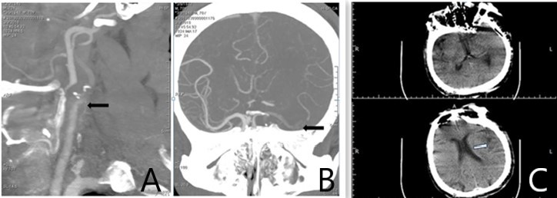
Figure 1 Head and neck computed tomography angiography and brain computed tomography findings. A: Computed tomography angiography (CTA) of the neck showing an embolism at the left carotid bifurcation; B: Intracranial CTA showing an embolism in the upper trunk of the left middle cerebral artery; C: Brain computed tomography showing a small infarction in the left insular lobe; the Alberta Stroke Program Early CT Score was 9.

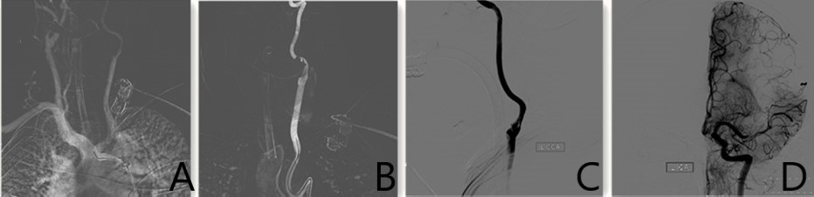
Figure 2 Intracranial angiography findings. A: Subaortic arch angiography shows a type III aortic arch where the left common carotid artery shares the main trunk with the brachiocephalic trunk; B: Simmon 2 catheterangiography showing that the left external carotid artery was not visible, and the left internal carotid artery showing slow blood flow; C: There was a thrombus at the beginning of the left internal carotid artery; D: The upper trunk of the left middle cerebral artery was occluded, but the anterior cerebral artery compensated for the blood supply of the middle cerebral artery via the lateral branches of the meninges.

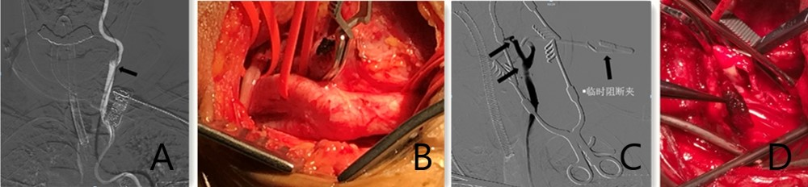
Figure 3 Imaging during surgery. A: An 8F guiding catheter was aspirated at the bifurcation of the left carotid artery, and no blood was observed; B: Percutaneous incision to expose the carotid artery, and the internal carotid blood flow was occluded; C: Partial recanalization of the external carotid artery was obtained by low-flow hand push angiography, but some clots remain unremoved; D: Carotid artery incision thrombectomy.

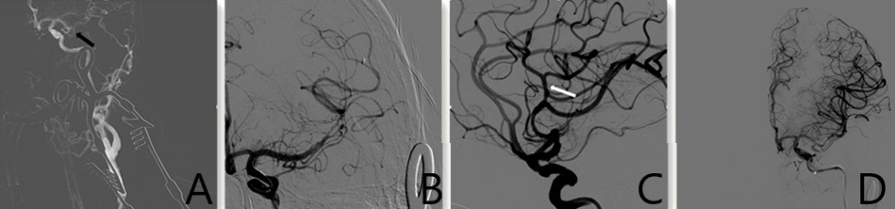
Figure 4 Middle cerebral artery blood flow recanalization modified thrombolysis in cerebral infarction level III. A: The upper trunk of the left middle cerebral artery is occluded, and the thrombus did not escape; B: Thrombectomy was performed with a Solitaire FR 6–30 mm stent; C: After thrombectomy, the blood flow was restored; D: Modified thrombolysis in cerebral infarction was stage III.

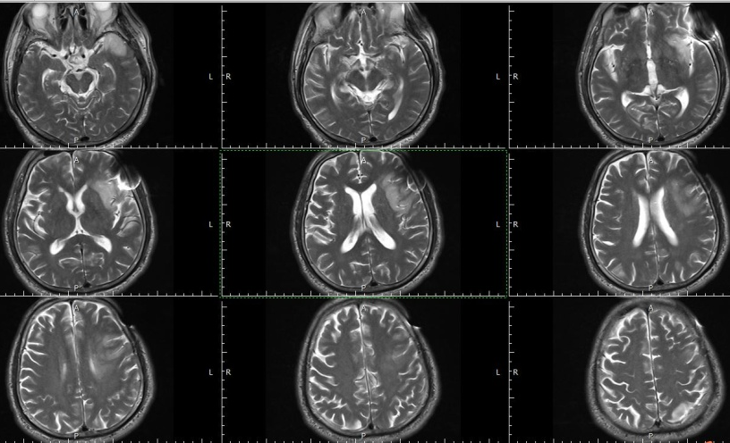
Figure 5 Brain magnetic resonance imaging shows small infarcts in the frontal and temporal lobes.

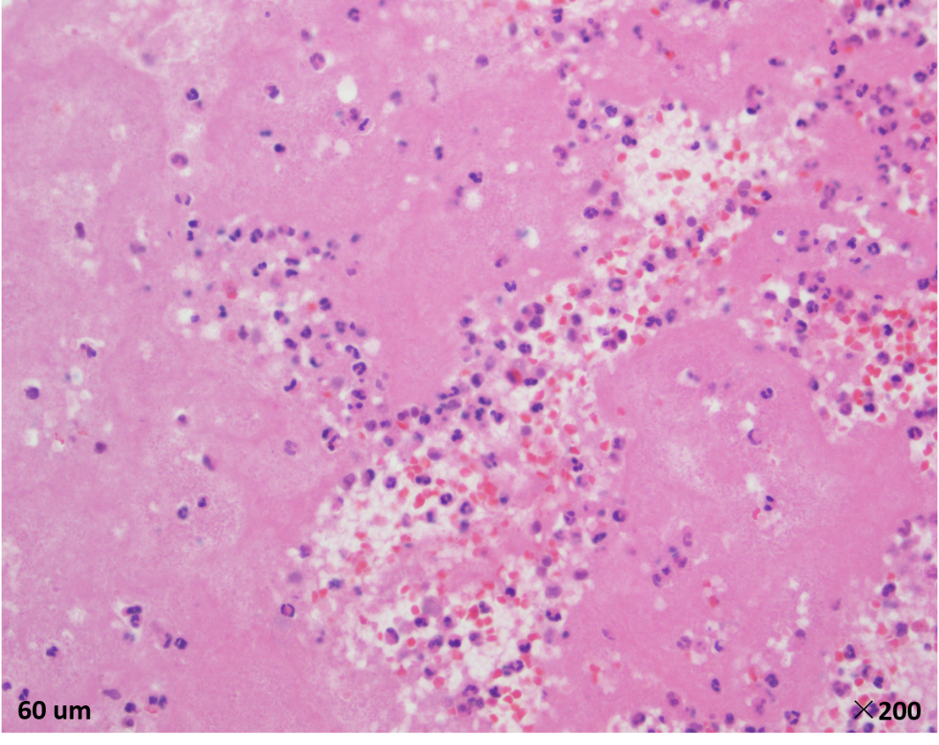
Figure 6 Pathological examination of the thrombus.

Table 1 Main characteristics of the patient
Clinical information
Age (yr) | 70
Chief complaint | Sudden inability to speak;  inability to move his right limb for 3 h
History of present illness | Atrial fibrillation history for more than 1 yr
Physical examination | Drowsiness and completely mixed aphasia;  Right limb was not movable
Electrocardiogram examination | Atrial fibrillation
CTA | Embolisms in the left carotid bifurcation and left middle cerebral artery
CT | A small infarct in the left insular lobe
NIHSS | 23
CTA: Computed tomography angiography; CT: Computed tomography; NHISS: Neurologic severity scores.

