Name of Journal: World Journal of Neurology
Manuscript NO: 79884
Manuscript Type: CASE REPORT

Possible convulsion and electroencephalographic abnormality in a patient taking long-term oral clarithromycin: A case report

Shiraishi W. Convulsion caused by clarithromycin

Wataru Shiraishi

Wataru Shiraishi, Department of Neurology, Kokura Memorial Hospital, Kitakyushu 802-8555, Fukuoka, Japan

Author contributions: Shiraishi W contributed to data collection, writing, and editing of the manuscript.

Corresponding author: Wataru Shiraishi, MD, PhD, Deputy Director, Doctor, Department of Neurology, Kokura Memorial Hospital, 3-2-1 Asano, Kokurakita-ku, Kitakyushu 802-8555, Fukuoka, Japan. whitestone_db5@yahoo.co.jp

Received: September 10, 2022
Revised: October 25, 2022
Accepted: October 31, 2022
Published online:

Abstract
BACKGROUND
Clarithromycin is a macrolide antibiotic commonly prescribed to patients with upper respiratory and otolaryngological infections. Neuropsychiatric adverse effects of clarithromycin include agitation, insomnia, delirium, psychosis, and seizure.

CASE SUMMARY
A 52-year-old man was admitted to our hospital with a convulsion. He had > 10-year history of clarithromycin intake for chronic sinusitis. One week before admission, he started to take diltiazem for angina pectoris. On admission, his convulsion subsided. His electroencephalography showed frontal intermittent rhythmic delta activity. One week after he ceased clarithromycin, his electroencephalographic abnormalities disappeared. We suggested that the patient developed convulsions due to increased blood levels of clarithromycin caused by oral administration of diltiazem, which is involved in CYP3A metabolism.

CONCLUSION
Clarithromycin has a relatively high safety profile and is a frequently prescribed drug. However, there are a few previous reports of clarithromycin-related convulsive disorders. Clinicians should be aware of the drug interaction and rare side effects of seizures.

Key Words: Clarithromycin; Convulsion; QT interval prolongation; Seizures; Case report

Shiraishi W. Possible convulsion and electroencephalographic abnormality in a patient taking long-term oral clarithromycin: A case report. World J Neurol 2022; In press

Core Tip: Clarithromycin is a frequently used medication and has a long history of use. The rarity of reports of convulsions induced by clarithromycin suggests that the induction of convulsions by clarithromycin is a rare phenomenon or has been overlooked. Clarithromycin is a frequently prescribed drug but has many interactions. Therefore, we report this case as a cautionary statement for all neurologists. Also, the measurement of QT time may be a valuable method of assessing clarithromycin excess.

INTRODUCTION
Although many drugs are known to cause drug-induced seizures, there are very few reports of clarithromycin-induced seizures^{[1,2]}. Clarithromycin is a macrolide antibiotic that is used frequently for upper respiratory tract infections and otolaryngological infections and is considered to be safe^{[3]}. In this case report, we show a case of convulsions with electroencephalography (EEG) abnormalities in a patient who had been taking clarithromycin for over ten years. After the discontinuation of clarithromycin, the EEG abnormality disappeared, and there was no recurrence of convulsive seizures.
In this case, the QTc showed a prolonged tendency in the electrocardiography (ECG) during the convulsions, which may have reflected the excessive clarithromycin state. Thus, clarithromycin-induced epilepsy is sporadic, and we report this case based on a discussion of its pathophysiological mechanisms.

CASE PRESENTATION
Chief complaints
Seizure.

History of present illness
A 52-year-old Japanese male with no past history of seizure was admitted to our hospital with generalized tonic-clonic seizure.

History of past illness
A detailed interview revealed that the patient had been taking clarithromycin (400 mg/d) for > 10 years to treat chronic sinusitis and had recently added diltiazem (100 mg/d) for hypertension, as prescribed by his family doctor.

Personal and family history
Nothing particular.

Physical examination
On admission, his seizure subsided. His vital signs showed no remarkable abnormalities. He had bit his tongue, but no incontinence was observed. He was alert and showed no neurological deficits.

Laboratory examinations
Laboratory examination showed a mild increase of HbA1c (6.6%; normal, 4.6%-6.2%). Since it was a night emergency, the blood concentration of clarithromycin could not be measured. No other abnormalities, including electrolytes, serum creatine phosphokinase, and lactate, were observed. Electroencephalography (EEG) showed frequent frontal intermittent rhythmic delta activities (FIRDA) (Figure 1A). On ECG, his QTc interval was 448 milliseconds (Bazett's formula^{[4]}; normal, < 450 milliseconds^{[5]}).

Imaging examinations
Head computed tomography, and magnetic resonance imaging revealed no brain abnormalities.

FINAL DIAGNOSIS
We diagnosed clarithromycin-induced seizures and determined that antiepileptic drugs were unnecessary.

TREATMENT
The cessation of clarithromycin ameliorated the EEG abnormalities. Also, he experienced no seizures to date.

OUTCOME AND FOLLOW-UP
His EEG showed a normal pattern without FIRDA (Figure 1B), and his QTc interval was 385 milliseconds. Medications other than clarithromycin were continued. We diagnosed clarithromycin-induced seizures and determined that antiepileptic drugs were unnecessary.

CONCLUSION
Clarithromycin has often been reported to cause psychiatric symptoms such as delirium^{[6]} and manic episodes^{[7]}, suggesting that clarithromycin may sometimes show central nervous system side effects. However, the clarithromycin-induced seizure is quite rare, with few previous reports^{[1,2]}. Clarithromycin is reported to increase neuronal activity, stimulate CA3 pyramidal neurons of the hippocampus by reducing GABAergic signaling, and cause neuronal hyperexcitability^{[8]}. However, the detailed mechanism of these effects is unknown, and further study is needed. Long-term macrolide usage is common for bronchiectasis, chronic obstructive pulmonary disease, and chronic rhinosinusitis^{[3]}. Our patient had been prescribed clarithromycin for chronic sinusitis for > 10 years. Liver CYP3A4 has been reported to metabolize clarithromycin^{[2]}. In the present case, diltiazem was added as an antihypertensive just before the seizure. Diltiazem is also reported to inhibit CYP3A^{[9]}. Thus, in the present case, the introduction of diltiazem may have increased the blood concentration of clarithromycin. Administering azithromycin instead of clarithromycin may be an option. Clarithromycin also causes QT interval prolongation. Our case showed a QTc time of 448 milliseconds at admission, and after discontinuation of clarithromycin, his QTc time improved to 385 milliseconds. Measurement of QT time may be a valuable method of assessing clarithromycin excess. Clarithromycin is a frequently used medication and has a long history of use. The rarity of reports of convulsions induced by clarithromycin suggests that the induction of convulsions by clarithromycin is a rare phenomenon or has been overlooked. Clarithromycin is a frequently prescribed drug but has many interactions. Therefore, we report this case as a cautionary statement for all neurologists.

ACKNOWLEDGEMENTS
We thank all the neurophysiological department workers for obtaining excellent EEG and ECG.

REFERENCES
1 Wanleenuwat P, Suntharampillai N, Iwanowski P. Antibiotic-induced epileptic seizures: mechanisms of action and clinical considerations. Seizure 2020; 81: 167-174 [PMID: 32827980 DOI: 10.1016/j.seizure.2020.08.012]
2 Bandettini di Poggio M, Anfosso S, Audenino D, Primavera A. Clarithromycin-induced neurotoxicity in adults. J Clin Neurosci 2011; 18: 313-318 [PMID: 21269833 DOI: 10.1016/j.jocn.2010.08.014]
3 Smith D, Du Rand I, Addy CL, Collyns T, Hart SP, Mitchelmore PJ, Rahman NM, Saggu R. British Thoracic Society guideline for the use of long-term macrolides in adults with respiratory disease. Thorax 2020; 75: 370-404 [PMID: 32303621 DOI: 10.1136/thoraxjnl-2019-213929]
4 HC B. An Analysis of the Time-Relations of Electrocardiograms. Heart 1920: 353 [DOI: 10.1016/0002-8703(46)90430-9]
5 Schwartz PJ, Crotti L, Insolia R. Long-QT syndrome: from genetics to management. Circ Arrhythm Electrophysiol 2012; 5: 868-877 [PMID: 22895603 DOI: 10.1161/CIRCEP.111.962019]
6 Pejčić AV. Delirium associated with the use of macrolide antibiotics: a review. Int J Psychiatry Clin Pract 2022; 26: 29-42 [PMID: 33026877 DOI: 10.1080/13651501.2020.1828933]
7 Neufeld NH, Mohamed NS, Grujich N, Shulman K. Acute Neuropsychiatric Symptoms Associated With Antibiotic Treatment of Helicobacter Pylori Infections: A Review. J Psychiatr Pract 2017; 23: 25-35 [PMID: 28072642 DOI: 10.1097/PRA.0000000000000205]
8 Bichler EK, Elder CC, García PS. Clarithromycin increases neuronal excitability in CA3 pyramidal neurons through a reduction in GABAergic signaling. J Neurophysiol 2017; 117: 93-103 [PMID: 27733592 DOI: 10.1152/jn.00134.2016]
9 Renton KW. Inhibition of hepatic microsomal drug metabolism by the calcium channel blockers diltiazem and verapamil. Biochem Pharmacol 1985; 34: 2549-2553 [PMID: 4015695 DOI: 10.1016/0006-2952(85)90541-6]

Footnotes
Informed consent statement: Informed consent was obtained from the patient for publication of this case.

Conflict-of-interest statement: All the authors declare no conflict of interest.

CARE Checklist (2016) statement: The authors have read the CARE Checklist (2016), and the manuscript was prepared and revised according to the CARE Checklist (2016).

Open-Access: This article is an open-access article that was selected by an in-house editor and fully peer-reviewed by external reviewers. It is distributed in accordance with the Creative Commons Attribution NonCommercial (CC BY-NC 4.0) license, which permits others to distribute, remix, adapt, build upon this work non-commercially, and license their derivative works on different terms, provided the original work is properly cited and the use is non-commercial. See: https://creativecommons.org/Licenses/by-nc/4.0/

Provenance and peer review: Unsolicited article; Externally peer reviewed.
Peer-review model: Single blind

Peer-review started: September 10, 2022
First decision: October 24, 2022
Article in press:

Specialty type: Neurosciences
Country/Territory of origin: Japan
Peer-review report’s scientific quality classification
Grade A (Excellent): 0
Grade B (Very good): B, B
Grade C (Good): 0
Grade D (Fair): 0
Grade E (Poor): 0

P-Reviewer: Bello AK, Nigeria; Liao JX, China S-Editor: Liu JH L-Editor: A P-Editor: Liu JH
Figure Legends
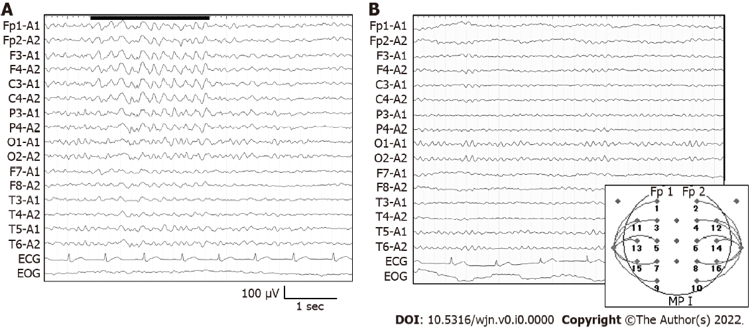
Figure 1 Electroencephalography on admission and on day 7. A: Frontal intermittent rhythmic delta activities (FIRDA) were detected on admission; B: Electroencephalography at 7 d after the cessation of clarithromycin. FIRDA has disappeared and 10 Hz alpha waves were observed.

