Name of Journal: World Journal of Clinical Cases
Manuscript NO: 42843
Manuscript Type: CASE REPORT

Metastatic low-grade endometrial stromal sarcoma with sex cord and smooth muscle differentiation: A case report

Zhu Q et al. Case report of endometrial sarcoma

Qi Zhu, Yan-Qin Sun, Xiao-Qing Di, Bing Huang, Jian Huang

Qi Zhu, Yan-Qin Sun, Xiao-Qing Di, Bing Huang, Jian Huang, Center of Pathology Diagnosis and Research, Affiliated Hospital of Guangdong Medical University, Zhanjiang 524023, Guangdong Province, China

Yan-Qin Sun, Xiao-Qing Di, Bing Huang, Jian Huang, Department of Pathology, Guangdong Medical University, Dongguan 523808, Guangdong Province, China

ORCID number: Qi Zhu (0000-0002-6959-4172); Yan-Qin Sun (0000-0002-0322-0100); Xiao-Qing Di (0000-0002-9606-4847); Bing Huang (0000-0001-5093-1290); Jian Huang (0000-0001-8117-1028).

Author contributions: Huang J found this rare case; Zhu Q and Di XQ performed the gross and histological examination; Huang B collected and analyzed the photos; Sun YQ and Huang J wrote, reviewed and revised the manuscript; Zhu Q and Sun YQ contributed equally to this work.

Informed consent statement: Consent was obtained from the patient.

Conflict-of-interest statement: The authors declare that they have no competing interests.

CARE Checklist (2013) statement: The manuscript was prepared and revised according to the CARE Checklist (2013).

Open-Access: This article is an open-access article which was selected by an in-house editor and fully peer-reviewed by external reviewers. It is distributed in accordance with the Creative Commons Attribution Non Commercial (CC BY-NC 4.0) license, which permits others to distribute, remix, adapt, build upon this work non-commercially, and license their derivative works on different terms, provided the original work is properly cited and the use is non-commercial. See: http://creativecommons.org/licenses/by-nc/4.0/

Manuscript source: Unsolicited manuscript

Corresponding author to: Jian Huang, MD, Academic Research, Chief Doctor, Center of Pathology Diagnosis and Research, Affiliated Hospital of Guangdong Medical University, No. 57 South of the People's Avenue, Xiashan District, Zhanjiang 524023, Guangdong Province, China. 18665763598@163.com
Telephone: +86-759-2386985

Received: October 12, 2018
Peer-review started: October 13, 2018
First decision: November 15, 2018
Revised: December 9, 2018
Accepted: December 12, 2018
Article in press:
Published online:

Abstract
BACKGROUNDS
Metastatic low-grade endometrial stromal sarcomas (LG-ESS) with sex cord-like and smooth muscle-like differentiation are rare. This article reports a case of a recurrent many times and with extensive pelvic and abdominal metastasis, and with the literature review.

CASE SUMMARY
In this report, a case of 47-year-old female patient was diagnosed as multiple cystic masses in the pelvic cavity by magnetic resonance imaging examination. Based on the postoperative pathological section and hematoxylin and eosin and immunohistochemical staining analysis of the surgical specimen, it was diagnosed as a metastatic low-grade endometrial stromal sarcoma with sex cord and smooth muscle differentiation.

CONCLUSION
LG-ESS is a low-grade malignant tumor with high recurrence rate and metastasis probability. Diagnosis for the first time is easily misdiagnosed. It is essential to distinguish LG-ESS with sex cord-like differentiation from uterine tumour resembling ovarian sex cord tumour.

Key words: Endometrial stromal sarcoma; Sex cord-like; Smooth muscle-like; Pathological changes; Immunohistochemistry; Case report

© The Author(s) 2018. Published by Baishideng Publishing Group Inc. All rights reserved.

Core tip: Endometrial stromal sarcomas are common tumours. Metastatic low-grade endometrial stromal sarcoma (LG-ESS) with sex cord and smooth muscle differentiation, however, is an extremely rare diagnosis. To date, only 2 cases have been reported in the literature. Histopathologic examination revealed a uterine leiomyoma within a pelvic mass. LG-ESS with sex cord-like differentiation should be distinguished from uterine tumors resembling ovarian sex cord tumors.

Zhu Q, Sun YQ, Di XQ, Huang B, Huang J. Metastatic low-grade endometrial stromal sarcoma with sex cord and smooth muscle differentiation: A case report. World J Clin Cases 2018; In press

INTRODUCTION
Endometrial stromal sarcoma (ESS) is a mesenchymal tumor, including low-grade ESS (LG-ESS), high-grade ESS (HG-ESS) and undifferentiated ESS (UESS). Uterine stromal sarcoma accounts for about 1% of the total uterine malignant tumors and 10% of the uterine sarcoma^{[1]}. However, LG-ESS with sex cord-like and smooth muscle-like tissue differentiation as well as extensive metastasis is rarely reported. Here, we reported such a case for the first time and review the relevant literature.

CASE PRESENTATION
Chief complaints
Abdominal distension without obvious cause, frequent urination, and urinary incontinence for 10 d.

History of present illness
Jan 14, 2018, a 47-year-old female patient came to our hospital for treatment due to "abdominal distension for 10 d and swelling of both lower limbs for 3 d". The ultrasound examination showed a huge hyperechoic light mass in the liver and the peritoneal multiple solidity placeholders. Then the patient was admitted to be in hospital as “primary liver cancer”.

History of past illness
A laparoscopic partial hysterectomy was performed in 2014 for uterine fibroids, with a pathological diagnosis of uterine leiomyoma. In 2011, a laparoscopic myomectomy was performed for uterine fibroids, with a pathological diagnosis of endometrial stroma and smooth muscle mixed tumor with sex cord-like differentiation.

Menstrual history
Regular menstrual cycle but more menstrual flow. The patient denied family history of genetic disease and history of cancer.

Physical examination
The patient's mental state, appetite, food intake, and sleeping status were good, and her body weight was 5 kg higher than it was before onset. The pelvic mass was clinically investigated, and the patient was admitted to the hospital for a malignant ovarian tumor.

Laboratory examination
Laboratory findings indicated that CA125: 189.5 U/mL, albumin: 29.5 g/L, alanine aminotransferase: 7.8 U/L, creatinine 50.0 μmol/L, indirect bilirubin: 3.3 μmol/L, direct bilirubin: 2.1 μmol/L, total bilirubin: 5.4 μmol/L, prothrombin time: 12.6 s, platelet volume distribution width: 9.6%.

Imaging examination
Ultrasound examination showed that, large hyperechoic light mass in the liver, multiple solid occupying in the abdominal cavity, as well as a large amount of fluid in the abdominal cavity. A magnetic resonance imaging examination revealed multiple cystic masses in the pelvic cavity of the middle and lower abdomen, with local fusion. A tumor of adnexal origin was strongly considered, as the tumor was pushing the adjacent organs and blood vessels, with a clear boundary. The uterus could not be seen, and the bilateral adnexa were unclear. Plain and enhanced computed tomography scanning revealed multiple masses of different sizes in the middle and lower abdominal-pelvic cavity, strongly suggesting malignant tumors originating from the reproductive organs. IVP showed the whole process of angiography showed no visualization of the right ureter and the lower segment of left ureter, no dilatation of the bilateral pelvis and calyx, and poor bladder filling.

Pathology examination
The specimen contained three solitary masses of 13-25 cm in diameter. The cut surface was grayish-white-yellow, with a tough texture and intact capsule, showing hemorrhaging and cystic changes (Figure 1A-C). A 3.5 cm segment of the small intestine contained a nodule on the cut surface between the muscle and serosal layers, with a 1.5 cm diameter, grayish-white color, and a tough texture (Figure 1D). A segment of the oviduct, 4 cm long and 0.5 cm in diameter, contained a nodule under the serosa of 1.5 cm in diameter, and the cut surface was gray with a tough texture (Figure 1E). A large mass of omentum tissue, with an area of 26 cm × 23 cm × 22 cm, showed several scattered nodules, with diameters of 1.5-2.5 cm, and a cut surface of grayish-white and grayish-yellow, with a tough texture (Figure 1F).
The specimens were fixed in 10% neutral formalin, processed, embedded in paraffin, routinely sectioned at a thickness of 4 μm, stained with hematoxylin and eosin, and observed and photographed under light microscopy. Microscopic observation of the (pelvic/abdominal) mass showed diffusely distributed tumor cells, in the shapes of cords or small islands in some areas, which were connected in a network. The tumor cells were uniformly sized and shaped like short spindles. The cells were benign, and mitotic figures were rare (< 3/10 HPF) (Figure 2A). The tumor tissue was rich in blood vessels, and some tumor cells were distributed in a vortex-like appearance around the blood vessels (Figure 2B). Many sex cord-like differentiated tumor cells were observed (Figure 2C), and some tumor cells were differentiated into smooth muscle cells (Figure 2D). The tumor cells showed "tongue-like" invasive growth (Figure 2E), and vascular invasion in the encapsulated portion was observed in some area (Figure 2F). Part of the stroma showed obvious hyaline degeneration, forming a starburst-like structure (Figure 2G), while foam cells and inflammatory cells were also observed (Figure 2H). Combined with the immunohistochemical analysis, the results were in line with low-grade endometrial stromal sarcoma with sex cord-like and smooth muscle-like differentiation (pelvic/abdominal cavity, small mesentery, and right oviduct). The microscopic morphologies of the small intestine, oviduct, and omental nodules were consistent with that of the pelvic/abdominal tumor (Figure 2I-J). The pathological sections from 2011 and 2014 were reviewed, and their pathological morphologies were consistent with that of the new one. The final pathological diagnosis was low-grade endometrial stromal sarcoma with sex cord-like and smooth muscle differentiation, with extensive metastasis in the sigmoid colon, oviduct, and omentum.
The tumor cells were CD10 diffuse (+) (Figure 3A), Vimentin (+), SMA (partial +) (Figure 3B), CD56 (partial +) (Figure 3C), CD99 (focal +) (Figure 3D), cyclinD1 (weak focal +), DOG-1 (partial +), CD34 (vessel +), ER (+++, 90%) (Figure 3E), and PR (+++, 90%) (Figure 3F), and the ki-67 index was approximately 3%. The results of the remaining immunohistochemistry tests were negative.

FINAL DIAGNOSIS
Metastatic low-grade endometrial stromal sarcoma with sex cord and smooth muscle differentiation.

TREATMENT
Jan 30, 2018, the patient was performed surgery involved small mesenteric tumor resection, partial sigmoid omentectomy, and left salpingectomy, with intraoperative observation of 400 mL intra-abdominal pale yellow ascites, the absence of a uterus, normal appearance of the left adnexa and right ovary, a nodule approximately 1.5 cm in diameter on the isthmus of the right oviduct, and multiple tumors in the small intestinal mesentery. The largest tumor was approximately 30 cm × 25 cm × 20 cm, the diameters of the other two tumors were 15 and 13 cm, and the nodule at the sigmoid colon was 3 cm × 2 cm × 2 cm. Different sized nodules were scattered throughout the omentum, pelvic cavity, and abdominal cavity, and the lesion diameters were 0.5-3 cm. Then patient was performed anti-infection treatment with antibiotics, potassium chloride rehydration, as well as infusion of albumin to correct hypoproteinemia, postoperative recovery is acceptable, but the patient was followed up without further treatment.

OUTCOME AND FOLLOW-UP
A recent regular follow-up was carried by telephone, and the patient was recuperated at home without any abnormality.

DISCUSSION
Per the new World Health Organization classification for female genital tumors (4th edition, 2014), endometrial stroma and related tumors are divided into five types: endometrial stromal nodules, LG-ESS, HG-ESS, UESS, and uterine tumors resembling ovarian sex cord tumors (UTROSCTs)^{[1]}. LG-ESS is a rare uterine tumor that accounts for 0.2% of gynecologic malignancies.
LG-ESS tumors are generally 1-25 cm, with an average of 8-11 cm in size. The tumors are mostly nodular, and the cut surface is grayish-white or brownish-yellow, with cystic changes in some cases. Microscopically, the tumor cells are elliptical to short fusiform, with less cytoplasm, similar to the interstitial cells of the proliferative endometrium, and the tumor cells can be arranged around the small spiral arteries. LG-ESS has low cellular atypia, and mitosis is rare. The tumor cells invade the myometrium in a tongue-like pattern, often accompanied by vascular invasion. Tumor stromal cells can differentiate into various tissues, such as ovarian cord, smooth muscle, and glandular tissue. Foam cells can be observed in the lesions, and hyaline degeneration and mucoid changes often occur in the matrix^{[1]}. In addition to the basic pathomorphological characteristics of LG-ESS described above, the case reported here was accompanied by extensive sex cord-like and smooth muscle differentiation in the ovary. Immunohistochemical CD10 was positive in all regions, including the regions with sex cord-like and smooth muscle differentiation, indicating that these cells were derived from the endometrial stromal cells, which is consistent with LG-ESS^{[2]}. In the region with ovarian sex cord-like tumor cell differentiation, CD56 was positive, and CD99 was focal positive, while all other antibodies, including inhibin, calretinin, and Melan-A, were negative, suggesting that the tumor cells in this ovarian sex cord-like differentiated region were immature, and the characteristics of ovarian mature sex cord-like cells were not fully expressed. Although some tumor cells were morphologically characterized as having cord-like differentiation in trabecular, cord, nested, or small tubular structural arrangements, no Leydig cells or Sertoli cell-like tubular sex cord-like structures were observed. Studying cases with LG-ESS-associated sex cord-like differentiation revealed that the available literature included mainly case reports, with no systematic research^{[3-7]}. Regarding how to assess the sex cord-like differentiation in LG-ESS, we believe that in addition to the presence of the sex cord-like differentiated structures, including the trabecular, cord, or small tubular structures in the LG-ESS background, immunohistochemical assays are conducive to making assessments. Inhibin, calretinin, Melan-A, CD99, and CD56 are marker antigens for sex cord-like differentiation, and their positive expression suggests sex cord-like differentiation^{[1]}. However, not all these antigens are positive, and in most cases, only some of these antigens are expressed. CD56 is generally expressed only in the region with sex cord-like differentiation, while CD10 is usually expressed weakly in this region. For the case reported here, CD56 and CD99 were expressed in the sex cord-like differentiated region, while inhibin, calretinin, and Melan-A were negative.
LG-ESS with sex cord-like differentiation should be distinguished from UTROSCTs. The concept of UTROSCTs was first proposed by Clement et al^{[6]} in 1976. When sex cord-like elements are found in LG-ESS, they are also called endometrial stromal tumors with sex cord-like elements (ESTSCLEs). Morphologically, ESTSCLEs and UTROSCTs are greatly overlapped, and distinguishing them is difficult. Generally, for ESTSCLEs, the proportion of sex-like elements is low (no more than 10%), CD10 is strongly positive, and some ovarian sex cord tumor marker antigens are expressed such as inhibin, calretinin, Melan-A, CD99, and CD56. In UTROSCTs, the sex cord-like elements must be greater than 50%, the differentiation should be relatively mature, and the positive marker antigen expression rate in ovarian cord tumors should be high. Molecular detection is also conducive to making this distinction. ESTSCLEs are prone to t(7;17) (p15;q21) JAZF1-SUZ12 (JJAZ1) gene fusion, while UTROSCTs have no JAZF1-SUZ12 gene fusion^{[1]}. Distinguishing ESTSCLEs from UTROSCTs is clinically significant. ESTSCLEs are a concomitant malignancy of LG-ESS, while UTROSCTs have low-grade malignancy potential, and most UTROSCTs are benign in clinical practice. Younger women can undergo hysterectomies with ovarian preservation^{[8]}.
In addition to sex cord-like differentiation, LG-ESS may also be associated with other tissue differentiation such as smooth muscle. Interestingly, in the case reported here, the regions with sex cord-like and smooth muscle-like differentiation were greatly overlapped. Whether this suggests that these two differentiated tissues are derived from the same progenitor cells requires further study. LG-ESS can occur in many areas outside the uterus, such as the ovaries, small intestine, pelvic cavity, abdominal cavity, retroperitoneum, vagina, bladder, and lymph nodes. Their morphologies are the same as those in LG-ESS of uterine origin, which often causes difficulty in the initial pathological diagnosis, and the initial diagnosis is correct in only 50% of cases^{[9]}. LG-ESS occurring outside the uterus may be associated with endometriosis. In the initial diagnosis, a comprehensive assessment should be made carefully by reviewing the morphology, immunohistochemical expression, molecular pathology, and clinical history. Our case is one of recurrence and metastasis, previously diagnosed as endometrial stroma and smooth muscle mixed tumor with sex cord-like differentiation and uterine leiomyoma. The morphologies of the previous two diagnoses were the same as that of the new one. Therefore, when LG-ESS is associated with a heterogeneous component such as sex cord-like and smooth muscle-like differentiation, it must be distinguished from other tumor types in the diagnosis. Most importantly, immunohistochemistry application should be highlighted in such cases in order to abolish misleading diagnosis and subsequent clinical decisions in favor of the patient. Clinically, LG-ESS is generally indolent, and total hysterectomy is currently the main treatment.

CONCLUSION
LG-ESS is a low-grade malignant tumor with high recurrence rate and metastasis probability. Diagnosis for the first time is easily misdiagnosed. It is essential to distinguish LG-ESS with sex cord-like differentiation from uterine tumour resembling ovarian sex cord tumour.

REFERENCES
1 Kurman RJ, Carcangiu ML, Herrington CS, Young RH. WHO Classilication of Tumours of Female Reproductive Organs. 4th ed. Lyon: International Agency for Research on Cancer, 2014: 141-145
2 McCluggage WG, Sumathi VP, Maxwell P. CD10 is a sensitive and diagnostically useful immunohistochemical marker of normal endometrial stroma and of endometrial stromal neoplasms. Histopathology 2001; 39: 273-278 [PMID: 11532038 DOI: 10.1046/j.1365-2559.2001.01215.x]
3 Richmond AM, Rohrer AJ, Davidson SA, Post MD. Low-grade endometrial stromal sarcoma with extensive sex cord differentiation, heterologous elements, and complex atypical hyperplasia: Case report and review of literature. Gynecol Oncol Rep 2016; 19: 34-38 [PMID: 28054022 DOI: 10.1016/j.gore.2016.12.002]
4 Yenicesu O, Tokmak A, Sirvan AL, Danisman N, Güngör T. Low-grade endometrial stromal sarcoma combined with leiomyoma (stromomyoma): A bizarre tumor of the uterus in a premenopausal woman. J Exp Ther Oncol 2018; 12: 281-286 [PMID: 30476382]
5 Sato S, Ojima Y, Kanda M, Kizaki T, Ohara N. Endometrial Stromal Sarcoma Arising from Endometrial Polyp: A Case Report. Kobe J Med Sci 2018; 64: E36-E42 [PMID: 30381725]
6 Clement PB, Scully RE. Uterine tumors resembling ovarian sex-cord tumors. A clinicopathologic analysis of fourteen cases. Am J Clin Pathol 1976; 66: 512-525 [PMID: 961630 DOI: 10.1093/ajcp/66.3.512]
7 Kurman RJ, Ellenson LH, Ronnett BM, editors. Blaustein’s Pathology of the Female Genital Tract. New York: Springer US, 2011
8 Schraag SM, Caduff R, Dedes KJ, Fink D, Schmidt AM. Uterine Tumors Resembling Ovarian Sex Cord Tumors - Treatment, recurrence, pregnancy and brief review. Gynecol Oncol Rep 2017; 19: 53-56 [PMID: 28119954 DOI: 10.1016/j.gore.2017.01.004]
9 Mukhopadhyay M, Das C, Parvin T, Basu K. Undifferentiated Uterine Sarcoma: An Uncommon Case Report. J Clin Diagn Res 2017; 11: ED03-ED04 [PMID: 28511398 DOI: 10.7860/JCDR/2017/24924.9370]
P-Reviewer: Bonanno E, Georgios P S-Editor: Wang JL L-Editor: E-Editor:

Specialty type: Medicine, research and experimental
Country of origin: China
Peer-review report classification
Grade A (Excellent): 0
Grade B (Very good): B
Grade C (Good): C
Grade D (Fair): 0
Grade E (Poor): 0
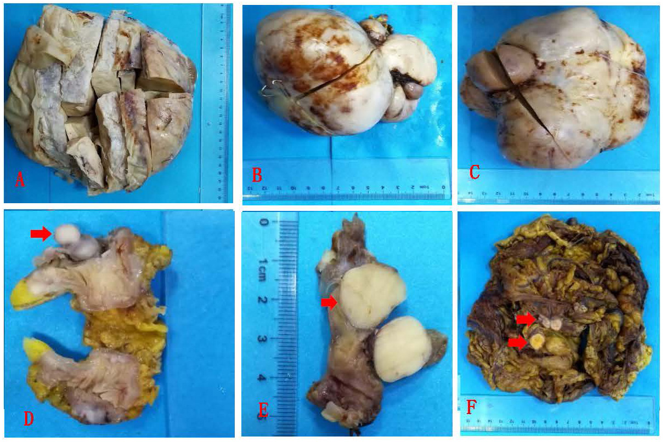

Figure 1 General view of low-grade endometrial stromal sarcoma. A: A pelvic mass with a maximum diameter of 25 cm; B: A mass from abdominal cavity with a maximum diameter of 13 cm; C: A mass from abdominal cavity with a maximum diameter of 15 cm; D: A mass from small intestine wall with a maximum diameter of 1.5 cm (arrow); E: A mass from uterine tube wall with a maximum diameter of 1.5 cm (arrow); F: Omentum tissues, several scattered nodules were shown with diameters of 1.5-2.5 cm (arrows).

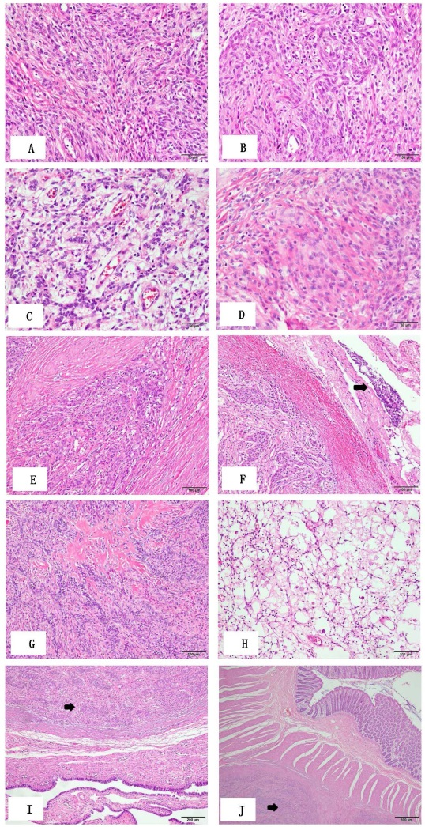
Figure 2 Primary microscopic morphological characteristics of low-grade endometrial stromal sarcoma. A: Tumor cells are diffusely distributed, uniformly sized, and short spindle-shaped; the cells are benign, and mitotic figures are rare (original magnification ×400); B: Tumor cells are swirled around the blood vessels (original magnification ×400); C: Sex cord-like differentiated tumor cells arranged in cords (original magnification ×400); D: Smooth muscle-like differentiated tumor cells (original magnification ×400); E: Tumor cells showing tongue-like invasive growth (original magnification ×400); F: Tumor cells invading the encapsulated vessel, indicated by the arrow (original magnification ×200); G: Stroma showing obvious hyaline degeneration, forming a starburst-like structure (original magnification ×200); H: Many foam cells and inflammatory cells were observed in some localized areas (original magnification ×200); I: The tumor invading the muscle wall of the oviduct, indicated by the arrow (original magnification ×100); J: The tumor invading the wall of the small intestine, indicated by the arrow (original magnification ×40).

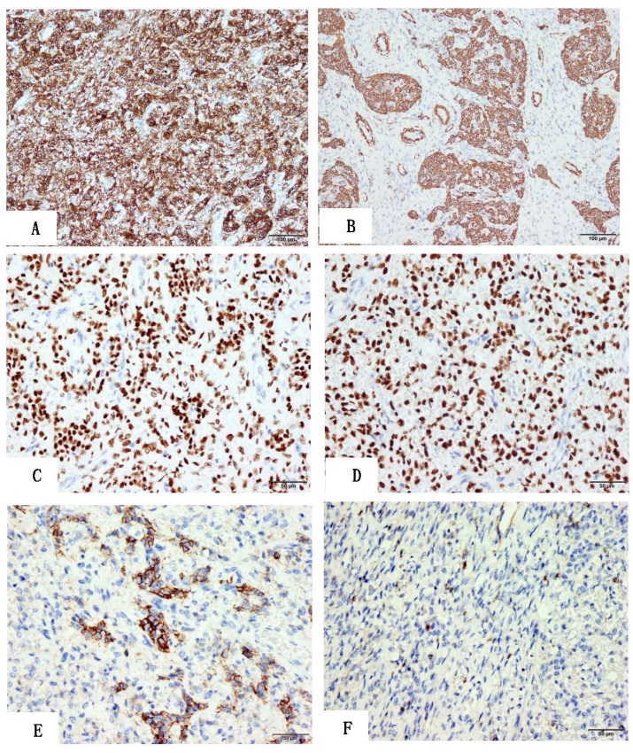
Figure 3 Main immunohistochemical staining results for low-grade endometrial stromal sarcoma. A: Tumor cells were strongly diffusely positive for CD10 (original magnification ×200); B: Tumor cells were partially positive for SMA (original magnification ×200); C: Tumor cells were partially positive for CD56 (original magnification ×200); D: Tumor cells were partially positive for CD99 (original magnification ×200); E: Tumor cells were diffusely positive for ER (>90%) (original magnification ×400); F: Tumor cells were diffusely positive for PR (>90%) (original magnification ×400).

