Name of Journal: World Journal of Clinical Cases
Manuscript NO: 65729
Manuscript Type: CASE REPORT

Successful management of delirium with dexmedetomidine in a patient with haloperidol-induced neuroleptic malignant syndrome: A case report

Yang CJ et al. Dexmedetomidine in neuroleptic malignant syndrome

Chi-Ju Yang, Ching-Tang Chiu, Yu-Chang Yeh, Anne Chao

Chi-Ju Yang, Department of Pharmacy, National Taiwan University Hospital, Taipei 100220, Taiwan

Ching-Tang Chiu, Yu-Chang Yeh, Anne Chao, Department of Anesthesiology, National Taiwan University Hospital, Taipei 100220, Taiwan

Author contributions: Yang CJ and Yeh YC wrote the manuscript; Chiu CT reviewed the literature; Chao A revised the manuscript; all authors were involved in writing the manuscript and approved the final manuscript.

Supported by: National Taiwan University Hospital Fund, No. MS 213.

Corresponding author: Anne Chao, MD, Doctor, Department of Anesthesiology, National Taiwan University Hospital, National Taiwan University, No. 7 Chung Shan South Road, Taipei 100220, Taiwan. chaoanne123@gmail.com

Received: March 24, 2021
Revised: November 4, 2021
Accepted: December 7, 2021
Published online:

Abstract
BACKGROUND
We report a case of lorazepam-induced agitated delirium treated with haloperidol, which in turn triggered the onset of neuroleptic malignant syndrome (NMS). The latter condition, a medical emergency, was effectively treated with medical treatment and dexmedetomidine, a versatile and highly selective short-acting alpha-2 adrenergic agonist with sedative-hypnotic and anxiolytic effects.

CASE SUMMARY
A 65-year-old man with a history of bipolar disorder presented to the emergency department with severe abdominal discomfort after binge eating. During his hospital stay, he received intravenous lorazepam for insomnia. On the next day, he became delirious and was thus treated with seven doses (5 mg each) of haloperidol over a 48 h period. Signs of NMS (hyperthermia, rigidity, myoclonus of upper limbs, impaired consciousness, tachypnea, and dark urine) became apparent and haloperidol was immediately suspended and brisk diuresis was initiated. On intensive care unit admission, he was confused, disoriented, and markedly agitated. Dexmedetomidine infusion was started with the goal of achieving a Richmond Agitation-Sedation Scale score of -1 or 0. NMS was resolved gradually and the patient stabilized, permitting discontinuation of dexmedetomidine after 3 d.

CONCLUSION
Dexmedetomidine may be clinically helpful for the management of NMS, most likely because of its sympatholytic activity.

Key Words: Haloperidol; Dexmedetomidine; Delirium; Neuroleptic malignant syndrome; Alpha-2 adrenergic agonists; Case report

Yang CJ, Chiu CT, Yeh YC, Chao A. Successful management of delirium with dexmedetomidine in a patient with haloperidol-induced neuroleptic malignant syndrome: A case report. World J Clin Cases 2021; 0(0): 0000-0000 URL: https://www.wjgnet.com/2307-8960/full/v0/i0/0000.htm DOI: https://dx.doi.org/10.12998/wjcc.v0.i0.0000

Core Tip: Neuroleptic malignant syndrome (NMS), a life-threatening condition characterized by hyperthermia, rigidity, altered mental status, and dysautonomia, can occur in 0.02%–3% of patients who receive haloperidol. Herein, we report a case of lorazepam-induced agitated delirium treated with haloperidol, which further triggered NMS. The NMS was effectively managed with medical therapy and dexmedetomidine, a versatile and highly selective short-acting alpha-2 adrenergic agonist with sedative-hypnotic and anxiolytic effects. Dexmedetomidine may be clinically helpful for the management of NMS because of its sympatholytic activity. In the presence of rapid shallow breathing, dexmedetomidine may provide better patient comfort with less respiratory depression than does propofol.

INTRODUCTION
Delirium, a transient, reversible organic mental syndrome characterized by disorganized thinking and altered consciousness, commonly occurs in acutely hospitalized elderly patients^{[1]}. Hospital-acquired delirium can be triggered by certain drugs administered upon admission or during the patient’s stay, including benzodiazepines^{[2]}. While haloperidol is a commonly accepted first-line treatment against agitated delirium^{[3]}, the risk of serious adverse events is not negligible. Among them, neuroleptic malignant syndrome (NMS), a life-threatening condition characterized by hyperthermia, severe muscle rigidity, altered mental status, and autonomic dysfunction, can occur in 0.02%–3% of all patients who receive haloperidol^{[4]}. The clinical management of NMS poses major challenges, but intensive care unit (ICU) medications are emerging as part of the therapeutic armamentarium^{[5]}.

Herein, we report a case of lorazepam-induced agitated delirium treated with haloperidol, which in turn triggered the onset of NMS. The latter condition, a medical emergency, was effectively managed with medical treatment and dexmedetomidine, a versatile and highly selective short-acting alpha-2 adrenergic agonist with sedative-hypnotic and anxiolytic effects^{[6]}. Because extreme sympathetic nervous system activation is involved in the pathophysiology of NMS^{[7]}, we hypothesized that dexmedetomidine may be clinically beneficial for managing this medical emergency because of its sympatholytic activity^{[8]}.

CASE PRESENTATION
Chief complaints
A 65-year-old man presented to the emergency department with severe abdominal discomfort after binge eating.

History of present illness
Because of food impaction, oral intake and medications were discontinued. However, lorazepam was administered intravenously to treat insomnia. The next day, the patient became delirious and was thus treated with seven doses (5 mg each) of haloperidol over a 48 h period. Unfortunately, he developed hyperthermia (body temperature: 40.6 °C) accompanied by tachypnea (respiratory rate: 40 breaths per min), tachycardia (heart rate: 128 beats per min), impaired consciousness, muscle rigidity, and dark urine. The serum creatine kinase (CK) levels were markedly increased (1910 U/L) (Figure 1), indicating rhabdomyolysis. NMS was diagnosed, and haloperidol was immediately stopped. Adequate hydration and body cooling were implemented; additionally, bromocriptine (2.5 mg/3 times daily) and transdermal patches containing rotigotine (2 mg/24 h) were applied to overcome the hypodopaminergic state. The patient was subsequently transferred to the ICU for intensive monitoring and treatment of NMS.

History of past illness
The patient’s medical history was notable for bipolar disorder, and his medications included trihexyphenidyl, quetiapine, flupentixol, and flunitrazepam.

Personal and family history
Bipolar disorder.

Physical examination
Upon initial evaluation, the patient’s temperature was 36 °C, the heart rate 102 beats per min, and the respiratory rate 20 breaths per min. A physical examination revealed abdominal tension.

Laboratory examinations
The laboratory findings upon ICU admission were as follows: CK, 21000 U/L; blood urea nitrogen, 29 mg/dL; creatinine, 1.4 mg/dL; potassium, 4.5 mEq/L; blood pH, 7.4; PCO₂, 31 mmHg; PO₂, 70 mmHg; HCO₃, 23 mEq/L; and base excess, -1.5 mmol/L.

Imaging examinations
Computed tomography revealed food impaction accompanied by bowel distension from the esophagus to the small intestine (Figure 2).

FINAL DIAGNOSIS
Lorazepam-induced delirium treated with haloperidol, which in turn triggered NMS.

TREATMENT
On ICU admission, the patient was confused and disoriented to time, space, situation, and persons. His Glasgow coma score (GCS) was 13 (Eye 4, Motor 5, and Verbal 4) and papillary light reflexes were bilaterally positive. Severe rigidity and myoclonus (especially in the upper extremities) were evident. Additionally, the patient was severely agitated (Richmond Agitation-Sedation Scale (RASS)^{[9]} score = 3), and made attempts at removing his intravenous catheter and nasogastric tube. In addition to continuation of medical management, dexmedetomidine infusion was started (initial rate: 0.2 µg/kg/h) with the goal of achieving a RASS score of -1 or 0. Owing to persistent agitation (accompanied by shouting and attempts to remove restraints), dexmedetomidine dosing was further increased to 0.5 µg/kg/h. Gradual resolution of muscle rigidity, myoclonus, and agitation was observed over the next day (GCS score: 14). Thus, the dosage of dexmedetomidine was lowered to 0.3 µg/kg/h. The family’s presence at the patient’s bed side was encouraged. Containment measures were removed and the dexmedetomidine dosing was further reduced. Full cooperation was achieved 72 h after the initial infusion of dexmedetomidine, which was thus discontinued. After full regression of rhabdomyolysis and rigidity, the patient was transferred to the general ward for further care. Figure 3 depicts the timeline of the main clinical events.

OUTCOME AND FOLLOW-UP
The patient did not present additional episodes of delirium and was successfully discharged 18 d after admission. He is currently undergoing regular follow-up at our psychiatric clinic.

DISCUSSION
We describe a complex case of lorazepam-induced delirium occurring in an elderly hospitalized patient who was admitted for food impaction. Treatment of delirium with haloperidol precipitated the onset of NMS, an uncommon, yet life-threatening, complication of antipsychotics. Early diagnosis and removal of precipitating agents are very important in the management of NMS. NMS was managed with dexmedetomidine, an ICU drug, which successfully corrected autonomic instability. Clinical improvement was observed within a few days and the patient was successfully discharged 18 d after admission. Our case provides an illustrative example of how polypharmacotherapy in acutely hospitalized elderly patients can give rise to medical emergencies requiring ICU care.

Benzodiazepines are a common cause of drug-induced delirium. In the elderly, because of the decreased renal clearance and other age-related pharmacodynamic and pharmacokinetic changes, these drugs can accumulate and cause toxicity and delirium^{[10]}. Our patient became delirious after in-hospital administration of lorazepam for insomnia. Although the mechanisms of benzodiazepine-induced delirium are not well defined, neurotransmitter imbalances with excess brain dopaminergic activity are common in delirious patients^{[10,11]}. Importantly, while medications can induce delirium, they may also be used to manage its symptoms^{[10]}. Owing to their antidopaminergic effects, typical antipsychotics like haloperidol are commonly used in managing delirium^{[3]}. As in our patient, haloperidol can be given at multiple doses (2–5 mg every 15–30 min) until clinical improvement is achieved^{[12]}. However, the use of haloperidol for managing delirium in our case precipitated the onset of NMS, possibly as a result of excess dopamine D₂ receptor blockade in the hypothalamic, nigrostriatal, mesolimbic, and mesocortical pathways^{[13]}.

Once NMS is diagnosed, ICU drugs like dexmedetomidine or propofol are potentially effective management options^{[14,15]}. Because extreme sympathetic nervous system activation is involved in the pathophysiology of NMS^{[7]}, we reasoned that dexmedetomidine may be helpful in the management of this medical emergency because of its sympatholytic activity^{[8]}. In the presence of rapid shallow breathing as in our case, dexmedetomidine may also provide better patient comfort with less respiratory depression than does propofol^{[16]}. Importantly, dexmedetomidine also suppresses the spontaneous firing rate of locus coeruleus neurons and decreases heat generation by alpha-2 adrenergic receptor blockade in the hypothalamus^{[17]}. Hence, it can successfully correct the profound thermogenesis and hypermetabolism typical of NMS as it did in our patient. While recommendations for specific treatments in NMS continue to be based on small-sized studies and clinical experience, this case serves as a useful reminder to clinicians to consider dexmedetomidine as part of the current therapeutic armamentarium.

CONCLUSION
Dexmedetomidine may be clinically beneficial for managing NMS because of its sympatholytic activity and its capacity to reduce heat generation. In the presence of rapid shallow breathing, dexmedetomidine may also provide better patient comfort with less respiratory depression than does propofol.

REFERENCES
1 Rieck KM, Pagali S, Miller DM. Delirium in hospitalized older adults. Hosp Pract (1995) 2020; 48: 3-16 [PMID: 31874064 DOI: 10.1080/21548331.2019.1709359]
2 Collier R. Hospital-induced delirium hits hard. CMAJ 2012; 184: 23-24 [PMID: 22158403 DOI: 10.1503/cmaj.109-4069]
3 Shen YZ, Peng K, Zhang J, Meng XW, Ji FH. Effects of Haloperidol on Delirium in Adult Patients: A Systematic Review and Meta-Analysis. Med Princ Pract 2018; 27: 250-259 [PMID: 29518791 DOI: 10.1159/000488243]
4 Pileggi DJ, Cook AM. Neuroleptic Malignant Syndrome. Ann Pharmacother 2016; 50: 973-981 [PMID: 27423483 DOI: 10.1177/1060028016657553]
5 Ware MR, Feller DB, Hall KL. Neuroleptic Malignant Syndrome: Diagnosis and Management. Prim Care Companion CNS Disord 2018; 20: 0-0 [PMID: 29325237 DOI: 10.4088/PCC.17r02185]
6 Weerink MAS, Struys MMRF, Hannivoort LN, Barends CRM, Absalom AR, Colin P. Clinical Pharmacokinetics and Pharmacodynamics of Dexmedetomidine. Clin Pharmacokinet 2017; 56: 893-913 [PMID: 28105598 DOI: 10.1007/s40262-017-0507-7]
7 Gurrera RJ. Sympathoadrenal hyperactivity and the etiology of neuroleptic malignant syndrome. Am J Psychiatry 1999; 156: 169-180 [PMID: 9989551 DOI: 10.1176/ajp.156.2.169]
8 Gertler R, Brown HC, Mitchell DH, Silvius EN. Dexmedetomidine: a novel sedative-analgesic agent. Proc (Bayl Univ Med Cent) 2001; 14: 13-21 [PMID: 16369581 DOI: 10.1080/08998280.2001.11927725]
9 Sessler CN, Gosnell MS, Grap MJ, Brophy GM, O'Neal PV, Keane KA, Tesoro EP, Elswick RK. The Richmond Agitation-Sedation Scale: validity and reliability in adult intensive care unit patients. Am J Respir Crit Care Med 2002; 166: 1338-1344 [PMID: 12421743 DOI: 10.1164/rccm.2107138]
10 Alagiakrishnan K, Wiens CA. An approach to drug induced delirium in the elderly. Postgrad Med J 2004; 80: 388-393 [PMID: 15254302 DOI: 10.1136/pgmj.2003.017236]
11 Ali S, Patel M, Jabeen S, Bailey RK, Patel T, Shahid M, Riley WJ, Arain A. Insight into delirium. Innov Clin Neurosci 2011; 8: 25-34 [PMID: 22132368]
12 Wang EH, Mabasa VH, Loh GW, Ensom MH. Haloperidol dosing strategies in the treatment of delirium in the critically ill. Neurocrit Care 2012; 16: 170-183 [PMID: 22038577 DOI: 10.1007/s12028-011-9643-3]
13 Berman BD. Neuroleptic malignant syndrome: a review for neurohospitalists. Neurohospitalist 2011; 1: 41-47 [PMID: 23983836 DOI: 10.1177/1941875210386491]
14 Yu C, Kaul R, Ostwani W. Dexmedetomidine infusion as a novel supportive therapy for fluphenazine-induced neuroleptic malignant syndrome in a 10-year-old boy: a case report and review of literature. J Pediatr Neurol 2020; [DOI:10.1055/s-0040-1721380]
15 Sakamoto A, Hoshino T, Suzuki H, Kimura M, Ogawa R. Repeated propofol anesthesia for a patient with a history of neuroleptic malignant syndrome. Nihon Ika Daigaku Zasshi 1999; 66: 262-265 [PMID: 10466342 DOI: 10.1272/jnms.66.262]
16 Tomar GS, Singh F, Ganguly S, Gaur N. Is dexmedetomidine better than propofol and fentanyl combination in minor day care procedures? A prospective randomised double-blind study. Indian J Anaesth 2015; 59: 359-364 [PMID: 26195832 DOI: 10.4103/0019-5049.158740]
17 Bajwa SJ, Gupta S, Kaur J, Singh A, Parmar S. Reduction in the incidence of shivering with perioperative dexmedetomidine: A randomized prospective study. J Anaesthesiol Clin Pharmacol 2012; 28: 86-91 [PMID: 22345953 DOI: 10.4103/0970-9185.92452]

Footnotes
Informed consent statement: Informed written consent was obtained from the patient for publication of this report and any accompanying images.

Conflict-of-interest statement: The authors declare that they have no conflict of interest to disclose.

CARE Checklist (2016) statement: The authors have read the CARE Checklist (2016), and the manuscript was prepared and revised according to the CARE Checklist (2016).

Open-Access: This article is an open-access article that was selected by an in-house editor and fully peer-reviewed by external reviewers. It is distributed in accordance with the Creative Commons Attribution NonCommercial (CC BY-NC 4.0) license, which permits others to distribute, remix, adapt, build upon this work non-commercially, and license their derivative works on different terms, provided the original work is properly cited and the use is non-commercial. See: https://creativecommons.org/Licenses/by-nc/4.0/

Provenance and peer review: Unsolicited article; Externally peer reviewed.

Peer-review started: March 24, 2021
First decision: October 16, 2021
Article in press:

Specialty type: Critical care medicine
Country/Territory of origin: Taiwan
Peer-review report’s scientific quality classification
Grade A (Excellent): 0
Grade B (Very good): B
Grade C (Good): C
Grade D (Fair): 0
Grade E (Poor): 0

P-Reviewer: Arslan M, Song J S-Editor: Wang JL L-Editor: Wang TQ P-Editor: Wang JL
Figure Legends
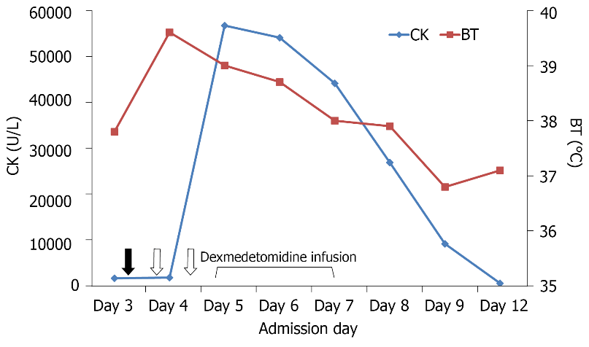
Figure 1 Time course of haloperidol administration (Black arrow: 15 mg; white arrow: 10 mg) and dexmedetomidine infusion in relation to changes in BT and serum CK levels. BT: Body temperature; CK: Creatine kinase.

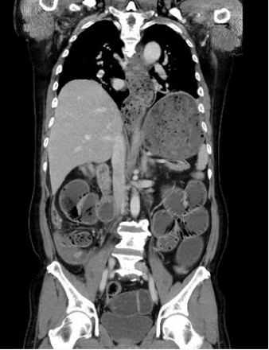
Figure 2 Abdominal computed tomography findings. Digestive tract distension was shown from the esophagus to the small bowel.

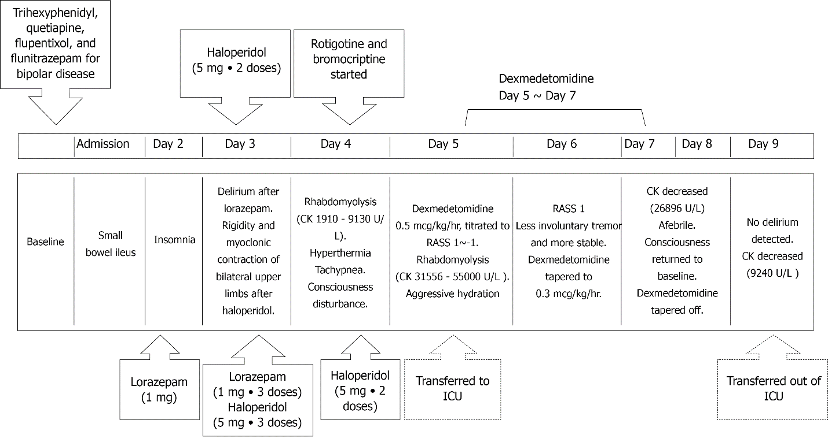
Figure 3 Timeline depicting the onset of lorazepam-induced delirium followed by the development of neuroleptic malignant syndrome. CK: Creatine kinase; RASS: Richmond agitation-sedation scale; ICU: Intensive care unit.

