Name of Journal: World Journal of Clinical Cases
Manuscript NO: 70688
Manuscript Type: ORIGINAL ARTICLE

Retrospective Cohort Study
Computed tomography perfusion imaging evaluation of angiogenesis in patients with pancreatic adenocarcinoma

Liu W et al. CT perfusion imaging evaluation of angiogenesis

Wen Liu, Bo Yin, Zong-Hui Liang, Yang Yu, Na Lu

Wen Liu, Department of Radiology, Jinshan Hospital, Fudan University, Shanghai 201508, China

Bo Yin, Yang Yu, Na Lu, Department of Radiology, Huashan Hospital, Fudan University, Shanghai 200000, China

Bo Yin, Na Lu, Department of Radiology, Huashan Hospital North, Fudan University, Shanghai 200000, China

Zong-Hui Liang, Department of Radiology, Shanghai Jing’an District Central Hospital, Huashan Hospital Jing’an Branch, Fudan University, Shanghai 200000, China

Author contributions: Liu W drafted the manuscript and assisted with data analysis; Yin B and Yu Y participated in the design and oversight of the study, and were involved in data collection; Lu N participated in the design of the study and assisted with data analysis; Liang ZH was involved in data collection and assisted with data analysis; all authors have read and approved the final manuscript.

Supported by the National Science Foundation of China, No. 81701686; the Science and Technology Commission of Shanghai Municipality, No. 134119b1600; and the Shanghai Natural Science Foundation, No. 18ZR1405700.

Corresponding author: Na Lu, Department of Radiology, Huashan Hospital, Fudan University, No. 12 Wulumuqi Middle Road, Jing’an District, Shanghai 200000, China. drluna@126.com

Received: August 14, 2021
Revised: October 30, 2021
Accepted: February 16, 2022
Published online: March 16, 2022

Abstract
BACKGROUND
Pancreatic adenocarcinoma is one of the most common malignant tumors of the digestive system. More than 80% of patients with pancreatic adenocarcinoma are not diagnosed until late stage and have distant or local metastases.

AIM
To investigate the value of computed tomography (CT) perfusion imaging in the evaluation of angiogenesis in pancreatic adenocarcinoma patients.

METHODS
This is a retrospective cohort study. Patients with pancreatic adenocarcinoma and volunteers without pancreatic diseases underwent CT perfusion imaging from December 2014 to August 2017 in Huashan Hospital, Fudan University Shanghai, China.

RESULTS
A total number of 35 pancreatic adenocarcinoma patients and 33 volunteers were enrolled. The relative blood flow (rBF), and relative blood volume (rBV) were significantly lower in patients with pancreatic adenocarcinoma than in the control group (P < 0.05). Conversely, the relative permeability in patients with pancreatic adenocarcinoma was significantly higher than that in controls (P < 0.05). In addition, rBF, rBV, and the vascular maturity index (VMI) were significantly lower in grade III-IV pancreatic adenocarcinoma than in grade I-II pancreatic adenocarcinoma (P < 0.05). Vascular endothelial growth factor (VEGF), CD105-MVD, CD34-MVD, and angiogenesis rate (AR) were significantly higher in grade III-IV pancreatic adenocarcinoma than in grade I-II pancreatic adenocarcinoma (P < 0.05). Significant correlations between rBF and VEGF, CD105-MVD, AR, and VMI (P < 0.01) were observed. Moreover, the levels of rBV were statistically significantly correlated with those of VEGF, CD105-MVD, CD34-MVD, and VMI (P < 0.01).

CONCLUSION
Perfusion CT imaging may be an appropriate approach for quantitative assessment of tumor angiogenesis in pancreatic adenocarcinoma.

Key Words: Pancreatic adenocarcinoma; Perfusion computed tomography; Angiogenesis; Evaluation; Imaging; Quantitative assessment

©The Author(s) 2022. Published by Baishideng Publishing Group Inc. All rights reserved.

Citation: Liu W, Yin B, Liang ZH, Yu Y, Lu N. Computed tomography perfusion imaging evaluation of angiogenesis in patients with pancreatic adenocarcinoma. World J Clin Cases 2022; 10(8): 2393-2403
URL: https://www.wjgnet.com/2307-8960/full/v10/i8/2393.htm
DOI: https://dx.doi.org/10.12998/wjcc.v10.i8.2393

Core Tip: A total of 35 pancreatic adenocarcinoma patients and 33 volunteers were enrolled in the study. The relative blood flow, relative blood volume, and relative peak enhancement were significantly lower in patients with pancreatic adenocarcinoma than in the control group (P < 0.05). Conversely, the relative permeability in patients with pancreatic adenocarcinoma was significantly higher than that in controls (P < 0.05).

INTRODUCTION
Pancreatic adenocarcinoma is one of the most common malignant tumors of the digestive system. The prognosis of pancreatic adenocarcinoma is poor, with 5-year survival rates lower than 5%^{[1]}. Importantly, more than 80% of patients with pancreatic adenocarcinoma are not diagnosed until late stage and have distant or local metastases^{[1,2]}. Therefore, early detection of pancreatic adenocarcinoma is critical for improving prognosis outcomes.
Accumulating evidence indicates that vascularity is crucially involved in the tumorigenesis and drug responsiveness of pancreatic adenocarcinoma^{[3,4]}. Thus, the evaluation of angiogenesis in pancreatic adenocarcinoma is of considerable significance for the diagnosis, treatment, and prognosis^{[5-8]}. Computed tomography (CT) perfusion imaging provides information on tissue hemodynamics, which facilitates the more effective characterization and identification of pancreatic adenocarcinoma^{[9-11]}. For instance, perfusion CT imaging has been widely applied in brain tumors, and the perfusion parameters have been proven to be of great significance in brain disease diagnosis^{[12-15]}. However, relative perfusion parameters in pancreatic adenocarcinoma diagnosis have not yet been reported.
Therefore, in the present study, we performed perfusion CT imaging to explore the correlations between CT perfusion parameters and immunohistochemical angiogenesis indices, and their application for evaluating their diagnostic value in pancreatic adenocarcinoma.

MATERIALS AND METHODS
Study design and subjects
This retrospective cohort study was conducted in Fudan University from December 2014 to August 2017. Subjects with pancreatic ductal adenocarcinoma and volunteers without pancreatic diseases were enrolled. Pancreatic adenocarcinoma patients with other pancreatic diseases were excluded. This study protocol was approved by the Institutional Review Board of Fudan University, Shanghai, China (2014-04-02). Written informed consent was obtained from each participant.

Procedures
Perfusion CT imaging was performed using a 64-slice spiral CT scanner (SOMATOM Sensation 64, Siemens Medical Solutions, Forchheim, Germany). The baseline unenhanced CT acquisition provided wide coverage of the whole organ of interest. The field of view of perfusion CT imaging was positioned to include the maximum visible area of the tumor and a relevant arterial vessel. The abdominal aorta was used as an arterial input. An abdominal bandage was utilized to reduce the artifacts caused by respiratory motion. CT perfusion examinations were then performed in a continuous volume scan pattern using the following parameters: tube voltage 100 kV, tube current 80 mA, and a matrix of 512 × 512 pixels. The reconstructed slice thickness was 7.2 mm; the acquisition collimation was 7.2 mm, with 280 slices in each dataset. An average radiation dose of 9.3 mGy was applied. A volume of 50 mL of Omnipaque®300 (GE Healthcare, Shanghai, China) was administered at a high flow rate (5 mL/s) using a high-pressure syringe. The contrast medium bolus was followed immediately by 15 mL of normal saline flush to increase the peak arterial enhancement. Stationary CT scans were then acquired every 1 s over a period of 70 s, with a delay of 4 s.
The obtained images were independently evaluated by two radiologists with more than 10 years’ experience. Dynamic CT perfusion data were analyzed by the pancreatic perfusion CT software package (Syngo, Siemens, Erlangen, Germany). Based on the maximum-slope method, color maps of CT perfusion parameters, including blood flow (BF), blood volume (BV), permeability, time to peak and mean transit time, maximum-density-projection and contrast-enhanced CT images were extracted. Furthermore, regions of interest (ROIs) were positioned on the highest intensity projection of tumor parenchyma to avoid selecting the vascular or the necrotic areas, and normal pancreas tissue in patients with pancreatic adenocarcinoma. For large heterogeneous tumors, the average value of three ROIs in the tumor parenchyma was used. In the control group, ROIs were located on the pancreatic head and cauda. Each CT perfusion parameter was measured three times, and the mean values were used. Relative CT perfusion parameters, including relative BF (rBF), relative BV (rBV), relative permeability (rPermeability), relative peak enhancement (rPE), and relative time to peak (rTTP) were calculated as follows: Relative CT perfusion parameters = parameters of pancreatic adenocarcinoma tumor parenchyma/ parameters of adjacent relatively normal pancreatic tissue. The relative CT perfusion parameters in the controls were calculated as parameters of the pancreatic head/ parameters of the pancreatic cauda.
Tumor specimens were resected and the expression of vascular endothelial growth factor (VEGF), CD105, CD34, and alpha-smooth muscle actin (α-SMA) was detected by immunohistochemical staining. Yellow and brown yellow were used to indicate positive cells on the premise of excluding non-specific staining. Five random visual fields were selected at high magnification, and 100 cells in each visual field of each section were observed. Microvascular density (MVD) was determined by counting the total number of positive vessel walls in each tumor section. MVD was then graded using a scale of 0-5: 0 point, the proportion of chromogenic cells was less than 5%; 1 point, chromogenic cells ranged from 5% to 25%; 2 points, chromogenic cells ranged from 25% to 50%; 3 points, chromogenic cells ranged from 50% to 75%; 4 points, the proportion of chromogenic cells was more than 75%; 5 points, all cells were positive. Angiogenesis rate (AR) and vascular maturity index (VMI) are important indicators of tumor angiogenesis. AR was calculated using the following formula: AR = (CD105-MVD/CD34-MVD) ×100%. VMI was calculated according to the formula: VMI = (α-SMA-MVD/CD34-MVD) ×100%.
Demographic characteristics including age, gender, and tumor grade were collected at enrollment.

Statistical analysis
Continuous data conforming to a normal distribution are expressed as mean ± standard deviation (SD). Continuous data with non-normal distribution are presented as median (interquartile range, IQR); these data were analyzed using the independent t-test or Mann-Whitney U-test where appropriate. Categorical data are presented as count (percentage) and compared using the χ² test. Pearson correlation coefficients were employed to assess the correlations between relative CT perfusion parameters and immunohistochemical indices. Statistical analysis was performed using the SPSS 17.0 package (SPSS Inc., Chicago, IL, United States), and two-tailed P < 0.05 was considered statistically significant.

RESULTS
Baseline characteristics
A total of 68 subjects were enrolled in our analysis: 35 cases (17 males, age range 46-79 years, 25 cases with grade I-II, 10 cases with grade III-IV) in the pancreatic adenocarcinoma group and 33 cases (20 males, age range 28-68 years) in the control group. The rBV, rBF, and rPE values of the tumor parenchyma in patients with pancreatic adenocarcinoma were significantly lower than those in the control group (P < 0.01), and the rTTP and rPermeability values of the tumor parenchyma were significantly higher than those of the controls (P < 0.01) (Table 1).
In addition, the relative CT perfusion parameters of patients with grade I-II pancreatic adenocarcinoma (n = 25) and those with grade III-IV pancreatic adenocarcinoma (n = 10) (P < 0.01) were significantly different. RBF and rBV values were significantly lower in grade III-IV pancreatic adenocarcinoma than in grade I-II pancreatic adenocarcinoma (P < 0.01) (Table 2). Patients with pancreatic adenocarcinoma had a lower density on the maximum-density projection images, as well as lower values of blood flow, blood volume, and permeability than those of the adjacent relatively normal pancreatic tissue and those in the control group (Figures 1 and 2).

Correlations between relative CT perfusion parameters and immunohistochemical indicators in patients with pancreatic adenocarcinoma
Additionally, VMI values were significantly lower in grade III-IV pancreatic adenocarcinoma than in grade I-II pancreatic adenocarcinoma (P < 0.05). VEGF, CD105-MVD, CD34-MVD, and AR showed significantly higher values in grade III-IV pancreatic adenocarcinoma than in grade I-II pancreatic adenocarcinoma (P < 0.05). However, no significant difference was observed in (α-SMA)-MVD between grade I-II pancreatic adenocarcinoma and grade III-IV pancreatic adenocarcinoma (P > 0.05) (Figure 3). Furthermore, the levels of VEGF, CD105-MVD, and CD34-MVD were significantly higher in grade III-IV pancreatic adenocarcinoma than in grade I-II pancreatic adenocarcinoma. No significant difference was found in (α-SMA)-MVD between grade I-II pancreatic adenocarcinoma and grade III-IV pancreatic adenocarcinoma. A significant correlation was detected between rBF and VEGF, CD105-MVD, AR, and VMI (P < 0.01) and between rBV and VEGF, CD105-MVD, CD34-MVD, and VMI (P < 0.01). There was a moderate correlation between rBV and AR (r = -0.412, P < 0.05), and CD34-MVD (r = -0.407, P < 0.05), as depicted in Table 3 and Figure 4A and B. No significant correlations were observed between rPermeability, rPE, and rTTP and the immunohistochemical indices (P > 0.05) (Table 3).

DISCUSSION
In the present study, we found a correlation between the relative CT perfusion parameters and the immunohistochemical indicators. These findings indicate that CT perfusion parameters may be a useful noninvasive tool for pancreatic adenocarcinoma diagnosis.
CT perfusion imaging is performed on the basis of the central volume principle by monitoring the first pass of a bolus of iodinated contrast agent through the cerebral vasculature^{[16-19]}. The quantitative parameters from perfusion CT can reflect the pancreatic tissue vascularity directly and can thus be utilized as a tool for detecting disturbance of the pancreatic microcirculation^{[20]}. The relative CT perfusion parameters are beneficial for the reduction of the individual differences in pancreatic perfusion. The results of this investigation indicated that relative CT perfusion quantitative parameters may be valuable for detecting disturbances in the pancreatic microcirculation in pancreatic adenocarcinoma.
Here, we found that the rBF and rBV values in patients with pancreatic adenocarcinoma were lower than those in the controls. The rBF and rBV values in grade III-IV pancreatic adenocarcinoma were significantly lower than those in grade I-II pancreatic adenocarcinoma. Considering that the rBF and rBV values could reveal blood perfusion in pancreatic adenocarcinoma to some extent, we suggest that low rBF and rBV values may be associated with fibrosis and arteriolosclerosis in pancreatic adenocarcinoma. Therefore, rBF and rBV values could provide useful information for the evaluation of angiogenesis in patients with pancreatic adenocarcinoma.
VEGF, CD34, CD105, and AR are frequently used indicators to evaluate tumor angiogenesis. VEGF is critically involved in angiogenesis induction^{[7,21,22]}. CD34 is a total vascular endothelial cell marker, which is present in the vast majority of the blood vessels in the tumor^{[23]}. CD105 is a member of the transforming growth factor-β superfamily that participates in angiogenesis and maintaining vascularity, which is highly expressed in the endothelial cells of nascent tumor blood vessels and the vascular endothelial cells of the tumor margin. CD105 was considered an ideal target in tumor therapy for suppression of tumor angiogenesis^{[24]}. CD105-MVD was found to be an independent prognostic marker for most solid tumors^{[25]}. AR represents the percentage of CD105-MVD/CD34-MVD, reflecting the proportion of neovascularization. In the present study, we found that VEGF, CD105-MVD, CD34-MVD, and AR in grade III-IV pancreatic adenocarcinoma were significantly higher than those in grade I-II pancreatic adenocarcinoma, which is in accordance with the general characteristics of malignant tumors, that is, tumor angiogenesis is more pronounced in pancreatic adenocarcinoma with higher malignancy. Negative correlations were found between VEGF, CD105-MVD, AR, and rBF, as well as between VEGF, CD105-MVD, CD34-MVD, and rBV. These results might have been due to the decreased amount of residual pancreatic tissue.
Previous results demonstrated that VMI played a major role in tumor blood supply^{[26]}. Our results showed that VMI was significantly lower in grade III-IV pancreatic adenocarcinoma than in grade I-II pancreatic adenocarcinoma (P < 0.05). A positive correlation was observed between rBV, rBF, and VMI. These results could be attributed to larger quantities of mature vessels in grade I-II pancreatic adenocarcinoma than in grade III-IV pancreatic adenocarcinoma^{[27]}. It was reported that the percentage of tumor vessels with function was less than 5% and absence of smooth muscle actin-positive pericyte coverage of tumor vessels correlated with hematogenous metastasis and prognosis of the neoplasm^{[28]}. Accumulating evidence has shown that rBF and rBV correlate with angiogenesis markers to some extent; however, further research is required to confirm these findings.
The relative permeability of the tumor tissue in patients with pancreatic adenocarcinoma was higher than that in normal controls, which is similar to previously reported findings^{[16,29]}. Furthermore, this outcome is consistent with the influence of the increased immature neovascularization in pancreatic adenocarcinoma. The incomplete endothelium of immature tumor vessels augmented the permeability of the blood vessel walls. However, certain controversies have been reported. For example, Ho et al^{[20]} found no significant difference between the permeability of pancreatic adenocarcinoma and that of normal tissues. Additionally, Matsusaki et al^{[30]} reported that the permeability of tumor tissue in patients with pancreatic adenocarcinoma was lower than that in normal controls. Perhaps these results were associated with the existence of fibrosis and sclerosis in pancreatic adenocarcinoma.
This study is not without limitations. The sample size was relatively small, and thus a future larger study is warranted to confirm the present results. In addition, there may be selection bias due to the single center design of our investigation despite our attempts to consecutively include potential subjects for analysis.

CONCLUSION
In conclusion, the rBF and rBV values of pancreatic adenocarcinoma are correlated with the immunohistochemistry indices of angiogenesis to a certain extent. These findings suggest that perfusion CT imaging may be an appropriate technique for quantitative assessments of pancreatic adenocarcinoma microvasculature.

ARTICLE HIGHLIGHTS
Research background
Pancreatic adenocarcinoma is one of the most common malignant tumors of the digestive system. More than 80% of patients with pancreatic adenocarcinoma are not diagnosed until late stage and have distant or local metastases.

Research motivation
To investigate the value of computed tomography (CT) perfusion imaging in the evaluation of angiogenesis in pancreatic adenocarcinoma patients.

Research objectives
To investigate the value of computed tomography (CT) perfusion imaging in the evaluation of angiogenesis in pancreatic adenocarcinoma patients.

Research methods
This is a retrospective cohort study. Patients with pancreatic adenocarcinoma and volunteers without pancreatic diseases underwent CT perfusion imaging from December 2014 to August 2017 in Huashan Hospital, Fudan University Shanghai, China.

Research results
A total of 35 pancreatic adenocarcinoma patients and 33 volunteers were enrolled. The relative blood flow (rBF), and relative blood volume (rBV) were significantly lower in patients with pancreatic adenocarcinoma than in the control group (P < 0.05). Conversely, the relative permeability in patients with pancreatic adenocarcinoma was significantly higher than that in controls (P < 0.05). In addition, rBF, rBV, and the vascular maturity index (VMI) were significantly lower in grade III-IV pancreatic adenocarcinoma than in grade I-II pancreatic adenocarcinoma (P < 0.05). Vascular endothelial growth factor (VEGF), CD105-MVD, CD34-MVD, and angiogenesis rate (AR) were significantly higher in grade III-IV pancreatic adenocarcinoma than in grade I-II pancreatic adenocarcinoma (P < 0.05). Significant correlations between rBF and VEGF, CD105-MVD, AR, and VMI (P < 0.01) were observed. Moreover, the levels of rBV were statistically significantly correlated with those of VEGF, CD105-MVD, CD34-MVD, and VMI (P < 0.01).

Research conclusions
Perfusion CT imaging may be an appropriate approach for the quantitative assessment of tumor angiogenesis in pancreatic adenocarcinoma.

Research perspectives
Further research on perfusion CT imaging for quantitative assessment of tumor angiogenesis in pancreatic adenocarcinoma is warranted.

REFERENCES
1 Nishikawa Y, Tsuji Y, Isoda H, Kodama Y, Chiba T. Perfusion in the tissue surrounding pancreatic cancer and the patient's prognosis. Biomed Res Int 2014; 2014: 648021 [PMID: 25302302 DOI: 10.1155/2014/648021]
2 Hezel AF, Kimmelman AC, Stanger BZ, Bardeesy N, Depinho RA. Genetics and biology of pancreatic ductal adenocarcinoma. Genes Dev 2006; 20: 1218-1249 [PMID: 16702400 DOI: 10.1101/gad.1415606]
3 Iordache S, Angelescu R, Filip MM, Costache MI, Popescu CF, Gheonea DI, Sãftoiu A. Power Doppler endoscopic ultrasound for the assessment of pancreatic neuroendocrine tumors. Endosc Ultrasound 2012; 1: 150-155 [PMID: 24949353 DOI: 10.7178/eus.03.006]
4 Kim SI, Shin JY, Park JS, Jeong S, Jeon YS, Choi MH, Choi HJ, Moon JH, Hwang JC, Yang MJ, Yoo BM, Kim JH, Lee HW, Kwon CI, Lee DH. Vascular enhancement pattern of mass in computed tomography may predict chemo-responsiveness in advanced pancreatic cancer. Pancreatology 2017; 17: 103-108 [PMID: 27780664 DOI: 10.1016/j.pan.2016.10.008]
5 Longo V, Brunetti O, Gnoni A, Cascinu S, Gasparini G, Lorusso V, Ribatti D, Silvestris N. Angiogenesis in pancreatic ductal adenocarcinoma: A controversial issue. Oncotarget 2016; 7: 58649-58658 [PMID: 27462915 DOI: 10.18632/oncotarget.10765]
6 Craven KE, Gore J, Korc M. Overview of pre-clinical and clinical studies targeting angiogenesis in pancreatic ductal adenocarcinoma. Cancer Lett 2016; 381: 201-210 [PMID: 26723874 DOI: 10.1016/j.canlet.2015.11.047]
7 Georgiadou D, Sergentanis TN, Sakellariou S, Filippakis GM, Zagouri F, Vlachodimitropoulos D, Psaltopoulou T, Lazaris AC, Patsouris E, Zografos GC. VEGF and Id-1 in pancreatic adenocarcinoma: prognostic significance and impact on angiogenesis. Eur J Surg Oncol 2014; 40: 1331-1337 [PMID: 24480377 DOI: 10.1016/j.ejso.2014.01.004]
8 Jayson GC, Kerbel R, Ellis LM, Harris AL. Antiangiogenic therapy in oncology: current status and future directions. Lancet 2016; 388: 518-529 [PMID: 26853587 DOI: 10.1016/S0140-6736(15)01088-0]
9 Delrue L, Blanckaert P, Mertens D, Van Meerbeeck S, Ceelen W, Duyck P. Tissue perfusion in pathologies of the pancreas: assessment using 128-slice computed tomography. Abdom Imaging 2012; 37: 595-601 [PMID: 21811851 DOI: 10.1007/s00261-011-9783-0]
10 Grözinger G, Grözinger A, Horger M. The role of volume perfusion CT in the diagnosis of pathologies of the pancreas. Rofo 2014; 186: 1082-1093 [PMID: 25122172 DOI: 10.1055/s-0034-1384876]
11 Ha J, Choi SH, Byun JH, Kim KW, Kim SY, Kim JH, Kim HJ. Meta-analysis of CT and MRI for differentiation of autoimmune pancreatitis from pancreatic adenocarcinoma. Eur Radiol 2021; 31: 3427-3438 [PMID: 33146798 DOI: 10.1007/s00330-020-07416-1]
12 Xie Y, Huang H, Guo J, Zhou D. Relative cerebral blood volume is a potential biomarker in late delayed radiation-induced brain injury. J Magn Reson Imaging 2018; 47: 1112-1118 [PMID: 28796443 DOI: 10.1002/jmri.25837]
13 Kameda K, Uno J, Otsuji R, Ren N, Nagaoka S, Maeda K, Ikai Y, Gi H. Optimal thresholds for ischemic penumbra predicted by computed tomography perfusion in patients with acute ischemic stroke treated with mechanical thrombectomy. J Neurointerv Surg 2018; 10: 279-284 [PMID: 28600481 DOI: 10.1136/neurintsurg-2017-013083]
14 Payabvash S, Oswood MC, Truwit CL, McKinney AM. Acute CT perfusion changes in seizure patients presenting to the emergency department with stroke-like symptoms: correlation with clinical and electroencephalography findings. Clin Radiol 2015; 70: 1136-1143 [PMID: 26155937 DOI: 10.1016/j.crad.2015.06.078]
15 Smitha KA, Gupta AK, Jayasree RS. Relative percentage signal intensity recovery of perfusion metrics—an efficient tool for differentiating grades of glioma. Br J Radiol 2015; 88: 20140784 [PMID: 26110202 DOI: 10.1259/bjr.20140784]
16 Chen A, Shyr MH, Chen TY, Lai HY, Lin CC, Yen PS. Dynamic CT perfusion imaging with acetazolamide challenge for evaluation of patients with unilateral cerebrovascular steno-occlusive disease. AJNR Am J Neuroradiol 2006; 27: 1876-1881 [PMID: 17032859]
17 Lu N, Feng XY, Hao SJ, Liang ZH, Jin C, Qiang JW, Guo QY. 64-slice CT perfusion imaging of pancreatic adenocarcinoma and mass-forming chronic pancreatitis. Acad Radiol 2011; 18: 81-88 [PMID: 20951612 DOI: 10.1016/j.acra.2010.07.012]
18 Lu N, Di Y, Feng XY, Qiang JW, Zhang JW, Wang YG, Guo QY. Comparison between acetazolamide challenge and 10% carbon dioxide challenge perfusion CT in rat C6 glioma. Acad Radiol 2012; 19: 159-165 [PMID: 22212420 DOI: 10.1016/j.acra.2011.09.017]
19 Lu N, Di Y, Feng XY, Qiang JW, Zhang JW, Wang YG, Liu Y. CT perfusion with acetazolamide challenge in C6 gliomas and angiogenesis. PLoS One 2015; 10: e0121631 [PMID: 25781321 DOI: 10.1371/journal.pone.0121631]
20 Li HO, Sun C, Xu ZD, Miao F, Zhang DJ, Chen JH, Li X, Wang XM, Liu C, Zhao B. Low-dose whole organ CT perfusion of the pancreas: preliminary study. Abdom Imaging 2014; 39: 40-47 [PMID: 24258077 DOI: 10.1007/s00261-013-0045-1]
21 Zhou R, Curry JM, Roy LD, Grover P, Haider J, Moore LJ, Wu ST, Kamesh A, Yazdanifar M, Ahrens WA, Leung T, Mukherjee P. A novel association of neuropilin-1 and MUC1 in pancreatic ductal adenocarcinoma: role in induction of VEGF signaling and angiogenesis. Oncogene 2016; 35: 5608-5618 [PMID: 26804176 DOI: 10.1038/onc.2015.516]
22 Costache MI, Iordache S, Costache CA, Dragos E, Dragos A, Saftoiu A. Molecular Analysis of Vascular Endothelial Growth Factor (VEGF) Receptors in EUS-guided Samples Obtained from Patients with Pancreatic Adenocarcinoma. J Gastrointestin Liver Dis 2017; 26: 51-57 [PMID: 28338114 DOI: 10.15403/jgld.2014.1121.261.eus]
23 Miyata Y, Mitsunari K, Asai A, Takehara K, Mochizuki Y, Sakai H. Pathological significance and prognostic role of microvessel density, evaluated using CD31, CD34, and CD105 in prostate cancer patients after radical prostatectomy with neoadjuvant therapy. Prostate 2015; 75: 84-91 [PMID: 25307287 DOI: 10.1002/pros.22894]
24 Huang YK, Liu H, Wang XZ, Zhu S. Annexin A2 and CD105 expression in pancreatic ductal adenocarcinoma is associated with tumor recurrence and prognosis. Asian Pac J Cancer Prev 2014; 15: 9921-9926 [PMID: 25520129 DOI: 10.7314/apjcp.2014.15.22.9921]
25 Zhou L, Yu L, Ding G, Chen W, Zheng S, Cao L. Overexpressions of DLL4 and CD105 are Associated with Poor Prognosis of Patients with Pancreatic Ductal Adenocarcinoma. Pathol Oncol Res 2015; 21: 1141-1147 [PMID: 25986715 DOI: 10.1007/s12253-015-9937-4]
26 D'Onofrio M, Gallotti A, Mantovani W, Crosara S, Manfrin E, Falconi M, Ventriglia A, Zamboni GA, Manfredi R, Pozzi Mucelli R. Perfusion CT can predict tumoral grading of pancreatic adenocarcinoma. Eur J Radiol 2013; 82: 227-233 [PMID: 23127804 DOI: 10.1016/j.ejrad.2012.09.023]
27 Karamysheva AF. Mechanisms of angiogenesis. Biochemistry (Mosc) 2008; 73: 751-762 [PMID: 18707583 DOI: 10.1134/s0006297908070031]
28 Gilead A, Meir G, Neeman M. The role of angiogenesis, vascular maturation, regression and stroma infiltration in dormancy and growth of implanted MLS ovarian carcinoma spheroids. Int J Cancer 2004; 108: 524-531 [PMID: 14696116 DOI: 10.1002/ijc.11583]
29 Yonenaga Y, Mori A, Onodera H, Yasuda S, Oe H, Fujimoto A, Tachibana T, Imamura M. Absence of smooth muscle actin-positive pericyte coverage of tumor vessels correlates with hematogenous metastasis and prognosis of colorectal cancer patients. Oncology 2005; 69: 159-166 [PMID: 16127287 DOI: 10.1159/000087840]
30 Li Y, Li P, Jin M, Jiang C, Gao Z. Docetaxel-encapsulating small-sized polymeric micelles with higher permeability and its efficacy on the orthotopic transplantation model of pancreatic ductal adenocarcinoma. Int J Mol Sci 2014; 15: 23571-23588 [PMID: 25526569 DOI: 10.3390/ijms151223571]

Footnotes
Institutional review board statement: This investigation was approved by the Institutional Review Board of Fudan University, Shanghai, China (2014-04-02)

Clinical trial registration statement: Not applicable.

Conflict-of-interest statement: The authors have declared that they have no competing interests.

Data sharing statement: No additional data are available.

Open-Access: This article is an open-access article that was selected by an in-house editor and fully peer-reviewed by external reviewers. It is distributed in accordance with the Creative Commons Attribution NonCommercial (CC BY-NC 4.0) license, which permits others to distribute, remix, adapt, build upon this work non-commercially, and license their derivative works on different terms, provided the original work is properly cited and the use is non-commercial. See: http://creativecommons.org/Licenses/by-nc/4.0/

Provenance and peer review: Unsolicited article; Externally peer reviewed.
Peer-review model: Single blind

Peer-review started: August 14, 2021
First decision: October 16, 2021
Article in press: February 16, 2022

Specialty type: Medicine, research and experimental
Country/Territory of origin: China
Peer-review report’s scientific quality classification
Grade A (Excellent): 0
Grade B (Very good): B, B
Grade C (Good): C
Grade D (Fair): D, D
Grade E (Poor): 0

P-Reviewer: Naserian S, Setiawati R, Shamseldeen AA S-Editor: Wang LL L-Editor: Webster JR P-Editor: Yu HG
Figure legends
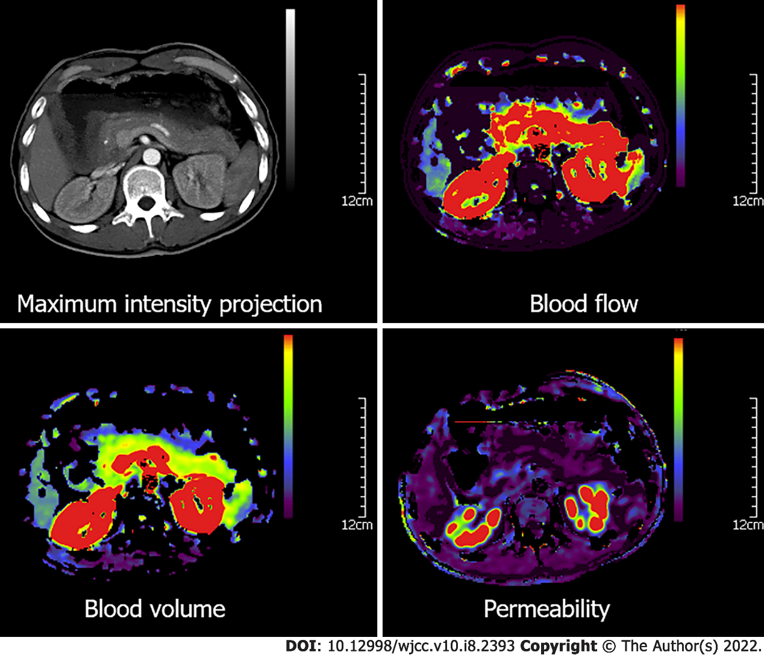
Figure 1 Representative computed tomography perfusion parameters in the pancreas of a healthy volunteer.

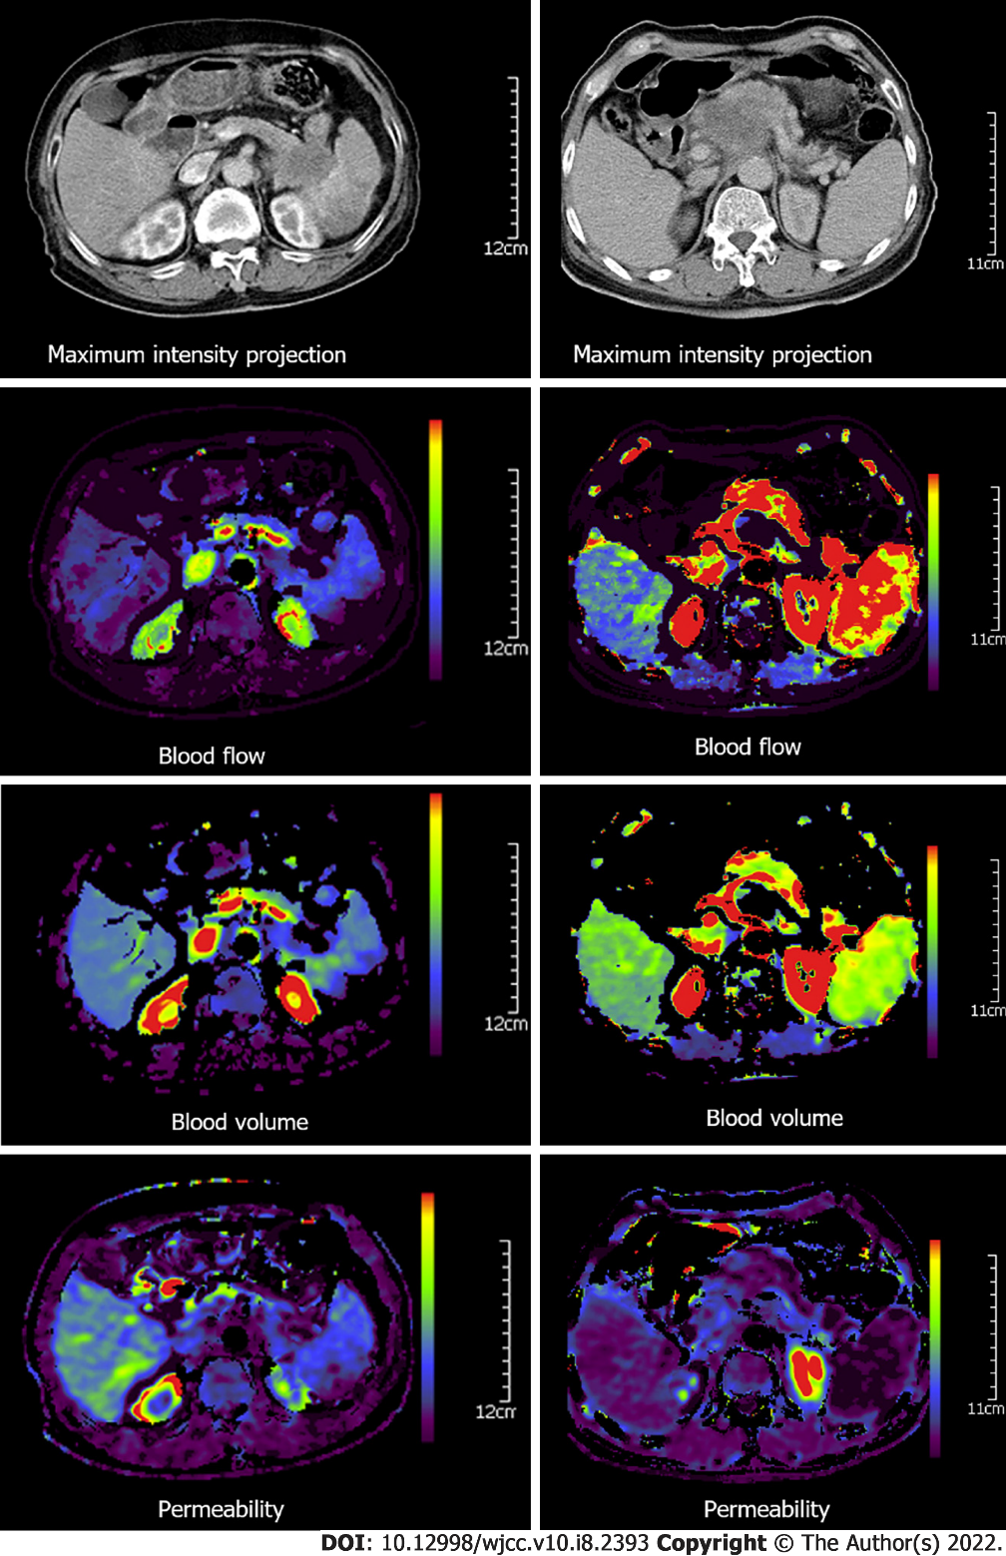
Figure 2 Representative computed tomography perfusion parameters of grade II (left) vs grade III (right) pancreatic adenocarcinoma patients. The pancreatic adenocarcinoma patients had a lower density on the maximum-density projection images, as well as lower values of blood flow, blood volume, and permeability, as compared with the adjacent relatively normal pancreatic tissue.

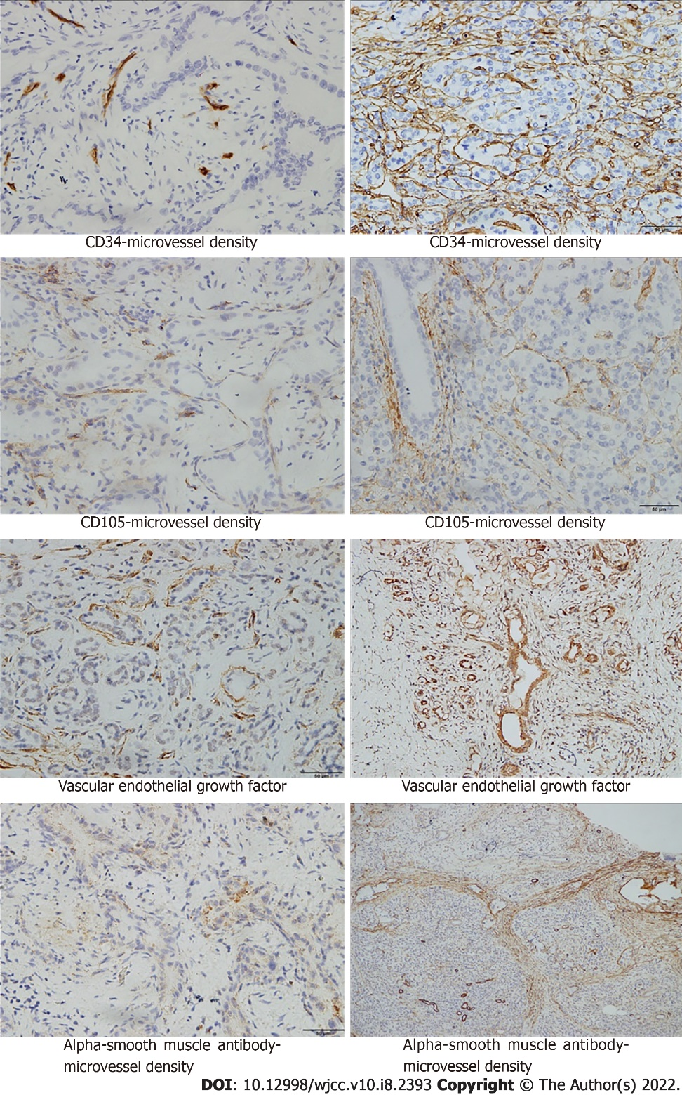
Figure 3 Immunohistochemical indicators in patients with pancreatic adenocarcinoma. CD34-MVD, CD105-MVD, VEGF, and (α-SMA)-MVD in patients with grade III pancreatic adenocarcinoma (right) were compared with CD34-MVD, CD105-MVD, VEGF, and (α-SMA)-MVD in patients with grade I pancreatic adenocarcinoma (left). Magnification × 400.

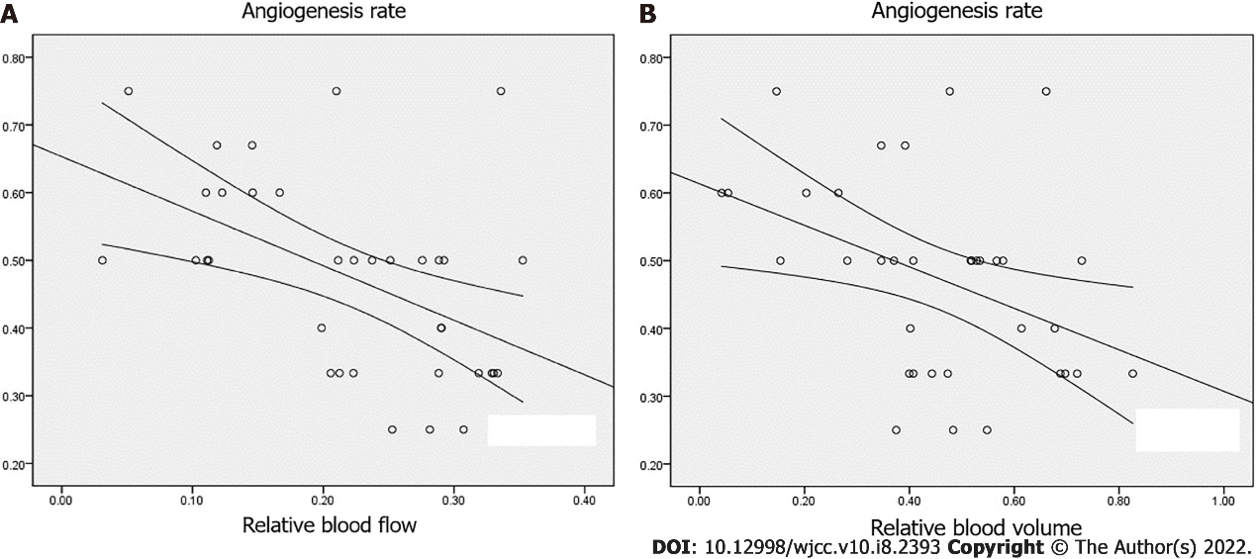
Figure 4 Correlation between relative blood flow and relative blood volume and angiogenesis rate. A: Correlation between relative blood flow and angiogenesis rate (AR); B: Correlation between relative blood volume and AR.

Table 1 Demographic features
 | Pancreatic adenocarcinoma (n = 35) | Controls (n = 33) | P value
Age (yr) | 61.5 (46-79) | 48 (28-68) | < 0.001
Gender
Male | 17 (48.6%) | 20 (60.6%) | 0.342
Female | 18 (51.4%) | 13 (39.4%)
rBF | 0.222 ± 0.089 | 1.000 ± 0.023 | < 0.001
rBV | 0.453 ± 0.193 | 0.993 ± 0.076 | < 0.001
rPE | 0.576 ± 0.278 | 1.003 ± 0.008 | < 0.001
rPermeability | 6.000 ± 1.395 | 0.949 ± 0.165 | < 0.001
rTTP | 1.917 ± 0.208 | 1.014 ± 0.039 | < 0.001
rBF: Relative blood flow; rBV: Relative blood volume; rPermeability: Relative permeability; rPE: Relative peak enhancement; rTTP: Relative time to peak.

Table 2 Relative computed tomography perfusion parameters of grade I-II pancreatic adenocarcinoma vs grade III-IV pancreatic adenocarcinoma
 | Grade I-II pancreatic adenocarcinoma (n = 25) | Grade III-IV pancreatic adenocarcinoma (n = 10) | P value
rBF | 0.266 ± 0.057 | 0.111 ± 0.042 | < 0.001
rBV | 0.546 ± 0.127 | 0.223 ± 0.123 | < 0.001
rPE | 0.586 ± 0.265 | 0.552 ± 0.321 | 0.750
rPermeability | 5.841 ± 1.413 | 6.393 ± 1.336 | 0.297
rTTP | 1.919 ± 0.208 | 1.911 ± 0.218 | 0.915
rBF: Relative blood flow; rBV: Relative blood volume; rPermeability: Relative permeability; rPE: Relative peak enhancement; rTTP: Relative time to peak.

Table 3 Correlation between relative computed tomography perfusion parameters and immunohistochemical indicators in pancreatic adenocarcinoma patients
Pearson correlation | rBF | rBV | rPE | rPermeability | rTTP
VEGF | -0.670^{b} | -0.557 ^{b} | -0.182 | 0.107 | 0.071
CD105-MVD | -0.489 ^{b} | -0.549 ^{b} | -0.002 | 0.016 | 0.030
CD34-MVD | -0.241 | -0.407ª | -0.074 | 0.072 | -0.028
AR | -0.497^{b} | -0.412ª | 0.049 | -0.046 | 0.020
VMI | 0.603^{b} | 0.499^{b} | -0.119 | -0.043 | 0.150

ªP < 0.05.

^{b}P < 0.01. AR: Angiogenesis rate; VMI: Vascular maturity index.

Published by Baishideng Publishing Group Inc
7041 Koll Center Parkway, Suite 160, Pleasanton, CA 94566, USA
Telephone: +1-925-3991568
E-mail: bpgoffice@wjgnet.com
Help Desk: https://www.f6publishing.com/helpdesk
https://www.wjgnet.com

© 2022 Baishideng Publishing Group Inc. All rights reserved.

