Name of Journal: World Journal of Clinical Cases
Manuscript NO: 78599
Manuscript Type: CASE REPORT

Spontaneous remission of hepatic myelopathy in a patient with alcoholic cirrhosis: A case report

Chang CY et al. Spontaneous remission of HM

Chun-Yan Chang, Chen Liu, Fang-Fang Duan, Hang Zhai, Shan-Shan Song, Song Yang

Chun-Yan Chang, Chen Liu, Fang-Fang Duan, Hang Zhai, Shan-Shan Song, Song Yang, Division Third Center of Hepatology, Beijing Ditan Hospital, Capital Medical University, Beijing 100015, China

Author contributions: Chang CY designed and contributed to the manuscript draft; Liu C and Duan FF analyzed and interpreted the imaging data; Zhai H and Song SS collected the patient’s clinical data; Yang S reviewed this paper and approved the final version of this manuscript.

Supported by Chinese Foundation for Hepatitis Prevention and Control, Tianqing Liver Disease Research Fund Subject, No. TQGB20210050; and Beijing Municipal Administration of Hospitals Incubating Program, No. PX2022071.

Corresponding author: Song Yang, Doctor, PhD, Director, Doctor, Professor, Teacher, Division Third Center of Hepatology, Beijing Ditan Hospital, Capital Medical University, No.8 Jingshun East Street, Chaoyang District, Beijing 100015, China. sduyangsong@163.com

Received: July 6, 2022
Revised: August 24, 2022
Accepted: September 19, 2022
Published online:

Abstract
BACKGROUND
Hepatic myelopathy (HM) is a rare neurological complication of advanced cirrhosis. Prognosis of patients with HM is generally poor without timely liver transplantation or interventional therapy. Self-resolving HM in patients with alcoholic cirrhosis has never been reported.

CASE SUMMARY
A 53-year-old man with alcoholic cirrhosis and recurrent overt hepatic encephalopathy for 1 year was admitted for lower extremity weakness, slow movement, and stumbling gait. The patient was diagnosed with HM after excluding other causes of spastic paraparesis. The patient refused liver transplantation. However, the patient kept total abstinence and received a multidisciplinary treatment for complications of decompensated cirrhosis. The symptoms of HM resolved gradually after 2 years of treatment. All complications of alcoholic cirrhosis resolved after 4 years of follow-up.

CONCLUSION
The case demonstrates that HM can resolve in patients without liver transplantation after total abstinence and systemic management of complications.

Key Words: Alcoholic cirrhosis; Hepatic myelopathy; Hepatic encephalopathy; Spastic paraparesis; Therapeutics; Case report

Chang CY, Liu C, Duan FF, Zhai H, Song SS, Yang S. Spontaneous remission of hepatic myelopathy in a patient with alcoholic cirrhosis: A case report. World J Clin Cases 2022; In press

Core Tip: Hepatic myelopathy (HM) is a rare neurological complication of advanced cirrhosis. Prompt liver transplantation or interventional therapy may reverse the symptoms of HM. Self-resolving HM in patients with alcoholic cirrhosis has never been reported. Our report presents that self-resolving HM in a patient with alcoholic cirrhosis is possible without any liver transplantation and interventional therapy after promptly controlling the etiology and systemic management of complications. This case provides new insight into the self-remission of patients with HM.

INTRODUCTION
Hepatic myelopathy (HM) is a rare neurological complication of advanced cirrhosis. The clinical manifestations of HM are progressive spasmodic paralysis of the limbs and do not involve sensory or sphincter motor symptoms, commonly in patients with recurrent hepatic encephalopathy (HE)^{[1]}. Other causes of spastic paraparesis and partial transverse myelopathy should be ruled out before establishing the diagnosis^{[2]}. Although the first case of HM was reported 30 years ago, the prognosis profiles of patients with HM, especially the rare cases, remain obscure^{[3]}. Limited data have demonstrated that prompt liver transplantation or interventional therapy may reverse the symptoms of HM^{[4]}. In 2017, di Biase et al^{[5]} has reported the first case of self-resolving HM in patients with hepatitis C virus (HCV)-related cirrhosis after HCV treatment. Since then, no case of self-resolving HM was reported. To the best of our knowledge, no case of self-resolving HM for alcoholic cirrhosis has been reported. Herein, we report the first case of self-resolving HM from our large cohort of patients with alcoholic cirrhosis^{[6]}. We also reviewed the treatment of patients with HM.

CASE PRESENTATION
Chief complaints
A 53-year-old man with alcoholic cirrhosis was admitted to Beijing Ditan Hospital of Capital Medical University for lower extremity weakness, slow movement, and stumbling gait that required walking assistance with a crutch in January 2015.

History of present illness
The patient was diagnosed with decompensated alcoholic cirrhosis with ascites in September 2011. In December 2011, he was admitted to the hospital due to gastroesophageal variceal bleeding and received splenectomy combined with a gastroesophageal devascularization surgery. In April 2013, he was hospitalized for comorbid acute hepatitis B and suffered from recurrent overt HE since then. Since January 2015, the patient gradually developed weakness in both lower limbs, slow movement, and hobbling gait.

History of past illness
The patient had no relevant medical history.

Personal and family history
The patient had a history of heavy drinking for 25 years, with an average alcohol intake of 200 g per day.

Physical examination
Abdominal examination suggested hepatomegaly and positive shifting dullness. Neurological system examinations demonstrated slurring speech, normal cranial nerves, increased muscle tension and grade 4/5 power of lower limbs, exaggerated deep tendon reflexes, and no sensory deficit or sphincteric involvement.

Laboratory examinations
Serial results of liver function and whole blood count are presented in Table 1. Blood ammonia concentration fluctuated between 50 and 87 μmol/L during the occurrence of overt HE. In January 2015, hospitalization, hepatitis B surface antigen, and anti-HCV tests were negative. Additionally, human immunodeficiency virus (HIV), Syphilis, Epstein-Barr virus (EBV), and cytomegalovirus tests were negative. Serum vitamin B-12 level was normal. Cerebrospinal fluid analysis was normal.

Imaging examinations
Contrast abdominal computed tomography revealed liver cirrhosis, esophageal and gastric varices, gastro-left renal shunt, and portal vein thrombosis (Figure 1). Magnetic resonance imaging (MRI) of the brain indicated hyperintensities in the bilateral globus pallidus (Figure 2). Moreover, whole spinal MRI and lumbosacral MRI were performed and revealed normal results. The electromyogram showed normal nerve conduction velocity in the bilateral tibial nerves. Somatosensory evoked potentials of the lower limbs were normal. Motor evoked potential was abnormal in both lower limbs.

FINAL DIAGNOSIS
Multidisciplinary expert consultation was performed; this included experts in hepatology, neurology, infectious diseases, and radiology, to find for the cause of the spastic paraparesis. The cranial and spinal MRI showed no intracranial or spinal space occupation. Normal serum vitamin B-12 levels allowed subacute combined degeneration of the spinal cord to be ruled out. Primary lateral sclerosis was not considered since spastic paraparesis in this patient get spontaneously resolved and does not involve the upper limbs. Spinal multiple sclerosis was excluded based on the normal spinal MRI and lack of sensory deficit or sphincteric involvement. Myelopathy related to HIV, EBV or other pathogens infections was ruled out based on the normal infection biomarkers and normal cerebrospinal fluid status. Moreover, hereditary spastic paraplegia, Wilson’s disease, radiation myelopathy, vascular spinal cord disease, and other causes of spastic paraparesis were ruled out due to the lack of specific neurological features and lack of characteristic distinguishing abnormalities on neuroimaging. The patient was diagnosed with HM after exclusion of any other potential causes of spastic paraparesis.

TREATMENT
The patient rejected liver transplantation for financial reasons. The patient chose abstinence and took furosemide, spironolactone, lactulose, L-ornithine-L-aspartate for ascites and HE. The patient was followed up every 3-6 mo.

OUTCOME AND FOLLOW-UP
The patient chose abstinence and symptomatic treatment. During follow-up, he had less ascites and overt HE attacks. Since 2018, he had reported gradual improvement of his lower limb weakness and hobbling gait. In August 2019, the patient reported that he could walk without the assistance of a crutch. The liver function test revealed normal alanine transaminase, aspartate transaminase and albumin levels. Abdominal ultrasound revealed no signs of ascites and disappearance of the portal vein thrombosis. The patient was regularly followed up until October 2021, and has since demonstrated normal liver function and regular limb movement.

DISCUSSION
HM is a rare complication of cirrhosis, which is common in patients with portosystemic shunts and recurrent HE. Its main clinical manifestation is progressive spastic paraparesis. Diagnosis of HM needs to exclude other causes for spastic paraparesis, which include amyotrophic lateral sclerosis, hereditary and toxic myelopathy, multiple sclerosis, paraneoplastic syndromes, radiation myelopathy, infectious causes of myelopathy, and vascular spinal cord disease^{[7]}. Regarding this patient, he had a history of cirrhosis and recurrent HE attacks. Contrast abdominal computed tomography showed portosystemic shunting. In addition, MRI of the brain indicated cirrhosis and HE. The diagnosis of HM was established after exclusion other potential causes of spastic paraparesis by multidisciplinary expert consultation.
Early spinal cord injury in HM is characterized by symmetrical demyelination of corticospinal tracts due to nitrogenous toxins such as ammonia. The demyelination is reversable with prompt management of the underlying liver disease and/or portosystemic shunts. As the disease progresses, axonal loss occurs, which may be irreversible^{[8,9]}.
Troisi et al^{[10]} reported the first case of a patient with HM in whom myelopathy improved after liver transplantation. Since then, an increasing number of studies have demonstrated that liver transplantation might reverse HM^{[1,4,11-15]}, although some studies have reported otherwise^{[16,17]}. When comparing patients in whom HM was reversed after liver transplantation and patients whose HM was not reversed, it is generally recognized that the likelihood of HM reversal may be higher when liver transplantation is performed within 18 mo after the onset of symptomatic HM^{[4]}. This theory was further verified by Koul et al’s report, in which two children with acute HM after hepatitis A infection recovered completely after receiving donor liver transplantation^{[14]}.
For HM secondary to transjugular intrahepatic portosystemic shunt (TIPS) or surgical splenorenal shunt, reports have revealed that prompt shunt occlusion or shunt limitation may reverse HM^{[18-21]}. Some studys have reported that shunt limitation, not shunt occlusion, is useful for reversing early-onset HM after TIPS^{[20,21]}. Shunt limiting is preferred, as total shunt occlusion might have a higher risk of adverse events related to the rapid increase of portal hypertension. Moreover, Philips et al^{[22]} reported partial splenic artery embolization (PSAE) for a patient with HM. Neurological function improved rapidly and constantly after PSAE. The authors concluded that PSAE may improve liver function, decrease PHT, and lower portosystemic shunting in this way to ameliorate neurological symptoms. Intestinal microbiota is closely related to HE, and some studies have reported that fecal microbiota transplantations (FMT) might improve HE^{[23]}. Based on this, Sun et al^{[24]} reported a case of HM in a patient who received FMT, and neurological function improved after three repetitions of FMT. More studies have revealed that repairing gut microbiota may decrease portal hypertension and repair the blood-brain barrier^{[25,26]}. Further, there is increasing data to demonstrate the usefulness of FMT for improving HE^{[27,28]}. Considering the shared pathogenesis of HM and HE, FMT for HM seems promising and is worth further investigation.
In 2017, di Biase et al^{[5]} reported an interesting case of self-resolving HM. This patient with HCV-related cirrhosis was treated with sofosbuvir plus ribavirin. HM improved 6 mo after HCV treatment. The case demonstrates that self-resolving HM might be possible after relief of the underlying liver disease. As in our case, HM was relieved with total abstinence, and liver function was restored. Additionally, the 6-year follow-up demonstrated sustained re-compensation of liver cirrhosis in this case.

CONCLUSION
As the first reported case of self-resolving HM in a patient with alcoholic cirrhosis, the case demonstrates that self-remission of HM is possible even without liver transplantation after total abstinence and systemic management of complications.

REFERENCES
1 Koo JE, Lim YS, Myung SJ, Suh KS, Kim KM, Lee HC, Chung YH, Lee YS, Suh DJ. Hepatic myelopathy as a presenting neurological complication in patients with cirrhosis and spontaneous splenorenal shunt. Korean J Hepatol 2008; 14: 89-96 [PMID: 18367861 DOI: 10.3350/kjhep.2008.14.1.89]
2 Jeske J, Schädlich HJ, Sandmann J, Karbe H, Haupt WF, Karenberg A. [Acute paraparesis in chronic hepatic disease]. Nervenarzt 1991; 62: 130-132 [PMID: 1851969]
3 Gospe SM Jr, Caruso RD, Clegg MS, Keen CL, Pimstone NR, Ducore JM, Gettner SS, Kreutzer RA. Paraparesis, hypermanganesaemia, and polycythaemia: a novel presentation of cirrhosis. Arch Dis Child 2000; 83: 439-442 [PMID: 11040156 DOI: 10.1136/adc.83.5.439]
4 Caldwell C, Werdiger N, Jakab S, Schilsky M, Arvelakis A, Kulkarni S, Emre S. Use of model for end-stage liver disease exception points for early liver transplantation and successful reversal of hepatic myelopathy with a review of the literature. Liver Transpl 2010; 16: 818-826 [PMID: 20583082 DOI: 10.1002/lt.22077]
5 di Biase L, Picillo M, Freitas ME, Bui E, Fasano A. Hepatitis C Virus-Related Hepatic Myelopathy After Treatment With Sofosbuvir and Ribavirin: A Case Report. Ann Intern Med 2017; 166: 379-380 [PMID: 28265655 DOI: 10.7326/L16-0038]
6 Duan F, Liu C, Liu Y, Chang C, Zhai H, Xing H, Cheng J, Yang S. Nomogram to Predict the Survival of Chinese Patients with Alcohol-Related Liver Disease. Can J Gastroenterol Hepatol 2021; 2021: 4073503 [PMID: 34616695 DOI: 10.1155/2021/4073503]
7 Ben Amor S, Saied MZ, Harzallah MS, Benammou S. Hepatic myelopathy with spastic paraparesis: report of two cases and review of the literature. Eur Spine J 2014; 23 Suppl 2: 167-171 [PMID: 23728397 DOI: 10.1007/s00586-013-2828-z]
8 Weissenborn K. Portosystemic encephalopathy. Handb Clin Neurol 2014; 120: 661-674 [PMID: 24365345 DOI: 10.1016/B978-0-7020-4087-0.00045-0]
9 Utku U, Asil T, Balci K, Uzunca I, Celik Y. Hepatic myelopathy with spastic paraparesis. Clin Neurol Neurosurg 2005; 107: 514-516 [PMID: 16202825 DOI: 10.1016/j.clineuro.2004.10.002]
10 Troisi R, Debruyne J, de Hemptinne B. Improvement of hepatic myelopathy after liver transplantation. N Engl J Med 1999; 340: 151 [PMID: 9917218 DOI: 10.1056/nejm199901143400216]
11 Weissenborn K, Tietge UJ, Bokemeyer M, Mohammadi B, Bode U, Manns MP, Caselitz M. Liver transplantation improves hepatic myelopathy: evidence by three cases. Gastroenterology 2003; 124: 346-351 [PMID: 12557140 DOI: 10.1053/gast.2003.50062]
12 Qu B, Liu C, Guo L, Yang Y, Li JH, Yu L, Lv Y. The role of liver transplantation in the treatment of hepatic myelopathy: case report with review of the literature. Transplant Proc 2009; 41: 1987-1989 [PMID: 19545775 DOI: 10.1016/j.transproceed.2009.01.105]
13 Baccarani U, Zola E, Adani GL, Cavalletti M, Schiff S, Cagnin A, Poci C, Merkel C, Amodio P, Montagnese S. Reversal of hepatic myelopathy after liver transplantation: fifteen plus one. Liver Transpl 2010; 16: 1336-1337 [PMID: 21031552 DOI: 10.1002/lt.22149]
14 Koul R, Lal BB, Pamecha V, Sarin S, Alam S. Liver Transplantation Reverses Hepatic Myelopathy in 2 Children With Hepatitis A Infection. Child Neurol Open 2021; 8: 2329048X20983763 [PMID: 33490305 DOI: 10.1177/2329048X20983763]
15 Zhu Z, Liu Y, Wu W, Huang D, Guo Y, Zheng H, Wang N, Xu Z, Li X, Qin J, Liu L, Nashan B. Liver Transplantation Reverses Hepatic Myelopathy in Hepatitis B-Related Decompensated Liver Cirrhosis: Case Report and Review of the Literature. Transplant Proc 2022; 54: 158-160 [PMID: 34961599 DOI: 10.1016/j.transproceed.2021.11.016]
16 Counsell C, Warlow C. Failure of presumed hepatic myelopathy to improve after liver transplantation. J Neurol Neurosurg Psychiatry 1996; 60: 590 [PMID: 8778275 DOI: 10.1136/jnnp.60.5.590]
17 Nardone R, Buratti T, Oliviero A, Lochmann A, Tezzon F. Corticospinal involvement in patients with a portosystemic shunt due to liver cirrhosis: a MEP study. J Neurol 2006; 253: 81-85 [PMID: 16047111 DOI: 10.1007/s00415-005-0930-9]
18 Conn HO, Rössle M, Levy L, Glocker FX. Portosystemic myelopathy: spastic paraparesis after portosystemic shunting. Scand J Gastroenterol 2006; 41: 619-625 [PMID: 16638707 DOI: 10.1080/00365520500318932]
19 Wang MQ, Liu FY, Duan F. Management of surgical splenorenal shunt-related hepatic myelopathy with endovascular interventional techniques. World J Gastroenterol 2012; 18: 7104-7108 [PMID: 23323015 DOI: 10.3748/wjg.v18.i47.7104]
20 Zhao H, Liu F, Yue Z, Wang L, Fan Z. Evaluation of mid- and long-term efficacy of shunt limiting for hepatic myelopathy after transjugular intrahepatic portosystemic shunt. Clin Res Hepatol Gastroenterol 2016; 40: 440-446 [PMID: 26724169 DOI: 10.1016/j.clinre.2015.11.004]
21 Zhao H, Yue Z, Wang L, Fan Z, He F, Dong X, Liu F. Benefits of Early Treatment for Patients with Hepatic Myelopathy Secondary to TIPS: A Retrospective Study in Northern China. Sci Rep 2018; 8: 15184 [PMID: 30315180 DOI: 10.1038/s41598-018-33216-1]
22 Philips CA, Kumar L, Augustine P. Partial splenic artery embolization for severe hepatic myelopathy in cirrhosis. Hepatology 2018; 67: 1169-1171 [PMID: 29059463 DOI: 10.1002/hep.29597]
23 Tandon P, Madsen K, Kao D. Fecal microbiota transplantation for hepatic encephalopathy: Ready for prime time? Hepatology 2017; 66: 1713-1715 [PMID: 28734127 DOI: 10.1002/hep.29396]
24 Sun L, Li J, Lan LL, Li XA. The effect of fecal microbiota transplantation on Hepatic myelopathy: A case report. Medicine (Baltimore) 2019; 98: e16430 [PMID: 31305466 DOI: 10.1097/MD.0000000000016430]
25 Braniste V, Al-Asmakh M, Kowal C, Anuar F, Abbaspour A, Tóth M, Korecka A, Bakocevic N, Ng LG, Kundu P, Gulyás B, Halldin C, Hultenby K, Nilsson H, Hebert H, Volpe BT, Diamond B, Pettersson S. The gut microbiota influences blood-brain barrier permeability in mice. Sci Transl Med 2014; 6: 263ra158 [PMID: 25411471 DOI: 10.1126/scitranslmed.3009759]
26 Huang HC, Tsai MH, Chang CC, Pun CK, Huang YH, Hou MC, Lee FY, Hsu SJ. Microbiota transplants from feces or gut content attenuated portal hypertension and portosystemic collaterals in cirrhotic rats. Clin Sci (Lond) 2021; 135: 2709-2728 [PMID: 34870313 DOI: 10.1042/CS20210602]
27 Afecto E, Ponte A, Fernandes S, Silva J, Gomes C, Correia J, Carvalho J. Fecal microbiota transplantation in hepatic encephalopathy : a review of the current evidence and future perspectives. Acta Gastroenterol Belg 2021; 84: 87-90 [PMID: 33639698 DOI: 10.51821/84.1.884]
28 Hassouneh R, Bajaj JS. Gut Microbiota Modulation and Fecal Transplantation: An Overview on Innovative Strategies for Hepatic Encephalopathy Treatment. J Clin Med 2021; 10 [PMID: 33477417 DOI: 10.3390/jcm10020330]

Footnotes
Informed consent statement: Informed written consent was obtained from the patient for publication of this report and any accompanying images.

Conflict-of-interest statement: All the authors report no relevant conflicts of interest for this article.

CARE Checklist (2016) statement: The authors have read the CARE Checklist (2016), and the manuscript was prepared and revised according to the CARE Checklist (2016).

Open-Access: This article is an open-access article that was selected by an in-house editor and fully peer-reviewed by external reviewers. It is distributed in accordance with the Creative Commons Attribution NonCommercial (CC BY-NC 4.0) license, which permits others to distribute, remix, adapt, build upon this work non-commercially, and license their derivative works on different terms, provided the original work is properly cited and the use is non-commercial. See: https://creativecommons.org/Licenses/by-nc/4.0/

Provenance and peer review: Unsolicited article; Externally peer reviewed
Peer-review model: Single blind

Peer-review started: July 6, 2022
First decision: August 4, 2022
Article in press:

Specialty type: Medicine, research and experimental
Country/Territory of origin: China
Peer-review report’s scientific quality classification
Grade A (Excellent): 0
Grade B (Very good): 0
Grade C (Good): C, C, C, C
Grade D (Fair): 0
Grade E (Poor): 0

P-Reviewer: Ferrarese A, Italy; Surani S, United States S-Editor: Wang JJ L-Editor: A P-Editor:

Figure Legends
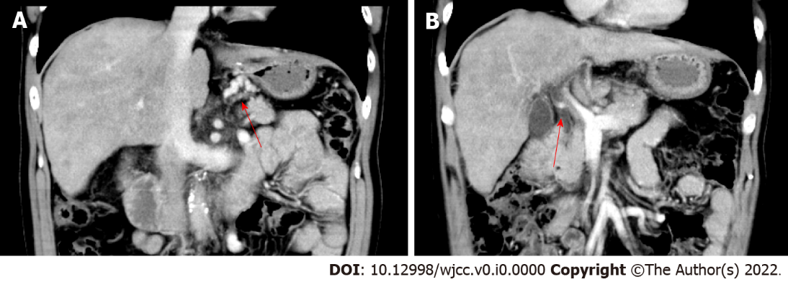
Figure 1 Contrast abdominal computed tomography revealed cirrhosis, esophageal and gastric fundus varicose veins, fundus-left renal shunt, and portal vein thrombosis. A: Arrow shows portal vein thrombosis; B: Arrow shows esophagogastric varices.

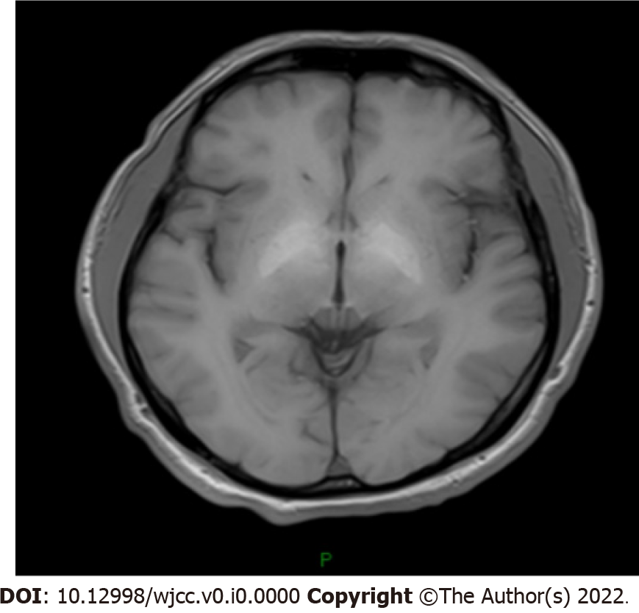
Figure 2 The cranial magnetic resonance imaging revealed increased T1W symmetric signal in the bilateral globus pallidus.

Table 1 Serial results of liver function test and whole blood cell count
 | September, 2011 | September, 2012 | September, 2014 | February, 2015 | August, 2019 | October, 2021
ALT (U/L) | 25 | 18 | 717 | 28 | 42 | 25
AST (U/L) | 42 | 26 | 976 | 46 | 62 | 32
ALB (g/L) | 30.0 | 32.0 | 33.2 | 32.2 | 36.1 | 41.3
TBIL (μmol/L) | 53.1 | 15.7 | 109.4 | 19.3 | 47.0 | 16.7
Hb (g/L) | 108 | 82 | 127 | 139.0 | 159 | 153
WBC (10⁹/L) | 6.4 | 8.5 | 9.4 | 8.8 | 7.5 | 7.6
PLT (10⁹/L) | 71 | 278 | 159 | 79 | 100 | 121
ALB: Albumin; ALT: Alanine transaminase; AST: Aspartate transaminase; Hb: Hemoglobin; PLT: Platelet; TBIL: Total bilirubin; WBC: White blood cell.

