Name of journal: World Journal of Clinical Cases
ESPS Manuscript NO: 17089
Manuscript Type: Case Report

First description of cervical intradural thymoma metastasis

Marotta N et al. Cervical intradural thymoma metastasis

Nicola Marotta, Cristina Mancarella, Davide Colistra, Alessandro Landi, Demo Eugenio Dugoni, Roberto Delfini

Nicola Marotta, Cristina Mancarella, Davide Colistra, Alessandro Landi, Demo Eugenio Dugoni, Roberto Delfini, Department of Neurology and Psychiatry, Division of Neurosurgery, University of Rome “Sapienza”, 00161 Rome, Italy

Author contributions: All the authors contributed to this manuscript.

Institutional review board statement: The study was reviewed and approved by the Department of Neurology and Psychiatry, Division of Neurosurgery, University of Rome “Sapienza” Institutional review board.

Informed consent statement: The study participant provided informed verbal consent prior to study enrollment.

Conflict-of-interest statement: None.

Open-Access: This article is an open-access article which was selected by an in-house editor and fully peer-reviewed by external reviewers. It is distributed in accordance with the Creative Commons Attribution Non Commercial (CC BY-NC 4.0) license, which permits others to distribute, remix, adapt, build upon this work non-commercially, and license their derivative works on different terms, provided the original work is properly cited and the use is non-commercial. See: http://creativecommons.org/licenses/by-nc/4.0/

Correspondence to: Alessandro Landi, MD, PhD, Department of Neurology and Psychiatry, Division of Neurosurgery, University of Rome “Sapienza”, Viale del Policlinico 155, 00161 Rome, Italy. dott.alessandro.landi@gmail.com
Telephone: +39-6-49979105
Fax: +39-6-49979105

Received: February 11, 2015
Peer-review started: February 12, 2015
First decision: May 13, 2015
Revised: May 30, 2015
Accepted: August 30, 2015
Article in press:
Published online:

Abstract
Thymoma and thymic carcinoma are rare epithelial tumors, which originate from the thymus gland. According to the World Health Organization there are “organotypic” (type A, AB, B1, B2, B3) and “not organotypic” (thymic carcinomas) thymomas. Type B3 thymomas are aggressive tumors, which can metastasize. Despite the rarity of these lesions, only 7 cases of extradural metastasis are described in the literature. We report the first and unique case of a man with cervical intradural B3 thymoma metastasis. A 46-years old man underwent thymoma surgical removal. The year after the procedure he was treated for a parietal pleura metastasis. In 2006 he underwent cervical-dorsal extradural metastasis removal and C5-Th1 stabilization. Seven years after he came to our observation complaining left cervicobrachialgia and reduction of strength of the left arm. He performed a cervical spine magnetic resonance imaging, which showed a new lesion at C5-C7 level. The patient underwent surgery for the intradural B3 thymoma metastasis. Neurological symptoms improved although the removal was subtotal. He went through postoperative radiation therapy with further mass reduction. Spinal metastases are extremely rare. To date, only 7 cases of spinal extradural metastasis have been described in the literature. This is the first case of spinal intradural metastasis. Early individuation of these tumors and surgical treatment improve neurological outcome in patients with spinal cord compression. A multimodal treatment including neoadjuvant chemotherapy, surgery and postoperative radiation therapy seems to improve survival in patients with metastatic thymoma.

Key words: Thymoma; Metastasis; Intradural lesion; Spinal tumor; Spinal surgery

© The Author(s) 2015. Published by Baishideng Publishing Group Inc. All rights reserved.

Core tip: To date, only 7 cases of spinal extradural thymoma metastasis have been described in the literature. We report the first case of spinal intradural thymoma metastasis. Early individuation of these tumors and surgical treatment improve neurological outcome in patients with spinal cord compression. A multimodal treatment including neoadjuvant chemotherapy, surgery and postoperative radiation therapy seems to improve survival in patients with metastatic thymoma.

Marotta N, Mancarella C, Colistra D, Landi A, Dugoni DE, Delfini R. First description of cervical intradural thymoma metastasis. World J Clin Cases 2015; In press

INTRODUCTION
Thymoma and thymic carcinoma are uncommon epithelial lesions, which originate from the thymus gland. To date, the true incidence is not known, but it’s estimated of 0-15 cases/100000 people. Between the V and VI decade of life and this pathology represents 0.2%-1.5% of all malignancies^{[1]}. According to the World Health Organization there are “organotypic” (type A, AB, B1, B2, B3) and “not organotypic” (thymic carcinomas) thymomas. Type A, AB, B1 and B2 thymomas are benign tumors. Type B3 thymomas are aggressive tumors of intermediate malignity^{[2]}. Spinal metastases are very uncommon. In the literature, only 7 patients with spinal extradural metastasis have been described. We report the first and unique case of a man with cervical intradural B3 thymoma metastasis.

CASE REPORT
A thymoma was resected in a 46-year-old male in 1989. He did not submit himself to adjuvant therapy. A year after the procedure he underwent parietal pleura metastasis resection. The patient remained disease-free until 2006, when he complained reduction of strength of the left arm, for the presence of a cervico-dorsal extradural metastasis. He underwent resection of the lesion and C5-Th1 stabilization (Figure 1). The lesion was totally removed (R0) and the dura mater appeared intact.
In 2013, the patient came to our observation complaining left cervicobrachialgia and reduction of strength of the left arm. A cervical spine magnetic resonance imaging (MRI) showed a new lesion at C5-C7 level (Figure 2). The lesion showed a homogeneous enhancement after Gd in the T1-weighted sequences, and enclosed the spinal cord, especially on the left side. From the imaging, it was not clear if the lesion was extradural or intradural. Intraoperatively, there wasn’t pathological tissue in the epidural space; it appeared only after opening the dura mater. The patient underwent a nearly-total resection, in order to preserve the spinal cord from the surgical manipulation. The lesion was intradural-extramedullary. It was adherent to the spinal cord surface in its lateral and anterior portions.
A spinal metastasis of the type B3 thymoma according to World Health Organization 2004 was diagnosed (well-differentiated thymic carcinoma according to Marino and Muller-Hermelick)^{[3]}. The immunohistochemical examination demonstrated positivity of neoplastic cells for CK19 and p63 and CD1a positive T-cells (Figure 3). Even if the resection was not total, no postoperative neurological deficits were observed. After 3 months, the cervico-thoracic spine MRI showed a small residual tumor, especially anteriorly to the cervical spinal cord (Figure 4). Subsequently, focal radiotherapy (25.5 Gray) was given. Cervical MRI after radiation treatment, showed almost total disappearance of the mass (Figure 5). The patient is now symptoms free.
A search was carried out about spinal thymoma metastasis in English language literature. We excluded a work because available only in Japanese language^{[4]} and one because it did not report sufficient data to be included in our series. We used the following key words: “thymoma metastasis”, “thymic carcinoma”, “spinal cord compression”, “spinal metastasis”. The data were extracted according to these parameters: (1) author and year of publication; (2) age; (3) sex; (4) time to spinal metastasis; (5) site of spinal metastasis; (6) sign and symptoms; (7) surgery; (8) follow-up; (9) radiotherapy; and (10) classification of histological type of the thymoma^{[5-9]}.

DISCUSSION
We found 6 papers, in which 7 cases were described. We included our case in the review, for a total number of 8 cases of spinal thymoma metastasis. 4 patients were males and 3 were females. About the age, the average was 51.4 years old (range 29-70 years). The median time since thymoma diagnosis and spinal metastasis was 7.9 years (range 1-17 years); in one case the spinal metastasis was diagnosed before primary tumor; the case with longer time to spinal metastasis was our case. The spinal metastases were localized at thoracic level in 4 cases, at cervico-thoracic site in 1 case, cervical level in 2 cases, and lumbar level in 1 case. Patients presented symptoms related to the thymoma in 2 cases (myasthenia gravis); in all cases they had neurological symptoms related to the spinal metastasis (motor deficit, sensitive deficit or pain). All patients underwent surgical treatment. During the follow-up, 3 patients died after 3 mo, 5 mo and 2 years respectively; 4 patients survived with a time of follow-up from 9 mo to 8 years (our case). Five patients didn’t had radiation therapy, 2 underwent RT. Histological diagnosis wasn’t based on the actual WHO classification in 2 cases; the histological subtype was B2 in 1 case, B3 in 2 cases, C in 2 cases.
Thymoma and thymic carcinoma are uncommon epithelial lesions, which originate from the thymus gland. Thymoma is a rare tumor, commonly associated with the myasthenia gravis (15%); local dissemination occurs quickly, but distant spinal metastasis may occur up to 16 years after the diagnosis of thymomas. They can metastasize to the pleura regional nodes, liver and lung. Spinal metastases are very uncommon. In the literature, only 7 patients with spinal extradural metastasis have been described. We report a unique case of spinal intradural metastasis. On MRI, the vertebral metastases appear hypointense on T1-weighted images and hyperintense on T2-weighted images. It is possible a paravertebral muscles and vertebral elements infiltration, evident on axial views. Gadolinium administration shows an important enhancement. Computed tomography scan shows infiltration of the vertebral body, with both osteolitic and osteoblastic lesions. The spinal metastasis can cause, in fact, vertebral collapse, spinal instability and neurological deterioration. Early diagnosis and surgery have the goal to control pain, maintain and to preserve and reduce motor deficits. It is fundamental to take in account that an invasive thymoma can metastasize both extradurally and intradurally, because patient’s survival may be extended by an early diagnosis followed by an appropriate treatment.
We report the first case of spinal intradural metastasis. It’s not yet known the gold standard of treatment, but a multimodal treatment which includes neoadjuvant chemioterapy, surgery and post-operatory radiotherapy seems to improve survival in patients with metastatic thymoma.

COMMENTS
Case characteristics
Left cervicobrachialgia and reduction of strength of the left arm.

Differential diagnosis
It is fundamental to take in account that an invasive thymoma can metastasize both extradurally and intradurally.

Imaging diagnosis
The lesion showed a homogeneous enhancement after Gd in the T1-weighted sequences, and enclosed the spinal cord, especially on the left side.

Pathological diagnosis
A spinal metastasis of the type B3 thymoma according to World Health Organization 2004 was diagnosed (well-differentiated thymic carcinoma according to Marino and Muller-Hermelick).The immunohistochemical examination demonstrated positivity of neoplastic cells for CK19 and p63 and CD1a positive T-cells.

Treatment
Surgical nearly-total resection and focal radiotherapy.

Related reports
The spinal metastasis can cause, in fact, vertebral collapse, spinal instability and neurological deterioration. Early diagnosis and surgery have the goal to control pain, maintain and to preserve and reduce motor deficits.

Term explanation
Extradural, outside the dura mater.

Experiences and lessons
Multimodal treatment which includes neoadjuvant chemioterapy, surgery and post-operatory radiotherapy seems to improve survival in patients with metastatic thymoma.

Peer-review
The present case report is worth publishing, as it documents an extremely rare case of an intradural thymoma metastasis.

REFERENCES
1 Engels EA, Pfeiffer RM. Malignant thymoma in the United States: demographic patterns in incidence and associations with subsequent malignancies. Int J Cancer 2003; 105: 546-551 [PMID: 12712448 DOI: 10.1002/ijc.11099]
2 Okumura M, Ohta M, Tateyama H, Nakagawa K, Matsumura A, Maeda H, Tada H, Eimoto T, Matsuda H, Masaoka A. The World Health Organization histologic classification system reflects the oncologic behavior of thymoma: a clinical study of 273 patients. Cancer 2002; 94: 624-632 [PMID: 11857293]
3 Marino M, Müller-Hermelink HK. Thymoma and thymic carcinoma. Relation of thymoma epithelial cells to the cortical and medullary differentiation of thymus. Virchows Arch A Pathol Anat Histopathol 1985; 407: 119-149 [PMID: 3927579 DOI: 10.1007/BF00737071]
4 Akamatsu H, Tsukuura T, Matsunaga H, Suzuki A. [Study of combination therapy for thymoma: a case of stage IV which presented as total spinal block caused by epidural metastasis and which preoperative combination therapy was effective for minimizing the tumor]. Kyobu Geka 1993; 46: 1156-1160 [PMID: 8258926]
5 Alafaci C, Salpietro FM, Grasso G, Passalacqua M, Lucerna S, Romano A, Tomasello F. Spinal cord compression by a metastasizing thymoma. Acta Neurochir (Wien) 1999; 141: 215-216 [PMID: 10189506 DOI: 10.1007/s007010050289]
6 Farin A, Aryan HE, Abshire BB. Thymoma metastatic to the extradural spine. J Clin Neurosci 2005; 12: 824-827 [PMID: 16198922 DOI: 10.1016/j.jocn.2004.09.028]
7 Liu T, Qiu G, Tian Y. Thymic carcinoma with primary spine metastasis. J Clin Neurosci 2011; 18: 840-842 [PMID: 21435886 DOI: 10.1016/j.jocn.2010.08.038]
8 Toba H, Kondo K, Takizawa H, Tangoku A. Recurrent thymoma with a pleural dissemination invading the intervertebral foramen. Eur J Cardiothorac Surg 2009; 35: 917-919 [PMID: 19269845 DOI: 10.1016/j.ejcts.2009.01.036]
9 Hong B, Nakamura M, Hartmann C, Brandis A, Ganser A, Krauss JK. Delayed distant spinal metastasis in thymomas. Spine (Phila Pa 1976) 2013; 38: E1709-E1713 [PMID: 24335640 DOI: 10.1097/BRS.0000000000000029]

P-Reviewer: Sotelo J, Takahashi H, Widmann G S-Editor: Tian YL
L-Editor: E-Editor:

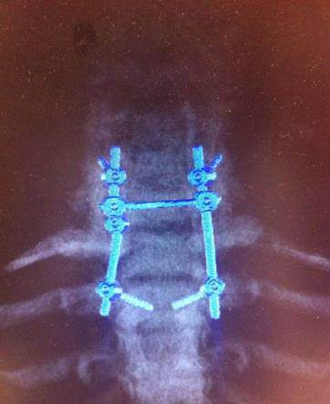
Figure 1 Maximum intensity projection reconstructions from computed tomography scan show C5-Th1 stabilization after the first intervention.

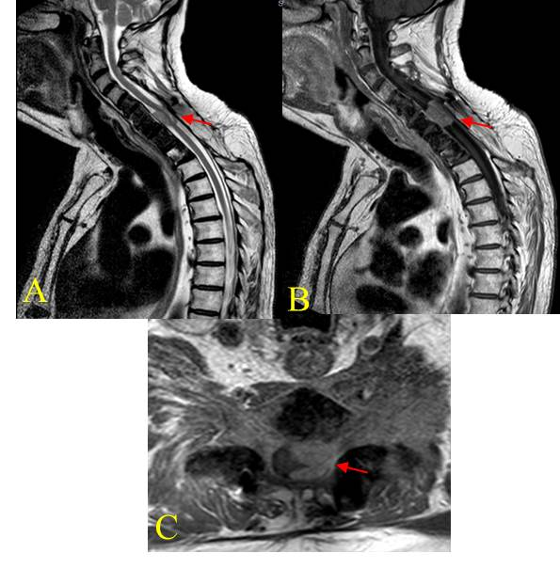
Figure 2 Cervical spine magnetic resonance imaging. A: C5-C7 lesion with homogeneous enhancement after Gd in the T1-weighted sequences; B: T2 weighted sequences showing the enclosed spinal cord; C: Especially on the left side (red arrow).

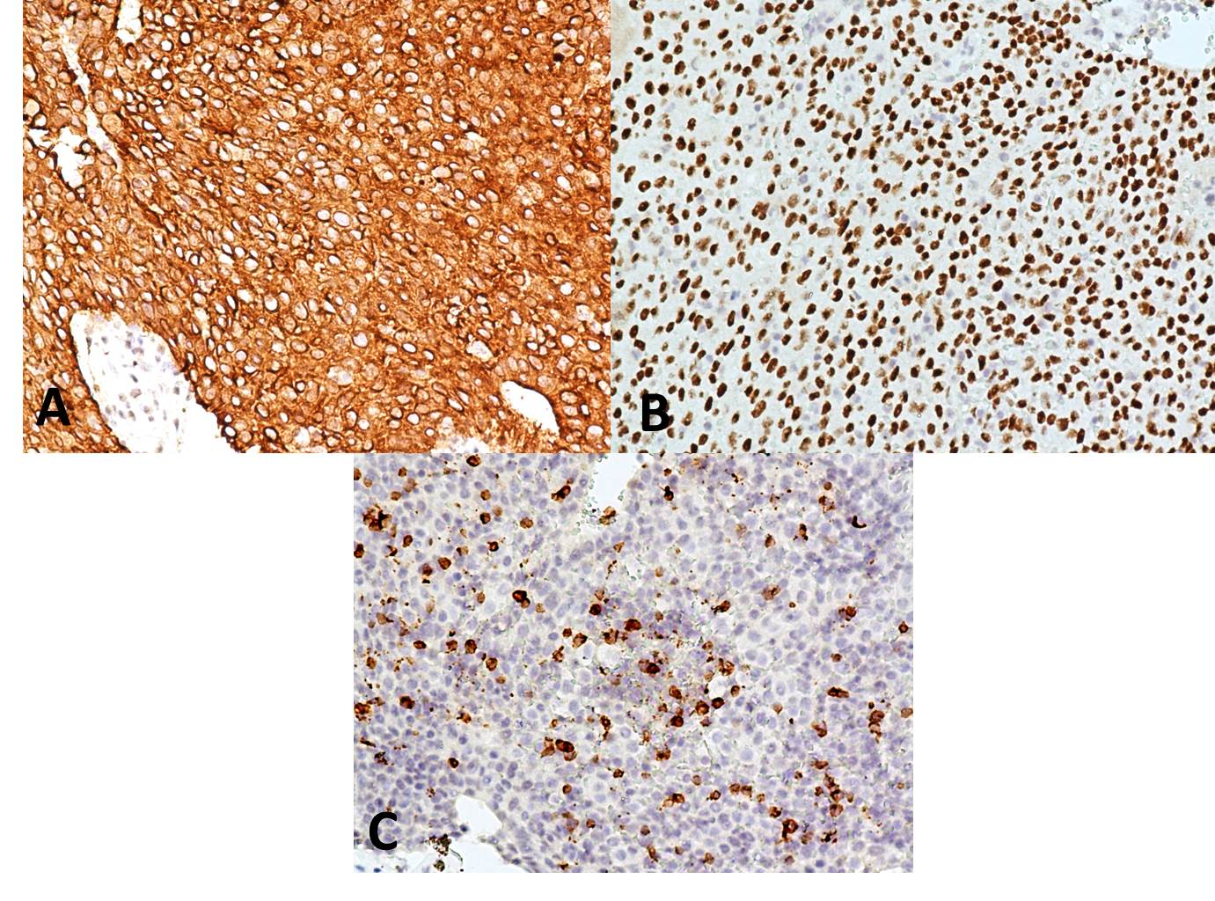
Figure 3 The immunohistochemical examination demonstrated positivity of neoplastic cells for (A) CK19, (B) p63 and (C) CD1a positive T-cells.

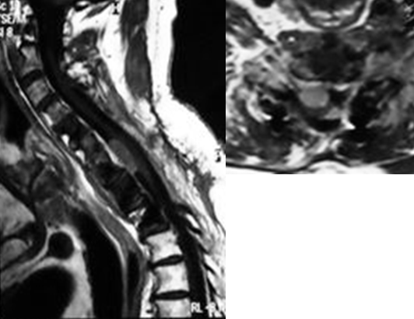
A
B

Figure 4 Magnetic resonance imaging of the cervico-thoracic spine at 3-month follow-up showing (A) a small residual tumor, expecially anteriorly to the cervical spinal cord and (B) axial view (red arrow).

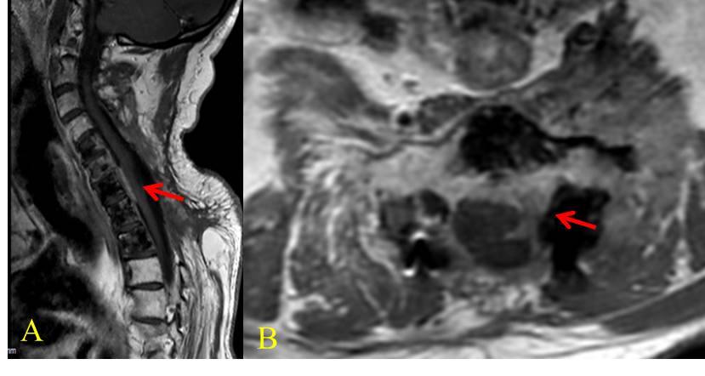
Figure 5 Cervical magnetic resonance imaging after radiation treatment, (A) almost total disappearance of the mass and (B) axial view (red arrow).

