Name of Journal: World Journal of Gastroenterology
Manuscript NO: 88973
Manuscript Type: LETTER TO THE EDITOR

Liver decompensation after rapid weight loss from semaglutide in a patient with non-alcoholic steatohepatitis -associated cirrhosis

Peverelle M et al. Semaglutide-triggered decompensation of NASH cirrhosis

Matthew Peverelle, Jonathan Ng, James Peverelle, Ryan D. Hirsch, Adam Testro

Matthew Peverelle, Jonathan Ng, James Peverelle, Ryan D. Hirsch, Liver transplant unit, Austin Health, Melbourne 3084, Australia

Adam Testro, Liver transplant unit, Austin Health, Heidelberg 3084, Victoria, Australia

Author contributions: Peverelle M, Ng J and Peverelle J designed research and collected data; Hirsch RD analyzed data and designed figures; Testro A analyzed and interpreted data; All authors contributed to the drafting of the manuscript and all authors have given final approval for its submission.

Corresponding author: Matthew Peverelle, MD, Doctor, Liver transplant unit, Austin Health, 145 Studley Rd, Heidelberg VIC 3084, Melbourne 3084, Australia. matthewpeverelle@gmail.com

Received: October 17, 2023
Revised: November 10, 2023
Accepted: December 2, 2023
Published online: December 21, 2023

Abstract
There is rapidly increasing uptake of GLP-1 (glucagon-like peptide-1) agonists such as semaglutide worldwide for weight loss and management of non-alcoholic steatohepatitis (NASH). However, there remains a paucity of safety data in the vulnerable NASH cirrhotic population. We report herein the first documented case of liver decompensation and need for liver transplant waitlisting in a patient with NASH-cirrhosis treated with semaglutide. Rapid weight loss led to the development of ascites and hepatic encephalopathy and an increase in the patients Model for Endstage Liver Disease-Na (MELD-Na) score from 11 to 22. Aggressive nutritional supplementation was commenced and the semaglutide was stopped. Over the following months she regained her weight and her liver recompensated and her MELD-Na decreased to 13, allowing her to be delisted from the transplant waitlist. This case serves as a cautionary tale to clinicians using semaglutide in the cirrhotic population and highlights the need for more safety data in this patient group.

Key Words: Semaglutide; Non-alcoholic steatohepatitis; Cirrhosis; Non-alcoholic steatohepatitis cirrhosis; Glucagon-like peptide 1 agonists; Weight loss

©The Author(s) 2023. Published by Baishideng Publishing Group Inc. All rights reserved.

Citation: Peverelle M, Ng J, Peverelle J, Hirsch RD, Testro A. Liver decompensation after rapid weight loss from semaglutide in a patient with non-alcoholic steatohepatitis -associated cirrhosis. World J Gastroenterol 2023; 29(47): 6165-6167
URL: https://www.wjgnet.com/1007-9327/full/v29/i47/6165.htm
DOI: https://dx.doi.org/10.3748/wjg.v29.i47.6165

Core Tip: Patients with NASH cirrhosis who lose weight rapidly (approximately ≥ 1% of body weight per week) with semaglutide are at risk of liver decompensation. This complication requires the immediate cessation of semaglutide and aggressive nutritional rehabilitation with supplemental protein feeds and micronutrients. Restoration of lost weight can lead to liver recompensation; however, consideration of liver transplantation should be given to patients who fail to respond to treatment.

TO THE EDITOR
We read with interest the systematic review and meta-analysis by Zhu et al^{[1]} reporting on the efficacy and safety of semaglutide in patients with non-alcoholic fatty liver disease (NAFLD). Analyzing three randomized control trials involving 458 patients, they found that semaglutide was effective at improving histologic and radiologic markers of non-alcoholic steatohepatitis (NASH) activity but not histologic fibrosis. The risk of serious adverse events was similar compared to placebo, and importantly, no cases of hepatic decompensation occurred.
We herein present a case of liver decompensation in a patient with NASH cirrhosis after the use of semaglutide. A 68-year-old female with compensated NASH cirrhosis [Model for Endstage Liver Disease-Na (MELD-Na) score 11] was prescribed semaglutide 2.4 mg once weekly to manage her diabetes and obesity. Her other medications at the time included salbutamol for asthma. The semaglutide led to 10 kg weight loss (11% body weight) within 8 wk of treatment before it was stopped. After approximately 8% body weight loss she developed new onset hepatic encephalopathy (HE) requiring the use of lactulose and rifaximin. She also developed ascites requiring diuretic therapy (spironolactone 100 mg and frusemide 40 mg; further increases limited by postural hypotension) and two large-volume paracenteses. Patient adherence to prescribed medications was confirmed by her family during this time. Due to her rapid weight loss, her semaglutide was stopped. Despite stabilization of her weight, she continued to decompensate and her MELD-Na continued to rise (Figure 1). On referral to our service her MELD-Na was 22 (bilirubin 40 µmol/L, creatinine 44, international normalized ratio 1.6, Na 128). Investigations for alternate causes of decompensation including infection, alcohol consumption, hepatocellular carcinoma and portal vein thrombosis were negative. We concluded her liver decompensation was most likely secondary to semaglutide-induced rapid weight loss and malnutrition. She was commenced on high energy and high protein supplementation consisting of 60 g Sustagen twice-daily and micronutrient replacement with thiamine. She also underwent assessment for liver transplantation. Over the following 3 mo, she was reviewed each month by a transplant hepatologist and dietitian to assess her clinical progress, nutritional intake and adherence to treatment. Over this period, she managed to regain 5 kg (6%) of her ideal body weight, and this was associated with an improvement in her ascites and HE and a reduction in MELD-Na to 19 (Figure 1). By 6 mo her weight had returned to baseline, she no longer required abdominal paracentesis and her MELD-Na was 13. She was de-listed from the transplant waitlist and remains compensated at last follow-up.
Our case highlights the potential risk of rapid weight loss with semaglutide in the vulnerable NASH cirrhosis population. In our case, the rapidity of weight loss was significantly greater compared to the studies included in Zhu et al’s^{[1]} meta-analysis (10 kg after 8 wk vs 6.5 kg after 48-72 wk). Loomba et al’s^{[2]} study, included within the meta-analysis, involved patients with NASH cirrhosis and did not report any cases of hepatic decompensation. Of note, our patients pre-semaglutide MELD-Na score was higher (11 for our patient vs. 7.6 in the study group), potentially conferring a greater predisposition to decompensation. It is interesting to note that despite stabilization of her weight after stopping semaglutide, our patient continued to decompensate until she was reviewed at our tertiary centre, as illustrated in Figure 1. Rapid weight loss is an established precipitant of hepatic decompensation in the post bariatric surgery population^{[3]}, with pathophysiological mechanisms thought to involve endogenous free-fatty acid oxidative damage, mitochondrial dysfunction and gut dysbiosis leading to hepatic inflammation and fibrosis^{[4-6]}. However, it should be noted that decompensation has generally occurred later (up to 5 years post-surgery) and degree of excess weight loss (i.e. the amount of weight above the ideal body weight) was up to 110%^{[7]}. Furthermore, the use of glucagon-like peptide 1 agonists such a semaglutide causes delayed gastric emptying, which may impact the absorption of concomitantly administered oral medications and therefore their efficacy. This may have contributed to our patients’ diuretic-refractory ascites. In patients with liver cirrhosis, it is therefore important to consider inadequate absorption of medical therapies as a contributor to failure to respond to standard treatment.
Clinicians should consider the use of semaglutide cautiously in patients with underlying NASH cirrhosis and should strictly adhere to the prescribing information and dose escalation protocols as recommended and consider using a lower dose of the drug. Failure to follow strict dose escalation protocol may lead to significant gastrointestinal side effects including nausea and vomiting, which may precipitate weight loss and decompensation. Furthermore, clinicians must exercise a low threshold for cessation should weight loss occur rapidly (≥ 1% of body weight/week) or signs of liver decompensation develop.

REFERENCES
1 Zhu K, Kakkar R, Chahal D, Yoshida EM, Hussaini T. Efficacy and safety of semaglutide in non-alcoholic fatty liver disease. World J Gastroenterol 2023; 29: 5327-5338 [PMID: 37899788 DOI: 10.3748/wjg.v29.i37.5327]
2 Loomba R, Abdelmalek MF, Armstrong MJ, Jara M, Kjær MS, Krarup N, Lawitz E, Ratziu V, Sanyal AJ, Schattenberg JM, Newsome PN; NN9931-4492 investigators. Semaglutide 2·4 mg once weekly in patients with non-alcoholic steatohepatitis-related cirrhosis: a randomised, placebo-controlled phase 2 trial. Lancet Gastroenterol Hepatol 2023; 8: 511-522 [PMID: 36934740 DOI: 10.1016/S2468-1253(23)00068-7]
3 Eilenberg M, Langer FB, Beer A, Trauner M, Prager G, Staufer K. Significant Liver-Related Morbidity After Bariatric Surgery and Its Reversal-a Case Series. Obes Surg 2018; 28: 812-819 [PMID: 28965313 DOI: 10.1007/s11695-017-2925-x]
4 Verna EC, Berk PD. Role of fatty acids in the pathogenesis of obesity and fatty liver: impact of bariatric surgery. Semin Liver Dis 2008; 28: 407-426 [PMID: 18956297 DOI: 10.1055/s-0028-1091985]
5 van Zutphen T, Ciapaite J, Bloks VW, Ackereley C, Gerding A, Jurdzinski A, de Moraes RA, Zhang L, Wolters JC, Bischoff R, Wanders RJ, Houten SM, Bronte-Tinkew D, Shatseva T, Lewis GF, Groen AK, Reijngoud DJ, Bakker BM, Jonker JW, Kim PK, Bandsma RH. Malnutrition-associated liver steatosis and ATP depletion is caused by peroxisomal and mitochondrial dysfunction. J Hepatol 2016; 65: 1198-1208 [PMID: 27312946 DOI: 10.1016/j.jhep.2016.05.046]
6 Drenick EJ, Fisler J, Johnson D. Hepatic steatosis after intestinal bypass--prevention and reversal by metronidazole, irrespective of protein-calorie malnutrition. Gastroenterology 1982; 82: 535-548 [PMID: 6797866]
7 Moolenaar LR, de Waard NE, Heger M, de Haan LR, Slootmaekers CPJ, Nijboer WN, Tushuizen ME, van Golen RF. Liver Injury and Acute Liver Failure After Bariatric Surgery: An Overview of Potential Injury Mechanisms. J Clin Gastroenterol 2022; 56: 311-323 [PMID: 35180151 DOI: 10.1097/MCG.0000000000001662]
Footnotes
Conflict-of-interest statement: Dr. Peverelle has nothing to disclose.

Open-Access: This article is an open-access article that was selected by an in-house editor and fully peer-reviewed by external reviewers. It is distributed in accordance with the Creative Commons Attribution NonCommercial (CC BY-NC 4.0) license, which permits others to distribute, remix, adapt, build upon this work non-commercially, and license their derivative works on different terms, provided the original work is properly cited and the use is non-commercial. See: https://creativecommons.org/Licenses/by-nc/4.0/

Provenance and peer review: Unsolicited article; Externally peer reviewed.

Peer-review model: Single blind

Peer-review started: October 17, 2023
First decision: October 31, 2023
Article in press: December 2, 2023

Specialty type: Gastroenterology and hepatology
Country/Territory of origin: Australia
Peer-review report’s scientific quality classification
Grade A (Excellent): A
Grade B (Very good): B
Grade C (Good): C
Grade D (Fair): 0
Grade E (Poor): 0

P-Reviewer: Barone M, Italy; Morozov S, Russia S-Editor: Lin C L-Editor: A P-Editor: Xu ZH
Figure Legends
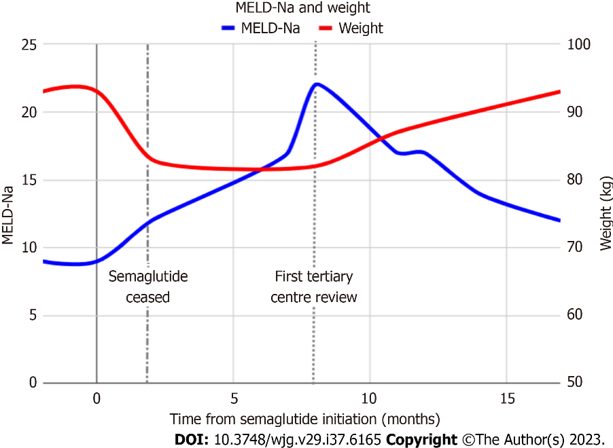
Figure 1 Patient’s weight change with semaglutide use and MELD-Na score over time.

Published by Baishideng Publishing Group Inc
7041 Koll Center Parkway, Suite 160, Pleasanton, CA 94566, USA
Telephone: +1-925-3991568
E-mail: bpgoffice@wjgnet.com
Help Desk: https://www.f6publishing.com/helpdesk
https://www.wjgnet.com

© 2023 Baishideng Publishing Group Inc. All rights reserved.

