Name of Journal: World Journal of Clinical Cases
Manuscript NO: 78891
Manuscript Type: CASE REPORT

Sun-burn induced upper limb lymphedema 11 years following breast cancer surgery: A case report

Li M et al. Sun burn induced upper limb lymphedema

Min Li, Jun Guo, Rong Zhao, Jin-Nan Gao, Ming Li, Lin-Ying Wang

Min Li, Jun Guo, Rong Zhao, Jin-Nan Gao, Lin-Ying Wang, Department of Breast Surgery, Shanxi Bethune Hospital, Shanxi Academy of Medical Science, Taiyuan 030032, Shanxi Province, China

Ming Li, Department of Cancer Research Institute, University of South Australia, Adelaide 5000, Australia

Author contributions: Li M participated in the hospital treatment, collected data, and drafted the manuscript; Gao JN supervised the data collection; Li M supervised the data analysis and revised the manuscript; Wang LY initiated the case study and revised the manuscript; And all the authors approved the manuscript.

Corresponding author: Lin-Ying Wang, MNurs, RN, Chief Nurse, Department of Breast Surgery, Shanxi Bethune Hospital, Shanxi Academy of Medical Science, No. 99 Longcheng Avenue, Taiyuan 030032, Shanxi Province, China. 394398876@qq.com

Received: July 20, 2022
Revised: September 2, 2022
Accepted: October 11, 2022
Published online: November 16, 2022

Abstract
BACKGROUND
Upper arm lymphedema is a common complication one year after breast cancer surgery, which profoundly impacts patients' quality of life.

CASE SUMMARY
We reported a case of lymphedema induced by prolonged sun exposure 11 years after breast cancer surgery.

CONCLUSION
Breast screening, patient education and follow-up after hospital discharge could help to prevent upper-arm lymphedema.

Key Words: Sun-burn; Breast cancer lymphedema; Breast neoplasms; Case report

©The Author(s) 2022. Published by Baishideng Publishing Group Inc. All rights reserved.

Citation: Li M, Guo J, Zhao R, Gao JN, Li M, Wang LY. Sun-burn induced upper limb lymphedema 11 years following breast cancer surgery: A case report. World J Clin Cases 2022; 10(32): 11987-11992
URL: https://www.wjgnet.com/2307-8960/full/v10/i32/11987.htm
DOI: https://dx.doi.org/10.12998/wjcc.v10.i32.11987

Core Tip: Upper arm lymphedema is a common complication one year after breast cancer surgery, which profoundly impacts patients' quality of life. We reported a case of lymphedema induced by prolonged sun exposure 11 years after breast cancer surgery.

INTRODUCTION
Breast cancer is one of the most common malignancies, accounting for 15% of female tumors^{[1]}. Since 2000, the incidence in China has been increasing with a 1% annual increment^{[2]}. Although survival has been significantly improved due to advances in treatment, the quality of life was affected, sometimes due to lymphedema on the affected side^{[3]}. Lymphedema is the main complication after cancer treatment, affecting 12%–28% of the patients after axillary dissection and 3.5%–7.5% after sentinel node biopsy^{[4]}. Patients have upper limb lymph accumulation due to lymphatic vessel rupture and deformation. Lymphedema causes shoulder joint dysfunction and affects patients' mental well-being^{[5,6]}. Research shows that approximately 1/5th of patients in China develop secondary upper limb lymphedema within one year of having breast cancer surgery^{[7]}. Although various approaches have been used, lymphedema remains the most common chronic complication of breast cancer treatment, with only palliative therapies available^{[8]}. Therefore, prevention against modifiable risk factors has become critical. Risk factors for lymphedema include overweight/obesity, high blood pressure, axillary lymph node dissection, chemotherapy, local radiotherapy^{[9]}, limb overload, trauma and infection^{[10]}.
Postoperative infection, delayed healing and improper nursing can hinder lymphatic vessel reconstruction and the establishment of collateral circulation^{[11]}. When using heat therapy, individuals should use common sense and proceed with caution. If there is swelling in the at-risk limb or increased swelling in the lymphedematous limb, stop using heat, such as a hot tub or sauna. Recently, we cured a patient with severe limb lymphedema following solar dermatitis with massive infection, 11 years after right breast cancer surgery. We hereby report this case with the patient's informed consent.

CASE PRESENTATION
Chief complaints
She complained of progressive swelling and heaviness of the right upper limb after a 4-d (approximately 15 h) of outdoor fieldwork under the direct sun. At that time, the patient wore a short-sleeved shirt with no covering on both upper limbs. She experienced chest wall burning pain on the seventh day and came to seek help on the ninth day. On September 9, 2021, she was admitted with forearm erythema, desquamation, and a body temperature of 39.4 ˚C. Prior to this, the patient's upper limbs were normal, and his right upper limb was always protected, with no mosquito bites, infections or injuries. When the patient was exposed to the hot sun nine days ago, she mistakenly believed that she had been in surgery for more than 10 years and did not need to protect his upper limb, which resulted in swelling and pain in his right upper limb and sunburn on his left upper limb.

History of present illness
Figure 1 depicts the affected limb on admission. According to the group standard of the Chinese Nursing Society for lymphedema evaluation (T/CNAS 05-2020), combined with the symptoms reported voluntarily by patients. Following admission, we performed a Breast Cancer & Lymphedema Symptom Experience Index evaluation and measured the circumference. The difference in the circumference between the affected and healthy sides was > 3 cm and diagnosed as severely sunburned lymphedema of the right upper limb^{[12]}. Supplementary Table 1 shows the circumference measurements of both arms.

History of past illness
The right-handed female patient, aged 61, underwent modified radical mastectomy for the right breast cancer (with chemotherapy and radiotherapy of the axilla and chest) in our department 11 years ago. She continued a regular follow-up (The patient was followed up every three months for two years after the operation, every six months for the next 3-5 years and once a year after five years of operation). After breast surgery, there was no complaint of right upper limb discomfort; therefore, arm circumference measurement was not performed regularly.

Physical examination
Comparison of circumferences of left and right upper limbs.

Laboratory examinations
She was also diagnosed with a chest wall infection on the affected side after blood tests.

FINAL DIAGNOSIS
Breast cancer lymphedema.

TREATMENT
Based on bacterial culture results, an eight days 400 U penicillin (b.i.d) therapy was initiated along with a standard of daily dressing and close monitoring of the blood circulation of the infected skin. The patient was advised to wear loose dresses to avoid friction. On the ninth day after the infection was cured, a physiotherapist started a lymphatic drainage massage daily for 40 min. The centripetal massage was also performed twice daily for 30 min with a sleeve pressure of < 40 mmHg. After the physiotherapy, the patient was instructed to wear elastic sleeves. The circumference measurements were taken daily at 5:00 pm to monitor the recovery (Supplementary Table 2). On the 15th day of admission, the patient was discharged after a comprehensive examination of fully recovered limb and function. Figure 2 shows the limbs on the discharge day. We followed the patient telephonically at two weeks, one month, three months, and six months after discharge, and the patient reported no change in any function or circumference of the right limb. Throughout her hospital stay and follow-up calls, she was encouraged to discuss her negative feelings with the care team and to be actively involved in making decisions about treatment and monitoring and prevention of lymphedema.

OUTCOME AND FOLLOW-UP
The patient got a comprehensive recovery, and there was no complaint of discomfort in the follow-up visit.

DISCUSSION
One of the most common post-surgical complications among breast cancer survivors is lymphedema, which can evolve into irreversible interstitial fibrosis^{[13]}. Therefore, the screening and monitoring of lymphedema are important. The most common clinical manifestations of lymphedema include infection, swelling, pain, discomfort, and reduced joint dexterity^{[14]}. American national lymphedema network declaration indicates that patients should be advised to avoid air traveling, maceration, skin puncture (blood collection), compression (blood pressure measurement), skin infection and extreme temperatures of the affected limb^{[15]}. The patient, in this case, had lymphedema due to high temperature. The evaluation is primarily based on the symptoms of patients. In the early stages, patients typically present with a subtle onset of arm or hand swelling, accompanied by a sensation of heaviness in the limb. Swelling in the middle and late stages cannot be relieved by raising or applying external pressure to the affected limb. The scope of involvement is broad and has an orange-peel appearance^{[16]}. The Chinese Nursing Society's Group standard for prevention and care of lymphedema after breast cancer surgery (T/CNAS 05-2020) states that all breast cancer patients should be screened for lymphedema risk before being discharged from the hospital after surgery.
Lymphedema risk scales should be used following a breast cancer operation to identify high-risk patients. Furthermore, for high-risk patients, compliance with preventive behaviors should be monitored at least every six months for the first two years after the operation, and whether lymphedema developed or not should be evaluated. All patients did not have typical presentations. People who are at high risk should accept the objective physical examination, which may include limb measurements, magnetic resonance imaging^{[17]}, lymphoscintigraphy^{[18]}, indocyanine green^{[19]}, and bioimpedance spectroscopy. In a retrospective study of over 165000 hospital admissions for lymphedema, the majority of cases (92%) were associated with cellulitis in the United States between 2012 and 2017^{[20,21]}. Research proves that prolonged exposure of affected limbs to ultraviolet radiation stimulates inflammatory mediators to dilate and infiltrate the blood vessel and damages the skin barrier function, leading to local oozing and even infection. This might be due to high protein deposition in the interstitial tissues that accelerates the growth and reproduction of bacteria^{[22,23]}.
The case indicates that patients should be informed to avoid sun exposure shortly or long after breast cancer surgery, especially in regions where people culturally like beaches and outdoor activities. Patients' knowledge, attitude and behavior play a key role in preventing lymphedema in breast cancer patients^{[24]}. The medical care team should disseminate evidence-based knowledge of lymphedema, guide and train patients to avoid risks, and follow up and closely monitor their practice following hospital discharge.
Baseline upper limb circumference is an objective measurement used to monitor the prevention, occurrence and outcome of lymphedema in breast cancer patients. In this case, overall circumference changes before and after the occurrence of lymphedema and after the treatment could not be evaluated, suggesting the need to record complete upper limb measurements for the rehabilitation of breast cancer patients.
Currently, there are no internationally recognized effective treatments for lymphedema^{[24]}. The conservative treatment of established lymphedema consists of a multimodality regimen that includes general self-care measures (exercise, skin care), compression therapy (compression bandaging, compression garments, intermittent pneumatic compression), and physiotherapy (e.g., simple lymphatic drainage, manual lymphatic drainage, complete decongestive therapy)^{[25,26]}. In China, upper arm lymphedema could be significantly prevented if breast cancer screening is promoted in the community, based on the success of western countries for early detection and less radical surgical treatment^{[27]}.

CONCLUSION
We reported a case of lymphedema caused by prolonged sun exposure 11 years after breast cancer surgery and radiotherapy. Breast screening, patient education and follow-up after hospital discharge could help to prevent upper-arm lymphedema.

REFERENCES
1 Chen W, Zheng R, Baade PD, Zhang S, Zeng H, Bray F, Jemal A, Yu XQ, He J. Cancer statistics in China, 2015. CA Cancer J Clin 2016; 66: 115-132 [PMID: 26808342 DOI: 10.3322/caac.21338]
2 Li J, Fan JH, Pang Y. A Nationwide Hospital-based Multicenter Clinical Epidemiological Investigation for Female Primary Breast Cancer in China. Zhongguo Zhongliu 2013; 4: 254-259 [DOI: 10.3969/j.issn.1006-7256.2017.14.018]
3 Allemani C, Weir HK, Carreira H, Harewood R, Spika D, Wang XS, Bannon F, Ahn JV, Johnson CJ, Bonaventure A, Marcos-Gragera R, Stiller C, Azevedo e Silva G, Chen WQ, Ogunbiyi OJ, Rachet B, Soeberg MJ, You H, Matsuda T, Bielska-Lasota M, Storm H, Tucker TC, Coleman MP; CONCORD Working Group. Global surveillance of cancer survival 1995-2009: analysis of individual data for 25,676,887 patients from 279 population-based registries in 67 countries (CONCORD-2). Lancet 2015; 385: 977-1010 [PMID: 25467588 DOI: 10.1016/S0140-6736(14)62038-9]
4 DiSipio T, Rye S, Newman B, Hayes S. Incidence of unilateral arm lymphoedema after breast cancer: a systematic review and meta-analysis. Lancet Oncol 2013; 14: 500-515 [PMID: 23540561 DOI: 10.1016/S1470-2045(13)70076-7]
5 Hayes SC, Rye S, Battistutta D, DiSipio T, Newman B. Upper-body morbidity following breast cancer treatment is common, may persist longer-term and adversely influences quality of life. Health Qual Life Outcomes 2010; 8: 92 [PMID: 20804558 DOI: 10.1186/1477-7525-8-92]
6 Cal A, Bahar Z. Women's Barriers to Prevention of Lymphedema After Breast Surgery and Home Care Needs: A Qualitative Study. Cancer Nurs 2016; 39: E17-E25 [PMID: 26641643 DOI: 10.1097/NCC.0000000000000326]
7 Wang Y, Jia L, Zhu S. Clinical observation on the treatment of upper limb lymphedema associated with breast cancer with breast pulse tongluo lotion. Zhongri Youhao Yiyuan Xuebao 2014; 28: 171-172 [DOI: 10.3969/j.issn.1001-0025.2014.03.012]
8 Michelotti A, Invernizzi M, Lopez G, Lorenzini D, Nesa F, De Sire A, Fusco N. Tackling the diversity of breast cancer related lymphedema: Perspectives on diagnosis, risk assessment, and clinical management. Breast 2019; 44: 15-23 [PMID: 30580170 DOI: 10.1016/j.breast.2018.12.009]
9 Soran A, Wu WC, Dirican A, Johnson R, Andacoglu O, Wilson J. Estimating the probability of lymphedema after breast cancer surgery. Am J Clin Oncol 2011; 34: 506-510 [PMID: 21127413 DOI: 10.1097/COC.0b013e3181f47955]
10 Zhang X, Brown JC, Paskett ED, Zemel BS, Cheville AL, Schmitz KH. Changes in arm tissue composition with slowly progressive weight-lifting among women with breast cancer-related lymphedema. Breast Cancer Res Treat 2017; 164: 79-88 [PMID: 28391397 DOI: 10.1007/s10549-017-4221-9]
11 Fu MR, Axelrod D, Cleland CM, Qiu Z, Guth AA, Kleinman R, Scagliola J, Haber J. Symptom report in detecting breast cancer-related lymphedema. Breast Cancer (Dove Med Press) 2015; 7: 345-352 [PMID: 26527899 DOI: 10.2147/BCTT.S87854]
12 Professional Committee of Breast Cancer of China Anti-cancer Association. Guidelines and Specifications for Diagnosis and Treatment of Breast Cancer of China Anti-Cancer Association (2015 Edition). Zhongguo Zhongliu 2015; 25: 692-754 [DOI: 10.3969/j.issn.1007-3969.2015.09.010]
13 Bryant JR, Hajjar RT, Lumley C, Chaiyasate K. Clinical Inquiry-In women who have undergone breast cancer surgery, including lymph node removal, do blood pressure measurements taken in the ipsilateral arm increase the risk of lymphedema? J Okla State Med Assoc 2016; 109: 589-591 [PMID: 29292975]
14 Barlow S, Dixey R, Todd J, Taylor V, Carney S, Newell R. 'Abandoned by medicine'? A qualitative study of women's experiences with lymphoedema secondary to cancer, and the implications for care. Prim Health Care Res Dev 2014; 15: 452-463 [PMID: 25146257 DOI: 10.1017/S1463423613000406]
15 Position Statement of the National Lymphedema Network. Lymphedema risk reduction practices. [cited 10 June 2022]. Available from: http://www.lymphnet.org/pdfDocs/nlnriskreductionpdf.2012
16 Damstra RJ, Halk AB; Dutch Working Group on Lymphedema. The Dutch lymphedema guidelines based on the International Classification of Functioning, Disability, and Health and the chronic care model. J Vasc Surg Venous Lymphat Disord 2017; 5: 756-765 [PMID: 28818234 DOI: 10.1016/j.jvsv.2017.04.012]
17 Duewell S, Hagspiel KD, Zuber J, von Schulthess GK, Bollinger A, Fuchs WA. Swollen lower extremity: role of MR imaging. Radiology 1992; 184: 227-231 [PMID: 1609085 DOI: 10.1148/radiology.184.1.1609085]
18 Mihara M, Hara H, Araki J, Kikuchi K, Narushima M, Yamamoto T, Iida T, Yoshimatsu H, Murai N, Mitsui K, Okitsu T, Koshima I. Indocyanine green (ICG) lymphography is superior to lymphoscintigraphy for diagnostic imaging of early lymphedema of the upper limbs. PLoS One 2012; 7: e38182 [PMID: 22675520 DOI: 10.1371/journal.pone.0038182]
19 Qin ES, Bowen MJ, Chen WF. Diagnostic accuracy of bioimpedance spectroscopy in patients with lymphedema: A retrospective cohort analysis. J Plast Reconstr Aesthet Surg 2018; 71: 1041-1050 [PMID: 29650264 DOI: 10.1016/j.bjps.2018.02.012]
20 Lopez M, Roberson ML, Strassle PD, Ogunleye A. Epidemiology of Lymphedema-related admissions in the United States: 2012-2017. Surg Oncol 2020; 35: 249-253 [PMID: 32932222 DOI: 10.1016/j.suronc.2020.09.005]
21 Boettler MA, Kaffenberger BH, Chung CG. Cellulitis: A Review of Current Practice Guidelines and Differentiation from Pseudocellulitis. Am J Clin Dermatol 2022; 23: 153-165 [PMID: 34902109 DOI: 10.1007/s40257-021-00659-8]
22 Snyder M, Turrentine JE, Cruz PD Jr. Photocontact Dermatitis and Its Clinical Mimics: an Overview for the Allergist. Clin Rev Allergy Immunol 2019; 56: 32-40 [PMID: 29951786 DOI: 10.1007/s12016-018-8696-x]
23 Chachaj A, Małyszczak K, Pyszel K, Lukas J, Tarkowski R, Pudełko M, Andrzejak R, Szuba A. Physical and psychological impairments of women with upper limb lymphedema following breast cancer treatment. Psychooncology 2010; 19: 299-305 [PMID: 19399782 DOI: 10.1002/pon.1573]
24 Cormier JN, Rourke L, Crosby M, Chang D, Armer J. The surgical treatment of lymphedema: a systematic review of the contemporary literature (2004-2010). Ann Surg Oncol 2012; 19: 642-651 [PMID: 21863361 DOI: 10.1245/s10434-011-2017-4]
25 Executive Committee of the International Society of Lymphology. The diagnosis and treatment of peripheral lymphedema: 2020 Consensus Document of the International Society of Lymphology. Lymphology 2020; 53: 3-19 [PMID: 32521126]
26 McLaughlin SA, DeSnyder SM, Klimberg S, Alatriste M, Boccardo F, Smith ML, Staley AC, Thiruchelvam PTR, Hutchison NA, Mendez J, MacNeill F, Vicini F, Rockson SG, Feldman SM. Considerations for Clinicians in the Diagnosis, Prevention, and Treatment of Breast Cancer-Related Lymphedema, Recommendations from an Expert Panel: Part 2: Preventive and Therapeutic Options. Ann Surg Oncol 2017; 24: 2827-2835 [PMID: 28766218 DOI: 10.1245/s10434-017-5964-6]
27 Hua-Ping H, Jian-Rong Z, Zeng Q. Risk Factors Associated with Lymphedema among Postmenopausal Breast Cancer Survivors after Radical Mastectomy and Axillary Dissection in China. Breast Care (Basel) 2012; 7: 461-464 [PMID: 24715827 DOI: 10.1159/000345459]

Footnotes
Informed consent statement: The patient has signed the informed consent form and uploaded it before treatment, and the study has passed the review of our hospital's ethics committee.

Conflict-of-interest statement: All the authors report no relevant conflicts of interest for this article.

CARE Checklist (2016) statement: The authors have read the CARE Checklist (2016), and the manuscript was prepared and revised according to the CARE Checklist (2016).

Open-Access: This article is an open-access article that was selected by an in-house editor and fully peer-reviewed by external reviewers. It is distributed in accordance with the Creative Commons Attribution NonCommercial (CC BY-NC 4.0) license, which permits others to distribute, remix, adapt, build upon this work non-commercially, and license their derivative works on different terms, provided the original work is properly cited and the use is non-commercial. See: https://creativecommons.org/Licenses/by-nc/4.0/

Provenance and peer review: Unsolicited article; Externally peer reviewed.

Peer-review model: Single blind

Peer-review started: July 20, 2022
First decision: August 22, 2022
Article in press: October 11, 2022

Specialty type: Medicine, research and experimental
Country/Territory of origin: China
Peer-review report’s scientific quality classification
Grade A (Excellent): 0
Grade B (Very good): 0
Grade C (Good): C
Grade D (Fair): D
Grade E (Poor): 0

P-Reviewer: Vinh-Hung V, Martinique; Yap RVC, Philippines S-Editor: Liu XF L-Editor: A P-Editor: Liu XF

Figure Legends
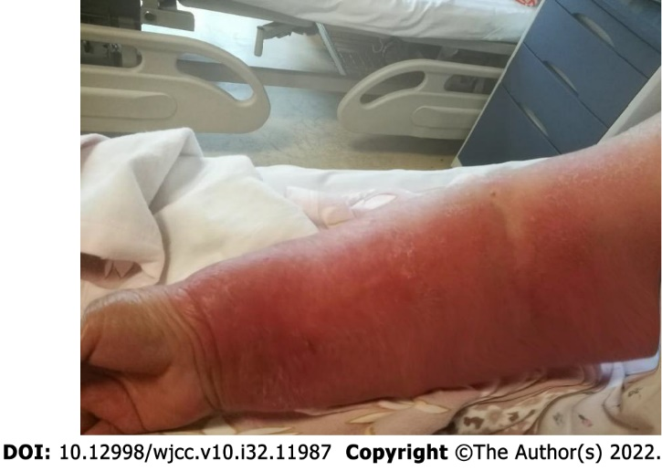
Figure 1 Patients affected right limb on admission (on September 9, 2021) (Supplementary Table 1).

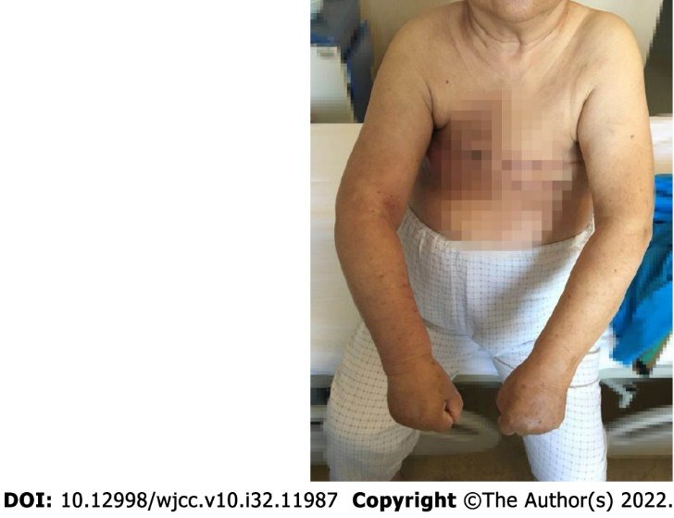
Figure 2 Comparison of the affected limb on discharge Supplement (Supplementary Table 2).

Published by Baishideng Publishing Group Inc
7041 Koll Center Parkway, Suite 160, Pleasanton, CA 94566, USA
Telephone: +1-925-3991568
E-mail: bpgoffice@wjgnet.com
Help Desk: https://www.f6publishing.com/helpdesk
https://www.wjgnet.com

© 2022 Baishideng Publishing Group Inc. All rights reserved.

