Name of Journal: World Journal of Gastroenterology
ESPS Manuscript NO: 20319
Manuscript Type: Case report

Characteristic clinical features of Aspergillus appendicitis: Case report and literature review

Gjeorgjievski M et al. Aspergillus appendicitis associated with neutropenia and AML

Mihajlo Gjeorgjievski, Mitual B Amin, Mitchell S Cappell

Mihajlo Gjeorgjievski, Mitchell S Cappell, Division of Gastroenterology and Hepatology, William Beaumont Hospital, Royal Oak, Mi 48073, United States

Mitual B Amin, Anatomic Pathology, William Beaumont Hospital, Royal Oak, Mi 48073, United States

Mitual B Amin, Mitchell S Cappell, Oakland University William Beaumont School of Medicine, Royal Oak, Mi 48073, United States

Author contributions: All authors equally contributed to this paper.

Institutional review board statement: Case report exempted/approved by William Beaumont Hospital IRB on 12/01/2014.

Conflict-of-interest statement: None for all authors. This paper does not discuss any confidential pharmaceutical industry data reviewed by Dr. Cappell as a consultant for the United States Food and Drug Administration Advisory Committee on Gastrointestinal Drugs.

Open-Access: This article is an open-access article which was selected by an in-house editor and fully peer-reviewed by external reviewers. It is distributed in accordance with the Creative Commons Attribution Non Commercial (CC BY-NC 4.0) license, which permits others to distribute, remix, adapt, build upon this work non-commercially, and license their derivative works on different terms, provided the original work is properly cited and the use is non-commercial. See: http://creativecommons.org/licenses/by-nc/4.0/

correspondence to: Mitchell S Cappell, MD, PhD, Chief, Division of Gastroenterology and Hepatology, William Beaumont Hospital, MOB #602, 3535 West Thirteen Mile Road, Royal Oak, Mi 48073, United States. mscappell@yahoo.com
Telephone: +1-248-5511227
Fax: +1-248-5517581

Received: June 1, 2015
Peer-review started: June 2, 2015
First decision: June 19, 2015
Revised: July 13, 2015
Accepted: August 30, 2015
Article in press:
Published online:

Abstract
This work aims to facilitate diagnosing Aspergillus appendicitis, which can be missed clinically due to its rarity, by proposing a clinical pentad for Aspergillus appendicitis based on literature review and one new case. The currently reported case of pathologically-proven Aspergillus appendicitis was identified by computerized search of pathology database at William Beaumont Hospital, 1999-2014. Prior cases were identified by computerized literature search. Among 10980 pathology reports of pathologically-proven appendicitis, one case of Aspergillus appendicitis was identified (rate = 0.01%). A young boy with profound neutropenia, recent chemotherapy, and acute myelogenous leukemia presented with right lower quadrant pain, pyrexia, and generalized malaise. Abdominal-computed tomography scan showed a thickened appendiceal wall and periappendiceal inflammation, suggesting appendicitis. Emergent laparotomy showed an inflamed, thickened appendix, which was resected. The patient did poorly postoperatively with low-grade-fevers while receiving antibacterial therapy, but rapidly improved after initiating amphotericin therapy. Microscopic examination of a silver-stain of the appendectomy specimen revealed fungi with characteristic Aspergillus morphology, findings confirmed by immunohistochemistry. Primary Aspergillus appendicitis is exceptionally rare, with only 3 previously reported cases. All three cases presented with neutropenia, recent chemotherapy, acute leukemia, and suspected appendicitis; the two prior cases initially treated with antibacterial therapy fared poorly before instituting anti-Aspergillus therapy. The current patient satisfied all these five criteria. Based on these four cases, a clinical pentad is proposed for Aspergillus appendicitis: clinically-suspected appendicitis, neutropenia, recent chemotherapy, acute leukemia, and poor clinical response if treated solely by antibacterial/anti-candidial therapy. Patients with this proposed pentad may benefit from testing for Aspergillus infection by silver-stains/immunohistochemistry and considering empirical anti-Aspergillus therapy pending a tissue diagnosis.

Key words: Aspergillosis; Aspergillus appendicitis; Fungal appendicitis; Appendicitis; Neutropenia; Chemotherapy; Acute myelocytic leukemia

© The Author(s) 2015. Published by Baishideng Publishing Group Inc. All rights reserved.

Core tip: This work reports the fourth reported case of isolated Aspergillus appendicitis, further characterizes this syndrome, and identifies a clinical pentad associated with this syndrome: clinically-suspected appendicitis, neutropenia, recent chemotherapy, acute leukemia, and poor clinical course if treated solely with antibacterial or anti-Candidial antibiotics. These risk factors are biologically reasonable. Immunosuppression from neutropenia and acute leukemia may promote Aspergillus appendicitis. Local gastrointestinal ulcers from recent chemotherapy provides a nidus for fungal colonization. In patients presenting with this proposed pentad, Aspergillus appendicitis should be considered in the differential diagnosis, special silver stains should be performed to evaluate for this infection, and empiric anti-Aspergillus therapy may be considered pending tissue diagnosis.

Gjeorgjievski M, Amin MB, Cappell MS. Characteristic clinical features of Aspergillus appendicitis: Case report and literature review. World J Gastroenterol 2015; In press

Introduction
The diagnosis of isolated (primary) Aspergillus appendicitis may be clinically overlooked or delayed because of its exceptional rarity, as shown by a review of the English literature revealing only three cases, and its association with profound immunosuppression (Table 1)^{[1-3]} that can delay or mask the usual clinical features of appendicitis^{[4,5]}. Yet, delayed diagnosis and therapy for Aspergillus appendicitis may have dire patient consequences, as occurred in two of the three previously reported cases^{[1,2]}. A new patient is reported of isolated Aspergillus appendicitis who presented with five striking clinical findings, and a novel syndromic pentad is proposed as a diagnostic tool, based on this new case report and review of the three previously reported cases that demonstrated nearly identical findings.
Computerized search using the words “appendicitis” and “Aspergillus” of the pathology database at William Beaumont Hospital, Royal Oak, July 1999-December 2014, revealed only 1 case of Aspergillus appendicitis (0.01% rate) among 10,980 pathology reports of appendicitis proven by pathologic examination of the appendectomy specimen. Published reports of Aspergillus appendicitis were identified by computerized literature search using PubMed; and review of general textbooks and specialized monographs in gastroenterology, pathology, and infectious diseases. One case report of isolated Aspergillus appendicitis written in German was professionally translated^{[6]}. Case reports of small intestinal Aspergillosis without known or documented appendiceal involvement were excluded^{[7]}. This study received exemption/approval by William Beaumont Hospital IRB on December 1, 2014.

Case report
An 8-year-old boy with acute myelogenous leukemia (AML), diagnosed one month earlier, and with profound neutropenia, after receiving two cycles of IV chemotherapy with daunorubicin, cytarabine, thioguanine, etoposide and dexamethasone, presented with low-grade pyrexia and chills for one day. Physical examination revealed temperature = 36.8 ⁰C, pulse = 111 beats/min, blood pressure = 94/63 mmHg. and mild right lower quadrant (RLQ) tenderness without rebound tenderness. The leukocyte count = 200 cells/mm³ (normal 4800-10100 cells/mm³), neutrophil count < 100 cells/mm³ (normal 1600-7200 cells/mm³), hematocrit = 36.3% (normal in male boy, age 6-9 years: 33.6%-43.4%), and platelet count = 90000/mm³ (normal 150000-400000/mm³). Abdominal ultrasound was unrevealing. Abdomino-pelvic computed tomography (CT) showed a mildly enlarged appendix without an appendicolith or periappendiceal inflammation, findings possibly consistent with early appendicitis. The patient was rehydrated with normal saline and administered IV antibiotic therapy with amoxicillin, gentamicin and metronidazole, but developed increasing RLQ abdominal pain and several episodes of vomiting during the ensuing 24 h. Repeat abdomino-pelvic CT scan revealed a dilated appendiceal lumen, thickened appendiceal wall, and periappendiceal fat stranding, findings consistent with appendicitis (Figure 1).
Emergency laparotomy revealed an inflamed, edematous, dusky appendix without appendiceal perforation but with thickened periappendiceal mesentery. The appendix was resected. Microscopic examination of hematoxylin and eosin stains of histologic sections of the resected appendix showed an acute necrotizing appendicitis, with scattered questionable fungal hyphal forms. Postoperatively, the patient continued to be ill with persistent moderate pyrexia for 12 d, while receiving IV ampicillin, gentamicin, and metronidazole antibiotic therapy and filgrastim (granulocyte colony stimulating factor). Due to this poor clinical response, evident risk factors for fungal appendicitis, and questionable findings of fungal hyphae on a conventional hematologic stain, a Grocott-Gomori methenamine-silver nitrate stain was performed on the resected specimen which revealed numerous fungal hyphae that showed features characteristic of Aspergillus of septation and acutely angled branching, and which was confirmed as Aspergillus by immunohistochemistry (Figure 2A, B). The specific species causing the Aspergillus infection could not be determined in the formalin fixed tissue. On day 13 IV amphotericin-B was added to the antibiotic regimen and the patient rapidly improved clinically, with defervescence and gradual recovery of the leukocyte count to 3400 cells/mm³. He was discharged after 21 d of IV amphotericin therapy to receive oral itraconazole as an outpatient. During 8 months of follow up, the patient had 2 relapses of AML, but no evident Aspergillus recurrence, while continuing oral antifungal prophylaxis with itraconazole.

Discussion
Aspergillus, a widespread fungus in the environment, usually enters the human body by airborne transmission and colonizes the nasal cavities or facial sinuses. Invasive pulmonary aspergillosis accounts for 90%-98% of invasive Aspergillus infections, but hematogenous spread may cause disseminated infection^{[8-12]}, or rarely isolated infections of other organs, including central nervous system, heart, liver, kidneys, and gastrointestinal (GI) tract^{[13-17]}. Based on a literature review of more than 3000 cases of Aspergillus infection, Denning et al. hypothesized that isolated GI aspergillosis generally arises from ingestion of food contaminated with Aspergillus, and colonization by Aspergillus of GI ulcers which can arise from antecedent chemotherapy^{[10,18]}.
Aspergillus fumigatus is the most frequent species that causes human infections, followed by A. flavus, A. terreus, A. niger, and A. nidulans^{[19]}. The risk of pulmonary infection and hematogenous spread greatly increases with immunosuppression, including profound neutropenia, glucocorticoid therapy, and neutrophilic or phagocytic dysfunction from acute leukemia^{[20,21]}, chronic granulomatous disease, and advanced human immunodeficiency virus infection^{[7,22-24]}.
GI aspergillosis is rare^{[7,22,25]}, isolated GI aspergillosis is even rarer, and isolated Aspergillus appendicitis is exceedingly rare. For example, in a review of 1,538 patients with aspergillosis, only 85 (5.5%) had GI aspergillosis, and only 14 (0.8%) patients had isolated GI aspergillosis^{[7]}. The currently reported case of isolated appendiceal aspergillosis represents only the fourth reported case in the English literature (Table 1). A fifth case published in German in 1959^{[6]} is detailed in Table 1, but not presently analyzed because (1) it was published before the advent of modern laboratory and imaging tests for appendicitis, such as abdominal ultrasound or CT; and (2) the case report lacked critical clinical details, such as microscopic findings, due to brevity of the report.
All four analyzed cases, including the current case, presented with a distinct syndrome of clinically-suspected appendicitis, acute leukemia [either AML or acute lymphocytic leukemia (ALL)], recently administered chemotherapy, and neutropenia (Table 1)^{[1-3]}; and three of the patients, including the current case, initially did poorly when receiving antibacterial therapy without anti-Aspergillus therapy^{[1,2]}. The fourth case received anti-Aspergillus therapy promptly without delay. Four other cases of appendiceal aspergillosis were reported with other GI involvement, but without clinically apparent extraintestinal spread (Table 2)^{[26-29]}, of which one had disseminated aspergillosis demonstrated by autopsy^{[29]}. All four of these cases, like the four cases of isolated Aspergillus appendicitis, had underlying AML or ALL, neutropenia, and recent chemotherapy.
To promote early diagnosis and appropriate treatment, a clinical pentad is proposed for suspected Aspergillus appendicitis of: (1) clinically-suspected appendicitis; (2) neutropenia; (3) recent chemotherapy; (4) underlying acute leukemia; and (5) poor response if administered antibacterial antibiotics or anti-Candidial therapy without anti-Aspergillus therapy. The hypothesized pathophysiology of the proposed syndromic pentad is Aspergillus, presumably ingested in contaminated food (1) colonizes GI ulcers or areas of mucositis induced by chemotherapy. Mucosal ulcers commonly occurs after chemotherapy with daunorubicine, which was administered in 3 of the 4 reported cases^{[2,3,current report]}, or after chemotherapy with cytarabine^{[30]}, which was administered in 2 of the 4 reported cases^{[3,current report]}, (fourth patient received unspecified chemotherapy^{[1]}). Aspergillus then invades the appendiceal wall due to immunosuppression from (2) neutropenia and (3) acute leukemia^{[31]}. The patients, despite immunosuppression, still present clinically (4) with RLQ pain and fever suggestive of appendicitis; and (5) the patients with Aspergillus infection should not respond to conventional antibacterial or anti-Candidial antibiotics.
Patients satisfying this pentad should be: (1) evaluated for Aspergillus by microscopic examination with special stains, such as Grocott-Gomori methenamine silver or periodic acid-Schiff (PAS)-diastase stains, supplemented by immunohistochemistry as necessary because the fungal elements may not be readily visible on routine hematoxylin and eosin stained slides; (2) should have the entire resected appendix submitted for histologic examination if the standardly reviewed one or two representative sections of the appendix lack identifiable fungal structures; and (3) should be considered for empiric anti-Aspergillus therapy if doing poorly on conventional antibiotic therapy pending a tissue diagnosis. The importance of early anti-Aspergillus therapy is emphasized by two of the four reported cases of isolated Aspergillus appendicitis improving dramatically after instituting anti-Aspergillus therapy and appendectomy. Of note, the prognosis of isolated Aspergillus appendicitis appears to be better than that of Aspergillus appendicitis combined with Aspergillus enterocolitis.
This work illustrates that neutropenia after chemotherapy is an important risk factor for Aspergillus appendicitis/enterocolitis, and emphasizes the importance of filgrastim therapy to decrease the severity or duration of neutropenia after chemotherapy. Filgrastim helps prevent febrile neutropenia from Aspergillus or other opportunistic infections in experiments in mice^{[32,33]}, or in clinical trials^{[34,35]}, and is likely important in treating Aspergillus appendicitis or enterocolitis occurring in the setting of neutropenia.
The proposed pentad is subject to criticism. First, the data are limited to four cases of isolated Aspergillus appendicitis and four cases of Aspergillus appendicitis with other GI involvement, and therefore require further confirmation. However, all four case reports generally satisfied the proposed pentad. Second, the reviewed cases may lack clinical details because of their retrospective nature. Third, cases obtained from the literature, particularly individual case reports, are subject to reporting bias. For example, clinicians might selectively report and journal editors might selectively publish only dramatic cases of poor response to antibacterial therapy and rapid recovery after instituting anti-Aspergillus therapy. Fourth, although the proposed syndromic pentad may be highly sensitive for Aspergillus appendicitis, the specificity is unstudied and might only be moderate. The differential diagnosis in patients satisfying this pentad also includes (bacterial) neutropenic typhlitis, with or without bacterial appendicitis^{[36,37]}, and appendicitis caused by other fungi^{[38]}, including Candida^{[29]}, Mucor^{[39]}, and Histoplasma^{[40,41]}. Therefore, this pentad should not be viewed as diagnostic, but merely as clinically useful to raise a suspicion of potential Aspergillus appendicitis. All five criteria appear to be typical for Aspergillus appendicitis, but the first four criteria may also occur with (bacterial) neutropenic typhlitis/enterocolitis and only the fifth criterion of poor response to conventional therapy is relatively specific for Aspergillus appendicitis.
This clinical pentad may become increasingly important clinically because of an increasing incidence of invasive Aspergillus^{[42]}, and an increasing incidence of severe neutropenia from more potent immunosuppressive chemotherapy and more frequent stem cell transplantation^{[14]}. It is important to recognize neutropenic patients with invasive Aspergillus because they may fare poorly with solely antibacterial or anti-Candidial therapy (e.g., fluconazole) without specific anti-Aspergillus therapy (e.g., voriconazole or amphotericin). Addition of another factor to the pentad of persistently positive galactomannan antigenemia in patients with suspected appendicitis might be useful diagnostically but is not warranted at this point because of a lack of data in the reported cases of appendiceal aspergillosis^{[43]}.

Comments
Case characteristics
An 8-year-old boy with acute myelogenous leukemia, diagnosed one month earlier, and with profound neutropenia, after receiving two cycles of IV chemotherapy with daunorubicin, cytarabine, thioguanine, etoposide and dexamethasone, presented with low-grade pyrexia and chills for one day.

Clinical diagnosis
Physical examination revealed temperature = 36.8 ⁰C, pulse = 111 beats/min, blood pressure = 94/63 mmHg. and mild right lower quadrant (RLQ) tenderness without rebound tenderness. The leukocyte count=200 cells/mm³ (normal 4800-10100 cells/mm³), neutrophil count < 100 cells/mm³ (normal 1600-7200 cells/mm³), hematocrit = 36.3% (normal in male boy, age 6-9 years: 33.6%-43.4%), and platelet count = 90000/mm³ (normal 150000-400000/mm³).

Differential diagnosis
Clinical presentation is an episode of febrile neutropenia. The differential diagnosis includes neutropenic typhlitis and/or appendicitis, due to local opportunistic infections including bacterial infections, Candida, Mucor, Histoplasma, or Aspergillus.

Laboratory diagnosis
The leukocyte count = 200 cells/mm³ (normal 4800-10100 cells/mm³), and neutrophil count < 100 cells/mm³ (normal 1600-7200 cells/mm³). These findings demonstrate profound neutropenia.

Imaging diagnosis
Abdomino-pelvic computed tomography scan revealed a dilated appendiceal lumen, thickened appendiceal wall, and periappendiceal fat stranding, findings consistent with appendicitis.

Pathological diagnosis
Microscopic examination of hematoxylin and eosin stains of histologic sections of the resected appendix showed an acute necrotizing appendicitis, with scattered questionable fungal hyphal forms. A Grocott-Gomori methenamine-silver nitrate stain performed on the resected specimen revealed numerous fungal hyphae that showed features characteristic of Aspergillus of septation and acutely angled branching, and which was confirmed as Aspergillus by immunohistochemistry.

Treatment
The patient underwent appendectomy for the appendicitis and was administered IV filgrastim (granulocyte colony stimulating factor) for the profound neutropenia. On postoperative day 13 IV amphotericin-B therapy was added when Aspergillus appendicitis was identified by special stains performed on the resected appendix.

Related reports
Review of the modern literature revealed only 3 other reported cases of isolated Aspergillus appendicitis, aside from one case very briefly reported in German in 1959.

Experiences and lessons
Analysis of the current case and review of the three prior case reported in the modern literature, suggest that patients with Aspergillus appendicitis may clinically present with a pentad of: clinically-suspected appendicitis, neutropenia, recent chemotherapy, acute leukemia, and poor clinical response if treated solely by antibacterial/anti-candidial therapy.

Peer-review
The strengths of the article include: reporting a well-documented case of isolated Aspergillus appendicitis, thorough review of the three previously reported cases as identified by review of the modern literature, and the proposal of a clinical pentad to facilitate clinical recognition of Aspergillus appendicitis. The main weakness, as pointed out by peer review, is that only four cases have been reported of isolated Aspergillus appendicitis, and therefore the conclusions about the general clinical presentation of this infection are tentative and require further confirmation.

References
1 Park BH, Suh JH, Choi HJ, Cha HJ, Nam CW, Kim YM. Acute appendicitis associated with aspergillosis in a leukemia patient: case report. Korean J Pathol 2010; 44: 330-332
2 Kontoyiannis DP, Mathur M, Chen YB, Shellito PC, Tse JY. Case records of the Massachusetts General Hospital. Case 13-2014. A 41-year-old man with fever and abdominal pain after stem-cell transplantation. N Engl J Med 2014; 370: 1637-1646 [PMID: 24758620 DOI: 10.1056/NEJMcpc1305994]
3 Rogers S, Potter MN, Slade RR. Aspergillus appendicitis in acute myeloid leukaemia. Clin Lab Haematol 1990; 12: 471-476 [PMID: 2081387]
4 Bova R, Meagher A. Appendicitis in HIV-positive patients. Aust N Z J Surg 1998; 68: 337-339 [PMID: 9631905]
5 Lee J, Tashjian DB, Moriarty KP. Missed opportunities in the treatment of pediatric appendicitis. Pediatr Surg Int 2012; 28: 697-701 [PMID: 22622518 DOI: 10.1007/s00383-012-3108-4]
6 Staib F. [Appendicitis and amp; cecal phlegmons caused by Aspergillus]. Dtsch Med Wochenschr 1959; 84: 220-221 [PMID: 13630116]
7 Eggimann P, Chevrolet JC, Starobinski M, Majno P, Totsch M, Chapuis B, Pittet D. Primary invasive aspergillosis of the digestive tract: report of two cases and review of the literature. Infection 2006; 34: 333-338 [PMID: 17180588]
8 Hori A, Kami M, Kishi Y, Machida U, Matsumura T, Kashima T. Clinical significance of extra-pulmonary involvement of invasive aspergillosis: a retrospective autopsy-based study of 107 patients. J Hosp Infect 2002; 50: 175-182 [PMID: 11886192]
9 Duthie R, Denning DW. Aspergillus fungemia: report of two cases and review. Clin Infect Dis 1995; 20: 598-605 [PMID: 7756482]
10 Denning DW, Stevens DA. Antifungal and surgical treatment of invasive aspergillosis: review of 2,121 published cases. Rev Infect Dis 1990; 12: 1147-1201 [PMID: 2267490]
11 Wiley JM, Smith N, Leventhal BG, Graham ML, Strauss LC, Hurwitz CA, Modlin J, Mellits D, Baumgardner R, Corden BJ. Invasive fungal disease in pediatric acute leukemia patients with fever and neutropenia during induction chemotherapy: a multivariate analysis of risk factors. J Clin Oncol 1990; 8: 280-286 [PMID: 2299371]
12 Albelda SM, Talbot GH, Gerson SL, Miller WT, Cassileth PA. Pulmonary cavitation and massive hemoptysis in invasive pulmonary aspergillosis. Influence of bone marrow recovery in patients with acute leukemia. Am Rev Respir Dis 1985; 131: 115-120 [PMID: 3966697]
13 Bai QX, Huan Y, Wang JH, Yang LJ, Dong HJ. Successful treatment of liver aspergilloma by caspofungin acetate first-line therapy in a non-immunocompromised patient. Int J Mol Sci 2012; 13: 11063-11070 [PMID: 23109838 DOI: 10.3390/ijms130911063]
14 Chasan R, Patel G, Malone A, Finn M, Huprikar S. Primary hepatic aspergillosis following induction chemotherapy for acute leukemia. Transpl Infect Dis 2013; 15: E201-E205 [PMID: 24034232 DOI: 10.1111/tid.12127]
15 van der Velden WJ, Blijlevens NM, Klont RR, Donnelly JP, Verweij PE. Primary hepatic invasive aspergillosis with progression after rituximab therapy for a post transplantation lymphoproliferative disorder. Ann Hematol 2006; 85: 621-623 [PMID: 16758192]
16 Stevens DA, Melikian GL. Aspergillosis in the 'nonimmunocompromised' host. Immunol Invest 2011; 40: 751-766 [PMID: 21985304 DOI: 10.3109/08820139.2011.614307]
17 Sanders DL, Pfeiffer RB, Hashimoto LA, Subramony C, Chen F. Pseudomembranous gastritis: a complication from aspergillus infection. Am Surg 2003; 69: 536-538 [PMID: 12852516]
18 Denning DW. Therapeutic outcome in invasive aspergillosis. Clin Infect Dis 1996; 23: 608-615 [PMID: 8879787]
19 Dagenais TR, Keller NP. Pathogenesis of Aspergillus fumigatus in Invasive Aspergillosis. Clin Microbiol Rev 2009; 22: 447-465 [PMID: 19597008 DOI: 10.1128/CMR.00055-08]
20 Gerson SL, Talbot GH, Hurwitz S, Strom BL, Lusk EJ, Cassileth PA. Prolonged granulocytopenia: the major risk factor for invasive pulmonary aspergillosis in patients with acute leukemia. Ann Intern Med 1984; 100: 345-351 [PMID: 6696356]
21 Pagano L, Caira M, Candoni A, Offidani M, Martino B, Specchia G, Pastore D, Stanzani M, Cattaneo C, Fanci R, Caramatti C, Rossini F, Luppi M, Potenza L, Ferrara F, Mitra ME, Fadda RM, Invernizzi R, Aloisi T, Picardi M, Bonini A, Vacca A, Chierichini A, Melillo L, de Waure C, Fianchi L, Riva M, Leone G, Aversa F, Nosari A. Invasive aspergillosis in patients with acute myeloid leukemia: a SEIFEM-2008 registry study. Haematologica 2010; 95: 644-650 [PMID: 19850903 DOI: 10.3324/haematol.2009.012054]
22 Karaman I, Karaman A, Boduroğlu EC, Erdoğan D, Tanır G. Invasive Aspergillus infection localized to the gastric wall: report of a case. Surg Today 2013; 43: 682-684 [PMID: 22864935 DOI: 10.1007/s00595-012-0255-0]
23 Denning DW. Aspergillosis. In: Longo DL, Kasper DL, Jameson JL, Fauci AS, Hauser SL, Loscalzo J, eds. Harrison’s Principles of Internal Medicine, 18th Edition. New York City, McGraw – Hill, 2012. Pages: 1655-1660
24 Bartlett JG. Aspergillosis update. Medicine (Baltimore) 2000; 79: 281-282 [PMID: 10941357]
25 Prescott RJ, Harris M, Banerjee SS. Fungal infections of the small and large intestine. J Clin Pathol 1992; 45: 806-811 [PMID: 1401213]
26 Weingrad DN, Knapper WH, Gold J, Mertelsmann R. Aspergillus Peritonitis complicating perforated appendicitis in adult acute leukemia. J Surg Oncol 1982; 19: 5-8 [PMID: 6948978]
27 Alaskar A, Salih SB, Alshammari K, Bakkar M, Alkushi A. Appendicitis and intestinal infarction due to aspergillosis in a patient with acute myeloid leukemia. J Appl Hematol 2014; 5: 65-68
28 Bömelburg T, Roos N, von Lengerke HJ, Ritter J. Invasive aspergillosis complicating induction chemotherapy of childhood leukaemia. Eur J Pediatr 1992; 151: 485-487 [PMID: 1396907]
29 Larbcharoensub N, Boonsakan P, Kanoksil W, Wattanatranon D, Phongkitkarun S, Molagool S, Watcharananan SP. Fungal appendicitis: a case series and review of the literature. Southeast Asian J Trop Med Public Health 2013; 44: 681-689 [PMID: 24050103]
30 Slavin RE, Dias MA, Saral R. Cytosine arabinoside induced gastrointestinal toxic alterations in sequential chemotherapeutic protocols: a clinical-pathologic study of 33 patients. Cancer 1978; 42: 1747-1759 [PMID: 709532]
31 Ben-Ami R, Lewis RE, Kontoyiannis DP. Enemy of the (immunosuppressed) state: an update on the pathogenesis of Aspergillus fumigatus infection. Br J Haematol 2010; 150: 406-417 [PMID: 20618330 DOI: 10.1111/j.1365-2141.2010.08283.x]
32 Arber C, Bitmansour A, Shashidhar S, Wang S, Tseng B, Brown JM. Protection against lethal Aspergillus fumigatus infection in mice by allogeneic myeloid progenitors is not major histocompatibility complex restricted. J Infect Dis 2005; 192: 1666-1671 [PMID: 16206084]
33 BitMansour A, Cao TM, Chao S, Shashidhar S, Brown JM. Single infusion of myeloid progenitors reduces death from Aspergillus fumigatus following chemotherapy-induced neutropenia. Blood 2005; 105: 3535-3537 [PMID: 15576478]
34 Aapro MS, Bohlius J, Cameron DA, Dal Lago L, Donnelly JP, Kearney N, Lyman GH, Pettengell R, Tjan-Heijnen VC, Walewski J, Weber DC, Zielinski C. 2010 update of EORTC guidelines for the use of granulocyte-colony stimulating factor to reduce the incidence of chemotherapy-induced febrile neutropenia in adult patients with lymphoproliferative disorders and solid tumours. Eur J Cancer 2011; 47: 8-32 [PMID: 21095116 DOI: 10.1016/j.ejca.2010.10.013]
35 Weycker D, Barron R, Edelsberg J, Kartashov A, Legg J, Glass AG. Risk and consequences of chemotherapy-induced neutropenic complications in patients receiving daily filgrastim: the importance of duration of prophylaxis. BMC Health Serv Res 2014; 14: 189 [PMID: 24767095 DOI: 10.1186/1472-6963-14-189]
36 Nesher L, Rolston KV. Neutropenic enterocolitis, a growing concern in the era of widespread use of aggressive chemotherapy. Clin Infect Dis 2013; 56: 711-717 [PMID: 23196957 DOI: 10.1093/cid/cis998]
37 Ikard RW. Neutropenic typhlitis in adults. Arch Surg 1981; 116: 943-945 [PMID: 7259499]
38 Gorschlüter M, Mey U, Strehl J, Schmitz V, Rabe C, Pauls K, Ziske C, Schmidt-Wolf IG, Glasmacher A. Invasive fungal infections in neutropenic enterocolitis: a systematic analysis of pathogens, incidence, treatment and mortality in adult patients. BMC Infect Dis 2006; 6: 35 [PMID: 16504141]
39 ter Borg F, Kuijper EJ, van der Lelie H. Fatal mucormycosis presenting as an appendiceal mass with metastatic spread to the liver during chemotherapy-induced granulocytopenia. Scand J Infect Dis 1990; 22: 499-501 [PMID: 2218411]
40 Lamps LW, Molina CP, West AB, Haggitt RC, Scott MA. The pathologic spectrum of gastrointestinal and hepatic histoplasmosis. Am J Clin Pathol 2000; 113: 64-72 [PMID: 10631859]
41 Cappell MS, Mandell W, Grimes MM, Neu HC. Gastrointestinal histoplasmosis. Dig Dis Sci 1988; 33: 353-360 [PMID: 3277825]
42 Pfaffenbach B, Donhuijsen K, Pahnke J, Bug R, Adamek RJ, Wegener M, Ricken D. [Systemic fungal infections in hematologic neoplasms. An autopsy study of 1,053 patients]. Med Klin (Munich) 1994; 89: 299-304 [PMID: 8072452]
43 Kazan E, Maertens J, Herbrecht R, Weisser M, Gachot B, Vekhoff A, Caillot D, Raffoux E, Fagot T, Reman O, Isnard F, Thiebaut A, Bretagne S, Cordonnier C. A retrospective series of gut aspergillosis in haematology patients. Clin Microbiol Infect 2011; 17: 588-594 [PMID: 20636423 DOI: 10.1111/j.1469-0691.2010.03310.x]

P-Reviewer: Charfi S, Kim MY S-Editor: Ma YJ L-Editor: E-Editor:

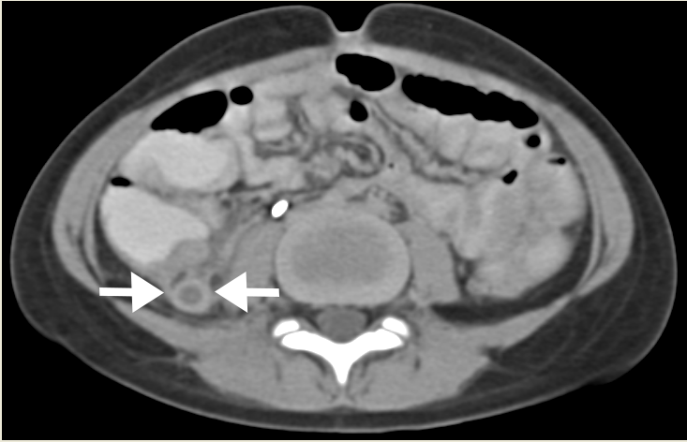
A
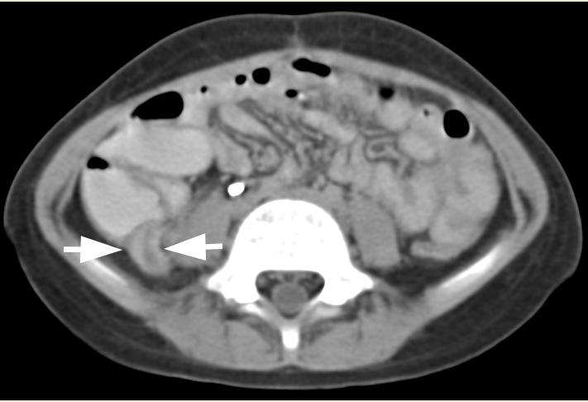
B
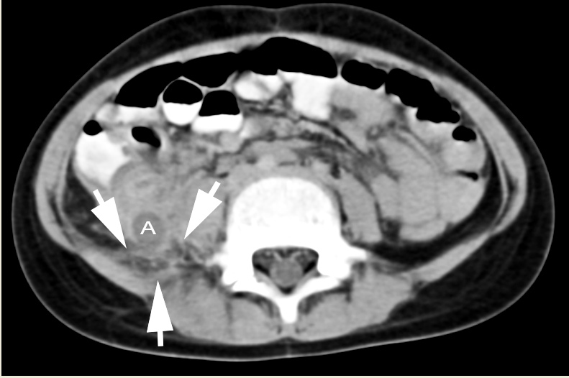
C
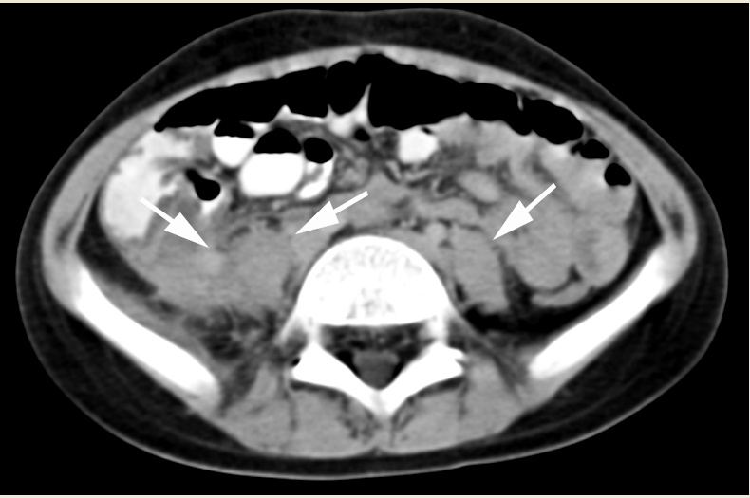
D
Figure 1 computed tomography images. computed tomography images of abdomen using IV non-ionic contrast and standard oral contrast demonstrates dilated appendiceal ostium and thickened appendiceal wall in cross-section (arrows in A); dilated lumen and thickened wall of vermiform appendix in longitudinal section (arrows in B); periappendiceal fat stranding (arrows in C, A = appendix in C); and an enlarged right psoas muscle with indistinct margins from local extension of the appendiceal inflammation (enlarged right psoas muscle with indistinct margins identified in D by 2 arrows, as compared to normal-sized left psoas muscle with distinct margins identified by 1 arrow). The appendix measures approximately 11 mm in diameter from outer wall to outer wall. All these findings are consistent with acute appendicitis. There is no evident appendicolith or typhlitis.

A

B
Figure 2 Photomicrograph. A: Photomicrograph of a hematoxylin-eosin stained, full thickness, cross-section of the resected appendiceal specimen shows a thickened appendiceal wall due to a severe mixed inflammatory infiltrate (A, low power). The high power view (A-inset) of the area, indicated by an asterisk on the low power view, shows one questionable fungal hyphae (arrowhead) within a gland partially destroyed by the necrotizing inflammation (arrow); B: Photomicrograph of a Grocott-Gomori methenamine-silver (GMS) nitrate stain reveals invasive, septate, hyphal forms with acutely angled branches, characteristic of Aspergilus species (B-right side-low power, B-left lower inset-high power). The hyphae are confirmed as Aspergillus species by immunohistochemistry (B-left upper inset-high power).

Table 1 Case reports of isolated Aspergillus appendicitis without other known Aspergillus infection
Age and sex (reference) | Underly-ing condition | Chemotherapy received prior to appendicitis | Symptom appearance after initiating chemotherapy | Neutro-penia at presen- tation | Abdominal imaging | Pathologic findings in resected appendix | Therapy and outcome
8-yr-old male^{[1]} | ALL | Initial therapy: Vincristine, prednisolone, L-asparaginase, intra- thecal methotrexate.  Chemotherapy during relapse not reported. | 14 months after therapy restarted for a relapse. | Yes. | USD: enlarged appendix, cecal wall thickened, and small periappendiceal fluid collection. | Necrosis and inflammation in mucosa and nearby muscle consistent with acute appendicitis. Many septated fungal hyphae showing acute-angle branching, characteristic of Aspergillus. | Fared poorly for 10 d while treated with conventional antibiotic therapy of ceftazdime and amikacin before undergoing appendectomy. Did well after appendectomy. Discharged in stable condition at postoperative day 10 (not mentioned whether received antifungal therapy after appendectomy).
41-yr-old male^{[2]} | ALL- (B-cell type with BCR-ABL trans-location). | Induction therapy: cyclophosphamide, daunorubicin, vin-cristine, prednisone, L-asparaginase, and dasatinib; Maintenance therapy: 6-mercaptopurine and dasatinib; Received stem cell transplantation. | 12 d after transplantation; 5 mo after initiation of chemotherapy. | Yes. | CT: cecal wall thickened, thickened retrocecal appendix, and periappendiceal inflammatory changes; small amount of free fluid present. | Full-thickness invasion of appendiceal wall including serosa; fungal angioinvasion with vessels occluded by hyphal forms; positive methenamine-silver stain. | Fared extremely poorly for 6 d with conventional antibiotic therapy plus acyclovir and fluconazole. Improved after appendectomy and after receiving liposomal amphotericin B and micafungin (switched on day 3 to voriconazole and micafungin due to acute renal injury). Discharged 46 d after appendectomy. Clinically stable 12 mo after hospitalization, without further aspergillus complications.
21-yr-old male^{[3]} | AML- M1. | Mitozantrone and cytarabine.  Later treatment with daunorubicin and cytarabine. | 30 d after diagnosis. | Yes. WBC = 500/mm³ (no neu- trophils seen) | USD: dilated bowel loops and right hydronephrosis.  CT scan: right hydroureter extending down into pelvis with loss of fat planes in the region, consistent with inflammatory process around distal ureter. | Coagulative necrosis of appendiceal tip with septate fungal hyphae with dichotomous branching pattern, permeating and occluding arterial branches.  Immunoperoxidase stain demonstrated Aspergillus flavus. | Amphotericin B  Second laparotomy 6 d after first showed 3 small bowel perforations.  Died at day 49 from bleeding from Aspergillus invasion of iliac vein.
39-yr-old, sex not stated^{[6]1} | Not reported. | NA | NA | Not reported. | Not reported (case published in 1959 before abdominal CT or USD became available). | At surgery: inflamed, enlarged, gangrenous appendix with severe surrounding inflammation. Microscopic pathology not reported. | Did poorly postoperatively with high spiking fevers, overwhelming sepsis, and progressive jaundice while receiving streptomycin and 2 other antibacterial antibiotics. On day 9 therapy with antimycotic trichomycin initiated after Aspergillus nidulans isolated from appendiceal culture. Died 3 d later from progressive organ failure.
8-yr-old male  [Current Case Report] | AML-M5. | Daunorubicin, cytarabine, thioguanine, etopiside, and dexamethasone. | 30 d. | Yes. WBC=  200/mm³ | USD: no evident right lower quadrant abscess or free fluid. CT: inflammatory changes in right lower quadrant with thick-walled appendix and dilated appendiceal lumen. | Branched, septate fungal hyphae invading full thickness of appendiceal wall without discrete perforation. | Underwent appendectomy: Did poorly initially postoperatively while receiving antibacterial antibiotics. Recovered after receiving amphotericin B and discharged after 21 d of this therapy.  No signs of disseminated Aspergillosis during 8 mo of follow up while receiving prophyliaxis with itraconazole.
¹Case excluded from analysis in this paper because this case report was published in 1959 before modern imaging tests became available and this case report lacks critical clinical details due to its brevity. AML: Acute myelogenous leukemia; ALL: Acute lymphocytic leukemia; CT: Computerized tomography; USD: Ultrasound; DIC: Disseminated intravascular coagulation; WBC: White blood cell; NA: Not available.

Table 2 Reported cases of Aspergillus appendicitis with additional gastrointestinal involvement
Age and sex. areas of aspergillus infection [reference] | Underly-ing condition | Chemotherapy received prior to appendicitis | Presentation with symptoms after initiation of chemotherapy | Neutropenia at time of developing symptoms | Abdominal imaging | Pathologic findings in resected appendix | Antifungal therapy:  Outcome
11-yr-old male.  Extensive GI involvement including appendix and cecum (typhlitis)  ^{[28]} | AML | Cytarabine, daunorubicin, and etoposide. | Day 12 after initiating chemotherapy. | Yes | USD: thickened intestinal walls with indistinct hypoechogenic area reaching from cecal pole to mesenteric root. | Performed cecal resection and appendectomy. Chronic, partially hemorrhagic inflammation of intestine infiltrated by Aspergillus. Fungal hyphae also demonstrated within blood vessels. | Amphotericin B and fluoro-cytosine: Patient succumbed to septic shock while on persistent antifungal therapy 6 wk after admission. Autopsy demonstrated disseminated Aspergillosis.
38-yr-old male. Only appendix and cecum infected^{[26]} | ALL | Vincristine and prednisone and intrathecal methotrexate. Later changed to cytoxan and Adriamycin. | Hospital day 7. | Yes, WBC = 100/mm³ | Gallium scan: increased uptake in midabdomen and pelvis consistent with infectious process.  CT: increased density in right lower quadrant consistent with an abscess or fluid-filled cecum. | Laparotomy: appendix not found (apparently due to destruction), but cecal perforation with surrounding abscess with multiple coloenteric fistulas found. Resected specimen showed Aspergillus hyphae in necrotic area of bowel wall invading peritoneal surfaces. | Amphotericin B: Stable at 6 mo follow-up, with right lung infiltrate that identified on previous x-ray, being stable in size.
62-yr-old female.  Appendix, cecum, ascending colon and ileum infected^{[27]} | AML M6 | Induction therapy: cytarabine for 7 d and idarubicin for 3 d. | Day 16 after initiating chemotherapy. | Yes, WBC = 600/mm³, no neutrophils. | CT: inflammatory changes and fat stranding surrounding dilated appendix. Small amount of adjacent free fluid in pelvis. | Resected 2.5 cm segment of small bowel and 60 cm segment of cecum and ascending colon. Microscopic evaluation of sections of bowel and appendix showed transmural intestinal infarction with hemorrhagic plugs within intestine blood vessels and fungal hyphae with septation and acute branching angles. Fungal stain revealed morphology consistent with Aspergillus. | Voriconazole started empirically 20 d after admission, before surgery: Patient expired from cardiac arrest 26 d after admission.
5-yr-old female. Appendix involved with widespread GI infection^{[29]} | AML and diffuse large B-cell lymphoma | 6 cycles of ThaiPOG protocol. | Not specified. | Yes. | CT: early abscess formation in distal ileum and appendix. | Pathological confirmation of appendicitis caused by invasive aspergillosis. | Amphotericin B, metronidazole and piperacillin with tazobactam: Died 1 d later from septicemia with DIC; Autopsy disclosed fungal infection disseminated throughout body.
GI: Gastrointestinal; AML: Acute myelogenous leukemia; ALL: Acute lymphocytic leukemia; NA: Not applicable; WBC: White blood cell; CT: Computerized tomography; USD: Ultrasound; DIC: Disseminated intravascular coagulation.
Figure 2A

