Name of journal: World Journal of Gastroenterology
ESPS Manuscript NO: 4354
Columns: CASE REPORT

Adjuvant surgery for advanced extrahepatic cholangiocarcinoma

Oshiro Y et al. Adjuvant surgery for advanced extrahepatic cholangiocarcinoma

Yukio Oshiro, Kazuhiro Takahashi, Ryoko Sasaki, Tadashi Kondo, Shingo Sakashita, Nobuhiro Ohkohchi

Yukio Oshiro, Kazuhiro Takahashi, Ryoko Sasaki, Tadashi Kondo, Nobuhiro Ohkohchi, Department of Surgery, Division of Gastroenterological and Hepatobiliary Surgery, and Organ Transplantation, University of Tsukuba, Tsukuba 305-8575, Japan

Shingo Sakashita, Department of Pathology, Faculty of Medicine, University of Tsukuba, Tsukuba 305-8575, Japan

Author contributions: All authors made substantial contributions to the acquisition, analysis, and interpretation of data and participated in writing the paper; Ohkohchi N gave final approval of the version to be published.

Correspondence to: Yukio Oshiro, MD, PhD, Department of Surgery, Division of Gastroenterological and Hepatobiliary Surgery, and Organ Transplantation, University of Tsukuba, 1-1-1 Tennodai, Tsukuba, 305-8575, Japan. oshiro@md.tsukuba.ac.jp

Telephone: +81-29-8533221 Fax: +81-29-8533222
Received: June 27, 2013 Revised: August 4, 2013
Accepted: August 16, 2013

Published online:

Abstract
Patients with Stage IV cholangiocarcinoma are currently not considered to be surgical candidates and are typically offered systemic chemotherapy. Recently, several novel systemic chemotherapy regimens have allowed an initially unresectable cholangiocarcinoma to be resectable. The aim of this article is to present the usefulness of adjuvant surgery in a case of advanced cholangiocarcinoma that was successfully treated with gemcitabine. A 72-year-old man was diagnosed with distal cholangiocarcinoma with liver metastases (T2N0M1, cStage IV). He underwent metal stent placement in the duodenum to alleviate jaundice. After 18 courses of chemotherapy using gemcitabine without severe drug toxicities, a computed tomography scan showed that the liver metastases in S6 and S7 had disappeared. The patient underwent subtotal stomach-preserving pancreaticoduodenectomy and lymph node dissection. The final stage was T1N0M0, fStage I. The patient underwent 6 cycles of adjuvant chemotherapy using gemcitabine. The patient is alive and well 6 years and 9 mo after the diagnosis.

© 2013 Baishideng. All rights reserved.

Key words: Extrahepatic cholangiocarcinoma; Adjuvant surgery; Conversion surgery; Chemotherapy; Gemcitabine

Core tip: Patients with Stage IV cholangiocarcinoma are currently not considered to be surgical candidates and are typically offered systemic chemotherapy. Recently, several novel systemic chemotherapy regimens have allowed an initially unresectable cholangiocarcinoma to be resectable. In a patient with advanced extrahepatic cholangiocarcinoma, gemcitabine (GEM) induced a dramatic reduction of the tumor, which led to curative resection and a long-term survival of 6 years and 9 mo. This result suggests the possibility of advantages of using GEM for the treatment of advanced cholangiocarcinoma, and GEM-based chemotherapy could be performed more often for unresectable cholangiocarcinomas.

Oshiro Y, Takahashi K, Sasaki R, Kondo T, Sakashita S, Ohkohchi N. Adjuvant surgery for advanced extrahepatic cholangiocarcinoma.

Available from:
DOI:

INTRODUCTION
Cholangiocarcinoma continues to exhibit poor survival rates compared with other gastrointestinal malignancies^{[1–4]}. Most cholangiocarcinoma patients are not surgical candidates. Patients with Stage IV cholangiocarcinoma are currently inoperable and are typically offered systemic chemotherapy. The most promising approaches involve the use of single agents such as gemcitabine (GEM), which has been shown to be effective against cholangiocarcinoma in phase II trials^{[5–7]}. In these trials, the response rates for GEM ranged from 8% to 36%, and the overall survival (OS) ranged from 6.3 to 16 mo. We describe a rare case of stage IV cholangiocarcinoma with liver metastases that was initially deemed unresectable and became resectable after GEM chemotherapy and showed a favorable outcome.

CASE REPORT
The patient was a 72-year-old man referred from a local hospital complaining of jaundice. The laboratory data on admission showed the following elevated values: total bilirubin (T-bil), 6.2 mg/dL (normal range, 0.2–1.2 mg/dL); lactic acid dehydrogenase, 243 U/L (124–232 U/L); alkaline phosphatase 354 U/L (120–320 U/L); and γ-glutamyl transpeptidase, 181 U/L (5–55 U/L). All the tumor markers tested were within the normal limits: carcinoembryonic antigen (CEA), 2.3 ng/mL (normal range, < 5.0 ng/mL), and carbohydrate antigen 19-9, 12.0 U/mL (< 37 U/mL). Abdominal computed tomography (CT) and ultrasonography showed mild dilatation of the common bile duct and bilateral dilation of the intrahepatic bile ducts. Abdominal computed tomography angiography (CTA) detected wall thickening in the distal common bile duct, and the lesion was enhanced by contrast (Figure 1). CT and CTA showed two liver metastases, which measured 8 mm (S6) and 8 mm (S7) in diameter (Figure 2). According to the Union Internationale Contre le Cancer (UICC) guidelines, the patient was diagnosed with lower cholangiocarcinoma (cT2N0M1, cStage IV) ^{[8]}.
The patient underwent successful placement of a self-expandable metal duodenal stent to relieve jaundice. The patient received a total of 18 cycles of GEM. GEM was administered intravenously at a dose of 800 mg/m² per day on days 1, 8, and 15 in a 28-d cycle. Adverse events were graded according to the National Cancer Institute Common Toxicity Criteria Grading System (Version 2.0, April 1999). ^{[9]} Severe drug toxicities (grade 3 or 4) were not observed.
After 18 cycles of chemotherapy, CT showed that the two liver metastases in S6 and S7 disappeared. The tumor was clinically downstaged to stage IB (cT2N0M0).
Four weeks after the completion of chemotherapy, the operation was successfully performed. Peritoneal lavage cytology demonstrated no cancer cells in the abdominal cavity. No microscopic invasion of the resected bile duct stump was observed in an intraoperative frozen specimen. The patient underwent curative resection consisting of SSPPD with D2 lymphadenectomy without resecting any other organs.
Tumor cells were detected in the distal bile duct upon microscopic examination (Figure 3). According to the UICC guidelines, the final classification of the tumor was T2N0M0 Stage IB. The patient was discharged on postoperative day 61 in good condition. The patient subsequently received six cycles of adjuvant GEM chemotherapy similar to the preoperative regimen. The patient is alive at 6 years and 9 months after the diagnosis and 5 years after the surgery.

DISCUSSION
The prognosis of patients with cholangiocarcinoma is poor, with a five-year survival rate of approximately 25% to 55%^{[1-4]}. To overcome this clinical challenge, several strategies, including adjuvant chemotherapy, adjuvant radiotherapy, and adjuvant chemoradiotherapy have been considered for treating cholangiocarcinoma^{[10-13]}. Few randomized clinical trials have evaluated the utility of adjuvant therapy following R0 resection of cholangiocarcinoma, and most of the current studies are small and retrospective. Therefore, no standard adjuvant modalities have been universally adopted for the treatment of cholangiocarcinoma, and the role of chemotherapy for unresectable cholangiocarcinoma has not been established. Although there has been no standard chemotherapy for cholangiocarcinoma, GEM has been the most actively used agent against cholangiocarcinoma. We treated a patient with advanced extrahepatic cholangiocarcinoma with liver metastases. The patient showed a dramatic response to GEM, which led to curative resection and long-term survival of more than 6 years. GEM may be an effective chemotherapeutic agent for treating cholangiocarcinoma, and a randomized clinical trial needs to be performed.
The feasibility of adjuvant surgery for cholangiocarcinoma has not been determined. Recently, in colorectal, gastric, and pancreatic cancer, several authors have reported “conversion surgery” or “adjuvant surgery” ^{[14-16]}. Suzuki et al^{[14]} demonstrated that adjuvant surgery was effective in 20 advanced gastric cancer patients (Stage IV) based on liver or distant lymph node metastasis. The overall survival of patients in the partial response and curative resection groups was prolonged. The survival of patients with H or N factor was also prolonged when they received curative surgery. However, the survival of patients with P factor was not prolonged. Locally advanced pancreatic cancer may be a good indication for adjuvant surgery after sustained favorable responses to chemotherapy, even in patients with initially unresectable disease^{[16]}. In 2013, Kato et al. reported that eight patients with initially unresectable advanced biliary tract cancer who underwent adjuvant surgery had significantly longer survival than 14 patients who were unable to undergo surgery^{[17]}. Of the eight patients in the surgery group, four patients had gallbladder carcinoma and four patients had intrahepatic cholangiocarcinoma. To our knowledge, from 1983 to 2013, in the field of bile duct cancer, only 16 cases in nine reports underwent adjuvant surgery, including the cases in the report by Kato et al (Table 1^{[17-25]}). Of the 16 patients, 10 patients received GEM, 3 received S-1, 2 received GEM and S-1, 1 received GEM combined with cisplatin and fluorouracil, and 1 received cisplatin/interferon alpha-2b/doxorubicin/fluorouracil-combination chemotherapy. None of the 16 cases involved extrahepatic cholangiocarcinoma. To the best of our knowledge, this is the first report of adjuvant surgery for extrahepatic cholangiocarcinoma.
Medical oncologists and surgeons have identified surgical candidates among patients with initially unresectable colorectal and gastric cancer who responded favorably to multimodal treatment^{[14,15]}. In some cases, the addition of surgery resulted in increased long-term survival. Surgical resection coupled with multimodal treatment is called “adjuvant surgery.” Surgical resection can be classified as curative (no evidence of remaining disease after surgery) or palliative (remaining disease after surgery). Therefore, adjuvant surgery aims to be curative and not palliative after the response to chemotherapy ^{[14]}.
In a strategy involving adjuvant surgery, adjuvant chemotherapy is considered necessary after the operation. In our patient, the liver metastases showed a surprising complete response without severe toxicity after GEM chemotherapy. Additionally, the patient received adjuvant chemotherapy using GEM as an outpatient and developed no adverse reactions. In previous phase II studies using single-agent GEM, major adverse reactions included neutropenia, leukopenia, and anemia were observed with little severe toxicity^{[5–7]}. The results suggests that GEM is suitable for outpatients because of its mild toxicity.
The UK ABC-02 study defined the standard of care for unresectable advanced biliary tract cancer^{[26]}. Valle et al^{[26]} reported that cisplatin with GEM (GEMC) was associated with a significant survival advantage compared with GEM alone. The median OS was 11.7 months for GEMC and 8.1 months for GEM alone^{[26]}. A Japanese trial of 83 patients using the same treatment regimens as UK ABC-02 showed the median survival and overall response rate of GEMC vs GEM alone were 11.2 mo vs 7.7 mo and 19.5% vs 11.9%, respectively. These results were consistent with the results of the UK ABC-02 study. GEMC was found to be effective and well tolerated, which indicates that it could also be a standard regimen for Japanese patients^{[27]}.
In conclusion, in a patient with advanced extrahepatic cholangiocarcinoma, GEM induced a dramatic reduction of the tumor, which led to curative resection. The patient was still living 6 years and 9 mo after the study. The results suggest possible advantages of using GEM for the treatment of advanced cholangiocarcinoma. GEM-based chemotherapy could be more commonly administered for unresectable cholangiocarcinoma. Furthermore, “adjuvant surgery” (i.e., R0 resection) may significantly contribute to curing cholangiocarcinoma. An evidence-based consensus should be developed on potentially resectable cholangiocarcinoma with liver metastases in each hospital.

REFERENCES
1. Nagorney DM, Donohue JH, Farnell MB, Schleck CD, Ilstrup DM. Outcomes after curative resections of cholangiocarcinoma. Arch Surg 1993; 128: 871-879 [PMID: 8393652]
2. DeOliveira ML, Cunningham SC, Cameron JL, Kamangar F, Winter JM, Lillemoe KD, Choti MA, Yeo CJ, Schulick RD. Cholangiocarcinoma: thirty-one-year experience with 564 patients at a single institution. Ann Surg 2007; 245: 755–762 [PMID: 17457168 DOI: 10.1097/01.sla.0000251366.62632.d3]
3. Sasaki R, Takahashi M, Funato O, Sasaki R, Takahashi M, Funato O, Nitta H, Murakami M, Kawamura H, Suto T, Kanno S, Saito K. Prognostic significance of lymph node involvement in middle and distal bile duct cancer. Surgery 2001;129: 677–683 [PMID: 11391365 DOI: 10.1067/msy.2001.114555]
4. Oshiro Y, Sasaki R, Kobayashi A, Murata S, Fukunaga K, Kondo T, Oda T, Ohkohchi N. Prognostic relevance of the lymph node ratio in surgical patients with extrahepatic cholangiocarcinoma. Eur J Surg Oncol2011 37: 60-64 [PMID: 21094016 DOI: 10.1016/j.ejso.2010.10.011.]
5. Penz M, Kornek GV, Raderer M, Ulrich-Pur H, Fiebiger W, Lenauer A, Depisch D, Krauss G, Schneeweiss B, Scheithauer W. Phase II trial of two-weekly gemcitabine in patients with advanced biliary tract cancer. Ann Oncol 2001; 12: 183-186 [PMID- 11300321]
6. Tsavaris N, Kosmas C, Gouveris P, Gennatas K, Polyzos A, Mouratidou D, Tsipras H, Margaris H, Papastratis G, Tzima E, Papadoniou N, Karatzas G, Papalambros E. Weekly gemcitabine for the treatment of biliary tract and gallbladder cancer. Invest New Drugs 2004; 22: 193-198 [PMID: 14739669 DOI: 10.1023/B:DRUG.0000011797.09549.53]
7. Okusaka T, Ishii H, Funakoshi A, Yamao K, Ohkawa S, Saito S, Saito H, Tsuyuguchi T. Phase II study of single-agent gemcitabine in patients with advanced biliary tract cancer. Cancer Chemother Pharmacol 2006; 57: 647-653 [PMID: 16142487 DOI: 10.1007/s00280-005-0095-3]
8. Union Internationale Contre le Cancer. TNM classification of malignant tumours. 7th ed. New York, NY: Wiley-Liss, 2009
9. National Institute of Health. NCI: Common Toxicity Criteria, Version 2.0. Available from: http://ctep.info.nih.gov/reporting/ctc.html
10. Gerhards MF, van Gulik TM, González González D, Rauws EA, Gouma DJ. Results of postoperative radiotherapy for resectable hilar cholangiocarcinoma. World J Surg 2003; 27: 173-179 [PMID: 12616432 DOI: 10.1007/s00268-002-6434-1]
11. Todoroki T, Ohara K, Kawamoto T, Koike N, Yoshida S, Kashiwagi H, Otsuka M, Fukao K. Benefits of adjuvant radiotherapy after radical resection of locally advanced main hepatic duct carcinoma. Int J Radiat Oncol Biol Phys 2000; 46: 581-587[PMID: 10701737 DOI: 10.1016/S0360-3016(99)00472-1]
12. Kelley ST, Bloomston M, Serafini F, Carey LC, Karl RC, Zervos E, Goldin S, Rosemurgy P, Rosemurgy AS. Cholangiocarcinoma: advocate an aggressive operative approach with adjuvant chemotherapy. Am Surg 2004; 70: 743-748 [PMID: 15481288]
13. McMasters KM, Tuttle TM, Leach SD, Rich T, Cleary KR, Evans DB, Curley SA. Neoadjuvant chemoradiation for extrahepatic cholangiocarcinoma. Am J Surg 1997; 174: 605-608 [PMID: 9409582 DOI: 10.1016/S0002-9610(97)00203-1]
14. Suzuki T, Tanabe K, Taomoto J, Yamamoto H, Tokumoto N, Yoshida K, Ohdan H. Preliminary trial of adjuvant surgery for advanced gastric cancer ONCOLOGY LETTERS 2010; 1: 743-747 [PMID: 22966373]
15. Power DG and Kemeny NE: Chemotherapy for the conversion of unresectable colorectal cancer liver metastases to resection. Crit Rev Oncol Hematol 2011; 79: 251-264 [PMID: 20970353 DOI: 10.1016/j.critrevonc.2010.08.001]
16. Kato K, Kondo S, Hirano S, Tanaka E, Shichinohe T, Tsuchikawa T, Matsumoto J. Adjuvant surgical therapy for patients with initially-unresectable pancreatic cancer with long-term favorable responses to chemotherapy. J Hepatobiliary Pancreat Sci 2011; 18:712-716 [PMID: 21455748 DOI: 10.1007/s00534-011-0391-8]
17. Kato A, Shimizu H, Ohtsuka M, Yoshidome H, Yoshitomi H, Furukawa K, Takeuchi D, Takayashiki T, Kimura F, Miyazaki M. Surgical resection after downsizing chemotherapy for initially unresectable locally advanced biliary tract cancer: a retrospective single-center study. Ann Surg Oncol 2013; 20: 318-324 [PMID: 23149849 DOI: 10.1245/s10434-012-2312-8]
18. Slupski MW, Szczylik C, Jasinski MK. Unexpected response to systemic chemotherapy in case of primarily nonresectable advanced disseminated intrahepatic cholangiocarcinoma. World J Surg Oncol 2007; 5: 36 [PMID: 17376238 DOI: 10.1186/1477-7819-5-36]

19. Shirabe K, Tomoyuki Abe Kiyoshi Kajiyama, Kazuya Akahoshi. The Survival Impact of Chemotherapy in the Patients with Gall Bladder Cancer ―A pilot study― Journal of Japan Biliary Association 2008; 22: 41-46 (in Japanese)
20. Kitajima K, Kobayashi S, Shiba H, Uwagawa T, Ishida Y, Aiba K, Kawakami M, Yanaga K.Successful treatment of advanced gallbladder cancer with an anticancer drug S-1: assessment based on intratumoral gene. Int J Clin Oncol 2008; 13: 545-551 [PMID:19093184doi: 10.1007/s10147-008-0777-z]
21. Morimoto H, Ajiki T, Takase S, Fujita T, Matsumoto T, Mita Y, Matsumoto I, Fujino Y, Suzuki Y, Kuroda Y, Ku Y. Resection of gallbladder cancer with hepatic metastasis after chemotherapy with gemcitabine. J Hepatobiliary Pancreat Surg 2008; 15: 655-658 [PMID: 18987939 DOI: 10.1007/s00534-007-1311-9]
22. Kanaji S, Kobayashi I, Fujita T, Ueno K, Tsuchida S, Kawasaki K, Ohno M, Osawa M, Fujino Y, Tominaga M, Nakamura T. A case of curatively resected biliary tract cancer with peritoneal dissemination through effective response to chemotherapy of S-1. Gan To Kagaku Ryoho 2009; 36:1337-1339 (in Japanese) [PMID: 19692774]
23. Kim SH, Kim IH, Kim SW, Lee SO. Repetitive response to gemcitabine that led to curative resection in cholangiocarcinoma World J Gastroenterol. 2009; 15: 4593-4595 [PMID: 19777621 DOI: 10.3748/wjg.15.4593]
24. Ohno T, Koguchi H, Miura A, Tanaka Y, Endo M, Matsunaga S, Hasegawa I, Kato A, Tokuda Y, Sakakibara K. A case of advanced ampullary carcinoma successfully resected after primary chemotherapy with s-1 and gemcitabine. Gan To Kagaku Ryoho 2009; 36: 999-1002 (in Japanese) [PMID:19542724]

25. Hasegawa N, Abei M, Sasaki R, Pak S, Moriwaki T, Minami Y, Fukuda K, Hirai S, Shoda J, Ohkouchi N, Hyodo I. A case with Stage IVb advanced gallbladder cancer curatively resected following effective S-1 chemotherapy. Journal of Japan Biliary Association 2010; 24: 723-728 (in Japanese)
26. Valle J, Wasan H, Palmer DH , Cunningham D, Anthoney A, Maraveyas A, Madhusudan S, Iveson T, Hughes S, Pereira SP, Roughton M, Bridgewater J; ABC-02 Trial Investigators.Cisplatin plus gemcitabine versus gemcitabine for biliary tract cancer. N Engl J Med 2010; 362: 1273-1281 [PMID: 20375404 DOI: 10.1056/NEJMoa0908721]
27. Okusaka T, Nakachi K, Fukutomi A, et al. Gemcitabine alone or in combination with cisplatin in patients with biliary tract cancer: a comparative multicentre study in Japan. Br J Cancer 2010; 103: 469-474 [PMID: 20628385 DOI: 10.1038/sj.bjc.6605779]

P-Reviewer Erichsen R S-Editor Song XX L-Editor E-Editor

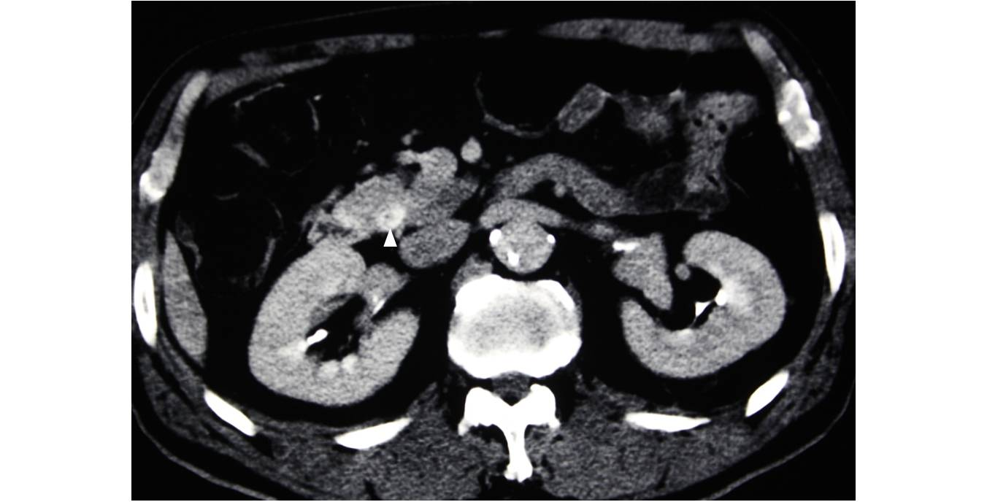
Figure 1 Abdominal computed tomography angiography image of the common bile duct. Thickening of the wall of the lower common bile duct, which enhances with contrast, was observed (arrowhead).

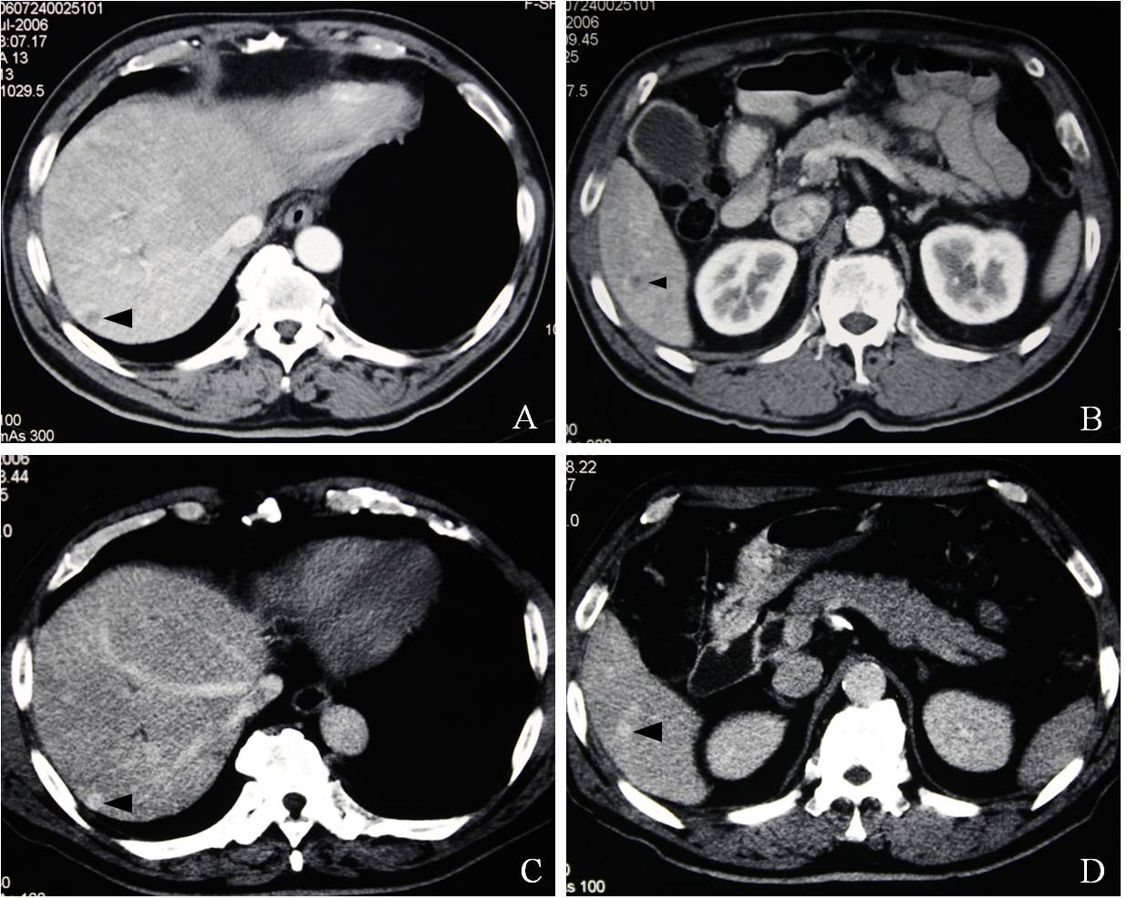
Figure 2 Abdominal computed tomography and computed tomography angiography images at two different levels are shown. A: Computed tomography (CT) showed a low-density mass measuring 8 mm in diameter located in segment 7 of the liver (arrowhead); B: CT showed a low-density mass measuring 8 mm in diameter in segment 6 (arrowhead); C: Computed tomography angiography (CTA) demonstrated an enhancing mass lesion at the same location as in Figure 2A (arrowhead); D: CTA demonstrated an enhancing mass lesion at the same location as in Figure 2B (arrowhead).

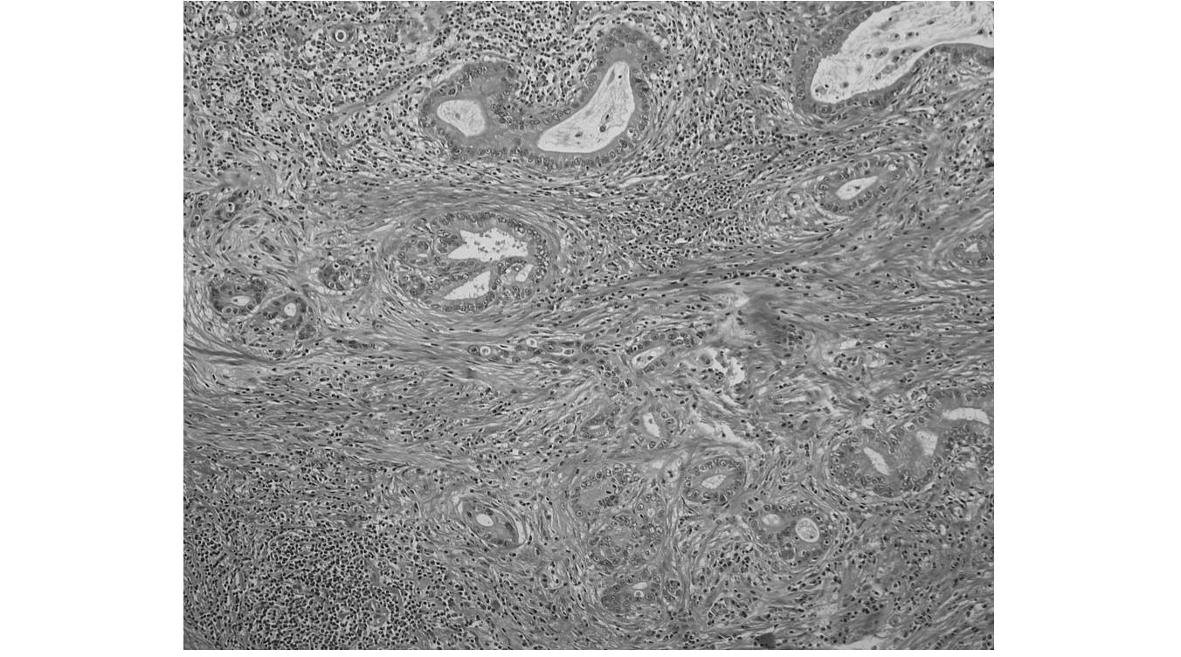
Figure 3 Histopathologic appearance of the cholangiocarcinoma (hematoxylin and eosin, 200×). Tumor cells were detected in the lower bile duct on microscopic examination.

Table 1 Cases of advanced bile duct cancer treated with adjuvant surgery following effective chemotherapy
Ref. Diagnosis Metastasis/invasion Chemotherapy Response
regimen

Slupski et al^{[18]} intrahepatic cholangiocarcinoma lung metastases CDDP, 5-FU, IFN, PR
doxorubicin
Shirabe et al ^{[19]} gallbladder cancer para-aortic LNs GEM, CDDP, 5-FU PR
Kitajima et al^{[20]} gallbladder cancer dissemination S-1 CR
Morimoto et al^{[21]} gallbladder cancer liver metastasis GEM CR
Kanaji et al^{[22]} intrahepatic cholangiocarcinoma dissemination S-1 CR
Kim et al^{[23]} intrahepatic cholangiocarcinoma portal vein invasion GEM PR
Ohno et al^{[24]} ampulla of Vater cancer liver metastasis GEM, S-1 CR
Hasegawa et al^{[25]} gallbladder cancer hepatic invasion S-1 PR
para-aortic LN
Kato et al^{[17]} intrahepatic cholangiocarcinoma hepatic vein invasion GEM SD
intrahepatic cholangiocarcinoma hepatic vein invasion GEM PR
intrahepatic cholangiocarcinoma arterial invasion GEM SD
intrahepatic cholangiocarcinoma insufficient remnant GEM PR
liver volume
gallbladder cancer arterial invasion GEM SD
gallbladder cancer arterial invasion GEM PR
gallbladder cancer arterial invasion GEM SD
portal vein invasion
gallbladder cancer arterial invasion GEM SD

CDDP: Cisplatin; 5-FU: Fluorouracil; IFN: Interferon; PR: Partial response; CR: Complete response; GEM: Gemcitabine; LN: Lymph node; SD: Stable disease.

