Name of Journal: World Journal of Gastrointestinal Endoscopy
Manuscript NO: 39962

Manuscript Type: REVIEW

Stepwise evaluation of liver sectors and liver segments by endoscopic ultrasound

Sharma M et al. EUS of liver segments and liver sectors

Malay Sharma, Piyush Somani, Chittapuram Srinivasan Rameshbabu, Tagore Sunkara, Praveer Rai

Malay Sharma, Piyush Somani Department of Gastroenterology, Jaswant Rai Speciality Hospital, Meerut 25001, Uttar Pradesh, India

Piyush Somani, Department of Gastroenterology, Thumbay Hospital, Dubai 415555, United Arab Emirates

Chittapuram Srinivasan Rameshbabu, Department of Anatomy, Muzaffarnagar Medical College, Muzaffarnagar 251001, Uttar Pradesh, India

Tagore Sunkara, Department of Gastroenterology and Hepatology, the Brooklyn Hospital Center, Clinical Affliate of The Mount Sinai Hospital, Brooklyn, NY 11201, United States

Praveer Rai, Department of Gastroenterology, Sanjay Gandhi Post Graduate Institute, Lucknow 226014, Uttar Pradesh, India

ORCID number: Malay Sharma (0000-0003-2478-9117); Piyush Somani (0000-0002-5473-7265); Chittapuram Srinivasan Rameshbabu (0000-0002-6505-2296); Tagore Sunkara (0000-0001-9536-9027); Praveer Rai (0000-0002-5041-619X).

Author contributions: Sharma M wrote the manuscript; Somani P, Rameshbabu CS, Sunkara T and Rai P edited the manuscript; Sharma M, Somani P and Rameshbabu CS designed the study.

Conflict-of-interest statement: Authors declare no conflict of interests for this article.

Open-Access: This article is an open-access article which was selected by an in-house editor and fully peer-reviewed by external reviewers. It is distributed in accordance with the Creative Commons Attribution Non Commercial (CC BY-NC 4.0) license, which permits others to distribute, remix, adapt, build upon this work non-commercially, and license their derivative works on different terms, provided the original work is properly cited and the use is non-commercial. See: http://creativecommons.org/licenses/by-nc/4.0/

Manuscript source: Invited manuscript

Correspondence to: Malay Sharma, MD, Doctor, Department of Gastroenterology, Jaswant Rai Speciality Hospital, Saket, Meerut 25001, Uttar Pradesh, India. sharmamalay@hotmail.com
Telephone: +91-983-7031148
Fax: +91-121-2657154

Received: May 25, 2018
Peer-review started: May 25, 2018
First decision: June 14, 2018
Revised: August 16, 2018
Accepted:
Article in press:
Published online:

Abstract
The liver has eight segments which are referred to by numbers or by names. The numbering of the segments is done in an anti-clockwise manner with the liver being viewed from the inferior surface, starting from Segment I (the caudate lobe). Standard anatomical description of the liver segments is available by computed tomographic scan, and ultrasonography. Endoscopic ultrasound (EUS) has been used for a detailed imaging of many intra-abdominal organs and for the assessment of intra-abdominal vasculature. A stepwise evaluation of the liver segments by EUS has not been described. In this article, we have described a stepwise evaluation of the liver segments by EUS. This information can be useful for planning successful radical surgeries, better preparation for biopsy, portal vein embolization, transjugular intrahepatic portosystemic shunt, tumour resection or partial hepatectomy and for planning EUS guided diagnostic and therapeutic procedures.

Key words: Endoscopic ultrasound; Hepatic vein; Liver sectors; Portal vein; Liver segments; Caudate lobe; Cantlie line; Falciform ligament; Gallbladder

© The Author(s) 2018. Published by Baishideng Publishing Group Inc. All rights reserved.

Core tip: Standard anatomical description of the liver segments is available by computed tomographic scan, and ultrasonography. A stepwise evaluation of the liver segments by endoscopic ultrasound (EUS) has not been described. In this article, we have described a stepwise evaluation of the liver segments by EUS. This information can be useful for planning successful radical surgeries, better preparation for biopsy, portal vein embolization, transjugular intrahepatic portosystemic shunt, tumour resection or partial hepatectomy and for planning EUS guided diagnostic and therapeutic procedures.

Sharma M, Somani P, Rameshbabu CS, Sunkara T, Rai P. Stepwise evaluation of liver sectors and liver segments by endoscopic ultrasound. World J Gastrointest Endosc 2018; In press

INTRODUCTION
The French surgeon and anatomist Claude Couinaud described “two lobes” (right and left), “two hemi-livers” (right and left), “four sectors” and “eight segments” of the liver. The two lobes are separated by the falciform ligament, the two hemi-livers are separated by the Cantlie’s line, the four sectors are separated by the planes of three hepatic veins (portal fissures or scissurae) and the eight segments are separated by an imaginary transverse plane passing by the portal vein bifurcation (Figure 1 and Table 1)^{[1]}. Each of the segments is an independent segment and has its own vascular inflow, outflow and biliary drainage. The segments are referred to by number or by names^{[2,3]}. The numbering of the segments is done in an anti-clockwise manner starting from Segment I (the caudate lobe). The segments II to IV belong to the left and segments V to VIII belong to the right hemi-liver (Table 1)^{[2-4]}. Standard anatomical description of the liver segments is available by computed tomographic (CT) scan^{[5]}. A stepwise evaluation of the liver segments is also described by ultrasonography^{[6,7]}. Endoscopic ultrasound (EUS) has been used for a detailed imaging of many intra-abdominal organs and for the assessment of intra-abdominal vasculature^{[8-11]}. A stepwise evaluation of the liver segments by EUS has not been described. In this article, we describe a stepwise evaluation of the liver segments by EUS.

APPLIED ANATOMY AND THE HOME BASES FOR IMAGING
The home bases of liver imaging are given in the figure and the table (Table 2 and Figure 2A). The main key of the imaging is following of the hepatic vein tributaries and the portal vein branches. The three hepatic veins divide the liver into four vertical sectors; right anterior, right posterior, left medial and left lateral (Figure 1). The plane of portal vein bifurcation creates a transverse plane that crosses the vertical planes and divides the four sectors into eight segments (Figures 1, 2A and Table 1). The right hepatic vein lies in the right portal fissure and separates the right hemi liver into anterior and posterior sectors. The left hepatic vein lies in the left portal fissure and separates the left hemi liver into medial and lateral sectors. The middle hepatic vein lies in the main portal fissure and separates the anterior division of right liver from medial division of left liver. The main portal vein bifurcates into the right and the left branches which travel in an imaginary transverse plane of the transverse fissure. The extrahepatic part of the left branch of the portal vein is known as the transverse part and the intrahepatic part of left branch of the portal vein is known as the umbilical part. The extrahepatic part of left branch of portal vein lies in the gastrohepatic ligament on its inferior surface. The umbilical part of portal vein is surrounded on all sides by the liver (Figure 1). The right portal vein divides into two branches after entering the liver. The anterior branch supplies the anterior sector of right lobe and the posterior branch supplies the posterior sector of the right lobe (Figures 1, 2A and Table 2). The gallbladder, the right kidney, the fissures on the under surface of liver, and the ligaments of liver are acting as additional home bases of imaging for liver segments. The inferior surface of liver has an H shaped fissure where the right and left limbs of H are made by right and left sagittal fissures and the transverse limb is formed by the porta hepatis. The left sagittal fissure has upper and lower limbs which are formed by the fissure for the ligamentum venosum and the fissure for ligamentum teres. The upper part of ligamentum venosum is attached to the inferior vena cava (IVC). The lower part of ligamentum teres extends to the inferior surface of liver (Figure 2B and Table 2). The relationship of caudate lobe is crucial in understanding the segments of liver. When seen from the stomach the caudate lobe lies between the stomach and IVC. The hepatic veins join the IVC (Figure 2B).

POSITION OF THE PATIENT AND THE POSITIONS OF OPERATOR
EUS can be done with the patient in a prone, left lateral, or supine position and the descriptions in this article have been done with the patient in a prone position. The position of the operator can change with the movement of the body (or hand) which transfers the effect of rotation towards the tip of scope when the scope is maintained in a straight position. The three positions are open position to left, neutral position and an open position to right. In an open position to left, the operator faces the patient’s feet, in a neutral position, the operator faces the body of the patient and in an open position to right, the operator faces the head of the patient. A clockwise rotation from an open position to left in stomach moves the imaging axis of the probe from a dorsal to a lateral and subsequently to a ventral position (Figure 3A). A reverse of this happens when scope is rotated anticlockwise after seeing the right kidney.

THREE STATIONS OF IMAGING
The imaging is possible from three stations: Station 1: abdominal part of esophagus and stomach; station 2: duodenal bulb; and station 3: 2nd part of duodenum (Figure 3B and Table 3). Each station shows the segments in different anatomical relationships and the differences in the segmental assessment of imaging are described in the table.

Station 1: Imaging from lower end of esophagus and stomach
This station of imaging is the most convenient method of imaging and is discussed in detail. Generally, it requires a rotation of scope in three positions (Figure 3A) and a shift of the scope in and out to the four different levels (Figure 4A). During this rotation the sectors come close to the probe in following order left lateral, left medial, right anterior and right posterior (Table 4).

Imaging from open position to the left: From the open position to left, the portal vein branches going to segment II and III are identified (Figure 5A). Imaging of the intrahepatic part of the left branch of portal vein (umbilical part) within the umbilical fissure gives a fish eye appearance as it is completely surrounded on all sides by the liver parenchymal tissue (Figure 5B). The fisheye appearance indicates the left edge of the H of the transverse fissure from where the upper and lower limbs of left sagittal fissure can be followed by slight in and out movement to trace the ligamentum venosum and ligamentum teres (Figure 5B and 5C). Further rotation traces the transverse fissure from the left edge of H towards the right edge of H and follows the umbilical part of the left branch of portal vein towards the transverse part of left branch. During this rotation from left edge to the right edge, the appearance of hepatic artery into two branches, the union of right and left branch of portal vein and the division of common hepatic duct into right and left branches appear one by one in the transverse fissure (Figures 4B and 5D).

Imaging from the neutral position: Further rotation traces the course of extrahepatic part of the left branch of portal vein (transverse part) within the transverse fissure (Figure 6A). At this point the union of right and left branches of portal vein is seen (Figure 6B). Near the union point the extrahepatic part of right branch of the portal vein can be seen to join the transverse part of portal vein from a direction coming from 6 O’clock within the transverse fissure. The right branch of portal vein is often seen traveling close to the neck of gallbladder. Near the right edge of the transverse fissure, the union of right and left ducts is seen in front of the right branch of portal vein (Figure 6C). The imaging of the right branch of portal vein is easy through the caudate process of liver in the area above the transverse fissure and below the IVC (Figure 6D).

Imaging from an open position to the right: Further rotation with slight upward angulation traces the extrahepatic part of right branch of portal vein towards the intrahepatic part. Imaging of the intrahepatic part of the right branch of portal vein usually requires a decrease in frequency to increase penetration depth and an increase in the depth of the imaging to include the entire right lobe of liver along with the hyperechoic diaphragm, which is seen beyond the convex upper surface of liver (Figure 7A). Usually the imaging of right part of liver is made easy by the window provided by the IVC and the caudate process (Figure 7B). The right branch of portal vein can be followed to the division into an anterior and a posterior branch. Usually, with a linear scope the vision of the anterior branch is best seen when the middle hepatic vein is seen on the far side of the screen (Figure 7C). A relatively more posterior view of the course of posterior division of right portal vein branches is possible through the caudate process between the porta hepatis and the IVC and it is usually possible to see the segmental branches to segment VI and VII (Figure 7D).

Station 2: Imaging from duodenal bulb

Neutral position: Imaging from duodenal bulb shows a view of liver hilum (transverse fissure) where the portal vein is easily identified, with right and left angulation, up and down movements and in and out adjustments.

Open position to left: The portal vein bifurcation defines the line between superior and inferior segments. An anticlockwise rotation traces the transverse fissure towards the gallbladder and the right edge of the transverse fissure where the right lobe segments are seen.

Open position to right: A clockwise rotation after tracing the portal vein bifurcation traces the transverse fissure towards the left edge of the transverse fissure where the left lobe segments are seen. The lower border of caudate lobe lies above the bifurcation and above the transverse part of the left branch of portal vein.

Station 3: Imaging from descending duodenum
An open position to the right places the scope in a parallel axis with the superior mesenteric vein from the descending duodenum. From this position an anti-clockwise rotation traces the course of IVC from a 10 O’clock position to 4 O’clock position and sequentially brings the hilum of the right kidney, the right lobe of liver, the hilum of the liver and gallbladder and lastly the left lobe of liver in the view (Figure 8). In this process the segments belonging to the posterior surface and bare area of liver are easily followed close to the IVC. The first segment close to the lower most part of IVC just above the adrenal gland and right kidney belongs to segment VI (Figure 8A). Once the gallbladder is seen the segment V lies close to the upper surface of gallbladder. Near the hilum of liver the segment I is identified between the portal vein and IVC. On maximum anti-clockwise rotation the probe lies close to the upper most part of IVC near the joining of hepatic veins, where the superior segments (VII, VIII, IVA and II) are visualized.

SYSTEMATIC APPROACH TO IDENTIFY LIVER SEGMENTS
The imaging of segments is done in eight steps: (1) Identify lobes; (2) Identify sectors (right and left portal fissures); (3) Identify the plane of superior and inferior segments (transverse fissure/liver hilum); (4) Identify left sagittal fissure and the liver ligaments; (5) Identify caudate lobe (posterior to transverse fissure); (6) Identify left lobe segments; (7) Identify quadrate lobe (anterior to transverse fissure); and (8) Identify right lobe segments

Identify lobes (Cantlie’s line)

Applied anatomy: The Cantlie’s line passes through the middle hepatic vein (main portal fissure) superiorly. It also corresponds to a vertical plane passing diagonally from the middle of the gallbladder fossa anteriorly and inferiorly to the left side of the IVC posteriorly (Figure 2B).

Technique of examination: Identify IVC and the middle hepatic vein is identified merging into IVC (Figure 9A and B).

Identify sectors

Applied anatomy: Each right and left hemi-liver is subdivided by the left and right hepatic veins, lying in the left and right portal fissures. The course of left hepatic vein divides left lobe into medial and lateral sectors. The course of right hepatic vein divides the right lobe into anterior and posterior sectors.

Technique of examination: Identify the merger of left and right hepatic veins into IVC (Figure 9C and D).

Identify the plane of superior and inferior segments
Applied anatomy: The portal vein and its branches in the transverse fissure acts as a guide to divide the liver into superior (VII, VIII, IVa and II) and inferior segments (III, IVb VandVI). The applied anatomy of fissures and ligaments is already discussed in additional home bases. The joining of the three hepatic veins into supra hepatic part of IVC determines the uppermost margin of superior segments related to IVC.

Technique of examination: The umbilical fissure is identified within the left lobe of liver. Clockwise rotation along the umbilical fissure traces the transverse plane of the transverse fissure within which the left and right branches of portal vein are seen (Figure 6C and D and 10).

Identify left sagittal fissure and the liver ligaments
Applied anatomy: The applied anatomy of fissures and ligaments is already discussed in additional home bases.

Technique of examination: The umbilical fissure is identified within the left lobe of liver. The ligaments are identified attached to the upper and lower part of umbilical fissure (Figure 5C).

Identify the caudate lobe

Applied anatomy: Anatomy texts describe the caudate lobe as a midline, vertically oriented hepatic lobe, seen on the posterior aspect of the liver separating a portion of the right and left hepatic lobes in an H configuration. The horizontal bar of the H configuration represents the transverse fissure of porta hepatis, which includes the horizontal portion of both portal veins. Above the bar is the caudate lobe of the liver and below the bar is the medial segment, or quadrate lobe, of the left lobe of the liver^{[12]}.

Technique of examination: The caudate lobe may be imagined as a midline wedge in a sagittal plane, with its tip extending cephalad up to the insertion of left and middle hepatic veins into IVC and its base or posterior border facing the IVC (Figure 11A and B). The right, (or medial, border) of the pyramid, is continuous with the parenchyma of the right lobe of the liver via the caudate process (Figure 11C). The anterior border of the caudate lobe is separated from the medial segment of the left lobe of the liver superiorly by the fissure for the ligamentum venosum, and inferiorly by the left portal triad and portal bifurcation (Figure 11D). A clockwise rotation after identification of the left lobe of liver from an open position to left will help in identification of the ligamentum venosum (Figure 11D). Upper border of umbilical part of the left branch of portal vein is attached to ligamentum venosum and serves as an accurate anatomic boundary of the lowermost limit and anterior margin of the caudate lobe (Figure 11D).

The caudal margin of the caudate lobe form the cephalad margin, or lintel, of the foramen of Winslow, projects into the lesser sac where it is related to the right crus of diaphragm and inferior phrenic artery. The left (or lateral border) of the caudate lobe, projects into the superior recess of the lesser peritoneal sac and is covered anteriorly by the gastrohepatic ligament (lesser omentum) which separates it from segments 2 and 3 anteriorly and segment VIII in the right lateral wall (Figure 12B). The vascular inflow and biliary drainage to the caudate lobe comes from both the right and left pedicles. The right side of the caudate, the caudate process, largely derives its portal venous supply from the right portal vein or the bifurcation of the main portal vein (Figure 12C). The left portion of the caudate derives its portal venous inflow from the left portal vein.

Caudate process a two-way window for imaging of right and left lobe of liver in EUS: The caudate lobe, caudate process and IVC acts as window of imaging from left side to right side of liver and vice versa. While imaging from the abdominal part of esophagus and stomach the window allows left to right visualization. While imaging from duodenal bulb and 2nd part of duodenum the window allows right to left visualization (Figure 11C, D; 12A, C and 13).

Identify left lobe
Applied anatomy: The left lobe lies anterior to the esophagogastric junction and the fundus of stomach.

Technique of examination: The segments of the left lobe are best visualized with slight up tilting of the scope from the fundus of stomach. In this position, the left part of the heart is visualized through the diaphragm and the left hepatic vein is easily identified as the border between the left medial and two left lateral segments (III anterior-inferior and segment II posterior-superior). Further demarcation of the segments II as the upper segment and segment III as the lower segment is possible by the plane passing by the portal vein bifurcation (Figure 14A and B). This plane is not usually visualized during imaging of left lateral segments (II and III) in an open position to left where the fisheye appearance of umbilical part is not visualized. A line can be extrapolated from the upper border of the fisheye appearance of LPV for proper demarcation (Figure 14B). The visualization of left medial segment is seen between the probe and middle hepatic vein (Figure 14C). The presence of middle hepatic vein and the presence of upper border of left branch of portal vein indicates the area where the segment I communicates with segment IV (Figure 14D).

Identify segment IV a and IV b (quadrate lobe)

Applied anatomy: The segment IV is located between the plane passing by the middle hepatic vein on the right and the axis of the umbilical scissura on the left. This segment can be divided into an upper (IV A) and a lower (IV B) segment by a horizontal line passing through the umbilical portion of the left branch of portal vein. The IV B segment (Quadrate lobe) is demarcated on the visceral surface anteriorly by inferior edge of liver, on the right side by the gallbladder fossa, posteriorly by the porta hepatis, and on the medial side by the fissure for ligamentum teres (Figure 14B and D).

Technique of examination: The segment IV is easily identified near the middle hepatic vein. The identification of gallbladder, ligamentum teres and the umbilical fissure also helps in identification of liver segments (Figure 14D).

Identify right lobe segments

Applied anatomy: The right liver consists of anterior and posterior segments, divided by the presence of right hepatic vein in the right portal fissure (Figure 15A).

Technique of examination: A simple crossover of lines passing through the upper border of left branch of portal vein and along the axis of right hepatic vein will divide the right hemi-liver into four segments (Figure 15).

CONCLUSION
The Table 5 summarizes the evaluation of different liver segments from different positions by EUS. Routine use of Couinaud’s liver segmentation may be important in planning successful radical surgery. This description will allow better preparation for biopsy, portal vein embolisation, transjugular intrahepatic portosystemic shunt, tumour resection or partial hepatectomy for transplantation. Such advance planning will reduce intra-and postoperative difficulties and complications. In this article, we have given a detailed description of EUS anatomy of liver and liver segmentation. This information may be useful in planning EUS guided diagnostic and therapeutic procedures involving liver pathologies^{[13,14]}.

ACKNOWLEDGMENTS
Pran Prakash (Graphic designer) for his contribution.

REFERENCES
1 Rutkauskas S, Gedrimas V, Pundzius J, Barauskas G, Basevicius A. Clinical and anatomical basis for the classification of the structural parts of liver. Medicina (Kaunas) 2006; 42: 98-106 [PMID: 16528125]
2 Sakamoto Y, Kokudo N, Kawaguchi Y, Akita K. Clinical Anatomy of the Liver: Review of the 19th Meeting of the Japanese Research Society of Clinical Anatomy. Liver Cancer 2017; 6: 146-160 [PMID: 28275581 DOI: 10.1159/000449490]
3 Lafortune M, Madore F, Patriquin H, Breton G. Segmental anatomy of the liver: a sonographic approach to the Couinaud nomenclature. Radiology 1991; 181: 443-448 [PMID: 1924786 DOI: 10.1148/radiology.181.2.1924786]
4 Sahani D, Mehta A, Blake M, Prasad S, Harris G, Saini S. Preoperative hepatic vascular evaluation with CT and MR angiography: implications for surgery. Radiographics 2004; 24: 1367-1380 [PMID: 15371614 DOI: 10.1148/rg.245035224]
5 Germain T, Favelier S, Cercueil JP, Denys A, Krausé D, Guiu B. Liver segmentation: practical tips. Diagn Interv Imaging 2014; 95: 1003-1016 [PMID: 24388431 DOI: 10.1016/j.diii.2013.11.004]
6 Brown BM, Filly RA, Callen PW. Ultrasonographic anatomy of the caudate lobe. J Ultrasound Med 1982; 1: 189-192 [PMID: 7169640 DOI: 10.7863/jum.1982.1.5.189]
7 Smith D, Downey D, Spouge A, Soney S. Sonographic demonstration of Couinaud's liver segments. J Ultrasound Med 1998; 17: 375-381 [PMID: 9623474 DOI: 10.7863/jum.1998.17.6.375]
8 Bhatia V, Hijioka S, Hara K, Mizuno N, Imaoka H, Yamao K. Endoscopic ultrasound description of liver segmentation and anatomy. Dig Endosc 2014; 26: 482-490 [PMID: 24355092 DOI: 10.1111/den.12216]
9 Ramesh Babu CS, Sharma M. Biliary tract anatomy and its relationship with venous drainage. J Clin Exp Hepatol 2014; 4: S18-S26 [PMID: 25755590 DOI: 10.1016/j.jceh.2013.05.002]
10 Rameshbabu CS, Wani ZA, Rai P, Abdulqader A, Garg S, Sharma M. Standard imaging techniques for assessment of portal venous system and its tributaries by linear endoscopic ultrasound: a pictorial essay. Endosc Ultrasound 2013; 2: 16-34 [PMID: 24949362 DOI: 10.7178/eus.04.005]
11 Sharma M, Babu CS, Garg S, Rai P. Portal venous system and its tributaries: a radial endosonographic assessment. Endosc Ultrasound 2012; 1: 96-107 [PMID: 24949345 DOI: 10.7178/eus.02.008]
12 Dodds WJ, Erickson SJ, Taylor AJ, Lawson TL, Stewart ET. Caudate lobe of the liver: anatomy, embryology, and pathology. AJR Am J Roentgenol 1990; 154: 87-93 [PMID: 2104732 DOI: 10.2214/ajr.154.1.2104732]
13 Vauthey JN, Zimmitti G, Shindoh J. From Couinaud to molecular biology: the seven virtues of hepato-pancreato-biliary surgery. HPB (Oxford) 2012; 14: 493-499 [PMID: 22762396 DOI: 10.1111/j.1477-2574.2012.00502.x]
14 Liau KH, Blumgart LH, DeMatteo RP. Segment-oriented approach to liver resection. Surg Clin North Am 2004; 84: 543-561 [PMID: 15062661 DOI: 10.1016/j.suc.2003.12.003]

P-Reviewer: de Moura DTH, Dhaliwal HS, Sandhu DSS-Editor: Ji FF L-Editor: E-Editor:

Specialty type: Gastroenterology and hepatology
Country of origin: India
Peer-review report classification
Grade A (Excellent): A, A
Grade B (Very good): 0
Grade C (Good): C
Grade D (Fair): 0
Grade E (Poor): 0
Table 1 The sectors and the segments of liver

Four hepatic sectors | Eight hepatic segments
 | Segment I - the caudate lobe
Left lateral sector | Segment II - posterosuperior  Segment III - anteroinferior
Left medial sector | IVa - superior segment  IVb - inferior segment
Right anterior sector | Segment V - inferior segment  Segment VIII - superior segment
Right posterior Sector | Segment VI - Inferior segment  Segment VII - superior segment

This table shows the relationship of hepatic sectors and hepatic segments. The four segments of left liver are: I (caudate); II (left lateral superior); III (left lateral inferior); and IV (left medial) [subdivided into superior (IVa) and inferior parts (IVb) by Bismuth]. The four segments of right liver are: V (right anteroinferior); VI (right posteroinferior); VII (right posterosuperior) and VIII (right anterosuperior). The caudate lobe is often called an independent segment.

Table 2 The home bases of imaging for liver segments

Home bases | Defining of segments
Hepatic veins | LHV separates II and III from IV (a and b)  MHV separates IV a from VIII and IV b from V  RHV separates V and VIII from VI and VII respectively
Portal vein and it’s branches | Superior segments lie above and inferior segments lie below the transverse fissure  The LPV supplies segments II to IV  The RPV supplies segments V to VIII
IVC | IVC passes through the bare area of liver and is related to superior segments in the upper part, the segment I for most of its course and with the segment VI close to the lower most part above the right kidney
IVC suprahepatic part | A transverse plane defines the upper limit of superior segments (II, IV, VIII and VII)
Ligamentum teres | Separates segment III from IV b
Ligamentum venosum | Separates I from IV a and II
Gallbladder | Neck lies close to segment V, fundus close to segment VI, from stomach IV b comes between the gallbladder and probe

IVC: Inferior vena cava; LHV: Left hepatic vein; MHV: Middle hepatic vein; RHV: Right hepatic vein; LPV: Left branch of the portal vein; RPV: Right branch of the portal vein.

Table 3 A difference in the segments of imaging from the three positions

Station | Comment | Segments visualized
Abdominal part of esophagus and stomach | Probe in the esophagus lies close to left lobe of liver and in the stomach close to visceral surface of liver | Superior segments and caudate lobe are in direct contact with lower end of esophagus  All segments except segment VIII on the visceral surface of liver are in contact with the stomach
Duodenal bulb | Probe lies close to the hilum of liver | Direct contact with segment I and right lobe liver segments  Left side segments are seen through caudate lobe, caudate process and IVC
2nd part of duodenum. | Probe lies close to the hilum of liver | Direct contact with segment I and right lobe liver segments  Left side segments are seen through caudate lobe, caudate process and IVC
IVC: Inferior vena cava.

Table 4 The structures from three positions from station 1

Clockwise rotation from an open position to left | Part of portal vein | Part of hepatic vein | Other home base structures | Main sector of liver visualized | Main segments of liver visualized | Figure no for segment
Open position to left | PII and PIII | LHV | Diaphragm and heart | left medial closer to left lateral¹ | II, III and IV | 2a, 2b, 3a, 5a
Neutral position after approximately 60° to 75° clockwise rotation | Fisheye appearance of LPV | MHV | Left edge of transverse fissure attached to ligamentum venosum and ligamentum teres | Left medial closer to probe than right anterior | I and IV | 3a, 5b
Open position to right after further approximately 60° to 75° clockwise rotation | RPV dividing into anterior and posterior branches | RHV | Right edge of transverse fissure, IVC, gallbladder and caudate process | Right anterior closer to probe than right posterior | V, VI, VII and VIII | 3a, 7a  7c, 7d
¹When the scope is in maximum open position only left lateral segment is seen. IVC: Inferior vena cava; LHV: Left hepatic vein; MHV: Middle hepatic vein; RHV: Right hepatic vein; LPV: Left branch of the portal vein.

Table 5 The representation of liver segments

Home base structure | Comment | Figure No.
Hepatic veins | The main left hepatic vein drains the two lateral segments of the left lobe (segments II and III) | 9D
 | The middle vein drains segment IV and the anterior sector of the right lobe (segments V and VIII) | 9B
 | The right vein drains the remainder of the right lobe (segments VI and VII) and a variable portion of segments V and VIII | 9C
Hepatic vein tributaries | The higher tributary of LHV going towards the diaphragmatic and costal surface belongs to segment II | 9D
 | The higher tributary of MHV going towards the diaphragmatic and costal surface belongs to segment VIII | 9B, 14C, 14D
 | The higher tributary of RHV going towards the diaphragmatic and costal surface belongs to segment VII | 15A, 15C
 | The tributary of LHV going towards the liver hilum drains segment IVa | 14B
 | The tributary of MHV going towards the liver hilum drains segment IVb | 14D
 | The tributaries of RHV going towards the liver hilum drains segments V and VIII | 9C
Right and left branches of Portal vein | The right branch of portal vein supplies the right liver (segments V to VIII) | 7A, B, C, D
 | The left branch of portal vein supplies the left liver (segments II to IV) | 5A, B, C, D  6A, B
 | The caudate lobe receives direct branches from both right and left branches | 12C
Segmental branches of portal vein | The extrahepatic part supplies segment I | 11D
 | The anterior branch of RPV supplies segments V and VIII | 7C
 | The posterior branch of RPV supplies segments VI and VII | 7D
Right kidney | Lies lateral to infrahepatic part of IVC | 8A
Caudate lobe | Forms an important anatomical landmark | 10A, B, D, 11 A, B, C

IVC: Inferior vena cava; LHV: Left hepatic vein; MHV: Middle hepatic vein; RHV: Right hepatic vein; LPV: Left branch of the portal vein; RPV: Right branch of the portal vein.

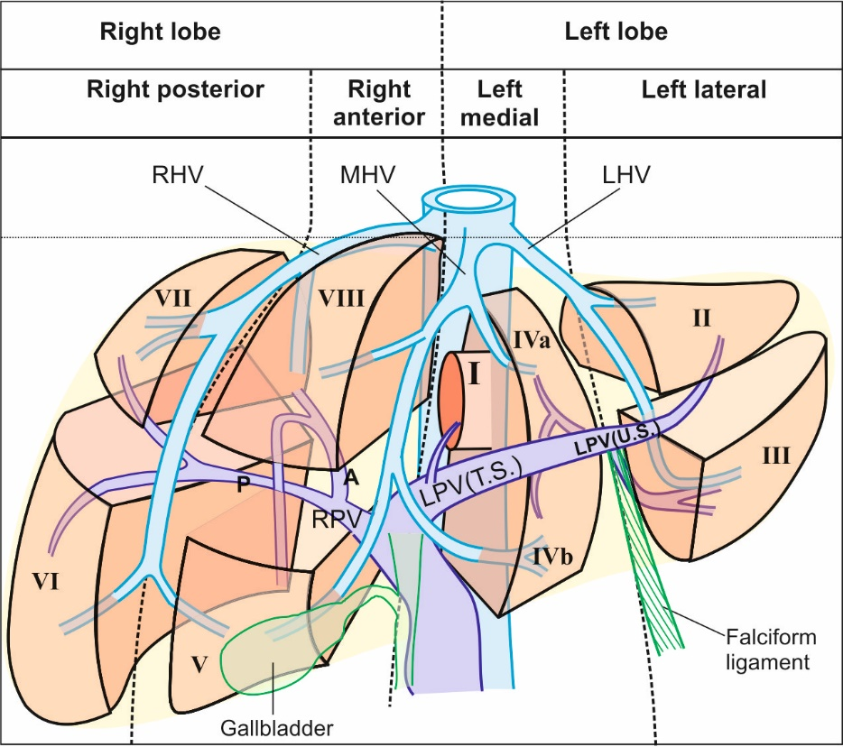
Figure 1 The three vertical planes and a transverse plane, divide the liver into four sectors and eight segments. The vertical planes divide the liver into four sectors. The transverse plane divides the liver into superior and inferior segments. LHV: Left hepatic vein; MHV: Middle hepatic vein; RHV: Right hepatic vein; LPV: Left branch of the portal vein; RPV: Right branch of the portal vein.
A B
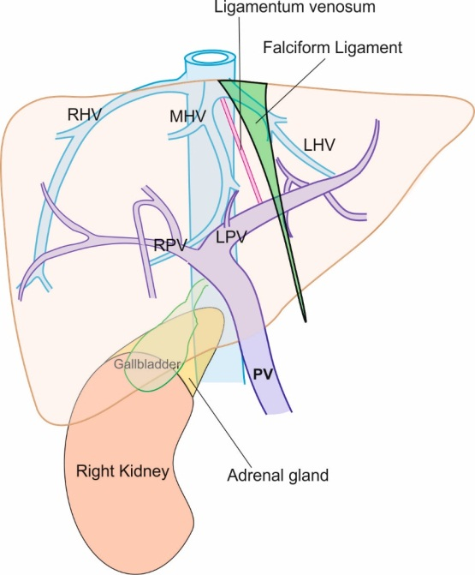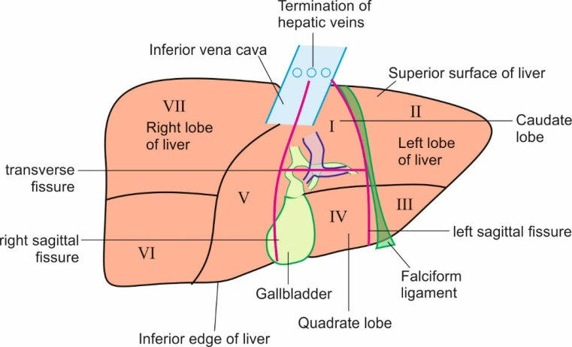
Figure 2 Diagram showing the home bases of imaging and visceral surface of liver.
A: The endoscopic ultrasonography home bases of imaging for liver segments include inferior vena cava (IVC) during its course behind the liver up to the right atrium, three hepatic veins in portal fissures and their joining point into IVC, portal vein (PV) and its branches in transverse fissure, right kidney, Ligamentum teres, Ligamentum venosum and Gallbladder; B: The caudate lobe lies between the stomach and IVC. The hepatic veins join the IVC. The ligamentum venosum and ligamentum teres are attached to the upper and lower border of left branch of PV at the angulation between the transverse and umbilical part. The visceral surface of liver comes in contact with all segments except segment VIII. LHV: Left hepatic vein; MHV: Middle hepatic vein; RHV: Right hepatic vein; LPV: Left branch of the portal vein; RPV: Right branch of the portal vein.

A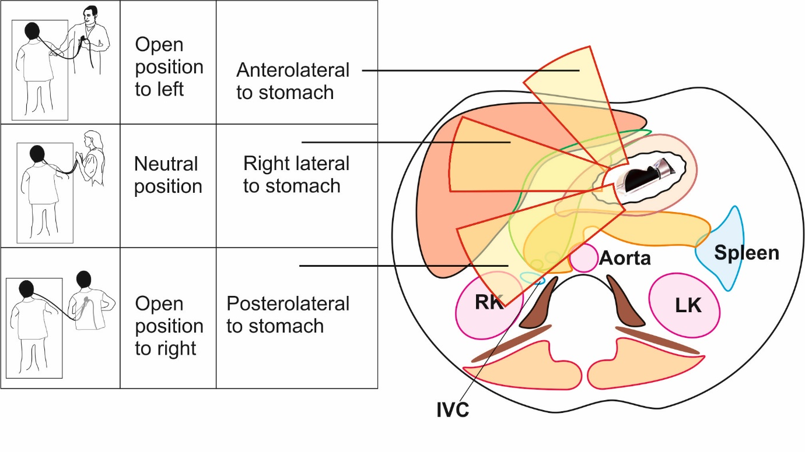
B
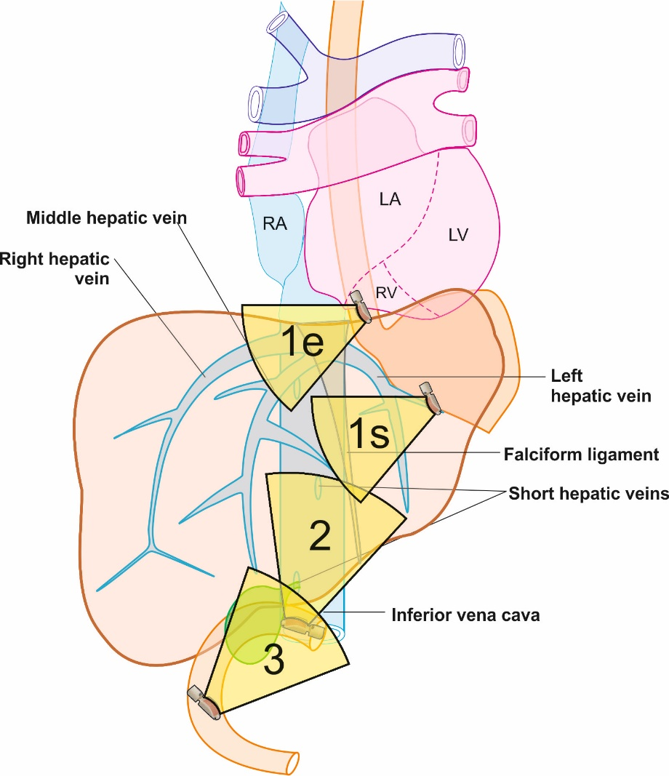
Figure 3 Different operator positions during imaging and three stations of imaging are seen. A: Rotation is the key movement and should be done in a straight position to transfer the effect of rotation to the tip of the ultrasonic transducer. During imaging from stomach, the open position to left starts imaging structures placed dorsal to the probe in the esophagus and stomach and primarily screens the left lobe of liver. The neutral position screens the structures near the liver hilum and the open position to the right screens the right lobe of liver; B: The three stations of imaging for liver segments: station 1: abdominal part of esophagus (1e) and stomach (1s), station 2: duodenal bulb, and station 3: 2nd part of duodenum. IVC: Inferior vena cava. RK: Right kidney; LK: Left kidney.

A
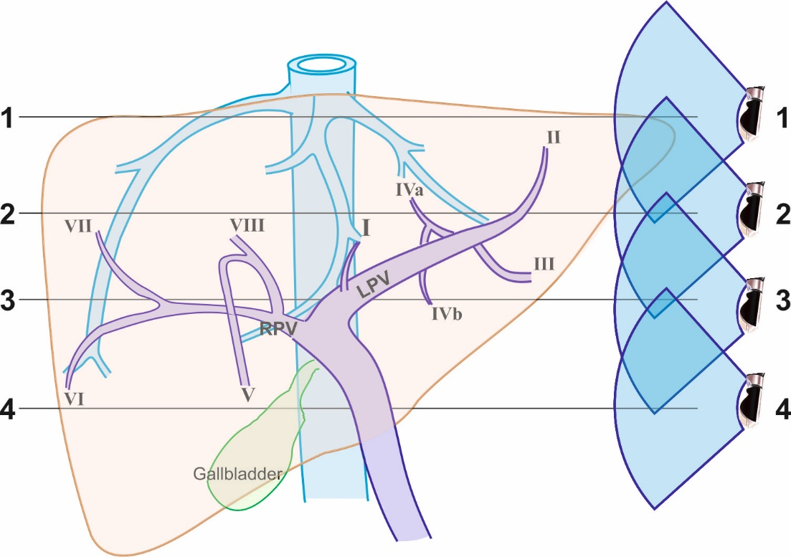
B
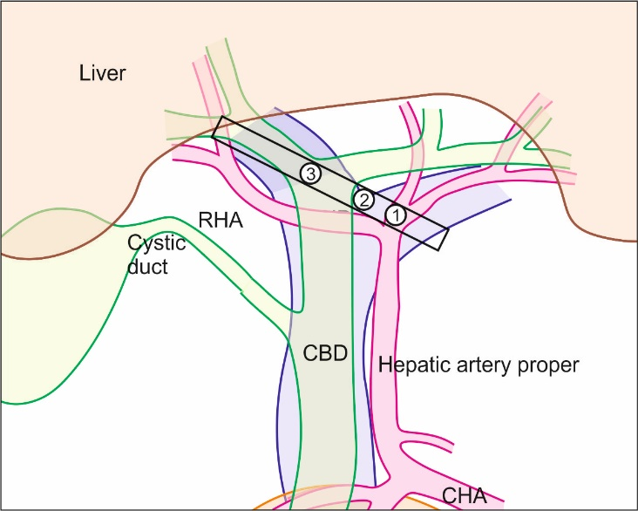
Figure 4 Figures showing hepatic vein tributaries with portal vein branches and hilar structures during rotation from left to right edge of transverse fissure. A: The imaging of hepatic vein tributaries and portal vein (PV) branches as the home bases during imaging from abdominal part of esophagus and stomach; B: This image shows the hilar structures with the divisions during a rotation from left edge of the transverse fissure to the right edge (1); hepatic artery into two branches (2); the union of right and left branch of PV (3); the division of common hepatic duct into right and left branches. LPV: Left branch of the portal vein; RPV: Right branch of the portal vein; CHA: Common hepatic artery; RHA: Right hepatic artery.

A
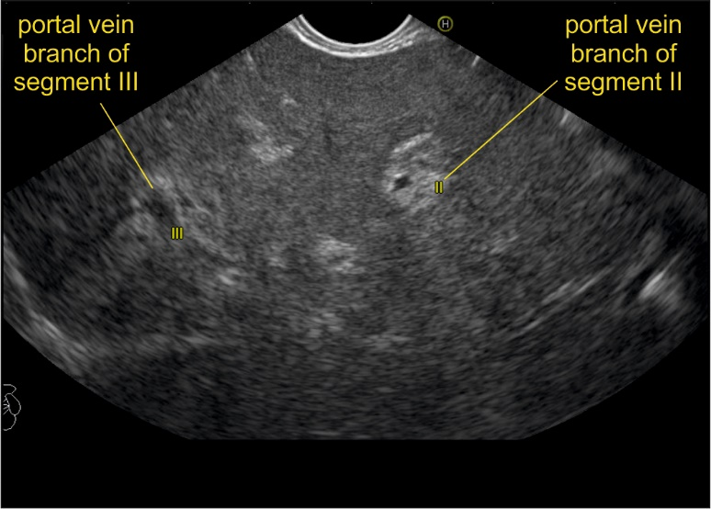
B
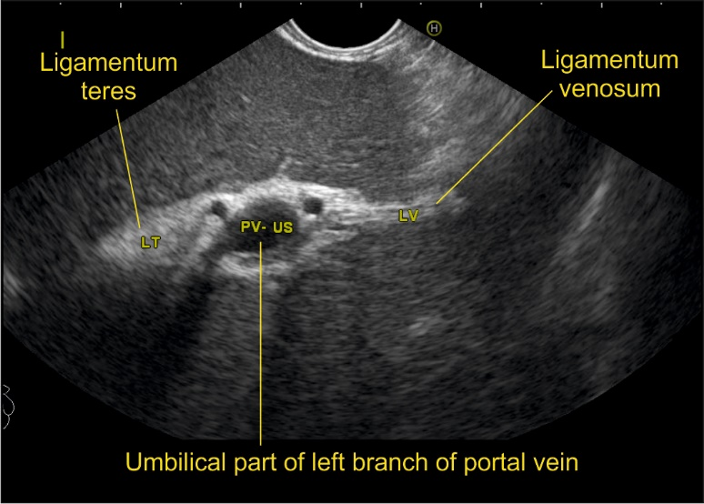
C
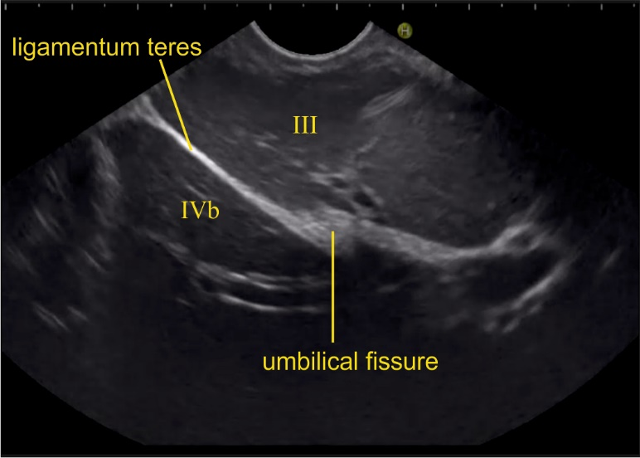
D
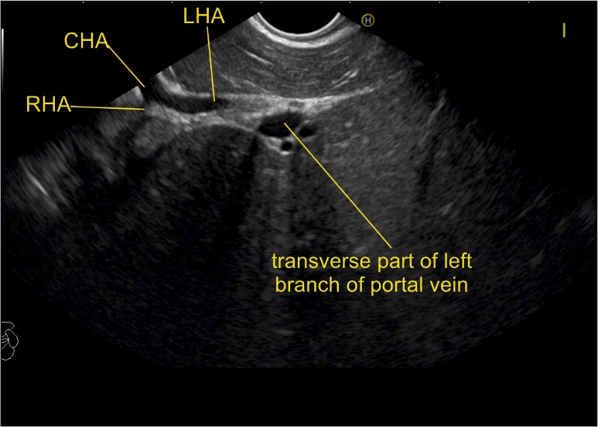

Figure 5 Imaging of liver segments from station 1. A: Imaging from abdominal part of esophagus showing segment II and III portal vein (PV) branches; B: The fisheye appearance of the umbilical part of left branch of PV as seen from abdominal part of esophagus; C: Imaging from visceral surface of liver showing that the ligamentum teres attached to the lower part of umbilical vein; D: On clockwise rotation near the left edge of porta hepatis, the umbilical part enters the transverse fissure. At this point the bifurcation of common hepatic artery can be seen towards the left edge of the transverse fissure. This image shows the entry of left branch of common hepatic artery into the transverse fissure. CHA: Common hepatic artery; RHA: Right hepatic artery; LHA: Left hepatic artery.

A
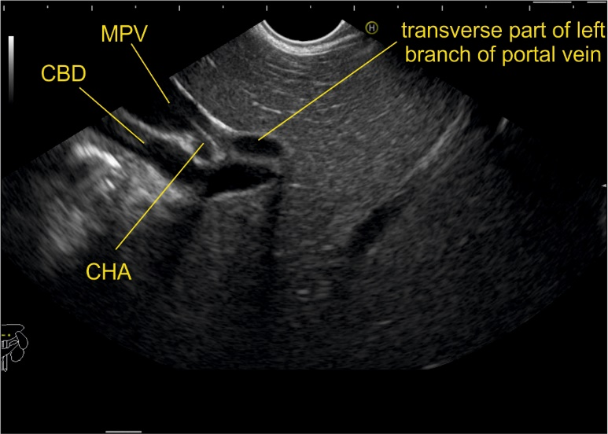
B
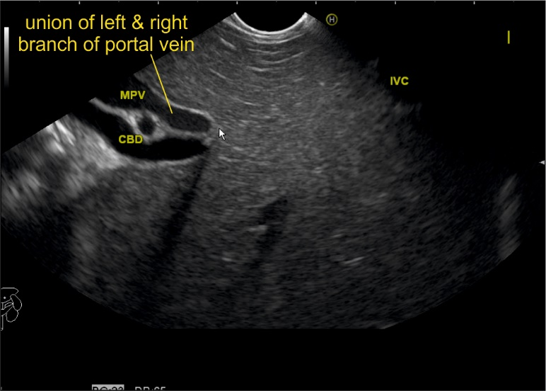
C
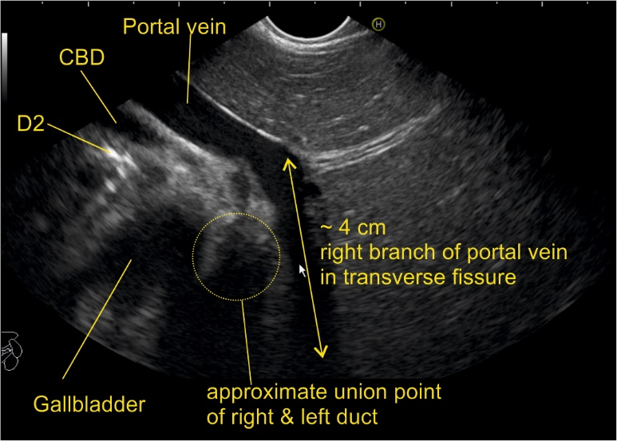
D
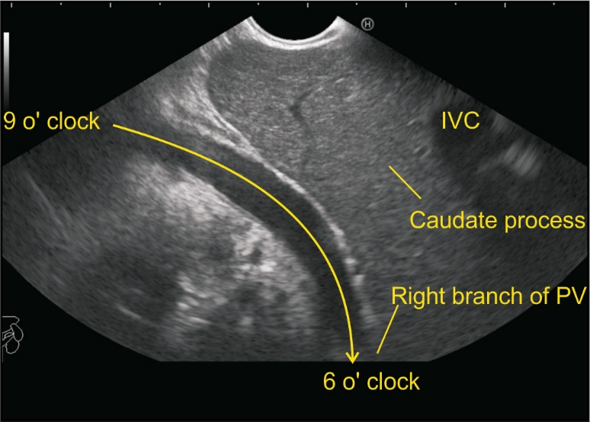
Figure 6 Imaging from neutral position from station 1 showing the tracing of portal vein and its branches during clockwise rotation from left to right edge of transverse fissure. A: Further clockwise rotation traces the course of left branch of portal vein (PV) in the transverse fissure; B: Further rotation shows the union of right and left branch of PV; C: This image shows the approximate 5 cm breadth of transverse fissure within which the right branch of PV joins the left branch; D: The imaging of right branch of PV is easy through the caudate process of liver. With slight up angulation, the right branch of PV is seen in the transverse fissure going from 6 to 9 o’clock position. CHA: Common hepatic artery; IVC: Inferior vena cava; PV: Portal vein; CBD: Common bile duct; MPV: Main portal vein.

A
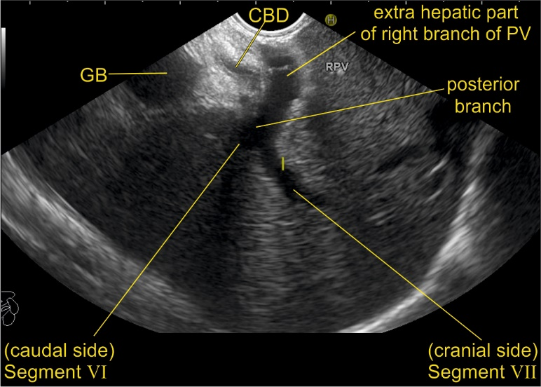
B
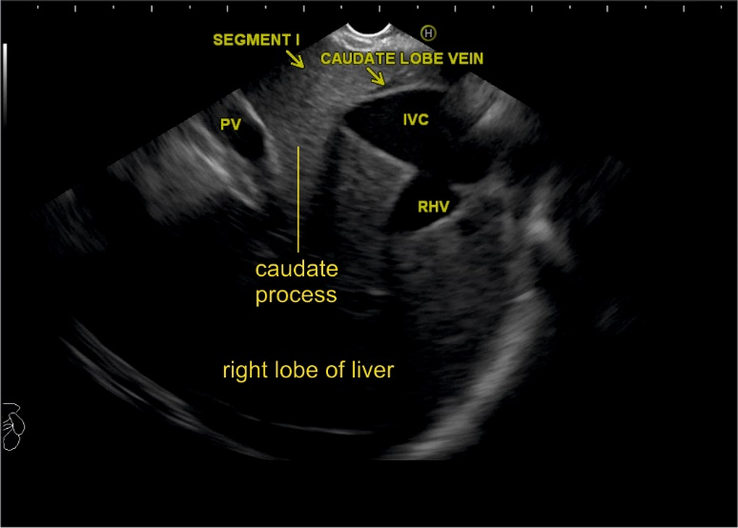
C
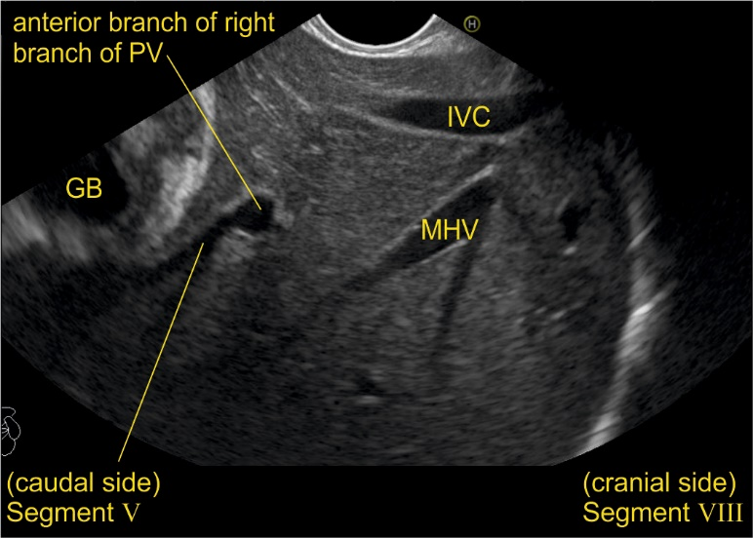
D
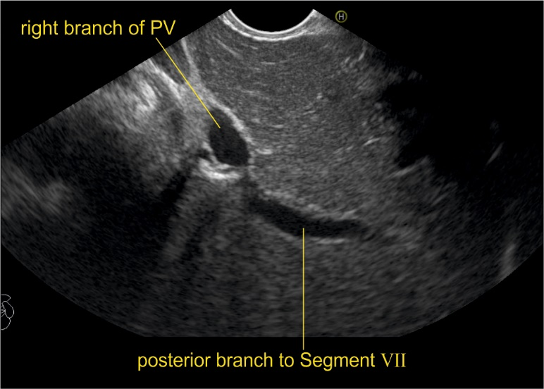
Figure 7 Imaging from station 1 showing right portal vein and its branches in relation to liver segments. A: Imaging of the intrahepatic/extrahepatic part of the right branch of portal vein (PV) is seen along with the right lobe of liver and the hyperechoic diaphragm; B: The inferior vena cava (IVC) and caudate process provide a good window of imaging for right lobe of liver (The caudate lobe is connected with the right lobe of liver through caudate process). In this location presence of IVC may also provide a satisfactory window of imaging; C: A view of the divisions of the right branch of PV is possible through caudate process. In this case, the anterior branch is supplying the segments V and VIII of liver; D: The division of segment VI and VII branches is visualized. The upper part of the posterior branch goes towards segment VII. CBD: Common bile duct; GB: Gallbladder; PV: Portal vein; RHV: Right hepatic vein; MHV: Middle hepatic vein.

A
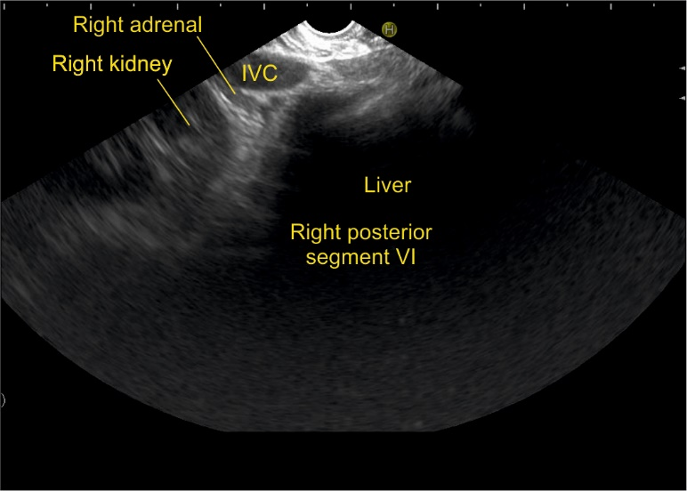
B
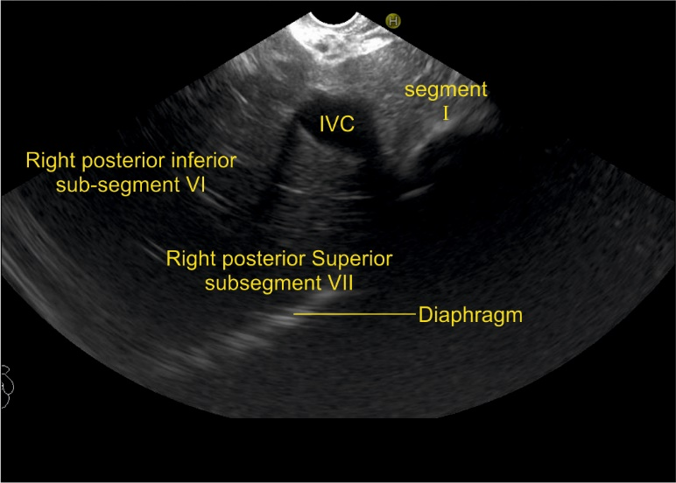
C
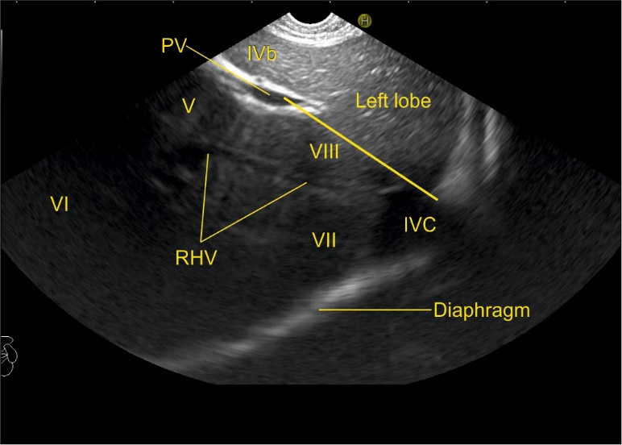
D
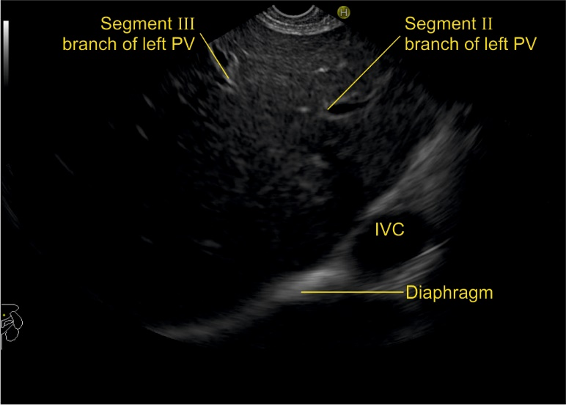
Figure 8 Imaging from descending duodenum showing the structures visualized during anticlockwise rotation from open position to right. A: Imaging from descending duodenum showing the right kidney and inferior vena cava (IVC). The right adrenal gland is seen behind the IVC; B: Imaging from descending duodenum showing the IVC moving towards the diaphragm. The caudate lobe is seen between the probe and the IVC. The caudate lobe indicates the approximate place of transverse part of left branch of PV; C: Imaging from descending duodenum showing the right hepatic vein. It divides the segments of right lobe. A line between the cranial end of IVC and PV gives approximate location of right and left half of liver; D: The segmental branches (II and III) of umbilical part of PV are seen with IVC at 4 o’clock position. RHV: Right hepatic vein.

A
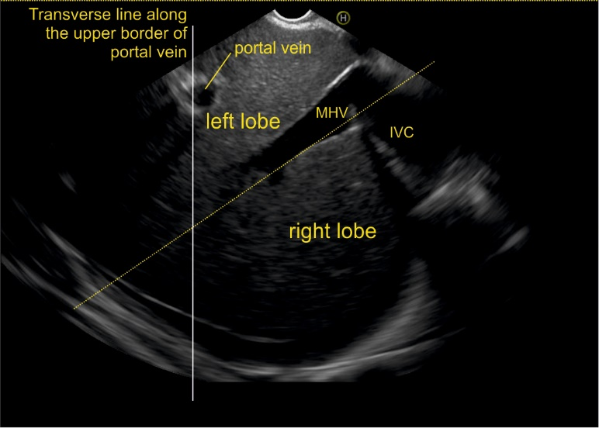
B
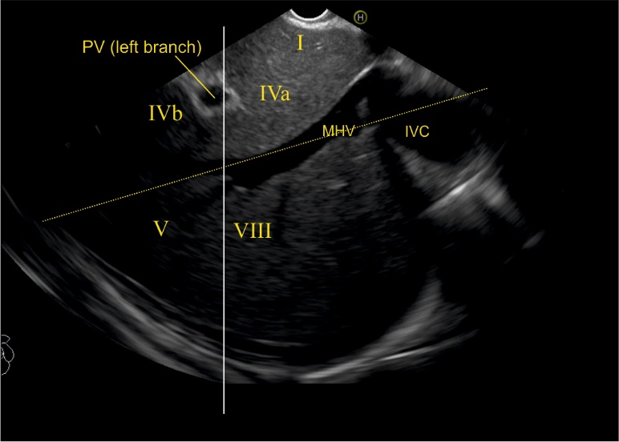
C
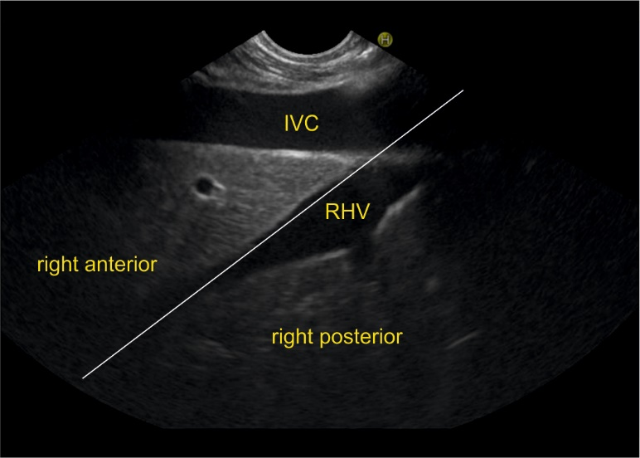
D
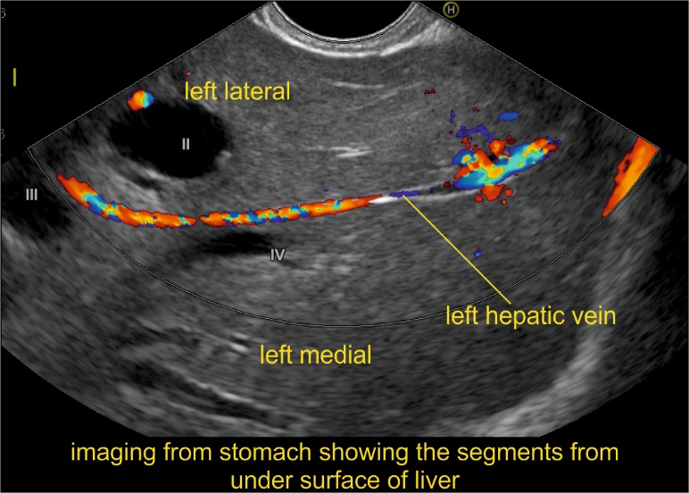
Figure 9 Imaging from station 1 showing hepatic vein branches and their relations to liver segments. A: The middle hepatic vein lies in the course of the Cantlie’s line and separates the left and right lobe of liver; B: The segmental division is shown for segment I, IVa, IVb, V and VIII; C: The right hepatic vein separates the right anterior and right posterior sector; D: The left hepatic vein separates the left medial and left lateral sector. MHV: Middle hepatic vein; RHV: Right hepatic vein; IVC: Inferior vena cava.

A
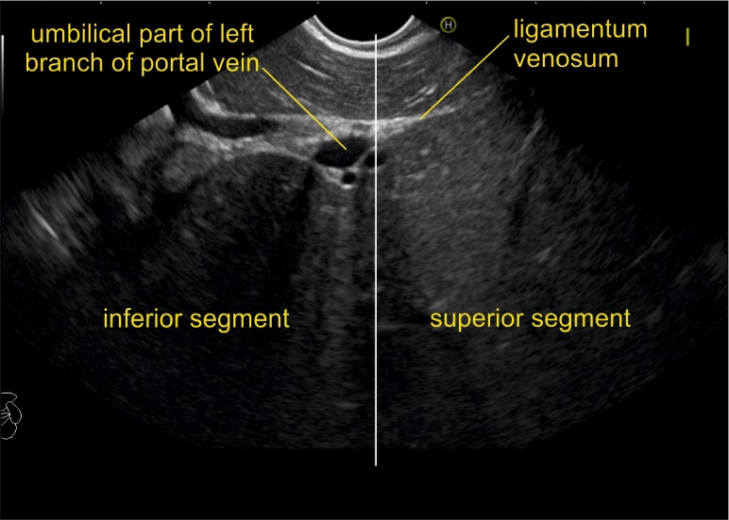
B
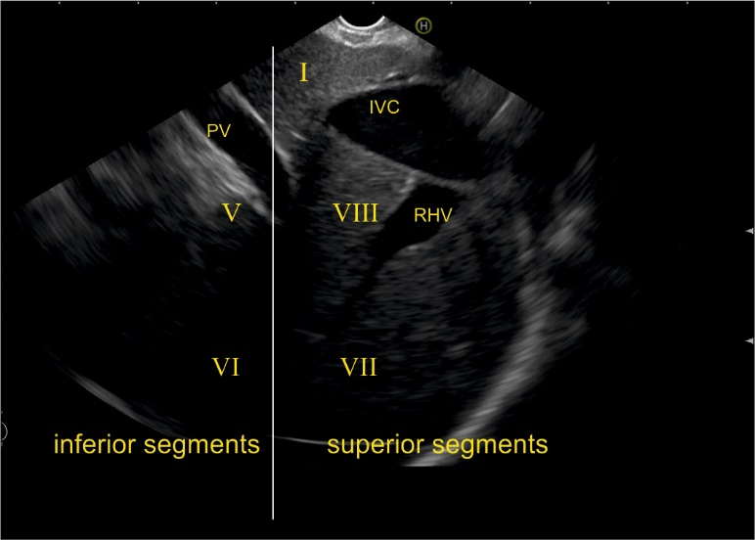
C
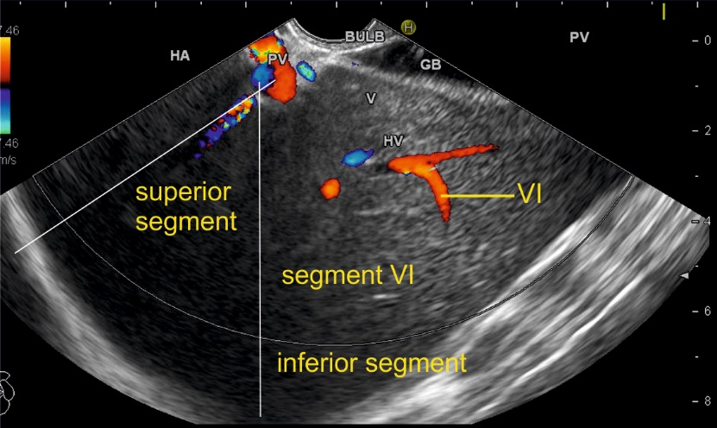
D
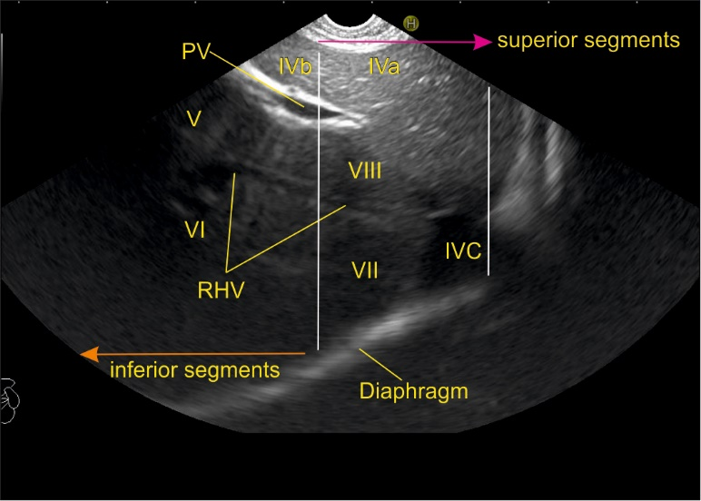
Figure 10: Images showing the division of superior and inferior liver segments by portal vein and its branches. A: Line at the level of upper border of umbilical segment of portal vein (PV) dividing the superior and inferior segment; B: The white line divides the superior and inferior segments. This diagram from the esophagus shows the right side of liver through the caudate lobe of liver and inferior vena cava (IVC). The presence of hepatoduodenal ligament around the PV may not allow a similar quality of visualization of the inferior segments (V and VI); C: This image from station 2 (Duodenum bulb) shows the right and middle hepatic vein. The right hepatic vein goes parallel to the surface of gallbladder and the middle hepatic vein goes towards the neck of gallbladder. Only the right lobe is seen through the gallbladder; D: The right hepatic vein drains the segments VI and VII and a variable portion of segments V and VIII. Segment I has direct drainage into intrahepatic/ retro hepatic part of IVC. RHV: Right hepatic vein.

A
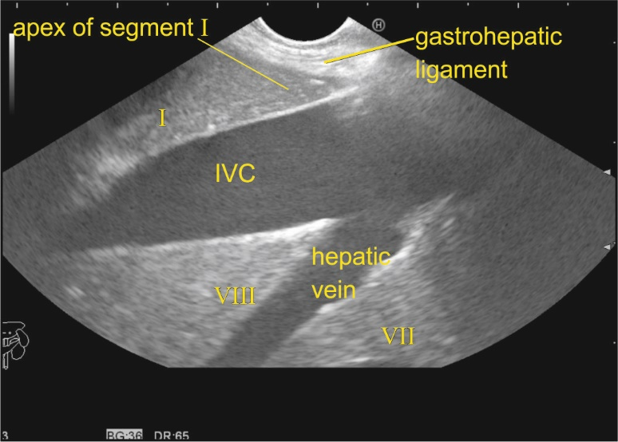
B
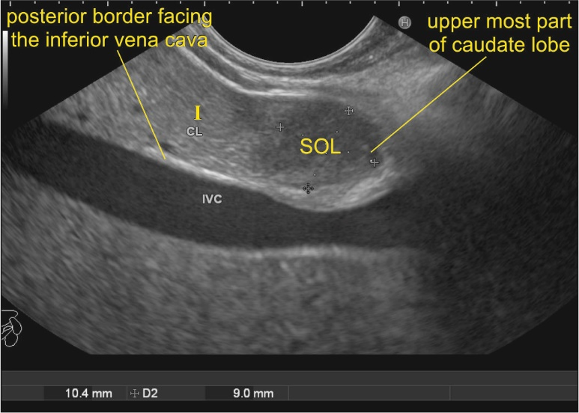
C
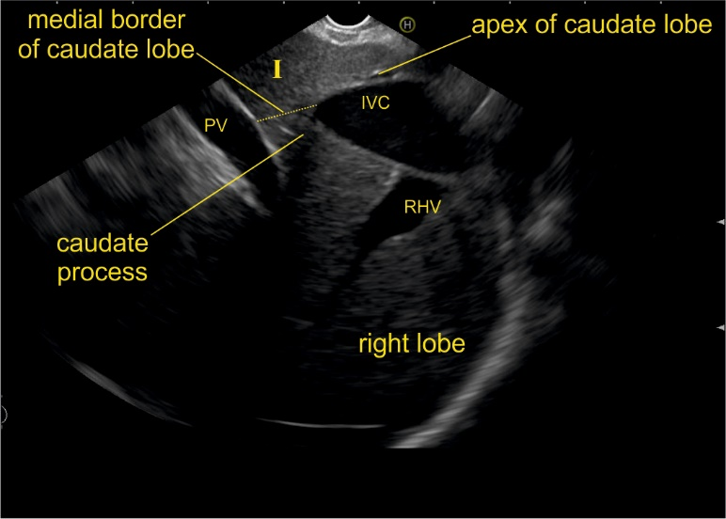

D
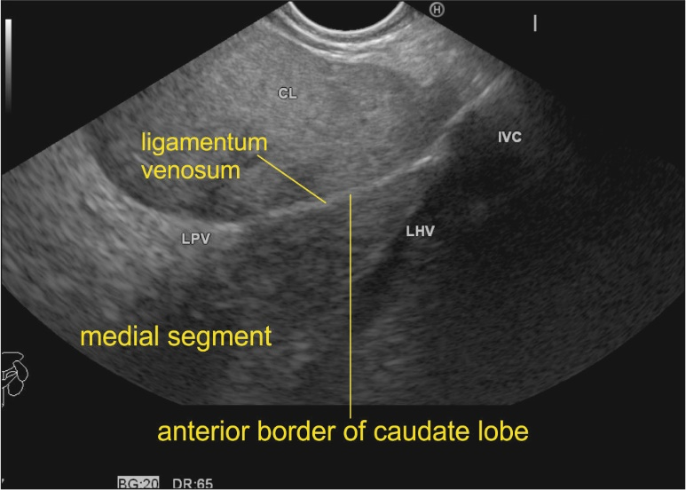

Figure 11 Images showing the caudate lobe, its boundaries and its relations. A: The apex of caudate lobe lies like a wedge near the joining of hepatic veins. The base faces inferior vena cava (IVC); B: A small metastatic space occupying lesion (SOL) is seen near the tip of the caudate lobe of liver near the diaphragm between the probe and the IVC. Anterior margin of lesion is limited by fissure for ligamentum venosum; C: The continuity of caudate lobe into the right lobe of liver via caudate process; D: This figure shows the course of ligamentum venosum proceeding towards the umbilical part of PV and dividing the left medial segment from the caudate lobe. The ligamentum venosum is the anterior border of pyramidal shaped caudate lobe. The attachment of ligamentum venosum demarcates the lowest limit of the anterior border. LHV: Left hepatic vein; LPV: Left branch of the portal vein; RHV: Right hepatic vein.

A
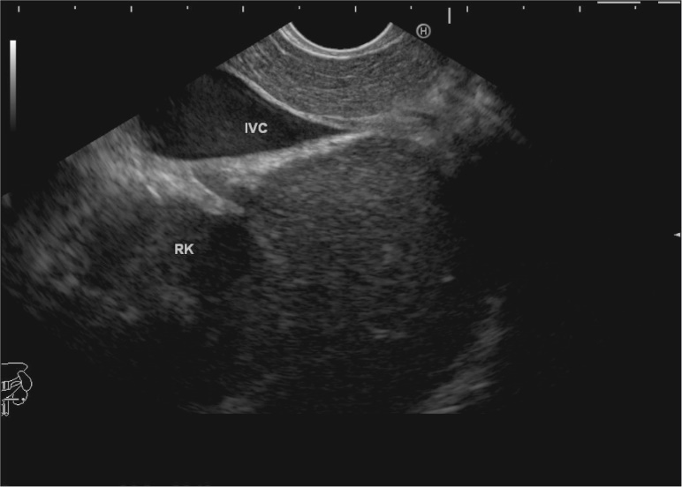
B
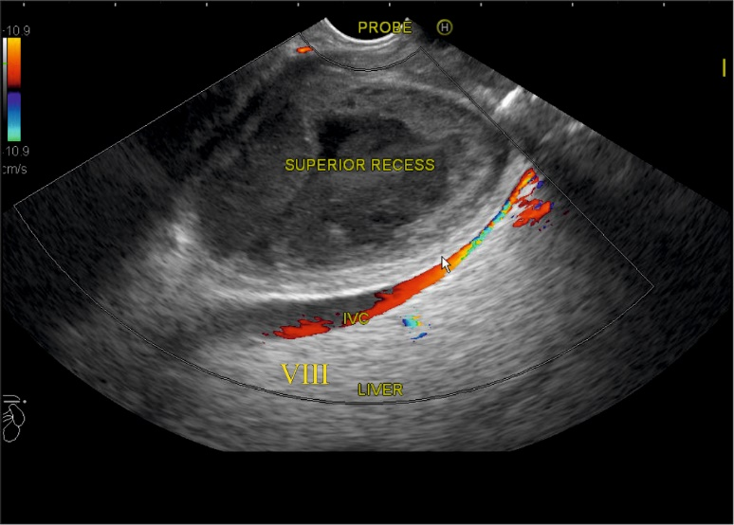
C
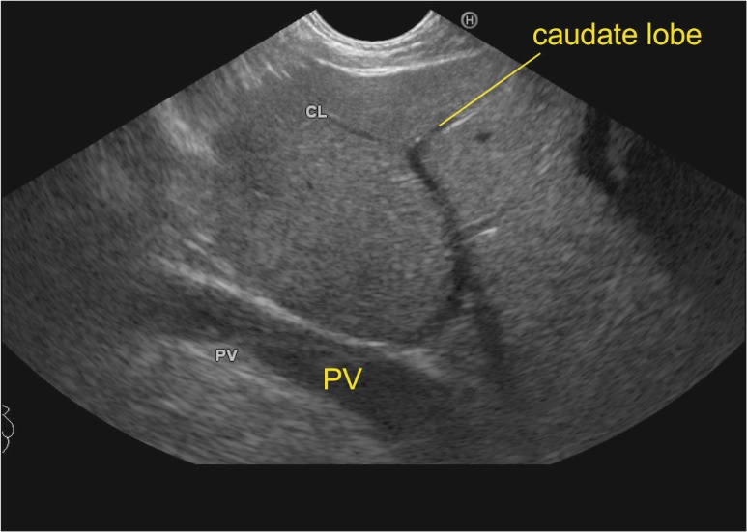

Figure 12 Images showing the caudate lobe, its boundaries and its relations. A: The exit of inferior vena cava (IVC) from the liver demarcates the lowest limit of the posterior border. The right kidney is seen through the IVC. The segments VI lies above the right kidney; B: The left border of caudate lobe lies close to superior recess of lesser sac, which is filled with fluid in this case. C: The vascular supply of caudate lobe from the right branch of portal vein (PV). The right and the left lobe of liver lie on either side of right and left sagittal fissure and the caudate and quadrate lobe lie posterior and anterior to the transverse fissure. RK: Right kidney.

A
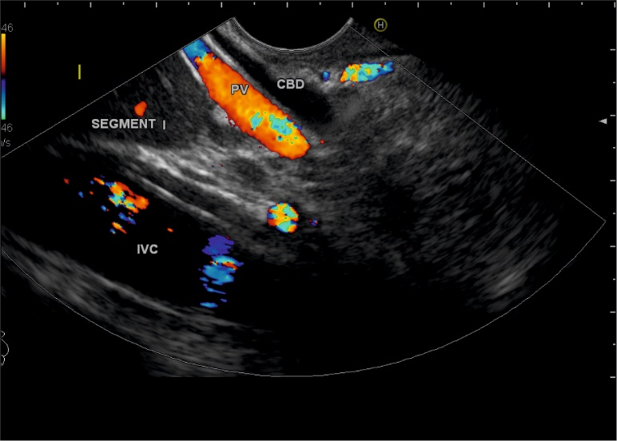
B
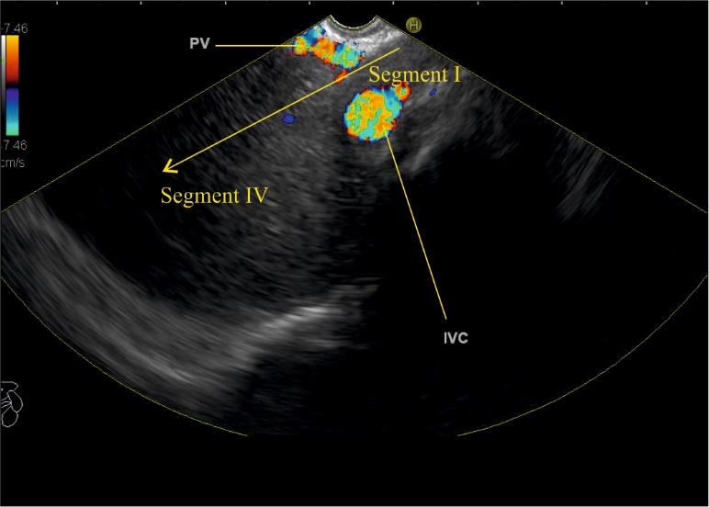
C
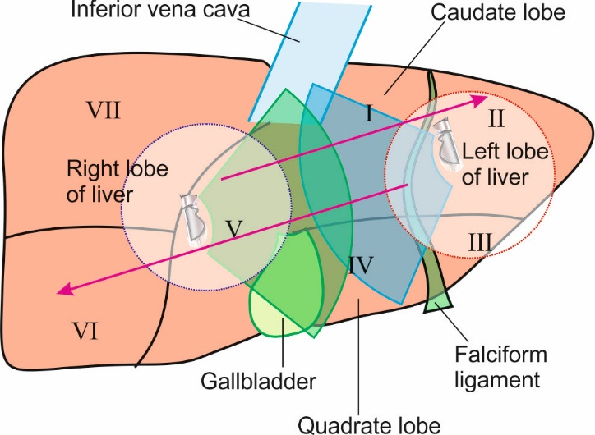
D
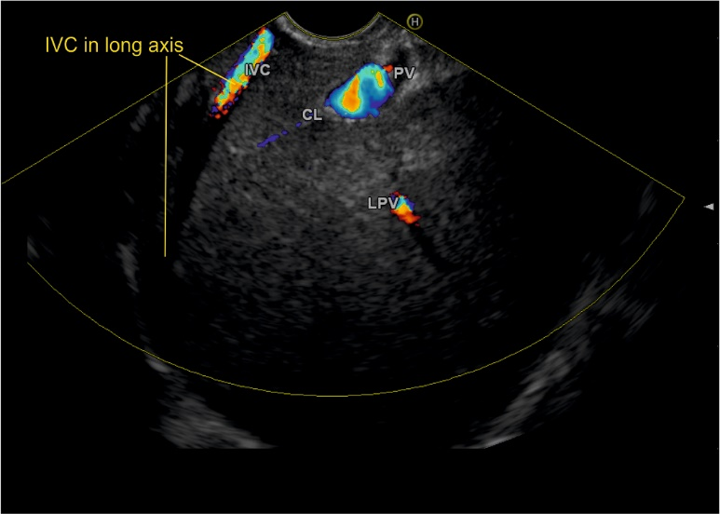

Figure 13 Imaging of caudate lobe from different stations of imaging. A: The figure shows imaging of caudate lobe through the portal vein (PV) in front of inferior vena cava (IVC) from the duodenal bulb; B: The figure shows imaging of caudate lobe between the PV and IVC from the descending duodenum; C: The caudate process acts as a two-way window for imaging of right and left lobe of liver in endoscopic ultrasonography. The circle in red outline shows the approximate area of gastric impression on the visceral surface of the left lobe of liver and shows that the imaging of right lobe is possible through the caudate lobe and caudate process. The circle in the blue outline shows the approximate area of duodenal impression on the visceral surface of the right lobe of liver and shows that the imaging of left lobe is possible through the caudate lobe and caudate process; D: This figure shows the imaging of left lobe of liver through the caudate lobe from duodenal bulb. PV: Portal vein; CBD: Common bile duct.

A
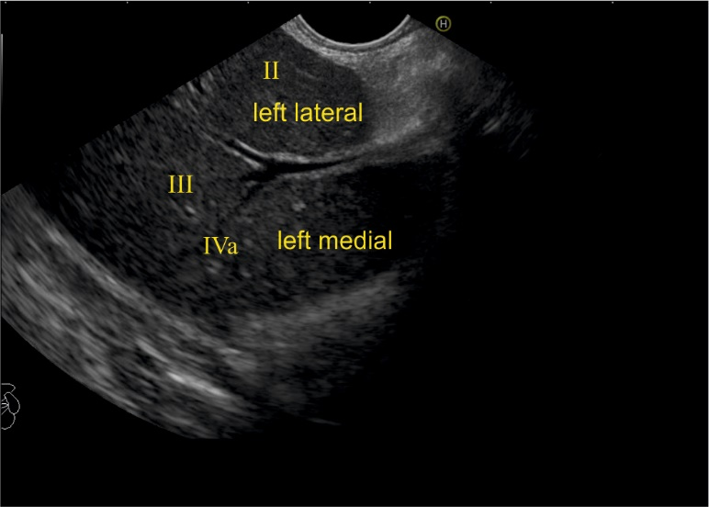
B
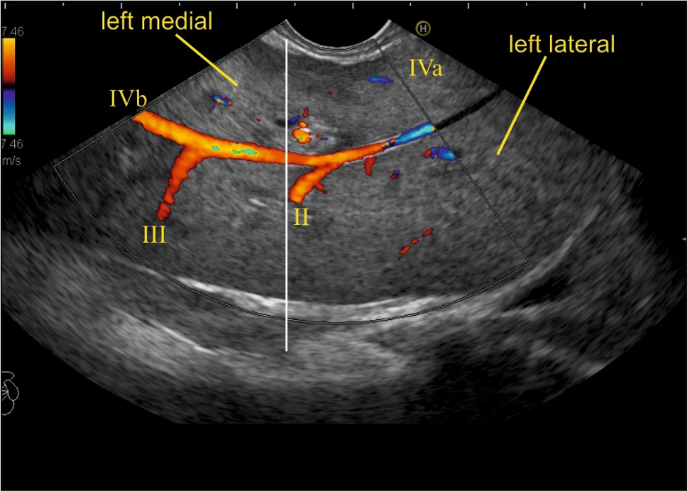
C
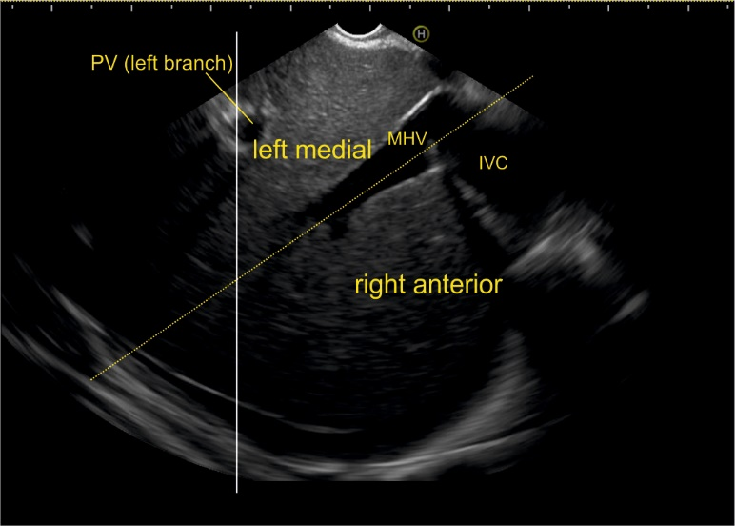
D
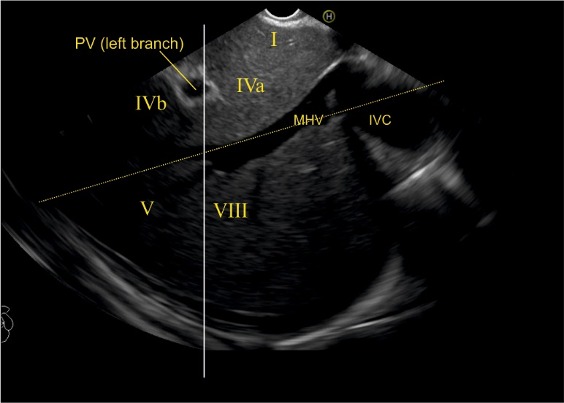

Figure 14 Figures showing hepatic veins dividing liver segments. A: Image showing left lobe segments; B: The upper and lower tributaries of hepatic vein indicate the upper and lower segments of left lateral and left medial sectors. The segment II, III, IVa and IVb veins are seen. In this case, the imaging is done from the visceral surface of the liver and from an area close to the antrum and body. Hence, the segment IV b appears closer to the probe than segment III. It must be clear that while imaging from the lower end of esophagus, the left lateral segment is closer while during imaging from visceral surface of liver the orientation of segment may vary depending on the location of probe. (Near antrum IV is closer than III, near fundus and proximal body III is closer than IV). The white line is an extrapolated line which has been drawn in an approximate axis from the upper part of umbilical part of left branch of PV; C: A line going through the middle hepatic vein separates the left medial and right anterior sector; D: A line along the upper part of the transverse fissure (along the upper edge of PV) subdivides the upper and lower segments of left medial (IVa and IVb) and right anterior (VIII and V) segments. MHV: Middle hepatic vein; IVC: Inferior vena cava.

A
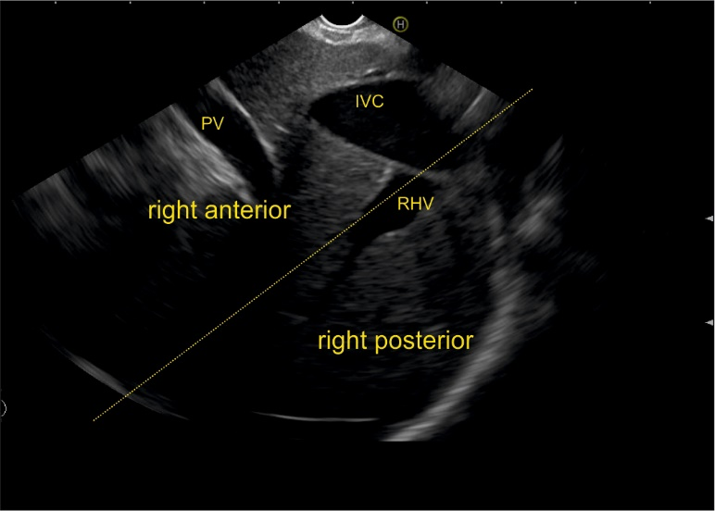
B
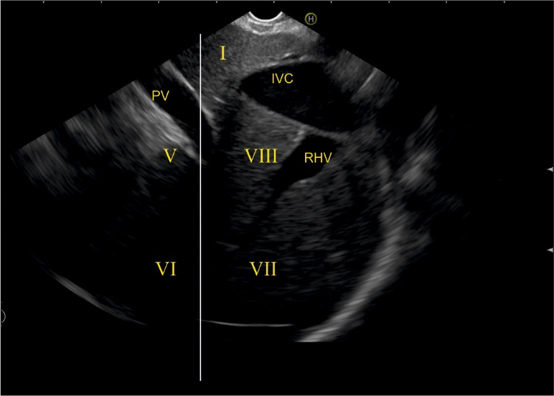
C
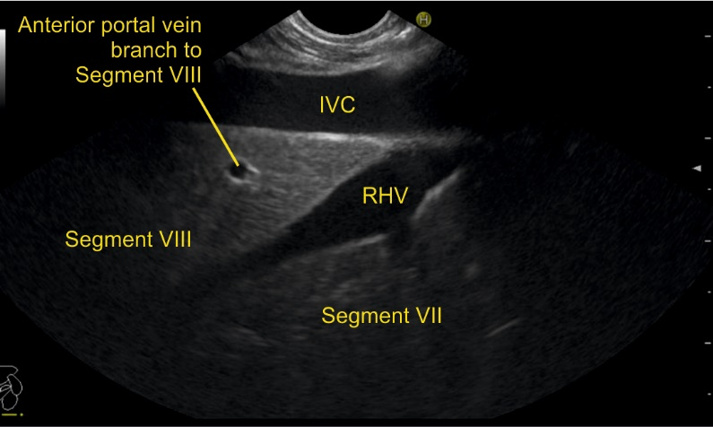
D
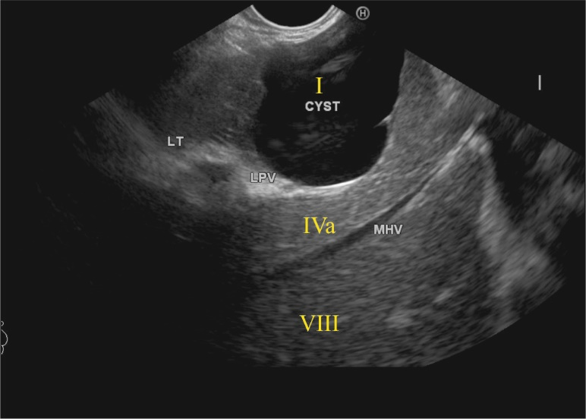

Figure 15 Liver sectors and liver segments are visualized. A: This figure shows inferior vena cava (IVC) running parallel to the probe in a long axis. A line along the right hepatic vein divides the liver into an anterior and posterior sector; B: The right lobe of liver contains segment V to VIII. The segments are seen through the caudate process. The white line is drawn along the upper border of curving part of the portal vein; C: The right hepatic vein is seen joining the IVC at an angle of around 60°. The segment VII is seen above the hepatic vein and the segment VIII is seen between hepatic vein and IVC; D: The middle hepatic vein drains segment IV, segment V and VIII. RHV: Right hepatic vein; LPV: Left branch of the portal vein.

