Name of Journal: World Journal of Stem Cells
Manuscript NO: 90791
Manuscript Type: ORIGINAL ARTICLE

Basic Study
Evaluation of genetic response of mesenchymal stem cells to nanosecond pulsed electric fields by whole transcriptome sequencing

Lin JJ et al. Genetic response of MSCs to nsPEFs

Jian-Jing Lin, Tong Ning, Shi-Cheng Jia, Ke-Jia Li, Yong-Can Huang, Qiang Liu, Jian-Hao Lin, Xin-Tao Zhang

Jian-Jing Lin, Shi-Cheng Jia, Xin-Tao Zhang, Department of Sports Medicine and Rehabilitation, Peking University Shenzhen Hospital, Shenzhen 518036, Guangdong Province, China

Tong Ning, Institute of Medical Science, The Second Hospital, Cheeloo College of Medicine, Shandong University, Jinan 250033, Shandong Province, China

Ke-Jia Li, Department of Biomedical Engineering, Institute of Future Technology, Peking University, Beijing 100871, China

Yong-Can Huang, Shenzhen Engineering Laboratory of Orthopaedic Regenerative Technologies, Peking University Shenzhen Hospital, Shenzhen 518036, Guangdong Province, China

Qiang Liu, Jian-Hao Lin, Arthritis Clinical and Research Center, Peking University People’s Hospital, Beijing 100044, China

Co-first authors: Jian-Jing Lin and Tong Ning.

Co-corresponding authors: Jian-Hao Lin and Xin-Tao Zhang.

Author contributions: Lin JJ, Ning T, and Jia SC designed the project, wrote the original draft, and edited the final version of the manuscript; Ning T and Li KJ analyzed the data; Jia SC drew the tables and figures; Huang YC, Liu Q, and Lin JH revised the manuscript; Lin JH and Zhang XT provided financial support and ensured the final manuscript, and they are the co-corresponding authors of this manuscript; Lin JJ and Ning T contributed equally to the work; and all authors have read and approved the final version of the manuscript.

Supported by the National Natural Science Foundation, China, No. 82272568, 81902247, and 32201013; Natural Science Foundation of Shandong Province, China, No. ZR2021QH275; Natural Science Foundation of Jinan City, China, No. 202225070; and Guangdong Basic and Applied Basic Research Foundation, China, No. 2022A1515220056.

Corresponding author: Xin-Tao Zhang, PhD, Chief Physician, Department of Sports Medicine and Rehabilitation, Peking University Shenzhen Hospital, No. 1120 Lianhua Road, Futian District, Shenzhen 518036, Guangdong Province, China. zhangxintao@sina.com

Received: December 13, 2023
Revised: January 31, 2024
Accepted: February 28, 2024
Published online:

Abstract
BACKGROUND
Mesenchymal stem cells (MSCs) modulated by various exogenous signals have been applied extensively in regenerative medicine research. Notably, nanosecond pulsed electric fields (nsPEFs), characterized by short duration and high strength, significantly influence cell phenotypes and regulate MSCs differentiation via multiple pathways. Consequently, we used transcriptomics to study changes in messenger RNA (mRNA), long noncoding RNA (lncRNA), microRNA (miRNA), and circular RNA expression during nsPEFs application.

AIM
To explore gene expression profiles and potential transcriptional regulatory mechanisms in MSCs pretreated with nsPEFs.

METHODS
The impact of nsPEFs on the MSCs transcriptome was investigated through whole transcriptome sequencing. MSCs were pretreated with 5-pulse nsPEFs (100 ns at 10 kV/cm, 1 Hz), followed by total RNA isolation. Each transcript was normalized by fragments per kilobase per million. Fold change and difference significance were applied to screen the differentially expressed genes (DEGs). Gene Ontology and Kyoto Encyclopedia of Genes and Genomes analyses were performed to elucidate gene functions, complemented by quantitative polymerase chain reaction verification.

RESULTS
In total, 263 DEGs were discovered, with 92 upregulated and 171 downregulated. DEGs were predominantly enriched in epithelial cell proliferation, osteoblast differentiation, mesenchymal cell differentiation, nuclear division, and wound healing. Regarding cellular components, DEGs are primarily involved in condensed chromosome, chromosomal region, actin cytoskeleton, and kinetochore. From aspect of molecular functions, DEGs are mainly involved in glycosaminoglycan binding, integrin binding, nuclear steroid receptor activity, cytoskeletal motor activity, and steroid binding. Quantitative real-time polymerase chain reaction confirmed targeted transcript regulation.

CONCLUSION
Our systematic investigation of the wide-ranging transcriptional pattern modulated by nsPEFs revealed the differential expression of 263 mRNAs, 2 miRNAs, and 65 lncRNAs. Our study demonstrates that nsPEFs may affect stem cells through several signaling pathways, which are involved in vesicular transport, calcium ion transport, cytoskeleton, and cell differentiation.

Key Words: Nanosecond pulsed electric fields; Whole transcriptome sequencing; Mesenchymal stem cells; Genetic response; Stem cell engineering

Lin JJ, Ning T, Jia SC, Li KJ, Huang YC, Liu Q, Lin JH, Zhang XT. Evaluation of genetic response of mesenchymal stem cells to nanosecond pulsed electric fields by whole transcriptome sequencing. World J Stem Cells 2024; In press

Core Tip: Nanosecond pulsed electric fields (nsPEFs) have been found to regulate the osteogenic, chondrogenic, and adipogenic differentiation of mesenchymal stem cells (MSCs). We hypothesized that several key factors may be regulated by nsPEFs, thereby influencing the biological functions of MSCs. Following exposure of MSCs to nsPEFs, we identified the differential expression of 263 messenger RNAs, 65 long noncoding RNAs, and 2 microRNAs. Verification by quantitative polymerase chain reaction and Gene Ontology and Kyoko Encyclopedia of Genes and Genomes enrichment analyses demonstrated the involvement of chromosome, cytoskeleton, and calcium signaling pathways following nsPEFs pretreatment. These results may be very meaningful for the further application of nsPEFs in MSCs.

INTRODUCTION
Mesenchymal stem cells (MSCs), as seed cells in regenerative repair, have been extensively applied in preclinical and clinical research in regenerative medicine, such as osteoarthritis^{[1]}, cartilage defects^{[2]}, and bone defects^{[3]}. The differentiation and function of MSCs can be modulated by various exogenous signals, including biological factors^{[4]}, drug formulations^{[5]}, and physical signals^{[6]}. The quest for an appropriate exogenous signal to regulate the functions and differentiation of stem cells remains a dynamic area of investigation for numerous researchers.
Pulsed electric fields (PEFs), as a crucial biophysical signal, can induce changes in cell membranes and alterations in intracellular calcium ion concentrations. Under specific conditions, PEFs can significantly influence cell phenotypes and regulate stem cell differentiation through multiple pathways^{[7,8]}. However, the biological effects of traditional PEFs are relatively weak, and the time required for the emergence of a differentiating response can often range from hours to days^{[9]}. This may be attributed to the fact that the pulse width of traditional PEFs is in the microsecond range or higher, exceeding the intrinsic charging and discharging time of cell membranes (in the range of hundreds of nanoseconds). As a result, traditional PEFs face difficulties in deeply penetrating the cell interior due to the shielding effect of the cell membrane^{[10]}. In contrast, nanosecond PEFs (nsPEFs) represent nanosecond-duration, high-strength electric fields, with a shorter pulse width than the charging and discharging time of the cell membrane. Furthermore, nsPEFs can deeply penetrate into cellular organelles and exhibit significant biological effects^{[11]}. In our previous research, it was found that nsPEFs can influence the osteogenic, adipogenic, and chondrogenic differentiation of MSCs by regulating DNA methylation and the MAPK signaling pathway^{[12]}. Although nsPEFs show strong regulatory effects on MSCs differentiation, previous studies have mainly focused on specific molecules or pathways, and a comprehensive exploration of the mechanisms by which nsPEFs regulate MSCs has not been conducted.
Transcriptomics analysis, by examining messenger RNA (mRNA), long noncoding RNA (lncRNA), microRNA (miRNA), and circular RNA (circRNA), allows for a comprehensive understanding of changes in gene expression. It also holds significant importance in unraveling alterations in biological processes. In this study, we first utilized high-throughput transcriptomics sequencing to detect the changes of mRNA, miRNA, lncRNA, and circRNA expression in MSCs after nsPEFs treatment. Additionally, we carried out Gene Ontology (GO) and Kyoto Encyclopedia of Genes and Genomes (KEGG) analyses to explore the biological processes and signaling pathways associated with differentially expressed target genes. Furthermore, we validated their expression levels using quantitative real-time polymerase chain reaction, providing further support for the application of nsPEFs in MSCs.

MATERIALS AND METHODS
Cell isolation and culture
All animal experiments were approved by the Institutional Animal Care and Use Committee of Peking University (COE-GeZ-7). Rat bone marrow MSCs (rMSCs) were harvested from 8-wk-old Sprague-Dawley rats according to our previous study^{[13]}. MSCs were cultured in expansion medium composed of Dulbecco’s modified Eagle’s medium (DMEM, Hyclone) supplemented with 10% (v/v) fetal bovine serum (Gibco) and 1% penicillin/streptomycin (Amresco), in a humidified incubator at 37 °C with 5% CO₂. Cells were trypsinized with 0.25% (w/v) trypsin (Invitrogen, Carlsbad, CA, United States) upon reaching 85% confluence. MSCs at passage 5 were used for subsequent experiments.

Application of nsPEFs
We previously found that nsPEFs (100 ns, 10 kV/cm, 1 Hz, 5 pulses) can improve the stemness of porcine bone marrow MSCs, human bone marrow MSCs, and rMSCs, and promote osteochondral defect repair in rats^{[12-14]}. In this study, nsPEFs with the same parameters were applied to regulate MSCs performance. According to our previous study^{[12-14]}, one million MSCs were suspended in 1 mL of DMEM within a 0.4-cm gap cuvette (Bio-Rad, 165-2088, United States) and stimulated by 5 pulses of nsPEFs (100 ns at 10 kV/cm, 1 Hz), and the time interval between two pulses was 1 s. The cells were then subjected to nsPEFs with a duration of 100 ns, as previously described. Five pulses were applied at 1-s intervals between each pulse. MSCs without nsPEFs stimulation served as the control group.

RNA isolation
Total RNA was isolated from the cells 24 h after exposure with the miRNA extraction kit (Cat#TR205-200, Tanmo). Qualified total RNA was further purified with the RNAClean XP Kit (Cat#A63987, Beckman Coulter, Inc.Kraemer Boulevard Brea, CA, United States) and the RNase-Free DNase Set (Cat#79254, QIAGEN, GmBH, Germany). RNA quantity was assessed by UV spectrometry at 260 nm/280 nm absorbance on a spectropchotometer (NanoDrop Technologies, Wilmington, DE, United States).

RNA-seq and differentially expressed gene analysis
The filtered clean reads were mapped to the reference genome database. Each transcript was normalized by fragments per kilobase per million to eliminate the influence of gene length and sequencing depth. The counts of each sample were mapped to the annotated genome after standardization and normalization. Finally, fold change (FC) and difference significance were used to screen the differentially expressed genes (DEGs). Each group of cells was sequenced with three independent biological replicates.

GO and KEGG enrichment analysis
GO term and KEGG pathway enrichment analyses were performed using the tool for Function Annotation in DAVID (https://david.ncifcrf.gov/). The KEGG pathway maps were obtained from the KEGG database (http://www.kegg.jp/).

Expression validation using quantitative polymerase chain reaction
Total RNA was extracted from 1 × 10⁶ cells treated with 1 mL TRIzol. RNA purity and concentration were determined by a NanoDrop 2000 spectropchotometer (Thermo Fisher Scientific). cDNA was synthesized with the ReverTra Ace qPCR Kit (TOYOBO, FSQ-101) and then subjected to quantitative polymerase chain reaction using Power SYBR Green PCR Master Mix (ABI, 4368708). The mRNA levels were determined using 50 ng of cDNA on an Applied Biosystems 7300. All template amplifications were conducted in triplicate with a three-step polymerase chain reaction process. Using Actin expression as a normalization control, the relative expression was calculated using the 2^{-ΔΔCt} method. The primer sequences are provided in Table 1.

Statistical analysis
All numerical data from quantitative polymerase chain reaction are presented as the mean ± SD. Comparisons between groups were performed by the independent sample t-test. Results are presented as the mean ± SD. The Student’s t-test was used to evaluate the difference between the two groups using Prism 8.21 software (GraphPad). The statistical significance level was set at P < 0.05.

RESULTS
Identification of DEGs
Differentially expressed lncRNAs and mRNAs (n = 4) are displayed using Volcano plots (Figure 1) and heat maps (Figure 2). The top 20 differentially expressed lncRNAs and mRNAs in the nsPEFs-treated group compared to the control group are listed in Tables 2 and 3, respectively.
In total, 263 DEGs were identified in the PRJNA931816 dataset, of which 92 and 171 were significantly (|log2FC| > 0.585 and q < 0.05) upregulated and downregulated, respectively (Figures 1A and 2A). Of these DEGs, 65 were lncRNAs, of which 36 and 19 were significantly (|log2FC| > 1 and q < 0.05) upregulated and downregulated, respectively (Figures 1B and 2B); 0 were circRNAs (Figure 1C); and 2 were miRNAs, both of which were significantly upregulated (Figure 1D).

Enrichment analysis of DEGs
To investigate the biological functions and pathways of DEGs, KEGG and GO analyses were conducted for the 263 DEGs. Figure 3 demonstrates the mainly enriched functional annotations from three aspects, including biological processes, cellular components (CC), and molecular functions (MF). From the perspective of biological processes, DEGs were mainly enriched in epithelial cell proliferation, osteoblast differentiation, mesenchymal cell differentiation, nuclear division, and wound healing. From the perspective of CC, DEGs are mainly involved in condensed chromosome, chromosomal region, actin cytoskeleton, and the kinetochore. From the perspective of MF, DEGs are mainly involved in glycosaminoglycan binding, integrin binding, nuclear steroid receptor activity, cytoskeletal motor activity, and steroid binding. When the upregulated mRNAs were enriched, 12 mRNAs were found to be involved in chromosome segregation (biological process). For example, among the 12 mRNAs, Top2a is a conserved regulator of chromatin topology which plays an important role in catalyzing reversible DNA double-strand breaks^{[15]}. From the perspective of CC, upregulated mRNAs were mainly enriched in the chromosome, centromeric region, kinetochore, and midbody. From the perspective of MF, upregulated mRNAs were mainly enriched in integrin binding. When the downregulated mRNAs were enriched, they are involved in the extracellular space (CC). Among the 12 mRNAs, Wnt11 encodes a protein that plays an important role in regulating extracellular matrix (ECM) organization^{[16]}, and Smoc1 encodes an extracellular glycoprotein that is a critical regulator of cell attachment to the ECM by binding to calcium^{[17]}. From the perspective of GO, downregulated mRNAs were mainly enriched in the positive regulation of gene expression, cell differentiation, and ventricular septum morphogenesis (Figure 3A and C). The detailed relationship between DEGs and GO are shown by the Chord diagram of GO (Figure 3E). GO analysis classified genes heavily involved in epithelial cell proliferation and osteoblast differentiation, among others.
Moreover, KEGG analysis shown in Figure 3B, D, and F demonstrated that DEGs mainly participate in the calcium signaling pathway, ECM-receptor interaction, focal adhesion, and vascular smooth muscle contraction. A Waterfall plot was generated to reveal the potential effects of nsPEFs on signaling pathways (Figure 3F). Other related signaling pathways such as the regulation of actin cytoskeleton, PI3K-Akt signaling pathway, Rap1 signaling pathway, cGMP-PKG signaling pathway, and Hippo signaling pathway-multiple species may also contribute to completing the reaction process of MSCs to nsPEFs. The term cluster showed that nsPEFs may stimulate the cells through the calcium signaling pathway, etc.

Enrichment analysis of differentially expressed lncRNA and miRNAs
The GO enrichment analysis results for the differentially expressed lncRNAs, miRNAs, and mRNAs are shown in Figure 4. Based on the target genes of differentially expressed lncRNAs, the most significantly enriched biological processes were regulation of endothelial cell migration, and ribonucleoprotein complex subunit organization. The most significantly enriched CC were the oligosaccharyltransferase complex, endoplasmic reticulum protein-containing complex, chromosome, and centromeric region. The most significantly enriched MF were tubulin binding, nuclear retinoid X receptor binding, and nuclear retinoic acid receptor binding (Figure 4A). Moreover, in Figure 4B, KEGG analysis shows that differentially expressed lncRNAs mainly participate in the glycerophospholipid metabolism signaling pathway.
Based on the target genes of differentially expressed miRNAs, the most significantly enriched biological processes were the flavonoid metabolic process, cellular glucuronidation, vesicle fusion to plasma membrane, and animal organ regeneration. The most significantly enriched CC were the intrinsic component of organelle membrane, the integral component of organelle membrane, and the peroxisome. The most significantly enriched MF were glucuronosyltransferase activity, hexosyltransferase activity, and MAP kinase activity (Figure 4C). In addition, KEGG analysis in Figure 4D shows that differentially expressed miRNAs mainly participate in porphyrin metabolism, ascorbate and aldarate metabolism, biosynthesis of cofactors, and the pentose and glucuronate interconversions signaling pathway.

Validation of mRNA expression using quantitative polymerase chain reaction
We confirmed the accuracy of sequencing data for selected mRNAs, and the mRNA validation results were consistent with the RNA-seq data (Figure 5). According to the related signaling pathway, we selected seven upregulated mRNAs, aldehyde dehydrogenase 3 family member A1 (Aldh3a1), centromere protein F (Cenpf), kinesin family member 20B (Kif20b), epiregulin (Ereg), Nek2, nuclear receptor subfamily 3 group C member 2 (Nr3c2), and scinderin (Scin). The expression of these seven genes was found to be increased 2.02-fold, 1.8-fold, 2.11-fold, 2.12-fold, 1.66-fold, 2.01-fold, and 2.19-fold, respectively, in nsPEFs-treated cells. We selected six downregulated mRNAs, Actg2, Asic3, Crybat4, Nog, Stxbp5 L, and Tubb2b. The expression of these genes was found to be decreased in nsPEFs-treated cells, indicating that the mRNA validation results were consistent with the RNA-seq data.

DISCUSSION
In this study, nsPEFs-treated rMSCs were evaluated by whole transcriptome sequencing in terms of mRNA, lncRNA, circRNA, and miRNA expression. Previous studies have shown that nsPEFs can regulate the expression levels of some mRNAs in MSCs and upregulate the differentiation potential of MSCs^{[12]}. nsPEFs can regulate the chondrogenic differentiation of MSCs through phosphorylation of molecules of the MAPK signaling pathways^{[14]}. nsPEFs can also regulate the differentiation potential of MSCs through demethylation of stemness genes^{[12]}, and can induce nodule formation in osteoblasts^{[18]}. However, the lack of a systematic study hinders further application of nsPEFs in stem cell differentiation.
Using whole transcriptome sequencing, 263 differentially expressed mRNAs (q < 0.05, |log2FC| > 0.585), 2 differentially expressed miRNAs, and 65 differentially expressed lncRNAs were identified, which are involved in stem cell differentiation, calcium ions, plasma membrane, cell skeleton, chromatin, cell adhesion, etc. Our previous study found that nsPEFs (100 ns, 10kV/cm) with specific parameter combinations could promote the chondrogenic, osteoblastic, and adipogenic differentiation of stem cells, but did not induce apoptosis under these parameters^{[13,15]}. Therefore, a combination of 100 ns and 10 kV/cm was selected to conduct electrical stimulation treatment on rMSCs to determine their effects on the gene expression profile. mRNA analysis indicated that nsPEFs may affect cell differentiation, calcium ions, plasma membrane, and other aspects. The expression levels of Scin, Ereg, Kif20b, Aldh3a1, Nr3c2, and Cenpf were upregulated. To better understand the universal effects of nsPEFs on mammalian cells, we compared the gene expression profiles between rMSCs (our data), TM3 cells, Jurkat cells, and U937 cells based on publicly available data^{[19,20]}. We found that the gene expression levels of 23 genes were co-upregulated in rMSCs and TM3 cells, including Kif20b, which indicated that nsPEFs may cause common effects (Supplementary Figure 1). Compared with rMSCs, we found more common DEGs in TM3 cells (23 genes) than in Jurkat cells (3 genes) and U937 cells (6 genes). The reason for this may be that TM3 and rMSCs are adherent cells, and they are from mice or rats, while U937 and Jurkat cells are suspension cells, and are from humans. The 23 common DEGs are involved in the ECM-receptor interaction signaling pathway. Electric fields were reported to regulate ECM structure^{[21]} and synthesis^{[22]}. On the other hand, the ECM was reported to participate in regeneration^{[23]} and play an important role in stem cell fate^{[24]}. The ECM may be involved in the regulation of cell fate by nsPEFs, which could be further investigated focusing on ECM-receptor interaction. KIF20B was reported to be involved in cell proliferation^{[25]}. Scin belongs to the gelolysin protein superfamily, which is involved in the regulation of cytoskeleton and transport in cell vesicles. It has an important regulatory role in the release of intracellular calcium ions, behaving as a filamentous actin-severing and capping protein^{[26]}. The actin filament network, which in turn leads to the release of secretory vesicles^{[27]}, plays an important role in actin-dependent membrane fusion^{[26]}. Ereg belongs to the epidermal growth factor family and is separated from stem cells. It has been reported that Ereg can promote the migration and chemotactic ability of adipose stem cells through the MAPK signaling pathway^{[28]}. Cenpf plays an important role in the microtubule network, which may be related to SNARE proteins which are involved in plasma membrane circulation^{[29]}. These genes remain to be explored in nsPEFs-treated stem cells.
MiRNAs play an important biological function by regulating downstream gene translation. We found that nsPEFs had few effects on miRNAs, and the expression levels of novel.118 and novel.106 were significantly upregulated. GO/KEGG analyses of the target genes of miRNAs showed that nsPEFs may affect vesicle fusion to the plasma membrane, MAPK, etc. In addition, nsPEFs were reported to affect the MAPK signaling pathway by phosphorylation of p38, JNK, and ERK^{[30]}. Bone regeneration can be regulated via the MAPK signaling pathway under specific hydrogel treatment^{[31]}. High-voltage PEFs with short durations, can permeabilize cell membranes with a duration ranging from microseconds to nanoseconds^{[32]}. nsPEFs can also regulate membrane pore formation and upregulate the release of exosomes^{[33]}, and vesicle fusion was related to exosome formation^{[34]}. In addition, studies have shown that electroporation can increase the production of exosomes by increasing intracellular calcium ions^{[35]}. Following nsPEFs treatment, exosome release from tumor cells was also significantly increased^{[33]}. Exosomes, released from stem cells, could stimulate wound regeneration and bone regeneration^{[36,37]}. Thus, nsPEFs may affect exosome formation through vesicle fusion to the plasma membrane in stem cells, which requires further investigation.
Based on the target genes of differentially expressed lncRNAs, the most significant MF involved tubulin binding after nsPEFs treatment and the most significant signaling pathways involved glycerophospholipid metabolism and mismatch repair. In addition, studies have shown that nsPEFs with certain parameters can be applied to regulate the level of cell differentiation^{[12]}, promote the release of the intracellular calcium pool^{[38]}, and trigger reversible perforation of the cell membrane^{[39]}. A previous study showed that nsPEFs could affect chromosome structure by inducing extracellular release of chromosomal DNA in a calcium-dependent manner^{[40]}. nsPEFs with high intensity (60 kV/cm) can induce damage to the cytoskeleton and nuclear membrane^{[41]}. Chromosome structure is sensitive to physical stimulation. Extremely-low-frequency magnetic fields could stabilize active chromatin, partially depending upon chromatin status^{[42]}. Chromosomes can be oriented, aligned, and translated by high-frequency electric fields, in a frequency-dependent manner^{[43]}. Chromatin accessibility played an important role in gene expression and cell fate^{[44]}. Chromatin undergoes a binary off/on switch during cell fate transitions^{[45]}. Electric fields were reported to change cell fate partially through regulation of calcium and modulation of electrically charged cell-surface receptors in response to the electric field^{[46]}. Thus, nsPEFs may affect the chromatin accessibility and fate of stem cells, which remains to be explored.
The calcium signaling pathway may play an important role in the process of reaction of MSCs to nsPEFs. A previous study showed that nsPEFs could induce calcium flux in osteoblasts^{[47]}. In our study, DEGs and the target genes of lncRNAs and miRNAs were enriched in the calcium signaling pathway as shown by GO/KEGG analyses. Calcium release caused by nsPEFs may be due to nanopore formation in the endoplasmic reticulum^{[48]}. Furthermore, nsPEFs may activate TMEM16F (or anoctamin 6), a protein functioning as a calcium-dependent scramblase, which contributes to the reaction of calcium release due to nsPEFs^{[49]}. BAPTA-AM, a calcium chelator, could attenuate the upregulated phosphorylation level of JNK caused by nsPEFs^{[14]}. Calcium may contribute to apoptosis in hair follicle stem cells through Piezo1^{[50]}. Calcium uptake was reported to control mitochondrial calcium homeostasis and hematopoietic stem cell differentiation, two important determinants in stem cell fate^{[51]}. Calcium-activated potassium channel activity can influence MSC differentiation through membrane potential and intracellular calcium oscillations^{[52]}. Consequently, the calcium signaling pathway may play an important role in the effects caused by nsPEFs in stem cells.

CONCLUSION
There are few studies on the effect of nsPEFs on stem cells at the whole transcriptomic level. The effects of nsPEFs on stem cells were systematically studied, and 263 differentially expressed mRNAs, 2 differentially expressed miRNAs, and 65 differentially expressed lncRNAs were identified. It was shown that nsPEFs may affect stem cells via several signaling pathways and may involve vesicular transport, calcium ion transport, the cytoskeleton, and cell differentiation. Our study is the first to investigate the expression profile of the whole transcriptome in nsPEFs-treated stem cells. This study provides a certain basis for the application of nsPEFs in stem cell differentiation and tissue regeneration.

ARTICLE HIGHLIGHTS
Research background
Mesenchymal stem cells (MSCs) have been extensively applied in preclinical and clinical research in regenerative medicine. Their differentiation and function are modulated by various exogenous signals, which provide potential strategies for researchers to explore appropriate exogenous signals to regulate the functions and differentiation of stem cells. Nanosecond pulsed electric fields (nsPEFs) represent nanosecond-duration, high-strength electric fields to significantly influence cell phenotypes and regulate stem cell differentiation through multiple pathways. Thus, we used transcriptomics analysis to analyze messenger RNA (mRNA), long noncoding RNA (lncRNA), microRNA (miRNA), and circular RNA (circRNA) expression to identify changes in gene expression following treatment with nsPEFs.

Research motivation
The differentiation and function of MSCs are regulated by nsPEFs. However, the mechanism, especially changes in gene expression after nsPEFs treatment, remains unclear.

Research objectives
To reveal gene expression in MSCs pretreated with nsPEFs and explore the potential gene regulatory mechanism.

Research methods
We used whole transcriptome sequencing to investigate the effects of nsPEFs on MSC transcriptome. Five pulses of nsPEFs (100 ns at 10 kV/cm, 1 Hz) were applied to pretreat MSCs. Total RNA was isolated after pretreatment of MSCs; each transcript was normalized by fragments per kilobase per million. Fold change and difference significance were used to screen the differentially expressed genes (DEGs). Gene Ontology and Kyoto Encyclopedia of Genes and Genomes analyses were conducted to identify gene function, and the results were verified by quantitative polymerase chain reaction.

Research results
The top 20 differentially expressed lncRNAs and mRNAs were revealed. Two hundred and sixty-three DEGs were identified in the PRJNA931816 dataset, of which 92 were upregulated and 171 were significantly downregulated, respectively. DEGs were mainly enriched in epithelial cell proliferation, osteoblast differentiation, mesenchymal cell differentiation, nuclear division, and wound healing. As for cellular components, DEGs were mainly involved in condensed chromosome, chromosomal region, actin cytoskeleton, and the kinetochore. With regard to molecular functions, DEGs are mainly involved in glycosaminoglycan binding, integrin binding, nuclear steroid receptor activity, cytoskeletal motor activity, and steroid binding. Quantitative real-time polymerase chain reaction was used to verify the seven upregulated mRNAs, Aldh3a1, Cenpf, Kif20b, Ereg, Nek2, Nr3c2, and Scin, and six downregulated mRNAs, Actg2, Asic3, Crybat4, Nog, Stxbp5 L, and Tubb2b.

Research conclusions
Our systematic investigation of the wide-ranging transcriptional pattern modulated by nsPEFs revealed the differential expression of 263 mRNAs, 2 miRNAs, and 65 lncRNAs. We showed that nsPEFs may affect stem cells via several signaling pathways and involve vesicular transport, calcium ion transport, the cytoskeleton, and cell differentiation.

Research perspectives
This study is the first to investigate the expression profile of the whole transcriptome in nsPEFs-treated stem cells. The findings provide a certain basis for the application of nsPEFs in stem cell differentiation and tissue regeneration.

ACKNOWLEDGEMENTS
The authors are grateful to Peking University, Peking University People Hospital, and Peking University Shenzhen Hospital for providing the research instruments and workplace.

REFERENCES
1 McKinney JM, Pucha KA, Doan TN, Wang L, Weinstock LD, Tignor BT, Fowle KL, Levit RD, Wood LB, Willett NJ. Sodium alginate microencapsulation of human mesenchymal stromal cells modulates paracrine signaling response and enhances efficacy for treatment of established osteoarthritis. Acta Biomater 2022; 141: 315-332 [PMID: 34979327 DOI: 10.1016/j.actbio.2021.12.034]
2 Zhang J, Zhang M, Lin R, Du Y, Wang L, Yao Q, Zannettino A, Zhang H. Chondrogenic preconditioning of mesenchymal stem/stromal cells within a magnetic scaffold for osteochondral repair. Biofabrication 2022; 14 [PMID: 35226893 DOI: 10.1088/1758-5090/ac5935]
3 Choi DH, Lee KE, Oh SY, Lee SM, Jo BS, Lee JY, Park JC, Park YJ, Park KD, Jo I, Park YS. Tonsil-derived mesenchymal stem cells incorporated in reactive oxygen species-releasing hydrogel promote bone formation by increasing the translocation of cell surface GRP78. Biomaterials 2021; 278: 121156 [PMID: 34597900 DOI: 10.1016/j.biomaterials.2021.121156]
4 Fan L, Chen J, Tao Y, Heng BC, Yu J, Yang Z, Ge Z. Enhancement of the chondrogenic differentiation of mesenchymal stem cells and cartilage repair by ghrelin. J Orthop Res 2019; 37: 1387-1397 [PMID: 30644571 DOI: 10.1002/jor.24224]
5 Chen Y, An X, Wang Z, Guan S, An H, Huang Q, Zhang H, Liang L, Huang B, Wang H, Lu M, Nie H, Wang J, Dai X, Lu X. Transcriptome and lipidome profile of human mesenchymal stem cells with reduced senescence and increased trilineage differentiation ability upon drug treatment. Aging (Albany NY) 2021; 13: 9991-10014 [PMID: 33795523 DOI: 10.18632/aging.202759]
6 Kusuyama J, Bandow K, Shamoto M, Kakimoto K, Ohnishi T, Matsuguchi T. Low intensity pulsed ultrasound (LIPUS) influences the multilineage differentiation of mesenchymal stem and progenitor cell lines through ROCK-Cot/Tpl2-MEK-ERK signaling pathway. J Biol Chem 2014; 289: 10330-10344 [PMID: 24550383 DOI: 10.1074/jbc.M113.546382]
7 Hess R, Jaeschke A, Neubert H, Hintze V, Moeller S, Schnabelrauch M, Wiesmann HP, Hart DA, Scharnweber D. Synergistic effect of defined artificial extracellular matrices and pulsed electric fields on osteogenic differentiation of human MSCs. Biomaterials 2012; 33: 8975-8985 [PMID: 22995709 DOI: 10.1016/j.biomaterials.2012.08.056]
8 Guo W, Zhang X, Yu X, Wang S, Qiu J, Tang W, Li L, Liu H, Wang ZL. Self-Powered Electrical Stimulation for Enhancing Neural Differentiation of Mesenchymal Stem Cells on Graphene-Poly(3,4-ethylenedioxythiophene) Hybrid Microfibers. ACS Nano 2016; 10: 5086-5095 [PMID: 27144593 DOI: 10.1021/acsnano.6b00200]
9 Bicer M, Sheard J, Iandolo D, Boateng SY, Cottrell GS, Widera D. Electrical Stimulation of Adipose-Derived Stem Cells in 3D Nanofibrillar Cellulose Increases Their Osteogenic Potential. Biomolecules 2020; 10 [PMID: 33353222 DOI: 10.3390/biom10121696]
10 Yao C, Hu X, Mi Y, Li C, Sun C. Window effect of pulsed electric field on biological cells. IEEE Trans Dielectr Electr Insul 2009; 16: 1259-1266 [DOI: 10.1109/TDEI.2009.5293936]
11 Ning T, Zhang K, Heng BC, Ge Z. Diverse effects of pulsed electrical stimulation on cells - with a focus on chondrocytes and cartilage regeneration. Eur Cell Mater 2019; 38: 79-93 [PMID: 31478555 DOI: 10.22203/eCM.v038a07]
12 Li K, Ning T, Wang H, Jiang Y, Zhang J, Ge Z. Nanosecond pulsed electric fields enhance mesenchymal stem cells differentiation via DNMT1-regulated OCT4/NANOG gene expression. Stem Cell Res Ther 2020; 11: 308 [PMID: 32698858 DOI: 10.1186/s13287-020-01821-5]
13 Li K, Fan L, Lin J, Heng BC, Deng Z, Zheng Q, Zhang J, Jiang Y, Ge Z. Nanosecond pulsed electric fields prime mesenchymal stem cells to peptide ghrelin and enhance chondrogenesis and osteochondral defect repair in vivo. Sci China Life Sci 2022; 65: 927-939 [PMID: 34586575 DOI: 10.1007/s11427-021-1983-y]
14 Ning T, Guo J, Zhang K, Li K, Zhang J, Yang Z, Ge Z. Nanosecond pulsed electric fields enhanced chondrogenic potential of mesenchymal stem cells via JNK/CREB-STAT3 signaling pathway. Stem Cell Res Ther 2019; 10: 45 [PMID: 30678730 DOI: 10.1186/s13287-019-1133-0]
15 Uusküla-Reimand L, Wilson MD. Untangling the roles of TOP2A and TOP2B in transcription and cancer. Sci Adv 2022; 8: eadd4920 [PMID: 36322662 DOI: 10.1126/sciadv.add4920]
16 Heilig AK, Nakamura R, Shimada A, Hashimoto Y, Nakamura Y, Wittbrodt J, Takeda H, Kawanishi T. Wnt11 acts on dermomyotome cells to guide epaxial myotome morphogenesis. Elife 2022; 11 [PMID: 35522214 DOI: 10.7554/eLife.71845]
17 Kim JA, Choi YA, Yun HS, Bae YC, Shin HI, Park EK. Extracellular calcium-binding peptide-modified ceramics stimulate regeneration of calvarial bone defects. Tissue Eng Regen Med 2016; 13: 57-65 [PMID: 30603385 DOI: 10.1007/s13770-015-9066-x]
18 Vadlamani RA, Nie Y, Detwiler DA, Dhanabal A, Kraft AM, Kuang S, Gavin TP, Garner AL. Nanosecond pulsed electric field induced proliferation and differentiation of osteoblasts and myoblasts. J R Soc Interface 2019; 16: 20190079 [PMID: 31213169 DOI: 10.1098/rsif.2019.0079]
19 Kasprzycka W, Trębińska-Stryjewska A, Lewandowski RB, Stępińska M, Osuchowska PN, Dobrzyńska M, Achour Y, Osuchowski ŁP, Starzyński J, Mierczyk Z, Trafny EA. Nanosecond Pulsed Electric Field Only Transiently Affects the Cellular and Molecular Processes of Leydig Cells. Int J Mol Sci 2021; 22 [PMID: 34681896 DOI: 10.3390/ijms222011236]
20 Roth CC, Glickman RD, Tolstykh GP, Estlack LE, Moen EK, Echchgadda I, Beier HT, Barnes RA Jr, Ibey BL. Evaluation of the Genetic Response of U937 and Jurkat Cells to 10-Nanosecond Electrical Pulses (nsEP). PLoS One 2016; 11: e0154555 [PMID: 27135944 DOI: 10.1371/journal.pone.0154555]
21 Nguyen HT, Wei C, Chow JK, Nguy L, Nguyen HK, Schmidt CE. Electric field stimulation through a substrate influences Schwann cell and extracellular matrix structure. J Neural Eng 2013; 10: 046011 [PMID: 23838058 DOI: 10.1088/1741-2560/10/4/046011]
22 Aaron RK, Ciombor DM, Simon BJ. Treatment of nonunions with electric and electromagnetic fields. Clin Orthop Relat Res 2004: 21-29 [PMID: 15021127 DOI: 10.1097/00003086-200402000-00005]
23 Yang Y, Lin H, Shen H, Wang B, Lei G, Tuan RS. Mesenchymal stem cell-derived extracellular matrix enhances chondrogenic phenotype of and cartilage formation by encapsulated chondrocytes in vitro and in vivo. Acta Biomater 2018; 69: 71-82 [PMID: 29317369 DOI: 10.1016/j.actbio.2017.12.043]
24 Chermnykh E, Kalabusheva E, Vorotelyak E. Extracellular Matrix as a Regulator of Epidermal Stem Cell Fate. Int J Mol Sci 2018; 19 [PMID: 29584689 DOI: 10.3390/ijms19041003]
25 Chen J, Zhao CC, Chen FR, Feng GW, Luo F, Jiang T. KIF20B Promotes Cell Proliferation and May Be a Potential Therapeutic Target in Pancreatic Cancer. J Oncol 2021; 2021: 5572402 [PMID: 34539784 DOI: 10.1155/2021/5572402]
26 Wang X, Shelton SD, Bordieanu B, Frank AR, Yi Y, Venigalla SSK, Gu Z, Lenser NP, Glogauer M, Chandel NS, Zhao H, Zhao Z, McFadden DG, Mishra P. Scinderin promotes fusion of electron transport chain dysfunctional muscle stem cells with myofibers. Nat Aging 2022; 2: 155-169 [PMID: 35342888 DOI: 10.1038/s43587-021-00164-x]
27 Chumnarnsilpa S, Robinson RC, Grimes JM, Leyrat C. Calcium-controlled conformational choreography in the N-terminal half of adseverin. Nat Commun 2015; 6: 8254 [PMID: 26365202 DOI: 10.1038/ncomms9254]
28 Cao Y, Wang L, Yang H, Lin X, Li G, Han N, Du J, Fan Z. Epiregulin promotes the migration and chemotaxis ability of adipose-derived mesenchymal stem cells via mitogen-activated protein kinase signaling pathways. J Cell Biochem 2018; 119: 8450-8459 [PMID: 30011072 DOI: 10.1002/jcb.27069]
29 Pooley RD, Moynihan KL, Soukoulis V, Reddy S, Francis R, Lo C, Ma LJ, Bader DM. Murine CENPF interacts with syntaxin 4 in the regulation of vesicular transport. J Cell Sci 2008; 121: 3413-3421 [PMID: 18827011 DOI: 10.1242/jcs.032847]
30 Morotomi-Yano K, Akiyama H, Yano K. Nanosecond pulsed electric fields activate MAPK pathways in human cells. Arch Biochem Biophys 2011; 515: 99-106 [PMID: 21933660 DOI: 10.1016/j.abb.2011.09.002]
31 Liu Y, Zhang Y, Zheng Z, Zhong W, Wang H, Lin Z, Li L, Wu G. Incorporation of NGR1 promotes bone regeneration of injectable HA/nHAp hydrogels by anti-inflammation regulation via a MAPK/ERK signaling pathway. Front Bioeng Biotechnol 2022; 10: 992961 [PMID: 36213055 DOI: 10.3389/fbioe.2022.992961]
32 Safaei Z, Thompson GL. Histone deacetylase 4 and 5 translocation elicited by microsecond pulsed electric field exposure is mediated by kinase activity. Front Bioeng Biotechnol 2022; 10: 1047851 [PMID: 36466344 DOI: 10.3389/fbioe.2022.1047851]
33 Qian J, Chen T, Wu Q, Zhou L, Zhou W, Wu L, Wang S, Lu J, Wang W, Li D, Xie H, Su R, Guo D, Liu Z, He N, Yin S, Zheng S. Blocking exposed PD-L1 elicited by nanosecond pulsed electric field reverses dysfunction of CD8(+) T cells in liver cancer. Cancer Lett 2020; 495: 1-11 [PMID: 32949680 DOI: 10.1016/j.canlet.2020.09.015]
34 van Niel G, D'Angelo G, Raposo G. Shedding light on the cell biology of extracellular vesicles. Nat Rev Mol Cell Biol 2018; 19: 213-228 [PMID: 29339798 DOI: 10.1038/nrm.2017.125]
35 Yang Z, Shi J, Xie J, Wang Y, Sun J, Liu T, Zhao Y, Zhao X, Wang X, Ma Y, Malkoc V, Chiang C, Deng W, Chen Y, Fu Y, Kwak KJ, Fan Y, Kang C, Yin C, Rhee J, Bertani P, Otero J, Lu W, Yun K, Lee AS, Jiang W, Teng L, Kim BYS, Lee LJ. Large-scale generation of functional mRNA-encapsulating exosomes via cellular nanoporation. Nat Biomed Eng 2020; 4: 69-83 [PMID: 31844155 DOI: 10.1038/s41551-019-0485-1]
36 Zhang Y, Shi L, Li X, Liu Y, Zhang G, Wang Y. Placental stem cells-derived exosomes stimulate cutaneous wound regeneration via engrailed-1 inhibition. Front Bioeng Biotechnol 2022; 10: 1044773 [PMID: 36568306 DOI: 10.3389/fbioe.2022.1044773]
37 Ma S, Zhang Y, Li S, Li A, Li Y, Pei D. Engineering exosomes for bone defect repair. Front Bioeng Biotechnol 2022; 10: 1091360 [PMID: 36568296 DOI: 10.3389/fbioe.2022.1091360]
38 Mao Z, Zhang Y, Lu N, Cheng S, Hong R, Liu QH. Carbon Nanotubes Enabling Highly Efficient Cell Apoptosis by Low-Intensity Nanosecond Electric Pulses via Perturbing Calcium Handling. Small 2020; 16: e1904047 [PMID: 31799810 DOI: 10.1002/smll.201904047]
39 Pakhomov AG, Gianulis E, Vernier PT, Semenov I, Xiao S, Pakhomova ON. Multiple nanosecond electric pulses increase the number but not the size of long-lived nanopores in the cell membrane. Biochim Biophys Acta 2015; 1848: 958-966 [PMID: 25585279 DOI: 10.1016/j.bbamem.2014.12.026]
40 Koga T, Morotomi-Yano K, Sakugawa T, Saitoh H, Yano KI. Nanosecond pulsed electric fields induce extracellular release of chromosomal DNA and histone citrullination in neutrophil-differentiated HL-60 cells. Sci Rep 2019; 9: 8451 [PMID: 31186478 DOI: 10.1038/s41598-019-44817-9]
41 Stacey M, Fox P, Buescher S, Kolb J. Nanosecond pulsed electric field induced cytoskeleton, nuclear membrane and telomere damage adversely impact cell survival. Bioelectrochemistry 2011; 82: 131-134 [PMID: 21719360 DOI: 10.1016/j.bioelechem.2011.06.002]
42 Manser M, Sater MR, Schmid CD, Noreen F, Murbach M, Kuster N, Schuermann D, Schär P. ELF-MF exposure affects the robustness of epigenetic programming during granulopoiesis. Sci Rep 2017; 7: 43345 [PMID: 28266526 DOI: 10.1038/srep43345]
43 Andrews MJ, McClure JA. Effects of high frequency electric fields on mammalian chromosomes in vitro. J Biol Phys 1978; 6: 69-86 [DOI: 10.1007/BF02311220]
44 Klemm SL, Shipony Z, Greenleaf WJ. Chromatin accessibility and the regulatory epigenome. Nat Rev Genet 2019; 20: 207-220 [PMID: 30675018 DOI: 10.1038/s41576-018-0089-8]
45 Li D, Shu X, Zhu P, Pei D. Chromatin accessibility dynamics during cell fate reprogramming. EMBO Rep 2021; 22: e51644 [PMID: 33480184 DOI: 10.15252/embr.202051644]
46 Thrivikraman G, Boda SK, Basu B. Unraveling the mechanistic effects of electric field stimulation towards directing stem cell fate and function: A tissue engineering perspective. Biomaterials 2018; 150: 60-86 [PMID: 29032331 DOI: 10.1016/j.biomaterials.2017.10.003]
47 Zhou P, He F, Han Y, Liu B, Wei S. Nanosecond pulsed electric field induces calcium mobilization in osteoblasts. Bioelectrochemistry 2018; 124: 7-12 [PMID: 29990600 DOI: 10.1016/j.bioelechem.2018.06.009]
48 Scarlett SS, White JA, Blackmore PF, Schoenbach KH, Kolb JF. Regulation of intracellular calcium concentration by nanosecond pulsed electric fields. Biochim Biophys Acta 2009; 1788: 1168-1175 [PMID: 19230822 DOI: 10.1016/j.bbamem.2009.02.006]
49 Muratori C, Pakhomov AG, Gianulis E, Meads J, Casciola M, Mollica PA, Pakhomova ON. Activation of the phospholipid scramblase TMEM16F by nanosecond pulsed electric fields (nsPEF) facilitates its diverse cytophysiological effects. J Biol Chem 2017; 292: 19381-19391 [PMID: 28982976 DOI: 10.1074/jbc.M117.803049]
50 Xie Y, Chen D, Jiang K, Song L, Qian N, Du Y, Yang Y, Wang F, Chen T. Hair shaft miniaturization causes stem cell depletion through mechanosensory signals mediated by a Piezo1-calcium-TNF-α axis. Cell Stem Cell 2022; 29: 70-85.e6 [PMID: 34624205 DOI: 10.1016/j.stem.2021.09.009]
51 Bonora M, Kahsay A, Pinton P. Mitochondrial calcium homeostasis in hematopoietic stem cell: Molecular regulation of quiescence, function, and differentiation. Int Rev Cell Mol Biol 2021; 362: 111-140 [PMID: 34253293 DOI: 10.1016/bs.ircmb.2021.05.003]
52 Pchelintseva E, Djamgoz MBA. Mesenchymal stem cell differentiation: Control by calcium-activated potassium channels. J Cell Physiol 2018; 233: 3755-3768 [PMID: 28776687 DOI: 10.1002/jcp.26120]

Footnotes
Institutional animal care and use committee statement: This study was approved by the Ethics Committee of Peking University (No. COE-GeZ-7).

Conflict-of-interest statement: All the authors report no relevant conflicts of interest for this article.

Data sharing statement: The datasets supporting the conclusions of this article are available in the NCBI database, with unique accession code PRJNA931816. The hyperlink to dataset(s) is https://www.ncbi.nlm.nih.gov/bioproject/PRJNA931816/. All other data are included in this article.

ARRIVE guidelines statement: The authors have read the ARRIVE guidelines, and the manuscript was prepared and revised according to the ARRIVE guidelines.

Open-Access: This article is an open-access article that was selected by an in-house editor and fully peer-reviewed by external reviewers. It is distributed in accordance with the Creative Commons Attribution NonCommercial (CC BY-NC 4.0) license, which permits others to distribute, remix, adapt, build upon this work non-commercially, and license their derivative works on different terms, provided the original work is properly cited and the use is non-commercial. See: https://creativecommons.org/Licenses/by-nc/4.0/

Provenance and peer review: Invited article; Externally peer reviewed.
Peer-review model: Single blind

Peer-review started: December 13, 2023
First decision: January 24, 2024
Article in press:

Specialty type: Cell and tissue engineering
Country/Territory of origin: China
Peer-review report’s scientific quality classification
Grade A (Excellent): 0
Grade B (Very good): B, B
Grade C (Good): C
Grade D (Fair): 0
Grade E (Poor): 0

P-Reviewer: Delben PB, Brazil; Mohammadzadeh I, Iran; Soltani R, Iran S-Editor: Wang JJ L-Editor: Wang TQ P-Editor:

Figure Legends
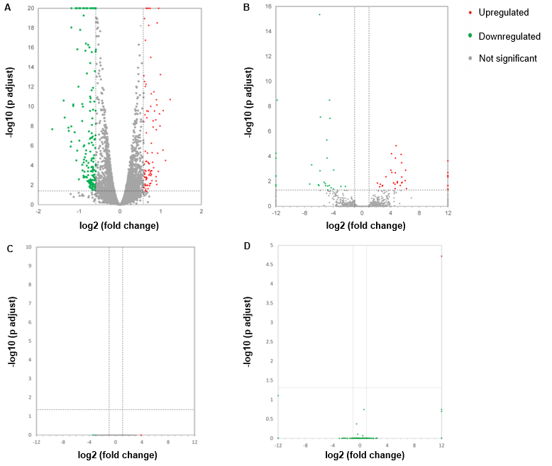
Figure 1 Volcano plots illustrating comparisons of differentially expressed messenger RNAs, long noncoding RNAs, circular RNAs, and microRNAs between each nanosecond pulsed electric field-treated group and the control group. A: Differentially expressed messenger RNAs; B: Differentially expressed long noncoding RNAs; C: Differentially expressed circular RNAs; D: Differentially expressed microRNAs.

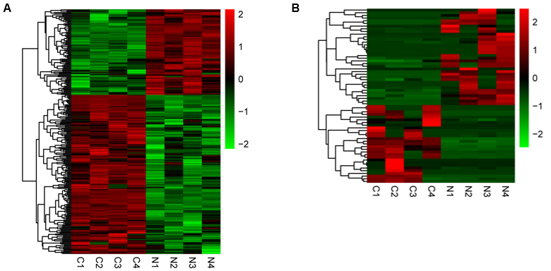
Figure 2 Heat maps displaying the hierarchical clustering of differentially expressed messenger RNAs and long noncoding RNAs. A: Differentially expressed messenger RNAs, B: Differentially expressed long noncoding RNAs. Red indicates up-regulation and green indicates down-regulation.

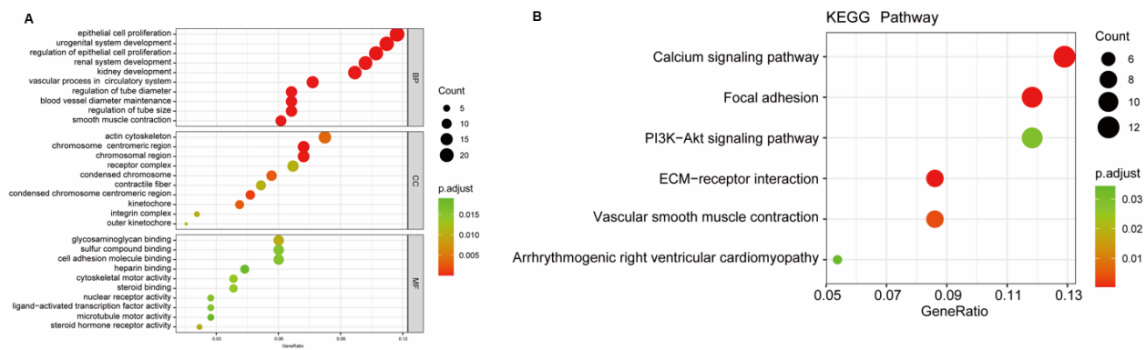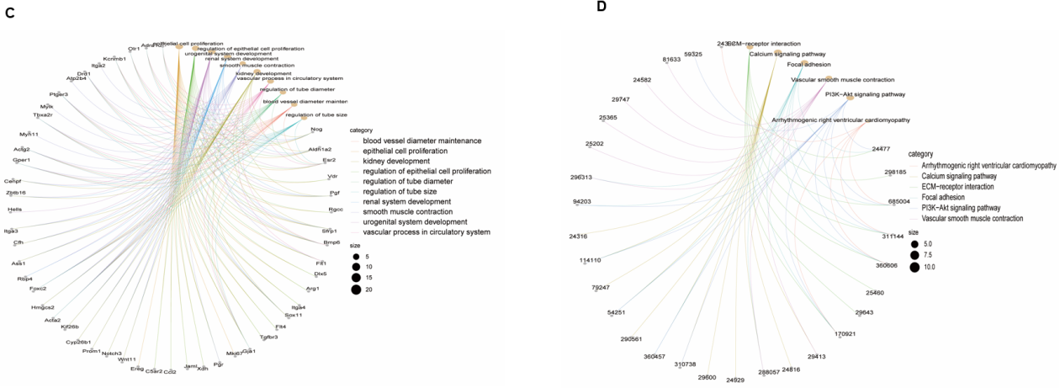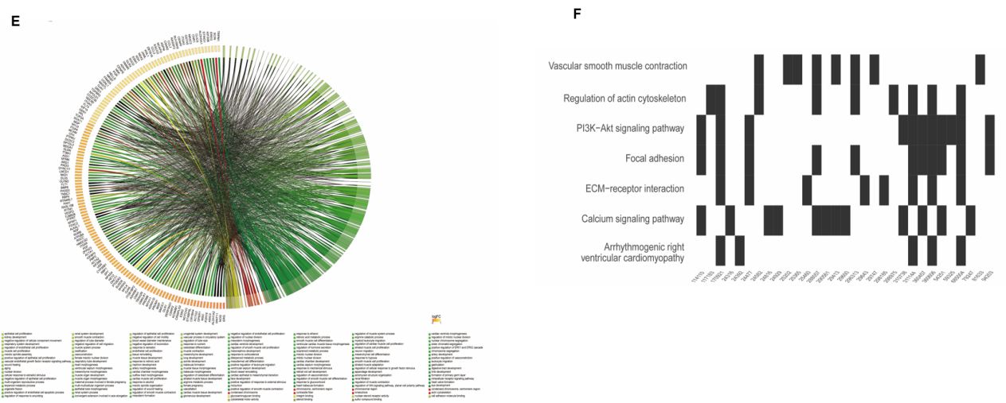
Figure 3 Gene Ontology and Kyoto Encyclopedia of Genes and Genomes enrichment analyses of DE messenger RNAs. A: Gene Ontology (GO) analysis of differentially expressed messenger RNAs (mRNAs). Bubble chart represents the significantly enriched pathways from the GO analysis. The color of dots in the bubble chart indicates the significance of the enriched category, and the size represents the scale of enriched genes in the terms; B: Kyoto Encyclopedia of Genes and Genomes (KEGG) analysis of differentially expressed mRNAs; C: Gene-concept network (cnetplot) of GO analysis; D: Gene-concept network (cnetplot) of KEGG analysis; E: Chord diagram of GO; F: Waterfall plot of KEGG analysis. KECG: Kyoto Encyclopedia of Genes and Genomes.

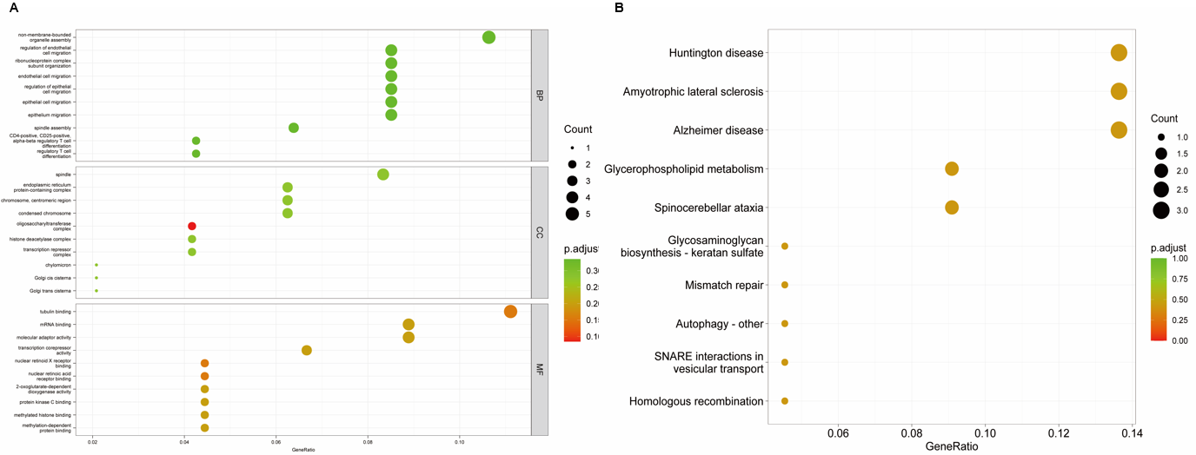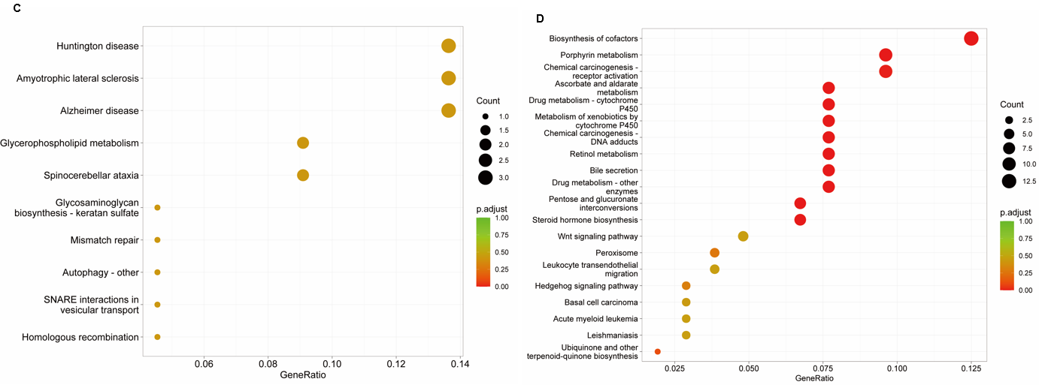
Figure 4 Gene Ontology and Kyoto Encyclopedia of Genes and Genomes enrichment analyses of target genes of differentially expressed long noncoding RNAs and microRNAs. A: Gene Ontology (GO) analysis of target genes of differentially expressed long noncoding RNAs (lncRNAs); B: Kyoto Encyclopedia of Genes and Genomes (KEGG) analysis of target genes of differentially expressed lncRNAs; C: GO analysis of target genes of differentially expressed microRNAs (miRNAs); D: KEGG analysis of target genes of differentially expressed miRNAs.

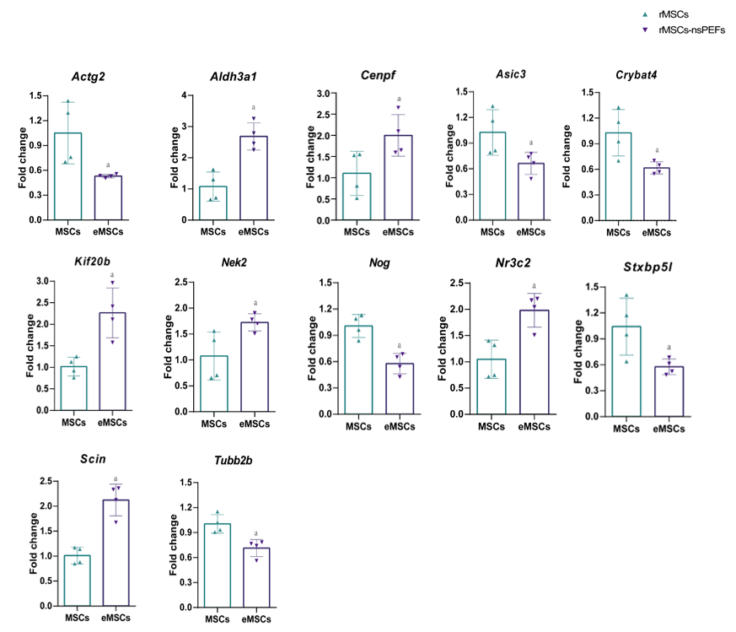
Figure 5 Gene expression validation by quantitative polymerase chain reaction. The error bars represent the standard deviations of measurements in three separate sample runs (n = 3). ªP < 0.05. rMSCs: Rat bone marrow mesenchymal stem cells; MSCs: Mesenchymal stem cells; eMSCs: Mesenchymal stem cells stimulated with nanosecond pulsed electric fields; nsPEFs: Nanosecond pulsed electric fields.

Table 1 Primer sequences used in the study
Primer | Primer sequence (5’ to 3’)
Actg2-F | CTCTCTCCACCTTCCAGCAAA
Actg2-R | AGGGCCCCGCTTCATC
Nek2-F | TGGAGGGCCTGACAATCTG
Nek2-R | CCACCACACTGAGTTTCTGGTTT
Cenpf-F | GGAGAGCCTGTGTGCATGTG
Cenpf-R | ACGTGAGCAGGAGGTTATGAAAC
Scin-F | TGGCCGAAGATGATGTCATG
Scin-R | CTTTGCCAATCCAAATGAAGATC
Kif20b-F | TGTGCCACACCAGTCACAATT
Kif20b-R | ACCTCGCCACTCTTCCTCTTC
Nog-F | CGAGGGTTTTCAATGAACTTTTTT
Nog-R | AGTGCATTACATGAACCAGAAAGC
Ereg-F | GGGTTGCCACAAGTCTGAACA
Ereg-R | GCATGCTGCACATCCTTGTC
Asic3-F | GCCTGCTTACCATCCTTGAGA
Asic3-R | CCCCAGGACTCTGTCTTGGA
Aldh3a1-F | TCCCACCGCCGCTCTT
Aldh3a1-R | GCCTTGTGAGCTTCTTCATTCA
Tubb2b-F | GGCGAGGATGAGGCTTGA
Tubb2b-R | TTCACCTCAGCTTTCCCTAACC
Cryba4-F | CGTGCTGGAGAGCGATCA
Cryba4-R | AGCCCCACTCCCTGAAGTG
Nr3c2-F | CGCACAGCAATATGAAAACCA
Nr3c2-R | GCCCCTTTCCCCCAGAA
Stxbp5l-F | AAGCCTCAGCAGGAAAAGCA
Stxbp5l-R | TGCCCGGTCCAGGAATG
Actin-F | TCTGTGTGGATTGGTGGCTCTA
Actin-R | CTGCTTGCTGATCCACATCTG

Table 2 Top 20 differentially expressed long noncoding RNAs
LncRNA_ID | Locus | Log2FC | Q value
NONRATT027355.2 | 7:143840739-143841394 | 6.223946 | 0.038374
NONRATT014734.2 | 19:44137444-44139463 | 6.103516 | 0.001285
NONRATT000391.2 | 1:78818388-78818948 | 6.035452 | 0.008784
NONRATT030693.2 | X:115351001-115352258 | 5.611966 | 0.011922
MSTRG.1686.44 | 1:180852586-181353774 | 5.574714 | 0.004533
NONRATT029722.2 | 9:113936538-113936864 | 5.563687 | 0.013263
MSTRG.1686.24 | 1:180804226-181295177 | 5.546189 | 0.000326
NONRATT024954.2 | 6:50889024-50923726 | 5.468331 | 7.04E-05
NONRATT010080.2 | 14:83648401-83660792 | 5.356187 | 0.021489
NONRATT021215.2 | 4:29083076-29092661 | -5.06373 | 0.022244
NONRATT015697.2 | 2:211078318-211078606 | -5.08835 | 0.01522
NONRATT002358.2 | 1:80335470-80336633 | -5.27782 | 0.011922
NONRATT015446.2 | 2:188562082-188565332 | -5.7896 | 7.11E-08
NONRATT026659.2 | 7:30291089-30293287 | -5.84278 | 0.001419
NONRATT017622.2 | 20:7219444-7220293 | -5.89986 | 4.44E-16
NONRATT031234.2 | X:116752819-116754309 | -5.9906 | 0.021489
NONRATT024688.2 | 6:136358084-136363672 | -6.06997 | 0.018677
NONRATT024848.2 | 6:25912732-26051235 | -7.01177 | 0.000482
NONRATT005942.2 | 10:84682448-84688899 | -7.27093 | 0.016558
NONRATT002900.2 | X:157319040-157323878 | -11.8256 | 3.16E-09
LncRNA: Long noncoding RNA; FC: Fold change.

Table 3 Top 20 differentially expressed messenger RNAs
Gene ID | Gene name | Log2FC | Q value
ENSRNOG00000017609 | Cnga4 | 4.049502 | 0.041927
ENSRNOG00000005883 | Nek10 | 3.164517 | 0.001515
ENSRNOG00000051612 | AABR07044570.1 | 3.006014 | 0.020392
ENSRNOG00000003891 | Porf1 | 2.826433 | 0.000369
ENSRNOG00000042070 | Ticam2 | 2.821013 | 0.00501
ENSRNOG00000046566 | Tub | 2.803217 | 0.006364
ENSRNOG00000032973 | Il13ra2 | 2.661856 | 1.68E-08
ENSRNOG00000025261 | AABR07050407.1 | 2.232324 | 0.00943
ENSRNOG00000001959 | Mx1 | 2.073926 | 0.049836
ENSRNOG00000031598 | Atp8b4 | 2.055746 | 0.024695
ENSRNOG00000003283 | Rcsd1 | -2.09387 | 0.018919
ENSRNOG00000010454 | Ccno | -2.1785 | 0.011229
ENSRNOG00000002456 | Hlf | -2.44194 | 0.021066
ENSRNOG00000052129 | Nwd1 | -2.45693 | 0.032717
ENSRNOG00000014424 | RGD1563354 | -2.46926 | 0.016841
ENSRNOG00000049115 | Ccr5 | -2.73203 | 0.01083
ENSRNOG00000055401 | Kcnc1 | -3.13004 | 0.021817
ENSRNOG00000055318 | AABR07068030.1 | -3.34625 | 0.000321
ENSRNOG00000014556 | Cdh20 | -3.47543 | 0.025307
ENSRNOG00000054723 | AABR07058174.1 | -3.5912 | 0.047547
ENSRNOG00000011946 | Ptn | -3.6805 | 0.000634
FC: Fold change.

