Name of journal: World Journal of Gastroenterology
Manuscript NO: 36449
Manuscript Type: ORIGINAL ARTICLE

Retrospective Study
Childhood-onset inflammatory bowel diseases associated with mutation of Wiskott–Aldrich syndrome protein gene

Ohya T et al. Analysis of genetic background in IBD

Takashi Ohya, Masakatsu Yanagimachi, Kentaro Iwasawa, Shuichiro Umetsu, Tsuyoshi Sogo, Ayano Inui, Tomoo Fujisawa, Shuichi Ito

Takashi Ohya, Masakatsu Yanagimachi, Shuichi Ito, Department of Pediatrics, Yokohama City University, Yokohama, Kanagawa 236-004, Japan

Kentaro Iwasawa, Shuichiro Umetsu, Tsuyoshi Sogo, Ayano Inui, Tomoo Fujisawa, Department of Pediatric Hepatology and Gastroenterology, Saiseikai Yokohama-shi Tobu Hostopital, Turumi-ku, Yokohama, Kanagawa 230-0012, Japan

Masakatsu Yanagimachi, Department of Pediatrics, Tokyo Medical and Dental University, Bunkyo-ku, Tokyo 113-8519, Japan

ORCID number: Takashi Ohya (0000-0002-0898-0539); Masakatsu Yanagimachi (0000-0003-0153-7283); Kentaro Iwasawa (0000-0002-5387-0099); Shuichiro Umetsu (0000-0002-6129-5127); Tsuyoshi Sogo (0000-0001-8986-1699); Ayano Inui (0000-0002-1973-4376); Tomoo Fujisawa (0000-0002-5046-0318); Shuichi Ito (0000-0002-5242-8987).

Author contributions: Ohya T, Yanagimachi M and Ito S designed the research; Ohya T, Iwasawa K, Umetsu S, Sogo T, Inui A and Fujisawa T performed the research; Ohya T and Yanagimachi M analyzed the data; and Ohya T wrote the paper

Institutional review board statement: The study was reviewed and approved by the Ethics Committees of the Yokohama City University School of Medicine and Saiseikai Yokohama-shi Tobu Hospital (number: A140724004).

Informed consent statement: All study participants, or their legal guardians, provided written informed consent prior to study enrollment.

Conflict-of-interest statement: All authors have no conflict of interest.

Data sharing statement: No additional data are available.

Open-Access: This article is an open-access article which was selected by an in-house editor and fully peer-reviewed by external reviewers. It is distributed in accordance with the Creative Commons Attribution Non Commercial (CC BY-NC 4.0) license, which permits others to distribute, remix, adapt, build upon this work non-commercially, and license their derivative works on different terms, provided the original work is properly cited and the use is non-commercial. See: http://creativecommons.org/licenses/by-nc/4.0/

Manuscript source: Unsolicited manuscript

Correspondence to: Masakatsu Yanagimachi, MD, PhD, Assistant Professor, Department of Pediatrics, Tokyo Medical and Dental University, 1-5-45 Yushima, Bunkyo-ku, Tokyo 113-8519, Japan. myanagimachi.ped@tmd.ac.jp
telephone: +81-3-58035249
Fax +81-3-58035246

Received: October 31, 2017
Peer-review started: November 1, 2017
First decision: November 14, 2017
Revised: November 21, 2017
Accepted: November 28, 2017
Article in press:
Published online:

Abstract
Aim
To screen primary immunodeficiency, Wiskott–Aldrich syndrome (WAS), and chronic granulomatous disease (CGD) among children with inflammatory bowel disease (IBD).

Methods
This was a single-center retrospective study. Eighteen children with IBD were investigated. We analyzed their expression of Wiskott–Aldrich syndrome protein (WASP) in lymphocytes and superoxide generation in phagocytes using flow cytometry. When the expression of WASP or superoxide generation was low or absent, we performed genetic analysis to determine the cause of this.

Results
Eighteen patients were classified as having ulcerative colitis (n = 10), Crohn’s disease (n = 5), or IBD-unclassified (n = 3). In total, three patients revealed low expression of WASP associated with a WAS gene c.1378 C>T p.Pro460Ser mutation, which has previously been reported as a pathogenic mutation in WAS and X-linked thrombocytopenia. However, with respect to the major symptoms of WAS, none of these three patients showed either thrombocytopenia or increased susceptibility to infection, but one patient showed generalized eczema. No CGD patients were discovered in this study.

Conclusion
Despite the lack of typical clinical manifestations of WAS, low expression of WASP could be associated with the pathogenesis of a subtype of IBD patients.

Key words Inflammatory bowel disease; Wiskott–Aldrich syndrome; Primary immunodeficiency; Children; Screening

© The Author(s) 2017. Published by Baishideng Publishing Group Inc. All rights reserved.

Core tip: Inflammatory bowel disease (IBD) has multiple etiologies, including genetic and environmental factors. Recent reports have described how some children with Wiskott–Aldrich syndrome (WAS) present IBD or IBD-like gastroenterocolitis. In this study, we found a WAS c.1378C>T, p.Pro460Ser mutation in three children with IBD. These patients did not present typical symptoms of WAS, such as thrombocytopenia and recurrent infection. However, WAS is known to be associated with an increased risk of malignancies including lymphoma, as well as autoimmune diseases. Therefore, in any long-term follow-up, the analysis of WASP expression in children with IBD should be considered even if major symptoms of WAS are absent.

Ohya T, Yanagimachi M, Iwasawa K, Umetsu S, Sogo T, Inui A, Fujisawa T, Ito S. Childhood-onset inflammatory bowel diseases associated with mutation of Wiskott–Aldrich syndrome protein gene. World J Gastroenterol 2017; In press

INTRODUCTION
Inflammatory bowel disease (IBD), including ulcerative colitis (UC) and Crohn’s disease (CD), is a chronic inflammatory disorder of the gastrointestinal tract. IBD is caused by multiple factors; genetics, epigenetics, environment, microbiota and immune responses^{[1–3]}. Recently, it was discovered that some patients with primary immunodeficiencies initially develop IBD or IBD-like gastroenterocolitis, especially in childhood. IBD that occur in primary immunodeficiencies is likely to be refractory to conventional treatments and is often more prominent than the susceptibility to infection^{[4]}. It has been reported that children with Wiskott–Aldrich syndrome (WAS) and chronic granulomatous disease (CGD) could develop IBD or IBD-like gastroenterocolitis^{[5]}. WAS is an X-linked disorder characterized by the triad of thrombocytopenia with small platelets, eczema, and recurrent infection. X-linked thrombocytopenia (XLT) is a milder form of WAS characterized by isolated thrombocytopenia. In WAS cases, gastrointestinal inflammation mimicking UC has occasionally been documented^{[5–7]}. CGD is caused by defective phagocyte superoxide generation leading to impaired microbial killing, in which gastrointestinal inflammation mimicking CD has also occasionally been documented^{[5,8–10]}. In this study, we analyzed WAS and CGD in children with IBD and described their clinical features. WAS and CGD are among the more common monogenic primary immunodeficiencies, for the diagnosis of which rapid methods using flow cytometry have been established^{[11,12]}. Therefore, these two diseases were selected for this study. The diagnosis of underlying primary immunodeficiencies is important for investigating the pathogenesis of IBD, selecting appropriate treatment, taking precautions regarding malignancies and autoimmune diseases, and performing genetic counseling.

MATERIALS AND METHODS
Patients and methods
Patients with childhood-onset IBD, which developed earlier than at 17 years old and was consistent with the Paris classification A1a+A1b^{[13]}, were recruited from Saiseikai Yokohama-shi Tobu Hospital, Yokohama, Japan, between July 2015 and July 2016. All patients had already been diagnosed with IBD prior to recruitment into this study. The diagnosis and classification of IBD were made based on clinical, endoscopic, radiological, and histological findings, in accordance with the Revised Porto Criteria^{[14]}. IBD was classified into three disease entities: CD, UC, and IBD-unclassified (IBD-U). Blood samples were collected from patients after obtaining written informed consent from their parents or guardians, and also collected from healthy young adults as a control. This study was performed in accordance with the Declaration of Helsinki and approved by the institutional ethics committees of Yokohama City University School of Medicine and Saiseikai Yokohama-shi Tobu Hospital (number: A140724004).
For initial screening, flow cytometric analysis was performed to evaluate the expression of Wiskott–Aldrich syndrome protein (WASP) in lymphocytes and superoxide generation in phagocytes. Patients’ white blood cells were analyzed using an EC800 flow cytometry analyzer (Sony Biotechnology, Tokyo, Japan). Forward scatter and side scatter were collected in linear mode to gate lymphocytes and neutrophils. Genetic analysis of the WAS gene was performed upon the discovery of low or absent expression of WASP.

WASP analysis
Intracellular staining of WASP was performed in accordance with a previously described method^{[12,15]}. Whole blood was separated into peripheral blood mononuclear cells (PBMCs) by Lymphoprep® (Axis-Shield PoC AS, Oslo, Norway). The PBMCs were fixed in a fixation buffer (BD Biosciences Pharmingen, San Diego, CA, United States) for 15 min at room temperature, and then permeabilized in Perm/Wash buffer (BD Biosciences Pharmingen). They were then incubated with a rabbit anti-WASP monoclonal antibody (Abcam, Cambridge, United Kingdom) for 30 min at 4 °C. After washing, they were incubated with an Alexa Fluor 488-conjugated anti-rabbit IgG Fab2 fragment (Cell Signaling Technology, Danvers, MA, United States) for 30 min at 4 °C. The PBMCs were then washed again and centrifuged at 1500×g for 1 min, twice. The obtained pellets were then resuspended in buffer and immediately analyzed by flow cytometry.

DHR123 assay
The DHR123 assay was performed in accordance with a previously described method^{[16]}. Whole blood (100 µl) and 1 ml of 0.1 mmol/L DHR123 (Lambda Fluoreszenz Technologie GmbH, Vienna, Austria) were added to each tube. The tubes were incubated at 37°C for 15 min to stain the phagocytes with DHR123. After incubation, 25 mM ethylenediaminetetraacetic acid and 25 µg/ml phorbol myristate acetate (Sigma-Aldrich, St. Louis, MO, United States) were added to each tube. The tubes were incubated again at 37 °C for 20 min. They were then centrifuged at 400×g for 5 min and the supernatant was discarded. Lysis buffer was added to the tubes. After 15 min, the tubes were centrifuged at 400 × g for 5 min and the supernatant was discarded. Subsequently, the pellets were suspended in buffer and immediately analyzed by flow cytometry.

Gene mutation analysis
WAS gene analysis was performed for all patients who showed normal and low expression of WASP. Genomic DNA was extracted from peripheral blood leukocytes using a QIAamp® DNA Blood Mini Kit (QIAGEN, Hilden, Germany). Polymerase chain reaction (PCR) primer sequences were derived from previous reports^{[17,18]}. PCR was performed with a thermal cycler under the following conditions: initial denaturation at 94 °C for 5 min; then 32 cycles with denaturation at 94 °C for 1 min, annealing at 55-60 °C for 1 min, and extension at 72 °C for 1 min; and then final extension at 72 °C for 10 min. Each PCR product was electrophoresed on an agarose gel to confirm its size. To determine its DNA sequence, direct sequencing was performed using an Applied Biosystems 3730xl DNA Analyzer and Sequence Scanner version 1.0 software (Applied Biosystems, Waltham, MA, USA), under the conditions recommended by the manufacturer. In silico analysis of the mutated WAS sequence was performed using PolyPhen-2 (Polymorphism Phenotyping V.2, http://genetics.bwh.harvard.edu/pph2/dbsearch.shtml) and SIFT (http://sift.jcvi.org/) in addition to a literature review of the mutated gene sequence.

RESULTS
Patient characteristics
Eighteen patients were enrolled in this study, the characteristics of whom are summarized in Table 1. Ten patients were classified as having UC, five as CD, and three as IBD-U. The median ages at first presentation of clinical symptoms for these three groups were 9.5, 12.0, and 6.0 years old, respectively. In five patients, age at the onset was 6 years or younger and they classified into very early onset IBD (VEOIBD)^{[19]}. One patient with CD had refractory eczema, but no patients developed thrombocytopenia or susceptibility to infection suggestive of WAS or CGD.

WASP analysis, DHR123 assay, and genetic analysis
WASP expressions of healthy controls were normal. Three patients (UC, n = 2; CD, n = 1) showed low expression of WASP compared with the healthy controls (Figure 1A), but no patients showed a complete lack of WASP expression. Subsequent WAS gene analysis revealed the same mutation (c.1378C>T, p.Pro460Ser) in all three patients (Figure 1B). This mutation is located in the verprolin, cofilin, and acidic domain in exon 11 of the WAS gene. Additionally, this mutation was not found in any of 15 patients with normal expression of WASP. We performed in silico analysis of the mutation using Polyphen2 and SIFT, in addition to a literature review. PolyPhen-2 suggested that this is a benign mutation, while SIFT suggested that it is a tolerated one. However, in the literature review, we found four patients with typical WAS (n = 1) or XLT (n = 3) sharing the same c.1378C>T, p.Pro460Ser mutation of the WAS gene, who exhibited low expression of WASP (Table 2)^{[20-23]}. DHR123 assays revealed no patients with abnormal superoxide generation. Therefore, no patients were diagnosed with CGD.

Clinical course of three patients with WAS mutation
The clinical features of the three patients with the WAS mutation are summarized in Table 3. Patient 3 was classified into VEOIBD. Although all three patients had diarrhea, none of them showed either thrombocytopenia or increased susceptibility to infection, two of the major symptoms of WAS and XLT. Their mean platelet volumes were within the normal range. Only Patient 1 showed eczema, one of the major symptoms of WAS. Interestingly, this eczema was markedly exacerbated after the initiation of tumor necrosis factor alpha (TNFα) blockade treatment (Figure 2), but immediately improved upon its discontinuation. At the time of writing, none of these patients has developed other autoimmune diseases or malignancies. Additionally, no patients have a family history suggestive of WAS.
Endoscopic findings in these three patients were consistent with those of typical CD or UC. Patient 1 had long linear ulcerations and cobble stone appearance in the ileum to the colon (Figure 3A). Patient 2 showed edematous and friable mucosa with superficial bleeding in the descending colon and sigmoid colon (Figure 3B and C). Patient 3 had edematous mucosa with granularity and erythema in the rectum from the sigmoid colon to the rectum (Figure 3D) and inflammatory polyps in the sigmoid colon. All three patients had successfully achieved remission with the medications shown in Table 3.

DISCUSSION
In infants and children, primary immunodeficiencies such as common variable immunodeficiency, CGD, IL-10 signaling defects, X-linked lymphoproliferative syndrome type 2, immune dysregulation, polyendocrinopathy, enteropathy, X-linked syndrome and WAS could present as IBD or IBD-like colitis^{[24-29]}. Recently, genome-wide association studies of IBD have identified 163 genetic loci^{[30]} and 50 monogenic disorders including primary immunodeficiency associated with IBD-like immunopathology^{[19]}. Underlying primary immunodeficiency may easily be missed by clinicians. Cannioto et al^{[5]} reported one CGD and three WAS patients among 16 children with IBD diagnosed before 2 years of age. However, their clinical symptoms were typical of WAS and CGD.
In this study, we investigated children with IBD to screen underlying WAS and CGD. As a result, we found three patients with a WAS c.1378C>T, p.Pro460Ser mutation, but found none with CGD using flow cytometry. WAS is an X-linked disorder characterized by the triad of thrombocytopenia with small platelets, eczema, and recurrent infection. WAS gene mutations are associated with a wide spectrum of disease, from typical WAS to XLT characterized by isolated thrombocytopenia^{[31,32]}. Generally, clinical manifestations correlate with the level of WASP expression. Classical WAS tends to be associated with the complete absence of WASP, whereas incomplete WAS and XLT are likely to be associated with low or absent expression. However, the phenotype does not always reflect the genotype of WAS mutations. Although in silico analysis suggested that the WAS c.1378C>T, p.Pro460Ser mutation would not be pathogenic, the mutation detected in our patients was previously reported in four patients with typical WAS or XLT^{[29-32]} (Table 2). One of them had double mutations (p.Pro460Ser and p.Met474Thr). Three of them showed low WASP expression, but none developed IBD or IBD-like colitis. In contrast, our patients did not show thrombocytopenia or recurrent infection despite low WASP expression in their lymphocytes. Only one patient showed refractory eczema. Eczema in WAS is known as an atopic dermatitis-like manifestation. This patient’s cutaneous manifestation was atopic dermatitis-like eczema at onset, which then shifted to scaling eczema and pigmentation (Figure 2). His eczema was exacerbated by TNFα blockade treatment, but improved rapidly upon its discontinuation. TNFα blockade frequently causes cutaneous complications such as vasculitis and eczema in patients with IBD. Scaling eczema is the most common cutaneous complication in adults, while psoriasis-like manifestations are most frequently seen in children^{[33,34]}. Our patient’s eczema differed from the typical TNFα blockade-related cutaneous complications in children, but resembled those in adults. There may be possibility that WAS mutation is associated with TNFα blockade-cutaneous complication and prediction for the complication. Endoscopic findings in three patients were typical of CD or UC, and were not distinguishable between patients with the mutation and without it. Only one of five VEOIBD patients in our study showed low expression of WASP and WAS mutation. VEOIBD patients often have different symptoms from older children and adults with IBD^{[25]}. In general, genetics is suggested to be an important factor in VEOIBD^{[35]}. WAS mutation might be associated with pathogenesis of VEOIBD. In the ExAC database (exac.broadinstitute.org), the frequency of WAS c.1378C>T, p.Pro460Ser mutation is 0.03817 in East Asians, and it appears to be more common in East Asians than in other ethnic groups. The frequency of this mutation in this study is 0.1667 (3/18), which is much higher than in East Asians. Therefore, WAS c.1378C>T, p.Pro460Ser mutation could be a risk factor for IBD development.
Patients with a WAS mutation are likely to develop autoimmune diseases, with up to 40% developing hemolytic anemia, neutropenia, vasculitis, IBD/IBD-like colitis, or renal disease^{[5,9,10,36]}. The incidence of autoimmune diseases in XLT is lower than in typical WAS^{[37]}. However, Imai et al. reported that autoimmune diseases are equally common in patients with absent versus low expression of WASP^{[38]}. Precaution for new-onset autoimmune diseases is important in our patients.
Snapper et al^{[39]} reported that WASP-deficient mice developed chronic colitis. The colons of these mice were diffusely dilatated and had mucosal thickening due to crypt hyperplasia and the presence of mixed lymphocytic and neutrophilic infiltrate within the lamina propria^{[39]}. WASP is expressed in the cytoplasm of hematopoietic cells. It acts as a signal transducer from cell surface receptors, and also plays essential roles in cell–cell interactions, cell movement, and cell division^{[40,41]}. WASP dysfunction, leading to impaired regulatory T cells and expansion of autoreactive B cells^{[42,43]}, may provoke autoimmune diseases including IBD/IBD-like colitis^{[44]}. The impaired regulatory T cells caused by WASP dysfunction also affect microbiota, which may lead to IBD/IBD-like colitis. Above all, WASP analysis may reveal the possible risk of new-onset autoimmune diseases.
Patients with typical WAS also have an increased risk of malignancies: 12%–30% of patients suffer from them, among which B-cell lymphoma is particularly common. Because there have been few reports of malignancies in patients with XLT, their incidence is presumably lower in XLT than in WAS^{[37,45,46]}. However, TNFα blockade and azathioprine, which are the main treatments for refractory IBD, significantly increase the risk of lymphoma^{[47-49]}. Thus, careful monitoring in patients with WAS mutation is necessary, especially under these two treatments.
This study has several limitations, including the small number of patients and the fact that it is a single-center study. Additional study with a greater number of patients is thus now underway. Further functional analysis to examine whether the WAS c.1378C>T, p.Pro460Ser mutation affects thrombocytosis and lymphocyte function is needed, although this mutation has previously been reported in some patients with WAS or XLT. In addition, there is a need for the screening of other primary immunodeficiencies known to be associated with the presentation of IBD or IBD-like gastroenterocolitis.
In conclusion, we found a WAS c.1378C>T, p.Pro460Ser mutation in three children with IBD, the lymphocytes of whom exhibited low WASP expression. We suggest that low WASP expression has an association with the development of IBD/IBD-like colitis. Therefore, the analysis of WASP expression in children with IBD should be considered even if the triad of WAS symptoms is absent. Screening for underlying immunodeficiencies including WAS and CGD may contribute to improving patient management and outcome. Especially, physicians can pay more attention to the increased future risk of malignancy and autoimmune disease in IBD patients with WAS mutation.

ARTICLE HIGHLIGHTS
Research background
Inflammatory bowel disease (IBD), including ulcerative colitis (UC) and Crohn’s disease (CD), is a chronic inflammatory disorder of the gastrointestinal tract. Recently, it was discovered that some patients with primary immunodeficiencies initially develop IBD or IBD-like gastroenterocolitis, especially in childhood.

Research motivation
Children with Wiskott–Aldrich syndrome (WAS) and chronic granulomatous disease (CGD) could develop IBD or IBD-like gastroenterocolitis. The diagnosis of underlying primary immunodeficiencies such as WAS and CGD is important for investigating the pathogenesis of IBD, selecting appropriate treatment, taking precautions regarding malignancies and autoimmune diseases, and performing genetic counseling.

Research objectives
To screen primary immunodeficiency, WAS and CGD, among children with inflammatory bowel disease (IBD), and to investigate their clinical features.

Research methods
This was a single-center retrospective study. Eighteen children with IBD were investigated. We performed intracellular staining of Wiskott–Aldrich syndrome protein (WASP) to analyzed their expression in lymphocytes and DHR123 assay to analyze superoxide generation in phagocytes using flow cytometry. When the expression of WASP or superoxide generation was low or absent, we performed direct DNA sequence to determine the cause of this. In silico analysis was performed using PolyPhen-2 (Polymorphism Phenotyping V.2, http://genetics.bwh.harvard.edu/pph2/dbsearch.shtml) and SIFT (http://sift.jcvi.org/), in addition to a literature review of the mutated gene sequence.

Research results
DHR123 assays revealed no patients with abnormal superoxide generation. Three patients (UC, n = 2; CD, n = 1) showed low expression of WASP compared with the healthy controls. WAS gene analysis revealed the same mutation (c.1378C>T, p.Pro460Ser) in all three patients. The mutation was previously reported in four patients with typical WAS or XLT. But, in silico analysis suggested that the mutation would not be pathogenic. Our patients with the mutation did not show thrombocytopenia or recurrent infection despite low WASP expression in their lymphocytes. Only one patient showed refractory eczema.

Research conclusions
We found a WAS c.1378C>T, p.Pro460Ser mutation in three children with IBD, the lymphocytes of whom exhibited low WASP expression. We suggest that low WASP expression has an association with the development of IBD/IBD-like colitis. Therefore, the analysis of WASP expression in children with IBD should be considered even if the triad of WAS symptoms is absent.

Research perspectives
In this study, we found a WAS c.1378C>T, p.Pro460Ser mutation in three children with IBD. These patients did not present typical symptoms of WAS, such as thrombocytopenia and recurrent infection. However, WAS is known to be associated with an increased risk of malignancies including lymphoma, as well as autoimmune diseases. Therefore, in any long-term follow-up, the analysis of WASP expression in children with IBD should be considered even if major symptoms of WAS are absent.

REFERENCES
1 Dinwiddie DL, Bracken JM, Bass JA, Christenson K, Soden SE, Saunders CJ, Miller NA, Singh V, Zwick DL, Roberts CC, Dalal J, Kingsmore SF. Molecular diagnosis of infantile onset inflammatory bowel disease by exome sequencing. Genomics 2013; 102: 442-447 [PMID: 24001973 DOI: 10.1016/j.ygeno.2013.08.008]
2 Maloy KJ, Powrie F. Intestinal homeostasis and its breakdown in inflammatory bowel disease. Nature 2011; 474: 298-306 [PMID: 21677746 DOI: 10.1038/nature10208]
3 Khor B, Gardet A, Xavier RJ. Genetics and pathogenesis of inflammatory bowel disease. Nature 2011; 474: 307-317 [PMID: 21677747 DOI: 10.1038/nature10209]
4 Agarwal S, Mayer L. Diagnosis and treatment of gastrointestinal disorders in patients with primary immunodeficiency. Clin Gastroenterol Hepatol 2013; 11: 1050-1063 [PMID: 23501398 DOI: 10.1016/j.cgh.2013.02.024]
5 Cannioto Z, Berti I, Martelossi S, Bruno I, Giurici N, Crovella S, Ventura A. IBD and IBD mimicking enterocolitis in children younger than 2 years of age. Eur J Pediatr 2009; 168: 149-155 [PMID: 18546019 DOI: 10.1007/s00431-008-0721-2]
6 Catucci M, Castiello MC, Pala F, Bosticardo M, Villa A. Autoimmunity in wiskott-Aldrich syndrome: an unsolved enigma. Front Immunol 2012; 3: 209 [PMID: 22826711 DOI: 10.3389/fimmu.2012.00209]
7 Dupuis-Girod S, Medioni J, Haddad E, Quartier P, Cavazzana-Calvo M, Le Deist F, de Saint Basile G, Delaunay J, Schwarz K, Casanova JL, Blanche S, Fischer A. Autoimmunity in Wiskott-Aldrich syndrome: risk factors, clinical features, and outcome in a single-center cohort of 55 patients. Pediatrics 2003; 111: e622-e627 [PMID: 12728121]
8 Hauck F, Koletzko S, Walz C, von Bernuth H, Klenk A, Schmid I, Belohradsky BH, Klein C, Bufler P, Albert MH. Diagnostic and Treatment Options for Severe IBD in Female X-CGD Carriers with Non-random X-inactivation. J Crohns Colitis 2016; 10: 112-115 [PMID: 26464403 DOI: 10.1093/ecco-jcc/jjv186]
9 Marks DJ, Miyagi K, Rahman FZ, Novelli M, Bloom SL, Segal AW. Inflammatory bowel disease in CGD reproduces the clinicopathological features of Crohn's disease. Am J Gastroenterol 2009; 104: 117-124 [PMID: 19098859 DOI: 10.1038/ajg.2008.72]
10 Marciano BE, Rosenzweig SD, Kleiner DE, Anderson VL, Darnell DN, Anaya-O'Brien S, Hilligoss DM, Malech HL, Gallin JI, Holland SM. Gastrointestinal involvement in chronic granulomatous disease. Pediatrics 2004; 114: 462-468 [PMID: 15286231]
11 Jirapongsananuruk O, Malech HL, Kuhns DB, Niemela JE, Brown MR, Anderson-Cohen M, Fleisher TA. Diagnostic paradigm for evaluation of male patients with chronic granulomatous disease, based on the dihydrorhodamine 123 assay. J Allergy Clin Immunol 2003; 111: 374-379 [PMID: 12589359]
12 Kawai S, Minegishi M, Ohashi Y, Sasahara Y, Kumaki S, Konno T, Miki H, Derry J, Nonoyama S, Miyawaki T, Horibe K, Tachibana N, Kudoh E, Yoshimura Y, Izumikawa Y, Sako M, Tsuchiya S. Flow cytometric determination of intracytoplasmic Wiskott-Aldrich syndrome protein in peripheral blood lymphocyte subpopulations. J Immunol Methods 2002; 260: 195-205 [PMID: 11792389]
13 Levine A, Griffiths A, Markowitz J, Wilson DC, Turner D, Russell RK, Fell J, Ruemmele FM, Walters T, Sherlock M, Dubinsky M, Hyams JS. Pediatric modification of the Montreal classification for inflammatory bowel disease: the Paris classification. Inflamm Bowel Dis 2011; 17: 1314-1321 [PMID: 21560194 DOI: 10.1002/ibd.21493]
14 Levine A, Koletzko S, Turner D, Escher JC, Cucchiara S, de Ridder L, Kolho KL, Veres G, Russell RK, Paerregaard A, Buderus S, Greer ML, Dias JA, Veereman-Wauters G, Lionetti P, Sladek M, Martin de Carpi J, Staiano A, Ruemmele FM, Wilson DC; European Society of Pediatric Gastroenterology, Hepatology, and Nutrition. ESPGHAN revised porto criteria for the diagnosis of inflammatory bowel disease in children and adolescents. J Pediatr Gastroenterol Nutr 2014; 58: 795-806 [PMID: 24231644 DOI: 10.1097/MPG.0000000000000239]
15 Vowells SJ, Sekhsaria S, Malech HL, Shalit M, Fleisher TA. Flow cytometric analysis of the granulocyte respiratory burst: a comparison study of fluorescent probes. J Immunol Methods 1995; 178: 89-97 [PMID: 7829869]
16 Futatani T, Miyawaki T, Tsukada S, Hashimoto S, Kunikata T, Arai S, Kurimoto M, Niida Y, Matsuoka H, Sakiyama Y, Iwata T, Tsuchiya S, Tatsuzawa O, Yoshizaki K, Kishimoto T. Deficient expression of Bruton's tyrosine kinase in monocytes from X-linked agammaglobulinemia as evaluated by a flow cytometric analysis and its clinical application to carrier detection. Blood 1998; 91: 595-602 [PMID: 9427714]
17 Giliani S, Fiorini M, Mella P, Candotti F, Schumacher RF, Wengler GS, Lalatta F, Fasth A, Badolato R, Ugazio AG, Albertini A, Notarangelo LD. Prenatal molecular diagnosis of Wiskott-Aldrich syndrome by direct mutation analysis. Prenat Diagn 1999; 19: 36-40 [PMID: 10073904]
18 Park SK, Kim CS, Song DK, Kim JY, Choi IJ, Kim DK. A familial case of Wiskott-Aldrich Syndrome with a hotspot mutation in exon 2 of the WAS Gene. J Korean Med Sci 2007; 22: 998-1001 [PMID: 18162713 DOI: 10.3346/jkms.2007.22.6.998]
19 Uhlig HH, Schwerd T, Koletzko S, Shah N, Kammermeier J, Elkadri A, Ouahed J, Wilson DC, Travis SP, Turner D, Klein C, Snapper SB, Muise AM; COLORS in IBD Study Group and NEOPICS. The diagnostic approach to monogenic very early onset inflammatory bowel disease. Gastroenterology 2014; 147: 990-1007.e3 [PMID: 25058236 DOI: 10.1053/j.gastro.2014.07.023]
20 Lutskiy MI, Rosen FS, Remold-O'Donnell E. Genotype-proteotype linkage in the Wiskott-Aldrich syndrome. J Immunol 2005; 175: 1329-1336 [PMID: 16002738]
21 Lee WI, Huang JL, Jaing TH, Wu KH, Chien YH, Chang KW. Clinical aspects and genetic analysis of taiwanese patients with wiskott-Aldrich syndrome protein mutation: the first identification of x-linked thrombocytopenia in the chinese with novel mutations. J Clin Immunol 2010; 30: 593-601 [PMID: 20232122 DOI: 10.1007/s10875-010-9381-x]
22 Gulácsy V, Freiberger T, Shcherbina A, Pac M, Chernyshova L, Avcin T, Kondratenko I, Kostyuchenko L, Prokofjeva T, Pasic S, Bernatowska E, Kutukculer N, Rascon J, Iagaru N, Mazza C, Tóth B, Erdos M, van der Burg M, Maródi L; J Project Study Group. Genetic characteristics of eighty-seven patients with the Wiskott-Aldrich syndrome. Mol Immunol 2011; 48: 788-792 [PMID: 21185603 DOI: 10.1016/j.molimm.2010.11.013]
23 Ouchi-Uchiyama M, Sasahara Y, Kikuchi A, Goi K, Nakane T, Ikeno M, Noguchi Y, Uike N, Miyajima Y, Matsubara K, Koh K, Sugita K, Imaizumi M, Kure S. Analyses of Genetic and Clinical Parameters for Screening Patients With Inherited Thrombocytopenia with Small or Normal-Sized Platelets. Pediatr Blood Cancer 2015; 62: 2082-2088 [PMID: 26175287 DOI: 10.1002/pbc.25668]
24 Uhlig HH. Monogenic diseases associated with intestinal inflammation: implications for the understanding of inflammatory bowel disease. Gut 2013; 62: 1795-1805 [PMID: 24203055 DOI: 10.1136/gutjnl-2012-303956]
25 Xiao Y, Wang XQ, Yu Y, Guo Y, Xu X, Gong L, Zhou T, Li XQ, Xu CD. Comprehensive mutation screening for 10 genes in Chinese patients suffering very early onset inflammatory bowel disease. World J Gastroenterol 2016; 22: 5578-5588 [PMID: 27350736 DOI: 10.3748/wjg.v22.i24.5578]
26 Kelsen JR, Dawany N, Moran CJ, Petersen BS, Sarmady M, Sasson A, Pauly-Hubbard H, Martinez A, Maurer K, Soong J, Rappaport E, Franke A, Keller A, Winter HS, Mamula P, Piccoli D, Artis D, Sonnenberg GF, Daly M, Sullivan KE, Baldassano RN, Devoto M. Exome sequencing analysis reveals variants in primary immunodeficiency genes in patients with very early onset inflammatory bowel disease. Gastroenterology 2015; 149: 1415-1424 [PMID: 26193622 DOI: 10.1053/j.gastro.2015.07.006]
27 Begue B, Verdier J, Rieux-Laucat F, Goulet O, Morali A, Canioni D, Hugot JP, Daussy C, Verkarre V, Pigneur B, Fischer A, Klein C, Cerf-Bensussan N, Ruemmele FM. Defective IL10 signaling defining a subgroup of patients with inflammatory bowel disease. Am J Gastroenterol 2011; 106: 1544-1555 [PMID: 21519361 DOI: 10.1038/ajg.2011.112]
28 de Ridder L, Weersma RK, Dijkstra G, van der Steege G, Benninga MA, Nolte IM, Taminiau JA, Hommes DW, Stokkers PC. Genetic susceptibility has a more important role in pediatric-onset Crohn's disease than in adult-onset Crohn's disease. Inflamm Bowel Dis 2007; 13: 1083-1092 [PMID: 17476680 DOI: 10.1002/ibd.20171]
29 Biank V, Broeckel U, Kugathasan S. Pediatric inflammatory bowel disease: clinical and molecular genetics. Inflamm Bowel Dis 2007; 13: 1430-1438 [PMID: 17600381 DOI: 10.1002/ibd.20213]
30 Jostins L, Ripke S, Weersma RK, Duerr RH, McGovern DP, Hui KY, Lee JC, Schumm LP, Sharma Y, Anderson CA, Essers J, Mitrovic M, Ning K, Cleynen I, Theatre E, Spain SL, Raychaudhuri S, Goyette P, Wei Z, Abraham C, Achkar JP, Ahmad T, Amininejad L, Ananthakrishnan AN, Andersen V, Andrews JM, Baidoo L, Balschun T, Bampton PA, Bitton A, Boucher G, Brand S, Büning C, Cohain A, Cichon S, D'Amato M, De Jong D, Devaney KL, Dubinsky M, Edwards C, Ellinghaus D, Ferguson LR, Franchimont D, Fransen K, Gearry R, Georges M, Gieger C, Glas J, Haritunians T, Hart A, Hawkey C, Hedl M, Hu X, Karlsen TH, Kupcinskas L, Kugathasan S, Latiano A, Laukens D, Lawrance IC, Lees CW, Louis E, Mahy G, Mansfield J, Morgan AR, Mowat C, Newman W, Palmieri O, Ponsioen CY, Potocnik U, Prescott NJ, Regueiro M, Rotter JI, Russell RK, Sanderson JD, Sans M, Satsangi J, Schreiber S, Simms LA, Sventoraityte J, Targan SR, Taylor KD, Tremelling M, Verspaget HW, De Vos M, Wijmenga C, Wilson DC, Winkelmann J, Xavier RJ, Zeissig S, Zhang B, Zhang CK, Zhao H; International IBD Genetics Consortium (IIBDGC), Silverberg MS, Annese V, Hakonarson H, Brant SR, Radford-Smith G, Mathew CG, Rioux JD, Schadt EE, Daly MJ, Franke A, Parkes M, Vermeire S, Barrett JC, Cho JH. Host-microbe interactions have shaped the genetic architecture of inflammatory bowel disease. Nature 2012; 491: 119-124 [PMID: 23128233 DOI: 10.1038/nature11582]
31 Rich RR, Fleisher TA, Shearer WT, Schroeder Jr HW, Frew AJ, Weyand CM. Clinical immunology: principles and practice, 4th ed. Philadelphia: Elsevier Saunders; 2012
32 Notarangelo LD, Miao CH, Ochs HD. Wiskott-Aldrich syndrome. Curr Opin Hematol 2008; 15: 30-36 [PMID: 18043243 DOI: 10.1097/MOH.0b013e3282f30448]
33 Mälkönen T, Wikström A, Heiskanen K, Merras-Salmio L, Mustonen H, Sipponen T, Kolho KL. Skin reactions during anti-TNFα therapy for pediatric inflammatory bowel disease: a 2-year prospective study. Inflamm Bowel Dis 2014; 20: 1309-1315 [PMID: 24918318 DOI: 10.1097/MIB.0000000000000088]
34 Hellström AE, Färkkilä M, Kolho KL. Infliximab-induced skin manifestations in patients with inflammatory bowel disease. Scand J Gastroenterol 2016; 51: 563-571 [PMID: 26728295 DOI: 10.3109/00365521.2015.1125524]
35 Sartor RB. Mechanisms of disease: pathogenesis of Crohn's disease and ulcerative colitis. Nat Clin Pract Gastroenterol Hepatol 2006; 3: 390-407 [PMID: 16819502 DOI: 10.1038/ncpgasthep0528]
36 Chen N, Zhang ZY, Liu DW, Liu W, Tang XM, Zhao XD. The clinical features of autoimmunity in 53 patients with Wiskott-Aldrich syndrome in China: a single-center study. Eur J Pediatr 2015; 174: 1311-1318 [PMID: 25877044 DOI: 10.1007/s00431-015-2527-3]
37 Ochs HD, Thrasher AJ. The Wiskott-Aldrich syndrome. J Allergy Clin Immunol 2006; 117: 725-38; quiz 739 [PMID: 16630926 DOI: 10.1016/j.jaci.2006.02.005]
38 Imai K, Morio T, Zhu Y, Jin Y, Itoh S, Kajiwara M, Yata J, Mizutani S, Ochs HD, Nonoyama S. Clinical course of patients with WASP gene mutations. Blood 2004; 103: 456-464 [PMID: 12969986 DOI: 10.1182/blood-2003-05-1480]
39 Snapper SB, Rosen FS, Mizoguchi E, Cohen P, Khan W, Liu CH, Hagemann TL, Kwan SP, Ferrini R, Davidson L, Bhan AK, Alt FW. Wiskott-Aldrich syndrome protein-deficient mice reveal a role for WASP in T but not B cell activation. Immunity 1998; 9: 81-91 [PMID: 9697838]
40 Westerberg LS, Meelu P, Baptista M, Eston MA, Adamovich DA, Cotta-de-Almeida V, Seed B, Rosen MK, Vandenberghe P, Thrasher AJ, Klein C, Alt FW, Snapper SB. Activating WASP mutations associated with X-linked neutropenia result in enhanced actin polymerization, altered cytoskeletal responses, and genomic instability in lymphocytes. J Exp Med 2010; 207: 1145-1152 [PMID: 20513746 DOI: 10.1084/jem.20091245]
41 Blundell MP, Worth A, Bouma G, Thrasher AJ. The Wiskott-Aldrich syndrome: The actin cytoskeleton and immune cell function. Dis Markers 2010; 29: 157-175 [PMID: 21178275 DOI: 10.3233/DMA-2010-0735]
42 Adriani M, Aoki J, Horai R, Thornton AM, Konno A, Kirby M, Anderson SM, Siegel RM, Candotti F, Schwartzberg PL. Impaired in vitro regulatory T cell function associated with Wiskott-Aldrich syndrome. Clin Immunol 2007; 124: 41-48 [PMID: 17512803 DOI: 10.1016/j.clim.2007.02.001]
43 Humblet-Baron S, Sather B, Anover S, Becker-Herman S, Kasprowicz DJ, Khim S, Nguyen T, Hudkins-Loya K, Alpers CE, Ziegler SF, Ochs H, Torgerson T, Campbell DJ, Rawlings DJ. Wiskott-Aldrich syndrome protein is required for regulatory T cell homeostasis. J Clin Invest 2007; 117: 407-418 [PMID: 17218989 DOI: 10.1172/JCI29539]
44 Petersen SH, Sendel A, van der Burg M, Westerberg LS. Unraveling the repertoire in wiskott-Aldrich syndrome. Front Immunol 2014; 5: 539 [PMID: 25386182]
45 Sullivan KE, Mullen CA, Blaese RM, Winkelstein JA. A multiinstitutional survey of the Wiskott-Aldrich syndrome. J Pediatr 1994; 125: 876-885 [PMID: 7996359]
46 Liu DW, Zhang ZY, Zhao Q, Jiang LP, Liu W, Tu WW, Song WX, Zhao XD. Wiskott-Aldrich syndrome/X-linked thrombocytopenia in China: Clinical characteristic and genotype-phenotype correlation. Pediatr Blood Cancer 2015; 62: 1601-1608 [PMID: 25931402 DOI: 10.1002/pbc.25559]
47 Herrinton LJ, Liu L, Weng X, Lewis JD, Hutfless S, Allison JE. Role of thiopurine and anti-TNF therapy in lymphoma in inflammatory bowel disease. Am J Gastroenterol 2011; 106: 2146-2153 [PMID: 22031357 DOI: 10.1038/ajg.2011.283]
48 Khan N, Abbas AM, Lichtenstein GR, Loftus EV Jr, Bazzano LA. Risk of lymphoma in patients with ulcerative colitis treated with thiopurines: a nationwide retrospective cohort study. Gastroenterology 2013; 145: 1007-1015.e3 [PMID: 23891975 DOI: 10.1053/j.gastro.2013.07.035]
49 Kotlyar DS, Lewis JD, Beaugerie L, Tierney A, Brensinger CM, Gisbert JP, Loftus EV Jr, Peyrin-Biroulet L, Blonski WC, Van Domselaar M, Chaparro M, Sandilya S, Bewtra M, Beigel F, Biancone L, Lichtenstein GR. Risk of lymphoma in patients with inflammatory bowel disease treated with azathioprine and 6-mercaptopurine: a meta-analysis. Clin Gastroenterol Hepatol 2015; 13: 847-58.e4; quiz e48-50 [PMID: 24879926 DOI: 10.1016/j.cgh.2014.05.015]
P-Reviewer: Chiba T, Gassler N, Serban ED, Sergi CM, Zouiten-Mekki l
S-Editor: Gong ZM L-Editor: E-Editor:
Specialty type: Gastroenterology and hepatology
Country of origin: Japan
Peer-review report classification
Grade A (Excellent): 0
Grade B (Very good): B, B
Grade C (Good): C, C, C
Grade D (Fair): 0
Grade E (Poor): 0

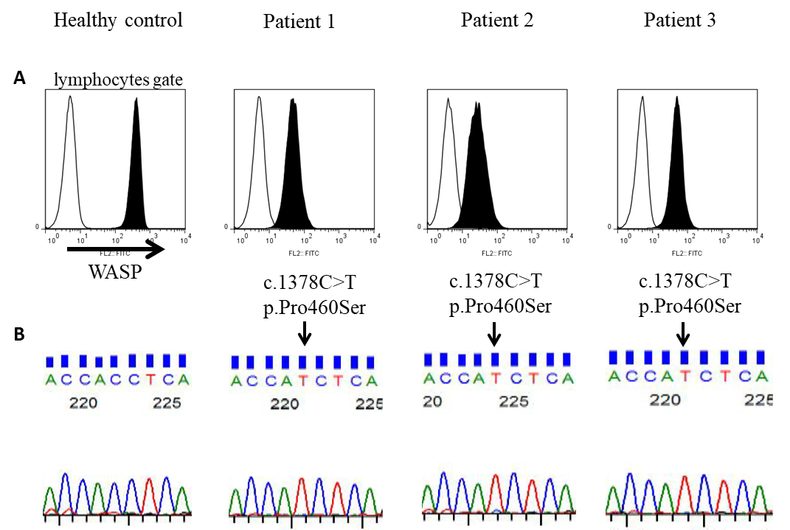
Figure 1 Analysis of Wiskott–Aldrich syndrome protein in patients’ lymphocytes (A). Histograms represent intracellular Wiskott–Aldrich syndrome protein (WASP) staining (shaded area) and negative staining (unshaded area). Three patients with childhood-onset IBD presented low expression of WASP compared with that in the healthy control. B: WAS gene analysis. The three patients who showed low expression of WASP had the same mutation, c.1378C>T p.Pro460Ser.

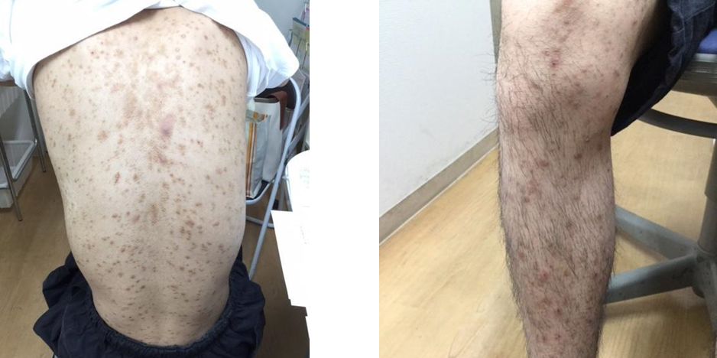
Figure 2 Cutaneous manifestations of Patient 1 (scaling eczema and pigmentation).

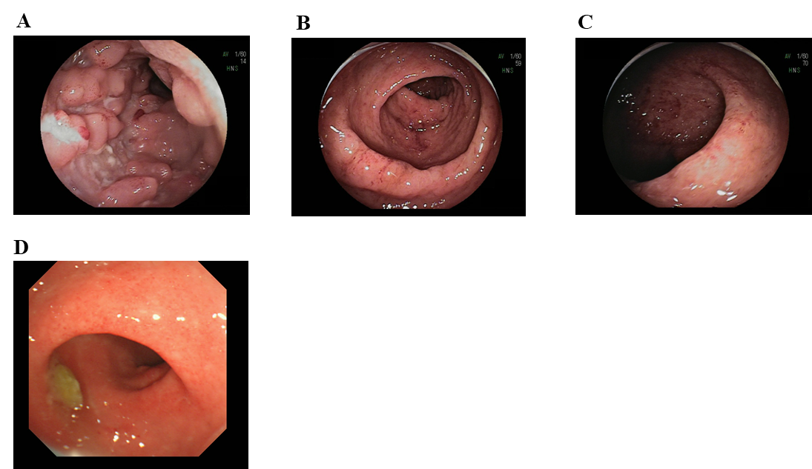
Figure 3 Endoscopic findings in the patients with WAS c.1378C>T, p.Pro460Ser mutation. A: Patient 1: long linear ulcerations and cobble stone appearance in the ileum. B and C: Patient 2: edematous and friable mucosa with superficial bleeding in the descending colon and sigmoid colon. D: Patient 3: edematous mucosa with granularity and erythema in the rectum.

Table 1 Characteristics of patients with childhood-onset inflammatory bowel disease in this study (n = 18)
Disease | UC | CD | IBD-U
n | 10 | 5 | 3
Sex (male, female) | 8, 2 | 4, 1 | 1, 2
Median age at onset in years (range) | 9.5 (1-13) | 12.0 (6-13) | 6.0 (1-9)
Symptoms (number of positive patients)
diarrhea | 10 | 5 | 1
mucosal aphthae | 1 | 2 | 0
eczema | 0 | 1 | 0
skin abscesses | 0 | 0 | 0
thrombocytopenia | 0 | 0 | 0
recurrent infection | 0 | 0 | 0
UC: ulcerative colitis; CD: Crohn’s disease; IBD-U: inflammatory bowel disease–unclassified.

Table 2 Previous reports of the c.1378C>T, p.Pro460Ser mutation of Wiskott–Aldrich syndrome
Phenotype | Sex | Age at onset | Platelet (×10³/μl) | WASP expression | Ref.
XLT | M | 8 months | 65-100 | low | Lutskiy et al^{[20]}
XLT | M | 4 days | low | low | Lee et al^{[21]}
WAS | M | N.D. | low | N.D. | Gulacsy et al^{[22]1}
XLT | M | 6 years | 5 | low | Ouchi-Uchiyama et al^{[23]}
¹This patent has double mutation (p.Pro460Ser and p.Met474Thr). ND: no data; XLT: X-linked thrombocytopenia; WAS: Wiskott–Aldrich syndrome; WASP: Wiskott–Aldrich syndrome protein.

Table 3 Clinical features of three patients with WAS c.1378C>T, p.Pro460Ser mutation
Patient | Sex | Diagnosis | Age at onset | Clinical symptoms | Platelet count (× 10³/μl) /mean platelet volume (fl) | Present status and treatment
Patient 1 | M | CD | 12 yr | Fever, Eczema, Watery diarrhea | 431/8.9 | Remission mesalazine, azathioprine and infliximab
Patient 2 | M | UC | 11 yr | Mucous-bloody diarrhea | 220/10.4 | Remission mesalazine and azathioprine
Patient 3 | M | UC | 2 yr | Mucous-bloody diarrhea | 339/9.4 | Remission mesalazine and prednisolone enema
UC: ulcerative colitis; CD: Crohn’s disease; mean platelet volume (fl), normal 8.9-12.6.

