Name of Journal: World Journal of Clinical Cases
Manuscript NO: 62029
Manuscript Type: CASE REPORT

Can kissing cause paraquat poisoning: A case report and review of literature

Lv B et al. Kissing causes paraquat poisoning

Bing Lv, Dong-Feng Han, Jing Chen, Hai-Bin Zhao, Xiao-Liang Liu

Bing Lv, Dong-Feng Han, Xiao-Liang Liu, Emergency Department, First Hospital of Jilin University, Changchun 130000, Jilin Province, China

Jing Chen, Hai-Bin Zhao, Department of Endocrinology and Nephrology, Central Hospital of Tonghua, Tonghua 134000, Jilin Province, China

Author contributions: All of the authors contributed to the conception and writing of the article; all of the authors approved the version to be submitted.

Corresponding author: Xiao-Liang Liu, PhD, Doctor, Emergency Department, First Hospital of Jilin University, No. 71 Xinmin Street, Changchun 130000, Jilin Province, China. l_xl@jlu.edu.cn

Received: December 26, 2020
Revised: May 7, 2021
Accepted: May 20, 2021
Published online:

Abstract
BACKGROUND
Paraquat is an effective, broad-spectrum, highly toxic quaternary ammonium herbicide. Paraquat poisoning has been reported frequently in recent years. It has severe lung, kidney, liver, and nervous system toxicity, and there is currently no specific antidote. Paraquat poisoning may follow ingestion, inhalation, and skin contact. There have been no previous reports of paraquat poisoning that resulted from kissing. This rare case provides a new reference for the prevention of paraquat poisoning.

CASE SUMMARY
A 27-year-old man came to the emergency department complaining that he had come into contact with paraquat by kissing his girlfriend, who had taken 80-120 mL 20% paraquat. After admission, his lung computed tomography (CT) showed increased lung markings. Redness and a burning sensation developed on his tongue, which progressed to painful erosions and coalescent ulcers. The final diagnosis was mild paraquat poisoning. Anti-inflammatory, antioxidant, and symptomatic treatment were initiated and continued for 7 d. Dyspnea did not occur, subsequent lung CT showed no significant changes, and the tongue pain was slightly improved. One month after discharge, the tongue injury was resolved.

CONCLUSION
This case indicated that the tongue and lung tissues are particularly vulnerable to paraquat toxicity, even after a limited exposure.

Key Words: Paraquat; Poisoning; Pesticides; Tongue; Lung; Case report

Lv B, Han DF, Chen J, Zhao HB, Liu XL. Can kissing cause paraquat poisoning: A case report and review of literature. World J Clin Cases 2021; In press

Core Tip: We report a rare case of exposure to a trace amount of paraquat by kissing, which has never been reported before. This case was accidental, but it reminds us that we should pay attention to trace paraquat poisoning because it has damaging effects, especially on the tongue.
INTRODUCTION
Paraquat is an effective broad-spectrum, highly toxic quaternary ammonium herbicide that is widely used in agriculture and animal husbandry in developing countries^{[1,2]}. Paraquat poisoning has been reported frequently in recent years and it remains a serious challenge in both public health and emergency medicine^{[3-5]}. It is quickly distributed after intake, and results in kidney, lung, liver, and nervous system toxicity. There is currently no specific antidote^{[6,7]}. Paraquat is reported to cause multiple organ failure, with a fatality rate as high as 40%-80%^{[8]}. The main routes of paraquat poisoning are ingestion, inhalation, and skin contact^{[9-11]}. Recently, a patient with paraquat poisoning was admitted of the Central Hospital of Tonghua from the emergency department. He was exposed to paraquat by kissing. At that route has never been reported before, we decided to report this case to provide a new reference for the prevention of paraquat poisoning.

CASE PRESENTATION
Chief complaints
A 27-year-old Han Chinese man came to the emergency department complaining of oral contact with paraquat 3 h previously.

History of present illness
Approximately 3 h before admission, the patient’s girlfriend took 80-120 mL 20% paraquat to commit suicide. He kissed her several times. Because he was drunk and emotional, the unusual smell that he noticed did not alert him. During these events, he swallowed at least once. After presentation at the emergency department, he did not feel any discomfort.

History of past illness
There is no history of past illness to disclose.

Personal and family history
There is no special family history to disclose.

Physical examination
The patient’s vital signs of on admission were body temperature 36.5℃, pulse 82 beats/min, respiratory rate 19 breaths/min, and blood pressure 16.7/10.0 kPa. The patient was in a normal mental state. His chest auscultation breath sounds were clear without rhonchi and rales. His heart rate was 82 beats/min, his heart rhythm was regular, and no heart murmur was heard. Although no damage to the oral cavity or pharynx was observed on admission, redness and burning sensations of his tongue occurred the next day and gradually progressed to painful erosions and coalescent ulcers (Figure 1). During hospitalization, his percutaneous arterial oxygen saturation remained above 95%.

Laboratory examination
On admission, routine blood tests showed leukocytosis (14.07 × 10⁹/L) with predominant neutrophils (90.90%), which were considered as a stress response. The plasma paraquat concentration was 0.117 μg/mL. Liver and renal function, routine urine tests, and arterial blood gas analysis remained within normal limits during his hospitalization.

Imaging examinations
Twenty-four hours after admission, lung computed tomography (CT) showed an increase of lung markings (Figure 2). The patient reported that previous medical examination reports had not shown any lung abnormalities.

FINAL DIAGNOSIS
The final diagnosis was mild paraquat poisoning.

TREATMENT
The patient was treated with gastric lavage following admission to the emergency department. Inpatient treatment during 7 d of hospitalization (7 d) were once daily dexamethasone 80 mg intravenous drip and reduced glutathione 2.4 g intravenous infusion, twice daily pantoprazole 40 mg intravenous drip and torasemide 20 mg intravenous infusion drip, and rinsing the mouth with water several times a day.

OUTCOME AND FOLLOW-UP
The clinical course was uneventful. The patient recovered well and was discharged on day 7. He did not develop dyspnea, lung CT scans revealed no progressive lung lesions. His liver, lung, and kidney functions remained normal. Other than a slight improvement of pain, there was no significant resolution of the tongue lesion, but 1 mo after hospital discharge, the tongue had healed well.

DISCUSSION
The International Program for Chemical Safety classifies paraquat is a class II, moderately dangerous, pesticide^{[9]}. It causes liver, kidney, digestive tract, and especially lung toxicity^{[12]}. Its toxicity depends on the route of exposure and the dose taken. The absorption rate of paraquat in the gastrointestinal tract is 5%-15%, and the paraquat plasma concentration reaches a peak within 0.5-4.0 h after absorption^{[13]}. Approximately 15 h after oral administration, the concentration of paraquat in the lungs reaches a peak, which is 10-90 times the plasma concentration^{[14]}. An oral dose of 5-15 mL of 20% paraquat is usually fatal^{[15-18]}. Considering the patient’s chief complaint, the course of illness, and good recovery, we considered his actual intake to have been less than 5 mL.
The specific mechanism of paraquat-induced lung injury is complex and it is considered to involve diffuse alveolar collapse, vascular congestion, adherence of activated platelets, and inflammatory-cell infiltration caused by oxidative stress^{[19,20]}. Because of a lack of specific drugs to treat the lung injury, palliative treatment is mainstream in clinical practice. This patient received anti-inflammatory, antioxidant, and symptomatic treatment, but clinical studies have suggested that the benefits of those treatments are limited^{[6]}, which is consistent with our experience. We believe that the main reason for his satisfactory recovery was that the intake dose was too small to cause any significant oxidative damage.
Paraquat-induced lung injury pathophysiologically manifests as reduced pulmonary ventilation, reduced lung compliance, and ventilation/perfusion defects^{[21]}. In the early stage, lung CT shows no abnormality or only an increase of lung markings and mild ground-glass-like changes. In the middle and late stages, the lung CT shows diffuse ground-glass changes, pulmonary fibrosis and lung consolidation^{[22-25]}. Two days after admission, this patient’s lung CT showed increased lung markings. Subsequent lung CTs showed no further aggravation of the lung injury. We were surprised that exposure to such a small dose of paraquat led to pulmonary imaging changes without dysfunction of other organs. Consequently, we believe that the lung is very vulnerable and susceptible to paraquat toxicity.
Oral paraquat can damage the tongue and pharynx. Initial responses include erythema and swelling of the tongue that gradually progress to erosions and ulcerations covered with yellow necrotic tissue^{[26,27]}. The symptoms include severe pain, difficulty swallowing, and excessive salivation^{[28,29]}. In previous cases of tongue injury, the patients took at least 10-15 mL of 20% paraquat orally^{[28,30]}. The patient did not directly take paraquat orally, but was indirectly exposed to a mixture of paraquat and saliva through kissing. This is a route of intoxication that was previously unknown to us. That is what we were interested in. Initially, we thought that exposure to such a small amount of paraquat was not enough to cause tongue damage. However, to our surprise, the patient developed damage to his tongue on the second day of admission, indicating that the tongue is particularly vulnerable and susceptible to paraquat. We did not find any studies on the minimum concentration or dose of paraquat that can cause tongue damage, which deserves investigation.

CONCLUSION
This case shows that even exposure to trace paraquat can lead to tongue damage and pulmonary imaging changes, suggesting that the tongue and lung tissues are particularly vulnerable and susceptible to paraquat. Poisoning by kissing was accidental, but it reminds us that we should pay attention to the prevention of trace paraquat poisoning caused by some surprising routes, such as using containers that once contained paraquat to drink water, close contact with the sparger spraying paraquat, and others.

REFERENCES
1 Blanco-Ayala T, Andérica-Romero AC, Pedraza-Chaverri J. New insights into antioxidant strategies against paraquat toxicity. Free Radic Res 2014; 48: 623-640 [PMID: 24593876 DOI: 10.3109/10715762.2014.899694]
2 de Pont ACJM, Volbeda M. Extracorporeal Treatment for Paraquat Poisoning. Crit Care Med 2018; 46: e1015-e1016 [PMID: 30216323 DOI: 10.1097/CCM.0000000000003282]
3 Wesseling C, Corriols M, Bravo V. Acute pesticide poisoning and pesticide registration in Central America. Toxicol Appl Pharmacol 2005; 207: 697-705 [PMID: 16153991 DOI: 10.1016/j.taap.2005.03.033]
4 Konthonbut P, Kongtip P, Nankongnab N, Tipayamongkholgul M, Yoosook W, Woskie S. Paraquat Exposure of Pregnant Women and Neonates in Agricultural Areas in Thailand. Int J Environ Res Public Health 2018; 15 [PMID: 29865285 DOI: 10.3390/ijerph15061163]
5 Shadnia S, Ebadollahi-Natanzi A, Ahmadzadeh S, Karami-Mohajeri S, Pourshojaei Y, Rahimi HR. Delayed death following paraquat poisoning: three case reports and a literature review. Toxicol Res (Camb) 2018; 7: 745-753 [PMID: 30310653 DOI: 10.1039/c8tx00120k]
6 Gawarammana IB, Buckley NA. Medical management of paraquat ingestion. Br J Clin Pharmacol 2011; 72: 745-757 [PMID: 21615775 DOI: 10.1111/j.1365-2125.2011.04026.x]
7 Dinis-Oliveira RJ, Duarte JA, Sánchez-Navarro A, Remião F, Bastos ML, Carvalho F. Paraquat poisonings: mechanisms of lung toxicity, clinical features, and treatment. Crit Rev Toxicol 2008; 38: 13-71 [PMID: 18161502 DOI: 10.1080/10408440701669959]
8 Feng N, Bian Z, Zhang X, Wang C, Chen J. Rapamycin reduces mortality in acute-stage paraquat-induced toxicity in zebrafish. Singapore Med J 2019; 60: 241-246 [PMID: 30402654 DOI: 10.11622/smedj.2018132]
9 Zhou Q, Kan B, Jian X, Zhang W, Liu H, Zhang Z. Paraquat poisoning by skin absorption: Two case reports and a literature review. Exp Ther Med 2013; 6: 1504-1506 [PMID: 24250726 DOI: 10.3892/etm.2013.1320]
10 Yu HS, Lee CH, Jee SH, Ho CK, Guo YL. Environmental and occupational skin diseases in Taiwan. J Dermatol 2001; 28: 628-631 [PMID: 11770720 DOI: 10.1111/j.1346-8138.2001.tb00049.x]
11 Lee K, Park EK, Stoecklin-Marois M, Koivunen ME, Gee SJ, Hammock BD, Beckett LA, Schenker MB. Occupational paraquat exposure of agricultural workers in large Costa Rican farms. Int Arch Occup Environ Health 2009; 82: 455-462 [PMID: 18762966 DOI: 10.1007/s00420-008-0356-7]
12 Sun S, Jiang Y, Wang R, Liu C, Liu X, Song N, Guo Y, Guo R, Du L, Jiang S, Li Y, Qiu Z, Zhao G, Zhou Y. Treatment of Paraquat-Induced Lung Injury With an Anti-C5a Antibody: Potential Clinical Application. Crit Care Med 2018; 46: e419-e425 [PMID: 29293144 DOI: 10.1097/CCM.0000000000002950]
13 Xu W, Wang L, Wang Q, Li XH, Hu D, Li C, Wu T, Mohan C, Peng A, Shi Y. Paraquat Poisoning Followed by Toxic Epidermal Necrolysis: A Report of Two Cases and Published Work Review. Dermatology 2015; 231: 209-212 [PMID: 26228174 DOI: 10.1159/000433578]
14 Schaper A, Ceschi A, Deters M, Kaiser G. Of pills, plants, and paraquat: the relevance of poison centers in emergency medicine. Eur J Intern Med 2013; 24: 104-109 [PMID: 23245927 DOI: 10.1016/j.ejim.2012.11.013]
15 Khazraei S, Marashi SM, Sanaei-Zadeh H. Ventilator settings and outcome of respiratory failure in paraquat-induced pulmonary injury. Sci Rep 2019; 9: 16541 [PMID: 31719587 DOI: 10.1038/s41598-019-52939-3]
16 Gao Y, Guo S, Wang Y, Yu S, Wang M, Lu X, Li Y. Lymphocyte and its CD4+ and CD8+ subgroup changes after paraquat poisoning. Hum Exp Toxicol 2019; 38: 1024-1030 [PMID: 31104516 DOI: 10.1177/0960327119851252]
17 Huang J, Xuan D, Li X, Ma L, Zhou Y, Zou H. The value of APACHE II in predicting mortality after paraquat poisoning in Chinese and Korean population: A systematic review and meta-analysis. Medicine (Baltimore) 2017; 96: e6838 [PMID: 28746171 DOI: 10.1097/MD.0000000000006838]
18 Ko DR, Chung SP, You JS, Cho S, Park Y, Chun B, Moon J, Kim H, Kim YH, Kim HJ, Lee KW, Choi S, Park J, Park JS, Kim SW, Seo JY, Park HY, Kim SJ, Kang H, Hong DY, Hong JH. Effects of Paraquat Ban on Herbicide Poisoning-Related Mortality. Yonsei Med J 2017; 58: 859-866 [PMID: 28541002 DOI: 10.3349/ymj.2017.58.4.859]
19 Dinis-Oliveira RJ, Sousa C, Remião F, Duarte JA, Navarro AS, Bastos ML, Carvalho F. Full survival of paraquat-exposed rats after treatment with sodium salicylate. Free Radic Biol Med 2007; 42: 1017-1028 [PMID: 17349929 DOI: 10.1016/j.freeradbiomed.2006.12.031]
20 Dearden LC, Fairshter RD, Morrison JT, Wilson AF, Brundage M. Ultrastructural evidence of pulmonary capillary endothelial damage from paraquat. Toxicology 1982; 24: 211-222 [PMID: 6927641 DOI: 10.1016/0300-483x(82)90003-8]
21 Wu Q, Xu Q, Jian X, Wang H, He X, Gao B, Wang K, Kan B. A new sight for paraquat poisoning from immunology. Immunopharmacol Immunotoxicol 2018; 40: 269-272 [PMID: 30040510 DOI: 10.1080/08923973.2018.1490319]
22 Yanling W, Duo G, Zuojun G, Zhongqiang S, Yankai W, Shan L, Hongying C. Radiomics Nomogram Analyses for Differentiating Pneumonia and Acute Paraquat Lung Injury. Sci Rep 2019; 9: 15029 [PMID: 31636276 DOI: 10.1038/s41598-019-50886-7]
23 Im JG, Lee KS, Han MC, Kim SJ, Kim IO. Paraquat poisoning: findings on chest radiography and CT in 42 patients. AJR Am J Roentgenol 1991; 157: 697-701 [PMID: 1892020 DOI: 10.2214/ajr.157.4.1892020]
24 Bartlett RM, Murali D, Nickles RJ, Barnhart TE, Holden JE, DeJesus OT. Assessment of fetal brain uptake of paraquat in utero using in vivo PET/CT imaging. Toxicol Sci 2011; 122: 551-556 [PMID: 21546347 DOI: 10.1093/toxsci/kfr104]
25 Isha IT, Alam ZHMN, Shaha BK, Bari MS, Bari MZJ, Chowdhury FR. Paraquat induced acute kidney injury and lung fibrosis: a case report from Bangladesh. BMC Res Notes 2018; 11: 344 [PMID: 29843773 DOI: 10.1186/s13104-018-3425-3]
26 Dobson RS, Smith AC. Effect of paraquat on the oral mucosa. Br Dent J 1987; 163: 160 [PMID: 3478057 DOI: 10.1038/sj.bdj.4806227]
27 Adams JR, Nusrath M, Bryant DG. Oral mucosal response to exposure to diquat: a rare occupational injury. Br J Oral Maxillofac Surg 2008; 46: 601-602 [PMID: 18400346 DOI: 10.1016/j.bjoms.2008.03.003]
28 Patel RK, Sa DK, Behra A, Meher K. A Rare Case of "Paraquat Tongue". Indian J Dermatol 2020; 65: 245-246 [PMID: 32565580 DOI: 10.4103/ijd.IJD_659_18]
29 Kumar S. Paraquat tongue. Indian J Gastroenterol 2016; 35: 321 [PMID: 27435617 DOI: 10.1007/s12664-016-0673-9]
30 Hudson M, Patel SB, Ewen SW, Smith CC, Friend JA. Paraquat induced pulmonary fibrosis in three survivors. Thorax 1991; 46: 201-204 [PMID: 2028434 DOI: 10.1136/thx.46.3.201]

Footnotes
Informed consent statement: Informed written consent was obtained from the patient for publication of this report and any accompanying images.

Conflict-of-interest statement: The authors declare that they have no competing interests.

CARE Checklist (2016) statement: The authors have read the CARE Checklist (2016), and the manuscript was prepared and revised according to the CARE Checklist (2016).

Open-Access: This article is an open-access article that was selected by an in-house editor and fully peer-reviewed by external reviewers. It is distributed in accordance with the Creative Commons Attribution NonCommercial (CC BY-NC 4.0) license, which permits others to distribute, remix, adapt, build upon this work non-commercially, and license their derivative works on different terms, provided the original work is properly cited and the use is non-commercial. See: http://creativecommons.org/Licenses/by-nc/4.0/

Manuscript source: Unsolicited manuscript

Peer-review started: December 26, 2020
First decision: April 29, 2021
Article in press:

Specialty type: Emergency medicine
Country/Territory of origin: China
Peer-review report’s scientific quality classification
Grade A (Excellent): 0
Grade B (Very good): B
Grade C (Good): 0
Grade D (Fair): 0
Grade E (Poor): 0

P-Reviewer: Chuang PC S-Editor: Zhang L L-Editor: Filipodia P-Editor:

Figure Legends
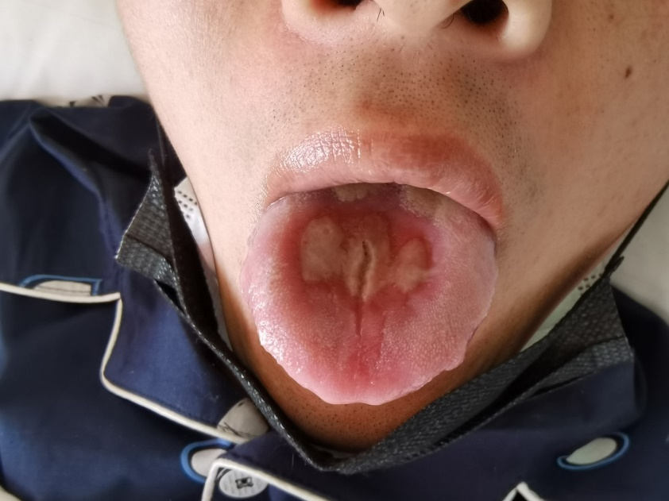
Figure 1 Five days after admission, deep fissures were interposed in the areas of coalescent ulcers on the tongue.
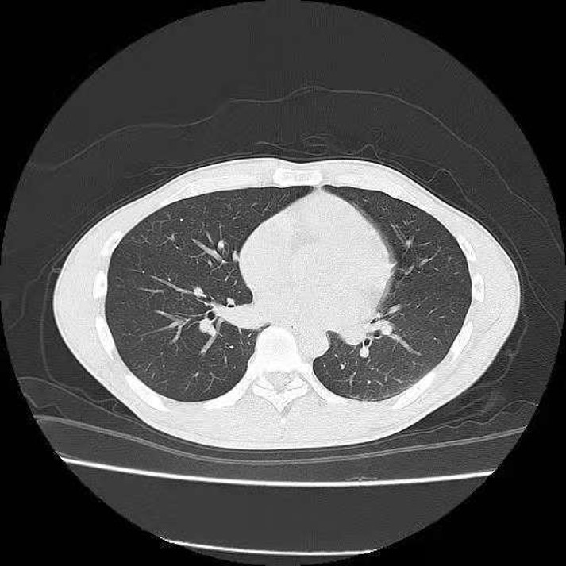
Figure 2 Twenty-four hours after admission, lung computed tomography showed increased lung markings.

