Name of Journal: World Journal of Clinical Cases
Manuscript NO: 42330
Manuscript Type: CASE REPORT

Schwannoma originating from recurrent laryngeal nerve in a thyroid cancer patient: A case report and review of literature

Xu XQ et al. Schwannoma originating from recurrent laryngeal nerve

Xie-Qun Xu, Tao Hong, Chao-Ji Zheng

Xie-Qun Xu, Tao Hong, Chao-Ji Zheng, Department of General Surgery, Peking Union Medical College Hospital, Chinese Academy of Medical Sciences and Peking Union Medical College, Beijing 100730, China

ORCID number: Xie-Qun Xu (0000-0003-0347-5258); Tao Hong (0000-0002-5445-2315); Chao-Ji Zheng (0000-0003-1814-1699).

Author contributions: Xu XQ gathered data, prepared the initial manuscript draft, and approved the final draft; all other authors contributed to patient care, offered expert advice on manuscript preparation, and approved the final draft; Hong T was the principal investigator and approved the final draft.

Informed consent statement: The study participant provided informed written consent prior to study enrollment.

Conflict of interest statement: The authors have no conflict of interest to declare.

CARE Checklist (2016) statement: The authors have read the CARE Checklist (2016), and the manuscript was prepared and revised according to the CARE Checklist (2016).

Open-Access: This article is an open-access article which was selected by an in-house editor and fully peer-reviewed by external reviewers. It is distributed in accordance with the Creative Commons Attribution Non Commercial (CC BY-NC 4.0) license, which permits others to distribute, remix, adapt, build upon this work non-commercially, and license their derivative works on different terms, provided the original work is properly cited and the use is non-commercial. See: http://creativecommons.org/licenses/by-nc/4.0/

Manuscript source: Unsolicited manuscript

Correspondence to: Tao Hong, MD, Doctor, Department of General Surgery, Peking Union Medical College Hospital, Chinese Academy of Medical Sciences and Peking Union Medical College, Shuaifuyuan 1, Dongcheng District, Beijing 100730, China. xiequnxu@gmail.com
Telephone: +86-10-69152610
Fax: +86-10-69152610.

Received: September 20, 2018
Peer-review started: September 21, 2018
First decision: October 25, 2018
Revised: November 5, 2018
Accepted:
Article in press:
Published online:

Abstract
BACKGROUND
Schwannoma rarely originates from the recurrent laryngeal nerve, there are few reports on Schwannoma originating from the recurrent nerve in the mediastinum. Herein, we present one extremely rare case of Schwannoma originating from the recurrent laryngeal nerve in the neck.

CASE SUMMARY
This is a case report of one patient diagnosed with thyroid cancer with Schwannoma originating from the recurrent laryngeal nerve in the neck incidentally found during the thyroidectomy and a review of the literature.

CONCLUSION
Preoperative diagnostic examinations are of less use for detecting schwannoma originating from a recurrent laryngeal nerve in the neck in such small size which may only incidentally be found during the thyroidectomy. Surgical excision with opening the capsule and shelling out the tumor is the treatment of choice, if the nerve was unable to be preserved, end-to-end recurrent laryngeal nerve anastomosis may be a simple and minimally invasive reconstruction to improve phonation.

Key words: Schwannoma; Recurrent laryngeal nerve; Thyroid cancer; Head and neck; Surgery; Case report

© The Author(s) 2018. Published by Baishideng Publishing Group Inc. All rights reserved.

Core tip: Schwannoma originating from left recurrent laryngeal nerve is very rare. This paper showed the clinical manifestation and management, then systematic literature review was done. This case has very useful clinical practice meanings for residents and medical students, including physicians and surgeons. Surgical excision with opening the capsule and shelling out the tumor is the treatment of choice, if the nerve was not able to be preserved, end-to-end recurrent laryngeal nerve anastomosis may be a simple and minimally invasive reconstruction to improve phonation.

Xu XQ, Hong T, Zheng CJ. Schwannoma originating from recurrent laryngeal nerve in a thyroid cancer patient: A case report and review of literature. World J Clin Cases 2018; In press

INTRODUCTION
Schwannoma is a rare tumor originating from any peripheral nerve or nerve root sheath, mostly in the head, neck, or extremities, which can occur as isolated or multiple lesions^{[1]}. These tumors are difficult to be diagnosed preoperatively as they may present at a multitude of sites which mimics a multitude of other neck lesions. Schwannoma rarely originates from the recurrent laryngeal nerve, there are only few reports on Schwannoma originating from the recurrent nerve in the mediastinum. The rarity and unremarkable symptoms of these tumors often result in a difficult preoperative diagnosis. Herein, we present one extremely rare case of Schwannoma originating from the recurrent laryngeal nerve in the neck.

CASE PRESENTATION
Chief complaints
Suspected thyroid cancer found in a routine health screening ultrasound with hoarseness for one year.

History of present illness
A 61 years old man was referred to our hospital due to suspected thyroid cancer found in a routine health screening ultrasound with hoarseness for one year.

History of past illness
None specific.

Physical examination
Unremarkable.

Laboratory testing
The laboratory data confirmed normal thyroid and parathyroid function.

Imaging examination
The thyroid ultrasound showed a solitary nodule with hypoechogenicity, irregular borders, and microcalcifications about 0.6 cm × 0.6 cm in the left thyroid lobe. The preoperative laryngoscope revealed limited motion and low tension of left vocal cord (Figure 1), which was suspected paralysis of left recurrent laryngeal nerve caused by tumor invasion.

TREATMENT
The patient performed the thyroid nodule resection, and the intraoperative frozen-section examination confirmed the diagnosis of thyroid papillary carcinoma, so total thyroidectomy with prophylactic ipsilateral central compartment lymph node dissection. While dissecting the left recurrent laryngeal nerve, a mass originating from the left recurrent laryngeal nerve was found (Figure 2). Enucleation of the mass was tried, but the capsule could not be dissected from the nerve, so the mass was resected along the nerve, and the left recurrent laryngeal nerve was end-to-end anastomosed with 7-0 proline (Figure 3).

FINAL DIAGNOSIS
The resected tumor was a well-encapsulated solid mass measuring about 1.0 cm × 0.5 cm (Figure 4). The pathological results revealed an ancient type of schwannoma with a fibrous capsule which showed nuclear palisading and hyaline growth of spindle cells, the immunohistochemistry assay was positive for S100. The final diagnosis was a benign neurilemoma originating from the left recurrent laryngeal nerve.

OUTCOME AND FOLLOW-UP
The postoperative recovery for the patient was uneventful, and his phonation reported by himself was improved compared with that before the surgery one week later.

DISCUSSION
Schwannomas are benign nerve sheath tumors of Schwann cell origin arising from nerves covered with a neurilemmal sheath. The tumor is usually solitary and can arise from any cranial or peripheral nerve which is also called neurinoma, peripheral glioma, peripheral fibroblastoma, schwannoma and neurilemmoma. About 25%–40% of cases occur in head and neck region^{[1]}. Schwannoma rarely originates from the recurrent laryngeal nerve, there are few reports on Schwannoma originating from the recurrent laryngeal nerve in the mediastinum^{[2-4]}. To the best of our knowledge a case of ancient schwannoma of the left recurrent laryngeal nerve found incidentally in a thyroidectomy with such small size has not been reported in the literature.
Imagings such as ultrasound, CT and MRI are often used to differentiate the lesions in the neck and to investigate the anatomical relationship between the lesions and the surrounding tissues. The most common ultrasound feature of a schwannoma is a well-defined, hypoechoic, homogeneous nodule without an echoic hilum. The nerve from which the tumor originates may seem to be stretched over the capsule, while the nerve fibers themselves may be thickened around the mass. The suspected diagnosis would not be made in most cases before the ultrasound imaging and they may often mimic an enlarged or metastasized lymph node in the neck^{[5]}. Razek et al^{[6]} showed that diffusion-weighted MR imaging may be used for differentiation of schwannoma and lymph node, MRI is capable of reliably imaging not only the tumor and its capsule but also the nerve from which the tumor arises.
But usually, preoperative diagnostic examinations are of less use for detecting schwannoma originating from a recurrent laryngeal nerve in such small size which may only incidentally be found during the thyroidectomy like this case. Generally, schwannoma originating from the recurrent laryngeal nerve may firstly mimic thyroid mass or lymph node. Therefore, resection is necessary, both to remove the tumor and for diagnosis. If enucleation is possible by opening the capsule and shelling out the tumor, functional preservation of the nerve might be achieved. However, in most cases as seen here, complete tumor excision with end-to-end nerve anastomosis may be the only feasible option^{[1]}. Unfortunately, if the nerve was not able to be preserved, end-to-end recurrent laryngeal nerve anastomosis may be a simple and minimally invasive reconstruction to improve phonation, although the reinnervated vocal cord did not regain normal movement, phonation was remarkably improved. Surgical reinnervation has been proved to be effective in restoring neural function to laryngeal muscles, which could prevent atrophy of laryngeal muscles, improve the bulk and position of vocal folds and enhance overall vocal quality^{[7]}.
In conclusion, in cases of small thyroid nodules with unexplained preoperative vocal palsy, a co-existent pathology such as schwannoma of the recurrent laryngeal nerve may be suspected. Surgical excision with opening the capsule and shelling out the tumor is the treatment of choice, if the nerve was not able to be preserved, end-to-end recurrent laryngeal nerve anastomosis may be a simple and minimally invasive reconstruction to improve phonation.

EXPERIENCES AND LESSONS
Schwannomas originating from the recurrent laryngeal nerve are difficult to be diagnosed preoperatively as they may present at a multitude of sites which mimics a multitude of other neck lesions. Surgical excision with opening the capsule and shelling out the tumor is the treatment of choice, if the nerve was not able to be preserved, end-to-end recurrent laryngeal nerve anastomosis may be a simple and minimally invasive reconstruction. The reconstruction of recurrent laryngeal nerve anastomosis may improve phonation.

REFERENCES
1 Pillai S, Agarwal AC, Mathew M, Nayak DR. Ancient schwannoma mimicking a thyroid mass with retrosternal extension. BMJ Case Rep 2013; 2013: pii: bcr2013200608 [PMID: 24001735 DOI: 10.1136/bcr-2013-200608]
2 Sasaki K, Kohno T, Mun M, Yoshiya T. Thoracoscopic removal of middle mediastinal schwannoma originating from recurrent nerve. Thorac Cardiovasc Surg 2008; 56: 375-377 [PMID: 18704866 DOI: 10.1055/s-2008-1038471]
3 Varaldo E, Crespi G, Ansaldo GL, Borgonovo G, Boccardo F, Torre G. Neurinoma originating from the recurrent nerve: report of a case. Surg Today 2008; 38: 633-634 [PMID: 18612788 DOI: 10.1007/s00595-007-3714-2]
4 Ito T, Komatsu D, Nakata T, Kumaki T, Aoki T, Kasuga Y. Neurilemoma originating from the left recurrent nerve in the superior mediastinum: report of a case. Surg Today 2004; 34: 769-771 [PMID: 15338351 DOI: 10.1007/s00595-004-2794-5]
5 Miyauchi A, Matsusaka K, Kawaguchi H, Nakamoto K, Maeda M. Ansa-recurrent nerve anastomosis for vocal cord paralysis due to mediastinal lesions. Ann Thorac Surg 1994; 57: 1020-1021 [PMID: 8166501 DOI: 10.1016/0003-4975(94)90230-5]
6 Razek AAKA, Ashmalla GA. Assessment of paraspinal neurogenic tumors with diffusion-weighted MR imaging. Eur Spine J 2018; 27: 841-846 [PMID: 28821978 DOI: 10.1007/s00586-017-5265-6]
7 Miyauchi A, Inoue H, Tomoda C, Fukushima M, Kihara M, Higashiyama T, Takamura Y, Ito Y, Kobayashi K, Miya A. Improvement in phonation after reconstruction of the recurrent laryngeal nerve in patients with thyroid cancer invading the nerve. Surgery 2009; 146: 1056-1062 [PMID: 19958932 DOI: 10.1016/j.surg.2009.09.018]

P-Reviewer: Akbulut S, Dhiwakar M, Noussios GI, Razek AAKA S-Editor: Ji FF L-Editor: E-Editor:

Specialty type: Medicine, research and experimental
Country of origin: China
Peer-review report classification
Grade A (Excellent): 0
Grade B (Very good): 0
Grade C (Good): C, C, C
Grade D (Fair): D
Grade E (Poor): 0

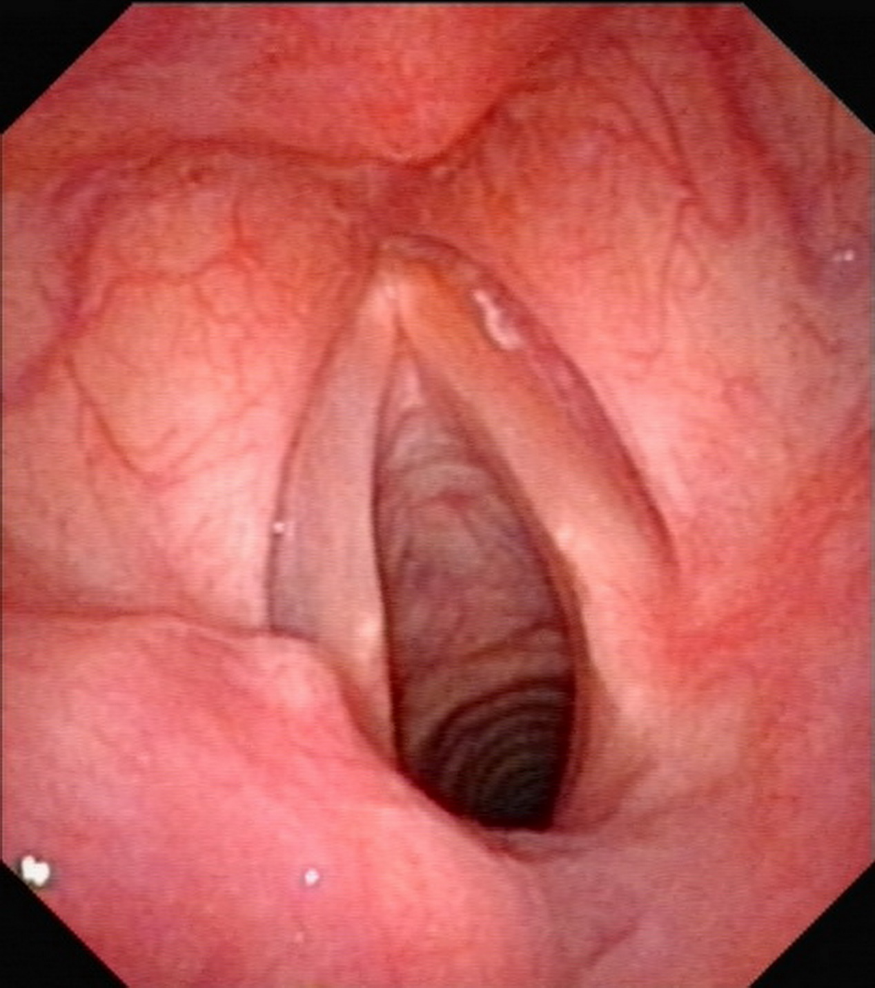
Figure 1 The preoperative laryngoscope revealed limited motion and low tension of left vocal cord.
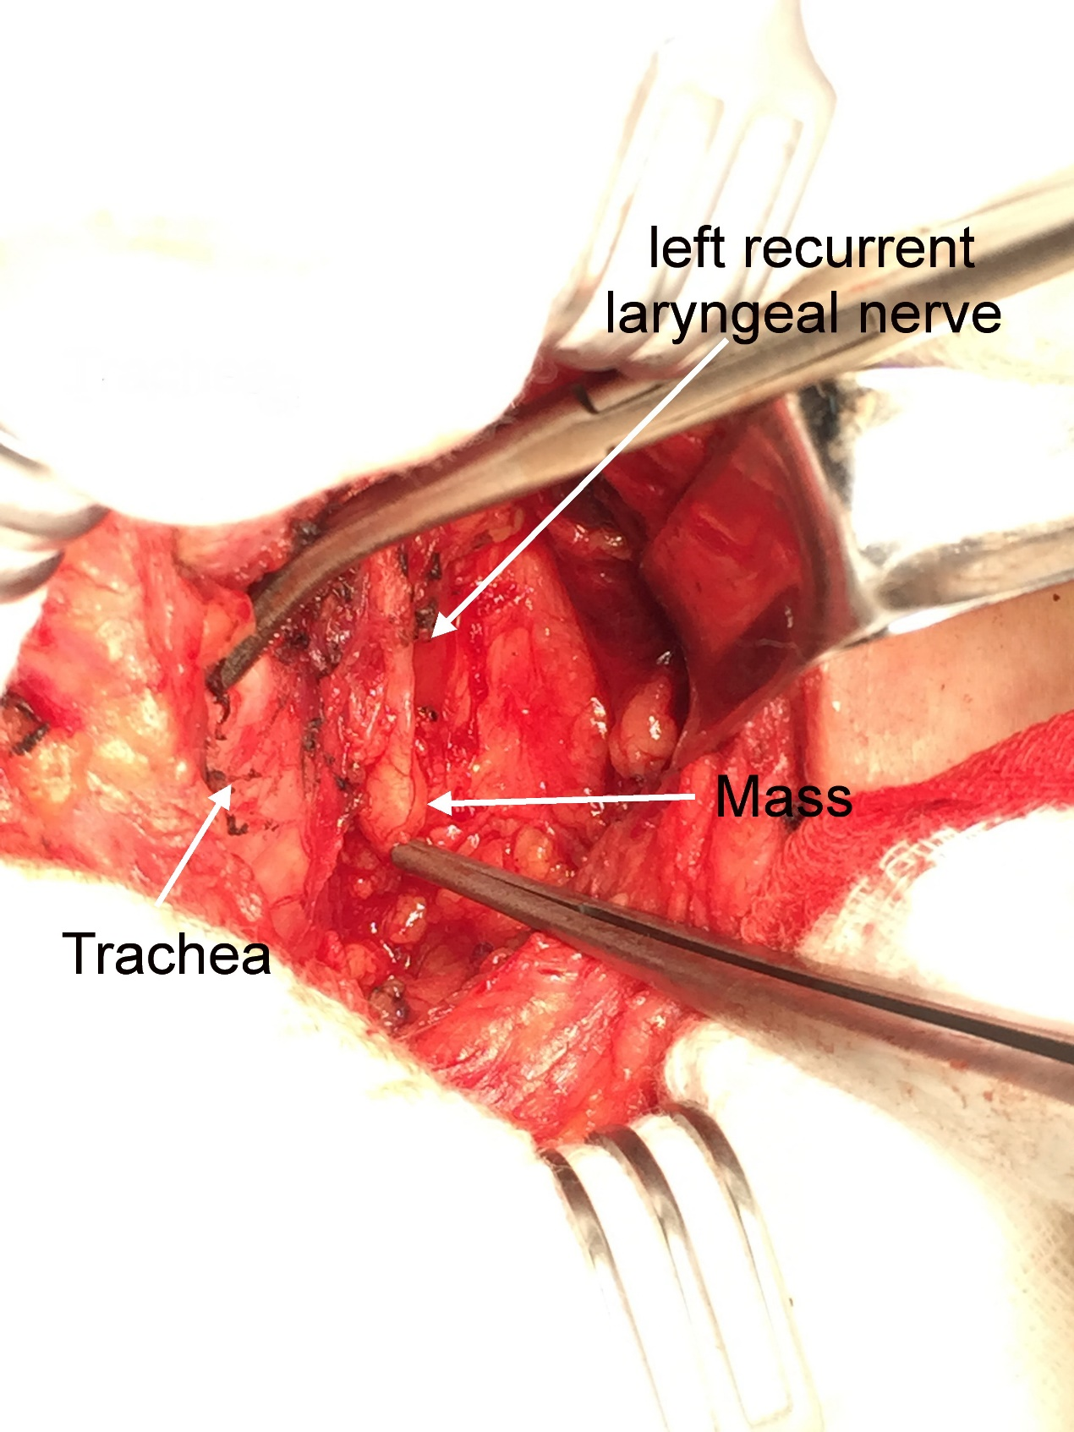

Figure 2 During the operation, a mass originating from the left recurrent laryngeal nerve was found (arrow).
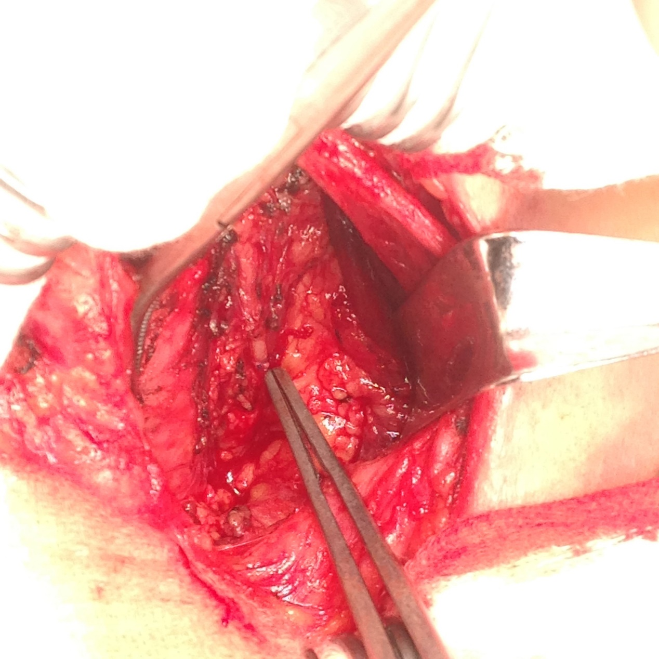
Figure 3 The end-to-end anastomosed recurrent laryngeal nerve.
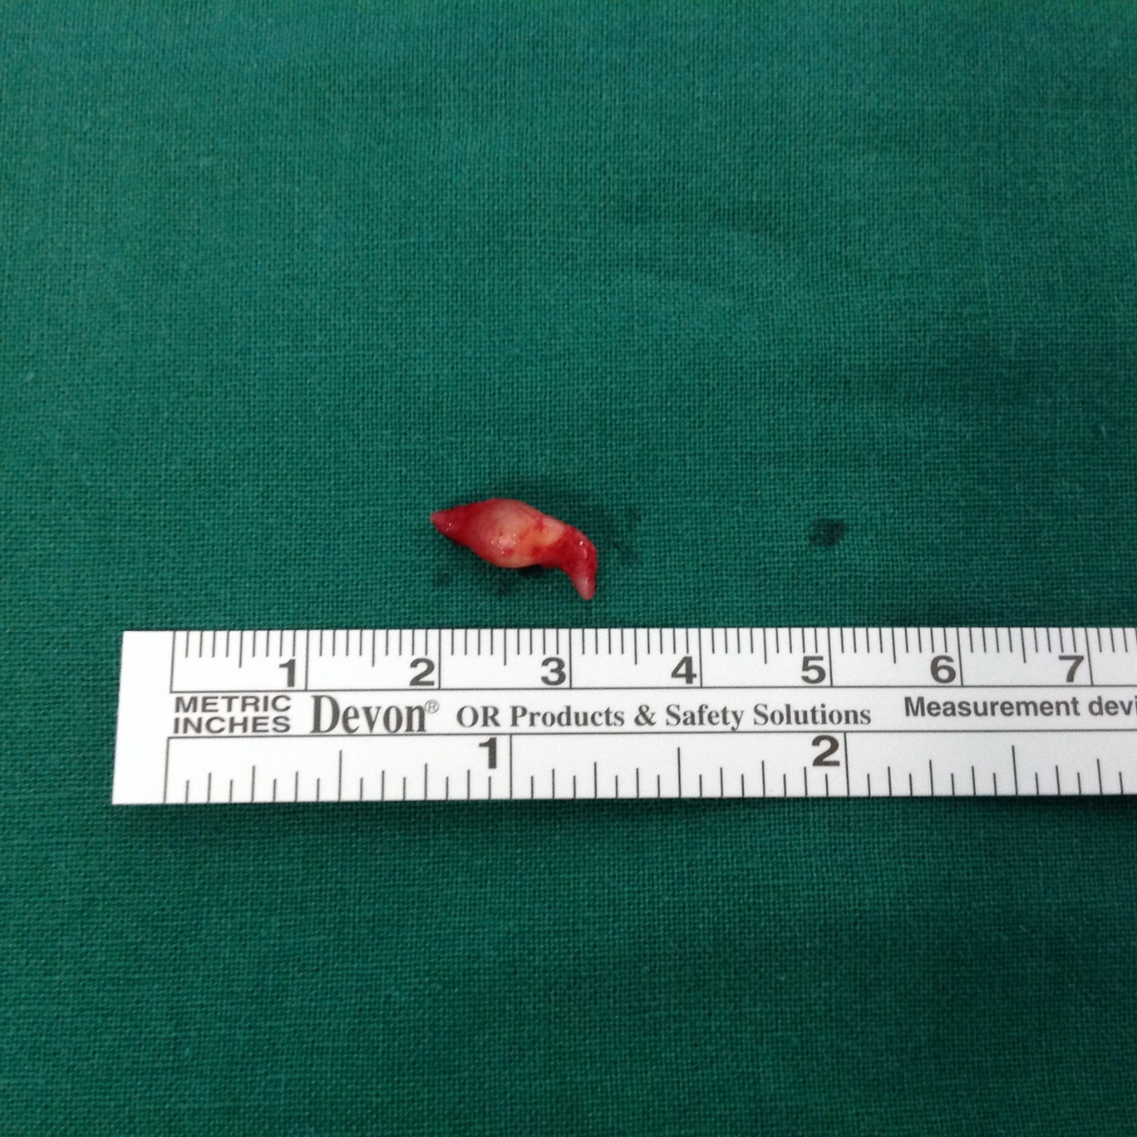
Figure 4 The resected tumor was a well-encapsulated solid mass measuring about 1.0 cm × 0.5 cm.

