Name of Journal: World Journal of Clinical Cases
Manuscript NO: 87739
Manuscript Type: CASE REPORT

Azacitidine maintenance therapy for blastic plasmacytoid dendritic cell neoplasm allograft: A case report

Tao LL et al. BPDCN: A case report

Li-Li Tao, Hui-Ting Wen, Zi-Yi Wang, Juan Cheng, Li Zhao

Li-Li Tao, Zi-Yi Wang, Department of Hematology, The First Clinical Medical College, Lanzhou University, Lanzhou 730000, Gansu Province, China

Hui-Ting Wen, Juan Cheng, Li Zhao, Department of Hematology, The First Hospital of Lanzhou University, Lanzhou 730000, Gansu Province, China

Author contributions: Tao LL designed the study and wrote the manuscript; Wen HT and Wang ZY collected and analyzed the data; Tao LL and Cheng J prepared figures; Cheng J and Zhao L was in charge of patient treatment and designed the paper; All authors have read and approved the final manuscript.

Corresponding author: Li Zhao, Doctor, MD, Chief Doctor, Department of Hematology, The First Hospital of Lanzhou University, No. 1 Donggangxi Road, Chengguan District, Lanzhou 730000, Gansu Province, China. zhaoli@lzu.edu.cn

Received: August 25, 2023
Revised: December 12, 2023
Accepted: December 19, 2023
Published online:

Abstract
BACKGROUND
Blastic plasmacytoid dendritic cell neoplasm (BPDCN) is a rare, highly invasive malignant neoplasm. There is no universally accepted standard of care because of its rarity and the dearth of prospective research. It is still challenging for some patients to achieve persistent clinical remission or cure, despite the success of allogeneic hematopoietic stem cell transplantation (allo-HSCT), indicating that there is still a significant recurrence rate. We report a case of prevention of BPDCN allograft recurrence by azacitidine maintenance therapy and review the relevant literature.

CASE SUMMARY
We report a 41-year-old man with BPDCN who was admitted to hospital due to skin sclerosis for > 5 mo’ duration. BPDCN was diagnosed by combined clinical assessment and laboratory examinations. Following diagnosis, the patients underwent induction consolidation chemotherapy to achieve the first complete remission, followed by bridging allo-HSCT. Post-transplantation, azacitidine (75 mg/m² for 7 d) was administered as maintenance therapy, with repeat administration every 4–6 wk and appropriate extension of the chemotherapy cycle. After 10 cycles, the patient has been disease free for 26 mo after transplantation. Regular assessments of bone marrow morphology, minimal residual disease, full donor chimerism, Epstein–Barr virus, and cytomegalovirus all yielded normal results with no abnormalities detected.

CONCLUSION
Azacitidine may be a safe and effective maintenance treatment for BPDCN following transplantation because there were no overt adverse events during the course of treatment.

Key Words: Blastic plasmacytoid dendritic cell neoplasm; Azacitidine; Allogeneic hematopoietic stem cell transplantation; Maintenance therapy; Case report

Tao LL, Wen HT, Wang ZY, Cheng J, Zhao L. Azacitidine maintenance therapy for blastic plasmacytoid dendritic cell neoplasm allograft: A case report. World J Clin Cases 2023; In press

Core Tip: Blastic plasmacytoid dendritic cell neoplasm (BPDCN) is a rare and aggressive hematological tumor with cutaneous invasion as the first clinical manifestation, as well as lymph nodes, soft tissues, peripheral blood, and bone marrow involvement. The first recommended treatment option is allogeneic hematopoietic stem cell transplantation, but there is still a high recurrence rate after transplantation. We present a case of azacitidine maintenance treatment to prevent BPDCN allograft relapse in our center.

INTRODUCTION
Blastic plasmacytoid dendritic cell neoplasm (BPDCN) is a rare hematological malignancy that develops from a precursor of plasmacytoid dendritic cells. The median age of BPDCN patients at diagnosis is 61–67 years, and the median overall survival (OS) is 12–14 mo^{[1,2]}.
Pathomorphological and immunophenotypic characteristics are the key factors used to diagnose BPDCN. The 2022 5th edition of the World Health Organization Classification of Myeloid and Histiocytic/Dendritic Neoplasms^{[3]} places BPDCN after myeloid neoplasms, which are thought to be derived from common myeloid progenitors that give rise to monocytes/histiocytes/dendritic cells and are morphologically easily confused with other more common myeloid malignancies. The classification focuses on immunophenotypic diagnosis^{[3]}. Our patient expressed CD4, CD56, CD123, CD303 and CD304, and none of the expected negative markers were present. Bridging allogeneic hematopoietic stem cell transplantation (allo-HSCT) after the first complete remission (CR1) with induction consolidation chemotherapy is currently the best option for treating BPDCN. Patients can undergo maintenance therapy after transplantation to reduce recurrence and lengthen survival. We present a case of a patient diagnosed with BPDCN at our center who was treated with azacitidine maintenance therapy after allo-HSCT and had good outcomes.

CASE PRESENTATION
Chief complaints
In September 2020, a 41-year-old man was admitted to our hospital for skin sclerosis for > 5 mo’ duration.

History of present illness
Symptoms started 2 wk before presentation with purplish subcutaneous nodules on the skin of the head, trunk and limbs.

History of past illness
The patient was previously healthy. There was no disease history in other systems.

Personal and family history
The patient denied any family history of malignant tumors.

Physical examination
Physical examination revealed scattered cyanotic subcutaneous nodules on the skin of the head, trunk and extremities, higher than the skin surface, with clear boundaries, no tenderness and poor mobility. The head induration and ulceration formed dark purple scabs, and no abnormalities were found in the remaining physical examination (Figure 1A-C).

Laboratory examinations
No abnormality was found in routine blood and urine analyses.

Imaging examinations
Positron emission tomography–computed tomography (PET-CT) revealed a 28-mm-long thickening of the subcutaneous soft tissue behind the left scapula, as well as mild fluorodeoxyglucose uptake (maximum standard uptake value 1.26).

Further diagnostic work-up
Bone marrow cytology showed active granulopoiesis megakaryocytes were visible, platelets were scattered in clusters, and the lymphocyte ratio was normal. Pathological biopsy showed malignant infiltration of hematopoietic tissue in the abdominal skin. Immunohistochemistry showed (Figure 2): CD4 (+), CD56 (+), CD123 (+), CD43 (+), CD45 (+), CD7 (+), CD99 (+), CD2 (+/-, poor signal localization), CD5 (-), CD20 (-), CD30 (-), CD34 (-), CD117 (-), CD138 (-), myeloperoxidase (-), terminal deoxynucleotidyl transferase (less +), TIA-1 (-), Ki-67 (+, 80%–90%). We considered the diagnosis of BPDCN. Flow cytometry of bone marrow cells revealed that 0.49% of cells (occupying nuclei) expressed CD123, Human leukocyte antigen (HLA)-DR (a subtype of Major histocompatibility complex class II), CD56, CD123, CD303, CD304, CD4, and CD7dim, but not CD34, CD117, CD33, CD13, CD11b, CD14, CD64, CD5, CD3, CD4, CD8, or CD2. Epstein–Barr encoding region in situ hybridization was negative, as was TCR gene rearrangement. Karyotype: 46, XY[20]. Bone marrow biopsy revealed a small amount of juvenile cell hyperplasia.

FINAL DIAGNOSIS
Given the immunohistochemistry results and clinical history, bone marrow infiltration of BPDCN was considered.

TREATMENT
The treatment was as follows (Figure 3). From February 2021, he was given three cycles of induction chemotherapy with the idarubicin/cytarabine regimen and the high-dose cytarabine regimen, the patient's damaged skin healed (Figure 1). In April 2021, review of minimal residual disease (MRD) results less than 10⁻⁴; PET-CT showed that fluorodeoxyglucose uptake was not abnormally high on systemic imaging. In May 2021, allo-HSCT was performed. The donor’s son had an HLA compatibility of 6/12. Pretreatment scheme: Cotysine arabinoside + busulfan/cyclophosphamide + anti-thymocyte globulin; Neutrophil engraftment appeared at day + 12 post-transplantation, and platelet engraftment showed up at + 15. Review of the quantitative results of Epstein–Barr virus (EBV) DNA in July 2021: 7.63 × 10⁴. EBV results turned negative after a single dose of rituximab 100 mg. In September 2021, azacitidine (75 mg/m² for 7 d) maintenance treatment was administered, which was repeated every 4–6 wk, and the chemotherapy cycle was appropriately extended.

OUTCOME AND FOLLOW-UP
At 26 mo after transplantation, the patient had been treated for 10 cycles, and no serious adverse events occurred. Regular review detected MRD, bone marrow morphology, EBV, chimerism, and cytomegalovirus.

DISCUSSION
The diagnosis of BPDCN was confirmed after the pathomorphological findings were considered. BPDCN is extremely rare worldwide, and there is no standard unified treatment protocol. Local radiotherapy, systemic chemotherapy, and HSCT are common clinical treatment regimens^{[4]}. The cyclophosphamide, doxorubicin, vincristine, prednisone, hyperfractionated cyclophosphamide, vincristine, doxorubicin, and dexamethasone, acute lymphoblastic leukemia-like, acute myeloid leukemia (AML)-like, and NK/T-like regimens, among others, are commonly used chemotherapeutic regimens. Clinical trials using 5-azacitidine to treat BPDCN have also yielded positive results^{[5]}. However, the number of cases so treated was small, and the long-term therapeutic effect requires confirmation in large clinical trials. Some cases of BPDCN can be transformed into AML or may coexist with myelodysplastic syndromes. TET2 gene mutations associated with DNA methylation have been identified in BPDCN patients. The demethylating agent azacitidine has been approved for the treatment of moderate to high-risk myelodysplastic syndromes and AML. Given that BPDCN is also a myeloid malignancy, azacitidine may be used for its treatment as well. Pagano et al^{[6]} assessed the efficacy in 43 patients of various chemotherapeutic regimens, concluding that ALL-like regimens were superior to AML-like regimens. The first CD123-targeted drug, tagraxofusp (SL-401), was approved in 2018 for patients aged ≥ 2 years with BPDCN. SL-401, a recombinant fusion protein that directly targets the interleukin 3 receptor on the surface of BPDCN cells, has shown moderate efficacy in this disease, but the number of cases is limited, and more convincing prospective randomized controlled trials are needed to validate this finding^{[7,8]}. Bridging allo-HSCT after CR1 with induction consolidation chemotherapy is currently the best option for treating AML and BPDCN^{[9,10]}. By analyzing 15 patients with BPDCN who received allo-HSCT and underwent marrow clearance, Lu et al^{[9]} found an OS rate of 73.3% ± 10.5%. However, the risk of relapse after transplantation remains high, with 40%–70% of AML patients relapsing within the first year of treatment, and the 1-year OS rate for relapsed patients is only 23%^{[11,12]}. Patients who receive maintenance therapy after transplantation may experience fewer relapses and live longer.
Azacitidine has been recognized as one of the best agents for post-transplant maintenance therapy in AML patients, but there is still disagreement about when to begin maintenance therapy after transplantation, the duration of therapy, the optimal maintenance dose, and whether a combination of drugs is needed^{[13,14]}. Azacitidine administration soon after transplantation was found to improve the graft-versus-leukemia (GVL) effect by increasing CD8+ T-cell responses induced by epigenetic-silencing-related oncogenes. Azacitidine increased the GVL effect but not the incidence of graft-versus-host disease (GVHD), which may be related to the increase in T regulatory cell numbers^{[15]}. It also has no effect on neutrophil implantation, and similar immunomodulatory effects of another methylating drug, decitabine, have not been reported^{[13,16,17]}. There have been cases of exploratory use of azacitidine or decitabine in the maintenance treatment of AML or myelodysplastic syndromein in China and elsewhere^{[16]}, with good efficacy, but the azacitidine dose is typically 32 mg/m² for 5 d. Azacitidine has less cytotoxicity and milder myelosuppressive effects than decitabine. Azacitidine is better tolerated by patients as a post-transplant maintenance therapy for AML (32/36 mg/m², 5 d) and significantly prolongs OS and disease-free interval (DFS), according to phase 1 and 2 clinical studies^{[18,19]}. Lou et al^{[15]} assessed the efficacy of azacitidine (75 mg/m², 7 d) maintenance therapy in 30 AML transplant patients. They treated 10 patients who were positive for MRD prior to azacitidine treatment, and nine of the 10 MRD-positive patients, including all seven flow MRD-positive patients and two of three molecular MRD-positive patients, became negative after treatment. The median OS of the 30 patients was 33.7 ± 1.8 mo, with a 3-year OS rate of 83.2% ± 9.9% and a 3-year DFS rate of 81.3% ± 9.4%. By the end of the study, four (13.33%) patients had relapsed, for a 3-year cumulative relapse rate of 18.7% ± 9.4%. A total of 23.33% (7/30) of the treated patients had grade III/IV myelosuppression. Two patients had varying degrees of cutaneous chronic GVHD reduction, one patient had hepatic GVHD exacerbation, and no patient had new-onset GVHD. The use of azacitidine (75 mg/m², 7 d) in maintenance therapy after allo-HSCT in AML patients reduces the relapse rate, improves OS, and is safe and well tolerated without increasing the incidence of GVHD. Patients require continuous treatment for maximum benefit because the recommended duration of azacitidine in phase 2 studies is up to 12 mo^{[19]}.

CONCLUSION
Our patient’s age at onset was 41 years, with skin and bone marrow involvement, and there were no significant adverse effects during treatment, indicating that azacitidine is safe and effective as post-transplant maintenance therapy in patients with BPDCN, but these results need to be confirmed in larger-sample prospective clinical trials.

REFERENCES
1 Trottier AM, Cerquozzi S, Owen CJ. Blastic plasmacytoid dendritic cell neoplasm: challenges and future prospects. Blood Lymphat Cancer 2017; 7: 85-93 [PMID: 31360087 DOI: 10.2147/BLCTT.S132060]
2 Jegalian AG, Buxbaum NP, Facchetti F, Raffeld M, Pittaluga S, Wayne AS, Jaffe ES. Blastic plasmacytoid dendritic cell neoplasm in children: diagnostic features and clinical implications. Haematologica 2010; 95: 1873-1879 [PMID: 20663945 DOI: 10.3324/haematol.2010.026179]
3 Khoury JD, Solary E, Abla O, Akkari Y, Alaggio R, Apperley JF, Bejar R, Berti E, Busque L, Chan JKC, Chen W, Chen X, Chng WJ, Choi JK, Colmenero I, Coupland SE, Cross NCP, De Jong D, Elghetany MT, Takahashi E, Emile JF, Ferry J, Fogelstrand L, Fontenay M, Germing U, Gujral S, Haferlach T, Harrison C, Hodge JC, Hu S, Jansen JH, Kanagal-Shamanna R, Kantarjian HM, Kratz CP, Li XQ, Lim MS, Loeb K, Loghavi S, Marcogliese A, Meshinchi S, Michaels P, Naresh KN, Natkunam Y, Nejati R, Ott G, Padron E, Patel KP, Patkar N, Picarsic J, Platzbecker U, Roberts I, Schuh A, Sewell W, Siebert R, Tembhare P, Tyner J, Verstovsek S, Wang W, Wood B, Xiao W, Yeung C, Hochhaus A. The 5th edition of the World Health Organization Classification of Haematolymphoid Tumours: Myeloid and Histiocytic/Dendritic Neoplasms. Leukemia 2022; 36: 1703-1719 [PMID: 35732831 DOI: 10.1038/s41375-022-01613-1]
4 Sweet K. Blastic plasmacytoid dendritic cell neoplasm: diagnosis, manifestations, and treatment. Curr Opin Hematol 2020; 27: 103-107 [PMID: 31972688 DOI: 10.1097/MOH.0000000000000569]
5 Laribi K, Denizon N, Ghnaya H, Atlassi M, Besançon A, Pineau-Vincent F, Gaulard P, Petrella T. Blastic plasmacytoid dendritic cell neoplasm: the first report of two cases treated by 5-azacytidine. Eur J Haematol 2014; 93: 81-85 [PMID: 24571716 DOI: 10.1111/ejh.12294]
6 Pagano L, Valentini CG, Pulsoni A, Fisogni S, Carluccio P, Mannelli F, Lunghi M, Pica G, Onida F, Cattaneo C, Piccaluga PP, Di Bona E, Todisco E, Musto P, Spadea A, D'Arco A, Pileri S, Leone G, Amadori S, Facchetti F; GIMEMA-ALWP (Gruppo Italiano Malattie EMatologiche dell'Adulto, Acute Leukemia Working Party). Blastic plasmacytoid dendritic cell neoplasm with leukemic presentation: an Italian multicenter study. Haematologica 2013; 98: 239-246 [PMID: 23065521 DOI: 10.3324/haematol.2012.072645]
7 DiPippo AJ, Wilson NR, Pemmaraju N. Targeting CD123 in BPDCN: an emerging field. Expert Rev Hematol 2021; 14: 993-1004 [PMID: 34607517 DOI: 10.1080/17474086.2021.1988848]
8 Lee SS, McCue D, Pemmaraju N. Tagraxofusp as treatment for patients with blastic plasmacytoid dendritic cell neoplasm. Expert Rev Anticancer Ther 2020; 20: 543-550 [PMID: 32460559 DOI: 10.1080/14737140.2020.1776120]
9 Lu Y, Sun RJ, Zhang JP, Xu F, Du ZC, Tong GL, Wang Y, Lu DP. Allogeneic hematopoietic stem cell transplantation with myeloablative conditioning regimen for blastic plasmacytoid dendritic cell neoplasm patients in complete remission: a single center study. Leuk Lymphoma 2022; 63: 3092-3099 [PMID: 36067510 DOI: 10.1080/10428194.2022.2118531]
10 Nayak RK, Chen YB. Maintenance therapy for AML after allogeneic HCT. Front Oncol 2022; 12: 895771 [PMID: 36016625 DOI: 10.3389/fonc.2022.895771]
11 Ali N, Tomlinson B, Metheny L, Goldstein SC, Fu P, Cao S, Caimi P, Patel RD, Varela JC, Andrade L, Balls JW, Baer L, Smith M, Smith T, Nelson M, de Lima M, Mori S. Conditioning regimen intensity and low-dose azacitidine maintenance after allogeneic hematopoietic cell transplantation for acute myeloid leukemia. Leuk Lymphoma 2020; 61: 2839-2849 [PMID: 32650686 DOI: 10.1080/10428194.2020.1789630]
12 Bejanyan N, Weisdorf DJ, Logan BR, Wang HL, Devine SM, de Lima M, Bunjes DW, Zhang MJ. Survival of patients with acute myeloid leukemia relapsing after allogeneic hematopoietic cell transplantation: a center for international blood and marrow transplant research study. Biol Blood Marrow Transplant 2015; 21: 454-459 [PMID: 25460355 DOI: 10.1016/j.bbmt.2014.11.007]
13 Xuan L, Liu Q. Maintenance therapy in acute myeloid leukemia after allogeneic hematopoietic stem cell transplantation. J Hematol Oncol 2021; 14: 4 [PMID: 33407700 DOI: 10.1186/s13045-020-01017-7]
14 Molica M, Breccia M, Foa R, Jabbour E, Kadia TM. Maintenance therapy in AML: The past, the present and the future. Am J Hematol 2019; 94: 1254-1265 [PMID: 31429099 DOI: 10.1002/ajh.25620]
15 Lou D, Liu L, Qin WW. [Efficacy of maintenance therapy with azacitidine for acute myeloid leukemia after allo-geneic hematopoietic stem cell transplantation]. Zhongguo Zhongliu Linchuang 2022; 49: 642-647 [DOI: 10.12354/j.issn.1000-8179.2022.20220063]
16 Yoshimoto G, Mori Y, Kato K, Odawara J, Kuriyama T, Ueno T, Obara T, Yurino A, Yoshida S, Ogawa R, Ohno Y, Iwasaki H, Eto T, Akashi K, Miyamoto T. Azacitidine for the treatment of patients with relapsed acute myeloid leukemia after allogeneic stem cell transplantation. Leuk Lymphoma 2021; 62: 2939-2948 [PMID: 34159882 DOI: 10.1080/10428194.2021.1941937]
17 Goodyear OC, Dennis M, Jilani NY, Loke J, Siddique S, Ryan G, Nunnick J, Khanum R, Raghavan M, Cook M, Snowden JA, Griffiths M, Russell N, Yin J, Crawley C, Cook G, Vyas P, Moss P, Malladi R, Craddock CF. Azacitidine augments expansion of regulatory T cells after allogeneic stem cell transplantation in patients with acute myeloid leukemia (AML). Blood 2012; 119: 3361-3369 [PMID: 22234690 DOI: 10.1182/blood-2011-09-377044]
18 de Lima M, Giralt S, Thall PF, de Padua Silva L, Jones RB, Komanduri K, Braun TM, Nguyen HQ, Champlin R, Garcia-Manero G. Maintenance therapy with low-dose azacitidine after allogeneic hematopoietic stem cell transplantation for recurrent acute myelogenous leukemia or myelodysplastic syndrome: a dose and schedule finding study. Cancer 2010; 116: 5420-5431 [PMID: 20672358 DOI: 10.1002/cncr.25500]
19 Craddock C, Jilani N, Siddique S, Yap C, Khan J, Nagra S, Ward J, Ferguson P, Hazlewood P, Buka R, Vyas P, Goodyear O, Tholouli E, Crawley C, Russell N, Byrne J, Malladi R, Snowden J, Dennis M. Tolerability and Clinical Activity of Post-Transplantation Azacitidine in Patients Allografted for Acute Myeloid Leukemia Treated on the RICAZA Trial. Biol Blood Marrow Transplant 2016; 22: 385-390 [PMID: 26363443 DOI: 10.1016/j.bbmt.2015.09.004]

Footnotes
Informed consent statement: Informed written consent was obtained from the patient for publication of this report and any accompanying images.

Conflict-of-interest statement: All the authors report no relevant conflicts of interest for this article.

CARE Checklist (2016) statement: The authors have read CARE Checklist (2016), and the manuscript was prepared and revised according to CARE Checklist (2016).

Open-Access: This article is an open-access article that was selected by an in-house editor and fully peer-reviewed by external reviewers. It is distributed in accordance with the Creative Commons Attribution NonCommercial (CC BY-NC 4.0) license, which permits others to distribute, remix, adapt, build upon this work non-commercially, and license their derivative works on different terms, provided the original work is properly cited and the use is non-commercial. See: https://creativecommons.org/Licenses/by-nc/4.0/

Provenance and peer review: Unsolicited article; Externally peer reviewed.

Peer-review model: Single blind

Peer-review started: August 25, 2023
First decision: December 7, 2023
Article in press:

Specialty type: Medicine, research and experimental
Country/Territory of origin: China
Peer-review report’s scientific quality classification
Grade A (Excellent): 0
Grade B (Very good): B
Grade C (Good): 0
Grade D (Fair): 0
Grade E (Poor): 0

P-Reviewer: Shalaby MN, Egypt S-Editor: Li L L-Editor: A P-Editor: Li L
Figure Legends
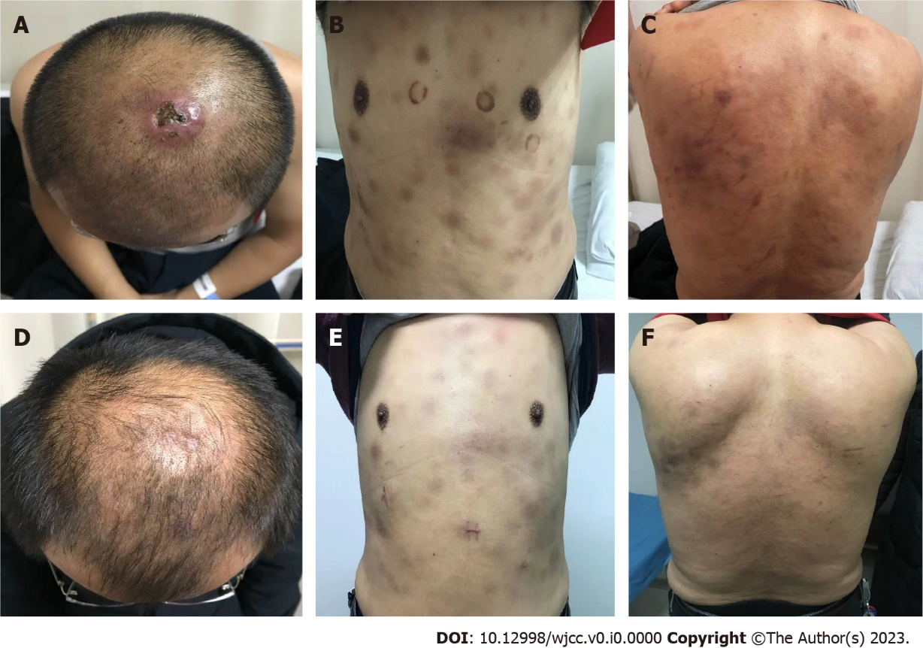
Figure 1 Skin lesion characteristics in patient with blastic plasmacytoid dendritic cell neoplasm. A: On admission for physical examination Breakdown of subcutaneous nodules on the head; B: Abdominal skin nodule; C: Skin nodules on back; D-F: In February 2021, skin healing was induced by idarubicin combined with cytarabine (IA) regimen combined with high-dose cytarabine regimen for a total of three cycles.
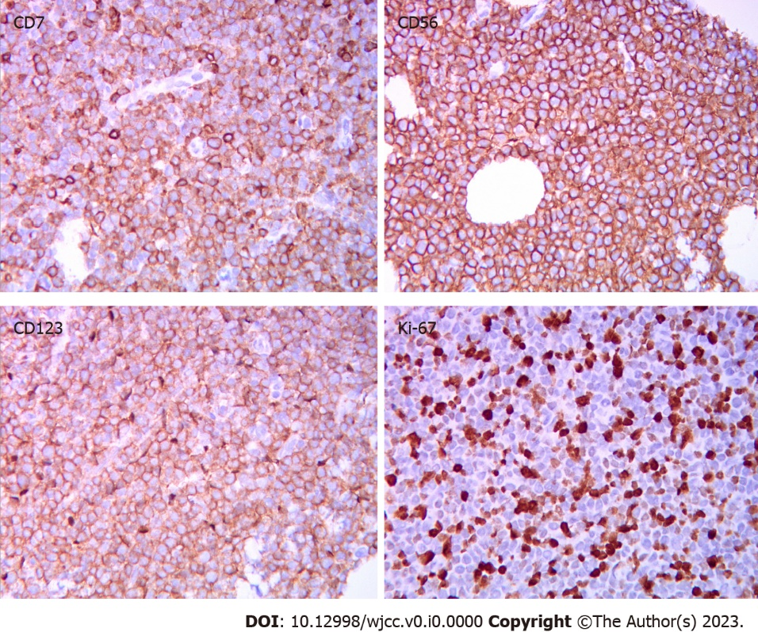
Figure 2 Abdominal skin tumor cells diffusely positive for CD7, CD56, CD23, Ki-67 (hematoxylin and eosin, 400 ×).

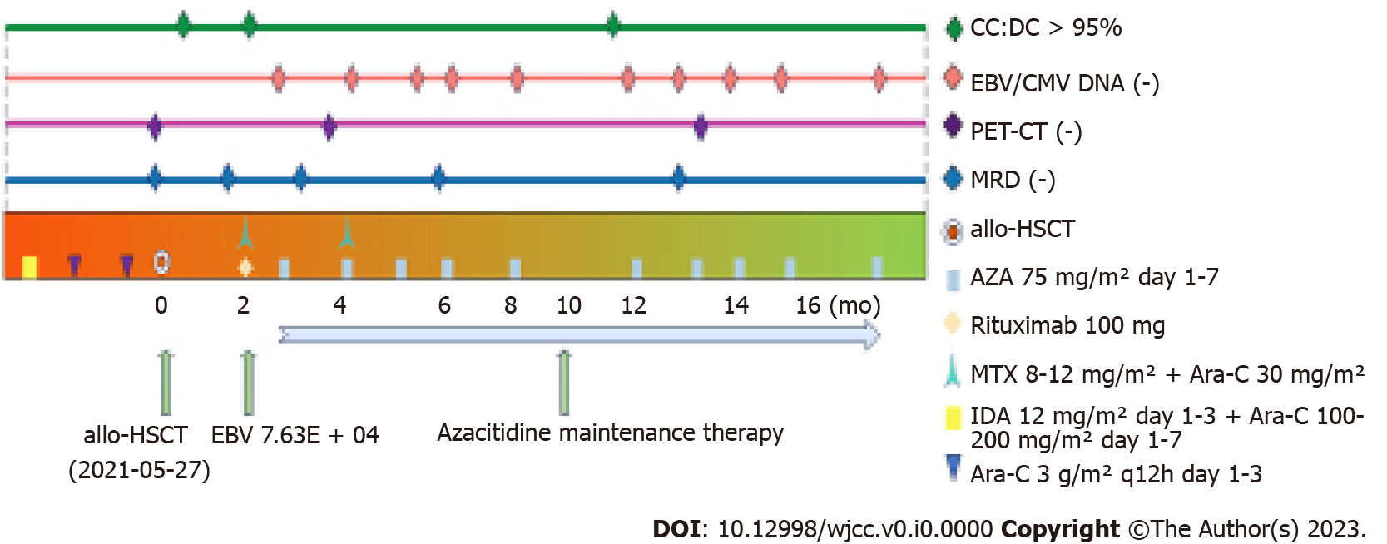
Figure 3 The treatment process and efficacy evaluation of patient with blastic plasmacytoid dendritic cell neoplasm. allo-HSCT: Allogeneic hematopoietic stem cell transplantation; AZA: Azacitidine; MTX: Methotrexate; IDA: Idarubicin; Ara-C: Cytarabine; CC: Complete donor chimerism; DC: Donor chimerism; MRD: Minimal residual disease; EBV: Epstein–Barr virus; CMV: Cytomegalovirus; PET-CT: Positron emission tomography–computed tomography.

