Name of Journal: World Journal of Orthopedics
Manuscript NO: 89159
Manuscript Type: ORIGINAL ARTICLE

Retrospective Study
Acetabular cup size trends in total hip arthroplasty

McKenna DP et al. Cup trends in hip arthroplasty

Daniel Patrick McKenna, Alex Price, Timothy McAleese, Darren Dahly, Paul McKenna, May Cleary

Daniel Patrick McKenna, Alex Price, Timothy McAleese, Paul McKenna, May Cleary, Department of Trauma and Orthopaedics, University Hospital Waterford, Waterford X91 ER8E, Ireland

Darren Dahly, Department of Epidemiology and Public Health, University College Cork, Cork T12 XF62, Ireland

Author contributions: All of the aforementioned authors contributed to this article; the study concept and design was devised by McKenna P and Cleary M; data collection was performed by McKenna DP and Price A; data analysis was completed by Dahly D; write up was completed by Mckenna DP with edits and proof reading provided by McAleese T, McKenna P and Cleary M.

Corresponding author: Daniel Patrick McKenna, MBChB, Surgeon, Department of Trauma and Orthopaedics, University Hospital Waterford, Dunmore Road, Waterford X91 ER8E, Ireland. danielmckenna21@rcsi.com

Received: October 22, 2023
Revised: December 4, 2023
Accepted: December 27, 2023
Published online: January 18, 2024

Abstract
BACKGROUND
Total hip arthroplasty (THA) is a common procedure for end stage osteoarthritis. The learning curve for THA is complex and challenging. One of the most difficult skills to master is acetabular reaming. We wish to identify if experience in arthroplasty leads to preservation of more bone stock.

AIM
To investigate if increasing surgeon experience will predict an ever decreasing acetabular cup size.

METHODS
A retrospective case series of four attending orthopaedic surgeons was completed. All uncemented elective total hip arthroplasties since appointment were selected for inclusion. The size of acetabular cup used was noted and logistic regression was used to identify if a trend to smaller cups existed.

RESULTS
A total of 1614 subjects were included with a mean age of 64 years. Overall cups were on average 0.18mm smaller per year (95% confidence interval -0.25 to -0.11, P < 0.001). Individual surgeon trends showed cup sizes to decrease 0.27 mm/year for surgeon A, 0.02 mm/year for surgeon B, 0.15 mm/year for surgeon C and 0.29 mm/year for surgeon D. Three of the four surgeons had a more pronounced trend to smaller cups for male subjects than their female counterparts.

CONCLUSION
We found increasing surgeon experience to be associated with an ever-decreasing acetabular cup size. Smaller acetabular cup size may act as a surrogate marker of surgical proficiency by virtue of decreased acetabular reaming.

Key Words: Hip; Arthroplasty; Acetabulum; Cup; Learning

©The Author(s) 2024. Published by Baishideng Publishing Group Inc. All rights reserved.

Citation: McKenna DP, Price A, McAleese T, Dahly D, McKenna P, Cleary M. Acetabular cup size trends in total hip arthroplasty. World J Orthop 2024; 15(1): 39-44
URL: https://www.wjgnet.com/2218-5836/full/v15/i1/39.htm
DOI: https://dx.doi.org/10.5312/wjo.v15.i1.39

Core Tip: The learning curve for total hip arthroplasty is complex and challenging. One of the most difficult skills to master is acetabular reaming. We hypothesise that with increasing surgeon experience there will be a trend to smaller acetabular cup sizes as a result of less acetabular reaming. A retrospective case series of four attending orthopaedic surgeons was completed. A total of 1,614 cups were analysed. Overall cups were on average 0.18mm smaller per year (95% confidence interval -0.25 to -0.11, P < 0.001). We found increasing surgeon experience to be associated with an ever decreasing acetabular cup size.

INTRODUCTION
The incidence of hip osteoarthritis and its associated morbidity is an ever increasing global health burden^{[1]}. Management can take numerous forms however total hip arthroplasty (THA) is oftentimes necessary^{[2]}. Competency in elective hip arthroplasty is a skill derived from both knowledge of the procedure and surgeon experience.
In this study we hypothesise that acetabular cup size decreases in accordance with increasing THA experience. We propose that familiarity with the procedure will result in preservation of bone stock through decreased acetabular reaming. This trend may act as a surrogate marker of surgical competency and understanding of the procedure.
This case series of consultant arthroplasty surgeons practicing in the Republic of Ireland compares the cup sizes used with increasing experience. Our question is, does consultant experience predict an ever-decreasing acetabular cup size?

MATERIALS AND METHODS
Four consultant arthroplasty surgeons were selected for this case series. The practices of each surgeon were analysed by the size of the acetabular cup components used in their elective THAs. Theatre log books were analysed and cross referenced with the Irish National Orthopaedic Register^{[3]}.
All primary elective uncemented THAs performed under each consultant since appointment were selected. Baseline demographics and implant sizes were recorded. The manufacturer and product details for each cup used were noted. Linear regression analysis was used to examine for a statistically significant trend towards smaller acetabular cup size.
For the purposes of analysis each surgeon served as their own control. We acknowledge that individual surgeons prefer different cup sizes. The average size of cup that each surgeon chose when relatively inexperienced was deemed to be their baseline preference. It was the trend with time, regardless of whether the surgeon prefers large or small cups at baseline, that was of primary interest.

RESULTS
Consultant experience ranged from four to ten years. Cumulatively this data provided analysis for 30 years of practice. In total 1614 cases were completed between February 2012 and September 2022. Subjects had an average age of 64 years and a male preponderance of 51%.
Firstly the overall trend for uncemented acetabular components used against time was analysed. Year on year there was a statistically significant trend towards decreasing cup size. Cups were on average 0.18mm smaller per year (95% confidence interval -0.25 to -0.11, P < 0.001).
Individual consultant practices were then examined. For each surgeon there was a negative trend in acetabular cup size. The trend for surgeon A was -0.27 mm/year, surgeon B was - 0.02 mm/year, surgeon C was -0.15 mm/year and surgeon D had the most pronounced trend at -0.29 mm/year. Scatter plots were used to depict the trends for male and female cup sizes in Figure 1 respectively.
Finally the effect of gender was analysed. We found that for three of the surgeons the trend in decreasing cup size was more pronounced for male subjects. Relative to females, the trend for smaller cups was 0.1 mm/year greater in male subjects for surgeon A, 1.19 mm/year for surgeon B and 1.64 mm/year for surgeon C. Surgeon D had the opposite trend with their female subjects having greater decrease in cup size compared to males at 0.53 mm/year.

DISCUSSION
Training in orthopaedic surgery and the learning curve associated with individual procedures are ever evolving. Despite the virtues of simulation, apprenticeship learning still forms the basis of training^{[4]}. However the definition of when a surgeon has become fully “trained” is not well-defined. Acetabular reaming is recognised as one of the most difficult skills in hip arthroplasty teaching^{[5]}. Our findings were in keeping with our hypothesis that increasing experience would confer decreasing cup sizes. This is despite all of the operating surgeons completing arthroplasty fellowships prior to appointment as a consultant.
There is a paucity of evidence examining the trend for acetabular cup sizing in THA vs clinician experience. To our knowledge this case series is the first to investigate this theory. However one of the related skillsets needed for hip arthroplasty is proficiency in templating. It has been suggested that proficiency in cup size templating occurs at between 50 and 100 cases^{[6]}. Given that templating is used to guide the ultimate acetabular component selected, one could expect the trend for cup size to remain static. Our findings identify that a trend towards smaller cup sizes exist, ever after performing more than 100 arthroplasties.
Interestingly 100 cases has been cited in other facets of hip arthroplasty as the critical volume needed to demonstrate competency. Recent interest in the direct anterior approach for hip arthroplasty has spawned a body of data examining the learning curve for this technique. A systematic review from Nairn et al^{[7]} found that surrogate markers for competency such as intraoperative time and complication rates appear to plateau once a caseload of 100 cases has been reached. Perhaps acetabular reaming is a more subtle marker of competency in senior surgeons that can be used to assess familiarity with the procedure.
During our analysis we noted the following two cups systems to be in use; Trident Acetabular System (Stryker, Michigan, United Sates) and Pinnacle Hip Solutions (De Puy Synthes, Massachusetts, United States). These components were used by all four surgeons. None of the practices examined exclusively used one acetabular cup for the duration of the study. Even with this heterogenicity we found a significant trend to smaller cup sizes. For surgeons who are still acquiring arthroplasty skills and techniques, it should be noted that these uncemented cups ideally transmit forces through the acetabulum in a similar topographical distribution to the native hip joint^{[8]}. Knowledge of these three load bearing surfaces should also for bone stock preservation and emphasises the need for intraoperative visual control.
The other finding of note from our study is that for three of the four consultant practices examined, the trend for decreasing cup size was more pronounced for male than female subjects. The size of reamer, depth of reaming and the angle subtended during the reaming process are all acknowledged to influence the volume of acetabular bone loss^{[9]}. The reason for the male subjects having a more pronounced trend to smaller cups can only be speculated at this stage. It may be due to subconscious biases such as conservative reaming in osteoporotic acetabula which tend to be female. Our findings could present a target for future training if male subjects are found to be at risk of excess reaming and unnecessary bone loss.
Another hypothesis as to why the trend was more pronounced for males is the biomechanical properties of the pelvis that allow for press fit cup designs. In vitro testing has demonstrated that stable cup fixation is best achieved by buttressing against the three bones that comprise the acetabulum^{[10]}. Female pelvises are known to be smaller and deeper than their male counterparts^{[11]}. Given that the peripheral acetabular bone stock is of critical importance to stability, we speculate that the more inexperienced surgeon may use larger cups for male subjects in an effort to ensure adequate fixation in their shallower acetabula.
The main strengths of this case series are the number of subjects and the expertise of the fellowship trained arthroplasty surgeons. To the authors’ knowledge it is the first descriptor of acetabular cup size trend vs surgeon experience. The main weaknesses are its inherently descriptive nature and the lack of an scientific explanation for the discrepancy in trends for male vs female subjects. We also acknowledge that a lack of data regarding the components used limits our results. Cup design is known to influence cup seating in THA^{[12]}. This may in turn influence the degree of reaming required for different components.
Further studies examining surgeons of varying experience may show a more pronounced learning curve from larger to smaller cup sizes. We expect the decrease in cup size to be more evident with increasing surgeon experience. This in turn could be a marker of proficiency when gauging the abilities of an arthroplasty surgeon in training.

CONCLUSION
In our case series of four consultant hip arthroplasty surgeons, acetabular implant sizes continue to trend smaller with increasing experience in clinical practice. Fellowship trained arthroplasty surgeons continue to develop component sizing preferences even after their formalised training and this may serve as a surrogate marker of familiarity with the procedure and proficiency.

ARTICLE HIGHLIGHTS
Research background
To the authors knowledge this is the first study examining total hip arthoplasty experience and the relationship with acetabular cup size. Other facets of arthroplasty learning are documented however the trend towards ever decreasing cup sizes has not been previously described in the literature.

Research motivation
The motivation for this study was derived from noting a trend towards smaller acetabular cup sizes by one of the arthroplasty surgeons in our institution. We wanted to investigate if this observation was in fact correct and if so identify the underlying reasons.

Research objectives
The main objective was to record acetabular cup size used against time. This was completed by means of chart review. Future research by means of a prospective trial would benefit from standardization in cup size used.

Research methods
The log books from our elective theaters were cross checked with the national hip database. Acetabular cup sizes used were recorded for each surgeon. Logistic regression was then used to assess the trend against time.

Research results
We found experience in hip arthroplasty predicts an ever-decreasing acetabular cup size. The main unresolved question is why does this trend exists? This retrospective study also highlights that the trend for males appears to be more pronounced. This finding was unexpected and again the exact reason for this can only be speculated at this stage.

Research conclusions
This study proposes that even despite being fully trained in hip arthroplasty, a trend exists to ever decreasing acetabular cup sizes for arthroplasty surgeons.

Research perspectives
Future research should be targeted at investigating if these smaller acetabular cups result in improved clinical outcomes and also at the underlying reasons for this trend.

REFERENCES
1 Fu M, Zhou H, Li Y, Jin H, Liu X. Global, regional, and national burdens of hip osteoarthritis from 1990 to 2019: estimates from the 2019 Global Burden of Disease Study. Arthritis Res Ther 2022; 24: 8 [PMID: 34980239 DOI: 10.1186/s13075-021-02705-6]
2 British Hip Society (BSH), British Orthopaedic Association (BOA), Royal College of Surgeons of England (RCSEng). Commissioning Guide: Pain Arising from the Hip In Adults. London: British Orthopaedic Association, 2017
3 National Office of Clinical Audit. Irish National Orthopaedic Register. National Office of Clinical Audit. [cited 8 August 2023]. Available from: https://www.noca.ie/audits/irish-national-orthopaedic-register
4 De Boey S, Maes M, Mertens P. Teaching hip surgery to orthopaedic residents: what’s new? Hip Int 2020; 30: 42-47 [PMID: 32907428 DOI: 10.1177/1120700020916451]
5 Howgate D, Garfjeld Roberts P, Kendrick B, Rees J. Key performance and training parameters in primary total hip arthroplasty - an expert consensus using the Delphi technique. Hip Int 2023; 33: 411-419 [PMID: 34748447 DOI: 10.1177/11207000211056864]
6 Waldstein W, Bouché PA, Pottmann C, Faschingbauer M, Aldinger PR, Windhager R, Merle C. Quantitative and individualized assessment of the learning curve in preoperative planning of the acetabular cup size in primary total hip arthroplasty. Arch Orthop Trauma Surg 2021; 141: 1601-1608 [PMID: 33709204 DOI: 10.1007/s00402-021-03848-6]
7 Nairn L, Gyemi L, Gouveia K, Ekhtiari S, Khanna V. The learning curve for the direct anterior total hip arthroplasty: a systematic review. Int Orthop 2021; 45: 1971-1982 [PMID: 33629172 DOI: 10.1007/s00264-021-04986-7]
8 Widmer KH, Zurfluh B, Morscher EW. Contact surface and pressure load at implant-bone interface in press-fit cups compared to natural hip joints. Orthopade 1997; 26: 181-189 [PMID: 9157358 DOI: 10.1007/s001320050084]
9 Lavigne M, Rama RK, Ganapathi M, Nuño N, Winzenrieth R, Vendittoli PA. Factors affecting acetabular bone loss during primary hip arthroplasty--a quantitative analysis using computer simulation. Clin Biomech (Bristol, Avon) 2008; 23: 577-583 [PMID: 18295383 DOI: 10.1016/j.clinbiomech.2008.01.007]
10 Widmer KH, Zurfluh B, Morscher EW. Load transfer and fixation mode of press-fit acetabular sockets. J Arthroplasty 2002; 17: 926-935 [PMID: 12375254 DOI: 10.1054/arth.2002.34526]
11 Wang SC, Brede C, Lange D, Poster CS, Lange AW, Kohoyda-Inglis C, Sochor MR, Ipaktchi K, Rowe SA, Patel S, Garton HJ. Gender differences in hip anatomy: possible implications for injury tolerance in frontal collisions. Annu Proc Assoc Adv Automot Med 2004; 48: 287-301 [PMID: 15319131]
12 Ruhr M, Baetz J, Pueschel K, Morlock MM. Influence of acetabular cup thickness on seating and primary stability in total hip arthroplasty. J Orthop Res 2022; 40: 2139-2146 [PMID: 34855229 DOI: 10.1002/jor.25232]

Footnotes
Institutional review board statement: This study was classified as a service evaluation. In keeping with local guidelines and practice it did not require formal institutional board review.

Informed consent statement: Consent was not sought from subjects given its anonymised and retrospective nature.

Conflict-of-interest statement: The authors have no conflicts of interest to declare.

Data sharing statement: The dataset and statistical analysis information can be made available by the corresponding author upon request to danielmckenna21@rcsi.com. Consent was not sought from subjects given its anonymised and retrospective nature.

Open-Access: This article is an open-access article that was selected by an in-house editor and fully peer-reviewed by external reviewers. It is distributed in accordance with the Creative Commons Attribution NonCommercial (CC BY-NC 4.0) license, which permits others to distribute, remix, adapt, build upon this work non-commercially, and license their derivative works on different terms, provided the original work is properly cited and the use is non-commercial. See: https://creativecommons.org/Licenses/by-nc/4.0/

Provenance and peer review: Unsolicited article; Externally peer reviewed.

Peer-review model: Single blind

Peer-review started: October 22, 2023
First decision: November 29, 2023
Article in press: December 27, 2023

Specialty type: Orthopedics
Country/Territory of origin: Ireland
Peer-review report’s scientific quality classification
Grade A (Excellent): 0
Grade B (Very good): B
Grade C (Good): C
Grade D (Fair): 0
Grade E (Poor): 0

P-Reviewer: Widmer KH, Switzerland; Yan ZQ, China S-Editor: Lin C L-Editor: A P-Editor: Yuan YY

Figure Legends
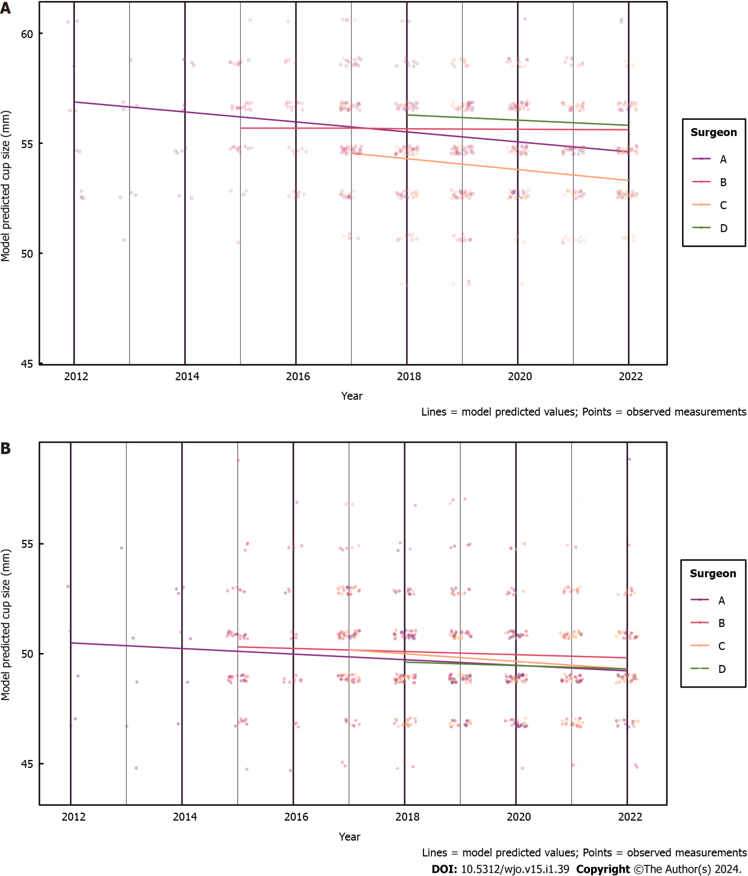
Figure 1 Cup size trends. A: Male; B: Female.

Published by Baishideng Publishing Group Inc
7041 Koll Center Parkway, Suite 160, Pleasanton, CA 94566, USA
Telephone: +1-925-3991568
E-mail: office@baishideng.com
Help Desk: https://www.f6publishing.com/helpdesk
https://www.wjgnet.com

© 2024 Baishideng Publishing Group Inc. All rights reserved.

