Name of Journal: World Journal of Gastroenterology
ESPS Manuscript NO: 22199
Manuscript Type: CASE REPORT

Implantation of esophageal cancer onto post-dissection ulcer after gastric endoscopic submucosal dissection

Asai S et al. Cancer implantation to post-dissection ulcer

Satoshi Asai, Koutarou Takeshita, Yuki Kanou, Eisuke Nakao, Kirie Hashimoto, Takumi Ichinona, Naoki Fujimoto, Eisuke Akamine, Takuji Mori, Atsuhiro Ogawa

Satoshi Asai, Koutarou Takeshita, Yuki Kanou, Eisuke Nakao, Kirie Hashimoto, Takumi Ichinona, Naoki Fujimoto, Eisuke Akamine, Takuji Mori, Atsuhiro Ogawa, Department of Gastroenterology, Tane General Hospital, Nishi-ku, Osaka 550-0025, Japan

Author contributions: Asai S drafed of the article; Takeshita K, Kanou Y were involved in charge of this patient; Nakao E make figures; Hashimoto K, Ichinona T, and Fujimoto N performed follow-up examination; Akamine E performed ESD for this patient; Mori T made critical revision of the article for important intellectual content; Ogawa A concepted and designed, critical revised the article for important intellectual content, final approval of the article.

Institutional review board statement: The study was reviewed and approved by the Tane General Hospital Institutional Review Board.

Informed consent statement: A study participant provided informed written consent prior to study enrollment.

Conflict-of-interest statement: Authors declare no conflict of interest for this article.

Open-Access: This article is an open-access article which was selected by an in-house editor and fully peer-reviewed by external reviewers. It is distributed in accordance with the Creative Commons Attribution Non Commercial (CC BY-NC 4.0) license, which permits others to distribute, remix, adapt, build upon this work non-commercially, and license their derivative works on different terms, provided the original work is properly cited and the use is non-commercial. See: http://creativecommons.org/licenses/by-nc/4.0/

Correspondence to: Satoshi Asai, MD, Assistant Director of Endoscopy Center, Department of Gastroenterology, Tane General Hospital, 1-12-21 Kujouminami, Nishi-ku, Osaka 550-0025, Japan. bonyaritetsu1226@hotmail.co.jp
Telephone: +81-6-65811071
Fax: +81-6-65812520

Received: August 19, 2015
Peer-review started: August 21, 2015
First decision: September 9, 2015
Revised: October 13, 2015
Accepted: December 8, 2015
Article in press:
Published online:

Abstract
A case in which implantation of esophageal squamous cell carcinoma onto a post-dissection gastric ulcer was strongly suspected is presented. A 72-year-old man with alcoholic liver cirrhosis underwent esophagogastroduodenoscopy (EGD). Esophageal cancer (EC) (Mt, 20 mm, 0-Is) and gastric cancer (GC) (antrum, 15 mm, 0-IIc) were identified. Biopsy specimens revealed moderately differentiated squamous cell carcinoma (SCC) and differentiated adenocarcinoma, respectively. The GC was resected by endoscopic submucosal dissection (ESD) [14 × 9 mm, type 0-IIc, tub1, pT1a(M), ly0, v0, HM(-), VM(-)]. Two months after ESD, radiation therapy was started for the EC, and an almost complete response was obtained. Nine months after the ESD, a follow-up EGD showed a submucosal tumor-like lesion with ulceration, located immediately under the post-ESD scar, and biopsy specimens showed moderately differentiated SCC. There were no similar lesions suggesting hematogenous or lymphatic metastasis in the stomach.

Key words: Implantation; Esophageal cancer; Gastric cancer; Endoscopic submucosal dissection; Post-dissection ulcer

© The Author(s) 2015. Published by Baishideng Publishing Group Inc. All rights reserved.

Core tip: A 72-year-old-man had gastric adenocarcinoma and esophageal squamous cell carcinoma (SCC); the gastric cancer was resected by endoscopic submucosal dissection (ESD), and the esophageal cancer was treated by radiation therapy two months after the ESD. The post ESD scar was found to be elevated and ulcerated during follow-up examination nine months after ESD, and the biopsy specimens showed SCC. It was strongly suspected that the lesion was the result of implantation of esophageal cancer onto the post-ESD ulcer, because the tumor was located immediately under the scar, and there were no similar lesions suggesting hematogenous or lymphatic metastasis.

Asai S, Takeshita K, Kanou Y, Nakao E, Hashimoto K, Ichinona T, Fujimoto N, Akamine E, Mori T, Ogawa A. Implantation of esophageal cancer onto post-dissection ulcer after gastric endoscopic submucosal dissection. World J Gastroenterol 2015; In press
INTRODUCTION
Implantation of cancer cells onto the ulcer after endoscopic submucosal dissection (ESD) is extremely rare, although implantation onto the site of a stapled anastomosis after colectomy or implantation of pharyngoesophageal malignancy onto a percutaneous endoscopic gastrostomy (PEG) site is a well-known phenomenon. There is a reported case of local recurrence thought to be from implantation of tumor cells after rectal ESD[], and there is also a report of implantation after endoscopic mucosal resection in a patient with rectosigmoid cancer[]. However, to the best of our knowledge, implantation of cancer cells from a malignancy of another organ to the ulcer after ESD has never been reported. Thus, a case in which implantation of esophageal squamous carcinoma onto post-dissection gastric ulcer was strongly suspected is reported.

CASE REPORT
A 72-year-old man with alcoholic liver cirrhosis underwent esophagogastroduodenoscopy (EGD). Risky esophageal varices (EV), esophageal cancer (EC) (Mt, left, 20 mm, 0-Is, depth of SM2), and gastric cancer (GC) (L, post, 15 mm, 0-IIc, depth of M) were identified. Biopsy specimens revealed moderately differentiated squamous cell carcinoma (SCC) and differentiated adenocarcinoma, respectively (Figure 1).
Considering his comorbidity and general condition, the treatment strategy shown in Figure 2 was planned. Repeated biweekly endoscopic variceal ligation therapy (EVL) was performed until the EV disappeared before radiation therapy for the EC. In addition, the GC was resected by ESD during the same period of time. The operation time was 63 min, and the resected specimen was 22 mm in diameter. No complications occurred. On histology, the lesion was 14 × 9 mm, type 0-IIc, tub1, pT1a(M), UL(-), ly0, v0, HM(-), VM(-) (Figure 3).
Two months after ESD, when the post-ESD ulcer was healed (Figure 3E) and the EV had disappeared, radiation therapy (RT) was started for the EC at 60 Gy/6 wk, and an almost complete response was obtained at the end of the RT.
A follow-up EGD 7 mo after the ESD showed a slight elevation on the post ESD scar (Figure 4A), but biopsy specimens did not show any malignancy. Two more months later, EGD showed a submucosal tumor-like lesion with ulceration, 15 mm in size, located immediately under the post-ESD scar, and there were no other similar elevated lesions in the stomach. Magnifying endoscopy with narrow band imaging showed that the base of the elevation was covered with normal mucosa. Endoscopic ultrasonography (EUS) findings indicated that the tumor mainly involved the submucosal layer. The tumor was also recognized as a well-demarcated, early enhanced mass on CT. At that time, some swollen lymph nodes were observed around the esophagus, but no hematogenous metastases, such as lung or liver metastases, were detected. Biopsy specimens from the edge of the ulcer on the top of the elevated lesion revealed moderately differentiated SCC, which closely resembled the EC (Figure 4B-G).
It was strongly suspected that the lesion was implantation of EC onto the post-ESD ulcer after ESD for GC because the tumor was located immediately under the scar, and there were no similar lesions suggesting hematogenous metastasis. Because local recurrence of the esophageal cancer was also found by follow-up EGD at that time, the patient was managed with best supportive care. The tumor seemed to be Borrmann type 2, and there were no other lesions suggesting intramural metastases in the stomach a year after the ESD (Figure 5).

DISCUSSION
In the current case, the post ESD scar at the gastric antrum was found to be elevated and ulcerated during follow-up examination after ESD for gastric adenocarcinoma, and the biopsy specimen from that lesion revealed SCC. Although direct implantation, hematogenous metastasis, intramural metastasis (lymphatic dissemination), and primary gastric SCC were considered potential causes, implantation was thought to be the most likely because the solitary SCC grew directly under the post ESD scar in the antrum. Hematogenous metastasis to the stomach usually presents with multiple lesions in the gastric wall. In the literature[,], intramural metastasis to the stomach is predominantly located in the upper portion of the stomach. The possibility that primary gastric squamous cell carcinoma, which is quite a rare histological type, arose immediately under the post ESD scar was thought to be extremely low. Furthermore, the histological examination revealed that the tissue taken from the gastric lesion resembled that from the esophageal cancer. A review of 44 cases of stomal metastases after PEG from pharyngoesophageal malignancy concluded that the risk factors, such as the higher risk of stomal metastases with endoscopic rather than surgical gastrostomy, are more consistent with direct implantation of cancerous cells at the stoma than with hematogenous or lymphatic dissemination at a wound site^{[5]}. All these previous reports strongly support the implantation hypothesis.
As the mechanism of implantation in the current case, it is possible that a relatively large amount of cancer cells were exfoliated by continuous physical contact of the scope against the EC during gastric ESD, which took one hour and reached the post-dissection ulcer, which was regarded as freshly cut tissue. It has also been reported that colorectal cancer cells could exfoliate into the intestinal lumen due to intraoperative manipulation, and such cells have high viability[]. There is another possibility that implantation occurred at a later date following ulcer healing after ESD, for example, by EVL or food intake. Since this case required EVL and APC procedures after ESD that would be unusual in regular cases, these frequent endoscopic approaches to the esophagus may have been associated with implantation of esophageal cancer. In fact, the EVL procedures were carried out twice, followed by one APC procedure after ESD. Although the tip of the inserted flexible over tube used for the EVL procedure was far from the esophageal cancer, because it was shorter than the length from his mouth to the esophageal cancer, these frequent approaches might have caused the cancer cells to exfoliate to a certain degree. However, at the time of the procedures, the post-dissection ulcer bed was completely covered by a white coat, and freshly cut tissue was not exposed. It was assumed that implantation was not able to occur in such a situation even if many cancer cells were exfoliated.
We have to carefully develop treatment strategies for patients with double cancers, keeping in mind that implantation can occur after ESD. The present patient could not undergo surgery for EC because of his comorbidities. However, if the case were operable, esophagectomy and reconstruction by gastric tube following gastric ESD would result in SCC recurrence under the post ESD scar in the gastric tube, and he would have to undergo reoperation. On the other hand, esophagectomy prior to the treatment of gastric cancer leaves some risks. For example, there is a risk that gastric cancer may involve the suture line of the gastric tube. Even if the patient could avoid the situation above, we need to perform the technically demanding ESD in the gastric tube after esophagectomy. Moreover, we have to consider additional surgical operations in the case of GC, which is a proven contraindication after ESD.
There are some ways to reduce the risk of implantation after ESD. First, it is important to prevent exfoliation of cancer cells as much as possible. Specifically, in addition to gentle manipulation of both lesions, application of an over tube designed for double balloon endoscopy for covering another lesion may be useful. Second, washing out the post-dissected ulcer and surrounding area to remove exfoliated cancer cells may be effective, though there is no evidence for this in the field of endoscopy. It has been reported that intraluminal lavage can help prevent tumor cell implantation to the anastomotic site after rectal cancer surgery[]. Third, closure of the post ESD ulcer by endoscopic clipping could be beneficial when another lesion exists on the oral side of the lesion to be resected by ESD, as in the present case, because implantation might occur at a later date following ulcer healing after ESD.
This was the first report of a case of implantation of esophageal SCC onto a post-dissection ulcer after ESD for early gastric adenocarcinoma. We should keep this fact in mind and develop treatment strategies for patients with double cancers carefully.

COMMENTS
Case characteristics
A follow-up esophagogastroduodenoscopy (EGD) for a 72-year-old man after the gastric endoscopic submucosal dissection (ESD) followed by radiation therapy against the esophageal squamous cell carcinoma (SCC) showed a submucosal tumor-like lesion immediately under the post-ESD scar.

Clinical diagnosis
It was strongly suspected that the lesion was implantation of esophageal SCC on to the post-ESD ulcer because biopsy specimen taken form the lesion revealed SCC.

Differential diagnosis
Hematogenous or lymphatic metastasis from the esophageal cancer was taken into consideration.
Imaging diagnosis
It was strongly suspected on EGD that the lesion was the result of implantation of esophageal cancer onto the post-ESD ulcer, because the tumor was located immediately under the scar, and there were no similar lesions suggesting hematogenous or lymphatic metastasis.

Pathological diagnosis
Biopsy specimens from the edge of the ulcer on the top of the elevated lesion revealed moderately differentiated SCC, which closely resembled the esophageal cancer.

Treatment
Best supportive care only.

Related reports
There is a reported case of local recurrence thought to be from implantation of tumor cells after rectal ESD, and there is also a report of implantation after endoscopic mucosal resection in a patient with rectosigmoid cancer.

Experiences and lessons
A case of implantation of esophageal cancer to gastric ulcer after ESD is extremely rare. However this possibility should be kept in mind and strategies to manage patients with double cancers should be developed carefully.

Peer-review
In this report, implantation of esophageal cancer cells is strongly suspected through the clinical course and endoscopic findings. From this point of view, the discussion paragraph is well structured and includes useful information for readers. This case report could be helpful for readers to treat double cancers of gastrointestinal tract.

REFERENCES
1 Inoue T, Fujii H, Koyama F, Nakagawa T, Uchimoto K, Nakamura S, Ueda T, Nishigori N, Kawasaki K, Obara S, Nakamoto T, Nakajima Y. Local recurrence after rectal endoscopic submucosal dissection: a case of tumor cell implantation. Clin J Gastroenterol 2014; 7: 36-40 [PMID: 24523830 DOI: 10.1007/s12328-013-0445-3]
2 Tajika M, Niwa Y, Bhatia V, Kondo S, Tanaka T, Mizuno N, Hara K, Hijioka S, Haba S, Ogura T, Hirai T, Yamao K, Yatabe Y. A first report of tumor cell implantation after EMR in a patient with rectosigmoid cancer. Gastrointest Endosc 2012; 75: 1117-1118 [PMID: 21762905 DOI: 10.1016/j.gie.2011.05.028]
3 Ebihara Y, Hosokawa M, Kondo S, Katoh H. Thirteen cases with intramural metastasis to the stomach in 1259 patients with oesophageal squamous cell carcinoma. Eur J Cardiothorac Surg 2004; 26: 1223-1225 [PMID: 15541989]
4 Saito T, Iizuka T, Kato H, Watanabe H. Esophageal carcinoma metastatic to the stomach. A clinicopathologic study of 35 cases. Cancer 1985; 56: 2235-2241 [PMID: 4052968]
5 Cappell MS. Risk factors and risk reduction of malignant seeding of the percutaneous endoscopic gastrostomy track from pharyngoesophageal malignancy: a review of all 44 known reported cases. Am J Gastroenterol 2007; 102: 1307-1311 [PMID: 17488255]
6 Umpleby HC, Fermor B, Symes MO, Williamson RC. Viability of exfoliated colorectal carcinoma cells. Br J Surg 1984; 71: 659-663 [PMID: 6478151]
7 Matsuda A, Kishi T, Musso G, Matsutani T, Yokoi K, Wang P, Uchida E. The effect of intraoperative rectal washout on local recurrence after rectal cancer surgery: a meta-analysis. Ann Surg Oncol 2013; 20: 856-863 [PMID: 22987097 DOI: 10.1245/s10434-012-2660-4]
P-Reviewer: Hironaka S, Tohda G, Tsuji Y S-Editor: Yu J L-Editor: E-Editor:

A
B
C

D
Figure 1 Esophagogastroduodenoscopy findings. A: An elevated lesion 20 mm in size was detected in the left wall of the middle thoracic esophagus. The endoscopic findings indicated that the lesion was esophageal cancer with a depth of SM2; B, C: Biopsy specimens revealed moderately differentiated squamous cell carcinoma (hematoxylin-eosin stain; magnification: B × 40, C × 200); D: A small erosion with surrounding reddish mucosa was also found in the posterior wall of the gastric antrum, which was suspected to be gastric mucosal cancer.

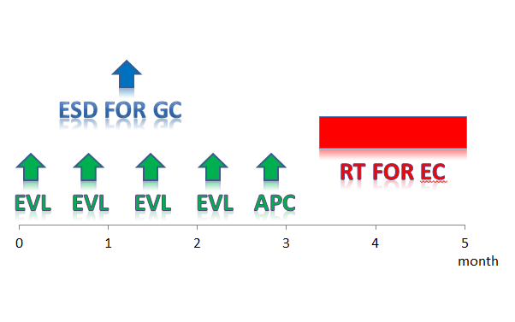
Figure 2 Treatment strategy. Repeated biweekly endoscopic variceal ligation therapy was performed in advance before radiation therapy for the esophageal cancer. The gastric cancer was resected by endoscopic submucosal dissection during the same period of time.

A
B
C
D
E
Figure 3 Gastric endoscopic submucosal dissection. A, B: Successful complete en bloc resection by endoscopic submucosal dissection (ESD) was performed. The operation time was 63 min, and the resected specimen was 22 mm in diameter; C, D: On histology, the lesion was differentiated type mucosal cancer 14 mm in size, and completely resected (magnification: C × 40, D × 200); E: Two months after ESD, the post ESD ulcer was healed and became a red scar.

A
B
C
D
E
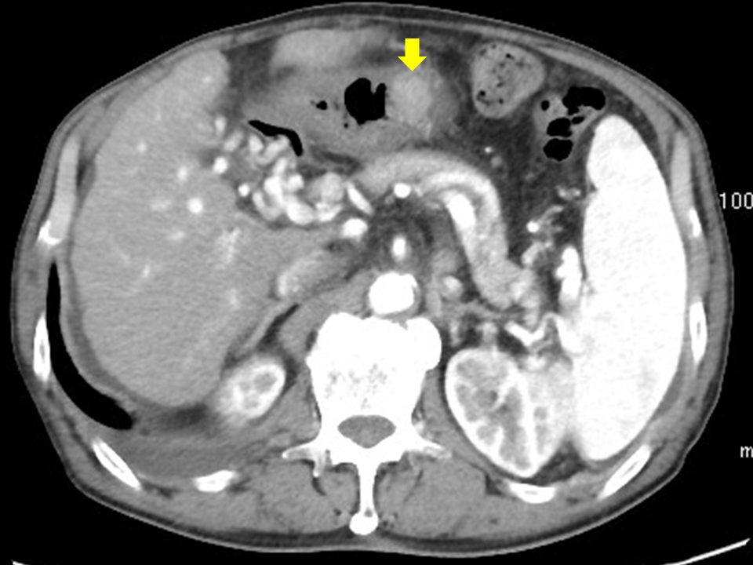
F
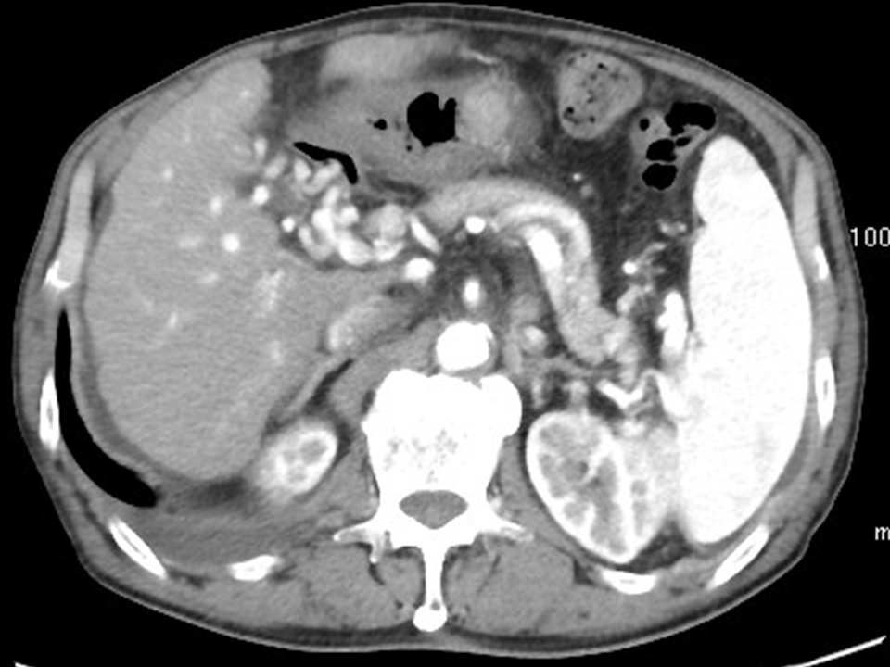
G
Figure 4 Follow-up esophagogastroduodenoscopy after endoscopic submucosal dissection. A: A follow-up esophagogastroduodenoscopy (EGD) 7 mo after endoscopic submucosal dissection (ESD) showed a slight elevation on the post ESD scar, but biopsy specimens did not show any malignancy; B: Two more months later, EGD showed a submucosal tumor-like lesion with ulceration 15 mm in size, located right under the post ESD scar; C: Magnifying endoscopy with narrow band imaging showed that the base of the elevation was covered with normal mucosa; D: EUS findings indicated that the tumor mainly involved the submucosal layer; E: The tumor was also recognized as well-demarcated, early enhanced mass on CT; F, G: Biopsy specimens from the edge of the ulcer on the top of the elevated lesion revealed moderately differentiated SCC, which resembled the EC (magnification: F × 40, G × 200)
Figure 5 The tumor seemed to be Borrmann type 2 a year after the endoscopic submucosal dissection.

