Name of Journal: World Journal of Clinical Cases
Manuscript NO: 68720
Manuscript Type: ORIGINAL ARTICLE

Retrospective Study
Retrospective analysis of surgically treated pT4b gastric cancer with pancreatic head invasion

Jin P et al. Surgical treatment for pT4b gastric cancer

Peng Jin, Hao Liu, Fu-Hai Ma, Shuai Ma, Yang Li, Jian-Ping Xiong, Wen-Zhe Kang, Hai-Tao Hu, Yan-Tao Tian

Peng Jin, Hao Liu, Fu-Hai Ma, Shuai Ma, Yang Li, Jian-Ping Xiong, Wen-Zhe Kang, Hai-Tao Hu, Yan-Tao Tian, Department of Pancreatic and Gastric Surgery, National Cancer Center/National Clinical Research Center for Cancer/Cancer Hospital, Chinese Academy of Medical Sciences and Peking Union Medical College, Beijing 100021, China

Author contributions: Jin P and Liu H were involved in study conception, data analysis and interpretation, production of tables and figures, writing the first draft, and revising it critically in light of comments from other authors and reviewers; Ma FH was involved in production of high-resolution figures and manuscript revision; Tian YT was involved in study conception and design, data interpretation, manuscript revision, and discussion; Li Y, Kang WZ and Ma S were involved in data acquisition and literature review; Hu HT and Xiong JP were involved in the manuscript revision and discussion.

Supported by National Natural Science Foundation of China, No. 81772642 and No. 82072734.

Corresponding author: Yan-Tao Tian, MD, Professor, Department of Pancreatic and Gastric Surgery, National Cancer Center/National Clinical Research Center for Cancer/Cancer Hospital, Chinese Academy of Medical Sciences and Peking Union Medical College, No. 17 Panjiayuan Nanli, Chaoyang District, Beijing 100021, China. tianyantao@cicams.ac.cn

Received: June 2, 2021
Revised: July 3, 2021
Accepted: August 5, 2021
Published online:

ABSTRACT
BACKGROUND
For advanced gastric cancer patients with pancreatic head invasion, some studies have suggested that extended multiorgan resections (EMR) improves survival. However, other reports have shown high rates of morbidity and mortality after EMR. EMR for T4b gastric cancer remains controversial.

AIM
To evaluate the surgical approach for pT4b gastric cancer with pancreatic head invasion.

METHODS
A total of 143 consecutive patients with gastric cancer with pancreatic head invasion were surgically treated between 2006 and 2016 at the China National Cancer Center. Gastric cancer was confirmed in 76 patients by postoperative pathology and retrospectively analyzed. The patients were divided into the gastrectomy plus en bloc pancreaticoduodenectomy group (GP group) and gastrectomy alone group (GA group) by comparing the clinicopathological features, surgical outcomes, and prognostic factors of these patients.

RESULTS
There were 24 patients (16.8%) in the GP group who had significantly larger lesions (P < 0.001), a higher incidence of advanced N stage (P = 0.030), and less neoadjuvant chemotherapy (P < 0.001) than the GA group had. Postoperative morbidity (33.3% vs 15.3%, P = 0.128) and mortality (4.2% vs 4.8%, P = 1.000) were not significantly different in the GP and GA groups. The overall 3-year survival rate of the patients in the GP group was significantly longer than that in the GA group (47.6%, median 30.3 mo vs 20.4%, median 22.8 mo, P = 0.010). Multivariate analysis identified neoadjuvant chemotherapy [hazard ratio (HR) 0.290, 95% confidence interval (CI): 0.103–0.821, P = 0.020], linitis plastic (HR 2.614, 95% CI: 1.024–6.675, P = 0.033), surgical margin (HR 0.274, 95% CI: 0.102–0.738, P = 0.010), N stage (HR 3.489, 95% CI: 1.334–9.120, P = 0.011), and postoperative chemoradiotherapy (HR 0.369, 95% CI: 0.163–0.836, P = 0.017) as independent predictors of survival in patients with pT4b gastric cancer and pancreatic head invasion.

CONCLUSION
Curative resection of the invaded pancreas should be performed to improve survival in selected patients. Invasion of the pancreatic head is not a contraindication for surgery.

Key words: Gastric cancer; T4; R0 resection; Prognostic factors; Extended multiorgan resection; Pancreatectomy

Jin P, Liu H, Ma FH, Ma S, Li Y, Xiong JP, Kang WZ, Hu HT, Tian YT. Retrospective analysis of surgically treated pT4b gastric cancer with pancreatic head invasion. World J Clin Cases 2021; In press

Core tip: This was a retrospective study to evaluate the surgical approach for pT4b gastric cancer with pancreatic head invasion. The overall 3-year survival rate of the patients in the gastrectomy plus en bloc pancreaticoduodenectomy group was significantly longer than that in the gastrectomy alone group. Curative resection of the invaded pancreas should be performed to improve survival after balancing the risk and survival benefit.

INTRODUCTION
Gastric cancer is the fifth most common cancer worldwide and the third leading cause of cancer-related mortality^{[1]}. Advanced disease at presentation accounts for 39%–44% of newly diagnosed gastric cancer cases^{[2]}. Despite improvements in early diagnosis and neoadjuvant or adjuvant chemotherapy, radical surgery is still the conventional curative treatment for gastric cancer. In patients with advanced gastric cancer, extended multiorgan resection (EMR) may be needed to achieve R0 resection. Some studies have suggested that EMR improves the survival rate of T4b patients^{[3-5]}. However, other studies have shown high rates of morbidity and mortality after EMR^{[6]}. Therefore, EMR for T4b gastric cancer remains controversial.
In advanced gastric cancer, the pancreas is the most frequently invaded organ. Min et al^{[7]} reported that patients with pancreatic invasion had worse survival when they underwent pancreaticoduodenectomy. Postoperative pancreatic fistula is the most frequently reported complication after combined surgery. The performance of additional partial pancreatectomy and splenectomy to facilitate D2 lymphadenectomy was abandoned. This is because it increased the postoperative morbidity significantly without positive overall survival benefits^{[8,9]}. The benefits of en bloc partial pancreatectomy for advanced gastric cancer with pancreatic invasion should be critically evaluated, given its potential of increased morbidity. However, only a few reports evaluating partial or total pancreatectomy for these patients have been published^{[5,10-13]}. The aim of this study was to investigate the clinicopathological features, surgical outcomes, and prognostic factors of these patients.

MATERIALS AND METHODS
Patients
A total of 143 consecutive gastric cancer with pancreatic head invasion were surgically treated from January 2006 to December 2016 at our hospital. Of these patients, 76 who underwent surgery [gastrectomy combined with pancreatectomy (GP) or gastrectomy alone (GA)] with pancreatic invasion confirmed by postoperative pathology were enrolled. The remaining 67 patients underwent palliative bypass or exploratory surgery. The study group consisted of 65 men (85.5%) and 11 women (14.5%) aged 28–74 years (mean 56.0 ± 10.7 years). The inclusion criteria were: (1) gastric cancer patients diagnosed with pancreatic head invasion who underwent curative gastrectomy combined with GP or GA; (2) patients without distant metastasis or other malignancies; and (3) patients with complete clinicopathological and follow-up records. The exclusion criteria were: (1) patients who underwent palliative gastrojejunostomy or exploratory surgery; (2) patients who presented with pancreatic metastasis after radical gastrectomy; and (3) patients with pancreatic body or tail invasion (Figure 1). T4 gastric cancer is defined according to the American Joint Committee on Cancer (AJCC) tumor node metastasis (TNM) system. Our study was performed in accordance with the Declaration of Helsinki, which was approved by the Institutional Review Board of our hospital (No. 14-067/857).

Surgical procedures
In cases where pancreatic invasion was considered during surgery, the curative-intent GP procedures were performed with en bloc gastrectomy combined with pancreaticoduodenectomy and D2 or D2+ lymphadenectomy. In contrast, en-bloc gastrectomy with D2 or D2+ lymphadenectomy without pancreatectomy (GA) was performed when the surgeon considered macroscopically inflammatory reactions, but postoperative pathology confirmed pancreatic invasion.

Clinicopathological features and surgical outcomes
Clinicopathological variables included: age, gender, body mass index (BMI), preoperative albumin, preoperative hemoglobin, neoadjuvant chemotherapy, postoperative treatment, tumor size, Borrmann type, histological type, lymphovascular invasion, perineural invasion, surgical margin (R0 or R1), and pathological stage (T, N or M). Surgical outcomes included the type of surgery, operation time, blood loss, postoperative hospital stay, morbidity, mortality, and overall survival rates. Postoperative morbidity and mortality were graded with a modified Clavien–Dindo classification. Postoperative mortality was defined as death within 30 d after surgery. The TNM stage was evaluated according to the 8th TNM AJCC/Union for International Cancer Control guidelines. The presence or absence of gross residual disease was classified as negative resection margin (R0), microscopic tumor infiltration (R1), and macroscopic residual tumor (R2).

Adjuvant therapy
Perioperative neoadjuvant or adjuvant chemotherapy (AC) after surgery was mainly based on fluorouracil in combination with platinum chemotherapy. The regimens were based on widely accepted studies^{[14,15]}. Fifty-four patients who underwent neoadjuvant chemotherapy (NAC) and 43 patients who underwent AC were included: 20 received S-1 plus oxaliplatin; 15 docetaxel, oxaliplatin and S-1; and eight capecitabine plus oxaliplatin. The median number of courses of AC was six (5–8), while that of NAC was three (2–4). A total of 33 patients received postoperative concurrent chemoradiotherapy, the dose of which was the same as that used in a previous study^{[16]}. In case of recurrence, patients were advised to consult an oncologist to adjust the treatment plan.

Follow up
Patients were asked to re-examination every 3 mo for the first 2 years after surgery, then every 6 mo for 3 years, and annually thereafter. Clinicopathological features and survival data were obtained from electronic medical records, outpatient clinical visits and telephone interviews by the authors. Patients were followed up until death or December 31, 2020.

Statistical analysis
Statistical analyses were calculated with SPSS version 22.0. All continuous variables were assessed using the t test. Categorical variables were compared using the Fisher’s exact or χ² tests. The Kaplan–Meier method was used to calculate cumulative survival rates and the log-rank test was used to evaluate statistically significant differences. Multivariate analysis of prognostic significance was performed using Cox’s proportional hazard model. P < 0.05 was considered statistically significant.

RESULTS
Clinicopathological features
In total, 76 gastric cancer patients with pancreatic head invasion who underwent surgical operation were enrolled from 2006 to 2016 in our hospital. Age, gender, BMI, American Society of Anesthesiologists scores, AC, histological type, Borrmann types, lymphatic and venous invasion, perineural invasion, preoperative albumin, and hemoglobin levels were comparable between the two groups. The percentage of patients receiving postoperative chemotherapy or chemoradiotherapy in the GA and GP groups had no significant difference (P = 0.199). However, NAC was administered more in the GA group than in the GP group (84.6% vs 41.7%, P < 0.001). Small tumor diameter (P < 0.001) was associated with the GA group. The GP group had a high N stage (P = 0.030), although the median number (n = 29) of harvested lymph nodes was similar between the two groups. The clinicopathological features of the 76 patients are summarized in Table 1.

Surgical outcomes
The overall perioperative 30-d mortality (4.2% vs 4.8%, P = 1.000) and postoperative morbidity (33.3% vs 15.3% P = 0.128) were similar in the GP and GA groups. Those in the GP group had longer operation times (223.3 ± 41.6 vs 192.9 ± 29.6, P = 0.003) and postoperative hospital stays (18.2 ± 5.9 vs 10 ± 3.6, P < 0.001) than those in the GA group. The details of the operation and postoperative complications are summarized in Table 2. The overall 3-year survival rate of the pT4 patients in the GP group was significantly longer than that in the GA group (47.6%, median 30.3 mo vs 20.4%, median 22.8 mo, P = 0.010) (Figure 2).

Prognostic factors of the pT4b patients
Of all the prognostic factors evaluated, tumor type (linitis plastica/not), tumor diameter, NAC (yes/no), N stage, operation type, lymphovascular invasion (yes/no), surgical margin (R0/R1), and postoperative treatment (chemotherapy/chemoradiotherapy) were statistically significant by univariate analysis. Only NAC (P = 0.020), tumor type (linitis plastica/not) (P = 0.033), N stage (P = 0.011), surgical margin (R0/R1) (P = 0.010), and postoperative treatment (P = 0.017) were identified as independent prognostic factors by multivariate survival analysis (Table 3). Surgical margin (R0/R1) was identified as the most powerful prognostic factor.

DISCUSSION
There are few reports that have directly evaluated partial or total pancreatectomy due to confined tumor invasion to the pancreas. Most studies evaluated EMR as one group. Some patients underwent radical gastrectomy with extended en bloc resection of the head or tail of the pancreas to achieve R0 resection. However, with macroscopic assessment of organ involvement in preoperative and intraoperative staging, it is sometimes difficult to distinguish histological invasion from peritumoral inflammation. Some patients who underwent gastrectomy alone, were identified to be pT4b with pancreatic invasion in the final postoperative histological examination. The present study is novel in that it directly assessed the prognostic factors for the patients in the two groups.
The predictive value of computed tomography in identifying T4 disease was found to be ≤ 50%^{[17]}. The accuracy of endoscopic ultrasound was only 46.2% for T stage and 66.7% for N stage. The incidence of pathologically confirmed T4 cancers was found to be 38.1% by intraoperative assessment. Previous studies reported that pathological invasion was confirmed in only 14%–65% of gastric cancer patients treated with EMR^{[4,18-20]}. All patients who underwent EMR were confirmed with pancreatic invasion in our study. Comparison between the GP and GA groups demonstrated that patients with larger lesions, higher N stage and less NAC were associated with a higher possibility of receiving GP. Given the significantly poorer survival with R1/R2 resection and the difficulty of perioperative assessment, we recommend that GP should be performed in patients with T4b gastric cancer for curative resection. The alternative of “peeling” an adherent tumor off of the pancreas carries a high risk of leaving behind a positive margin.
Of the prognostic factors evaluated, only NAC, N stage, surgical margin (R0/R1), tumor type, and postoperative treatment were identified as independent prognostic factors by multivariate analysis (Table 3). The cumulative 3-year survival rate of the T4b patients in the GP group was significantly longer than that in the GA group. Previous reports demonstrated that the 5-year survival rate of the patients with the R0 resection was 30.6%–37.8%. The percentage of R0 resection after multivisceral resection was 38%–100%. Tran et al^{[18]} reported that R0 resection rate reached 100% in 34 patients after additional partial pancreatectomy. Our results also suggested that R0 resection was an important prognostic factor associated with improved survival for T4b gastric cancer with pancreatic invasion.
Lymph node metastasis was reported to be one of the important prognostic factors in patients with gastric cancer. Yasuo reported that patients with pN3 lymph node metastasis have dismal prognosis even if R0 resection is achieved and thus those patients may be not suitable candidates for GP. In the present study, the prognosis of patients with N2 lymph node metastasis was significantly better than the prognosis of those with N3 lymph node metastasis.
With major advances in systemic chemotherapy for advanced gastric cancer, the median survival of patients has been prolonged to > 12 mo. In particular, NAC has been used as a treatment option. In our study, patients treated with NAC had significantly better survival. However, as a national cancer center, we have patients from all over the country. Different patients received different treatments, which was a limitation of our study. Becker et al^{[21]} reported that nearly 50% of patients with locally advanced gastric cancer were downstaged by NAC. Recently, a meta-analysis showed morbidity and perioperative mortality were not influenced by NAC^{[22]}. Therefore, we recommend that NAC should be considered first, followed by GP in patients with pancreatic invasion. Furthermore, patients presenting with progression on perioperative therapy or who cannot tolerate chemotherapy should be excluded from GP.
Tran et al^{[18]} reported a significantly higher percentage of Clavien–Dindo grade ≥ III complications for patients with gastric cancer undergoing gastrectomy with partial pancreatectomy. Another study showed that patients with postoperative complications had a threefold increased likelihood of not receiving AC^{[23]}. In our study, the overall perioperative 30-d mortality (4.2% vs 4.8%, P = 1.000) and postoperative morbidity (33.3% vs 15.3% P = 0.128) were similar in the GP and GA groups. There were no surgery-related deaths in our study. Therefore, we recommend an algorithm for the management of the related patients as Figure 3 showed.

CONCLUSION
NAC followed by a curative resection including radical gastrectomy, extensive lymph node dissection, and en bloc resection of invaded pancreas plus postoperative chemoradiotherapy might be considered as a valid treatment option to improve the survival rate of patients with pT4b gastric cancer with pancreatic head invasion. However, it should be cautiously performed in selected patients. It may be worthwhile to perform a pR0 resection after balancing the risk and survival benefit. Large randomized control trials are needed to confirm the results.

ARTICLE HIGHLIGHTS
Research background
For advanced gastric cancer patients with pancreatic head invasion, extended multiorgan resection remains controversial.

Research motivation
To evaluate the surgical approach for pT4b gastric cancer with pancreatic head invasion.

Research objectives
To evaluate the surgical approach for pT4b gastric cancer with pancreatic head invasion.

Research methods
A total of 143 consecutive gastric cancer with pancreatic head invasion were surgically treated between 2006 and 2016 at the China National Cancer Center. Of these patients, 76 confirmed by postoperative pathology were retrospectively analyzed. They were divided into the gastrectomy plus en bloc pancreaticoduodenectomy group (GP group) and gastrectomy alone group (GA group). The clinicopathological features, surgical outcomes, and prognostic factors of these patients were compared.

Research results
The GP group had significantly larger lesions (P < 0.001), higher incidence of advanced N stage cancer (P = 0.030), and less neoadjuvant chemotherapy (NAC) (P < 0.001) than the GA group. Postoperative morbidity (33.3% vs 15.3% P = 0.128) and mortality (4.2% vs 4.8%, P = 1.000) were not significantly different in the GP and GA groups. The overall 3-year survival rate of the patients in the GP group was significantly longer than that in the GA group (47.6%, median 30.3 mo vs 20.4%, median 22.8 mo, P = 0.010). Multivariate analysis identified NAC [hazard ratio (HR) 0.290; 95% confidence interval (CI): 0.103–0.821; P = 0.020], linitis plastic (HR 2.614; 95% CI: 1.024–6.675, P = 0.033), surgical margin (HR 0.274; 95% CI: 0.102–0.738; P = 0.010), N stage (HR 3.489; 95% CI: 1.334–9.120, P = 0.011), and postoperative chemoradiotherapy (HR 0.369; 95% CI: 0.163–0.836, P = 0.017) as independent predictors of survival in patients with pT4b gastric cancer and pancreatic head invasion.

Research conclusions
NAC followed by curative resection including radical gastrectomy, extensive lymph node dissection, and en bloc resection of invaded pancreas plus postoperative chemoradiotherapy might be considered as a valid treatment option to improve the survival rate of patients with pT4b gastric cancer with pancreatic head invasion.

Research perspectives
Surgical role for T4b patients

REFERENCES
1 Wang FH, Shen L, Li J, Zhou ZW, Liang H, Zhang XT, Tang L, Xin Y, Jin J, Zhang YJ, Yuan XL, Liu TS, Li GX, Wu Q, Xu HM, Ji JF, Li YF, Wang X, Yu S, Liu H, Guan WL, Xu RH. The Chinese Society of Clinical Oncology (CSCO): clinical guidelines for the diagnosis and treatment of gastric cancer. Cancer Commun (Lond) 2019; 39: 10 [PMID: 30885279 DOI: 10.1186/s40880-019-0349-9]
2 Brenner H, Rothenbacher D, Arndt V. Epidemiology of stomach cancer. Methods Mol Biol 2009; 472: 467-477 [PMID: 19107449 DOI: 10.1007/978-1-60327-492-0_23]
3 Shchepotin IB, Chorny VA, Nauta RJ, Shabahang M, Buras RR, Evans SR. Extended surgical resection in T4 gastric cancer. Am J Surg 1998; 175: 123-126 [PMID: 9515528 DOI: 10.1016/S0002-9610(97)00268-7]
4 Martin RC 2nd, Jaques DP, Brennan MF, Karpeh M. Extended local resection for advanced gastric cancer: increased survival versus increased morbidity. Ann Surg 2002; 236: 159-165 [PMID: 12170020 DOI: 10.1097/00000658-200208000-00003]
5 van der Werf LR, Eshuis WJ, Draaisma WA, van Etten B, Gisbertz SS, van der Harst E, Liem MSL, Lemmens VEPP, Wijnhoven BPL, Besselink MG, van Berge Henegouwen MI; Dutch Upper Gastrointestinal Cancer Audit (DUCA) group. Nationwide Outcome of Gastrectomy with En-Bloc Partial Pancreatectomy for Gastric Cancer. J Gastrointest Surg 2019; 23: 2327-2337 [PMID: 30820797 DOI: 10.1007/s11605-019-04133-z]
6 Cuschieri A, Fayers P, Fielding J, Craven J, Bancewicz J, Joypaul V, Cook P. Postoperative morbidity and mortality after D1 and D2 resections for gastric cancer: preliminary results of the MRC randomised controlled surgical trial. The Surgical Cooperative Group. Lancet 1996; 347: 995-999 [PMID: 8606613 DOI: 10.1016/s0140-6736(96)90144-0]
7 Min JS, Jin SH, Park S, Kim SB, Bang HY, Lee JI. Prognosis of curatively resected pT4b gastric cancer with respect to invaded organ type. Ann Surg Oncol 2012; 19: 494-501 [PMID: 21837527 DOI: 10.1245/s10434-011-1987-6]
8 Cuschieri A, Weeden S, Fielding J, Bancewicz J, Craven J, Joypaul V, Sydes M, Fayers P. Patient survival after D1 and D2 resections for gastric cancer: long-term results of the MRC randomized surgical trial. Surgical Co-operative Group. Br J Cancer 1999; 79: 1522-1530 [PMID: 10188901 DOI: 10.1038/sj.bjc.6690243]
9 Bonenkamp JJ, Songun I, Hermans J, Sasako M, Welvaart K, Plukker JT, van Elk P, Obertop H, Gouma DJ, Taat CW. Randomised comparison of morbidity after D1 and D2 dissection for gastric cancer in 996 Dutch patients. Lancet 1995; 345: 745-748 [PMID: 7891484 DOI: 10.1016/s0140-6736(95)90637-1]
10 Toh BC, Rao J. Laparoscopic D2 total gastrectomy and en-mass splenectomy and distal pancreatectomy for locally advanced proximal gastric cancer. Surg Endosc 2018; 32: 2156 [PMID: 28842726 DOI: 10.1007/s00464-017-5801-9]
11 Piso P, Bellin T, Aselmann H, Bektas H, Schlitt HJ, Klempnauer J. Results of combined gastrectomy and pancreatic resection in patients with advanced primary gastric carcinoma. Dig Surg 2002; 19: 281-285 [PMID: 12207071 DOI: 10.1159/000064581]
12 Sakamoto Y, Sakaguchi Y, Sugiyama M, Minami K, Toh Y, Okamura T. Surgical indications for gastrectomy combined with distal or partial pancreatectomy in patients with gastric cancer. World J Surg 2012; 36: 2412-2419 [PMID: 22699747 DOI: 10.1007/s00268-012-1681-2]
13 Ojima T, Nakamura M, Hayata K, Yamaue H. Robotic D2 total gastrectomy with en-mass removal of the spleen and body and tail of the pancreas for locally advanced gastric cancer. Surg Oncol 2020; 35: 22-23 [PMID: 32805528 DOI: 10.1016/j.suronc.2020.07.007]
14 Bang YJ, Kim YW, Yang HK, Chung HC, Park YK, Lee KH, Lee KW, Kim YH, Noh SI, Cho JY, Mok YJ, Kim YH, Ji J, Yeh TS, Button P, Sirzén F, Noh SH; CLASSIC trial investigators. Adjuvant capecitabine and oxaliplatin for gastric cancer after D2 gastrectomy (CLASSIC): a phase 3 open-label, randomised controlled trial. Lancet 2012; 379: 315-321 [PMID: 22226517 DOI: 10.1016/S0140-6736(11)61873-4]
15 Sasako M, Sakuramoto S, Katai H, Kinoshita T, Furukawa H, Yamaguchi T, Nashimoto A, Fujii M, Nakajima T, Ohashi Y. Five-year outcomes of a randomized phase III trial comparing adjuvant chemotherapy with S-1 versus surgery alone in stage II or III gastric cancer. J Clin Oncol 2011; 29: 4387-4393 [PMID: 22010012 DOI: 10.1200/JCO.2011.36.5908]
16 Macdonald JS, Smalley SR, Benedetti J, Hundahl SA, Estes NC, Stemmermann GN, Haller DG, Ajani JA, Gunderson LL, Jessup JM, Martenson JA. Chemoradiotherapy after surgery compared with surgery alone for adenocarcinoma of the stomach or gastroesophageal junction. N Engl J Med 2001; 345: 725-730 [PMID: 11547741 DOI: 10.1056/NEJMoa010187]
17 Colen KL, Marcus SG, Newman E, Berman RS, Yee H, Hiotis SP. Multiorgan resection for gastric cancer: intraoperative and computed tomography assessment of locally advanced disease is inaccurate. J Gastrointest Surg 2004; 8: 899-902 [PMID: 15531245 DOI: 10.1016/j.gassur.2004.08.005]
18 Tran TB, Worhunsky DJ, Norton JA, Squires MH 3rd, Jin LX, Spolverato G, Votanopoulos KI, Schmidt C, Weber S, Bloomston M, Cho CS, Levine EA, Fields RC, Pawlik TM, Maithel SK, Poultsides GA. Multivisceral Resection for Gastric Cancer: Results from the US Gastric Cancer Collaborative. Ann Surg Oncol 2015; 22 Suppl 3: S840-S847 [PMID: 26148757 DOI: 10.1245/s10434-015-4694-x]
19 Cheng CT, Tsai CY, Hsu JT, Vinayak R, Liu KH, Yeh CN, Yeh TS, Hwang TL, Jan YY. Aggressive surgical approach for patients with T4 gastric carcinoma: promise or myth? Ann Surg Oncol 2011; 18: 1606-1614 [PMID: 21222167 DOI: 10.1245/s10434-010-1534-x]
20 Ozer I, Bostanci EB, Orug T, Ozogul YB, Ulas M, Ercan M, Kece C, Atalay F, Akoglu M. Surgical outcomes and survival after multiorgan resection for locally advanced gastric cancer. Am J Surg 2009; 198: 25-30 [PMID: 18823618 DOI: 10.1016/j.amjsurg.2008.06.031]
21 Becker K, Langer R, Reim D, Novotny A, Meyer zum Buschenfelde C, Engel J, Friess H, Hofler H. Significance of histopathological tumor regression after neoadjuvant chemotherapy in gastric adenocarcinomas: a summary of 480 cases. Ann Surg 2011; 253: 934-939 [PMID: 21490451 DOI: 10.1097/SLA.0b013e318216f449]
22 Coccolini F, Nardi M, Montori G, Ceresoli M, Celotti A, Cascinu S, Fugazzola P, Tomasoni M, Glehen O, Catena F, Yonemura Y, Ansaloni L. Neoadjuvant chemotherapy in advanced gastric and esophago-gastric cancer. Meta-analysis of randomized trials. Int J Surg 2018; 51: 120-127 [PMID: 29413875 DOI: 10.1016/j.ijsu.2018.01.008]
23 Schouwenburg MG, Busweiler LAD, Beck N, Henneman D, Amodio S, van Berge Henegouwen MI, Cats A, van Hillegersberg R, van Sandick JW, Wijnhoven BPL, Wouters MWJ, Nieuwenhuijzen GAP; Dutch Upper GI Cancer Audit group. Hospital variation and the impact of postoperative complications on the use of perioperative chemo(radio)therapy in resectable gastric cancer. Results from the Dutch Upper GI Cancer Audit. Eur J Surg Oncol 2018; 44: 532-538 [PMID: 29439836 DOI: 10.1016/j.ejso.2018.01.008]

Footnotes
Institutional review board statement: The study was approved by the Institutional Review Board of National Clinical Research Center for Cancer/Cancer Hospital (No. 14-067/857).

Informed consent statement: The patient provided informed written consent.

Conflict-of-interest statement: The authors declare that they have no competing interests.

Data sharing statement: Technical appendix, statistical code, and dataset available from the corresponding author at [tianyantao@cicams.ac.cn].

Open-Access: This article is an open-access article that was selected by an in-house editor and fully peer-reviewed by external reviewers. It is distributed in accordance with the Creative Commons Attribution NonCommercial (CC BY-NC 4.0) license, which permits others to distribute, remix, adapt, build upon this work non-commercially, and license their derivative works on different terms, provided the original work is properly cited and the use is non-commercial. See: http://creativecommons.org/Licenses/by-nc/4.0/

Manuscript source: Unsolicited manuscript

Peer-review started: June 2, 2021
First decision: June 22, 2021
Article in press:

Specialty type: Oncology
Country/Territory of origin: China
Peer-review report’s scientific quality classification
Grade A (Excellent): 0
Grade B (Very good): B
Grade C (Good): C
Grade D (Fair): 0
Grade E (Poor): E

P-Reviewer: Pruthi DS, Toriumi T S-Editor: Yan JP L-Editor: Kerr C P-Editor:
Figure Legends
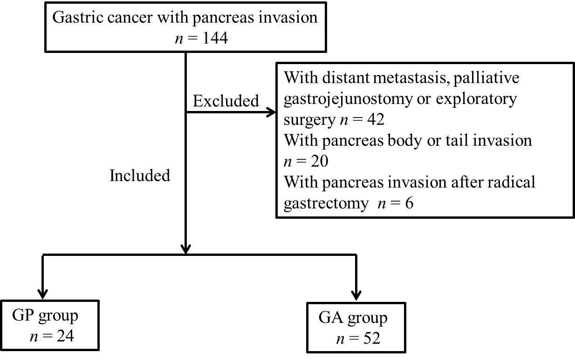
Figure 1 Flowchart of study inclusion.

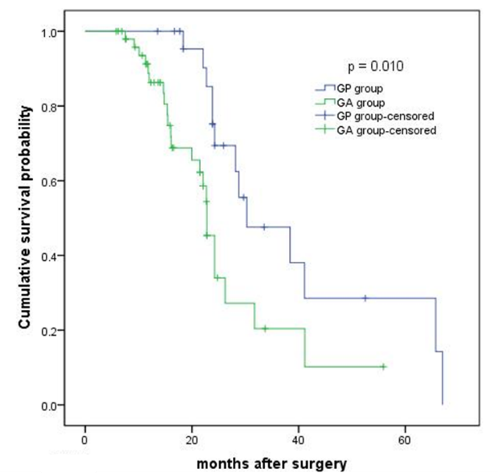
Figure 2 Overall 3-year survival rate of the pT4 patients in the GP group was significantly longer than that in the GA group (47.6%, median 30.3 mo vs 20.4%, median 22.8 mo, P = 0.010). GP group: Gastrectomy plus en bloc pancreaticoduodenectomy group; GA group: Gastrectomy alone group.

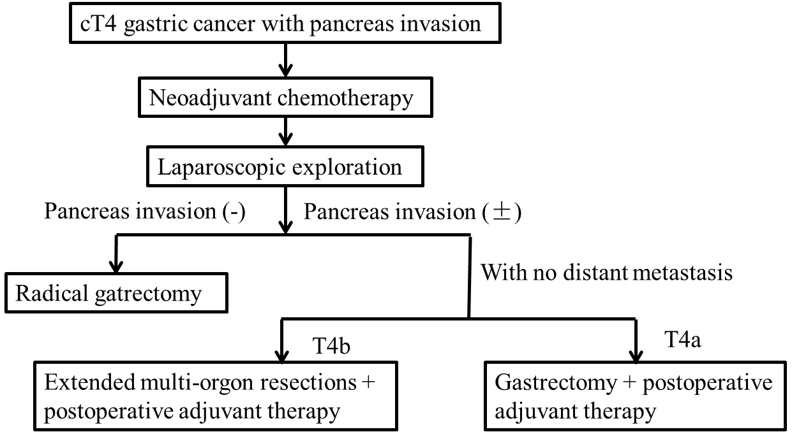
Figure 3 Flowchart of suggested treatment for cT4 gastric cancer with pancreatic head invasion.

Table 1 Clinicopathological features of patients undergoing gastrectomy plus pancreatectomy and palliative gastrectomy alone
Variable | GP group, (n = 24) (%) | GA group, (n = 52) (%) | P value
Gender |  |  | 0.486
Male | 22 (91.7) | 43 (82.7)
Female | 2 (8.3) | 9 (17.3)
Age (yr) |  |  | 0.254
< 65 | 16 (66.7) | 41 (78.8)
≥ 65 | 8 (33.3) | 11 (21.2)
BMI (kg/m²) | 23.5 ± 3.5 | 23.2 ± 3.3 | 0.779
ASA score |  |  | 0.45
< 3 | 16 (66.7) | 39 (75.0)
≥ 3 | 8 (33.3) | 13 (25.0)
Neoadjuvant chemotherapy |  |  | < 0.001
Yes | 10 (41.7) | 44 (84.6)
No | 14 (58.3) | 8 (15.4)
Postoperative therapy |  |  | 0.199
Chemotherapy | 11 (45.8) | 32 (61.5)
Chemoradiotherapy | 13 (54.2) | 20 (38.5)
Preoperative albumin (g/L) | 37.9 ± 4.9 | 36.3 ± 5.1 | 0.083
Preoperative hemoglobin (g/L) | 119.0 ± 28.2 | 108.3 ± 26.5 | 0.058
Linitis plastica |  |  | 0.059
Yes | 1 (4.2) | 11 (21.2)
No | 23 (95.8) | 41 (78.8)
Borrmann type |  |  | 0.312
I | 1 (4.2) | 1 (1.9)
II | 8 (33.3) | 18 (34.6)
III | 14 (58.3) | 23 (44.2)
IV | 1 (4.2) | 10 (19.2)
Tumor size (cm) | 9.3 ± 2.3 | 6.7 ± 1.9 | < 0.001
Histological type |  |  | 0.945
Poorly differentiated | 20 (83.3) | 43 (82.7)
Well–moderately differentiated | 4 (16.7) | 9 (17.3)
Pathological N stage |  |  | 0.03
N0 | 0 (0.0) | 0 (0.0)
N1 | 0 (0.0) | 0 (0.0)
N2 | 5 (20.8) | 17 (32.7)
N3a | 5 (20.8) | 16 (30.8)
N3b | 14 (58.3) | 19 (36.5)
Lymphovascular invasion |  |  | 0.168
Yes | 22 (91.7) | 41 (78.8)
No | 2 (8.3) | 11 (21.2)
Neural invasion |  |  | 0.638
Yes | 17 (70.8) | 34 (65.4)
No | 7 (29.2) | 18 (34.6)
Surgical margin |  |  | < 0.001
R0 | 21 (87.5) | 0 (0.0)
R1 | 3 (12.5) | 52 (88.5)
Values are percentages or mean ± SD. GA: Gastrectomy alone; GP: Gastrectomy plus pancreatectomy; BMI: Body mass index; ASA: American Society of Anesthesiologists.

Table 2 Surgical outcome of patients undergoing gastrectomy plus pancreatectomy and gastrectomy alone
Variable | GP group, (n = 24) (%) | GA group, (n = 52) (%) | P value
Intraoperative blood loss (mL) | 443.8 ± 104.6 | 144.2 ± 64.7 | < 0.001
Operation time (min) | 223.3 ± 41.6 | 192.9 ± 29.6 | 0.003
Postoperative hospital stay (d) | 18.2 ± 5.9 | 10 ± 3.6 | < 0.001
Postoperative mortality | 1 (4.2) | 2 (3.8) | 1
Postoperative morbidity | 8 (33.3) | 8 (15.3) | 0.128
Local complications | 5 (20.8) | 6 (11.5) | 0.324
Abdominal infection | 1 | 0
Anastomotic fistula | 0 | 1
Abdominal hemorrhage | 1 | 0
Gastrointestinal hemorrhage | 0 | 1
Disruption of wound | 1 | 0
Pancreatic fistula | 2 | 3
Duodenal stump fistula | 0 | 1
Systemic complications | 3 (12.5) | 2 (3.8) | 0.177
Pulmonary infection | 1 | 0
Pneumothorax | 1 | 1
Renal failure | 0 | 0
Diabetic ketoacidosis | 1 | 0
Cardio- and cerebrovascular event | 0 | 1
Clavien–Dindo classification |  |  | 0.309
II | 1 | 3
IIIa | 2 | 1
IIIb | 3 | 1
IVa | 1 | 0
IVb | 0 | 1
V | 1 | 2
GA: Gastrectomy alone; GP: Gastrectomy plus pancreatectomy.

Table 3 Univariate and multivariate analysis of prognostic factors for pT4 gastric cancer with pancreatic head invasion
Variable | Univariate analysis |  | Multivariate analysis
 | HR (95% CI) | P value | HR (95% CI) | P value
Age ≥ 65/< 65 yr | 1.19 (0.567–2.505) | 0.644 | — | —
Gender (male/female) | 1.01 (0.369–2.101) | 0.346 | — | —
Preoperative hemoglobin < 35 g/L (yes/no) | 1.09 (0.423–3.205) | 0.524 | — | —
Preoperative anemia | 1.18 (0.523–2.985) | 0.502 | — | —
(hemoglobin < 90 g/L) (yes/no)
Neoadjuvant chemotherapy (yes/no) | 0.180 (0.073–0.446) | < 0.001 | 0.29 (00.103–0.821) | 0.02
Operation type (GP/GA) | 0.393 (0.188–0.819) | 0.013 | 0.689 (0.157–3.019) | 0.621
Borrmann type |  | 0.159 | — | —
I | 1
II | 1.399 (0.266–7.358) | 0.692
III | 0.479 (0.164–1.403) | 0.179
IV | 0.398 (0.144–1.100) | 0.076
Tumor diameter > 7/≤ 7 cm | 0.380 (0.190–0.758) | 0.006 | — | —
Tumor type (linitis plastica/not) | 2.764 (1.127–6778) | 0.026 | 2.614 (1.024–6.675) | 0.033
Intraoperative blood loss > 400mL (yes/no) | 1.089 (0.347–2.102) | 0.154
Operation time > 240 min | 1.021 (0.233–3.112) | 0.423
Surgical margin (R0/R1) | 2.501 (1.177–5.314) | 0.017 | 0.274 (0.102–0.738) | 0.01
Lymphovascular invasion (yes/no) | 2.512 (1.066–5.921) | 0.035 | 1.517 (0.930–2.476) | 0.095
Perineural invasion (yes/no) | 1.545 (0.781–3.054) | 0.211 | — | —
Differentiation type (poor/well–moderate) | 1.358 (0.610–3.021) | 0.454 | — | —
N stage（N0/N1/N2/N3a/N3b） | 1.708 (1.103–2.644) | 0.016 | 3.489 (1.334–9.120) | 0.011
Postoperative treatment (chemotherapy/chemoradiotherapy) | 0.347 (0.159–0.757) | 0.008 | 0.369 (0.163–0.836) | 0.017
HR: Hazard ratio; CI: Confidence interval; GP: Gastrectomy combined with pancreatectomy; GA: Gastrectomy alone.

